

To explore if stop and search powers impact on the public’s confidence in policing.
School: UWTSD Swansea
Degree: BSc (Hons) Professional Policing Practice
Due Date: 8th April 2024
Word Count: 8,800.

Acknowledgements

First and foremost, I'd want to thank my dissertation tutor, Michelle Hill, for all her help and support throughout this process. Michelle has been available for any one-to-one chats I’ve needed, provided me with endless support and has been very understanding, for all of this and more I will always be grateful.
In addition, I would like to thank all the police staff from my time at training who have helped me throughout this process. I would also like to thank my colleagues who have been very supportive and a great sounding board when I have needed them.
Finally, I would like to give sincere thanks to my family and my wife for their endless support and kindness. Their time, guidance, and support, not only through my third year but throughout my entire time at university has given me the motivation to power through. I cannot express how grateful I am, and how lucky I feel to have this foundation of support, now and in the future.

Declaration
This work has not previously been accepted in substance for any degree and is not being concurrently submitted in candidature for any degree.
Signed G. Bennett Date: 08.04.2024.
STATEMENT 1
This dissertation is being submitted in partial fulfilment of the requirements for the degree of BA.
Signed G. Bennett Date: 08.04.2024.
STATEMENT 2
This dissertation is the result of my own independent work/investigation, except where otherwise stated.
Other sources are acknowledged in the Reference Section.
Signed G. Bennett Date: 08.04.2024.
STATEMENT 3
I hereby give consent for my dissertation, if accepted, to be available for photocopying and for interlibrary loan, and for the title and summary to be made available to outside organisations.
Signed G. Bennett Date: 08.04.2024.

STATEMENT 4
I hereby give consent for my dissertation, if accepted, to be available on the university’s IT system to those who have consent to use the system.
Signed G. Bennett Date: 08.04.2024.

Table of Contents
Acknowledgements 1
Declaration ……………………………………………………….………………………….3
Chapter 1: Introduction 9
1.2 Background and rationale 9
1.3 Research aim and Objectives. 10
1.3.1 Aim 10
1.3.2 Objectives 11
1.4 Research Structure 11
1.5 Conclusion 12
2. Chapter Two: Literature Review 13
2.1 Introduction 13
2.2 The history surrounding the development and use of stop and search powers. 14
2.3 Stop and search powers and their purpose. 15
2.3.1 Searching a vehicle. 16
2.4 The impact on local community relationships with the Police. 18
2.4.1 Positive interactions. 18
2.4.2 Negative interactions. 20
2.4.3 The disproportionality. 22
2.4.5 Changing demographics ……………………………………………………...23
2.6 Conclusion. 25
3. Chapter Three: Methodology 26
3.1 Introduction. 26
3.2 Research Methods. 27
3.3 Research tools. 29
3.4 Ethical considerations. 31
3.5 Survey Design. 33
3.6 Sample 34
3.7 Conclusion …………………………...…………………………………………….34
4. Chapter Four: Data Analysis 35
4.1 Introduction. 35
4.2 Questionnaire Findings. 35
4.2.1 Responses to questions 1 and 2. 35
4.2.2 Responses to questions 3 and 4 …………………………….…………….37
4.2.3 Responses to questions 5 and .6.……………………..…………………..39
4.2.4 Responses to questions 7 and 8.…………………………………………..41
4.2.5 Responses to questions 9 and 10 …………………………………………42
4.2.6 Responses to questions 11 and 12………………………………..………..44
4.2.7 Responses to questions 13 and 14 ………………………..……………….46
4.2.8 Responses to questions 15 and 16 ………………..……………………….47
4.2.9 Responses to question 17 ………….…………………………………….….49
4.3 Conclusion…………….………………………………………………….……….51
5. Chapter Five: Findings and conclusion. ………………………………………………52
5.1 Introduction. 52
5.2 Objectives…………………………………………………………………………… 52
5.2.1 Objective 1…………………………………………………………...…………….52
5.2.2 Objective 2.…….…………………………………………………………..……...53
5.3 Main Findings 53
5.4 Conclusion 54
5.5 Recommendations 55
5.6 Final thoughts ……………………………………………………………………….58
6. Bibliogrpahy 59
7. Appendices 68
7.1 Appendix 1 – Questionnaire disclaimer 68
7.2 Appendix 2 – Copy of Questionnaire 69
7.3 Appendix 3 - Questionnaire Answers 73
7.4 Appendix 4 – Ethics Form 80

Chapter 1: Introduction

Introduction
This chapter aims to deliver a background and rationale for the study. It will outline and explain the aim and objectives of the research, with its description and structure.
The purpose of this study is to determine how the public view police stop and search powers in England and Wales. This project will also examine if this power is an effective strategy for preventing crime and whether it raises or lowers public confidence in Police forces.

Background and rationale
Police stop and search powers has provoked intense debates, raising concerns about privacy, racism, and the effectiveness of such measures, as noted in research and policies. Fagan et al, (2009) argued that stop and search methods had a disproportionate impact on minority populations, exposing patterns of racial bias and discrimination in policing strategies. Bradford et al, (2009) found that stop and search encounters might erode public trust in the police, particularly when regarded as unjust or unreasonable, hindering efforts to develop strong police-community ties.
Despite arguments in favour of stop and search as a crime prevention tool, concerns about its effectiveness and unintended consequences persist, as evidenced by Tiratelli et al. (2018), which call stop and search ineffective in reducing crime rates and improving public safety. The debate over stop and search reflects broader societal tensions over race, equality, and public safety, leading to ongoing conversations, research, changes in policy to strike a balance between policing needs and the protection of individual rights.
Stop and search encounters are based on the police power to detain people and conduct searches in public places, they’re an important tool for crime prevention and detection, but also raise concerns about racial profiling, discrimination, and confidence in the community Tucker-Gail et al., (2019). Critics argue that stop and search powers, exacerbate social inequalities, erode trust between law enforcement agencies and the communities they serve (Cooper et al., (2021).
The researcher was motivated to explore this subject because of the effectiveness with which this power and information can be used and shared. Another reason for the research is to determine how effective this power is in preventing crime and whether it has a positive impact on the community.

Research aim and Objectives.

Aim
The aim of this dissertation is to explore if stop and search powers impact on the public’s confidence in policing.

Objectives
- 1). To explore stop and search powers and their purpose.

- 2). To what extent has stop and search powers impacted on local community relationships.

Research Structure
To meet the objectives of this research, this dissertation will contain five chapters.
Chapter one addressed the research by offering a background, rationale, aim, and multiple objectives.

The second chapter contains a literature review that examines the subject's study. The literature review will contribute to a better understanding of the history of the development and use of stop and search powers, as well as its impact on local community interactions with the police, changing demographics, and disproportionality.
The third chapter will demonstrate the appropriate research method and tools for this study. Chapter four will examine the data gathered using the methods described in Chapter three.
The fifth chapter will review the research's aim and objectives. To conclude, there will be a discussion of the final thoughts, main results, conclusions, and recommendations.

Conclusion
Chapter one introduced the research, identified the aim and objectives, and outlined why this research is beneficial within examining the police power of stop and search. The next chapter will present a literature review, bringing more depth to the issues discussed in chapter one.

2. Chapter Two: Literature Review.

2.1 Introduction
The purpose of this chapter is to review current academic literature which will identify current powers used by South Wales police to search any persons and any vehicle. It will also examine the impact and effectiveness of these powers on the local communities they care for. It may identify any gaps in the literature and provisions that could be considered soon to identify what extent these powers have on the community. This review will aim to explore the complex and multifaceted feelings and attitudes of communities towards the police powers to stop and search. Reviewing the thoughts of the communities of these powers will help provide information on whether this is an effective power or simply a hindrance on the police and/or the public.
The literature review will analyse stop and search powers, their purpose, the history surrounding stop and search, positive interactions, negative interactions, changing demographics and the disproportionality associated with stop and search, with the following objectives:
1). To explore stop and search powers and their purpose.
2). To what extent has stop and search powers impacted on local community relationships.

2.2 The history surrounding the development and use of stop and search powers.

In 1981, rioting occurred in Brixton, London, because of police stop searches causing tensions in the community. A police initiative to lower Brixton's high crime rate resulted in many black teenagers being stopped and searched. Prior to the riots, there were 943 stop and searches in Brixton, unsettling communities and heightening tensions between police officers and young people. 279 police officers and at least 45 members of the public suffered injuries throughout the six hours of violence (Brenton, 2010). According to Lord Scarman's study in 1984 into the riots, the breakdown of connections between the police and the communities they served was caused by the overuse of this power. People in the neighbourhood started to lose faith in and respect for the police after hearing the accounts of numerous innocent young people who had been stopped and searched. With the Scarman Report, policing underwent an important change. Following that, a new authority to stop and search a person or vehicle was created by the Police and Criminal Evidence Act of 1984 (PACE), Keeling, (2017).

The investigation into the murder of Stephen Lawrence in London in 1993, resulted in the publication of the Macpherson report. Stephen Lawrence was killed by a gang of white men and from his death a public inquiry accused the Metropolitan police to be institutionally racist, within the report, they found that the excessive use of stop and search against people from "minority ethnic communities" was strongly condemned. The criminal justice system and interactions between the police and the black community took the stage. The use of police stop-and-search powers on black persons was one of the findings of "institutional racism" from the police. Black people's objections to police stop and search practices were among the strongest during the second part of the inquiry, which involved evidence being gathered on "background issues" at several locations across the country (Bridges, (2001).

2.3 Stop and search powers and their purpose.
Under section 1 P.A.C.E(Police and Criminal evidence act), (Home office, (2013) a police officer has the right to stop and search a person or a vehicle to look for stolen or illegal objects, offensive weapons, articles used in burglary, theft and items used in criminal damage. Before stopping a person and searching them, an officer must have reasonable grounds to believe that they are in possession of stolen or illegal items HMIC, (2015). Under PACE code A, ‘search is more likely to be effective, legitimate, and secure public confidence if reasonable grounds for suspicion are based on a range of objective factors’ (Archer et al. (2023), p.32). When used with reasonable grounds, stop and search laws are simple to follow. According to P.A.C.E. 1984, there must be an objective foundation for the suspicion based on facts, information, and/or intelligence that are pertinent to the possibility of discovering an article Yesufu, (2013).
Under the Misuse of drugs act (1971), a constable may search a person and hold them for the purpose of a search if the constable has reasonable grounds to believe that the person is in possession of a controlled drug. Any vehicle or vessel they suspect may contain the drug should be searched. Anything that was discovered during the search and seems to be proof of an infraction should be seized (Misuse of drugs act 1971, (2011).
Its role in eradicating crime and acquiring evidence is another advantageous element. Authorities may come across information or make arrests related to criminal conduct, which may result in the conclusion of open criminal cases. Effective stop and search procedures can help locate and detain criminals connected to a variety of other crimes, clearing cases, as demonstrated by Ratcliffe and Taniguchi (2015). As a result, the community's faith in the police's ability to uphold law and order is increased while simultaneously furthering the interests of justice.
According to (Nagin et al. (2015) pp. 74-100), deterrence works at the individual level for people who have been arrested by the police. A certain percentage of persons who are searched will either be placed under arrest or given a different punishment. It seems likely that these people would be deterred from committing crimes in the future. Similarly, even in cases where a person has not broken any laws, just being stopped, and searched could have a deterrent effect on their behaviour in the future. People’s perceptions of danger may be altered by seeing or learning about stop and search procedures; they may come to feel, that police are capable of apprehending criminals.

2.3.1 Searching a vehicle.
Under section 163, road traffic act 1998. A person driving a motor vehicle on a road must stop the vehicle on being required to do so by a constable in uniform. The same laws that permit police to search pedestrians also permit them to search vehicles. The Police and Criminal Evidence Act, The Misuse of Drugs Act of 1971, and The Firearms Act of 1968 are ones most used (HMIC, (2013).
Although stopping and searching someone and their vehicle is rarely grounds for dismissing a police officer, two Metropolitan police officers were recently dismissed for allegedly smelling cannabis when they pulled over and searched athletes Ricardo dos Santos and Bianca Williams. They stated the automobile ran a red light. It hadn't. A Metropolitan deputy assistant commissioner, Matt Ward, apologised and said: “Today’s findings also highlight that we still have a long way to go to earn the trust of our communities, particularly our black communities, when it comes to our use of stop and search” (Dodd, 2023).

2.4 The impact on local community relationships with the Police.

2.4.1 Positive interactions.
Joel Miller et al., (2001) evaluated information from a survey with Youth Lifestyles in 1998/1999, speaking to 3,391 young people in England and Wales, who were offenders and non-offenders. The survey found that 64% of those who were stopped and searched by police thought that they did a "fairly" or "very" good job, and that 66% of those who had not committed a crime or used drugs felt the same way (Miller et. Al, 2001). Community Scrutiny Panels, composed of members of the public and frequently chaired by an independent party, review randomly selected records and footage of stop and search incidents, and reflect on whether officers have acted appropriately, providing feedback to their local force. Since 2019, 40,000 weapons have been seized through stop and search, which has resulted in over 220,000 arrests (HMIC, (2023).
Police stop and search procedures have the potential to reduce crime and deter future criminal activity. This practise acts as a preventative measure to deter people from carrying illegal materials and committing crimes. Hales (2018) research indicates that the sheer existence of stop and search operations can serve as a deterrent since people are less likely to carry weapons or contraband when they are aware that they run the danger of being stopped and searched by the police. Stop and search can improve public safety and help to lower crime rates in this way. Despite the absence of any indication of spatial displacement, police stop interventions result in meaningful and significant drops in crime. According to a review of research using community surveys, stopping pedestrians does not have a detrimental impact on community opinions towards the police, suggesting that the intervention's unintended consequences may only negatively influence those who were directly affected by it. Reviews in the past have frequently been unable to locate proof of detrimental effects on public perceptions of the police (Peterson et al., 2023).

Effective police stop and search procedures that respect citizens' rights can dramatically increase public safety. Police departments may reduce the risk of harm to locals by stopping guns, drugs, and other illegal items before they enter communities. A well-executed stop and search technique adds to a higher level of general community well-being. A safer and more secure atmosphere can result from the elimination of weapons, drugs, and other hazards from the streets, which can increase community members' feelings of security, according to Lum et al. (2018).

2.4.2 Negative interactions
At its worst, the police may receive little to no praise for a job well done, while a negative encounter has a significant negative impact on communities’ perceptions of the police's performance and even their legitimacy (Skogan, (2006). Numerous residents believe that stop and search procedures are racially biased or prejudiced, which causes unfavourable emotions and erodes public confidence. The lessons are learned more rapidly, people give bad incidents more weight, and negative experiences have a greater influence on behaviours (Skogan, (2006). Peterson et al. (2023), state that those who are stopped are substantially more likely to experience unfavourable results in their mental and physical health, views towards police, and other factors. Weitzer and Touch, (2005), pp. 1009-1030) purport that increased tensions between the police and the community because of frequent and aggressive stop searches may undermine community policing initiatives.
The efficiency of police stops and search operations in lowering crime rates is a topic of continuous discussion. According to some research, these actions have a minor influence on reducing crime. Overuse of stop and search may result in over policing in some neighbourhoods, which can irritate residents. When these encounters are centred on transgressions of a minor nature, resources could be diverted from tackling more urgent problems like violent crime and community involvement (Alpert and Dunham, (1997) pp. 480-505). Nearly one in ten stop and search arrests in 2018–19 was made for public order offences after nothing was found. When a search produces an outcome—typically an arrest—but no stolen or forbidden item is discovered, it may incite or worsen public opinion of the police and undermine confidence. Yet, despite the possible harm to police-community ties, many forces still view these as "positive outcomes." Although records studied showed that more searches were self-generated (55 percent) than were driven by information from third parties (37 percent), and few were intelligence-led (9 percent), searches based on information or intelligence are more likely to be successful (HMICFR, (2021).
Police stop and search policies in the UK have also come under question for their effectiveness on neighbourhood relations. According to research, the widespread and frequently ineffective practise can harm relationships between the police and the community. Over policing may alienate residents, reducing their willingness to assist the police or report crimes. This may make it more difficult for law enforcement to deal with more serious crimes and obstruct community policing operations (Crawley and Crawley, (2008).
Reiner, (2010) wrote that in disadvantaged and minority communities, residents frequently view stop and search operations as symbols of excessive policing, an invasion of their privacy, and a manifestation of authoritative overreach, these law enforcement powers can arouse feelings of distrust and apprehension. To make decisions about policing practises and policies that are in the best interests of all community members, law enforcement agencies and researchers can develop a more nuanced understanding of the complex dynamics that underlie police-community relations. Members of the Turkish and Jamaican communities in the United Kingdom participated in surveys conducted by Fountain et al. (2007). The residents of these neighbourhoods’ express worries about drug supply issues, but they are very hesitant to work with the police to address them because they believe that they are being unfairly singled out due to racism and stereotyping, especially when it comes to the stop and search tactic.
Stop and search policies have left young people who have been searched feeling harassed, scared, and frightened, which has caused them to "reject any notion that they have value, save that which they derive from their own peer group" (Reid Howie, (2001).
Delsol and Shiner, (2015) suggest that stop and search procedures frequently fall short of the requirements for "reasonable suspicion," with authorities using factors like a person's suspicious behaviour or looks as grounds for detaining a suspect.
Flacks (2020) examined the case of Mohidin and others vs The Commissioner of the Police of the Metropolis. This dealt with the compensation given to young people who were stopped and searched for the discomfort and grief they had endured. It is crucial to consider the long-term effects of stop and search policies on youth communities, rather than viewing them as a temporary inconvenience, a necessary evil, or even as a simple challenge to police legitimacy or community relations. The Mohidin case serves as an example of how police officers stigmatise the use of public space by some youth and how stop and search powers are used as a tool for punishment in addition to, or in place of, legitimate ways of detecting criminal activity.

2.4.3 The disproportionality
Stop-and-search practices have been strongly related to racist behaviour by police officers in Britain, where a disproportionate number of Black and minority ethnic people are stopped and searched compared to White people (Ellis, (2010).
Ellis (2010) may be slightly out of date, but according to data from The Office for National Statistics (2022), police in England and Wales conducted 526,024 stops and searches in 2021–2022, in compliance with section 1 PACE. Of 526,024 searches conducted under section 1 PACE, 66,772 led to an arrest. The rate of searches for persons of African or Black British descent was 6.2 times higher than for those of European descent (Office of National Statistics, (2022). One could argue that nothing has changed since 2010 based on the numerous police searches that continue to be directed at individuals of African or Black British descent.
Nothing, according to Ben Bowling and Coretta Phillips (2007), has harmed the relationship between the police and the black community more than the improper use of stop and search. They claim that the figures demonstrate how disproportionately these powers are used against black people, which is a sign of racial discrimination. The use of stop and search powers should be restricted if they cannot be successfully controlled. Black people are almost twice as likely as white people to go through the criminal justice system because of being stopped and searched by the police. The "availability" argument may not have succeeded in increasing public confidence in the use of the power because of this Bowling and Phillips, 2007).

2.5 Changing demographics
Some of the initiatives used by police forces in the UK to enhance the usage and scrutiny of stop and search was published by the IOPC (Independent Office for Police Conduct) (IOPC, (2023). 200 stop and search records involving white persons and 200 stop and search records involving people from other ethnic backgrounds were reviewed by an independent consultant hired by Gwent Police. For those coming from a deprived ethnic background, the grounds were weaker. The Superintendent portfolio leader delivered the findings to all sergeants. South Wales Police organise "Let's Talk about Race" gatherings with facilitators from outside racial organisations. The body-worn video's 30-second video-only buffer has been eliminated by Staffordshire Police to allow for the recording of both audio and video instantly on recording. Additionally, the IOPC advises forces to adopt measures to ensure that the efforts are having the desired effect for both them and their local communities.

2.6 Conclusion
This chapter achieved the first objective:
- To what extent has stop and search powers impacted on local community relationships.

This chapter achieved the second objective:
- To explore stop and search powers and their purpose.

In conclusion to this literature review, it is evident that there is a substantial amount of research that has been carried out regarding the police powers of stop and search and the opinions on the effectiveness of these powers. The disproportionality of these powers being used on ethnic minorities still something that is being closely examined due to the figures released.
The next chapter of this dissertation will seek to identify the methodology that will be the most appropriate and suitable to conduct primary research surrounding the observed gaps witnessed within the literature review.

3. Chapter Three: Methodology.

3.1 Introduction
This chapter is the methodology and will explain how the research will be conducted. This chapter shall commence with a description of the research methods used in the dissertation, followed by an explanation of the research tools chosen and the rationale behind their selection, followed by an outline of the dissertation's ethical commitment.

A methodology comprises a set of procedures, guidelines, or methods used to conduct a methodical research process for a dissertation. The objective is to offer a distinctive and significant outcome that will advance the field of research. For understanding and learning, research is essential. According to Saunders et al. (2019), it is the process of raising awareness and knowledge about a specific subject.
Creswell and Creswell, (2017) stated that research is a thorough investigation into the unknown in which various methodologies are used to find, analyse, and understand aspects to push the boundaries of knowledge. Research is done to either develop or test a theory. Deductive research can incorporate a qualitative approach (Cooper & Endacott, (2007).
This chapter aims to discuss the methods that will be used to conduct this research.

3.2 Research Methods
A range of techniques are employed in research methods to collect information and draw important conclusions that are vital to the advancement of knowledge in many fields. A mixed method approach was used in this research. Mixed methods research combines qualitative and quantitative methods to create a more thorough knowledge by combining data from several sources, which improves the validity and dependability of conclusions (Creswell & Creswell, 2017).
Quantitative research is a cornerstone methodology that uses numerical data and statistical analyses to identify patterns and trends within a population or sample (Creswell & Creswell, 2017). Research reliability and validity are essential because without ongoing data findings, information and data would become older. The researcher will enable the data to be collected to be legitimate, trustworthy, and authentic to ensure that it is factual and that the goals and objectives of this study are as stated (Saunders et al, 2009).
A Qualitative approach will be used for this research. A qualitative approach is distinguished by its focus on using non-numeric data to understand and explore the complexity of human experiences and behaviours. It frequently makes use of methods like questionnaires and content analysis. (Denzin & Lincoln, (2018).
Rather than imposing predetermined categories, qualitative research aims to capture the contextuality of data, embracing the subjective perspectives of participants and permitting the creation of themes and patterns from the data itself (Charmaz, (2014).
Triangulated research was considered. However, data triangulation involves the use of multiple sources of data, such as interviews to provide a comprehensive understanding of the phenomenon under investigation (Patton, 1999). Interviews and the use of numerous sources of data would not be feasible in this case due to financial and time restrictions and hence, the triangulated approach was not selected.
Another method of research is the single research method. A single research method, such as experiments, or ethnography, is the application of a single strategy or technique to study a phenomenon of interest or research issue (Bryman, (2016). While single research methodologies offer systematic and controlled ways to inquiry, they also serve a critical role in advancing knowledge across multiple disciplines (Creswell, 2014). Additionally, it is discovered that they could provide issues with validity, dependability, and scope (Bryman, (2016). As a result, the researcher decided against using this approach.
To achieve the best results, the researcher has opted for a mixed method approach that combines both qualitative and quantitative data. This strategy not only makes use of data and statistics, but also incorporates patterns that have been identified through this and other studies.

3.3 Research tools
The researcher will make and distribute questionnaires to collect a variety of anonymous responses. As a research tool, questionnaires have many advantages. Questionnaire’s enable researchers to gather data from many participants in a very short amount of time, hence aiding the investigation of broad trends and patterns (Dillman et al, (2014).
By integrating questionnaires with a qualitative approach, a mixed-methods approach can assist to overcome some constraints, such as potential bias, and provide a thorough grasp of the topic of study (Creswell & Creswell, (2017).
The chosen strategy is to create one questionnaire which will be available on a hyperlink. Researchers can learn more about participants’ experiences and viewpoints by using questionnaires, which are especially good at gathering self-reported data on attitudes, beliefs, and actions. When researching psychological phenomena or social constructs that might not be readily visible, this feedback method is beneficial. (Babbie, (2016) pp.255-270).
Questionnaires provide participants with a certain level of anonymity, which encourages open communication on delicate subjects that people may be reluctant to bring up in in-person interviews. Anonymity reduces social desirability bias, it increases the validity of responses bias (Kiesler & Sproull, (1986) pp. 402-413).
The researcher planned to create a survey that has both pre-programmed answers and open-ended questions that allow respondents to express their opinions and feelings about the subject. Interviews and other tools were taken into consideration. It was discovered, nevertheless, that surveys could be more affordably sent to a greater number of individuals and that interviews would be more expensive. Surveys provide for anonymity, which encourages more honest responses. Moreover, questionnaires can help researchers spot patterns and trends more quickly than interviews do.
Limitations in a study are issues and situations that the researcher cannot control. They sometimes impact the outcome and conclusions made, and they restrict the extent to which a study can proceed. No matter how carefully it is designed and carried out, every study has its limits (Simon & Goes, (2013). There are a few limitations to this study that has been identified by the researcher. This dissertation has a time limit due to the type and logic of the research. This had an impact on the amount of time that respondents could access and complete the questionnaire. The time limits and deadlines could affect how many people participate. The paper has a word restriction of 10,000 words and a deadline for producing the results and the analysis generated by them. There are drawbacks to using a questionnaire, such as the time it takes to construct the questionnaire, the time to gain responses and the resources needed to complete this and send to others (Ghauri et al, (2020). One disadvantage will be the reliance on others to complete this within a certain time frame. The amount of free time available to complete this study will depend on the individual completing the form, there is an expectation that some may not have time to complete these within the time frame. A disadvantage of utilising this technique is its anonymity. Participants may feel they can give more undesirable answers if they are anonymous, and it will be challenging to contact them later to get further details or clarification.
Owing to the number of respondents that are expected, online forms will be used for the survey. Participants who agree to participate will get this, which they can finish and return. The researcher intends to complete between 20 and 50 questionnaires to get sufficient data. The data will then be examined, with the results shown in a variety of graphs and charts to help identify any patterns. The questionnaire's respondent will remain anonymous because it only asks for the most basic personal information, including the respondent's ethnicity; no further questions ask for information that may be used to identify them. Graphs and tables will be created using the quantitative data given. The data can then be easily translated, and the qualitative data will be passed to the next chapter exactly as provided.

3.4 Ethical considerations
Ethical concerns are crucial while carrying out this research project, which is why a comprehensive ethics form had been completed before the project began to make sure all potential aspects were accepted. UWTSD gave its permission to conduct the research before any research was conducted. Prior to any kind of participation, throughout the primary data collection process, participants were briefed on the purpose of the research and how their input will be used for data analysis. The right to anonymity was upheld to protect the privacy of those who volunteered their time to help with the project, even though qualitative interviews allow for a more candid conversation between the researcher and participant.
Before beginning the questionnaire, all participants received comprehensive information on the study's purpose through a disclaimer and were made fully aware that participation was entirely voluntary. The disclaimer was distributed to each potential participant. The disclaimer contained the researcher's contact information so that participants in the study who had any questions may ask questions or get more information. This information is included at the beginning of the questionnaire to guarantee that participants understand the process, are giving informed consent, and that everyone is aware of the research's aims. The questionnaire was only for people above the age of 18, and by filling out the form and answering the questions, you gave the researcher your agreement. Anyone could leave the study at any moment. No personal information will be gathered or retained, ensuring that no people or places are identified. All data provided is anonymized and devoid of any identifiable information. After data collection is complete, all information will be destroyed.

This study will not be subject to any major ethical constraints. Participants will be asked for permission to use anonymized data, the questions themselves will be morally sound, and as said earlier, no personal information will be included.

3.5 Survey Design
The online questionnaire will include a variety of questions to guarantee that sufficient information can be gathered. Web-based surveys for data collection often produce higher-quality data because they include validation checks that warn respondents when their responses are improbable or incomplete. Item nonresponse and "don't know" responses are stated to be less common in Web-based surveys than in postal questionnaires, even when forced-choice formats are not used (Marleen et al, 2010).
Participants will be asked open and closed questions to obtain this data. Respondents feel empowered and engaged when open-ended questions allow them to express themselves freely without being constrained by preconceived categories or response possibilities (Krosnick & Presser, (2010), pp. 263–313). However, there are some drawbacks to asking open-ended questions. According to Conrad and Blair (1996), one difficulty is the likelihood of ambiguous or partial responses, which may make it difficult for participants to express themselves effectively or provide sufficient information, making it more difficult for the researcher to draw valuable conclusions.

Closed questions reduce survey responses for respondents and researchers by expediting the data collection process. It is critical to recognise that, unlike open-ended alternatives, closed questions may limit the depth of insights gained (Couper, (2008).

3.6 Sample
A small sample of the population is essential for research since the overall population is too big to allow for comparisons (Ghauri et al, (2020).
To ensure that study findings are relevant to a specific group of interest, a well-defined target population must be chosen. To strengthen the study's external validity and allow for more general conclusions to be derived from the sample, the sample should be representative of the target population (Babbie, 2016). The questionnaires will be distributed to the public rather than police officers. The reason for this is that they may have a biassed perspective of stop and search powers, and members of the community are required to meet the aims at hand.
It is frequently impractical or resource-intensive for researchers to survey the entire population, therefore they use sampling procedures to choose a representative subset (Trochim & Donnelly, (2008).

3.7 Conclusion
All the different components of this research approach have been identified and explained in this chapter. The objective of the following chapter is to compile, examine, and summarise the results of the data gathered and carried out using the techniques that were mentioned in this chapter. Compiling, analysing, and presenting the results from the data collection techniques mentioned in this chapter will be the aim of the next chapter.

4. Chapter Four: Data Analysis.

4.1 Introduction
The purpose of this study is to investigate how the public views the value of police stop and search powers. To do this, two main objectives were determined to investigate through research and an online survey.
1). To explore stop and search powers and their purpose.

2). To what extent has stop and search powers impacted on local community relationships.

This section will present and evaluate the information obtained from the research. To gather information about how the public views stop and search powers and how they affect their communities, an online poll was prepared and completed by 21 people. This chapter will refer to the analysis carried out as part of the literature review and the online study completed.

4.2 Questionnaire Findings.

4.2.1 Responses to questions 1 and 2.
Question 1) What ethnic group do you identify as?
Figure 1 -21 responses
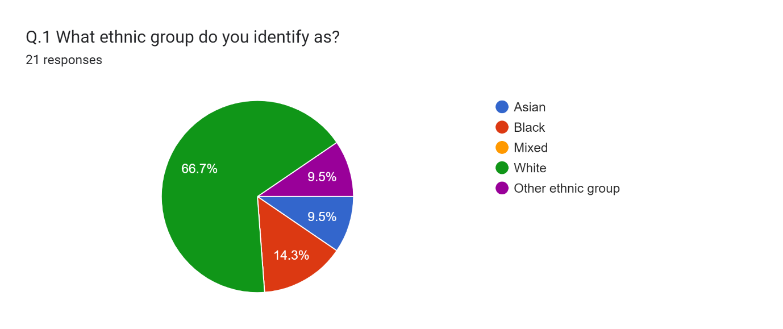
It was crucial to comprehend the topics covered from the perspectives of many diverse ethnic groups to get a more comprehensive picture of the community's viewpoint of police stop and search powers. This essential characteristic's demographic is within a reasonable range. While more representation from ethnic groups would have been preferred by the researcher, this provides a good overview of the primary participants.

Question 2) Have you or a vehicle you were travelling in ever been stopped and searched by police?
Figure 2 – 21 responses.
Finding out how many people had been stopped and searched by the police was the aim of question 2.
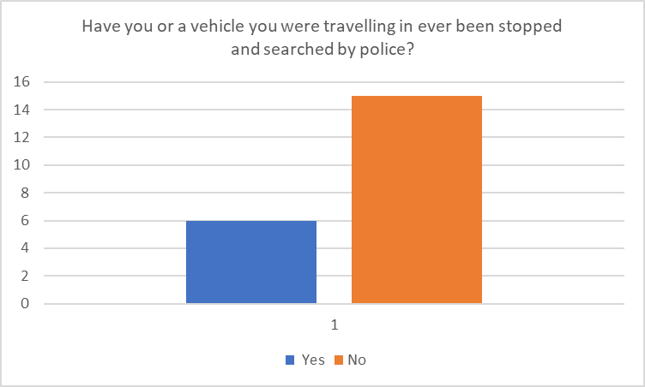
The next three questions focused on the experiences of those who had been stopped and searched by the police, thus those who answered "no" were instructed to move on to question 6.
4.2.2 Responses to questions 3 and 4.
Question 3) How did you feel after the stop and search was conducted?
Figure 3 – 6 responses
Merely 33.3% said they had felt the same way previously and 33.3% of respondents said that they felt harassed, unhappy, and upset following their police stop and search. This went against the findings of (Miller et al. (2001) report, which indicated that 66% of people who had not broken the law thought the police performed a good job. This also affirmed (Reid Howie Associates, (2001) which stated that young people who had been stopped and searched left them, feeling harassed, scared and frightened. This demonstrates that since the research was done, the attitudes and behaviours of persons who have been stopped and searched have remained unchanged.
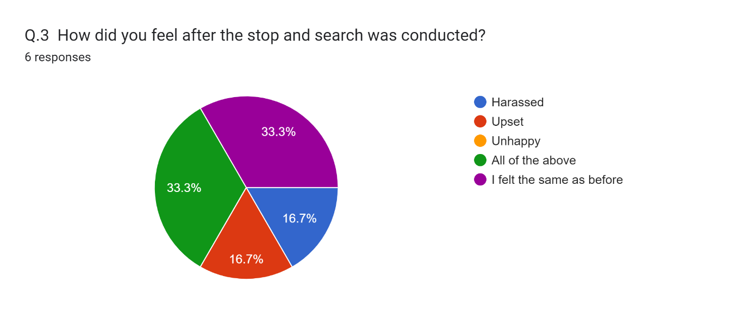
Question 4) Has being stopped and search effected your mental health?
Figure 4 – 6 responses.
50% of respondents said the experience had a detrimental effect on their mental health. Question 4 confirmed Skogan’s, (2006) claim that the stop and search would cause unfavourable emotions which is supported by the participants responses to this question.
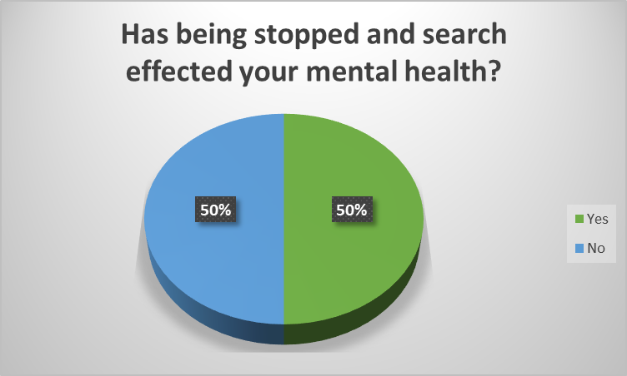

4.2.3 Responses to questions 5 and 6.
Question 5) Were the ground and/or reasonable suspicions explained clearly to you?
Figure 5 – 6 responses.
Question 5 showed whether grounds and/or suspicions were used by officers to explain to the person being searched prior to the search beginning. This affirms the point made by Delsol and Shiner, (2015) that the procedures of stop and search are not being followed correctly under the ‘reasonable suspicion’ as authorities have used suspicious behaviour, or the persons looks as grounds to detain and search them.

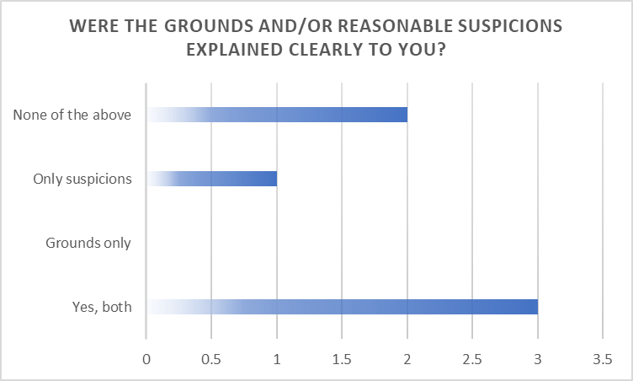

Question 6) As a member of the community do you feel the police power of stop and search deters criminals?
Figure 6 – 21 responses.
Question 6 asked if the public believed that the police discouraged criminal activity by using the stop and search power. Numerous individuals made it clear that they thought the power effectively deters criminal activity. These results are in line with those of Ratcliffe and Taniguchi (2015), who discovered that while advancing the goals of justice, the community's confidence in the police's ability to maintain law and order also increases.
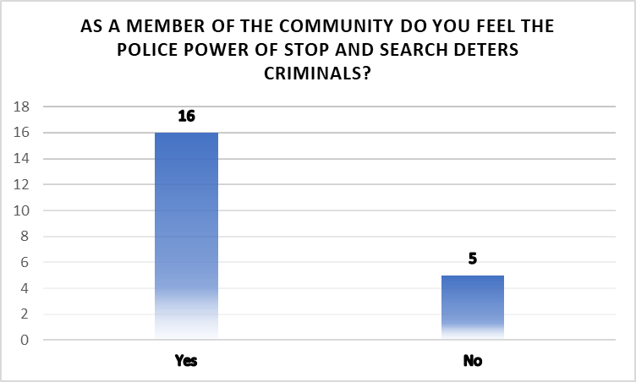

4.2.4 Responses to questions 7 and 8.
Question 7) What impact has stop and search had on your community?
Figure 7 – 21 responses.
To assess the use of the stop and search authority and how the community views it, it was necessary to look at how it affected the community. Just 4.7% of respondents thought this was detrimental to their community. The results also support the research by Lum et al. (2018), which found that a well-implemented stop and search strategy raises the general well-being of the community. 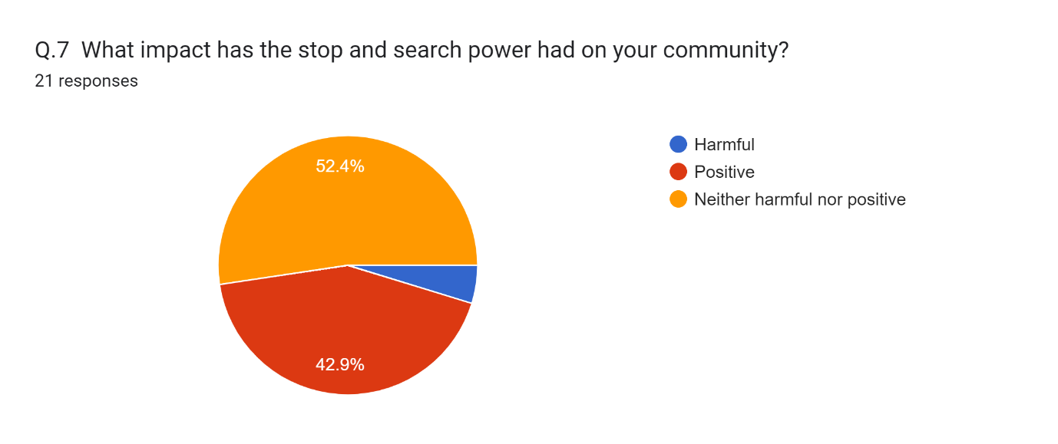
Question 8) Do you agree that stop and search is effective in reducing crime in communities?
Figure 8 – 21 responses.
The overwhelming majority of participants believed that stop and search was a useful power in reducing crime in communities. These answers go counter to the research's findings (Weizer and Touch, (2005). They contended that more frequent and forceful stop searches could jeopardise efforts by community policing. One may argue that the reason for the significant differences in answers is the time gap between their study and this study.
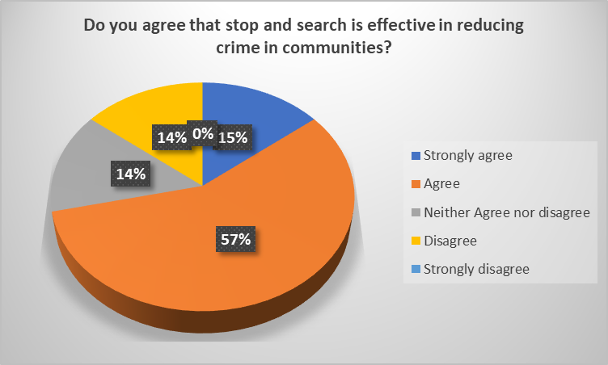

4.2.5 Responses to questions 9 and 10.
Question 9) Does stop and search within the community increase the community’s faith in police?
Figure 9 – 21 responses.
This found that over half of participants agreed that stop and search increased the community’s faith in police. These responses contradict the finding within the study conducted by Reiner (2010). Although there is a time difference between this study and that of Reiner (2010). Reiner stated that residents can view stop and search operations as symbols of excessive policing and an authoritative overreach. Which is disproved by these findings. 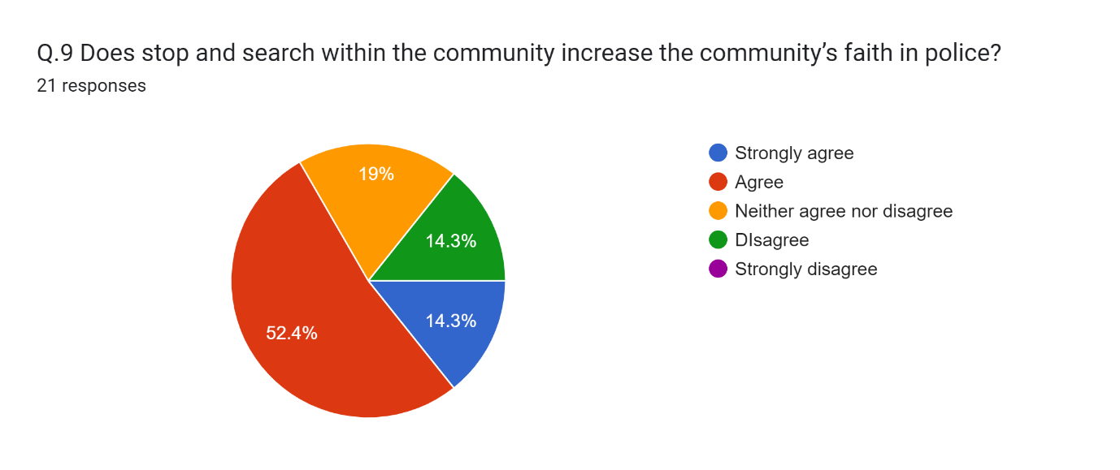
Question 10) Does stop and search make people more or less likely to report issues to the police?
Figure 10 – 21 responses.
Question 10 looked at whether people would be more or less likely to report issues to the police because of stop and search powers. These findings support (Nagin et al, (2015) pp. 74-100), they stated that people seeing or learning about stop and search procedures, would make people feel that police are capable of apprehending criminals. Which could explain why many participants would feel more likely to report issues to the police.
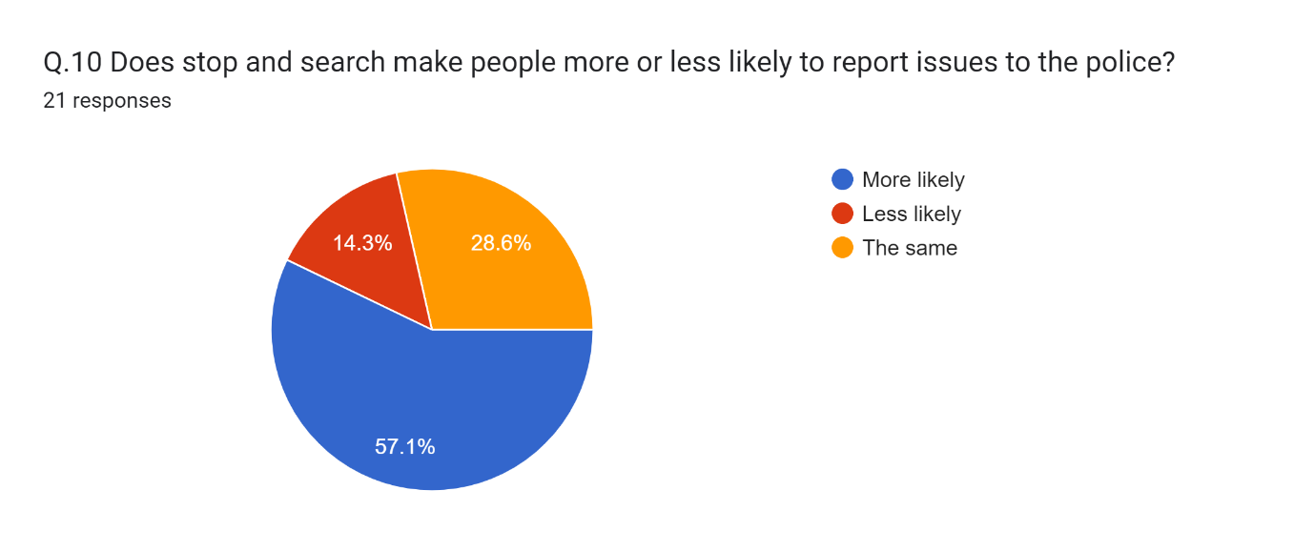

4.2.6 Responses to questions 11 and 12.
Question 11) Do you think police stop and search powers are used fairly towards black, Asian and minority ethnic (BAME) people and white people in Britain today?
Figure 11 – 21 responses.
Contrasting to some research, responses to question 11 showed that 66.7% of people felt that BAME members were equally targeted by the police for stop and search. This contradicts Ellis (2010) that stated that black people are stopped and searched a disproportionate number of times compared to white people and that there is racist behaviour used by police officers in Britain.
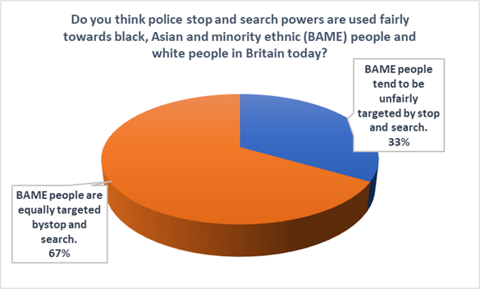
Question 12) In your opinion, based on what you seen or heard (not through social media) has stop and search harmed the relationship between the police and BAME members?
Figure 12 -21 responses.
A significant number of participants stated that they believed that stop and search has harmed the relationship between the police and BAME members. These results are supported by research conducted by Bowling and Phillips (2008) which states that nothing has harmed the relationship more than the improper use of stop and search powers. 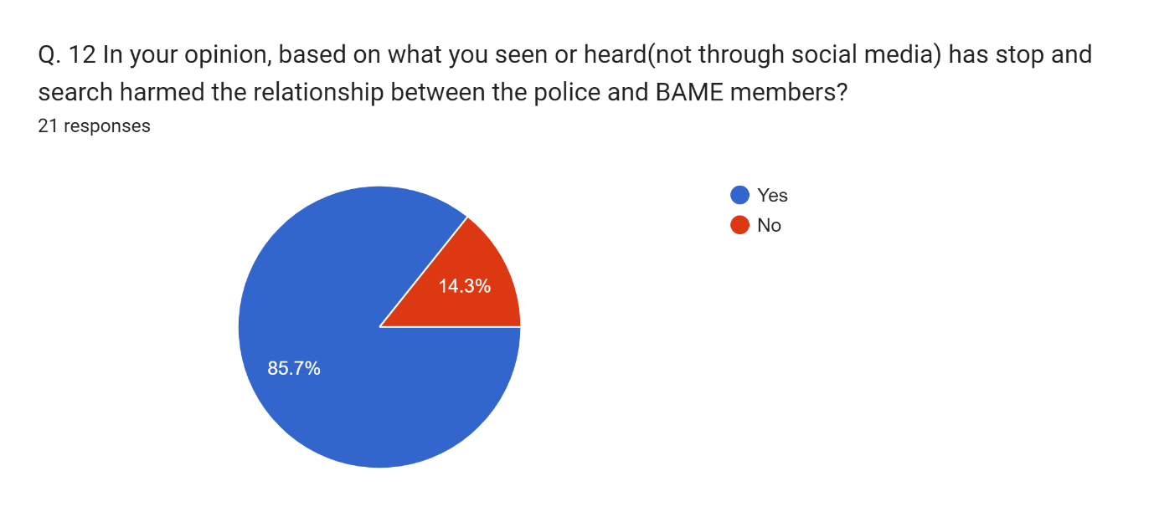
4.2.7 Responses to questions 13 and 14.
Question 13) In your opinion, based on what you have seen or heard (not through social media) has stop and search been used as a way of punishment or a legitimate way of detecting criminal activity?
Figure 13 – 21 responses.
The participants felt that the stop and search powers are a way of detecting criminal activity. This contradicts the report by Flacks (2020) which states that stop and search powers are used as a tool for punishment and not as a legitimate way of detecting criminal activity.
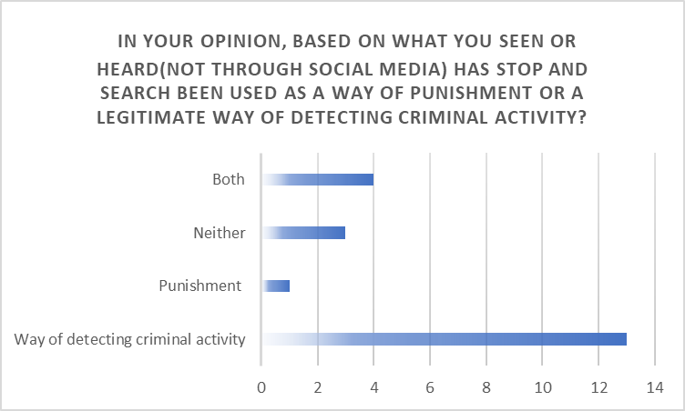

Question 14) Do you agree that police officers use fair and accurate information to decide who is stopped and searched?
Figure 14 – 21 responses.
Question 14 showed that 52.4% agreed that police officers use fair and accurate information to decide who is stopped and searched. This contradicts the information provided by the IOPC (2023) which stated that the grounds for the searches, such as the information, is far weaker in those from an ethnic background.
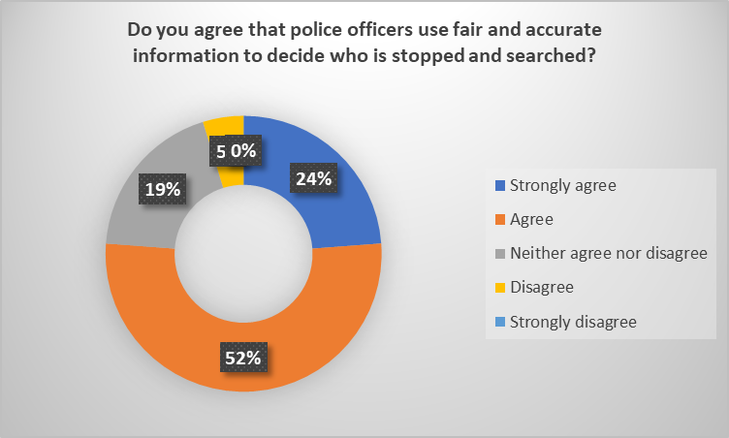
4.2.8 Responses to questions 15 and 16.
Question 15) Does stop and search increase confidence of security within the community?
Figure 15 – 21 responses.
As supported by Peterson et al (2023), a high number of participants stated that they felt that stop and search increased confidence within their community. Peterson et al (2023) stated that police stop, and search has no detrimental impact towards the police from communities which is supported by these responses.
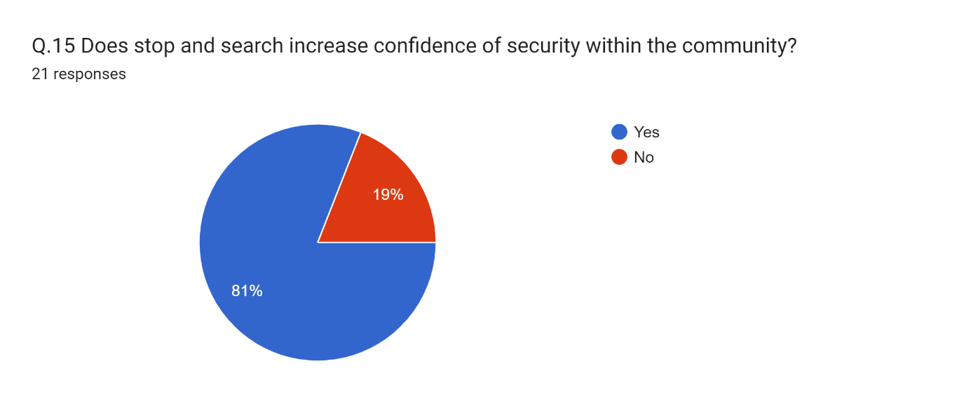

Question 16) If you have not been stopped or searched by police, how do you think it would make you feel if you were?
Figure 16 -21 responses.
Participants were encouraged to give written responses to question 16. Participants were asked to add any details they wished to share, using their own words to elaborate on their personal experiences.
One participant stated, they would feel ‘ok if it was explained and reasoned.’
Another stated ‘If they had grounds then I would be pleased that they were fulfilling their role legally.’

While another wrote:
‘Worried but also reassured that police are proactive.’

And another:
‘It would make me feel uncomfortable, like I had done something wrong even if I hadn't. Feel like everyone will be watching. make me feel anxious.’

This supported the assertion by Hales (2018) that the community was happy to have stop and search procedures because they believed they served as a deterrent to criminal activity.
A small number of individuals reported that they would feel discomfort and anxiety if they were stopped, which is supported by Peterson et al., (2023), claims that it may only negatively influence those directly affected, e.g., stopped and searched. According to several participants, they said that being stopped and searched would be detrimental to their mental health which gives weight to the argument provided by Fleck (2020). Fleck (2020) stated that it is crucial to consider the long-term effects of stop and search policies, particularly on youth communities.

4.2.9 Responses to question 17.
Question 17) Why would you have negative opinions to the police if you haven’t been stopped and searched?
It was also suggested that participants respond in writing to question 17. The participants were asked to add any more thoughts they would like to express, elaborating in their own words on their feelings regarding the police and what it would be like to be stopped and searched.
One participant stated, ‘Through word of mouth, other people's experiences impacting your opinion.’
Another stated ‘The media states that police are racist’.

While another wrote:
‘They are not using their powers to prevent criminal activity.’

This method was used to investigate and broaden the communities' perceptions of the police and see whether they would feel differently about being stopped and searched. This supports the claim made by Dodd, (2023) that police still have a distance to go before gaining the confidence of the public. It is evident from media reports that the police force's ability to impact the trust of larger populations has not yet reached the desired level that they would hope for. One comment regarding racism falls in line with claims made by Fountain et al (2007), who stated that members of the Turkish and Jamaican communities feel they are singled out due to racism and stereotyping in the police.

4.3 Conclusion
In conclusion, the present study identified that the general public, although a small number, believe that police stop, and search powers are beneficial to their communities.
This chapter has successfully analysed the data and discovered the communities’ views on police stop and search. The last chapter will achieve the final objective of looking at conclusions, findings and recommendations of the stop and search power and it’s use in communities.

5. Chapter Five: Findings and conclusion.

5.1 Introduction
The findings and conclusion chapter will attempt to provide a summary of the study, identify its shortcomings, and suggest further lines of inquiry for researchers conducting similar research in the future. It will assess if the objectives set have been achieved and end with recommendations pertaining to the matter.
The aim of this study was to investigate the effectiveness of the Police’s power to stop and search in England and Wales.
To achieve this the research had the following objectives:
5.2 Objectives
5.2.1 Objective 1. To explore stop and search powers and their purpose.
This objective was completed with an in-depth literature review, which focused on previous research that had been found relating to the police power of stop and search. The present study aimed to investigate the history surrounding the development of the power, the purpose of the power, the legal power itself and the disproportionality of its use. One of the purposes behind the stop and search power is deterring criminals. Participants in the poll, 16 out of 21, agreed that the authority to stop and search does have the effect of discouraging criminal activity. According to a study by Hales (2018), people are less likely to carry weapons and contraband when they are aware that they could be stopped and searched by the authorities. These opinions are consistent with that finding.

5.2.2 Objective 2. How do stop and search powers impact on local community relationships with the police
To gather data for this study, a mixed method approach was employed. A convenient sample of the public was given access to a questionnaire that was created to investigate the general public's opinion. In order to accomplish this goal, a thorough literature study was also conducted. Its purpose was to find out what the community thought about the power, how effective it was, what literature was supportive of the power, and what prior research had to say about the validity of the power. One factor affecting relationships within the community was the aftermath, 66.7% of respondents in the public survey who said that being stopped and searched had a detrimental effect on their mental health. This supported the claim stated by (Peterson et al. (2023) that those who are stopped are probably going to have negative effects on their physical. and emotional well-being. The fact that the power effectively lowers crime was one of the benefits that emerged from the research. According to the survey, 72% of respondents thought it was effective in lowering crime. A report from HMIC (2023) also revealed that since 2019, 220,000 arrests had been made as a result of the police using this power.

5.3 Main Findings
Members of the community felt that the police power of stop, and search was an effective crime prevention technique with 42.9% of participants stating that they felt it had a positive impact on their community and only 4.7% felt it was harmful to the community. This contradicts the research by (Reiner, (2010) who stated that residents view stop and search operations as symbols of excessive policing. One other finding was that analysis of data and research found that many members of the public felt that the police power of stop and search targeted minority groups and as such left them feeling a lack of trust towards the police force.
Qualitative questionnaires with members of the community highlighted that there is evidently more work to be done with officers giving clear explanations as to why someone has been searched, such as explaining the grounds and/or reasonable suspicion to the person. The questionnaire found that neither the appropriate grounds and/or suspicions were explained to the person being stopped and searched by 2 out of 6 people. (Delsol and Shiner, (2015) stated that stop and search procedures frequently fall short of the requirements for “reasonable suspicion” which was supported by the survey findings.

5.4 Conclusion
In conclusion, the dissertation has drawn attention to and emphasised the impact that police power to stop and search people and their vehicles has on local communities. The researcher has adopted an unbiased stance and has covered both the pros and cons from the community. The literature's gaps have been noted, outlined and could be investigated further to increase awareness and advance present knowledge. The dissertation has brought attention to the existing problems in the hopes that more funding will be made available to support future interactions between the police and communities.
As previously mentioned, the goal of this study's researcher was to better understand how these powers affected the interaction between the police and the community and the communities perception of these powers. The researcher is optimistic that recommendations can be put into practice to enhance public perception because of a greater understanding and perception of this subject.

5.5 Recommendations
Upon completing this dissertation, numerous recommendations can be made throughout this study as there seems to be ongoing community dissatisfaction over the efficiency of police stop and search powers and the following recommendations have been made:
- The initial recommendation is to think about long- or short-term assistance. People who have been stopped and searched may need additional time and assistance over the course of a few months to make sure that this experience has not negatively impacted the way they feel, as many have reported that going through this has adversely affected their emotional well-being.

- The age range of individuals who had been stopped and searched as well as public opinion concerning this could be studied further. This could offer a deeper comprehension of the subject, which could be utilised to identify areas that could require more focus and dedication.

- Another recommendation would be to increase the sample size of participants for the questionnaire, which may not accurately reflect the entire society. Despite the diversity of responses and participant ethnicity, the relatively small sample size only provides a snapshot of viewpoints. A wider population could be reached by extending the questionnaire’s duration for completion and employing different strategies by the researcher, such as sending reminders to participants and utilising social media and online forums. As Gladwell, (2008) explains in "Outliers," the demographics of study participants may limit the generalizability of findings, highlighting the impact of context on research outcomes.

- The police should be aware of racial discrimination and try harder to identify a more balanced approach to improve the relationship between the police and their communities, especially with black and ethnic minority communities. It is estimated that searches of black or African American individuals are 6.2% more likely than searches of European immigrants (Office of National Statistics, 2022). Lowering this will help to boost public confidence. It is also advised to conduct additional research to look at the long-term impacts of community initiatives and police reforms on lowering racial disparities in policing and advancing fair law enforcement procedures. This is supported by members of the public who completed the questionnaire’s views, with one stating ‘the media states that police are racist’.

- If this research were to be carried out again, a longer time frame might be used. Due to time and scheduling constraints, it was not always possible to locate and review more recent studies. It appears that little recent research has been done on the topic, which might be because other policing-related concerns are receiving greater attention.

- Finally, it can be suggested to promote how the intervention can reduce crime, identify criminal activities, and aid in the recovery of missing or wanted individuals. The relationship between the police and communities may be strengthened by more efficiently disseminating the findings through news organisations, community meetings and social media.

5.6 Final Thoughts
There are still many lessons to learn, and improvements are needed with the use of this power in the communities policed in England and Wales, particularly ethnic communities. Another lesson to learn from using this power is the aftercare of the individual that the power has been used upon. Public opinion has positively differed slightly from research found in the literature review and the public perception gained through questionnaires is that there are many benefits to the police stop and search power in their communities.

Bibliography
- Alpert, G. P., & Dunham, R. G. (1997). ‘Policing Urban Disorder: Comparison of On-Officer Video and Suspect Reports of Force’. Police Quarterly, 1(4), pp. 480-505.

- Archer, B., Ellison, G. and Blockley, T (2023) Police Procedure and Evidence in the Criminal Justice System. St Albans: Critical publishing.

- Babbie, E.R (2016). The Practice of Social Research. 14TH edition. Cengage Learning, Belmont.

- Bowling, & Phillips, C. (2007). Disproportionate and Discriminatory: Reviewing the Evidence on Police Stop and Search. Modern Law Review, 70(6), pp. 936–961.

- Bradford, B., Jackson, J., & Stanko, E. A. (2009). Contact and confidence: Revisiting the impact of public encounters with the police. Policing & Society, 19(1), pp. 20–46.

- Brenton, F. (2010). ‘Brixton Riots (April 10-12, 1981),’ BlackPast.org. Available at: https://www.blackpast.org/global-african-history/brixton-riots-april-10-12-1981/ (Accessed on:9th October 2022).

- Bridges, L. (2001). Race, Law, and the State. Race & Class, 43(2), pp. 61-76. Available at: https://doi-org.ezproxy.uwtsd.ac.uk/10.1177/0306396801432005.

- Bryman, A. (2016). Social research methods. Oxford University Press.

- Charmaz, K. (2014). Constructing Grounded Theory. Sage Publications.

- Conrad, F. G., & Blair, J. (1996). Sources of Error in Cognitive Interviews. Public Opinion Quarterly, 60(4), pp. 551–575.

- Cooper & Endacott, (2007), Emergency medicine journal, Generic qualitative research: a design for qualitative research in emergency care? Volume 24, Issue 12, pp. 1-12. DOI:10.1136/emj.2007.050641.

- Cooper, L., et al. (2021). ‘Stop and Search Powers: Balancing Security and Liberty in the UK and the US.’ Criminology & Criminal Justice, 21(4), pp. 454-471.

- Couper, M. P. (2008). Designing Effective Web Surveys. Cambridge University Press.

- Crawley, E., & Crawley, L. (2008). ‘Racism, policing, and the 'Macpherson Report'. The Political Quarterly, 79(3), pp. 347-355.

- Creswell, J. W., & Creswell, J. D. (2017). Research Design: Qualitative, Quantitative, and Mixed Methods Approaches. Sage Publications.

- Delsol and Shiner, (2015) Stop and Search: The Anatomy of a Police Power. London: Palgrave.

- Denzin, N. K., & Lincoln, Y. S. (2018). The Sage Handbook of Qualitative Research. Sage Publications.

- Dillman, D. A., Smyth, J. D., & Christian, L. M. (2014). Internet, Phone, Mail, and Mixed-Mode Surveys: The Tailored Design Method. John Wiley & Sons.

- Dodd, V. (2023) ‘Met officers sacked for lying in stop and search of black athletes in car’, The Guardian, 25th October. Available at: https://www.theguardian.com/uk-news/2023/oct/25/met-officers-guilty-of-gross-misconduct-over-stop-and-search-of-black-athletes (Accessed: 26 October 2023).

- Ellis (2010), ‘Stop and search: disproportionality, discretion and generalisations’, The Police Journal, Volume 83, 9, pp. 1-10 DOI: 10.1358/pojo.2010.83.0.476.

- Fagan, J., Geller, A., Davies, G. and West, V. (2010). Chapter 13. Street Stops and Broken Windows Revisited: The Demography and Logic of Proactive Policing in a Safe and Changing City, Race, Ethnicity, and Policing: New and Essential Readings. New York, USA: New York University Press, pp. 309-348.

- Flacks, S. (2020) ‘Law, necro politics and the stop and search of young people’, Theoretical Criminology, 24(2), pp. 387-405. DOI: https://doi-org.ezproxy.uwtsd.ac.uk/10.1177/1362480618774036.

- Fountain, J., Roy, A., Crompton, N., Anitha, S. and Patel, K., (2007). ‘Stop and search or stop and engage? Factors influencing community-police engagement around drug supply issues’. Drugs and Alcohol Today, 7(3), pp. 37-46. DOI:10.1108/17459265200700025.

- Ghauri, P., Grønhaug, K. and Strange, R. (2020) Research Methods in Business Studies. Cambridge University Press.

- Gladwell, M., (2008). Outliers: The story of success. Little, Brown.

- Hales, G. (2018). ‘Police Stop and Search in England and Wales: A Deterrent Effect?’ European Journal of Criminology, 15(4), pp. 491-514.

- HMIC (2013) Stop and Search Powers: Are the police using them effectively and fairly? Available at: https://assets-hmicfrs.justiceinspectorates.gov.uk/uploads/stop-and-search-powers-20130709.pdf (Accessed: 05th October 2023).

- HMIC, (2015), Stop And search powers 2: are the police using them effectively and fairly? Available at: https://assets-hmicfrs.justiceinspectorates.gov.uk/uploads/stop-and-search-powers-2.pdf (Accessed: 9th October 2023).

- HMIC, (2023) Police powers: stop and search [blog]. 23rd June 2023. Available at: https://homeofficemedia.blog.gov.uk/2023/06/23/police-powers-stop-and-search/ (Accessed: 12 October 2023).

- HMICFR, (2021), Disproportionate use of police powers. Available at: https://assets-hmicfrs.justiceinspectorates.gov.uk/uploads/disproportionate-use-of-police-powers-spotlight-on-stop-search-and-use-of-force.pdf (Accessed 14th October 2023).

- Home office, (2013) Police and Criminal Evidence Act 1984(PACE) codes of practice. Available at:https://www.gov.uk/guidance/police-and-criminal-evidence-act-1984-pace-codes-of-practice (Accessed: 3rd October 2023).

- IOPC, (2023), National stop and search survey report – October 2023. Available at: https://www.policeconduct.gov.uk/publications/national-stop-and-search-survey-report-october-2023 (Accessed on: 20 October 2023).

- Keeling, P (2017) No respect: Young BAME men, the police and stop and search. Available at: https://www.criminaljusticealliance.org/wp-content/uploads/No-Respect-290617-1.pdf (Accessed: 10th October 2022).

- Kiesler, S., & Sproull, L. (1986). Response Effects in the Electronic Survey. Public Opinion Quarterly, 50(3), pp. 402–413.

- Krosnick, J. A., & Presser, S. (2010). Question and Questionnaire Design. In P. V. Marsden & J. D. Wright (Eds.), Handbook of Survey Research, 2nd edition, Emerald Group Publishing Limited, pp. 263–313.

- Lum, C., Koper, C. S., Telep, C. W., & Hennigan, K. M. (2018). Receptivity to Police Legitimacy: The Influence of Officer Race and Gender. Policing: An International Journal, 41(4), pp. 407-426.

- Simon M. & Goes J., (2013), Dissertation and Scholarly research: recipes for success. Seattle, WA: Dissertation success LLC.

- Marleen M. H. J. van Gelder, Reini W. Bretveld, Nel Roeleveld, (2010) Web-based Questionnaires: The Future in Epidemiology?, American Journal of Epidemiology, Volume 172, Issue 11, pp. 1292–1298, Available at: https://doi.org/10.1093/aje/kwq291.

- Miller, J., Bland, N. and Quinton, P., (2001). ‘A Challenge for Police-Community Relations: Rethinking Stop and Search in England and Wales’. European Journal on Criminal Policy and Research, 9(1), pp. 71 - 90. DOI:10.1023/A:1011271727673.

- Misuse of drugs act 1971, c.38 Available at: https://www.legislation.gov.uk/ukpga/1971/38/section/23 (Accessed on: 6th October 2023).

- Nagin, D., Solow, R. M. and Lum, C. (2015), ‘Deterrence, Criminal Opportunities and Police’, Criminology, 53 (1) pp. 74–100. DOI: https://doi.org/10.1111/1745-9125.12057.

- Office of National statistics, (2022), Police powers and procedures: Stop and search arrests, England and Wales, year ending 31 March 2022. Available at: https://www.gov.uk/government/statistics/police-powers-and-procedures-stop-and-search-and-arrests-england-and-wales-year-ending-31-march-2022/police-powers-and-procedures-stop-and-search-and-arrests-england-and-wales-year-ending-31-march-2022 (Accessed: 14 October 2023).

- Patton, M. Q. (1999). Enhancing the quality and credibility of qualitative analysis. Health Services Research, 34(5 Pt 2), pp. 1189–1208.

- Petersen, K., Weisburd, D., Fay, S., Eggins, E., & Mazerolle, L. (2023). ‘Police stops to reduce crime: A systematic review and meta-analyses. Campbell systematic reviews, 19(1), pp. 01-42 DOI: 10.1002/cl2.1302.

- Ratcliffe, J. H., & Taniguchi, T. (2015). ‘Is Crime More Probable in the Few Hot Spots that Really Matter?’ Police Quarterly, 18(3), pp. 275-294.

- Reid Howie Associates (2001). Police stop and search among white and minority ethnic young people in Scotland. Edinburgh: Scottish Executive.

- Reiner, R. (2010). The politics of the police. Oxford University Press.

- Saunders, M., Lewis, P. and Thornhill, A. (2009) Research methods for business students. England: Pearson Education Limited.

- Saunders, M., Lewis, P. and Thornhill, A. (2009) Research methods for business students. England: Pearson Education Limited.

- Saunders, M., Lewis, P., Thornhill, A. and Bristow, A. (2019) Research Methods for Business Students, 5th ed., Harlow: Pearson Education.

- Skogan, W. G. (2006). ‘Asymmetry in the impact of encounters with the police’. Policing and Society, 16(2), pp. 99-126.

- Tiratelli, M., Quinton, P. and Bradford, B., (2018). Does stop and search deter crime? Evidence from ten years of London-wide data. The British journal of criminology, 58(5), pp.1212-1231.

- Trochim, W.M. and Donnelly, J.P., (2008). Qualitative and unobtrusive measures. The research methods knowledge base, 2, pp.151-167.

- Tucker-Gail, K. A., et al. (2019). "The Influence of Context on Public Attitudes Toward Police Use of Stop-and-Search Powers: Evidence from a Survey Experiment." Policing: A Journal of Policy and Practice, 13(3), pp. 597-614.

- Weitzer, R & Touch, S. A. (2005). ‘Racially biased policing: Determinants of citizen perceptions’. Social forces, 83 (3), pp. 1009-1030.

- Yesufu, S. (2013), ‘Discriminatory use of police stop-and-search powers in London, UK’ International Journal of Police Science & Management,15(4), pp.286-287.Available at: https://researchspace.ukzn.ac.za/bitstream/handle/10413/10393/Yesufu_Shaka_2013.pdf;jsessionid=50F4209113B62ED8AB17842A3C5CA279?sequence=1.

Appendices

7.1 Appendix 1 – Questionnaire disclaimer
Disclaimer
Since my goal is to compile the thoughts and opinions of adults only, this questionnaire is only for those who are at least 18 years old. This is a voluntary questionnaire, and by answering it, you are indicating that you are over the age of 18 and that you give the research your complete consent. None of the research participants get any payment or reward for participating in this study.
This questionnaire is based on your experiences, what you’ve seen or heard, rather than response from media/Facebook or other outlets. It is about your personal experience.
Although this is just based on your experiences and/or opinions, there is no right or wrong answer. All I ask is for you to be honest when filling this out so I can give the most accurate account possible. You will remain anonymous during this process, and neither I nor anybody else will be able to determine who you are. By clicking the close button on your web browser, you can end the research at any moment.
I appreciate you taking the time to read this questionnaire through to the end.
If you would want more information about the aforementioned or my research, please email me at 2031207@student.uwtsd.ac.uk <mailto:2031207@student.uwtsd.ac.uk> .

Appendix 2 – Copy of Questionnaire
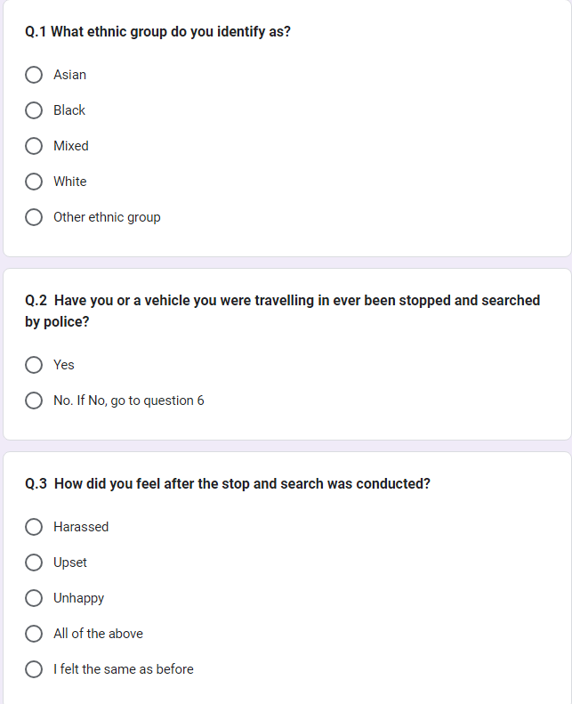
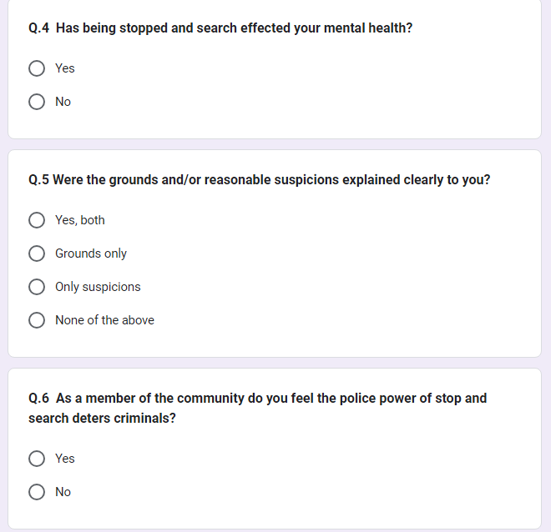
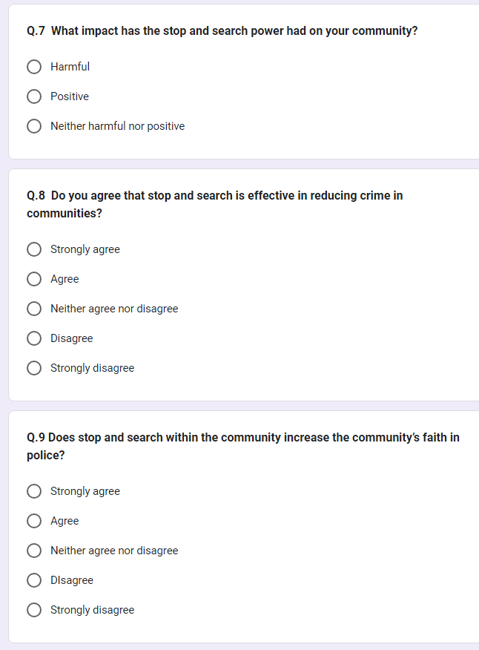
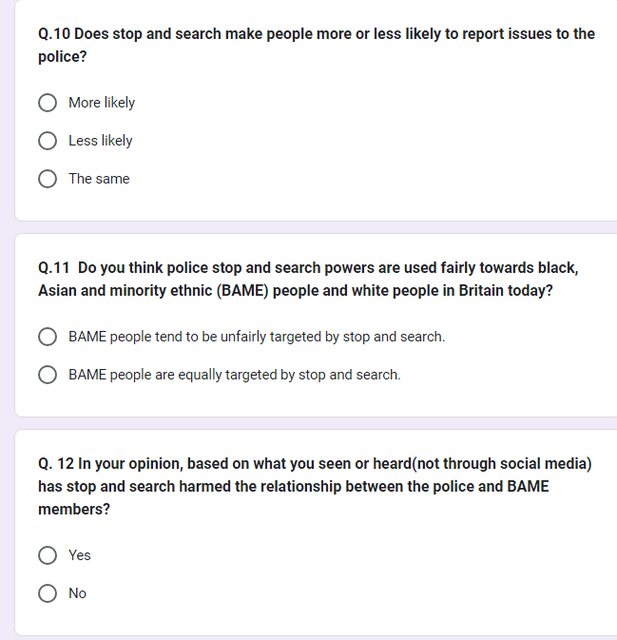

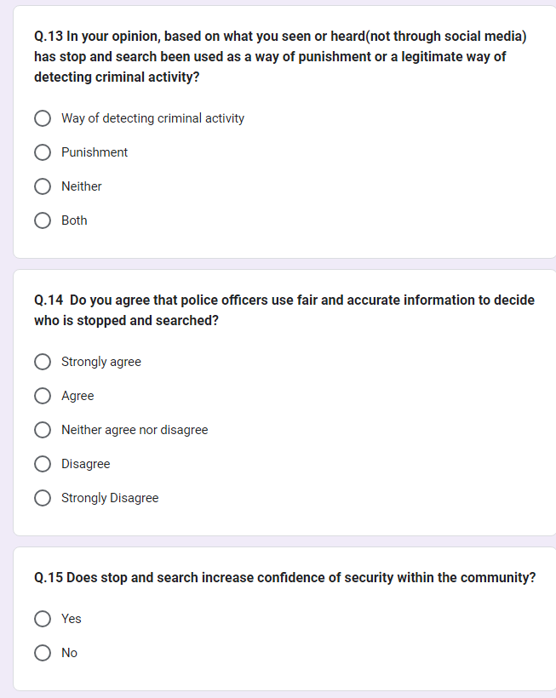
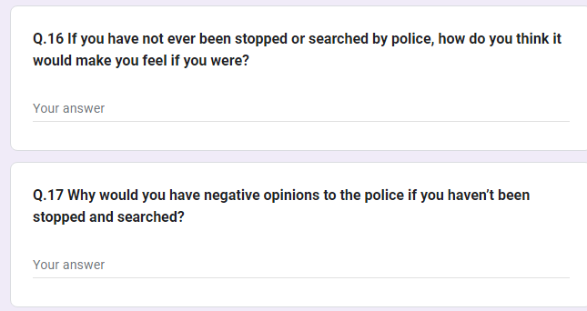

7.3 Appendix 3 - Questionnaire Answers
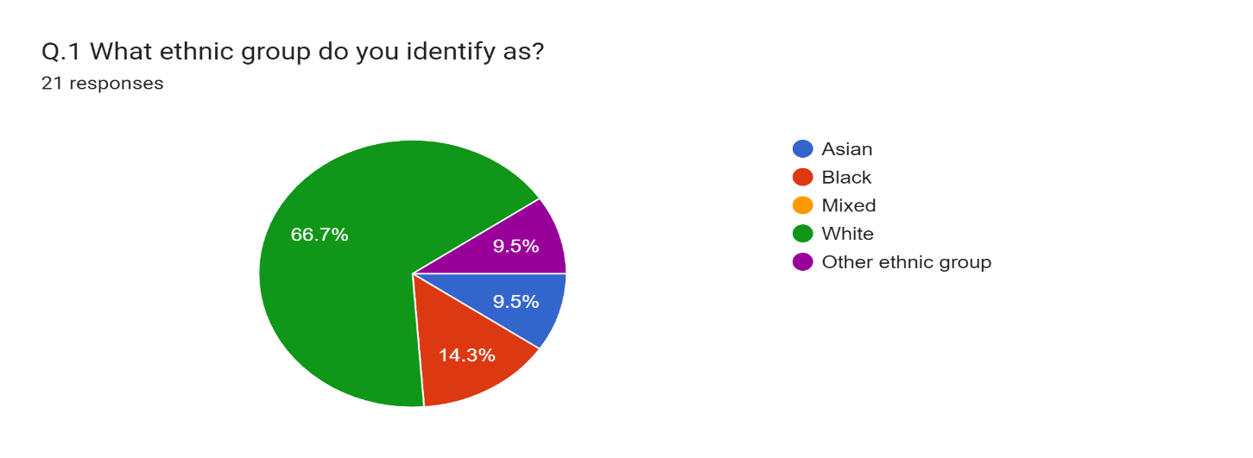
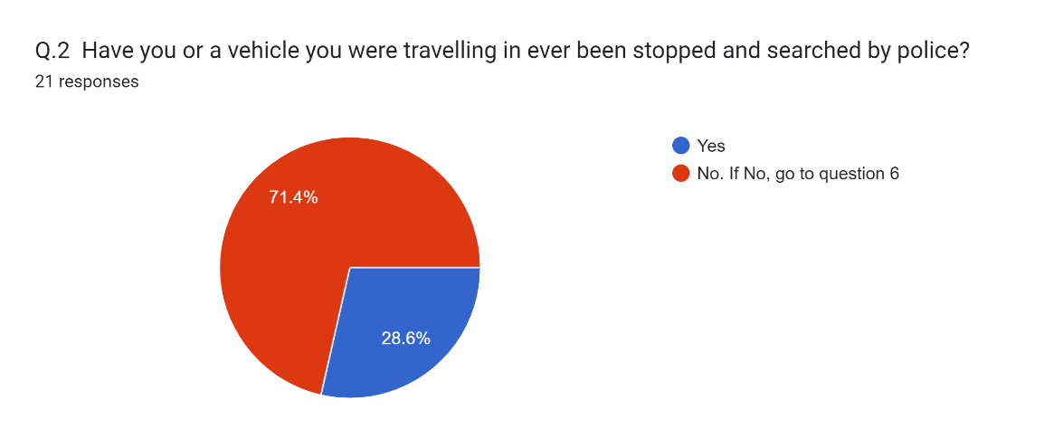
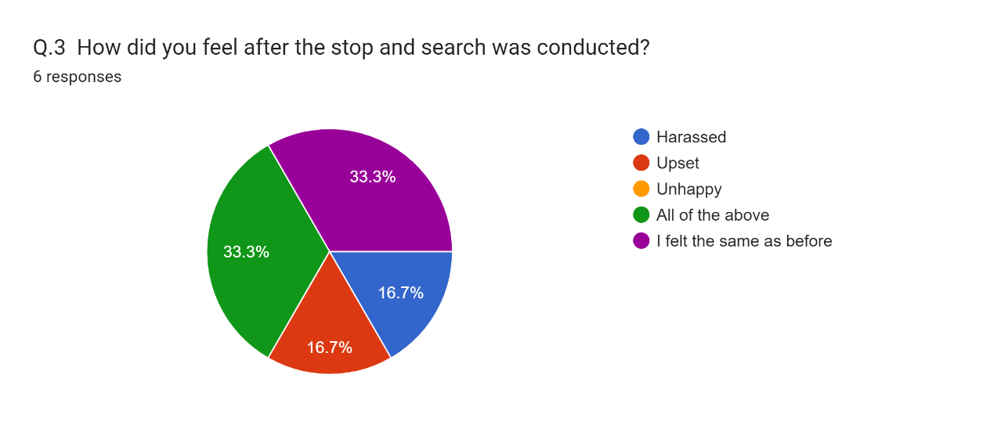
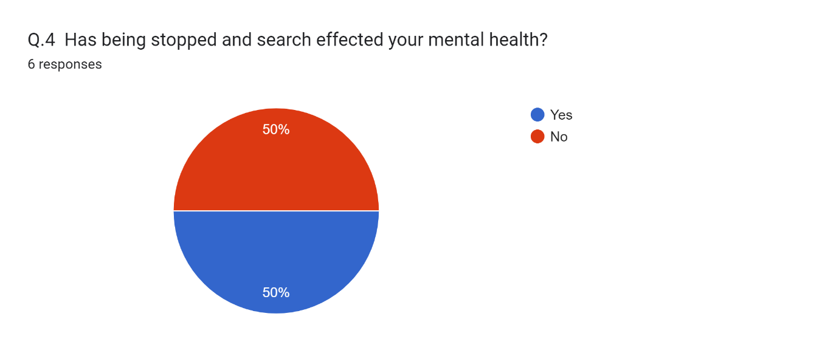
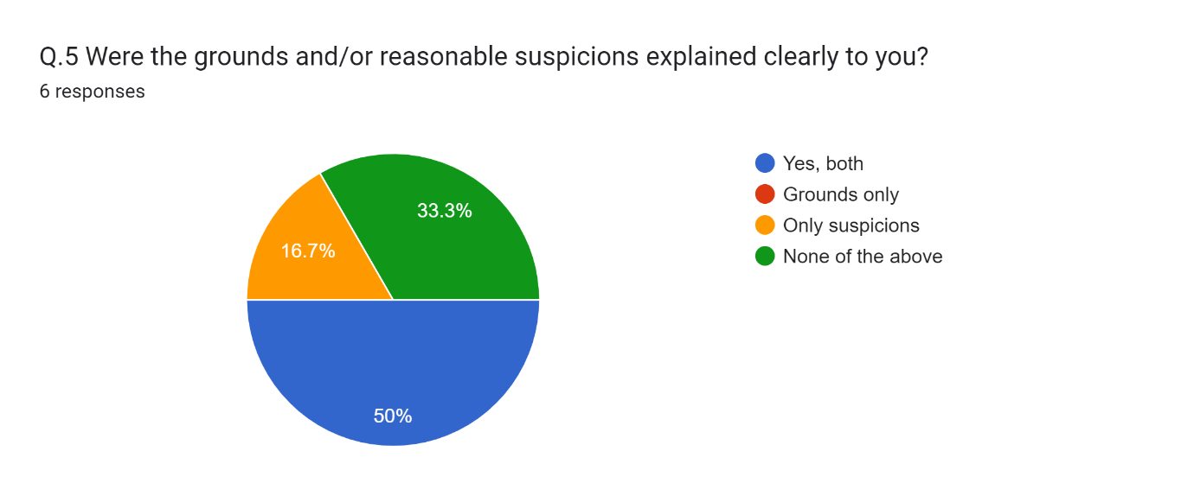
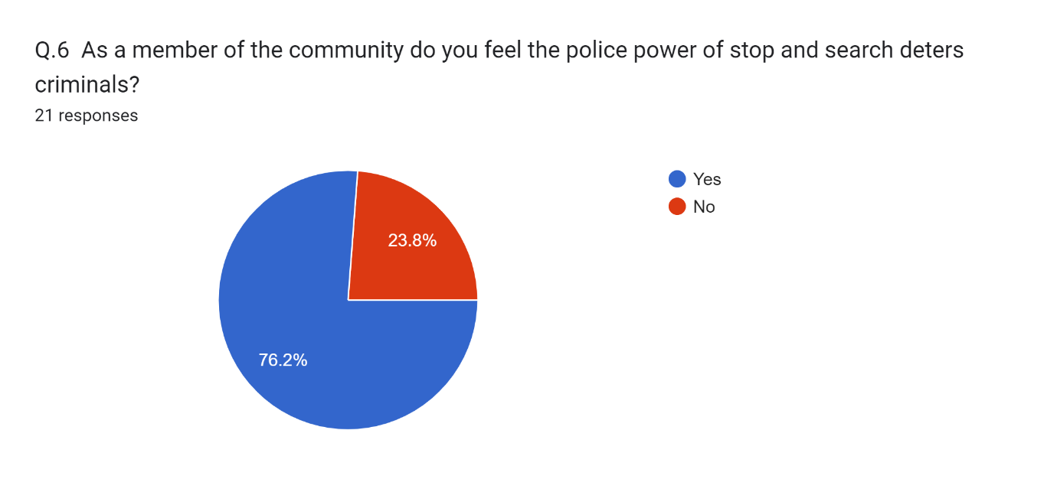
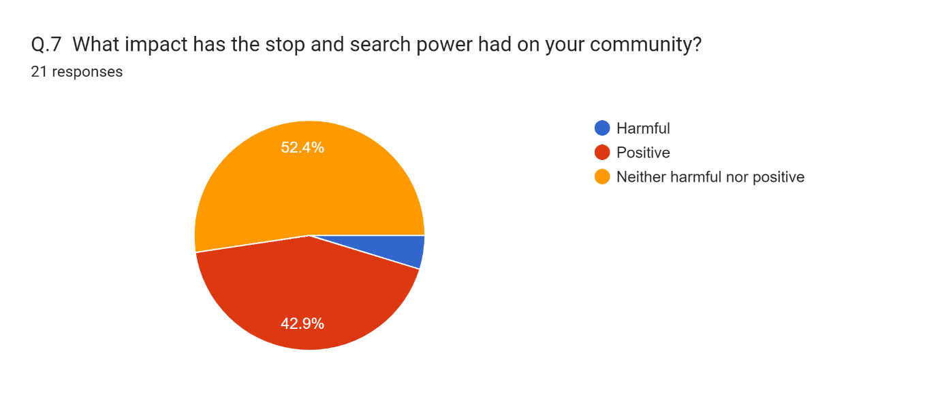
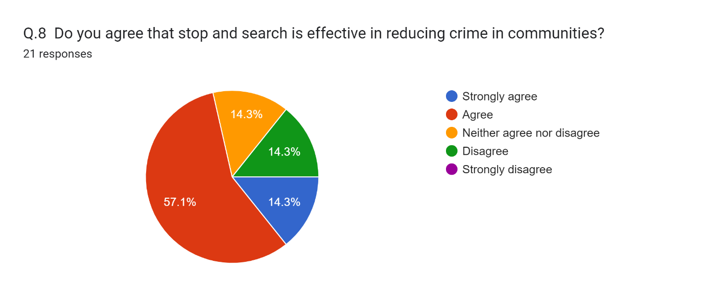
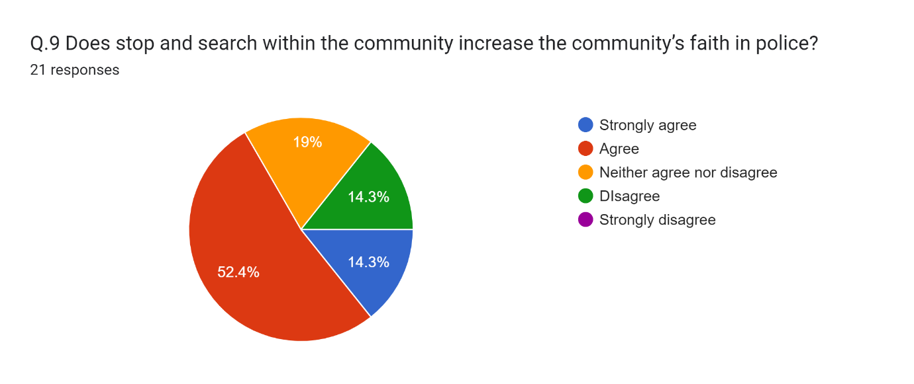
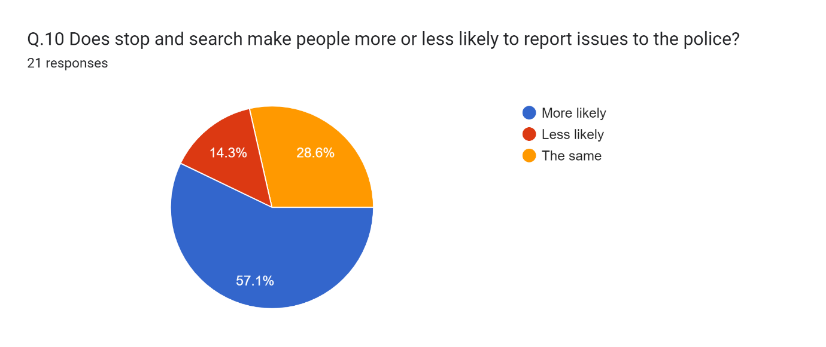
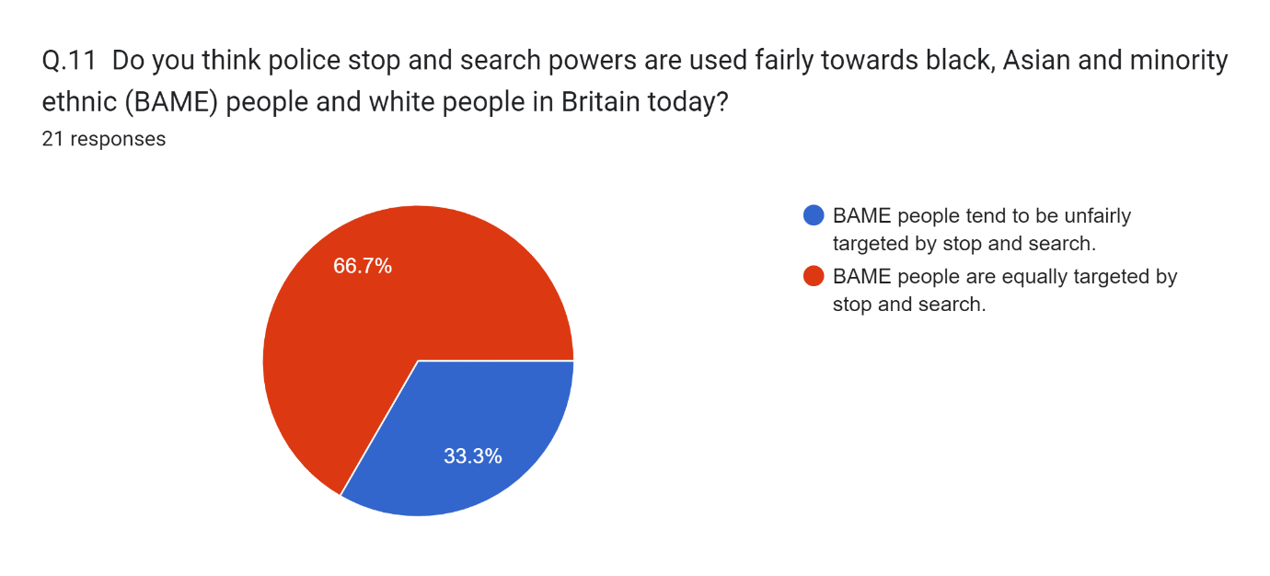
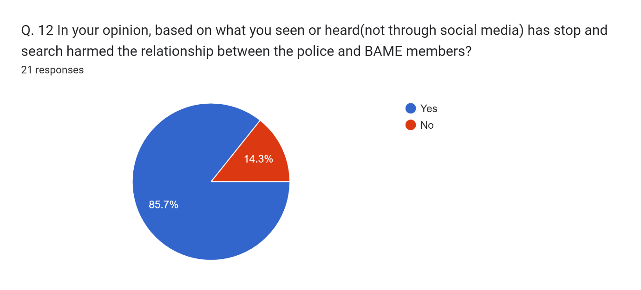
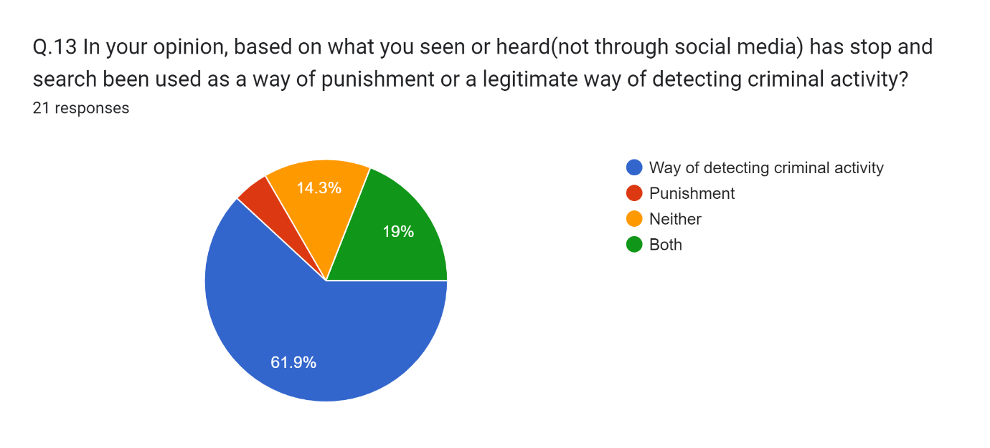
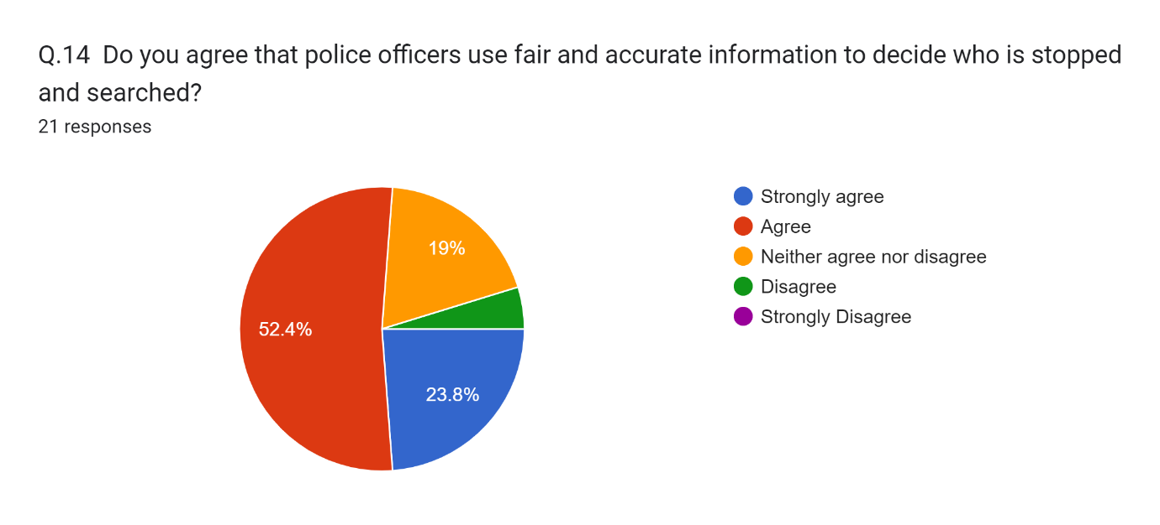
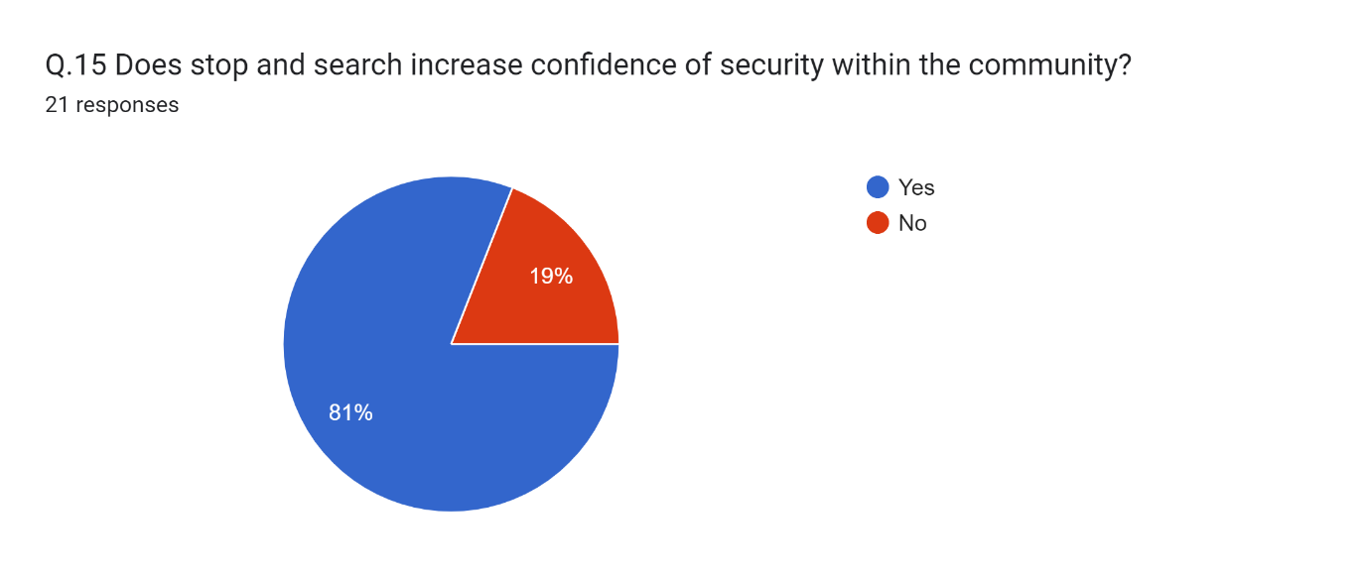

Q.16 If you have not ever been stopped or searched by police, how do you think it would make you feel if you were?
13 responses
- I would be happy to comply if the search and ground were explained to me.
- OK IF IT WAS EXPLAINED AND REASONED.
- it would make me feel uncomfortable, like i had done something wrong even if i hadn't. Feel like everyone will be watching. make me feel anxious.
- As long as they had the grounds and used powers correctly I would be fine with it.
- If they had grounds then I would be pleased that they were fulfilling their role legally.
- I think I would feel initially embarrassed about it, but I wouldn't be worried about it as I know that the police wouldn't find anything on me that I shouldn't have!.
- If there are sufficient grounds then I would be fine.
- n/a.
- I think I would feel okay, as there would be a reason that I am being stopped searched.
- Worried but also reassured that police are proactive.
- that the police are hopefully doing it for the right reasons, based on the correct information.
- It would be part of a process so would just appreciate that there is job to be done.
- Fine if I hadn't done anyt wrong.

Q.17 Why would you have negative opinions to the police if you haven’t been stopped and searched?
11 responses
- SOCIAL MEDIA.
- They are not using their powers to prevent criminal activity.
- Attitude of some police officers is poor when dealing with members of the public.
- Through word of mouth, other people's experiences impacting your opinion.
- The media states that police are racist.
- n/a.
- I wouldn't have any negative opinions.
- Past experiences when you have reported incidents.
- None.
- Unknown.
- It not being explained properly to me or the police being rude.

7.4 Appendix 4 – Ethics Form
APPLICATION FOR ETHICAL APPROVAL

RESEARCH STUDENTS
This form is to be completed by the student within SIX months for full-time students and TWELVE months for part time students, after the commencement of the research degree or following progression to Part Two of your course.

Once complete, submit this form via the MyTSD Doctoral College Portal at (https://mytsd.uwtsd.ac.uk).

This document is also available in Welsh.

RESEARCH STAFF ONLY
All communications relating to this application during its processing must be in writing and emailed to pgresearch@uwtsd.ac.uk , with the title ‘Ethical Approval’ followed by your name.

STUDENTS ON UNDERGRADUATE OR TAUGHT MASTERS PROGRAMMES should submit this form (and receive the outcome) via systems explained to you by the supervisor/module leader.

In order for research to result in benefit and minimise risk of harm, it must be conducted ethically. A researcher may not be covered by the University’s insurance if ethical approval has not been obtained prior to commencement.

The University follows the OECD Frascati manual definition of research activity: “creative work undertaken on a systematic basis in order to increase the stock of knowledge, including knowledge of man, culture and society, and the use of this stock of knowledge to devise new applications”. As such this covers activities undertaken by members of staff, postgraduate research students, and both taught postgraduate and undergraduate students working on dissertations/projects.

The individual undertaking the research activity is known as the “principal researcher”.

Ethical approval is not required for routine audits, performance reviews, quality assurance studies, testing within normal educational requirements, and literary or artistic criticism.

Please read the notes for guidance before completing ALL sections of the form.

This form must be completed and approved prior to undertaking any research activity. Please see Checklist for details of process for different categories of application.

SECTION A: About You (Principal Researcher)
1 | Full Name: |  | GARETH BENNETT
2 | Tick all boxes that apply: |  | Member of staff: | ☐ | Honorary research fellow: | ☐
 | Undergraduate Student | ☐ | Taught Postgraduate Student | ☐ | Postgraduate Research Student | ☒

3 | Institute/Academic Discipline/Centre: | University of Wales, Trinity Saint David
4 | Campus: | Swansea
5 | E-mail address: | 2031207@student.uwtsd.ac.uk
6 | Contact Telephone Number: | 07772969825
 | For students:
7 | Student Number: | 2031207
8 | Programme of Study: | Professional Policing Practice
9 | Director of Studies/Supervisor: | Michelle Hill

SECTION B: Approval for Research Activity
1 | Has the research activity received approval in principle?  (please check the Guidance Notes as to the appropriate approval process for different levels of research by different categories of individual) |  | YES | ☒ | NO | ☐
 |  |  |  |  | Date
2 | If Yes, please indicate source of approval (and date where known): Approval in principle must be obtained from the relevant source prior to seeking ethical approval | Research Degrees Committee |  | ☒
2 |  | Institute Research Committee |  | ☐
2 |  | Other (write in) |  | ☐

SECTION C: Internal and External Ethical Guidance Materials
 | Please list the core ethical guidance documents that have been referred to during the completion of this form (including any discipline-specific codes of research ethics, location-specific codes of research ethics, and also any specific ethical guidance relating to the proposed methodology). Please tick to confirm that your research proposal adheres to these codes and guidelines. You may add rows to this table if needed.
1 | UWTSD Research Ethics & Integrity Code of Practice | ☒
2 | UWTSD Research Data Management Policy | ☒
3 | [List any other relevant documents here] | ☐

SECTION D: External Collaborative Research Activity
If there are external collaborators then you should gain consent from the contact persons to share their personal data with the university. If there are no external collaborators then leave this section blank and continue to section E.
1 | Institution
2 | Contact person name
3 | Contact person e-mail address
4 | Is your research externally funded? |  | YES | ☐ | NO |  | ☐
5 | Are you in receipt of a KESS scholarship? |  | YES | ☐ | NO |  | ☐
6 | Are you specifically employed to undertake this research in either a paid or voluntary capacity? | Voluntary | YES | ☐ | NO | ☐
7 |  | Employed | YES | ☐ | NO | ☐
8 | Is the research being undertaken within an existing UWTSD Athrofa Professional Learning Partnership (APLP)? | If YES then the permission question below does not need to be answered. | YES | ☐ | NO |  | ☐
9 | Has permission to undertake the research has been provided by the partner organisation? | (If YES attach copy)  If NO the application cannot continue | YES | ☐ | NO |  | ☐

Where research activity is carried out in collaboration with an external organisation
10 | Does this organisation have its own ethics approval system? | YES | ☐ | NO | ☐
 | If Yes, please attach a copy of any final approval (or interim approval) from the organisation (this may be a copy of an email if appropriate).

SECTION E: Details of Research Activity
1 | Indicative title: | An investigation into the effectiveness of the Police’s power to stop and search in England and Wales.
2 | Proposed start date: | 14.08.2023 | Proposed end date: | 08.04.2023
Introduction to the Research (maximum 300 words per section)
Ensure that you write for a Non-Specialist Audience when outlining your response to the points below:
- Purpose of Research Activity
- Proposed Research Question
- Aims of Research Activity
- Objectives of Research Activity
Demonstrate, briefly, how Existing Research has informed the proposed activity and explain
- What the research activity will add to the body of knowledge
- How it addresses an area of importance.
3 | Purpose of Research Activity  The goal of this study is to determine if the communities that the police serve benefit from the use of stop and search powers by the police.  The study will also look at whether using this ability to prevent crime increases or decreases public confidence in police forces.  This study will examine how well these abilities prevent criminal activity.  It will also examine whether the use of police powers in Wales and England builds public trust in the force.  (this box should expand as you type)
4 | Research Question  To explore if stop and search powers impact on the public’s confidence in policing.  (this box should expand as you type)
5 | Aims of Research Activity  1). To explore stop and search powers and their purpose.  2). To what extent has stop and search powers impacted on local community relationships.  (this box should expand as you type)
6 | Objectives of Research Activity  6. Evaluation of stop and search figures in England and Wales.  7. To identify if stop and search deters crime within communities.  8. Review to decide if stop and search builds public confidence.  9. Evaluate if stop and search addresses early intervention and prevent crime.  (this box should expand as you type)
Proposed methods (maximum 600 words)
Provide a brief summary of all the methods that may be used in the research activity, making it clear what specific techniques may be used. If methods other than those listed in this section are deemed appropriate later, additional ethical approval for those methods will be needed. You do not need to justify the methods here, but should instead describe how you intend to collect the data necessary for you to complete your project.
7 | I'll explore using a survey to gather information from the public so that I may examine it for any potential trends or gaps in secondary data.  (this box should expand as you type)
Location of research activity
Identify all locations where research activity will take place.
8 | Swansea.  (this box should expand as you type)
Research activity outside of the UK
If research activity will take place overseas, you are responsible for ensuring that local ethical considerations are complied with and that the relevant permissions are sought. Specify any local guidelines (e.g. from local professional associations/learned societies/universities) that exist and whether these involve any ethical stipulations beyond those usual in the UK (provide details of any licenses or permissions required). Also specify whether there are any specific ethical issues raised by the local context in which the research activity is taking place, for example, particular cultural and/or legal sensitivities or vulnerabilities of participants. If you live in the country where you will do the research then please state this.
9 | N/A  (this box should expand as you type)

10 | Use of documentation not in the public domain: Are any documents NOT publicly available? | NO | ☒
10 |  | YES | ☐
11 | If Yes, please provide details here of how you will gain access to specific documentation that is not in the public domain and that this is in accordance with the current data protection law of the country in question and that of England and Wales.  (this box should expand as you type)

 | Does your research relate to one or more of the seven aims of the Well-being of Future Generations (Wales) Act 2015? | YES | NO
12 | A prosperous Wales | ☐ | ☒
13 | A resilient Wales | ☐ | ☒
14 | A healthier Wales | ☐ | ☒
15 | A more equal Wales | ☐ | ☒
16 | A Wales of cohesive communities | ☐ | ☒
17 | A Wales of vibrant culture and thriving Welsh language | ☐ | ☒
18 | A globally responsible Wales | ☐ | ☒
19 | If YES to any of the above, please give details:
 | (this box should expand as you type)

SECTION F: Scope of Research Activity
 | Will the research activity include: | YES | NO
1 | Use of a questionnaire or similar research instrument? | ☒ | ☐
2 | Use of interviews? | ☐ | ☒
3 | Use of focus groups? | ☐ | ☒
4 | Use of participant diaries? | ☐ | ☒
5 | Use of video or audio recording? | ☐ | ☒
6 | Use of computer-generated log files? | ☐ | ☒
7 | Participant observation with their knowledge? | ☐ | ☒
8 | Participant observation without their knowledge? | ☐ | ☒
9 | Access to personal or confidential information without the participants’ specific consent? | ☐ | ☒
10 | Administration of any questions, test stimuli, presentation that may be experienced as physically, mentally or emotionally harmful / offensive? | ☐ | ☒
11 | Performance of any acts which may cause embarrassment or affect self-esteem? | ☐ | ☒
12 | Investigation of participants involved in illegal activities? | ☐ | ☒
13 | Use of procedures that involve deception? | ☐ | ☒
14 | Administration of any substance, agent or placebo? | ☐ | ☒
15 | Working with live vertebrate animals? | ☐ | ☒
16 | Procedures that may have a negative impact on the environment? | ☐ | ☒
17 | Other primary data collection methods. Please indicate the type of data collection method(s) below. | ☐ | ☒
 | Details of any other primary data collection method:  (this box should expand as you type) | ☐ | ☒
If NO to every question, then the research activity is (ethically) low risk and may be exempt from some of the following sections (please refer to Guidance Notes).

If YES to any question, then no research activity should be undertaken until full ethical approval has been obtained.

SECTION G: Intended Participants
If there are no participants then do not complete this section, but go directly to section H.

 | Who are the intended participants: | YES | NO
1 | Students or staff at the University? | ☐ | ☒
2 | Adults (over the age of 18 and competent to give consent)? | ☒ | ☐
3 | Vulnerable adults? | ☐ | ☒
4 | Children and Young People under the age of 18? (Consent from Parent, Carer or Guardian will be required) | ☐ | ☒
5 | Prisoners? | ☐ | ☒
6 | Young offenders? | ☐ | ☒
7 | Those who could be considered to have a particularly dependent relationship with the investigator or a gatekeeper? | ☐ | ☒
8 | People engaged in illegal activities? | ☐ | ☒
9 | Others. Please indicate the participants below, and specifically any group who may be unable to give consent. | ☐ | ☒
 | Details of any other participant groups:  (this box should expand as you type) | ☐ | ☒

Participant numbers and source
Provide an estimate of the expected number of participants. How will you identify participants and how will they be recruited?
10 | How many participants are expected? | I anticipate that there will roughly be between 15 and 30 participants.  (this box should expand as you type)
11 | Who will the participants be? | Adults (persons over the age of 18).  (this box should expand as you type)
12 | How will you identify the participants? | Each person will receive a number that I will use to identify them. There will be no collection or disclosure of names or addresses.  (this box should expand as you type)

 | Information for participants: | YES | NO | N/A
13 | Will you describe the main research procedures to participants in advance, so that they are informed about what to expect? | ☒ | ☐ | ☐
14 | Will you tell participants that their participation is voluntary? | ☒ | ☐ | ☐
15 | Will you obtain written consent for participation? | ☒ | ☐ | ☐
16 | Will you explain to participants that refusal to participate in the research will not affect their treatment or education (if relevant)? | ☐ | ☐ | ☒
17 | If the research is observational, will you ask participants for their consent to being observed? | ☐ | ☐ | ☒
18 | Will you tell participants that they may withdraw from the research at any time and for any reason? | ☒ | ☐ | ☐
19 | With questionnaires, will you give participants the option of omitting questions they do not want to answer? | ☒ | ☐ | ☐
20 | Will you tell participants that their data will be treated with full confidentiality and that, if published, it will not be identifiable as theirs? | ☒ | ☐ | ☐
21 | Will you debrief participants at the end of their participation, in a way appropriate to the type of research undertaken? | ☒ | ☐ | ☐
22 | If NO to any of above questions, please give an explanation
 | (this box should expand as you type)

 | Information for participants: | YES | NO | N/A
24 | Will participants be paid? | ☐ | ☒ | ☐
25 | Is specialist electrical or other equipment to be used with participants? | ☐ | ☒ | ☐
26 | Are there any financial or other interests to the investigator or University arising from this study? | ☐ | ☒ | ☐
27 | Will the research activity involve deliberately misleading participants in any way, or the partial or full concealment of the specific study aims? | ☐ | ☒ | ☐
28 | If YES to any question, please provide full details
 | (this box should expand as you type)

SECTION H: Anticipated Risks

Outline any anticipated risks that may adversely affect any of the participants, the researchers and/or the University, and the steps that will be taken to address them.

If you have completed a full risk assessment (for example as required by a laboratory, or external research collaborator) you may append that to this form.
1 | Full risk assessment completed and appended? |  | Yes | ☐
1 |  |  | No | ☒
2 | Risks to participants  For example: sector-specific health & safety, emotional distress, financial disclosure, physical harm, transfer of personal data, sensitive organisational information
 | Risk to participants:  Emotional distress  (this box should expand as you type) | How you will mitigate the risk to participants:  It's crucial to let participants know they can stop participating in the study whenever they want.  Before being asked to join, participants are informed about the study's subject.  I will ensure that no participant's identity is known.  (this box should expand as you type)
3 | If research activity may include sensitive, embarrassing or upsetting topics (e.g. sexual activity, drug use) or issues likely to disclose information requiring further action (e.g. criminal activity), give details of the procedures to deal with these issues, including any support/advice (e.g. helpline numbers) to be offered to participants. Note that where applicable, consent procedures should make it clear that if something potentially or actually illegal is discovered in the course of a project, it may need to be disclosed to the proper authorities
N/A

(this box should expand as you type)
4 | Risks to the investigator  For example: personal health & safety, physical harm, emotional distress, risk of accusation of harm/impropriety, conflict of interest
 | Risk to the investigator:  N/A  (this box should expand as you type) | How you will mitigate the risk to the investigator:  N/A  (this box should expand as you type)
5 | University/institutional risks  For example: adverse publicity, financial loss, data protection
 | Risk to the University:  N/A  (this box should expand as you type) | How you will mitigate the risk to the University:  N/A  (this box should expand as you type)
6 | Environmental risks  For example: accidental spillage of pollutants, damage to local ecosystems
 | Risk to the environment:  N/A  (this box should expand as you type) | How you will mitigate the risk to environment:  N/A  (this box should expand as you type)

 | Disclosure and Barring Service
 | If the research activity involves children or vulnerable adults, a Disclosure and Barring Service (DBS) certificate must be obtained before any contact with such participants. | YES | NO | N/A
7 | Does your research require you to hold a current DBS Certificate? | ☐ | ☐ | ☒
8 | If YES, please give the certificate number. If the certificate number is not available please write “Pending”; in this case any ethical approval will be subject to providing the appropriate certificate number.

SECTION I: Feedback, Consent and Confidentiality

1 | Feedback  What de-briefing and feedback will be provided to participants, how will this be done and when?
I will keep the findings for my own use after they have been compiled and analysed. Participants won't be contacted, but if they want to learn the results, they can contact me on the provided number, and the results can be discussed.

(this box should expand as you type)
2 | Informed consent  Describe the arrangements to inform potential participants, before providing consent, of what is involved in participating. Describe the arrangements for participants to provide full consent before data collection begins. If gaining consent in this way is inappropriate, explain how consent will be obtained and recorded in accordance with prevailing data protection legislation.
The terms and conditions relating to information gathering and consent will be fully explained before participants take part in any study survey.

(this box should expand as you type)
3 | Confidentiality / Anonymity  Set out how anonymity of participants and confidentiality will be ensured in any outputs. If anonymity is not being offered, explain why this is the case.
From the beginning, confidentiality and anonymity will be available. No personal information, like names or addresses, will be recorded on the surveys.

Participants will each receive a unique identification number, which will be used to identify them.

(this box should expand as you type)

SECTION J: Data Protection and Storage

 | Does the research activity involve personal data (as defined by the General Data Protection Regulation 2016 “GDPR” and the Data Protection Act 2018 “DPA”)? | YES | NO
1 | “Personal data” means any information relating to an identified or identifiable natural person (‘data subject’). An identifiable natural person is one who can be identified, directly or indirectly, in particular by reference to an identifier such as a name, an identification number, location data, an online identifier or to one or more factors specific to the physical, physiological, genetic, mental, economic, cultural or social identity of that natural person. Any video or audio recordings of participants is considered to be personal data. | ☐
 | If YES, provide a description of the data and explain why this data needs to be collected:
2 | N/A  (this box should expand as you type)
 | Does it involve special category data (as defined by the GDPR)? | YES | NO
3 | “Special category data” means sensitive personal data consisting of information as to the data subjects’ –  (a) racial or ethnic origin,  (b) political opinions,  (c ) religious beliefs or other beliefs of a similar nature,  (d) membership of a trade union (within the meaning of the Trade Union and Labour Relations (Consolidation) Act 1992),  (e) physical or mental health or condition,  (f) sexual life,  (g) genetics,  (h) biometric data (as used for ID purposes), | ☐
 | If YES, provide a description of the special category data and explain why this data needs to be collected:
4 | N/A  (this box should expand as you type)

 | Will data from the research activity (collected data, drafts of the thesis, or materials for publication) be stored in any of the following ways? | YES | NO
5 | Manual files (i.e. in paper form)? | ☐ | ☒
6 | University computers? | ☐ | ☒
7 | Private company computers? | ☒ | ☒
8 | Home or other personal computers? | ☐ | ☒
9 | Laptop computers/ CDs/ Portable disk-drives/ memory sticks? | ☒ | ☐
10 | “Cloud” storage or websites? | ☒ | ☐
11 | Other – specify: | ☐ | ☒
12 | For all stored data, explain the measures in place to ensure the security of the data collected, data confidentiality, including details of backup procedures, password protection, encryption, anonymisation and pseudonymisation:
Only I will have access to the research and the systems are password protected.
(this box should expand as you type)

 | Data Protection
 | Will the research activity involve any of the following activities: | YES | NO
13 | Electronic transfer of data in any form? | ☐ | ☒
14 | Sharing of data with others at the University outside of the immediate research team? | ☐ | ☒
15 | Sharing of data with other organisations? | ☐ | ☒
16 | Export of data outside the UK or importing of data from outside the UK? | ☐ | ☒
17 | Use of personal addresses, postcodes, faxes, emails or telephone numbers? | ☐ | ☒
18 | Publication of data that might allow identification of individuals? | ☐ | ☒
19 | Use of data management system? | ☐ | ☒
20 | Data archiving? | ☐ | ☒
21 | If YES to any question, please provide full details, explaining how this will be conducted in accordance with the GDPR and Data Protection Act (2018) (and any international equivalents, where appropriate):
N/A

(this box should expand as you type)
22 | List all who will have access to the data generated by the research activity:
Only myself

(this box should expand as you type)
23 | List who will have control of, and act as custodian(s) for, data generated by the research activity:
Only myself

(this box should expand as you type)
24 | Give details of data storage arrangements, including security measures in place to protect the data, where data will be stored, how long for, and in what form. Will data be archived – if so how and if not why not.
N/A

(this box should expand as you type)
25 | Please indicate if your data will be stored in the UWTSD Research Data Repository (see https://researchdata.uwtsd.ac.uk/ ). If so please explain. (Most relevant to academic staff)
N/A

(this box should expand as you type)
26 | Confirm that you have read the UWTSD guidance on data management (see https://www.uwtsd.ac.uk/library/research-data-management/) | YES | ☒
27 | Confirm that you are aware that you need to keep all data until after your research has completed or the end of your funding | YES | ☒

SECTION K: Declaration
The information which I have provided is correct and complete to the best of my knowledge. I have attempted to identify any risks and issues related to the research activity and acknowledge my obligations and the rights of the participants.

In submitting this application I hereby confirm that I undertake to ensure that the above named research activity will meet the University’s Research Ethics and Integrity Code of Practice which is published on the website: https://www.uwtsd.ac.uk/research/research-ethics/
1 | Signature of applicant: | G.Bennett | Date:  27.08.2023

For STUDENT Submissions:
2 | Director of Studies/Supervisor: |  | Date:
3 | Signature: |  | Date:

For STAFF Submissions:
4 | Academic Director/ Assistant Dean: |  | Date:
5 | Signature: |  | Date:

Checklist: Please complete the checklist below to ensure that you have completed the form according to the guidelines and attached any required documentation:
☒ | I have read the guidance notes supplied before completing the form.
☒ | I have completed ALL RELEVANT sections of the form in full.
☒ | I confirm that the research activity has received approval in principle
☐ | I have attached a copy of final/interim approval from external organisation (where appropriate)
☐ | I have attached a full risk assessment (where appropriate) ONLY TICK IF YOU HAVE ATTACHED A FULL RISK ASSESSMENT
☒ | I understand that it is my responsibility to ensure that the above named research activity will meet the University’s Research Ethics and Integrity Code of Practice.
☒ | I understand that before commencing data collection all documents aimed at respondents (including information sheets, consent forms, questionnaires, interview schedules etc.) must be confirmed by the DoS/Supervisor, module tutor or Academic Director.

RESEARCH STUDENTS ONLY
Once complete, submit this form via the MyTSD Doctoral College Portal at (https://mytsd.uwtsd.ac.uk).

RESEARCH STAFF ONLY
All communications relating to this application during its processing must be in writing and emailed to pgresearch@uwtsd.ac.uk , with the title ‘Ethical Approval’ followed by your name.

STUDENTS ON UNDERGRADUATE OR TAUGHT MASTERS PROGRAMMES should submit this form (and receive the outcome) via systems explained to you by the supervisor/module leader.

