

ENTREPRENEURSHIP LCBB5001
ASSESSMENT 2
VALENTIN DANIEL SUSANU
2019937

Table of Contents
Introduction 2
Geodemographic Data 3
Demand Estimation 3
Competition 4
Positioning map 5
Porter’s five forces 6
Political 7
Economic 7
Social, and Technological: 8
Legal, and Environmental: 8
Market Entry Alternatives 8
Conclusion 9
References: 9

Introduction
The tourism and travel companies expand into the international markets for recovering from the pandemic situation. The company Simigeria Petru needs to analyze the macro-environmental factors, target market as well as the level of competition it will be facing in the UK during its expansion. In addition, an analysis and justification for the chosen market entry strategy will be provided along with an evaluation of the risks associated with the market entry method.

Geodemographic Data
The UK tourism sector will be worth 257 billion Euros by the end of 2025. The UK is the 10th largest tourism destination in the world with more than 39 million visitors (Statista, 2022). UK tourism plays a major part in the growth and development of the country’s economy. The UK tourism industry includes private and public sector organizations along with SMEs, international private businesses as well as destination management organizations. The UK food culture includes a full breakfast with pies and bakeries. A wide variety of food from various cuisines of Europe as well as other parts of the globe is focused on by the UK population (Statista, 2022). In the UK culture, cakes, pastries, and pizzas along with other bakeries are favored in various festivals and celebrations. The UK food culture is multicultural and is influenced by the Romans as well as the French. The total UK population is over 66,796,807. Most of the UK population of all ages and genders are situated in England. It is analyzed that the demand for freshly baked bakeries in the UK has risen and is still rising. In addition, it also has been analyzed that the UK population have a fetish for food and fitness (Statista, 2022). England makes up over 84 % of the total UK population with around 5% of the UK population in Wales and over 8.5 % in Scotland along with 3% in Northern Ireland. The UK tourism sector supplies over 3-7 million jobs and impacts the UK's reputation as well as economic growth in a positive way. The British economy is positively impacted by tourism in England with a contribution of 106 billion Euros.

Demand Estimation
The target market for the products of Simigeria Petru is the UK population of all ages and gender. Pretzel is liked by the 18-34 age group of people. Hence, the target population in the UK by Pretzel company Simigeria petru in expansion to the UK is the age group of 18-34 years. Simigeria Petru can expand and grow in the UK pretzel, savoury snacks and bakery market with its products as the UK has great demand for bakery companies and bakery products. The value of savoury snacks, pretzels and bakeries in the UK is expected to grow by 4753 US million dollars. The UK bread and bakery products industry in the UK is growing significantly with a growth rate of 0.9%.
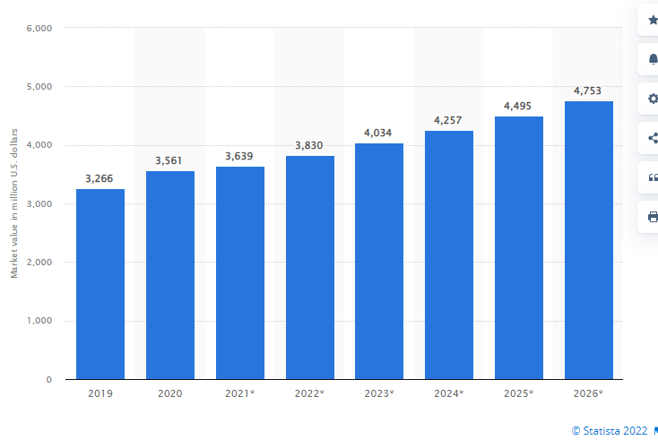

In the UK, the value of savoury snacks, pretzels and bakeries is 3830 US billion dollars as of the present year. After 3-4 years, the savoury snacks market in the United Kingdom is expected to grow by 1000 US billion dollars (Statista, 2022). In the UK bread and bakery products industry, the worth of the industry is approximately 8.7 Billion Euros between 2017-2022.

The UK food, as well as the tourism industry, is a large sector that contributes to the economic growth of the UK. The companies that are related to the food and tourism sector like Simigeria Petru are likely to perform well in expansion to the UK market. The marketing process of Simigeria Petru will be positively impacted by the demand for bakeries, savoury food and Pretzels in the UK. The revenue of the UK bread and bakery market is over 6.9 billion US dollars. The volume of bread products sold in the UK is over 1.9 billion Kg. The sales of bread, as well as freshly baked bakery products in the UK, are over 6.1 billion British pounds. A turnover of over 50 million British pounds is gained by the manufacturers and sellers of bakeries in the UK indicating a successful start and business continuity as well as marketing processes of Simigeria Petru in the UK (Zollo et al., 2020).

Competition
VRIO analysis
Resources and capabilities | Valuable | Rare | Inimitable | Organized
Product Quality | Yes | Yes | Yes | Yes
Technology and innovation | Yes | Yes | Yes | Yes
Marketing through digital assets | Yes | No | Yes | Yes

The above analysis of the resources and the capabilities of Simigeria Petru indicated that the resources in the company are valuable and organized. However, the resources and capabilities of Simigeria Petru are not rare and are inimitable as well. The product quality of Simigeria Petru is effective and capable of providing a competitive advantage to the company. The technology and innovation are capable of the company's growth and success. However, the marketing processes of Simigeria Petru are not rare and hence can face failure in the competitive advantage.Hence, the resources and capabilities of Simigeria Petru are able to provide a competitive advantage due to its product quality and taste as well as marketing processes (Simigeria Petru, 2022). But the company may next upgrade their strategies for the continuation of its competitive advantage. The company needs to improve its taste and varieties along with marketing processes for increasing its reputation.

Positioning map
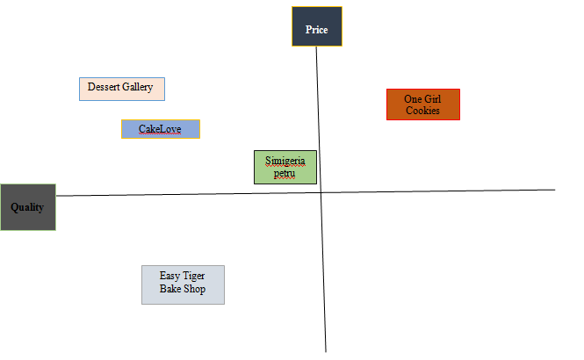

The direct competitors of Simigeria Petru in the UK are Dessert Gallery, CakeLove, Easy Tiger Bake Shop and One Girl Cookies. The competitors of Simigeria Petru are trying to compete with other bakery companies in the industry. The competitors of Simigeria Petru are competing with the quality and price of the products by the companies. The direct and indirect competitors of Simigeria Petru are competing through the application of the trends of marketing processes.

Competitive analysis:

 | Simigeria Petru | Dessert Gallery | CakeLove | Easy Tiger Bake Shop
Product Quality | Strong | Strong | Strong | Low
Product price | Medium | High | High | Low
Services | Strong | Medium | Strong | Medium
Marketing processes | Strong | Strong | Strong | Strong

The bakery company and its competitors are analyzed on the basis of the product quality, product price, services as well as marketing processes. The above analysis indicates that Simigeria Petru has strong product quality with medium pricing of the company products. In addition, the service delivery, and the marketing processes of Simigeria Petru are strong as well. However, the competitors of Simigeria Petru vary from strong too low.

Porter’s five forces
The impact of the five forces on the marketing process and business continuity along with the expansion of Simigeria Petru will be analyzed in the section:

Bargaining power of suppliers: High
Bargaining power of customers: High

The above analysis indicated that the bargaining power of the suppliers as well as the customers for Simigeria Petru is high. The suppliers give raw materials to the company that are used by the bakery company to make products. However, if the demands of the suppliers are not maintained by the company leaders, the suppliers can opt out of providing raw materials to the company. Hence, the bargaining power of Simigeria Petru is high as the company gets raw materials of good quality and standard from their suppliers (Simigeria Petru, 2022). On the other hand, the demands of the customers are not accepted by Simigeria Petru, the customers may opt for another company for their bakery products. Hence, the bargaining power of the customers is also high in the case of Simigeria Petru.

Competitive rivalry: Medium
The threat of new entrants: Medium
The threat of substitutes: Low
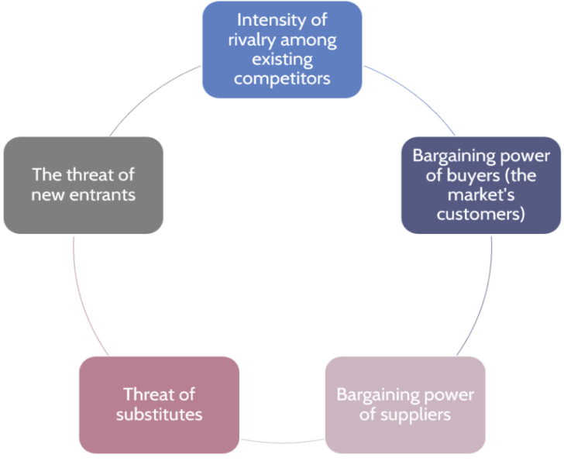
This Photo by Unknown Author is licensed under CC BY-SA-NC

The analysis indicated that competitive rivalry and the threat of new entrants have a medium impact on the marketing processes and expansion of Simigeria Petru in the UK. On the other hand, the analysis also demonstrated the low potential of substitutes in impacting the growth and competitive advantage of Simigeria Petru.

Macro Environmental factors
PESTLE Analysis of the UK:

Political

The impact of BREXIT is still affecting the international trade in Britain. The UK-EU trade has bounced back in 2020 by 18% (BBC News, 2021). The ratio of Political stability has been reported to increase by 90% on 2022’s August (TRADING ECONOMICS, 2022) . However, the country is recovering from the impact of Brexit, and the political stability is increasing which is a positive sign for international business.
Brexit has impacted the political condition of the country due to which the political stability of the company was disrupted, but the increasing ratio of political stability is showing hope for opening the door of international business

Economic
“Foreign Direct Investment (FDI)” policies of the UK have helped a lot the country to maintain its economic stability during Covid. FDI policies of this country will not create any obstacles for the company to expand its business in this country. Present FDI credits of the UK have increased between 2017-2018 by “6.6 Billion Euros”, and “4.0 Billion Euros” (Office for National Statistics, 2021). The increasing GDP rate of the country can give a massive scope to the company to expand its business in this nation. This country's present GDP rate is 7.44%, and 3.75% in 2021, and 2022 which proves its positive economic growth in the future that can increase the market scope of this company (Statista, 2022).
The positive FDI and increasing GDP rate of the UK has created enormous scope for foreign companies to expand their business in this country. Increasing FDI credits has proved that the country is welcoming other foreign organisations to expand their business in this country.

Social, and Technological:
The Romanian Pretzel company can get a huge customer base in terms of entering the UK as the people of this country are very fond of these kinds of products. As per the research findings obtained from Statista (2021), the sales percentage of cakes, pastry, and other bread products has increased the revenue up to “6.1 billion British Pounds” (Statista, 2021). After the fourth industrial revolution, the usage of different pieces of machinery in all the industries of the country has increased because the country is developing technologically. The use of digital media in marketing, and the influence of different “social media platforms” in marketing prove the change of technology in the marketing aspects of the UK that has increased the scope o foreign trade as well as domestic trade (Ponzoa, and Erdmann, 2021).
From the increasing sales percentage of the cakes, and pastry products in the market of the UK, it can be said that the population of this country is very fond of these products. Analysing the usage of e-commerce in the business of the UK, the company should increase its capability to promote its business through digital media.

Legal, and Environmental:
“The Consumer Rights Act 2015” of the UK gives the right to the customers to file a complaint against the buyer if any kind of problems occurred regarding purchasing (legislation.gov.uk, 2015).
"The Data Protection Act 2018" of the UK protects securing the personal data of an individual user in a business, and this context is important for trading because the concept of e-commerce involves collecting data of customers online (legislation.gov.uk, 2018)
Presently, the approach of green marketing in this country is focusing on environmental sustainability because of the increasing pollution rate (Lin et al. 2018)
Green marketing reduces the number of carbon emissions and focuses on increasing environmental sustainability by promoting eco-friendly products.
Therefore, the laws of the country are very specific and strict for the companies because the country always wants to protect the right of customers. The approach of green marketing is indicating sustainable business by protecting the environment of this country.

Market Entry Alternatives

The chosen market entry method for Simigeria Petru is direct exporting. This involves the direct export of the bakery products to the target customers of the UK (Falahat et al., 2020). Direct sales are included in the market entry methods of Simigeria Petru for expansion.

Simigeria Petru needs to establish its own retail presence in the UK market for expanding its sales and growth of revenue. Several advantages are observed for the chosen market strategy (Popescu et al., 2021). Simigeria Petru can select foreign representatives in the UK market. Simigeria Petru can adopt a direct exporting strategy for testing products in international markets. The use of direct exports is helpful in protecting the company's patents, goodwill, trademarks and other intangible assets (Tien and Ngoc, 2019).

Risks associated with direct exporting:

Risks associated with direct exporting are higher costs, larger risks of facing loss, difficulty in the maintenance of company stocks, huge distribution costs as well as too much dependence on the distributors (Schroeder et al., 2019).

Conclusion
The above presentation indicated that the expansion of Simigeria Petru in the UK will be positively impacted by the demand for the company products in the UK and the macro environment of the UK. In addition, the strategies of gaining a competitive advantage and using appropriate market entry modes are done by the pretzel and bakery company in the UK.

References:
Faisal Islam. 2021. Brexit: One year on, the economic impact is starting to show. BBC NEWS. Available at. https://www.bbc.com/news/business-59761292. [Accessed: 22 August 2022]
Falahat, M., Ramayah, T., Soto-Acosta, P. and Lee, Y.Y., 2020. SMEs internationalization: The role of product innovation, market intelligence, pricing and marketing communication capabilities as drivers of SMEs’ international performance. Technological Forecasting and Social Change, 152, p.119908. https://www.academia.edu/download/63819424/SMEs_internationalization20200703-9830-h0qldp.pdf
legistation.gov.uk. 2015. Consumer Rights Act 2015. Available at. https://www.legislation.gov.uk/ukpga/2015/15/contents/enacted. [Accessed: 21 August 2022]
legistation.gov.uk. 2018. Data Protection Act 2018. Available at. https://www.legislation.gov.uk/ukpga/2018/12/contents/enacted. [Accessed: 21 August 2022]
Lin, Y., Yang, S., Hanifah, H. and Iqbal, Q., 2018. An exploratory study of consumer attitudes toward green cosmetics in the UK market. Administrative Sciences, 8(4), p.71.
Office for National Statistics. 2022. UK foreign direct investment, trends and analysis: (alternative scenarios and the current account): April 2020. Available at. https://www.ons.gov.uk/economy/nationalaccounts/balanceofpayments/articles/ukforeigndirectinvestmenttrendsandanalysis/alternativescenariosandthecurrentaccountapril2020. [Accessed: 25 August 2022]
Ponzoa, J.M. and Erdmann, A., 2021. E-commerce customer attraction: Digital marketing techniques, evolution and dynamics across firms. Journal of Promotion Management, 27(5), pp.697-715.
Popescu, A., Dinu, T.A., Stoian, E. and Serban, V., 2021. Trends in the milling and baking industry in the EU-28 and Romania in the period 2015-2019. Scientific Papers Series “Management, Economic Engineering in Agriculture and Rural Development, 21(1), pp.601-612. http://managementjournal.usamv.ro/pdf/vol.21_1/Art69.pdf
Schroeder, A., Ziaee Bigdeli, A., Galera Zarco, C. and Baines, T., 2019. Capturing the benefits of industry 4.0: a business network perspective. Production Planning & Control, 30(16), pp.1305-1321. https://www.tandfonline.com/doi/pdf/10.1080/09537287.2019.1612111
Simigeriapetru, 2022. Petru’s deliciousness. Available from: https://www.simigeriapetru.ro/ [Available on 25 august 2022]
Statista, 2022. Bread and bakery products in the UK - statistics and facts. Available from: https://www.statista.com/topics/7306/bread-and-bakery-products-in-the-uk/#dossierKeyfigures [Available on 23 august 2022]
Statista, 2022. Value of the savory snacks market in the United Kingdom from 2019 to 2026. Available from: https://www.statista.com/statistics/1200012/savory-snack-market-size-in-united-kingdom/ [Available on 23 august 2022]
Statista. 2021. Sales from the manufacture of bread, fresh pastry goods and cakes in the United Kingdom (UK) from 2008 to 2020(in million GBP). Available at. https://www.statista.com/statistics/313539/bread-and-fresh-pastry-manufacturers-sales-in-the-united-kingdom-uk/. [Accessed: 21 August 2022]
Statista. 2022. United Kingdom: Real gross domestic product (GDP) growth rate from 2017 to 2027(compared to the previous year). Available at. https://www.statista.com/statistics/263613/gross-domestic-product-gdp-growth-rate-in-the-united-kingdom/. [Accessed: 24 August 2022]
Tien, N.H. and Ngoc, N.M., 2019. Comparative Analysis of Advantages and Disadvantages of the Modes of Entrying the International Market. International journal of advanced research in engineering and management, 5(7), pp.29-36. https://www.researchgate.net/profile/Nguyen-Tien-32/publication/338719711_Comparative_Analysis_of_Advantages_and_Disadvantages_of_the_Modes_of_Entrying_the_International_Market/links/61a3701407be5f31b7bd6da3/Comparative-Analysis-of-Advantages-and-Disadvantages-of-the-Modes-of-Entrying-the-International-Market.pdf
TRADING ECONOMICS. 2022. United Kingdom - Political Stability And Absence Of Violence/Terrorism: Percentile Rank, Upper Bound Of 90% Confidence Interval. Available at. https://tradingeconomics.com/united-kingdom/political-stability-and-absence-of-violence-terrorism-percentile-rank-upper-bound-of-90percent-confidence-interval-wb-data.html. [Accessed: 28 August 2022]
Zollo, L., Filieri, R., Rialti, R. and Yoon, S., 2020. Unpacking the relationship between social media marketing and brand equity: The mediating role of consumers’ benefits and experience. Journal of Business research, 117, pp.256-267. https://www.sciencedirect.com/science/article/am/pii/S0148296320302885

