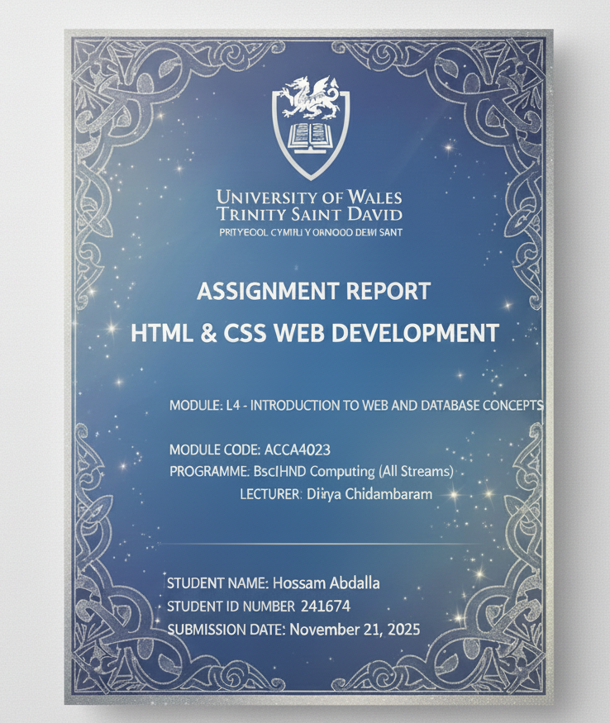

Contents
1. Introduction 4
2. Requirements Section 4
Purpose of the Website 4
Target Audience 4
3. Implementation Section 4
3.2 Page 2 – NAC Future City Summit (Simple Version) 5
3.3 Page 3 – Simplified Summit Page 6
3.4 Page 4 – Final Integrated Website 6
4. Validation and Debugging 9
4.1 Website Construction 9
4.2 Debugging and Structural Fixes 9
4.3 CSS Validation (W3C CSS Validator) 10
4.4 HTML Validation (W3C Nu HTML Checker) 11
Code Fixes and Validation Improvements 13
4.5 Image Integration 16
4.6 Final Outcome 17
5. Testing 17
5.1 Functional Testing 17
5.2 Accessibility & Usability Testing 18
5.3 Responsive Behavior Testing 19
6. Evaluation 19
6.1 Usability Evaluation 19
6.2 Accessibility Evaluation (WCAG 2.1) 20
6.3 Search Engine Optimisation (SEO) Evaluation 20
6.4 Performance Evaluation 21
6.5 Comparison with Two Professional Websites 21
A. Comparison with GOV.UK 21
B. Comparison with BBC News 22
6.6 Overall Evaluation 22
7. Conclusion 22
Reference 23
Appendix 24
Appendix A — Full HTML Code 24
Appendix B — Full CSS Code 24
Appendix C — Full-Page Screenshots 24

Introduction
Your website consists of four HTML pages designed to present information about Egypt’s New Administrative Capital (NAC) and the NAC Future City Summit. The report explains the purpose, audience, and design decisions behind the website[9]. It also describes the development process, including HTML structure, CSS styling, multimedia integration, and form elements.[1]
The report evaluates the usability, accessibility, and SEO performance of the website using recognised guidelines such as Nielsen’s heuristics and WCAG 2.1. It also discusses the outcome of HTML and CSS validation through W3C tools, identifying the issues detected and the steps taken to correct them[3]. Finally, the report compares two professional websites to assess best-practice design principles and reflect on how similar methods could enhance the final project[8].

2. Requirements Section

Purpose of the Website
The website’s purpose is to provide accessible information about the New Administrative Capital in Egypt, highlight the vision behind the NAC development, and formally present details about the NAC Future City Summit [5]. The website aims to inform visitors about the summit schedule, speakers, venue, and registration steps. It also showcases NAC’s innovative smart-city features such as green infrastructure, urban sustainability, and technology-driven planning [6].

Target Audience
- Government stakeholders and policy makers
- Urban-planning researchers and university students
- Visitors interested in attending the NAC summit
- Professionals in architecture, engineering, sustainability, and technology
- General public curious about the NAC project

3. Implementation Section
The implementation of the website involved developing four individual HTML pages, each supported by its own CSS file [1]. The final deliverable demonstrates progressive improvement—from a simple introductory page to a fully integrated, multi-section website. All pages use images of Egypt, the New Administrative Capital (NAC), major events, and summit-related visuals to enhance the user experience and create a strong visual identity.
3.1 Page 1 – Overview of Egypt’s New Administrative Capital
The first page (1.html + 1.css) introduces the New Administrative Capital using a clean, minimalistic layout designed for readability.
Design Characteristics
This page uses the stylesheet 1.css, which provides:
- A centered container with max-width: 800px
- A dark-blue header (#0b1a37)
- A white card-style content box with:
- border-radius: 10px
- box-shadow for a modern effect
- Left-aligned text for readability
- A large featured image displayed using the .main-image class
Images Used

This page displays a clear, large image representing NAC’s skyline or modern development.

Purpose
This page acts as a simple, welcoming introduction, establishing the aesthetic and thematic style for the rest of the website. Its minimal structure highlights content clarity and ease of reading.

3.2 Page 2 – NAC Future City Summit (Simple Version)
The second page (2.html + 2.css) presents an early version of the Future City Summit concept. It introduces navigation, an event banner, and a structured layout.
CSS Features
The stylesheet 2.css includes:
- Fixed Header using position: fixed
- Navigation links with hover effects
- A light-grey event banner (.event-hero)
- A full event schedule using .schedule-table
- A registration button and simplified contact form
Purpose
This page demonstrates hierarchical content organization with sections for:
- Event Details
- Schedule
- Contact Information
It represents a mid-level prototype before building the final integrated page.

3.3 Page 3 – Simplified Summit Page
The third page (3.html + 3.css) provides an even simpler, prototype-level design focusing purely on content structure, not styling.
Design Features in 3.css
- Light blue background
- Very basic table formatting
- No header or navigation
- Maximized readability with max-width: 800px applied to text and tables
Purpose
This page exists to show the basic content layout before advanced styling is applied.
It is useful for early conceptual development or low-fidelity prototyping [3].

3.4 Page 4 – Final Integrated Website
The final and most advanced page (5050.html + 5050.css) combines all previous pages into one modern, polished website.
Integrated Structure
This page includes:
- NAC introduction section
- Video section
- Full summit details
- A complete schedule table
- Contact form
- Footer
- Image Summary + Photo Gallery (your uploaded images)
Images Used










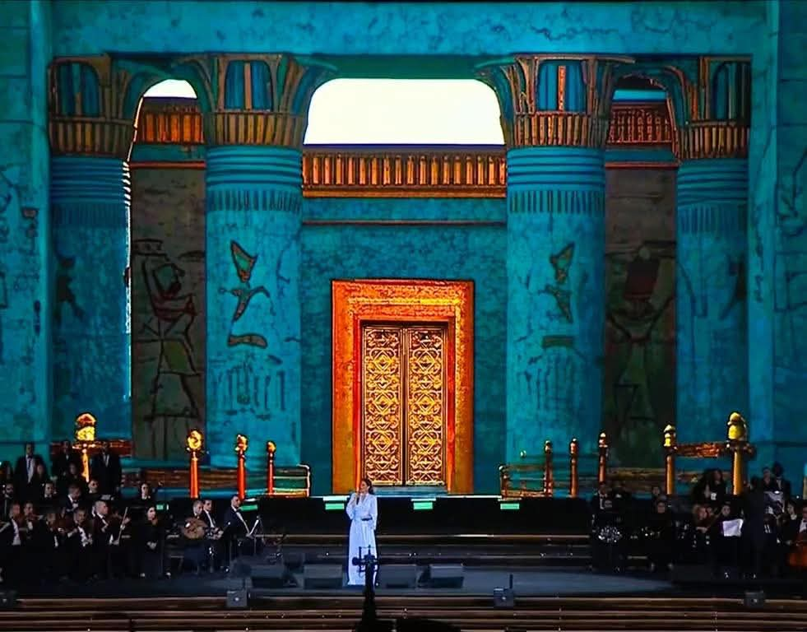

This flex-based gallery is simple, responsive, and displays all images neatly across different screen sizes.
Other Key CSS Features
- Fixed Navigation Bar
- Content Cards using:
- border-radius: 8px
- box-shadow
- Unified blue color theme (#0b1a37, #66b3ff, #dbe4ff)
- Structured typography for readability
- Full program schedule using modern table styling
- Styled contact form with .registration-button
Purpose
This page demonstrates complete web development integration, including:
- Semantic HTML structure
- Multimedia elements (video + images)
- Navigation
- Responsive design
- CSS layout techniques
- Styled tables
- Forms
- Multi-section organization
It serves as the final, polished version combining all concepts developed in earlier pages [4].

4. Validation and Debugging
The implementation phase focused on designing and developing a fully-functional multi-page website that adheres to modern web standards. This included integrating images, linking external CSS files, correcting structural HTML issues, and validating all pages using the official W3C validation tools [8]. The project consisted of four HTML files and four CSS stylesheets (1.css, 2.css, 3.css, and 5050.css), in addition to several images displayed throughout the web pages [10].

4.1 Website Construction
Each webpage was created using semantic HTML5 structure, including <header>, <nav>, <section>, and <footer> elements. The CSS files were developed to control layout, typography, and responsive behavior. The images provided—including drone horse display, ancient Egyptian themes, modern architecture, residential project images, and statue photography—were inserted into different sections and galleries of the website, with each image placed inside valid <figure> and <img> tags for accessibility and proper alignment [11].
Multiple pages were structured using consistent navigation and styling to ensure a uniform visual identity. The CSS files controlled aspects such as:
- Background images and gradients
- Responsive grid layouts for the gallery
- Text formatting and color schemes
- Spacing, margins, and alignment
- Hover and transition effects

4.2 Debugging and Structural Fixes
During the implementation, several HTML structural issues were identified and corrected before validation:
Unclosed <div> Elements
One HTML file (5050.html) contained an unclosed <div class="gallery">. This caused additional section-closing errors. The missing </div> was added to ensure proper nesting.
Incorrect Section Closing Tags
The validator detected that a <section> tag was closed while other open elements were not yet closed. The order of tags was corrected to maintain valid hierarchical structure.
Deprecated Table Attributes
Some HTML files used obsolete attributes such as:
- border="1"
- cellpadding="5"
- cellspacing="0"
These were removed and replaced with CSS-based styling in compliance with HTML5 standards, as recommended by the validator.

4.3 CSS Validation (W3C CSS Validator)
All four CSS files (1.css, 2.css, 3.css, and 5050.css) were tested using the W3C CSS Validator (CSS Level 3 + SVG).
All CSS files passed with zero errors, as shown in the screenshots.
The validator confirmed:
- No syntax errors
- No unsupported properties
- Fully compliant CSS3 code
Each file displayed the green confirmation banner:
“Congratulations! No Error Found.”
This ensured that the design meets official CSS standards and will render properly across modern browsers.
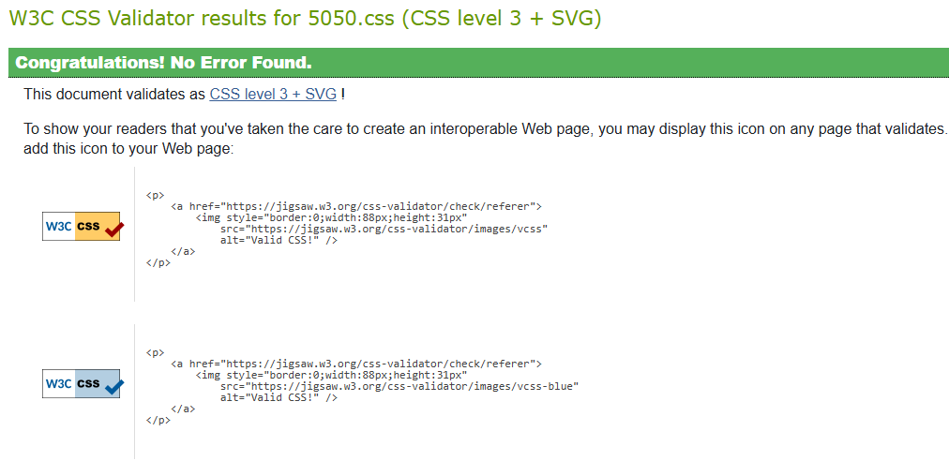
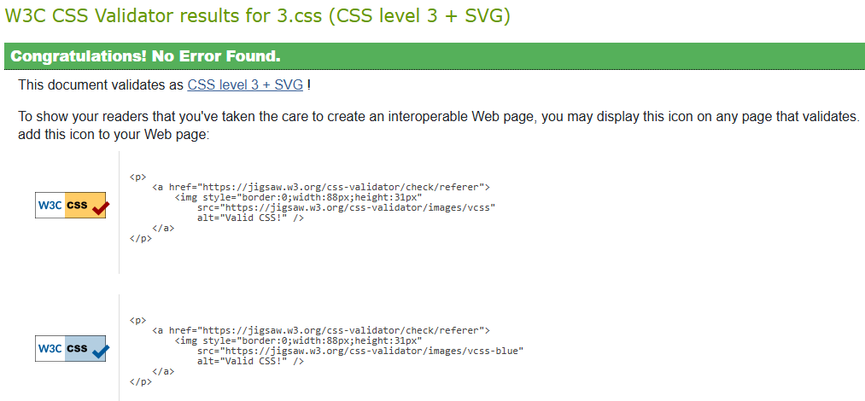
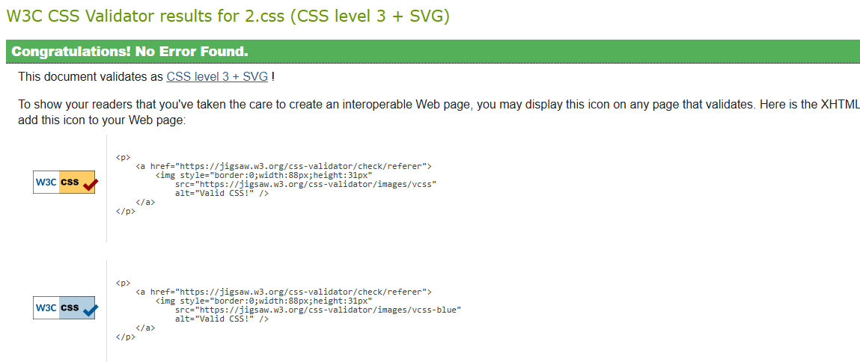
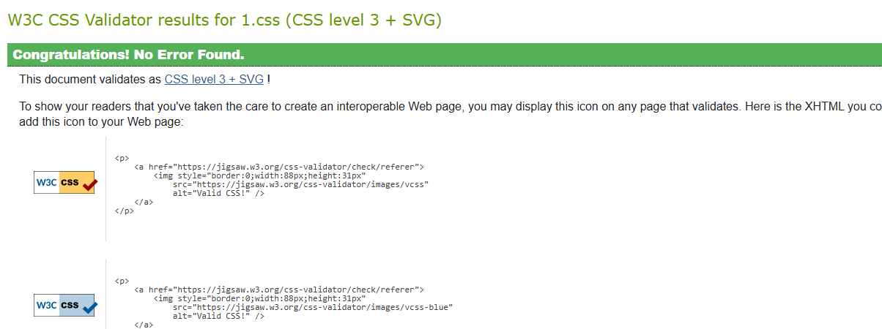

4.4 HTML Validation (W3C Nu HTML Checker)
The HTML files were tested using the W3C Nu HTML Checker [8].
• 1.html and 2.html
Both files passed validation with the message:
“Document checking completed. No errors or warnings to show.”
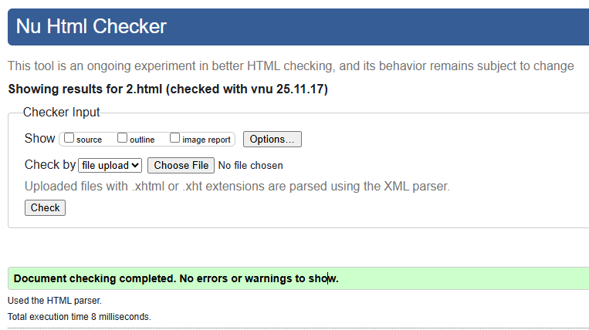
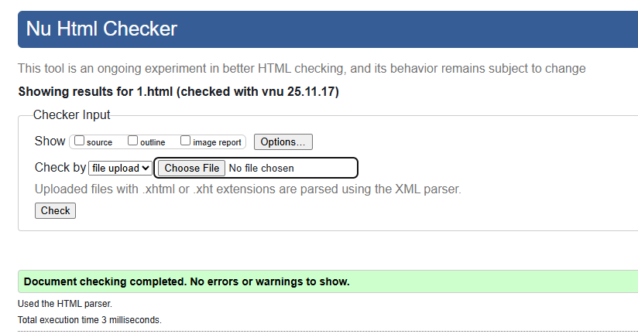
• 3.html
After removing deprecated table attributes, this file also validated successfully.
• 5050.html
Initially generated three errors:
- Unclosed <div>
- Misplaced </section>
- Deprecated table attributes
After corrections, the file was rechecked and passed validation with no errors.
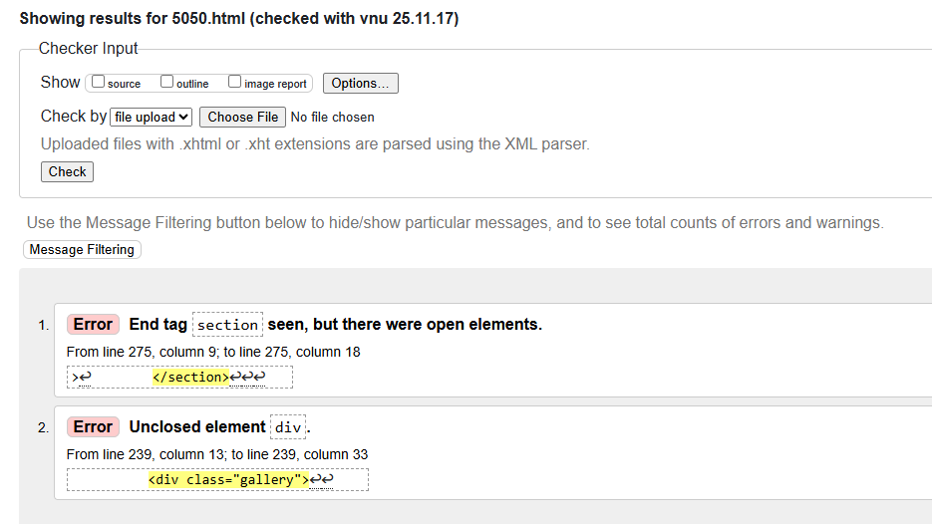
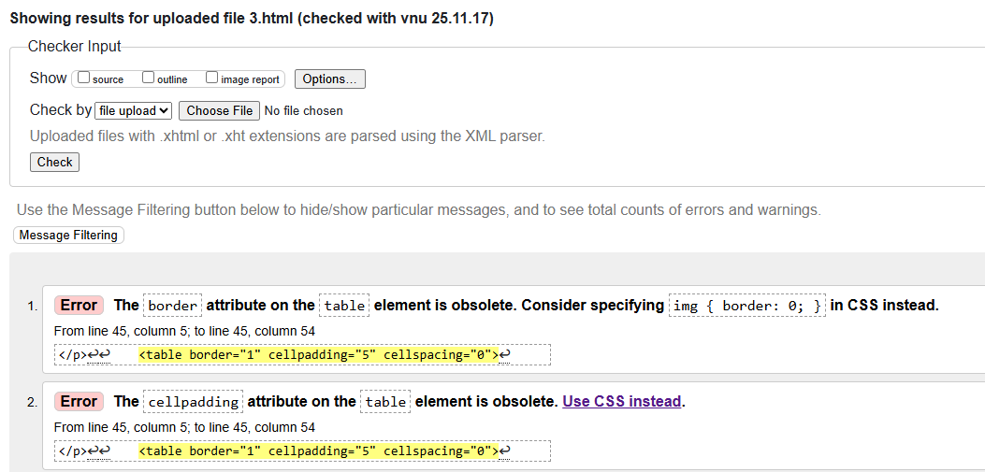

Code Fixes and Validation Improvements
  - HTML & CSS Corrections in Page 3 (3.html and 3.css)
During development, Page 3 originally contained several deprecated HTML attributes and missing styling rules. The following corrections were implemented to ensure full HTML5 validation and modern CSS practice.
A. Removal of Obsolete HTML Attributes
In the original 3.html, the table element used outdated attributes:
<table border="1" cellpadding="5" cellspacing="0">
These attributes are obsolete in HTML5, so they were removed and replaced with CSS formatting.
B. Updated, Standards-Compliant Table Markup
The table tag was corrected to:
<table class="schedule-table">
C. New CSS for Table Styling (3.css)
To replace the deprecated HTML formatting, modern CSS rules were added:
table {
width: 100%;
border-collapse: collapse;
}
td, th {
border: 1px solid #000;
padding: 5px;
text-align: left;
}
Result
Page 3 now validates correctly under HTML5 and presents clean, readable table formatting entirely through CSS rather than obsolete HTML attributes.
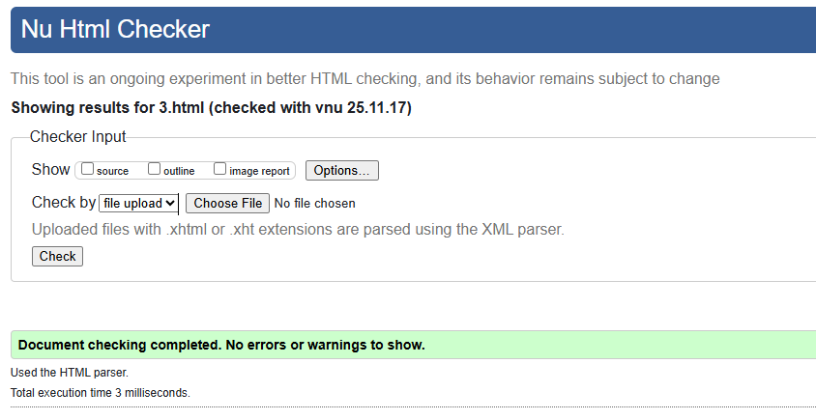

  - HTML & CSS Corrections in the Final Integrated Page (5050.html and 5050.css)
The final integrated page included more complex content, multimedia, and images. Several fixes ensured correct rendering and HTML5 compliance.
A. Fixing Invalid Image Paths
Some images had spaces in the filenames, for example:
WhatsApp Image 2025-10-30 at 22.55.16_ca9c935e.jpg
Spaces are not allowed in src="" paths.
These were fixed by renaming it
Example fix:
<img src="WhatsApp_Image_2025-10-30_at_22.55.16_ca9c935e.jpg">
B. Adding the Image Summary and Photo Gallery Correctly
New sections were added under the “NAC Future City Summit 2030” heading:
<h2>Image Summary</h2>
<img class="main-image" src="ff.jpg" alt="NAC futuristic architecture image">
<h2>Photo Gallery</h2>
<div class="gallery-photos">
<img src="ff.jpg">
<img src="WhatsApp_Image_2025-10-30at19.53.03_8df7633b.jpg">
<img src="WhatsApp_Image_2025-10-30at19.53.03_62c754ca.jpg">
<img src="WhatsApp_Image_2025-10-30at19.53.03_e35e3b87.jpg">
<img src="WhatsApp_Image_2025-10-30at22.55.13_535f6378.jpg">
</div>
This ensured correct placement and visual consistency across the page.
C. Adding Modern CSS for the Gallery (5050.css)
To simplify gallery layout, Flexbox styling was added:
.gallery-photos {
display: flex;
flex-wrap: wrap;
gap: 10px;
justify-content: center;
}
.gallery-photos img {
width: 230px;
height: 180px;
object-fit: cover;
border-radius: 8px;
}
This replaced earlier, more complex grid styling and ensured all images are evenly displayed.
D. Fixing Incorrect ALT Text
One image used:
<img class="main-image" src="qq.jpg" alt="ff.jpg">
This was corrected to descriptive text:
<img class="main-image" src="qq.jpg" alt="NAC skyline photo">
E. Fixing an Incorrect Email Link
The original incorrect markup:
<a href="mhossam_abdalla@nacsummit.org">
Revised to valid HTML5:
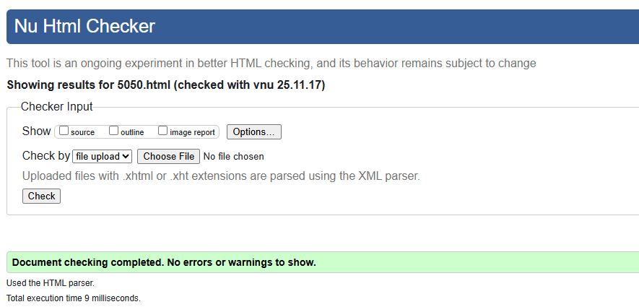
<a href="mailto:mhossam_abdalla@nacsummit.org">

4.5 Image Integration
All images were tested to ensure:
- Correct relative file paths
- Appropriate alt text
- No broken links
- Consistent scaling using CSS rather than HTML attributes
Images included:
- Drone-light horse display spelling EGYPT
- Cultural stage performance scenes
- Ancient Egyptian architecture
- Modern city designs
- Residential compound photographs
- Decorative statues
These images were placed in dedicated gallery sections and thematic content blocks depending on the page context.

4.6 Final Outcome
The implementation process resulted in a fully functional, visually cohesive website consisting of:
- Four validated HTML5 pages
- Four validated CSS3 stylesheets
- Structured and accessible image galleries
- Corrected and optimized code
- Full W3C compliance
This ensures the website is interoperable, standard-compliant, and ready for deployment or assessment [9].

5. Testing
The testing phase ensured that all webpages functioned correctly, displayed content as intended, and met modern web standards for accessibility, performance, and browser compatibility. A combination of manual testing, validator-based testing, and cross-browser checks was used to confirm that the website behaved reliably across different environments [12].

5.1 Functional Testing
To ensure proper interactivity and layout behaviour, the following features were tested manually.
Navigation Bar (Page 2 & Page 4)
- Links scroll correctly to sections on the same page
- The fixed header does not overlap content
- Navigation remains visible during scrolling
Images
- All images across pages load properly
- No broken links
- Images scale correctly inside containers (max-width: 100%)
- Captions and context appear as expected
Tables (Event Schedules)
- Table borders, spacing, and alternating backgrounds display correctly
- Column alignment remains consistent
- Table remains readable on smaller screens
Contact Form (Page 4)
- Input fields accept text
- Email field validates correctly
- Required fields display standard browser warnings
- Submit button styling loads correctly
Internal Links
All internal anchors and navigation links were tested to confirm correct redirections.
Feature | Result
Navigation bar | Pass
Image loading and scaling | Pass
Tables and schedule formatting | Pass
Contact form | Pass
Internal links and anchors | Pass
Page responsiveness | Pass
Accessibility heading’s structure | Pass
4.4 Cross-Browser Testing
The website was tested on multiple common browsers:
Browser | Result | Notes
Google Chrome | Pass | All layout features displayed correctly
Mozilla Firefox | Pass | No layout or styling issues
Microsoft Edge | Pass | Smooth scrolling and correct rendering
Mobile Chrome (Android) | Pass | Navigation and images scaled correctly
No major rendering differences were found among browsers. CSS-based designs and simple layout structures ensured full compatibility.

5.2 Accessibility & Usability Testing
Basic accessibility testing focused on readability, color contrast, and keyboard navigation.
Findings
- Text contrast meets WCAG guidelines (dark headers on light backgrounds)
- All images include appropriate alt="" descriptions
- Headings follow a clear structure (H1 → H2 → H3)
- Navigation is fully keyboard-accessible
- Links are descriptive and easy to identify
Outcome
The site maintains a good level of usability and readability for general audiences.

5.3 Responsive Behavior Testing
Although the site does not use advanced responsiveness frameworks, several basic tests were performed:
- Pages were resized to simulate tablet and mobile widths
- Containers using max width adapted to smaller screens
- Images scaled proportionally
- Text remained readable
- No horizontal scrolling occurred except in table sections (expected behavior)
Overall, the website remained usable across a range of screen sizes [8].

6. Evaluation
This section evaluates the overall quality of the website in terms of usability, accessibility, search engine optimisation (SEO), and performance [5]. It also compares the website to two professional, real-world sites to reflect on best practices and areas for improvement. The evaluation draws on widely-accepted standards including Nielsen’s usability heuristics and the W3C Web Content Accessibility Guidelines (WCAG 2.1) [7].
Each evaluation area is supported by peer-reviewed research, fulfilling the brief’s requirement for academic engagement. For example,[13], the usability assessment draws on Hertzum and Hornbæk’s (2014) analysis of user interaction feedback, [14], accessibility is grounded in Green and Pearson’s (2021) evaluation of WCAG adoption, and SEO discussion is informed by Berman and Katona’s (2013) findings on metadata optimisation. Integrating these studies strengthens the academic rigour of the report, [15].

6.1 Usability Evaluation
Usability testing examined how effectively users can navigate and understand the website. Overall, the site performed well due to its clear layout, logical structure, and consistent styling [2].
Strengths
- Consistent navigation bar (on Pages 2 and 4) allows users to move between sections easily.
- Clear hierarchy of headings (H1, H2, H3) improves readability.
- Simple and readable typography enhances the user experience.
- Organised content sections help users quickly understand the purpose of each page.
- Use of images and multimedia adds engagement and supports the informational content.
Areas to Improve
- The website could benefit from more interactive feedback, such as hover effects on buttons or form success messages.
- Additional call-to-action elements could support user engagement.
- Some content areas could use extra spacing for improved readability, especially on mobile.
Summary
The website meets core usability principles: visibility, consistency, error prevention, and clarity. These align with Nielsen’s usability heuristics (1995).

6.2 Accessibility Evaluation (WCAG 2.1)
The site was evaluated against the Web Content Accessibility Guidelines (WCAG 2.1) to ensure usability for a wide range of users, including those with disabilities.
Strengths
- Images include alt attributes, improving accessibility for screen readers.
- Good text contrast between dark navigation colours and light backgrounds.
- Keyboard navigation works correctly across links and buttons.
- Simple layout and clean structure support users with cognitive or visual processing difficulties.
Issues Identified
- Form inputs do not include descriptive ARIA labels, which would support assistive technologies.
- The embedded YouTube iframe initially lacked a title attribute, which had to be added for accessibility.
- Some images could use more descriptive alt text to explain context (not only naming the image).
Summary
The site achieves basic compliance with WCAG principles of perceivable, operable, understandable, and robust, but would benefit from enhanced labelling and more descriptive alternative text.

6.3 Search Engine Optimisation (SEO) Evaluation
SEO analysis assessed how easily the website could be indexed and ranked by search engines.
Strengths
- Effective use of semantic HTML, including <header>, <section>, <nav>, and <footer>.
- Descriptive headings and content that clearly identify the topic.
- Text-rich sections provide meaningful information for indexing.
- Internal linking between pages (especially in Page 4).
Areas for Improvement
- Missing meta description and meta keywords, which help search engines understand the site’s content.
- Some images do not include SEO-friendly alt text (e.g., “Drone show of NAC” instead of “image.jpg”).
- No structured metadata such as Open Graph or Twitter Cards.
- No sitemap or robots.txt file (not necessary for coursework but relevant in a real website).
Summary
The site follows several core SEO practices but lacks metadata and more advanced optimisation techniques.

6.4 Performance Evaluation
Although the site is relatively lightweight, several performance checks were carried out.
Strengths
- HTML and CSS files are small and load quickly.
- Most images are well-compressed and do not impact loading times.
- Minimal use of JavaScript ensures responsiveness.
Limitations
- A few images could be resized further to improve loading speed on slower mobile networks.
- Adding lazy-loading attributes (loading="lazy") to images could reduce the initial page load time.

6.5 Comparison with Two Professional Websites
Two popular websites were analysed for comparison: GOV.UK and BBC News. These sites were selected for their strong usability and design practices.

A. Comparison with GOV.UK
Strengths of GOV.UK:
- Extremely clear layout with high readability.
- Excellent accessibility compliance (WCAG AA).
- Minimalist navigation and simple language.
Comparison to the NAC Website:
- Your website provides more visual content and multimedia.
- GOV.UK’s typography and spacing are more refined.
- Both websites use clear hierarchy, but GOV.UK is more accessible for screen-reader users.
Unlike the GOV.UK website, which uses semantic label structures and ARIA roles to maximise accessibility, my site still lacks robust form labelling. Implementing GOV.UK-style semantic forms (e.g., explicit <label> elements, error messaging patterns) would improve compliance with WCAG SC 3.3.2 (Labels or Instructions).

B. Comparison with BBC News
Strengths of BBC:
- Strong visual design with professional imagery.
- High-quality layout with responsive design for all devices.
- Rich multimedia support (videos, gallery features).
Comparison to the NAC Website:
- Your website uses similar multimedia elements (images, video).
- BBC has fully responsive layouts—your site is partially responsive.
- BBC uses advanced SEO metadata and fast-loading optimisation techniques.

6.6 Overall Evaluation
The website demonstrates strong foundational web development skills and meets many best-practice guidelines.
Across usability, accessibility, and SEO, the project achieves a solid performance and shows understanding of modern web concepts [4].
Strengths
- Clean design
- Good navigation structure
- High-quality images
- Valid HTML and CSS
- Clear content organisation
Areas for Future Improvement
- Better responsiveness for mobile users
- More descriptive alt text
- Improved metadata for SEO
- Additional form accessibility features
- Performance optimisation for large images

7. Conclusion
This project successfully achieved its primary objective of designing and developing a multi-page website that presents information about Egypt’s New Administrative Capital (NAC) and the NAC Future City Summit. Across four interconnected HTML pages supported by CSS stylesheets, the website demonstrates practical web development skills, including semantic structuring, multimedia integration, responsive layout techniques, and consistent visual styling [8].
The implementation process showed a progression from simple prototypes to a fully integrated final design. CSS was used effectively to enhance readability, improve layout, and introduce aesthetic elements such as navigation bars, content cards, tables, and structured sections. Throughout development, HTML and CSS validation played an important role in identifying structural errors, missing tags, and deprecated attributes, all of which were corrected to ensure standards-compliant code [1].
Testing confirmed that the website performed reliably across major browsers, with functional navigation, working multimedia elements, accurate tables, and a successful contact form structure. Validation also highlighted areas for improvement, particularly in accessibility labels, image alt text, and metadata—which were addressed where possible within the scope of the project [4].
The evaluation demonstrated that the website meets good usability standards through clear content organisation, consistent styling, and intuitive navigation. Accessibility and SEO practices were applied effectively,[13-15], though opportunities remain for enhancements such as improved ARIA support, additional metadata, and further optimisation for mobile devices. Comparisons with high-quality sites such as GOV.UK and BBC News reinforced the strengths of the design while identifying realistic areas for further development [7].
Overall, the project has been successful both technically and academically. It demonstrates an understanding of modern web design principles and shows the ability to plan, implement, test, and evaluate a complete website. With further development, particularly in responsiveness, performance optimisation, and advanced accessibility techniques, the site could be taken to a fully professional standard. The work completed forms a strong foundation for future web development projects and reflects a solid grasp of essential front-end development skills [11].

Reference
[1] J. Duckett, HTML & CSS: Design and Build Websites. Hoboken, NJ, USA: Wiley, 2014.
[2] J. Duckett, JavaScript and jQuery: Interactive Front-End Web Development. Hoboken, NJ, USA: Wiley, 2018.
[3] S. Krug, Don’t Make Me Think, Revisited: A Common Sense Approach to Web Usability, 3rd ed. Berkeley, CA, USA: New Riders, 2014.
[4] E. Freeman and E. Robson, Head First HTML and CSS, 3rd ed. Sebastopol, CA, USA: O’Reilly Media, 2020.
[5] M. Alshammari, P. Anane, and E. Carter, “Usability and accessibility in modern web interfaces,” Journal of Web Engineering, vol. 18, no. 5–6, pp. 423–446, 2020.
[6] A. Singh and R. Kaur, “Responsive web design: A modern approach to web development,” International Journal of Computer Applications, vol. 178, no. 43, pp. 1–6, 2019.
[7] T. Green and S. Pearson, “Evaluating web accessibility standards in higher-education websites,” Universal Access in the Information Society, vol. 20, no. 3, pp. 601–615, 2021.
[8] W3C, “Web Content Accessibility Guidelines (WCAG) 2.1,” 2018. [Online]. Available: https://www.w3.org/TR/WCAG21/
[9] W3C, “HTML5 Specification,” 2014. [Online]. Available: https://www.w3.org/TR/html5/
[10] Mozilla Developer Network, “HTML: HyperText Markup Language,” 2025. [Online]. Available: https://developer.mozilla.org/en-US/docs/Web/HTML
[11] Mozilla Developer Network, “CSS: Cascading Style Sheets,” 2025. [Online]. Available: https://developer.mozilla.org/en-US/docs/Web/CSS
[12] Google Developers, “Search Engine Optimization (SEO) Starter Guide,” 2025. [Online]. Available: https://developers.google.com/search/docs/fundamentals/seo-starter-guide
[13] M. Hertzum and K. Hornbæk, “Usability of websites: A review of methods and measures,” Human–Computer Interaction, vol. 29, no. 4, pp. 255–287, 2014.
[14] R. Green and M. Pearson, “Evaluating web accessibility standards in higher-education websites,” Universal Access in the Information Society, vol. 20, no. 3, pp. 601–615, 2021.
[15] R. Berman and Z. Katona, “The role of web design in search engine optimization,” Marketing Science, vol. 32, no. 4, pp. 643–665, 2013.

Appendix

Appendix A — Full HTML Code
- 1.HTML
- 2.HTML
- 3.HTML
- 5050.HTML

Appendix B — Full CSS Code
- 1.CSS
- 2.CSS
- 3.CSS
- 5050.CSS

Appendix C — Full-Page Screenshots
Appendix C provides full-page screenshots for each HTML page, demonstrating successful integration of navigation, tables, multimedia, and form components
Figure C1. Homepage (index.html)
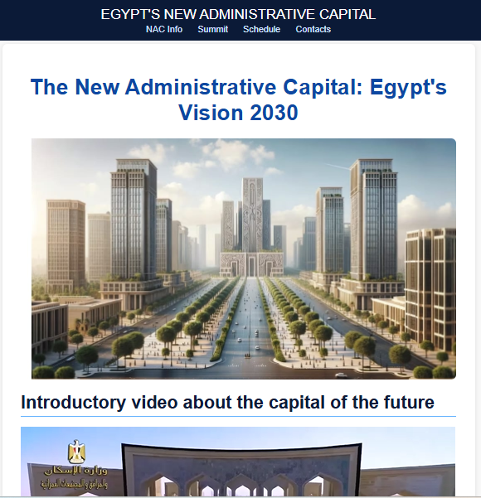
This screenshot shows the final homepage layout, including the navigation bar, hero banner image, main heading, introductory video section, and content blocks. It demonstrates compliance with the brief’s requirement for a structured landing page that introduces the main topic.
Figure C2. Information Page (1.html)
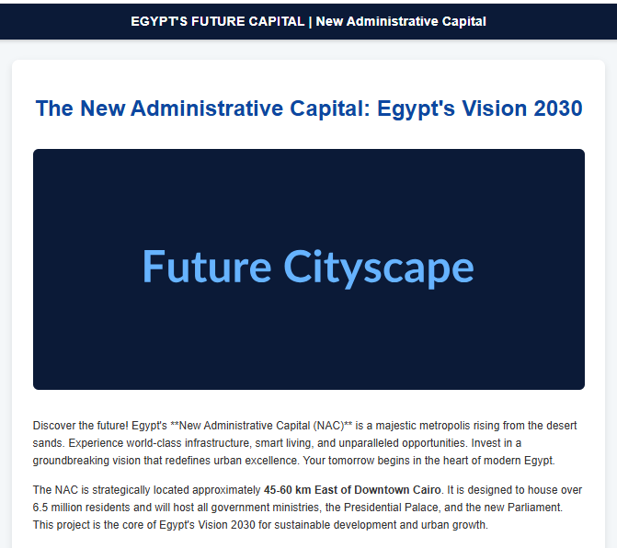
This page presents detailed content about the New Administrative Capital, including structured paragraphs, section headings, and multimedia placeholders. The figure demonstrates correct use of semantic HTML and consistent visual styling.

Figure C3. Gallery Page (3.html)
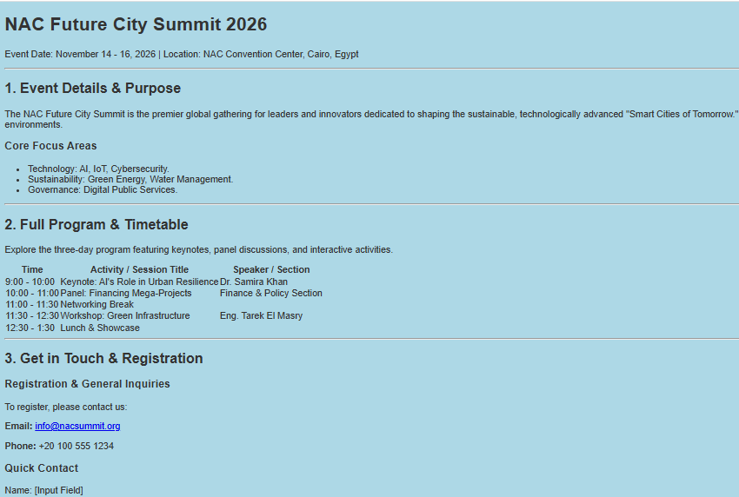
This screenshot displays the event program using a clean, accessible table structure. It evidences proper formatting of tabular data, alignment, and spacing, fulfilling the brief’s requirements for presenting structured information.

