
effective COMMUNICATION AND teamwork
Component 2 Report / 1863 words
Zoltan Balog
(2028534)
July 1, 2022
University of Wales Trinity Saint David

Content Page

Cover page………………………………………………………………………………………………….0
Content page………………………………………………………………………………………………1
Introduction…………………………………………………………………………………………………2
Main Findings…………………………………………………………………………………….3-4-5-6
Conclusions…………………………………………………………………………………………………7
References………………………………………………………………………………………………….8

Introduction

In this study, can see what problems can arise in an organization if they are not effectively managed. For their organization to be able to function, they need well-managed teamwork and communication. Organizational cohesion is critical. Organizations with a strong emphasis on teamwork are more innovative, find better solutions to challenges, and are more productive, according to research (Tanner, O.C. 2019). Teamwork is when people work and cooperate well together, using their individual skills, providing constructive feedback, and working collaboratively to achieve a goal. When working in groups, effective communication is more than just getting the job done quickly. It is an effective way to ensure that everyone on the team is up to speed on any topic that might have an impact on their work. Additionally, it fosters a sense of belonging and camaraderie among employees, which raises spirits and keeps them interested in their jobs (McDuffee, S. 2019). Two particularly good theories can help them to develop the team.
First, Bruce Tackman (1965) psychologist stated in five stages, how teams going through their development from the beginning till the end. The stages are forming, storming, norming, performing, and adjourning (The Happy Manager, 2021).
Second, according to Meredith Belbin (1981) “the nine teams’ role”, help minimise the conflict and balanced the team. The roles are shaper, co-ordinator, plant, monitor evaluator, implanter, specialist, team worker, resource investigator and completer finisher (Moultrie, J. 2016).
Key issues with the case study:
- Employees turnover and absence /managers must deal regularly with short of staff/.
- The team stacked in the forming stage, because of this their performance is poor /old members not helping the new members/.
- Management rarely communicates with the team if they do it is only one-way communicating.
- Team members under pressure without any support from the leaders.

Main Findings

After Andrea suggesting using Belbin’s (1981) theory to clearly define roles to fill all the position in the team. With this decision she gives responsibilities for each team members and they should be responsible for their own work to reach the common goals (Serban, R. 2017). She needs to find the right person in the right position to create the best possible balance in the team. This will prevent further conflict between team members. Different leaders and team members need to start communicating effectively to avoid problems within the new team. This can help Andrea strike a balance within her team, restoring a well-functioning work atmosphere. Individuals exhibit an unlimited variety of behaviours. However, a limited number of behaviours can make a significant contribution to team effectiveness. However, there are a limited number of useful behaviours that can have a significant impact on team effectiveness. The term “team role” is to describe similar behaviours grouped together (Channell, M. 2021)
With this case study, in the organization is not a team anymore, so Andrea should apply Tackman's (1965) theory to reform the team again. For their team to work effectively, she needs to build a diverse and inclusive team. She must first putt together the structure of the team to start forming. Andrea must help the team there during an exceedingly challenging time that we call storming. She needs to start allocating individual jobs, she also needs to teach them to work evenly not just for themselves, but with the team in mind. They need to start building trust within the team, to do this they need to encourage communicate effectively together to get to know each other better and thus build trust in them (Lumapps, 2020). She needs to hold team meetings more often to keep track of her team's progress and development. Once they have rich their trust, they arrive at the norming stage, they talk about their thoughts and feelings, elicit, and provide feedback from one another, and experiment with different approaches to the work at hand. During this phase, it becomes clear that the team's work ethic and shared leadership are well known (West Chester University, 2020). After learning about their position, the joint work began. In this state, everyone already knows what to do and what their responsibilities are in the organization. This is where the performing stage start. For Andrea to maintain this position, the team needs to give more positive feedback, she must recognise and reward team members.
The importance of getting effective communication is to understand her messages what she is sending out and to get the most out of it (Bhasin, H. 2020). Andrea can apply Schramm model of “two ways” communication model, which should help her to minimise the problem between team leaders and employees.

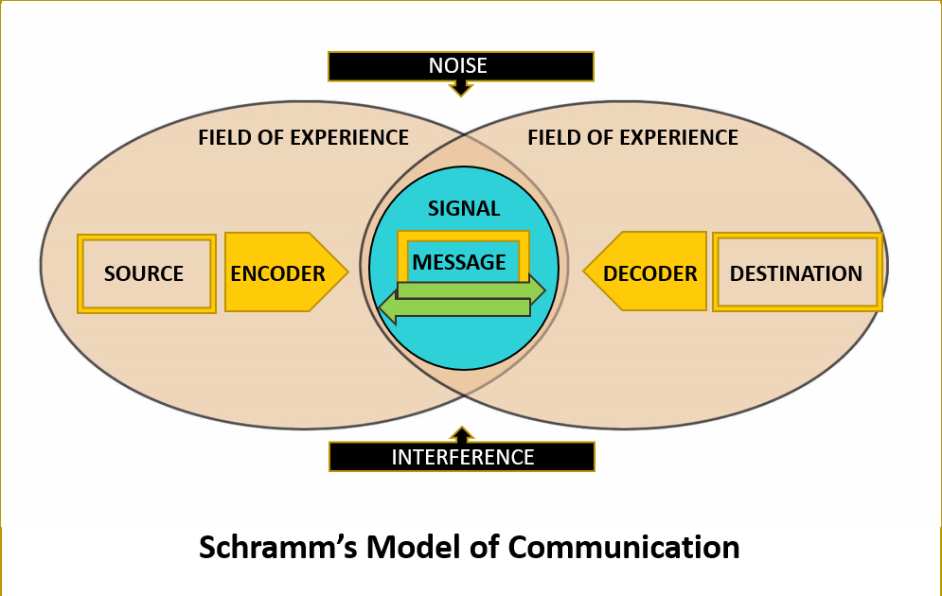

A company's overall success could be influenced by the quality of communication within the workplace (Gail, C. 2022). Now of the time, when information is delivered to its intended receiver, it is with the goal of being understood. The entire process of communication is rendered useless if the message received by the recipient cannot be understood or decoded (Mariya, 2022). Because communication was lacking in the organization, those who working there could not do their job. They did not receive enough support, they did not receive any basic training, so they could not do their job properly.
According to the Shannon and Weaver (1948) model of communication, this model is primarily developed to improve the effective communication between
sender and recipient (Communication Theory, 2014).
“The SMCR model refers to the sender-message-channel-receiver model of communication, also known as the Berlo model” (Cuofano, G. 2021).

Berlo’s model first start with the source who sending the information to the receiver. Before the receiver understands the messages must be good communication skills between them. The capacity to speak, read, write, and listen effectively is known as communication skills (SkillsYouNeed, 2011).
The ability to communicate verbally and nonverbally is also a sign of her talent. Communication is more effective when both the sender and the receiver are well-versed in the art of verbal exchange. Eye contact, facial expressions, body language, gestures, and posture are just a few instances of typical nonverbal communication. The efficacy of the communication process is enhanced by the source's or sender's communication skills.
If Andrea wants delegate effectively her team, she should know what task to be delegate. It is very important for her to provide the right support and give people the right advice. She should be provided to the people resources and training for develop themself. She must make sure her team understand everything, so she can open a clear communication channel with her team. This can help on her is she give daily brief to the team; she must motivate them, and she can also give feedback as well. By directing the team well, she can gain their trust, they will be more open to discussion and engagement with the team members. In high-trust workplaces, managers put the whole person first and support their staff members' professional and personal development (raths, 2019). With her support she can develop them skills and create a positive workplace for everyone. Positive people around her will change team moral, improve productivity, innovation, cooperation, promotes enthusiasm and efficiency. She can reduce stress, save time, increase profits, spread work out more evenly and improve relationship with her team members (Sloan, K. 2018). With those positive changes will help for Andrea to reduce employee’s turnover, minimise conflicts, so it will give to her and the company highly qualified happy people. But to maintain this, she needs to know how to deal effectively with the problems that may arise. She needs to deal well and diplomatically with disagreements. With excellent handling of problems, she can get a team that works well together, communicates and is efficient. “According to Thomas Kilmann model, a conflict management approach is natural for all of us” (Day, I. 2012).

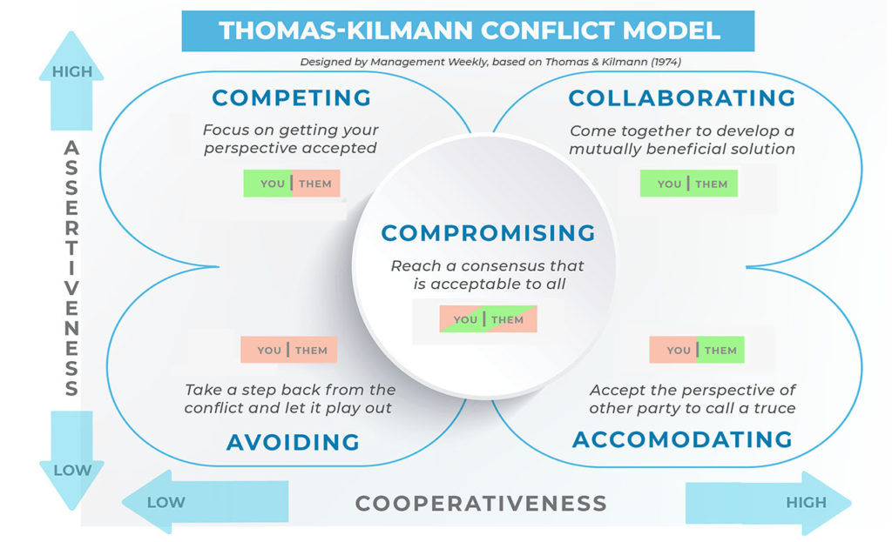
Conclusions
After Andrea took over the manager position of the social service to the local council, she finds herself with serious problems in the organization. Some of the problems Andrea must face, for example: employees’ turnover and absence high, poor performance of the department, shortage of staff, poor communication between managers and staff and no support from leaders. To solve these problems by presenting some useful theories, such as Bruce Tuckman five stages of team development. Also, another very useful theory from Meredith Belbin's nine team roles which can help her to rebuild the team. They have poor performance due to a lack of communication and one-way talk from managers. She must find balance in the team to minimise the problems. The management must communicate effectively and two-ways with their team members. Trust very important in team development, because can build open communication, develop personal and professional skills, and create a positive working atmosphere. Team delegation also very important, because if she don’t know what task to be delegate, she won’t be able to know who the right person for the task is. People can work effectively in organization if they have received some support, motivation, feedback, and rewards from their management. Good communication within a team is essential to solve problem. Together, without two-way communication, delegation, trust and respect, organization will never be successful and there will always be emerging problems.
References

merriam-webster (2018). Definition of TEAMWORK. [online] Merriam-webster.com. Available at: https://www.merriam-webster.com/dictionary/teamwork.[Accessed on 28/06/22]

McDuffee, S. (2019). How to Communicate Effectively to Improve Teamwork | TeamBonding. [online] TeamBonding. Available at: https://www.teambonding.com/how-to-communicate-effectively/.[Accessed on 28/06/22]

The Happy Manager (2021). Teamwork Theory | Tuckman’s Stages of Group Development. [online] The Happy Manager. Available at: teamwork-theory https://the-happy-manager.com/article/ /.[Accessed on 29/06/22]

Moultrie, J. (2016). Belbin’s team roles. [online] University of Cambridge. Available at: https://www.ifm.eng.cam.ac.uk/research/dmg/tools-and-techniques/belbins-team-roles/.[Accessed on 29/06/22]

Lumapps (2020). 8 Useful Ways to Enhance Teamwork in the Workplace. [online] LumApps. Available at: https://www.lumapps.com/solutions/enterprise-collaboration/improve-teamwork-in-the-workplace/.

West Chester University (2020). Tuckman’s Stages of Group Development - West Chester University. [online] www.wcupa.edu. Available at: https://www.wcupa.edu/coral/tuckmanStagesGroupDelvelopment.aspx.[Accessed on 23/06/22]
Serban, R. (2017). Team Dynamics Is About Playing Team Roles to Your Advantage. [online] Hubgets Blog. Available at: https://www.hubgets.com/blog/team-dynamics-belbin-team-roles/.[Accessed on 23/06/22]

Channell, M. (2021). Belbin’s team roles: How can team roles improve performance in the workplace? [online] www.tsw.co.uk. Available at: https://www.tsw.co.uk/blog/leadership-and-management/belbins-team-roles/.[Accessed on 23/06/22]

Bhasin, H. (2020). Schramm model of communication | Elements, Advantages & Limitations. [online] Marketing91. Available at: https://www.marketing91.com/schramms-model-of-communication/.[Accessed on 24/06/22]

Gail, C. (2022). Team Communication: Effective Group Collaboration & Teamwork. [online] hubspot.crystalknows.com. Available at: https://www.crystalknows.com/blog/team-communication[Accessed on 24/06/22]

Mariya (2022). Two-Way Communication: Importance and Best Practices. [online] ContactMonkey. Available at: https://www.contactmonkey.com/blog/two-way-communication.[Accessed on 24/06/22]

Communication Theory (2014). Shannon and Weaver Model of Communication. [online] Communication Theory. Available at: https://www.communicationtheory.org/shannon-and-weaver-model-of-communication/.[Accessed on 25/06/22]

Cuofano, G. (2021). What is Berlo’s SMCR model? Berlo’s SMCR Model In A Nutshell. [online] FourWeekMBA. Available at: https://fourweekmba.com/berlos-smcr-model/.[Accessed on 25/06/22]

SkillsYouNeed (2011). Communication Skills | SkillsYouNeed. [online] Skillsyouneed.com. Available at: https://www.skillsyouneed.com/ips/communication-skills.html.[Accessed on 25/06/22]

raths (2009). Successful Delegation: Using the Power of Other People’s Help. [online] Mindtools.com. Available at: https://www.mindtools.com/pages/article/newLDR_98.htm.[Accessed on 26/06/22]

Sloan, K. (2018). 6 Reasons Delegating is Good for Your Business - Due. [online] Due. Available at: https://due.com/blog/delegating-good-business/.[Accessed on 26/06/22]

Day, I. (2012). The Thomas Kilmann Model (TKI) - Conflict & Challenge. [online] Challenging Coaching. Available at: https://challengingcoaching.co.uk/conflict-and-challenge/.[Accessed on 27/06/22]

