A Key Workers Guidance for Promoting Effective Communication and Supporting Children Through Transitions in The Early Years.

- Keeley Jade Poole
2006636

Human Development
EAEE4003
Contents Page

Page

- How the guide can be used in practice 3
- Introduction 1
- The role of the adult 1
- The needs of the child 1
- Partnerships 1
- Interventions 1
- Proposed outcomes 1
- Reference list 1
How the guide can be used in practice

The purpose of this handbook is to enable the knowledge of all keyworkers who work closely and play an important role in children’s lives in the early years to recognise the significance of effective communication throughout the child’s education with all practitioners who are involved, the child’s parents or carers as well as the child themselves and to promote the child’s development efficiently through transitions.

From the guidance of this handbook, practitioners in the early years will have a clear understanding of the importance of transitions and how to manage them effectively. The key worker must ensure that communication is effective consistently for the importance of information being distributed (Oxfordshire County Council, 2017). Partnerships need to be built to enable a positive supportive background for the child during transition.

Introduction to transition

Transitions are a method of change that children and young people will encounter, from a very young age. Transitions are when the child experiences transitional changes from being at home to starting Nursery. They then transition from Nursery to Reception, and then to Year 1. Transitions can be an emotional period for parents and carers to encounter when their child experiences transitional changes, it can be an emotional experience for everyone who is involved in the process (Kirklees Council, 2013).

Transitions are an important element of a child’s life as they grow (Early Education, no date) and enhance the possibility of the child growing through new experiences and opportunities that may arise (Tower Hamlets, no date). As a key worker, supporting children through their transitions appropriately enables successful outcomes and encourages the children’s individual needs (Welsh Government, 2017).

The Maria Montessori Approach (1870 – 1952) meets the needs of every child and enables positive outcomes to be achieved for all. It is known as a thorough and successful approach for teaching in the early years (Montessori Group, no date). Montessori’s holistic approach enables children to be confident and thriving individuals. Montessori observed each child and discovered the most effective technique of teaching is for the children be hands on and develop through doing (Montessori Group, no date).
Practitioner’s must ensure the setting is encouraging and welcoming for the child who is transitioning to enable the child’s confidence to flourish through hands-on experiences, physically and expressing their interests through participating (Clough, Nutbrown and Selbie, 2008).

Urie Bronfenbrenner’s Ecological theory (1979) is a fundamental approach to practice that strengthens the parents and carers, as well as the individual child. The educational environment must be sensitive, successful and encouraging in order for Bronfenbrenner’s theory to be effective (Brooker, 2008).

Bronfenbrenner (1979) believed that for children, if they are alone with limited support and guidance, it may appear challenging to make progress in their developmental stages. Children must have support from practitioners and their family or carers when transitioning into new surroundings, to enable positive experiences through their four stages of development;
- Physical
- Social
- Emotional
- Intellectual (Lindon, 2012).

Bronfenbrenner believed it is a requirement for children to experience the correct support to allow levelled transitions, for children to understand and process transitions in the future with more ease. Bronfenbrenner established a diagram situated below; it is known as a ‘series of concentric circles’ (Lindon, 2012).

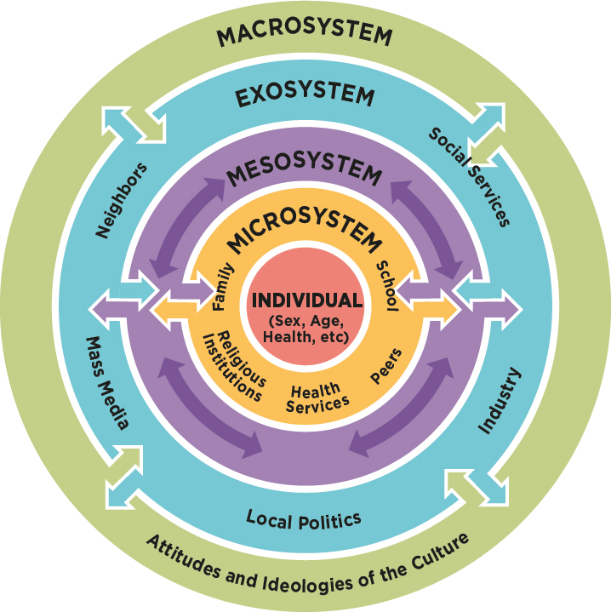
Bronfenbrenner’s Ecological Theory (1979) -

(Source: The National Academies of Sciences, 2020)

Within each circle, they are known as ‘systems’, microsystem, mesosystem, exosystem and macrosystem. In terms of the individual child’s development, every ‘phase’ of Bronfenbrenner’s diagram has an influence on how they progress (Fabian and Dunlop, 2007). Every setting that a child encounters has an importance and impact.
Therefore, it is key to ensure that all systems within the setting create partnerships, as the more professionals work together, the more effective the communication and the more powerful the links become and positive outcomes are to be expected as the individual child’s experiences are enhanced (Brooker, 2008).

The role of the adult

Dedicated planning and being in control as a practitioner, allows children to perceive security and familiarity when entering new surroundings (Central Bedfordshire, 2015).

To experience positive outcomes and for the child to have a steady process through transitions, practitioners must ensure planning is carried out to accomplish this. Being prepared for the child’s arrival ensuring key information on the child’s needs has been acknowledged and accumulated to enable the correct support to be given where necessary. Information can be passed on through the child’s parents or carers, or from a previous year group or setting allowing practitioners to be equipped and facilitate the knowledge of all practitioners that encourages the child through their transitions and promoting their development in all aspects of areas, especially the child’s keyworker (The Early Years Foundation Stage, 2007).

John Bowlby’s Attachment theory (1907 – 1990) focuses on effects of detachment and impacts on the child as a whole when transitioning and how attachments have a significance on the child’s individual development (Holmes, 2006). Bowlby believed that a child’s initial attachment is with their mother, however, he also believed that as children grow and experience transitions, attachments can develop with further individuals such as, a keyworker. Whether the child has one or many attachment bonds with individuals, this enables the purpose for the child to experience relief and certainty. A child with the appropriate support will develop an attachment with the key person naturally (Very Well Mind, 2020). Positive attachments and key workers are essential to a child’s sense of protection within a learning environment. Bowlby supports this (Holmes, 2006). Children’s developmental stages and confidence will begin to grow when establishing an attachment with a significant person in particular, a key person (Holmes, 2006).

The key worker has many elements within their role ensuring that a child’s care needs are met through feeding times, nappy changes, changing a child’s hearing aid batteries and ensuring hearing aid checks are completed (Foundation Stage Forum, 2020). A child may be anxious during a transition; therefore, the key person must ensure support the child and form a positive attachment between one another to fulfil and promote the child’s development to flourish to full potential in an effective and refreshing process (Central Bedfordshire, 2015).

When a child is transitioning, the key person must ensure they support the role within Bowlby’s theory, when the child has been separated from their parents or carers. When a child is starting in a new setting for the first time, they may be feeling apprehensive about an environment that is unfamiliar to them. Therefore, introducing oneself as a key person prior to the child’s start date, to the child, parents or carers is an essential first step to starting to support the transition process and so that the child has a familiar face. This is also for the practitioner to be aware of the level of support that is needed to be provided for the child as well as the family and to also acknowledge their background, for example.

- The child’s interests.
- Their ethnicity
- The family household, who lives at home.
- The child’s routine (Foundation Stage Forum, 2020).
The key person should be aware and seek this information in order for the setting as well as the practitioners to support the process to the full potential (Foundation Stage Forum, 2020).

Key workers must require a welcoming invitation to the child and their family for an induction to the child’s new setting for the child to get a feel of their new everyday setting, from the members of staff that will be supporting their transition and development, to the children that they potentially form new friendships with and to the new routines that the child will encounter (Central Bedfordshire, 2015).

As a key person, supporting the child through a current transition is key. However, it is also equally important to support the child and to prepare them for upcoming transitions that they are about to approach for example, moving up in a year group (milestone transitions). Ensuring that every individual child receives their entitlement of support for a constructive transition is essential to encourage a child’s confidence in taking opportunities that are provided in supporting their developmental stages (Oxfordshire County Council, 2017).

The Needs of the child

When transitioning into a new setting, the chances for positive transitions and development are enhanced for children if:

- Children form a positive relationship with their keyworker
- Transitions are made priority by the parents, carers and practitioners
- The setting is a secure place for the child
- The child’s starter days are informal and relaxed at activity times
- Children are encouraged to form friendships with other children
- Parents are involved and receive the correct support
- The child has familiarity (The Early Years Foundation Stage, 2007).

Although other practitioners are present to support the child, ensure that the child is aware a key person is present in order for them to feel secure once they have formed an attachment. For the child’s individual needs to be met with practitioners, parents and carers support, practitioners within the education setting must show awareness and significance of transitions to the parents, carers as well as the child. The children need to feel secure when settling into their new environment (Kirklees Council, 2013). Therefore, having an encouraging environment for the child to learn in will enable the child to develop positively and perceive their independence when approaching new experiences.
When a child is transitioning, whether that may be from a setting or moving up a year group, encouraging them to form friendships with children in their class can often ease the child’s transitional period and support them when adjusting to any new changes (The Early Years Foundation Stage, 2007).
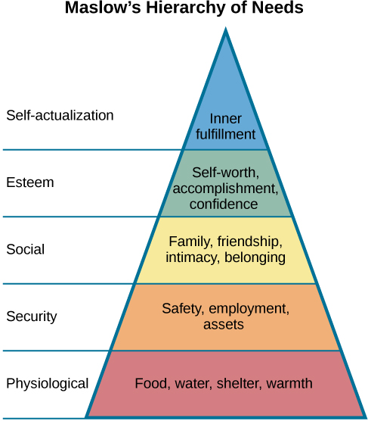

(Source: Lumen, no date)

Abraham Maslow Hierarchy of Needs (1962) is an effective model and a hierarchy that is a value to a child’s development (Pierre, 2015).

The theory’s pyramid contains five levels that are stated in order of importance for a child’s physical and human psychological needs. It enables others to have the understanding of the needs of the child, for them to be met and move onto the next focus, to feel emotionally secure and have a sense of belonging in their environment and within this world (Lumen, no date). A child’s physiological needs must be fulfilled first in order for their sense of security needs to be met (Learning Theories, 2020).
When a child is going through a transitional experience, ensure as a practitioner that you allow the child time for a ‘settling in period’ and familiarise themselves with new surroundings. Forming an attachment process with a key person will support this and ensure the child’s transition period is at more ease and enable sense of security (The Early Years Foundation Stage, 2007).

Child-centred approach is an extremely effective approach for early years settings as it supports children’s development in many ways. It allows the key person to observe and identify the child’s likes and dislikes in order to consolidate the child’s preferred areas of learning during their transition (WJEC, 2019b) enabling the child to be more at ease during settling in as they have familiarities to their interests and previous setting which can also make them feel valued, as the practitioner has put the child at the heart of their education and their needs as priority. Planning enhanced provision with engaging activities for the child enhances the chance of a smooth process when transitioning and enables them to choose and engage in the activities independently. This builds the child’s confidence in a positive manner and allows them to express their interests and areas of preferred (Designs for Education, 2020).
The child-centred approach enables the child to learn through hands-on experiences, gives the child the sense of importance and value, allows the child to make decisions independently and over all supports the child’s development in a holistic approach (WJEC, 2019b).

The Foundation Phase Framework puts the child’s individual needs at the centre of priority. Practitioners need to be aware that for a child to develop their areas of learning (socially, emotionally, intellectually and physically) they need access to opportunities to explore and develop their skills (WJEC, 2019a).
Supporting a child’s transition through enhanced provision encourages a child’s development through the seven areas of learning in the Foundation Phase curriculum

- Language, Literacy and Communication
- Personal, social, cultural diversity and well-being
- Welsh Language Development
- Mathematical Development
- Creative Development
- Knowledge and Understanding of the world
- and Physical Development (Welsh Government, 2015b).

The child-centred approach and the Foundation Phase Framework ensures that every child’s individual needs are met regardless of their abilities or ethnicity (Welsh Government, 2015b).

Children have the right to play as stated in the United Nations Convention on the Rights of the Child, Article 31 (UNCRC, 2019). Play is a key area of which children progress from during transitions and their overall development. Children develop many skills through playing, independently and with children. They develop skills such as

- creativity
- vocabulary
- social skills
- emotions
- and imagination (Family Lives, no date).

Partnerships

Partnerships enable children to feel supported and secure and encourage the child’s overall development, positively (Welsh Government, 2015a).

The first step to a successful partnership, is to recognise that the parent or carer at home is the child’s first attachment and educator, as Bowlby states in his theory (Welsh Government, 2015b).

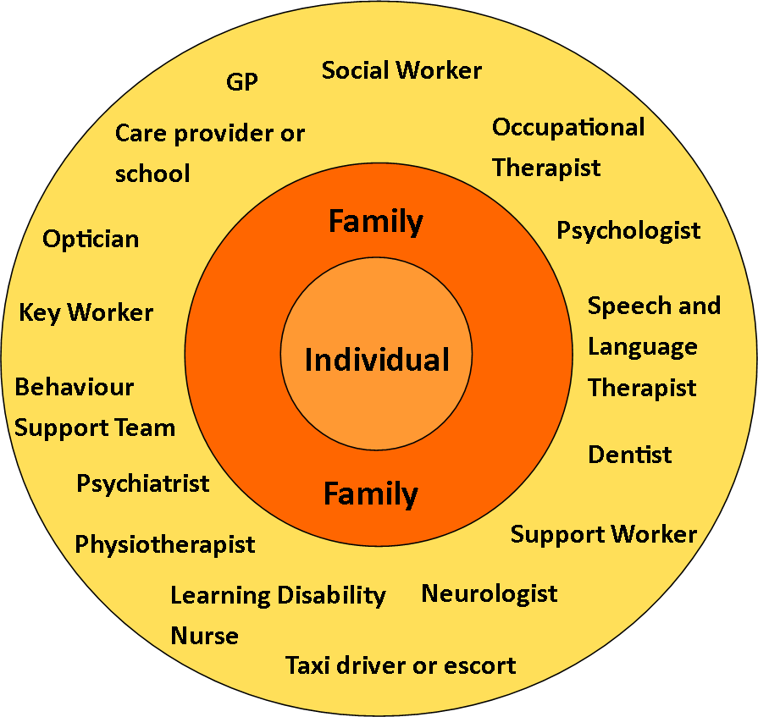

(Source: The Challenging Behaviour Foundation, 2020)

With restricted support and encouragement, it is likely that children will not develop to their full potential. Therefore, practitioners must ensure there is support available for the child with all necessary professionals for example, the key person, outside agencies and the parents (Lindon, 2012). Whilst the child is transitioning into a new setting, the key person forms a bond with the child, creating a ‘secure base’ in order for the child to feel secure and protected. The same applies for the parents or carers, practitioners must ensure that they are sensitive towards their emotions as the transitioning process can be difficult for them when separating from their child. However, effective communication during this process is essential so no information is misunderstood and relayed when it is necessary (Foundation Stage Forum, 2020).

The partnerships between the child, staff, parents and carers must be constructive to provide a positive unit of support for an effective transition for every individual involved, especially the child. Through effective communication, we learn the child’s likes and dislikes, background information, ethnicity, preferred activities, and their routines from the parents and child. Working together is one of the key areas that must be secure and available to access during transition (Central Bedfordshire, 2015).

If a child is transitioning from a previous setting, effective communication with previous professionals is equally important as effective communication at all times, to enable a clear understanding of the child’s progress in their current development and if any extra support can continue to be offered and in place for when the child starts (The Early Years Foundation Stage, 2007).

To support the family as well as the child during transition, providing a handbook of a complete plan of the child’s new setting will enhance their knowledge of the new environment. Invites to induction days, the child’s first term date, how to support their child upcoming and during the transition, the routine the child will entail and the key person and members of staff that will support the child’s development will allow the parents to be understanding, having the awareness and guide of the new setting that their child will be transitioning into and with the support of the family, will prepare the child for the transition and receive positive outcomes (Belfast Education and Library Board, no date).

Interventions

The Welsh Government (2014) states that their aim is to support “every child with the best possible start in life.”

The Reggio Emilia approach is a universal approach founded by Loris Malaguzzi and used within early years settings to create a positive and interesting philosophy of learning (Scholastic, 2020). With the focus of the child’s development, Vygotsky, Bruner and Piaget were influenced by the approach. Malaguzzi stated many factors in the Reggio Emilia Approach are essential to a child;
- The environment that the child is in
- Practitioners as learners
- The image of the child
- Positive partnerships between the parents, carers and professionals (Learning and Teaching Scotland, 2006).
The Reggio Approach has the philosophy for children to become critical thinkers and develop understanding of other individuals surrounding them through the opportunity of exploring new experiences and activities (Learning and Teaching, 2006). The theory enables children to achieve in a variety of areas in learning and retain exceptional concentration skills that is evident in their work (Scholastic, 2020).

The approach signifies a secure partnership between the community and schools. Practitioners, family and individuals within the community collaborate and encourage the child’s development to fulfil. Therefore, one must ensure the child recognises the unceasing potential that they encounter and to build on their understanding by ensuring the child is listened to but is also able to listen, so they feel they are a valuable individual (Learning and Teaching, 2006).

Proposed outcomes

Lev Vygotsky (1896 – 1934) believed that cognitive and language development are closely linked. Vygotsky proposed the ‘zone of proximal development’ and the ‘scaffolding process’ (Pacey, 2016), a process which enables children to enhance their knowledge and abilities, reaching their full potential within the ‘zone of proximal development’ to progress in their next stages of development with the support from professionals and parents, known as scaffolding (Shabani, 2010, p. 238).

Interacting with the children encourages them to communicate and express their interests during transitions, involving open-ended questions can support the child’s cognitive development which links with Vygotsky’s theory. Through this, a child and practitioner can solve problems, this is known as sustained shared thinking (Welsh Assembly Government, 2008).

Not all children are at the same developmental stage, every child is unique. Each child responds to new experiences and transitions in their own way and as keyworkers, support must be adapted to this (Fabian and Dunlop, 2007). Appropriate planning and the correct support are essential to a good practice and effective transitions; therefore, these must be carried out (Welsh Government, 2017).

As practitioners we must support the child and their family throughout the transition period in a sensitive approach to encourage their learning and development, to enhance their social skills and to ensure security is enabled for every individual to experience an effective and well-structured transition (Fabian and Dunlop, 2017).
Professor Donaldson has listened to many professionals in educational settings, in Wales and England, to provide a holistic curriculum in 2022 that can have changes adapted to it if necessary, by local settings (Welsh Government, 2015c). Donaldson believed that the current curriculum has become out-of-date in some areas of learning and practitioners need to support children to develop in their everyday basic skills, knowledge and understanding on life skills for example, careers and confidence within themselves (Welsh Government, 2015c).

The 4 motives of the new curriculum are for all children to become:
- Ethical, informed citizens
- Enterprising, creative contributors
- Healthy, confident individuals
- Ambitious, capable learners (Welsh Government, 2015d).

