E-Portfolio
Learning in the digital era
Lauryn Healy-Rahilly

Task one
Journal article

How adverse childhood experiences shape our brains
15 August 2022 Gary Donohoe

The majority of psychological theories on mental health conditions heavily depend on the fact that early childhood experiences and adversities cause an increased risk of psychological difficulties later in life. In recent decades there has been a focus on the limbic system. Through research, we have a greater knowledge that the limbic system is altered by early adversity and stress. From research, we also know that overactivation in the amygdala is a response to threats in those who have experienced childhood adversity (Mothersill & Donohoe, 2016).

For many years researchers have studied that childhood trauma might affect cognitive and social processes later in adulthood. This has made many researchers conclude that stress exposure may increase risk for serious mental health disorders via a cognitive pathway which is additional to the threat pathway (Mynin-Germeys & Os, 2007).

Through recent systematic reviews has found that accurate emotional regulation which is typically measured in terms of facial emotion recognition was negatively correlated with more exposure to childhood adversity. (Rokita et al.,2018).

There has been many significant changes and advances in brain imaging especially in the field of cognitive neuroscience over the last ten years in which the way we see brain activity during MRI scans. One of the networks used to see this is called ‘DMT’ (Default Mode Network). This network typically becomes active when at rest. Typically when someone is not focused on anything specific such as a task but rather ‘day dreaming’.

However, there are many limitations, there is a difficulty of making correct inferences from cross-sectional data. For example, in a recent study based on the ALSPAC longitudinal cohort of around 5,000 individuals followed from birth to 18 years, evidence is believed to show that childhood adversity in the first couple years of life was predicted to show poor signs of cognitive function at middle school ages. ( Holland et all.,2020).

Task one references:
( Donohue,2022). G.D. How adverse childhood experiences shape our brains.
https://www.bps.org.uk/psychologist/how-adverse-childhood-experiences-shape-our-brain

( Holland et all.,2020).

(Mothersill & Donohoe, 2016).

(Mynin-Germeys & Os, 2007).

(Rokita et al.,2018).

Task two:
Link to PowerPoint with audio on PowerPoint
Sceenshots of powerpoint

Reference list task two attached to last slide of powerpoint

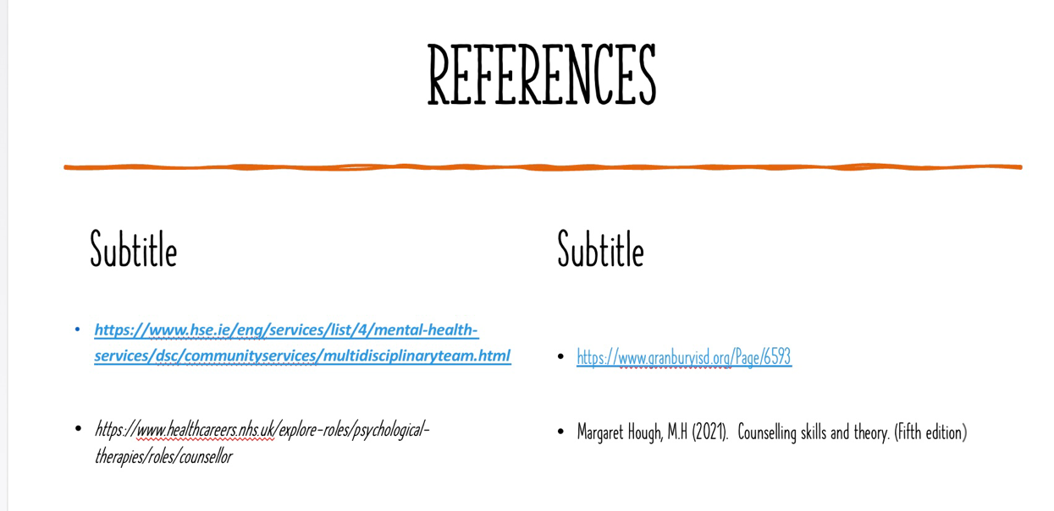





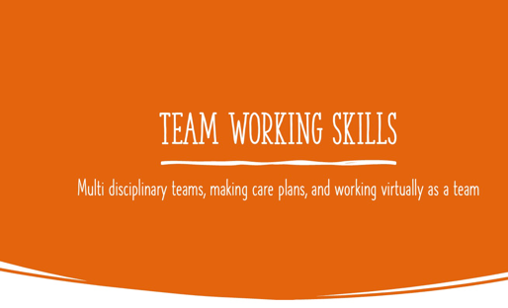
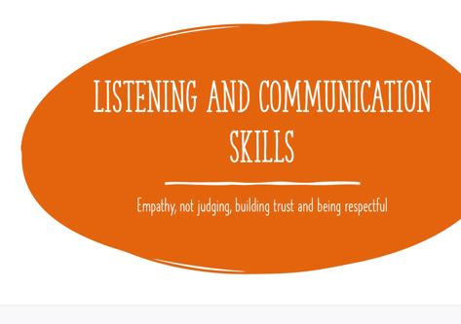
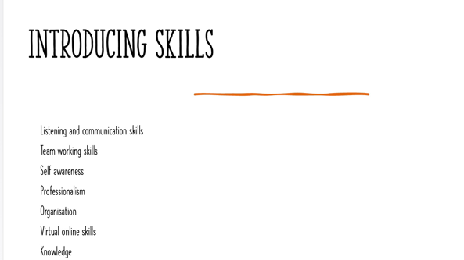
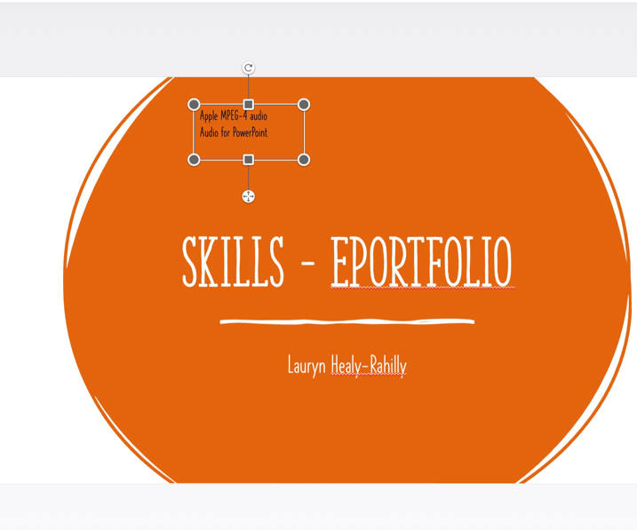
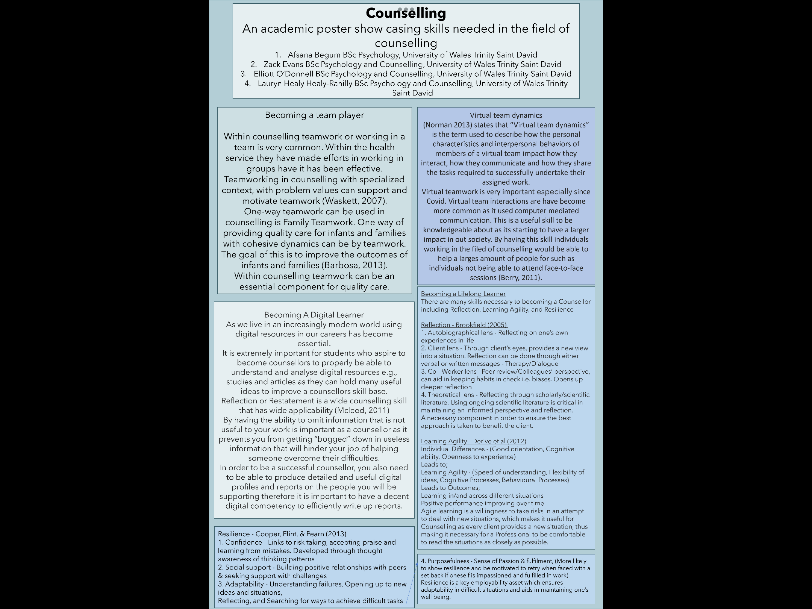

In order to make the poster effectively we decided to make a teams group chat with myself, Elliott, Afsana and Zach. We had multiple calls started by everyone in the group to update each other on how we were doing and to decide on equal workloads. On these phone calls we decided that we would do one unit each, send our ideas and work into the group that and then decide on the design of the academic poster. Once we all had finished our work and ready to design, Afsana kindly used all the ideas we had discussed and made the poster on her laptop whilst on call to the rest of the group on a shared screen. To reflect we all worked really well as a team, we demonstrated really good communication, organisational skills, and respect within the task. I felt very confident and trusted my group.

Unit 4 Elliott
Unit 3 me (Lauryn)
Unit 2 Afsana
Unit 1 zach
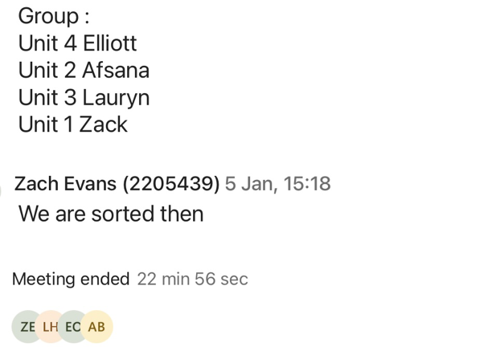
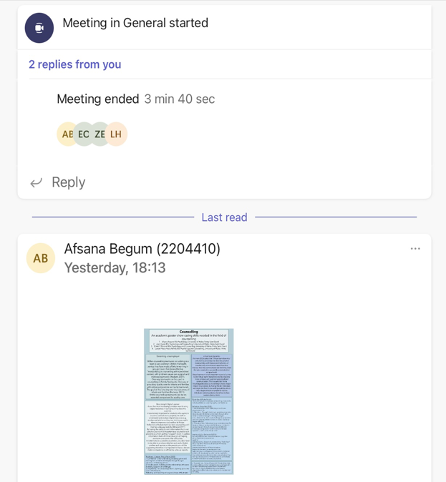
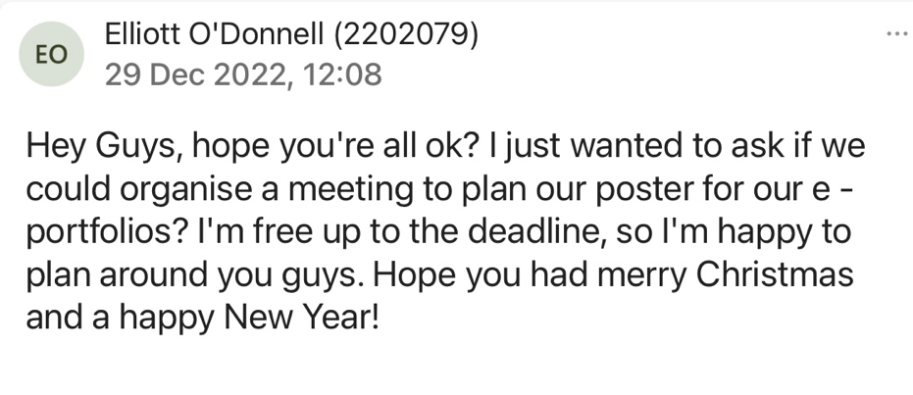
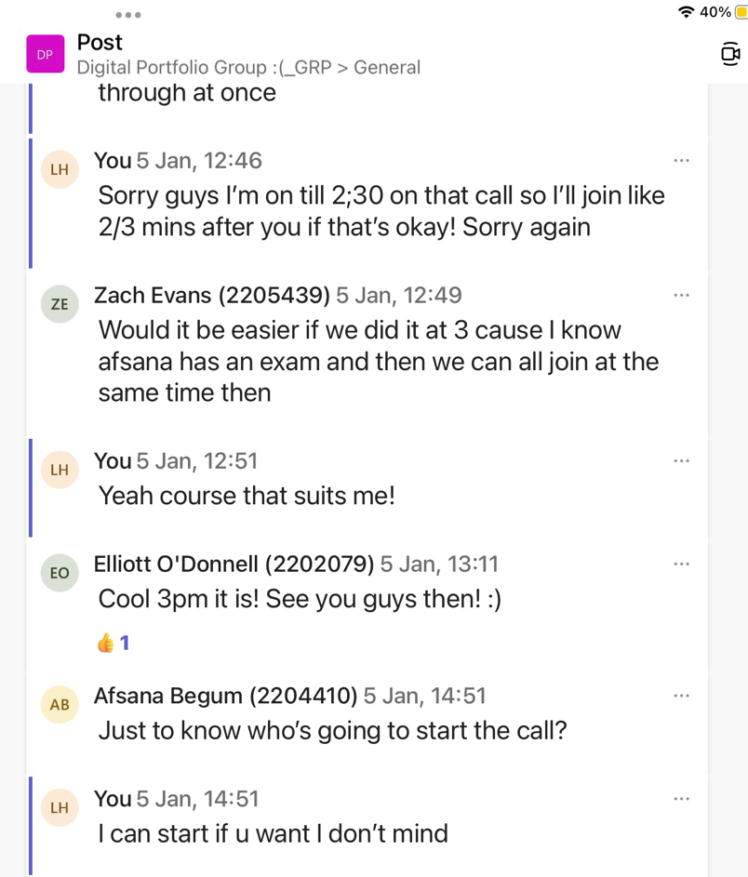



Reference list unit 3 (poster)
(Berry,2011).

(Norman,2013).

Full reference list from all tasks :
(Berry,2011).

( Donohue,2022). G.D. How adverse childhood experiences shape our brains.
https://www.bps.org.uk/psychologist/how-adverse-childhood-experiences-shape-our-brain

https://www.healthcareers.nhs.uk/explore-roles/psychological-therapies/roles/counsellor

( Holland et all.,2020).

https://www.hse.ie/eng/services/list/4/mental-health-services/dsc/communityservices/multidisciplinaryteam.html

Margaret Hough, M.H (2021). Counselling skills and theory. (Fifth edition)

(Mothersill & Donohoe, 2016).

(Mynin-Germeys & Os, 2007).

(Norman,2013).

(Rokita et al.,2018).

