Health & Safety Legislation
Introduction
Health and Safety in construction is a vital aspect to the success of a project as it determines safety for workers and nearby residents when followed correctly. There are many legislations that have been formed over the years in relation to health and safety in construction. When works such as re-roofing and installing external wall insulation commence, many health and safety dangers can arise when legislations are not adhered to. In the United Kingdom, there are several primary legislations that govern the majority of construction projects. Some examples include, the Health and Safety at Work Act (HSWA), the Control of Substances Hazardous to Health (COSHH) Regulations and Construction (Design and Management) Regulations (CDM).
As a trainee Health and Safety officer for UWTSD Construction, this report will discuss the primary legislations in construction, how they influence health and safety on site and how barriers to effective health and safety management on the construction project can be overcome. The report will conclude with the use of 5 risk assessments that cover their own significant activity in relation to the project.
Health & Safety Legislations in Construction
Health and Safety at Work Act (HSWA)
The Health and Safety at Work Act, also referred to as HSWA, was established in 1974 and is the primary piece of legislation in the UK covering occupational health and safety. The general aim of the legislation is to ensure health and safety is correctly followed by employers towards their employees and members of the public, employees towards themselves and each other, and people who are self-employed towards themselves and others. The act requires companies to provide adequate training of staff to ensure health and safety procedures are understood, adequate welfare provisions for staff at work, a safe working environment that is properly maintained and where operations within it are conducted safely and a suitable provision of relevant information, instruction, and supervision.
Control of Substances Hazardous to Health (COSHH)
The Control of Substances Hazardous to Health, also known as COSHH, enforces policies to companies in relation to the types of harmful substances that can be found on construction sites, how they can be prevented and how worker’s exposure to them can be reduced. There are many types of substances that are covered within the act, which includes chemicals (and products containing them), fumes, dusts, vapours, mists, nanotechnology, gases and germs. The act requires all employers to analyse the hazards associated with using dangerous materials and how accidents and emergencies are correctly dealt with. The risks to health and safety associated with handling, storing, or disposing of any of the substances must also be included in the evaluation. Employers must provide staff with the correct information, training and instructions about the risks and strategies about hazardous substances.
Personal Protective Equipment (PPE) at Work Regulations
The Personal Protective Equipment at Work act relates to all protective clothing that workers are required to wear on construction sites. PPE is defined as ‘all equipment (including clothing affording protection against the weather) which is intended to be worn or held by a person at work and which protects the person against one or more risks to that person’s health or safety, and any addition or accessory designed to meet that objective’. After an employer carries out a risk assessment, the suitable PPE for the project will be established and must be provided to workers free of charge. Typically on construction sites, workers will be required to wear a protective hard-hat, eye protection, high visibility coat/jacket and trousers, protective gloves and protective footwear.
The Reporting of Injuries, Diseases and Dangerous Occurrences Regulations (RIDDOR)
The Reporting of Injuries, Diseases and Dangerous Occurrences Regulations (RIDDOR) is a legislation that covers the reporting of accidents that include, deaths and major injuries, incapacity to work for more than 7 days, specified diseases and dangerous occurrences or near misses. If any of these occur, then a report must be sent to the HSE, and records should be kept of the incident. The act can involve employers, employees, self-employed, trainees and other people injured on employer’s premises such as visitors. Some examples of major injuries that should be reported to the HSE include any fracture other than to the fingers, thumbs or toes, amputation of any limb, dislocation of the shoulder, hip, knee or spine and loss of sight or penetrating eye injury. Examples of diseases that can be reported are poisonings, skin diseases such as dermatitis, lung diseases such as asbestosis, infections such as hepatitis, and other conditions such as hand-arm vibration syndrome. Examples of dangerous occurrences include structural collapses, fires/explosions, gas releases and incidents with dangerous substances in transit.
Working At Height Regulations (WAHR)
The Work at Height Regulations 2005 was established with the main goal of preventing death and injury to workers building from great heights. It is imperative for employers and site supervisors overseeing working at height activities to ensure that the job is meticulously planned, closely monitored, and executed by workers with competence. This involves putting on the appropriate gear for working at heights. Planning for low-risk, generally simple tasks will take less time and effort. In general, employees are required by law to take reasonable care of themselves and any individuals who might be impacted by their actions. They also have an obligation to work with their employer to ensure that their health and safety obligations are met.
Health & Safety Management on Site
Legislations are a huge influence on how health and safety is managed on site. Firstly, legislations allow for clear standards that are required in all areas of Great Britain, providing a framework to follow and consistency for health and safety in all construction projects. Specific guidelines would include health and safety practices for all parties.
Legislation also influences the assigning of roles and responsibilities within the construction project. For example, the Construction (Design and Management) Regulations enforces very specific duties to parties involved on a project, such as the CDM Client, Principle Contractor, Principle Designer and CDM Contractors and Designers. The clear and strict duties assigned to people ensures that all parties know their roles and what to expect from others.
Furthermore, legislations in construction are beneficial as they prioritise the use of risk assessments on projects. Risk assessments are documents that organisations create to assess construction activities relevant to their project and the dangers that can occur. Risk assessments are vital to the prevention of hazards and incidents on projects that if go unnoticed, will lead to damaging consequences.
In addition, legislations ensure that all parties on construction projects report all incidents and near-misses. This ensures that a culture of transparency and accountability is implemented across the country. The reporting of incidents also allows for the identification of the main causes of incidents and how they can be prevented in future projects.
Overcoming Barries for an Effective Management of Health & Safety
Health and safety in construction can face many barriers which can lead to damaging affects of projects. However in this scenario, with the proper use of legislations and guidance, these barriers can be overcome. Firstly, it is essential that clear communication is present between all parties on the project. This can be achieved by scheduling regular meetings where everyone can address their concerns and by ensuring frequent reports are published to the contractors and client.
Secondly, barriers to health and safety on site can be overcome by precise planning of the site access and space. Activities such as developing a site logistics plan can be done to establish where materials and equipment will be kept, where site entrances and walkways will be located and where public diversions will situate. Using clear signage and safety barriers can help achieve this.
Also, extra consideration must be made for nearby residents to the project site because any disruption will result in a breach of health and safety. One way to reduce this is by ensuring that no noisy/disruptive works take place during the evening or night when people are trying to rest. Furthermore, since hazardous substance can be present during works, it is vital that harmful materials do not escape site boundaries. For example, if dust from site spread outside boundaries, it is possible that nearby residents could inhale the harmful substance.
Lastly, in the construction project, it is essential that frequent site inspections and inductions take place, where safety measures are monitored and any issues are addressed. As a trainee Health and Safety Officer, this is a role that can be undertaken where frequent oversight and management of the health and safety on site is performed.
The Construction (Design and Management) Regulations (CDM Regulations)
Specific health and safety criteria for construction projects are outlined in the UK's Construction (Design and Management) Regulations (CDM Regulations). They seek to safeguard workers, maintain the safety of building sites, and guarantee excellent planning at every stage of the project. There are a number of different parties involved with the regulations, and are all given their own duties and responsibilities in relation to the construction project. The following outlines the different parties involved in a construction project and their obligations as impacted by the CDM Regulations.
Client
The client is the party who has construction project work completed for them and will have their own responsibilities in regards to health and safety. Firstly, the client must make sure the construction project has an appropriate budget for health and safety equipment and training. Secondly, the client must appoint a Principal Contractor and instruct for the completion of a construction phase plan. Also, a Principal Designer should be appointed if required in project scope. Furthermore, the client has an important role in ensuring that the public and the workers of the project are not exposed to violations of health and safety.
Principle Contractor
The Principle Contractor is a company or person hired by the client to complete the project work. The Principle Contractor’s main responsibility is to ensure the project work is adequately planned, managed and monitored. In terms of health and safety, the construction phase plan must be established and returned to the client. Also, the Principle Contractor must guarantee that competent and properly trained workers are allocated to the construction project, with the appropriate protective equipment. Lastly, the Principle Contractor is required to inform their workers about all relevant health and safety risks and instructions to overcome them.
Principle Designer
In terms of health and safety, several of the responsibilities of the Principle Designer must be complete in the pre-construction phase. The Principle Designer must consider all potential health and safety risks during the design phase, and throughout the life-cycle of the building. Also, the Principle Designer is required to coordinate and manage all health and safety concerns in regards to the project’s design. In addition, the Principle Designer must have a clear and consistent liaison with the Principle Contractor, ensuring that important health and safety information is transparent between them.
Workers
The workers on a construction project are the operatives that perform the tasks set to them such as driving heavy machinery, moving materials and erecting scaffolding. Since the workers are the party most at risk of health and safety hazards, it is essential that they are hyper-aware of the dangers that can occur. The workers must follow all health and safety instructions and training provided and wear all required PPE safety equipment. Also, workers on site must report any health and safety concerns or incidents to the higher parties as soon as possible.

Risk Assessments
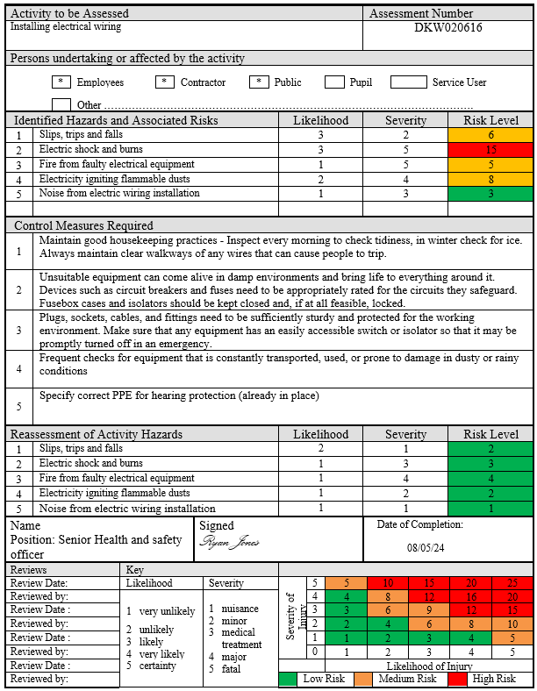

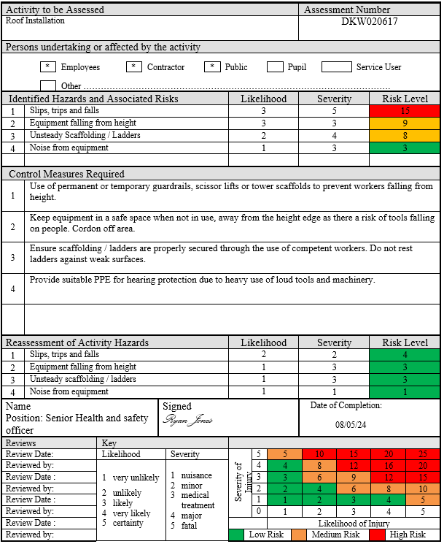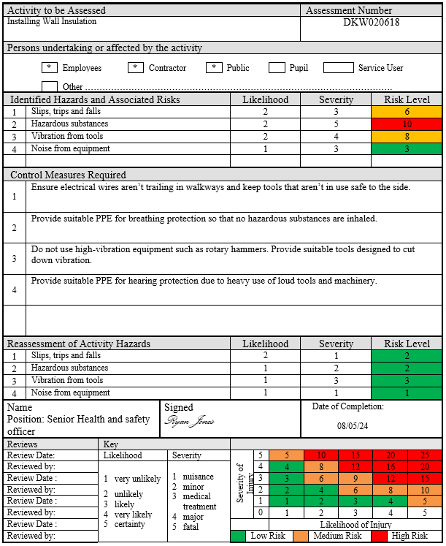

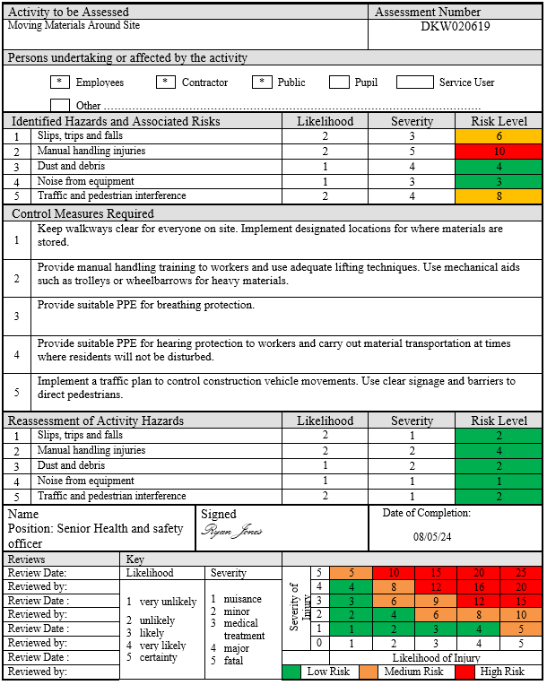
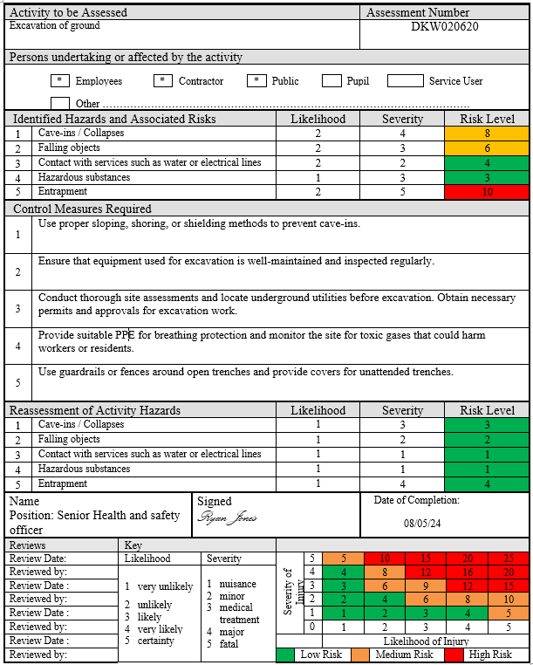
References
Health and Safety Executive (1974). Health and Safety at Work Act 1974. [online] Hse.gov.uk. Available at: https://www.hse.gov.uk/legislation/hswa.htm.
British Safety Council. (n.d.). The Health and Safety at Work Act Explained. [online] Available at: https://www.britsafe.org/training-and-learning/informational-resources/the-health-and-safety-at-work-act-explained#:~:text=The%20Management%20of%20Health%20and.
HSE (2023). Control of substances hazardous to health (COSHH) - health and safety topics in cleaning. [online] www.hse.gov.uk. Available at: https://www.hse.gov.uk/cleaning/topics/coshh.htm#:~:text=you%20must%20do-.
Health and Safety Executive (2022). Personal Protective Equipment (PPE) at Work Regulations from 6 April 2022. [online] www.hse.gov.uk. Available at: https://www.hse.gov.uk/ppe/ppe-regulations-2022.htm.
Health and Safety Executive (2019). Work at height - The law. [online] Hse.gov.uk. Available at: https://www.hse.gov.uk/work-at-height/the-law.htm.
www.hse.gov.uk. (n.d.). Health and safety in the film, theatre and broadcasting industries - CDM roles and duties. [online] Available at: https://www.hse.gov.uk/entertainment/cdm-2015/roles-and-duties.htm#:~:text=The%20three%20main%20CDM%20roles.

‌
‌
‌

‌

‌

‌

