Task 1 Driving Performance Handout – 1703573
Notes Wordcount 1875

Link to Presentation:

https://www.canva.com/design/DAFb8oJWE0M/f5Ed5EGPaWfCAHqeGxtkwg/edit?utm_content=DAFb8oJWE0M&utm_campaign=designshare&utm_medium=link2&utm_source=sharebutton

Task 2 below.

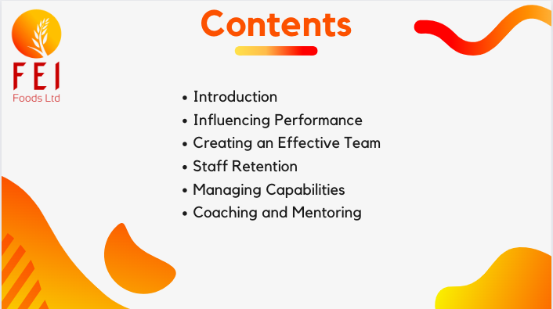
Slide one - Contents

Contents:
- Introduction
- Influencing Performance
- Creating an Effective Team
- Staff Retention
- Managing Capabilities
- Coaching and Mentoring

Slide 2 – Introduction
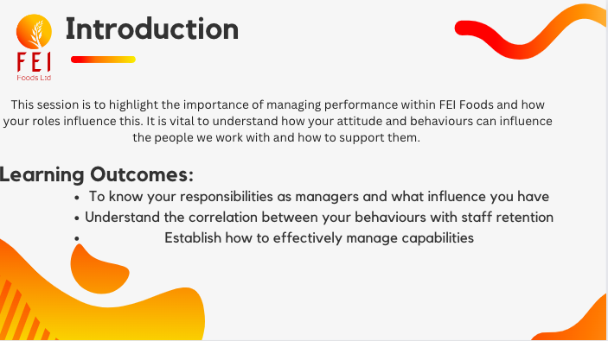
The purpose of this lunchtime learning session is to understand the importance of managing performance and how your roles as managers within the business can influence performance of employees.

By the end of this session, you should be comfortable in knowing what your roles and responsibilities are within the business and what influence you can have on your employees.

You should also be able to recognise the effect that your behaviours have on your employees and how that can link into staff retention within the business.

The final learning outcome of this session is to establish how to effectively manage capabilities. This means dealing with absence management or managing employee performance for example.

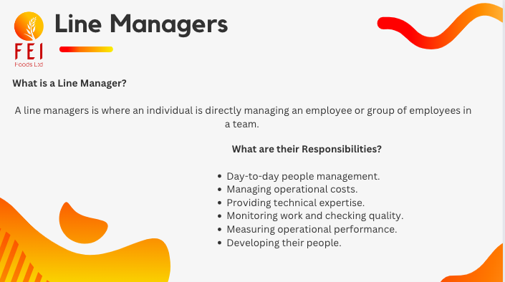
Slide 3 – Line Managers

A line managers is where an individual is directly managing an employee or group of employees in a team (CIPD, 2022).

While managing their team, the line manager is being monitored on the performance of that specific team by a member of staff higher up in the business. In this case, the line manager for production management will be the manufacturing manager (CIPD, 2022).

As a line manager, you are also responsible for ensuring your teams are supported and you are conscious of their health and wellbeing. You should be managing their workloads and working conditions to ensure these aspect will not cause them ill health(CIPD, 2022).

These responsibilities are key for working within the manufacturing industry and you will be using these daily.

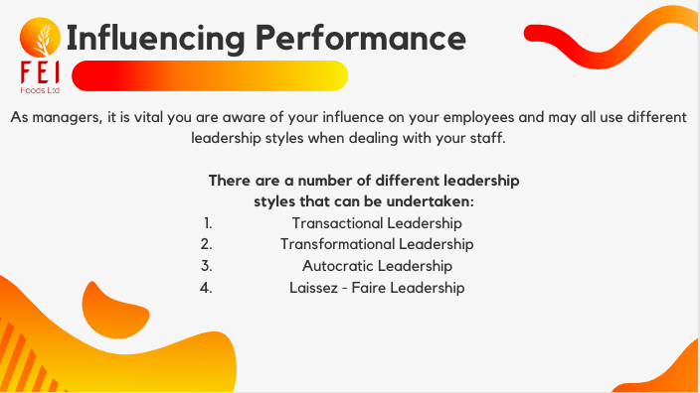
Slide 4 – Influencing Performance

Slide 5 – Influencing Performance
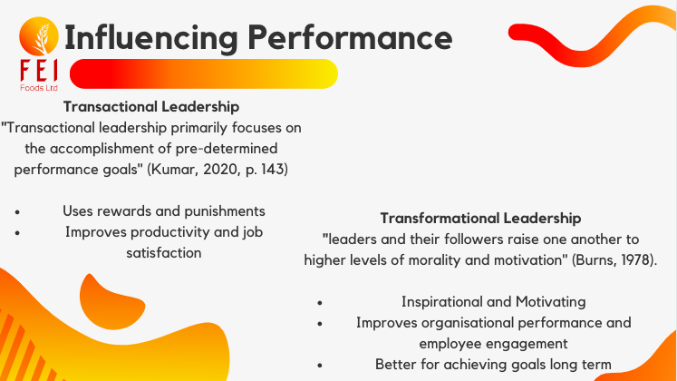
Transactional leadership is where rewards and punishments are used to encourage employees to achieve goals. This style of leadership can improve productivity of employees as well as job satisfaction but is likely not as effective in the workplace as transformational leadership for achieving goals long term (Judge & Piccolo, 2004).

Transformational leaders aim to encourage their employees, set clear goals as well as offers support. However, does have high expectations from their employees. This type of leadership is said to improve organisational performance as well as employee engagement (Avolio et al., 2009).

Slide 6 – Influencing Performance

Autocratic Leadership:
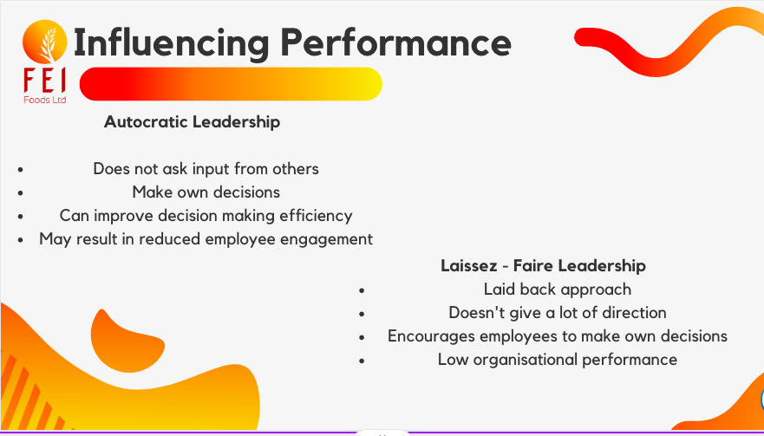
Autocratic leaders take decisions into their own hands for ease. They do not seek the opinions of others before making a decision. This style of leadership may improve decision making efficiency, however it is very likely to cause a reduction in employee engagement. Having a low engaged workforce may result in the staff turnover to go on the rise (Judge & Bono, 2001)

Laissez-Faire Leadership:
Laissez-faire leaders choose to undertake a more laid back approach to leading their teams, they tend to sit back and not give a lot of guidance and direction for what they want employees to do. This leaves the employees to make their own decisions. This type of leadership can result in a reduction in organisational performance, and can also cause low employee engagement. Low employee engagement may also increase staff turnover for the business (Hartog & Koopman, 2001).

Slide 7 - Creating an Effective Team

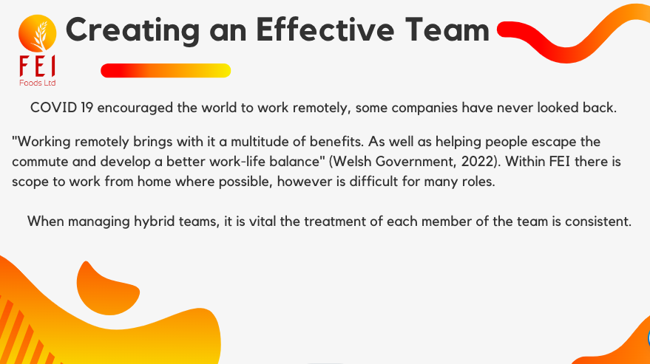
The rise of COVID 19 caused the government to ask people to work from home where possible, however, in FEI there were only select few people who could do this based on their role.

In present times, there are still a number of employees who work from home part time so it is vital as managers, you can fairly manage your teams. The treatment of each member of your team must be consistent.

Slide 8 - Creating an Effective Team

Group dynamics are key to ensuring you have an effective team.
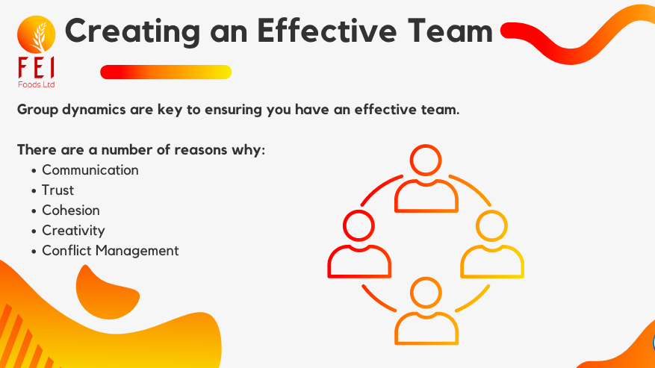
Communication:
In order for teams to function in the right way, effective communication is vital. Clear communication allows no opportunities for misunderstandings for roles and expectations. As a manager you should be encouraging your teams to be involved, give opinions and accept feedback (Nielsen, 2014).

Trust: The key to building good relationships within a team revolves around trust. Group dynamics encourage honesty and transparency that can help build trust within the team (Nielsen, 2014).

Cohesion: This relates to how synced the team is. Group dynamics can bring a sense of unity, inspiring more teamwork within the group (Lee-Kelley & Sankey 2008).

Creativity: Group dynamics can encourage creativity by giving employees the opportunities to try things out, take risks, and make their own decisions on things (Lee-Kelley & Sankey 2008).

Conflict Management:
Within any team in any business, there will always be conflicts whether they are big or small. Good group dynamics can aid these situations and they can be managed through honesty and transparency. This can also encourage continual development opportunities.

Slide 9 - Creating an Effective Team

Bruce Tukman's Forming, Storming, Norming, Performing and Adjourning model is used for creating effective teams.

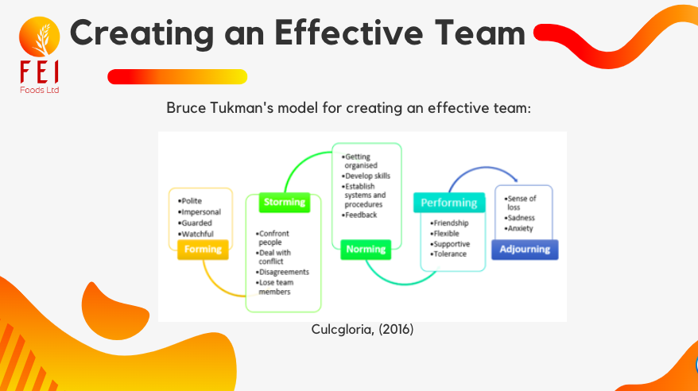
The model encourages teamwork and is vital for team developments. The first stage of the model is the forming stage where members of the team have positive attitudes towards eachother and the task at hand, they are quiet, polite and are risk adverse when it comes to speaking out. This particular stage may be undertaken over a longer period of time as each team member is encouraged to contribute their ideas and work collaboratively (Mindtools, 2019).

The second stage of the model is the storming phase. This is where the members of the team start to feel more comfortable within the team, becoming more forceful with ideas, pushing conflicts a bit more. This can be the most challenging stage for all teams. Despite this model being used for team development, it is common that more confrontations happen at this stage and members become less motivated and focussed on the task (Mindtools, 2019). Conflict can also be seen during the other stages of the model too, but the storming phase is the most common cause.

Norming is next where the task is becoming more organised, and the team begin to develop their skills. They have overcome the conflicts and are giving each other feedback. This is where the team is starting to develop into the performing stage (Culcgloria, 2016)

In the performing stage the team will be demonstrating good relationships, supporting each other and having tolerance (Mindtools, 2019).

The final stage is all about recognising the team's efforts, evaluating the task and the collaborations within the team.

Slide 10 – Staff Retention

As mentioned previously, different leadership styles can have impacts on the engagement of our employees and therefore the business' staff turnover.
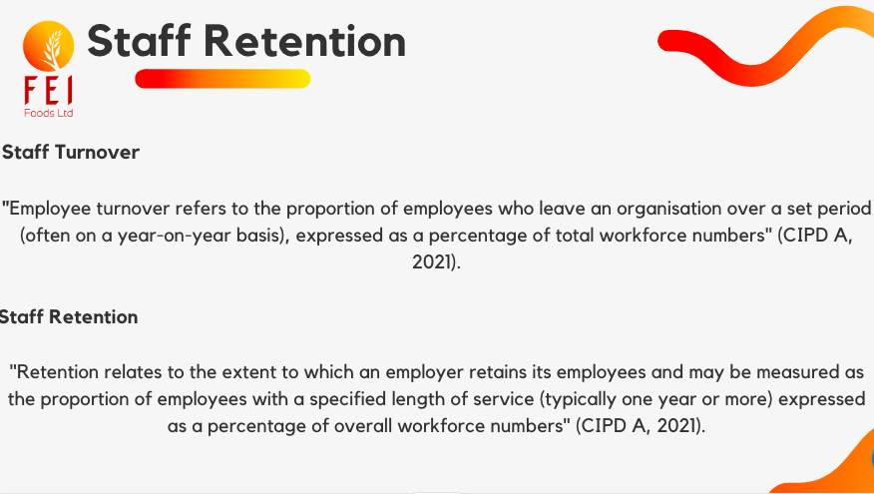
Both are important to a business turnover refers to the number of employees who leave the business within a set period of time and retention refers to the extent a business keeps its employees (Usually measured by length of service)

As you all know, FEI Foods has had high staff turnover in recent years and is continuously looking at ways to improve, listening to its staff and the management team to increase retention within the business.

Slide 11 - Staff Retention

There are a number of things business can look at implementing to improve staff retention:

Competitive Compensation and Benefits:
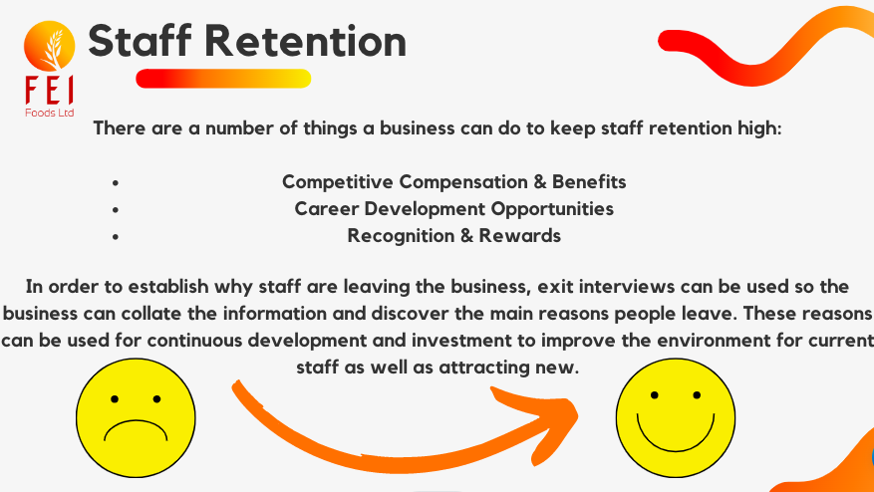
The business can look at their current offerings and benefits compared to similar businesses to establish whether they are being competitive. A competitive salary can make employees feel valued and wanted within the organisation (SHRM, 2019).

Career Development Opportunities:
Ensuring staff have ample opportunities to progress within the business demonstrates to them the business is interested in their development and are happy to invest in it. Having better opportunities to progress is likely to raise employee engagement and staff will stay at the business (SHRM, 2019)

Recognition and Rewards:
Recognising and rewarding employees that work hard and go above and beyond is vital for a business. It doesn't always have to have monetary value but is important to recognise those employees. This can also increase employee engagement and likely make them stay (WorldatWork, 2019).

Slide 12 – Managing Capabilities

There are a number of benefits to having an effective process to manage the absence of employees within an organisation.
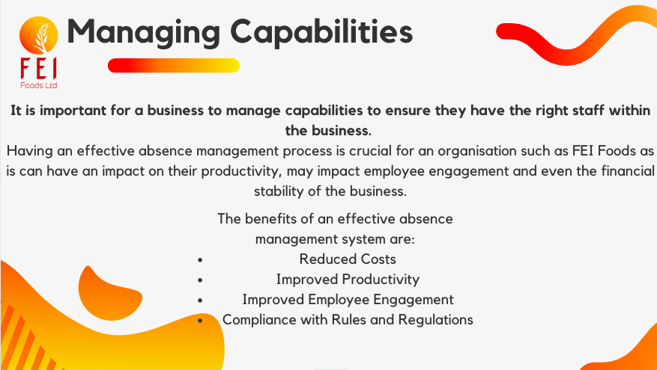
Reduced Costs:
One of the benefits to having an effective absence management process is that it can help to reduce the costs for the business with regards to temporary staff recruitment, such as the outsourcing of labour through external recruitment agencies. CIPD (2019) say that absences that are not planned for can end up costing businesses up to 8.4% in payroll costs, with outsourced staff often coming at a premium.

Improved Productivity:
Employees that are absent frequently over the course of a year can receive extra support from the business through an effectively deployed absence management process. Ensuring that employees feel supported during their absences can help to improve productivity levels and may not cause as much disruption to production in future (Health & Safety Executive, 2019).

Better Employee Morale: An effective absence management process may illustrate to employees that the business has the desire to support them and is not only interested in their wellbeing, but proactive in wanting to maintain a positive relationship between the organisation and its employees.

Compliance with Regulations:
An effective absence management process is also in place to ensure the business is following legal regulations such as sick pay. Failure to do so puts the business at risk of legal action, which can be potentially costly.

Slide 13 – Coaching & Mentoring

Coaching is also beneficial for:

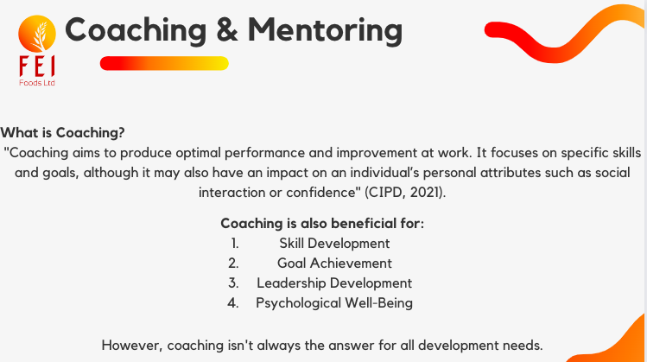
Skill development: Coaching develops new skills and knowledge for individuals. Coaching has been seen to improve individual professional skills as well as their knowledge (De Haan et al., 2018).

Goal achievement: Coaching can also encourage goal achievement. This is because it can give employees motivation, gives them accountability as well as feedback (De Hann et al., 2018).

Leadership development: Communication as well as dealing with conflict may all be developed through the use of coaching. Cox et al (2016) argue that coaching increases leadership effectiveness in employees.

Psychological well-being: Cox et al (2016) also argues that coaching can reduce employee stress levels and improves their well-being.

Despite there being a number of benefits to coaching, it is not always the solution to every development opportunity. Coaching should only be used when it is the best option for developing an employee.

Slide 14 – Coaching & Mentoring

The GROW Model stands for:

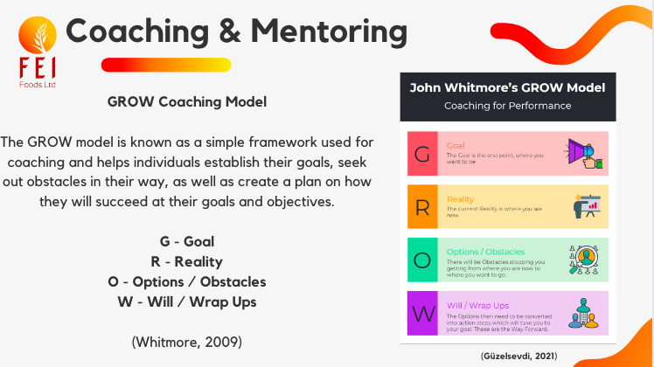
G: Goal - This is in relation to what goal the employee wants to achieve. This is an important first step in the model and the goal must be SMART (Specific, Measurable, Achievable, Relevant and Time Bound)

R: Reality - This is in relation to the situation the employee is in currently with regards to their goals. Reality means doing a SWOT analysis (strengths, weaknesses, opportunities, threats) to establish things that may interfere with the employee achieving their goals.

O: Options / Obstacles - This is where the employee and coach will discuss options for the best way forward.

W: Will / Way Forward - This is where the coach and employee will create a plan to help the employee achieve their goals. Again, this step of the model will need to be SMART.

Slide 15 – Coaching & Mentoring

The benefits of mentoring are:

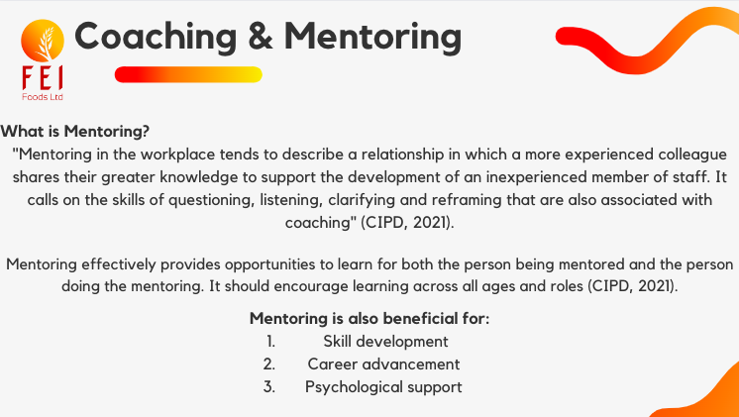
Mentoring can help employees develop their skills and knowledge in a range of areas. Having good mentoring relationships can be seen to improve job related skills (Ragis & Kram, 2007).

Career advancements is another benefit of monitoring by presenting employees with new opportunities. It has been argued that mentoring can improve employee' job satisfaction along with career success (Eby et al., 2008).

It has been argued that mentoring can benefit employees by providing them with psychological support, reducing stress levels, increasing their confidence and well-being (Ragins & Kram, 2007).

References:
Avolio, B. J., Walumbwa, F. O., & Weber, T. J. (2009) Leadership: Current theories, research, and future directions. Annual Review of Psychology, 60, 421-449.
Burns, J.M. (1978) Leadership. New York: Harper and Row.
CIPD. (2019) Absence Management Surveys. Available at:https://www.cipd.co.uk/knowledge/fundamentals/relations/absence/absence-management-surveys#gref (Accessed: 26 Apr. 2023)
CIPD. (2021) Coaching & Mentoring. Available at:https://www.cipd.co.uk/knowledge/fundamentals/people/development/coaching-mentoring-factsheet (Accessed: 26 Apr. 2023)
CIPD. (2022) Line managers' role in supporting the people profession. Available at:https://www.cipd.co.uk/knowledge/fundamentals/people/hr/line-managers-factsheet#gref (Accessed: 29 Mar. 2023
Culcgloria. (2016) Blog 2- Challenge of Managing Diverse Team. Available at: https://culcgloria.wordpress.com/2016/04/01/blog-2-challenge-of-managing-diverse-team/ (Accessed: 26 Apr. 2023)
Cox, E., Bachkirova, T., & Clutterbuck, D. (2016) The complete handbook of coaching (2nd ed.). California : Sage Publications
De Haan, E., Culpin, V., & Curd, J. (2018) The state of play in coaching today: A comprehensive review of the field. London: Henley Business School.
Eby, L. T., Allen, T. D., Evans, S. C., Ng, T., & DuBois, D. L. (2008) Does mentoring matter? A multidisciplinary meta-analysis comparing mentored and non-mentored individuals. Journal of Vocational Behavior, 72(2), 254-267.
Güzelsevdi, C. (2021) Whitmore’s GROW Model: Coaching for Performance. Available at:https://www.projectcubicle.com/john-whitmores-grow-model-coaching-for-performance/ (Accessed: 26 Apr. 2023)
Hartog, D. N., & Koopman, P. L. (2001) Leadership in organizations. In N. Anderson, D. S. Ones, H. K. Sinangil, & C. Viswesvaran (Eds.), Handbook of industrial, work, and organizational psychology (Vol. 2, pp. 166-187). California : Sage Publications.
Judge, T. A., & Piccolo, R. F. (2004) Transformational and transactional leadership: A meta-analytic test of their relative validity. Journal of Applied Psychology, 89(5), 755-768.
Judge, T. A., & Bono, J. E. (2001) Relationship of core self-evaluations traits—self-esteem, generalized self-efficacy, locus of control, and emotional stability—with job satisfaction and job performance: A meta-analysis. Journal of Applied Psychology, 86(1), 80-92.
Kumar, R. (2020) Principles of Management. India : Jyothis Publishers
Lee-Kelley, L., & Sankey, T. (2008) Global virtual teams for value creation and project success: A case study. International Journal of Project Management, 26(1), 51-62.
Nielsen, J. (2014) The effect of team dynamics on corporate communication: A case study of hybrid teams. Journal of Business and Technical Communication, 28(4), 427-455.
Ragins, B. R., & Kram, K. E. (2007). The roots and meaning of mentoring. Handbook of Career Studies, 3, 39-61.
SHRM. (2019) S H R M E M P L O Y E E B E N E F I T S 2 0 1 9. Available at:https://www.shrm.org/hr-today/trends-and-forecasting/research-and-surveys/documents/shrm%20employee%20benefits%202019%20executive%20summary.pdf (Accessed: 26 Apr. 2023)
Welsh Government. (2022) The pandemic opened the door to remote working, now we need to support this way of working for future generations. Available at:https://www.gov.wales/pandemic-opened-door-remote-working-now-we-need-support-way-working-future-generations (Accessed: 26 Apr. 2023)
Whitmore, J. (2009) Coaching for Performance: The Principles and Practice of Coaching and Leadership (4th ed.) Boston : Nicholas Brealey Publishing.

Task 2 - Driving Performance – Students Own



8th May 2022

MODULE NAME: Driving performance: BMHR7016
Name: Amy Collins
Student Number: 1703573
Wordcount: 1644

Executive Summary

The below report will discuss the effectiveness of performance appraisals while looking at the variety of methods to performance management. It will also look at the models of influence in relation to stakeholders.
There is no set definition for performance management but is said to improve performance between organisations and employees. 360 feedback, key performance indicators (KPIs) and Personal development plans (PDP) are all methods of performance management. 360 feedback is used to collate feedback about an employee for the purpose that the business can address accordingly, KPIs are metrics used to illustrate to the business if they are succeeding at meeting their aims and objectives, and PDPs are used to identify aims and objectives for employees.
A performance appraisal is used to monitor an employee’s performance against specific criteria. Annual performance appraisals are known to be soul crushing for employees. Due to this Microsoft have removed the annual appraisal scheme to increase morale. Performance appraisals are an opportunity to encourage development to employees, increasing personal performance.
Countries where culture includes maximising profits such as the USA, employees are judged on sales, compared to Japan where loyalty and teamwork is monitored.
The stakeholder matrix can be utilised when identifying key stakeholders that may have an interest in the performance of employees for example, supervisors and management. One advantage is it allows more inclusive decision making process. However, the model is classed as oversimplified, meaning assessments may not be representative of reality.

Introduction

This report will focus on the effectiveness of performance appraisals, delving into the various approaches to performance management, how valuable appraisals are as well as discussing how this varies between different organisations and different countries. It will also address how to use models of influence with regards to stakeholders within a business.

What is Performance Management and the Various Approaches?

Performance Management (PM) can be said to describe specific activities that can identify objectives for employees to help them understand their contribution to the business’ missions and values. PM can also be improving performance between employees and organisations while making employees responsible for their own performance by relating it to potential progression, rewards or even contract termination in some cases (CIPD, 2022).

360 feedback is one approach to performance management that can be used. This is a “process for collecting, quantifying, and reporting co-worker observations about an individual” (Church et al., 2019,P.2). This allows the collation of meaningful information about an employee so the business can address accordingly based on this information. Church et al (2019) state that 70% of companies utilise 360 feedback as part of their performance management approaches. It is argued that 360 feedback maximises results when used as part of development (Atwater et al., 2007). However, this type of performance management can be seen to cause discrepancies if having a number of people giving the feedback (Levy & Williams, 2004).

Key Performance Indicators (KPIs) can also be used as a method of performance management. These are known as metrics that can illustrate to a business how successful or unsuccessful they are at achieving their overall aims and objectives (Mindtools, 2022). Using KPIs as part of performance management has been suggested to improve employee engagement and boost morale within the workforce as giving employees clear goals to work towards is encouraging with them being able to have an understanding of their progress (McCabe, 2022).

Personal Development Plans (PDP) can be considered another performance management method. A PDP is where business identify aims and objectives for individuals, identify requirements for specific skills or knowledge, and deciding upon relevant development opportunities to ensure the requirements for skills or knowledge are met (CMI, 2020). (Beausaert et al., 2013) argues that a Personal Development Plan gives individuals the opportunity to be responsible for their own learning and encourages a more positive attitude. This makes it a more engaging performance management method for staff as they feel in control of their development.

What are Appraisals and What are their Values?
A performance appraisal can be considered one of the most important practices within human resource management where an employee’s performance is assessed against specific appraisal criteria. This process is implemented to achieve improved performance and align with the business’ goals and individual objectives (Addabbo et al., 2019)

With the current appraisal scheme in FEI Foods being conducted annually, it may be an option to review the process as “Annual assessments can be wildly inaccurate – not to mention soul-crushing” (Woolston, 2019). In the journal ‘The Evolution of Performance Management (2018) Pulakos et al suggest that businesses spend a vast amount of money on carrying out performance reviews on employees just for them to be “extremely costly and have no impact on productivity”. Based on this, businesses such as Dell and Microsoft have been seen to remove the performance appraisal process but will still need to review their employees using a varied method (Woolston, 2019).
Every year, the rejection of formal performance reviews is becoming more popular with fewer businesses opting to carry them out since 2017 (Smith, 2018). The traditional formal performance appraisal is frowned upon with both employees and HR professionals expressing disparagement towards it, calling it inaccurate, disrespectful and does not appear to deal with employees with poor performance (Cunningham, 2015). 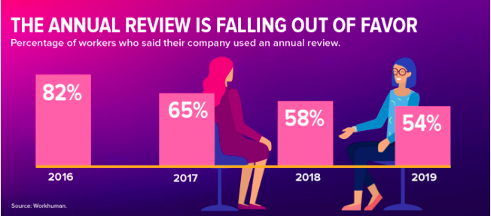
Figure 1: The decline in use of annual reviews (O’Connell, 2020)
Despite these arguments against performance appraisals, many employers still conduct them with their employees. The argument in favour of performance appraisals surround ensuring employees are carrying out their work to a set standard, the business can have a clear view of which employees are doing above and beyond their roles in order to gauge rewards and potential bonuses, as well as being able to pinpoint issues with individual performance and look to deal with them appropriately (Bright HR, 2023). Performance appraisals are also an opportunity for businesses to encourage development in their employees. Where they are lacking in some areas, a gentle conversation and support during a performance appraisal can identify areas in which they can be trained further, increasing their personal performance (Wilson, 2005).

The way in which appraisals are viewed can vary depending on the country in which the organisation is situated. Not only will this have an impact on the way in which an appraisal is conducted, but the location will also have an impact on how the results of an appraisal are analysed and implemented. For example, an article written by Fletcher & Williams (2016) in The Journal of Business Research suggests that some countries placed an increased emphasis on the performance of an individual and their ability to conduct the duties outlined in their job specification, while others are more likely to focus on somebody’s ability to fulfil their role as part of a team.

In countries where there is a culture which prioritises maximising profit, such as the United States, employees are more likely to be judged on tangible metrics such as sales and income, whereas countries like Japan are “more likely to focus on group or team performance, with an emphasis on qualities such as loyalty and teamwork.” (Fletcher & Williams, 2016).

How to use Models of Influence

Models of influence make reference to theoretical guidelines which provide structure to how either businesses or influential individuals can have an influence over the opinions and viewpoints of others, putting them in a strong position to be able to align themselves with their points of view or support their initiatives (De Colle & Werhane, 2008).
“To influence stakeholders, managers can draw on different models of influence, such as the Stakeholder Power-Interest Matrix, the Stakeholder Salience Model, the Stakeholder Engagement Continuum, or the Stakeholder Identification and Management Model” (Mitchell, Agle, & Wood, 1997; Bryson, 2004; Freeman et al., 2010).
These various models each have different desired affects. The Stakeholder Power-Interest Matrix, for example, splits relevant stakeholders into multiple categories dependent on the power that they hold within the organisation and the interest that they have. The matrix identifies 4x categories: low power/low interest, high power/low interest, low power/high interest, and high power/high interest. (Johnson & Scholes, 2002). It can be utilised when identifying key stakeholders that may have an interest in the performance of employees for example, supervisors and management. By doing so, the approach of the performance appraisal can be adapted to these stakeholders’ needs.

One of the key advantages to the Stakeholder Power-Interest Matrix is that it encourages those in power to take greater consideration for the opinions of stakeholders within the business, allowing for an overall more inclusive decision making process & championing a more thorough understanding of the potential impact of any business decisions (Bryson, 2004).

However, in a similar vein, Bryson (2004) also argues that this model is oversimplified when taking into consideration the complexities of relationships held between stakeholders, which risks an assessment which is not representative of reality. When designing an effective performance appraisal system, it has been said to be vital that you identify the key stakeholders and their interests (Karkoulian & Assaker, 2018). Despite this, Grote (2005) argues that a more flexible approach is needed when it comes to performance appraisals, where the employee’s goals and needs are taken into consideration.

Conclusion

In conclusion, it is clear that there are a number of performance management techniques that can be adopted by a business. With the PDP looking like the most favourable for staff as they feel more engaged and in control of their learning. It is also apparent that the use of performance appraisals is on the decrease, with it being more favourable to have more frequent, less formal meetings with staff to increase engagement within the workplace.

Recommendations

One recommendation that could improve individual performance, business performance and boost employee morale would be to replace the annual performance appraisals with weekly check ins with their line managers.
By making this type of change, the business may find a reduced cost as weekly check ins have seen employees to be happier and more satisfied at work. This will mean there is less of a need for a recruitment officer as staff turnover is likely to be less. The average salary for a recruitment officer is around £30,000 which could be saved if the business has a low turnover rate. Weekly check ins may also mean the business saves money as the line managers can use their time to support and develop their employees as opposed to just paying for a training course that caters to their needs. Annual performance appraisals just cause unwanted stress for the employees and therefore will not improve their overall performance.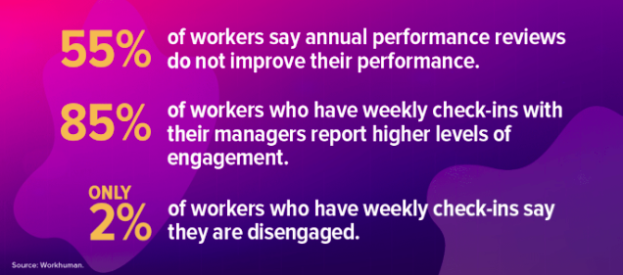
Figure 2: Reasons to remove Annual Performance Appraisals (O'Connell, 2020).
The business would incur costs with regards to time as each line manager will need to free up the time to sit with each of their subordinates for these weekly check ins. However, doing this should leave employees feeling happier and more engaged staff, and therefore having a better relationship with the business and want to achieve business goals and objectives. The business is already paying the salaries for these managers so should prioritise the workload to ensure the check ins ae factored in. Overall, the switch from annual appraisals to weekly should see an increase in staff morale, a reduction in turnover and a potential saving of around £30,000 for a recruitment officer.

References

Addabbo, T., Ales, E., Curzi, Y., Rymkevich, O. & Senatori, L. (2019) Performance Appaisal in Modern Employment Relations. New York : Springer International Publishing.

Atwater, L. E., Brett, J. F., & Charles, A. C., (2007) Multisource Feedback: Lessons and Implications for Practice. Human Resources Management, 46(2), pp.285-307.

Beausaert, S., Segers, M., Fouarge, D. and Gijselaers, W. (2013) Effect of using a personal development plan on learning and development. Journal of Workplace Learning 25(3), pp.145–158.

Bright HR. (2023) Why are employee appraisals important?. Available at: https://www.brighthr.com/articles/culture-and-performance/appraisals/why-are-employee-appraisals-important/ (Accessed: 15 Mar. 2023)

Bryson, J. M. (2004) What to do when stakeholders matter: Stakeholder identification and analysis techniques. Public Management Review, 6(1), 21-53.

CIPD. (2022) Performance Management: An Introduction. Available at: https://www.cipd.co.uk/knowledge/fundamentals/people/performance/factsheet (Accessed: 8 Mar. 2023)

Church, A.H., Bracken, D., Fleenor, J.W. and Rose, D.S. (2019) The handbook of strategic 360 feedback. New York : Oxford University Press.

CMI. (2020) Personal Development Planning. Available at: https://www.managers.org.uk/knowledge-and-insights/research/personal-development-planning/ (Accessed: 15 Mar. 2023)

Cunningham, L. (2015) In big move, Accenture will get rid of annual performance reviews and rankings. Available at: https://www.washingtonpost.com/news/on-leadership/wp/2015/07/21/in-big-move-accenture-will-get-rid-of-annual-performance-reviews-and-rankings/ (Accessed: 15 Mar. 2023)

De Colle, S., & Werhane, P. H. (2008) Models of stakeholder theory: Strategic vs. integrative. Journal of Business Ethics, 84(3), 301-313.

Fletcher, C. & Williams, R. (2016) Performance appraisal and management: The developing research agenda. Journal of Business Research, 69(1), 1-4

Grote, D. (2005) How to be good at performance appraisals: Simple, effective, done right. Harvard Business Press.

Johnson, G., & Scholes, K. (2002) Exploring corporate strategy: Text and cases. London : Pearson Education.

Karkoulian, S., & Assaker, G. (2018) A stakeholder approach to performance appraisal system design: An exploratory study. International Journal of Contemporary Hospitality Management, 30(1), 321-340.

Levy, P. E., & Williams, J. R., (2004) The Social of Performance Appraisal: A Review and Framework for the Future. Journal of Management, 30(6), pp.881-905.

McCabe, A. (2022) 6 Benefits of KPI Reporting. Available at: https://blog.hurree.co/6-benefits-of-kpi-reporting (Accessed: 15 Mar. 2023)

Mindtools. (2022) Performance Management and KPIs. Available at: https://www.mindtools.com/aia3zkb/performance-management-and-kpis (Accessed: 15 Mar. 2023)

Mitchell, R. K., Agle, B. R., & Wood, D. J. (1997) Toward a theory of stakeholder identification and salience: Defining the principle of who and what really counts. Academy of Management Review, 22(4), 853-886.

O’Connell, B. (2020) Performance Management Evolves. Available at: https://www.shrm.org/hr-today/news/all-things-work/pages/performance-management-evolves.aspx (Accessed: 15 Mar. 2023)

Pulakos, E.D., Mueller-Hanson, R. and Arad, S. (2019) The Evolution of Performance Management: Searching for Value. Annual Review of Organizational Psychology and Organizational Behavior, 6(1), pp.249–271.

Smith, A. (2018) More Employers Ditch Performance Appraisals. Available at: https://www.shrm.org/resourcesandtools/legal-and-compliance/employment-law/pages/more-employers-ditch-performance-appraisals.aspx (Accessed: 15 Mar. 2023)

Wilson, J. (2005) Human Resource Development: Learning & Training for Individuals & Organisations. London : Kogan Page.

Woolston, C. (2019) Why Appraisals are Pointless for Most People. Available at: https://www.bbc.com/worklife/article/20190501-why-appraisals-are-pointless-for-most-people#:~:text=The%20growing%20body%20of%20research%20questioning%20the%20value,at%20times%20fanfared%20in%20press%20releases%20and%20headlines. (Accessed: 15 Mar. 2023)

