Harry Byrne P133366

NOSS Worksheet 2 – network resources & routing and packet filtering

Contents
Abstract 3
1 Part 1: NTFS and Share Permissions 3
1.1 NTFS 3
1.2 Share Permissions 5
2 Part 2: Utilising Group Policy Management Console to better facilitate network object management 7
2.1 Group Policy Management Console Configuration 7
2.1.1 Removing Access to Control Panel 8
2.1.2 Removing Access to Command Prompt 9
2.1.3 Removing Access to Removable Media Devices 10
2.2 Restricting Software Installs 10
2.2.1 Enforcing Password Policy in the ‘nosstask.msft’ domain 12
3 Task 2 Routing and Packet Filtering 13
3.1 Using ARP and Routing Tables 13
3.1.1 Installing and Configuring a Routing and Remote Access Service 18
3.1.2 IP Packet Filtering 22
3.1.3 Filter 1: Stopping ‘anyone’ in PrivateNet 1 from Pinging the Router Firewall Service. 22
3.1.4 Filter 2: Restrict Access to FTP Service running on Server2 to only hosts in PrivateNet2 23
3.1.5 Filter 3: Only allow specific hosts in PrivateNet1 to access the FTPService running on Server2 26
4 TASK 3: OBSERVATIONAL TASKS 28
4.1 Sound Password Principles on Networks. 29
4.2 Importance of Failover Clusters 29
4.3 Draft Business Network Policy 30
4.3.1 Topology 30
4.3.2 Network access 31
4.3.3 Security Team 31
4.3.4 Analysis of security Risks 31
4.3.5 Monitoring of security operations 32
4.3.6 Mitigations in the event of violations 32
5 References 32

Abstract

To begin, this research examines how to manage and maintain network resources using network and security practices and how to use and implement network access and group policy management on the network built in the previous report. Second, it looks at how to set up routing and access services and set up firewalls with IP packet filtering. The final section delves more into good password principles, failover clustering, and drafting a network policy.

Part 1: NTFS and Share Permissions

Only devices partitioned with the NT File System can have NTFS permissions specified. Drives, Folders, and Files, all operating system resources, can have NTFS permissions set. From the user's perspective, NTFS continues to organise files into folders that are sorted, just as HPFS. There are no "special" items on the drive, and there is no reliance on the underlying hardware, such as 512-byte sectors, unlike FAT or HPFS. Furthermore, no unique disc locations such as FAT tables or HPFS Super Blocks exist[1].
All NTFS permissions are tied to the local operating system and user. NTFS permissions control who has access to which drives, files, and folders. Permissions are more granular than Share permissions in that they go beyond Read, Change (Modify), and Full Control.

NTFS

A file was created on client 1 named Share_Files_NOSS.

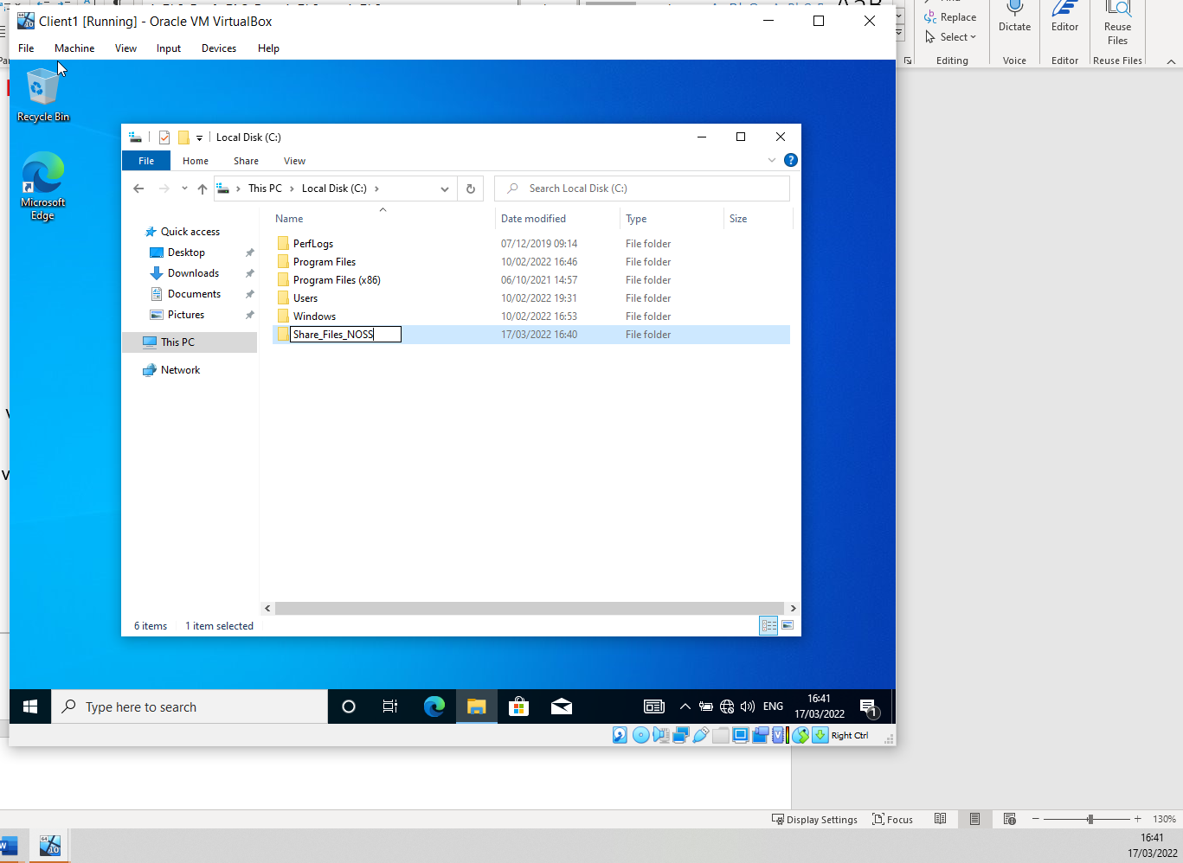

Within this files properties under security One user was set with full control.
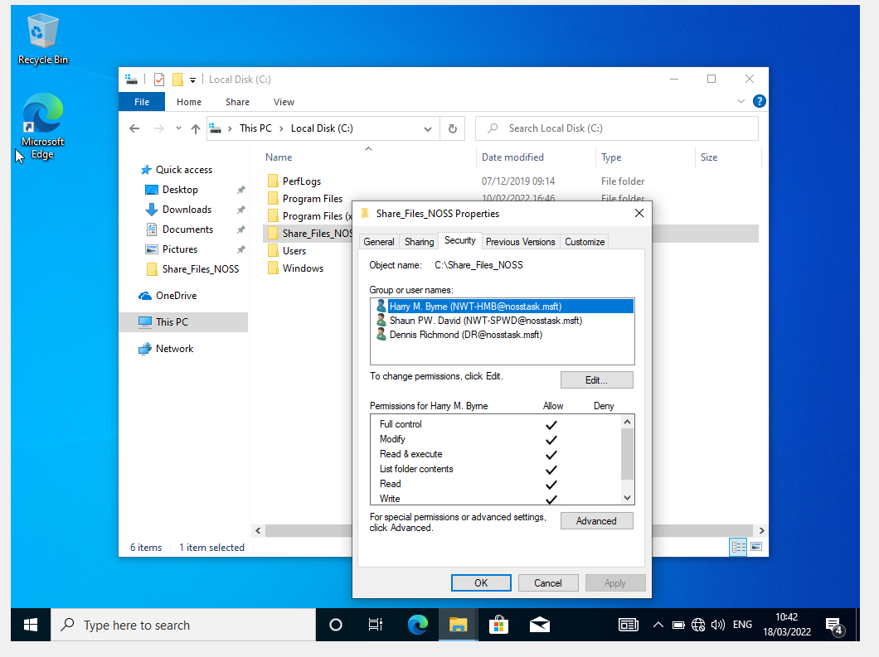

This user had access to the file and the ability to modify it.
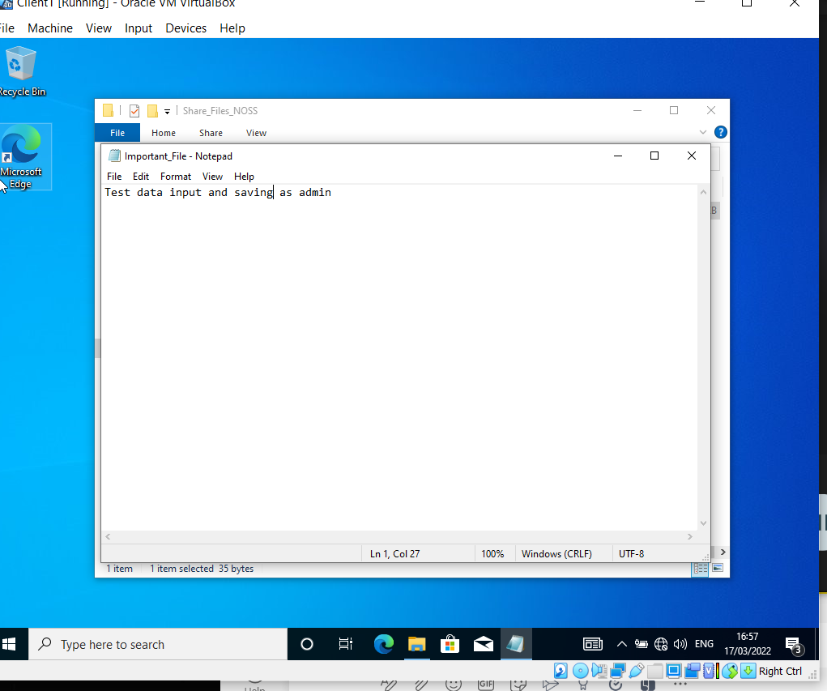

A second user was given restricted abilities so they had could not modify or write to the file.
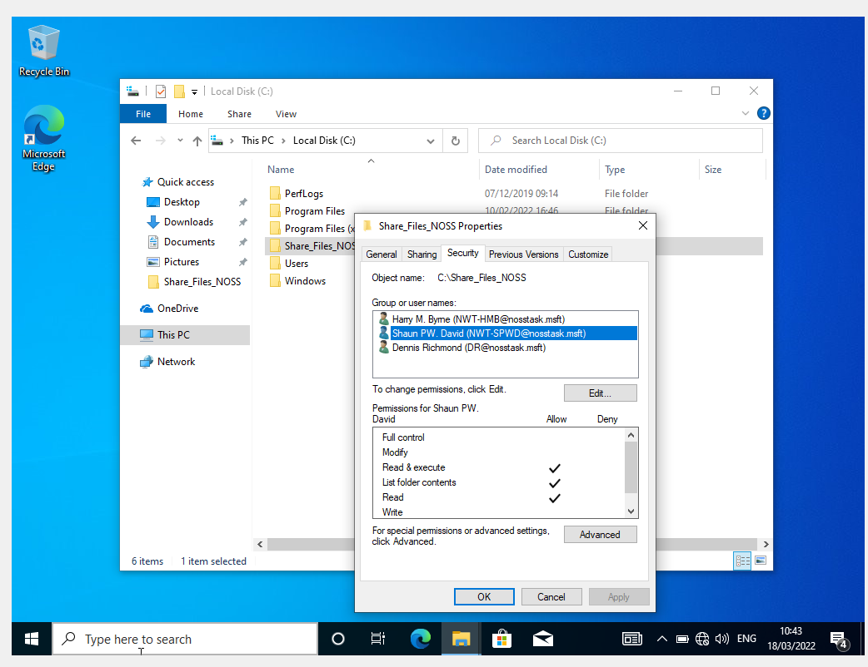
This message confirms the user did not have to permissions to modify.
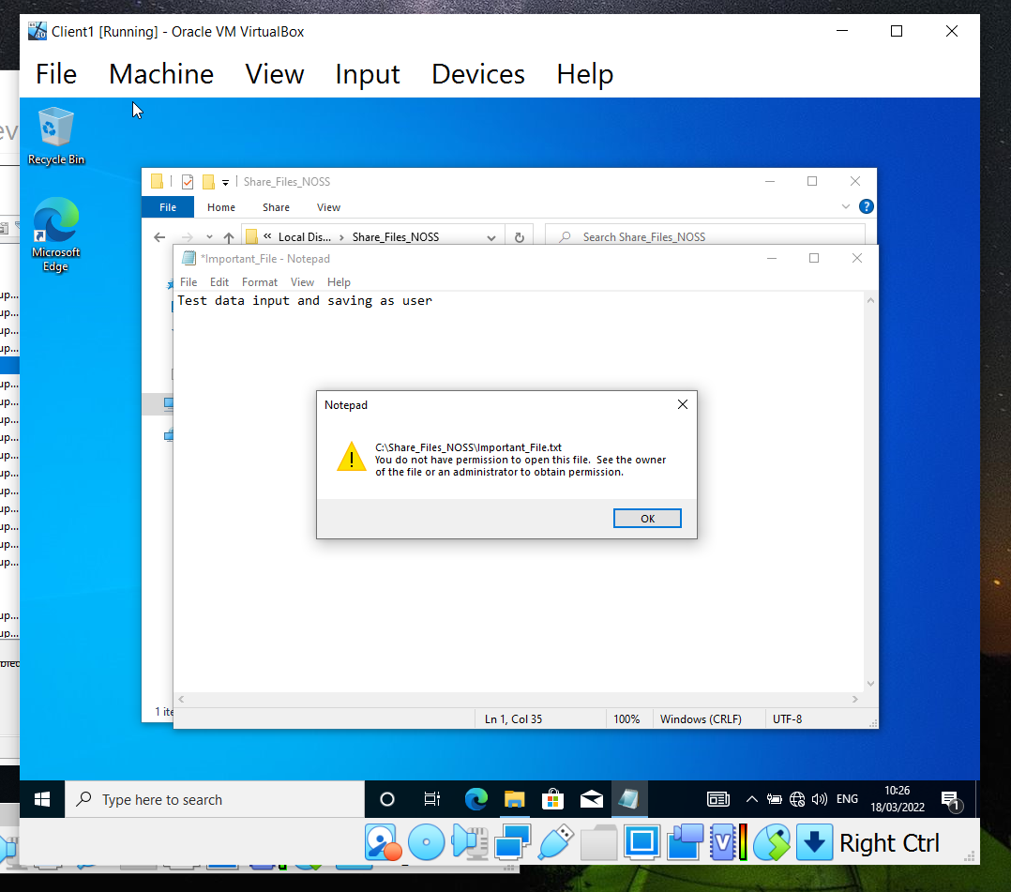

Share Permissions

Within a networked context, share permissions provide control over resource access. By default, when a file or folder is created on a networked system, it is not shared. Unless the administrator has deliberately hidden the share, files/folders and drives that are specifically shared on a system can be viewed by searching for a PC on your network and extending the accessible shares this system has supplied.

In server manager, a share file link is created named Shared_Files_NOSS$ the dollar sign hides the file for security purposes to users without the correct access rights.
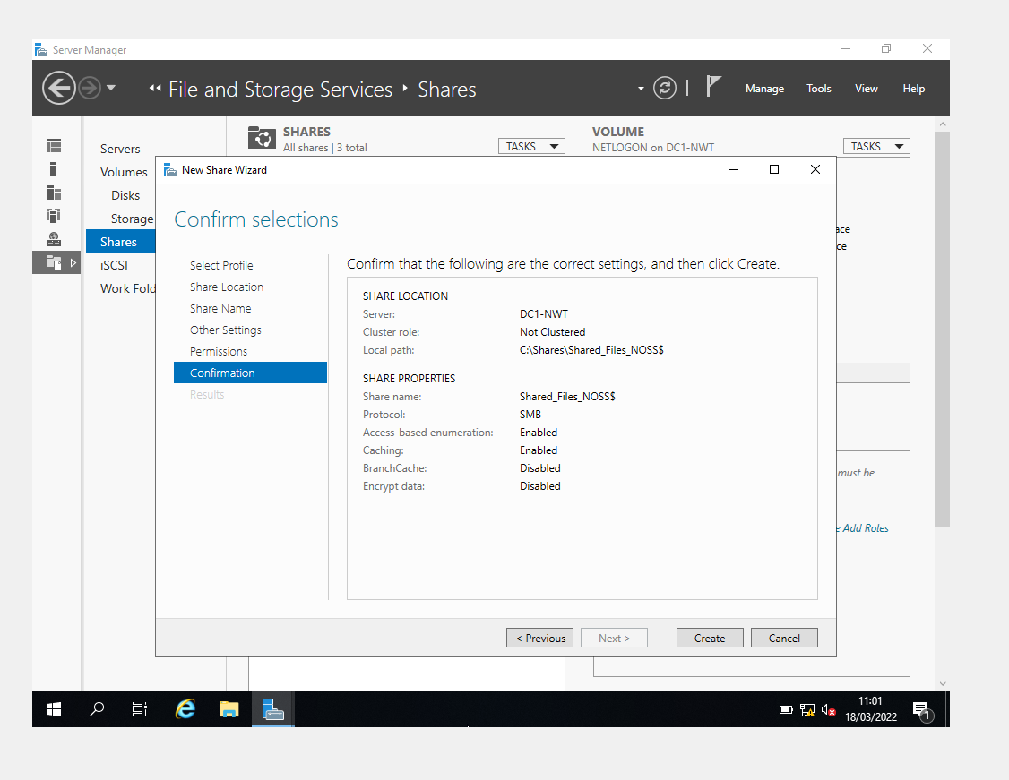

The administrator is shown to still be able to access the file from client 1.
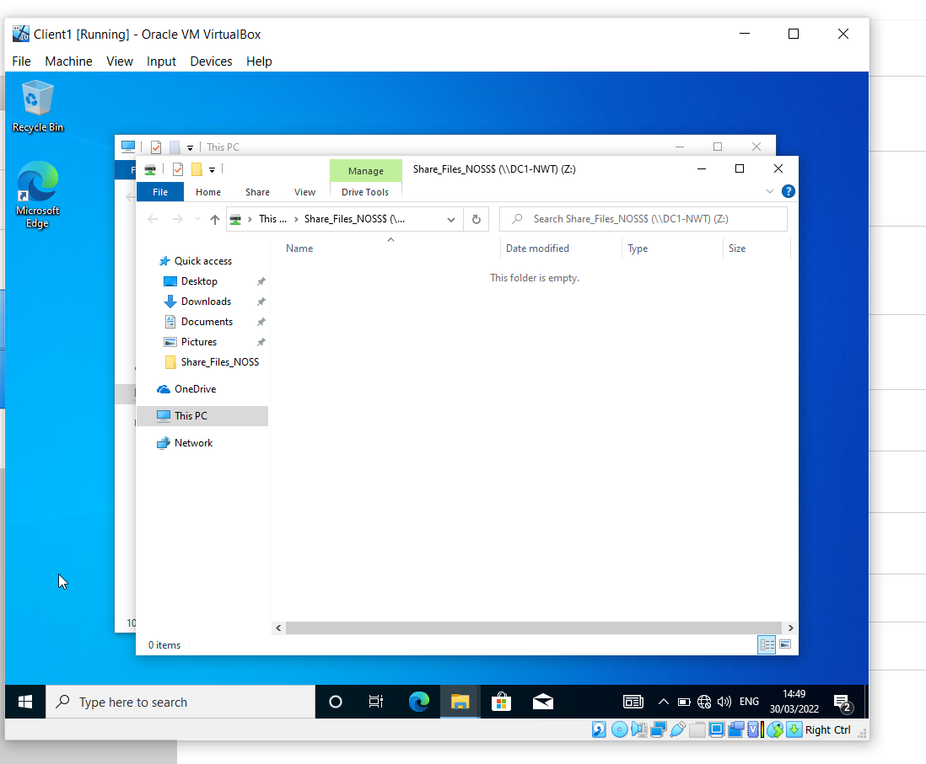
A user with restricted access is shown to have no access to the file.
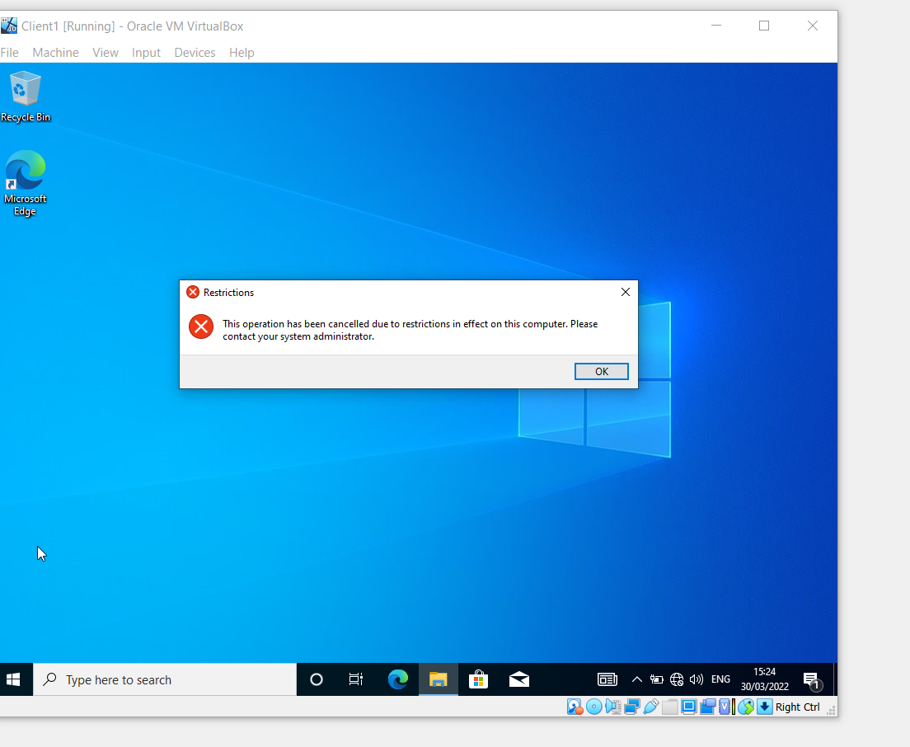

Part 2: Utilising Group Policy Management Console to better facilitate network object management
The major goal of Group Policy management is to automate the process of distributing settings to domain computers and users, which are frequently corporate or departmental wide. This clearly saves time in terms of manual configurations, but it also gives a way to control security settings centrally to guarantee that all essential systems are affected as required, without omission.
Local group policy differs from Group policy in that it can only be configured locally on Microsoft Windows systems. Local group policy isn't used over Group Policy since it requires an administrator to configure the settings on each machine in the network individually. For security purposes, some essential systems, such as domain controllers, require local group policy. Any system administrator can be delegated to manage a department or organization-wide configuration using Group Policy.

Group Policy Management Console Configuration

A new user created for the purpose of testing.
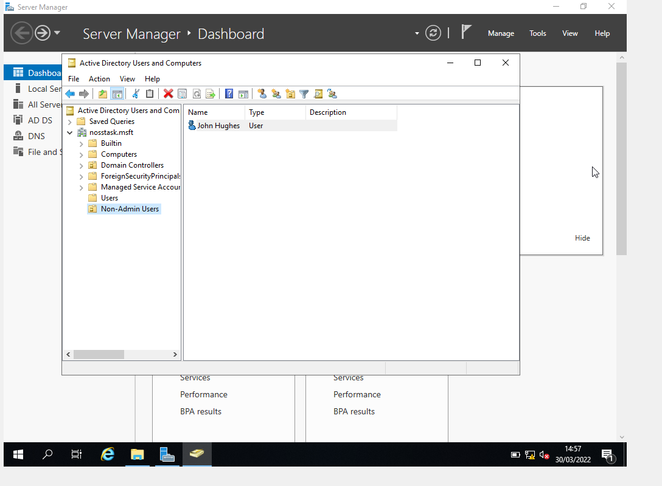

Removing Access to Control Panel

In GPMC (Group Policy Management Console) a new group policy object was created named NoCtrlPanAccess, this object was then set to prohibit access to control panel and PC Settings.
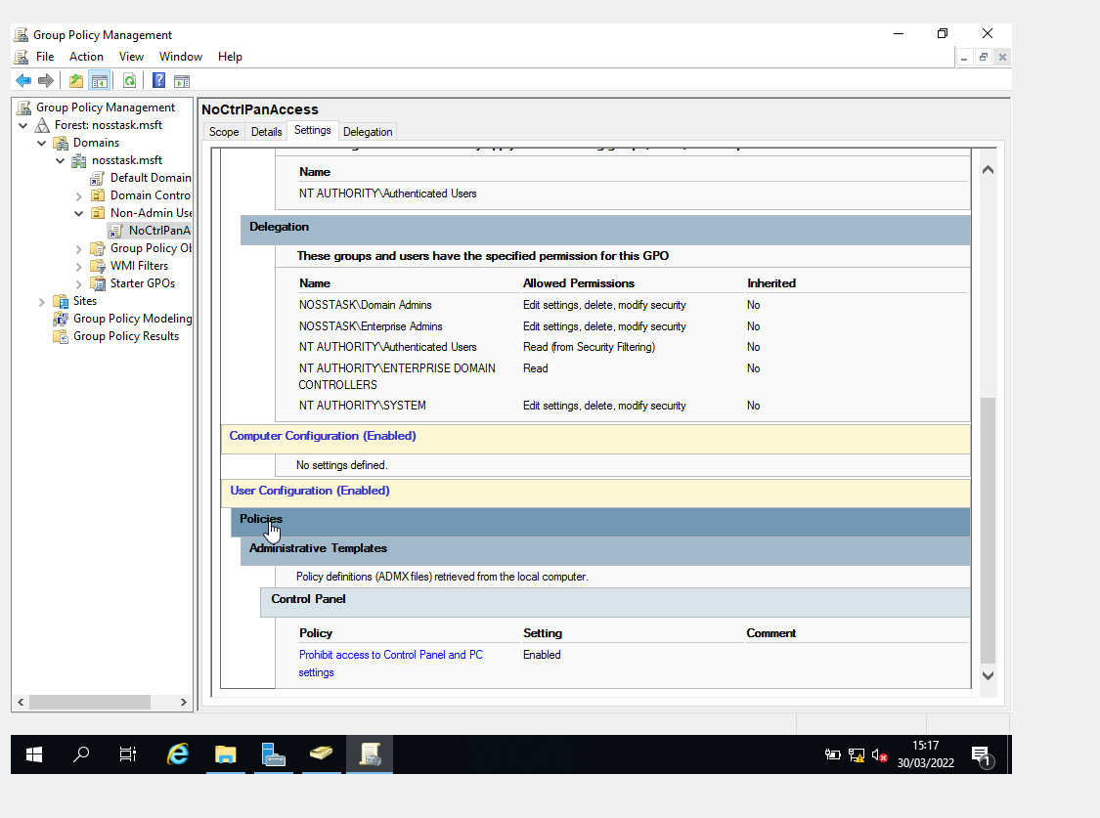

Access to control panel disabled.
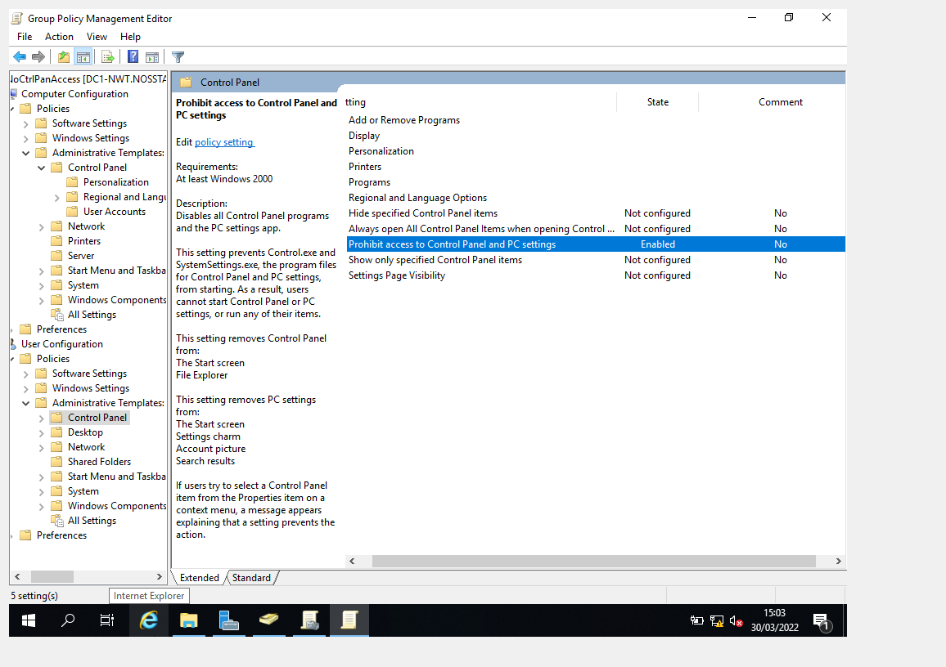

Removing Access to Command Prompt

In GPMC (Group Policy Management Console) a new group policy object was created named NoCmdPrmptAccess, this object was then set to prevent access to the command prompt.

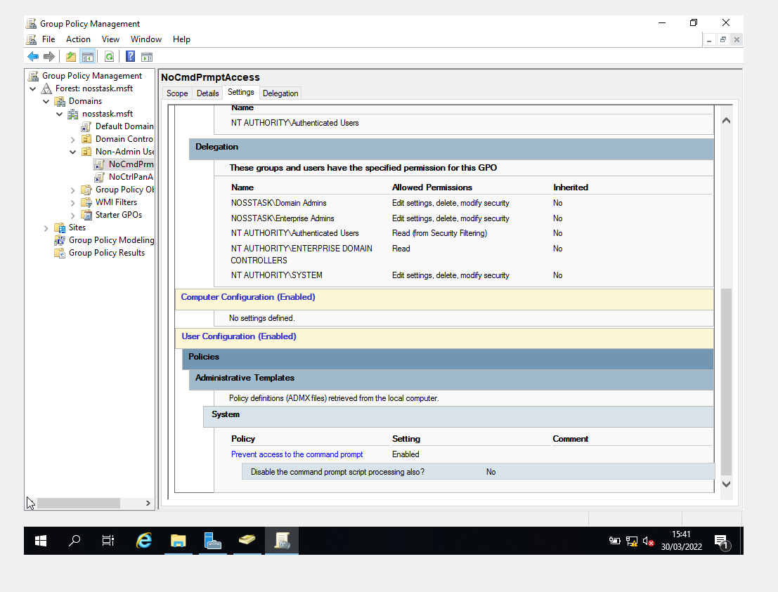

This was tested with the new user. Access to command prompt has been disabled
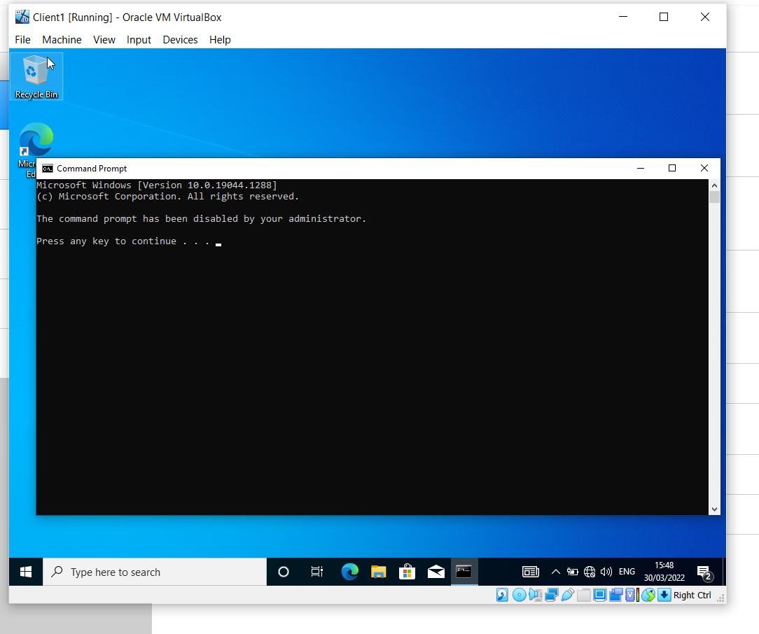

Removing Access to Removable Media Devices

In GPMC (Group Policy Management Console) a new group policy object was created named NoRemDriveAccess, this object was then set to deny all accesses for removable storage. Unfortunately as this was done on a VM, it was impossible to prove success.

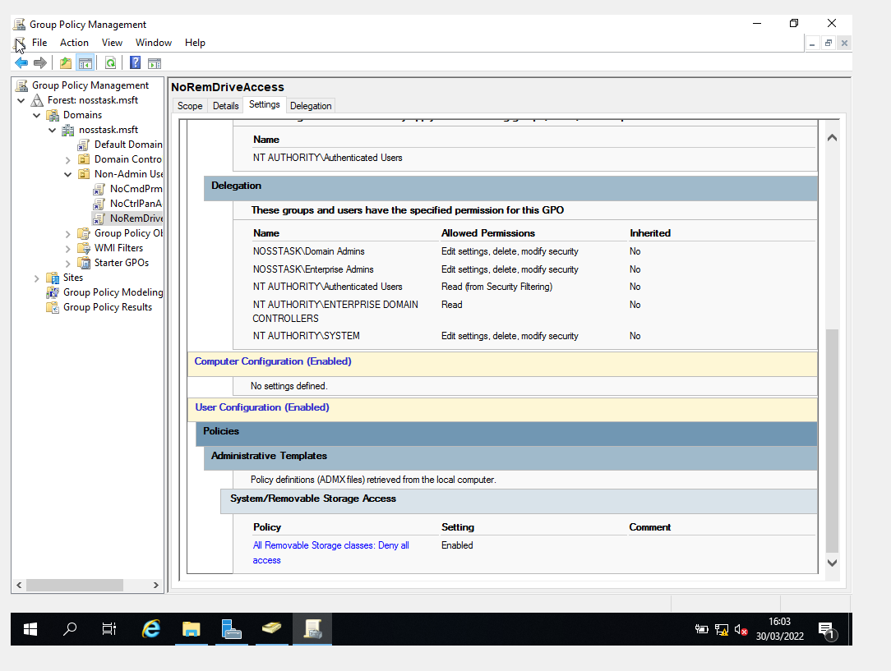

Restricting Software Installs

Upon restarting the worksheet, server 1 date and time seemed close to the last time used while client 1 had progressed. I assume this was to do with freezing the machine instead of going into shutdown. Client 1 given second network card attached to NAT to utilize host systems IP address. It will kind of masquerade client ones IP address and use the public host adaptor. This is needed for the testing of group policy on downloading software.

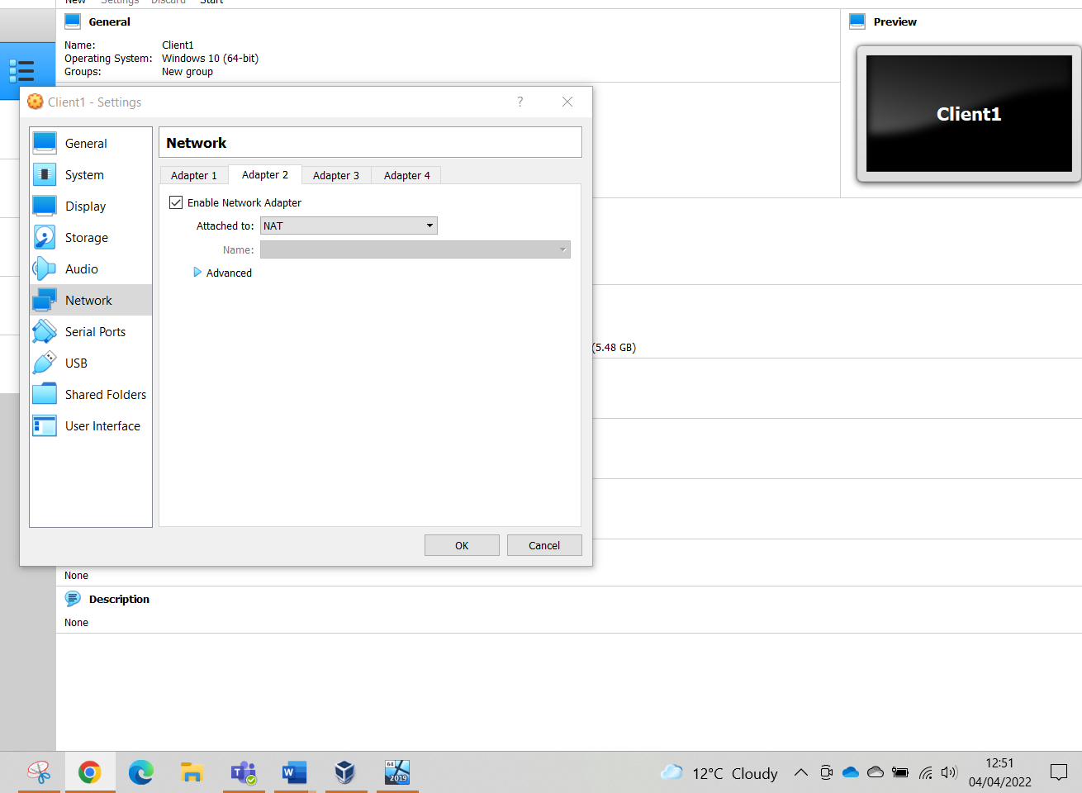

Client 1 was moved in active directory to NWClientComputers. This has to be done before next stage group policy. In GPMC (Group Policy Management Console) a new group policy object was created named NunauthSoftInstallS, this object was then set to prohibit user installs.
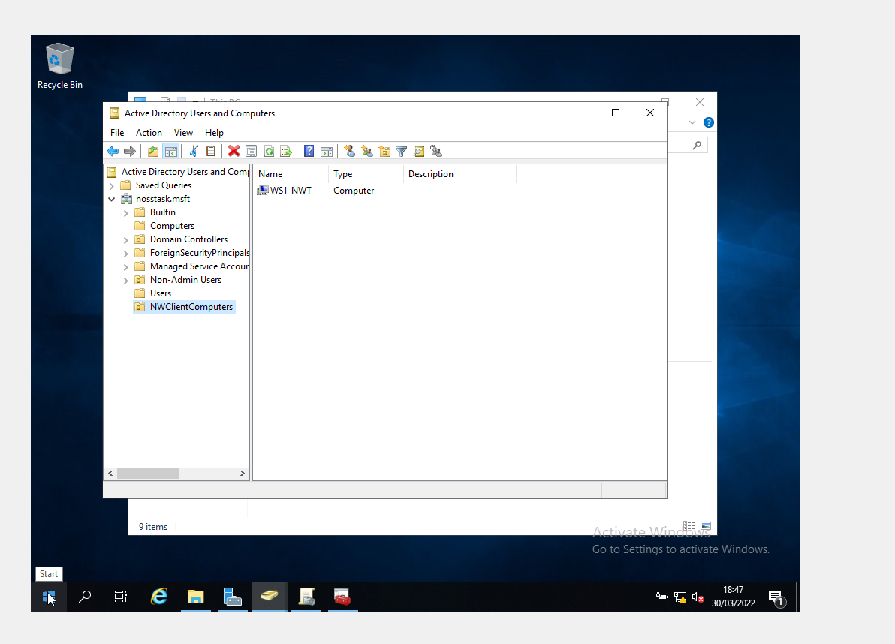
As can be seen, the non-administrative user could not install without a user account.
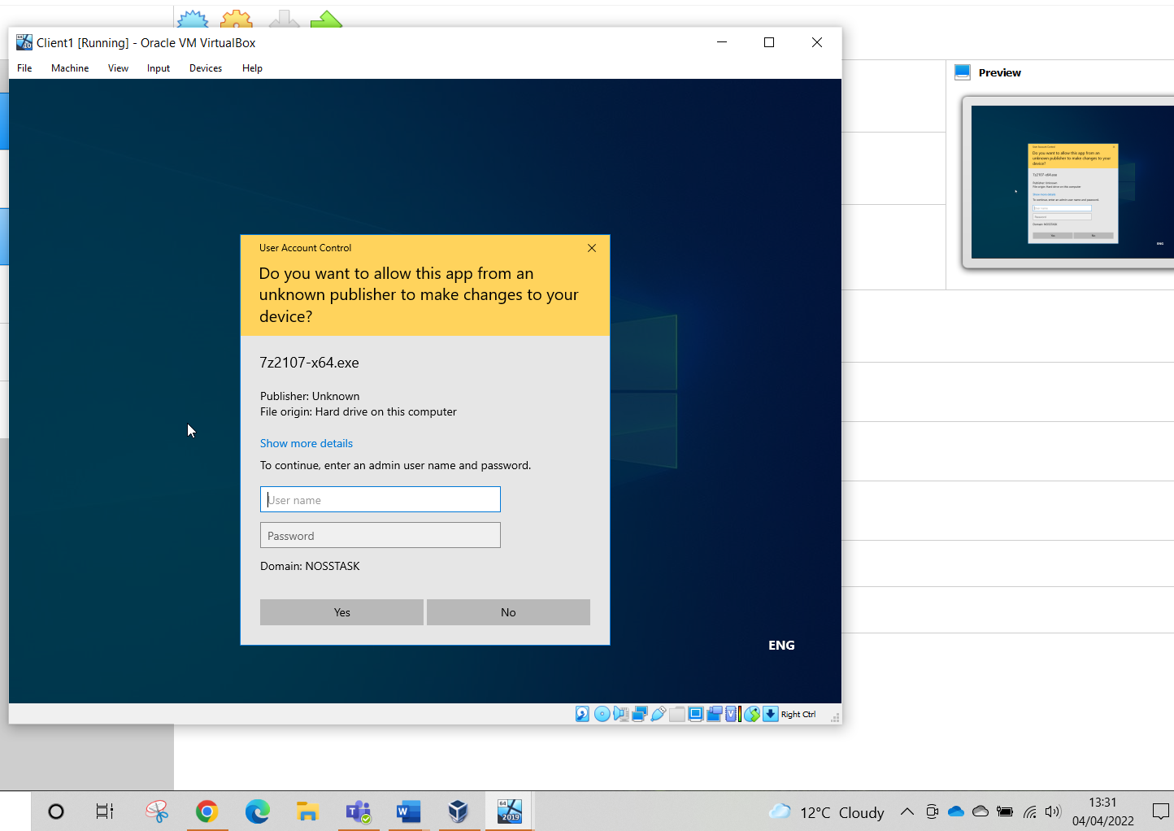

Enforcing Password Policy in the ‘nosstask.msft’ domain

A strong password policy is essential for network security. Stronger qualities connected with values minimise the likelihood of password cracking and enable the use of effective password security principles like 'passwords'. Passwords can be used in conjunction with minimum complexity requirements to enforce stricter password policies by specifying a longer predefined value length as a minimum requirement.
In GPMC Password settings were changed to what was specified on the worksheet.
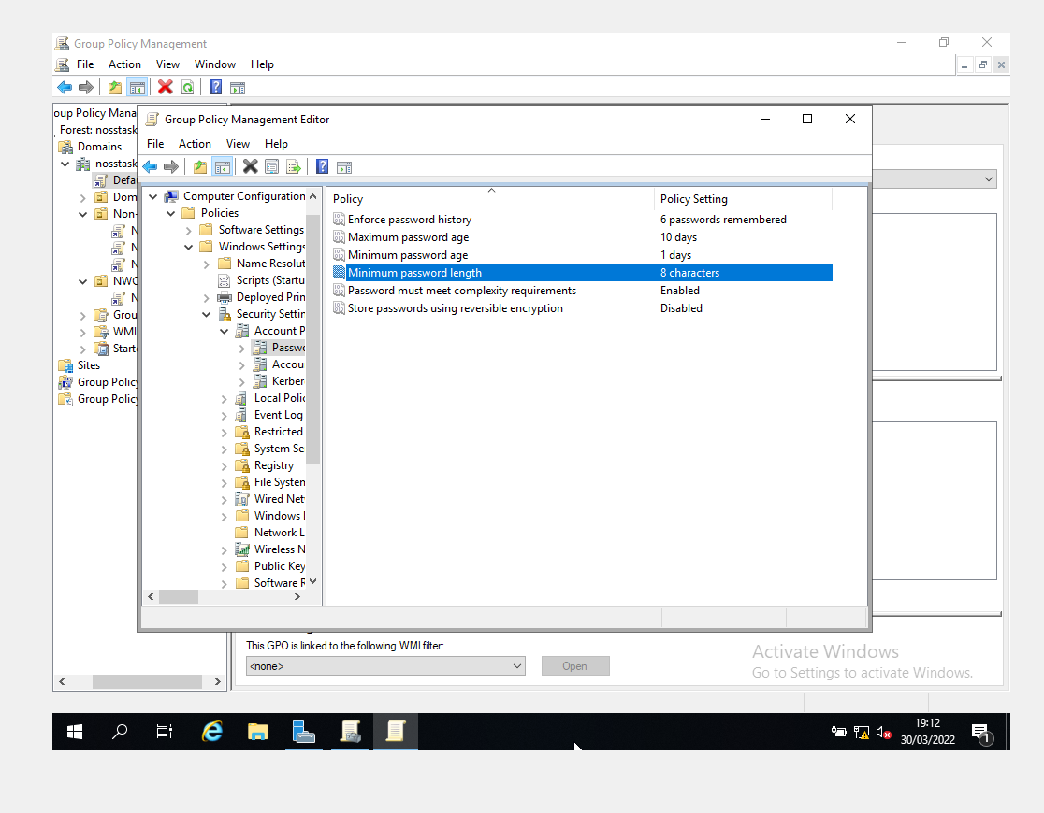
The user attempted to input a 7 character password on a new user as stipulated in worksheet which was denied.
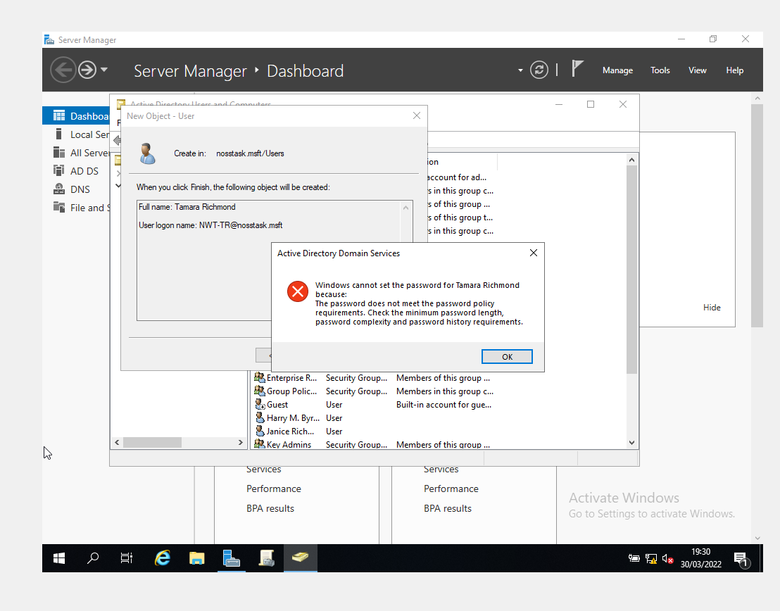

Task 2 Routing and Packet Filtering

Using ARP and Routing Tables

Firstly FTP Server was installed on Client 2 with the following options selected.
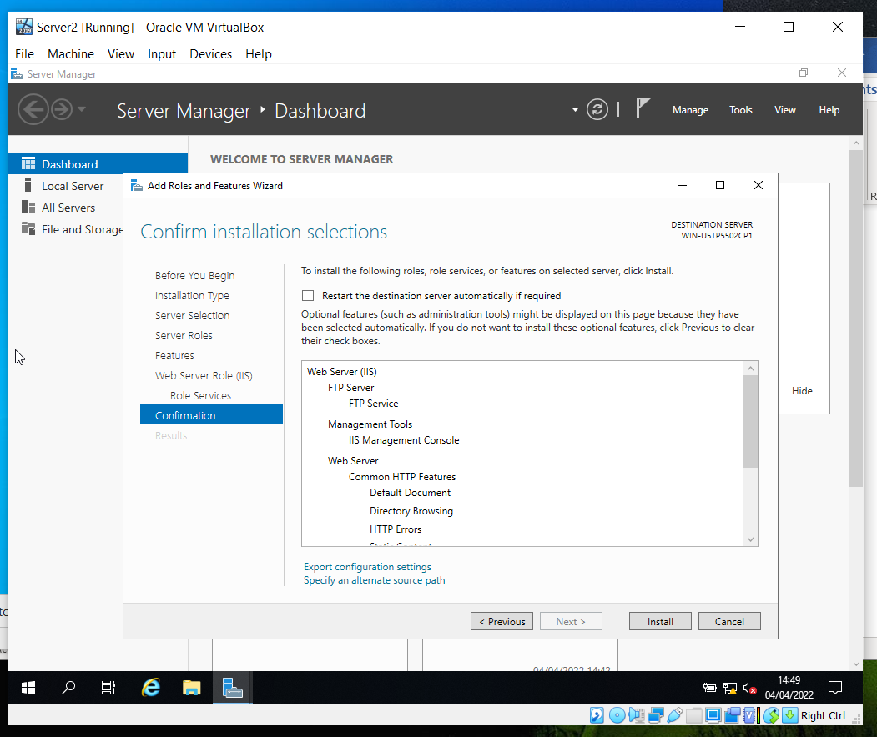

A new user was created as ftpuser22 password P@ssw0rd as stipulated.
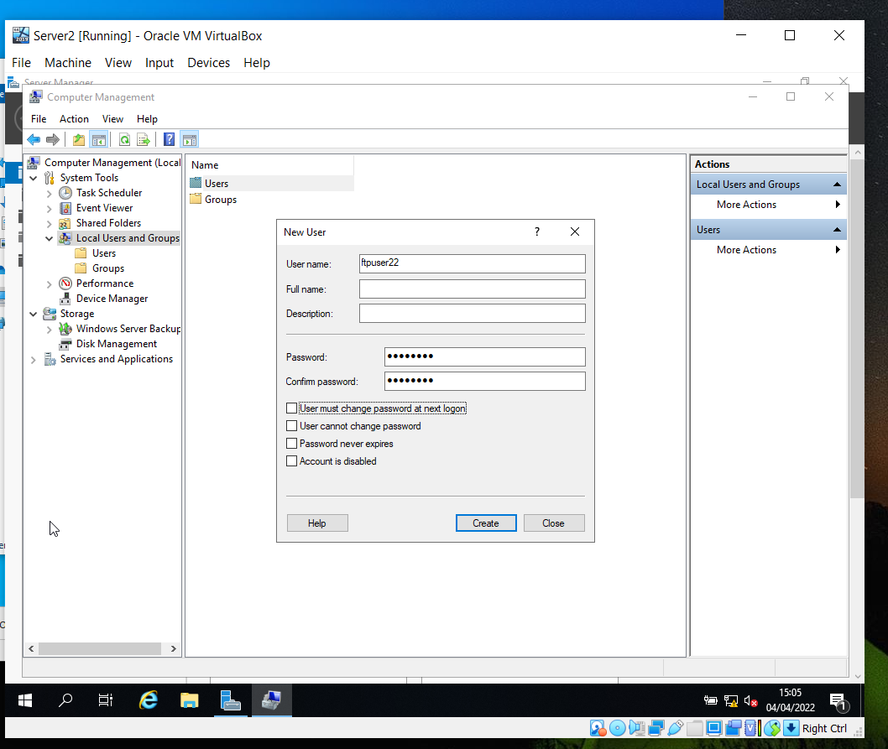

A FTP Site was then added.
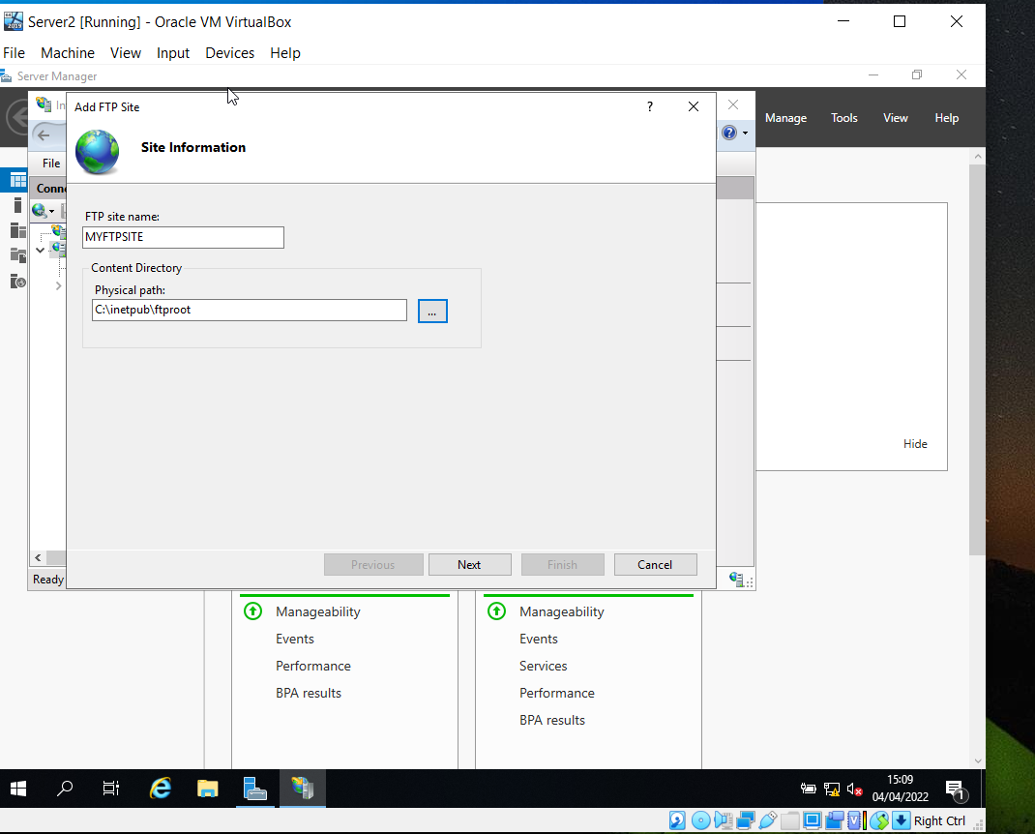

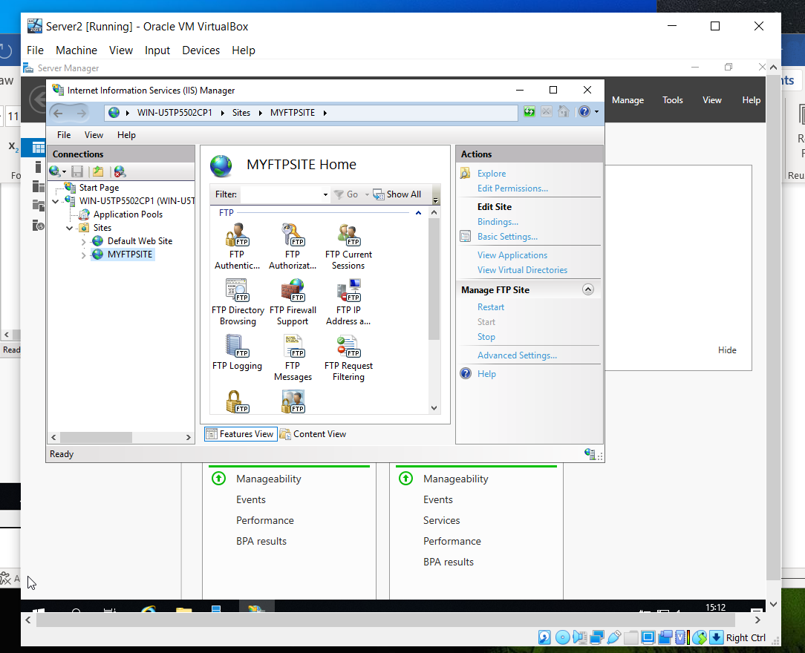
A banner was then set
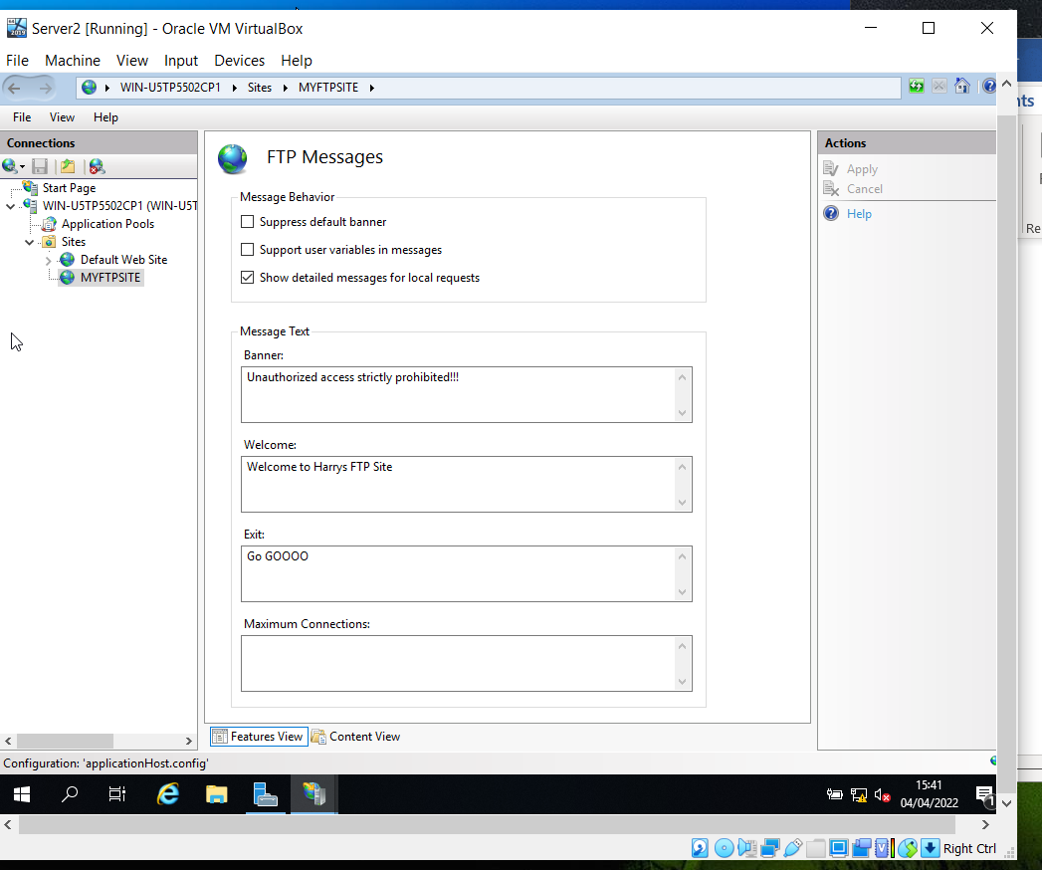

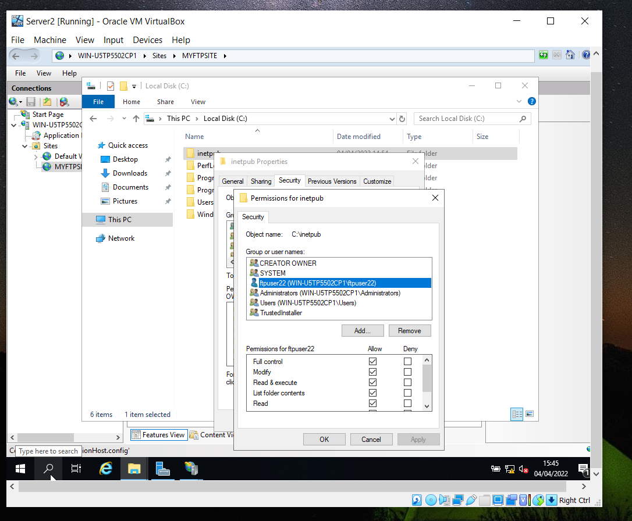
Next, a folder amd text file were created on the C directory of client 2 named MYFTPFiles, then a new folder called MyFtpuploads was created within C:\Inetpub\ftproot folder on Server 2

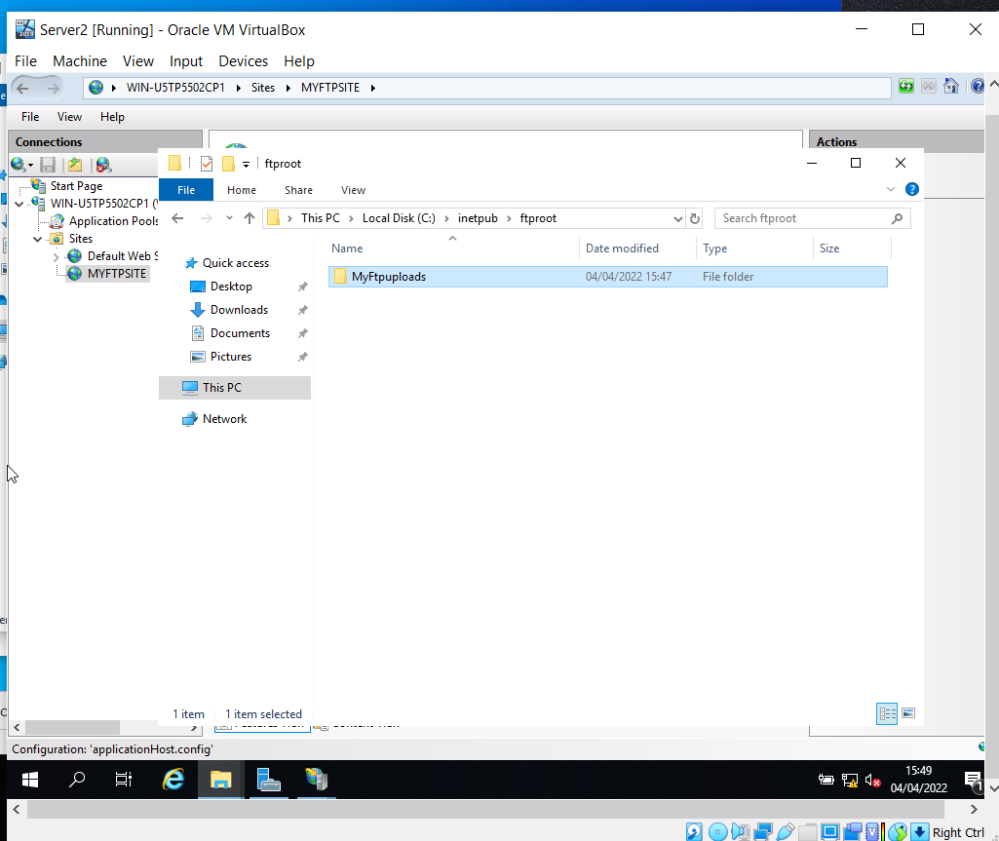
In command prompt client 2 connected with server 2 via FTP and uploaded the file to server 2.

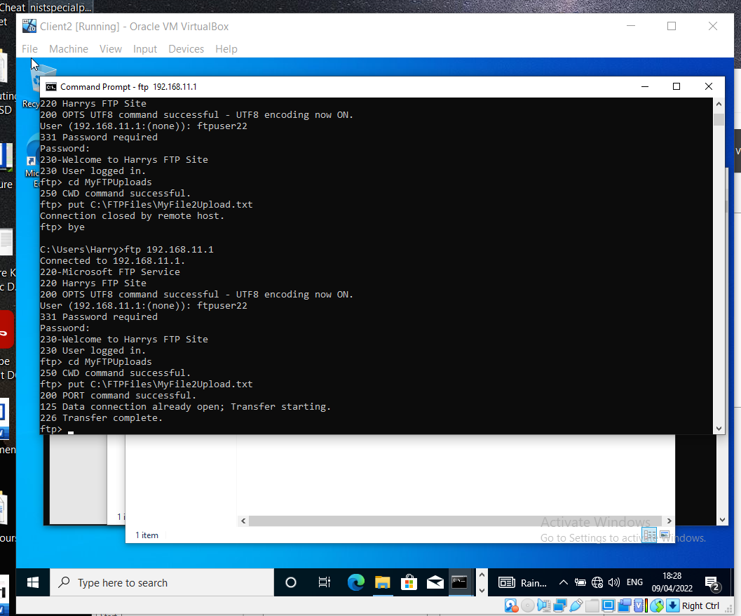

The file is seen in the MyFTPUploads folder on server 2.
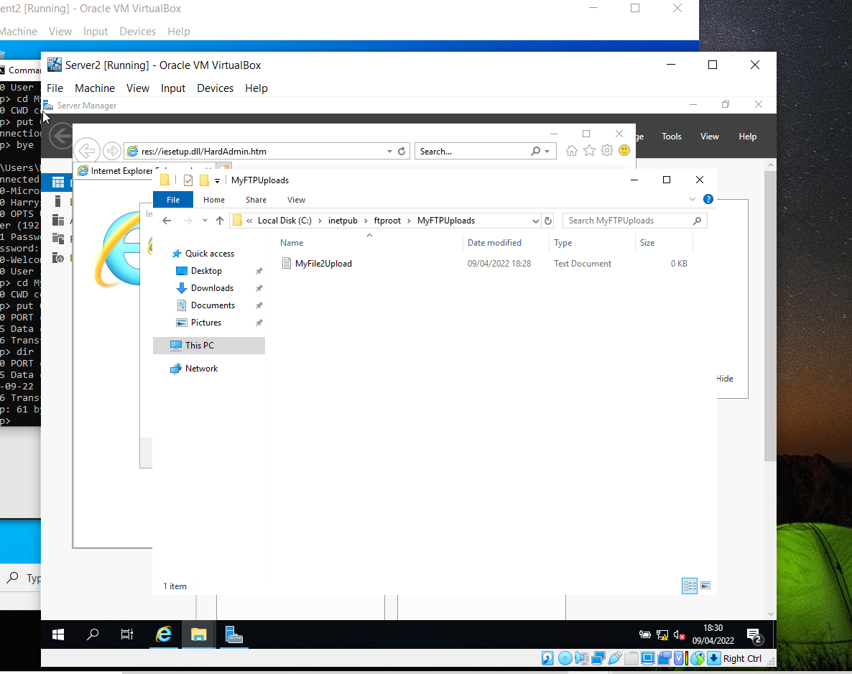

Installing and Configuring a Routing and Remote Access Service

This section deals with connecting the two separate networks as a LAN (Local Area Network).
In server manager on server 1 Direct Access and VPNs are selected.
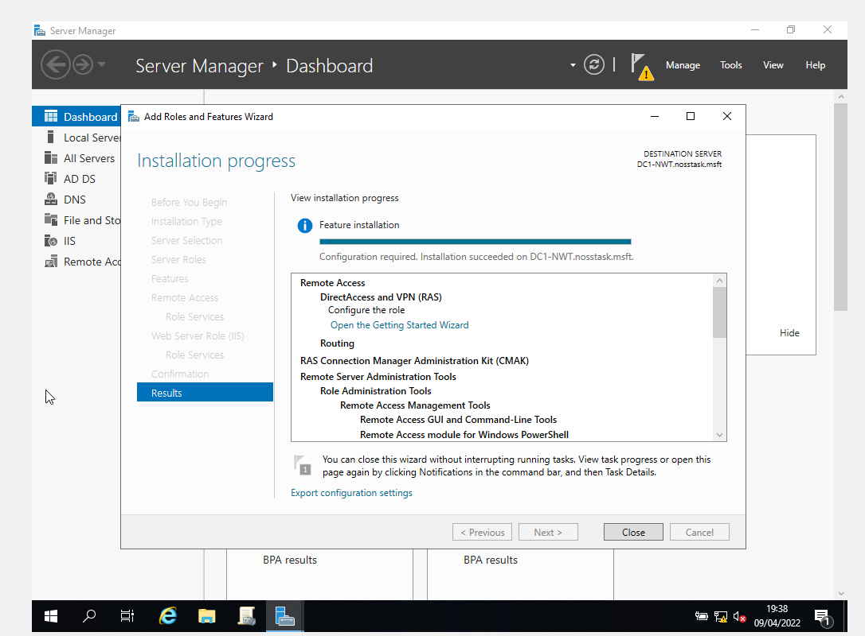

Routing and Remote Access wizard was set with Lan Routing selected.
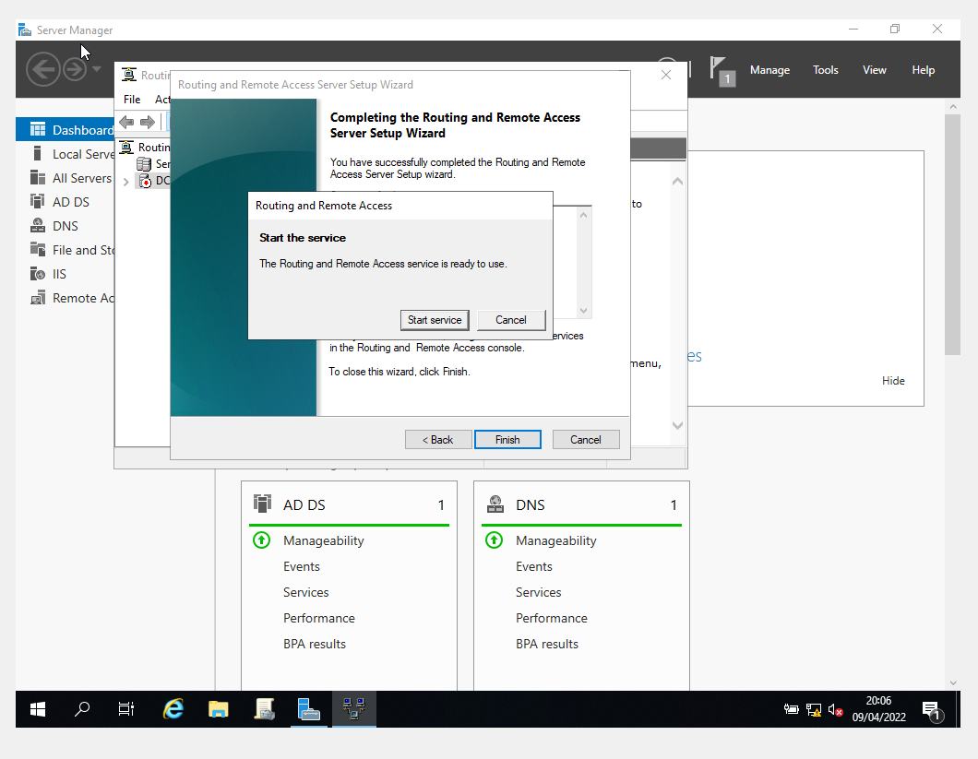
In the IPv4 section of routing and remote access RIP(Routing Information Protocol) V2 was selected.
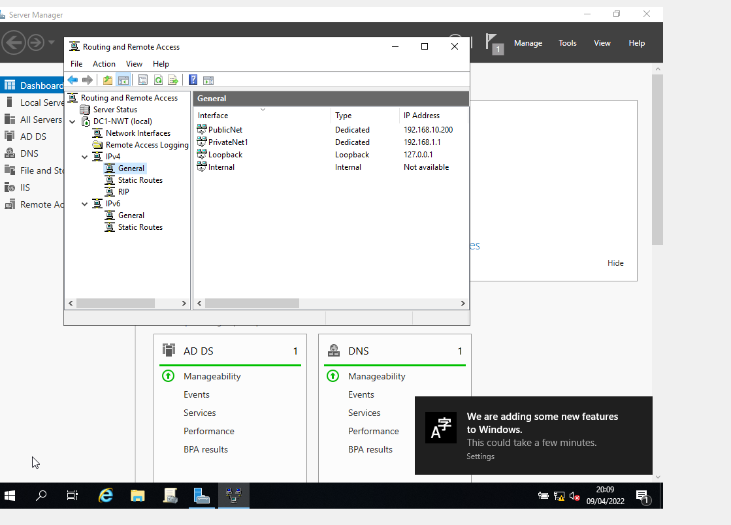

Next, new interfaces were added for the interfaces below on RIP. The previous steps were then carried out on server 2.
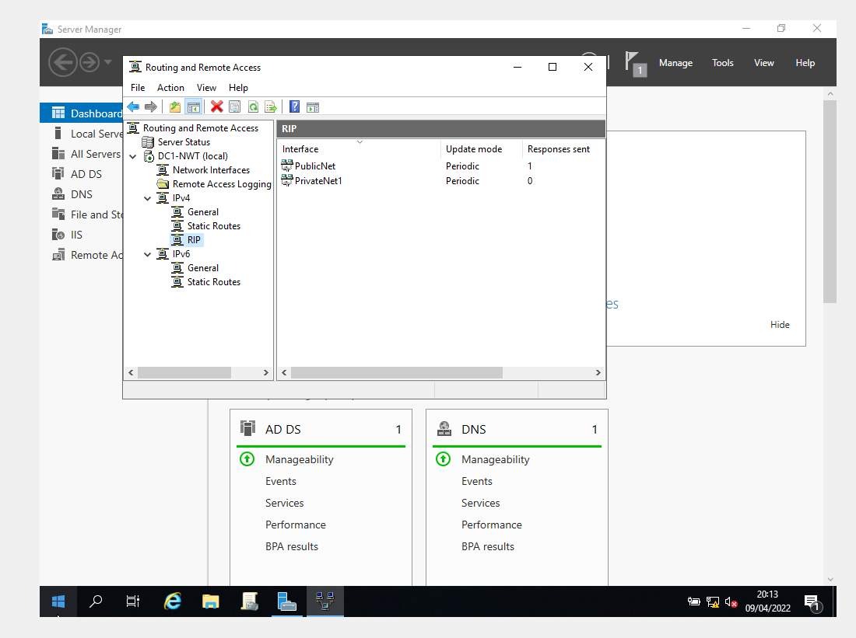
The Default gateways were also set.
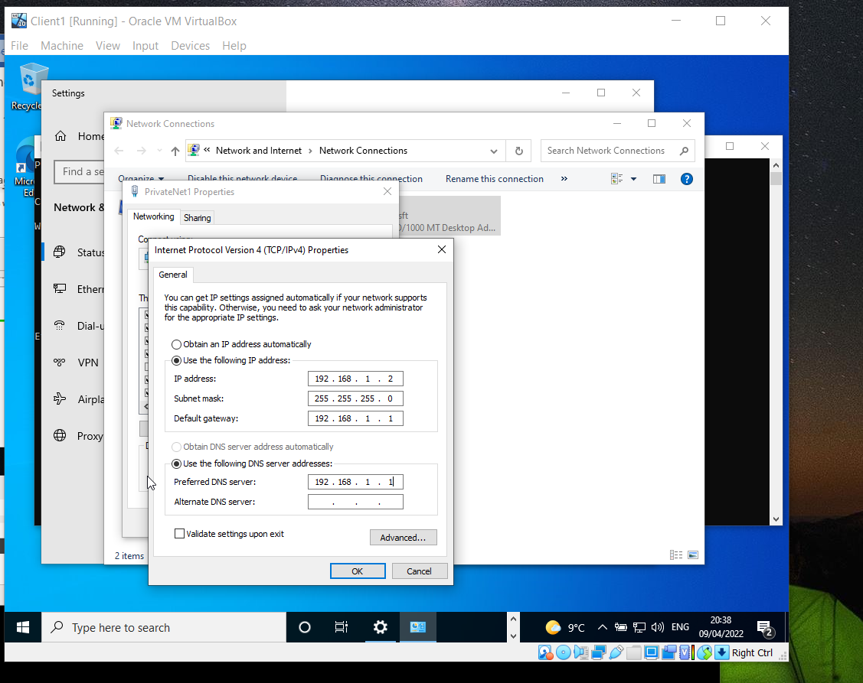

A ping from server 2 from server 1 successful.
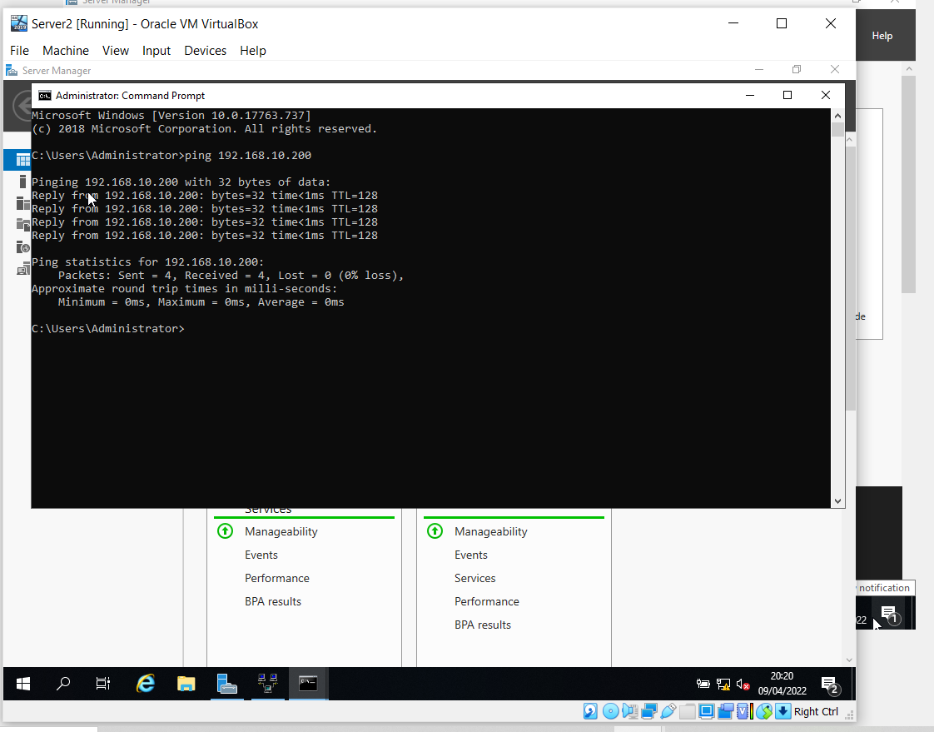

Route print, after enabling RIP shows that public net is communicating
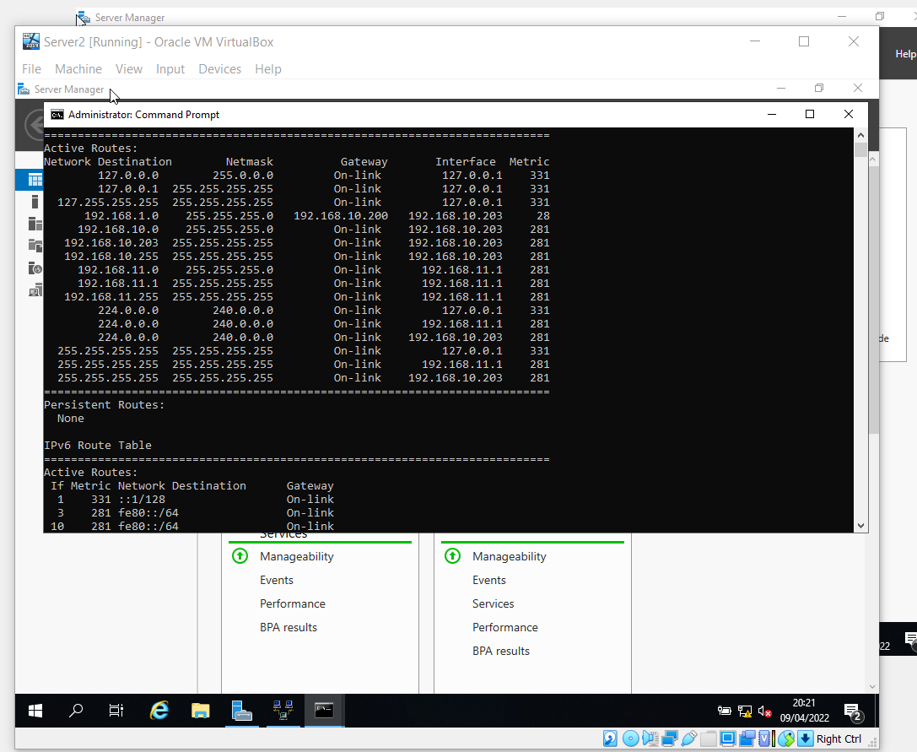

As client 2 to privatenet1
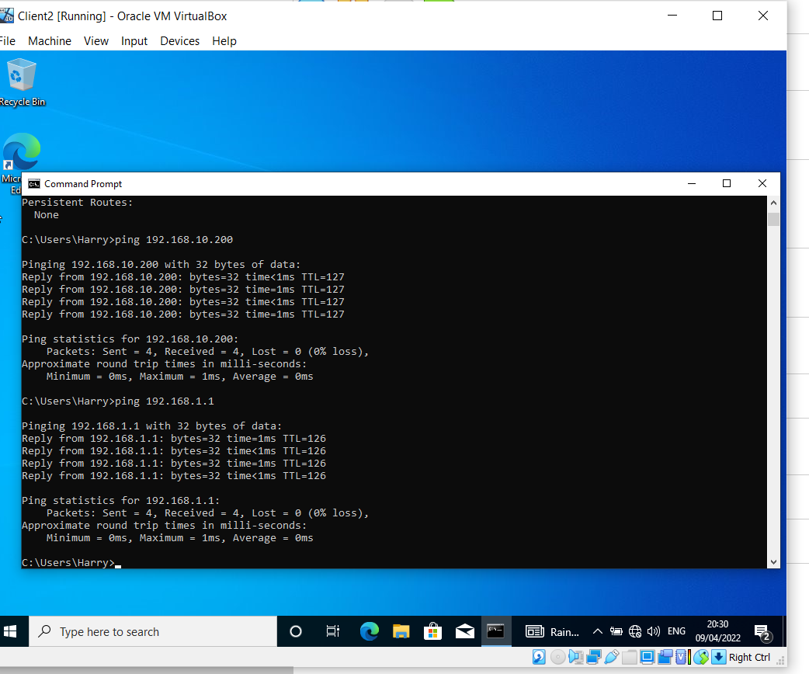

IP Packet Filtering

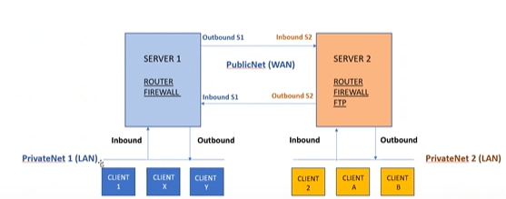
Diagram provided by Lee Cobley

Filter 1: Stopping ‘anyone’ in PrivateNet 1 from Pinging the Router Firewall Service.

To carry out this filter, it is set as an inbound filter on Server 1 with the IP address of PrivateNet 1 of the server. Subnet mask is set at 255.255.255.255 to tell the router to look to at exact host as it is set on IP address box on the network and not the entire network. ICMP (Internet Control Message Protocol) is the Ping protocol.
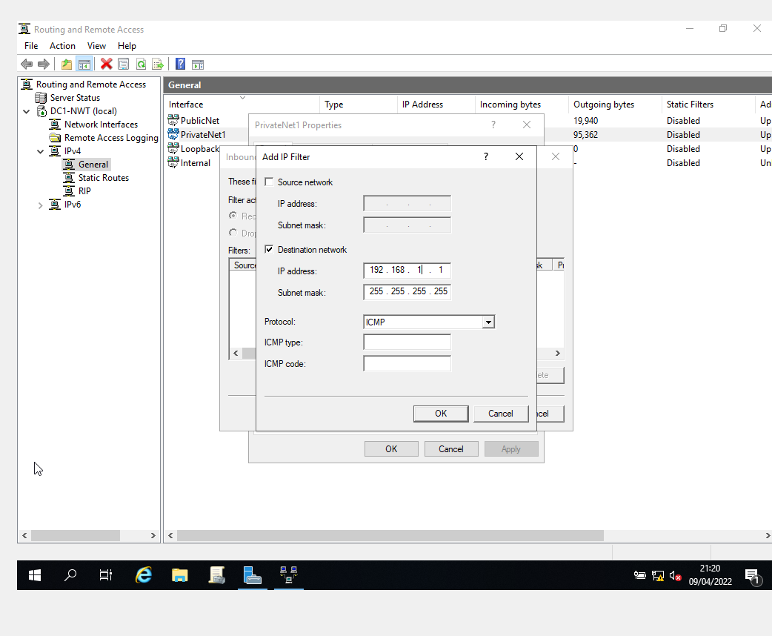
Screenshot shows the ping timed out on PrivateNet1 but was allowed access to PublicNet
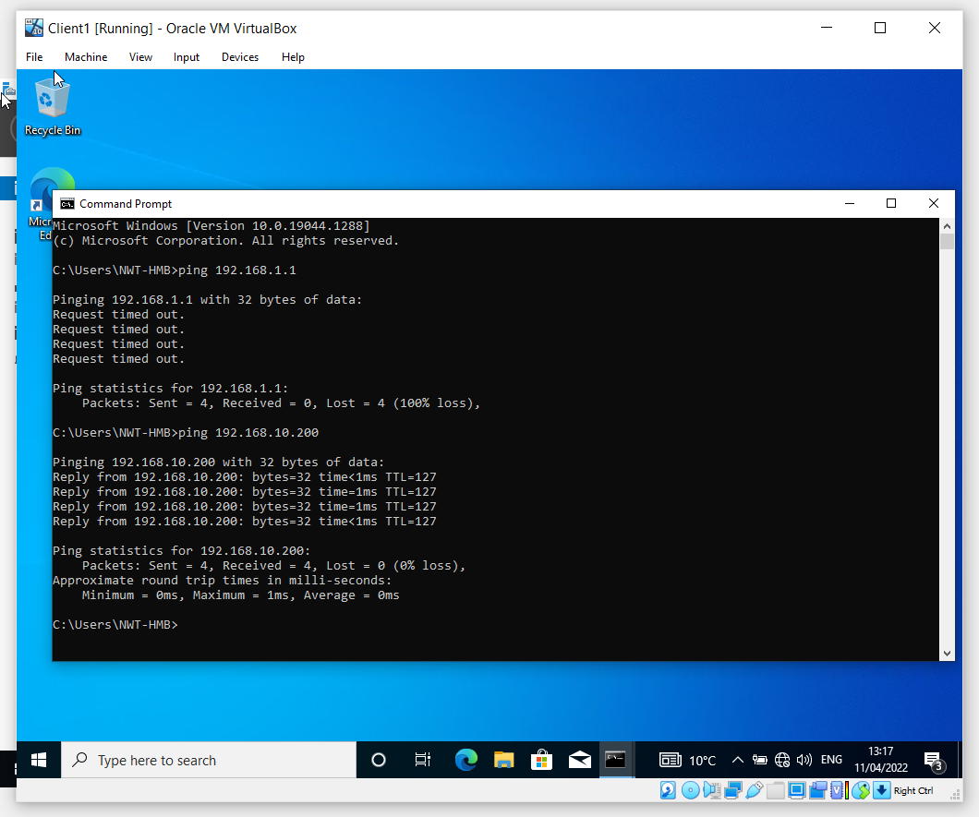

Filter 2: Restrict Access to FTP Service running on Server2 to only hosts in PrivateNet2

Outbound filter set this time on server 1 Destination IP address set at 192.168.10.203 as that’s server 2 where FTP(File Transfer Protocol) is set. TCP (Transmission Control Protocol) set this time in protocol with destination port 21 as that is the port reserved for passive TCP. Active TCP reserved port is 20.
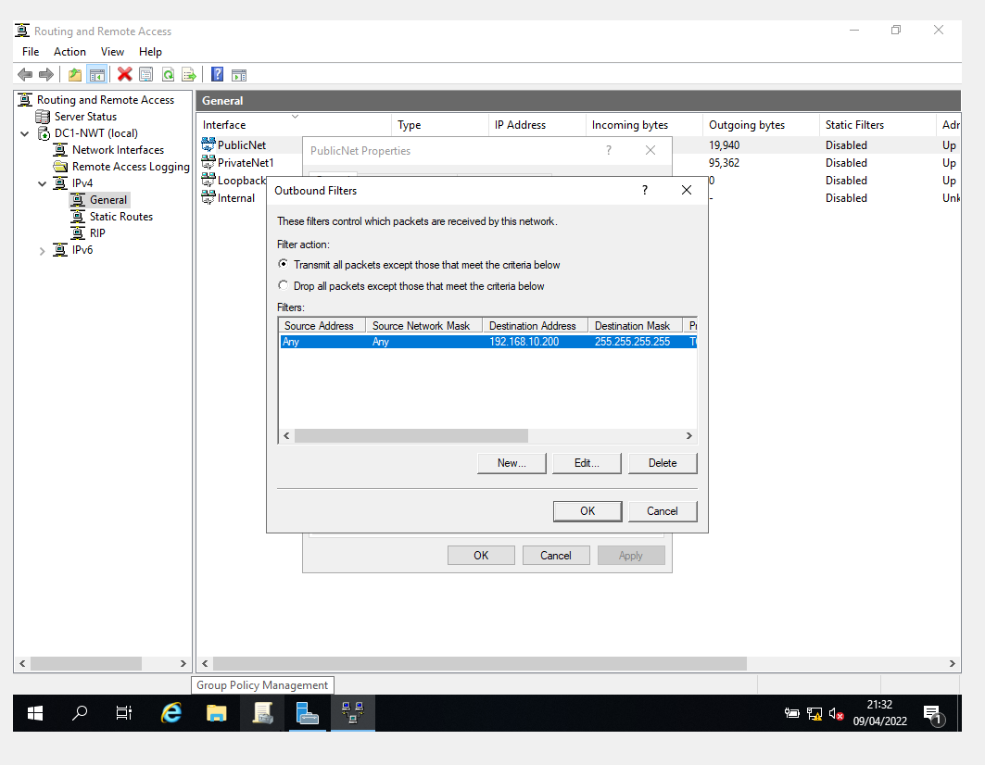

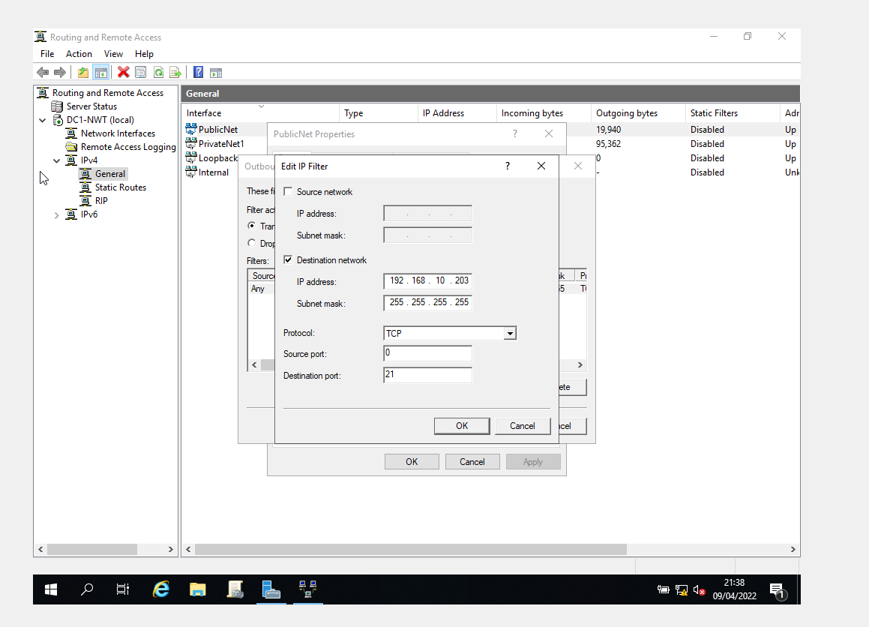
While this filter works when putting in the FTP address for 192.168.10.203 server 2 it does not work when not specifying that network.
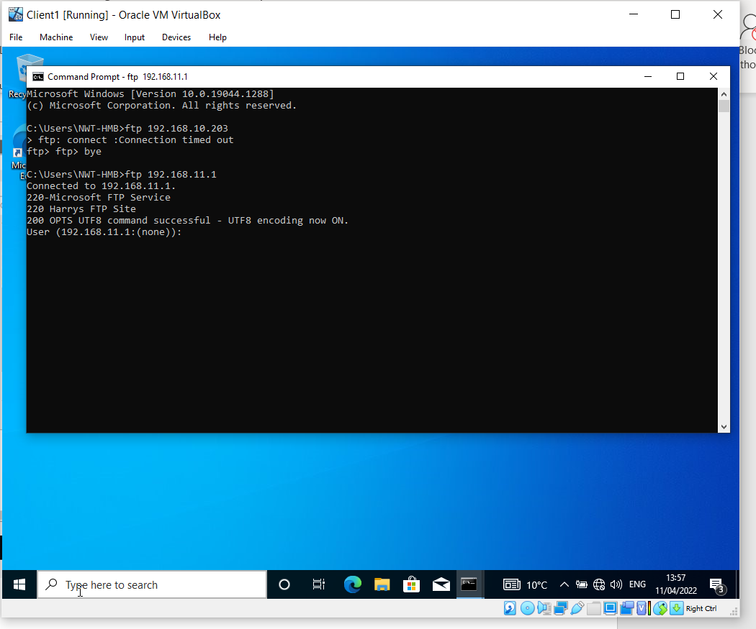
A second filter is added to stop FTP access from the network IP address that it could gain access from.
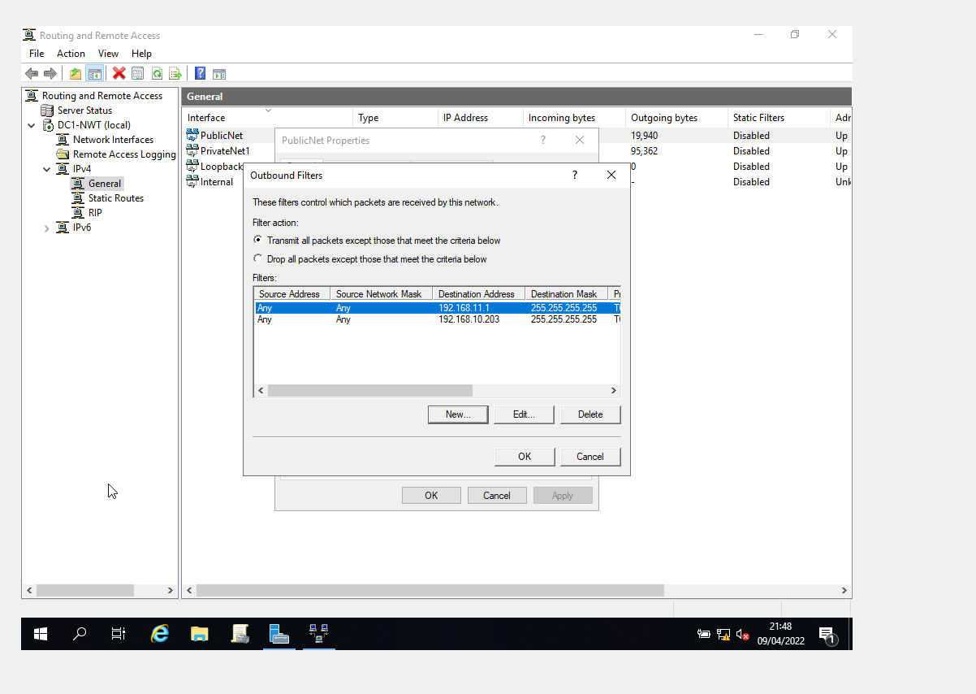

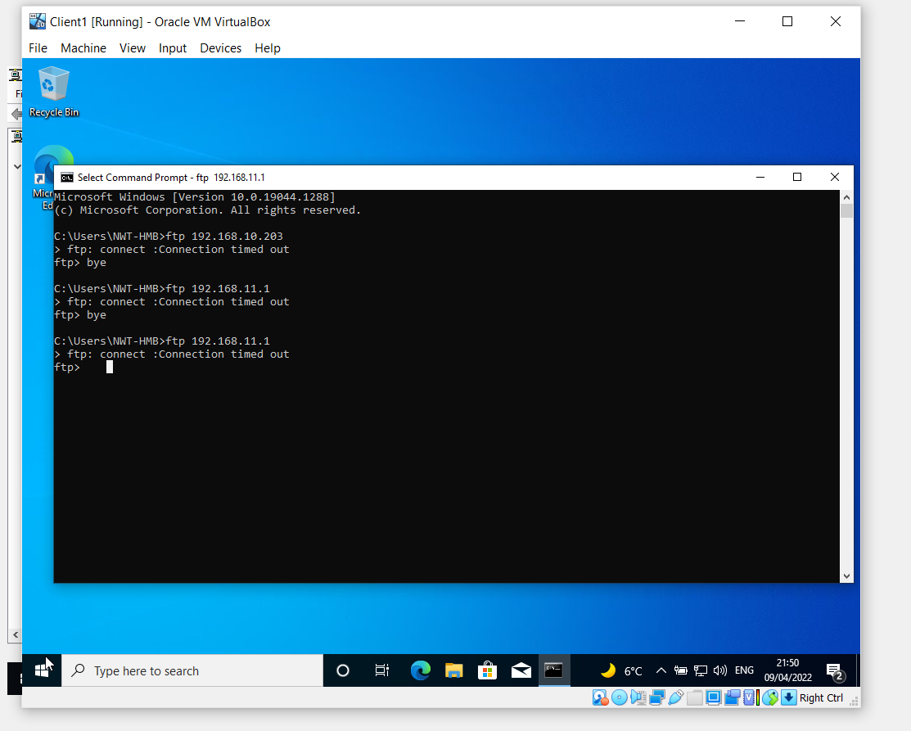

Filter 3: Only allow specific hosts in PrivateNet1 to access the FTPService running on Server2

The easiest way found to construct this filter was to firstly set it that client 1 on IP address 192.168.1.2 has access to the FTP on server 2
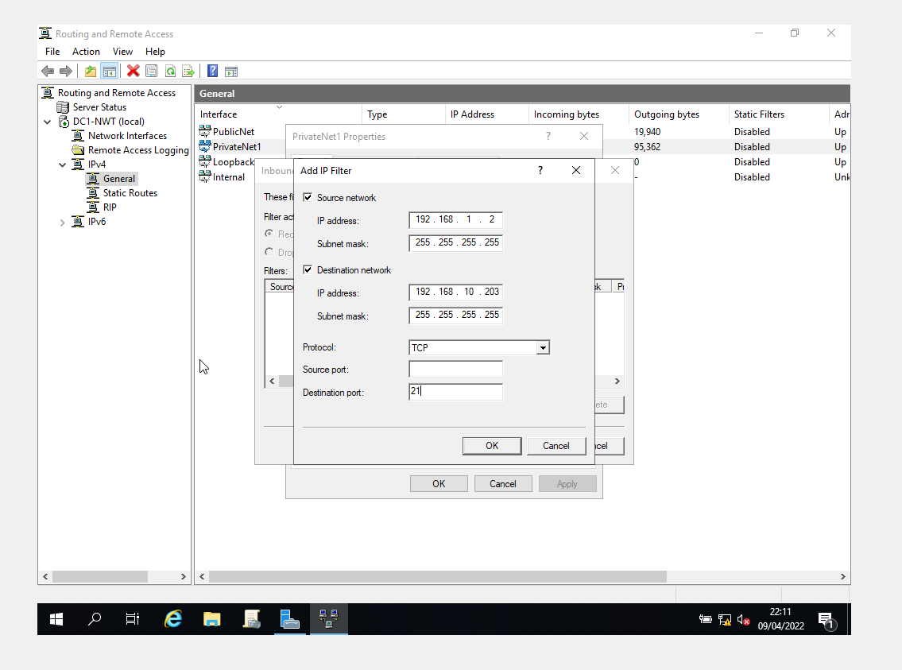
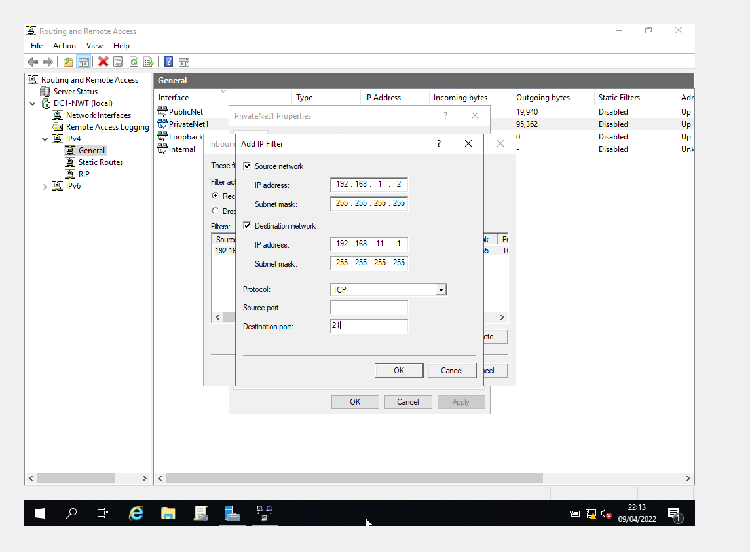
Note that option to drop selected which shows only rules applied can access FTP server
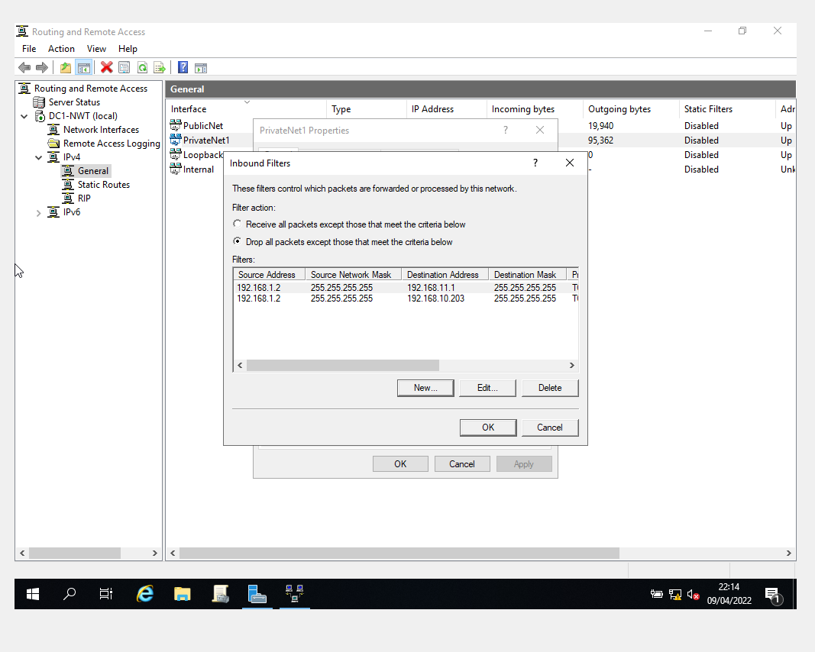
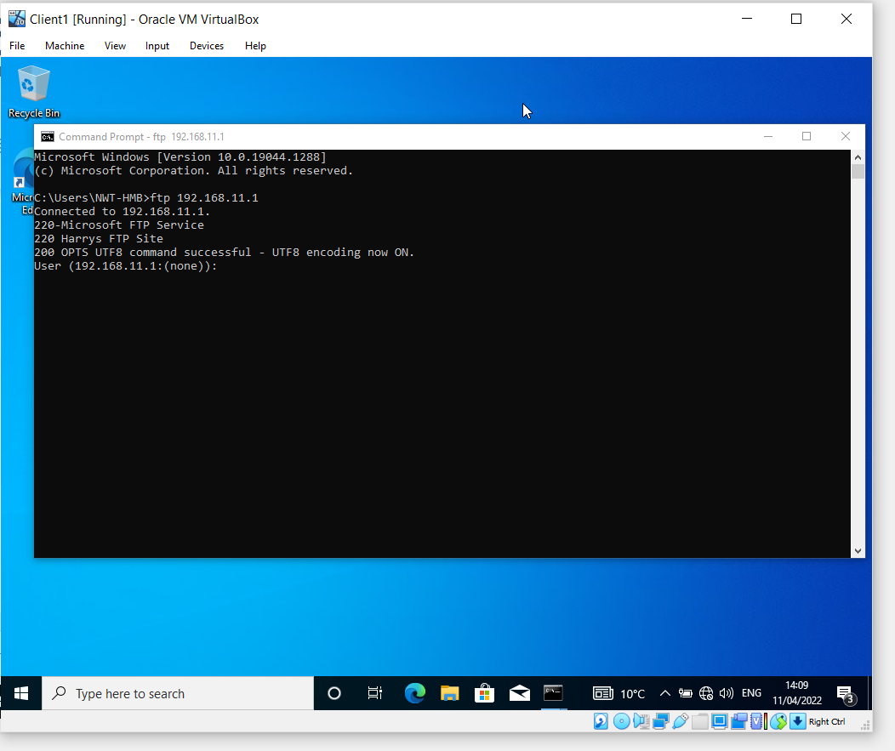

Impossible to show other clients not having access to FTP as there is only the one client. However using a ping command shows that it times out as everything other the FTP is dropped under filters set.
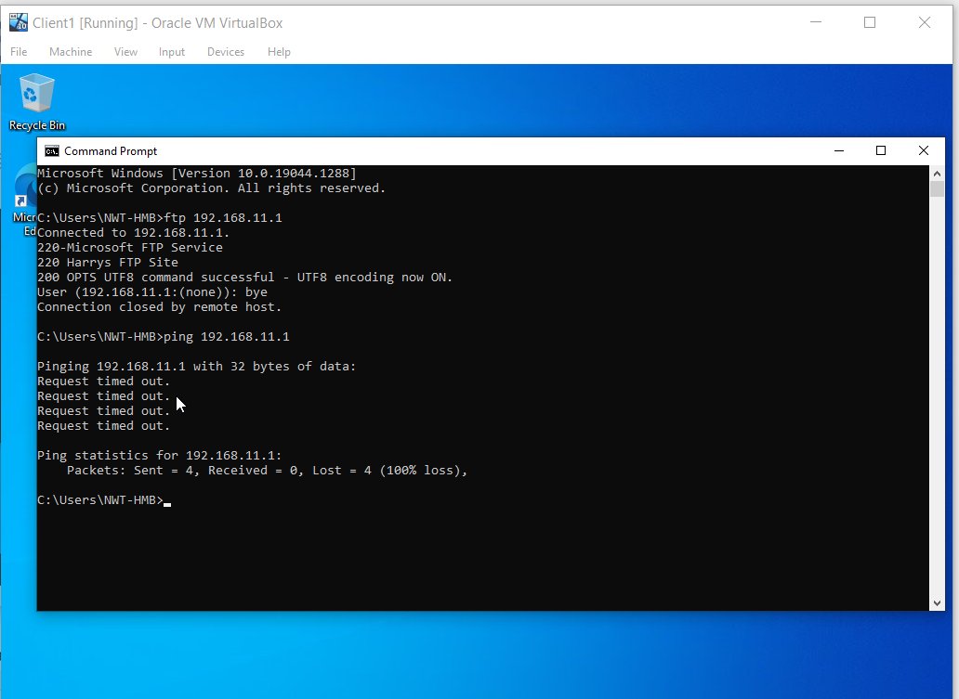

TASK 3: OBSERVATIONAL TASKS

Sound Password Principles on Networks.

In regard to the nature of this report we will look at good password principles used on a network as opposed to a home system where an average user would possibly used random password generators which are free or low cost and easily accessed online by companies such as Avast and NordPass, these are often accompanied with a password manager so the user would then just have to remember the one password for the password manager to access their saved passwords and usernames.
From a users point of view on an enterprise network, multifactor authentication is a method most users are familiar with now especially for services based on the cloud[2]. Multi-factor authentication is a method in which users are asked for an additional form of identity during the sign-in process, such as a code on their phone or a fingerprint scan. When you merely utilise a password to authenticate a user, you're leaving an attack vector open. An attacker could use the password to obtain access if it is weak or has been disclosed elsewhere. When a second form of authentication is required, security is enhanced since the additional element is difficult for an attacker to get or reproduce.[3]
From the perspective of a network administrator, there are many tools we have as have been shown previously in this report where we have password securities we can set up in windows server, particularly in default domain policy. Below can we see options for setting minimum password length, maximum password age, along with complexity set upon Microsoft guidelines to reduce users inputting obvious and easily guessed passwords.[4]
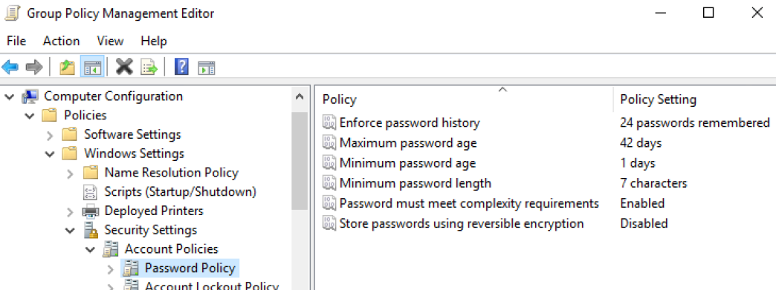

Importance of Failover Clusters

A failover cluster is a collection of autonomous computers that collaborate to improve the availability and scalability of clustered roles (formerly called clustered applications and services). The servers in a cluster (known as nodes) are connected via physical cables and software. If one or more cluster nodes fail, the remaining nodes take over service (a process known as failover). In addition, the clustered roles are monitored proactively to ensure that they are operating correctly. If they are malfunctioning, they are either restarted or moved to a different node.[5]

Cluster Shared Volume (CSV) is a feature of failover clusters that provides a consistent, distributed namespace for clustered roles to access shared storage from all nodes. With Failover Clustering, users experience a minimum of service interruptions.
There are a variety of roles and services that can benefit from failover clustering, but four technologies appear to make up the majority of clusters in data centres today: Exchange, Hyper-V, file services, also SQL.

Failover clustering: This requires at least two servers and operates on the active-passive principle, in which one server is active and the other is passive. It's typically used in databases, mail servers, and other backend systems.
Load-Balancing Clustering: Clustering for load-balancing requires at least two servers; Servers, on the other hand, are combined into a single virtual server and share heartbeats. As users connect to a single server. In regards to backend use, the loads are divided between the servers when it comes to processing. This normally is used on web servers and frontend processing settings in general.[6]
There are numerous roles and services that can benefit from failover clustering, but four technologies appear to make up the majority of clusters in data centres today: Microsoft Hyper-V, file services, Exchange, and SQL. If you are working with any of these technologies, which is likely the case, you should investigate the high-availability capabilities that can be provided for your infrastructure through the use of failover clustering.
Despite the fact that failover clustering provided by Windows Server is Microsoft-built and has the capability to work well out of the box with many Microsoft roles and services, it is important to note that you can also establish failover clustering for non-Microsoft applications. Failover clustering can also be utilised by third-party applications running on Windows Servers in your environment, as well as custom-built applications. As long as the application uses shared storage and you can specify the tasks that the clustering administration tools need to be able to perform against those applications – how to start the service, how to stop the service, how to monitor the service health, etc. – you can interface these custom services and applications with failover clustering and provide significant redundancy for virtually any type of application.[4]
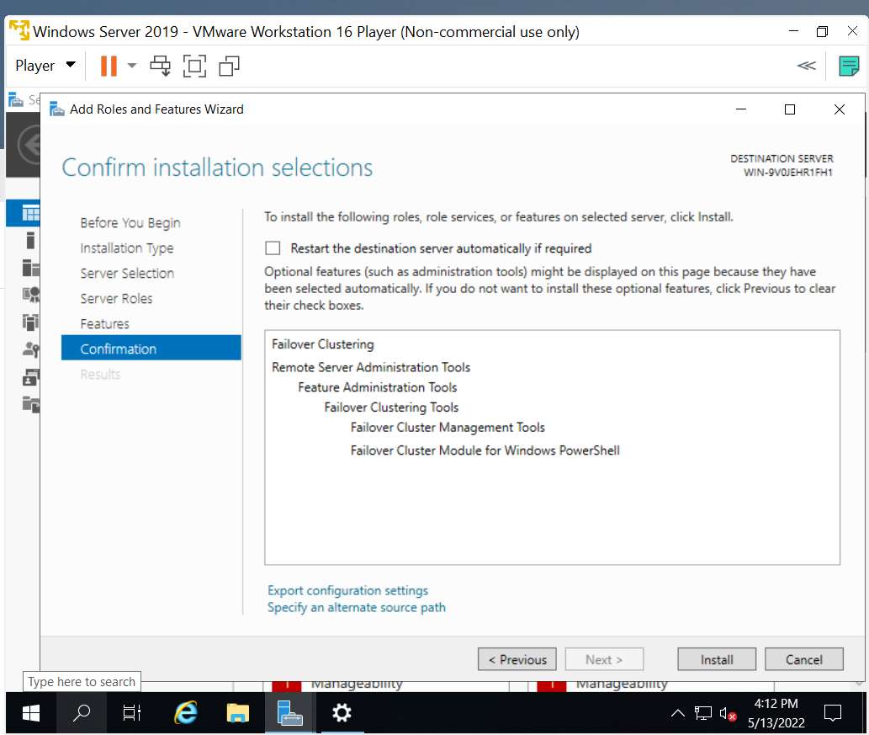

Draft Business Network Policy

Topology

As can be seen in the packet tracer diagram made, it was assumed that the enterprise network was based over five offices throughout the UK, it was also assumed that there were 4 hardwired workstations in each office with wireless access points should other team members be working wirelessly on laptops or tablets. As can be seen, redundancy has been included with 4 switches, 2 servers, 2 printers and 2 routers. The Reader can assume that each office would have an identical setup. In terms of intermediary devices on the network such as routers and switches, to secure them the first port of call would be to disable all unused ports, disable telnet as it as far less secure than SSH. All devices should be secured with encrypted passwords.[7], [8]

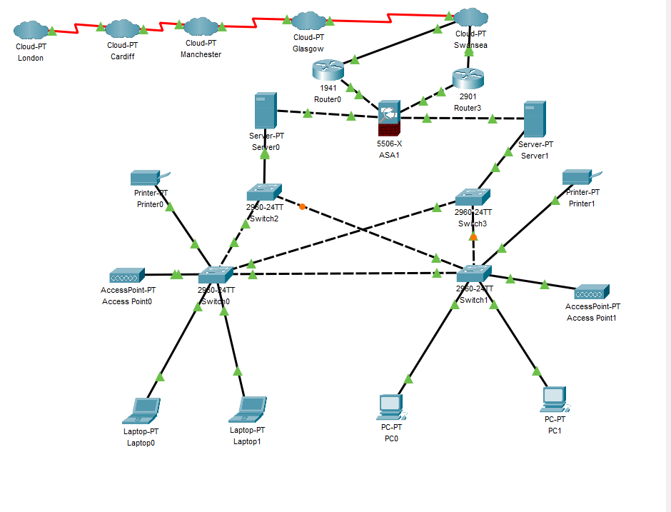

Network access
For users homeworking across VPNs (Virtual Private Networks) Multifactor authentication (MFA) increases the security of the sign-in procedure. Users give additional identification verification while accessing accounts or apps, such as scanning a fingerprint or inputting a code obtained by phone[9].The Network administrator will set passwords with a minimum level of complexity to expire every 30 days.

Security Team
The Security Manager works with the IT Infrastructure Services director to coordinate investigations into any claimed computer or network security compromises, incidents, or difficulties. All compromises or prospective compromises must be notified to the Information Technology department as soon as possible. Contacting the Security Manager is the responsibility of the IT Infrastructure Services director. System administrators are in charge of acting as security coordinators for local information systems. These people are in charge of assigning proper user privileges, monitoring access control logs, and taking other security measures for the systems they manage. They're also in charge of alerting the Security Manager to any suspect computer or network security activity. Security policies, standards, guidelines, and procedures for information systems are also implemented by system administrators.[10]

Analysis of security Risks
Corruption of data, loss of data, intellectual property theft, ransomware all big threats ref one

Monitoring of security operations
IDPS (Intrusion Detection and Prevention Systems) will be implemented. Intrusion detection is the constant monitoring and evaluation of events in a computer system or network for indications of potential incidents, such as infractions or looming threats of violations of computer security legislation, acceptable use standards, or standard security practises. Prevention of invasions is essential. Intrusion detection is the process of identifying and attempting to block potential intrusions.[11]

Mitigations in the event of violations
Servers are mirrored from one site to another to cover the eventuality of machinery failure or buildings involved in a disaster scenario. In reality for the size of the company and the limited IT staffing, it is thought that in the future they would mitigate to cloud storage as this allows for greater storage and scalability, accessibility, and disaster recovery along with heavily encrypted security controls. With costs constantly reducing for these services, it seems a likely path for small enterprise models to move this way. A scheduled backup for the data will be carried out on a nightly basis.

References

[1] “Overview of FAT, HPFS, and NTFS File Systems - Windows Client | Microsoft Docs.” https://docs.microsoft.com/en-us/troubleshoot/windows-client/backup-and-storage/fat-hpfs-and-ntfs-file-systems (accessed May 08, 2022).
[2] “Multi-factor authentication for online services - NCSC.GOV.UK.” https://www.ncsc.gov.uk/guidance/multi-factor-authentication-online-services (accessed May 12, 2022).
[3] “Azure AD Multi-Factor Authentication overview | Microsoft Docs.” https://docs.microsoft.com/en-GB/azure/active-directory/authentication/concept-mfa-howitworks (accessed May 12, 2022).
[4] J. Krause, Mastering Windows Server 2019, 2nd ed. Birmingham - Mumbai: Packt, 2019.
[5] “Failover Clustering | Microsoft Docs.” https://docs.microsoft.com/en-us/windows-server/failover-clustering/failover-clustering-overview (accessed May 13, 2022).
[6] Microsoft, Windows Server 2019 Administration Fundamentals, 2nd ed. Birmingham-Mumbai: Packt, 2018.
[7] “Securing Cisco Switches | Configuring Port Security - learncisco.net.” https://learncisco.net/courses/icnd-1/ethernet-lans/switch-security.html (accessed May 13, 2022).
[8] “8 Steps of Cisco Router Security Configuration | ⋆ IPCisco.” https://ipcisco.com/lesson/basic-cisco-router-security-configuration/ (accessed May 13, 2022).
[9] “Multifactor Authentication | MFA | Microsoft Security.” https://www.microsoft.com/en-gb/security/business/identity-access-management/mfa-multi-factor-authentication (accessed May 13, 2022).
[10] W. texas university, “Network Protection and Information Security Policy,” Txwes.Edu, pp. 1–15, 2012, [Online]. Available: https://txwes.edu/media/twu/content-assets/documents/it/Network-Protection-and-Info-Security-Policy.pdf
[11] J. Kizza and F. Migga Kizza, “Intrusion Detection and Prevention Systems,” Securing the Information Infrastructure, pp. 239–258, 2011, doi: 10.4018/978-1-59904-379-1.ch012.

