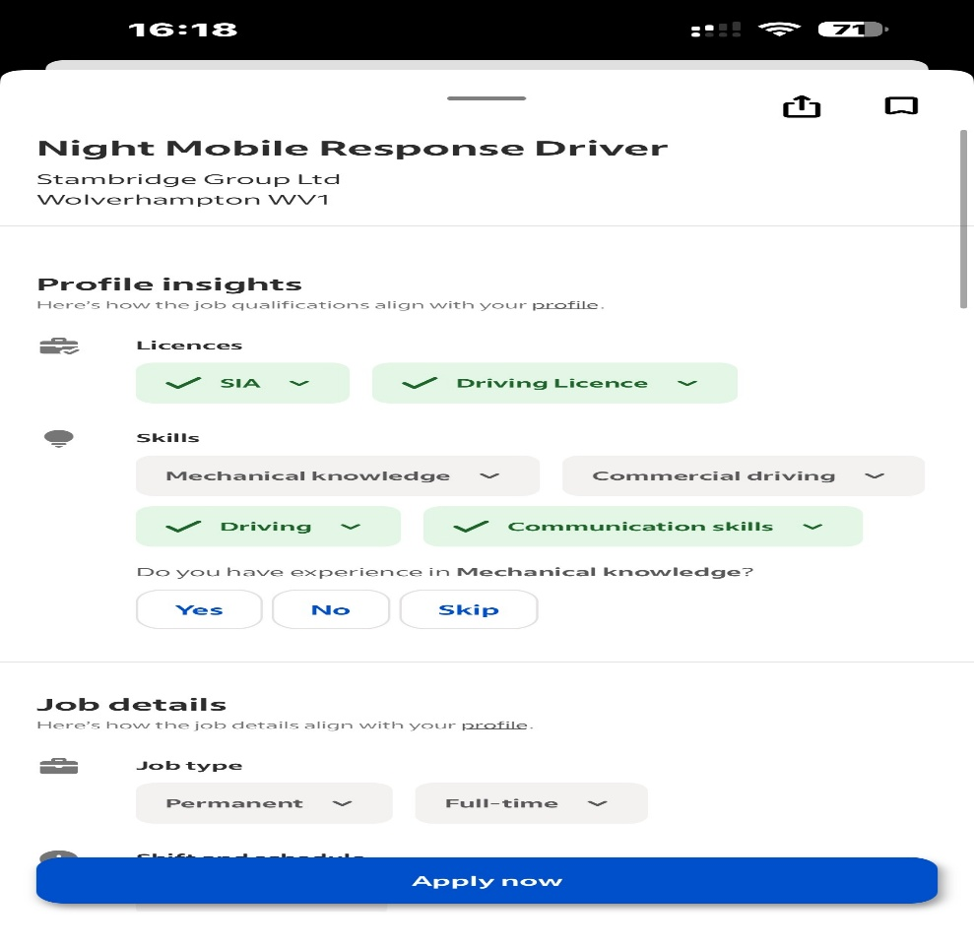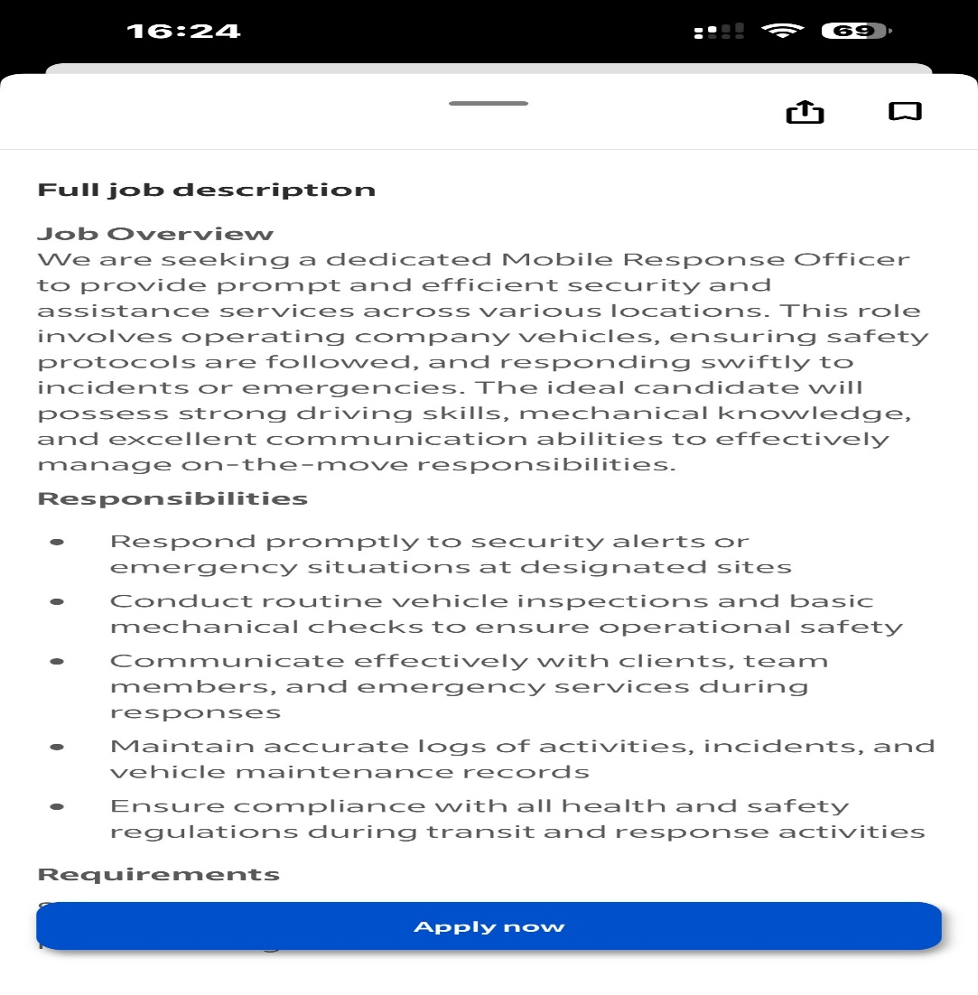

Hiring Manager 73 waite Road Stambridge Group LTD Willenhall Wolverhampton WV13 3EZ
WV1

Dear Hiring Manager,
I am writing to express my interest in the Security Mobile Driver position at Stambridge group Ltd. I have a strong background in mobile patrols, security operations, and rapid incident response, I bring the reliability, situational awareness, and professionalism required to excel in this role.
I have 5 years of experience in mobile patrols, responding to alarms, completing detailed incident reports, and ensuring the safety of clients, staff, and property. I am confident in navigating various environments, assessing risks quickly, and taking appropriate action to prevent or mitigate security threats as I hold ACT Awareness E-Learning and ACT Security E-Learning certificate. I hold a valid SIA licence, a clean UK driving record, and have extensive experience operating security vehicles safely and efficiently.
I consistently remain calm under pressure, communicate effectively, and am dedicated to high-quality service. I work well both independently and in teams, always upholding strong discipline and security.
I am eager to contribute to Stambridge Group Ltd and help advance your security services. Thank you for considering my application; I look forward to discussing how my skills fit your needs.

Yours sincerely,
Gurvinder singh

CV
Phone- 07939223466
Gurvinder singh
Bindabains11@gmail.com
Profile
I am very responsible, mature thinking and self motivated individual who can work well on my own initiative as well as part of team. I am a positive person who likes to see best in people and understand that in my role.
Employment History
Chandni chowk restaurant ( 2009 – 2019)
Axix security ( 2019- 2023)
Total security (2023 to current )
Qualifications
Bcom ( Bhuvneshwar University India)
UWTSD ( Certificate in higher education business skills for the work place)
Quality and skills
I can speak three languages Hindi, English and Punjabi. I am very punctual and I also have computer skills.

