E - Portfolio: Preparation for Dietetic Assistant Placement

CV

Name - Kerin Roberts
Location - Swansea, Wales
Email - Kerinrobertss13@icloud.com
Phone - 07460 585072

Profile

I am currently a nutrition student at the University of Wales Trinity Saint David seeking a part-time placement role as a dietetic assistant within the NHS. I am passionate about developing my practical skills and gaining experience in how nutrition supports recovery and the wellbeing of individuals in a clinical setting. Through my studies, I am building my knowledge in nutritional science, diet analysis/ planning and health promotion (University of Wales Trinity Saint David, 2024).
I hope to progress to a master’s degree in dietetics to pursue a career supporting patients through dietetic care.

Key Skills:
- Developing knowledge of nutritional science and public health
- Communication and empathy when supporting individuals
- Teamwork and collaboration in fast-paced settings
- Health, safety, and hygiene awareness
- Time management and organisation
- Customer service and professionalism
- Attention to detail and record-keeping

Education

University of Wales Trinity Saint David - BSc (Hons) Health, Nutrition and Lifestyle
Carmarthen campus
2023 - present
- Studying dietary analysis, physiology, science of nutrition, sport nutrition, health promotion etc.
- Developing understanding of evidence - based diet planning

Gower College Swansea - A Levels: Sociology, Criminology, Health & Social Care
Gorseinon campus
2017 - 2020

Pontarddulais
Comprehensive School - GCSEs including English, Mathematics and Sciences
2012 - 2017

Work Experience

Retail Assistant - Holland & Barrett, Llanelli (2023)
- Completed Qualified to Advise training, providing health and nutrition guidance.
- Supported customer wellbeing through evidence-based product recommendations.
Customer Assistant - Tesco Café, Swansea (2023)
- Maintained food hygiene and delivered excellent customer care.
- Strengthened teamwork and organisation skills in a busy environment.
Waitress - Wagamama, Swansea (2021-2022)
- Worked collaboratively with colleagues to deliver a fast, efficient service.
- Enhanced communication and time management skills.
Additional roles - JD sports, Seager’s, Footasylum, Home bargains etc. (2018-2022)
- Built confidence, professionalism and strong interpersonal skills.

2. Personal statement / Covering letter

Dear hiring manager,
I am writing to express my interest in a part-time placement role as a dietetic assistant within the NHS. As a nutrition student at the University of Wales Trinity Saint David, I am eager to apply my developing knowledge in a real-world healthcare environment and gain practical experience supporting patients through nutrition-based care.

My degree has provided me with a strong foundation in nutritional science, human physiology, and health promotion (University of Wales Trinity Saint David, 2024). I am particularly interested in understanding how diet and lifestyle interventions can be used to prevent and manage chronic disease (World Health Organization, 2025) and how nutrition supports recovery in hospital and community settings (British Dietetic Association, 2020).

My previous experience in customer service and hospitality has strengthened my communication, empathy, and teamwork skills. I take pride in being organised, adaptable, and approachable – qualities I believe are essential for supporting both patients and clinical staff.

This placement will give me valuable insight into the role of dietitians and dietetic assistants (British Dietetic Association, 2025; NHS Health Careers, no date), helping me to develop the practical and interpersonal skills required for a successful career in dietetics. Looking ahead, I intend to pursue a master’s degree in dietetics and become a registered dietician (National Careers Service, no date).

Thank you for considering my application.

Yours sincerely,
Kerin Roberts

3. Focus statement / CPD Rationale

SWOT analysis

Strengths:
- Strong academic foundation in nutrition and health promotion (University of Wales Trinity Saint David, 2024).
- Excellent communication and teamwork skills.
- Empathetic and professional approach with others.
- Gaining experience in the NHS to prepare for dietetics MSc (NHS Health Careers, no date; Cardiff Metropolitan University, no date).
- Learning from experienced professionals and observing patient care (British Dietetic Association, 2025).

Weaknesses:
- Limited direct clinical experience.
- Need to develop confidence in a clinical setting – record-keeping and patient interaction.
- High competition for placements (NHS Health Careers, no date).
- Balancing study commitments with placement hours.

Action Plan for professional development

Goal | Actions | Timeframe
Gain hands-on experience in a clinical setting | Apply for NHS dietetic assistant placement | Within 3 months
Strengthen practical dietetic knowledge | Shadow a registered dietician | Ongoing
Improve understanding of NHS procedures | Complete online NHS learning modules on confidentiality and patient safety | Before placement
Develop career progression | Research MSc dietetics entry requirements; plan next academic steps | During final year of degree

Focus statement

My long-term goal is to become a registered dietician, and I see the role of dietetic assistant as an important first step towards this. Through my nutrition degree, I am developing strong scientific knowledge in food, health, and the human body, but I recognise I need to apply this learning practically in a real clinical setting. A placement in the NHS will allow me to gain insight into the daily work of dieticians, understand how patient care is delivered, and strengthen skills required in a healthcare environment.
My SWOT analysis highlights that while I have strong communication and organisation skills from previous work experience, I need to experience in patient interaction, record-keeping and understanding NHS procedures. My action plan therefore focuses on gaining experience through placement and reflecting on my learning throughout.
I am particularly interested in how nutrition can be used as a therapeutic tool to manage and prevent disease/ illness which aligns closely with the principles of dietetic practice. In preparation for a future master’s in dietetics, I aim to strengthen my practical and professional experience. This placement will help develop my academic learning and future clinical work, giving me a realistic understanding of what it means to work in dietetic care and support patient wellbeing through nutrition.

Conclusion

Completing this e-portfolio has allowed me to reflect on my academic progress, personal skills and readiness for a dietetic assistant placement role. Through developing my CV, personal statement, SWOT analysis and an action plan, I have identified the knowledge and skills required for this clinical role, as well as the areas I need to improve on before pursuing a postgraduate degree in dietetics. I now feel more confident in applying for a placement role which would allow me to shadow experienced professionals and build my skills required for this job in the future.
Overall, this e-portfolio has clarified my career goals and motivated me further to work towards these goals of working in a clinical setting, contributing positively to patient care through nutrition and dietetic support.

Bibliography
British Dietetic Association, 2020. Nutrition at Home after Critical Illness. [Online]
Available at: https://www.bda.uk.com/static/d35eba3a-1cc3-4aeb-a658d0fb27ba1c2c/648708e0-59d9-4c22-911f3ab7810ac73a/Nutrition-at-home-after-critical-illness-FINAL-PDF-Version-June2020.pdf
[Accessed 29 October 2025].
British Dietetic Association, 2025. What is a dietitian?. [Online]
Available at: https://www.bda.uk.com/about-dietetics/what-is-dietitian.html
[Accessed 29 October 2025].
Cardiff Metropolitan University, no date. Dietetics Master's Degree - MSc/PgD. [Online]
Available at: https://www.cardiffmet.ac.uk/courses/postgraduate/msc-dietetics/
[Accessed 30 October 2025].
National Careers Service, no date. National Careers Service. [Online]
Available at: https://nationalcareers.service.gov.uk/job-profiles/dietitian
[Accessed 30 October 2025].
NHS Health Careers, no date. Dietitian. [Online]
Available at: https://www.healthcareers.nhs.uk/explore-roles/allied-health-professionals/roles-allied-health-professions/dietitian
[Accessed 29 October 2025].
University of Wales Trinity Saint David, 2024. BSc (Hons) Health, Nutrition and Lifestyle – course overview. [Online]
Available at: [Course information no longer available online.]
[Accessed 29 October 2025].
World Health Organization, 2025. Nutrition. [Online]
Available at: https://www.who.int/health-topics/nutrition#tab=tab_1
[Accessed 29 October 2025].

Appendices

Appendix 1 - CV
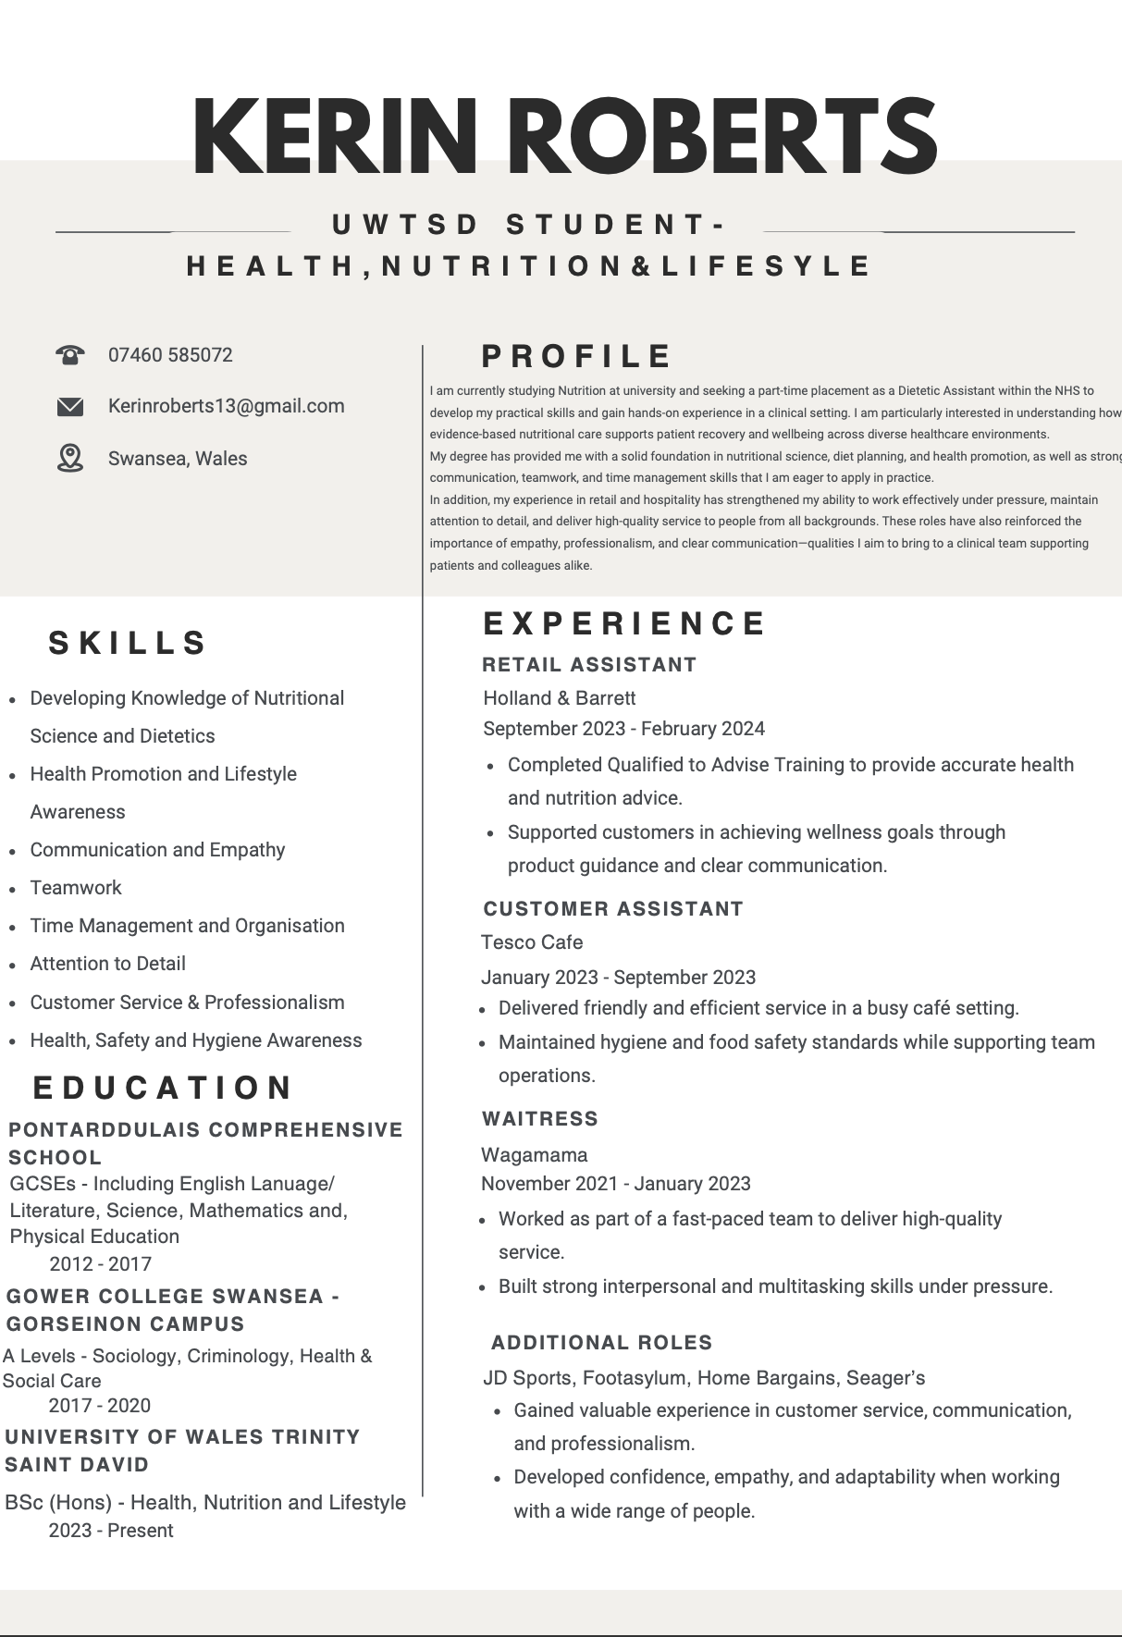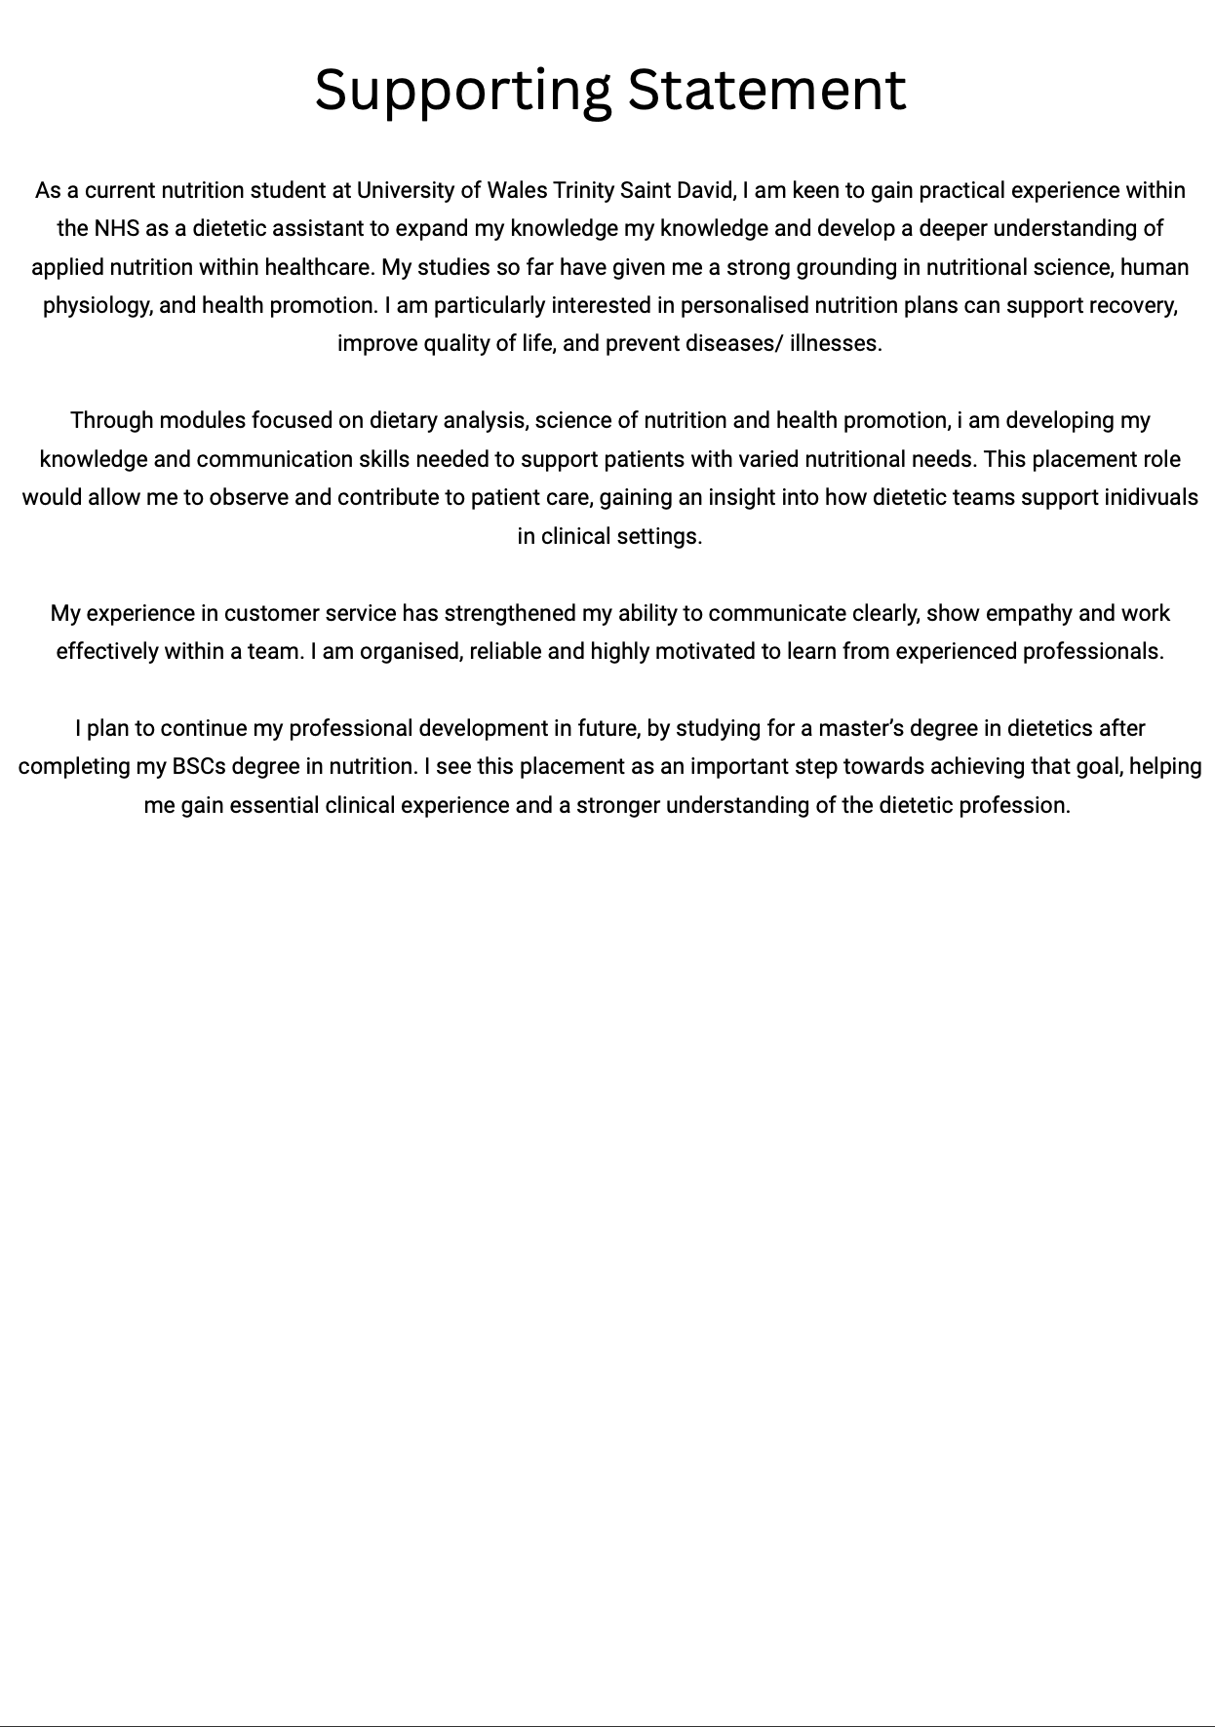

Appendix 2 - SWOT Analysis Template



