Lean & Agile Manufacturing MSc
The influencing factors on paper mill rejects in modern times and the potential solutions to reduce, reuse or recylce these rejects into process inputs or products of value.

Darryl Jackson, Student No:2219398
University Wales Trinity Saint David
Key Words – Paper Mill Rejects, Circular Economy, Sustainability, and Innovation



Master’s Thesis -The influencing factors on paper mill rejects in modern times and the potential solutions to reduce, reuse or recycle these rejects into process inputs or products of value.

Lean & Agile Manufacturing

Darryl Jackson, Student No:2219398

Supervisor – Andrew Thorn

January 2025

University Wales Trinity Saint David

Executive Summary
The origins of paper manufacturing can be found some 2000 years ago in China, since then the manufacturing process has developed into high speed machines up to 70 miles per hour and over 10 meters wide which in itself demonstrates the innovative nature of the process which now faces its next challenge, sustainability.
Sustainability or more importantly the need for a circular economy is now a core element of any paper manufacturer with the race to develop a process that is CO2 neutral very much underway with major players in the paper industry investing millions into research and technology.
The investigation explores the sustainability strategies for the major customers of the paper manufactures and how their needs are driving the paper industry, the influence of governments or local councils on sustainability by their implementation and execution of their recycling strategies and how the use of the define, measure, analyse, improve and control (DMAIC) framework can be used to reduce, reuse or recycle rejects in a greater fashion.
The data collected from Smurfit Westrock and the Confederations of paper industry was used in a hypercubic analysis alongside lean tools such as Failure Mode Effect Analysis (FMEA), Ichikawa diagrams and 5 whys to demonstrate that external factors influence the reject volumes of the paper mills and therefore market conditions that cause these are outside of their control leading to the need for a change in strategy and technology to deliver a reduced volume of rejects or a reuse of the rejects which could lead to a reduction on cost and tonnes of CO2 emitted (tCO2e)
Artificial Intelligence (AI) Cameras were used to determine incoming material compositions demonstrating that over 95% of the material can be classified, unfortunately only the surface material could be classified and was therefore deemed unsuitable as the baled paper material is at least 50 centimetres deep. The technology though gave good insight into its capabilities which could therefore be used in other applications with potential at material recycling facilities (MRF’s)
The second pilot explored the use of Pyrolysis to reduce the fibre and sand reject streams into biochar to then be sold onto the open market, the results demonstrated that paper mill sludge can now be used in a pyrolysis plant with at least 80% of the material being converted. These results would allow for a potential of over 1000T’s of CO2 being removed per annum, over a £1.3 million financial saving and intangible savings such as reputation and customer satisfaction.
Acknowledgements
- I would like to thank Smurfit Westrock for their support in my personal development and allowing me the time and finances to research a sustainable technology that could help deliver change for our industry.
- I would like to thank David Upton and Kevin Bussey for their support, mentorship and encouragement to complete my studies.
- I would like to thank my colleagues across Smurfit Westrock’s Recycling, Paper and Converting divisions for their support and input into my research especially the access to business data.
- I would like to thank IBS Paper Performance Group for access to their test facilities and input to the AI Camera research.
- I would like to thank Onnu and Woodtek for access to their test facilities and input to the Pyrolysis research.
- Finally, I would like to thank my wife Sam for her support, time and sacrifice that allowed me time to study.

Declaration Statement
I declare that the work in this dissertation was carried out in accordance with the regulations of UWTSD. The work is original except where indicated by special references in the text and no part of the dissertation has been submitted for any other degree.

Any views expressed in the dissertation are those of the author and in no way represent those of the UWTSD.

The dissertation has not been presented to any other University for examination either in the United Kingdom or overseas.

I hereby give permission for my work, if accepted, to be available for photocopying and inter-library loan, and for the title and summary to be made available to outside organisations.

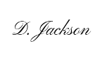
Signed:

Date: 2nd January 2025

Contents
Table of figures 7
Introduction 11
History of paper making 11
Modern Paper Manufacturing 12
Sustainability 16
Smurfit Westrock and Customers 18
Investigation Background 22
Problem Statement 23
Research Methods 23
Literature Review 38
Define 44
Measure 51
Analyse 55
Improve 59
Control 69
Conclusions 71
Recommendations for future research 73
References 74
Appendices 78

Table of figures
Figure 1 - Fragment of paper. 11
Figure 2 - Fabriano Paper 11
Figure 3- Nicolas Louis Robert's Machine Designs 12
Figure 4 - Bryan Donkin’s Fourdrinier Design 12
Figure 5- Paper and Board production 1872-2022. 12
Figure 6 - 10 Year Paper and Board Consumption 13
Figure 7 - 10 Year Paper and Board Consumption 13
Figure 8- UK Paper and Board Recycling 13
Figure 9- UK Paper Export by Destination 14
Figure 10 - English Recycling Rates 14
Figure 11 - Welsh Recycling Rate 14
Figure 12- Fibre Recycling Rate vs Fibre Length 15
Figure 13- Consumer Sustainability Feedback 16
Figure 14 -Change Cycle Example 17
Figure 15 - CEO Survey Results 17
Figure 16- Transformation change of solar energy capacity. 18
Figure 17- Smurfit Westrock Products 18
Figure 18- Smurfit Westrock Sustainability Targets 19
Figure 19 - Smurfit Westrock Sustainability Timeline 19
Figure 20- Mars Sustainability Timeline 20
Figure 21 -Nestle Sustainability Timeline 20
Figure 22- Proctor & Game Responsible Packaging 21
Figure 23- PepsiCo Responsible Packaging Result 21
Figure 24- Smurfit Westrock Circular Economy 22
Figure 25- Economic Growth Vs Sustainability 22
Figure 26 - Business Partnering for sustainability. 22
Figure 27 - Tuckman and Jensen’s Team Development Curve 24
Figure 28- Quad of Aims 25
Figure 29 - SWOT Analysis 26
Figure 30 - PESTEL Analysis 26
Figure 31 – Mendelow’s Stakeholder Matrix 27
Figure 32 - Stakeholder Impact on projects. 27
Figure 33 - SIPOC Layout Example 27
Figure 34- Process Flow Swimlane Vs VSM 28
Figure 35- Data Collection Plan Example 29
Figure 38- Off Target and High Distribution 29
Figure 36 - Normal Distribution Chart 29
Figure 37 - Off Target, Low Distribution 29
Figure 39- Distribution Chart Example 30
Figure 40 - 5 Why Example 30
Figure 41 - Ishikawa Diagram 30
Figure 42 - X-Y Matrix Example. 31
Figure 43 - FMEA Data Entry 32
Figure 44 - FMEA Scoring Matrix 32
Figure 45 - Hypercubic Model Results 33
Figure 46 - Hypercubic Model Setup 33
Figure 47 - Solution Refinement 34
Figure 48 - Pugh Matrix Example 34
Figure 49 - Change Curve 34
Figure 50 - Gannt chart example. 35
Figure 51- Control Chart 35
Figure 52- SPC Chart 36
Figure 53 -Standard Deviations 36
Figure 54 - VOC. 44
Figure 55 - Team Contract 45
Figure 56- Stakeholder Matrix 46
Figure 57 - Smurfit Westrock SWOT 46
Figure 58- SW PESTEL Analysis 47
Figure 59 - PESTEL Business Impact 48
Figure 60- 5W1H. 48
Figure 61- SIPOC. 49
Figure 62- Quad of Aims 50
Figure 63- Process Map 51
Figure 64 - Data Collection Plan 51
Figure 65- Total Mill Rejects Tonnes 52
Figure 66- Reject Types 52
Figure 67 - Rejects by category. 53
Figure 68- Regression Summary 53
Figure 69- Process Capability 54
Figure 70 – Financial Appraisal of Business Case 54
Figure 71 - Ishikawa diagram. 55
Figure 72- 5 Why's 56
Figure 73- X-Y Matrix 56
Figure 74- FMEA Highest Risks 57
Figure 75- High Grade Paper Influence 57
Figure 76- Kraft liner use in conversion plants. 58
Figure 77- SW Mold Recycled Volume Influence 58
Figure 78- External Supplier Influence 58
Figure 79- brainstorming. 59
Figure 80 - Pugh Matrix 59
Figure 81- Pyrolysis Gantt Chart 60
Figure 82- AI Camera Gantt Chart 60
Figure 83 - AI Camera Stakeholder Matrix 61
Figure 84- Pyrolysis Stakeholder Matrix 61
Figure 85 - Samples for AI Model Training 61
Figure 86 - Model Training 62
Figure 87 - Paper Mill Conveyor Vs Test Rig 62
Figure 88- Camera Distance to Conveyor 63
Figure 89 - Paper Defined Against Background 63
Figure 90- Misinterpreted Material 63
Figure 91 - Metal & Plastic Defined Against Background 64
Figure 92 - AI Camera Test Results 64
Figure 93 - Camera Location Vs Visible Paper 64
Figure 94 - laboratory Results. 65
Figure 95- Drying Unit 65
Figure 96 - R6/7 Reject Streams Collected 66
Figure 97 - Test Mix Compositions 66
Figure 98 – Pyrolysis Chamber 66
Figure 99 - Pyrolysis Chamber Internals 66
Figure 100 - Pyrolysis Mix Results 67
Figure 101 - Pyrolysis savings vs baseline data. 67
Figure 102 - Capital Expenditure Estimation 67
Figure 103 - ROI and IRR Calculations 68
Figure 104 - Control Plan Proposal 69
Figure 105 - SPC Chart Proposal - Biochar Production 69
Figure 106 - Incorporation of Pyrolysis Plant into Original state process. 70
Figure 107 – Smurfit Westrock Customer Feedback Survey Results 71

Introduction

History of paper making
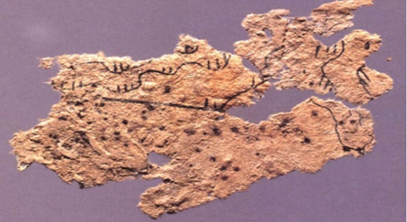
Paper manufacturing and its history are aligned with that of science, culture and technology whereby society has developed over centuries the need for greater communication and sharing of information. The need for information led to the development of paper as we know it today but its history can be traced back to China 2000 years ago where by materials such as hemp, tree bark and rags were mixed with water, beaten together to create a pulp before being used to form a sheet of paper. This type of paper can be seen in figure 1 which is the oldest fragment of paper found in China to date. (Cantavalla, 2019)
Figure 1 - Fragment of paper.
Paper manufacturing then developed into the middle east around AD751 as a result of capturing 2 Chinese prisoners in Samarkand who then helped develop the manufacturing of paper in the region which allowed for many of the Arabic religious beliefs to be documented. (Solberg, 2018)
In Europe many texts were documented on parchment and it was not until the 11th century that paper was introduced as an alternative although many first saw paper as inferior due to the rice water layer added to paper which meant insects would eat the paper resulting in the paper not lasting long. (Cantavalla, 2019).
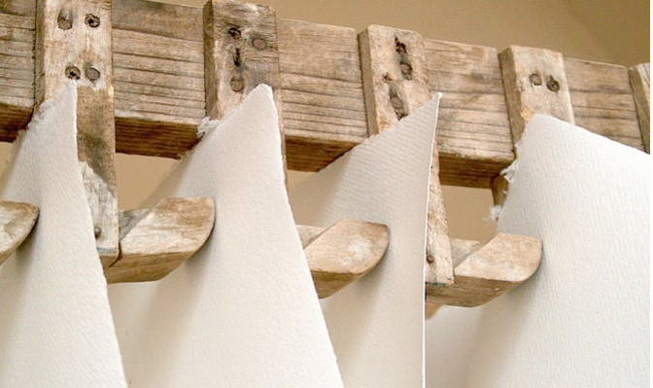
Italy is considered the paternal region of European paper making as Fabriano in the Marche region honed their techniques to develop high quality paper that could compete against parchments. (Noemi Proietti a, 2019) Fabriano’s manufacturing of quality paper is shown in figure 2, they are credited with other developments such as hydraulic hammer mills to reduce the time of pulp production, the use of gelatine as a way to deter insects, creation of different paper types and formats as well as inventing water marking. (Cantavalla, 2019)
Figure 2 - Fabriano Paper

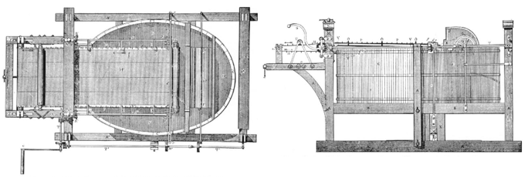
Modern paper manufacturing owes its heritage to the development of the paper machine created by a French engineer named Nicolas Louis Robert; his initial development was created during the 17th century whilst working for Leger Didot at Essones France. As designed in figure 3 Nicolas visioned the manufacturing of paper in long lengths driven by machinery and began designing such a machine, unfortunately his design of a fully functioning mechanical machine never came to fruition but his design of an endless wire to form a sheet of paper is undoubtably at the heart of every modern paper machine today. (R.H.Clapperton, 1937)
Figure 3- Nicolas Louis Robert's Machine Designs
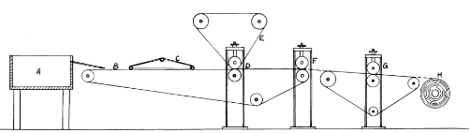
It was not until 1806 at Frogmore paper mill Hemel Hempstead that a fully mechanical paper machine could be designed by Bryan Donkin with the assistance of the Fourdrinier brothers as demonstrated in figure 4. This design today is still called a fourdrinier forming section and is capable of forming sheets of paper up to 11 meters wide at speeds of 2000 meters per minute. Since this development paper manufacturing has gone from strength to strength with the first paper machine globally reaching 1 mile per minute in 1997. (HAUNREITER, 1997)
Figure 4 - Bryan Donkin’s Fourdrinier Design

Modern Paper Manufacturing
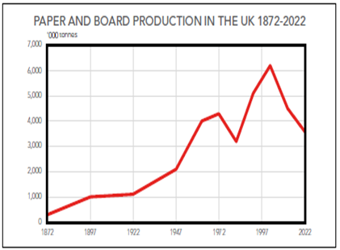
Paper manufacturing in more recent decades has been growing rapidly in the UK with demand for packaging as shown in figure 5. (industries, 22).
Figure 6 however shows a steady decline over the last decade driven by a reduction in newspaper and printed articles. The demand for corrugated boxes however has remained stable, other than the one increase of demand in 2020-2021 as a result of increased E Commerce driven by the Covid 19 pandemic as demonstrated in figure 7. (Industry, 2024 )
Figure 5- Paper and Board production 1872-2022.
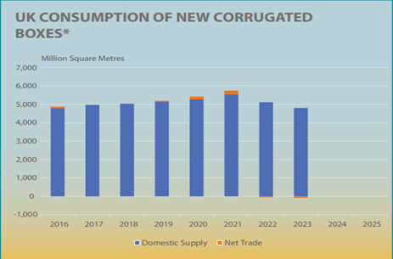
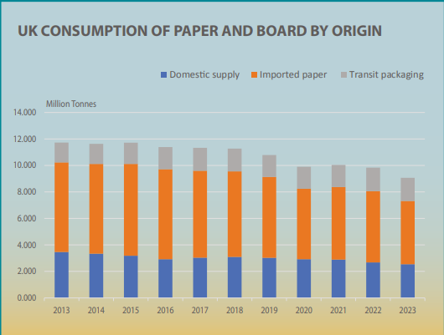
Figure 6 - 10 Year Paper and Board Consumption

Figure 7 - 10 Year Paper and Board Consumption

As paper and board demand has increased over many decades the demand for raw material has increased therefore leading to additional collections from households and retailers, this results in the quality of the available raw material reducing especially as the quality of recovered paper is affected by multiple issues. It is well documented with greater collections they are always detrimental to the quality of paper collected, especially when the collection rates are already high . (Ruben Miranda, 2012)
Easy to collect high quality material are sourced first by recycling groups and sold at a premium whilst in the case of a demand increase, lower quality and more dispersed sources are exploited such as recovery from households.
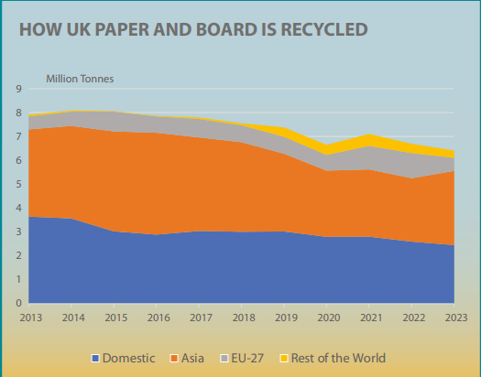
The quality of raw material has also been impacted by exporting raw material to India, China and Turkey as seen in figure 8 who pay above the spot price for higher quality material. (Industry, 2024 )
Figure 8- UK Paper and Board Recycling
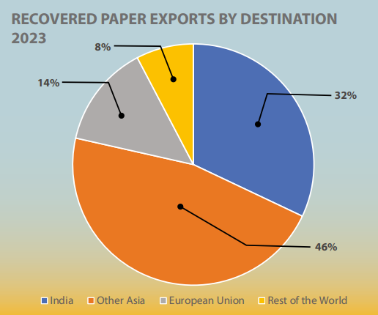
The exports of raw material for 2023 are shown in figure 9 which clearly show India and other Asian countries driving the export demand which reduces the available higher quality paper for UK paper mills.
With household collections increasing the requirement for sorting of recycled material is necessary at material recovery facilities (MRF’s) to try and separate into the desired streams such as metal, plastic, wood and fibre. This challenge was noted by (Plan, 2006)“It is known that the quality of recovered paper from English MRFs is not as good as in other countries. English MRFs are not achieving the quality standards of 3rd or 4th generation MRFs of North America and Europe” Their findings suggest that upt0 10-15% of all material in recovered paper is unusable for the manufacturing of paper, this therefore leaves paper facilities vulnerable to variations in quality from their raw material suppliers.
Figure 9- UK Paper Export by Destination
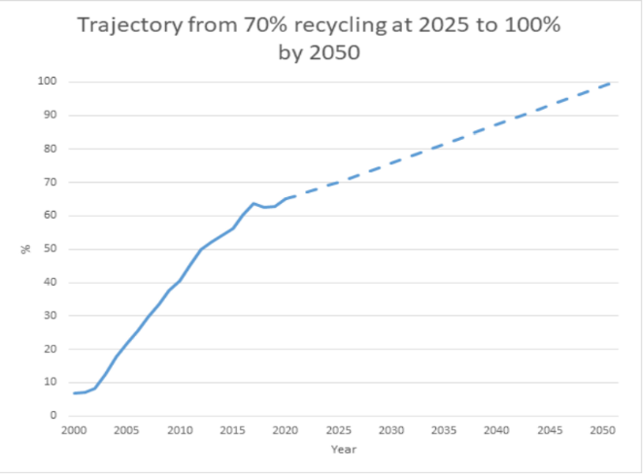
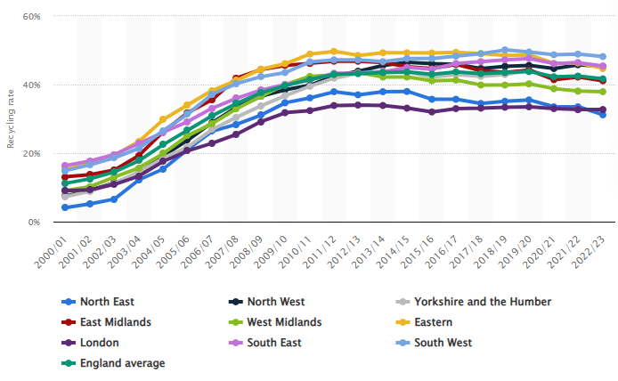
The UK government waste management plan (Affairs, 2021) indicates that the English recycling rate is currently at 42-44% which is below that of neighbouring countries such as Wales that sit at >65% (Government, 2019). The target for England is to be >65% by 2030 and for Wales >75%, these are bold targets for the English government considering their recycling rate growth has been static since 2010 as demonstrated in figure 10. When compared to figure 11 which shows the Welsh governments rate of recycling and forecast to 2050, we can see there is a clear difference in the rate of change since 2000.
Figure 10 - English Recycling Rates
Figure 11 - Welsh Recycling Rate
This rate of change could be explained by multiple variables but surely cultural and procedural practices must be at the heart of such improvements, for one that is significantly outperforming the recycling rate of its neighbour England this should be considered insightful and inspirational for other regions to follow.
The English waste management plan regulation 13(3) (Affairs, 2021) indicates that “every waste collection authority, when making arrangements for the collection of waste paper, metal, plastic and glass, to ensure that those arrangements are by way of separate collection” yet in regulation 13(4) allows conditions to be ignored if one of the following conditions is met “collecting waste together results in output of comparable quality, separate collection does not deliver the best environmental outcome, separate collection is not technically feasible or would entail disproportionate economic costs” . This fundamentally undermines the strategy of single material collections and promotes comingled recycling practices as local authorities can avoid additional costs of single collections by conducting comingled collections and passing the material onto the material recycling facility who absorb the additional cost. The MRF’s who then separate the material pass these additional costs onto their customers being industry such as plastic, glass and paper or waste to energy plants.
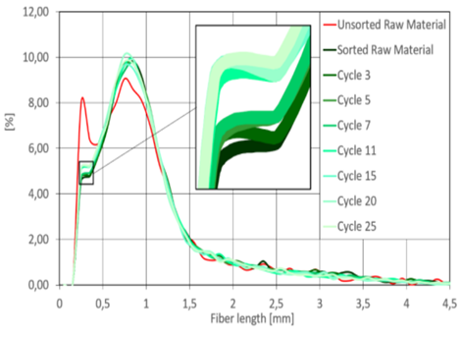
The reduced quality of the raw material results in the paper mill cleaning systems having to work harder and more efficiently to ensure removal of any contaminants such as metal, plastic, sand and fibre rejects. As we know from the work of (Eckhart, 2021) in figure 12 the fibres used in paper manufacturing although traditionally stated they can be recycled 7 times before the end of their functional use, we now see up to 25 times the fibres can be reused making the product a very sustainable option for the packaging needs of retailers and other customers alike.
Figure 12- Fibre Recycling Rate vs Fibre Length

Sustainability
The requirement of sustainable packaging and practices from retailers and customers has been increasing in recent times driven by the mandatory requirements of sustainability reporting from the EU. The EU “Green Deal” made the following pledge in December 2019, the European Commission made a commitment to review the provisions concerning non-financial reporting of Directive 2013/34/EU of the European Parliament and of the Council. The Green Deal is the new growth strategy of the Union. It aims to transform the Union into a modern, resource-efficient and competitive economy with no net emissions of greenhouse gases (GHG) by 2050. It also aims to protect, conserve and enhance the Union's natural
capital, and protect the health and well-being of Union citizens from environment-related risks and impacts. The Green Deal aims to decouple economic growth from resource use, and ensure that all regions and Union citizens participate in a socially just transition to a sustainable economic system whereby no person and no place is left behind. It will contribute to the objective of building an economy that works for the people, strengthening the Union’s social market economy, helping to ensure that it is ready for the future and that it delivers stability, jobs, growth and sustainable investment. (METSOLA, 2022)
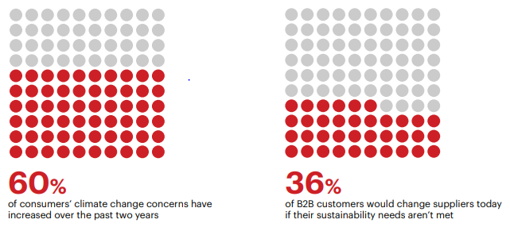
This mandatory requirement to separate economic factors and sustainability has changed the landscape of manufacturing of one that can no longer focus only on output and Earnings Before Interest Tax Depreciation Amortisation (EBITDA) but develop detailed strategies that are measurable for sustainability reporting as evidence for the European Union, shareholders and internal or external business stakeholders. As highlighted in figure 13 60% of consumers are now more concerned on climate change and 36% of Business to Business (B2B) customers would change suppliers if their sustainability needs are not met, this is a fundamental shift in business mentality whereby cost, lead time and quality are no longer the only principle drivers of supplier selection for consumers. (Company, 2024) Figure 13- Consumer Sustainability Feedback
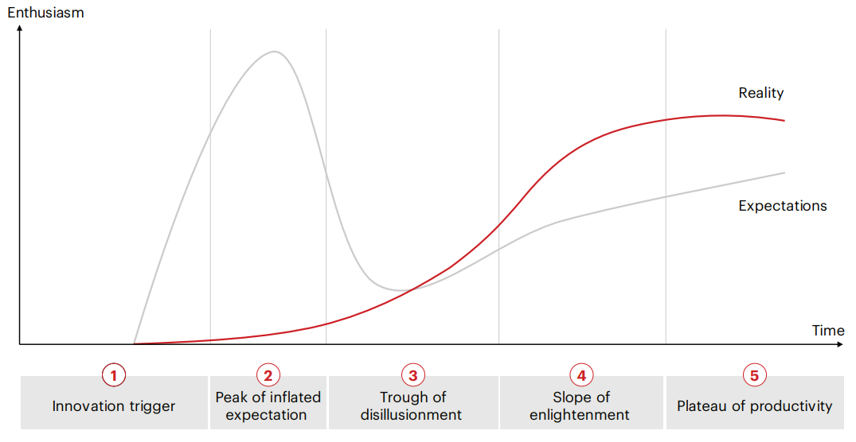
With this feedback in mind it is important to illustrate where society actually is with its approach with sustainability using transformation forecast charts as shown in figure 14. This predicts with the recent enthusiasm for sustainability coupled with the lack of evident change we would actually find ourselves in the trough of disillusionment and it will not be until the future we begin to see real change exceeding initial expectations.
Figure 14 -Change Cycle Example
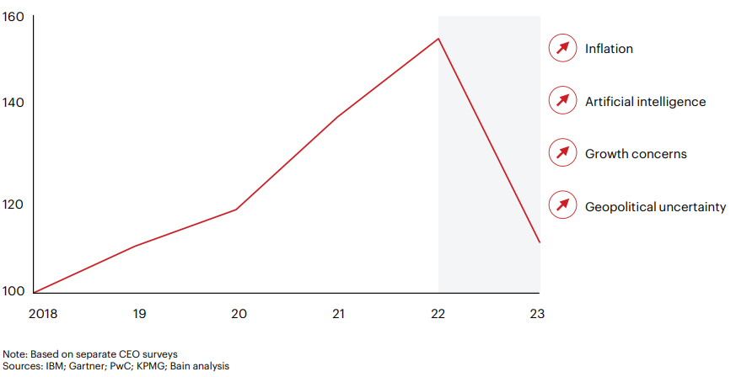
(Company, 2024)
This trough of disillusionment is only echoed by the recent CEO survey in figure 15 which shows the prioritisation of sustainability has been overtaken by geopolitical uncertainty, growth concerns, Artificial Intelligence (AI) and inflation. This aligned with the mandatory requirements of reporting, lack of progress and heightened interest many businesses are simply missing their commitments to sustainability resulting in damaged reputations and potentially fines.
Figure 15 - CEO Survey Results
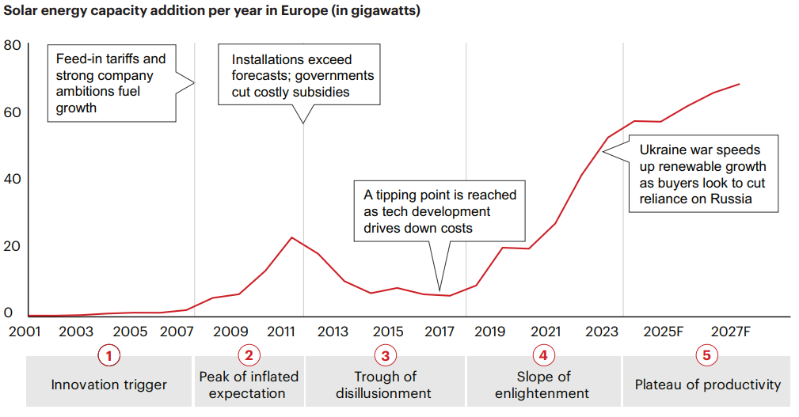
These challenges should not deter businesses from looking for sustainability improvements and practices as they bring great rewards in terms of investor engagement, customer delivery, profitability and reputation, therefore businesses should take solace in examples such as solar energy capacity as demonstrated in figure 16 which give evidence that these transformations are possible but can take not years but decades to see results. (Company, 2024)
Figure 16- Transformation change of solar energy capacity.

Smurfit Westrock and Customers
Smurfit Westrock’s history can be traced back to 1938 in Dublin when Jefferson Smurfit purchased a box making plant, later being listed on the stock exchange in 1964. In 2005 Smurfit merged with Kappa packaging forming Smurfit Kappa where it grew its European and south American business into the regional leaders for packaging. In July 2024 Smurfit Kappa became Smurfit Westrock after acquiring the north American entity Westrock. Smurfit Westrock is now a global leader in sustainable packaging with over 100,000 employees working at 63 paper mills, over 500 conversion plants in 40 countries world wide offering products ranging from simple brown boxes, bag in box and shelf ready packaging as seen in figure 17.
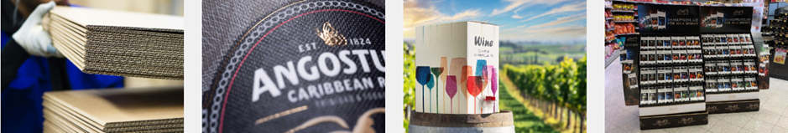
Figure 17- Smurfit Westrock Products
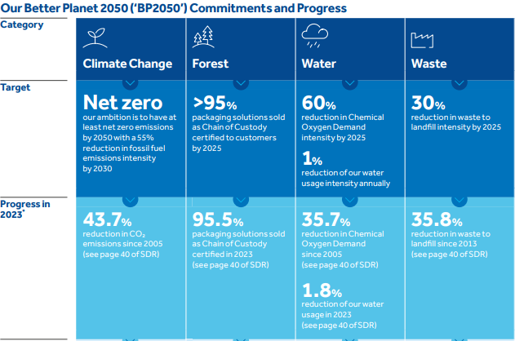
In recent times Smurfit Westrock has focused heavily on reducing its impact to the environment by having sustainability targets focused around CO2 emissions, use of fossil fuels, water management and landfilling rejects as shown in figure 18. As seen in recent results Smurfit Westrock is achieving its goals in waste reduction and chain of custody related to forestry with good progress also being made on climate change and water in line with the 2050 target. (Westrock, 2023)
Figure 18- Smurfit Westrock Sustainability Targets
Having a clear and transparent approach to sustainability is one of the strengths of Smurfit Westrock which in part plays a role in attracting new investors, satisfying regulations and other internal and external stakeholders. This approach is supported by a measurable plan as demonstrated in figure 19. This gives insight to the developments that have been achieved as well as the trajectory of the business versus its sustainability targets. If we consider the transformation curve as previously discussed we can see in 2005 could be considered the innovation trigger, the peak of excitement around 2007 followed by a plateau performance possibly indicating the trough of disillusionment from 2007-2010. This is then followed by the slope of enlightenment which now seems where the business has been for around 15 years.
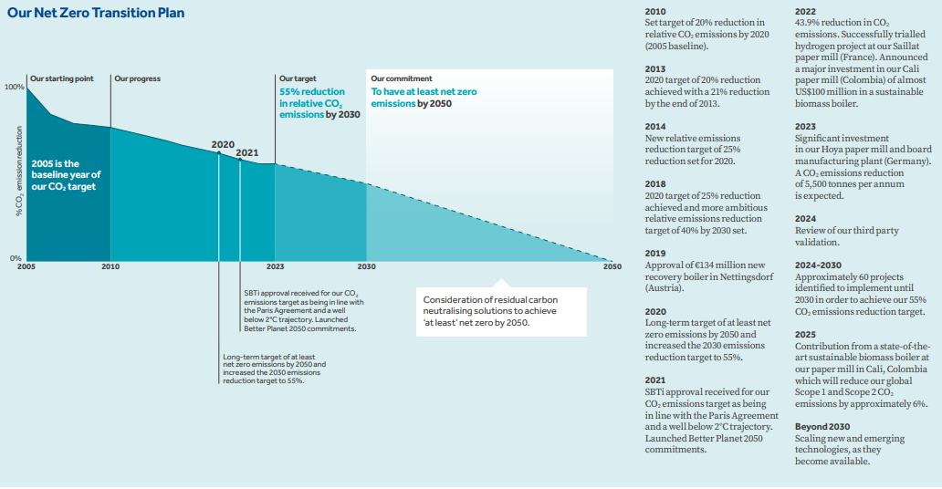
Figure 19 - Smurfit Westrock Sustainability Timeline
Part of what makes Smurfit Westrock successful is its partnerships with its major customers, these partnerships are based on shared values, share responsibility and understanding how we can add value to the supply chain by helping each other achieve our goals.
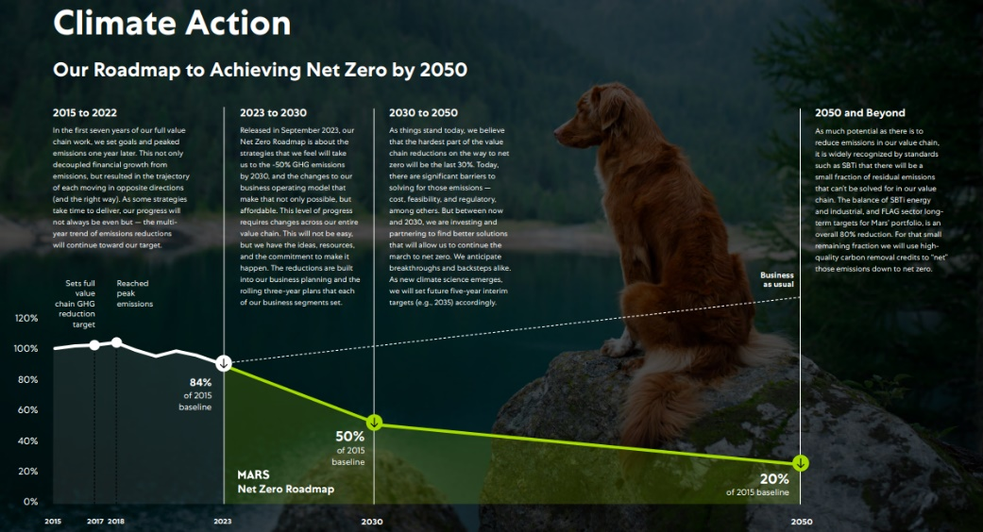
The major customers of Smurfit Westrock are PepsiCo, Nestle, Mars and Proctor & Gamble, these customers have very similar outlooks on sustainability as demonstrated by Mars in figure 20. Their approach and roadmap is almost identical to Smurfit Westrock with a drive to net zero before 2050 including a transparent timeline demonstrating progress and projections of performance. (Mars, 2023)
Figure 20- Mars Sustainability Timeline
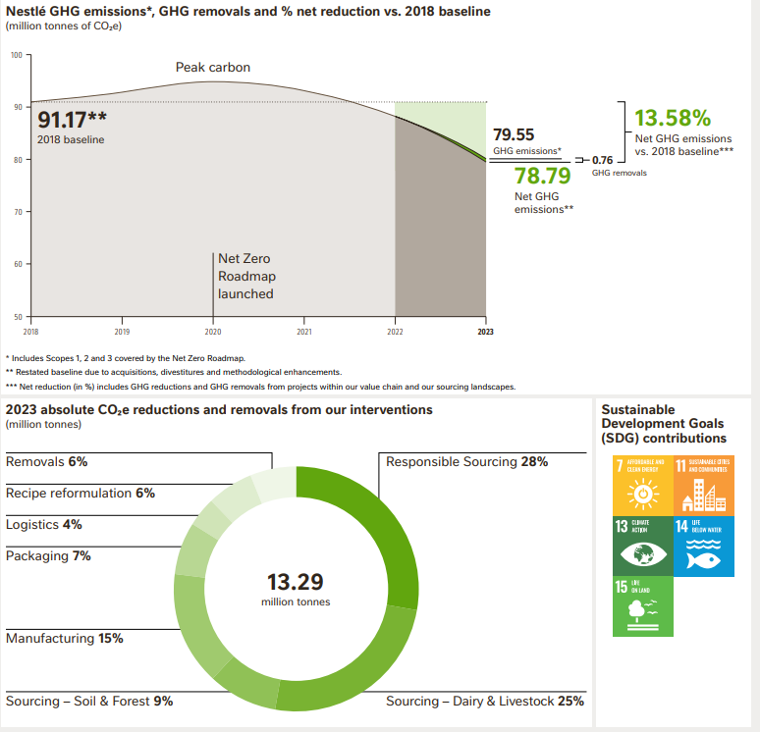
Nestle have a similar roadmap and also track individually the improvements they have made with packaging a clear area of improvement at 7% in figure 21. (Nestle, 2024)
Figure 21 -Nestle Sustainability Timeline
The direction and alignment of strategies are consistent across all of the major customers that Smurfit Westrock have, again in figure 22 and 23 we can clearly see that Proctor and Gamble as well as PepsiCo are driving towards 100% responsible packaging whereby it can be Reduced, Recycled, or Reused. (Gamble, 2023) (PepsiCo, 2023)

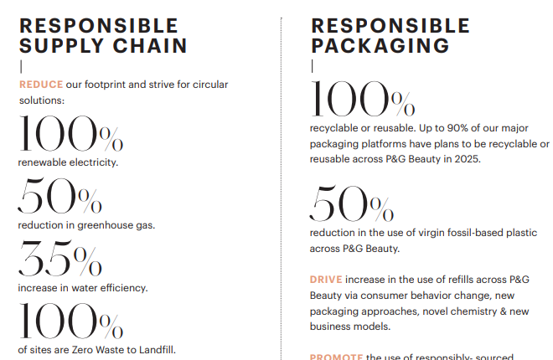
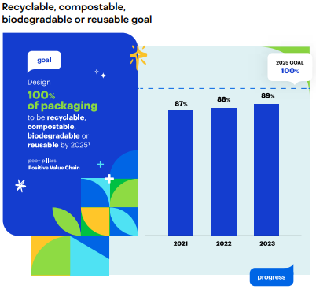
Figure 22- Proctor & Game Responsible Packaging
Figure 23- PepsiCo Responsible Packaging Result
The circular economy is a key consideration of the sustainability strategy of many businesses in modern times and Smurfit Westrock is no different. The circular economy was first coined by Pearce and Turner who described the principle as “everything is an input to everything else” The circular economy is considered to have a relationship between the economy and the environment which is prominent in this model. The model incorporates three economic functions of the environment: resource supplier, waste assimilator and source of utility. (Vasileios Rizos, 2017) Pearce and Turners work was inspired by (Boulding, 1966) who describes the open economy of the past "I am tempted to call the open economy the 'cowboy economy,' the cowboy being symbolic of the illimitable plains and also associated with reckless, exploitative, romantic, and violent behaviour, which is characteristic of open societies. The closed economy of the future might similarly be called the 'spaceman' economy, in which the earth has become a single spaceship, without unlimited reservoirs of anything, either for extraction or for pollution, and in which, therefore, man must find his place in a cyclical ecological system which is capable of continuous reproduction of material form even though it cannot escape having inputs of energy”. This statement is now truly reflected in modern society as demonstrated in by Smurfit WestRock’s example of how paper is sustainable and part of the circular economy.
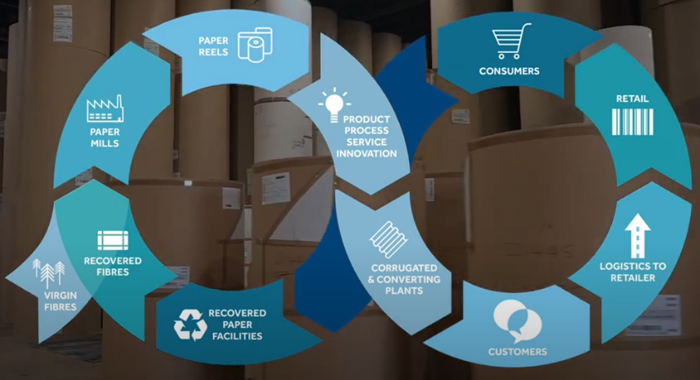
Figure 24 illustrates how fibre is taken as part of sustainable forestry involving timber merchants and reused and recycled multiple times as part of the circular economy. The challenge and undocumented part of this circular economy is the use of the rejected material from the paper making process which could be used in waste to energy, land regeneration, brick manufacturing and other industrial applications.
Figure 24- Smurfit Westrock Circular Economy

Investigation Background
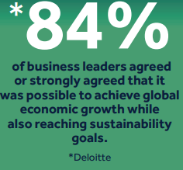
The catalyst of the investigation to explore opportunities to reduce paper mill rejects from the outlets of the stock preparation process is driven by the need to reduce the tonnes of CO2 emitted (tCO2e) from the process to the environment. The drive to reduce the tCO2e from our paper mills is dictated by EU regulations which the business must meet as part of the EU green deal (METSOLA, 2022), this is true of Smurfit Westrock customers too, therefore we have a shared responsibility to reduce our environmental impact and hold each other accountable for doing so. Should Smurfit Westrock fail to meet these targets and regulations it could potentially lead to loss of business and potentially fines, therefore we must find ways to be economical whilst environmentally responsible which 84% of business leaders believe is achievable as shown in figure 25. (Westrock, 2024)
Figure 25- Economic Growth Vs Sustainability
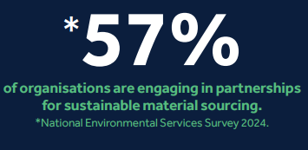
This ethos is supported by the Smurfit Westrock half year insights report detailed by multiple retail sources whereby consumer feedback indicates “Sustainable packaging and products and reducing waste are the two practices consumers value the most” (Westrock, 2024), the report also indicates that the strategy to partner with our major customers is aligned with other businesses as shown in figure 26.
Figure 26 - Business Partnering for sustainability.
The UK paper mills omit different types of rejects which all have contributing factors on the tCO2e that the business has to declare and report, these numbers are then analysed by our customers to ensure we are reducing our tCO2e in line with our strategy. These reductions cannot continue in their current fashion as the low hanging fruit available for quicks will soon dry up, therefore a detailed analysis of the process with potential innovative solutions to help Reduce, Recycle or Reuse the rejects of the process must be conducted.

Problem Statement
To understand the problem in detail we must review the whole paper manufacturing cycle from source to consumer, to do this requires information, data, opinions and solutions from multiple areas of our business as well external stakeholders to understand their wants and needs.
Although the project is driven by the needs of the customer we must also take into consideration our own internal benefits, even without the need to reduce tCO2e we must drive to reduce waste, improve quality and reduce costs as part of our businesses continuous improvement initiatives as suggested by Taiichi Ohno the founder of Lean principles (Monday, 2022).
With this in mind our problem to be investigated is the driving forces behind the rejects produced during paper manufacturing, how we can reduce them if at all, how do identify them, how to reuse them and how to recycle them? With energy to answer or provide potential solutions for these questions it is my belief we could give insight on delivering real value to our customers, shareholders and internal and external stakeholders.

Research Methods
The research will follow a traditional Define, Measure, Analyse, Improve and Control (DMAIC) as per lean six approaches, the reason to use this method is that the tools and techniques involved at each stage allow for a comprehensive review of the investigation before moving onto the next step. The steps undertaken during DMAIC are highlighted below with examples of how that research is displayed and used throughout the investigation.
The investigation will conclude with a theoretical control scenario as the research will be conducted as an industrial trial with the potential to be converted into a business capital project.
Define
The define phase is arguably the most important element of the DMAIC process due to the importance of defining the problem correctly, its impact to the business and identifying the size of the investigation. Before we start any investigation we must form a team with clear and understood roles within the team, this should include what skills you bring to the team so the project manager can allocate those best suited to roles and tasks that arise throughout the investigation. A contract of behaviour is also advised when starting a project or investigation to ensure team members are clear on the expectations both from the business and each other, this builds trust and respect amongst the team members by highlighting what will and will not be accepted throughout the time working together as well as aiding in the execution of project timelines.
When forming the team it is critical for the project manager to understand the changes the team will go through as they begin working more closely together, this is typically highlighted best by Tuckman’s model of team development (Tuckman, 1965) whereby the stages of team development were explored and concluded there are four stages of team development, Forming, Storming, Norming and Performing. In 1977 Tuckman and Jensen revisited this model and concluded that another stage of team development is in fact present which is Adjourning (Tuckman, 1977), the effectiveness of the team through its lifecycle is demonstrated below in figure 27.
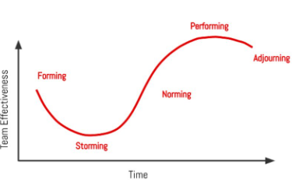
When the team is in the forming stage the group are typically eager to display their abilities and will be forming an identify and purpose as a team which leads to questioning of each other and the project, this then leads the group into storming whereby the group is conflicted and begin to compete to ensure their presence is felt and their character understood. During storming we can expect that emotions are higher here as there will be resistance from some members to work together or in a certain way to deliver the project outcomes, this should be managed by the project manager to ensure clarity throughout the team.
Figure 27 - Tuckman and Jensen’s Team Development Curve
Once the team has moved through the storming stage they begin to perform normally with lower levels of anxiety and emotions as the team now work collaboratively with a supporting nature, the project manager should take this opportunity to recognise their efforts, give feedback and ensure the energy is right in the team.
With the team now in a state of normality it is natural that they begin performing at an elevated level as they can act independently as a team to deliver results within a healthy team environment, the project manager should celebrate this culture and encourage the team to make decisions, give feedback to peers and problem solve amongst themselves.
The last stage of team development is Adjourning, this was added after the initial four stages as there was a recognised need to demonstrate the team change from executing the project tasks to process orientation. This stage is can often lead to team members leaving as they are more suited to task execution than managing processes long terms, this can lead to sadness in the team, a slight lack of performance or indeed the team moving back into one of the previous stages as new members may join the team.
A common concept used in defining the problem is 5W1H or the Kipling checklist due to the poem by (Kipling, 1902) which states “I keep six honest serving-men (They taught me all I knew); Their names are What and Why and When And How and Where and Who.” With this problem statement solution we ask the following questions, What is done? What is the purpose? What is necessary? Why it is done? Why is it done that way? When is it done? When would be better? When should it be done? How is it done? How can it be done better? Where is it done? Where is the best place to do it? Who does it and who could do it easier? From the answers to these questions we can begin to form a problem statement that is measurable, accurate and related to the problem at hand.
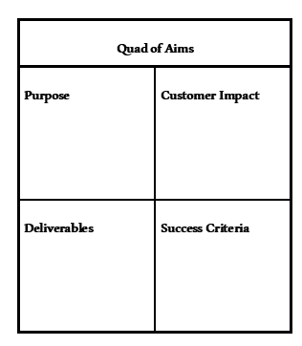
During the define phase a clear business case should be made as to why the problem is an issue, the cost to the business and the return on investment (ROI), this can be both in monetary and intangible means by way of reputation and customer satisfaction. Tools such as a quad of aims as per figure 28 can be utilised here to ensure that the project definition and scope is fully understood by all involved, this clarity at the start of the investigation allows for planning to be more accurate and delivered without question of missed agendas. What is in and out of the investigation scope must be clearly defined to ensure the team involved do not begin working in areas that are not agreed within the project scope, this can waste time and cause disharmony amongst the team.
Figure 28- Quad of Aims
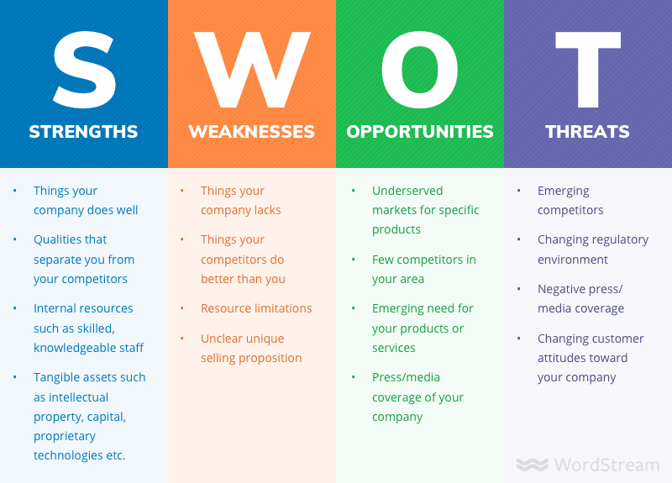
Additional tools for the business case we can consider are that of Strength, Weakness, Opportunity and Threat Analysis (SWOT) as described by Albert Humphries (Richard W. Puyt, 2023) which helps us understand the strategic importance of a problem and potential areas that could elevate a business further and what areas threaten a business as demonstrated in figure 29.
Figure 29 - SWOT Analysis
These type of reviews add context to how a business and its processes are setup to deliver goods and value to their customers and also demonstrate areas they are willing to neglect in pursuit of more important areas.
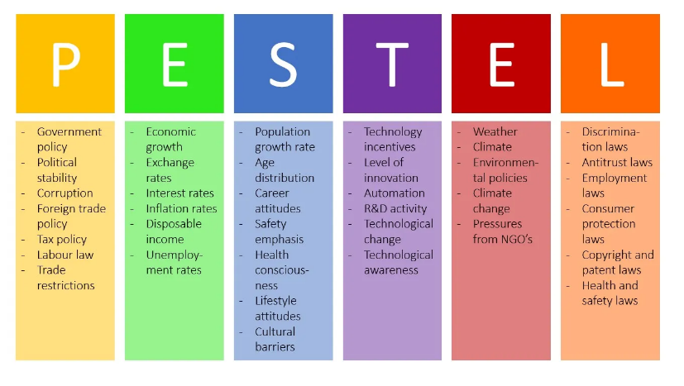
To compliment the SWOT analysis a Political, Economical, Social, Technological, Environmental and Legal (PESTEL) analysis can be evaluated such as figure 30 to understand the external factors that may affect your business and ultimately any project investigation you may proceed with. The work of Francis J. Aguilar set the foundations of the PESTEL analysis with his explanation of economic, technical, political and social influences on business environments. (Aguilar, 1967) A PESTEL analysis can be used for strategic planning, risk management when considering future improvements in particular if that involves business expansion which could be exposed further to external factors which then put the long term future of the business at risk. A key benefit of the PESTEL is that it can help highlight areas where your business could get ahead of its competition by reviewing these external factors regularly and understanding the consequences of the environment that you are competing in, if for example legislation is changing for transporting goods completing a PESTEL analysis could highlight this as a risk early and begin actions to navigate the change prior to our competitors therefore giving us a strategic benefit.
Figure 30 - PESTEL Analysis
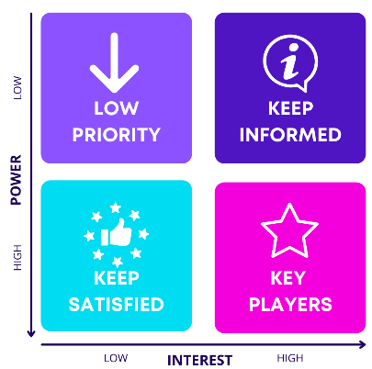
Another milestone in the define phase is the stakeholder matrix, this can follow the example by Aubrey Mendelow (Mendelow, 1991) in figure 31 whereby we review the interest and the influence of the stakeholders which then defines their level of involvement in the investigation or project. This sets a clear understanding of the level of communication a stakeholder can expect throughout the project without the team upsetting stakeholders with either too much or too little information which could then create disharmony in the team or worse impact the final result of the project.
Figure 31 – Mendelow’s Stakeholder Matrix
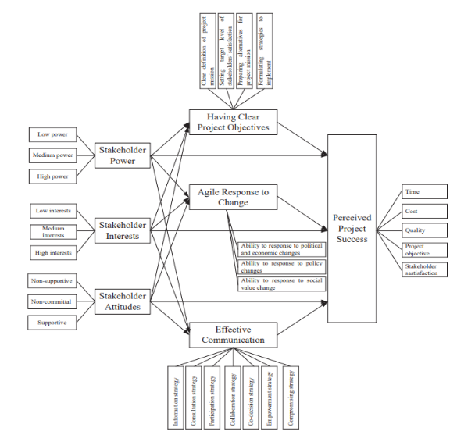
This is particularly important when the team faces hurdles that need removing to ensure they can proceed as demonstrated in figure 32 (Mohamed, 2018) , knowing which stakeholders have both the power and interest in the project to help solve problems or adjust to changes is pivotal to adhering to project plans.

Figure 32 - Stakeholder Impact on projects.
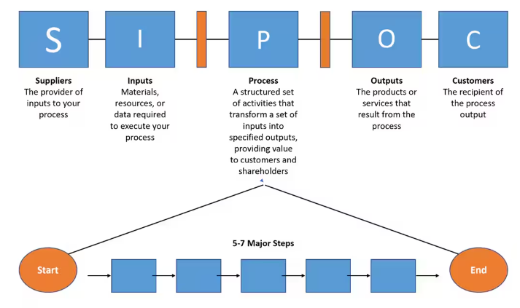
To ensure there is clarity on the process in question with relation to the problem statement, a high level process map should first be created but not before we have considered and identified the Suppliers, Inputs, Process, Outputs and Customers (SIPOC). This helps us map the current process state and highlight any potential bottlenecks that may need addressing during the project or investigation as shown by the example in Figure 33.
We identify the suppliers to ensure the quality of the inputs to the process and understand what implications they have on our process, this should consider efficiency to supply and the quality of the supply to our process. The inputs are identified as raw materials, resource and equipment, this should consider that any deviation from the supplier to the Input which results in the Input creating a failure in the process could lead to delays or losses in the production line further on.
Figure 33 - SIPOC Layout Example
Following the Suppliers and Inputs we create the level 1 process map which demonstrates the main steps in the process considering the inputs and outputs and their related consequences. The outputs should be identified as finished goods, completed services both in person and digital but overall the output should be what the customer finds value in and why the process exists in the first place.
Measure
The measure phase is the part of the investigation where by we define the process in detail, set the baseline performance, understand how we will collect data and provide a factual understanding of the current process state whilst offering insights to opportunities for improvement. (K Selvi, 2014)
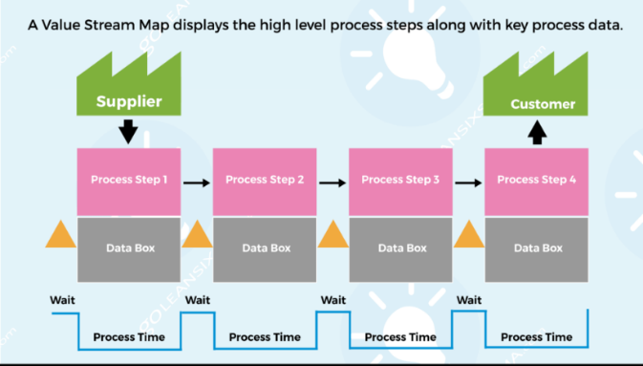
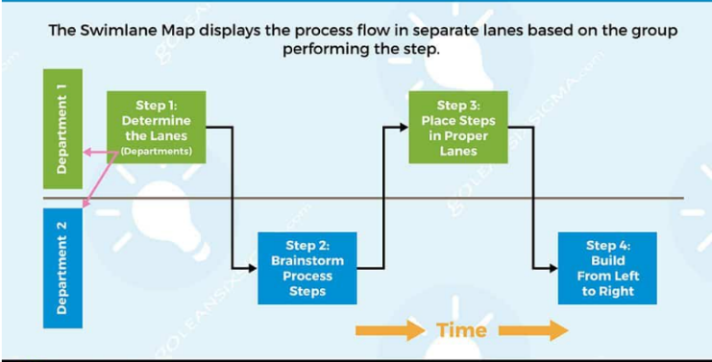
The first element of the measure phase is to detail the process in question, as per Demings ideas on a process being If you can’t describe what you are doing as a process, you don’t know what you’re doing. Creating a process map is achieved by detailing each step taken during the process, these come in two main types, a process flow that can also be split into a swim lane diagram and value steam maps (VSM’s) dependent of the level detail of required to map the process accurately as demonstrated in figure 34.
Figure 34- Process Flow Swimlane Vs VSM
Two tools that compliment these process maps are process stapling which is the action of stapling yourself to the workflow and following it through every step to understand what happens as well as spaghetti diagrams which track the process flow on a map of the area involved to look at the movements and time involved.
Following the process mapping it is necessary to create the data collection plan, this is critical to the understanding of what will be measured, how it will be measured , what type of collection is used, ensuring accuracy of data and then explaining how it would be visualised as demonstrated in figure 35. Without this clarity the investigation can move in the wrong direction as incorrect data can be collected which undermines the investigation or leads us to look at areas that are not included in the investigation as set out in the project scope.
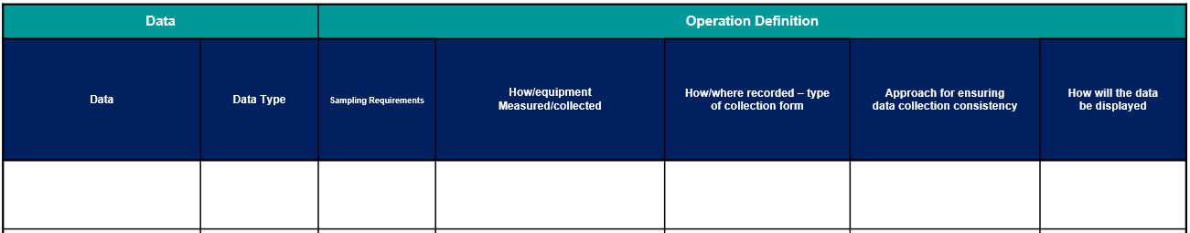
Figure 35- Data Collection Plan Example
Next in the measure phase is to establish the baseline in which the investigation can be measured against following any improvements, the baseline must be measurable in terms of volume, %, Defect Rate, Time, Cost, customer satisfaction scores to name but a few. This helps us understand what Key Performance Indicators (KPI’s) we can use throughout the investigation to demonstrate improvements or failures, these should be fixed at the start of the project to ensure we are not biased in our findings whereby targets are moved to make projects look more successful than they actually were.
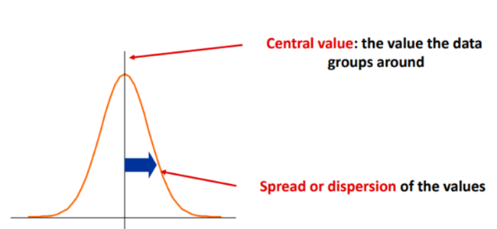
When establishing the baseline data we can then begin to use statistical analysis tools to identify trends and correlations in the data, this can include distribution and variation charts, Statistical process charts (SPC) and short to long term relationships. These measures are important to understand the current state of the process, if the process is centralised and evenly spread we are left with a chart such as figure 36.
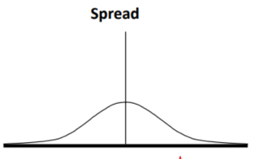
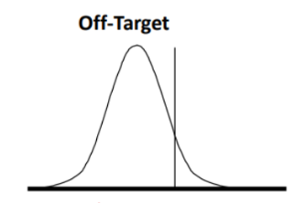
When the process is off target with low distribution the distribution chart looks like figure 37 whereby the distribution is low but not accurate. If the distribution is high but the average is on target but overall off target the distribution chart is recorded as per figure 38.
Figure 36- Off Target and High Distribution
Figure 37 - Normal Distribution Chart
Figure 38 - Off Target, Low Distribution
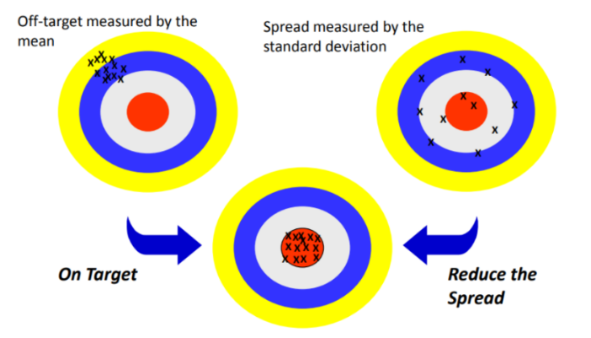
Another way to visualise this concept is by way of a bullseye as seen in figure 39, this shows the off target low distribution coupled with an off target high distribution, we are aiming for On Target, Low Distribution.
Figure 39- Distribution Chart Example
Analyse
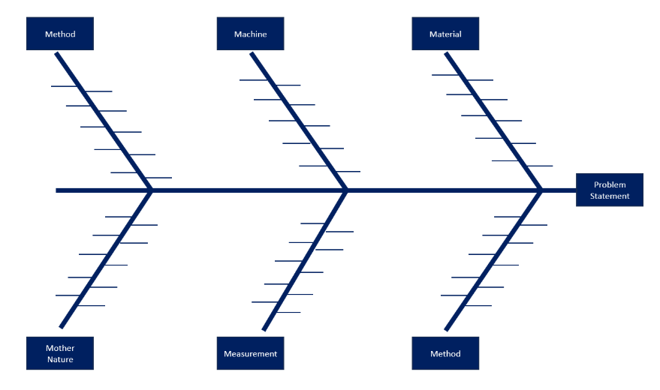
Once we have mapped our process in detail, collected our data and understood the current state we can begin to look for what might be driving the process issues by utilising root cause analysis. To conduct a root cause analysis we firstly utilise the problem statement as the target of our investigation and then discuss what is cause and effect of the problem by implementing an Ishikawa diagram or often referred to as a fishbone which was first pioneered by Kaoru Ishikawa in the 1960’s (C Botezatu, 2019). As shown below in figure 40 the problem statement sits at the head of the diagram and then we consider what could influence the problem statement using 6 predefined headers typically 5M1P, Machine, Method, Material, Measurement, Mother Nature and People.
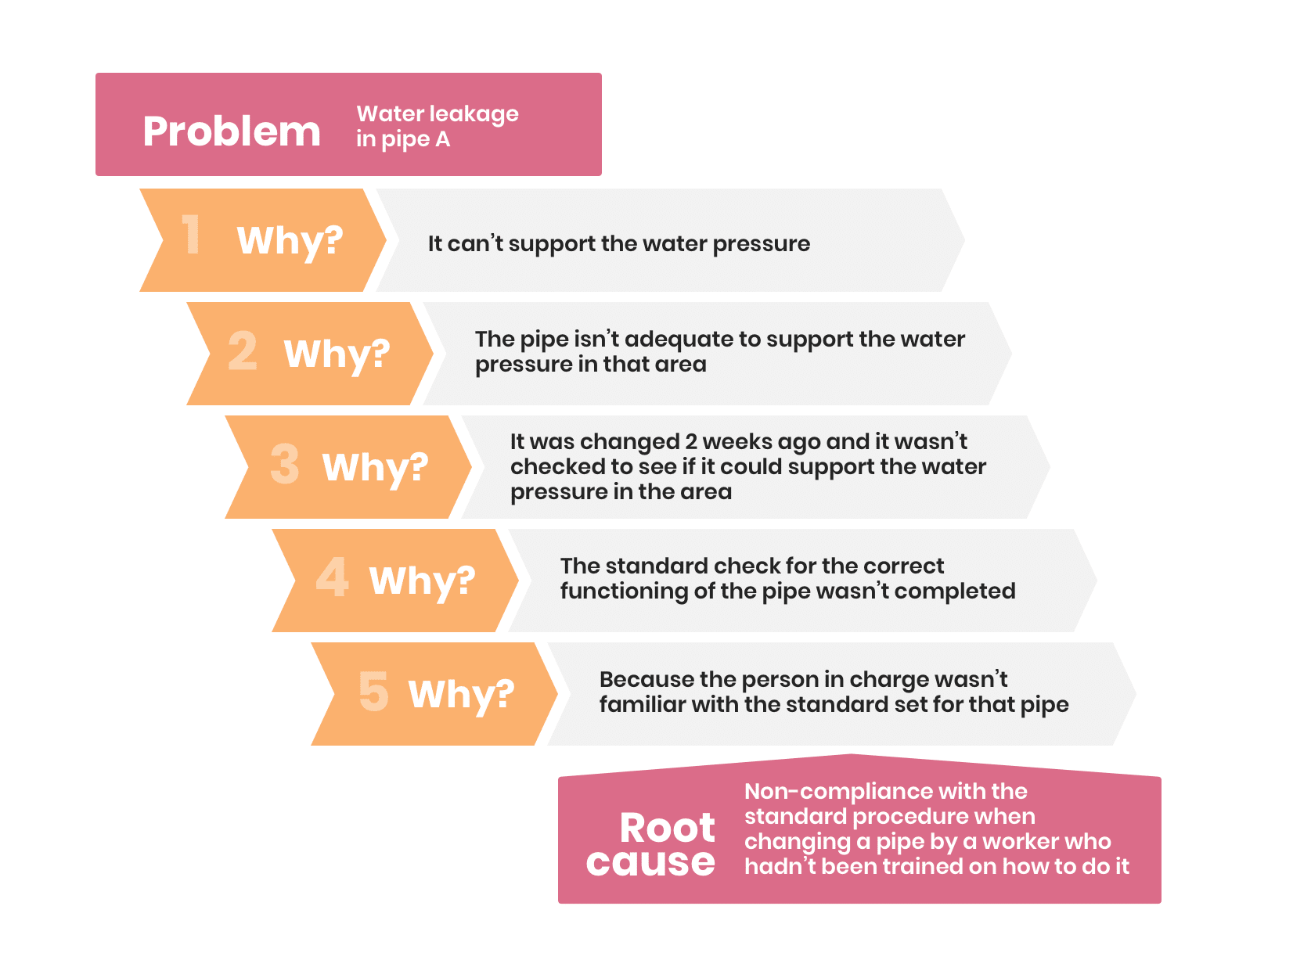
We consider what could cause the problem related to each of the 5M1P and then enter these as potential causes. We can then use validation techniques such as 5 Why created by Taiichi Ohno (Hall, 2002) to look for the potential root cause as shown in figure 41 example. This technique continues to ask the same question until we can go no further which then is considered the root cause, we can work this technique backwards by starting with the root cause and using the term therefore to move onto the next entry until we end at the problem.
Figure 40 - 5 Why Example
Figure 41 - Ishikawa Diagram
Once all of our potential root causes are identified ,those that we feel are the mostly likely to be related to the problem can be entered into an X-Y Matrix based on the importance to the customer and the relationship to each other. The stages of the X-Y Matrix are shown in figure 42, once complete we can then review the results to give the prioritisation matrix for the investigation, this will help set direction and reduce the risk that both the projects and the customers expectations are not met.
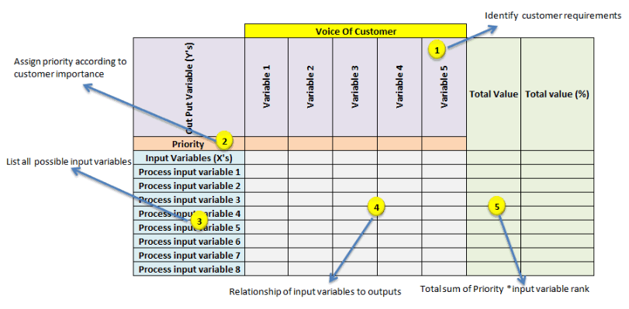
Figure 42 - X-Y Matrix Example.
Following the X-Y matrix we will utilise a Failure Mode Effect Analysis (FMEA) which is a method of identifying and preventing system failures and problems before they occur, the process was first introduced during the 1940’s by the US military then during the 1960’s by the aerospace industry and more famously by the Ford Motor Company in the 1960’s. (Kapil Dev Sharma, 2018).
The FMEA follows a set of questions regarding the potential failure mode, the effect of such a failure and how the current control measures allow for detection for each area of the process as per figure 43, this should be extremely detailed and critical of the process to ensure any potential failures are highlighted and suitable actions are put in place.
Figure 43 - FMEA Data Entry
Once the process steps are identified and questions answered we can then score each answer using a similar table as displayed in figure 44, depending on the highest severity, most likely to occur and how easy it is to detect a total risk priority number (RPN) is calculated with the higher the number the greater the risk. Once all of the steps have been calculated we can sort the process steps by the highest scores to indicate the areas that offer the biggest risk or opportunity.
Figure 44 - FMEA Scoring Matrix
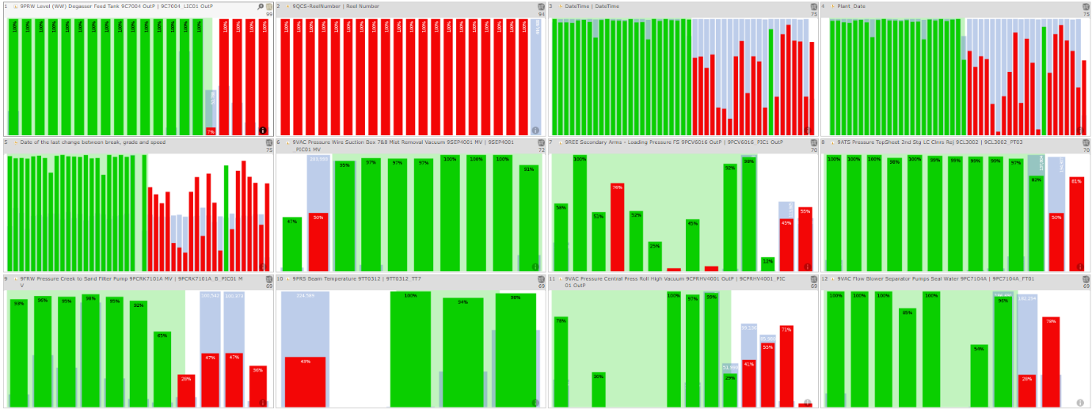
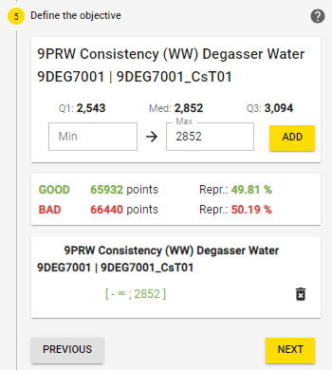
In a change to the conventional DMAIC approach of using regression analysis we will instead utilise Hypercubic analysis, this allows for limitless amounts of process variables to be added into a dataset which is followed by a question related to the data which the model then reviews for correlations and relationships. Once the data has been calculated in the model it will return the findings in a ranked order of correlation to the question asked, for example in figure 45 the model in question is asking why the process variable is above the median value highlighting that 50.19% of the values are above the median. The results returned are highlighted in figure 46, when we review the data we are looking for a clear split between the red and green data which indicates two clear operating ranges, one positive and one negative which we can then begin to review and ask questions as to how it may influence our process or project target.
Figure 45 - Hypercubic Model Results
Figure 46 - Hypercubic Model Setup
Improve
Moving into the improve phase requires the team to now invoke their creative thinking and to generate potential solutions for the problem or issue raised during the investigation, this can be facilitated by completing a brainstorming session whereby a group share ideas freely and are noted for later consideration.
When brainstorming team members typically use two types of thinking, Divergent and Convergent. Divergent thinking is typically associated with creativity, quick free flowing ideas over a short amount with unexpected connections being made. Convergent thinking on the other hand is critical in its nature, analytical and using logic, this type of thinking typically results in one solution for the problem and utilises standards and probabilities in their conclusions.
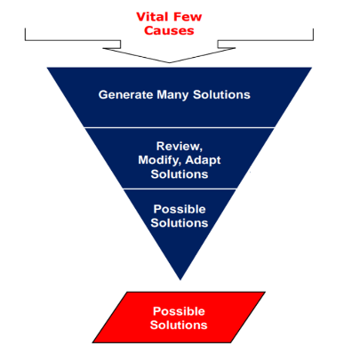
With this level of creativity and solution generation it is natural to create multiple solutions for the problem, as demonstrated in figure 47 we need to refine these ideas by reviewing them, maybe grouping them, modifying and adapting them into suitable solutions and in doing so we reduce the total number of solution to maybe one or two.
Figure 47 - Solution Refinement

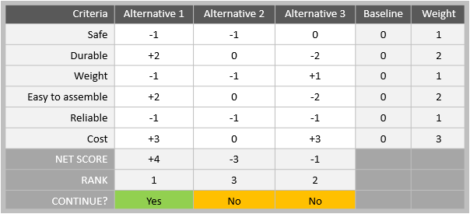
Once we have a group of solutions it can be difficult to reduce down to the one or two pilot solutions, therefore we can use tools such as a Pugh matrix (Pugh, 1990) whereby we score against a criteria set by the baseline process which helps us compare all the solutions against each other and highlight areas where each solution may be stronger or weaker as per figure 48.
Figure 48 - Pugh Matrix Example
With our solutions proposed we must now look to pilot and implement them to test against the baseline to review if we have improved or removed the problem, before we look to make any changes we should consider our stakeholders and their commitment to any proposed changes. To achieve this we can hold a stakeholder analysis to review all proposed solution and gather feedback whether they are happy to proceed or require more information before committing to any change.
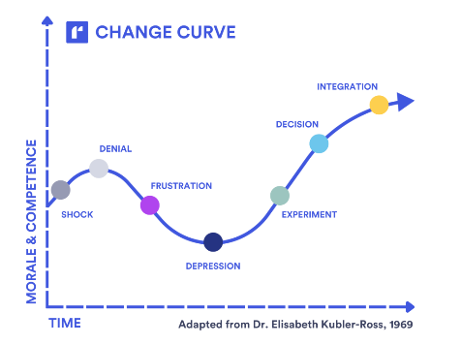
We must consider that any change will be managed sensitively and try to gauge where each stakeholder sits on the change curve, the change curve is based on the work of Elisabeth Kubler Ross which describes the stages of grief in patients with terminal illness but is now widely used to explain how to manage change. (Ross, 1969).
Figure 49 - Change Curve
As seen in figure 49 the original five stages is now considered seven stages whereby the first four are critical elements we must manage the stakeholders through to allow for experimentation and decisions on future changes, not considering our stakeholders position in the change curve can lead to stakeholders being left behind, feeling ignored and often they can disrupt any future implementations as they will actively work against the improvement due to the lack of consideration for their emotions, opinions and status in the project.
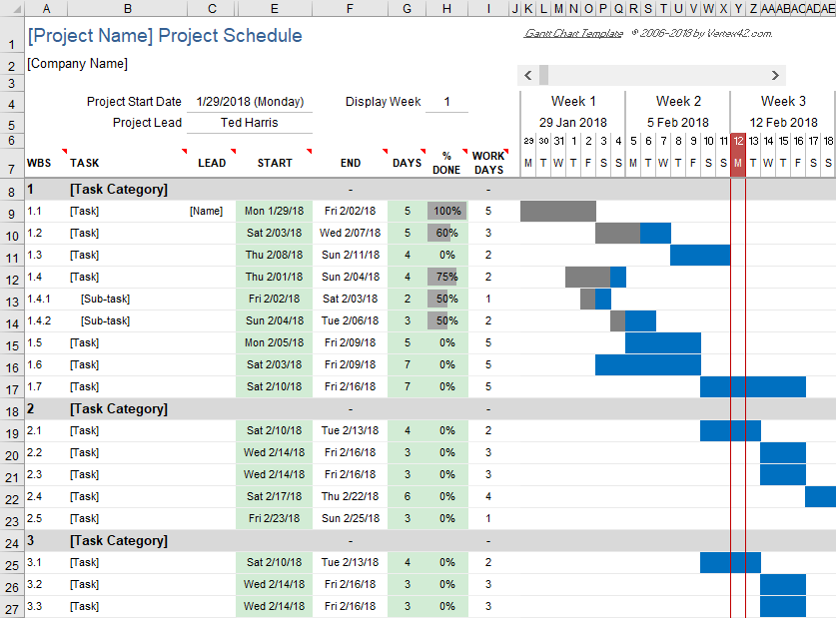
Once we have gathered the confidence and agreement of the stakeholders we can begin to build our implementation plan, to ensure good visibility and transparency of the change we should create a project plan by use of a Gannt chart, this allows multiple tasks to be grouped and mapped against a timeline with statuses and agreed completion dates as shown in figure 50. Critical to the implementation plan are the required resources, risks, risk contingency, barriers, standard operating practices and success criteria as set from the project investigation. These elements can be controlled under a management of change system which if managed correctly ensures all stakeholders needs are met and documentation is in place for any future state process. A simple yet effective way to implement the change is to follow the Plan Do Check Act (PDCA) cycle often credited to Walter A. Shewhart (Ronald Moen, 2009)which ensures that every stage of the improvement is considered as a milestone to move onto the next element, the planning will typically take up to 80% of the cycle with the implementation of the improvement, ensuring suitable control plans and monitoring is in place and finally any adjustments that are required that need actioning making up the final 20%.
Figure 50 - Gannt chart example.
Control
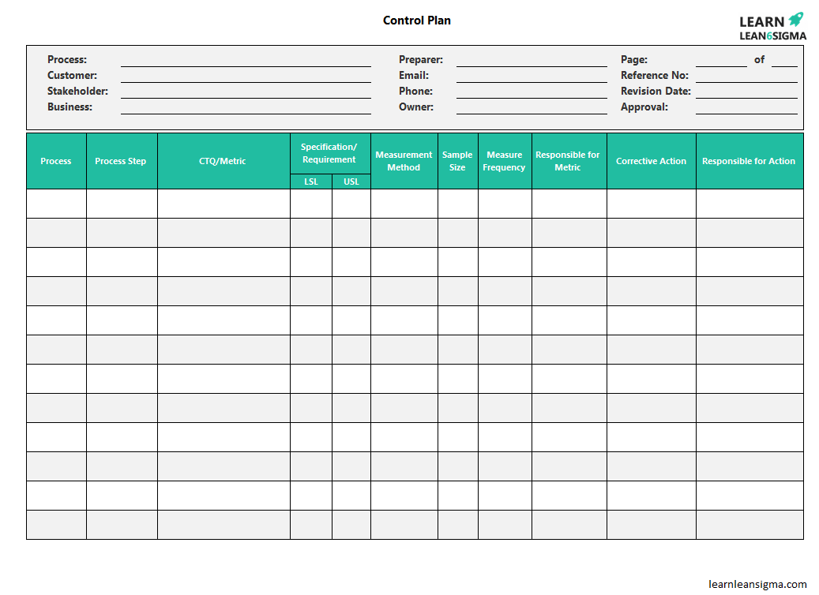
The control phase is the last action in the project where measures are put in place to ensure the new state process remains as the accepted standard of operation and we do not revert back to the old state, this can be maintained by creating a control plan that will include KPI’s, Upper and Lower Specification Limits (USL / LSL), how many checks will take place, the frequency of checking the data and who is responsible as shown in figure 51.
Figure 51- Control Chart
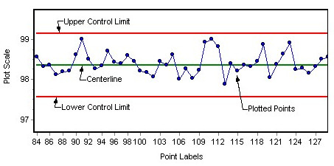
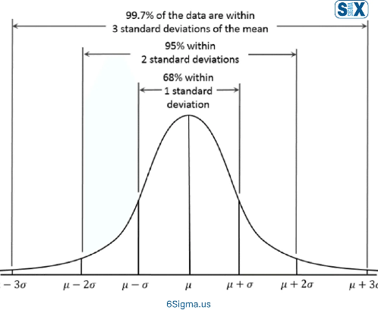
The control plan may lead to SPC charts being implemented as shown in figure 52, these are a critical visual aid to ensure the new process state does not drift outside of the agreed limits. The typical calculation for the specification limits are the target value or average +/- 1 standard deviation which means 68% of the data is within control as shown in figure 53, this sets a very tight band for the process to control within and allows us visibility of drift and non conformance to the target, moving to +/- 2 standard deviations is an option but this now means that the data is always 95% within the limits which allows much more flexibility for the process to be away from target but is considered to be of normal distribution.
Figure 52- SPC Chart
Figure 53 -Standard Deviations
Any control methods that are required for the process to remain positive must be captured with new Standard Operating Procedures (SOP’s) that clearly demonstrate any new tasks, methods, safety precautions including who is responsible, resource requirements and frequency of the SOP. If the SOP included new tasks that the team are unfamiliar performing training must be given to ensure clarity and understanding of how to perform the task, this training should be added to any training and skills matrix for these roles and the assessments signed off and reviewed by competent persons at regular intervals as per ISO9001 standards.
For this project a proposed control plan will be created with limits based on the industrial trial for a hypothetical scenario should any improvement be made in the future, this will give context of the expectations of any potential improvement and demonstrate what would be required to implement and maintain such a proposal.
Quantitative and Qualitative Research Methods
This approach is a recognised technique for problem solving with clear and defined control measures which are measurable against the baseline data. Many of the techniques used will be quantitative but elements of qualitative data collection will be used in the form of interviews and questionnaires which allow us to consider the opinions of subject matter experts (SME’s) whose experience in the field allows the investigation to have a well-rounded understanding of the process and problem alike.
This mixed approach using both quantitative and qualitive research allows for generalisations to be made against a wider population as the larger sample size of data can help reduce bias of research, this is especially true of quantitative data which is numerical data that allows for statistical analysis to be conducted which in turn allows for correlations and relationships to be identified and explored. As the structured data approach of qualitative research is defined, the research method can often be replicated with data sets from other industries and regions but following the same practices of the research originally conducted. This leads to further analysis to be completed and comparisons of results that could lead to an industry agreed best practice, greater understanding or even challenge our current understanding of any issue.
Although quantitative research is repeatable, powerful and insightful to solving problems it can have its limitations as it does not highlight any human behaviours or traits that may have led to the numerical results. We must consider all numerical analysis must also have an element of why and understanding, merely stating a value has increased or decreased without reasoning can result in a lack of substance to the analysis leaving it without meaning.
With this is in mind seeking qualitative research methods is important to understand the background of the quantitative data and give it reason, this is by understanding human behaviour, opinions and experiences from individuals or groups that have been exposed to or offer expertise to our subject area. The hope is that they can give reason to the quantitative research, comment on potential solutions, identify hurdles that prevent improvement and help direct the investigation into areas that add value.
Qualitative data gives context to the subject area although it can obviously have elements of bias due to the information coming from interviews and questionnaires, the questions therefore need to be aimed at gathering further insight and data to help find potential solutions to our problem. This research method is also more intensive in terms of time and collection methods as the structure needs developing and the questions created in a way that could be transformed into insightful additions to the quantitative data.

Literature Review
The six-sigma approach has been developed over the last 60 years through the likes of William Smith and Jack Welch, in particular at companies such as Motorola but their work is still being studied to give greater understanding and insight to its full capabilities.
(Ricardo Ba˜nuelas, 2005) reviewed the literature currently available around six sigma by studying the findings of other reports and explored a case study using the DMAIC methodology to reduce variability of a coating line. The evidence explored the use of Pareto, cause and effect matrix, quantitative data collection, Ishikawa diagrams followed by multi vary analysis, the conclusions of the study suggest that there was limited detailed case studies of the six sigma approach but the success of the case study was attributed to 6 sigma being an effective problem solving tool, management tool, project selection tool, promoting teamwork and the progress and tracking of project milestones.
(Andrés R. Cruz Herrera, 2019) provided research around the reduction of a quality problem linked to the collection centres for recycling polymers in Ecuador, their research focused around the DMAIC structure utilising statistical analysis demonstrating process capability with the use of Cp and Cpk. The research with the use of the DMAIC structure featuring tools such as VOC concluded that the process capability was not within the target tolerance of 3% impurities and with the addition of new process technology they were able to statistically prove the new technology was capable of achieving the 3% target level.
(Lenka GIRMANOVÁ, 2017) utilised a variety of tools and techniques like flow chart, histogram, Pareto, analysis of FMEA, data and Ishikawa diagram to improve the metallurgic product quality to avoid an increase in internal costs produced by low quality products.
By following the six-sigma approach they improved the 6 sigma level by 13%, this was achieved by reducing the volume of defective products in the annealing process which in turn reduced the processing costs.
(Pawan Kumar, 2021) explored the broader picture of DMAIC implementation in manufacturing by reviewing previous studies and their impact on quality control, defects per million opportunity (DPMO) were discussed and how 3.14 DPMO forms a key part of the six-sigma philosophy in delivering a reliable process with high standards of quality. Their findings concluded that due to the lack of awareness of true DMAIC practices in many organisations there is a resistance from employees and top management to change their way of working and embrace 6 sigma techniques and practices.
(Mr. Ganesh P. Jadhav, 2022) reviewed the use of DMAIC and Design, Measure, Analyse, Design, Verify (DMADV) literature to conclude areas for use and its benefits, multiple literature was reviewed from various industries. Their research found that DMAIC is a useful tool in manufacturing processes such as automotive part manufacturing, metal processing, gloves manufacturing, file manufacturing, laser mouse manufacturing, semiconductor manufacturing, grinding operations and rolling mills by productivity improvement, growing market share, retaining customers, reducing cycle time, reducing defects, developing new products and managing culture change.
A key understanding of the lean six sigma culture is the cost of poor quality (COPQ) and the impact this can have on a business, as famously quoted by (Deming, 2000) “Defects are not free, somebody makes them and gets paid for making them”. The hidden cost of poor quality should also be considered as many costs are not accounted for and therefore businesses do not have full transparency on the impact to their profit but also intangibles such as reputation.
(Uitto, 2024) reviewed the concept of cost of poor quality by reviewing multiple research studies and interviewing quality professionals on their experiences with the costs associated with quality. Their research found that typically the COPQ comes down to five fundamental failings in a business which are limited resources, lacking awareness and competence of employees, inefficient cross-functional collaboration, and unclear COPQ process, all of these items should be considered when starting to develop a culture of lean six sigma to ensure all of the employees are on the same journey as you intend for the business.
(Surange, 2013) explored the cost of quality both good and bad, this described the cost of good quality with focus on prevention and appraisal costs whilst poor quality focused around internal and external failures in particular highlighting the cost of poor quality typically ranging between 10-40% of a business turnover.
Their case study highlighted that although preventive cost may increase the total operational cost will decrease through the reduction of failure, utilising an effective quality program will allow leadership to make the cultural move from operational cost methodology to a state of minimal quality costs whilst reducing the problems found by customers.
The research also highlighted that many local plant level buyers do not have the systems and resource available to implement total quality management with the suppliers of the automotive industry in India, coupled with a lack of structure for supplier involved improvements which allows to determine the maturity of your supplier’s own quality systems to deliver on time, in full and in specification.
(Marcus Thomasson, 2013) used a mixture of qualitative and quantitative methods to develop a practical framework for continuously measuring and monitoring the COPQ in a production process. Their research reviewed the foundations of Lean manufacturing, the visible and invisible COPQ and process mapped many of the internal and external processes to allow for a transparent measurement system.
Their model split the losses and costs into 3 defined areas which were supplier costs, in house costs and customer costs with the elements of each being identified by following a step-by-step guide to highlight if it is a cost related to poor quality.
(S. Mahmood, 2015) reviewed literature of previous COPQ studies and demonstrated that the COPQ on average ranges between 16.91-26.9% of a company’s revenue, typical of the estimation made by (Surange, 2013). The research studies 42 previous studies to determine the level of maturity of measuring the COPQ, the results demonstrated there is great room for development and implementation of a quality cost measurement system in regard to the construction industry.
(Soliman, 2017) Reviewed the 8 wastes identified in lean manufacturing and potential solutions to help reduce their impact on a business, the 8 wastes are Transport, Inventory, Motion, Waiting, Over Production, Over Processing, Defects and Non utilised talent. The findings showed there are recognised strategies to improve all areas of waste but this is only possible with the commitment of the leadership in the business to employ such a culture but it is important not to merely copy the Toyota example but understand your own process and its opportunities.
Other paper manufacturers have to tried to adopt the Lean and Green approach to manufacturing. One such example is that demonstrated by (Adrian Vais a, 2006) where by lean principles were adopted over a 3-year period whilst driving an implementation of sustainability. The 3-year program reduced their waste water by 87% whilst also improving 5S, Kaizen and Total Quality Management (TQM) throughout the facility, in doing so they created twenty eight TQM groups to help drive it throughout the sites workforce which resulted in a turnover and profit increase of 300% with a total of $2million spent.
(Zahrotun Nihlah1, 2018) explores the use of value stream mapping (VSM), a type of process mapping to identify areas of waste reduction opportunity within the business, they review Value Add (VA), Necessary Non-Value Add (NNVA) Non Value Add (NVA) activities and the levels of Work In Progress (WIP) to ensure the pull through the process is streamlined. The results demonstrated by using the VSM that 82.92% was VA, 14.62% NNVA and 2.46% NVA in the current state but with their process recommendations the new process improved NVA to 1.01% demonstrating the potential of lean tools.
(Ig Jaka MULYANA, 2022) used examples of lean tools such as 5 why and waste assessment model to highlight areas that waste is present in higher education institutes, although typically applied to manufacturing sites this research shows how the tools can be applied throughout industry and service sectors. They identified 46 forms of waste in their process which could be improved to streamline their process, an interesting part of this research is that most of the waste was related to tutors trying to help their students from underperforming but actually were creating waste in their process.
In the paper making process there has been extensive research around the use of energy and rejects for many years, this is in part due to the industry being a high energy consumer but also related to the waste streams the process creates which are typically considered rejects but in more modern times we see trends moving to reusing these reject streams. The reject streams typically consist of biomass, plastics, wood, metal and other synthetic fibre all of which can be used in different technology as valuable inputs.
(Hannu Nurmesniemi, 2007) investigated the waste management program of the Stora Enso Oyj Veitsiluoto Mills in Northern Finland which at the start of 1994 were landfilling 42990 tonnes of rejects per annum, this is a significant amount of rejects which are both detrimental to the business and the environment, this level of landfill in modern times would be restricted and business disrupted by the need to reduce their tCO2e. The research found that by implementing a strong and managed waste management program, highlighting areas for opportunity and finding suitable solutions such as efficient incineration for the rejects the mills were able to reduce their land fill rejects to 6083 tonnes per annum.
(Gavrilescu, 2008) explored the use of biomass to create energy in pulp and paper mills, this is a recognised opportunity for many paper manufacturers. The research explored multiple regulations in regard to the release of emissions from incineration and the amount of energy created from bio energy in Europe, which also includes the fossil and non-fossil fuels consumed in paper mills with Biomass and Gas making up 84% of the total consumption for energy.
The result showed that multiple rejects from the paper mill can be used for energy generation, the rejects in line with a recycled paper mill such as plastic and fibre are considered viable options in specially designed combustors but must pay close attention to the release of Carbon dioxide CO2, Methane CH4 and Nitrous Oxide N2O.
(Wagner, 2005) researched the relationship between environmental and economic performance and influence of corporate strategies in regard to sustainability and environment, which was linked to previous work that showed a breaking point at which environmental and economic performance are no longer beneficial. The research was conducted in Europe by taking data from the confederations of European paper industry (CEPI) and calculating a hypothesis analysis which returned results showing that there is a negative relationship between environmental and economic performance in relation to the emissions-based index.
(L. Simão, 2018) investigated the alternative solutions for paper mill rejects such as dregs, lime mud, grits and pulp mill sludge which are all rejects common to paper mills globally therefore making the research interesting to the industry, in particular the research reviewing state of the art technology that offers new alternatives. The research suggests that the rejects can be used to generate energy by incineration and pyrolysis which heats the rejects in the absence of oxygen to produce a mixture of liquid and gaseous fuels and a solid material, this technology in 2018 was considered suitable for material such as wood, plastic and oil but the technology was not developed enough to try with pulp sludge.
(Hatem Abushammala, 2023) highlights during their research the need for the paper industry to exist due to its circular nature yet it has opportunity to improve its performance in regard to reject generation which they suggest can be up to 25% of that produced in some extreme examples. Their research suggests that the rejects from the process can be utilised in biofuels, biohydrogen, biomethane, heat, nanocellulose, hydrochar, construction materials and soil amendments.
(Byeong C. Min, 2015) conducted interesting research into the use of paper mill fine fibre rejects in the use of fermenting sugars for biofuels and bio plastics due to the cellulose found in the rejects, this gives an opportunity to explore the research of converting these fines into sugars which could then be sold for a profit or used in their process for other requirements. The research found that enzymatic conversion was possible using commercial cellulases although some fines such as calcium carbonate regularly found in paper system inhibit the enzyme hydrolysis but with the addition of a non-ionic surfactant Tween-80 helped decrease adsorption and increased the yield of sugars which could lead to an industrial solution in the future.
(M.C. Monte *, 2009) evaluated the impact of the European paper industry on sustainability and waste management, the initial figures highlighted that 70% of the European union’s paper originates from deinked recycled paper which generates diverse compositions of rejects, sludges and ashes which previously would be landfilled but due to legislation and higher taxes to landfill the industry is now quickly moving towards incineration technology and investment. The findings also found that technology such as pyrolysis had yet to be developed to an industrial standard, similar to the findings of (L. Simão, 2018) and that at the time of this research the most viable option for a reduction in rejects was to minimise the generation of the waste until technology could be scaled accordingly.

Define
Customer | Voice of the Customer | Key Issue | Measurable CTQ | Defect Definition
Operations Manager | There are too many rejects. | Reject Volume | Rejects T’s per month | Reject Volume
Finance Manager | Reject costs are too high | Business Cost | Cost per Month | Reject Cost
SHEQ Manager | CO2 per tonne is being impacted | Sustainability | CO2 per month | tCO2e
The investigation is required by the business as it has been highlighted that the cost of rejects has increased beyond an acceptable level therefore action must be taken to bring the rejects back under control, when we consider the business as the customer of the process we can create the VOC as seen in figure 54 which allows us to define the measurable CTQ’s.
Figure 54 - VOC.

The team put in place to investigate the current rejects is a mixture or engineers, technical, senior management, purchasing and finance to ensure we have a mixture of disciplines that can challenge the status quo and bring their expertise as SME’s of their respective fields as shown in figure 55. The contract of behaviour is also agreed with key elements to this investigation to be bold and think outside of the norm as we would of likely solved the issue should we of had a solution already available.
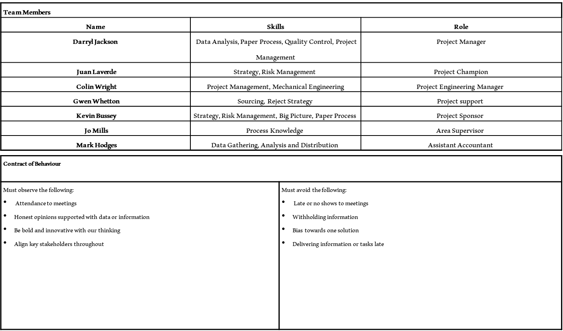
Figure 55 - Team Contract
This team is already working together in other areas of the business which allows us to consider the team is already beyond the forming stage and likely in the norming stage of the team cycle, this helps us understand who has the ability to remove road blocks and the team is aware of each other’s abilities and expertise.
When considering the stakeholders most are positive about the investigation as shown in figure 56 although the area supervisor is challenging as this is their area of the business and they have recently negotiated a long term contract for the reject removal by an external customer, although the contract keeps the costs stable for 5 years it is not in keeping with the future of circular economy whereby the rejects are used as an input to another process and the business reaps the rewards of using the rejects in this way. The long-term contract results in excess of £5 million spend over the contract period with no reduction in tCO2e which essentially stops any improvement in this reject stream unless we can financially benefit the business in excess of the contractual spend.
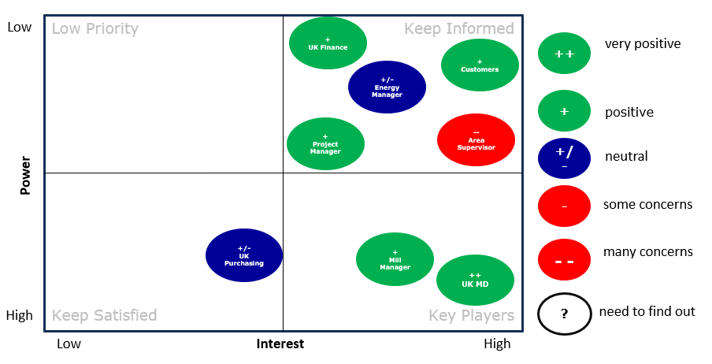
Figure 56- Stakeholder Matrix
The business is well positioned in the packaging market but this does not mean it doesn’t have threats, weaknesses, and opportunities for improvement. When we review the SWOT analysis for the business as seen in figure 57 the biggest risks are that our competitors move towards reducing their tCO2e with new technology before our business reacts therefore making them more attractive to our customers, this coupled with the lack of control on incoming material as local councils and the government are not as committed to single recycled streams but instead allow comingled collections which are then.
separated in MRF’s.
- Market share 22% UK, 30% Europe
- Profitability
- Operational diversity
- Ability to adapt products for customer needs.
- Historical evidence of reducing tCO2e
- Employees with high levels of experience
- Alignment with major customers on need for sustainable practices
- Geographically placed well to serve.
- Capital expenditure available for improvements.
- Take business from competitors with higher CO2/T paper.
- Invest in electrification.
- Hydrogen for energy on site
- Reuse or recycle rejected materials.
- Work with major customers to achieve their targets.
- Diversify the technology used vs our competitors.
- Equipment is difficult to change quickly.
- Energy intensive process
- Logistics is required to move product after manufacture.
- Investment to scale benefits across the whole business can take time.
- No Control of raw material from Consumers
- Government not close enough to the process to understand their impact.
- Competitors offering recyclability studies of our products.
- Competitors move ahead with technology.
- Larger faster manufacturers outperform us by making more tonnes of paper to offset CO2 and costs against
- Consumer buying trends move quickly to E commerce.
- Greenwashing occurring when products are sold misleading the consumer resulting in more rejects.
Strengths
Weaknesses
Opportunities
Threats
Figure 57 - Smurfit Westrock SWOT
The PESTEL analysis shown in figure 58 highlighted a lot of external influences on the business some of which could have a low impact and others that could have a high impact. Although these influences can affect our business, we need to seriously consider what defence we have to mitigate their risks.






The potential impact to the business of the items identified from the PESTEL analysis are shown below in figure 59, the key areas highlighted are the strategy around recycling, sustainable packaging, efficient recycling separation, customer expectations, shareholder expectations and sustainability reporting. All of these areas can be considered high risk but the only ones the business can manage and influence are the shareholders expectations and producing sustainable packaging whilst the other items are either mandatory tasks or areas that the business can give opinions and ideas on without guarantee of positive change.
L
E
T
S
E
P
Political
Brexit
Conservative government
Election Likely this year
Government Policy on waste
Collection strategy is to comingle recycled materials.
Sustainability agendas
Environmental
tCO2 Emissions
Water regulations for COD and BOD
Scope 1,2,3 CO2
Every tree that is cut down 3 are planted.
Recycling not clear to consumer
Climate change driving consumer trends
Impression that paper making is cutting down trees and not replacing them.
Gen Z more focused on recycling and being green than other generations.
Population increasing year on year.
Expectations that packaging is sustainably sourced.
Covid 19 pandemic
Social
Technology
Incentives for R&D from government
New technology typically not scaled or available yet for reject use.
AI technologies new to industry and unproven.
No Technology for efficient separation of recycled material
Economy
Highest inflation in 40 years
Low demand for packaging due to economy
Customer demand for sustainability drives profitability
Disposable income now lower
Consumer spending now at the same levels as post covid
Shareholders of large companies demand sustainability is part of the vision.
Reporting of sustainability now part of legal requirement
Environmental compliance for emissions
Future legislation expected to be tougher for tCO2e.
Legal
Figure 58- SW PESTEL Analysis
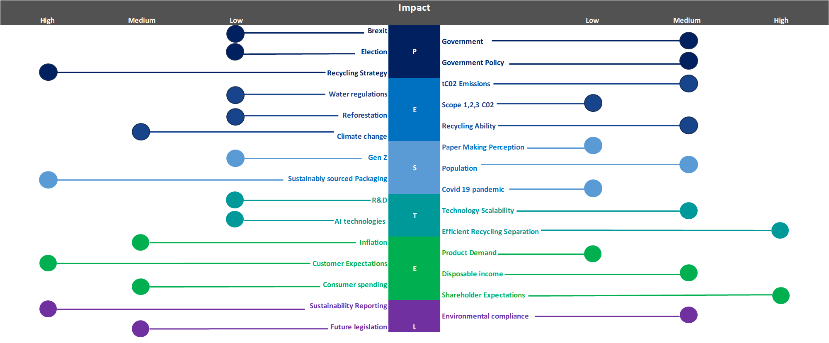
Figure 59 - PESTEL Business Impact
The problem statement is created using the 5W1H methodology, as shown in figure 60 we can now conclude our problem statement will be as follows. The reject rate of the paper mill is increasing which appears to be linked to the increase of the fibre and sand streams (R6/7) created by the automatic cleaning and screening of the fibre in stock preparation and stock approach, this is turn is increasing costs to the business.
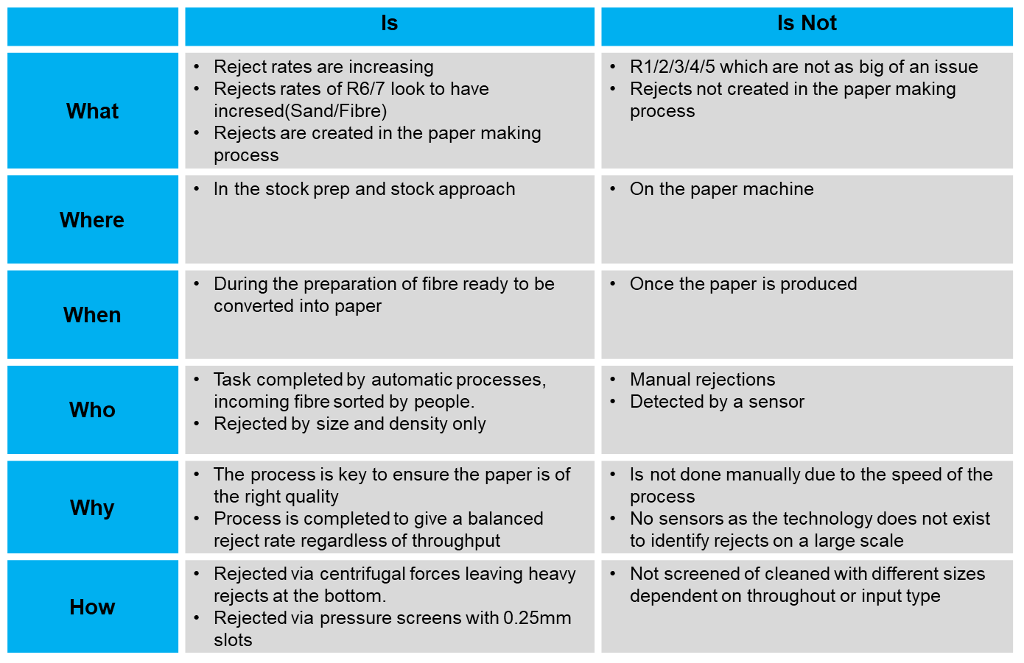
Figure 60- 5W1H.
From the SIPOC in figure 61 we are able to view the key elements of the process from a high-level perspective. We can see that there are multiple suppliers into the process which can create variability which is only amplified by the different grades of paper and rejected material, this potential variability from multiple sources makes traceability extremely difficult.




The process is quite traditional of a paper mill and the type of outputs would also be considered typical of this manufacturing, the customer element would be different dependent on the output stream of a paper mill and the strategic decisions made for the reuse, recycle or landfill of the rejects.
Supplier
Input
Process
Output
Customer
Local Councils
Supermarkets
Households
Smurfit Westrock
Retail Suppliers
International Imports
1.02 Paper
1.04 Paper
1.05 Paper
Clippings
Plastic
Metal
Ash
Sand
Collect Papers
Purchase Papers
Bale Paper
Transport Paper
Paper Enters Stock Prep
Good Fibre moves forward for production.
Rejected fibre and contaminants move to skips.
Rejects transported to end of use location.
Fibre converted to paper.
Fibre sent to customer.
Paper Reels
Fibre Rejects
Sand & Glass Rejects
Rope Rejects
Metal Rejects
Plastic Rejects
Smurfit Westrock
Land spread.
Waste to Energy
Metal Recycling
Environment
Figure 61- SIPOC.

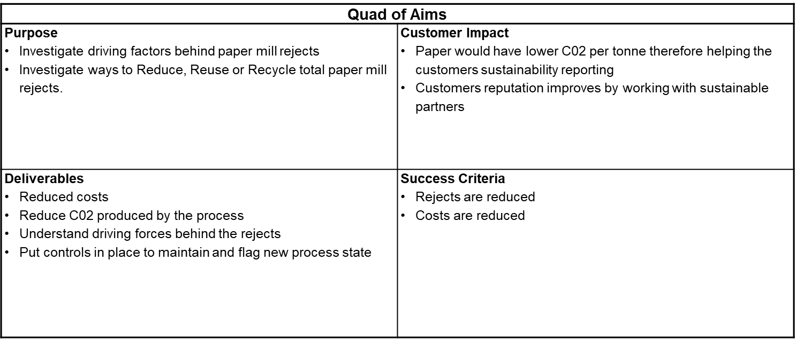
From the define phase we are able to conclude with the quad of aims as shown in figure 62, this sets out clear expectations of the investigation, what the customer could expect, the deliverables and success factors. At the end of the investigation, we can review the project’s success based on these early-stage conclusions. The success criteria and deliverables are directly related to the VOC, for the investigation to be successful we must look to satisfy the customer’s needs by way of creating solutions and controls that allow for their concerns to not reoccur or be highlighted in the future should they arise again.
Figure 62- Quad of Aims

Measure
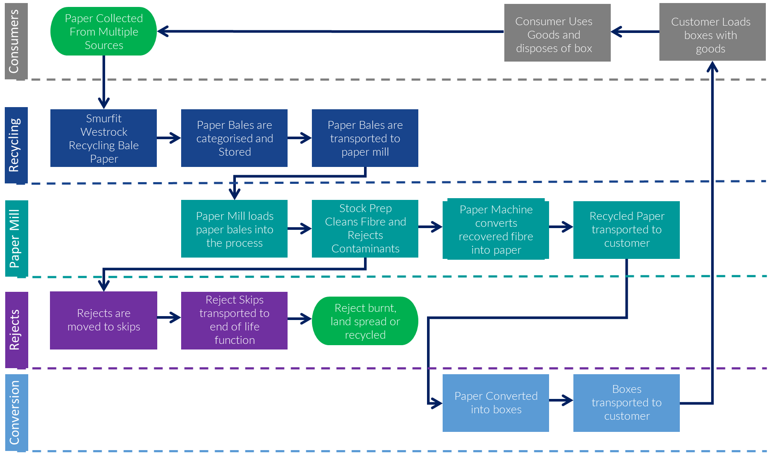
The process under investigation is displayed in figure 63, this demonstrates the circular configuration of the paper making process, the focus highlighted as the symptom of the problem is under the paper mill line when fibre is cleaned and then moved into the rejects line.
Figure 63- Process Map
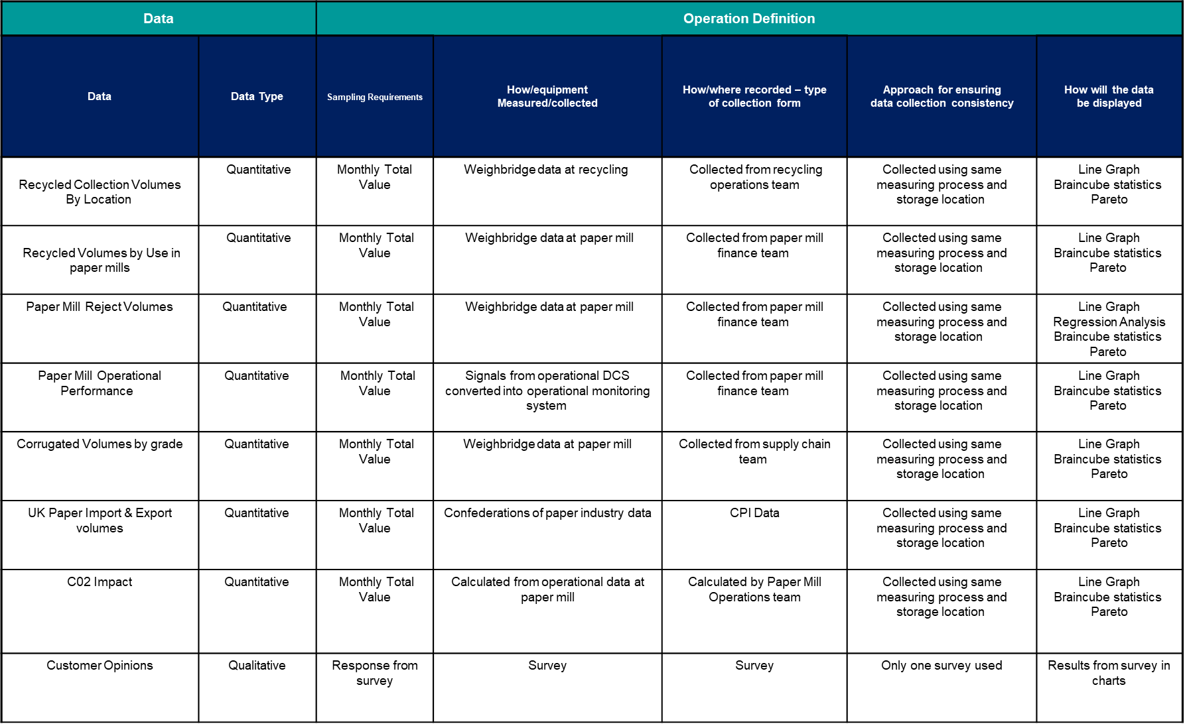
To begin measuring the process and its variables we must ensure we have a plan to collect the data to ensure it is accurate and representative, in figure 64 the data collection plan is highlighted with the areas of data collection and how they will be used.
Figure 64 - Data Collection Plan
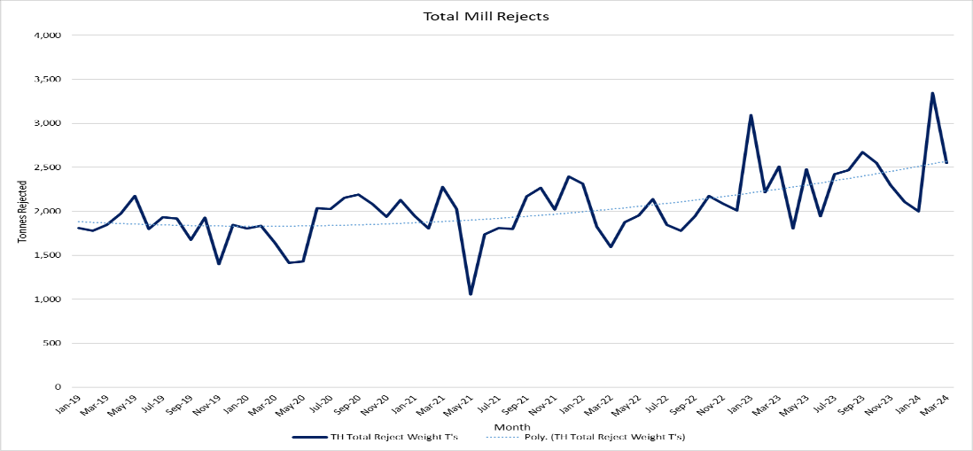
The current process for the total mill rejected volume is presented in figure 65, this clearly shows the increase in rejected material from circa 1800T’s per month increasing from Q4 2021 to circa 2500T’s per month in Q1 2024.
Figure 65- Total Mill Rejects Tonnes
The total mill rejected volume is made up of 4 components as visualised in figure 66.
R1 Ragger rope is used to collect debris from a hydro pulper which is a large tank with an agitator mixing water and fibre to the correct consistency ready for cleaning.
R2-3 Small and large metals are extracted from junk traps throughout the process and are extracted due to their weight and size.
R4-5 Small and large plastics are extracted from a drum screen which is a large cylindrical drum with holes in that only allow certain particle sizes to pass through.
R6-7 Fibre and Sand are extracted from pressure screens and centrifugal cleaners there rejecting by density and size.
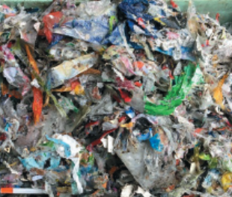

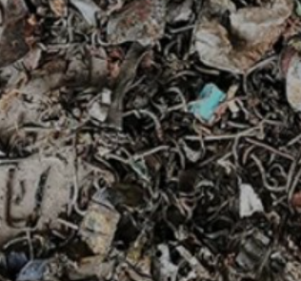
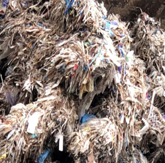
R1 – Ragger Rope R2-3 – Small and Large Metals R4-5 – Small and Large Plastics

R6/7 – Fibre and Sand
Figure 66- Reject Types
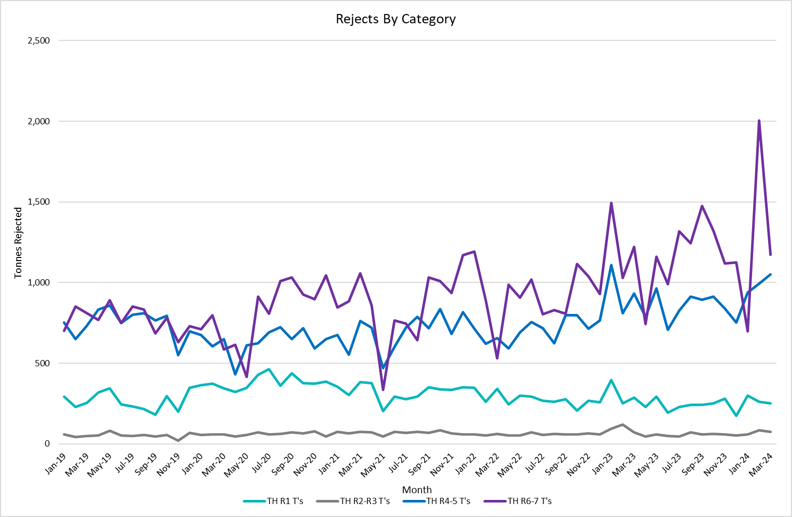
The current levels of rejects for the 4 reject streams are displayed in figure 67, the trend clearly shows that R6-7 and potentially R4-5 have increased above their normal performance, to understand their relationship a simple regression analysis can be performed to understand the correlation between each stream and the total mill rejects which can be seen in appendix 2-5.
Figure 67 - Rejects by category.
When comparing the results of the regression analysis as displayed in figure 68, we are able to clearly demonstrate that the R6-7 has the highest linear relationship at 0.95 followed by R4-5 at 0.8. The R squared number is calculating that the R4-5 rejects have 64% of the values falling onto the regression line where as R6-7 has 90% of its values falling onto the regression line making it statistically significant as the y values are explained by the x values. With this information we can confirm our problem statement is correct in investigating the increase of R6-7 rejects as the main driver of total mill rejects.
 | R1 | R2-3 | R4-5 | R6-7
Multiple R | 0.11 | 0.50 | 0.80 | 0.95
R Square | 0.01 | 0.25 | 0.64 | 0.90
Adjusted R Square | 0.00 | 0.24 | 0.63 | 0.90
Standard Error | 65.66 | 12.44 | 77.91 | 84.92
Observations | 63.00 | 63.00 | 63.00 | 63.00
Figure 68- Regression Summary

When reviewing the baseline data’s process capability in figure 69 the data suggests the process is off target and capable as the distribution is above the mean value when looking against the values for 1 and 2 standard deviations. The upper and lower spec limit are set as the typical values seen before the rejects began to increase.
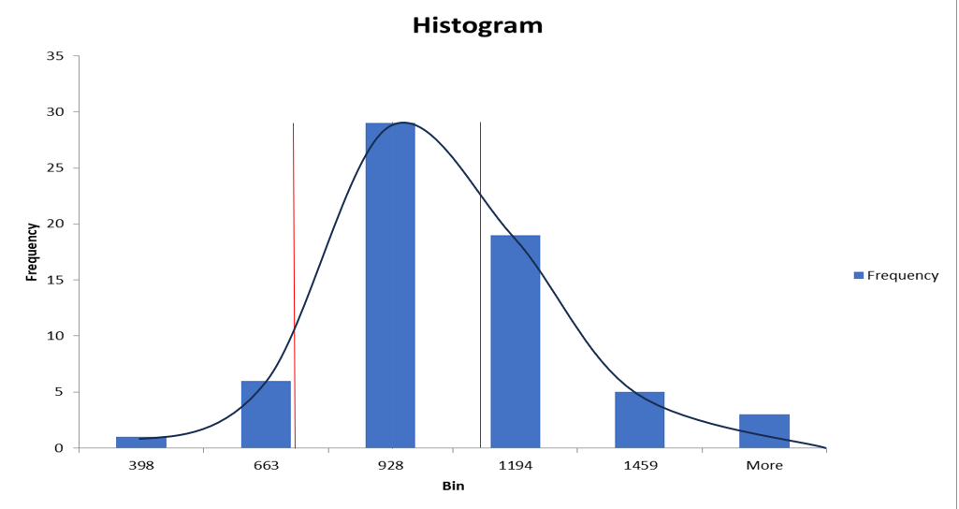
Figure 69- Process Capability
When reviewing the baseline data it is possible to calculate the total impact to the business to therefore create a financial appraisal for the business case as shown in figure 70, this demonstrates that there is the potential in excess of £1 million savings which does not consider the intangible benefits such as reputation, customer satisfaction and compliance which could bring potential new customers, maintain or increase market share and ensure our operations are in line with legal and political expectations.
Figure 70 – Financial Appraisal of Business Case

Analyse
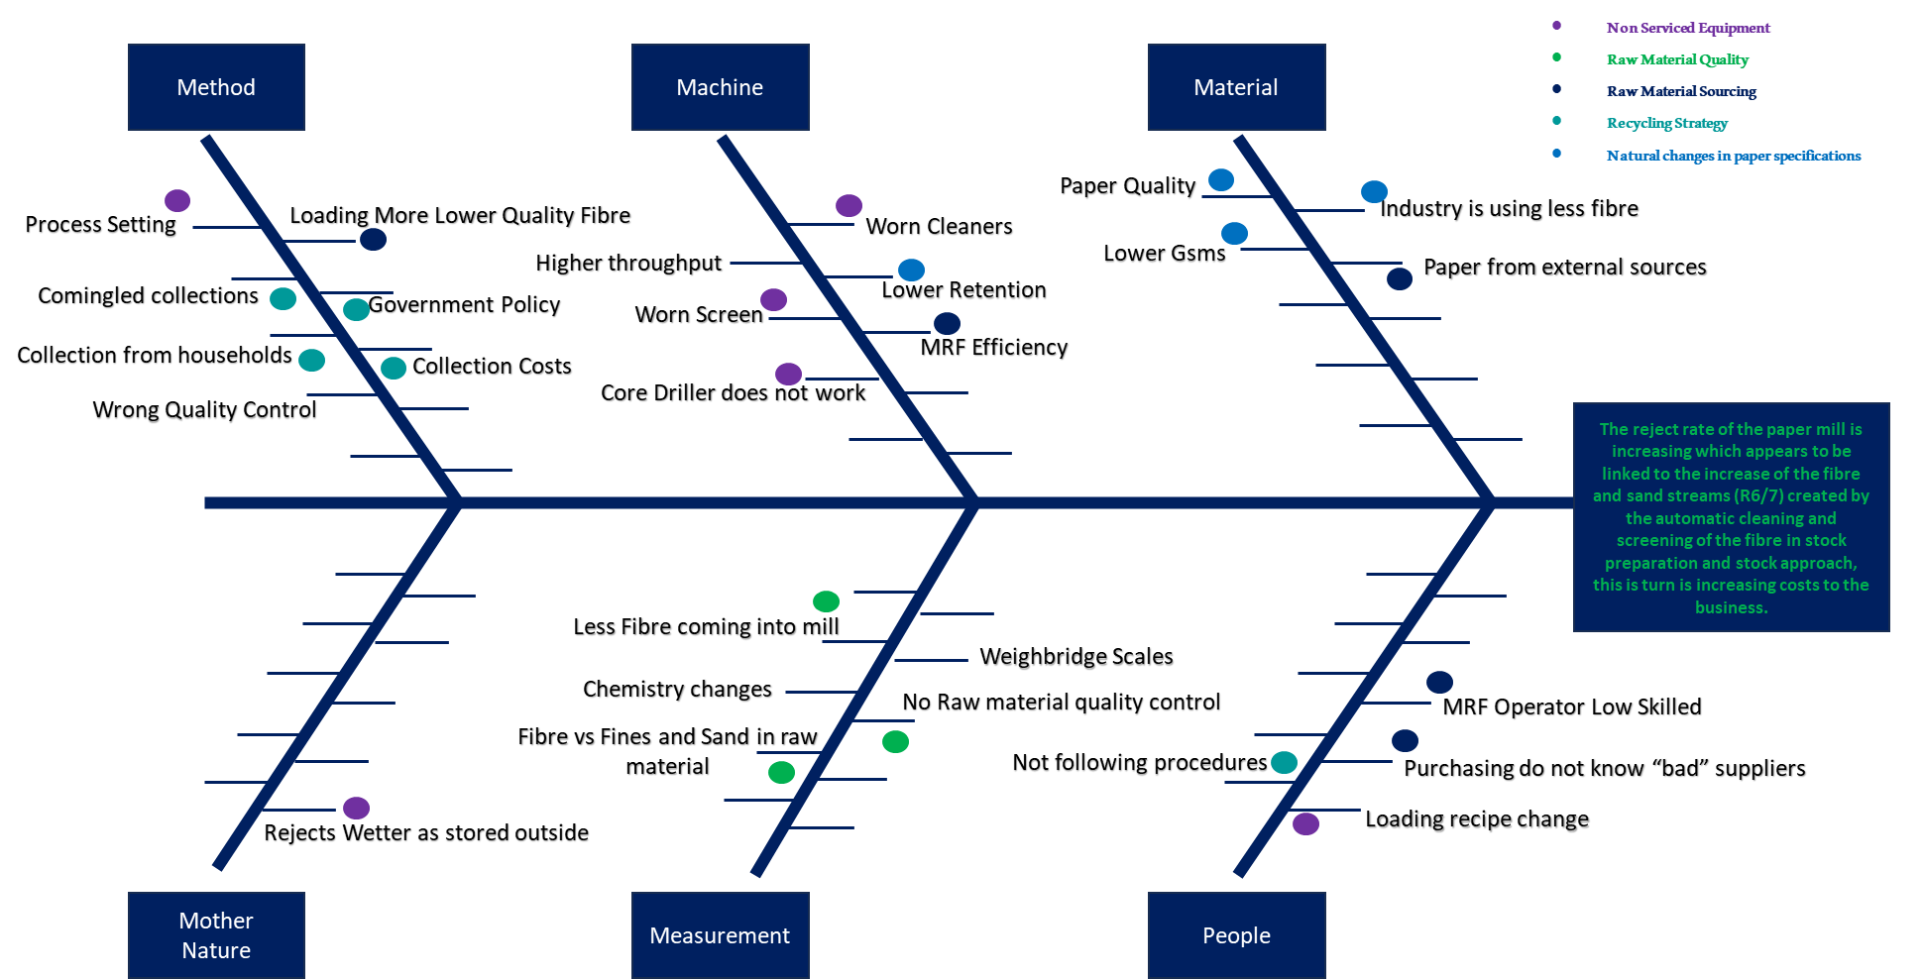
To begin the analyse phase an Ishikawa diagram is utilised as per figure 71 to collate potential root causes of the problem statement, this takes into consideration multiple areas of the process map that could lead to solving the problem identified.
The Ishikawa diagram groups the root causes into the traditional 6 categories to help us ensure we have covered all potential root causes and their type. From the initial grouping we have highlighted 28 potential root causes which we can then group into the following areas for investigation.
Figure 71 - Ishikawa diagram.
- Non-Serviced Equipment
- Raw Material Quality
- Raw Material Sourcing
- Recycling Strategy
- Natural changes in paper specifications
With the 5 key investigation areas above we can use 5 whys to validate these potential areas which should also help indicate some further potential root causes and whether they are process or people related.

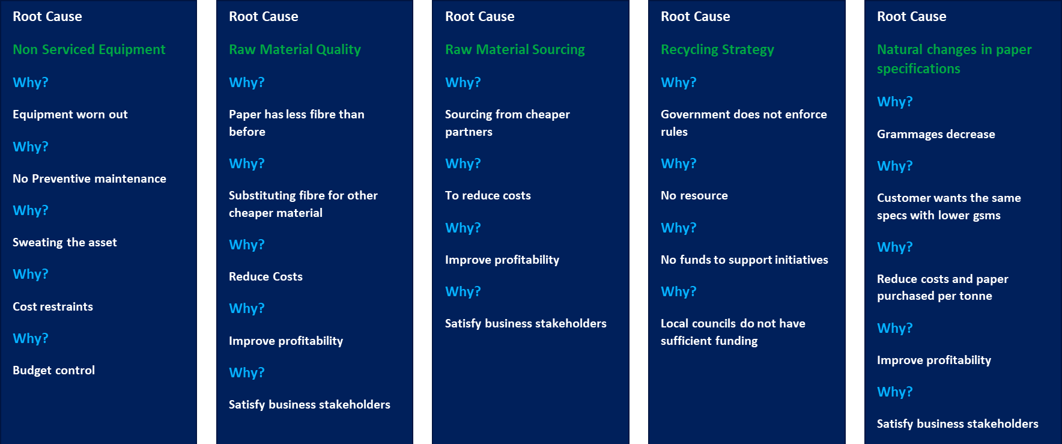
With the 5 whys as shown below in figure 72, it is possible to highlight that most of the root causes lead back to the need to satisfy the business stakeholders financially, therefore suggesting a struggling market that is short of cash flow to potentially pay dividends to shareholders or maintain previous years of financial success. This type of market condition can lead to a reduction in price share, a reduction in market shares due to customer dissatisfaction, redundancies to free up cash as well as companies beginning to sweat their assets further to retain cash flow.
Figure 72- 5 Why's
Following the 5 why validation the X-Y matrix is now utilised to review the impact of the process inputs vs the voice of the customer with the weighting supplied by the UK managing director as to the importance to the business. As displayed in figure 73 it is evident that the reject post process use has the highest value and is the easier to implement as the business has control over the use of the rejects and how they are handled post production. Although the current reject post process use is under contract the value can be negotiated allowing any future improvements to be implemented and the problem statements impact reduced or resolved fully.
Figure 73- X-Y Matrix
When reviewing the FMEA as shown in appendix 1 the process is scored based on severity, occurrence and detection which then allows us to sort the process steps into the most critical based on the RPN as displayed in figure 74. The most critical steps are the raw material being mixed with other streams, local councils not segregating recycled material, fibre being mixed with plastic and rejects not being utilised correctly. The first three of these steps are not levers the business can easily pull to gain results but would be required to lobby support from the government and local councils which could go against their parties commitments, available resources and committed spend which would then result in no improvement.
Figure 74- FMEA Highest Risks
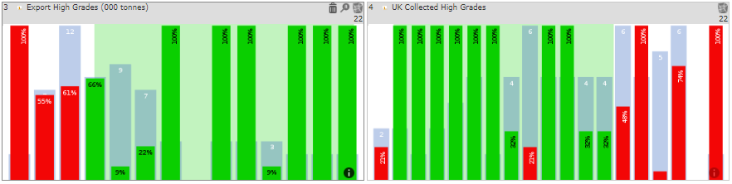
In reviewing the hypercubic analysis in appendix 6 we can highlight correlations to the R6-7 reject increase such as that in figure 75 where by the collection and exports of high-grade papers influence the highest tonnage of R6-7, this is likely due to high grade papers containing more fillers and ash which would not be retained fully in the paper making process therefore are rejected in these streams. Although this is correlated this is a market driven influence therefore outside of the businesses control.
Figure 75- High Grade Paper Influence
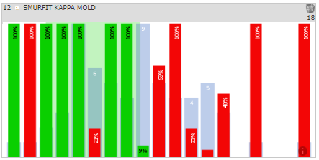
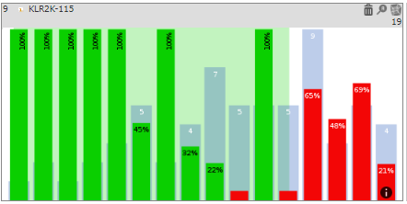
Other correlations as seen in figure 76 show the use of the paper grades such as Kraft Liner 125gsm in the conversion plants influencing the rejected tonnes of R6-7 as the side cuts are baled and sent back to the paper mills for recycling, although in principle a good idea the papers being sent may not be fit to be pulped in the current process and would require additional technology and treatment not currently available at the mill. This observation is supported by the correlation between Mold’s Smurfit Westrock conversion plants recycled volume showing higher rejected R6-7 tonnes as the volume increases as seen in figure 77.
Figure 76- Kraft liner use in conversion plants.
As well as collections, exports, paper grades and the businesses own internal conversion plants influencing the R6-7 rejects there is also the influence of external paper supplies such as Next and Kent County council which again show a negative impact on the R6-7 rejects as seen in figure 78.
Figure 77- SW Mold Recycled Volume Influence
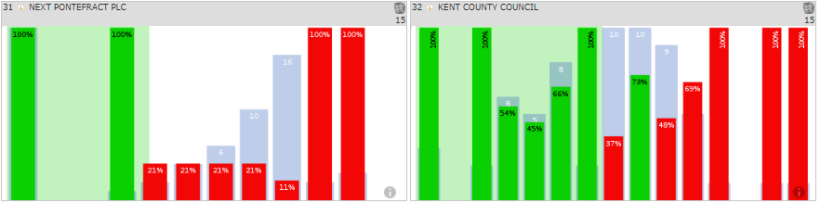
Figure 78- External Supplier Influence

In reflection of the hypercubic analysis it gives insight to the influences of the R6-7 rejects but brings to light the lack of control the mill has on the raw material quality as it is driven by market conditions, box designs, recycling rates, recycling location and import export volumes, this could therefore lead to additional quality control at the paper mill if quality control cannot be influenced onto the external parties.

Improve
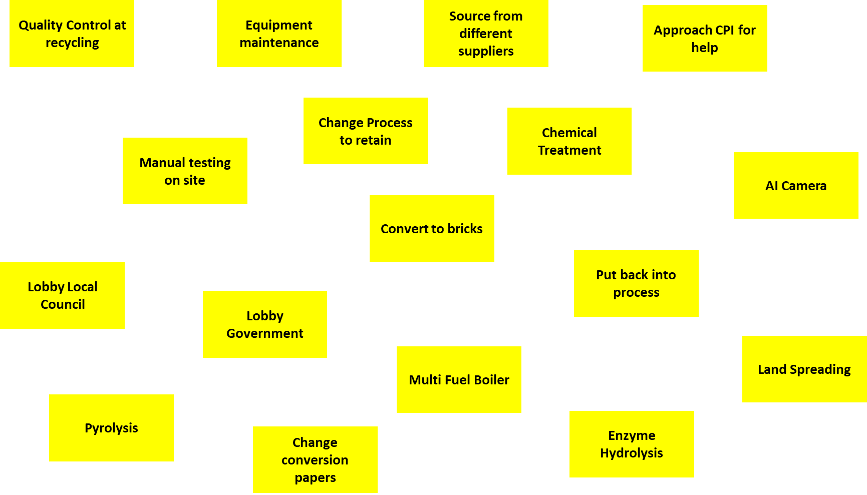
The first step of the improve phase is to generate ideas for potential solutions of the problem identified during the DMAIC process, to achieve this a brainstorming session as per figure 79 was completed for potential ideas to reduce, reuse or recycle the R6/7 reject stream. The ideas ranged from lobbying government and industry relations groups, changes to recycling strategy, new technology, process changes and working with customers to change their practices.
Figure 79- brainstorming.
From the brainstorming exercise we split the solutions down into a top 10 to then enter these into a Pugh matrix as highlighted in figure 80, this allows us to weight the solutions and score them against critical elements of any potential improvement. In figure 80 the Pugh matrix highlighted that exploring pyrolysis scored the highest as it offers a good return on investment and meets the success criteria of reducing costs and improving tCO2e, although pyrolysis is not as well-known and used in our industry there are good examples of pyrolysis being used especially by the Royal Navy on submarines whereby the rejects are converted into biochar to be used in soil regeneration.
Figure 80 - Pugh Matrix
The second investigation the Pugh matrix highlighted was an AI camera that could potentially give us critical information regarding the paper composition, therefore we could adjust our process accordingly to try and retain as much fibre and sand as possible based on the camera detection leading to a reduced reject volume.
The Implementation plan as shown in figure 81 for the investigation into pyrolysis will have a key milestone after the review of the European Biochar Certification (EBC), this is a critical milestone as this will demonstrate that the biochar produced by the pyrolysis process would be suitable for sale into agriculture and other industrial environments.
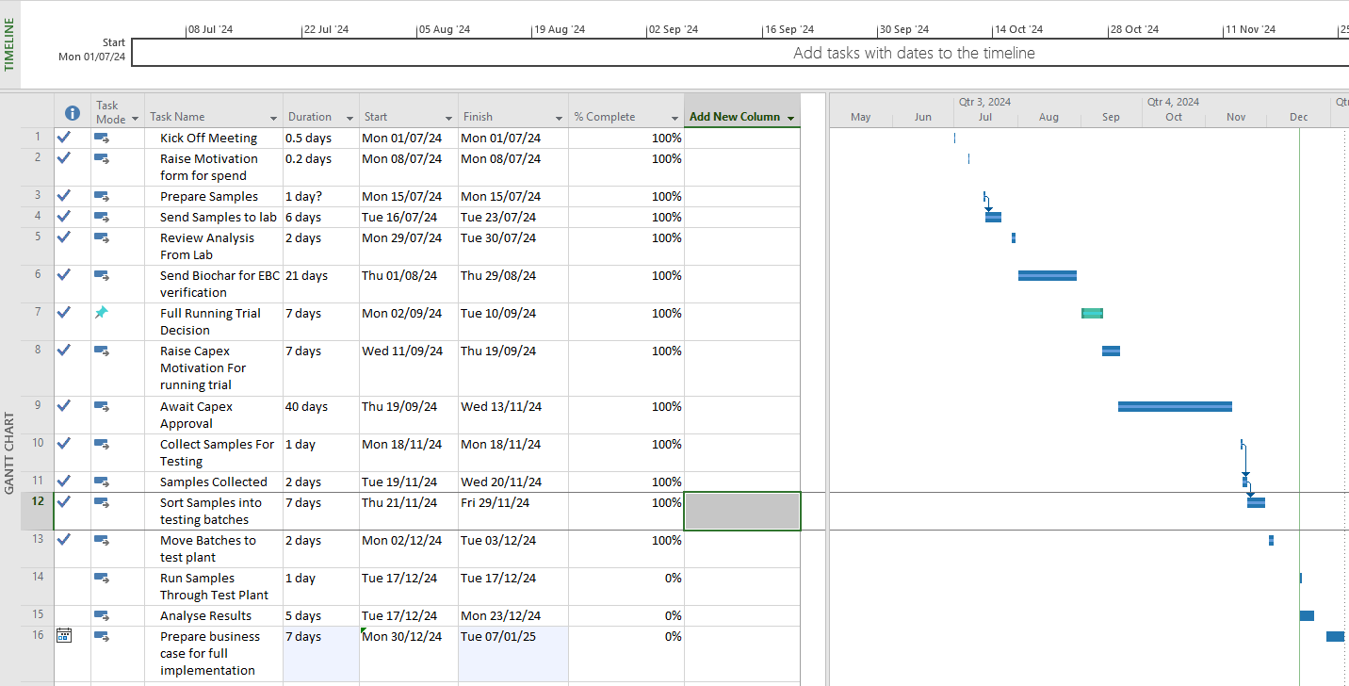
Figure 81- Pyrolysis Gantt Chart
The Implementation plan for the AI camera as shown in figure 82 will have a key milestone after the initial lab test as the application of a camera into the production process could potentially have limitations as the raw material available to review only represents a small sample of the raw material used.
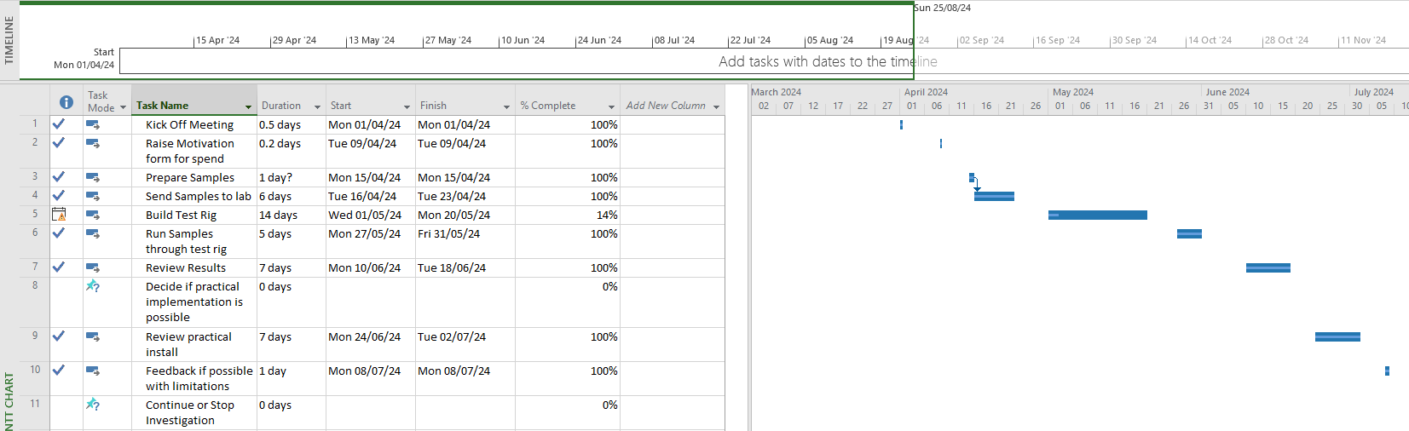
Figure 82- AI Camera Gantt Chart
To ensure the investigations are aligned with the stakeholders of the project the following matrix in figures 83 and 84 were performed to ensure clarity on the investigation. The stakeholders were more positive regarding the pyrolysis proposal due to the financial and tCO2e potential which also includes the capture of CO2 into the biochar which would be a measurable reduction in scope 1 emissions, this is transferable into positive messaging to our customers which in turn improves the positive reputation of the business which could lend itself to an uplift in sales or investors.
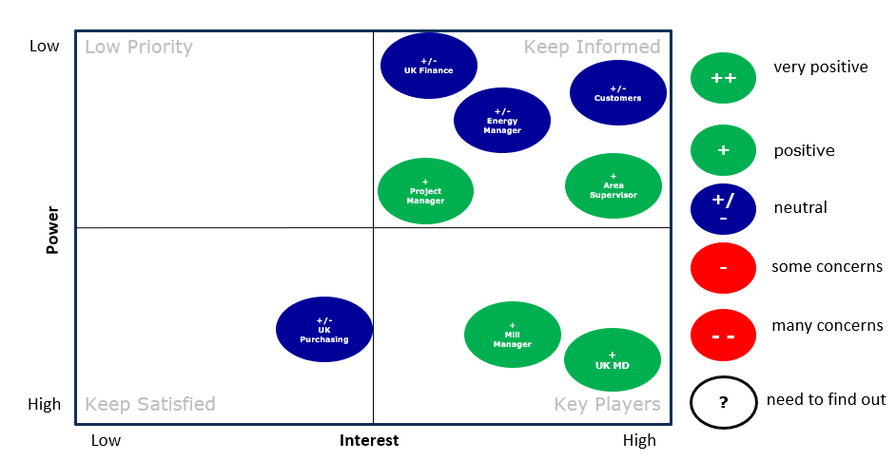
Figure 83 - AI Camera Stakeholder Matrix

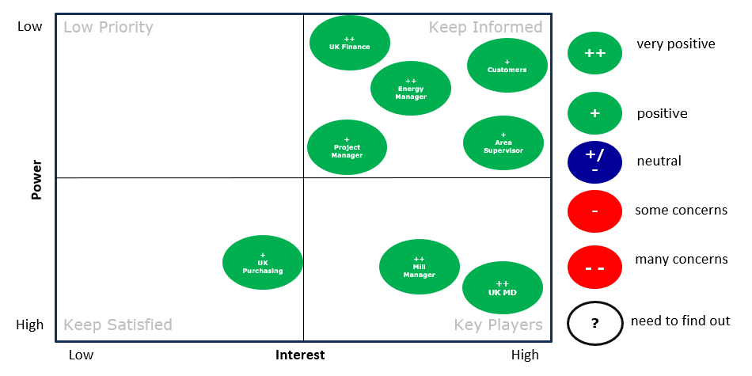
Figure 84- Pyrolysis Stakeholder Matrix
AI Camera Pilot
The first step of the AI camera trial is to collect samples to train the model, the model will be made up of wave lengths from a hyperspectral imaging camera taken from the feedback of the fibre, plastic and metal sample as shown in figure 85.
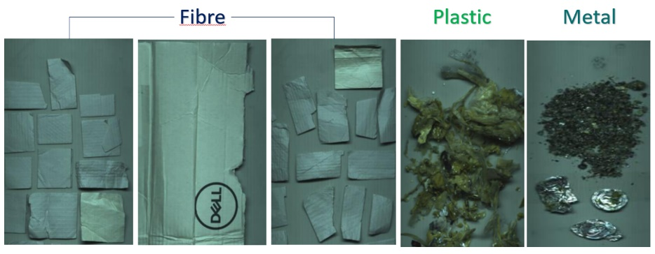
The material used is typical of that being supplied into the process, this allows us to understand the composition of the raw material which in turn could allow the process to be changed if the composition is detected to have changed.
Figure 85 - Samples for AI Model Training
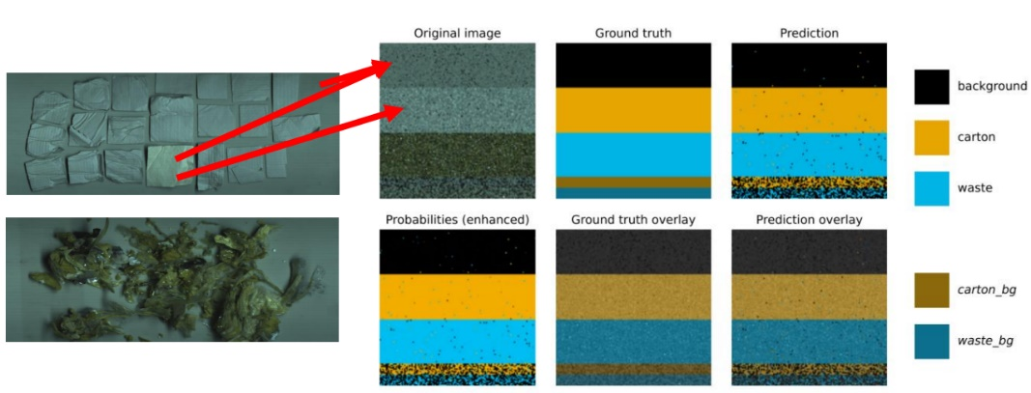
As the model learns the wavelength feedback from each material type it is then possible to begin predicting what the material feedback should be as demonstrated in figure 86. The image allows the AI camera to develop an understanding of what the material is and give feedback according to the learnings within the model, the background of the testing is shown as black, the carton or paper is shown as yellow with the waste material such as plastic or metal shown as blue.
Figure 86 - Model Training
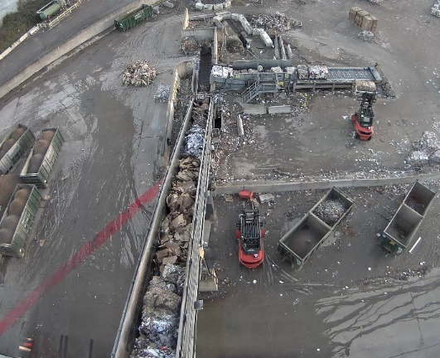
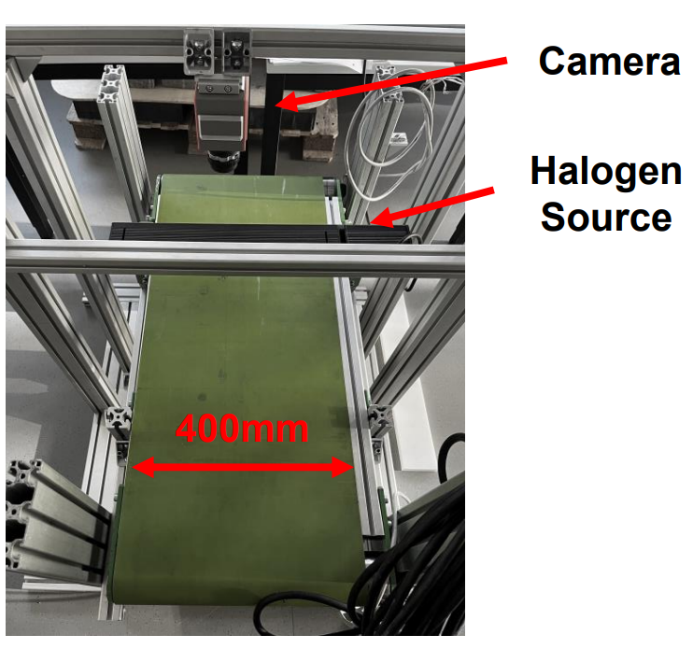
To allow for a comparable test environment to that of a conveyor supplying raw material into a paper mill a small test conveyor was built with the hyperspectral camera and light source above the camera, the conveyor speed was set to 1 meter per second the same speed that the paper mill conveyor runs to ensure the camera could potentially work in an operational environment.
Figure 87 - Paper Mill Conveyor Vs Test Rig
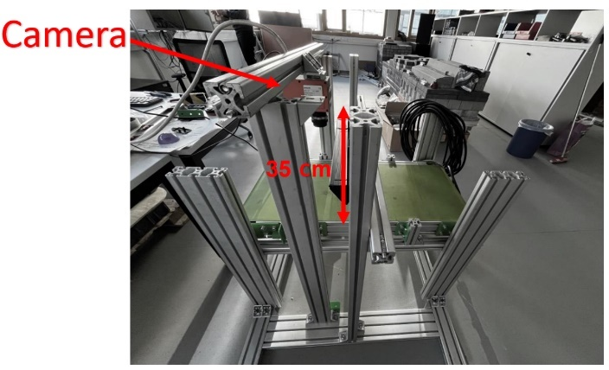
One of the current limitations to the technology is shown in figure 88 whereby the distance from the camera to the conveyor cannot exceed 35cm as the accuracy of the camera begins to reduce therefore,
we must consider this if the pilot moves to an operational trial.
Figure 88- Camera Distance to Conveyor
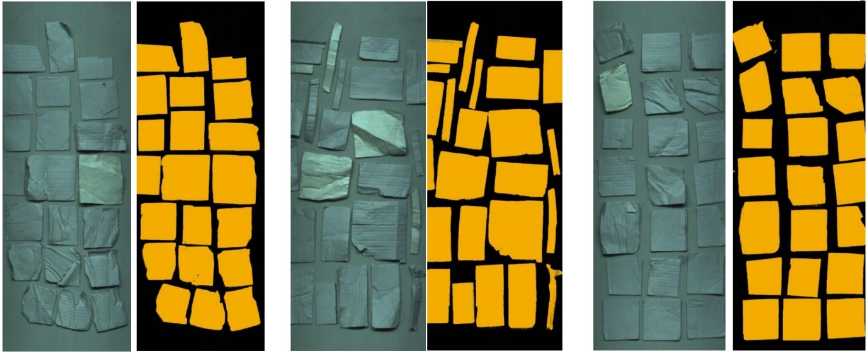
From the initial passes of the material through the test conveyor it is possible to see that the camera can detect paper as shown in figure 89 which clearly shows the paper defined by the orange colour against the background colour which is black.
Figure 89 - Paper Defined Against Background
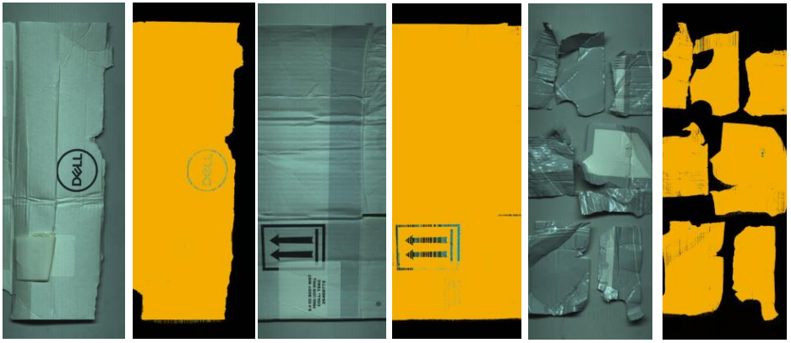
Interestingly with the model trained to have the wavelengths of metal in the AI model, the carbon within some of the print on the packaging is defined as metal or plastic as demonstrated in figure 90, the highly coated papers are also defined as plastic but this is in fact a starch coating. This effect could impact the final results of the AI camera as packaging with print or a highly coated surface could be misinterpreted as a reject material when in fact it is fibre, if this was in an operational scenario the process would be changed when in fact it would not be required.
Figure 90- Misinterpreted Material
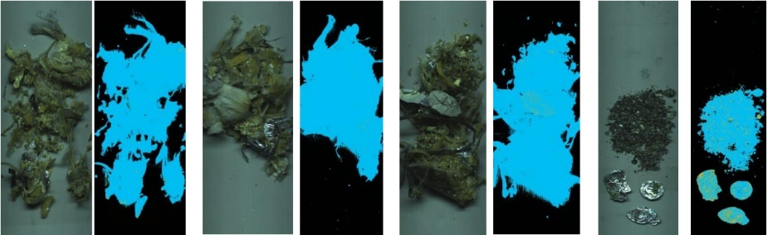
The metal and plastic material followed the same protocol as the fibre analysis as demonstrated in figure 91, the material is less defined to that of the fibre as it is quite close together but importantly the results show a clear difference between the fibre and the metal plastic learnings of the model.
Figure 91 - Metal & Plastic Defined Against Background
The results of the pilot shown in figure 92 demonstrate the AI Model was accurate as the average of the Intersection over Union (IoU) was 98.7%, the ability of the model to recall the material was 99.3% and the precision was 99.3% which all demonstrate a technology that has the ability to deliver accurate measurements under laboratory conditions.
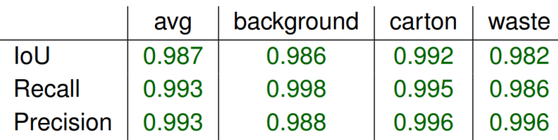
Figure 92 - AI Camera Test Results
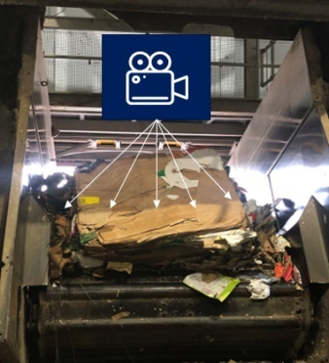
In an operational environment we would need to consider that the camera needs to be under 35cm to the material which is not always flat, the lighting would need to be consistent, the camera would need to be mounted in a protective box and on a stable mount to ensure no vibration and interference from outside variables. The biggest consideration is that the camera can only see the surface of the material on a conveyor therefore if the material is not spread out the camera is likely to only see a maximum of 10% of the incoming material as shown in figure 93.
Figure 93 - Camera Location Vs Visible Paper

Pyrolysis Pilot
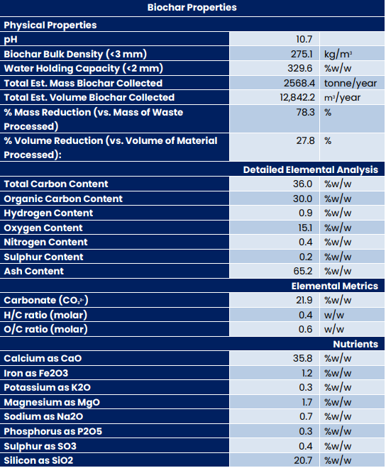
To begin the pyrolysis investigation samples of the fibre and sand R6/7 reject stream were taken and analysed under laboratory conditions to determine the quality of the biochar created, the EBC certification is critical to return the highest return on investment as biochar sells for different amounts based on the quality. The results of the laboratory tests were positive and are shown in figure 94, the carbon weight is in line with other EBC certified biochar created using agricultural waste although the ash and calcium levels are higher which would be related to the fines, calcium and other inorganics such as bentonite used in paper production.
Figure 94 - laboratory Results.
The principle behind the pyrolysis pilot is to utilise the reject streams as an input to the pyrolysis plant to convert the 11851 tonnes per annum of the R6/7 reject stream into biochar and a small side stream of rejects, the estimated conversion rate based on the laboratory is a weight reduction of circa 70% to be conservative therefore leaving 3555 tonnes per annum split 50:50 therefore leaving 1777 tonnes of rejects required to be removed to land spread and 1777 tonnes of biochar per annum with a value of circa £620,000.
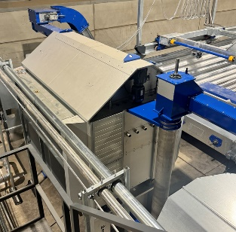
To achieve this the reject streams must be dried from an average of 45% down to 10%, with the heat of the pyrolysis exhaust it would be possible to utilise a dryer unit as shown in figure 95 prior to the pyrolysis plant which would use natural gas to heat the unit initially but once at full operating temperature the natural gas is turned off and the plant could become self-sufficient.
Figure 95- Drying Unit
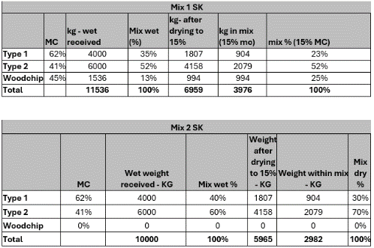
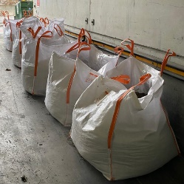
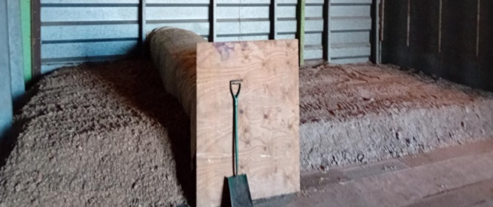
The material was collected from the paper mill and stored in 1 tonne bags ready to be mixed into the operational composition as shown in figure 96, this was made possible by diverting the rejected material from skips into the bags with the assistance of the local operations teams. Following the collection from the paper mill the rejects are sorted into the operation composition as per figure 96 and air dried for the purpose of the trial, the operational composition is split into two test batches, one with woodchips to increase the calorific value which should increase the temperature of the pyrolysis plant making it more efficient. The composition is made up as per figure 97, the woodchip makes up 25% of the total volume in mix 1 therefore this should provide the greater solution and a higher grade biochar with a higher sales value, although the purchase of woodchips adds cost to the process the woodchips can be purchased relatively cheap similar to that of power stations that use the woodchips or pellets as biofuel, the woodchips are the reject elements from timber merchants and sometimes ground and compressed into pellets.
Figure 96 - R6/7 Reject Streams Collected
Figure 97 - Test Mix Compositions
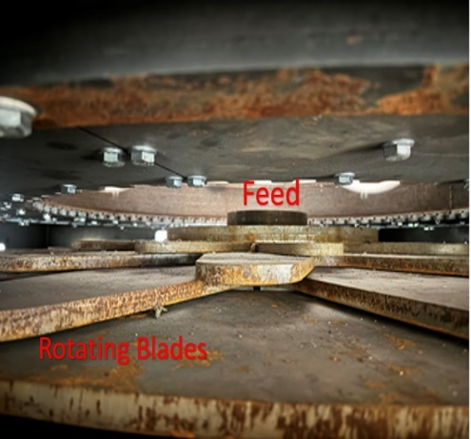
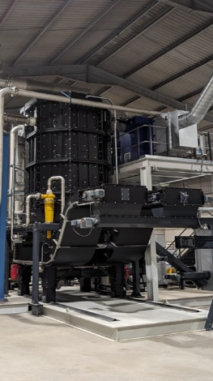
The pyrolysis plant incinerates the biomass provided in the absence of oxygen typically at temperatures above 500°C inside a specially designed chamber as shown in figure 98. Inside the chamber the biomass is fed into the bottom and then slowly dispersed across the plates inside which rotate to ensure the biomass is broken down adequately to allow for effective pyrolysis of the biomass as seen in figure 99. Once the biomass has been converted into biochar the dense material falls to the bottom of the chamber where it is collected and moved along a short conveyor where external bags sit to collect the biochar. The benefit of the pyrolysis plant is the exhaust heat which can be used in a small steam, air or water heat exchanger to add additional heat to our current paper making processes, these processes currently require direct steam to heat them therefore steam production from the current combined heat and power plant could be reduced which in turn reduces the natural gas required for the burners in the boiler and reduces the tCO2e for the site.
Figure 98 – Pyrolysis Chamber
Figure 99 - Pyrolysis Chamber Internals
The results of the test shown in figure 100 demonstrate that with the woodchip the efficiency of the pyrolysis is increased versus that of the non-woodchip mix, the business case for the woodchip will be based on the cost of removing the increase in rejects from the non-woodchip mix.
Figure 100 - Pyrolysis Mix Results
Based on the initial baseline data and the industrial pyrolysis trial we can demonstrate as per figure 101 that pyrolysis offers a viable option to recycle the rejects created during the paper making process by both reducing their volume, reducing their environmental impact whilst turning the process from a negative financial impact into a positive impact. The results do not consider the reuse of the heat from the exhaust to warm other process areas of the paper making process therefore with the exhaust air operating at 0.48 tonnes per hour with a temperature of circa 400°C this could amount to an additional £100 thousand per annum taking the total savings to £1.4 million.
Figure 101 - Pyrolysis savings vs baseline data.
To implement the project a significant capital investment would be required as calculated in figure 102, this takes into consideration civils, planning, instillation, electrical, gas and water connections, project planning and all related pyrolysis equipment which in turn allows us to give an estimate of the potential ROI and the internal rate of return(IRR) which should aim to be under 5 years for the return on investment time and greater than 20% for the IRR.
Figure 102 - Capital Expenditure Estimation
As calculated in figure 103 the ROI is between 3.17 and 3.48 years depending on the consideration of payback including interest which falls under the 5-year payback target and the IRR is 29.1% which is above our internal target of 20%.
Figure 103 - ROI and IRR Calculations

Control
Following the improvement phase of the project controls are required to ensure the process does not revert back to its original state, to achieve this a control plan is put in place as shown in figure 104. The control plan shows the process steps that require controlling, what the upper and lower control spec limits should be, how it is measured and the frequency and most importantly by who? For this investigation an example of what the control plan might look like should the industrial trial move to a capital investment and what would be required from the business to maintain such an improvement.
Figure 104 - Control Plan Proposal
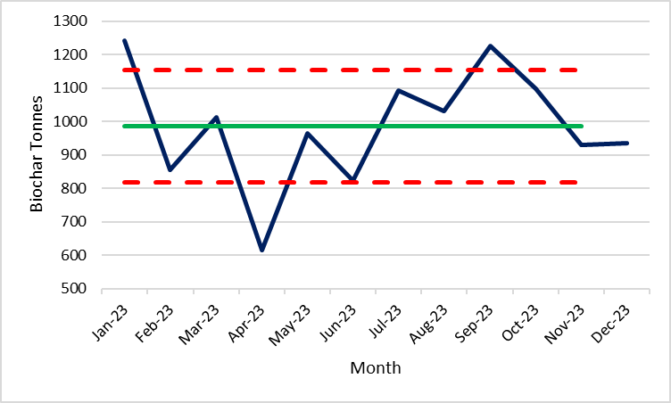
With the measurement control plan we can then create SPC charts with one example for the biochar weight created as shown in figure 105, the chart shows what the average performance would have been for 2023 based on the R6/7 reject streams being converted at 75% efficiency with the USL and LSL set at 1 standard deviation. The charts also show we would have been required to investigate higher production of biochar in Jan 23, Sept 23 and lower production for Apr 23.
Figure 105 - SPC Chart Proposal - Biochar Production
With new equipment being installed it is important to understand the new procedures, SOP’s and training required for those involved in the new implementation, the most effective way to understand the new requirements is to process map the new work flow as shown in figure 106. The original process has been modified to show how the pyrolysis plant could be incorporated into the original process state as highlighted inside the red box, this demonstrates we need to consider the items for SOP’s and training such as those listed below;

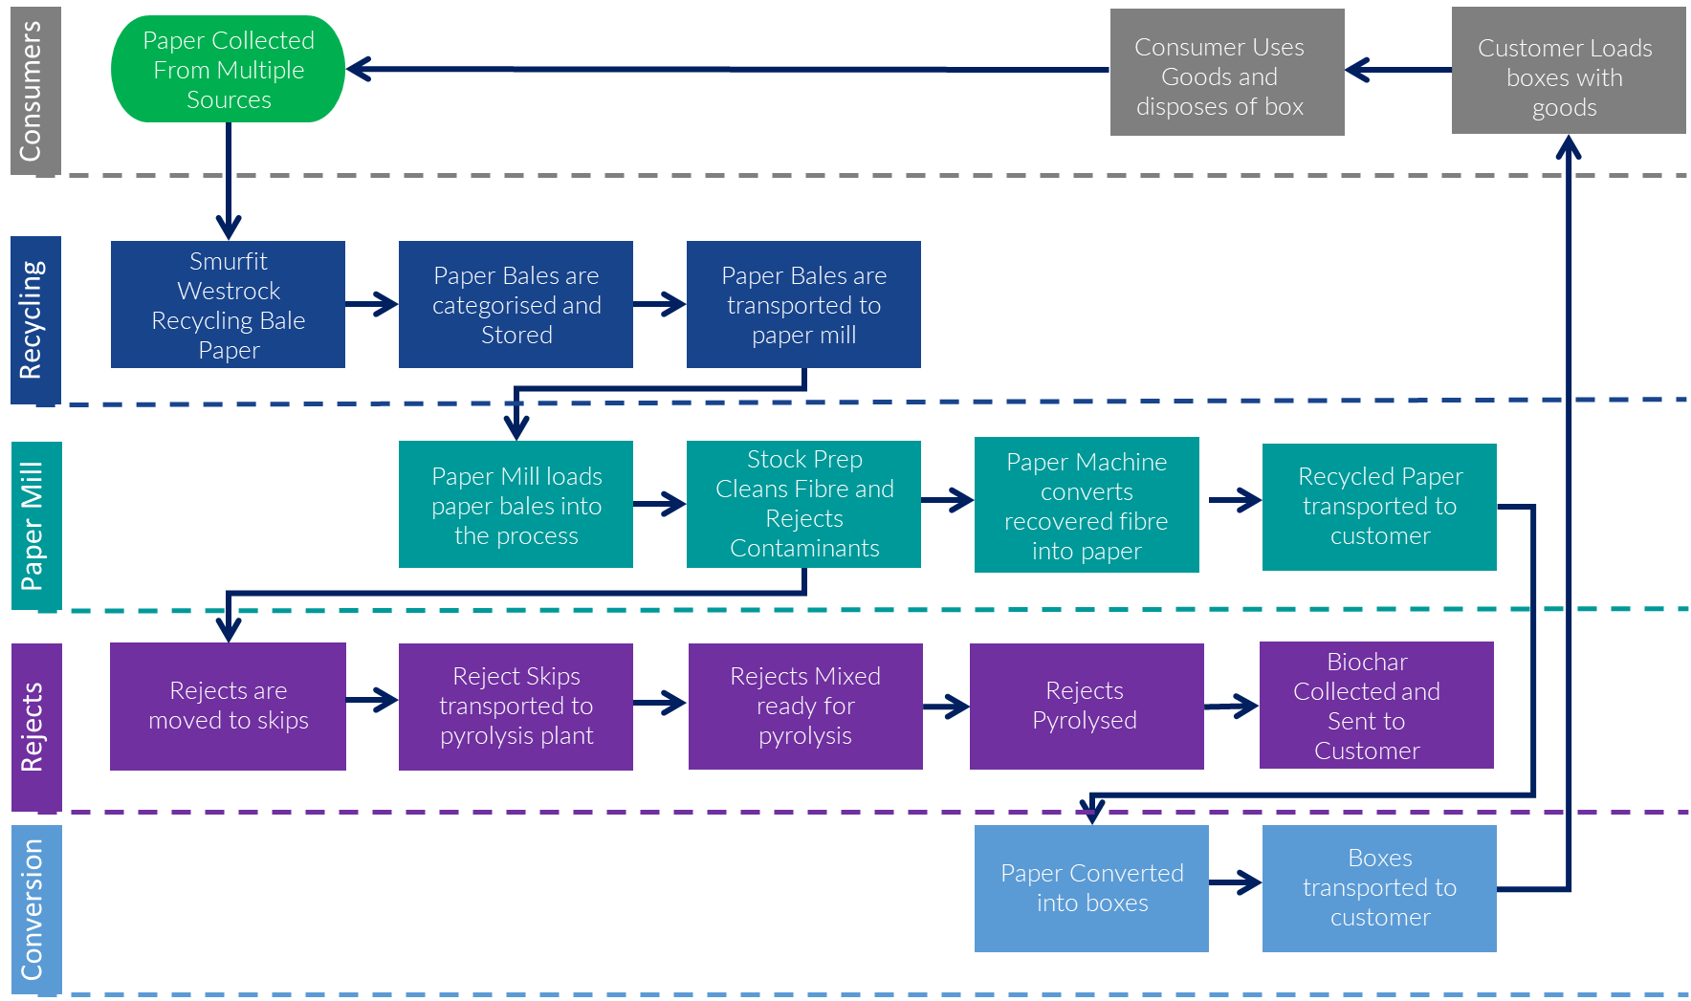

Figure 106 - Incorporation of Pyrolysis Plant into Original state process.
- Transporting rejects on site
- Use of mobile handling equipment
- Mixing of rejects and testing requirements
- Pyrolysis equipment maintenance
- Pyrolysis equipment fault finding
- Biochar collection and offsite transport
- Insurance inspections of equipment
With all of the new procedures, SOP’s and training a well-managed documentation system would be advised that can hold documents for ease of searching, hold records with alerts for updates or out of date items, this could be managed by a system such as SharePoint to ensure document control.
We must also consider the maintenance plans required to keep the equipment in a healthy state, typically a material resource planning system such as SAP or Maximo can be utilised for such tasks to ensure the bill of material is up to date, routine maintenance is tracked both from a frequency basis but also from a resource and cost consideration.

Conclusions
The investigation has given insight into the current recycling capabilities of the UK market and how they will ultimately influence not only the businesses own sustainability targets but also those of the UK government. The paper industry for many years has been innovative in their ability to manufacture paper but now sustainability, in particular the amount of tCO2e created per tonne of paper manufactured will become an equal to that of paper quality and cost, this change will affect market conditions, business strategy and the costs of manufacture which will all have an impact on wider society.
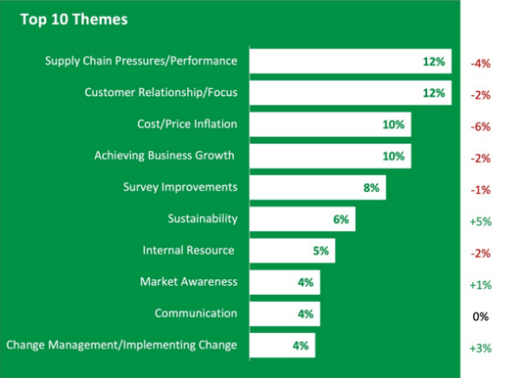
These changes are already beginning to materialise as we see in many businesses sustainability roadmap as well as other areas such as cost of raw material and consumer packaging increasing as a result of collections and increases in manufacturing costs, these changes should be considered significant and regular reviews of business strategies using tools such as PESTEL and SWOT should be utilised to adapt strategies to remain ahead of competitors. This is again only compelled in figure 107 by Smurfit Westrock’s customers feedback stating their biggest challenges for 2024 and sustainability seeing the biggest change since 2023.
Figure 107 – Smurfit Westrock Customer Feedback Survey Results
Throughout the investigation there has been an underlying frustration that the root cause of the increase in rejects is outside of the businesses control, therefore new technology and ways of working are required to handle our new reality. Although research into new technology and capabilities help our understanding of what is truly possible, the research shows there is more to do at source and the English government and local councils must take a stronger approach and commit to their legislation as demonstrated previously in figure 11 by the success of the Welsh government.
One common finding is the funding is not available to commit to recycling strategies and sustainability targets yet there is funding for research annually into new technology that lends itself to a sustainable future. Conducting separate collections of material to be recycled, conducting more quality checks of the material being collected and auditing these processes would cost more to provide but the local councils recycled product would be of a higher standard therefore surely demanding a higher price? These additional funds could then be used to fund the extra requirements and also produce passive income to invest into new technology for automatic segregation using AI cameras as demonstrated in this investigation.
The DMAIC process has given the investigation a structure that allows for multiple considerations of influencing factors as well as many tools that help give clarity on what direction the investigation should take. Using statistics to help understand what reject stream was driving the total reject volume of the business ensured the investigation was targeted at the biggest opportunity and not focused on a scope that was unachievable and too large to manage.
Understanding the VOC and the needs of business allowed very clear deliverables and success criteria to be determined and ensured the project team understood the expectations for the outcome of the investigation, without this clarity and direction managing the investigation could have been more difficult and lead to discontent within the team.
The investigation led to two investigations both with future potential in paper manufacturing processes, the first investigation into the AI camera to detect anomalies in the raw material gave very positive results but the application would need to be considered for any future use as the material needs to be flat to ensure the camera highlights a sufficient amount to consider the sample valid. The AI camera could potentially be used earlier in the paper collection cycle with possible applications at MRF’s or at paper recycling depots prior to bailing of material, any such application could lead to the grading of recycled paper material and pricing differentials based on quality but this would need an industry agreed change in purchasing strategies.
The pyrolysis investigation demonstrated that the technology has now moved on from facilities for wood and biomass but not paper mill sludge as stated by (L. Simão, 2018) to real industrial technology that can be utilised for the conversion of large volumes of paper mill sludge into biochar. The pyrolysis investigation met all of the deliverables and success criteria set out at the start of the project giving significant reductions in reject volumes, significant reductions in cost, significant reductions in tCO2e and potential intangible benefits to customers and reputation. This technology can now be considered ready for implementation in paper mills globally and should be considered in exchange for multi fuel boilers, land spreading or worst land filling.

Recommendations for future research
Following this research there are areas that would benefit from future research, this could lead to improvements in the paper industry as well as the greater recycling cycle. The use of AI cameras for better segregation at source could be explored to facilitate a greater categorisation of recycled material based on the composition feedback from the AI camera, this research would need to be undertaken in MRF’s or local recycling depots to ensure the material is loose enough to be scanned.
Exploring the correlations between government recycling strategies across different counties of the UK and their respective recycling rates with a consideration of total tCO2e emitted per county could give insight to successful execution of recycling strategies and how counties implemented them for best practices and learning that could be shared across the UK.
Consideration could also be given to the use of Pyrolysis with the plastic streams of paper mill rejects, although these contain less organic material which would lower the quality of the biochar the reduction in volume and subsequent reduction in transport cost and tCO2e could be significant and equally as viable as demonstrated during this research.

References
- Adrian Vais a, V. M. a. M. P. b. J. F., 2006. Lean and Green” at a Romanian secondary tissue paper and board mill—putting theory into practice. Resources, Conservation and Recycling, Volume 46, pp. 44-74.
- Affairs, D. F. E. F. &. R., 2021. Waste Management Plan For England, London, UK: UK Government.
- Aguilar, F. J., 1967. Scanning the business environment. New York: Macmillan.
- Andrés R. Cruz Herrera, J. d. P. U. A. a. L. L. L. L., 2019. Application of Six Sigma in Improving the Quality of Recyclable Polymer in Collection Centers. Pilsen, Proceedings of the International Conference on Industrial Engineering and Operations Management.
- Boulding, K. E., 1966. Environmental Quality in a Growing Economy, Baltimore: Johns Hopkins University Press..
- Byeong C. Min, B. V. B. V. S. J. a. B. V. R., 2015. Enhancement of the enzymatic hydrolysis of fines from recycled paper mill waste rejects. Min et al. Bioresour. Bioprocess, 2(40), pp. 2-10.
- C Botezatu, I. C. B. O. A. H. M. E. L. S., 2019. Use of the Ishikawa diagram in the investigation of some industrial processes. s.l., IOP Publishing.
- Cantavalla, S., 2019. History of paper - From its origins to present day. [Online]
Available at: https://www.pixarprinting.co.uk/blog/history-paper/
[Accessed 09 September 2024].
- Company, B. &., 2024. The Visionary CEO’s Guide to Sustainability 2024, s.l.: Bain & Company .
- Deming, W. E., 2000. Out of the Crisis. 2nd ed. New York: The MIT Press.
- Eckhart, D. R., 2021. RECYCLABILITY OF, Graz: Technische Universität Graz.
- Gamble, P. &., 2023. P_G_Responsible_Beauty_Action_Plan, Cincinnati: Proctor & Gamble.
- Gavrilescu, D., 2008. ENERGY FROM BIOMASS IN PULP AND PAPER MILLS. Environmental Engineering and Management Journal , 7(5), pp. 537-546.
- Government, W., 2019. Beyond Recycling, Cardiff: Welsh Government.
- Government, W., 2019. Beyond Recycling, 2019: Welsh Government.
- Hall, J. N. a. R. W., 2002. Ohno's Method, Creating a survival work culture. Fundamentals, 18(1), pp. 1-15.
- Hannu Nurmesniemi, R. P. R. K., 2007. A case study of waste management at the Northern Finnish pulp and paper mill complex of Stora Enso Veitsiluoto Mills. Waste Management, Volume 27, pp. 1939-1948.
- Hatem Abushammala, M. A. M. S. T. G. J. M., 2023. On the Conversion of Paper Waste and Rejects into High-Value materials and energy. Sustainability, Volume 15, pp. 1-21.
- HAUNREITER, K. J., 1997. 200th Anniversary of the paper machine Years Of. Tappi Journal, pp. 85-96.
- Ig Jaka MULYANA, L. P. S. H. V. A. H., 2022. LEAN WASTE IDENTIFICATION IN HIGHER EDUCATION INSTITUTION. Management Systems in prodicto, 30(3), pp. 200-206.
- industries, C. o. p., 22. 2021-22 Annual Review, Swindon: Conderations if paper industries.
- Industry, C. O. P., 2024 . Annual Report 2024, Swindon: Confederations Of Paper Industry.
- K Selvi, R. M., 2014. Six Sigma- Overview of DMAIC and DMADV. International Journal of Innovative Science and Modern Engineering (IJISME), 2(5), pp. 16-19.
- Kapil Dev Sharma, S. S., 2018. Failure Mode and Effect Analysis (FMEA) Implementation: A Literature Review. Journal of Advance Research in Aeronautics and Space Science, 5(1&2), pp. 1-17.
- Kipling, R., 1902. Just So Stories. London: CRW Publishing Limited.
- L. Simão, D. H. F. R.-P. J. A. L. O. R. K. M., 2018. Wastes from pulp and paper mills - a review of generation and recycling alternatives. Cerâmica, Volume 64, pp. 443-453.
- Lenka GIRMANOVÁ, M. Š. J. K. A. D. V. M., 2017. Application of Six Sigma Using DMAIC Methodology in the process of Product Quality Control in Metallurgical operation. Acta Technologica Agriculturae, Volume 4, pp. 104-109.
- M.C. Monte *, E. F. A. B. C. N., 2009. Waste management from pulp and paper production in the European Union. Waste Management, Volume 29, pp. 293-308.
- Marcus Thomasson, J. W., 2013. Cost of poor quality, definition and development of a process based framework, Gothenburg: Chalmers University Of Technology.
- Mars, 2023. 023 Sustainable in a Generation Report_5., McLean: Mars.
- Mendelow, A., 1991. Stakeholder Mapping. s.l., 2nd international conference on information systems.
- METSOLA, R., 2022. DIRECTIVE (EU) 2022/2464 OF THE EUROPEAN PARLIAMENT AND OF THE COUNCIL OF 14TH DECEMBER 2022. Official Journal Of the European Union, 322(15), pp. 1-66.
- Mohamed, T. S. N. &. S., 2018. STAKEHOLDER MANAGEMENT IN COMPLEX PROJECTS. Colombo, Sri Lanka, The 7th World Construction Symposium 2018: Built Asset Sustainability: Rethinking Design, Construction and Operations.
- Monday, L. M., 2022. Define, Measure, Analyse, Improve, Control (DMAIC) Methodology as a roadmap in quality improvement. Global Journal on Quality and Safety in healthcare, 5(2), pp. 44-46.
- Mr. Ganesh P. Jadhav, M. S. B. J. M. A. B., 2022. Six Sigma DMAIC Literature Review. s.l., Research Gate.
- Nestle, 2024. nestlé policy on environmental sustainability, Vevey: Nestle.
- Noemi Proietti a, G. R. b. D. C. a. C. P. c. P. d. S. B. b. F. S., 2019. Characterization of Handmade Papers (13th–15th century) from Camerino and Fabriano (Marche, Italy). Journal of cultural heritage, Volume 42, pp. 8-18.
- Pawan Kumar, M. A. K. U. K. M. S. K., 2021. Exploring the Potential of Six Sigma (DMAIC) in Minimizing the Production Defects. Dhaka, International Conference on Industrial & Mechanical Engineering and Operations Management.
- PepsiCo, 2023. pepsico-2023-esg-summary, Purchase: PepsiCo.
- Plan, T. W. a. R. A., 2006. The Waste and Resource Action Plan - Materials recovery facilities , Oxon: WRAP.
- Pugh, S., 1990. Total Design: Integrated Methods for Successful Product Engineering. 1 ed. Glasgow: Prentice Hall.
- R.H.Clapperton, 1937. The Paper-making Machine: Its Invention, Evolution, and Development. London: Pergamon Press Limited.
- Ricardo Ba˜nuelas, J. A. M. B., 2005. An Application of Six Sigma to reduce waste. QUALITY AND RELIABILITY ENGINEERING INTERNATIONAL, Volume 21, pp. 553-570.
- Richard W. Puyt, F. B. C. P. W., 2023. The origins of SWOT analysis. Long Range Planning, Volume 56, pp. 1-24.
- Ronald Moen, C. N., 2009. Evolution of the PDCA Cycle. Tokyo, Asian Network for Quality.
- Ross, E. K., 1969. On Grief & Grieving. New York: Scribner.
- Ruben Miranda, M. C. M. a. A. B., 2012. Analysis of the quality of the recovered paper from commingled collection systems. Resource, Conservation and Recycling, Volume 72, pp. 60-66.
- S. Mahmood, N. K., 2015. A LITERATURE REVIEW OF THE QUANTIFICATION OF HIDDEN COST OF POOR QUALITY IN THE HISTORICAL PERSPECTIVE. Journal of Quality and Technology Management, 11(1), pp. 1-24.
- Solberg, J., 2018. The papermaking tradition of Central Asia, Iowa: University of Iowa.
- Soliman, M. H. A., 2017. A COMPREHENSIVE REVIEW OF MANUFACTURING WASTES: TOYOTA PRODUCTION SYSTEM LEAN PRINCIPLES. Emirates Journal for Engineering Research, 22(2), pp. 1-10.
- Surange, S. N. T. •. V. S. M. •. U. M. B. L. M. G. •. V. G., 2013. Cost of Poor Quality Analysis for Automobile Industry: A Case study. The Institution of Engineers, 94(4), pp. 373-384.
- Tuckman, B. W., 1965. Developmental sequence in small group. Psychological Bulletin, 63(6), pp. 384-399.
- Tuckman, B. W. a. J. M. A. C., 1977. Stages of Small-Group Development Revisited. Group & Organization, 2(4), pp. 419-427.
- Turner, D. W. P. a. R., 1990. Economics of natural resources and the environment. Baltimore: The Johns Hopkins University Press.
- Uitto, E., 2024. Challenges of COPQ improvement projects in company X, Turku: Turku University of applied sciences.
- Vasileios Rizos, K. T. a. A. B., 2017. The Circular Economy, A review of definitions, processes and impacts, Brussels: CEPS.
- Wagner, M., 2005. How to reconcile environmental and economic performance to improve corporate sustainability: corporate environmental strategies in the European paper industry. Journal of Environmental Management, Volume 76, pp. 105-118.
- Westrock, S., 2023. Delivering a sustainable future - Smurfit Westrock Sustainability Developments 2023, Dublin: Smurfit Westrock.
- Westrock, S., 2024. Smurfit Westrock. [Online]
Available at: https://www.smurfitwestrock.com/products
[Accessed 10th September 2024].
- Westrock, S., 2024. UK Half-Yearly Insights Report 2024, 2024: Smurfit Westrock.
- Zahrotun Nihlah1, *. T. I., 2018. Lean Manufacturing: Waste Reduction Using Value Stream Mapping. E3S W eb of Conferences, Volume 73, pp. 1-6.

Appendices
- FMEA
PROCESS STEP | POTENTIAL FAILURE MODE | POTENTIAL EFFECTS OF FAILURE MODE | SEVERITY | POTENTIAL CAUSES OF FAILURE MODE | OCCURRENCE | CURRENT CONTROL MEASURES | DETECTION | RPN
What is the process step under investigation? | In what ways does the process step go wrong? | What is the impact of the failure on the output i.e. effects that the internal/external customer will notice? | SEVERITY | What causes the process step to go wrong? | OCCURRENCE | What are the existing controls and procedures that prevent either the cause or the Failure Mode? | DETECTION | RPN
Fibre Collection from Households | Households buy items online causing different paper being collected | Fibre type is different to normal | 5 | No measures to determine fibre type | 7 | Visual inspections only | 9 | 315
Fibre Collection from Households | Local councils do not segregate recycled material | Fibre is contaminated | 8 | Not possible to segregate at source | 7 | Visual inspections only | 8 | 448
Fibre Collection from Households | Disposal team mix recycled material | Fibre is contaminated | 7 | Human Error | 5 | No preventive measures | 7 | 245
Fibre Collection from Households | Recycled material is mixed with other streams at material recycling facility | Fibre is contaminated | 7 | No way to determine what is in the material | 8 | No preventive measures | 10 | 560
Fibre Collection from Households | Baling machine fails | Fibre is contaminated | 3 | Lack of maintenance on equipment | 4 | Routine maintenance, no online measures | 3 | 36
Fibre Collection from Supermarket | Shelf ready packaging increases fibre recovery | Fibre type is different to normal | 4 | No measures to determine fibre type | 5 | Visual inspections only | 8 | 160
Fibre Collection from Supermarket | Packaging is mixed with plastic at the supermarket | Fibre is contaminated | 6 | Lack of segregation and control | 6 | Visual inspections only | 7 | 252
Fibre Collection from Supermarket | Fibre is mixed with waste food | Fibre is contaminated | 8 | Lack of segregation and control | 4 | Visual inspections only | 7 | 224
Fibre Collection from Supermarket | Fibre is mixed with other sources at depot | Fibre is contaminated | 7 | Lack of segregation and control | 5 | Visual inspections only | 8 | 280
Fibre Collection from Corrugators | Fibre is mixed with other source of material | Fibre is contaminated | 7 | Lack of segregation and control | 5 | Paper only used | 5 | 175
Fibre Collection from Corrugators | Fibre type is not recyclable | Fibre type is different to normal | 5 | No measures to determine fibre type | 4 | Visual inspections only | 7 | 140
Fibre Collection from Corrugators | Fibre is sourced outside of company | Fibre is made with non-fibrous material | 3 | No measures to determine fibre type | 4 | Visual inspections only | 8 | 96
Collection Depot | Fibre is mixed from multiple sources | Fibre is contaminated | 4 | No quality control | 7 | Visual inspections only | 8 | 224
Collection Depot | Fibre is mixed with lower grade | Fibre is contaminated | 6 | Recycling depot's own profitability drives lower grades to be purchased | 8 | None | 8 | 384
Collection Depot | Fibre is mixed with plastic | Fibre in contaminated | 8 | recycling depot tries to drive weight up | 8 | None | 7 | 448
Collection Depot | Fibre is wet | Fibre substituted with water | 3 | moisture increase results in less fibre | 5 | Moisture measurements | 4 | 60
Transport to paper mill | Fibre is contaminated on route to mill | Fibre is contaminated | 4 | Haulier doesn’t clean trailer resulting in contamination | 3 | Visual inspections only | 7 | 84
Transport to paper mill | Fibre is not tested on delivery | Poor fibre enters the system | 3 | lack of resource | 2 | Core driller | 3 | 18
Transport to paper mill | Fibre is not tested on delivery | Poor fibre enters the system | 3 | Testing equipment doesn’t work | 2 | Core driller | 3 | 18
Transport to paper mill | Fibre is not tested on delivery | Poor fibre enters the system | 3 | No Suitable tests | 2 | Core driller | 3 | 18
Storage at Mill | Raw material is mixed with other material | Poor fibre enters the system | 4 | lack of segregation of quality types | 2 | Visual inspections only | 8 | 64
Storage at Mill | Raw material is mixed with other material | Poor fibre enters the system | 4 | Loose material mixes with baled material | 1 | Visual inspections only | 8 | 32
Pulper | Raw material is not broken down correctly | Fibre enters the rejects | 5 | Rotor no set correctly | 3 | 5 weekly maintenances | 7 | 105
Pulper | Raw material is not broken down correctly | Fibre enters the rejects | 5 | Screen worn | 3 | 5 weekly maintenances | 7 | 105
Pulper | Raw material is not broken down correctly | Fibre enters the rejects | 5 | Reject traps blocked | 4 | 5 weekly maintenances | 7 | 140
Pulper | Raw material is not broken down correctly | Fibre enters the rejects | 5 | Pulper level not set correctly | 1 | Setpoint on control system and visual inspection | 5 | 25
Detrashing | Plastic cleaning not separating fibre correctly | Fibre enters the rejects | 5 | Filling level not correct | 1 | Setpoint on control system and visual inspection | 5 | 25
Detrashing | Plastic cleaning not separating fibre correctly | Fibre enters the rejects | 5 | Washing not long enough | 3 | Setpoint on control system and visual inspection | 5 | 75
Detrashing | Plastic cleaning not separating fibre correctly | Fibre enters the rejects | 5 | Dirt traps blocked | 4 | Setpoint on control system and visual inspection | 5 | 100
Detrashing | Plastic cleaning not separating fibre correctly | Fibre enters the rejects | 5 | Reject press blocks | 3 | Setpoint on control system and visual inspection | 5 | 75
Detrashing | Plastic cleaning not separating fibre correctly | Fibre enters the rejects | 5 | Works on volume instead of torque | 1 | Setpoint on control system and visual inspection | 5 | 25
Course Screening | Fiber cleanliness is poor | Rejects increase | 5 | Screen worn | 3 | 5 weekly maintenances | 7 | 105
Course Screening | Fiber cleanliness is poor | Rejects increase | 5 | Rotor worn | 2 | 5 weekly maintenances | 7 | 70
Course Screening | Fiber cleanliness is poor | Rejects increase | 5 | incorrect setup | 2 | 5 weekly maintenances | 7 | 70
Course Screening | Fiber cleanliness is poor | Rejects increase | 5 | differential pressure too high | 3 | Setpoint on control system and visual inspection | 5 | 75
Centrifugal Cleaners | Fiber cleanliness is poor | Rejects increase | 5 | Differential pressure set incorrectly | 3 | Setpoint on control system and visual inspection | 5 | 75
Centrifugal Cleaners | Fiber cleanliness is poor | Rejects increase | 5 | Blocked cleaners | 4 | Setpoint on control system and visual inspection | 5 | 100
Centrifugal Cleaners | Fiber cleanliness is poor | Rejects increase | 5 | Cleaners too efficient | 2 | Setpoint on control system and visual inspection | 5 | 50
Fine Screening | Fiber cleanliness is poor | Rejects increase | 5 | Worn Screen | 3 | 5 weekly maintenances | 7 | 105
Fine Screening | Fiber cleanliness is poor | Rejects increase | 5 | Worn Rotor | 2 | 5 weekly maintenances | 7 | 70
Fine Screening | Fiber cleanliness is poor | Rejects increase | 5 | High Differential pressure | 4 | Setpoint on control system and visual inspection | 5 | 100
Fine Screening | Fibre cleanliness is poor | Rejects increase | 5 | Hole in screen | 1 | 5 weekly maintenances | 7 | 35
Reject Collection | Rejects get wet | Rejects increase | 7 | Left outside in the rain | 5 | Collect rejects weekly | 3 | 105
Reject Collection | Rejects weighed incorrectly | Rejects increase / decrease | 6 | weighbridge scales not calibrated | 2 | Calibrated annually | 2 | 24
Reject Collection | Rejects not utilised correctly | CO2 increases | 8 | Not used as an input to another process | 7 | No preventive measures | 8 | 448

- R1 Regression Summary

- R2-3 Regression Summary
- R4-5 Regression Summary

- R6-7 Regression Summary
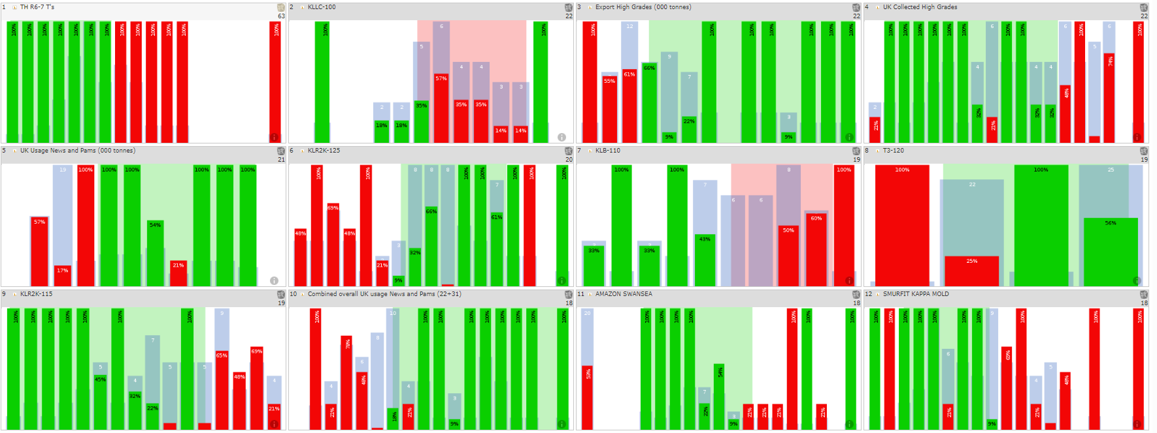
- Braincube Analysis Top 50



