University of Wales Trinity Saint David
Wales Institute of Science and Art


Integrating Project
ACHA4008

Sophie Hand, Chloe Rees, Chloe Giles, Sam Styles, Poppy White, Deniss Gavrilovs
2205445, 2218480, 2206140, 2218567, 2224519, 2103705
November 2022- January 2023

Contents
1 Introduction 2
1.1 Aims 3
1.2 Objectives 3
2 GANTT chart 3
3 Designs 3
3.1 Dimensions/ requirements 4
3.2 Aerodynamics 4
3.3 Materials 4
3.4 Suspension 4
3.5 Steering 4
3.6 Breaking systems 4
3.7 Costs 4
4 Meeting minutes 4
5 Conclusion 4

Introduction
The purpose of this group project is to create a soap box car or tricycle, in which we could come to the decision together of which one to design, this will be competing in the Richards Castle Soap Box Derby. Following the soap box regulations, we will design and produce a competitive soap box, to do this we will design at least two unique designs and decide as a group which one would be the most effective. Whilst following the exact dimensions and requirements rules, we will have a final design of an aerodynamic vehicle. To ensure that we have better aerodynamics and less drag, this can be achieved by looking at varied range materials to produce the soapbox to be lightweight. A good suspension on our soap box is crucial as there are many obstructions on the track, this is commonly a weak point on soap box cars. An important part of this is the steering as there is many narrow turns meandering throughout the track. We will finally be looking into different braking systems, and which one would be the most effective to use. Finally, looking into the costs of producing the product to ensure that it is cost effective and proficient.

Aims
The aim of the project is to produce a soap box to compete in the Richards Castle Soap Box Derby. This will be done by planning and designing as a group the best soap box car to win the Richards Castle Soap Box Derby.

Objectives
The objective is to create an efficient soap box making sure it withstands the race, whilst reaching high speeds, whilst keeping costs down, we must do this whilst communicating with the others in the team and working well to produce this on time.

GANTT chart
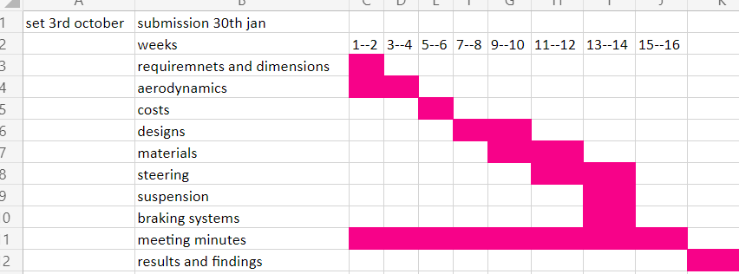
We have produced a GANTT chart to give ourselves a timeline of which things need to be done and to make sure that we are on target for finishing on time and completing the project with time to go back and make final tweaks.

Designs
Design 1:
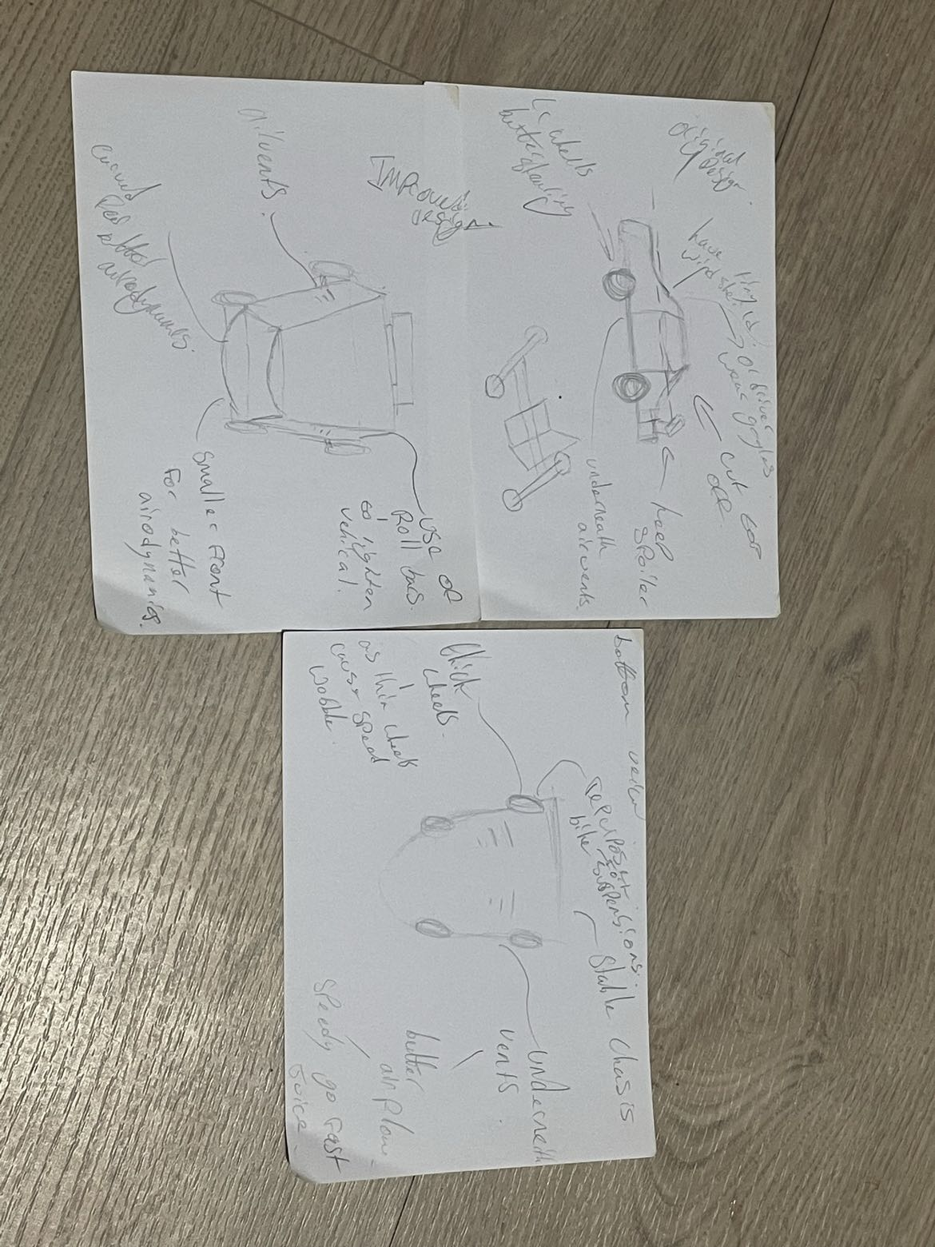
This design has promising ideas and we used this as a base to draw a second more improved version whilst keeping some of the original ideas
Design 2:
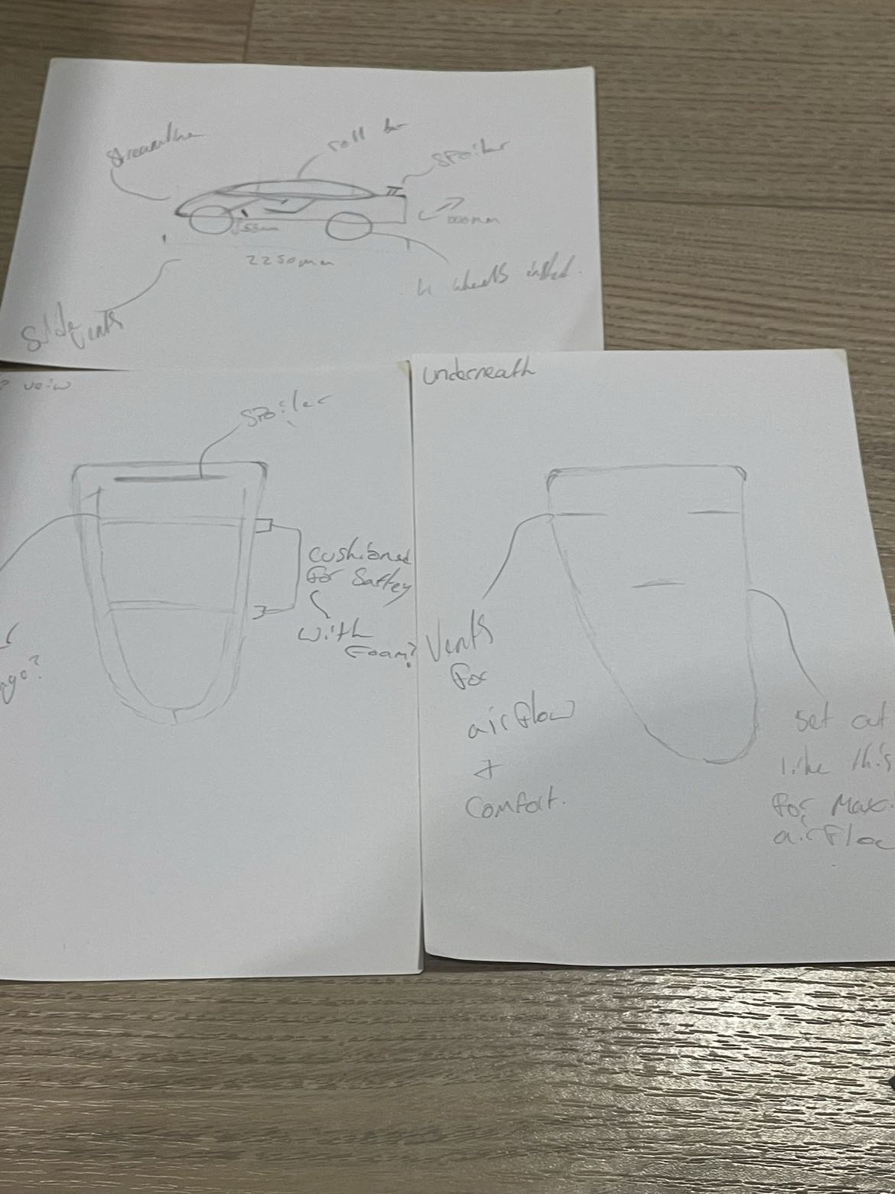

This is the final design following the requirements and the modifications needed to become more aerodynamic.

Dimensions/ requirements
The maximum soap box length is 2500mm and width 1500mm. Ground clearance must be a minimum of 50mm. Seat belts are highly recommended. The soap box Must have a substantial roll bar and it should be at least 35mm above the driver's helmet and the 2nd should extend at least 25mm beyond the driver's hands when placed at 12oclock on the steering wheel. The Soap box must be brightly coloured. The course is 550m long with a decent of 50m as it will expect to reach speeds ranging between 30-40MPH.

Aerodynamics
Aerodynamics are a vital part of the soapbox. I have researched the topic as well as using my own knowledge to make sure it is accurate and achievable as well as realistic making sure that I am keeping costs down. During the research, I discovered that having good aerodynamics is the ability to reduce drag and be able to travel at higher speeds we can do this by adding air vents to the underside of the vehicle to allow extra air flow, which reduces air resistance against the cars body, some of the other ways you can achieve this are adding a spoiler to help separate the airflow creating the downward force which therefore increases the grip at high speeds, reducing drag. Another thing to be aware of whilst designing this is to make sure that it is streamlined to ensure it does not slow down the vehicle you can do this by making sure that the back of the vehicle is bigger than the front to better aerodynamics. Lightweight materials add to the aerodynamics by allowing the vehicle to accelerate faster with a lower amount of energy.
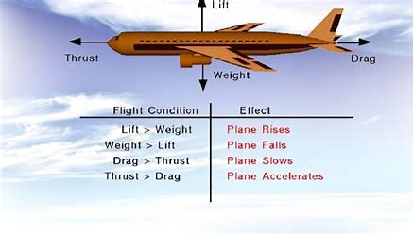

Materials
In order for the soap box car to succeed being the quickest, it is crucial that it is made from lightweight materials. There are several different materials to build the soap box out of such as plywood, wood, aluminium, medium-density fibreboard, and corrugated plastic. To be effective as possible it is necessary to use cheap and lightweight materials as we do not have an infinite budget, an advantage of this is it will save costs and create a much more aerodynamic soap box allowing it to be faster. To achieve this the best material to use would be plywood, it is lightweight and cost effective. It is a durable material that should not break when it encounters the obstacles at high speeds. It can also withstand drag for the vehicle’s speed and can be shaped easily, where the plywood is under too much stress, we could coat it in plastic.
The soap box also needs a strong chassis which can withstand the bumps from the track. We could use wood as it is a strong and cheap material however it could snap under pressure from landing after an obstacle. To ensure that our soap box has a strong chassis it is best to use a repurposed steel chassis from a 4-wheel pedal go-kart. These are commonly used on a soap box car as they are strong and should stand against from breaking when encountering obstacles at a high speed. The steel chassis base is a great material to use to create a sturdy base for the soap box car.
These two materials will create a strong body for the soap box which should hold up against if the soap box crashes. Additionally, these materials are lightweight which will aid the soap box to accelerate and gain speed faster. Furthermore, they are cheap materials that would make the soap box more cost effective.
Polystyrene and expanding foam can also be added to the soap box to improve the design by adding further dimension to the soap box. These both materials are low cost and extremely lightweight, which should not impact the costs and the speed of the soap box as it travels down the course.

Suspension

Soap box cars have to withstand obstacles, bumps and ramps therefore good suspension is a necessity. During our research we observed that the stability of rigid framed entrances was very poor due to the road surface in which the course is set up. A great option for the suspension and that is commonly used on other designs I have seen on these vehicles, would be wish bone and shock absorber set up. This setup could be cheap option and is also simple. I found quad bike shock absorbers for less than £10 and wish bones for less than £20 which I think would be the best option regarding performance design and cost. This type of suspension is effective as it would hold the wheels to the road surface therefore gaining more traction and control of the soap box car. Having this type of suspension could also be more protected by the body of the soap box as the shock absorbers could be moved inboard and a linkage system could be used.
This will also aid in reducing aerodynamic drag, which is one of the main limiting factors to speed in soapbox racing.

Cheap options
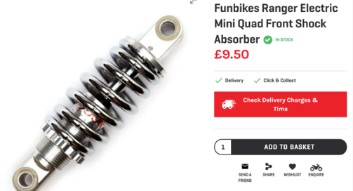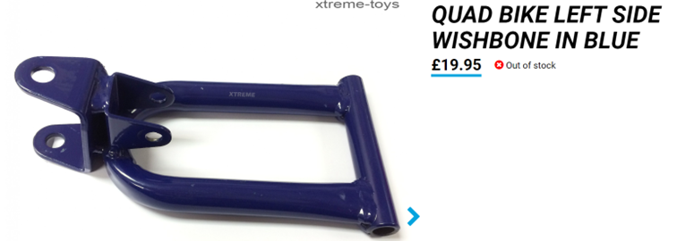

If there was an increase in budget other options are also available. Rear suspension from mountain bikes is also an option. Being equipped with adjustable rebound and compression damping, as well as gas pressure and preload. Springs with different spring rates can also be specified, but in order to calculate the correct spring rate both the total mass and the linkage ratio must be known.
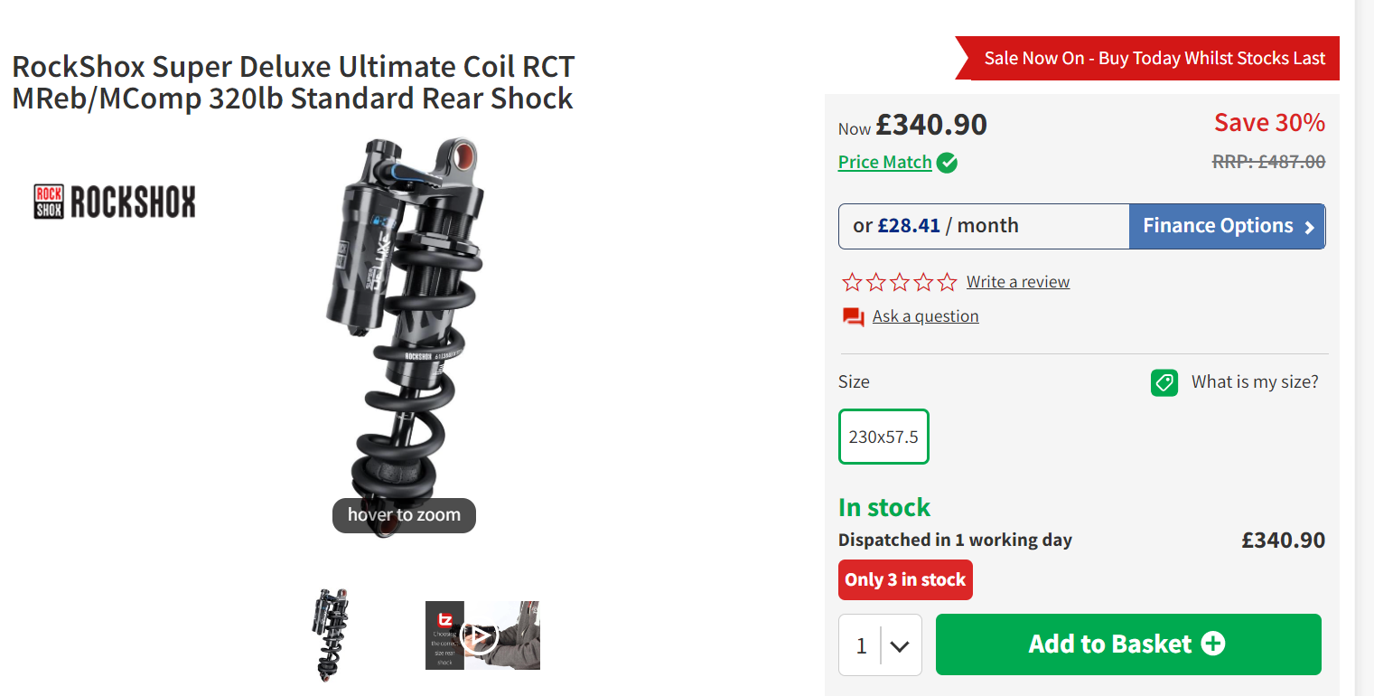

Steering
The steering is a vital part of the soap box cart. As a result, I have, researched the topic in detail to ensure it is accurate as well as realistic. During my research, I have come to conclude that the simplest and most effective system for steering would be the rack and pinion system. A rack and pinion system consists of two major parts. The rack is a metal bar that is connected to both wheels with specially designed slots in the middle of it. The pinion is a gear that fits into the slots of the rack and is directly connected to the steering wheel. The pinion moves the rack left to right as the steering wheel is turned which in turn, rotates the wheels in each direction.
One advantage of the rack and pinion steering system is cost. Since this system only contains two general components, this makes it perfect for our project as it keeps our costs low. Another advantage is the size of the system. The size of the rack and pinion system allows us to fit it into a smaller cart therefore allowing us to use less materials on the rest of the cart, which in turn, again, saves us in costs. One last advantage is that the pinion gear can be changed to increase or decrease steering sensitivity. The change of sensitivity can be adjusted to suit the driver’s needs.
One disadvantage is that there is no mechanical advantage. For example, such as in vehicles with power steering, although the weight of our cart would not make this a major disadvantage. Another disadvantage is the size of the pinion gear. If the size of the pinion gear is not setup correctly, then this could cause the steering to be too sensitive for the driver to control and therefore be a disadvantage.

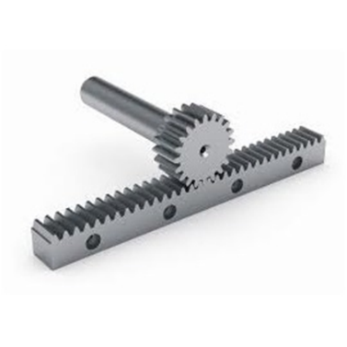

Braking systems
After the race has finished the braking system becomes a vital part of the soap box as it is used to bring the car to a halt to avoid others getting injured from the speed of the car.

Using push brakes rather than a handbrake is a lot more practical. This is because the handbrake is not as powerful or practical as the footbrake only the handbrake is used on its own, it will not bring the car to a stop very quickly. The handbrake only controls the rear end of the vehicle. There are very few cars who have a handbrake that controls the front of the car. The only time the handbrake is really used is when the vehicle is starting or parking. While using the handbrake, it usually locks the rear end, and the driver may lose control. By using push brakes, the driver has a lot more control of the car, where the driver can gradually slow down instead of coming to a full stop.

Costs
Materials:
Plywood - £12 for 1220mm x 610mm (x5)
Plastic- £17.75 per sheet 1200mm x 620mm x 1mm (x2)
Go-kart steel chassis - £100
Polystyrene - £12 for 2.4m x 1.2m (x4)
Expanding foam - £6/Can (x2)
Suspension:
Shock absorbers & wish bone - £30 (per axel) £120
Braking system:
Soap box master Push brake - £93.85
Steering:
Rack and pinion set - £106.72
Processes used on the vehicle.
Spot welding – Welder £50, Bottle of gas (Butane) £40, PPE £100, Wire steel £25.
Power drill £50, twin thread wood screws £2.50, wood brackets(flat brackets 12pk) £5.59.
Torque wrench, sockets, nuts.

Meeting minutes
Friday 10th October 2022. Room IQ001
Attendees: Sophie Hand (2205445), Sam Styles (2218567), Deniss Gavrilovs (2103705).
15:02- Discussion of different project roles and who would do each role.
15:17- Chloe Giles decided to investigate different braking system that can be used.
15:18- Aerodynamic features would be looked at by Sophie Hand.
15:19- Sam Styles, Sophie Hand would be producing 2 different soap box car designs.
15:20- Deniss Gavrilovs would oversee the steering we would use on the soap box.
15:21- Poppy White would look at a variety of suspension that would be suitable for our soap box car.
15:22- Sam Styles would be completing the costs of the project.
15:23- Everyone decided that the materials section would be completed by Chloe Rees
15:28- Sophie Hand did the first draft of a Gantt chart as it would give us an idea of when each section should be completed by.
15:34- Meeting ended as everyone understood what they had to do.
Friday 4th November 2022. Teams Online Meeting.
Attendees: Sophie Hand (2205445), Sam Styles (2218567), Chloe Rees (2218480)
13:14- Got up to date on the work that had to be completed and what was left to do by different members of the group.
13:20- Discussed different design ideas and what could be added to the soap box.
13:32- Concluded that the soap box should be as aerodynamic and cost effective as can be.
Tuesday 17th January 2023. Teams Online Meeting
Attendees: Sophie Hand (2205445), Sam Styles (2218567), Chloe Rees (2218480)
15:00- Read over the work done so far and then discussed about how we can improve certain sections of the project
15:09- Changed the wording in a few sections to look more professional and less repetitive.
15:15- Looked at the costs of all items that is needed in order to build the soap box.
15:21- finished the meeting by adding all the cost of the items together and getting to a final amount that needs to the spent on the soap box.

Conclusion
To conclude...
Overall...

