

Programme: BA Business Management
Module: Management Economics
Module code: LCBB5008
Lecturer: Taye Osadiya
Assignment Title: Component 1: Essay
Student name: Tatiana Cebotari (2123377)

Table of Contents
Introduction 3
Discussion 3
Task 1 3
Task 2 5
Conclusion 8
Reference List 9
Appendix 11

Introduction
In terms of defining an economic system, it can be stated that it is an effective combination of measurable elements based on an efficient market economy along with a planned economy (CFI, 2023a). The essay will align the concepts of demand and supply with the operations within an economy. There will be an analysis of government policies while determining disruptions from the advent of the global pandemic and BREXIT in the United Kingdom. Furthermore, fundamental economic issues related to the availability of fuel and its corresponding supply chain disruptions revolving around increasing price rates will be discussed in this essay.

Discussion
Task 1
a. Fundamental economic problems
The fundamental economic issues that have been determined in the case study revolve around the advent of the global pandemic. COVID-19 has been responsible for adversely influencing business operations after its aftermath. Every major developed economy including the United Kingdom is highly dependent on the regulations of the pandemic based on changing demand and supply approaches. The impact of the pandemic revolves around the shortage of demand and supply practices and such facilities have evidently influenced and impacted supply chain management. Such negative approaches even include imminent changes in prices resulting from high demand for fuel within the economy. Furthermore, high demand for fuel has been the primary outcome of a shortage of labour supply resulting from the increasing adversities of changes in demand and supply within the UK. For instance, lockdowns after the emergence of COVID-19 measured declining rates of demand across transportation fuels that have been leading to a reduced supply in response (GOV.UK, 2023).
The repercussions of COVID-19 caused a wide range of firms in the United Kingdom to rely on the importing of intermediate products and raw materials from abroad while exporting finished goods and components in an international context (adapted from the case study). As a result of the global pandemic, international supply chains have been put under immense pressure impacting the demand and supply operations within the economy. These recent pressures have been perceived as notably more severe than at any point ever since the index was initiated. As an outcome, there has been a potential shift in the appetite of consumers from services to products or goods during the global pandemic while partly driving pressure on supply chains. All such pressures on demand and supply chains led to an alarming increase in the purchasing of goods and services coupled with an extreme shortage of drivers contributing to problems in fuel supply (adapted from the case study).
At the primary outset, the influence of COVID-19 witnessed a broad scope of EU drivers leaving the UK creating a remarkable shortage of drivers seriously disrupting deliveries to the minority of a myriad of petrol stations. This had been the result of the exodus of drivers who had already left the economy and had been difficult to replace, mostly due to the global pandemic and BREXIT. This ensured that a wide range of consumers rushed to fill in their tanks as the news of the shortage of drivers had been reported leading to a rapid increase in demand when supply had already been constrained. Such constraints had been recorded with levels of fuel at forecourts within the worst-hit fields in the economy, averaging more than 20% during the adverse peak of the crisis, compared to a normal count of 43% (adapted from the case study). In this regard, the Consumer Behaviour Theory can be applied based on the domination of the Theory of Planned Behaviour and the Theory of Social Practice (Spangenberg and Lorek, 2019). Bankruptcies, end of redundancies or furlough, and high borrowings are other adversities.
b. Various ways of solving the challenges
Government intervention has been an exceptional approach in terms of resolving the challenging situation imposed by the adverse disruptions of the UK economy. For instance, immigration emphasises improvements revolving around effective practices aimed at economic development. Such policies are measured in terms of responding to the demographic objectives that have been set out by destination economies and to the needs of the established labour market (United Nations, 2023). Furthermore, regulations in the form of an active monetary policy can be applied in terms of ensuring effective economic practices that have been emerging after the advent of the global pandemic. In terms of addressing the evolving issues of BREXIT and COVID-19 with changing demand and supply, financial support from the UK government has been a major indication of development. For instance, the Monetarist Theory or Monetarism may be determined as a vital macroeconomic approach that primarily focuses on the significance of financial investments as key economic facets (CFI, 2023b).
Following this, the capacities of active government agencies relate to business engagement activities and the establishment of exclusive communication practices. For example, resident individuals and domiciled beings in the United Kingdom are taxed on worldwide income rates and capital gains (PWC, 2023). Furthermore, diagnosing and developing supply chain networks have been evolving as a major concern by the UK government in terms of setting out policies against increasing prices and costs of living after the adverse impact of the pandemic. The significance of stakeholders within an economy ensures the practice of rewarding and reevaluating employees while driving engagement as well as loyalty with purpose (McQuaker, 2020). It is the responsibility of efficient managers of an organisation to engage in effective practices of informing employees regarding the need for changes. This is because employees are considered to be one of the most essential assets of an organisation while being important to an economy. Furthermore, the capability of stakeholders needs to be assessed in terms of identifying their potential to recover economic operations.
In this regard of decision-making approaches, the theory of Bounded Rationality can be applied to the actions that have been undertaken by the government in the United Kingdom. Bounded Rationality is the concept where business entities lack context information on the results of potential outcomes leading to being forced to form less than optimal decisions identifying irrational outcomes (Hernandez and Ortega, 2019). This can be aligned with the approaches of the government in terms of exerting effective control on economic disruptions and political instabilities. For instance, inflation rates have been adversely impacting the operating functions within an economy related to changing demand and supply of fuel with increasing costs of production and living. Such issues have been improvised and developed with strategic decisions undertaken by the UK government in the form of relaxing stringent regulations of COVID-19 while improving proper teams for shortage management. Initiating alternative approaches to reduce waste generation while collaborating with suppliers in terms of reducing price rates that have been initiating operational issues within the UK economy.

Task 2
a. Relevance of Demand and Supply
The advent of the global pandemic has emphasised the concept of demand and supply relevant to the establishment of pricing strategies corresponding to the reduction and management of pressures. For instance, government policies ensured increasing interest rates within banks in the UK to 5.25% with the primary target of keeping inflation rates as low as 2% (Bank of England, 2023). Demand and supply practices within an economy are likely to reduce price and competition while driving costs of living to be low. However, inflation rates in the United Kingdom were 6.7% in the year 2023, a decline from the peak of 11.1% in the previous year (Clark, 2023). Furthermore, the operations of demand and supply relate to marketing or promotional strategies based on the idea of identifying the rapidly changing choices and preferences of consumers while promoting business ideas. Business productivity has been emphasised with the help of demand and supply based on fields of operational functions within an economy.
For instance, Amazon has been engaged in promoting its innovative business operations relating to the idea of involving artificial intelligence, content creation and cloud computing within its field of online expansion (HBR, 2023). The just-in-time system related to balancing inventory management strategies is likely to be influenced by the operations of demand and supply within the market. Investments have the capability to attract finances in the form of an initial public offering in terms of raising high capital investments while creating a massive spree of financial operations. The perception of consumers regarding the operations of an economy is likely to change from time to time and businesses are expected to conduct effective market analysis leading to the idea of ensuring demand and supply rates. Furthermore, developing a concrete understanding of the concept of demand and supply may lead to an exclusive management of workplace operations.
For instance, greater retention rates of workers or workforce with satisfaction rates being high in terms of assuring high salaries and timely payments. Furthermore, the relevance of demand and supply relies on the idea that employment, supply chain operations and costs of production are kept in a balance based on the changing choices and preferences of consumers within an economy. Supply and demand equilibrium refers to the idea that the quantity demanded of goods or services is equal to the quantity supplied of those commodities, irrespective of price rates and other economic determinants. This relates to risk management actions that can be identified in the form of changing demand and supply with a shift in price equilibrium. Following this, ensuring a balance in demand and supply may lead to the proper management of supply and shortage in terms of helping a shifting market demand.
It is necessary to understand that the concept of demand and supply work in correspondence to changes in the price of commodities influencing an increase or decrease in the demand and supply of those items. Price equilibrium or an equilibrium in the quantity demanded and quantity supplied of commodities relies on the confidence held by consumers in the economy. For instance, factors such as income, population, substitute goods and future implications are other determinants of a change in demand, irrespective of price changes. On the other hand, factors of supply primarily involve the cost of production, appropriate transportation, government policies and technological advancements. This relies on the idea of ensuring effective management within organisations based on the fact that demand and supply are the primary forces of determining or forecasting economic growth or downturns in the future. It is the responsibility of operational managers to convey economic stances to capable stakeholders.
b. Difference between elasticity and inelasticity of demand
Elasticity can be primarily defined as a general measure on the basis of the responsiveness of a wide range of economic variables in response to a broad scope of changes that have been taking place within other economic variables (CFI, 2023c). Following this, the elasticity of demand may be identified as a havoc change in the quantity demanded of goods and services corresponding to a slight change in economic factors such as price and income. In terms of determining the concept of inelastic demand, it can be stated as a measure where the demand of buyers for goods or services does not undergo any change with a change in the price of those commodities (Vipond, 2023). Furthermore, this indicates the static quantity of goods or services within an economy that does not change with economic downturns or upheavals. For example, any change in the price of fuel does not imply a change in the behaviour or quantity demanded of the commodity from consumers. Elastic and inelastic supply of commodities applies to a similar concept where the former has a havoc change and the latter has almost no change in quantity supplied based on changes in price (refer to the appendix).
Inelastic demand can be primarily referred to as a situation where the quantity demanded of commodities does not change with any change in the price of those goods and services (Surbhi, 2023). An example that can be applied to the concept of inelastic demand is salt where a change in its price does not initiate any change in the quantity demanded of this item. Such approaches are likely to be exemplified in the purpose of ensuring price flexibility by relying on protective measures during market disruptions. From a different perspective, an example of elastic demand can be identified as diamond where a slight increase in the price of this luxury commodity corresponds to a havoc decline in the quantity demanded of this item. Entry barriers currently revolve around financial, legal and political frameworks emphasised with the idea of elastic and inelastic demand. Elastic demand is considered to be less challenging leading to the initiation of lower rates of tax which may involve conflicts related to too much increase in price rates (Symes, 2022). However, inelastic demand is responsible for boosting revenue and sales volume within the economy but may engage in declining profit rates based on price-inelastic products or services.
c. The Laws of Supply and Demand
The principles of the law of demand and supply primarily contribute to corporate relationships while emphasising efficient maintenance within an economy (Velev, 2021). For instance, the law of demand is based on the assumption that every other factor other than price influencing demand remains constant within an economy. Following this, it can be stated that the law of demand believes in the idea that a change in the price of commodities creates a corresponding change in the demand for those items. For example, if the price of products and services increases within an economy, it may lead to a corresponding decline in the quantity demanded of those commodities. Similarly, a decline in the price of commodities within an economy may lead to a corresponding increase in the quantity demanded of those goods or services. Demand has an inversely proportionate relationship with changes in the price of commodities within an economy.
From a different perspective, the law of supply relies on the idea of the assumption that every other determinant of supply other than price is constant throughout economic operations. For instance, any change in the price of commodities that consumers are willing to pay may lead to a corresponding change in the supply of those goods or services. An increase in the price of products within an economy that consumers are eager to purchase, irrespective of high prices, may lead to a corresponding increase in the quantity supplied of those commodities. On a similar note, a decline in the price of luxury commodities may create less confidence in consumers leading to a corresponding decrease in the quantity supplied of those goods or services. This indicates that changes in the price of goods or services within an economy involve a directly proportionate relationship with changes in the price of those commodities.

Conclusion
From the above discussion, it can be derived that economic disruptions have been prevalent within the United Kingdom in terms of the advent of the global pandemic and BREXIT. Furthermore, the essay has highlighted issues with the increasing cost of fuel leading to an increased demand. However, the increased quantity demanded of fuel in the economy declined the supply of the commodity in the UK and this has been underpinned with theoretical approaches. The actions relevant to the law of demand and supply have been stated in this essay with an emphasis on demand elasticity and inelasticity influencing worldwide economies.

Reference List
Bank of England (2023) Monetary Policy. Available at: https://www.bankofengland.co.uk/monetary-policy (Accessed: 26 November 2023).
CFI (2023a) What is a Mixed Economic System? Available at: https://corporatefinanceinstitute.com/resources/economics/mixed-economic-system/ (Accessed: 26 November 2023).
CFI (2023b) What is the Monetarist Theory? Available at: https://corporatefinanceinstitute.com/resources/economics/monetarist-theory/ (Accessed: 26 November 2023).
CFI (2023c) What is Elasticity? Available at: https://corporatefinanceinstitute.com/resources/economics/elasticity/ (Accessed: 26 November 2023).
Clark, D. (2023) Inflation rate in the UK. Available at: https://www.statista.com/statistics/306648/inflation-rate-consumer-price-index-cpi-united-kingdom-uk/#:~:text=The%20UK%20inflation%20rate%20was,11.1%20percent%20in%20October%202022. (Accessed: 26 November 2023).
GOV.UK (2023) Supply and demand of transport fuels during COVID-19. Available at: https://assets.publishing.service.gov.uk/media/5f6b3b09e90e077c9b87dfd7/Supply_and_demand_of_transport_fuels_during_COVID-19.pdf (Accessed: 25 November 2023).
HBR (2023) Inside Amazon’s Growth Strategy. Available at: https://hbr.org/podcast/2023/07/inside-amazons-growth-strategy#:~:text=Since%20Amazon%20started%20as%20an,key%20to%20success%20is%20focus. (Accessed: 26 November 2023).
Hernandez, J.G.V. and Ortega, R.P. (2019) Bounded rationality in decision–making. MOJ Research Review, 2(1), pp.1-8.
McQuaker, L. (2020) The Importance Of Stakeholder Engagement And Building Brand Loyalty Through Purpose. Available at: https://www.forbes.com/sites/forbescommunicationscouncil/2020/05/27/the-importance-of-stakeholder-engagement-and-building-brand-loyalty-through-purpose/?sh=28057df01a89 (Accessed: 26 November 2023).
PWC (2023) Individual - Taxes on personal income. Available at: https://taxsummaries.pwc.com/united-kingdom/individual/taxes-on-personal-income (Accessed: 26 November 2023).
Spangenberg, J.H. and Lorek, S. (2019) Sufficiency and consumer behaviour: From theory to policy. Energy Policy, 129, pp.1070-1079.
Surbhi, S. (2023) Difference Between Elastic and Inelastic Demand. Available at: https://keydifferences.com/difference-between-elastic-and-inelastic-demand.html#KeyDifferences (Accessed: 26 November 2023).
Symes, S. (2022) Advantages & Disadvantages of Two External Factors When It Comes to Marketing Products. Available at: https://smallbusiness.chron.com/advantages-disadvantages-two-external-factors-comes-marketing-products-22207.html (Accessed: 26 November 2023).
United Nations (2023) Immigration Policies. Available at: https://www.un.org/en/development/desa/population/publications/pdf/policy/InternationalMigrationPolicies2013/Report%20PDFs/h_Ch_2.pdf (Accessed: 26 November 2023).
Velev, M.V. (2021) Entropy and free-energy based interpretation of the laws of supply and demand. SN Business & Economics, 1, pp.1-16.
Vipond, T. (2023) What is Inelastic Demand? Available at: https://corporatefinanceinstitute.com/resources/economics/inelastic-demand/ (Accessed: 26 November 2023).

Appendix
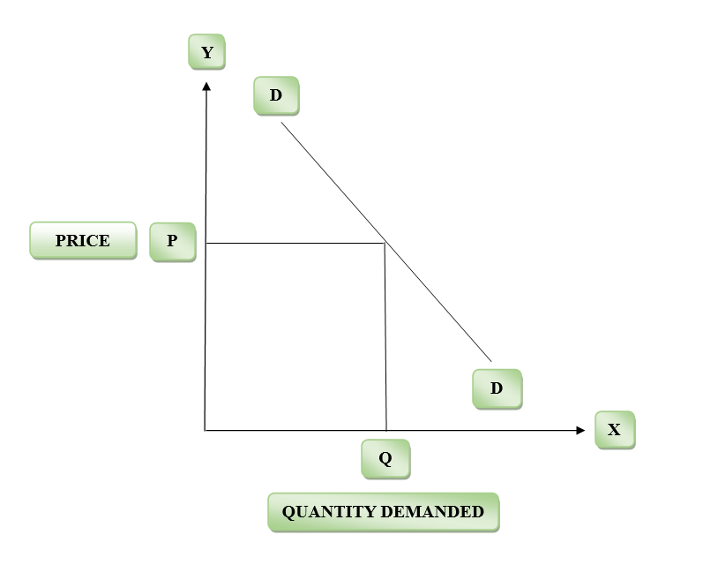
Figure 1: Law of Demand
(Source: Created by the learner)
Price of commodities (in GBP) | Quantity demanded (in lbs)
10 | 50
20 | 40
30 | 30
40 | 20
50 | 10
Table 1: Changes in the quantity demanded with a change in price
(Source: Created by the learner)
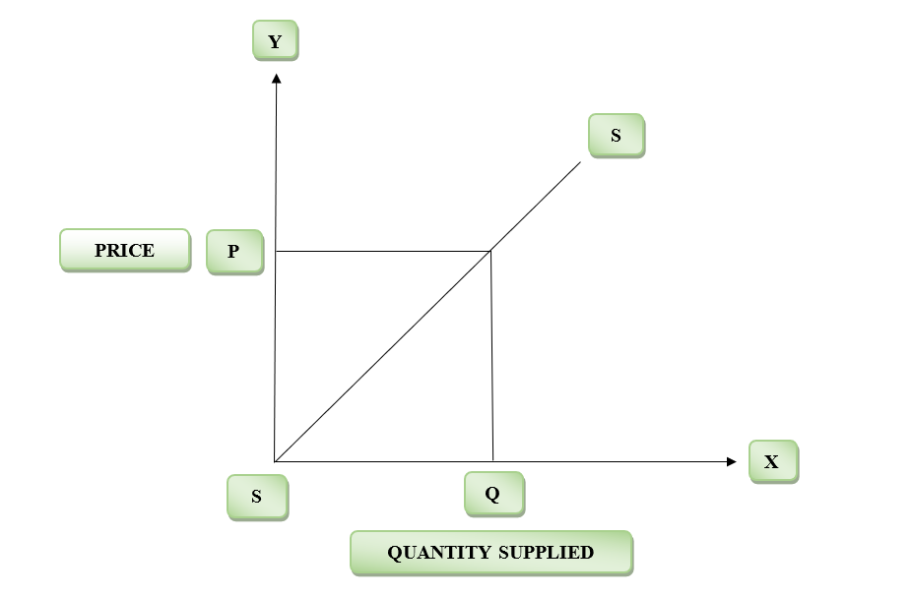
Figure 2: Law of Supply
(Source: Created by the learner)
Price of commodities (in GBP) | Quantity supplied (in lbs)
20 | 10
30 | 20
40 | 40
50 | 60
60 | 70
Table 2: Changes in the quantity supplied with a change in price
(Source: Created by the learner)
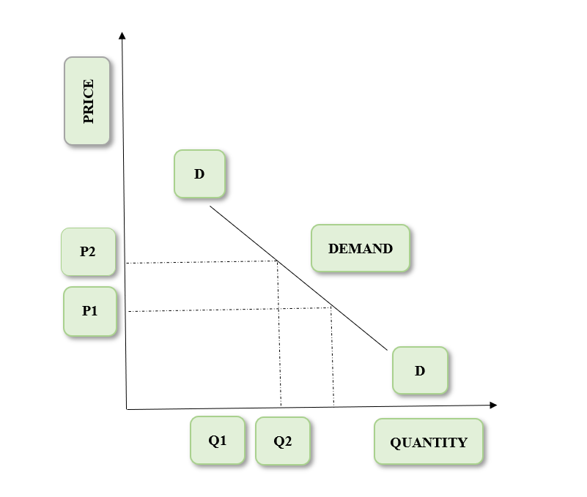
Figure 3: Elastic Demand
(Source: Created by the learner)
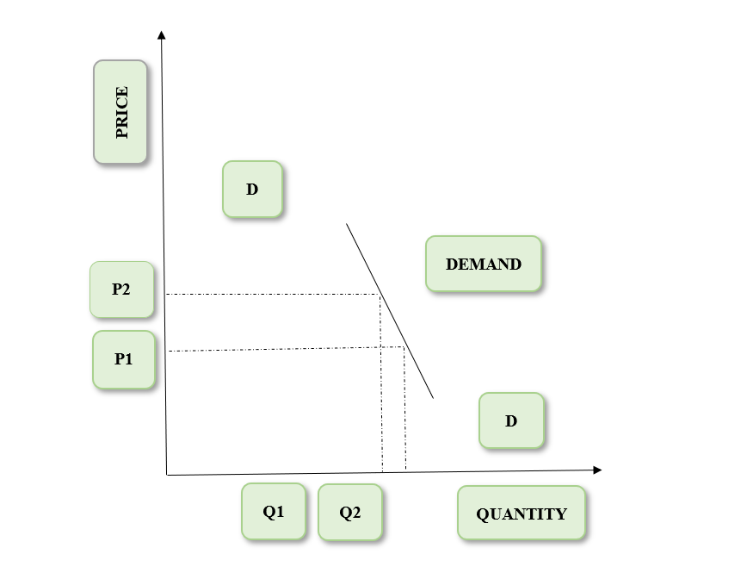
Figure 4: Inelastic demand
(Source: Created by the learner)
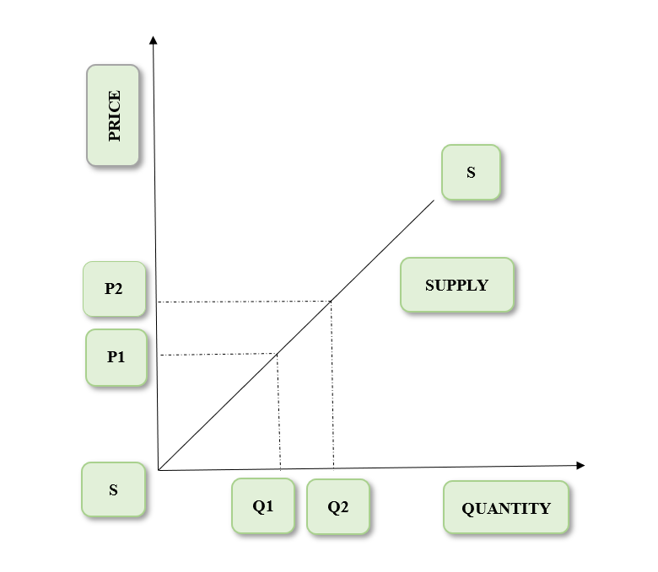
Figure 5: Elastic Supply
(Source: Created by the learner)
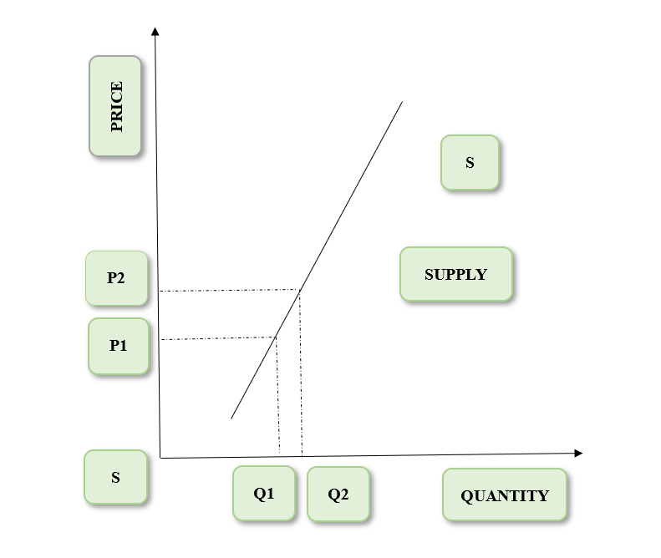
Figure 6: Inelastic Supply
(Source: Created by the learner)

