Thomas Rhys Evans
Student No: 1810164
Network Operating Systems and Services (NOSS)
(ACCA5023)
Worksheet 2

Table Of Contents
Heading | Page Number
Part 1 – Practical work | 1
Task 1: Pre-requisites | 1
Task 2: Deploying Active Directory | 3
Task 3: AD Account creation | 10
Task 4: Object attributes of interest | 13
Task 5: Adjoining the domain and testing user logins | 18
Part 2: Observational task | 25
a) DNS | 25
i) Recursive Resolvers | 25
ii) DNS Root Nameservers | 26
iii) TLD Nameserver | 27
iv) Authoritative nameserver | 27
v) DNS in active directory | 28
b) Additional roles and features | 28
i) DHCP | 28
ii) Hyper-V | 29
c) Access control in Active Directory | 30
d) AGDLP/AGUDLP | 30

Part 1 – Practical work
Task 1: Pre-requisites
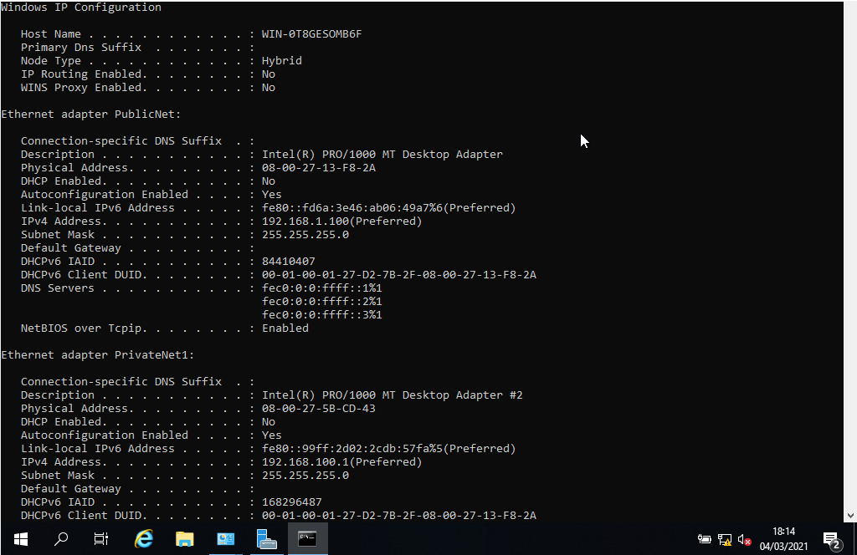
By running an ‘ipconfig /all’ command, the IP address of the server can be determined. DHCP is also disabled, showing that the server has been configured with a static IP.
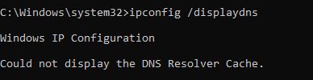
No DNS has been configured for the server to use and windows firewall has been completely disabled.
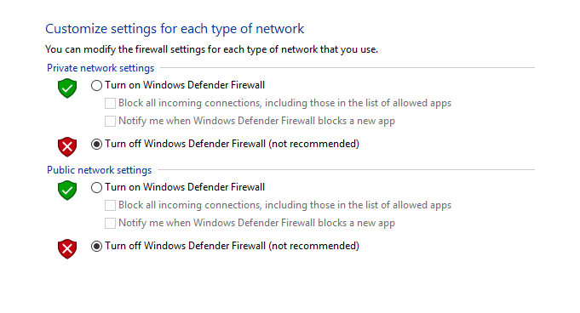
By selecting ‘This PC’ on the server, the properties can be accessed, in turn allowing the server name to be changed from the one configured by default.
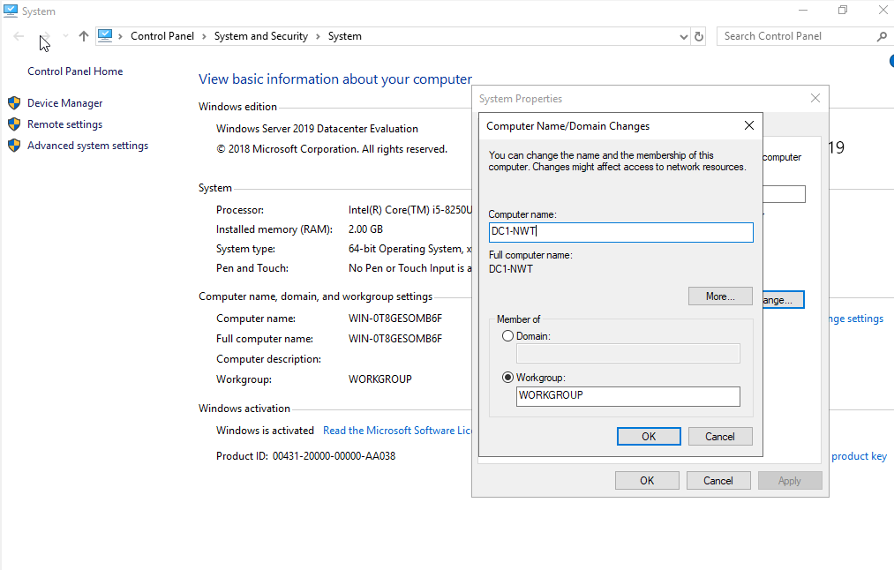
This server is to act as a domain controller. As such it has been provided with the name “DC1-NWT”, indicating this is the case. Ensuring a sensible naming convention is important, especially in complex environments. This allows IT administrators to know what each server is user for.
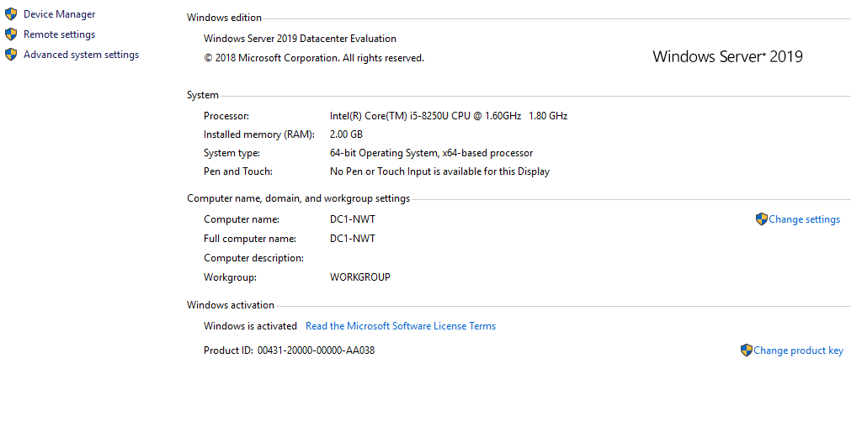
Here it can be seen, after a reboot, the renaming of the server has been completed.
Task 2: Deploying Active Directory
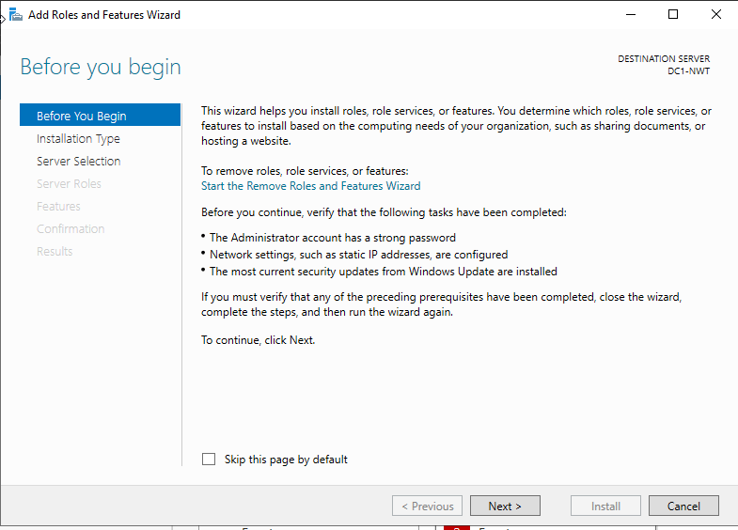
To begin installing Active Directory, server manager must first be loaded on the server. Selecting ‘Add roles and features’ on the server manager dashboard brings up the above wizard.
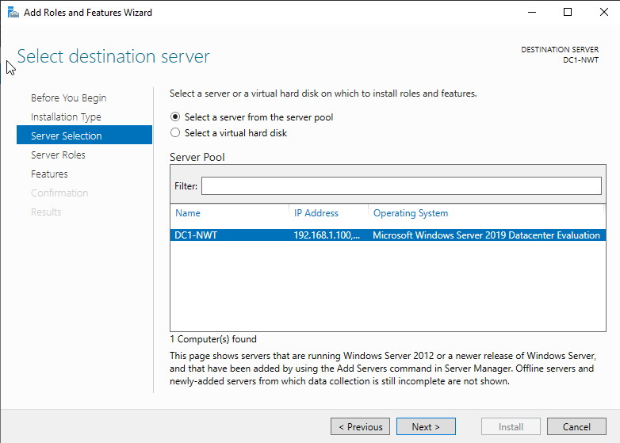
The current server is to act as the domain controller. This server is selected to begin installation.
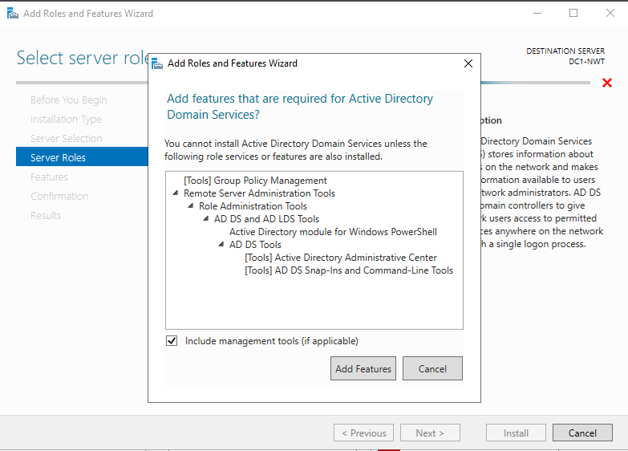
There are numerous roles and features that can be installed on a Windows Server, such as DHCP, File and storage, DNS and Hyper-V, among others. But on this occasion, Active Directory is required. As such, “Active Directory Domain Services” is chosen
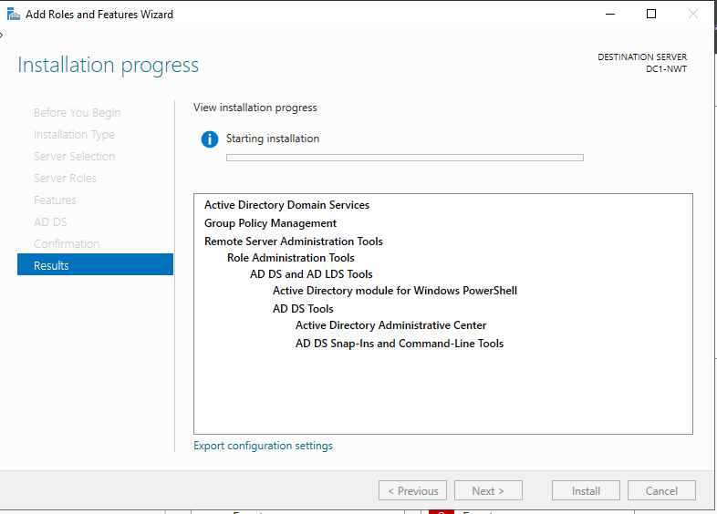
Once the install of the Active Directory service is complete, the service must then be configured.
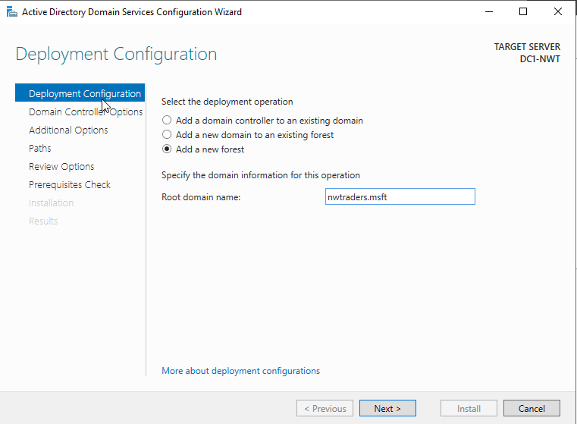
As this is a fresh install and the domain controller is not being added to an existing domain, a new domain must be created. This domain must be named, so the name “nwtraders.msft” is selected.
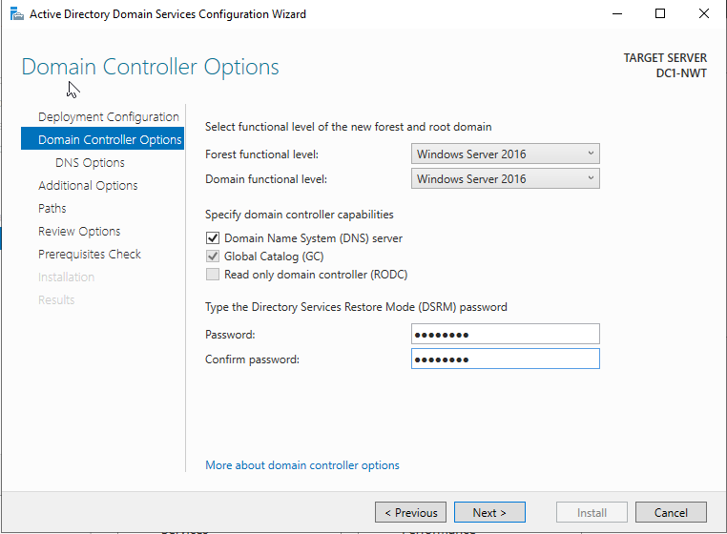
After selecting the domain name, the server must have it’s DNS capability enabled. This allows computer names to be resolved to IP addresses. The DSRM password is also set. This password is extremely important and must be both secure and stored for use in case of emergency. DSRM is effectively a “Safe mode” for active directory and is used to allow administrators access to repair, recover or restore Active Directory, particularly in the case of disaster recovery.
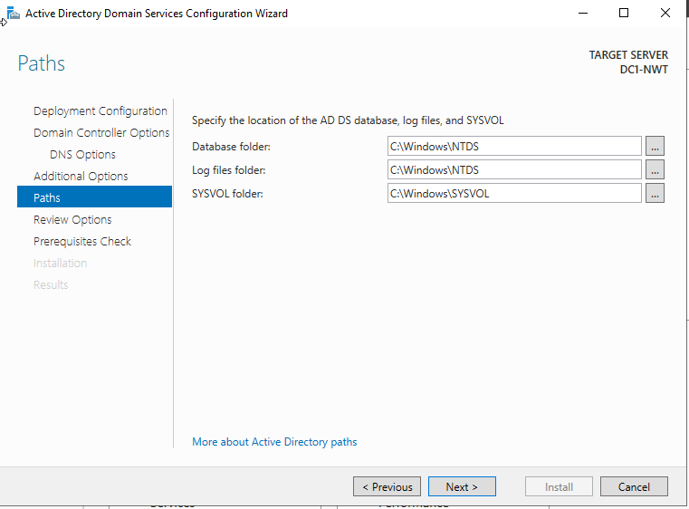
Next, paths must be specific. The database folder contains the NTDS.dit file, a database file that stores active directory information such as objects, groups, group memberships and password hashes. The SYSVOL folder will contain the domain’s public files that need to be accessed by clients on the domain
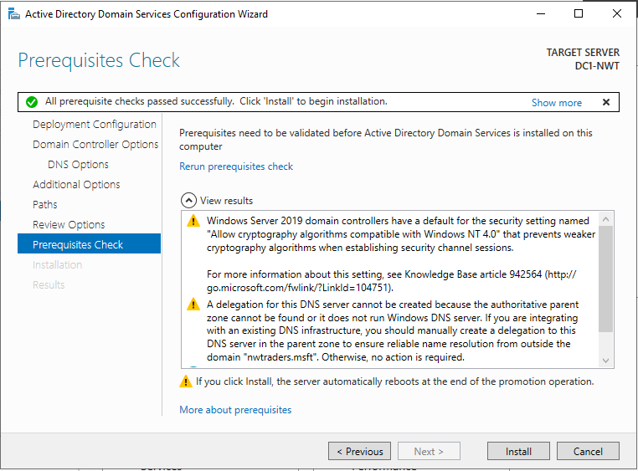
Once this configuration is complete, Windows Server will first run a pre-requisite check. These pre-requisites must be validated before ADDS can be installed on the server. Once these checks are complete, the installation can begin.

Once the install is complete and the server has been rebooted, the domain that has been created is accessible, as seen by the “NWTRADERS” part of the above log on screen. No user accounts have yet been created, so log on with the administrator account is currently the only way to access the server.
Task 3: AD Account creation
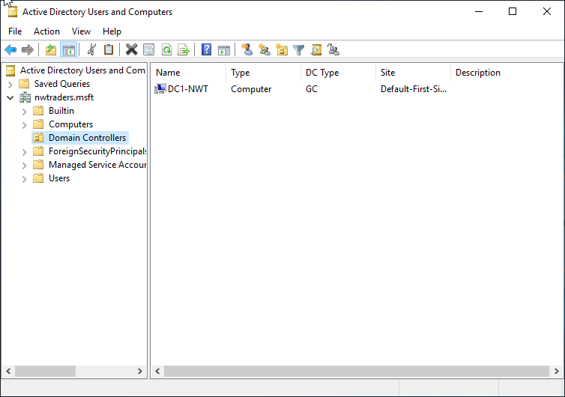
Once logged into the server, Active Directory can now be accessed. Active Directory Users and Computers is a management tool that allows administration of Active Directory. Above, the domain created previously can be seen. Also, the domain controller can be seen.
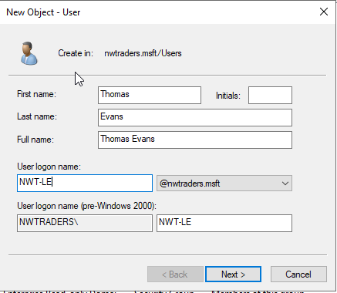
Accounts can now be created to allow additional users access to clients on the newly created domain. Above, the initial configuration of a new user is seen. The name of the user is entered, before a username is assigned. In an organisation a standard naming convention for users, as well as computers and servers, should be used.
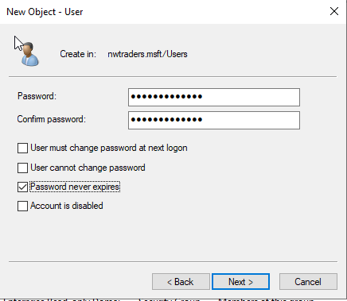
The password of the user account is then set, before being set to never expire. After clicking ‘next’, the account is created.

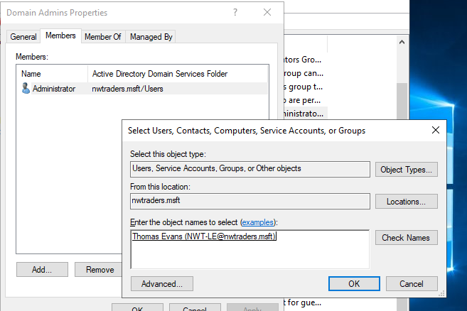
‘Domain admins’ is the highest level permission group in Active Directory and allows users who are a part of this group administrator access to the domain. Currently, only the ‘Administrator’ user account has access to this group. To provide the newly created account access to administer the domain, it must be added to this group
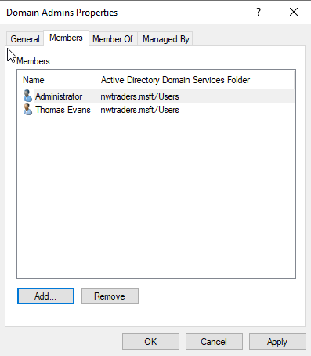
Once applied, ‘Thomas Evans’ will then be able to log on to the server and carry out administrator level tasks.
Task 4: Object attributes of interest
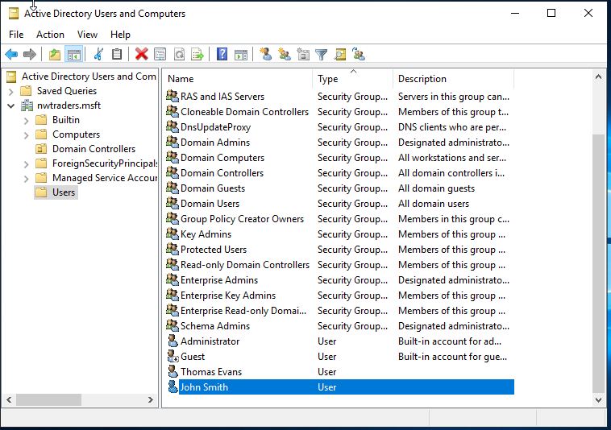
Here, the list of default groups within Active Directory can be seen. A user has already been added to the “Domain Admins” group, but now a new user needs domain access. This user is not an administrator and needs only to log on to PC’s to carry out non-admin tasks.
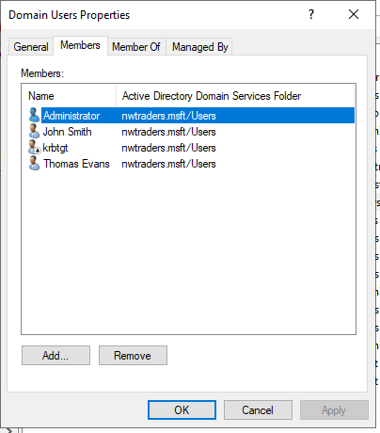
After creating the account for ‘John Smith’, it is added to the “Domain users” group. This group allows the account to log on to clients on the domain, but only as a “non-admin”.
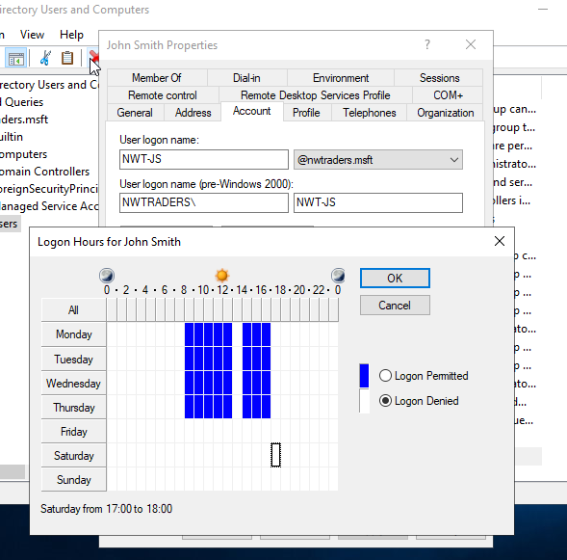
The time at which ‘John Smith’ can log on can also be set. This is particularly useful for security purposes. If employees only need access to the domain during pre-defined working hours, removing log on rights can stop them from accessing the system when not allowed. It can also help prevent unauthorised users from using stolen credentials to access the domain out of working hours.
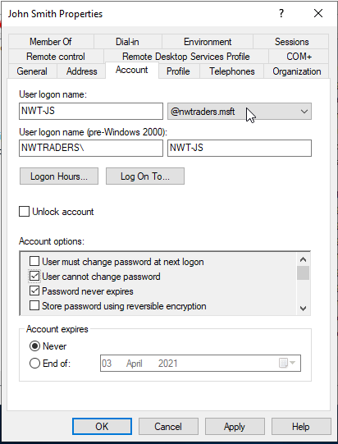

Task 5: Adjoining the domain and testing user logins
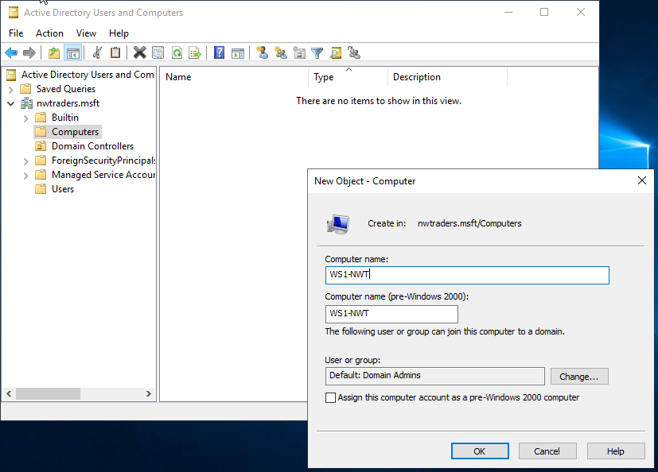
In order to connect a PC to a domain, the domain must first hold an computer object of the same name. To do this, a new computer object is created within the ‘Computers’ OU of Active Directory. As before, a naming convention is followed and the client name is to be called ‘WS1-NWT’
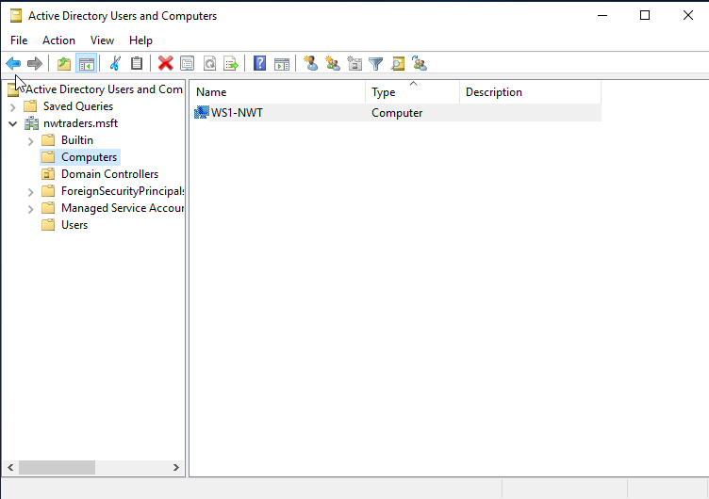
The client can be seen sat within the ‘Computers’ OU above. It is now possible to name the client to match the newly created object before adding it to the domain.

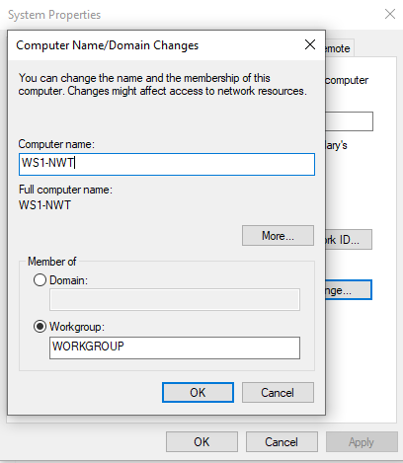
On ‘Client1’, in the same way as the ‘Server1’ name was changed, the client is assigned the name of the recently created computer object. After a reboot, the name of ‘Client1’ will be ‘WS1-NWT’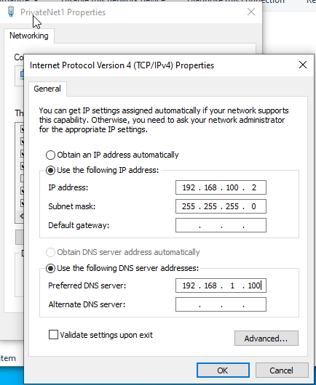
An amendment is then made to the IPV4 configuration on ‘Client1’. The domain controller is now acting as a DNS server for clients on the domain. As such, ‘Client1’ can now be configured to use the IP settings of the domain controller for DNS. This needs to be configured to allow the client and domain controller to resolve host names to IP address.
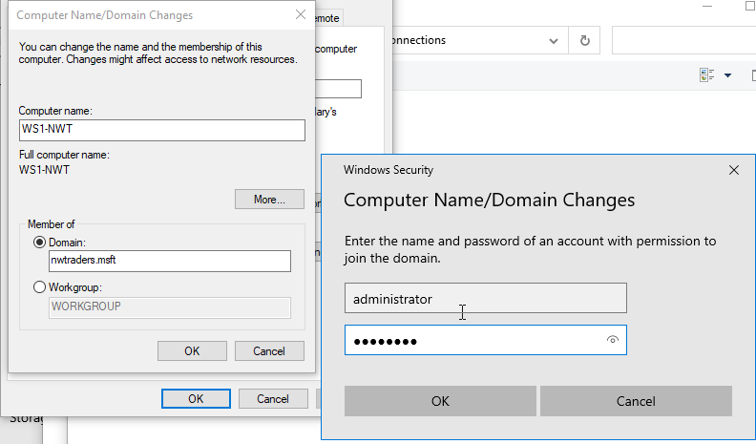
The client can then be added to the domain by changing the option from ‘Workgroup’ to the ‘Member of’ option and entering the name of the domain. Domain admin level credentials must be provided to allow the addition of the client to the domain, but once these are provided, the client joins successfully.
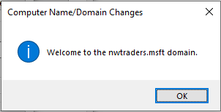
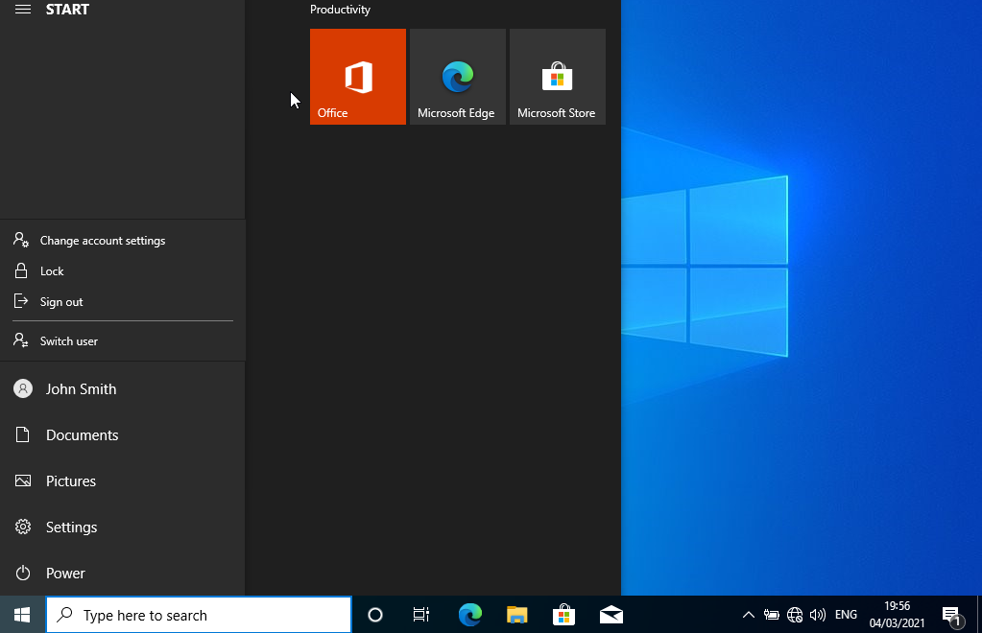
Above, ‘Client1’, running Windows 10, can be seen logged on with the previously created ‘John Smith’ domain account.
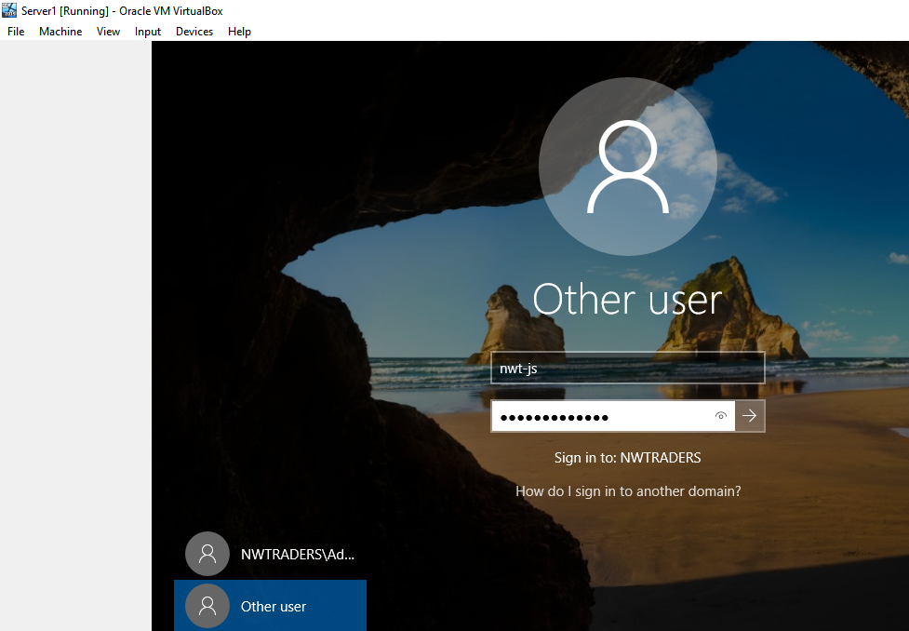
Attempting to log on to the domain controller server with the same ‘John Smith’ account throws an error, as ‘John Smith’ is not a domain admin and does not have permission to access the server.
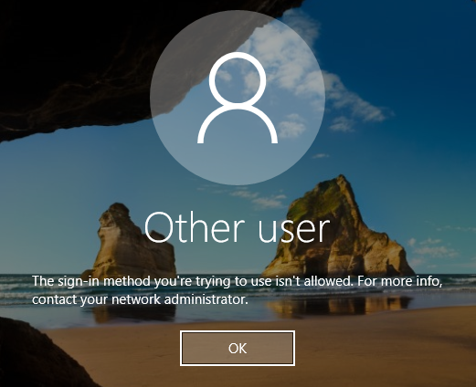

Part 2: Observational task
a) DNS
DNS is an abbreviation that stands for ‘ Domain name system’. DNS allows the translation of “human readable domain names into machine readable IP addresses’ [1]. Each device connected to the internet is given an IP address and attempting to remember the IP addresses for all of these devices would be impossible, but humans have a much easier time remembering a URL, for example www.google.co.uk.
When a user types ‘www.google.co.uk’ into their web browser, this queries a DNS server to translate the URL into an IP address, allowing the user to connect to the correct IP and load the webpage. There are 4 types of DNS servers that all DNS servers fall in to.
i) Recursive Resolvers
A recursive resolver is the first step of a DNS query. A recursive resolver can be seen as a “middle-man” that will respond to a DNS query by either providing cached data or sending a query to a root nameserver, followed by a request to a TLD nameserver and then an authoritative nameserver. Once the resolver receives a response from the authoritative nameserver with the corresponding IP, it relays this response back to the client. [2]
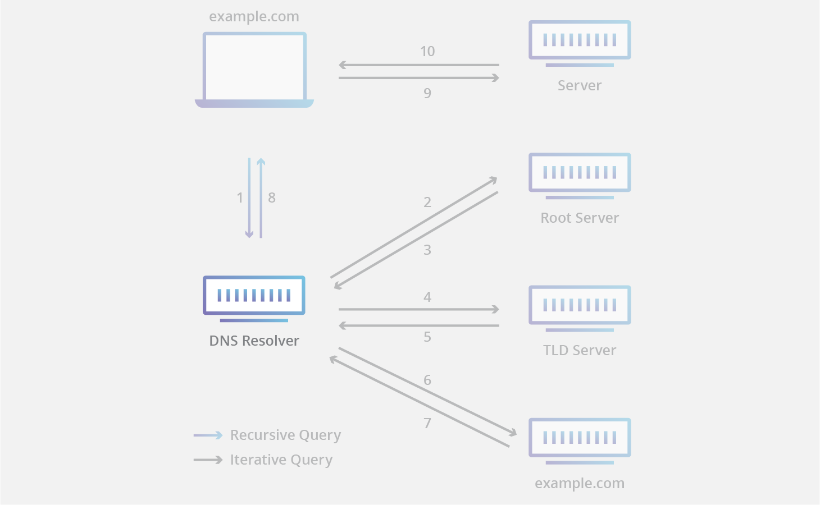
Figure 1 https://www.cloudflare.com/learning/dns/what-is-dns/ Recursive Resolver -
An important part of a resolvers job is to cache this information. If the same query is then performed within a certain timeframe, the recursive resolver can circumvent the entire process of querying numerous servers and provide the cached IP information to the client. Whilst this can reduce loading times for clients and increase efficiency, this process can open clients up to the possibility of DNS cache poisoning attacks, which divert internet traffic from legitimate servers to fake or malicious ones.

ii) DNS Root Nameservers
There are 13 DNS root nameservers and these are known to each recursive resolver. A root nameserver is the first step in a recursive resolvers DNS query. This query includes a domain name, and the response from the root nameserver directs the resolver to a TLD nameserver depending on the domain extension, such as .com, .net etc [3]
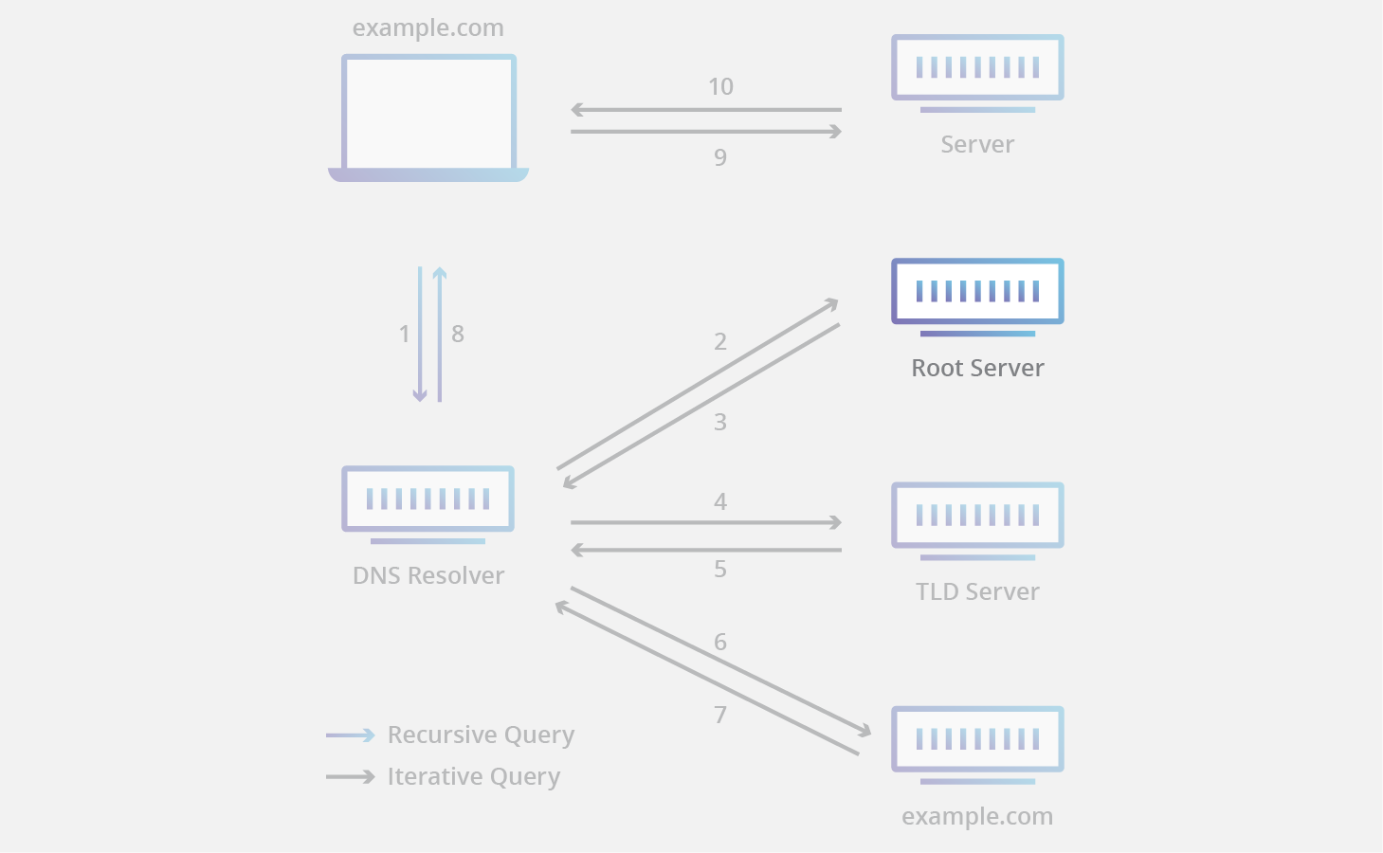
Figure 2 - https://www.cloudflare.com/learning/dns/what-is-dns/ DNS Root Nameservers -
The 13 DNS root server are operated and run by a non-profit organisation called the “Internet Corporation for Assigned Names and Numbers (ICANN)” [4]
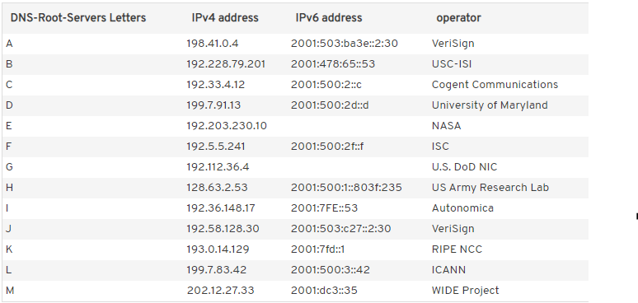
Figure 3 - https://www.ionos.co.uk/digitalguide/server/know-how/what-is-a-root-server-definition-and-background

iii) TLD Nameserver
TLD nameservers “maintain information for all the domain names that share a common domain extension” [4]. If a user has searched for ‘www.google.com’, after the recursive resolver receives a response from the root nameserver, it would then query a TLD nameserver responsible for handling requests for ‘.com’ domains. When the TLD nameserver receives this request it would then provide the resolver with the information to query the authoritative nameserver for that specific domain.
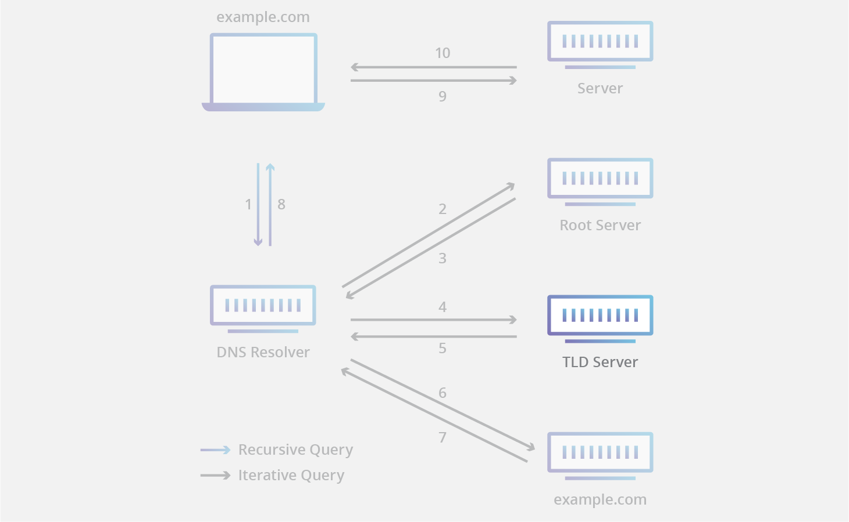
Figure 4https://www.cloudflare.com/en-gb/learning/dns/dns-server-types/#tld-nameserver?utm_referrer=https://www.cloudflare.com/learning/dns/what-is-dns/-
TLD nameservers are managed by the “Internet Assigned Numbers Authority (IANA)” [5], which is a branch of ICANN.
iv) Authoritative nameserver
The final step of a DNS query happens after a resolver receives a response from a TLD nameserver. This response directs the resolver to the authoritative nameserver for the requested domain. This server contains information about this domain and will provide the resolver with an IP address of the domain server found in the DNS record. [6]
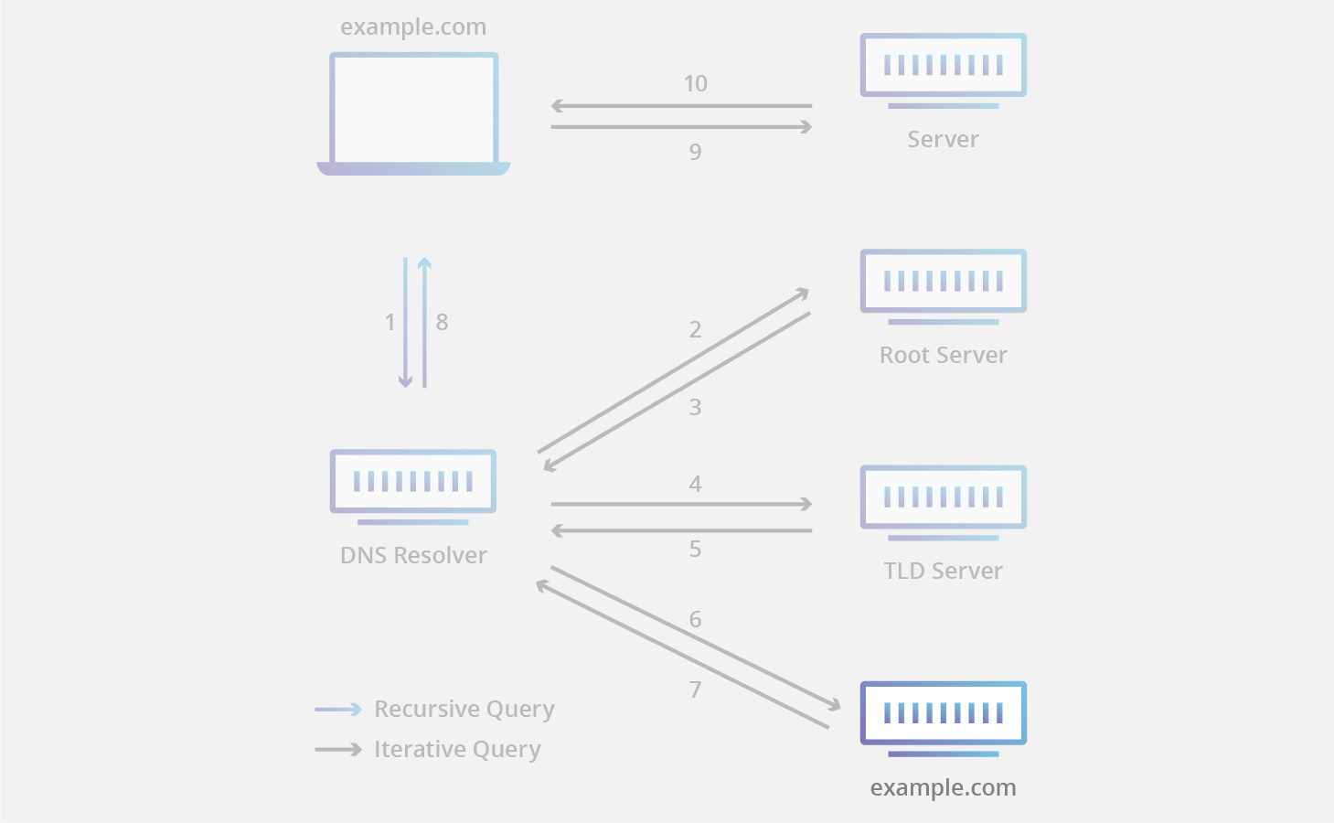
Figure 5https://www.cloudflare.com/en-gb/learning/dns/dns-server-types/#authoritative-nameserver?utm_referrer=https://www.cloudflare.com/learning/dns/what-is-dns/ -
Once this IP address is provided to the client, the device can then request files directly from the server and load the webpage.
v) DNS in active directory
Active directory is built on DNS, but where DNS namespace is used across the internet, active directory namespace is used across a private network. In active directory, DNS maintains a database of all the services that are running across the network, saved as entries called ‘Service Records’ (SRV). These records allow clients to access services such as printers, as well as identify the domain controllers [7]. When Active Directory functions such as authentication or updating are carried out, it is DNS that is used by computers to locate domain controllers. DNS is also used by different domain controllers to locate each other. [8]
b) Additional roles and features
Active directory domain services are just one of a number of separate roles and features than can be installed and configured on the Windows Server OS, many of these being critical roles needed within a domain environment.
i) DHCP
DHCP is an abbreviation that stands for ‘Dynamic Host Configuration Protocol’. In smaller networks containing a handful of PC’s, manually assigning static IP’s may not necessarily be too time consuming, but as an organisation scales and the number of PC’s grows to tens, hundreds or sometimes even thousands, manually providing an IP address to each of these would become unworkable.
Installing and configuring a DHCP server removes the need to manually assign devices an IP address on an internal network, instead handing this task over to the DHCP service. After installation of the DHCP service, a number of separate configuration options are available to network administrators. Network admins can assign an IP range, offering a pool of addresses available to clients. When clients contact the DHCP server, they can be provided any one of these available addresses, allowing them to be automatically provided with IP address instead of having to configure the client manually. IP’s can also be excluded from DHCP, to allow devices such as servers or printers that may need static addresses the opportunity to do so.
Lease durations are also set. An IP lease defines how long a client holds on to an IP address once it has been provided via DHCP. For instance, if a PC is powered off for a time that is longer than the DHCP lease time, then the IP address it was once assigned will be made available again in the DHCP pool, ready to be assigned to a new device requiring an IP. When this PC contacts the DHPC server next, it may be assigned a completely different IP from before. This all happens automatically and is handled by the DHCP server, saving administrators from having to manually assign IP addresses [9].
The benefits of enabling DHCP across a network include:
- Reliable IP address configuration. When the DHCP assigns the address, this removes the possibility of typing errors which can happen when inputting an IP address manually.
- Reduced network administration. DHCP allows for a centralised approach to TCP/IP config and automates this configuration [10]
ii) Hyper-V
Hyper-V is a role on Windows Server that allows users to create a virtual computing environment, comprising of virtual machines. Hyper-V allows the creation and management of these machines on Windows Server through ‘Hyper-V Manager’. By installing Hyper-V, multiple operating systems can be run on a single piece of hardware, each of them isolated from the others. This is particularly useful for organisations who are looking to efficiently utilise their computer and hardware resources, as they can dedicate portions of these resources to individual virtual machines. These resources, such as storage and RAM can also be assigned dynamically, ensuring the hardware on the host server is efficiently used and none is wasted.
Despite running on top of the Windows Server OS, ‘Hyper-V’ is a type 1 hypervisor as it has direct access to the underlying hardware [11]. By creating virtual switches, Hyper-V VM’s can also communicate with other computers and servers, whether these are physical or virtual.
There are a number of benefits to implementing Hyper-V in an enterprise environment. One of the biggest advantages lies in the fact that single servers can be utilised by more than one VM. By purchasing higher spec servers, the physical space needed to host a large number of different servers is reduced. No longer is there need to have individual servers running for each operating system. Now, it is possible to run tens and sometimes even hundreds of VM’s on one high spec piece of hardware, which in turn also saves on power costs. Hyper-V also supports the installation of different operating systems, allowing a mixed environment of different version of Windows, as well as Linux OS’s. These can all be managed from a single server through the Hyper-V remote connection tool.
Hyper-V can also aid organisations in back-up and recovery. Hyper-V has a feature called ‘Hyper-V replication’ which creates copies of VMs. These can be saved in another physical location and in the case of disaster recovery, these copies can be used to restore a VM, helping to minimise downtime [12].
Hyper-V can also be configured to work as part of a cluster. This means that several Hyper-V servers can be configured to work together and in the case one host server goes down or becomes unreachable, the other nodes in the cluster can pick up the workload. This can mean that even in the loss of a host server, a VM can carry on working with no noticeable loss of connection. If these nodes are clustered over different physical sites, they can even offer redundancy for issues such as power loss and complete loss of a datacentre. The redundancy and resilience features that come as part of a well designed and implemented virtual environment as a major benefit of Hyper-V.
VM’s created within Hyper-V can also be migrated with ease to other hosts, as well as exported and imported, to ensure they can be moved around to different physical servers whenever required. Being able to failover hosts to different Hyper-V nodes can also mean that any replacement, maintenance or rebooting of the underlying host doesn’t result in having to take the VM itself offline, again minimising downtime.
c) Access control in Active Directory
After installation of Active Directory in Windows Server, there are a number of builtin permissions groups that come pre-configured. Correctly implementing these groups can allow administrators granular access to what users on the domain can access. Some groups, such as ‘Domain admins’, allow user accounts in Active Directory administrative access at the highest level of Active Directory. Providing this level of access to someone who doesn’t need it, or is not responsible enough to be trusted with it, can have devastating effects. When using the ‘Domain admins’ permission group, as few members of the domain should be granted these kinds of permissions. Even in departments such as IT that are used to having a level of administrator access, ‘Domain admins’ should only be provided to key staff, often users highly skilled and who are responsible for carrying out high level technical tasks on the domain.
Below this level of root admin access, Active Directory has a number of other groups that provide administrator access, but to specific areas of the domain. ‘Hyper-V admins’, for example, allows complete access to all features within Hyper-V without the need for adding users to the ‘Domain admins’ or ‘Administrators’ group.
As is always the case in IT security, users should be provided the least amount of access they need to perform their required tasks. If a network engineer needs to be a DHCP admin, but doesn’t need administrator access to any other services or features, then there is no need to add them to an overall administrators group.
As well as stopping genuine users from being able to carry out tasks they shouldn’t, implementing robust Active Directory security groups is a defence against malicious actors who have obtained Active Directory credentials. Minimising the amount of ‘Domain Admins’ in turn minimises the chance one of these accounts gets compromised. The less there are, the less likely they are to be hacked. In addition, providing user accounts with segregated administrator access minimises the amount of damage that can be done if account credentials fall into malicious hands. Widely speaking, if a standard “Domain user” account is compromised that has no additional permission groups attached, then the damage than can be done is minimal, although there are ways to escalate privileges in accounts with no administrative access.

d) AGDLP/AGUDLP
AGDLP is an abbreviation that stands for ‘Account, global, domain local, permission’ and is Microsoft’s recommended procedure for implementing role-based access control (RBAC) across a windows domain [13]. The recommendation is that all users are added to groups in order to provide them access to the resources they need.
For example, a global group such as ‘Finance_Users’ could be created. This group would then be added to a domain local group, for instance called ‘Finance_resources’. Global groups can be seen as the ‘accounts’ group and the domain local group can be seen as the ‘resources’ group. The ‘Finance_resources’ group would be configured to provide access to network resources and adding ‘Finance_users’ to this group would mean that any user account part of ‘Finance_users’ gets the associated resources..
It is likely that the majority of users working for the finance department in an organisation would need access to a similar, and limited subset, of network resources. Now, when employees have their user accounts created, these accounts only need to be added to the ‘Finance_users’ group in order to provide them with the network resources they require. This differs to having to manually configure access for each user, for every resource they need, each time.
Implementing AGDLP procedures drastically reduces the overhead for maintenance on objects in Active Directory. If employees ever transfer to another department, they are simply removed from the permissions groups they no longer need and added to the new permissions group for their new role. Employees that leave the organisation simply have their permission groups removed before their account is deleted. This is an issue when permission groups aren’t used. If security identifiers are added to access control lists (ACL) for resources, and the associated user account is then deleted, then the security identifier becomes orphaned. Whilst this shouldn’t necessarily cause any operational issues, ACL lists can quickly become messy and contain numerous entries that don’t relate to active objects in Active Directory. This shouldn’t happen when AGDLP is implemented, as the group will be added to the ACL, not a specific user account. The group should never need to be deleted, only the user accounts that are members of the group, so the ACL remains accurate. The number of entries on the ACL will also be considerably less, ensuring that any audit of the permissions would be easier to undertake.
An example of users being provided access to an application following the same process can be seen below:

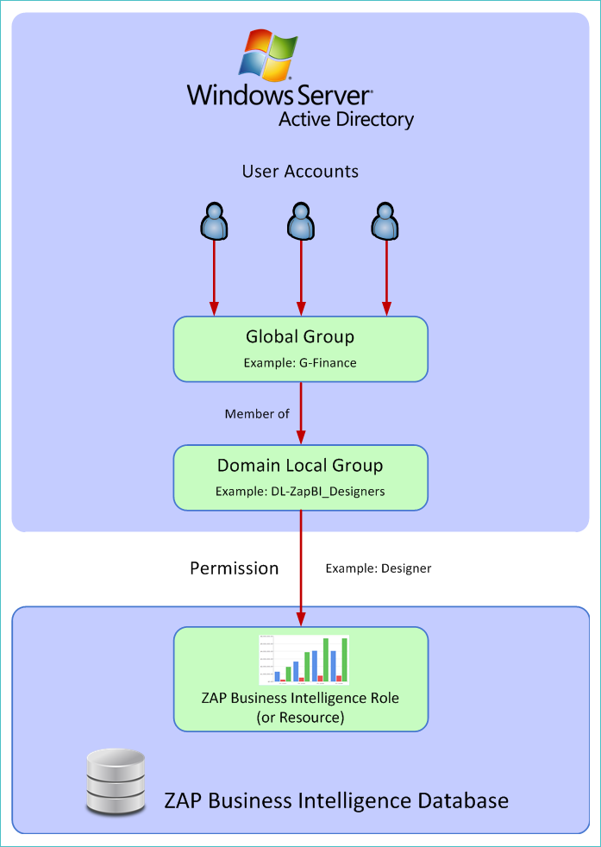
Figure 6 - https://help.zapbi.com/DataHub/CurrentVersion/content/topics/Security/security_about_rbac.htm

AGDULP follows nearly the same process, but allows permissions to be applied across multi domain environments. This allows users with the same roles and responsibilities across the enterprise but on different domains, access to the same resources.
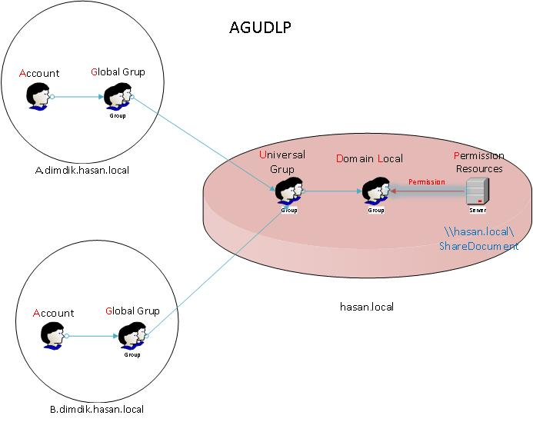
Figure 7 - https://social.technet.microsoft.com/wiki/contents/articles/22951.active-directory-group-scope-group-type-ozellikleri-tr-tr.aspx
The drawbacks of the AGDLP are the initial labour intensive work needed to properly configure the resources, groups and permissions, but once this has been completed, the ongoing maintenance is minimal. Administrators can simple create new user accounts, add them to existing groups and resources are automatically provided.

[1] | “What is DNS,” Amazon, [Online]. Available: https://aws.amazon.com/route53/what-is-dns/. [Accessed 11 March 2021].
[2] | “What is DNS,” Cloudflare, [Online]. Available: https://www.cloudflare.com/en-gb/learning/dns/dns-server-types/#recursive-resolver?utm_referrer=https://www.cloudflare.com/learning/dns/what-is-dns/. [Accessed 11 March 2021].
[3] | “DNS Root Server,” Cloudflare, [Online]. Available: https://www.cloudflare.com/en-gb/learning/dns/glossary/dns-root-server. [Accessed 11 March 2021].
[4] | “What is a root server,” IONOS, [Online]. Available: https://www.ionos.co.uk/digitalguide/server/know-how/what-is-a-root-server-definition-and-background/. [Accessed 11 March 2021].
[5] | “everything-you-need-to-know-about-iana,” IONOS, 21 June 2019. [Online]. Available: https://www.ionos.co.uk/digitalguide/server/know-how/everything-you-need-to-know-about-iana/. [Accessed 11 March 2021].
[6] | “Authoratative Nameserver,” [Online]. Available: https://www.cloudflare.com/en-gb/learning/dns/dns-server-types/#authoritative-nameserver?utm_referrer=https://www.cloudflare.com/learning/dns/what-is-dns/. [Accessed 11 March 2021].
[7] | “DNS and Active Directory,” Windows Active Directory, [Online]. Available: https://www.windows-active-directory.com/dns-and-active-directory.html. [Accessed 03 March 2021].
[8] | Microsoft, “ADDS,” Microsoft, [Online]. Available: https://docs.microsoft.com/en-us/windows-server/networking/dns/dns-top#:~:text=Active%20Directory%20Domain%20Services%20(AD,locate%20Active%20Directory%20domain%20controllers.. [Accessed 03 March 2021].
[9] | M. -. DHCP, “Whats new in DHCP,” Microsoft, [Online]. Available: https://docs.microsoft.com/en-us/windows-server/networking/technologies/dhcp/what-s-new-in-dhcp. [Accessed 11 March 2021].
[10] | “Microsoft - Network admin,” Microsoft, [Online]. Available: https://docs.microsoft.com/en-us/windows-server/networking/technologies/dhcp/dhcp-top#:~:text=DHCP%20provides%20the%20following%20benefits,Reduced%20network%20administration.. [Accessed 11 March 2021].
[11] | “Hyper-V on Windows Server,” Microsoft, [Online]. Available: https://docs.microsoft.com/en-us/windows-server/virtualization/hyper-v/hyper-v-on-windows-server. [Accessed 11 March 2021].
[12] | “Hyper-V Tech overview,” Microsoft, [Online]. Available: https://docs.microsoft.com/en-us/windows-server/virtualization/hyper-v/hyper-v-technology-overview. [Accessed 11 March 2021].
[13] | “Security about RBAC,” Zapbi, [Online]. Available: https://help.zapbi.com/DataHub/CurrentVersion/content/topics/Security/security_about_rbac.htm. [Accessed 11 March 2021].
[14] | “AGDLP,” tenfold security, [Online]. Available: https://www.tenfold-security.com/en/wiki/agdlp/. [Accessed 11 March 2021].

