
Connor Thomas (2503035)
2503035@student.uwtsd.ac.uk
Abstract
In this experiment, the LC circuit was simulated and measured to investigate its resonant behaviour. The input signal frequency was varied from 100 Hz to 20 kHz, and the node voltage was measured to determine the circuit's attenuation, resonant frequency, and Q factor. According to All About Circuits, in reactive circuits like the ones studied here, resonance is characterized by a significant change in impedance at a specific frequency. In this experiment, the simulated circuit showed a resonant frequency of 5.03 kHz, while the practical circuit operated at approximately 5.0 kHz, which closely matches the theoretical value of 5.03 kHz. Thus, the difference between the simulated and practical resonant frequencies was due to the non-ideal behaviour of the components within the practical circuit.
Resonance Lab

Table of Contents
Introduction 2
Simulation setup 3
Results 3
Discussion 4
Conclusion 5

Introduction
Resonance occurs in circuits containing both inductors and capacitors when the inductive reactance equals the capacitive reactance [1]. At this frequency, the circuits will respond as fully as possible to the supplied AC signal. In a parallel LC circuit, the impedance is maximum at the resonant frequency, leading to a higher voltage across the inductor and capacitor [2]. This property of LC circuits allows them to select for frequencies within a supplied signal and reject others [3].
Such circuits are often present within radio tuning circuits, communication systems, and bandpass filters [9]. Such circuits are often important components in electronic systems, as they allow the system to select certain frequencies in a signal and reject others.
The resonant frequency of a parallel LC circuit can be determined from its inductance and capacitance [5]. In addition to measuring the circuit's resonant frequency, the quality factor can provide information about how the circuit rejects frequencies other than the resonant frequency [6].
An investigation into a parallel LC circuit will be performed using simulation software and by constructing a circuit on a breadboard. The voltage across the constructed circuit will be measured at a range of input frequencies from 100 Hz to 20 kHz. The circuit's attenuation will be calculated at each of these frequencies, allowing the resonant frequency and quality factor to be determined. Furthermore, the results of the simulated and constructed circuits will be compared with the theoretical results for these circuits.

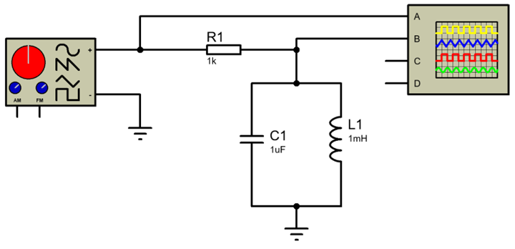
Figure 1 circuit diagram

Simulation setup

The circuit was constructed in simulation software. A signal generator, connected through a series resistor, was used to apply a 2 V peak-to-peak signal to the circuit, whose output voltage at the output node was to be measured. The signal generator frequency was varied from 100 Hz to 20 kHz. Within the circuit were a 1 kω resistor, a 1 mH inductor, and a 1 µF capacitor. Each of these components had values chosen to ensure the circuit would resonate within the experiment's measurable frequency range. The voltage at the circuit's output node was measured over a range of frequencies.
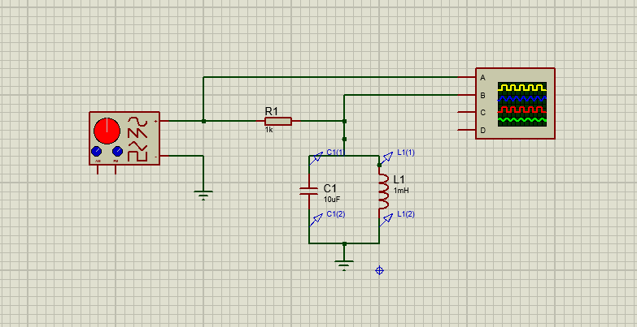
Figure 2 simulation circuit diagram

Each frequency was entered into a spreadsheet, and the attenuation equation was used to calculate the circuit's attenuation at each frequency. A graph of the signal attenuation from the circuit plotted against frequency on a logarithmic scale was produced. From this graph, the circuit's resonant frequency could be determined. Additionally, the half-power frequencies from the graph can be used to calculate the circuit's bandwidth and Q factor [7]. Each of these values can be compared with the theoretical resonant frequency of the circuit and with values obtained from measurements made with the circuit's simulation software.

Results
The attenuation response of the LC circuit was measured over a frequency range of 100 Hz to 20 kHz using both simulation and the practical circuit. At each frequency, the node voltage was measured, and the circuit's attenuation was calculated using the attenuation equation. These values were plotted against frequency to show the circuit's resonance behaviour [1].
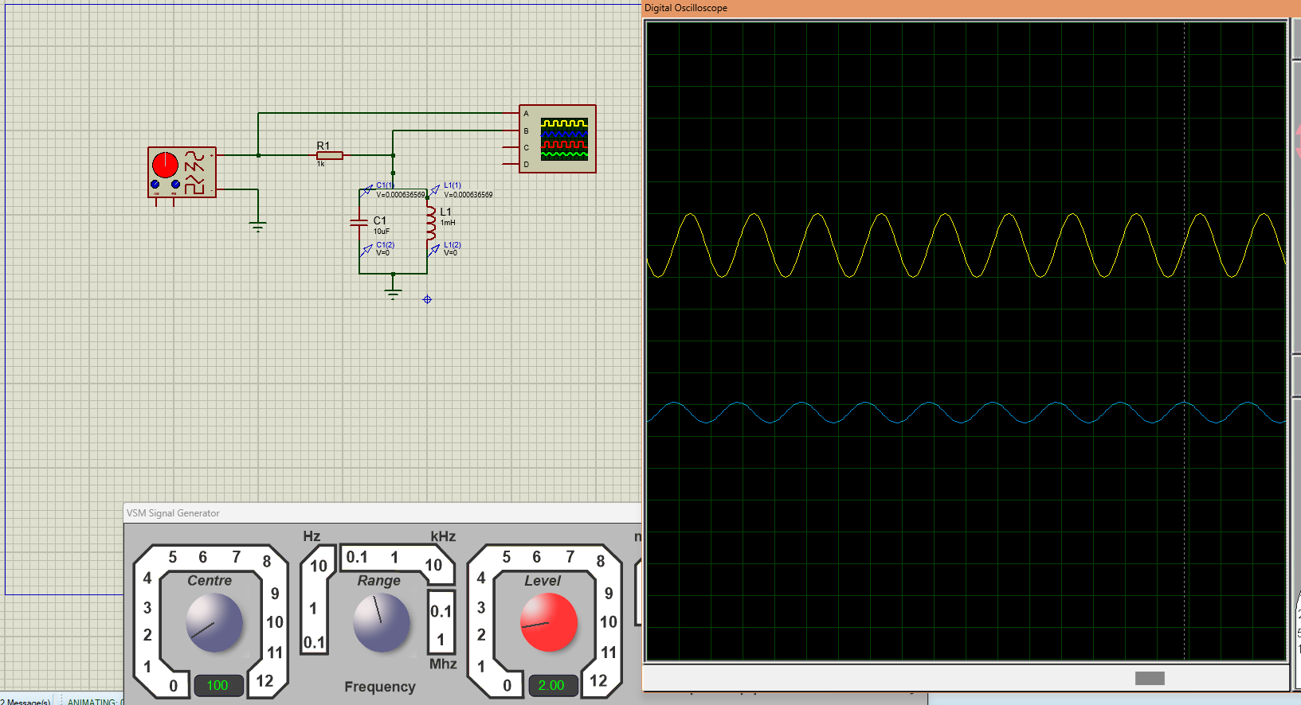
Figure 3 Simulated attenuation response of the parallel LC circuit.
The simulated circuit exhibited a resonance peak at approximately 5.03 kHz. At this frequency, the node voltage measured 1.92 V. The lower half-power frequency was measured at 2.0 kHz, with the upper half-power frequency at 2.6 kHz, yielding a bandwidth of 300 Hz. The Q factor of the circuit was calculated to be 7.7 utilising the bandwidth method [3].
Table :1 Results
frequency (Hz) | Input Voltage (V) peak ot peak | output Voltage (V) Peak to peak | Gain (dB)
1 | 2.08 | 0 | 0.00
2 | 2.08 | 0 | 0.00
5 | 2.08 | 0 | 0.00
10 | 2.08 | 0.01 | -46.36
20 | 2.08 | 0.03 | -36.82
50 | 2.04 | 0.06 | -30.63
100 | 2.04 | 0.09 | -27.11
200 | 2.08 | 0.15 | -22.84
500 | 2.08 | 0.32 | -16.26
1000 | 2.08 | 0.84 | -7.88
2000 | 2.08 | 1.44 | -3.19
5000 | 2.08 | 1.61 | -2.22
10000 | 2.08 | 0.96 | -6.72
20000 | 2.08 | 0.09 | -27.28
50000 | 2.08 | 0.04 | -34.32
100000 | 2.08 | 0.02 | -40.34

The practical circuit also exhibited a resonance peak at approximately 5.0 kHz. The node voltage was measured at 0.0184 V at this frequency. The circuit's attenuation decreased as the frequency approached the resonant frequency and increased beyond it, indicating the parallel LC circuit's resonance response. Both simulated and practical circuits exhibited resonance behaviour within the frequency range. Moreover, the resonant frequency of the practical circuit was similar to the theoretically calculated resonant frequency of the circuit.
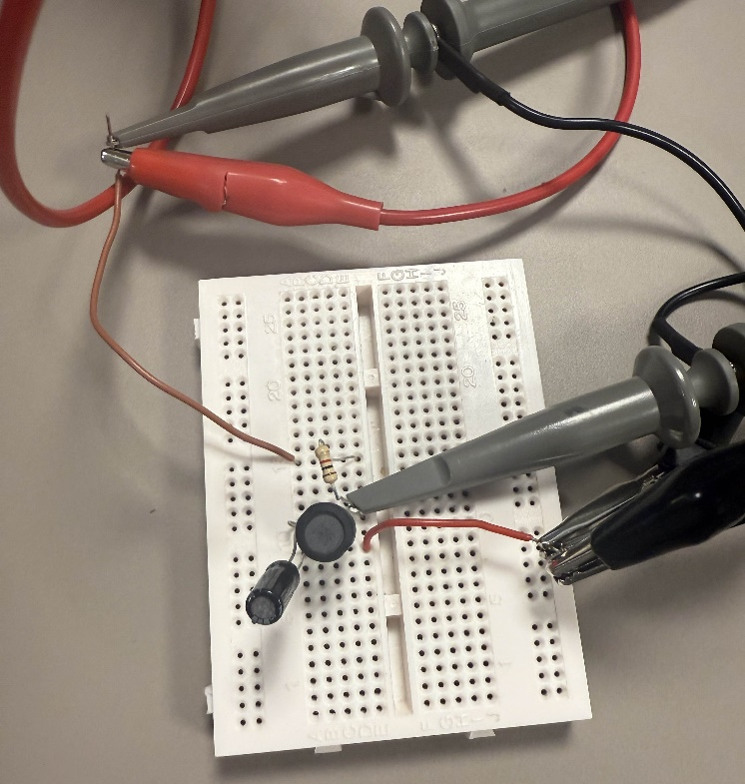
Figure 4 Practical parallel LC circuit constructed on a breadboard.

Discussion
The simulation results and the built circuits indicated the expected behaviour ofm a parallel LC circuit. The attenuation varied with frequency relative to the circuit's resonant frequency and changed again after passing through it. Thus, the circuit exhibited the expected response to frequencies near its resonant frequency, as determined [1].
The simulated frequency at which the circuit resonated was 5.03 kHz, whereas the practical circuit it was built into resonated at approximately 5.0 kHz. The theoretical resonant frequency, calculated by the resonance equation, was approximately 5.03 kHz. Thus, the practical circuit exhibited the expected relationship between theoretical and measured frequency. However, the simulated frequency did not accurately represent the practical circuit.
The simulated circuit exhibited a higher Q factor than the practical circuit. The Q factor of a circuit reflects its selectivity to its resonant frequency; the higher the Q factor, the more selective the circuit is to that frequency [3]. The simulated circuit was assumed to have ideal components, for example. In the real world, losses in the circuit reduce the Q factor, including internal resistance in the inductor, on breadboards and wires, and the resistance of the signal generator output [2].
The inductor's internal resistance reduced the circuit's impedance at resonance. Resistance is also introduced through the breadboards and wires. Furthermore, the wiring within the circuit also contributes to parasitic inductance and capacitance. Finally, the signal generator's resistance also contributed to the circuit's selectivity. Each of these factors reduces the circuit's selectivity at the resonant frequency [2].

Figure 6 simulation graph

Figure 5 practical Graph

Despite differences between the simulated and practical circuits, the small discrepancy between the measured and calculated resonant frequencies was due to component tolerances. The inductors and capacitors have component ratings. Furthermore, oscilloscope resolution can also contribute to differences between calculated and measured resonant frequencies.
Overall, the difference between the simulated and practical circuits indicates the difference between ideal and real-world circuits and components. Furthermore, it helps to explain why real circuits are less selective to the resonant frequency than simulated circuits.

Conclusion
In this experiment, the resonance of a parallel LC circuit was investigated using simulation software and practical measurements. The simulated resonant frequency was 5.03 kHz. In comparison, the practical resonant frequency of the built circuit was approximately 5.0 kHz, which is very close to the theoretical resonant frequency of 5.03 kHz calculated from the resonance equation [1].
The simulated circuit had a higher Q factor than the practical circuit. This is due to the inductor's internal resistance, as well as the breadboard and wires used in the circuit [2].
The resonant frequency of an LC circuit is determined by the values of L and C in the circuit. Any resistive elements in the circuit will affect the bandwidth of the circuit [3].

References
Reference List
[1] T. R. Kuphaldt, “Resonance in series-parallel circuits,” All About Circuits. [Online]. Available: https://www.allaboutcircuits.com/textbook/alternating-current/chpt-6/resonance-series-parallel-circuits/
[Accessed: Apr. 28, 2026].
[2] “Parallel LC resonant circuit,” EC Studio Systems. [Online]. Available: https://ecstudiosystems.com/discover/textbooks/basic-electronics/ac-circuits/parallel-lc-resonant-circuit/
[Accessed: Apr. 28, 2026].
[3] T. R. Kuphaldt, “Q factor and bandwidth of a resonant circuit,” All About Circuits. [Online]. Available: https://www.allaboutcircuits.com/textbook/alternating-current/chpt-6/q-and-bandwidth-resonant-circuit/
[Accessed: Apr. 28, 2026].
[4] “LC circuit,” Wikipedia, 2024. [Online]. Available: https://en.wikipedia.org/wiki/LC_circuit
[Accessed: Apr. 28, 2026].
[5] “Resonant frequency formula,” GeeksforGeeks, 2024. [Online]. Available: https://www.geeksforgeeks.org/physics/resonant-frequency-formula/
[Accessed: Apr. 28, 2026].
[6] R. C. Dorf and J. A. Svoboda, Introduction to Electric Circuits, 8th ed. Hoboken, NJ, USA: John Wiley & Sons, 2010.
[7] T. R. Kuphaldt, “Q factor and bandwidth of a resonant circuit,” Workforce LibreTexts, 2019. [Online]. Available:
https://workforce.libretexts.org/Bookshelves/Electronics_Technology/Electric_Circuits_II_-_Alternating_Current_%28Kuphaldt%29/06%3A_Resonance/6.06%3A_Q_Factor_and_Bandwidth_of_a_Resonant_Circuit
[Accessed: Apr. 28, 2026].
[8] M. T. Abuelma’atti et al., “Floating grounded series/parallel R-L, R-C and L-C immittance simulators employing VDTAs and only two grounded passive elements,” AEUE – Int. J. Electron. Commun., vol. 137, 2021, Art. no. 154095. doi: 10.1016/j.aeue.2021.154095.
[9] “Parallel resonance circuit tutorial,” Next Electronics. [Online]. Available: https://www.next.gr/parallel-resonance-circuit-tutorial
[Accessed: Apr. 28, 2026].
[10] “Resonance in series-parallel circuits,” CircuitBread, 2007. [Online]. Available:
https://www.circuitbread.com/textbooks/lessons-in-electric-circuits-volume-ii-ac/resonance/resonance-in-series-parallel-circuits
[Accessed: Apr. 28, 2026].

