
University of Wales Trinity Saint David
Wales Institute of Science and Art

Application of Computer Aided Engineering Processes
Structural Design & Fluid Analysis (ACHA6010)
Nathaniel Fullylove (2101005)
December 2023



2023

Contents
Contents 1
Table of Figures 2
Table of Tables 3
Table of Equations 3
1.0 Introduction 4
2.0 Literature Review 5
2.1 CAE Software 5
3.0 Validation Studies 6
3.1 Investigation Method 6
3.2 Thermal Solver Validation Study 6
3.2.1 Thermal Solver Validation Calculations 7
3.2.2 ANSYS Bimetallic Strip Case 8
3.2.3 Comparison of ANSYS and Calculated Values 9
3.3 Static Structural Solver Validation Study 10
3.3.1 Structural Solver Validation Calculations 10
3.3.2 ANSYS Cantilever Beam Case 11
3.4 Mesh Independence Study Results 12
3.4.1 Bimetallic Strip 12
3.4.2 Cantilever Beam 13
3.4.3 Piston 14
4.0 Computer Aided Design Modelling and Assembly 16
4.1 Piston Model 16
4.2 Assembly 16
5.0 Simulation of Kinematics, Thermal Effects, and Structural Analysis 18
5.1 Kinematic Simulation 18
5.2 Thermal Simulation 19
5.3 Structural Simulation 21
6.0 Iterative Piston Design Study 24
6.1 Design Iteration 1 24
6.2 Design Iteration 2 27
7.0 Conclusion 31
Reference List 32
Appendix 33

Table of Figures

Figure 1 - Bimetallic Strip Case Diagram (Dlubal, no date b) 6
Figure 2 - CAD Model of Bimetallic Strip 8
Figure 3 - Static Structural System in ANSYS Workbench 8
Figure 4 - Project Tree for the Bimetallic Strip Validation Study 9
Figure 5 - Total Deformation Results of the Bimetallic Strip from ANSYS 9
Figure 6 - Cantilever Beam Case Diagram (Dlubal, no date a) 10
Figure 7 - CAD model of the Cantilever Beam 11
Figure 8 - System Tree for Cantilever Beam Case 12
Figure 9 - Results of Cantilever Beam Study 12
Figure 10 - Graph showing the results of the Mesh Independence Study for the Bimetallic Strip 13
Figure 11 - Graph of Percentage Error of Maximum Deformation for the Cantilever Beam 14
Figure 12 - Graph of the results of the Mesh Independence Study for the Piston 15
Figure 13 - CAD model of the original piston design 16
Figure 14 - Assembly containing the original piston design. 17
Figure 15 - Joints used for the assembly in the fully linked analysis system. 17
Figure 16 - System Tree of a Fully Linked System 18
Figure 17 - Fully Linked Analysis System in ANSYS Workbench 18
Figure 18 - Transient Solver System Tree 19
Figure 19 - Graph produced by the joint probe in the transient solver. 19
Figure 20 - Steady-State Thermal Analysis System Tree 20
Figure 21 - Temperature Profile of the Original Piston Design 21
Figure 22 - System Tree for the Static Structural System in ANSYS 21
Figure 23 - Top View of Total Deformation of Original Piston 22
Figure 24 - Bottom View of Total Deformation of Original Piston 22
Figure 25 - Total Deformation of Original Piston 22
Figure 26 - Top View of Equivalent Stress of the Original Piston 23
Figure 27 - Bottom View of Equivalent Stress for the Original Piston 23
Figure 28 - Equivalent Stress of the Original Piston 23
Figure 29 - Iteration 1 Piston Design 24
Figure 30 - Equivalent Stress for Piston Iteration 1 (Top View) 25
Figure 31 - Equivalent Stress for Piston Iteration 1 (Bottom View) 25
Figure 32 - Equivalent Stress for Piston Iteration 1 25
Figure 33 - Total Deformation for Piston Iteration 1 (Top View) 26
Figure 34 - Total Deformation for Piston Iteration 1 (Bottom View) 26
Figure 35 - Total Deformation for Piston Iteration 1 26
Figure 36 - Iteration 2 of Piston Design 27
Figure 37 - Total Deformation of Piston Iteration 2 (Top View) 28
Figure 38 - Total Deformation of Piston Iteration 2 (Bottom View) 28
Figure 39 - Equivalent Stress of Piston Iteration 2 (Top View) 29
Figure 40 - Equivalent Stress of Piston Iteration 2 (Bottom View) 29
Figure 41 - Equivalent Stress of Piston Iteration 2 29
Figure 42 - Figure of the code written to calculate the maximum deformation values for the Bimetallic Strip validation study. 33
Figure 43 - Figure of code written to calculate the maximum deformation values for the Cantilever Beam validation study. 33
Figure 44 - Equivalent Stress for Original Piston Alternate material 33
Figure 45 - Equivalent Stress for Original Piston Alternate material (Bottom) 34
Figure 46 - Equivalent Stress for Original Piston Alternate material (Top) 34
Figure 47 - Total Deformation for Original Piston Alternate material 34
Figure 48 - Total Deformation for Original Piston Alternate material (Bottom) 35
Figure 49 - Total Deformation for Original Piston Alternate material (Top) 35
Figure 50 - Equivalent Stress for Iteration 2 Piston Alternate material (Bottom) 35
Figure 51 - Equivalent Stress for Iteration 2 Piston Alternate material (Top) 36
Figure 52 - Equivalent Stress for Iteration 2 Piston Alternate material 36
Figure 53 - Total Deformation for Iteration 2 Piston Alternate material (Bottom) 36
Figure 54 - Total Deformation for Iteration 2 Piston Alternate material (Top) 37
Figure 55 - Total Deformation for Iteration 2 Piston Alternate material 37

Table of Tables

Table 1 - Table of Properties for Bimetallic Strip Validation Study 7
Table 2 - Data Table for Cantilever Beam Case 10
Table 3 - Results of the Mesh Independence Study for the Bimetallic Strip 13
Table 4 - Table of Results from the Mesh Independence Study on the Cantilever Beam 14
Table 5 - Results of the Piston Mesh Independence Study 14
Table 6 - Table of values used in the Steady-State Thermal System 20

Table of Equations

Equation 1- Newtons Second Law 6
Equation 2 - Equation for Coefficient K for the Bimetallic Strip Case 7
Equation 3 - Equation for Maximum Deflection for the Bimetallic Strip Case 7
Equation 4 - Maximum Deformation from Axial Load equation for Cantilever Beam Case 11
Equation 5 - Maximum Deformation due to the Point Load for Cantilever Beam Case 11

1.0 Introduction

In recent decades, the integration of Computer Aided Engineering (CAE) tools has reshaped engineering practices, suggested by (Polyakov and Kamenev, 2010). This investigation looks into CAE processes and limitations, exploring practical applications through simulating a real-world system in a computational environment.
With a focus on enhancing structural performance and optimising mass, this investigation exemplifies the role of CAE tools in the engineering design process. It emphasises navigating the constraints inherent in computational approaches and considers thermal conditions for realistic simulations.
The investigation demands CAE software validation through analytical replication in ANSYS, coupled with an exploration of mesh sizing impact. Computer Aided Design (CAD) modelling emphasises a realistic geometry and assembly.
Subsequent sections explore kinematic simulation, thermal considerations, and static structural analysis. The investigation concludes with an iterative approach for enhancing component performance, informed by insights from Finite Element Analysis (FEA) studies.

2.0 Literature Review

2.1 CAE Software

CAE uses computer software for engineering analysis, design, and optimisation, covering disciplines like structural and thermal analysis, fluid dynamics, and electromagnetic simulations. It allows engineers to simulate real-world conditions, reducing development time and costs by evaluating designs before physical prototypes. Crucial in automotive, aerospace, and manufacturing, CAE provides insights into product behaviour, fostering innovative and efficient solutions.
CAE accelerates product development by enabling virtual design simulations, reducing time-to-market and costs. It enhances understanding of product behaviour, leading to improved performance, reliability, and safety. CAE facilitates rapid iteration and issue identification early in development, enhancing overall product quality. However, accurate simulation relies on precise data, and complex simulations may demand significant computational resources. User expertise is crucial, and virtual models may not capture all real-world complexities. Despite limitations, CAE remains pivotal, providing efficiency in designing and analysing complex systems.
The ideas in the previous paragraphs are supported by views from (Vasiljević et al., 2018) and (Kojima, 2000).
The CAE process is explained well by (Kagan, Fischer and Bar-Yoseph, 1999).

3.0 Validation Studies

When carrying out investigations using ANSYS, it would be appropriate to validate every solver type that is being used. In this investigation, kinematic, thermal, and structural solvers are being used. This means that a validation study for each of the previously mentioned solver must be carried out. However, as the kinematic solver is just calculating the equation below, it is assumed that the solver can easily compute this and as such a validation study for a kinematic solver is not required.

$$F = mA$$
Equation 1- Newtons Second Law

Validation studies were conducted for the thermal solver using a bimetallic strip and for the structural solver a cantilever beam. These studies will be discussed below, covering investigation methods and results.
A mesh independence study is then carried out, where the mesh element size is varied, and the results are analysed to determine whether the size of the mesh elements influence the results produced by ANSYS. This is done as mesh size has a direct impact on the FEA analysis accuracy as stated by (Zerfu and Ekaputri, 2021).

3.1 Investigation Method

For the bimetallic strip and cantilever beam validation studies the maximum deformation was calculated by hand and then calculated using ANSYS. This is done to compare the results and to see how accurate ANSYS is at carrying out the calculations. This will then either validate or invalidate the solver.

3.2 Thermal Solver Validation Study

As aforementioned, the validation case for the thermal solver is the study involving a bimetallic strip. The bimetallic strip is made up of two metals, the top layer of the strip being made of invar and the bottom of copper. The strip is restrained at the left end, while the right end is free, this is depicted in Figure 1. The entire strip is then loaded by a temperature difference, of 100 °C.
The equations required and the comparison of the results will be covered in this subsection of the report.

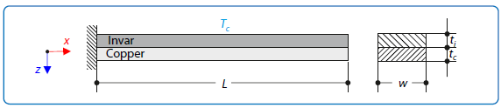
Figure 1 - Bimetallic Strip Case Diagram (Dlubal, no date b)

3.2.1 Thermal Solver Validation Calculations

The following are the equations that calculate the max deformation for the bimetallic study. The values and denotation of the variables can be found in Table 1.
Table 1 - Table of Properties for Bimetallic Strip Validation Study
 |  | Properties | Denotation | Value | Units
Material | Invar | Modulus of Elasticity | $$E_{i}$$ | 137000 | MPa
Material | Invar | Coefficient of Thermal Expansion | $$α_{i}$$ | 1.20E-06 | $$°C^{-1}$$
Material | Invar | Poisson's Ratio | $$ν_{i}$$ | 0.28 | n/a
Material | Copper | Modulus of Elasticity | $$E_{c}$$ | 130000 | MPa
Material | Copper | Coefficient of Thermal Expansion | $$α_{c}$$ | 2.00E-05 | $$°C^{-1}$$
Material | Copper | Poisson's Ratio | $$ν_{c}$$ | 0.354 | n/a
Geometry |  | Cross Section Width | w | 5 | mm
 |  | Invar Layer Thickness | $$t_{i}$$ | 1 | mm
 |  | Copper Layer Thickness | $$t_{c}$$ | 1 | mm
 |  | Length | L | 100 | mm
Load |  | Thermal Loading | $$T_{c}$$ | 100 | °C

Below is the equation to calculate the coefficient K which is then used to calculate the maximum deflection of the strip.
$$K_{1}=4+6\frac{t_{c}}{t_{i}}+4 {\left(\frac{t_{c}}{t_{i}}\right)}^{2}+ \frac{E_{c}}{E_{i}}{\left(\frac{t_{c}}{t_{i}}\right)}^{3}+ \frac{E_{c }t_{c}}{E_{i} t_{i} }$$
Equation 2 - Equation for Coefficient K for the Bimetallic Strip Case
The calculated value for K is 16.00275126. This can now be used in the calculation for maximum deflection.
The maximum deflection is defined by the following equation.

$$U_{z Max}= \frac{6\left(α_{i}- α_{c}\right)\left(t_{i}+ t_{c}\right)T_{c}}{{t_{s}}^{2}K_{1}} \frac{L^{2}}{2}$$
Equation 3 - Equation for Maximum Deflection for the Bimetallic Strip Case

The $t_{s}$ in Equation 3 is referring to the total thickness of the bimetallic strip. The final value calculated for maximum deflection was -7.048787933mm, or -0.007048788m.
The calculations for the bimetallic strip validation can be found in Figure 42 in the appendix.

3.2.2 ANSYS Bimetallic Strip Case

To begin using ANSYS to carry out the validation study for the thermal solver, a CAD model must be created. The model can be seen in Figure 2 below.

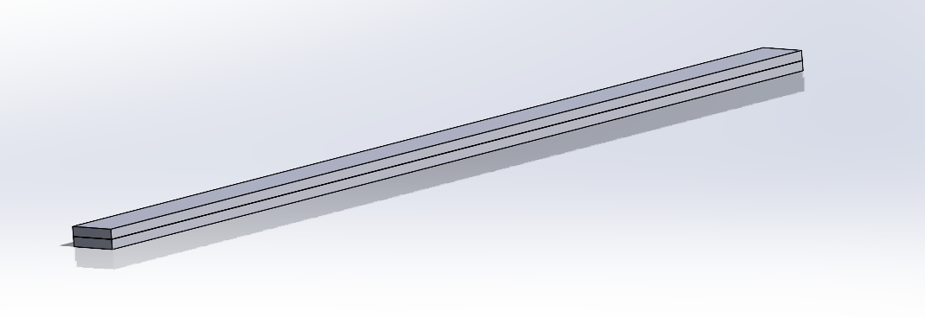
Figure 2 - CAD Model of Bimetallic Strip
Once this is made it can then be used within ANSYS Workbench, using a Static Structural analysis system, displayed in Figure 3 below.
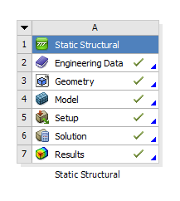
Figure 3 - Static Structural System in ANSYS Workbench

For the thermal solver, fewer material properties are required to run the solver so, within the Engineering Data section of the system, the required properties were just manually input for copper and invar. However, for more complex solvers it is easier to use premade materials or use software such as GRANTA to import materials.

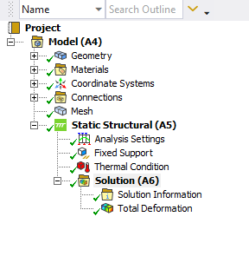
Figure 4 - Project Tree for the Bimetallic Strip Validation Study
In the above figure, the project tree for the bimetallic strip can be seen. In the tree the material for each strip can be selected, in the geometry tab, and a mesh can be applied to the model. Mesh element size can have an impact on the results, which will be covered later in this report, but an element size of 0.5 mm was used for the bimetallic strip. Then as per the diagram in Figure 1 the model is fixed at one end, and a thermal condition, of 122°C, is applied to the entire strip. A temperature of 122°C is used, as the ambient temperature in ANSYS was set to 22°C. Finally, the total deformation was outputted, producing the results seen in Figure 5 below.
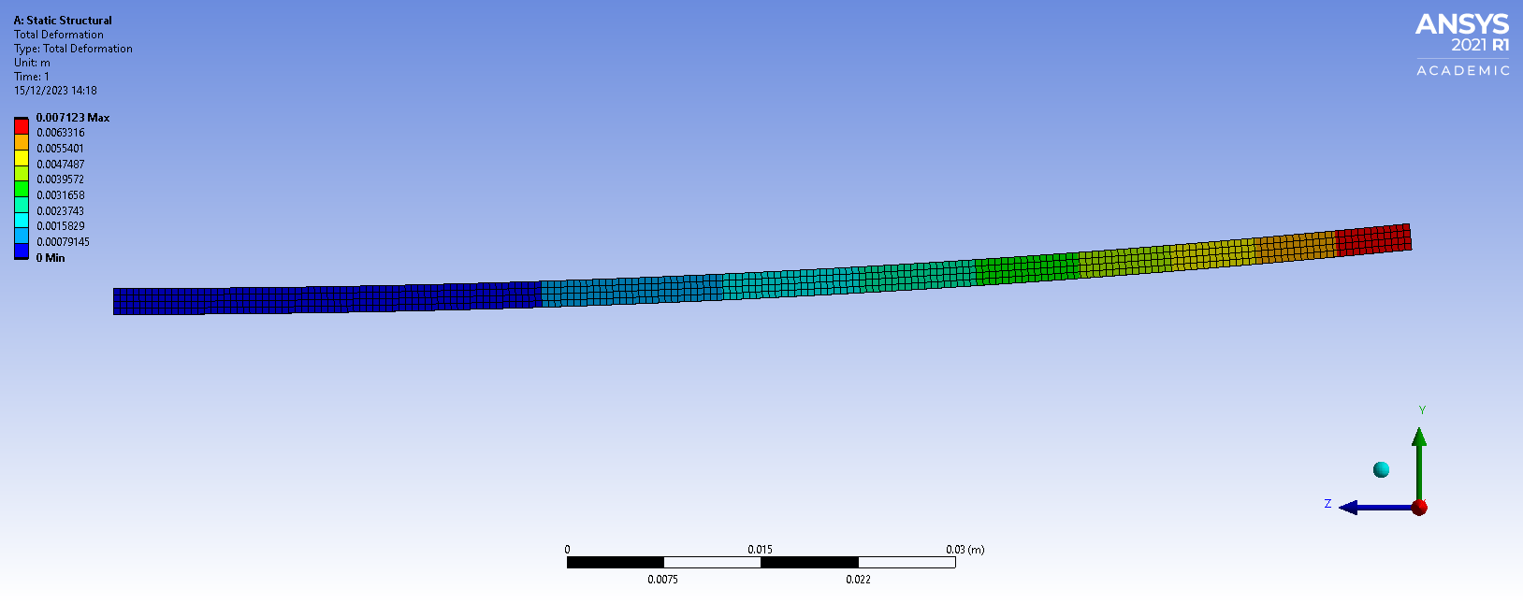
Figure 5 - Total Deformation Results of the Bimetallic Strip from ANSYS
As can be seen in Figure 5, the maximum deformation is 0.007123m, or 7.123mm and since it is bending upwards it can be thought of as being negative.

3.2.3 Comparison of ANSYS and Calculated Values

The calculated value of maximum deformation was -7.049mm and the value calculated by ANSYS was -7.123mm this produces an error of just 1.039% which is within acceptable tolerances for the thermal solver and hence validates the thermal solver. Considering a similar case of a 2.5% error being acceptable for a stress-strain curve produced by (Karthik et al., 2016), this is percentage is tolerable.

3.3 Static Structural Solver Validation Study

A cantilever beam is supported at the left end and is free at the right. An axial load, and a point load are both applied to the free end of the beam as shown in the figure below.
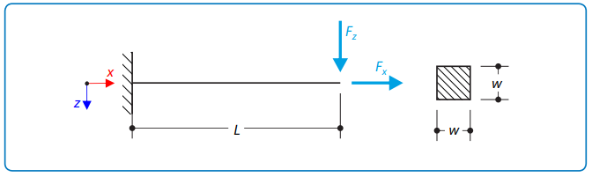
Figure 6 - Cantilever Beam Case Diagram (Dlubal, no date a)

3.3.1 Structural Solver Validation Calculations

The following are the equations and data required to calculate the maximum deformation for a cantilever beam. The denotation of the variables used in Table 2.

Table 2 - Data Table for Cantilever Beam Case
 |  | Property | Symbol | Value | Units
Material | Steel | Modulus of Elasticity | E | 310000.000 | MPa
Material | Steel | Poisson's Ratio | ν | 0.300 | n/a
Geometry | Cantilever Beam | Length | L | 10.000 | m
Geometry | Cantilever Beam | Cross-Section Width | w | 0.080 | m
Force |  | Point Load | $$F_{z}$$ | 7.650 | kN
 |  | Axial Force | $$F_{x}$$ | 1.600 | kN

Below are the equations required to calculate the maximum deformation for the axial and point loads.

$$u_{x max}= \frac{F_{x} L}{E A}$$
Equation 4 - Maximum Deformation from Axial Load equation for Cantilever Beam Case
The calculated value for this is 0.001190476mm. Which is a very small amount of deformation.

$$u_{z max}= \frac{F_{z} L^{3}}{3 E I_{y}}$$
Equation 5 - Maximum Deformation due to the Point Load for Cantilever Beam Case
The calculated value for the point load is 3557.477679mm, or 3.557477679m. This is a lot of deformation. However, looking at the case as a whole it is not unrealistic as the beam is only 0.080m wide and 10m long, so a lot of deformation due to a point load of 7650N would be expected. At this stage the deformation due to the axial load is negligible.

3.3.2 ANSYS Cantilever Beam Case

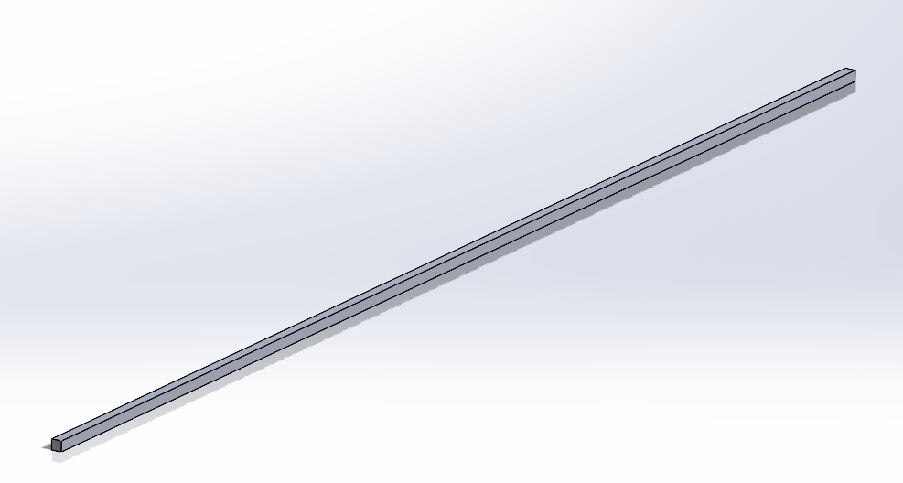
Figure 7 - CAD model of the Cantilever Beam

The CAD model gemoetry of the beam, seen in Figure 7 is imported into the static structural system in ANSYS Workbench. For this validation study, structural steel was used as the material in the engineering data section of the system.

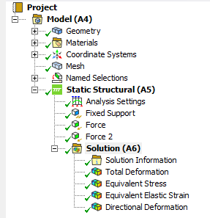
Figure 8 - System Tree for Cantilever Beam Case
In the figure above, the system tree for the cantilever beam study can be seen. It shows the fixed support and the two loads being applied to it. The element size used on this study was 0.05m. This size can be reduced to improve the accuracy of the solver, which will be covered by later.

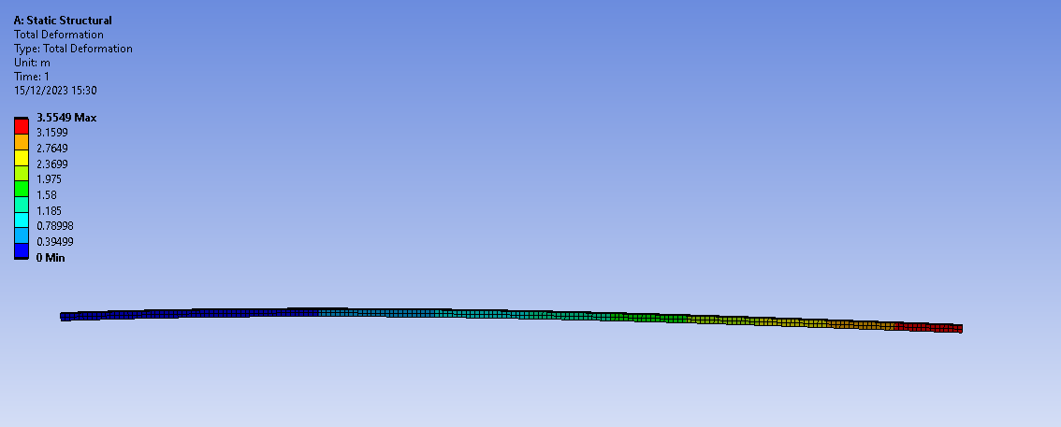
Figure 9 - Results of Cantilever Beam Study
As can be seen in Figure 9, the maximum deformation the beam is 3.5549m or 3554.9mm. This correlates well with the calculated value of 3557.477679mm, which has an error of -0.0725%, which is very small, and hence validates the structural solver.

3.4 Mesh Independence Study Results

3.4.1 Bimetallic Strip

For the Bimetallic Strip a range of 0.002.5m to 0.00001m element sizes was used to investigate whether the mesh size had an effect on the maximum deformation. The results of this investigation can be seen in the table below. The percentage error is calculated using the value calculated previously,
-7.048787933mm, as the baseline value.

Table 3 - Results of the Mesh Independence Study for the Bimetallic Strip
Element Size (m) | Max Deformation (m) | % Error of Max
2.50E-03 | -7.12190E-03 | 1.0372
1.00E-03 | -7.12330E-03 | 1.0571
7.50E-04 | -7.12360E-03 | 1.0613
6.00E-04 | -7.12330E-03 | 1.0571
5.00E-04 | -7.12300E-03 | 1.0528
4.00E-04 | -7.12210E-03 | 1.0401
3.00E-04 | -7.12150E-03 | 1.0316
2.50E-04 | -7.12130E-03 | 1.0287
1.00E-04 | -7.12030E-03 | 1.0145

From this table the percentage error can be plotted on a graph to determine if the mesh is independent of the results calculated. This can be seen in Figure 10 below.

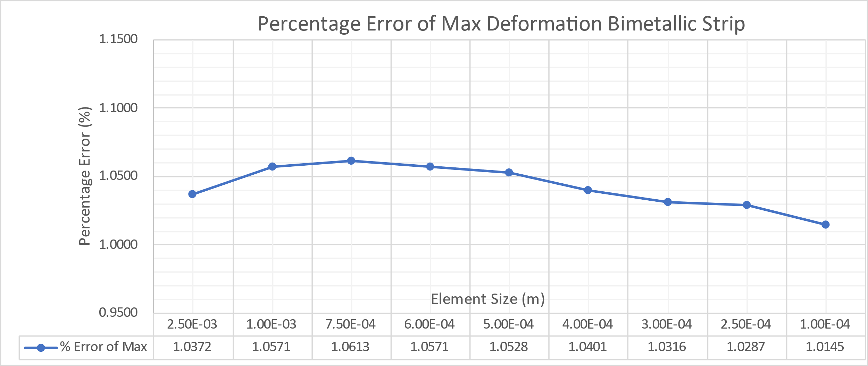
Figure 10 - Graph showing the results of the Mesh Independence Study for the Bimetallic Strip
As can be seen in the figure above, the mesh is not having a large impact on the results of the study as the range of percentage error is only 0.0468%. From this, it is clear that the mesh is independent of the results.

3.4.2 Cantilever Beam

For the cantilever beam a range of 0.075m to 0.0025m element size was used to investigate the effect of mesh size on the cantilever beam results. Below is a table of results for this investigation. The percentage error is calculated using the calculated value of maximum deformation, 3.557477679m.

Table 4 - Table of Results from the Mesh Independence Study on the Cantilever Beam
Element Size (m) | Max Deformation (m) | % Error of Max
0.07500 | 3.5546 | -0.0809
0.05000 | 3.5549 | -0.0725
0.02500 | 3.5555 | -0.0556
0.01000 | 3.5557 | -0.0500
0.00750 | 3.5557 | -0.0500
0.00500 | 3.5558 | -0.0472
0.00250 | 3.5558 | -0.0472

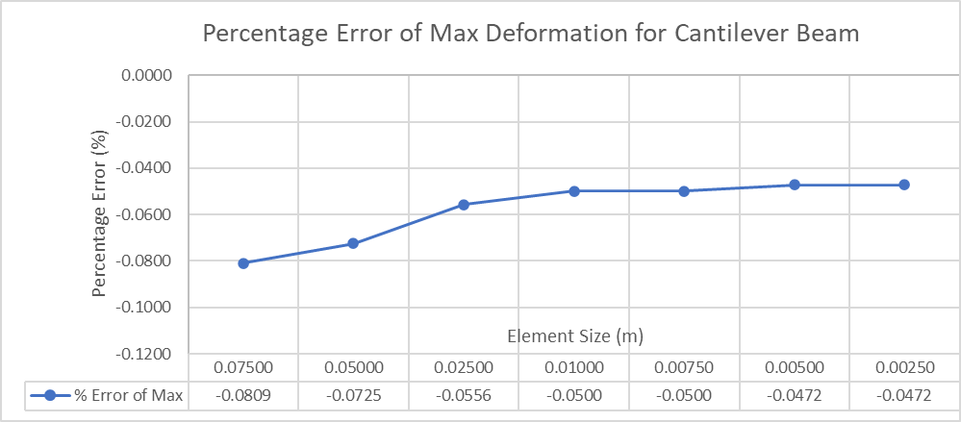
Figure 11 - Graph of Percentage Error of Maximum Deformation for the Cantilever Beam
It is clear from the figure above that there is not much change in the results when the mesh size changes, with a range of percentage error of just 0.0337%. This makes it clear that the mesh size is independent of the results of maximum deformation for the cantilever beam.

3.4.3 Piston

Due to the simplicity of the models used in the validation studies a mesh independence study must be carried out on a complex geometry as well, such as a piston. For this investigation a range of 0.00025m to 0.0085m element sizes was used. The results of the investigation are outlined in the table below.
Table 5 - Results of the Piston Mesh Independence Study
Element Size (m) | Max Def (m)
0.0085 | 2.5761E-05
0.0075 | 2.5903E-05
0.005 | 2.5997E-05
0.0025 | 2.6144E-05
0.001 | 2.7491E-05
0.00075 | 2.7831E-05
0.0005 | 2.9966E-05
0.00025 | 3.31E-05

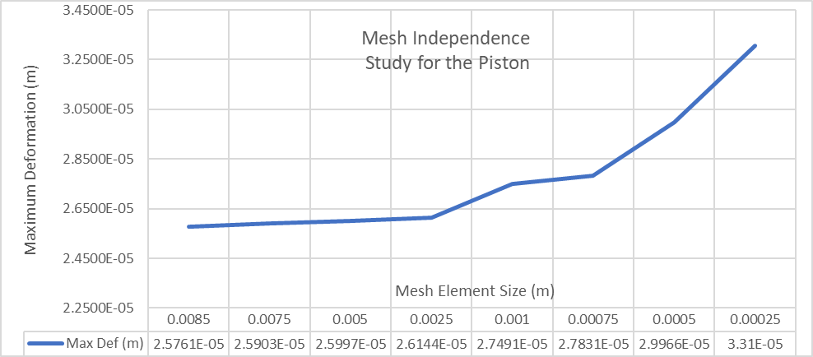
Figure 12 - Graph of the results of the Mesh Independence Study for the Piston
The graph above indicates that, for a more complex geometry, the ANSYS-calculated max deformation is minimally influenced by varying mesh sizes. The observed range of max deformation in this study is 7.34E-06m, confirming mesh independence. Notably, there is consistent max deformation even for element sizes ranging from 0.0085 to 0.0025m, a range within which subsequent piston mesh sizes fall.

4.0 Computer Aided Design Modelling and Assembly

It is crucial to ensure the utmost precision in assembling the components, as the accuracy of the CAD geometry plays a pivotal role in influencing the structural outcomes. The meticulousness applied to the assembly process will directly affect the reliability of the obtained structural results.

4.1 Piston Model

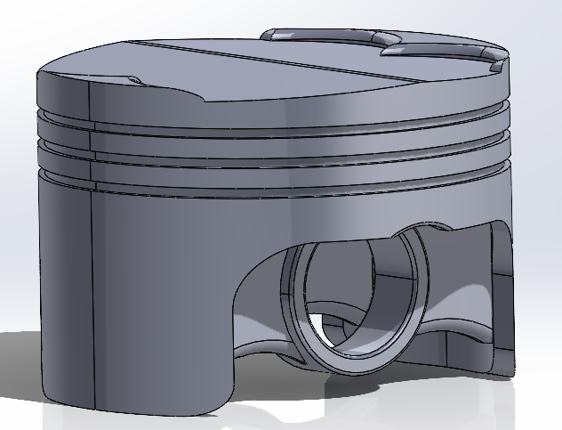
Figure 13 - CAD model of the original piston design

Figure 13 displays the model of the original piston design used in the baseline run in ANSYS. This component will be improved upon using the results of the fully linked analysis system discussed later. Due to the nature of the redesign using ANSYS, certain sections, such as the gudgeon pin hole and the width of the piston, have fixed hardpoints that cannot be altered without affecting the engine's characteristics.

4.2 Assembly

The assembly comprises an engine piston, a gudgeon pin, a connecting rod, and a crankshaft, collectively simulating engine motion and forces in ANSYS. Body-to-body revolute joints are employed for the gudgeon pin to the piston, gudgeon pin to the connecting rod, and connecting rod to the crankshaft. Additionally, body-to-ground general joints are applied to the crankshaft, allowing only z-axis rotation while fixing its position, and to the piston, enabling vertical movement. These joints ensure accurate simulation of engine motions. The assembly configuration is depicted in Figure 14.
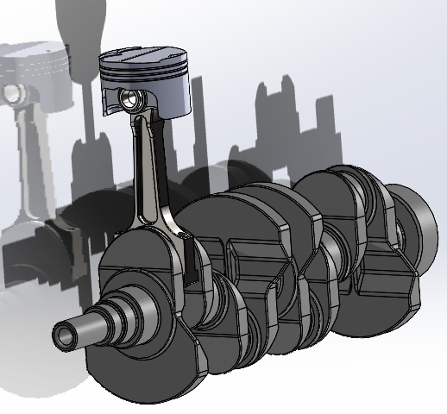
Figure 14 - Assembly containing the original piston design.

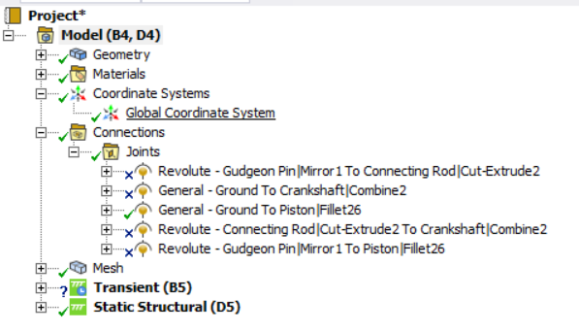
Figure 15 - Joints used for the assembly in the fully linked analysis system.

5.0 Simulation of Kinematics, Thermal Effects, and Structural Analysis

The material choice for the piston in simulations significantly influences results (Barve et al., 2023). Incorporating a modulus of elasticity curve introduces constraints during simulation, impacting results by causing areas with constraints to exhibit no deformation. Conversely, using a material with a single modulus value slightly affects results by employing a constant value in calculations. To affect the results the least, this report opts for an aluminium alloy with a single modulus value. This choice eliminates the need for additional constraints, ensuring simulation results are unaffected by such constraints.
However, results for the material using the curve can be found in the appendix in Figures 44-55.
Below is the system tree for the entire linked system and the systems in ANSYS Workbench.
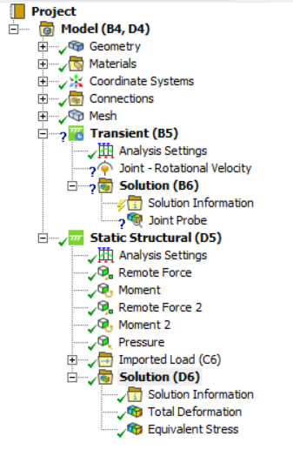
Figure 16 - System Tree of a Fully Linked System
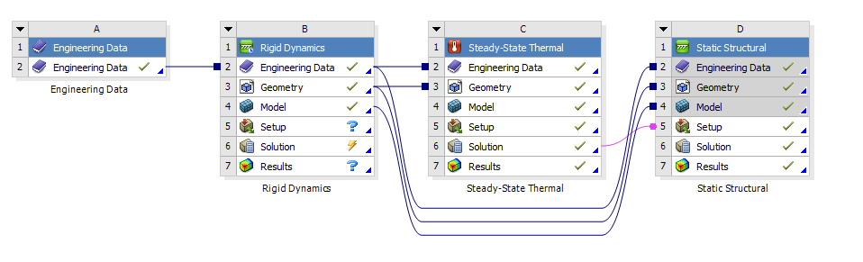
Figure 17 - Fully Linked Analysis System in ANSYS Workbench
In Figure 17, the fully linked system can be seen in ANSYS Workbench, a note to be made about the whole system is that the rigid dynamics results need to be put into the static structural system before the thermal system is solved.

5.1 Kinematic Simulation

To run a kinematic simulation on the assembly, a rigid dynamics analysis system is used, shown in Figure 18 below. The transient system will calculate all the forces that will act on the piston as the crankshaft rotates.

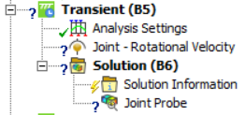
Figure 18 - Transient Solver System Tree
Within the analysis settings, seen in the figure above, a step end time of 0.05s is set and the time step is set to 0.0001s. A joint load is applied to the general joint on the crankshaft and a rotational velocity of 4000rpm is applied. Then a joint probe is applied to the joint between the gudgeon pin and the piston.
The joint probe produces the graph seen in the figure below.

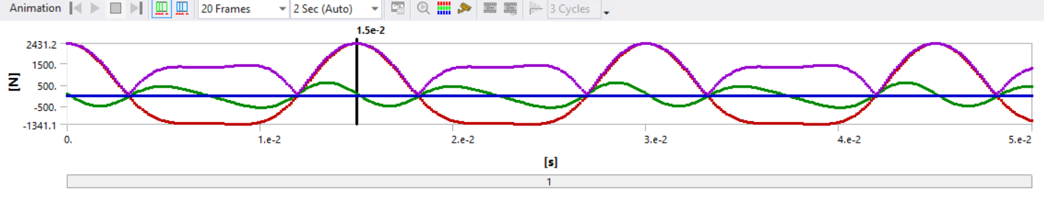
Figure 19 - Graph produced by the joint probe in the transient solver.
The peak total force value is chosen and retrieved, and the joint probe data is exported for use in the structural solver. It's noteworthy that in a comprehensive investigation of piston development, both maximum and minimum forces would be examined to obtain a fuller understanding. However, since this is not the case for this report it will not be completed.

5.2 Thermal Simulation

For the thermal simulation a steady-state thermal analysis system is used, as seen in Figure 17. For this all but the piston geometries are suppressed, and the piston is changed from rigid to flexible. Below is the thermal system tree.
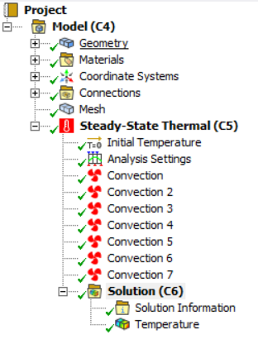
Figure 20 - Steady-State Thermal Analysis System Tree

A mesh element size of 0.005m is used on the piston, as mentioned previously this size is in a particular region of independence with regards to the results, hence why it was chosen for this investigation.
Temperatures were applied to each region of the piston, in the form of convections, as seen in the figure above. The values applied can be seen in Table 6.

Table 6 - Table of values used in the Steady-State Thermal System
Section | Film Coefficient (W/m^2 °C) | Temperature (°C)
Crown | 497.5 | 928.5
Crown Sides | 447.5 | 425
Top Groove | 437.5 | 190
Middle Groove | 437.5 | 190
Oil Grove | 338.75 | 163.75
Underside | 675 | 91.25
Skirt | 462.5 | 107.5

The analysis outputs the maximum temperature value, which is then used in the fully linked system, as depicted in Figure 17. This combined solution is utilized in the static structural solver, and the thermal solver results are illustrated in the figure below.
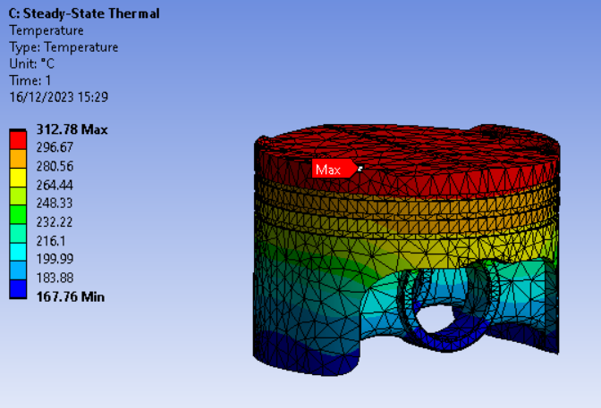
Figure 21 - Temperature Profile of the Original Piston Design

5.3 Structural Simulation

Finaly, the structural simulation uses the static structural analysis system. As was done with the thermal system all but the piston geometries are suppressed as this is the only model that is being investigated. The system tree can be found in Figure 22.
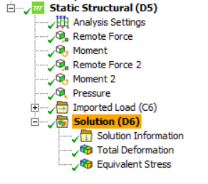
Figure 22 - System Tree for the Static Structural System in ANSYS
The remote forces and moments from the transient solver, applied prior to the thermal solver, were considered. A pressure of 1.05x10^7 Pa, typical for piston pressure at Top Dead Centre (TDC), was used for this analysis. This value is supported by a graph reaching around 100 bar for a spark ignition engine by (Ibrahim and Bari, 2008).
The imported load is the temperature profile imported from the previous system. This is all considered when calculating the final results of total deformation and stress which can be seen below.

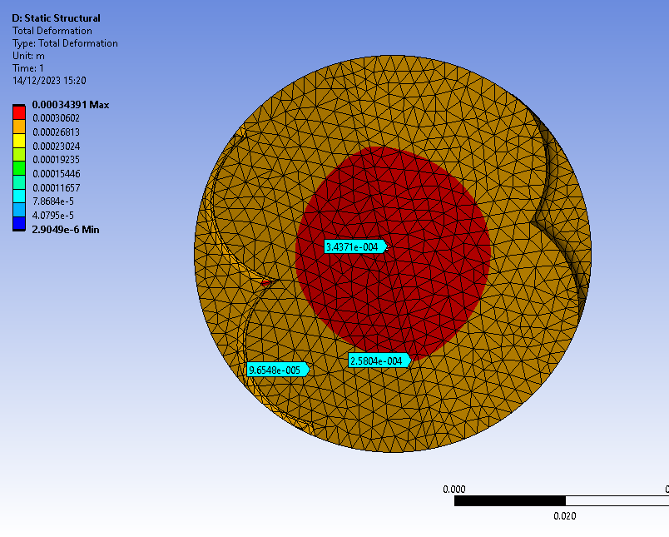
Figure 23 - Top View of Total Deformation of Original Piston
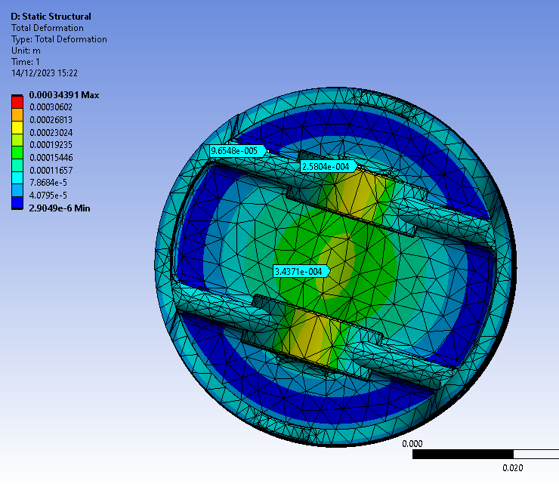
Figure 24 - Bottom View of Total Deformation of Original Piston
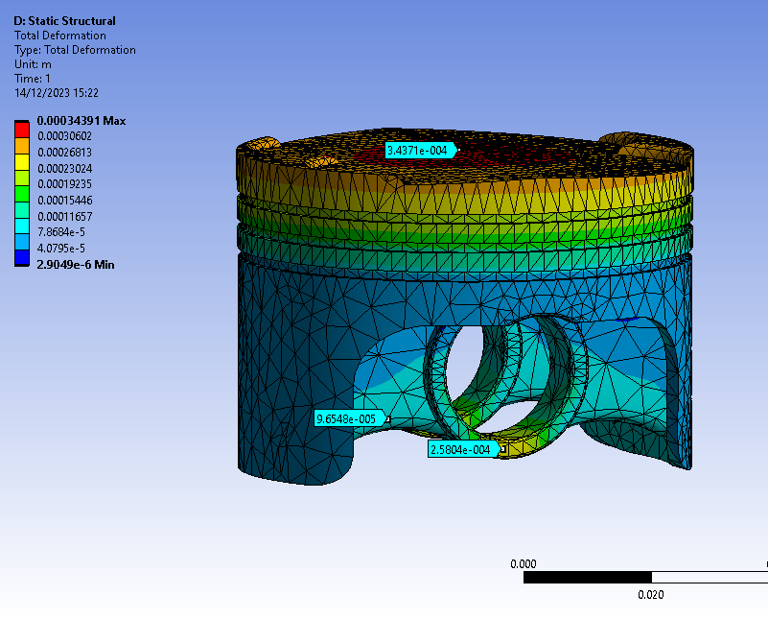
Figure 25 - Total Deformation of Original Piston

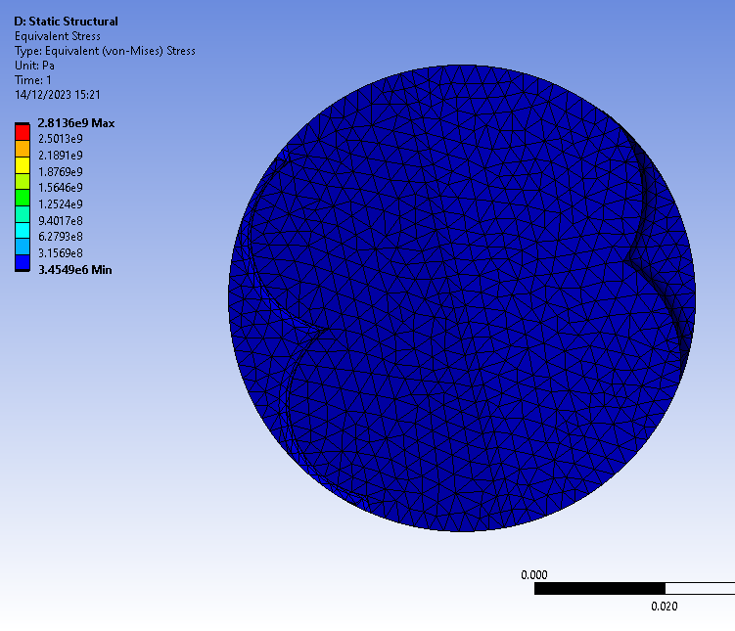
Figure 26 - Top View of Equivalent Stress of the Original Piston

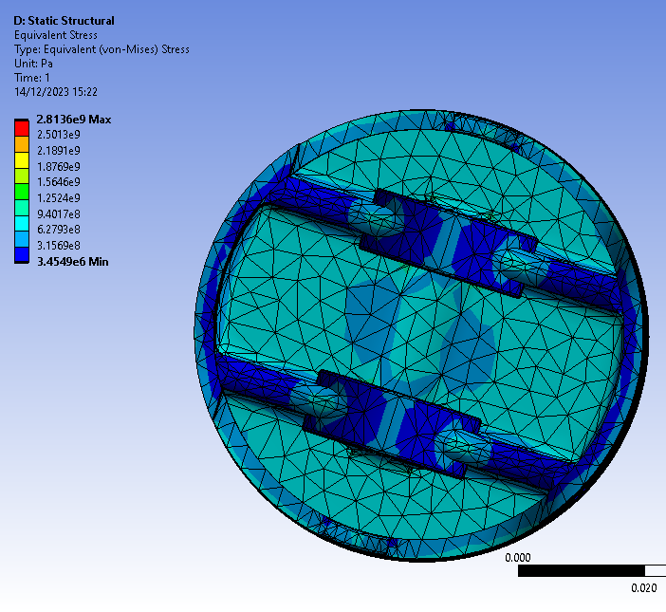
Figure 27 - Bottom View of Equivalent Stress for the Original Piston

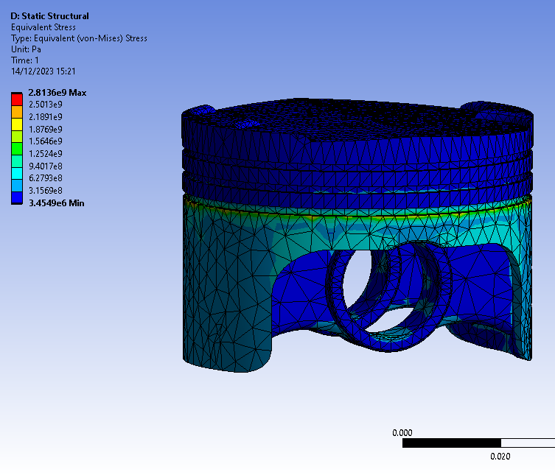
Figure 28 - Equivalent Stress of the Original Piston

6.0 Iterative Piston Design Study

The results of the investigation on the original piston can then be used to find low stress and deformation areas and use this information to improve the design of the piston. If there is low stress somewhere, mass can be taken out of it and if high stress is seen, then more material is required to strengthen that region.

6.1 Design Iteration 1

Looking at the results in Figures 23-28, it is clear that the top is seeing the most deformation. From this information a flat surface was considered, to see what affect that had on the deformation seen on the top of the piston. As less deformation is seen on the struts supporting the gudgeon pin holes mass can be removed from there. The first iteration of the piston from these original results can be seen in the figure below.
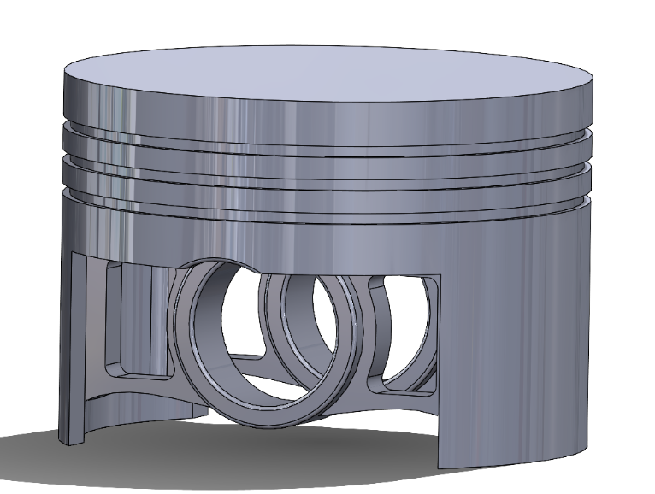
Figure 29 - Iteration 1 Piston Design
This model is then simulated the exact same way using the fully linked system as the original piston. The results from the first piston design are displayed below.

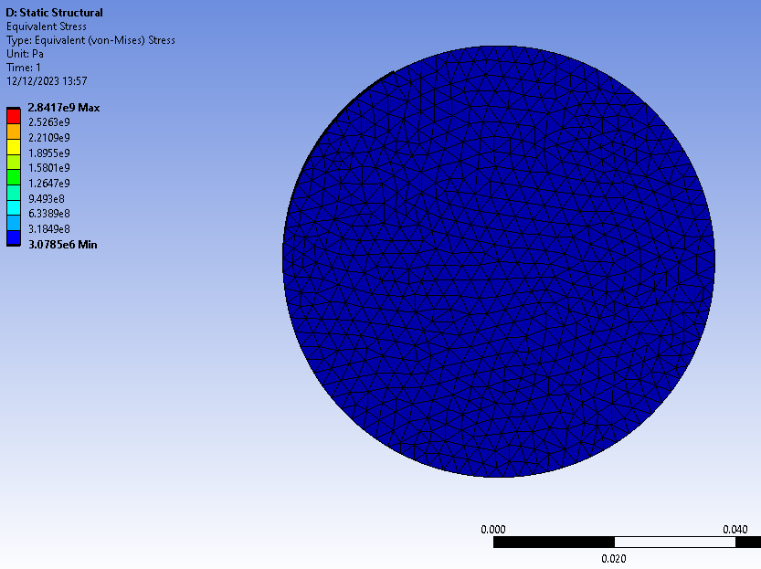
Figure 30 - Equivalent Stress for Piston Iteration 1 (Top View)
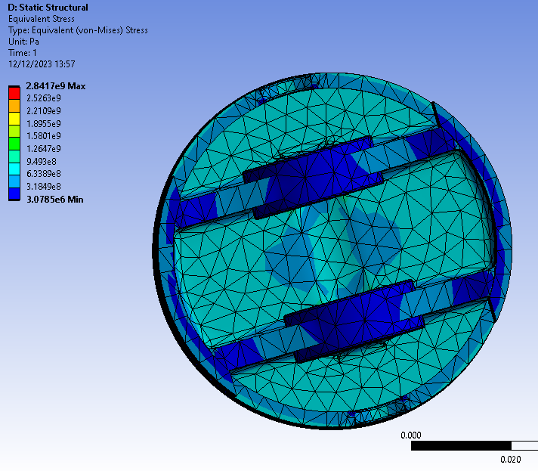
Figure 31 - Equivalent Stress for Piston Iteration 1 (Bottom View)
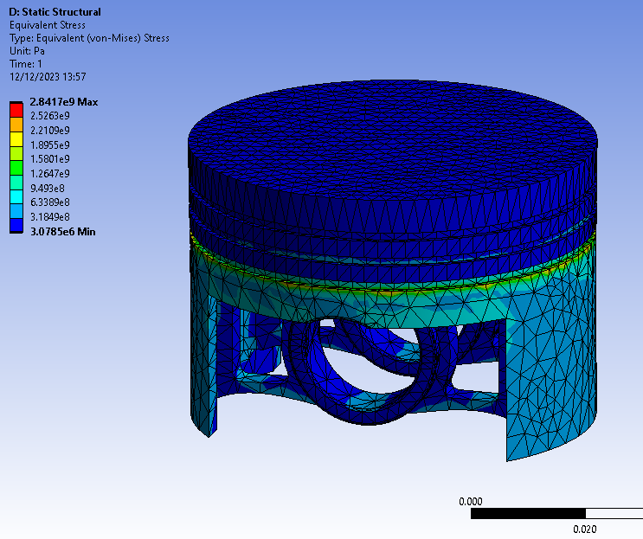
Figure 32 - Equivalent Stress for Piston Iteration 1

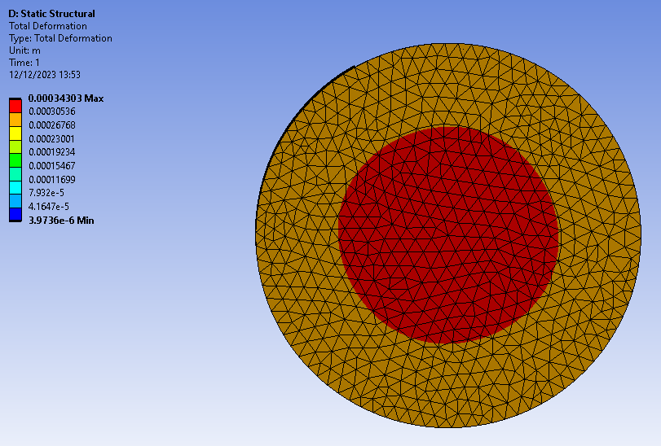
Figure 33 - Total Deformation for Piston Iteration 1 (Top View)
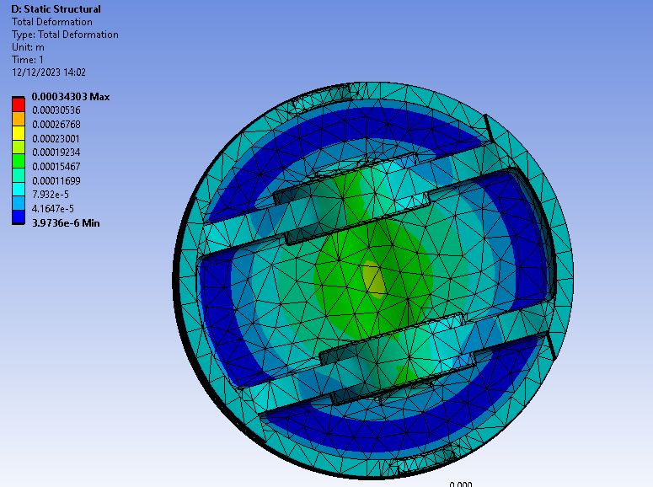
Figure 34 - Total Deformation for Piston Iteration 1 (Bottom View)

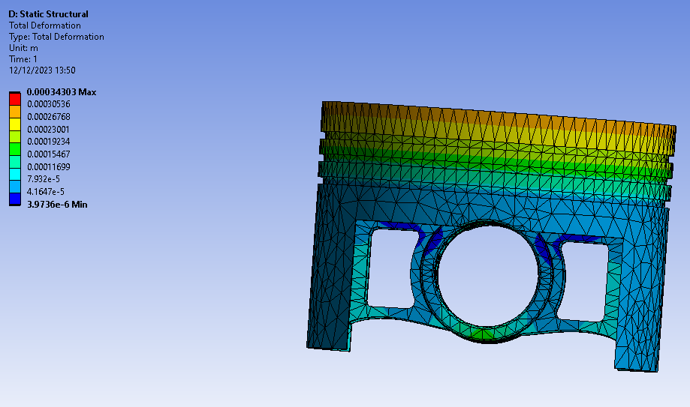
Figure 35 - Total Deformation for Piston Iteration 1
Following the design changes, deformation has slightly decreased and become more uniform on the top of the piston. The gudgeon pin hole shows a slight reduction in the bottom-side deformation, while the mass reduction in the support struts appears to have had minimal impact on stress levels. This implies the potential for further reduction. Overall, the total stress does not exhibit significant changes.

6.2 Design Iteration 2

For the second redesign, even more mass has been taken out from the underside of the piston, reducing it down from 255g down to 213g. Lower mass would mean that the piston sees less forces, so theoretically the stress should be lower. Also, a dome crown has been added to see its effect on the deformation. Below is the new design of the piston.
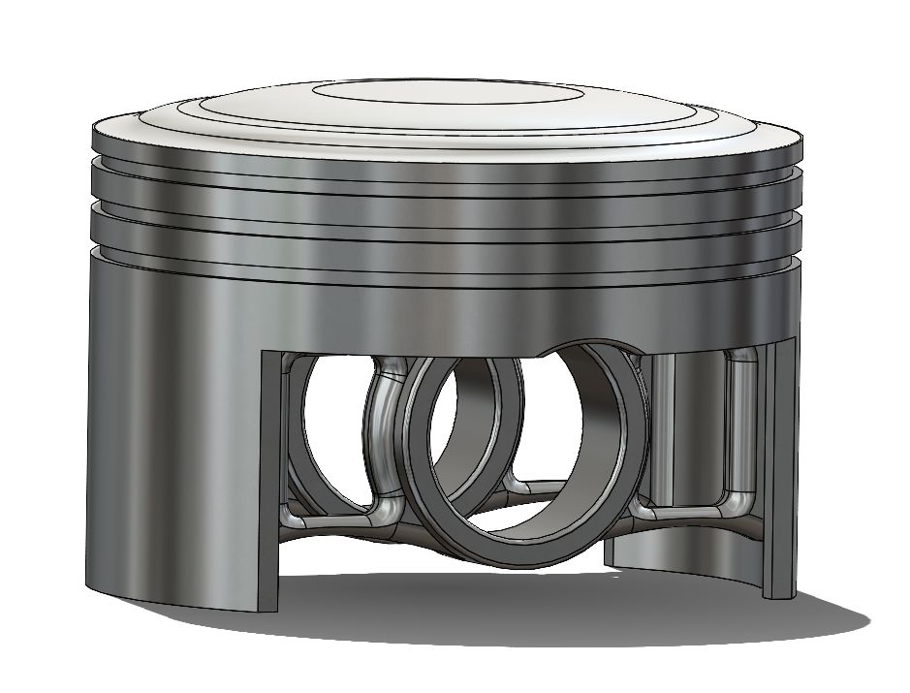
Figure 36 - Iteration 2 of Piston Design

Again, the same method is used to run this piston through the fully linked system as the previous two. However, for this design a mesh of 0.004m was used, as the piston has regions with too complex a geometry for an element size of 0.005m.

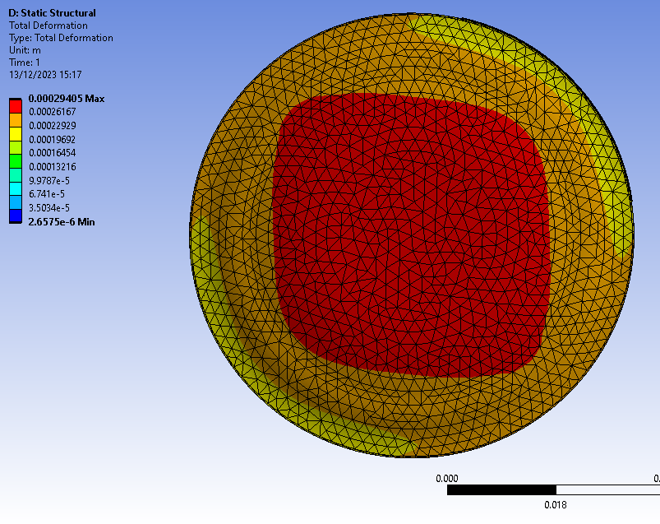
Figure 37 - Total Deformation of Piston Iteration 2 (Top View)
The top of the piston is seeing a decrease in deformation compared to the other two pistons, so the dome crown can be considered as a better design for the top of the piston.

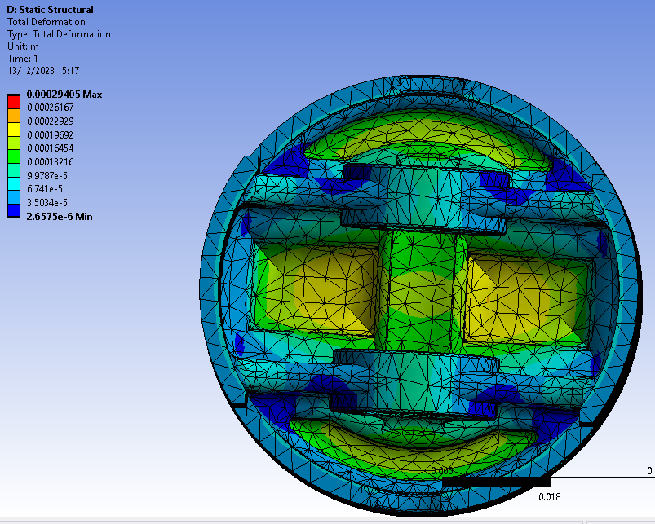
Figure 38 - Total Deformation of Piston Iteration 2 (Bottom View)
As depicted in the above figure, alterations to the underside of the piston, specifically the reduction in mass, does not exhibit concerning changes in the deformation observed. This supports the notion that removing mass from the piston is feasible without compromising its structural integrity.

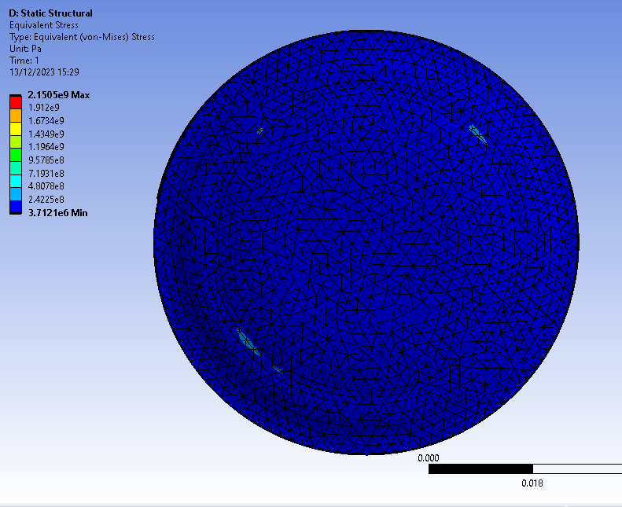
Figure 39 - Equivalent Stress of Piston Iteration 2 (Top View)
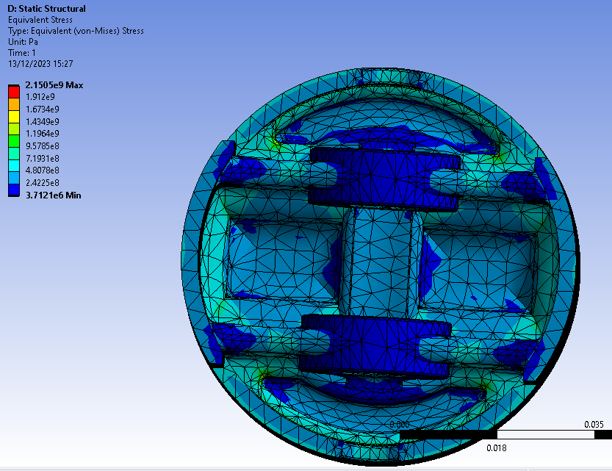
Figure 40 - Equivalent Stress of Piston Iteration 2 (Bottom View)
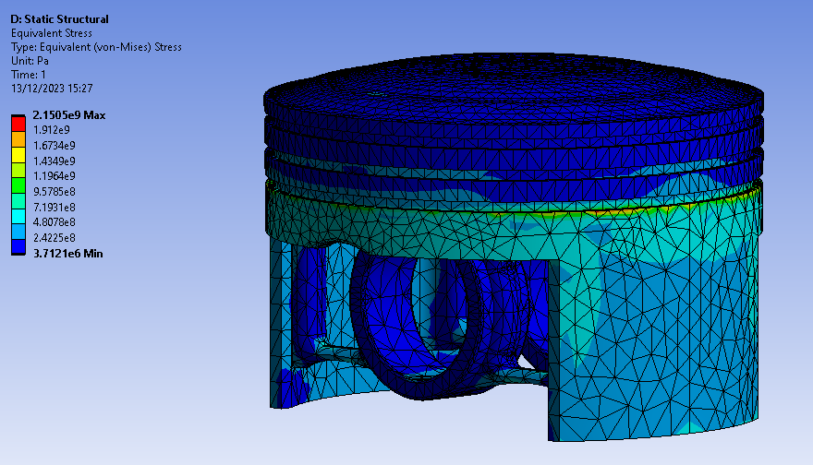
Figure 41 - Equivalent Stress of Piston Iteration 2
From the figures above it is clear that this design has reduced the total stress of the piston also, which will be beneficial overall.
However, it must be remembered that these results may not be 100% accurate as it is using the aluminium alloy with a single value for modulus of elasticity. But for the purpose of showing how a piston design can be improved through an iterative design process it is very useful.
The results from the Aluminium 6061, using a curve of Young’s Modulus, for the original piston and the final iteration can be found in the appendix, In Figures 44-55. As can be seen by these results, they do not seem quite right, hence the other material was chosen, further showing the limitations of CAE when it comes to the choice in material.

7.0 Conclusion

To conclude, in addition to the savings in time and prototyping products, CAE is a very powerful tool when it comes to simulating the motion of an assembly of components, and the thermal and structural capabilities of a component in that assembly. However, the geometry must be realistic, or the results will not be accurate. Following this, if the boundary conditions are not sufficient and accurate then the results will also suffer, so it is crucial to get these correct. This is why the decision on the material is so important as using a curve for Young’s Modulus means extra constraints are required, which can affect the results drastically, and hence was not used.
The report clearly shows the iterative process of improving the design of a component using CAE software, this shows how valuable CAE can be when designing a part, but as mentioned the setting up of the CAE software must be done correctly or the results of the iterative design will not be accurate and hence will not be usable for justifying component designs.

Reference List

Barve, J. et al. (2023) ‘Comparative analysis of material for flat & dome top piston for SI engine using ansys’, Materials Today: Proceedings [Preprint]. Available at: https://doi.org/10.1016/J.MATPR.2023.10.125.
Dlubal (no date a) Bending Cantilever with Axial Force | Dlubal Software. Available at: https://www.dlubal.com/en/downloads-and-information/examples-and-tutorials/verification-examples/000042 (Accessed: 16 December 2023).
Dlubal (no date b) Bimetallic Strip | Dlubal Software. Available at: https://www.dlubal.com/en/downloads-and-information/examples-and-tutorials/verification-examples/000078 (Accessed: 16 December 2023).
Ibrahim, A. and Bari, S. (2008) ‘Optimization of a natural gas SI engine employing EGR strategy using a two-zone combustion model’, Fuel, 87(10–11), pp. 1824–1834. Available at: https://doi.org/10.1016/j.fuel.2007.10.004.
Kagan, P., Fischer, A. and Bar-Yoseph, P.Z. (1999) ‘Integrated Mechanically Based CAE System’.
Karthik, R.M. et al. (2016) ‘A modular cantilever fixture and test methodology for thermoplastics: An alternative bending load case for validation of CAE material models’, Materials and Design, 89, pp. 727–736. Available at: https://doi.org/10.1016/j.matdes.2015.09.119.
Kojima, Y. (2000) ‘Mechanical CAE in Automotive Design’, R&D Review of Toyota CRDL, 35(4), pp. 1–10. Available at: http://www.tytlabs.com/english/review/rev354epdf/e354_001kojima.pdf (Accessed: 16 December 2023).
Polyakov, A.N. and Kamenev, S. V. (2010) ‘More efficient use of CAE systems in machine-tool design’, Russian Engineering Research, 30(1), pp. 67–71. Available at: https://doi.org/10.3103/S1068798X10010156/METRICS.
Vasiljević, S. et al. (2018) The Benefits of Application of CAD/CAE Technology in the Development of Vehicles in the Automotive Industry. Available at: https://www.proquest.com/docview/2102828149?parentSessionId=AWmLGDapjiPNUbClJg%2FghrjP%2F4aLf6kAxzlbYyja79c%3D&parentSessionId=SeOmG2Bspowh9CxE1TGIb2LWRdkmvlC%2Fck6YcYi82B0%3D&parentSessionId=8xkGwD4DCSg0xfIU14q9h0Ds3SjxxgoSJLcDENyiw2k%3D (Accessed: 16 December 2023).
Zerfu, K. and Ekaputri, J.J. (2021) ‘Nonlinear finite element study on element size effects in alkali-activated fly ash based reinforced geopolymer concrete beam’, Case Studies in Construction Materials, 15, p. e00765. Available at: https://doi.org/10.1016/J.CSCM.2021.E00765.

Appendix

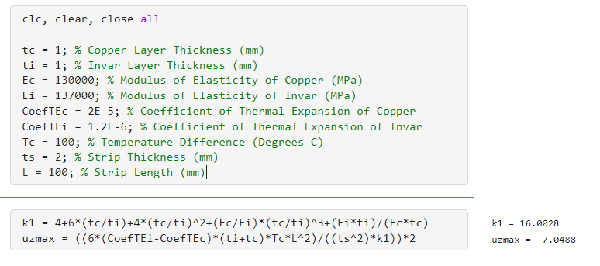
Figure 42 - Figure of the code written to calculate the maximum deformation values for the Bimetallic Strip validation study.
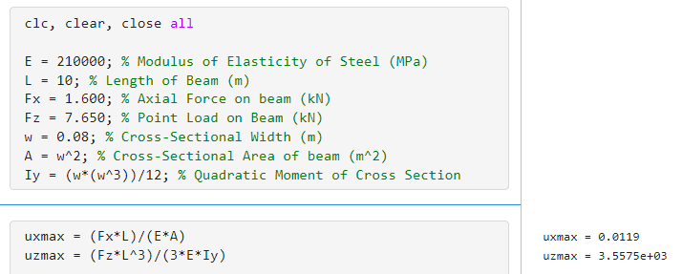
Figure 43 - Figure of code written to calculate the maximum deformation values for the Cantilever Beam validation study.

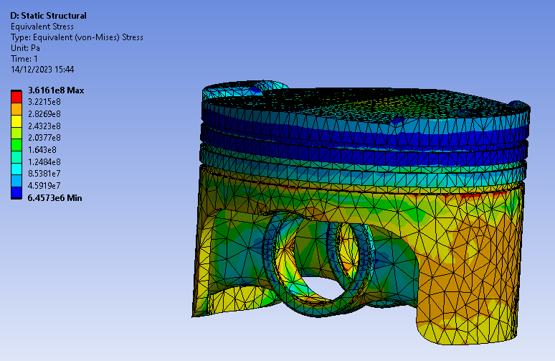
Figure 44 - Equivalent Stress for Original Piston Alternate material
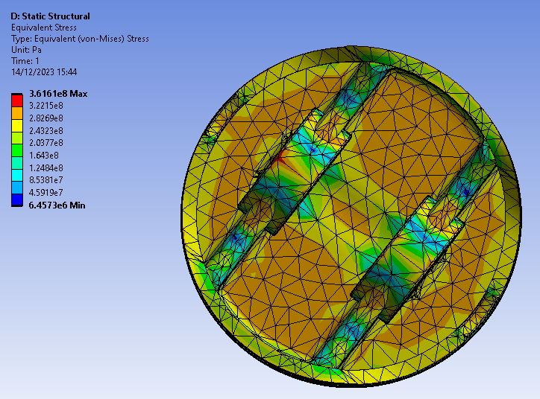
Figure 45 - Equivalent Stress for Original Piston Alternate material (Bottom)
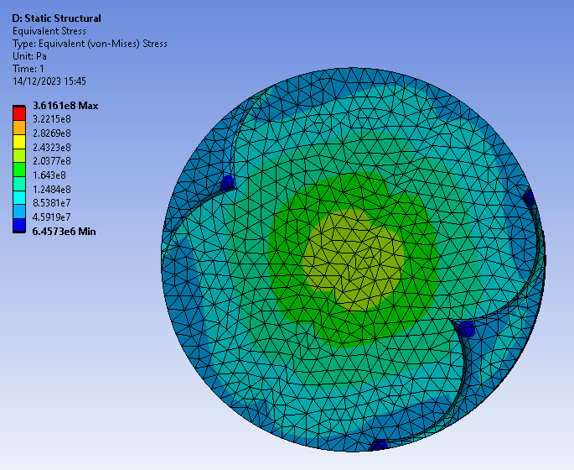
Figure 46 - Equivalent Stress for Original Piston Alternate material (Top)
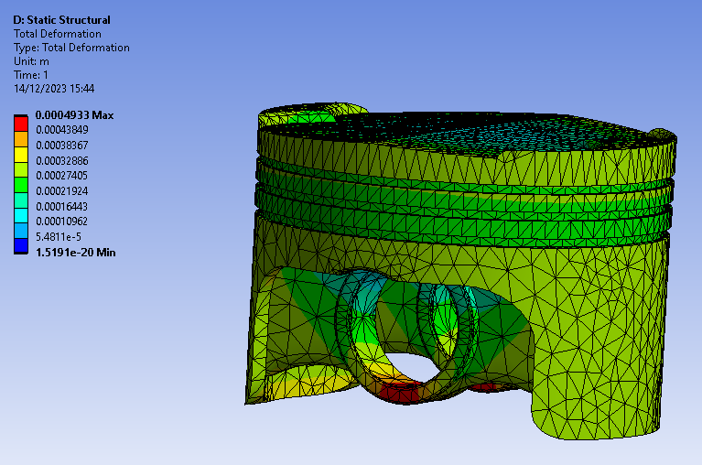
Figure 47 - Total Deformation for Original Piston Alternate material
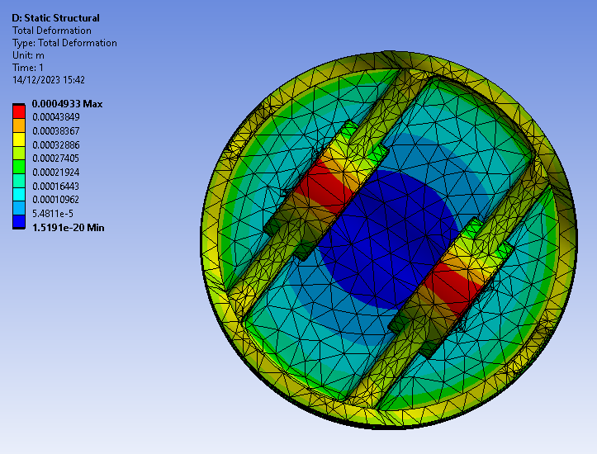
Figure 48 - Total Deformation for Original Piston Alternate material (Bottom)
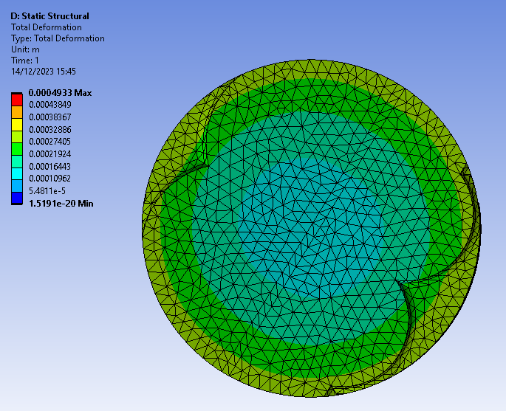
Figure 49 - Total Deformation for Original Piston Alternate material (Top)
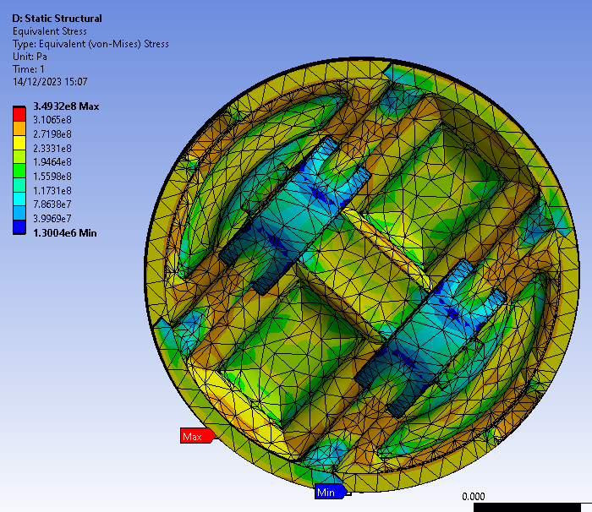
Figure 50 - Equivalent Stress for Iteration 2 Piston Alternate material (Bottom)
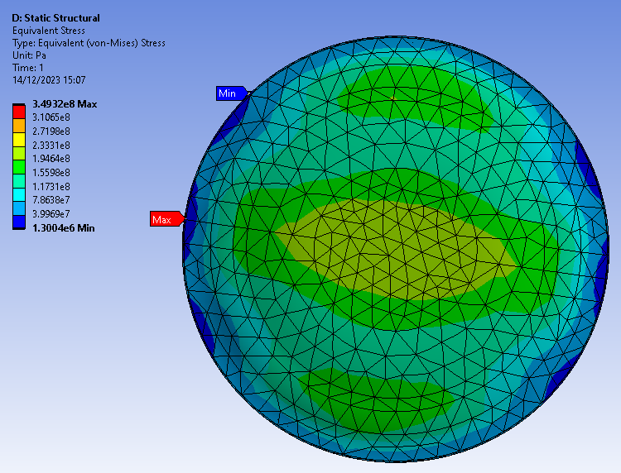
Figure 51 - Equivalent Stress for Iteration 2 Piston Alternate material (Top)
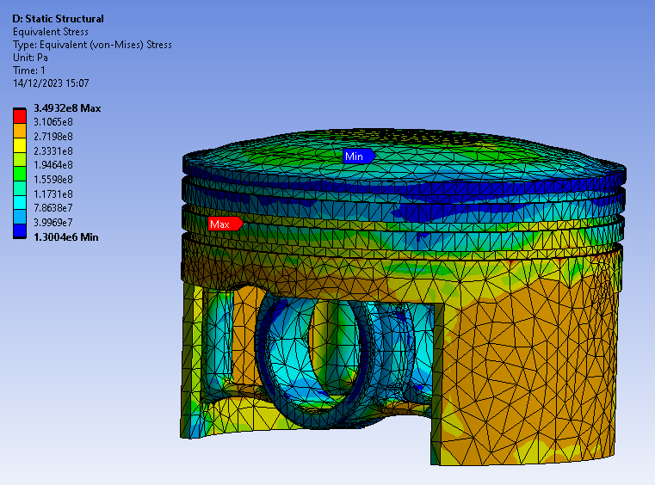
Figure 52 - Equivalent Stress for Iteration 2 Piston Alternate material
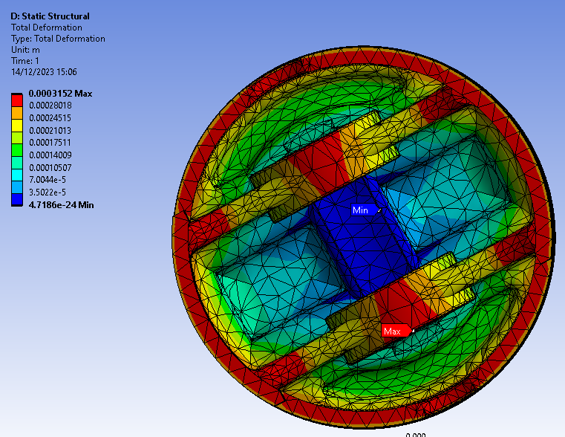
Figure 53 - Total Deformation for Iteration 2 Piston Alternate material (Bottom)
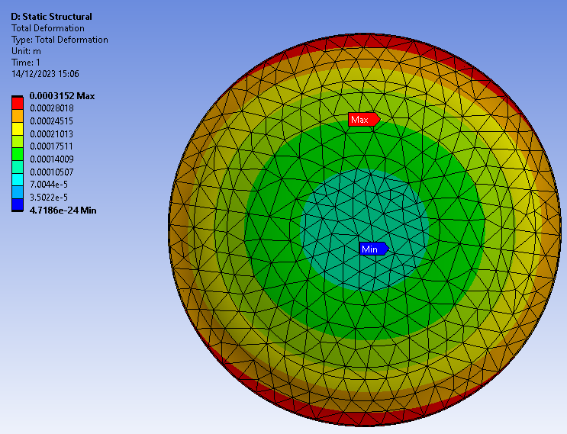
Figure 54 - Total Deformation for Iteration 2 Piston Alternate material (Top)
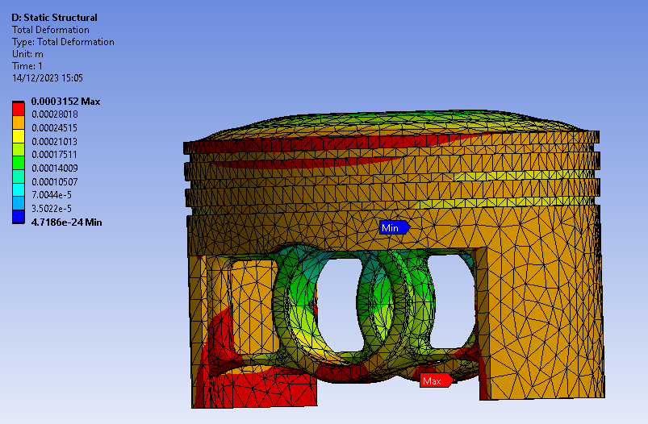
Figure 55 - Total Deformation for Iteration 2 Piston Alternate material

