Name- Utsav Kakadiya
Student ID- 2240174
Module code- LCBB4004
Module Name- Marketing Fundamentals
Lecturer- Tushara Balendran

Marketing

Fundamentals

Background/History of the Company
John Lewis Partnership plc (JLP) which is commonly known as John Lewis is a company with British background that aims and commits to go beyond and above for the customers, which allows them to do various things in a different manner. The company was founded 94 years ago that is in 1929 in Oxford Street, London by the founder John Spedan Lewis and operates throughout the United Kingdom, and also in Ireland. It is a retail public limited company which is headquartered in Westminster, London. The current chairman of the company is Dame Sharon White and Chief Executive Officer is Nish Kankiwala. It is owned by a trust and all the employees run the business or the department stores in short it is run by employees. John Lewis plc considers their employees as partners and a share of the profit is also provided to them. The company deals in various products namely, furniture, clothing, jewelry, cosmetics, watches, giftware, housewares, beds, photography, computing, audio-visuals, food, and direct and financial services. As per the reports of 2022, around 80,000 employees or partners, a revenue of £10.84 billion, operating income of £118.3 million, total assets of £7.785 billion, and total equity of £2.748 billion. The subsidiaries of John Lewis Partnership plc are Opun Home Improvements, Waitrose & Partners, and John Lewis & Partners (Salaman & Storey, 2016).
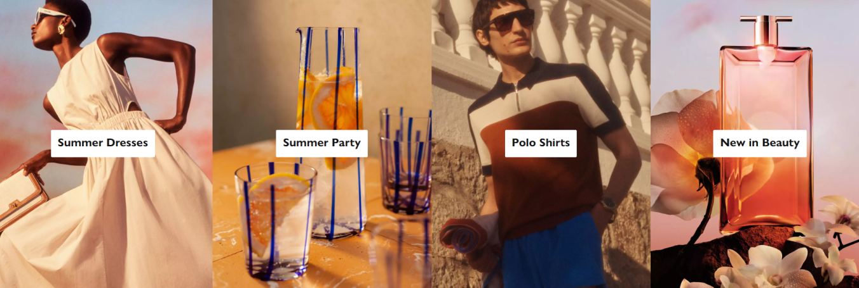
Figure 1: Products offered by John Lewis Partnership Plc (John Lewis.com, 2023).
The company’s first store was opened in Oxford Street, London in 1864 and was awarded a Royal Warrant by Queen Elizabeth II for the suppliers of haberdashery and household goods. Currently, the company has 35 stores in Great Britain. The second store of Peter Jones was acquired in 1905 by Lewis in Sloane Square, London. The first concessions of John Lewis in Ireland and Australia were opened in 2016. The first Christmas television advertisement of the company was launched in 2007 which depicted the countdown to Christmas has begun, and that became an annual tradition in British culture.
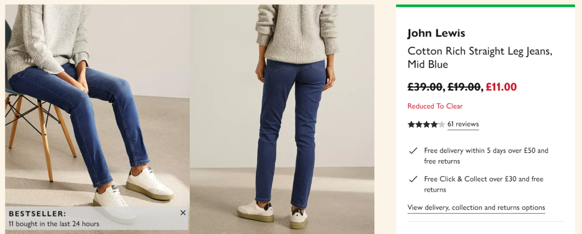
Figure 2: John Lewis Jeans
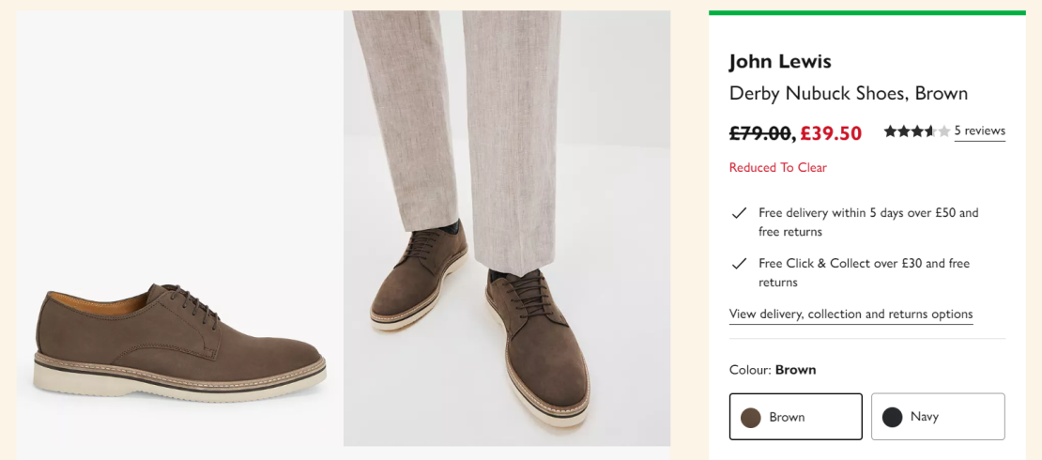
Figure 3: John Lewis Shoes
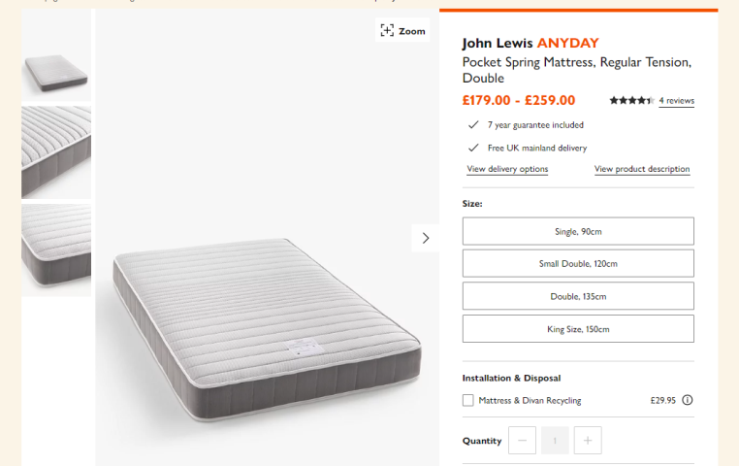
Figure 4: John Lewis Mattress

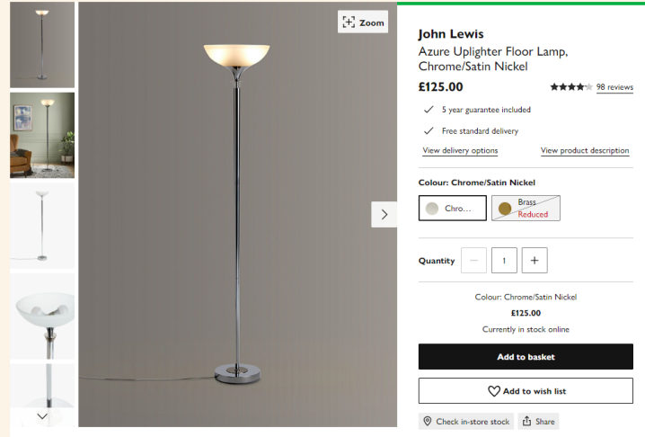
Figure 5: John Lewis Lamp
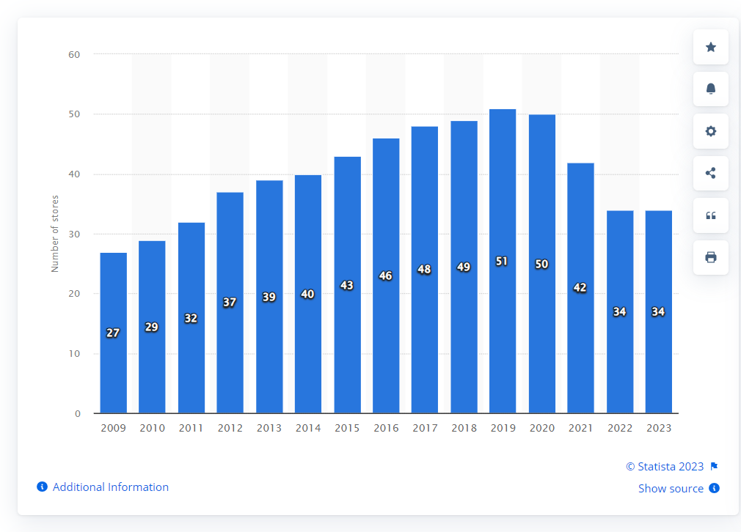
Figure 6: No. of John Lewis stores in the United Kingdom (UK) from 2009 to 2023 (Statista, 2023).
Talking about retail operations in a little bit of detail, first comes John Lewis & Partners which is located in the city center. The Oxford Street Store which is located in London is the largest outlet in the United Kingdom. New stores are opened in the areas where there are no John Lewis department stores. These types of stores will contain Home and Electrical departments with a cafe. Next comes Peter Jones which is located in central London and is the largest department store there. This independent store was bought up by John Lewis, who owned both businesses and then combined them into one. Waitrose & Partners was also owned by JLP in 1937 which has around 332 branches with 78,000 employees, according to a report in 2021. This company was started by Arthur Rose, David Taylor, and Wallace Waite whose areas of trading are the South of England and London. John Lewis also offers home telephone services and broadband, also operates a manufacturing business, and created an independent online supermarket named Ocado. The company has four committees: The nominations Committee, Audit and Risk Committee, Remuneration Committee, and Ethics and Sustainability Committee.

Segmentation, Targeting, and Position Strategies of John Lewis Partnership Plc
Segmentation:
Geographic Segmentation – Considering geographic segmentation is very important as people in different countries or cities have different cultures and preferences. The overall market of John Lewis is divided into various countries, cities, continents, and trading blocks. Delivery costs get a little bit critical in serving a variety of customers in different countries and zip codes (Verbeke, et al., 2018).
Demographic Segmentation – This segment helps the company to make sections on the basis of gender, age, occupation, income, ethnicity, generation, and religion. One of the famous demographic segmentation used in the United States is PRIZM. It combines geographic data with the behavior of the customers to understand their prospects and identify the markets. It has classified every United States household into 66 distinct segments based on demographic and behavior (Fulgoni, et al., 2016).
Psychographic Segmentation – Psychographic segmentation divides the market according to the potential buyers including their opinions on different aspects like social issues, leisure activities, personality characteristics, buying patterns, and other dimensions. The famous segmentation used by the company is VALS which classifies the adult population into 8 subgroups: Survivors, Makers, Experiencers, Believers, Thinkers, Strivers, Achievers, and Innovators (Gajanova, et al., 2019).
Behavioral Segmentation – This segmentation lets the company divide the range of buyers into groups that are based on product uses, knowledge of the product, and attitudes. This helps the company to focus on the key features by which they can provide the customers with the features they like the most about the brand. The key features keep changing with time, so continuous engagement in it increases customer satisfaction and net promoter score (Itani, et al., 2019).

Targeting Strategies:
John Lewis does not affect any particular market because the company offers a variety of products according to the different requirements and tastes of the customer. The company has both male and female customers having an average income of £40,000 per year so as to afford the high-end products offered by the company. They define their customers by saying that their customers are younger, more socially aware and urban, and people with liberal attitudes. The company targets the age group of 30 to 40 of upper-class and middle-class families who are able to pay for quality technologies, furnishings, and quality clothing. The company targets a wealthy group of society who maintain their quality of life with good quality products, services, and experiences (Karell & Miinimaki, 2020).
The advantages of targeting strategies include:
- Targeting a specific market or age group will reduce the wastage of investing in everything.
- By targeting specific ages, marital statuses, interests, and gender, the company can specify their audience who have their interests in the products and the services they provide.
- The company stands out from a lot of competition in the market.
- This gives the company brand-loyal customers.
The disadvantages of targeting strategies include:
- This can be time-consuming as the company has to invest its time in researching its target audience.
- Other customers are not taken into consideration.
- Targeting strategies are expensive to use as they need to spend extra money to research the needs of their consumers.

Position Strategies:
Positioning the company in the market is very important for its success and to sustain in this competitive environment. The company has created a distinct image in the customer’s mind for its brand with a specific identity of the products and services which they provide. Many people are using e-commerce websites and online retailing strategies for shopping and that’s why it is becoming increasingly critical.
The company John Lewis Partnership Plc is working on the price positioning. They provide customers with affordable price products for all age groups, genders, sizes, and species as compared to their competitors.
The company has a good advantage of price positioning strategy as it has increased the profit margins and perceived value of the company, and captured more value and trust from the customers. This has enhanced the brand image of the company creating high value, loyalty, retention, and quality among the customers.
It also has disadvantages like the demands of the customers affect the prices. High pricing requires great selling techniques because not everyone is convinced by it. It makes positioning a little bit difficult (Robinson & Hsieh, 2016).

The current marketing mix strategies of John Lewis Partnership Plc
Product Strategy: Products of John Lewis have higher ratings in the market. They provide a wide range of personal styling. The company provides various products including Electricals, technologies, home and design, fashion and beauty, gifts and celebrations, and baby and child. They have duvets, pillows, curtains, roller blinds, voile services, and exclusive designs of furnishing fabrics of their own brand that are made in their mill named Lancashire in Herbert Parkinson (Armstrong, et al., 2015).
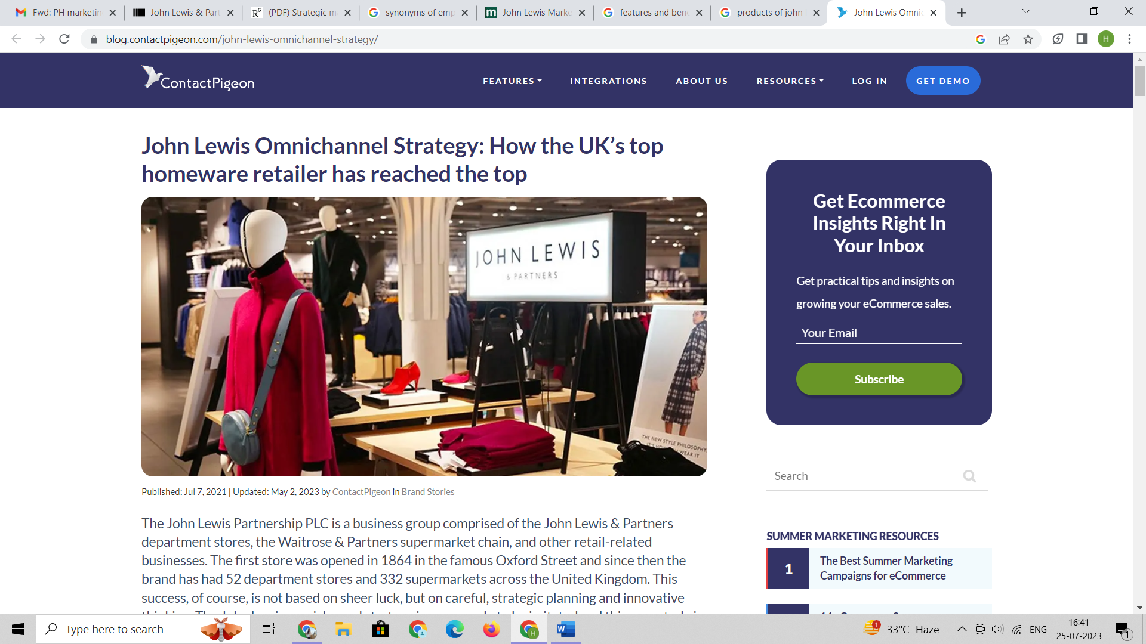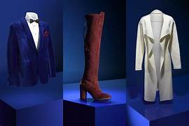
Figure 7: Retail store of John Lewis showing the products (ContactPigeon, 2023).
Pricing Strategy: The Company believes in a fair pricing strategy. They keep the quality of their products according to the prices they offer their customers. The prices of their competitors are checked by their price-monitoring team on a regular basis as it is necessary to sustain them in the market. They match the prices with their competitors so that customers could not get the same product at a lower price. Their annual revenue is about $ 3 billion. The company offers different prices for different types of products (Menon, et al., 2016)
.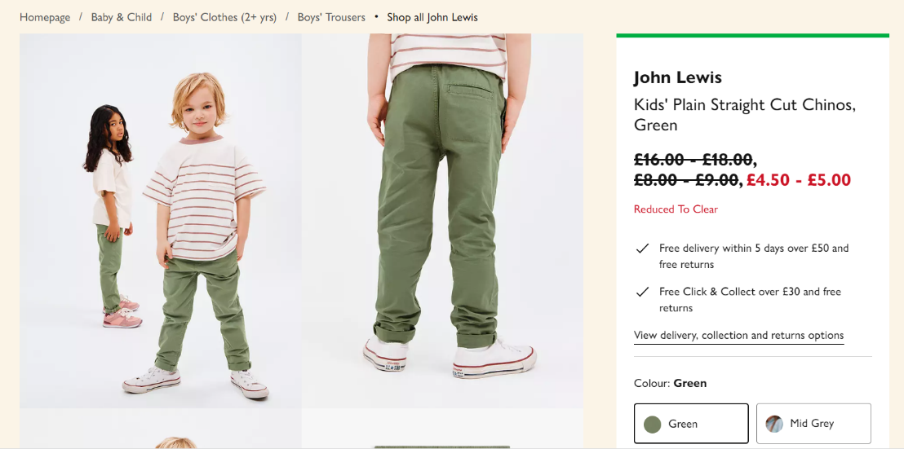 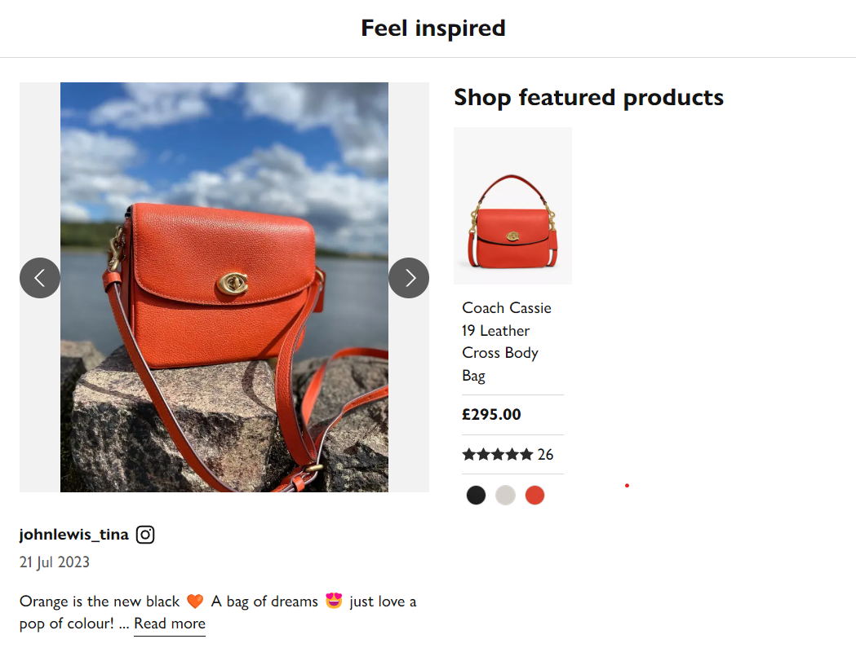
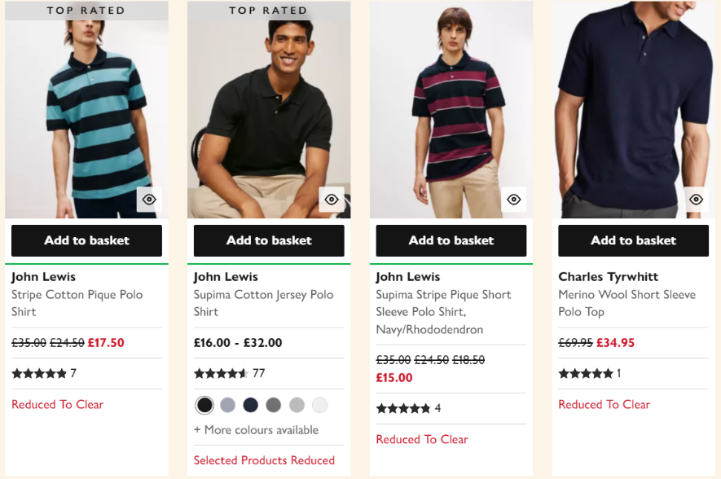

Place Strategy: The Company has different distribution channels so that customers should not face any problems in getting the products or their orders. John Lewis has a lot of exclusive retail stores. Their retail stores are the biggest evidence of the retail brand. It has various manufacturing plants and warehouses. The company also provides shopping benefits to its customers by being on various E-commerce platforms and also has provided them with a smart application for shopping of their own. The company has 50 stores in England and also has its store at Heathrow Airport. Some of its stores were closed permanently due to their poor performance during the time of COVID-19. The company John Lewis Partnership Plc delivers their products in a lot of countries (mba SKOOL, 2023).
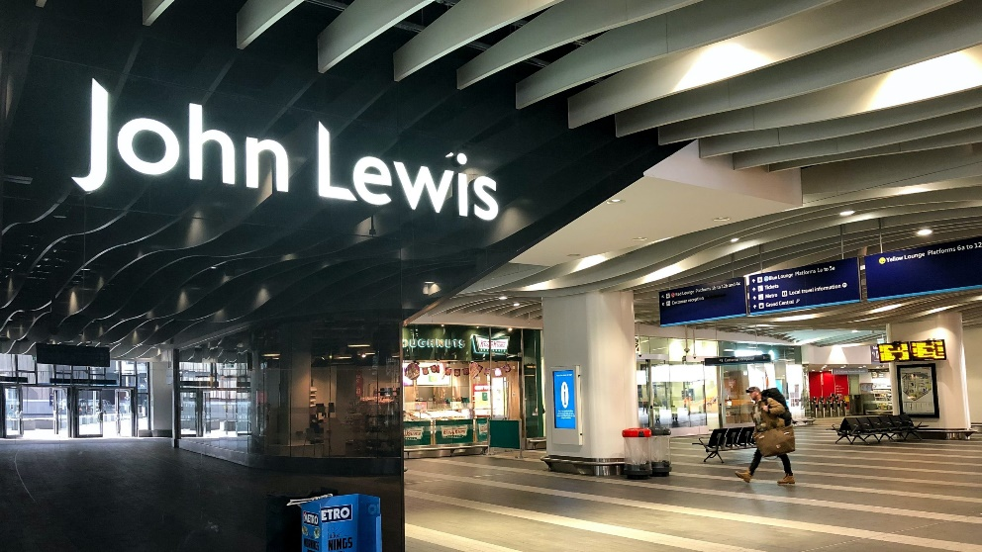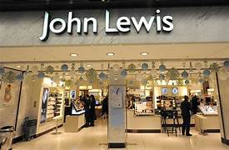
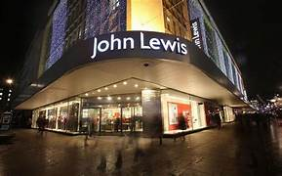
Promotion Strategy: The Company follows promotional strategies by making special advertisements and discounts on occasions and festivals during the year-end. Customers wait for the occasion of Christmas for mind-blowing and creative advertisements. They conduct Christmas campaigns for the past ten years like Buster the Boxer, The Bear and The Hare, The Journey, Monty the Penguin and The Long Wait. The company is advertising itself on the social media platforms like YouTube, Facebook, and Twitter. The company has also created awareness of the brand by sponsoring the Commonwealth Games (Ahmad, et al., 2015).
https://www.youtube.com/@johnlewisretail/about
https://instagram.com/johnlewis?igshid=NjIwNzIyMDk2Mg==
https://r.search.yahoo.com/_ylt=AwrKDgpmL8Fk6EYWtUy7HAx.;_ylu=Y29sbwNzZzMEcG9zAzEEdnRpZAMEc2VjA3Ny/RV=2/RE=1690410983/RO=10/RU=https%3a%2f%2fwww.johnlewis.com%2f/RK=2/RS=5ZGDxonpo0YICyRpBxaDuiv0msE-

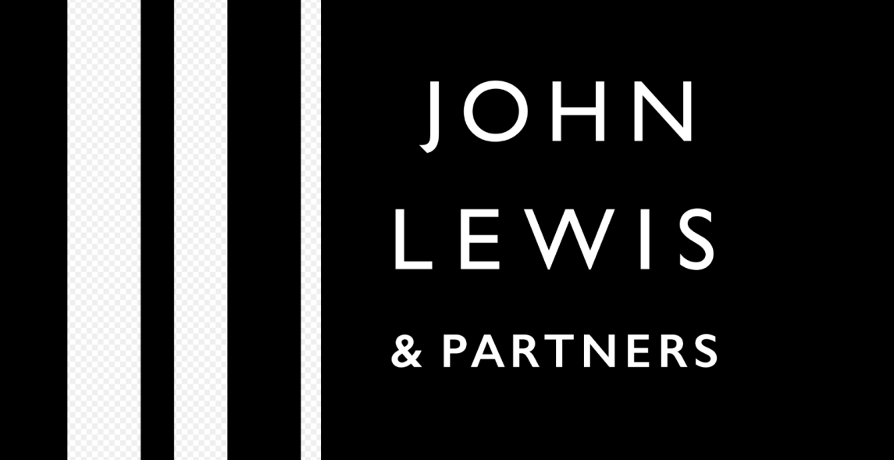
Figure 8: Logo of John Lewis Partnership Plc

References:
Ahmad, N., Salman, A., & Ashiq, R., 2015. The impact of social media on fashion industry: Empirical investigation from Karachiites. Journal of resources development and management, 7. Link: https://papers.ssrn.com/sol3/papers.cfm?abstract_id=2603275
Armstrong, C. M., Niinimäki, K., Kujala, S., Karell, E., & Lang, C., 2015. Sustainable product-service systems for clothing: exploring consumer perceptions of consumption alternatives in Finland. Journal of Cleaner production, 97, 30-39. Link: https://www.sciencedirect.com/science/article/abs/pii/S0959652614000596
ContactPigeon, 2023. John Lewis Omnichannel Strategy: How the UK’s top homeware retailer has reached the top. [ONLINE]. Available at: https://blog.contactpigeon.com/john-lewis-omnichannel-strategy/ [Accessed on 25 July 2023].
Fulgoni, G. M., Lipsman, A., & Davidsen, C., 2016. The power of political advertising: Lessons for practitioners: How data analytics, social media, and creative strategies shape US presidential election campaigns. Journal of Advertising Research, 56(3), 239-244. Link: https://www.journalofadvertisingresearch.com/content/56/3/239.short
Gajanova, L., Nadanyiova, M., & Moravcikova, D., 2019. The use of demographic and psychographic segmentation to creating marketing strategy of brand loyalty. Scientific annals of economics and business, 66(1), 65-84. Link: https://www.ceeol.com/search/article-detail?id=874471
Itani, O. S., Kassar, A. N., & Loureiro, S. M. C., 2019. Value get, value give: The relationships among perceived value, relationship quality, customer engagement, and value consciousness. International Journal of Hospitality Management, 80, 78-90. Link: https://www.sciencedirect.com/science/article/abs/pii/S027843191830269X
John Lewis.com., 2023. JOHN LEWIS & PARTNERS. [ONLINE]. Available at: https://www.johnlewis.com/ [Accessed on 25 July 2023].
Karell, E., & Niinimäki, K., 2020. A mixed-method study of design practices and designers’ roles in sustainable-minded clothing companies. Sustainability, 12(11), 4680. Link: https://www.mdpi.com/2071-1050/12/11/4680
Mba SKOOL., 2023. John Lewis Marketing Strategy & Marketing Mix (4Ps). [ONLINE]. Available at: https://www.mbaskool.com/marketing-mix/services/17590-john-lewis.html#product [Accessed on 25 July 2023].
Menon, R. V., Sigurdsson, V., Larsen, N. M., Fagerstrøm, A., & Foxall, G. R., 2016. Consumer attention to price in social commerce: Eye tracking patterns in retail clothing. Journal of Business Research, 69(11), 5008-5013. Link: https://www.sciencedirect.com/science/article/pii/S0148296316302351
Robinson, P. K., & Hsieh, L., 2016. Reshoring: a strategic renewal of luxury clothing supply chains. Operations Management Research, 9, 89-101. Link: https://link.springer.com/article/10.1007/s12063-016-0116-x
Salaman, G., & Storey, J., 2016. A better way of doing business?: Lessons from the John Lewis Partnership. Oxford University Press. Link: https://books.google.co.in/books?hl=en&lr=&id=kHnADAAAQBAJ&oi=fnd&pg=PT24&dq=john+lewis+headquarter&ots=wO6Epel15h&sig=4V9vegUX3UGESh5KOJtHYbwaNjE&redir_esc=y#v=onepage&q=john%20lewis%20headquarter&f=false
Statista., 2023. Number of John Lewis stores in the United Kingdom (UK) from 2009 to 2023. [ONLINE]. Available at: https://www.statista.com/statistics/420238/john-lewis-store-numbers-united-kingdom-uk/ [Accessed on 25 July 2023].
Verbeke, A., Coeurderoy, R., & Matt, T., 2018. The future of international business research on corporate globalization that never was…. Journal of International Business Studies, 49, 1101-1112. Link: https://link.springer.com/article/10.1057/s41267-018-0192-2

