Certificate of Higher Education in Business Skills for the Workplace

Academic Skills
LCLM 4001

Task 3 - Reflective Report

Student Name – Zaffar Hussain
Student ID – 2436275

Contents
Introduction 2
Description of Experiences 3
Analysis and Personal Reflection 4
Feelings 4
Evaluation 4
Analysis 4
Strengths and Areas for Improvement 5
Personal Growth 6
Conclusion 6
References: 7

Introduction
This reflective report set out to reflect and discuss the process of my learning with Academic Skills module that is a component of the Certificate of Higher Education in Business Skills of the Workplace programme. This report is designed to help me critically summarize my practice and growth experience and favour a systematic description of my issues by applying Gibbs Reflective Cycle (1988). I will consider some important aspects of the courses, related to Task 1 (Academic Skills Quiz), Task 2 (Academic Writing Exercise), and other activities and discussions in the classroom. Those assisted me to build the main academic skills like time management, referencing, note-taking, paraphrasing, and critical thinking.

Description of Experiences
One of the most important parts of the module was Task 1, the Academic Skills Quiz, which took place in Week 5. This quiz tested our understanding of essential academic principles, including plagiarism, referencing styles, time management techniques, academic misconduct, and notetaking methods. It was an eye-opener for me, as I realised I had some misconceptions about what constituted plagiarism and how to reference properly using the Harvard style.
Task 2, held in Week 7, required us to take notes from a given academic passage, paraphrase selected sentences, and compose a short academic paragraph. This was one of the most practical and demanding exercises, as it tested our ability to process information quickly and reproduce it accurately within the constraints of academic writing conventions (Dharmasaroja, 2024).
In addition to these tasks, several class activities and group discussions contributed significantly to my learning. One session on time management involved creating our weekly planners and discussing different strategies like the Eisenhower Matrix and Pomodoro Technique.
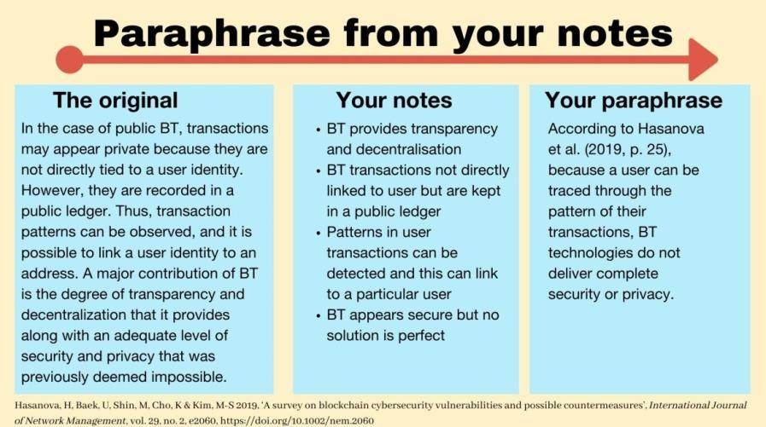
Source: Dharmasaroja, 2024).

Analysis and Personal Reflection

Feelings
At the beginning of the module, I felt overwhelmed by the academic expectations. Although I was excited to start the programme, I was also nervous because I lacked confidence in my academic writing and had very little experience with formal referencing or critical reading. I was particularly anxious about whether I would be able to keep up with others in the class who seemed more experienced. However, as the weeks progressed, I began to feel more at ease, especially after completing the first quiz and receiving support from my lecturers and peers. By engaging with the materials and participating in class activities, my confidence slowly grew.

Evaluation
Some elements of the module were very successful for me. I found that I was good at time management and organisation, which helped me to complete readings and tasks before class. The Academic Skills Quiz (Task 1) showed that I had a solid understanding of time management and referencing formats, even though I needed to revise some areas (Dharmasaroja, 2024).
However, there were also areas where I struggled. Task 2, for example, was difficult because paraphrasing under time pressure was not something I was used to. I often found myself too focused on changing words rather than fully understanding the meaning of the original sentence.
In addition, my academic paragraph lacked structure in the first draft.

Analysis
These experiences helped me understand that academic skills are not simply about memorising rules but about applying critical thinking and self-awareness. Task 1 helped me identify gaps in my knowledge, particularly around plagiarism and academic misconduct. To my surprise, I learnt that unintentional plagiarism is possible with the utter ease and why it is so vital to ensure that the most accurate paraphrase and sources can be appended (BÃ¡rbara, OrfanÃ³ and Wingate, 2020).
The impact of task 2 was even higher. The taking note exercise and the paraphrasing exercise demonstrated to me the significance of understanding of academic writing. I learned that effective paraphrasing involves fully understanding the text and expressing it in my academic voice. The process also taught me how to structure a paragraph around a clear central idea with supporting evidence, rather than simply combining unrelated facts.
The classroom activities on time management were also especially useful. Through the weekly planner activity, I realised I was underestimating how much time tasks would take. I began using the Pomodoro Technique, which was introduced during one of the class discussions, and it helped me stay focused and reduce procrastination. Implementing this technique significantly improved my productivity, especially while preparing for Task 2.

Strengths and Areas for Improvement
A key strength I discovered was my capability to stay organised and manage time effectively. I always attended class, completed readings beforehand, and took clear notes during lectures. I also showed strong listening skills and participated in discussions, which helped reinforce my learning (Ahmadpour, Shariati and Moghadam, 2025).
However, I still need to improve my academic writing, especially in terms of clarity and structure. Sometimes I tend to use informal language or include unnecessary details, which affects the overall quality of my writing. I also recognise that I essential to further develop my critical thinking. While I can summarise sources effectively, I struggle to evaluate arguments critically or identify weaknesses in the evidence provided.

Personal Growth
Overall, this module has played a key role in my personal growth. I now feel more self-assured in tackling academic assignments and know the importance of planning, research, and critical reflection. I’ve also become more independent in my learning and more comfortable with asking questions and seeking feedback. These changes have improved my self-esteem and motivated me to keep developing my academic abilities. I now view learning as a continuous process and understand the value of reflection in helping me grow (Bárbara, Orfanò and Wingate, 2020).
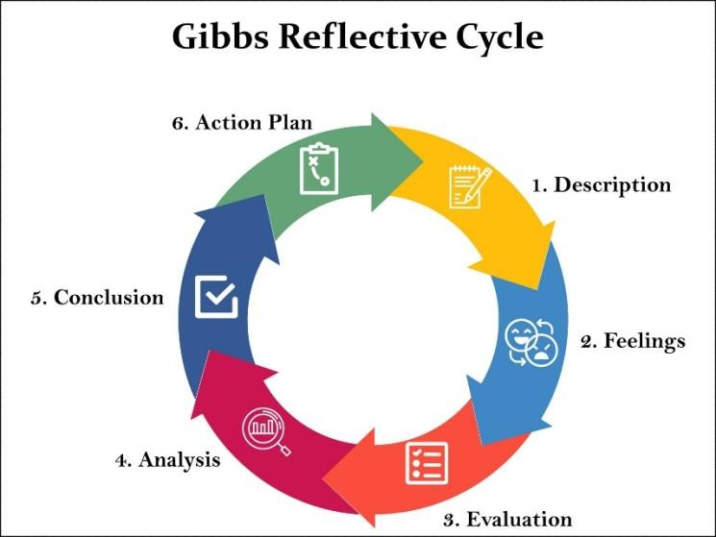
Source: (Bárbara, Orfanò and Wingate, 2020).

Conclusion
In deduction, the Academic Skills module has significantly influenced my development as a learner. Using Gibbs' Reflective Cycle, I have examined the key experiences that shaped my academic journey, particularly through Task 1, Task 2, and various class activities. I have become more aware of both my strengths, such as time management and active participation and my areas for improvement, especially academic writing and critical thinking. The feedback I received and the strategies I have learned, like the Pomodoro Technique and structured note-taking, have given me practical tools for success. Overall, this module has been a turning point in helping me transition into higher education with more confidence, responsibility, and motivation.

References:
Ahmadpour, N., Shariati, A. and Moghadam, M.P. (2025). Effect of narrative writing based on
Gibbs’ Reflective Model on the empathy and communication skills of nursing students. BMC Medical Education, 25(1), pp.1–9.
Bárbara, M., Orfanò and Wingate, U. (2020). Vol. 12(1)(2024): 118-135. [online] doi:https://doi.org/10.18485/esptoday.2024.12.1.6.
Dharmasaroja, P. (2024). Empowering Reflection and Reflective Writing in Medical Education.
Ramathibodi Medical Journal, [online] 47(2), pp.57–69. doi:https://doi.org/10.33165/rmj.2024.47.2.267231.

