Aminal Domestication a species example: Samoyed
Most dogs have been manipulated in very recent times and may bear little resemblance to their immediate forbears. These, dogs traditionally live in Siberia with hunter-fisher groups known as Samoyeds, hence the breed name. The Samoyed people used the dogs to pull their sleds, guard their property, for herding reindeer and keeping warm. The dogs sleep with people to keep them warm. Captain Robert Scott, an explorer brought the dogs to England in 1889. It was in England that Queen Alexandria, who loved these creatures, led to the breed being further developed or ‘improved’ and from there they spread throughout the rest of the world.
Their gene pool is closely related to the herder type dogs and some wolf-type dogs. Work on these dogs show that early similar forms – such at Botai, a Chalcolithic site in Kasikstan, can be used for pulling, sledding, carrying, hunting and ritual, possibly although if it is ritual is not fixed, uniform ritual being undertaken. Complete dogs or part of dogs are placed in foundations of buildings – domestic ones, in threshold, and in burials. Demonstrates a close interaction. Take a look at this one, a modern day form and then the image below.
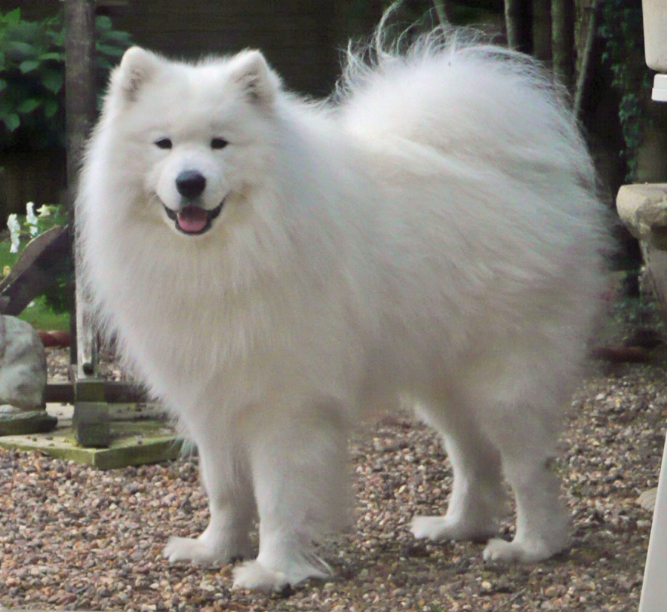 This shows the Samoyed breed, above, modern and after ‘improvement’, below ethno-historical image showing a nearer the original for. Look carefully at the differences, a lot less hairy, lighter framed and longer legged. Why were these features important to them and not us or Queen Alexandria and the Victorians? Think about the need to move through deep snow….Also note the flatter face, shorter and broader muzzle, why may these have changed over time?


