BLOGS – CYFLE I DYFU
Cyfle I Dyfu are holding a fantastic Xmas Stall on the Uplands Market for the Xmas display on the 16th of December with great ideas for Xmas gifts for all your nearest and dearest. The organisation have skilled individuals who are making all sorts of furniture ranging from outside benches, indoor furniture i.e. tables and chairs and crafted wood pieces that are great gifts for anyone who loves bespoke furniture. They hold their stalls all year through, the individuals who work for this project are taught carpentry skills and then display all their work on the stalls and sell their furniture, on a nonprofit basis. They are aiming to raise awareness for the project that are helping marginalized individuals who are looking to get into work but have not been offered the chance that other individuals are given. Through the Xmas period they are holding their stalls through a variety of different locations including Swansea, Carmarthenshire and Cardiff. I will be adding the venues that Cyfle I Dyfu will be holding their stalls over the Xmas Period. The next one will be in Swansea Uplands Market on the 16th of December between 9am and 1pm. They have a great display of all the beautiful products that are all created and designed by the organisation. The next event will be held on the 25th of February where they will start with new furniture and great new ideas for the organisation. They will be stall number 71 on the Uplands Market on the 16th of December so don’t miss out on the great products that are on offer with Cyfle I Dyfu.
By Jacky Robson
Cyfle I Dyfu is a social enterprise that creates different types of furniture and accessories for the home all made from wood that is made from scratch. All these products can be suitable for gifts as well as just furnishings for the house.
- Benches
Wooden benches are nice for the garden or a conservatory this kind of seating both ascetically pleasing and of high quality, making it ideal for any home this product will be a nice piece in livening up the home and will make your neighbors jealous or accommodates space and welcomes guests.

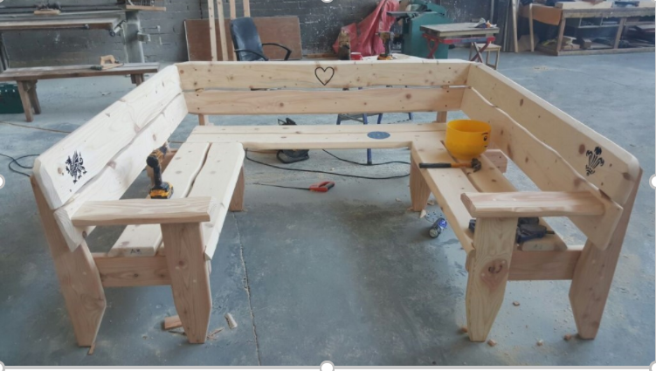
- picnic sets
Picnic sets are ideal for you to have wonderful meal out in the sun they add so much more dining spaces. Perfect for when you have a nice meal planned and you need some fresh air and to feel the sun on your face. This set Is a great piece for your outdoor dining meal.

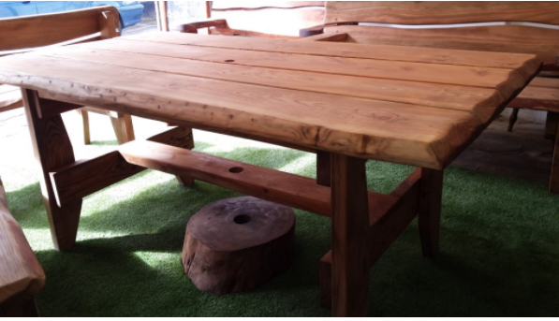
3. chopping boards
Chopping boards one of the most commonly used in the kitchen, used to prevent scratches and damage to your surfaces these very novelty items can be customized and have different engravings making them more personal. This can be a lovely addition to your cooking station and as a general piece of decoration.

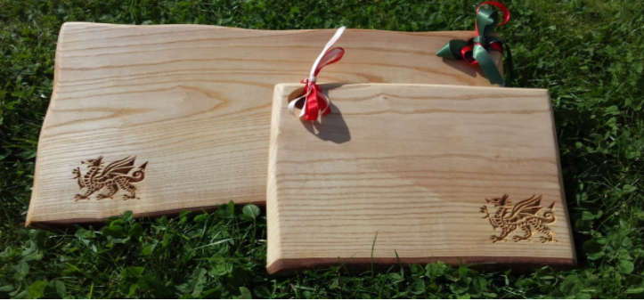
- .serving platters
serving platters ideal for cheese and meat lovers and with Christmas coming up platters all round. This board is ideal for parties and gathering where you can have a few of your closest friends and family around for a nice platter with a hint of Christmas chatter.

- bespoke items
At number one is the more novelty and personalised items such as a Dr who engraved decoration or some other bespoke items such as a board for you gin and tonic and maybe a display block for your favorite bottled beverage all these can be tailored and personalised to you making it a ideal option for a Christmas gift.
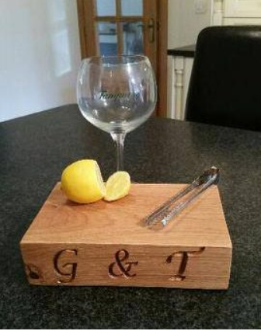
written by Cameron Borkett

Place where you don’t just get help but meet a new family
We have all heard of different rehabs and how they help people, they do no doubt. The place I want to talk about in this blog is Cyfle I Dyfu, which means ‘chance to grow’. Cyfle I Dyfu is a social enterprise that helps a whole range of people, whereas most of these enterprises tend to focus on a particular demographic.
Let me take you through what they do. The organisation specialises in making furniture, using traditional carpentry. These skills are taught to mainly people who are trying to find their way after they leave the prison system, however Cyfle I Dyfu is not limited to helping those from prison but also those with learning disabilities. The key vision of this organisation is to help those who are marginalised to back into work and giving them the tools to do so, which is fantastic.
Cyfle I Dyfu is run by the founder Andrew, who himself was marginalized, after realising he could not access the help he needed. Andrew embarked on this journey, which would go to help many across south wales. Cyfle I Dyfu is based in Swansea, a small but tight nit city. All the wood is sourced locally, making this more of a community project. The money generated by the furniture sold, is put back into the business and helps fund future projects.
Although Cyfle I Dyfu is self-sustaining, they could still use your help. You could get involved by following them on Facebook, twitter or pop into their store. Below I will add their contact details. Great organisation to be part off and gives value to all those who are involved with the project.
Facebook: Cyfle I Dyfu/ chance to grow
Twitter: @cyfle_i_dyfu
Web: www.cyfleidyfu.co.uk
blog by: Siyabonga Konze
URL-http://cyfle-i-dyfu.co.uk/where-to-find-us
Every year Cyfle I Dyfu set out stores in the town centre of Swansea where they place samples of their wooden products for the members of public to see while they are passing by doing their Christmas shopping.
At the first day of November the stalls open in the centre of the town, a big plaza covered made into small shops, surrounded my creameries, restaurants and all different kinds of souvenir shops
Our products are great gifts for family and friends, especially around the festive period. Customers queue to buy our products which range from the smallest gift ideas such as wooden engraved key rings and kitchen utensils, to our larger products such as tables and chairs for the use of your own home.
In the festive season a wide range of wooden products are given at lower prices to attract in more customers coming in as well as getting more into the products.
During the festive season each of the products are changed around every few days so that the members of public get to see the wide selection of wooden products that Cycle I Dyfu supply.
Cyfle I Dyfu have all different ranges of customers from the younger generation to the older generation.as you can see from the picture above the volunteers are explaining to the members of public all the information they need to find out about the wooden products they supply as well how much longer they last compared to normal.
CYFLE I DYFU
NASIR AHMED
P150345

LOVEXMASSTALS
Cyfle I Dyfu organisation - https://lovexmasstalls.wordpress.com
Through our organisation, we are raising awareness for our project Cyfle I Dyfu through the Christmas stalls and gift ideas they have done, and as it is Christmas time we decided to get people excited about great gift ideas for the upcoming festivities and to also advertise where our project will be displaying their Christmas gift ideas. The organisation are holding an event on the 16th of December, so we have blogged about the upcoming event and decided to add extra stalls up to that period also including some information on the project itself. Along with letting the public know what is up and coming we also decided to let people know what great crafted products our project make and to raise awareness of what our project are aiming to do and why they have created this project. We have shared this on our own personal Facebook pages, as well as sharing it with our fellow student pupils, by doing this we are hoping that people will gain more awareness about the Cyfle I Dyfu organisation and what they stand for, which is simply to give people a second chance in life.
Our group members include Jacky – Team Leader, Cameron – Team Leader, Nas, Joy and Siya as team workers helping with all different aspects of advertising for the organisation. Unfortunately, due to a few members of the group living outside of Swansea, it has proved difficult to meet up and group our ideas. Instead we have set a what’s app group up, where we can communicate and help each other whenever it is needed. Jacky and Cameron decided to do the Christmas stalls idea because we believe Christmas is a time of giving and what better way to get everyone excited about the products that our project create and to try encourage people to support individuals when they need it most, and to raise awareness when people are looking for inspiration in the Christmas period. Siya, has decided to blog about the project so that people have more of an understanding on why we are blogging about this organisation. It shows who the organisation are and why they are helping marginalized individuals.
Unfortunately, we were not able to meet the deadlines of our content plans, but we believe that we have still achieved what we have set out to do.
We are looking at volunteering on the stalls monthly. We are waiting for confirmation from the organisations leader named Andrew. He will be engaging with us as soon as he has availability.
More on why we have made the choices on our blogs and how we have managed to advertise for the organisation, we have all decided to use WordPress as it was easily accessible and one of the most popular blogging platforms. It was also used by fellow students and we found this was easier to connect and communicate with our piers.
Contents from Jacky
Jacky has started this essay off and Cameron, Siya and Nas have added their contents onto this essay and everyone has set up blogs.
Contents from Siya
This is a content page of the blog, giving an insight into the blog. Cyfle I Dyfu Christmas special and rehab with a twist, both blogs were written with the aim of promoting Cyfle I Dyfu. The first blog ‘Cyfle I Dyfu Christmas special’ is written about the furniture as well as the gifts available at Cyfle I Dyfu. The blog was intended make the most of Cyfle I Dyfu’s selling point of making personalised gifts. The blog was highlights this throughout.
The other blog, ‘rehab with a twist’ highlight the type of people the organisation helps. This centres on the type of skills people learn from Cyfle I Dyfu, which is traditional carpentry. The sub heading of the blog is ‘a place where you don’t just get help but meet a new family’ this is one of the main characteristics of Cyfle I Dyfu and helping marginalised people get back into work. The organisation states ‘to enable and empower marginalised people’ (Andrew, 2007). This epitomises the enterprise’s commitment to their philosophy of helping others.
Contents from Cameron
The reason I chose the top 5s for my blogs is because of the popularity of Top 10s top 50s over many years widely used with rating songs, movies, games and gifts so I thought I would have my own take on things, so I rated the products of Cyfle I Dyfu as they make some amazing things and that why I also put them in my top 5 types of gifts as they fit in well. I will also try and promote the blog at my volunteer radio station in Neath port Talbot, Radio phoenix this should help spread awareness and invite people to look in to the blogs.
I believe that making these blogs as a group helps with the AIDA model developed by St. Elmo Lewis AIDA is:
Awareness
Interest
Desire
Action
“E. St. Elmo Lewis developed a practical sales tool using the latest Scientific Management insights” (Lewis, 1898)
By advertising on our blogs, we have created an awareness on Cyfle I Dyfu by explaining what they do. Then going in to detail on their background could cause an interest as people will be more engaged if they know the ins and outs and personal and relatable aspects of the business. Desire by describing the different markets going on we hoped our blogs have created a desire for people to check the market out.
In the blog I have written about the Christmas stalls for Cyfle I Dyfu which were set out in the town centre of Swansea with a wide selection of the wooden products such as furniture to kitchen utensils
Contents from Nas
As group we decided to make a what’s-app group conversation so that we could get in touch much more easily and if we had any group discussion we could discuss the matter on the group as well as get everyone opinions
As a group we all set different kinds of tasks for each other so that everyone had a different role and they knew what they were doing. All the tasks were set out so that everyone had a specific part to do so we all knew what we were aiming to achieve within our blog posts.
My Experience
These past few months me and my team have been working together as a team to form an awareness for a company known as Cyfle I Dyfu which sold various types of wooden products.
At the start we didn't really know much about the Cyfle I Dyfu organization and to be honest it wasn't really an easy topic to do, reason is that it is a small company and there were limitations to what they do and what involvement we can have.
What We Have Done So Far
We have created a blogger to upload all our blogs which our team members themselves did so that we get a different view from every person as well as set up a twitter account uploading tweets about our Cyfle I Dyfu’s products and when our event time tables so that the people who are interested in these kinds of events can come and join.
As a group we have managed to use AIDA as a format for advertising which has been discussed previously by Cameron. I believe we have all used the marketing mix that is expected in the promotion of a company, organisation or promotion of products. We have not unfortunately had much communication from the organisation themselves as this is a busy period for them, but all feel we have managed to raise some awareness for them and promote what products they sell and why. We as a group have managed to pull together and achieve promotion for the organisation.
(Cordita, 2011)

References
(Andrew, 2011)
(Cordita, 2011)
(Lewis, 1898)

