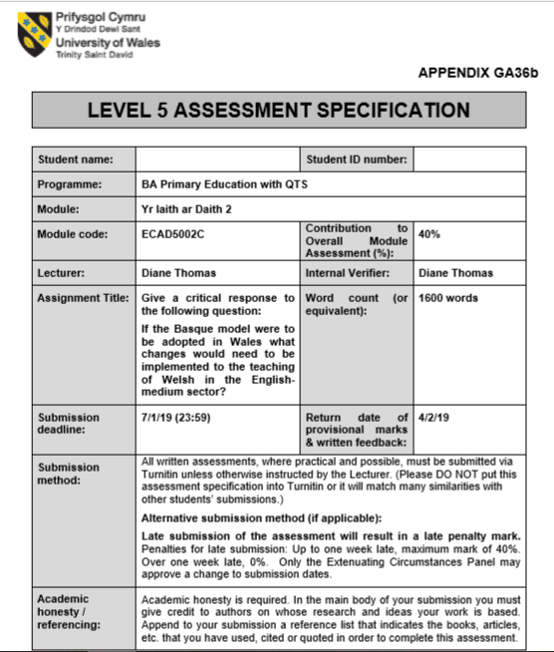
1700921
Corrie Jeremiah
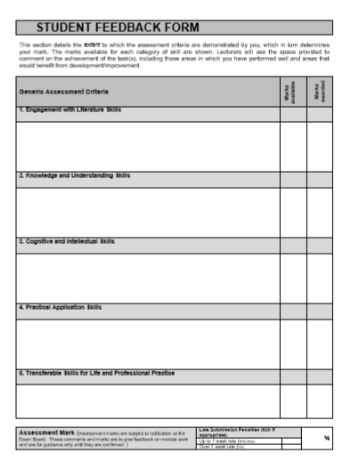
Give a critical response to the following question: If the Basque model were to be adopted in Wales what changes would need to be implemented to the teaching of Welsh in the English-medium sector?
The use of language is of extreme importance to each individual person as it impacts their lives daily despite their race, creed, and region of the world in which they live. However, language is more than merely a means of communication, it is also a tool which is able to convey traditions and values which can be related to a group’s identity. The use of language can help to forge friendships, cultural ties, and economic relationships. Yet, there isn’t a sole language which is used universally in each and every country. Collectively there is a total of around 7,000 living languages which are used worldwide, therefore it is not uncommon that around about 56% (ilanguages.org, 2018) of the world’s population have learnt and have even become fluent in more than one language. In fact, being bilingual or even multilingual is encouraged as it harbours many benefits not only for educational or career aspects but also for cognitive development. Within the European Union there are a total of twenty-three languages which are recognised, and just over half of these Europeans (around about 54%) are able to hold a conversation in at least one additional language whilst only a quarter are able to speak at least two additional languages. This shows that despite benefits that being both bilingual and multilingual brings there aren’t many countries that are successful in implementing it. However, the ‘An overview of the assessment of language proficiency in a sample of bilingual jurisdictions’ document looks specifically at how languages are presented in the education systems of several different countries, the country of Basque being one of them.
The country of Basque is located in the western Pyrenees which happens to straddle the border between both France and Spain on the Atlantic coast. In total, there are seven provinces that make up the country of Basque; four of which are located in Spain and the other three are located in France. Although the Basque Country does overlap both countries it is the Spanish side that’s most recognisable as being ‘Basque’, therefore the majority of the nation either speak Spanish or Basque. The education system in the Basque country has been praised for its ‘excellent’ results and it has been deemed as being a ‘model to follow in Europe’. It is well known that the Basque government have invested heavily in education over the last few years and that they have been successful in creating a strong sense identity as well encouraging ambition amongst their learners. It would prove interesting and even beneficial to examine their educational system and compare it to that which we have here in Wales.
The education system in Basque is somewhat similar to that which we have in Wales. Both educational systems guarantee the provision of compulsory education free of charge to pupils up to the age of 16 regardless of the difference in age upon entrance to compulsory education. Both systems also appear to be structured on the same three levels: the first being Primary which instructs pupils up to the age of 12, the second being Secondary which instructs pupils up to the age of 16, and the third and final structure being Further Education which is an optional route for pupils. The system in Basque is characterised by a bilingual system which happens to be the same for Wales, however, whereas the country of Basque learn both the language of Basque and Spanish which happen to be their two official languages, in Wales we learn the languages of Welsh and English. However, despite the few similarities that exist between the two education systems there are some rather noticeable differences. The main difference being that whilst many of the schools in Wales are split between being Welsh-medium or English-medium, the schools in Basque are categorised as being either A-model, B-model or D-model. A-model which is the tuition through the medium of Spanish with Basque being taught a total of three hours a week has become an unpopular option amongst parents and pupils in Basque as the overall language transfer is deemed to be ‘unsatisfactory’ by the government. However, both B-model and D-model schools have proved to be more of a success in regard to the overall transfer of language. The B-model schools teach through the medium of both Basque and Spanish; on average only thirty to forty percent of the curriculum is taught through the medium of Basque and the pupils also receive tuition on Basque as a subject. However, schools that are categorised as being D-model schools appear to be most popular amongst the public, as pupils receive tuition through the medium of Basque with Spanish being a compulsory subject (Hopwood et al. 2018). In terms of the educational system in Wales, it appears that the Welsh-medium schools resemble the D-model schools in Basque whilst the English-medium schools resemble the A-model schools. Yet, as previously stated the A-model school is a categorisation which is losing support due to its failure to transfer the language skills needed to converse fluently in both languages, an issue which is currently being examined in Wales in regard to the use of Welsh as a second language.
Currently Welsh as a second language is a statutory subject in the National Curriculum in Wales. However, it is not a core subject, therefore it is often conceived as not being as important as subjects such as English or Mathematics which have been awarded the ‘core subject’ status. Recent Estyn reports have shown that the overall standard of Welsh, particularly as a second language, has fallen annually over the last several years. In fact, achieving a low attainment in Welsh second language is not surprising, it is even considered by the public as being the ‘norm’. If this were the case for subjects that are deemed as being of more importance such as English or Mathematics then the government would put every effort into adjusting and adapting the curriculum in order to see better progress and results whilst undoubtably ensuing a ‘revolution’ (One language for all, 2015, p.1). It should be a major cause for concern that very few of the pupils who attend an English-medium school in Wales make good progress towards becoming a fluent Welsh speaker. Welsh is the national language of Wales and it is taught to each pupil who attends school in Wales from the moment they enter the Foundation Phase at five years old, therefore, it is extremely worrying that despite all the time and effort that is dedicated to learning the language there is still an alarmingly low number of individuals who feel as if they can converse fluently and confidently in Welsh.
From examining the education system in Basque, it could prove to be beneficial to further research and perhaps even implement some of their educational strategies here in Wales. Strategies such as promoting the benefits of becoming a B-model categorised school as it would encourage the use of both Welsh and English in the day to day lives of pupils. It has been stated that schools across Europe aren’t providing pupils with the language skills that are needed in order to converse both confidently and fluently in a language which is not their mother tongue. It appears that the focus in most education systems across Europe remains on aspects that are either deemed by the pupils as being too difficult or not of any use to them which can negatively affect their motivation and attitude towards learning languages. However, it is important to acknowledge that since the publication of reports such as ‘Successful Futures’ (Donaldson, 2015) and ‘Cymraeg 2050’ (2017) the Welsh government have taken steps to ensure that the Welsh language has a future amongst the next generation. Professor Graham Donaldson proposes six ‘Areas of Learning and Experience’ in the ‘Successful Futures’ document (2015), one of which is ‘Languages, Literacy and Communication’. These three aspects are as different as they are similar, however, it is the plural of the noun ‘languages’ which creates a certain level of interest as it does not single out one particular language which therefore creates the idea that languages such as Welsh and English will no longer be viewed as being individual subjects in the curriculum of Wales in the future but instead will be viewed as being equals and hold equal status of importance in the curriculum as both are recognised as being the co-official languages of Wales.
To conclude, I believe that the Basque model includes some very interesting approaches to education. Their aim to ensure that pupils leave the education system able to adequately communicate bilingually in the two official languages of their country is something to be commended and adapted here in Wales. It is important the pupils are given the opportunity to become fluent and confident when speaking and conversing in both languages recognised as being of importance by the government. The B-model approach used in the Basque country isn’t very common in Wales, however, should it be adapted pupils would be given more of an opportunity to build on their language skills daily as they will constantly be in use as tuition would be received through the medium of both languages, therefore successfully encouraging the pupils to become bilingual. The fact that there are also no formal or external assessments to be taken by the pupils in the Basque country until they reach the age of eighteen also helps the pupils to achieve bilingual status as they are able to learn and focus on aspects of the language which they view is of use them, focusing on topics which they may use or encounter during a conversation instead of learning specific content for the sake of preparing them for upcoming tests and assessments. Furthermore, it is clear to see that Wales is on the right track to encouraging bilingualism, however, there is still more possibilities that they could explore in order to ensure that the pupils receive the best education possible whilst also maintaining a positive attitude towards it.

Total word count: 1,679.

References:
Coughlan, S. (June 2016). The Basque education system, a model to follow in Europe, according to the prestigious British network BBC NEWS. Available at: https://www.bizkaiatalent.eus/en/educacion-vasca-modelo-europa-bbc/. (Accessed on 2nd January 2019).
De Valoes, L. (February 2014). Importance of Language – Why Learning a Second Language is Important. Available at:https://www.trinitydc.edu/continuing-education/2014/02/26/importance-of-language-why-learning-a-second-language-is-important/. (Accessed on 3rd January 2019).
Donaldson, G. (February 2015). Successful Futures Independent Review of Curriculum and Assessment Arrangements in Wales. (Accessed on 4th January 2019).
Euskadi.net. (2008). Education. Available at: http://www.basquecountry.eus/t32-448/en/contenidos/noticia/educacion_08/en_educacio/educacion.html (Accessed on 4th January 2019).
Hopwood, M. et al. (March 2018). An overview of the assessment of language proficiency in a sample of bilingual jurisdictions. (Accessed on 3rd January 2019).
iLanguages.org. (2018). Multilingual People - Are you a polyglot? Available at:http://ilanguages.org/bilingual.php. (Accessed on 2nd January 2019).
Inlingua. (2018). Why Learning Multiple Languages Is Important. Available at: https://idc.edu/learning-multiple-languages-important/ (Accessed on 3rd January 2016).
Kilgour, D. (October 1999). The Importance of Language. Available at: http://www.david-kilgour.com/mp/sahla.htm. (Accessed on 2nd January 2019).
Sirbu, A. (2015). THE SIGNIFICANCE OF LANGUAGE AS A TOOL OF COMMUNICATION. Available at:https://www.anmb.ro/buletinstiintific/buletine/2015_Issue2/FCS/405-406.pdf. (Accessed on 2nd January 2019).
The Telegraph. (December 2018). Why learn a foreign language? Benefits of bilingualism. Available at: https://www.telegraph.co.uk/education/educationopinion/10126883/Why-learn-a-foreign-language-Benefits-of-bilingualism.html. (Accessed on 3rd January 2019).
Unknown. (March 2017). The Basque Country – Is It Really A Country? Available at: https://www.alternative-aquitaine.co.uk/blog/the-basque-country-is-it-really-a-country. (Accessed on 2nd January 2019).
Welsh Government. (2017). Cymraeg 2050: A million Welsh speakers. (Accessed on 5th January 2019).
Welsh Government. (September 2013). One language for all. Review of Welsh second language at Key Stages 3 and 4. (Accessed on 5th January 2019).

