MODULE CODE: BMIH4003

ASSIGMENT 1

Title: The Role &Importance of Hospitality & Guest Services within the Hotel Industry

Student Id: 2234899
Student name: Nina Sokhan Kalashnikova

Lecturer name: Charlotte Joyner

Slide-1
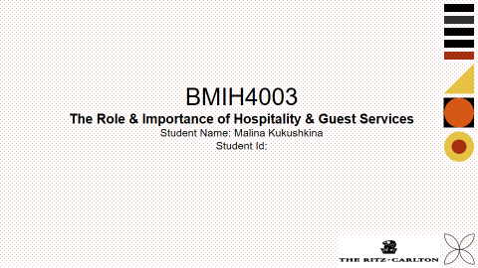
Slide-02
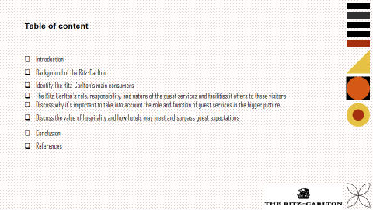

Slide-03
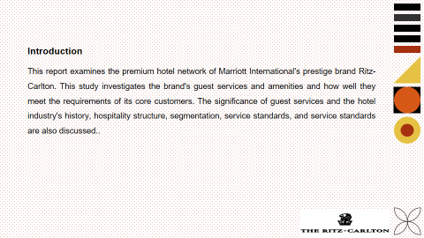

Introduction
This report analyzes Marriott International's luxury brand Ritz-Carlton’s premium hotel network. This research examines the brand's guest services and amenities and how it meets its core customers' needs. It also discusses the hotel industry's history, hospitality structure, segmentation, service standards, and guest services' importance. Because it knows these things, the Ritz-Carlton can create excellent experiences, exceed guest expectations, and remain a leader in premium hospitality.

Slide-4
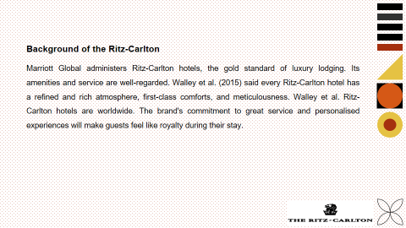

Background of the Ritz-Carlton
The Ritz-Carlton is a renowned luxury hotel brand under Marriott Global, known for its dazzling facilities and faultless service. With properties around the world, every Ritz-Carlton hotel offers a refined and rich climate, supplemented by first rate conveniences and scrupulousness (Walley et al., 2015). The brand's commitment to personalized experiences and legendary service ensures that guests feel truly pampered during their stay. From stunning locations to award-winning dining and spa facilities, The Ritz-Carlton epitomizes luxury and provides a memorable and indulgent experience for discerning travelers seeking the finest hospitality.

Slide-5
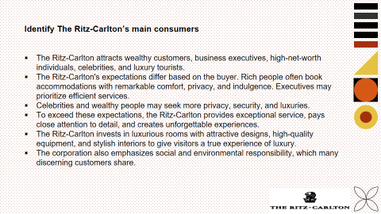

Identify The Ritz-Carlton’s main consumers
The Ritz-Carlton attracts wealthy customers, business executives, high-net-worth individuals, celebrities, and luxury tourists. These customers want luxury, personalized care, painstaking attention to detail, and unique experiences.
The Ritz-Carlton's expectations differ based on the buyer. Rich people often book accommodations with remarkable comfort, privacy, and indulgence. Executives may prioritize efficient services, modern meeting places, and uninterrupted connectivity. Celebrities and wealthy people may seek more privacy, security, and luxuries. Luxury travelers may want local activities, cultural insights, and personalized recommendations (Smith and Puczko, 2014)
To exceed these expectations, the Ritz-Carlton provides exceptional service, pays close attention to detail, and creates unforgettable experiences. Their "Ladies and Gentlemen" service attitude trains workers to anticipate and exceed guest needs. Staff learn visitor preferences to customize services.
The Ritz-Carlton invests in luxurious rooms with attractive designs, high-quality equipment, and stylish interiors to give visitors a true experience of luxury. They arrange exclusive meals, spa treatments, unique local tours, and special events for guests to make their stay memorable (Hayes anand Ninemeier, 2018)
The corporation also emphasizes social and environmental responsibility, which many discerning customers share. Eco-friendly methods, community involvement, and philanthropic giving can please socially concerned guests.
The Ritz-Carlton strives to create lifetime customers by providing excellent service, customized experiences, and exceeding expectations. This is the company's customer acquisition strategy.

Slide-6
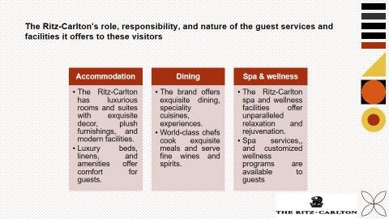

The Ritz-Carlton's role, responsibility, and nature of the guest services and facilities it offers to these visitors.
The Ritz-Carlton offers exceptional and outstanding guest services and facilities. These services and facilities include a wide range of options to satisfy their demanding customers.
Accommodations: The Ritz-Carlton has luxurious rooms and suites with exquisite decor, plush furnishings, and modern facilities. Luxury beds, linens, and amenities offer comfort for guests.
Dining: The brand offers exquisite dining, speciality cuisines, and innovative culinary experiences. World-class chefs cook exquisite meals and serve fine wines and spirits.
Spa and Wellness: The Ritz-Carlton spa and wellness facilities offer unparalleled relaxation and rejuvenation. Spa services, contemporary fitness centers, and customized wellness programs are available to guests (Kotler, Bowen, and Makens, 2013)

Slide-7
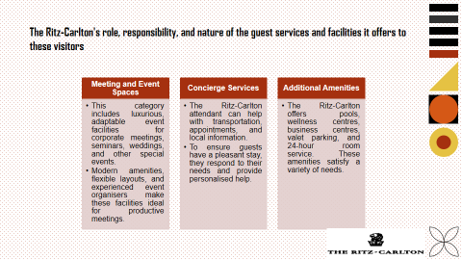
Meeting and Event Spaces: Elegant and adaptable event spaces are available for corporate gatherings, seminars, weddings, and other special occasions under this label. Modern amenities, flexible layout options, and expert event organizers make these venues ideal for productive meetings.
Concierge Services: The attendant at The Ritz-Carlton is accessible to assist with various arrangements, like transportation, appointments, and exhortations about the local area. They make a special effort to accommodate visitors' particular requirements and give individualized help for an issue free and brilliant stay (Kandampully, 2013)
Additional Amenities: The Ritz-Carlton offers a variety of extra conveniences, including pools, wellness focuses, business focuses, valet stopping, and 24-hour room administration, taking care of the different necessities of its visitors.
These guest services and facilities aim to give guests unique experiences, enhanced comfort, and a better stay. The Ritz-Carlton goes all out to give guests a sense of exclusivity, elegance, and luxury. This ensures that each client receives great service and enjoys a unique and unforgettable experience.

Slide-8
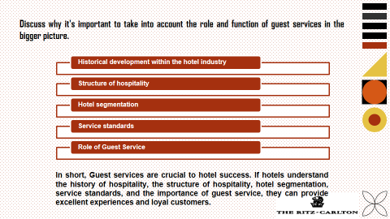

Discuss why it's important to take into account the role and function of guest services in the bigger picture
Guest services in hotels are vital to guest happiness, enjoyable experiences, and competitiveness. Guest services are important for several reasons:
- Historical development within the hotel industry: The hotel industry has evolved from simple lodging to complex businesses that offer a wide range of services. Guest services have become more crucial as hotels realize they need to deliver outstanding experiences to attract and retain guests (Pizam and Mansfeld, 2017).
- Structure of hospitality: Customers should always be prioritized and their requirements met. These underpin the hotel sector. Guest services involve personalized attention, anticipating guest preferences, and ensuring a problem-free stay.
- Hotel segmentation: Guest services are vital to providing experiences for specific guest categories because to the greater range of traveler tastes and market segmentation. Guest services customize their services for luxury travelers, business professionals, families, and adventurers (Pine and Gilmore, 2011)
- Service standards: The hotel's guest services department maintains brand service standards. They always treat customers well, which boosts the hotel's brand and reputation.
- Role of Guest Service: The hotel's guest service teams greet guests. They greet guests, answer queries, and make sure guests are satisfied with their stay. Guest service team coordinates with hotel departments to give customers a seamless and memorable experience (Dev and Olsen, 2018)

Slide-9
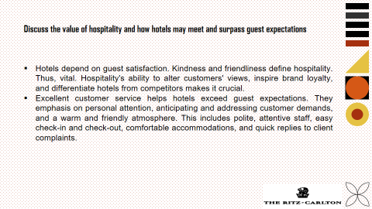

Discuss the value of hospitality and how hotels may meet and surpass guest expectations
Guest satisfaction is crucial to running a hotel. Hospitality is based on kindness and friendliness. Thus, it is crucial. Hospitality's ability to shape customers' attitudes, inspire brand loyalty, and set hotels apart from their competitors makes it vital (Xie, Zhang, and Zhang, 2017).
Hotels strive to exceed client expectations by delivering excellent customer service. They focus on giving each customer personalized attention, anticipating and meeting their needs, and providing a warm and welcoming atmosphere. This involves having friendly, responsive employees, simplified check-in and check-out operations, comfortable lodgings, and quick responses to customer complaints (Sigala and Robinson, 2018).

Slide-10
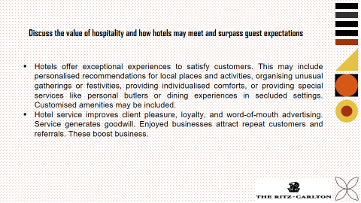
Hotels also provide unforgettable experiences to exceed clients' expectations. This may include tailored recommendations for local sites and activities, the organizing of unusual meetings or festivities, the supply of individualized comforts, or the delivery of special services like personal butlers or dining experiences in isolated settings. This may include a customized amenity package (O'Neill and Mattila, 2018)
Hotels that provide excellent service boost customer satisfaction, loyalty, and word-of-mouth advertising. Good service creates positive word-of-mouth. Visitors who enjoy a business are more likely to return and recommend it. These actions increase a business's clientele.

Slide-11
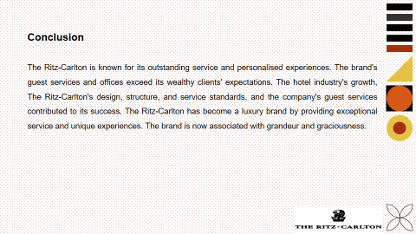

Conclusion
The Ritz-Carlton is the lead luxury hotel brand, known for its luxury, faultless assistance, and customized encounters. The brand's extraordinary guest services and offices surpass the expectations of its well-to-do customers. The Ritz-Carlton's prosperity can be credited to the hotel sector's authentic development, accommodation's design, structure, service standards, and guest services' significance. The Ritz-Carlton has become a luxury brand through providing excellent service and unforgettable experiences. This has made the brand associated with luxury and hospitality.

Slide-12
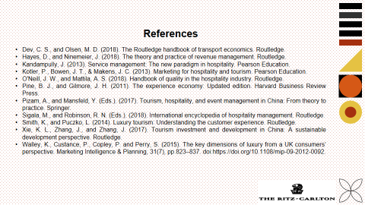

References
Dev, C. S., and Olsen, M. D. (2018). The Routledge handbook of transport economics. Routledge.
Hayes, D., and Ninemeier, J. (2018). The theory and practice of revenue management. Routledge.
Kandampully, J. (2013). Service management: The new paradigm in hospitality. Pearson Education.
Kotler, P., Bowen, J. T., & Makens, J. C. (2013). Marketing for hospitality and tourism. Pearson Education.
O'Neill, J. W., and Mattila, A. S. (2018). Handbook of quality in the hospitality industry. Routledge.
Pine, B. J., and Gilmore, J. H. (2011). The experience economy: Updated edition. Harvard Business Review Press.
Pizam, A., and Mansfeld, Y. (Eds.). (2017). Tourism, hospitality, and event management in China: From theory to practice. Springer.
Sigala, M., and Robinson, R. N. (Eds.). (2018). International encyclopedia of hospitality management. Routledge.
Smith, K., and Puczko, L. (2014). Luxury tourism: Understanding the customer experience. Routledge.
Xie, K. L., Zhang, J., and Zhang, J. (2017). Tourism investment and development in China: A sustainable development perspective. Routledge.
Walley, K., Custance, P., Copley, P. and Perry, S. (2015). The key dimensions of luxury from a UK consumers’ perspective. Marketing Intelligence & Planning, 31(7), pp.823–837. doi:https://doi.org/10.1108/mip-09-2012-0092.

