

MBA – Master of Business Administration
Human resource Management

LCMB7000

ASSIGNMENT 1

Student Name – Clerina Perara
Student ID - 2215774

Executive summary
The report focuses on the present conditions of the labour market in the UK. It provides a generalised overview of the UK labour market. Furthermore, the report attempts to analyse the current state of the UK labour market about the issues the labour market is facing in the present stage. It furthermore attempts to provide ways that may be implemented in mitigating the issues. Additionally, the report focuses on the impacts that Brexit and "covid-19" pandemic had on HR strategies, and how the changes that were brought about by the two formed differences in how HRM policies are viewed. In doing so, an analysis of the impacts has been made, and an attempt to mitigate the same has also been provided.

Table of Contents
1. Introduction 4
2. The present situation of the LM (Labour Market) in the UK 4
2.1 The labour market in the UK: A general overview 4
2.2 Analysis of the present condition of the LM 5
2.3 Issues associated with the labour market in the UK 5
2.4 Strategies to mitigate issues 6
3. The emerging changes in HR (Human Resourcing) Strategies in the post-Covid, post-Brexit external environment 8
3.1 HRM issues raised by the Pandemic 9
3.2 HRM issues raised by Brexit 9
3.3 Strategies to mitigate the issues 10
4. Conclusion 11
References 12

Table of Figures
Figure 1: The employment and unemployment rate in the UK labour market 4
Figure 2: Job vacancies in the UK from February to April 2022 6
Figure 3: Non-UK based workers in UK employment till 2021 7
Figure 4: Monthly GDP growth in the UK during Brexit announcement 9

1. Introduction
The term labour market, also referred to as the job market may be defined as the bridging of the supply and demand of labour, where the supply is initiated by the workers or employees, and the demand is generated by the organisation or the employer. Brexit has resulted in a skill shortage for numerous companies in the UK, EU supported hugely the development of the skills and technologies required for a UK-based organisation to grow. The labour market and its efficient function are crucial in developing the overall economy of the country and have close ties to a country’s finance, commodities and the service market at large. Furthermore, the UK has a tight labour market due to low employment rates and high vacancy levels. However, this has led to the development of certain issues in the current labour market of the UK. Additionally, this report other than looking into the LM of the UK would also assess the effects of Covid-19 and Brexit on the HR strategies in the UK. Nevertheless, it may be said the issue of the falling number of job vacancies has been somewhat mitigated by the lowering of unemployment rates. In comprehending the general overview of the UK labour market, an understanding needs to be drawn of the employment rates in the last five years. The employment rate of the UK in 2018 was “75.8%”, which increased to “76.5%” in 2019. All these have been well detailed and analysed in the entire report.

2. The present situation of the LM (Labour Market) in the UK

2.1 The labour market in the UK: A general overview
The LM in the UK has gone through drastic changes, especially after the advent of the worldwide pandemic. This has led to developments and changes in the ways which felicitate and make use of the labour market not just in the UK, but worldwide (Mayhew and Anand, 2020). However, there was a drop in employment in 2020, as the rate dropped to “74.6%”, which showed a gradual increase in 2021 with an employment rate of “75.5%”, The current employment rate in the UK, as of October 2022 is 75.6% (Statista, 2022). The pandemic harmed employment in the UK, as it lowered employment rates. This has directly affected the labour market of the UK, as employment directly affects the demand and supply of labour in the market.
The UK labour market, however, has risen from the setback that the pandemic and Brexit had resulted and is attempting to move forward. As of August to October 2022, the number of individuals who are “aged 16+” in employment was "32.77 million", with an employment rate of "75.6%" which is "0.2%" higher than the previous quarter (Researchbriefings.files.parliament.uk, 2022).
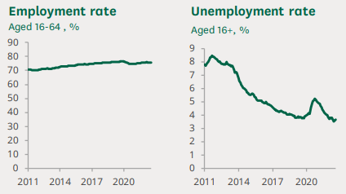

Figure 1: The employment and unemployment rate in the UK labour market
(Source: Researchbriefings.files.parliament.uk, 2022)

2.2 Analysis of the present condition of the LM
The current labour market in the UK has risen from the detrimental effects of the pandemic and Brexit and is attempting to turn around. However, the availability of a tight labour market has led to issues. As Li and Heath (2020) point out, the tightness in the labour market may be termed a causal factor in the development of minimum wages and has resulted in upward pressure towards inflation. The tight market may have put a certain pressure on the issues of inflation, but the tight market cannot be the main driving cause behind the same, as inflation has troubled the economy of countries worldwide and not just in the UK (Jones, 2022). The next section will focus on the issues of the current labour market and would find strategies to mitigate the same.

2.3 Issues associated with the labour market in the UK
There are a few pertaining issues beyond the effects of the pandemic and Brexit that still plague the UK Labour market. This includes the issue of the falling number of job vacancies. The total number of unique job postings in the UK for the term of August-September 2022 was "5.3 million", whereas in the previous year the number was "6.35 million" (Ons.gov.uk, 2022). This fall has been escorted by the other issues of inflation, increase in interest rates and energy and fuel prices. Furthermore, a survey reveals that "68% of SMEs and 86% of large organisations" are facing issues with skill shortages. The same survey has revealed that "72% of the organizations based in the UK have reported that skill shortage has resulted in increased workload among the existing employees, while “78%” of the organisations have reported decreased productivity, reduced output and profitability (Open.ac.uk, 2022). Furthermore, the issues of immigration and its effects on the labour market may be highlighted as part of the issues that pertain to the same.
Migration has been a standard issue in the UK, as more and more migrants attempt to seek refuge in the UK from Africa and abroad. There has been a rising demand that immigrants are taking away the jobs of UK-born citizens (Wadsworth, 2018). The “effects of immigration” on the LM usually depend on the skills of the immigrants and the existing workers and the attributes of the host economy (Migrationobservatory.ox.ac.uk, 2020). However, evidence suggests that there is a minimal impact of immigrants on the overall employment rate of UK-born citizens. Sirkeci et al. (2018) suggest the only way immigration affects employment in the UK labour market is if the immigrant has a higher education or knowledge of technical skills as compared to a UK-born employee. These three factors may be attributed to the issues that are faced by the current labour market in the UK.

2.4 Strategies to mitigate issues
The issues that have been highlighted require strategies that may be implemented in mitigating the issues. However, it may be noted that the issue of falling job vacancies has somewhat lowered in the past quarter of this year. The ONS (Office of National Statistics) reports that the unemployment rates in the UK have lowered in the past months since August, with the rate falling to 3.5%, which was previously 3.8% (Ons.gov.uk, 2022). Hence, it may be claimed that amid the falling number of job vacancies, the decrease in the unemployment rates has shown up as a strategy to mitigate the issue. On the other hand, this decline in the unemployment rates has also pointed out that there is a sharp rise in the number of working adults whom statisticians term as "economically inactive". Furthermore, the UK reports 1.2 million unemployed people in 2022, among which there was a growth of "economically inactive" individuals with a percentage of 21.7%, which rose by 0.6% in the past three months (Theguardian.com, 2022).
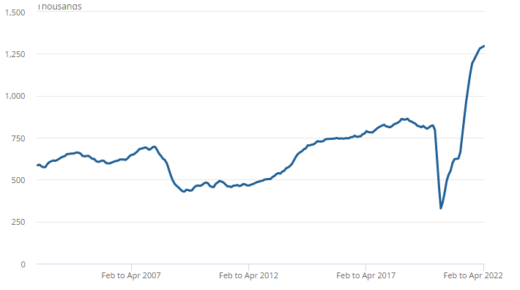

Figure 2: Job vacancies in the UK from February to April 2022
(Source: Ons.gov.uk, 2022)
The issue of skill shortage, however, is not an issue that may be mitigated that easily. A survey done on medium size businesses has reported that the current issue of skill shortage in the UK may pose a threat towards the growth of businesses (Oesch and Piccitto, 2019). Many organisations are evaluating their recruitment strategies given the issue that has risen. The Financial Times reported that "23% of the companies" are now moving away from hiring university or college graduates and preferring the recruitment of school pass outs (Financialtimes.com, 2022). This would result in the companies focusing on vocational training and developing the required skills that are best suited for the company’s needs, which would eventually lower the issues of skill shortage in the UK.
There is also a necessity to implement technologies that would aid in the development of skills. The other issue that needs mitigation is the effects of immigrants of the LM in the UK. In the third quarter of 2022, almost 72.5% of the total workforce in the UK was originating from outside Europe and the UK (Statista.com, 2022). However, the issues of immigration in the UK LM have a minimal effect on the employment of UK-born citizens.
The shortage of labour workers in the UK has given rise to the use of immigrants to replace them. The immigrants are also less demanding and more productive in aspect, which has led to the higher recruitment of immigrants in the UK LM (Edo, 2019). The only way the job encroaching of the immigrants may be countered is by increasing the skills of UK-based workers and having a standard pay scale in the organisations. This is added to the higher income they generate in the UK as compared to the income they would have received in their home country, making the jobs lucrative for the immigrants.
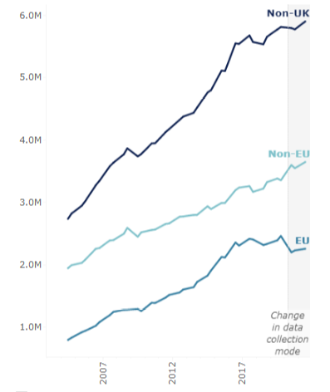

Figure 3: Non-UK based workers in UK employment till 2021
(Source: Migrationobservatory.ox.ac.uk, 2022)

3. The emerging changes in HR (Human Resourcing) Strategies in the post-Covid, post-Brexit external environment
The advent of the "Covid-19" pandemic and the implications of Brexit have forced organisations to review and redevelop their HRM strategies, in recent light of the changes these have brought in. It may be noted that while major industries and sectors reported a negative impact on their businesses, certain sectors including the health industry reported a positive impact of the pandemic (Hamouche, 2021). Brexit, on the other hand, closed the doors of the UK to the outer world, especially Europe. This has led to a fall in skilled workers and there is an acute case of skill shortage in the UK, as the European countries are not allowed to work with the ease they had when the UK was part of the EU (European Union). Furthermore, the implementation of Brexit has also led to changes in the country's legislation, which in turn has posed a challenge to the HRMs to change their organisational strategies to align them with the changing legislation (De Ville and Siles-Brügge, 2019). Hence, both the pandemic and Brexit had immense effects on the HRM strategies in the UK.

3.1 HRM issues raised by the Pandemic
The “Covid-19” pandemic had posed new challenges for the HRM to solve. This has led to the development of strategies that attempted to align with the changes that the pandemic brought. The pandemic forced the HRMs of organisations to form a defined policy for remote work, as most employees were doing WFH (Work from Home). This policy included the ways the team members were expected to communicate and be more productive towards the work they did in changed conditions (Butterick and Charlwood, 2021). Furthermore, the pandemic has also catalysed the usage of digitalisation in the workplace.
This digital transformation has also revised HR policies, as digital tools became more useful than ever due to the pandemic (Collings et al. 2021). Additionally, the pandemic also initiated more focus on employee well-being. Kalogiannidis, (2021) opinionated that the pandemic has helped in putting more focus on the employees' mental and physical well-being, aiding the organisations in realising how crucial it is for the further development of the company. This has led to a decrease in the productivity of the employees (Collings et al. 2021). Hence, there are differences in the way HRM was seeing pre-pandemic, and the way it is seen now, post-pandemic.

3.2 HRM issues raised by Brexit
Brexit has led to the development of new legislation in the UK. The HRM issues that Brexit has resulted in include the understanding of the new immigration system that has been implemented with the new legislation. The immigration system dictates that any non-UK individual seeking work in the UK would be required to comply with one of the immigration routes provided in the rules (Brown et al. 2019). Furthermore, the HRMs are also responsible for assisting their EU employees to achieve settled and pre-settled status. Furthermore, the chairman of Tesco PLC has urged the UK government to focus on building domestic chains and lower the dependence on global sources, after the implementation of Brexit (Export.org.uk, 2021). This came after the implementation of Brexit in the UK.
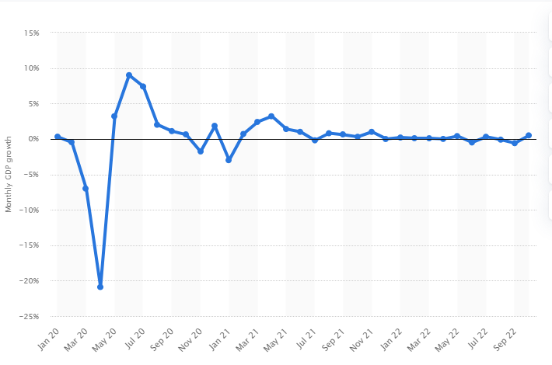

Figure 4: Monthly GDP growth in UK during the Brexit announcement
(Source: Statista.com, 2022)
Brexit ousted a chuck of skills that were otherwise used in the growth of these SMEs and organisations (Brown et al. 2019). Additionally, the HRMs of the organisation is also required to review the employment policies of the organisation. The employers and HRMs are expected to conduct an "Immigrant Audit", which would include the drafting, reviewing and process of amending the policies following the changed immigration policies of the UK government (Barzantny, 2018). Furthermore, there is also a necessity to introduce inclusive and diverse policies that would help in accommodating the new legislation and aid in the recruitment process. The former head of Sainsbury's had warned that Brexit would have a higher impact on the food market than the pandemic, as there would be chances of rising prices and lesser availability of commodities (Independent.co.uk, 2021). This warning has now become a reality in the UK as the issues of inflation and price rise have turned out to be contemporary issues.

3.3 Strategies to mitigate the issues
The issues and changes that the implications of the Pandemic and Brexit have brought in have long-term effects on the HRM policies and strategies in the UK. Furthermore, these changes have affected the way HRMs are handled on a general basis. It has been reported that at least 84% of the workers in the UK have adopted a hybrid working model (Employeebenefits.co.uk, 2022). Furthermore, digital transformation too, may not be seen as an issue, as digital transformation is a step forward towards progress. Schmalz et al. (2018) opine that digital transformation would have happened, even without the intervention of the pandemic.
The pandemic has forced employers to focus on employee well-being, which is a far cry from the usual productive, profit-oriented mindset of employers. This has led to greater productivity and employee satisfaction (Oesch and Piccitto, 2019). The requirement of reviewing employment policies has questioned the requirement for the implementation of Brexit in the country, and may not be mitigated unless the UK government attempts to ease the policies that have been changed due to Brexit, which eventually leads to skill shortage (Rubery et al. 2018). Hence, it may be noted that all is not effectively mitigated as newer thoughts are needed in the development of the same (Schilbach et al. 2022).

4. Conclusion
The report has focused on the current state of LM in the UK and the implications of Brexit and "Covid-19" on HRM strategies. In the first section, the report has drawn a brief overview of the LM in the UK and has attempted to assess the issues related to LM. The section has also focused on ways that may be implemented in mitigating the challenge. The second section has looked into the impact of Brexit and the pandemic on HRM strategies, analysing their impact and pivoting on the ways the issues may be addressed. The report has concluded by developing an understanding of the issues addressed. However, the issues with immigration policies that have resulted due to Brexit is a change that may not be entirely welcome in the HRM strategies. After complete analysis of the study it can be concluded that even though the effects of the pandemic on HRM are a global issue, Brexit naturally had its most effects on UK businesses. The issues of remote work may not be mitigated, as the world has already been introduced to the concept of hybrid working, which divides the work culture between remote work and office work. The pandemic simply accelerated the process of digitalization, which is here to stay and grow. This has led the HRMs to derive policies which centre on the well-being of the employees. The pandemic has left numerous individuals feeling hopeless and unmotivated towards their work.

References
Adzuna.co.uk (2022).Labour market intelligence in the UK.Available at https://www.adzuna.co.uk/hire/labour-market-intelligence/ [Accessed on 20.12.2022]
Barzantny, C., (2018). Human resources management and European business. In The Routledge Companion to European Business (pp. 190-199). Routledge. Available at: https://www.researchgate.net/profile/Pascale-Tremblay-2/publication/341512014_The_Impact_Of_Singing_On_Human_Communication_In_Aging/links/60fb1deb2bf3553b2909671e/The-Impact-Of-Singing-On-Human-Communication-In-Aging.pdf [Accessed on: 03.01.2023]
Brown, R., Liñares-Zegarra, J. and Wilson, J.O., (2019). The (potential) impact of Brexit on UK SMEs: regional evidence and public policy implications. Regional Studies, 53(5), pp.761-770. Available at: https://onlinelibrary.wiley.com/doi/pdf/10.1111/1467-8551.12663 [Accessed on: 03.01.2023]
Brown, R., Liñares-Zegarra, J. and Wilson, J.O., (2019). The (potential) impact of Brexit on UK SMEs: regional evidence and public policy implications. Regional Studies, 53(5), pp.761-770. Available at: https://www.sciencedirect.com/science/article/pii/S014829632200399X [Accessed on: 03.01.2023]
Butterick, M. and Charlwood, A., (2021). HRM and the COVID‐19 pandemic: How can we stop making a bad situation worse?. Human Resource Management Journal, 31(4), pp.847-856. Available at: https://www.researchgate.net/profile/Miroslava-Tokovska/publication/366052325_Technophobia_and_Technostress_in_Older_Adult_Employees_as_a_challenge_for_Human_Resource_Management/links/638f4d40484e65005be94739/Technophobia-and-Technostress-in-Older-Adult-Employees-as-a-challenge-for-Human-Resource-Management.pdf#page=181 [Accessed on: 03.01.2023]
Collings, D.G., McMackin, J., Nyberg, A.J. and Wright, P.M., (2021). Strategic human resource management and COVID‐19: Emerging challenges and research opportunities. Journal of Management Studies. Available at: https://www.ncbi.nlm.nih.gov/pmc/articles/PMC8013558/ [Accessed on: 03.01.2023]
Collings, D.G., Nyberg, A.J., Wright, P.M. and McMackin, J., (2021). Leading through paradox in a COVID‐19 world: Human resources comes of age. Human Resource Management Journal, 31(4), pp.819-833. Available at: https://research.bangor.ac.uk/portal/files/37819469/2021_Arnott_D_PhD.pdf#page=389 [Accessed on: 03.01.2023]
De Ville, F. and Siles-Brügge, G., (2019). The impact of Brexit on EU policies. Politics and Governance, 7(3), pp.1-6. Available at: https://dergipark.org.tr/en/download/article-file/2217399 [Accessed on: 03.01.2023]
Edo, A., (2019). The impact of immigration on the labor market. Journal of Economic Surveys, 33(3), pp.922-948. Available at: http://zbw.eu/econis-archiv/bitstream/11159/8761/1/1810186471_0.pdf [Accessed on: 03.01.2023]
Financialtimes.com (2022). UK employers look to hire school leavers as skills shortage bites. Available from https://www.ft.com/content/5def6c76-4669-4e7c-8a07-b4bd5f153914 [Accessed on 21.12.2022]
Fontaine, I., Galvez-Iniesta, I., Gomes, P. and Vila-Martin, D., (2020). Labour market flows: Accounting for the public sector. Labour Economics, 62, p.101770. Available at: https://hal.archives-ouvertes.fr/hal-02334064/file/fontaineetallabourmarketflows.pdf [Accessed on: 03.01.2023]
Hamouche, S., (2021). Human resource management and the COVID-19 crisis: Implications, challenges, opportunities, and future organizational directions. Journal of Management & Organization, 1, pp.1-16. Available at: https://www.cambridge.org/core/services/aop-cambridge-core/content/view/6857481FD64558659EE4C17C6DAE9AB9/S1833367221000158a.pdf/human_resource_management_and_the_covid19_crisis_implications_challenges_opportunities_and_future_organizational_directions.pdf [Accessed on: 03.01.2023]
Huang, A., Makridis, C., Baker, M., Medeiros, M. and Guo, Z., (2020). Understanding the impact of COVID-19 intervention policies on the hospitality labor market. International Journal of Hospitality Management, 91, p.102660. Available at: https://www.sciencedirect.com/science/article/am/pii/S0278431920302127 [Accessed on: 03.01.2023]
Jones, K., (2022). Heads in the Sand: the Absence of Employers in New Developments in UK Active Labour Market Policy. The Political Quarterly, 93(2), pp.253-260. Available at: https://onlinelibrary.wiley.com/doi/pdf/10.1111/1467-923X.13130 [Accessed on: 03.01.2023]
Kalogiannidis, S., (2021). The Impact of COVID-19 on Human Resource Management Practices and Future Marketing. International Journal of Industrial Marketing, 6(1), pp.43-55. Available at: https://www.academia.edu/download/84507865/14376.pdf [Accessed on: 03.01.2023]
Li, Y. and Heath, A., (2020). Persisting disadvantages: a study of labour market dynamics of ethnic unemployment and earnings in the UK (2009–2015).Journal of Ethnic and Migration Studies, 46(5), pp.857-878. Available at: https://www.tandfonline.com/doi/pdf/10.1080/1369183X.2018.1539241?needAccess=true& [Accessed on: 03.01.2023]
Mayhew, K. and Anand, P., (2020). COVID-19 and the UK labour market. Oxford Review of Economic Policy, 36(Supplement_1), pp.S215-S224. Available at: https://scholar.archive.org/work/gr5falpxjvdlhj7b3atm6exe5a/access/wayback/https://watermark.silverchair.com/graa017.pdf?token=AQECAHi208BE49Ooan9kkhW_Ercy7Dm3ZL_9Cf3qfKAc485ysgAAAqQwggKgBgkqhkiG9w0BBwagggKRMIICjQIBADCCAoYGCSqGSIb3DQEHATAeBglghkgBZQMEAS4wEQQMvze58-F7A2_xgOVrAgEQgIICV_55l8gMg7bii31oNhVBNOfHLTpFnS39848_4AWhF7RLlX9XqBOXHkQW829xr9UyMIiVJntSpYyI2352HxcTbROogqS_ayREeh4e4mpOaAQ2zUCSv9EUuqtUiPzCbEzWt1Lyie2gCXLc2qtlX_7-S5AUfiJKY26NEW6HV-X_PDXzfELomSkY0xFAGvM9DnrQNVP90jqjEAdhBvmHO8SI4W75bcjbrBoTJWf_3in9UtDgezGBtA79-6VFkg-HTUmruEaWcuBlXMgvssXjpxBgT_q0rbU3p-PEq4D16ZUPxZKrSC01SOsbn4ajbjVBL__bPcE8lpQ4J4X7HlEIlQc31HJ4uHrrTv8JETBI9169oBfO5YMSKWiatyIL8HsxTyWsNKn-zNmfKAa355JCgFiIRcjUnGHgkS1HzvEPSqPCPgiFbNgvjjsM3Acjuu7-flF5rU9VparyXjl7ixvzAyXBaBTUK5AMuNu0v7kI1Cmk0iDh0OXTEXJEPtb1-7lpp22Ur9-xZh-ufPSgyxM-rDWl8z5Zl920ULc-xfGe0uyfJESJS17zHgXjEmJhldP_PRaaHVQYOvD5SHCoo61yd3z-uJxa2XS2FKv1PRdZsZKaMzmdX6W0kbkQztU8nh5dLcYq7v1tfRdcVcHMx-XrpvMBFla85P11QoFS0OD2A0ZxJuxWgBcSQ-vxSZcJ4-6jGZmTH3I6DZg9Lw1vFclpJ3r0il_KP_d_F75cz4ImbgruwTXIw434qvtlZG-5XkIHqFVV69sJ55cxUnpnPGtr805psSnd7Ap6Bvpe [Accessed on: 03.01.2023]
Migrationobservatory.ox.ac.uk (2020). The labour market effects on immigration. Available from https://migrationobservatory.ox.ac.uk/resources/briefings/the-labour-market-effects-of-immigration/ [Accessed on 20.12.2022]
Migrationobservatory.ox.ac.uk (2022). Migrants in the UK labour market: An overview. Available from https://migrationobservatory.ox.ac.uk/resources/briefings/migrants-in-the-uk-labour-market-an-overview/ [Accessed on 21.12.2022]
Oesch, D. and Piccitto, G., (2019). The polarization myth: Occupational upgrading in Germany, Spain, Sweden, and the UK, 1992–2015. Work and Occupations, 46(4), pp.441-469. Available at: https://serval.unil.ch/resource/serval:BIB_8D746D65631C.P001/REF.pdf [Accessed on: 03.01.2023]
Ons.gov.uk (2022). Vacancies and Jobs in the UK: May 2022. Available from https://www.ons.gov.uk/employmentandlabourmarket/peopleinwork/employmentandemployeetypes/bulletins/jobsandvacanciesintheuk/may2022 [Accessed on 21.12.2022]
Ons.gov.uk (2022).Labour market overview. Available from https://www.ons.gov.uk/employmentandlabourmarket/peopleinwork/employmentandemployeetypes/bulletins/uklabourmarket/november2022 [Accessed on 20.12.2022]
Open.ac.uk (2022). Business barometer reveals impact of UK’s skill shortage. Available from https://www.open.ac.uk/business/barometer-2022 [Accessed on 20.12.2022]
Researchbriefings.files.parliament.uk (2022).UK labour market statistics. Available at https://researchbriefings.files.parliament.uk/documents/CBP-9366/CBP-9366.pdf [Accessed on 20.12.2022]
Ridgway, M., (2019). Brexit: human resourcing implications. Employee Relations: The International Journal. Available at: http://irep.ntu.ac.uk/id/eprint/36824/1/14067_Ridgeway.PDF [Accessed on: 03.01.2023]
Rubery, J., Grimshaw, D., Keizer, A. and Johnson, M., (2018). Challenges and contradictions in the ‘normalising’of precarious work. Work, Employment and Society, 32(3), pp.509-527. Available at: https://journals.sagepub.com/doi/abs/10.1177/0950017017751790 [Accessed on: 03.01.2023]
Schmalz, S., Ludwig, C. and Webster, E., (2018). The power resources approach: Developments and challenges. Global Labour Journal, 9(2). Available at: https://mulpress.mcmaster.ca/globallabour/article/view/3569/3157 [Accessed on: 03.01.2023]
Sirkeci, I., Acik, N., Saunders, B. and Přívara, A., (2018). Barriers for highly qualified A8 immigrants in the UK labour market. Work, employment and society, 32(5), pp.906-924. Available at: https://eprints.mdx.ac.uk/28572/1/Acik%20et%20al%202017%20Work%20Employment%20and%20Society.pdf [Accessed on: 03.01.2023]
Statista (2022).Employment rate in the UK. Available from https://www.statista.com/statistics/281992/employment-rate-in-the-united-kingdom/ [Accessed on 20.12.2022]
Statista.com (2022). Employment rate of UK and non-UK born adults in the United Kingdom from 1st quarter 1997 to 3rd quarter 2022. Available from https://www.statista.com/statistics/915732/immigrant-employment-rate-uk/ [Accessed on 21.12.2022]
Statista.com (2022). Monthly GDP growth in the UK from January 2020 to October 2022. Available from https://www.statista.com/statistics/941233/monthly-gdp-growth-uk/ [Accessed on 21.12.2022]
Statista.com (2022). Number of job vacancies in the United Kingdom from June 2001 to November 2022. Available from https://www.statista.com/statistics/283771/monthly-job-vacancies-in-the-united-kingdom-uk/ [Accessed on 21.12.2022]
Theguardian.com (2022). UK unemployment falls but number of long-term sick rises to record high. Available from https://www.theguardian.com/business/2022/oct/11/uk-unemployment-long-term-sick-jobless-level-pay-inflation [Accessed on 21.12.2022]
Wadsworth, J., (2018). Off EU go? Brexit, the UK labour market and immigration.Fiscal Studies, 39(4), pp.625-649.

