Virtual Learning Environment-The impact of Moodle on students

Name- Alina Pavlov
Student id- 1921481

Table of Contents
INTRODUCTION 4
SECONDARY RESEARCH 4
PRIMARY RESEARCH 5
CONCLUSION 15
REFERENCES 16

INTRODUCTION
Virtual learning environment (VLE) is considered as an educational technology which is based upon the web-page platform for the digital aspects within educational institutions. Hence, it helps teachers to plan lessons, manage administrative work and track the performance of students, along with offering additional material which they need. In the same way, current study main aim is to develop a deep understanding about VLE among others. Through this study, scholars want to shed a light upon VLE and how Moodle creates a direct impact upon the learning experience of students of University of Wales Trinity Saint David London Campus. The study will be based upon primary and secondary study that helps to understand the learning experience.

SECONDARY RESEARCH
As per the view of Boguslavsky, Muntean and Muntean (2020) Virtual learning environment is highly recommended to others because it helps to sharpen the skills and grow the career as well. It is an online course which is taught through online mode and that is why, due to its flexibility, most of the students are learning their own schedule instead of their mandatory class time. Hence, it is examine that this provide a vast variety of courses through which students selected their own learning courses Chui and et.al., (2020) argues that it also help to increase the learning among students and this in turn improve the inclusivity as well as easily accessible by others which in turn creates a direct impact upon others. Therefore, it is clearly reflected that with the help of VLE, students got an opportunity to improve technical skills and get immediate feedback on learning.
Al-Azawei and Al-Masoudy (2020) shared their views and stated that Moodle is an online platform which is easily accessible by a range of students and also accessible by others in order to track the performance of others along with proper reporting. Therefore, it is analysed that it provides a good learning platform that assists to meet the defined aim and determine the weaknesses and strengths of students as well. Hence, it is a customizable software through which student’s access loads of content and is easily available to the students as well. Carlotta Olivetti and et.al., (2020) argues that due to having loads of content, the majority of the students are getting confused and this in turn affects the results of their performance as well. So, it is analysed that there are both pros and cons of using any software.
Lai and et.al., (2020) analysed that due to current pandemic times, top universities use online platforms through which students are easily accessible their courses and this in turn analyse the performance of the students. On the other side, with the help of Moodle, which is compliant with advanced technology and personalized dashboard that clearly reflects that it helps the students to track progress of the students and analyse the needs of students as well. That is why it is used by the majority of the students because of flexibility and provides a greater learning experience to the students with regards to their study. Ruangvanich, Nilsook and Wannapiroon (2020) clearly reflected that Moodle is a rich resources toolkit through which students can share files, links to websites and this in turn generate the best outcome as well. So that it will help to improve the learning outcomes as well (Features of Moodle, 2020). Therefore, it is analysed that with the help of this online platform, the majority of the students are generating the best results and upload their documents with a maximum size limit of 64 MB. So that it will help them to meet the defined aim.

PRIMARY RESEARCH
It is the fresh study which in turn assists to determine the impact of VLE upon student’s learning and for that 15 students are selected from University of Wales Trinity Saint David London Campus. Hence, scholars should also make sure that they maintain confidentiality in which all the personal information will not share with anyone and this in turn generates the best outcome.
Theme 1- Yes Moodle is used to communicate, collaborate and build communities along with learning.
Particular | Respondent | % of respondent
Yes | 8 | 53.33
No | 7 | 46.67
Total | 15 | 100

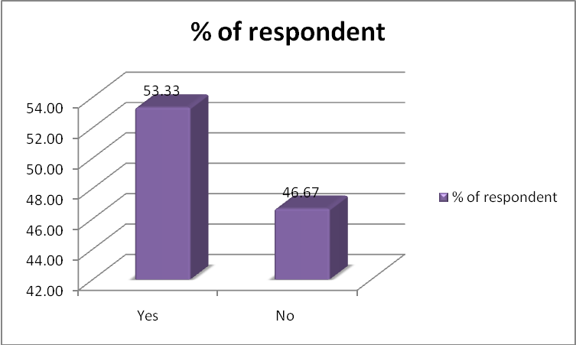
Interpretation- from the above primary research conducted over 15 students it was clearly seen that the Moodle as a tool is very useful. This tool is being used by the student in order to communicate, collaborate and build the communities which are assistive in learning in an effective manner. This is particularly because of the reason that this is a tool which is helpful for the student in learning any of the subject at any time. However, the rest of the students do not agree to this.
Theme 2- Moodle supports the entire popular browser.
Particular | Respondent | % of respondent
Moodle support all popular browsers | 10 | 66.67
Moodle does not support all popular browser | 3 | 20
I don't know | 2 | 13.33
Total | 15 | 100

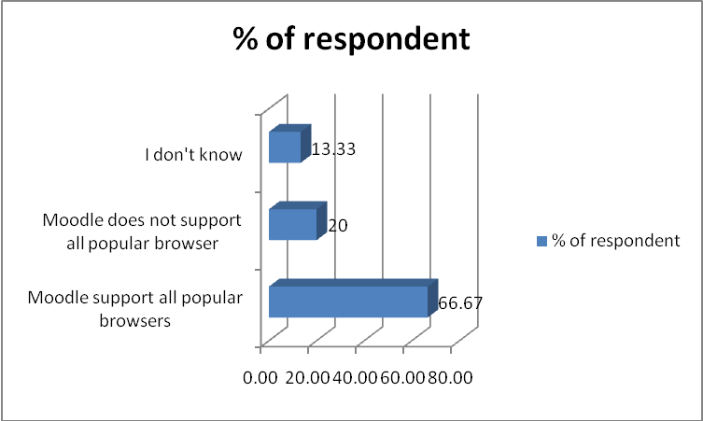
Interpretation- As per the primary survey and research conducted over 15 students 66.67 % of students agreed that Moodle is being supported by any type of browser. This is a good benefit for the student as they can have access to any of the Moodle courses at any time of the day which is helpful in their learning process which in turn result in growth and development.

Theme 3- Strongly agreed that the Moodle is an online learning tool or VLE
Particular | Respondent | % of respondent
Strongly agree | 6 | 40
Agree | 3 | 20
Neither agree nor disagree | 1 | 6.67
Disagree | 2 | 13.33
Strongly disagree | 3 | 20
Total | 15 | 100

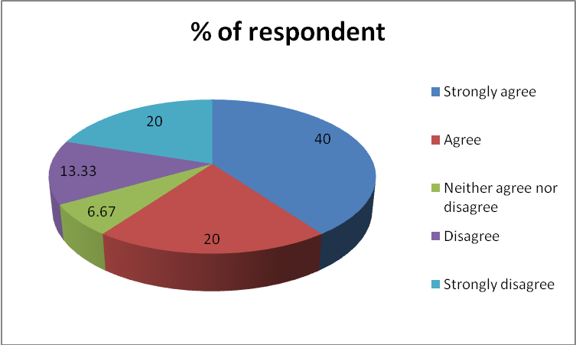
Interpretation- Through the above graph and table it is interpreted that Moodle is a learning tool because the majority of the students strongly agree with a statement. Out of 100%, 40& of them strongly agreed, while 20% of them strongly disagreed and only 13.33% of them disagreed. Therefore, Vasileiadis and et.al., (2020) also supported that there are various tools offered learning material and that it is dependent upon the educator who provides the same things in order to generate the best outcomes.

Theme 4- Yes the different types of document can be uploaded over moodle.
Particular | Respondent | % of respondent
Yes | 9 | 60
Maybe | 3 | 20
No | 3 | 20
Total | 15 | 100

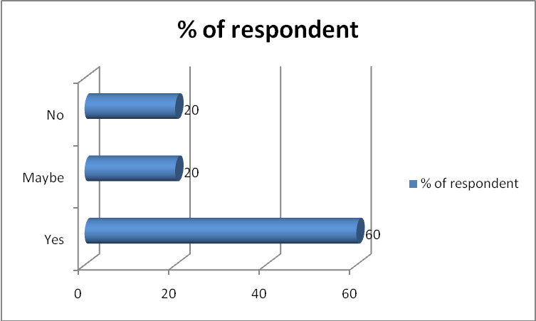
Interpretation- Yes, the students upload the documents in Moodle such that out of 15, 9 of them are stated yes, while 3 of them did not say anything. Thus, it is proved that students may easily access it and upload their work through which teachers track the performance in order to generate their results. Therefore, it is analysed that with the help of Moodle, the majority of the students determine their results and download the documents that lead to easy access through Moodle.

Theme 5- Strongly approve that there is option of downloading or printing the power point and word documents in Moodle.
Particular | Respondent | % of respondent
Strongly approve | 5 | 33.33
Approve | 3 | 20
Neither approve or disapprove | 4 | 26.67
disapprove | 1 | 6.67
strongly disapprove | 2 | 13.33
Total | 15 | 100

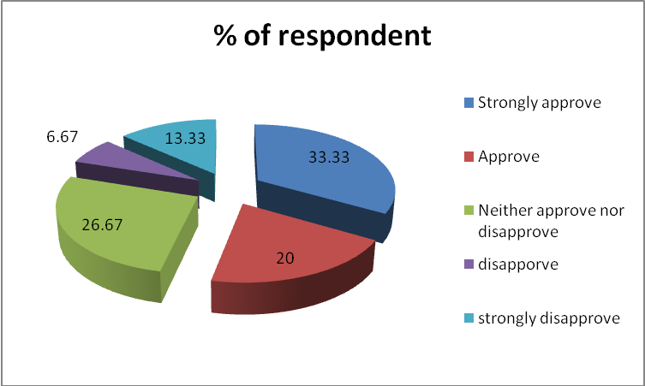
Interpretation- In accordance with the above table and graph it is interpreted that the majority of the students strongly approve that they easily download powerpoint and word documents in Moodle. Out of 100%, 33.33% of them strongly approve, while 20% approve and 26.66% either approve or disapprove. Hence, it is analysed that students can easily access through the online platform and this in turn generates the best results as well. Voloshynov and et.al., (2020) supported that with the help of online Moodle, students can easily download the documents through which students can easily generate the best outcomes.
Theme 6- Always the video or audio files can be put over the Moodle.
Particular | Respondent | % of respondent
Always | 6 | 40
Usually | 2 | 13.33
Sometimes | 2 | 13.33
Rarely | 3 | 20
Never | 2 | 13.33
Total | 15 | 100

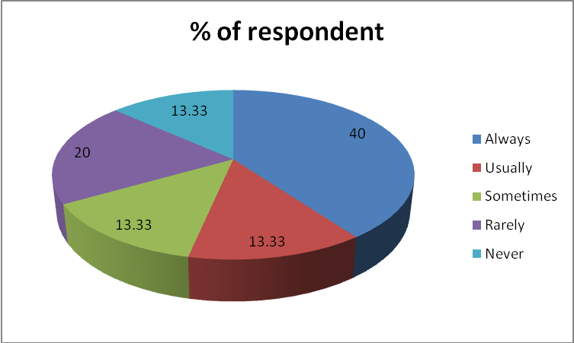
Interpretation- By using the primary research, it has been interpreted that the majority of the students are stated that they always put the videos and audio files into Moodle. So that 40% of them agreed that they always use video files, while 13.33% stated that usually they put video and 20% of them stated rarely. Hence, it is examined that with the help of an effective online platform, students can easily determine the best results which in turn improve the results and track the performance that helps to meet the defined aim.
Theme 7- 64 MB is the limit of the size of the file which can be uploaded into Moodle.
Particular | Respondent | % of respondent
30 MB | 2 | 13.33
50 MB | 3 | 20
64 MB | 10 | 66.67
Total | 15 | 100

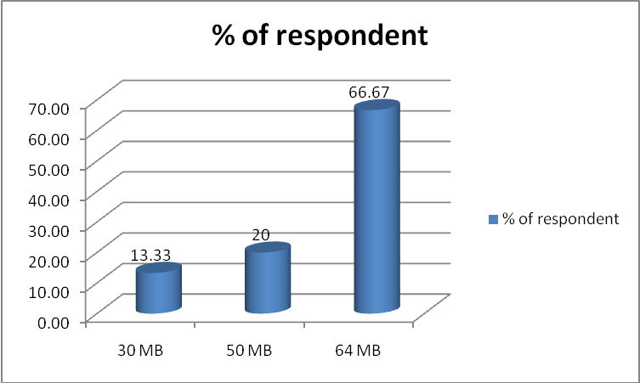
Interpretation- As per the above table and graph, it is interpreted that there is a limit of uploading the documents i.e. majority of the students are stated that 64MB is the maximum size through which students upload their documents into Moodle. On the other side, 13.33% of them stated that 30MB is the maximum limit and 20 of them are 50MB is the highest limit. Hence, Alkhateeb and Abdalla (2020) supported by stating that with the help of effective Moodle, students can easily upload the documents and this in turn improve the results and track the performance of students as well. Therefore, it is examined that within standard criteria, most of the students may easily access the documents.
Theme 8- Yes, Moodle can handle the diagrams and mathematical symbols.
Particular | Respondent | % of respondent
Yes | 11 | 73.33
No | 4 | 26.67
Total | 15 | 100

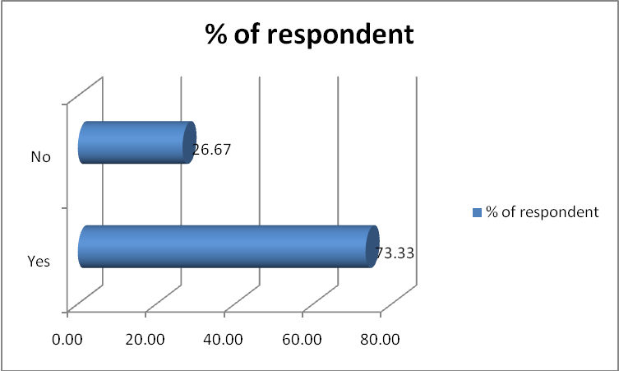
Interpretation- Moodle is easy to handle the diagrams and mathematical symbols easily such that 73.33% of them stated yes, while 26.67% of them stated no. Hence, it is clearly reflected that with the help of effective and presentable diagrams students are easily accessible to the documents and present the findings in a better manner. Also, Pérez-Pérez, Serrano-Bedia and García-Piqueres (2020) supported that Moodle provides better support to their students which in turn improves the performance that leads to generating effective findings and concludes the results as well.
Theme 9- It is true that the people can have a look and participate in Moodle courses.
Particular | Respondent | % of respondent
TRUE | 14 | 93.33
FALSE | 1 | 6.67
Total | 15 | 100

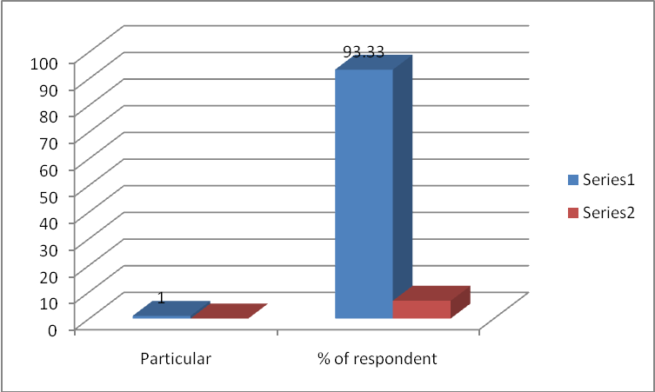
Interpretation- Yes, students are highly recommended to others to participate within Moodle because it provides a great understanding of Moodle courses. Such that out of 15, 14 are stated yes and only 1 of them stated no. Hence, Bogusevschi, Muntean and Muntean (2020) stated that Moodle is that online platform through which students are easily able to access the courses, upload their work and track the performance level and then the teacher takes action accordingly.
Theme 10- Definitely I would like to recommend Moodle platforms to others.
Particular | Respondent | % of respondent
Definitely would | 15 | 100
Probably would | 0 | 0
Probably would not | 0 | 0
Definitely would not | 0 | 0
Total | 15 | 100

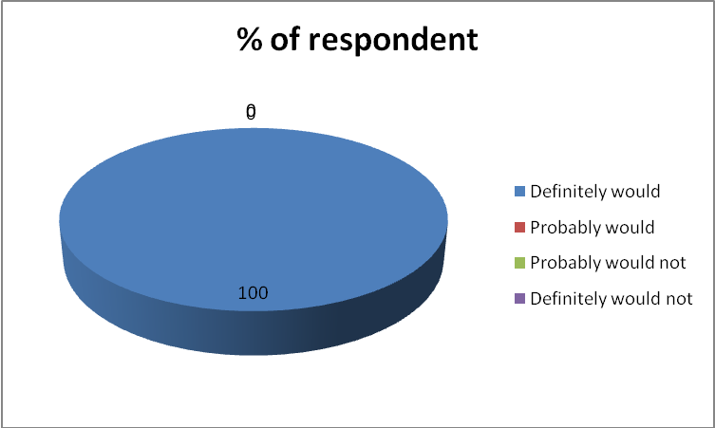
Interpretation- As the Moodle offers a range of options to the students and this in turn improves the results. That is why, selected respondents highly agree that they would definitely recommend Moodle platform to others and none of them stated anything. This is clearly reflected that with the help of an effective online platform, students are easily generated the best results and due to this pandemic time, students have to attend online classes which in turn improve the performance level. That is why 100% of them stated that they will definitely recommend this Moodle to others.

CONCLUSION
By summing up the above report it has been concluded that Moodle is an online platform that helps the students to meet the defined aim and enhance their learning experience as well. Therefore, it is clearly reflected that with the help of an effective online platform, students are easily uploading the documents and this in turn helps teachers to track the performance which in turn improve the results as well. Through primary research it has been concluded that the majority of the students are highly recommended to others to use Moodle in order to enhance their learning experience and this in turn improves the results as well. Therefore, it is concluded that VLE actually creates a positive learning impact upon their students.

REFERENCES
Books and Journals
Al-Azawei, A. and Al-Masoudy, M., 2020. Predicting Learners' Performance in Virtual Learning Environment (VLE) based on Demographic, Behavioral and Engagement Antecedents. International Journal of Emerging Technologies in Learning (iJET). 15(9). pp.60-75.
Alkhateeb, M.A. and Abdalla, R.A., 2020. Factors Influencing Student Satisfaction Towards Using Learning Management System Moodle. International Journal of Information and Communication Technology Education (IJICTE). 17(1). pp.138-153.
Bogusevschi, D., Muntean, C. and Muntean, G.M., 2020. Teaching and Learning Physics using 3D Virtual Learning Environment: A Case Study of Combined Virtual Reality and Virtual Laboratory in Secondary School. Journal of Computers in Mathematics and Science Teaching. 39(1). pp.5-18.
Carlotta Olivetti, E. and et.al., 2020. Engagement Evaluation in a Virtual Learning Environment via Facial Expression Recognition and Self-Reports: A Preliminary Approach. Applied Sciences. 10(1). p.314.
Chui, K.T. and et.al., 2020. Predicting at-risk university students in a virtual learning environment via a machine learning algorithm. Computers in Human Behavior. 107. p.105584.
Lai, C.H. and et.al., 2020. Developing a virtual learning tool for industrial high schools’ welding course. Procedia Computer Science. 172. pp.696-700.
Pérez-Pérez, M., Serrano-Bedia, A.M. and García-Piqueres, G., 2020. An analysis of factors affecting students´ perceptions of learning outcomes with Moodle. Journal of Further and Higher Education. 44(8). pp.1114-1129.
Ruangvanich, S., Nilsook, P. and Wannapiroon, P., 2020. System architecture of learning analytics in an intelligent virtual learning environment. Int. J. E-Educ. E-Bus. E-Manag. E-Learn. 10. pp.33-42.
Vasileiadis, K. and et.al., 2020. Α Multicultural Citizenship Education Program Through a Virtual Learning Environment Platform. International Journal of Learning and Development, 10(IKEEART-2020-2384), pp.52-68.
Voloshynov, S.A. and et.al., 2020. The use of LMS Moodle as an administration instrument of distance learning of future maritime specialists.
Online
Features of Moodle. 2020. [Online]. Available through: <https://docs.moodle.org/310/en/Features>

