TRSK5001

Internet-based research
Professor Gary Bunt

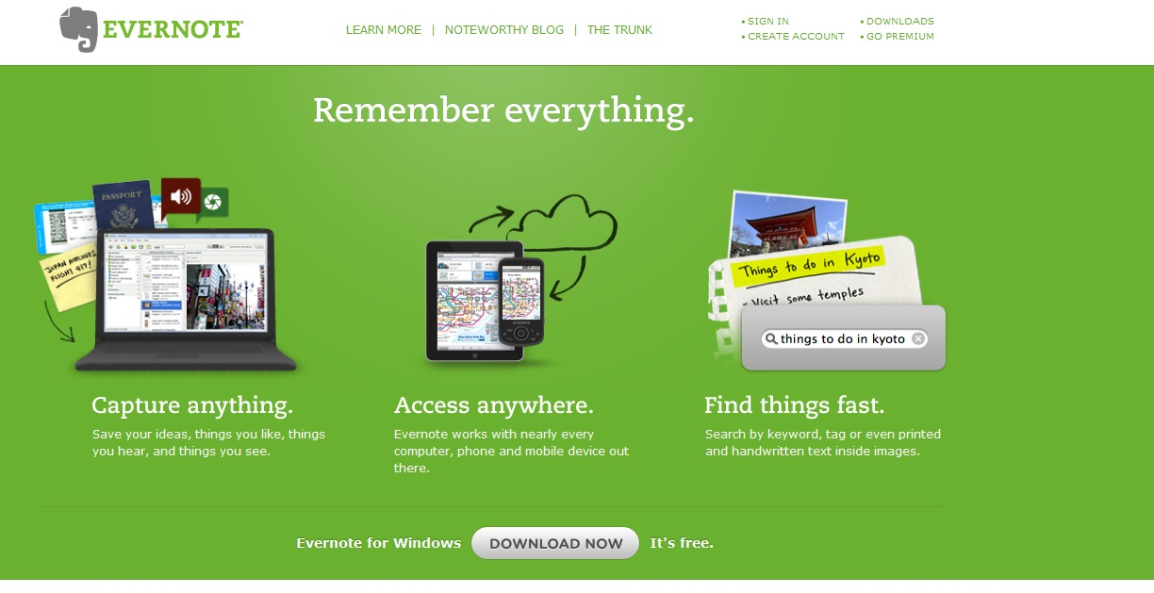

Generic Tools

Here’s a selection of the materials I discuss within my presentation. Many of these I use myself for research on a regular basis.

All these products and services can be found via search engines. Some of these are commercial products. Many of them are cross-platform, with Windows, Mac and/or (occasionally) Linux versions.

You will also find some of these products available for mobile phone, including Android and iPhone versions. You may also find versions for tablets, including iPads.

Information is provided for guidance only, and is subject to change.

Send me any tools you might be using for your own research, and let me know how you get on with any of the products I discuss.

They are listed in order of discussion.

Prof. Gary R. Bunt
Department of Theology, Religious Studies & Islamic Studies, University of Wales Trinity Saint David, Ceredigion SA48 7ED UK
g.bunt@uwtsd.ac.uk
@garybunt
virtuallyislamic.com

Product Listing

Ambrosia Wiretap – Audio recording for Internet content

Audacity – Audio recording for Internet content

Archive.org - includes the Internet WayBack Machine and other resources for capturing old websites and online content

Google Scholar - academic materials available for searching, download and purchase

Whois DomainTools - used for looking up owners of websites

Alexa - contains background information on websites, traffic information, etc

Evernote - useful online storage tool, which can be used across platforms

Instapaper - useful online storage tool, which can be used across platforms

KeepVid - easy way to download YouTube videos

Google Groups - subject specific forums

Google News - useful for researching on specific subject areas

RefWorks - referencing software

Zotero - referencing software

Endnote - referencing software

Typepad - blogging tool

Blogger.com - blogging tool

Wordpress - blogging tool

SocialSafe - social media archiving tool

Buffer - social media linking

Kippt - social media archiving resource

