
Gabriel Gog
Student ID: 2545710

Assessment 1 – Reading Task Template
Upload your photo of your A3 in-class notes here:
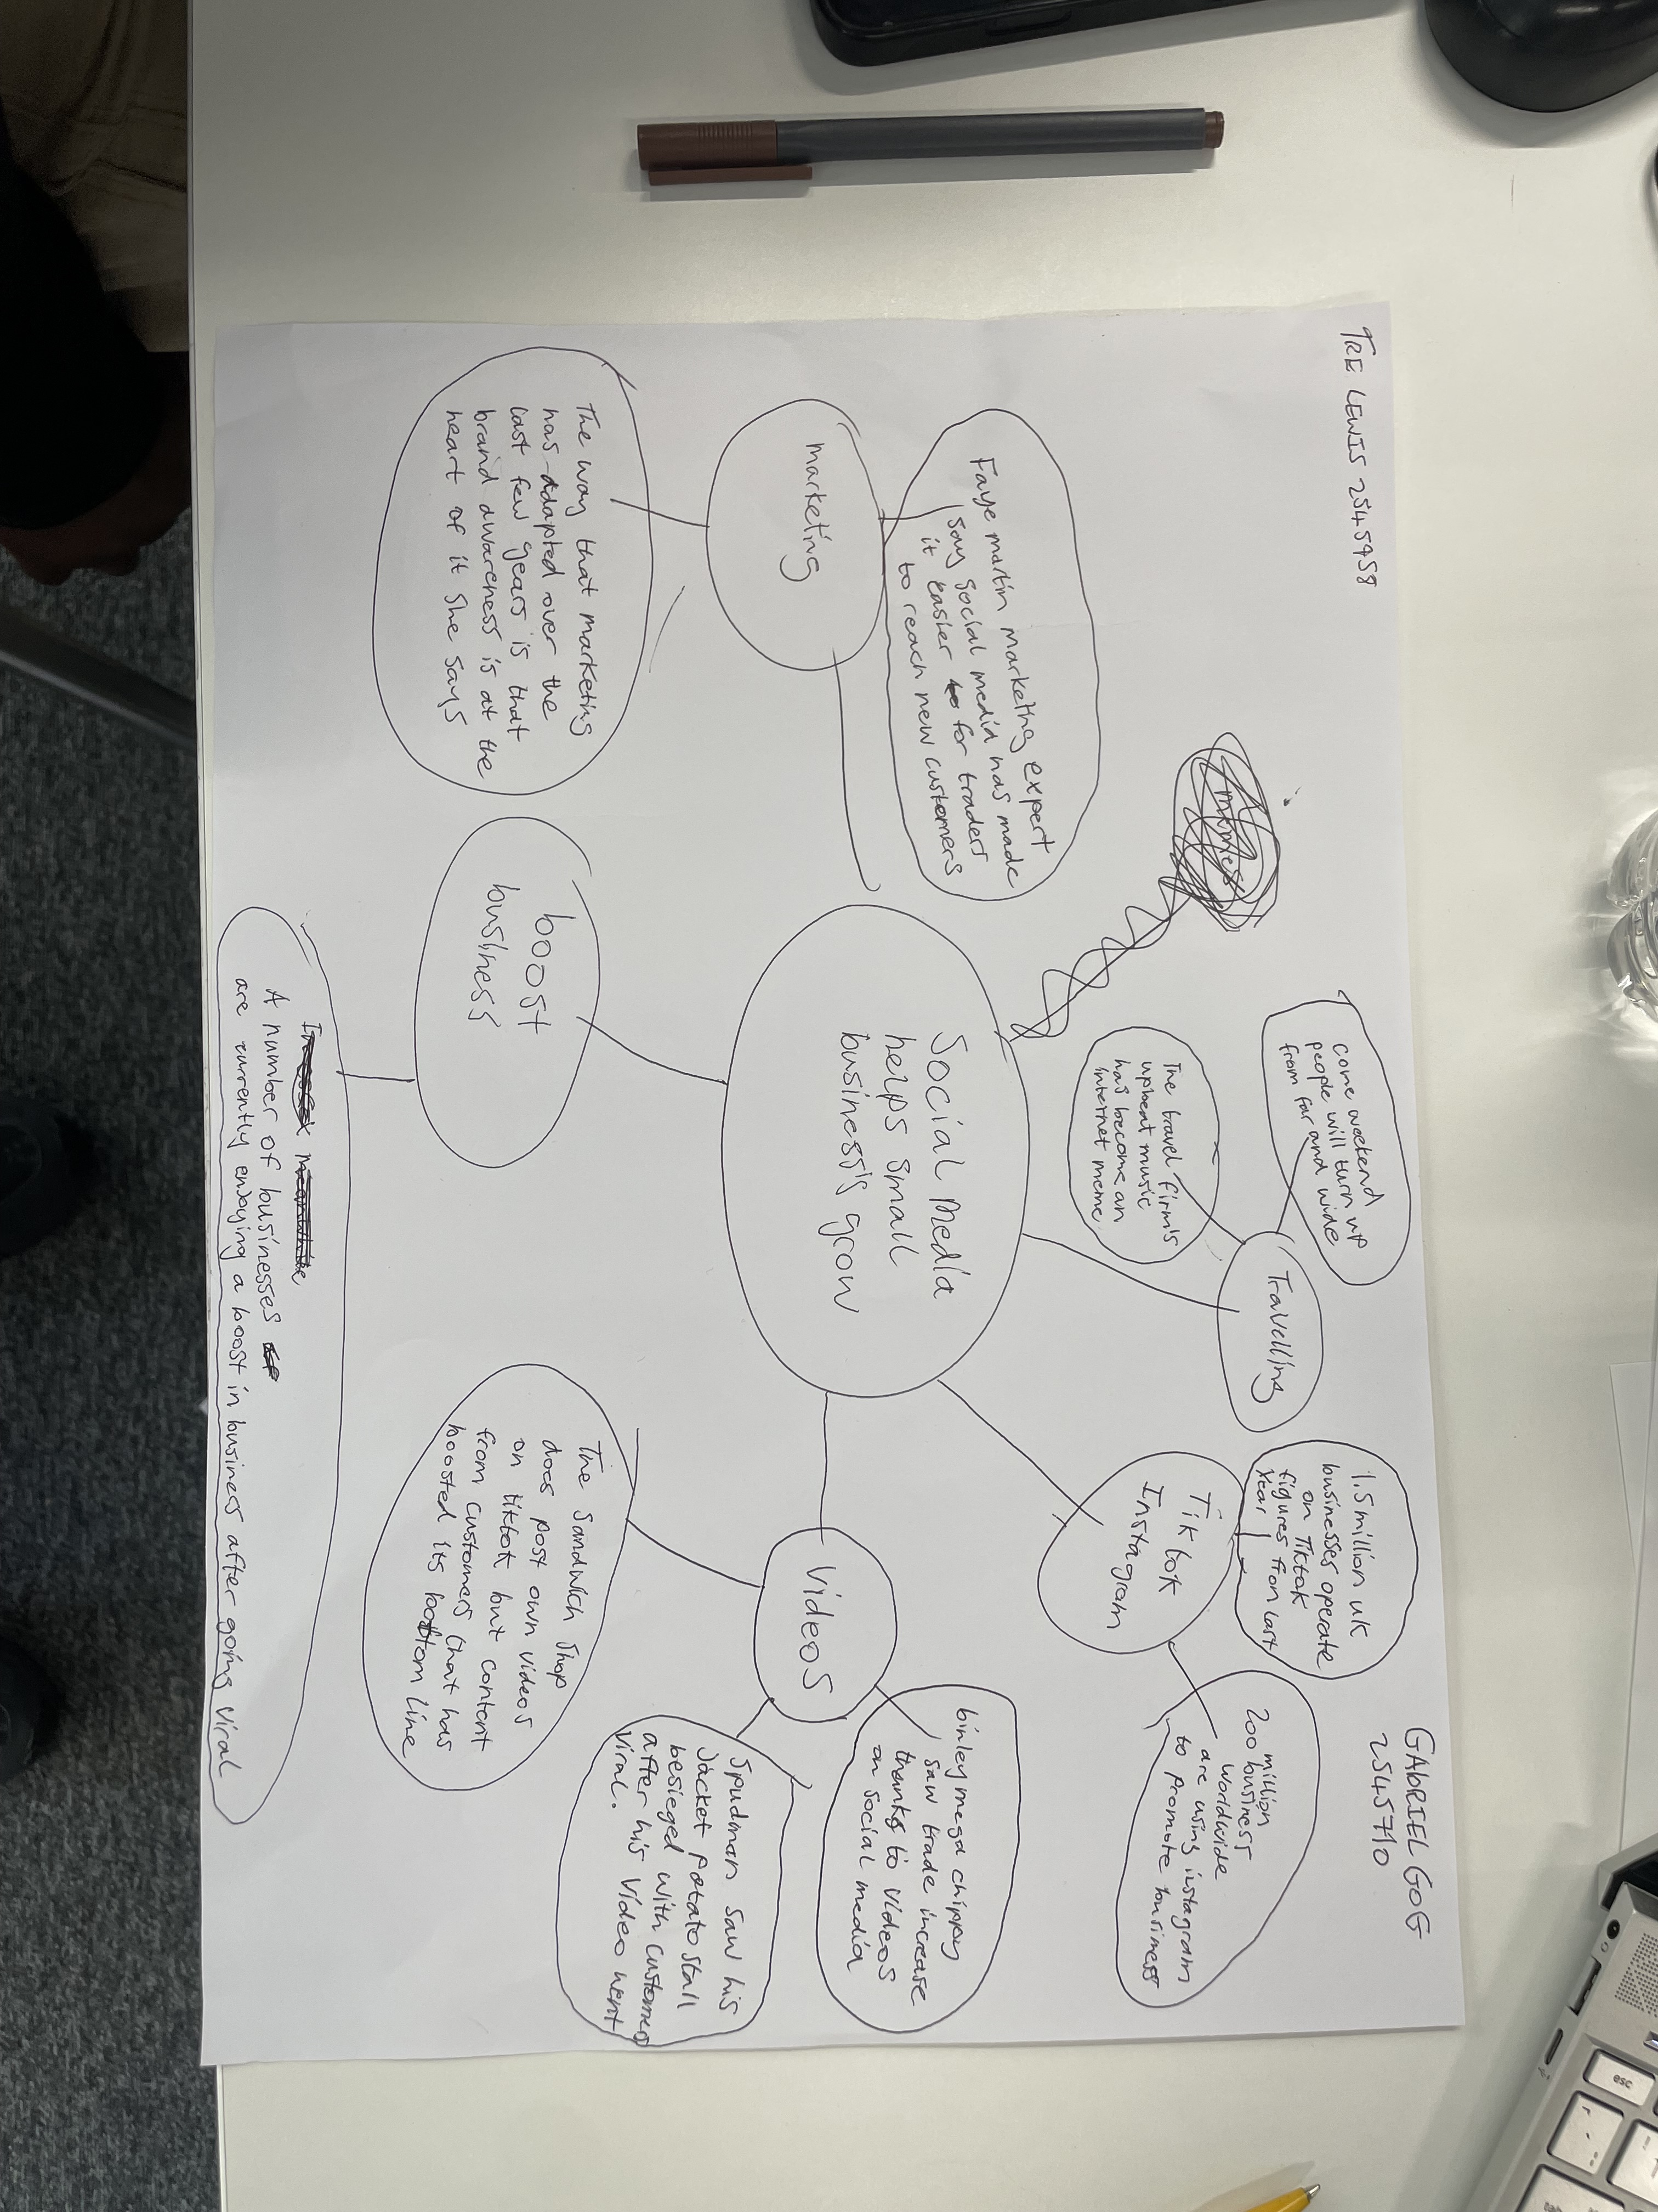

1a. What is the main idea of the text?
The main idea is that social media platforms such as TikTok, Instagram, and Facebook can help small businesses grow by increasing their profile and attracting customers across the UK and even other countries.

1b. What are two key points?
One key point is that viral social media videos encouraged people to travel long distances to visit businesses like Honywood Sandwich Shop and Krystalls Boutique.
Another key point is that true and interesting content helps businesses build customer trust, increase brand awareness, and improve sales.

1c. What part of the text did you find most important? Why?
The most important part is the marketing expert’s statement that “people buy from people.” I think this is important because it explains why customers prefer businesses that create genuine, relatable, and entertaining content instead of traditional advertisements.

1d. Was anything unclear or difficult to understand?
I was not sure about how businesses maintain their popularity after the initial viral trend ends and what long-term marketing strategies they use to keep attracting customers.
1e. How did your group help you understand the text better?
My group helped me by discussing the main ideas, explaining unfamiliar words, and sharing different opinions about how social media influences business success. This helped me understand the article from different perspectives.

2. One Sentence Reflection
Question: What did you find challenging about this task?
The hardest part was identifying the most important information and summarising the article in my own words while keeping the answers clear and compact.

