Name: Robert Dowle
Student Number: 2127680
Title of Report: What is Frailty and How the Therapy Assistant is Involved?

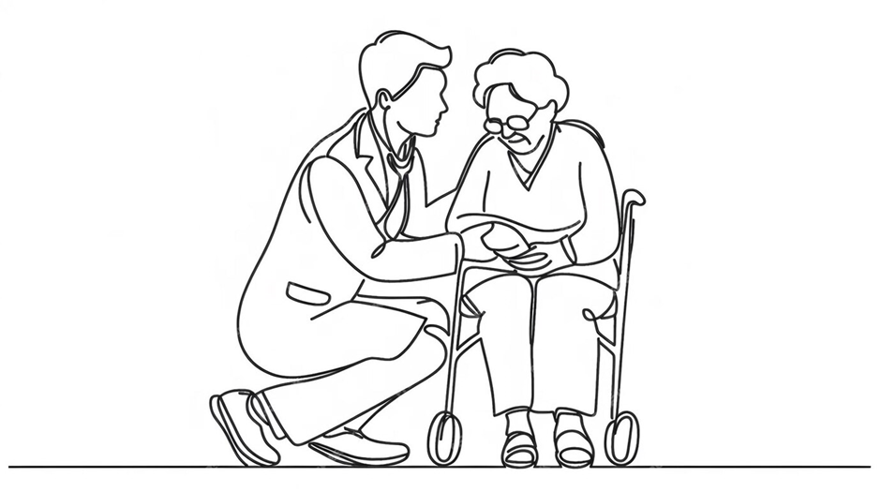

Contents

Title | Page
Introduction: | 3
Case Study: | 4
Overview of Frailty: | 5
Previous Approaches to Frailty: | 6
Current Approaches to Frailty: | 7
Co-Production: | 8
Clinical Governance and Supervision Framework: | 9
Conclusion and Recommendations: | 10
Reference List: | 11
Appendices: (including Critique Checklist) | 16

Introduction
Frailty can be defined a number of ways, historically it was thought a person had to be old to be frail, but frailty can occur at any age (Searle and Rockwood, 2020). Using Fried`s frailty phenotype model, (Pogam et al., 2022; Karunananthan and Bergman, 2023, p.9), if a person was to have a minimum of three out of five of the following attributes of, reduced weight, fatigue, reduced gait, minimum physical activities and reduced muscle power, they would be classified as frail. Whereas, Allison et al., (2021), class it as a syndrome which has no conclusive definition.
As of 2022, there were approximately 12.7 million adults aged 65 years or older, which equates to approximately 19% of the population (Barton et al., 2024), this ageing population is an increasing concern and the TAP`s role can help improve the quality of life for service users living with frailty. The NHS has a measuring tool to score the severity of a person`s frailty when they are identified, called the `Clinical Frailty Score` (CFS). CFS is based on a Canadian study by Professor Rockwood and has since been adopted by many health care providers. The CFS, has a number scale from 1-9, with each number giving a brief description of the presentation of the persons current capabilities and restrictions (Appendix A). The lower the number the more independent the person is, the higher the number the frailer they are. If a person scores five or higher they are classed as being frail. There is also the Electronic Frailty Index (eFI), used by some health care providers, which can provide screening for a person to be identified as frail. This tool is used to collate thirty-six specific conditions an individual has; the total number conditions are then divided by thirty-six to give the care provider a score which then identifies the patient`s risk of frailty (Appendix B).
This work will commence with a case study of a person with frailty and then move on to discuss frailty, consider previous and current approaches, coproduction and clinical governance in relation to this. Finally, there will be a conclusion with recommendations for future practice.

Case Study
The role of a Therapy Assistant Practitioner (TAP) working within the community will be considered through the use of a case study. The TAP has a caseload triaged by senior staff and can work without direct supervision in the appropriate therapy setting for patient rehabilitation, also the TAP can work in conjunction with other multi-disciplinary services to achieve these needs. The case will be focusing on a gentleman who was referred following a fall, who lives in the Carmarthen 2T`S catchment area of Hywel Dda University Health Board (HDUHB). The gentleman will be given the pseudo name John to maintain confidentiality.
Aged 87, John has a number of medical conditions which have contributed to him becoming frail and unsteady on his feet, these conditions include a dynamic hip screw, osteoarthritis, pacemaker, hypertension and chronic anaemia. Frailty can be a generalised term given to an older person who, like John have had a fall or are at risk of falling NICE (2023), but the Frailty Briefing Summary (n.d.) states it can impact any age group.
John was hospitalised following a fall at home, his wife reported John fell, due to tripping over the rug. Prior to admission John was confident, self-caring and mobile with a rollator in his bungalow. John did not sustain any serious injury but lost his confidence in himself and with walking, transferring and personal care, he was diagnosed frail whilst in hospital but, he recovered quickly due to his positive mental attitude but, it was identified he needed a care package on discharge. Once a care package was approved John was discharged and the TAP was asked to review him at home. On assessment he had a reduced gait pattern predominantly due to the fact that arthritis in John`s knees had limited the amount of extension (Foran and Sheth, 2023) which resulted in John falling. John had lost confidence in his walking and was having regular episodes of lethargy and needing the carers to support him with transfers and personal needs.
The TAP’s role was to aid John in regaining his lost confidence in mobility and general muscle strengthening, reducing his reliance on others and improving self-worth. With seven weekly sessions, focussing on lower and upper limb range of movements and strengthening exercises, John gradually advanced to not requiring aids to stand, instead using his own core strength, and he could walk short distances with close supervision. John was motivated to do exercises between sessions as he could see the benefits it was making, (Oyake et al., 2023). John was soon able to stand upright, march on the spot unsupported and maintain good posture when walking with the slightest flexion to his arthritic knees. As each session progressed John was able to improve his distance walking whilst using the rollator for support and no hands-on support was given by the TAP.
The TAP liaised with the Occupational Therapist (OT) and the care provider manager, so that the manual handling plan could be altered. This allowed care staff to encourage and supervise John with his mobility on a daily basis. This coproduction interdisciplinary approach was essential as it allowed John to continue to improve and maintain as much independence and confidence as possible (Warren and Warren, 2023).

Overview of Frailty
As previously noted, as of 2022, there were approximately 12.7 million adults, 65 years or older, equating to approximately 19% of the population (Barton et al., 2024). Age UK, (2020) mentions that 10% of over 65`s are classed as frail and this dramatically increases up to 50% when over 85 years of age. Welsh Government (2024) statistics state that there are 307,000 people in Wales aged 75 or more which equates to 9.9% of the total Welsh population in 2021 but, do not give a classification of these as a frailty number or percentage. Finding accurate data on the prevalence of frailty in Wales is very scarce, as most studies have been focussed on England. A study from the Stroke Association focused on frailty in Wales suggests there is little evidence previously to contribute to research in the country (Stroke Association, 2024).
Khalil and Gobbens, (2023) relate that frailty can impact the individual in many forms, such as reduced activities, lack of confidence and a reliance on others, such as family and friends or even requiring formal care by appropriate providers putting a strain on relationships and finances as seen in John’s case.
When a person is frail, they may not recognise it themselves and it can be missed and not be diagnosed formally by a health care professional (British Geriatrics Society, 2020). If this is the case then gaining access to the relevant services and treatments can be difficult for that person as highlighted in a study by Seeley, et al., (2023). When delays in receiving treatment for frailty is prolonged there can be a detrimental effect on the health of the person, which is becoming more common due to NHS waiting times (Limb, 2023). Another element that impacts the patients care is the physical ability to access services, for example are they able to drive, get public transport? This is where the TAP visiting the persons home can be of benefit (The Older People’s Commissioner for Wales, n.d.).

Previous Approaches to Frailty
Frailty has not been a commonly recognised condition much before this century; as noted by Tomkow, (2020), there were under fifty academic studies by 1998 and slightly fewer than four hundred by 2012, this is because it was not an identified condition. Therefore, it was not considered a worthy area for investigation but, since 2000, frailty has become more commonly considered within healthcare, the introduction of the CFS and eFI tools has firmly contributed to diagnosing a person with frailty. Thus, enabling health care providers the ability to understand frailty better and how to involve multidisciplinary teams to aid in that person`s needs to avoid potential further progression in the frailty spectrum. The Comprehensive Geriatric Assessment (CGA), (Appendix C), initially introduced in the 1940`s in the UK and further developed over the decades to the present-day further aids` healthcare workers in diagnosing frailty (Parker et al., 2017).
HDUHB is split into geographical areas, when focusing on the Carmarthenshire area, this is then split into three separate areas, Carmarthen, Amman Gwendraeth and Llanelli. Carmarthen and surrounding area had a population of approximately 57,666 in the year 2000; community physiotherapy had a very limited impact on patients who needed input, primarily due to the fact that there was only one part time qualified physiotherapist who was available to see patients in need of the service.
This was not effective, so investment and recruitment increased the department to improve the quality of service for patients. This resulted in more qualified staff but also a new role being made, the Band 4 therapy assistant, known as a TAP, who had a dual role with physiotherapy and OT, assessing patients that had been triaged by a qualified staff member. The TAP, instigated an audit over 5 years as to how many patients were assessed which resulted in an average of 225 new assessments per year, thereby aiding in reducing the waiting list and seeing patients in a timelier manner.
Initially the role was ward based and community, the TAP would identify frail patients by using the CFS score and when those patients were discharged home, the TAP would then visit them to ensure they were still managing their daily activities and give advice, aids or exercises as the needs were identified. This was a short-term intervention due to the daily hospital admission rates. This role developed to no longer attending ward-based work but focusing on GP led MDT`s, where the GP would identify frail patients in their own homes and seeking therapy intervention to avoid hospital admission. The TAP focusses on the goals of the patient and advises on risks and general strengthening exercise with appropriate aids necessary to maintain or improve the patients’ capabilities to avoid hospital admission. This role was later identified as a key component of the MDT and was invested in further, where there are now three dedicated TAPs involved in such frailty meetings throughout Carmarthenshire. The MDT includes the TAP, GP, Social Worker, Frailty Nurse, Social Prescriber, Psychologist, Pharmacist and any others if required. When gathered together the patients’ needs can be discussed and rapid appropriate referrals made. Streamlining referrals means the patient has more rapid intervention as promoted by a qualitative report by Boland et al., (2022).

Current Approaches to Frailty
With the CFS, eFI and CGS becoming more prevalent tools in identifying frailty with health care providers and having an increased knowledge of the makeup of frailty, this enables professionals to promote awareness and refer onto disciplines that specialise in treating these with frailty to enable them to avoid further risks. With the TAP intervention this would be therapy and holistic approaches would advocate by giving relevant exercise to reverse or delay frailty (Kwak and Thompson, 2020). Appropriate advice, equipment, risk avoidance, problem solving and also referring and liaising with other disciplines as necessary. To ensure that the treatment is person centred it is essential to understand the person`s conditions, limitations and actively listening to their story and needs with defined goal setting timelines and overcoming the challenges met methodically and correctly under relevant guidelines and practices within the TAP`s role and capabilities.
A randomized controlled study (RCS) by Talar et al., (2021) strongly advocates that resistance exercise is positive in delaying the progress of frailty in the older person, this strongly supports this element of the TAP`s role. A mixed method randomized trial by Nixon et al., (2021) for home-based exercise with frailty found that it was difficult to maintain high levels of retention in the study due to a number of factors where participants were not eligible or removed from the study on health concerns to fully appreciate the outcomes significantly, ideally this study should be renewed with this knowledge to be able to have a more conclusive and generalisable outcome for future needs. Further research in this area will help to establish the evidence base that TAP input in people`s homes is justified.
Factors that influence a TAP`s clinical decisions are having an awareness of the persons past medical history and current physical capabilities, but cognition awareness is an important factor as if the patient is not able to fully understand or replicate basic exercises this will make rehab difficult (Kleinsorge, 2021). Co-production involvement plus, gaining consent from the patient is essential, otherwise treatment cannot be implemented (Griffith, 2024). When completing an assessment an evaluation of the persons capabilities and limitations can be completed through verbal and physical outcomes, using relevant aids such as rollators, specific exercises, Tinetti scores (Scura and Munakomi, 2022), Berg Balance Test (Europe PMC, 2016) and the CFS. When all of these relevant considerations and tests are completed, further treatments can be implemented as necessary to meet the desired goals of the TAP and service user.

Coproduction
In the case study, John needed support from a number of disciplines – this is coproduction in action. These included Physiotherapy promoting body strengthening through relevant exercise and mobility, OT focussing on his aspects of daily living, transfer capabilities and dependence levels and Social Services who, evaluate the level of care required for him and source carers as appropriate. External agencies which contributed to John`s needs included Equipment Stores who delivered a rotunda and hospital bed and MiHome Care who provided care needs. The TAP seeks the advice of qualified practitioners when needed, to ensure quality of care is provided, these services worked together to meet John`s rehab goals. Working together to have a positive outcome for a patient is essential for coproduction, enabling quicker intervention with teams working towards an agreed goal. This can be achieved through team work and knowledge of each speciality’s expertise. Networking also enables better communication and timely interventions for all involved.
Typical barriers that can occur are services not being aware when other disciplines are already involved, due to factors such as, different software systems not being integrated so the individual cannot review who else is involved in the care of the patient and have up to date information. Patients may be unsure who is involved in their care and poor communication is known to be a major factor in reduced quality of care.
A literature review by Braithwaite et al., (2024) and a mixed method study by Gheduzzi et al., (2024) and The Chartered Society of Physiotherapy, (2022) understand that effective coproduction is essential with patient care outcomes, Realpe and Wallace, (2010) go further and put emphasis on care receivers being an integral part of coproduction. Farr et al., (2021) state there can be a negative effect when service users are involved in co-production and a meta-analysis study by Flinders et al., (2016) suggest, coproduction can have conflicting views, thereby limiting the approach and conclusion to the end goal. Different services can have different priorities through staffing or finances; this can result in inefficiency through repetition or omission.

Clinical Governance and Supervision Framework
There are seven pillars to Clinical Governance within the NHS (Appendix D) (Flint, 2024). The Training and Education Pillar indicates it is essential for the TAP to have relevant training, knowledge and competencies specific to the role, without such education the TAP would not be competent and may put themselves, colleagues and service users at risk.
The TAP needs the correct training prior to being allowed to undergo assessing patients, such as those with frailty. Appropriate training would be the Level 3 Diploma in Physiotherapy Support, overseen by qualified therapy staff and then progressing toward the University Level 4 TAP Diploma overseen by lecturers which, are all then provided by Agored Cymru, (Coleg Sir Gâr, 2024). E-Learning courses such as Safeguarding, Dementia Awareness and Information Governance which the TAP needs to update or renew on a regular basis are mandatory (Esr.nhs.uk, 2025). Maintaining E-Learning requirements ensures the TAP is up to date on current and new mandatory competencies.
Further input is received with Clinical Supervision for the TAP, generally given by the senior therapist weekly or monthly. This ensures the TAP is managing their own caseloads, treatment plans and discusses any relevant concerns either party has and how to remedy them effectively.
A qualitative study by Hall et al., (2022) proposes that not only geriatricians but, all specialised disciplines can consider frailty during assessments, benefitting all. A further qualitative study by Winter et al., (2021) also concluded that education of frailty should be emphasized in all areas not just gerontology.
Another pillar of Clinical Governance is Service User Engagement, which positively promotes service users’ interactions in their treatment plan, so that they have a voice in decision making and outcomes. The service user is the most important individual in any treatment plan as they are the ones who will feel the effect of any input the service provides. From the TAP perspective it is engaging with the service user, as promoted by a qualitative study by Sanders, et al., (2021) actively listening, being compassionate and understanding to their needs, appropriate goals and working together with others to achieve these at the highest standards and timeframe, to be effective and proactive. However, a further qualitative study by McAllister et al., (2021) understands that further knowledge and training is needed to benefit not only service user engagement but service providers also and more research will be required for this outcome.

Conclusion and Recommendations
As identified the relatively recent recognition and definition of frailty limits the evidence available. More academic and practice research is needed to aid in obtaining further knowledge and progressing this to the frontline services so they then can be applied in treatments. Due to the ever-aging population in the UK, more focus will be necessary to help care providers recognise and treat frailty in a multidisciplinary format.
From the TAP perspective, having exposure to patients who come under the `umbrella` of frailty, and increasing understanding of the condition aids in the ability to recognise it in future assessments and treatments. TAPs can liaise appropriately with senior staff, if they believe a patient may be identified as frail or at risk of becoming frail. NICE, (2023), Skelton, (2023) and elearning for healthcare, (n.d.) advocate adequate training for the TAP so that the TAP has knowledge with frailty. When adequate knowledge of frailty is then obtained the TAP can be confident in assessments and rehabilitation goals for the individual.
Specialist Frailty TAPs could provide a streamlined service for patients who are referred to the service; enabling patients to have a TAP who can treat them with enhanced knowledge of the condition and aid in prevention of further difficulties. When a TAP is confident in their abilities they can progress to more challenging assessments, implement therapy plans and more advanced patient care, record keeping would be more detailed, enhancing their communication and collaboration with other disciplines and service users. The TAP would also be able to provide adequate training to colleagues and carers as necessary. When opportunities arise for the TAP to progress their understanding and training in a field which they are interested in, then these should be nurtured, as challenging oneself is necessary to avoid complacency (van Hooff and van Hooft, 2022).

Reference List
Age UK (2020). Understanding frailty. [online] Age UK. Available at: https://www.ageuk.org.uk/our-impact/policy-research/frailty-in-older-people/understanding-frailty/.
Allison, R., Assadzandi, S. and Adelman, M. (2021). Frailty: Evaluation and Management. American Family Physician, [online] 103(4), pp.219–226. Available at: https://www.aafp.org/pubs/afp/issues/2021/0215/p219.html.
Barton, C., Sturge, G. and Harker, R. (2024). The UK’s changing population. [online] House of Commons Library. Available at: https://commonslibrary.parliament.uk/the-uks-changing-population/.
Boland, J., Banks, S., Krabbe, R., Lawrence, S., Murray, T., Henning, T. and Vandenberg, M. (2021). A COVID-19-era Rapid Review: Using Zoom and Skype for Qualitative Group Research. Public Health Research & Practice, [online] 32(2). doi:https://doi.org/10.17061/phrp31232112.
Braithwaite Stuart, L., Elliott, N., Hanmer, R. and Woodhead, A. (2024). Meaningful co-production to bring meaningful change: Developing the Allied Health Professionals Dementia Framework for Wales together. Dementia, 23(5), pp.724–740. doi:https://doi.org/10.1177/14713012241236116.
British Geriatrics Society (2020). End of Life Care in Frailty: Identification and prognostication | British Geriatrics Society. [online] www.bgs.org.uk. Available at: https://www.bgs.org.uk/resources/end-of-life-care-in-frailty-identification-and-prognostication.
elearning for healthcare. (n.d.). Frailty. [online] Available at: https://www.e-lfh.org.uk/programmes/frailty/.
Europe PMC (2016). Europe PMC. [online] Europepmc.org. Available at: https://europepmc.org/article/med/38325295 [Accessed 17 Apr. 2025].
Farr, M., Davies, P., Andrews, H., Bagnall, D., Brangan, E. and Davies, R. (2021). Co-producing knowledge in health and social care research: reflections on the challenges and ways to enable more equal relationships. Humanities and Social Sciences Communications, [online] 8(1), pp.1–7. doi:https://doi.org/10.1057/s41599-021-00782-1.
Flinders, M., Wood, M. and Cunningham, M. (2016). The politics of co-production: risks, limits and pollution. Evidence & Policy: A Journal of Research, Debate and Practice, 12(2), pp.261–279. doi:https://doi.org/10.1332/174426415x14412037949967.
Foran, J.R.H and Sheth, N.P. (2023) Arthritis of the knee Available at: https://orthoinfo.aaos.org/en/diseases--conditions/arthritis-of-the-knee/
Frailty briefing SUMMARY. (n.d.). Available at: https://www.eastsussexjsna.org.uk/media/l0udp4n3/frailty-briefing-march-2024.pdf [Accessed 10 Mar. 2025].
Gheduzzi, E., Savarese, M., Mangini, A., Mitidieri, S., Paleologo, M., Masella, C. and Graffigna, G. (2024). Co-producing and co-assessing a new service solution for enhancing health and social care integration: a participatory research protocol. BMC Health Services Research, 24(1). doi:https://doi.org/10.1186/s12913-024-11598-5.
Griffith, R. (2024). Key requirements for obtaining valid informed consent to treatment. British journal of nursing, 33(13), pp.644–645. doi:https://doi.org/10.12968/bjon.2024.0200.
Hall, N., Fluck, R., Imam, T., Jacob, T., Thompson, D., Tite, M., Backhouse, E., Dhesi, J. and Conroy, S. (2022). Developing frailty friendly hospitals: the Specialised Clinical Frailty Network. Future Healthcare Journal, pp.fhj.2022-0071. doi:https://doi.org/10.7861/fhj.2022-0071.
Karunananthan, S., and Bergman, H., (2023) `Frailty`, in Caplan, R., Morias, J., Fuks, A., Gauthier, S., Gold, P., Beauchet, O. and Bergman, H. (eds) `The Care Of The Older Person`. 5th edn. Abingdon: CRC Press, pp. 9-11.
Khalil, A. H., and Gobbens, R. J. J., (2023). What If the Clinical and Older Adults’ Perspectives about Frailty Converge? A Call for a Mixed Conceptual Model of Frailty: A Traditional Literature Review. Healthcare, 11(24), pp.3174–3174. doi:https://doi.org/10.3390/healthcare11243174.
Kleinsorge, T. (2021). Cognitive Capacity, Representation, and Instruction. Frontiers in Psychology, 12. doi:https://doi.org/10.3389/fpsyg.2021.701687.
Kwak, D. and Thompson, L.V. (2020). Frailty: Past, Present, and Future? Sports Medicine and Health Science, 3(1). doi:https://doi.org/10.1016/j.smhs.2020.11.005.
Limb, M. (2023). Long NHS waits and rising living costs are harming people’s health, show ONS data. BMJ, 380, p.479. doi:https://doi.org/10.1136/bmj.p479.
McAllister, S., Simpson, A., Tsianakas, V. and Robert, G. (2021). ‘What matters to me’: A multi‐method qualitative study exploring service users’, carers’ and clinicians’ needs and experiences of therapeutic engagement on acute mental health wards. International Journal of Mental Health Nursing, [online] 30(3), pp.703–714. doi:https://doi.org/10.1111/inm.12835.
NICE (2023). Improving care and support for people with frailty. [online] indepth.nice.org.uk. Available at: https://stpsupport.nice.org.uk/frailty/index.html
Nixon, A.C., Bampouras, T.M., Gooch, H.J., Young, H.M.L., Finlayson, K.W., Pendleton, N., Mitra, S., Brady, M.E. and Dhaygude, A.P. (2021). Home-based exercise for people living with frailty and chronic kidney disease: A mixed-methods pilot randomised controlled trial. PLOS ONE, 16(7), p.e0251652. doi:https://doi.org/10.1371/journal.pone.0251652.
Older Peoples Commissioner For Wales (n.d.) Accessing Health Services in Wales: Transport Issues and Barriers. Available at: https://olderpeople.wales/library/Accessing_Health_Services_in_Wales_-_Transport_Issues_and_Barriers.pdf
Oyake, K., Yamauchi, K., Inoue, S., Sue, K., Ota, H., Ikuta, J., Ema, T., Ochiai, T., Hasui, M., Hirata, Y., Hida, A., Yamamoto, K., Kawai, Y., Shiba, K., Atsumi, A., Nagafusa, T. and Tanaka, S. (2023). A multicenter explanatory survey of patients’ and clinicians’ perceptions of motivational factors in rehabilitation. Communications Medicine, [online] 3(1), p.78. doi:https://doi.org/10.1038/s43856-023-00308-7.
Parker, S.G., McLeod, A., McCue, P., Phelps, K., Bardsley, M., Roberts, H.C. and Conroy, S.P. (2017). New Horizons in comprehensive geriatric Assessment. Age and Ageing, 46(5), pp.713–721. doi:https://doi.org/10.1093/ageing/afx104.
Pogam, M.-A.L., Seematter-Bagnoud, L., Niemi, T., Assouline, D., Gross, N., Trächsel, B., Rousson, V., Peytremann-Bridevaux, I., Burnand, B. and Santos-Eggimann, B. (2022). Development and validation of a knowledge-based score to predict Fried’s frailty phenotype across multiple settings using one-year hospital discharge data: The electronic frailty score. eClinicalMedicine, 44, p.101260. doi:https://doi.org/10.1016/j.eclinm.2021.101260.
Realpe, A. and Wallace, L. (2010). What is co-production? Identify Innovate Demonstrate Encourage. [online] Available at: https://www.qi.elft.nhs.uk/wp-content/uploads/2017/01/what_is_co-production.pdf.
Scura, D. and Munakomi, S. (2022). Tinetti Gait and Balance Test. [online] PubMed. Available at: https://www.ncbi.nlm.nih.gov/books/NBK578181/.
Searle, S., and Rockwood, K., (2020) `Frailty and comprehensive geriatric assessment`, in Fillmore, H., F., and le May, A. (eds) Nursing Older People: Realities of Practice. Abingdon: Routledge, pp. 73-84.
Seeley, A., Glogowska, M. and Hayward, G. (2023). ‘Frailty as an adjective rather than a diagnosis’—identification of frailty in primary care: a qualitative interview study. Age and Ageing, [online] 52(6). doi:https://doi.org/10.1093/ageing/afad095.
Skelton, D. (2023). Dance does not necessarily reduce falls even if it can reduce some of the risk factors for falls – review of evidence from the Older People and Frailty Policy Research Unit. [online] Later Life Training. Available at: https://laterlifetraining.co.uk/dance-does-not-necessarily-reduce-falls-even-if-it-can-reduce-some-of-the-risk-factors-for-falls-review-of-evidence-from-the-older-people-and-frailty-policy-research-unit/ [Accessed 12 Apr. 2025].
Stroke.org.uk. (2024). ERFOS-Cymru: Evaluation of Risk Factor management, frailty and Outcomes post-Stroke. [online] Available at: https://www.stroke.org.uk/research/research-projects/erfos-cymru-risk-factors-frailty-after-stroke [Accessed 18 Mar. 2025].
Talar, K., Hernández-Belmonte, A., Vetrovsky, T., Steffl, M., Kałamacka, E. and Courel-Ibáñez, J. (2021). Benefits of Resistance Training in Early and Late Stages of Frailty and Sarcopenia: A Systematic Review and Meta-Analysis of Randomized Controlled Studies. Journal of Clinical Medicine, 10(8), p.1630. doi:https://doi.org/10.3390/jcm10081630.
The Chartered Society of Physiotherapy. (2022). The value of co-production. [online] Available at: https://www.csp.org.uk/frontline/article/value-co-production [Accessed 10 Mar. 2024].
Tomkow, L. (2020). The emergence and utilisation of frailty in the United Kingdom: a contemporary biopolitical practice. Ageing & Society, [online] 40(4), pp.695–712. doi:https://doi.org/10.1017/S0144686X18001319.

van Hooff, M.L.M. and van Hooft, E.A.J. (2022). Dealing with daily boredom at work: does self-control explain who engages in distractive behaviour or job crafting as a coping mechanism? Work & Stress, pp.1–21. doi:https://doi.org/10.1080/02678373.2022.2129515.
Warren, J. L. and Warren, J. S. (2023) The Case for Understanding Interdisciplinary Relationships in Health Care. Available at: https://pmc.ncbi.nlm.nih.gov/articles/PMC10262946/
Winter, R., Al-Jawad, M., Wright, J., Shrewsbury, D., Van Marwijk, H., Johnson, H. and Levett, T. (2021). What is meant by ‘frailty’ in undergraduate medical education? A national survey of UK medical schools. European Geriatric Medicine, 12(2), pp.355–362. doi:https://doi.org/10.1007/s41999-021-00465-9.
www.gov.wales. (2024). Older people and people living with frailty: integrated quality statement [HTML] | GOV.WALES. [online] Available at: https://www.gov.wales/older-people-and-people-living-frailty-integrated-quality-statement-html.

Appendices
Appendix A:
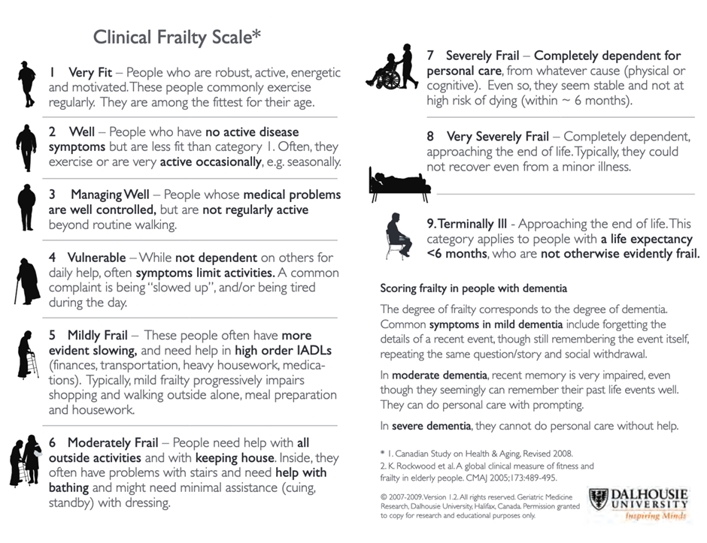

Appendix B:
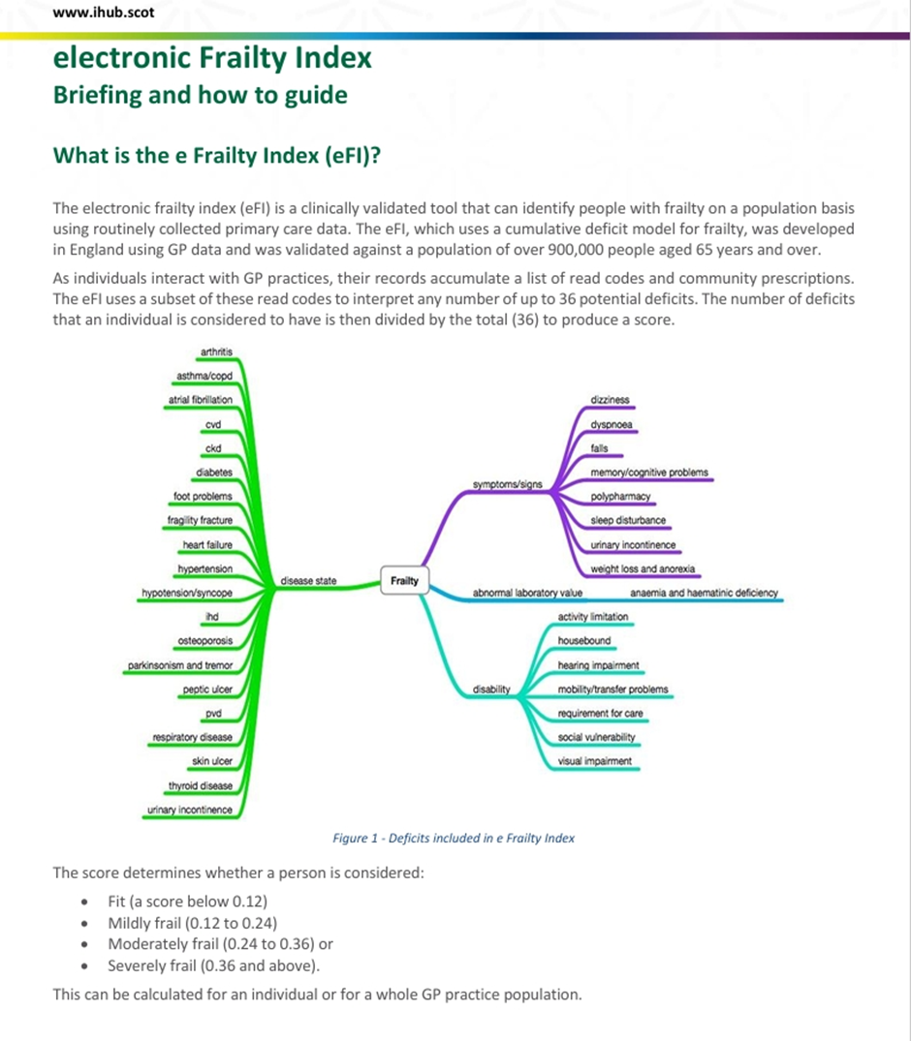
Appendix C:
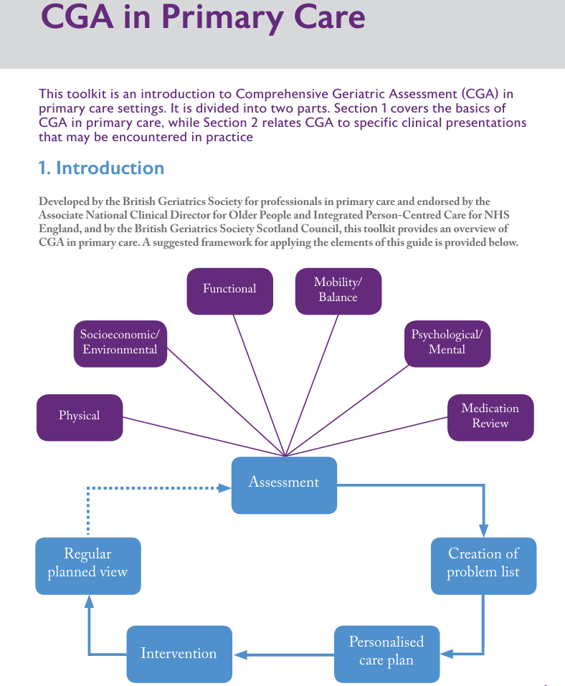
Appendix D:
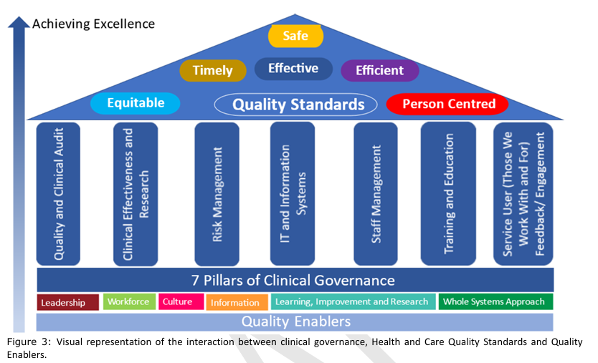

Appendix E: Critique Check List

Article Title | Author(s) | Year of publication | Journal name | Abstract  (y or n) | Methods/  instruments used | Reliable  (y or n) | Validity  (y or n) | Ethical Considerations  (y or n) | Reference list  (y or n)
‘Frailty as an adjective rather than a diagnosis’—identification of frailty in primary care: a qualitative interview study | Anna Seeley, Margaret Glogowska, and Gail Hayward | 2023 | BGS, Age and Ageing | Y | Qualitative semi-structured interviews and Thematic analysis supported by NVivo (version 12) software | Y | Y | Y | Y
Frailty: Past, present, and future? | Dongmin Kwak and LaDora V. Thompson | 2021 | Sports Medicine and Health Science | Y | Physical Frailty Phenotype and Frailty Index | Y | Y | Y | Y
The politics of co-production: risks, limits and pollution | Matthew Flinders, Matthew Wood and Malaika Cunningham | 2016 | Evidence & Policy | N | Meta-analysis of existing research, semi-structured interviews and a workshop | Y | Y | N | Y
What If the Clinical and Older Adults’ Perspectives about Frailty Converge? A Call for a Mixed Conceptual Model of Frailty: A Traditional Literature Review | Asya Hani Khalil and Robbert Gobbens | 2023 | Healthcare | Y | Literature review via journal database of PubMed and Google Scholar accessed through the AUB online library | Y | Y | N | Y
Meaningful co-production to bring meaningful change: Developing the Allied Health Professionals Dementia Framework for Wales together | Laura Braithwaite Stuart, Natalie Elliott, Rebecca Hanmer and Andrew Woodhead | 2024 | Sage Journals | Y | Literature review, workforce survey and listening events. | Y | Y | Y | Y
Co-producing and co-assessing a new service solution for enhancing health and social care integration: a participatory research protocol | Eleonora Gheduzzi and Mariarosaria Savarese, Alberto Mangini, Silvia Mitidieri, Michele Paleologo, Cristina Masella and Guendalina Graffigna | 2024 | BMC Health Services Research | Y | Mixed Method with Plan-Do-Check-Act management method and Intervention Scalability Assessment Tool (macro level) | Y | Y | Y | Y
Home-based exercise for people living with frailty and chronic kidney disease: A mixed-methods pilot randomised controlled trial | Andrew C. Nixon,Theodoros M. Bampouras, Helen J. Gooch, Hannah M. L. Young, Kenneth W. Finlayson, Neil Pendleton, Sandip Mitra, Mark E. Brady and Ajay P. Dhaygude | 2021 | Plos one | Y | Randomized Control Trail Mixed Method with Frailty Phenotype, CFS and interviews | Y | Y | Y | Y

