

Name: Yonatan Grmay
Student Number: 2433740

Assignment title : Network Operating Systems and Services
Module Name: Network Operating Systems and Services
Lecture: Md Abrar Jahin Almazi Bipon
Module code:ACCA5023
Date 23/Julay/2025

Table of Contents

1. Routing 1
Introduction 1
1.1 Routing in Birmingham Network 2
Objective 2
Installing Routing and Remote Access Service (RRAS) 2
Configuring RRAS 5
Windows Firewall Configuration 10
Verification 15
Outcome 16
1.2 Routing in London Network 16
Objective 16
Enabling IP Forwarding 17
Configuring Static Route 20
Configuring Linux Firewall 21
Verification 21
Discussion 22
Conclusion 22
2. Domain Server (Birmingham) 22
Introduction 22
2.1 Creating the Forest (yonatan.acca) 23
Objective 23
Figure 33: – Active Directory Users and Computers 24
2.2 Creating A Records 25
Objective 25
Figure 34: – Forward Lookup Zone 26
2.3 Creating Reverse Lookup Zone (PTR Records) 26
Objective 26
Figure 35: – Reverse Lookup Zone 27
Password Policy (Excellent Work Requirement) 27
Figure 36: – Password Policy 28
Verification 28
Discussion 29
Conclusion 29
3. Encrypted Connection Between Birmingham and London 30
Introduction 30
3.1 Configuring a Site-to-Site VPN 30
Objective 30
Configuring RRAS for VPN 31
Configuring the Site-to-Site VPN 32
Configuring Strong Encryption 33
Persistent Connection Configuration 34
Verification 35
Discussion 36
Conclusion 36
4. Users 37
4.1 Creating Domain User Accounts 37
Introduction 37
PowerShell Bulk User Creation 37
Verification 38
5. Domain Membership 39
5.1 Joining Computers to the Domain 39
Introduction 39
Configuration 39
Verification 40
6. DHCP Server 41
6.1 Configuring B-DC as DHCP Server 41
Introduction 41
DHCP Options 42
6.2 Configuring DHCP Relay 50
6.3 Client Verification 50
7. Test and Troubleshoot 53
Connectivity Testing 53
8. Disk Drive 54
8.1 Shared Storage 54
9. IIS Server 56
9.1 Creating the Website 56
10. Remote Desktop Services 58
10.1 Configuring Remote Desktop 58
Overall Conclusion 60

Acknowledgement

I am very grateful to my lecturer for his guidance and support during this coursework on networking. I also want to express my gratitude to my University for giving me the resources and hands-on experience to carry this out. This assignment allowed me to gain hands-on experience with network routing, Active Directory, DNS, DHCP, VPNs, file sharing, IIS, and Remote Desktop Services. Last but not least, I would like to thank all those who have contributed to the successful completion of this work.

1. Routing

Introduction
Routing is one of the most important functions within an enterprise network because it enables communication between different IP networks. In the topology provided for NOSS London 2026 Inc., the Birmingham network and the London network are located on separate subnets and therefore require routing to exchange traffic successfully. Windows Server 2022 located in Birmingham functions as the primary router through the Routing and Remote Access Service (RRAS), while the Debian Server in London performs packet forwarding using Linux IP forwarding.
The implementation of routing ensures that network devices located in Birmingham (172.16.1.0/24) can communicate with devices located in London (172.16.2.0/24) through the point-to-point network (10.0.0.0/30) shown in the coursework topology.
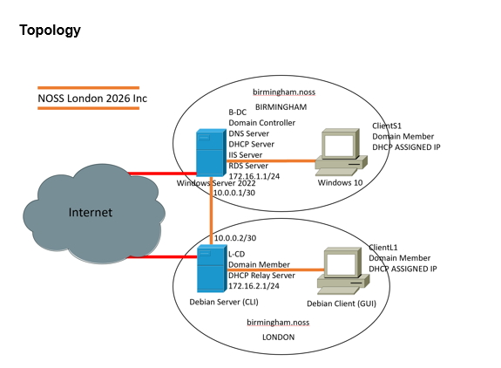
Figure 1 illustrates the network topology used throughout Coursework 2.

1.1 Routing in Birmingham Network

Objective
The objective of this task was to configure the Windows Server 2022 as the router between both sites by installing the Routing and Remote Access Service (RRAS). Additionally, Windows Defender Firewall was configured to allow ICMP traffic so that connectivity testing using the ping command could be performed.
The Birmingham Windows Server has two network interfaces:
Network Adapter | IP Address | Purpose
LAN Adapter | 172.16.1.1/24 | Birmingham Internal Network
WAN Adapter | 10.0.0.1/30 | Connection to London
This configuration follows the network topology supplied in Coursework 1.

Installing Routing and Remote Access Service (RRAS)
RRAS was installed using Windows Server Manager.
The following procedure was completed:
- Open Server Manager
- Select Add Roles and Features
- Choose Role-based installation
- Select the Windows Server 2022 machine
- Expand Remote Access
- Tick Routing
- Continue with the installation.
- Restart the server if required.
After installation, RRAS was configured.
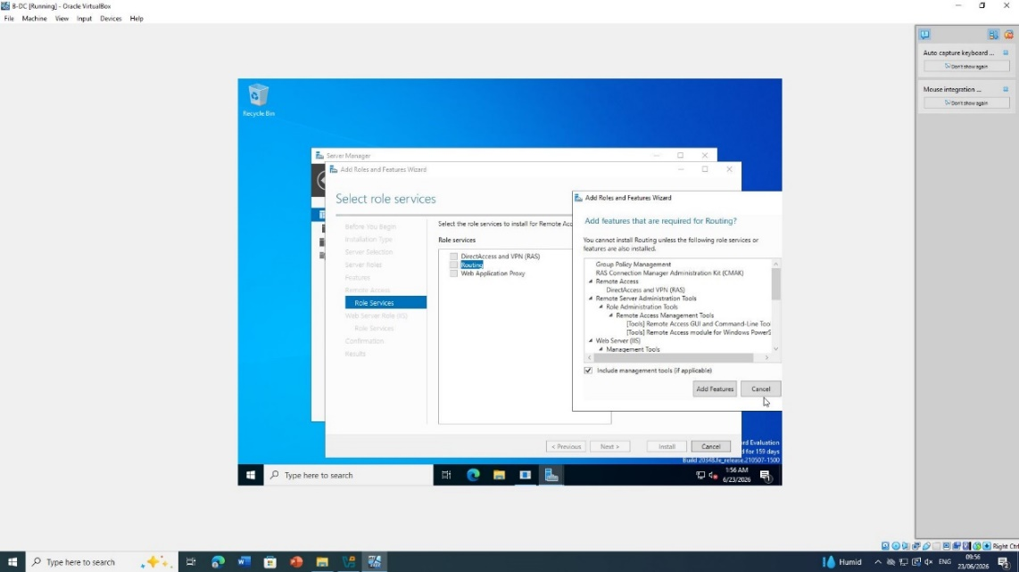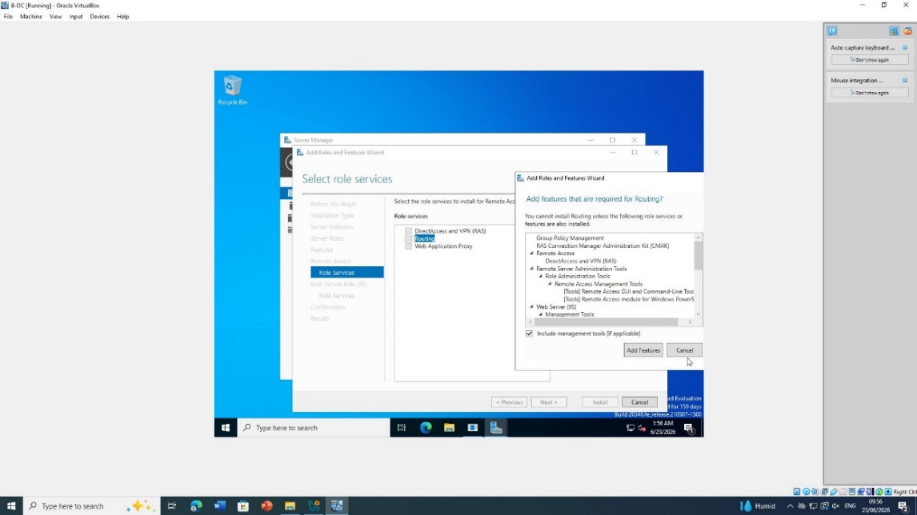

Figure 2 and 3: RRAS Role Installation
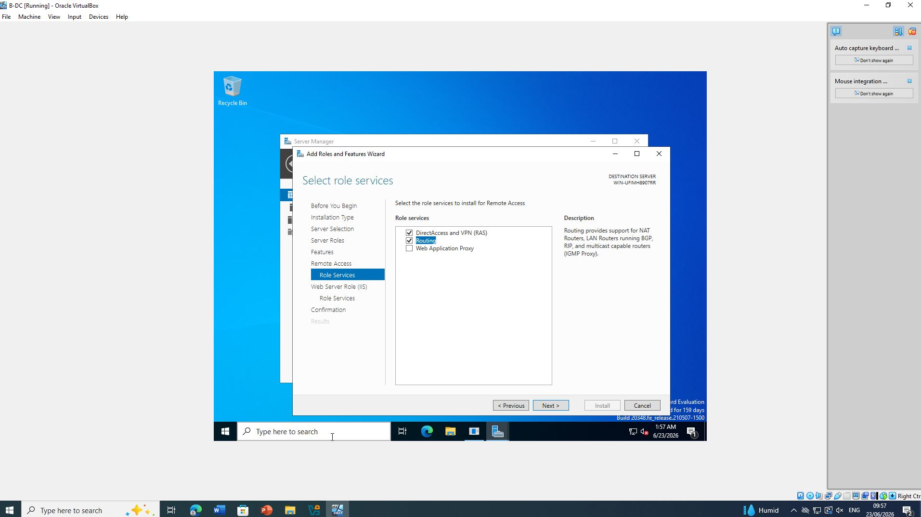
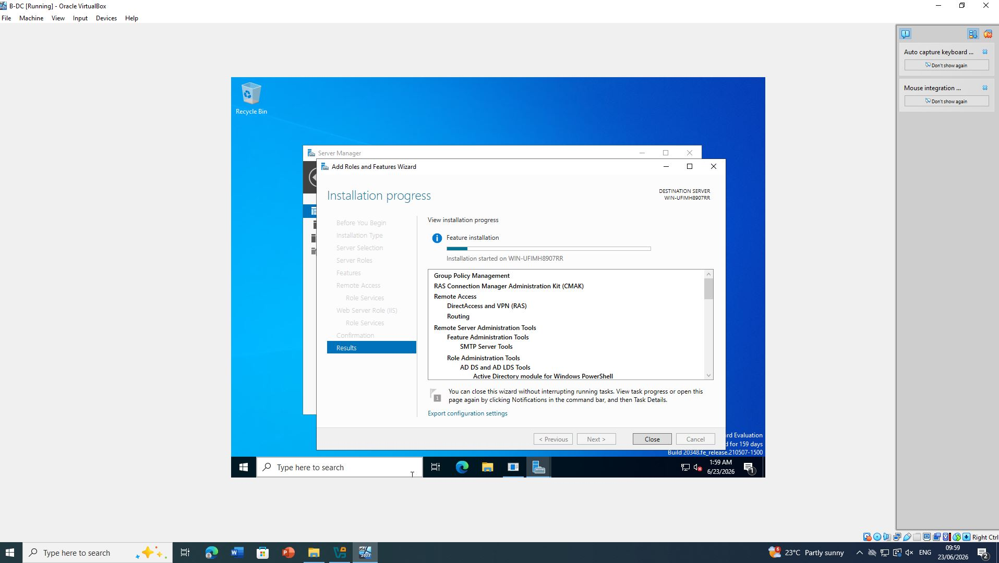

Figure 4 and 5: RRAS Role Installation

Configuring RRAS
After installation:
- Open
Tools
↓
Routing and Remote Access
- Right-click the server
- Select
Configure and Enable Routing and Remote Access
- Choose
Custom Configuration
- Tick
✔ LAN Routing
- Finish the wizard.
- Start RRAS service.
This enables Windows Server to forward packets between the Birmingham LAN and the point-to-point network.

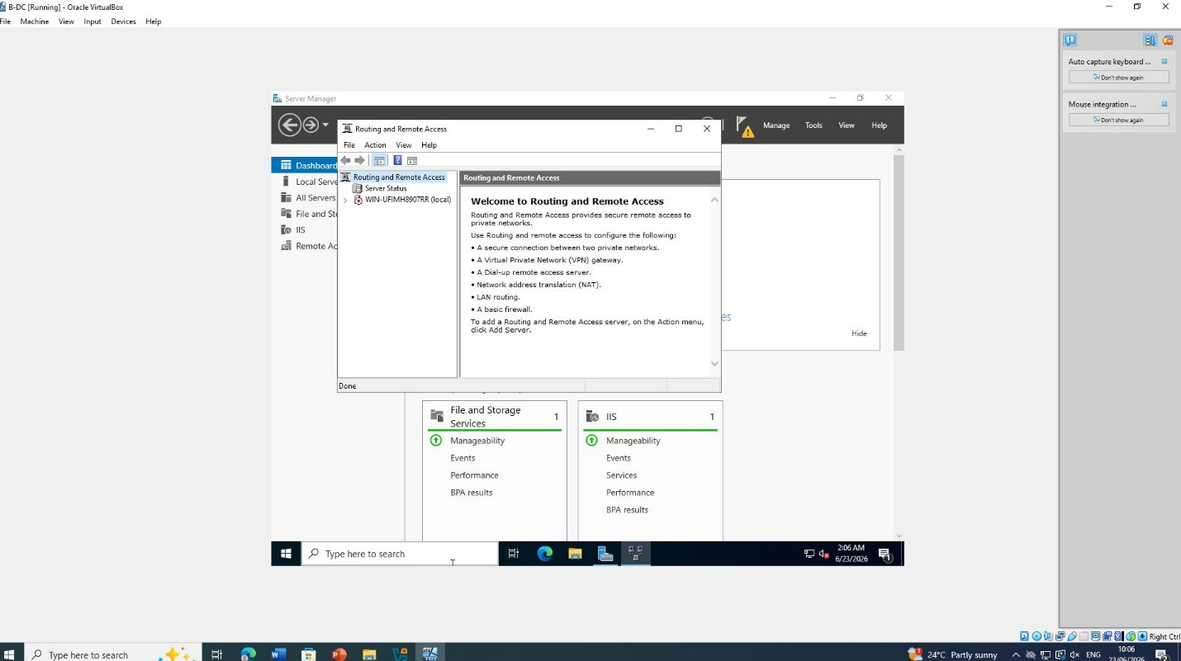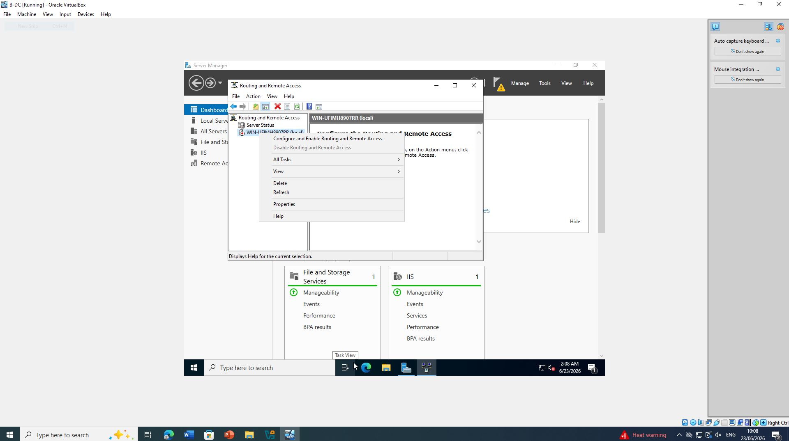

Figure 6 and 7: RRAS configured and running

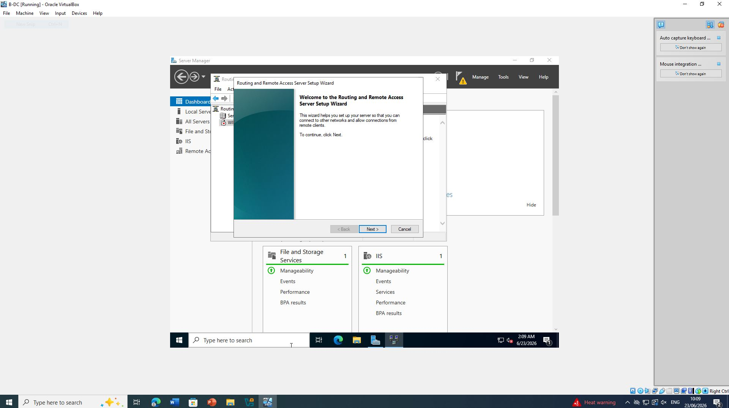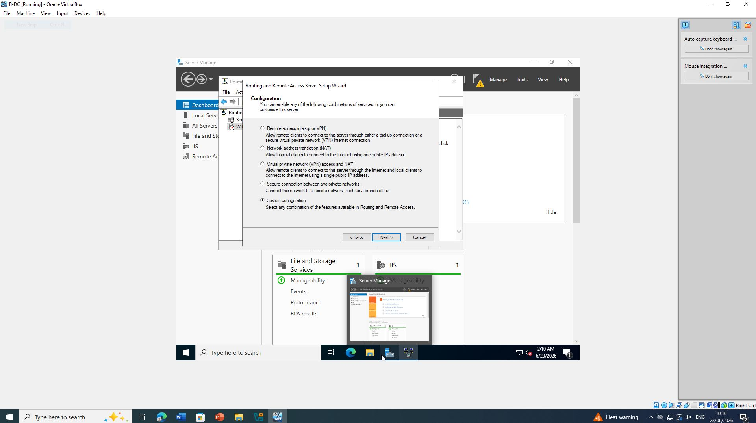

Figure 8 and 9: RRAS configured and running

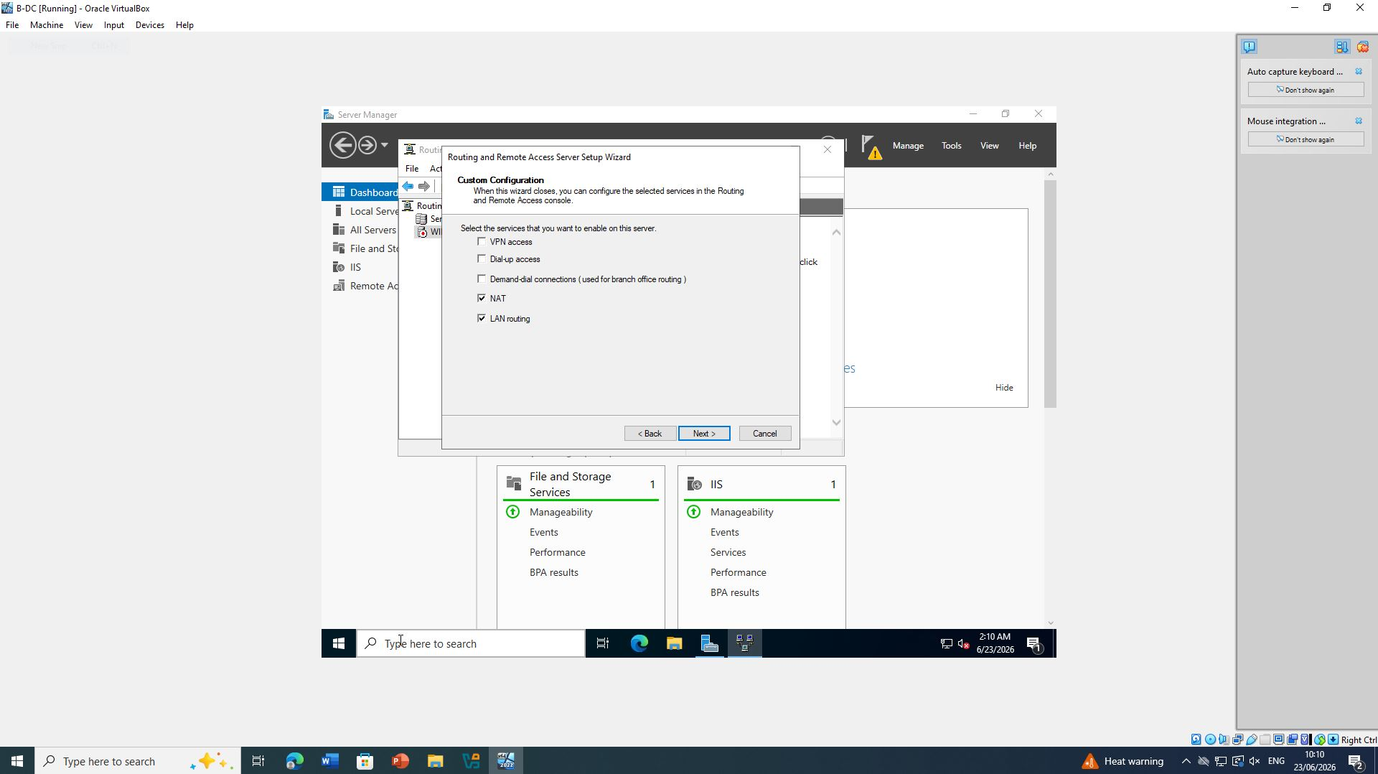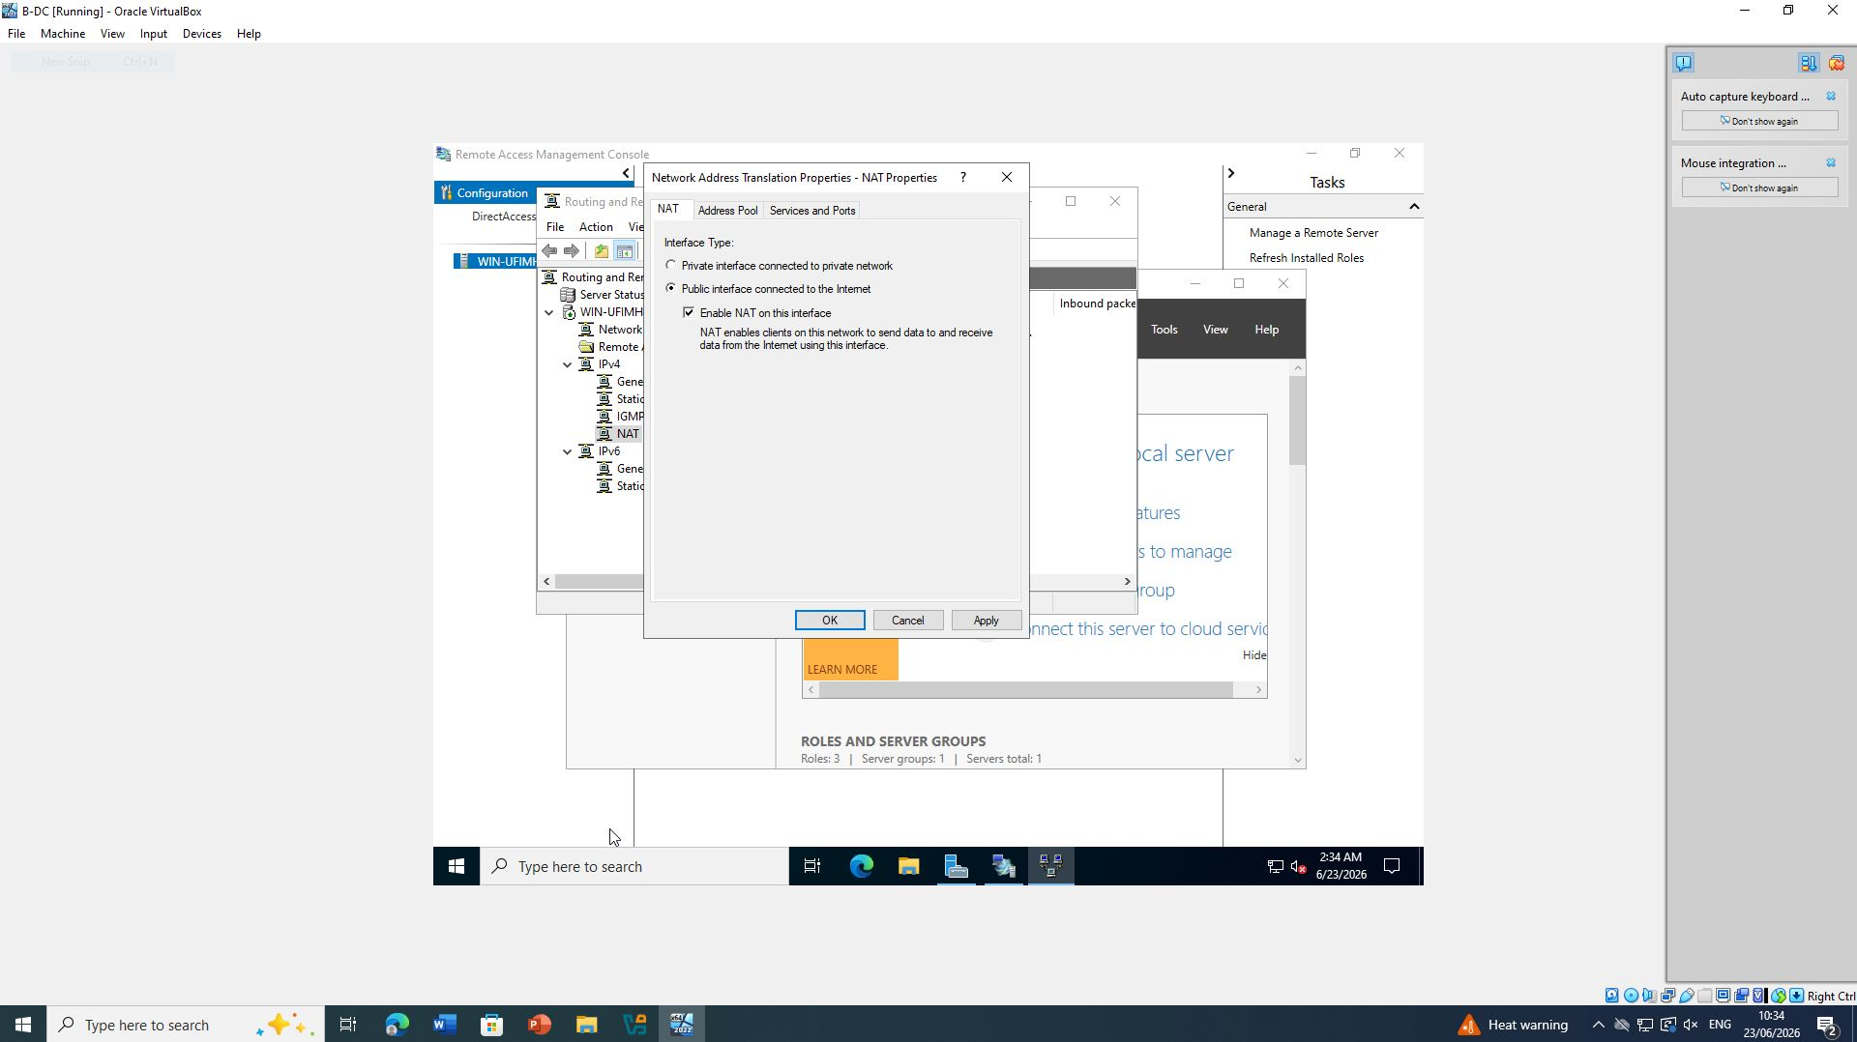

Figure 10 and 11: RRAS configured and running

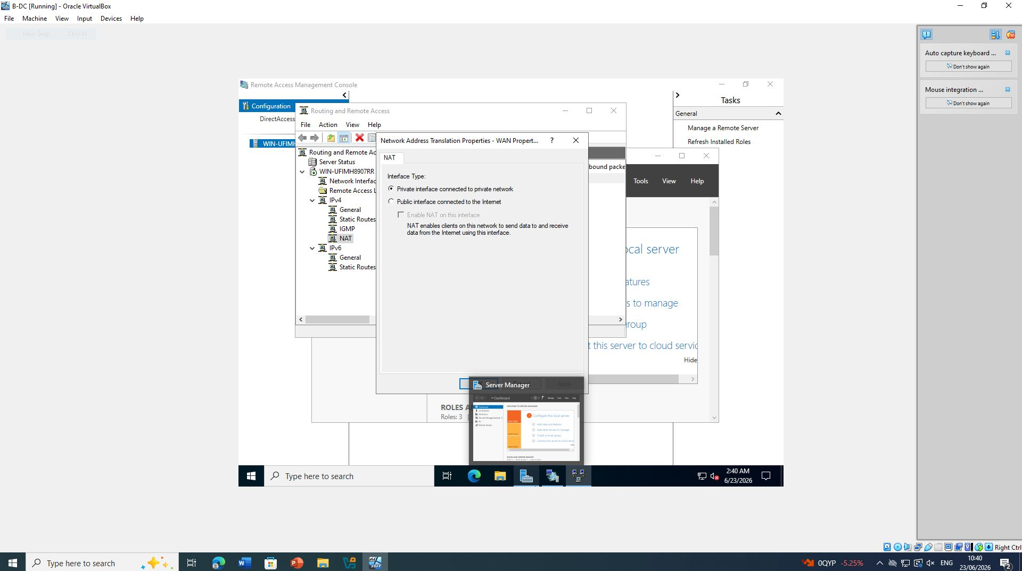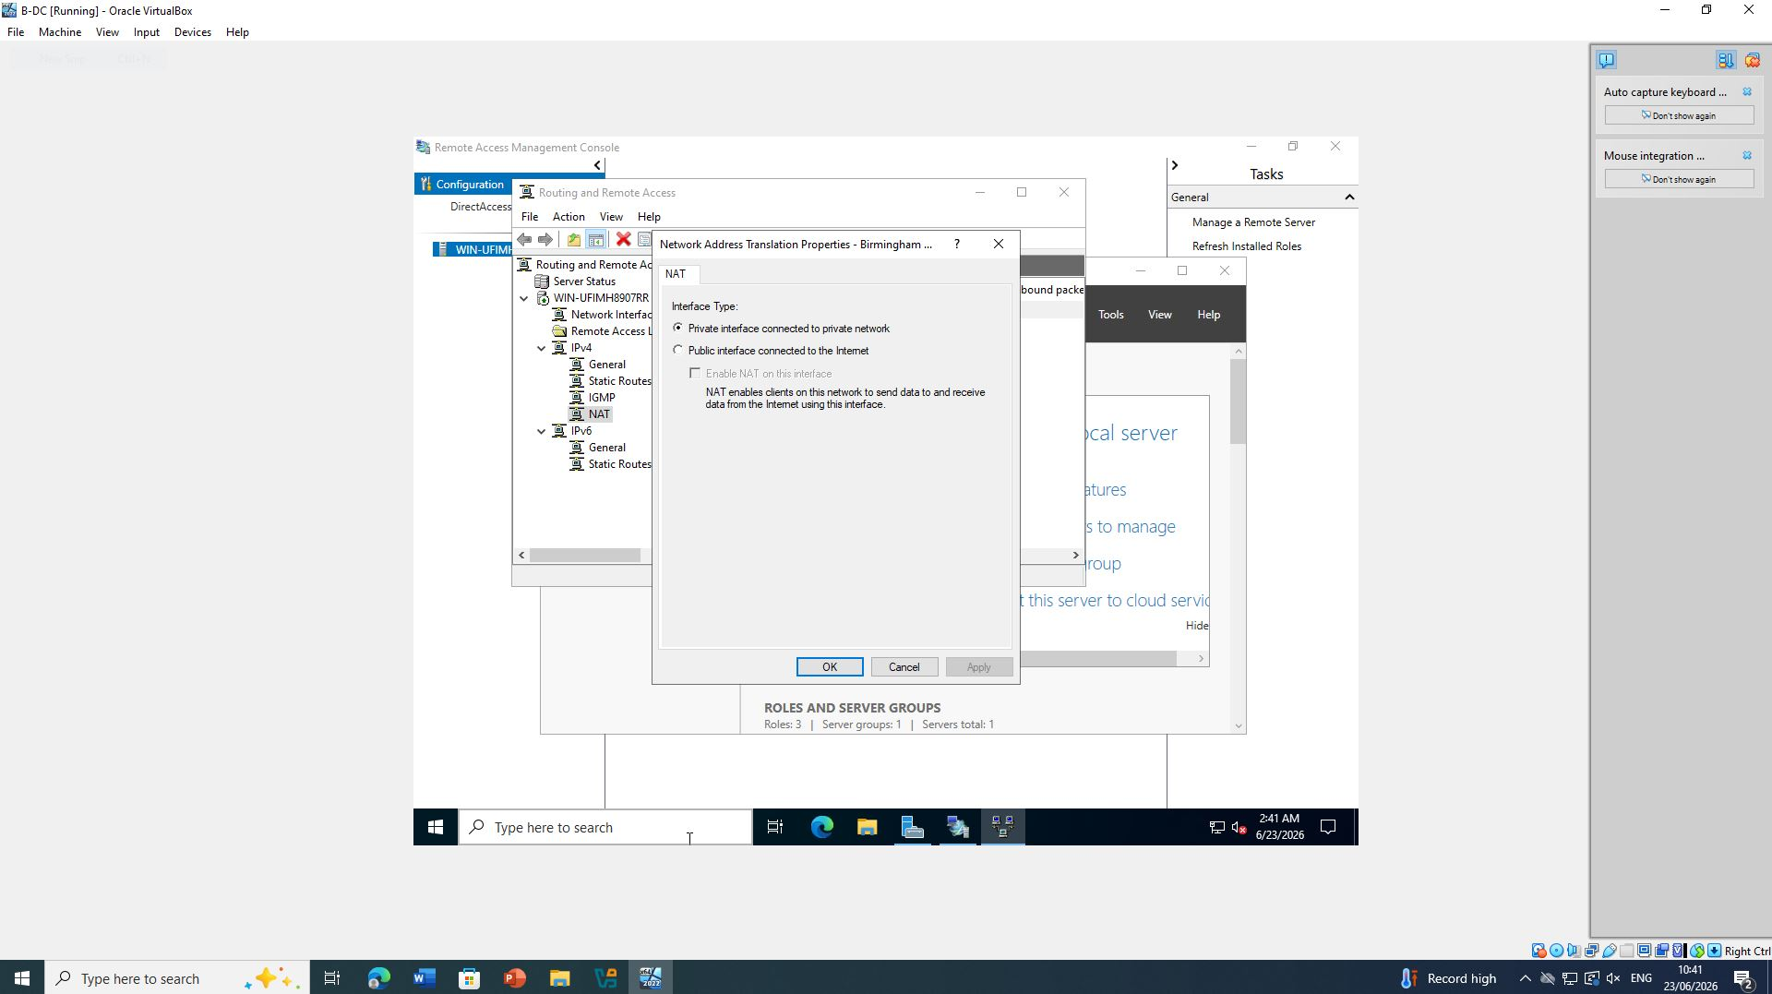

Figure 12 and 13: RRAS configured and running

Windows Firewall Configuration
By default, Windows Firewall blocks ICMP Echo Requests.
To allow connectivity testing, ICMP was enabled.
Procedure:
- Open
Windows Defender Firewall with Advanced Security
- Navigate to
Inbound Rules
- Locate
File and Printer Sharing (Echo Request – ICMPv4-In)
- Enable the rule.
Alternatively PowerShell can be used:
Allowing ICMP traffic assists network administrators in troubleshooting routing problems and verifying end-to-end connectivity.
(Microsoft, 2024)
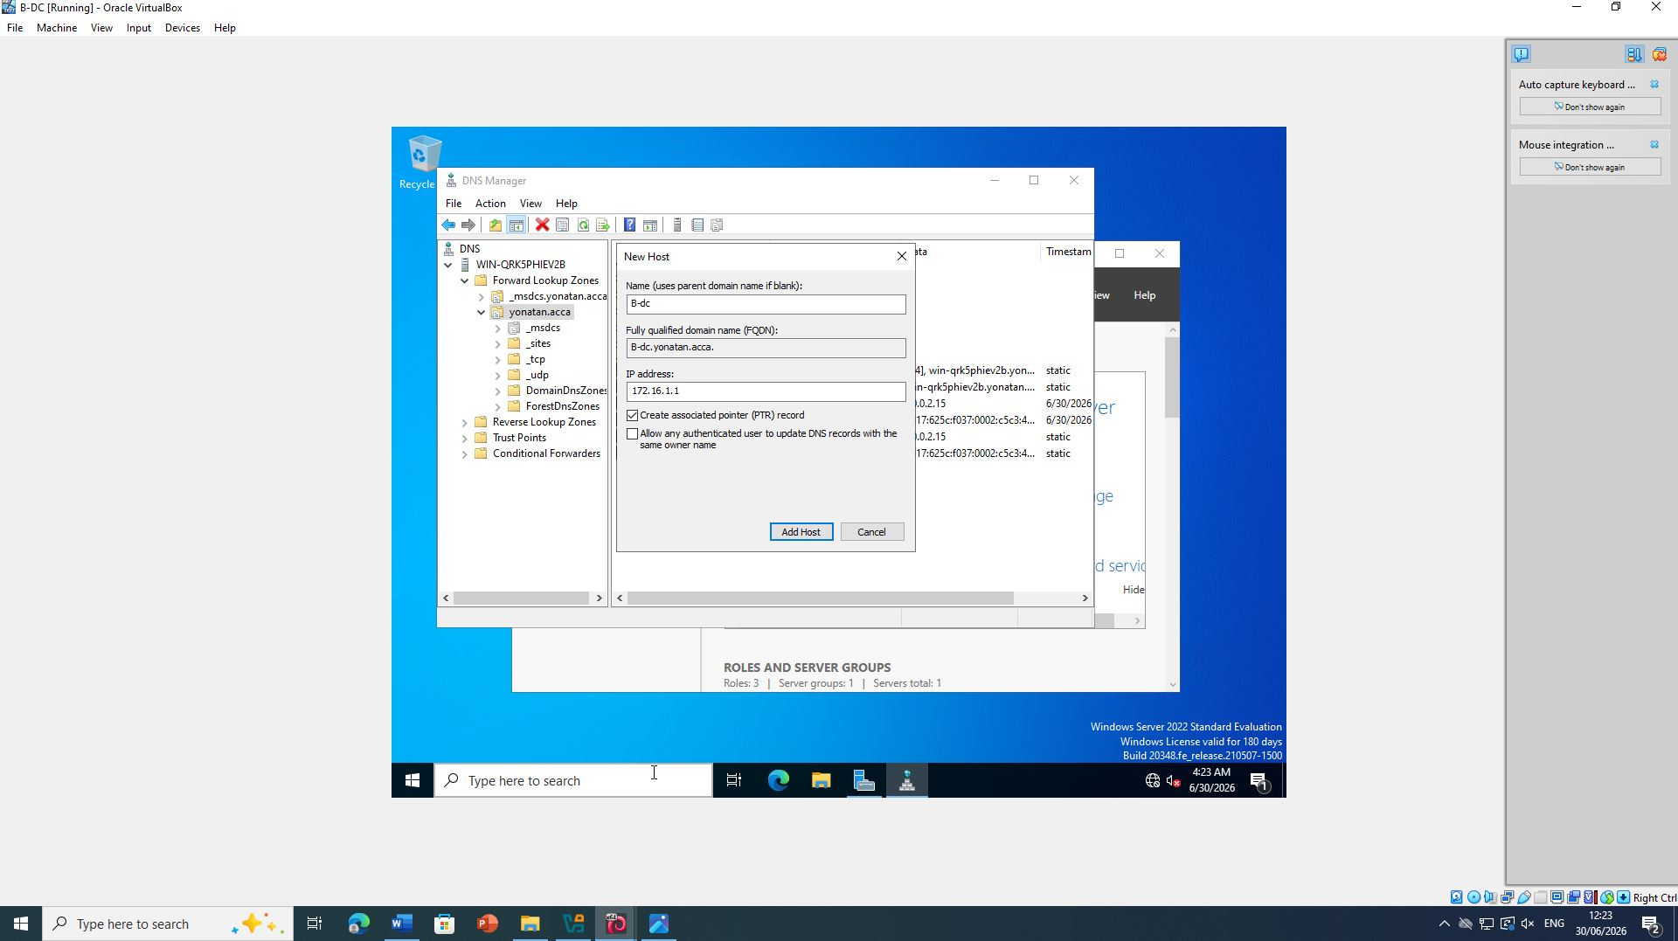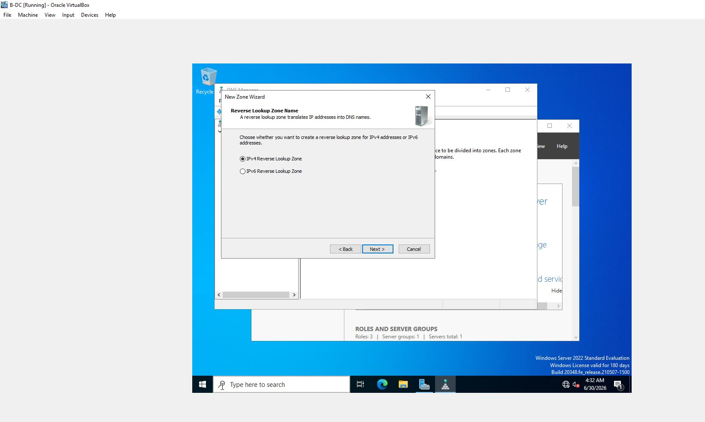

Figure 14 and 15: Windows Firewall (ICMP Rule Enabled)

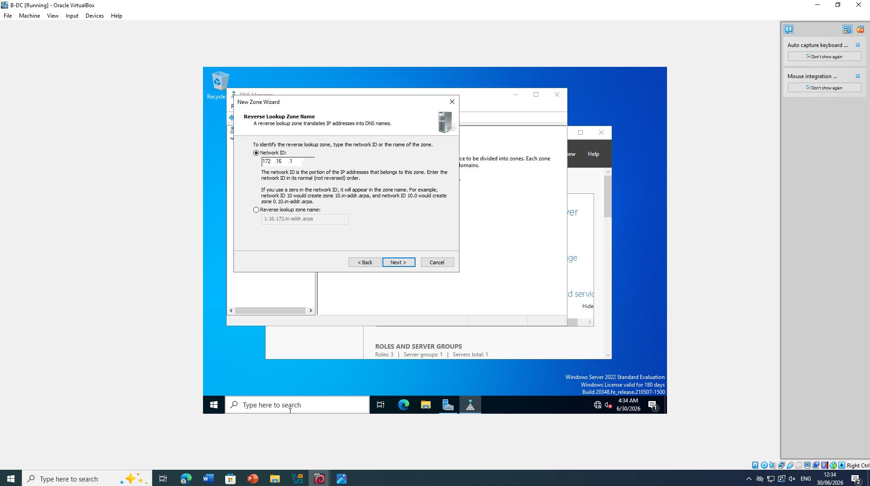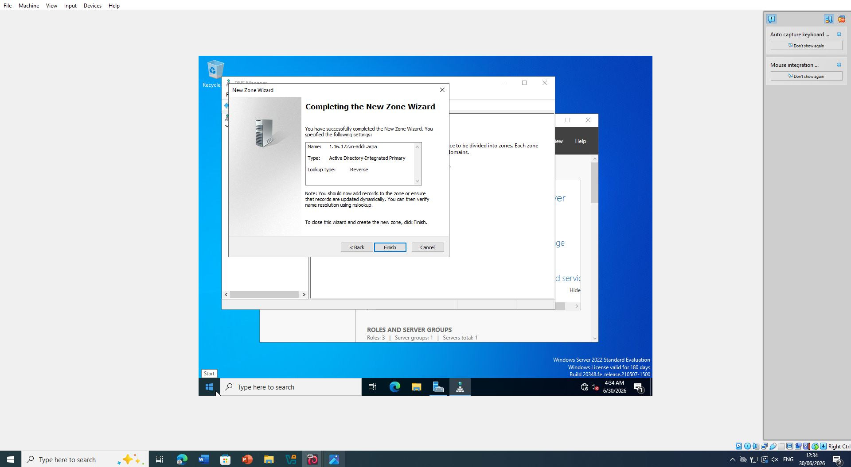

Figure 15 and 17: Windows Firewall (ICMP Rule Enabled)

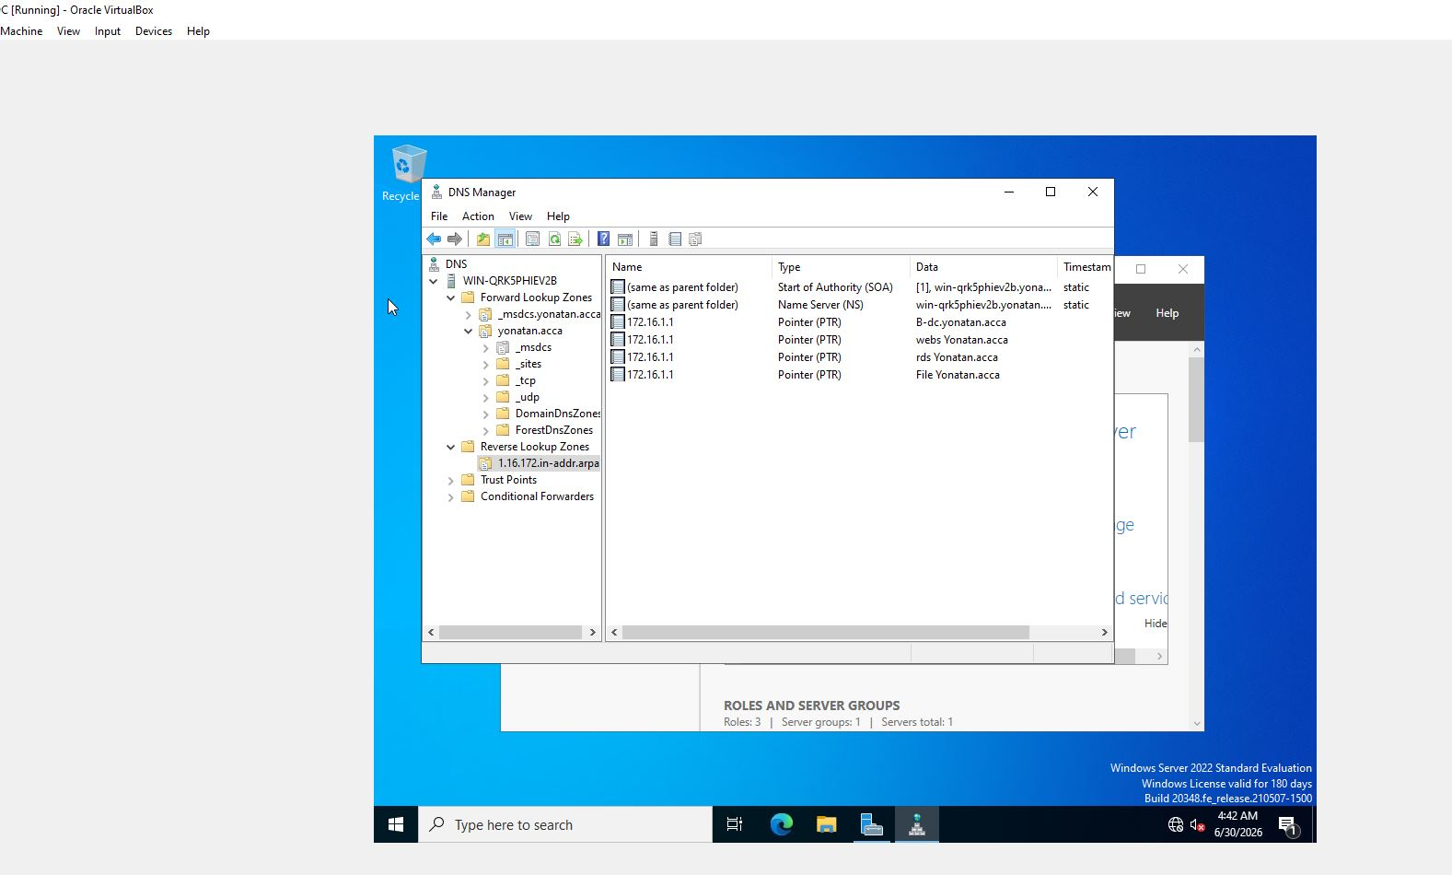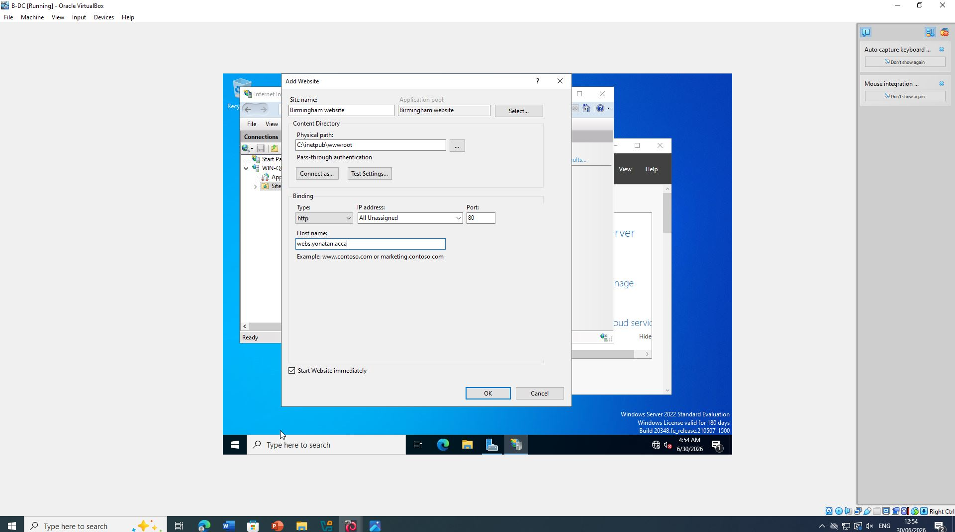

Figure 18 and 19: Windows Firewall (ICMP Rule Enabled)

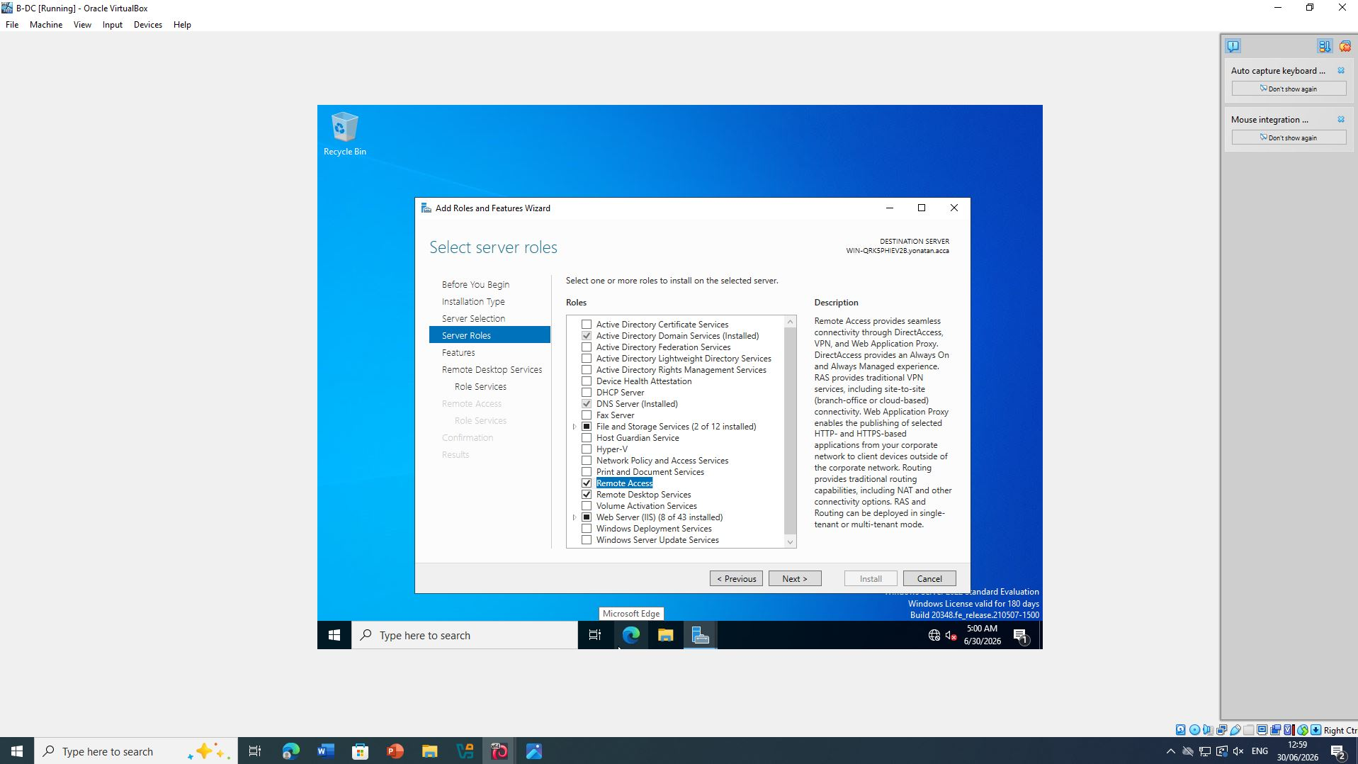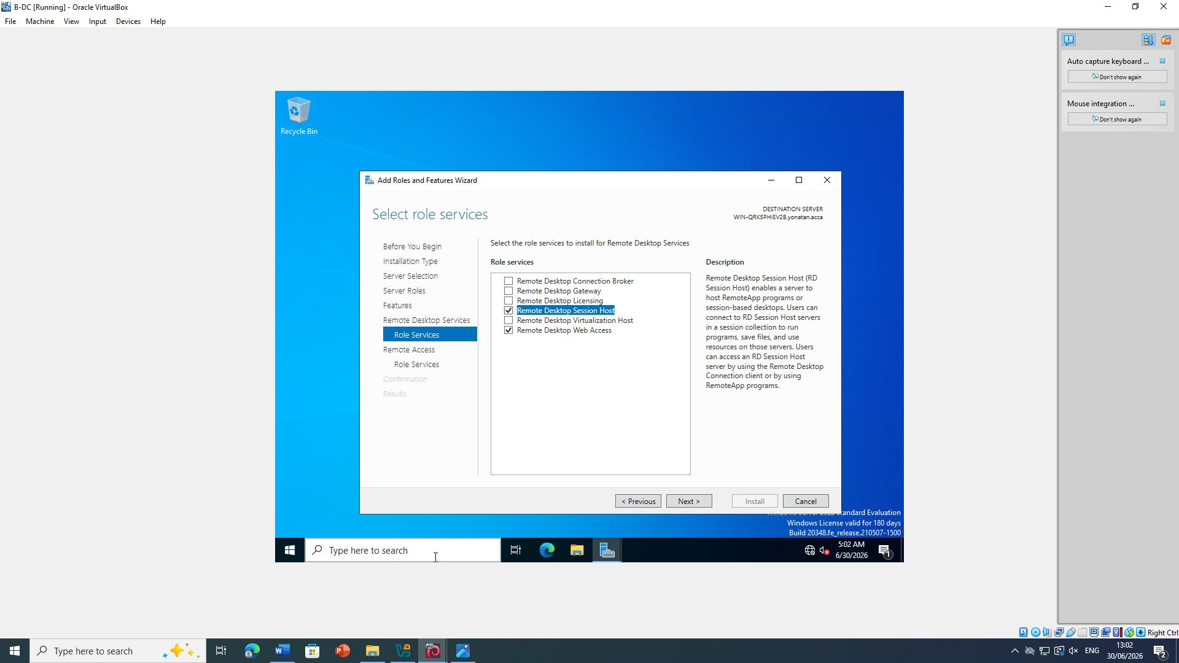

Figure 20 and 21: Windows Firewall (ICMP Rule Enabled)

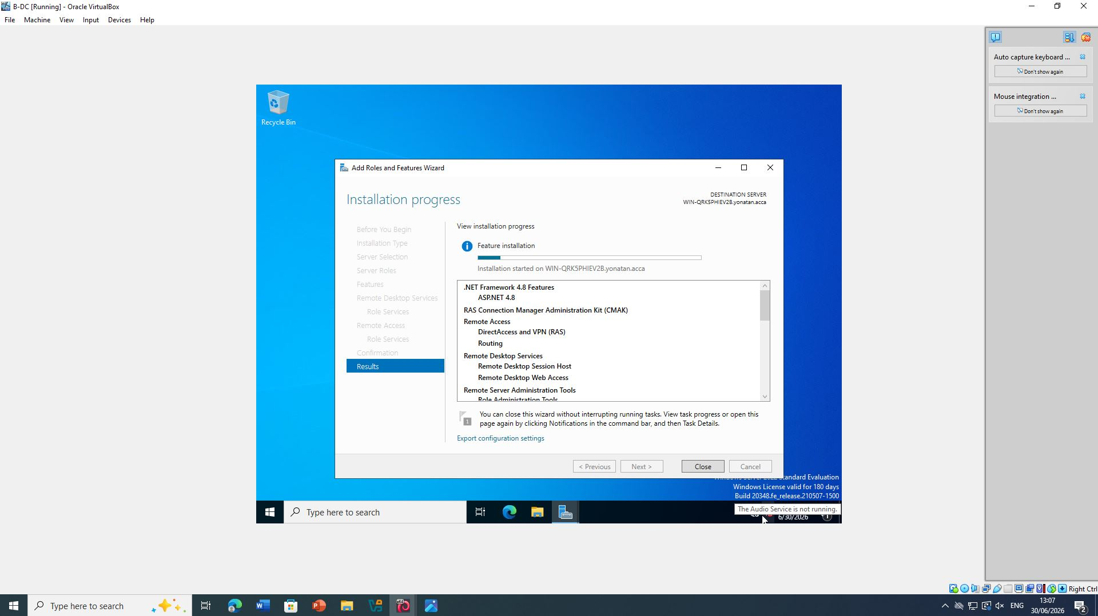

Figure 22: Windows Firewall (ICMP Rule Enabled)

Verification
Connectivity was verified using the Ping command.
Example:
ping 172.16.2.1
Successful replies confirmed that RRAS was routing traffic correctly.
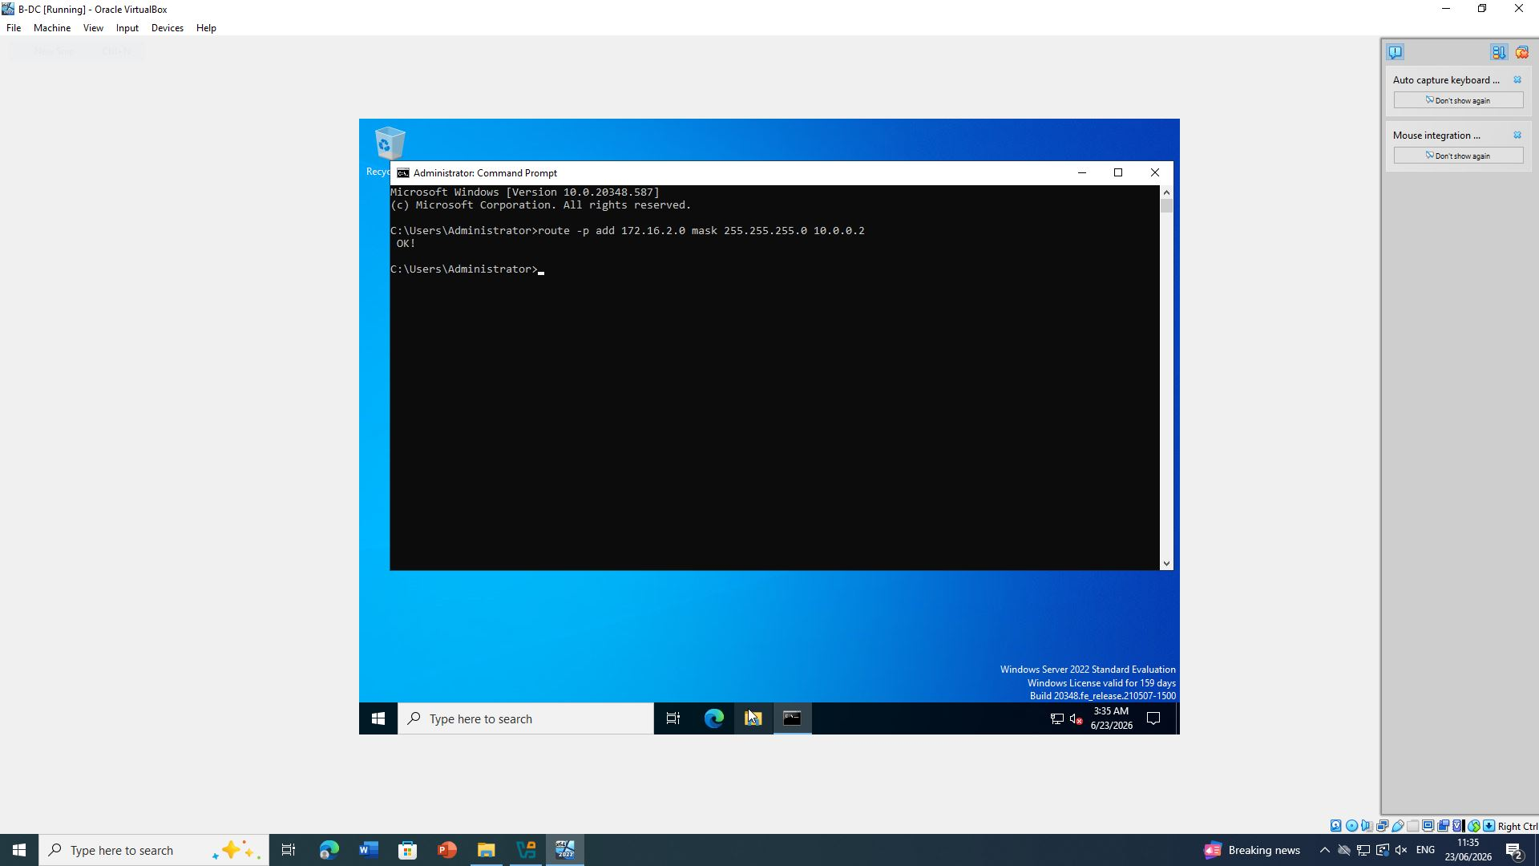

Figure 23: Ping from Windows Server

Outcome
The Windows Server successfully performed Layer 3 routing between Birmingham and London. RRAS dynamically forwarded packets received from one interface to the other, allowing communication between both LANs.

1.2 Routing in London Network

Objective
Unlike Windows Server, Debian Linux uses kernel IP forwarding for routing.
The objective was to enable persistent IP forwarding and configure static routes so that Linux forwards packets between the London LAN and Birmingham network.
According to Nemeth et al. (2021), Linux forwarding is controlled through the kernel parameter net.ipv4.ip_forward, which determines whether the operating system behaves as a workstation or as a router.

Enabling IP Forwarding
First, temporary forwarding was enabled:
sudo sysctl -w net.ipv4.ip_forward=1
To make the configuration persistent after reboot:
sudo nano /etc/sysctl.conf
Locate:
#net.ipv4.ip_forward=1
Modify to:
net.ipv4.ip_forward=1
Save the file.
Reload configuration:
sudo sysctl -p
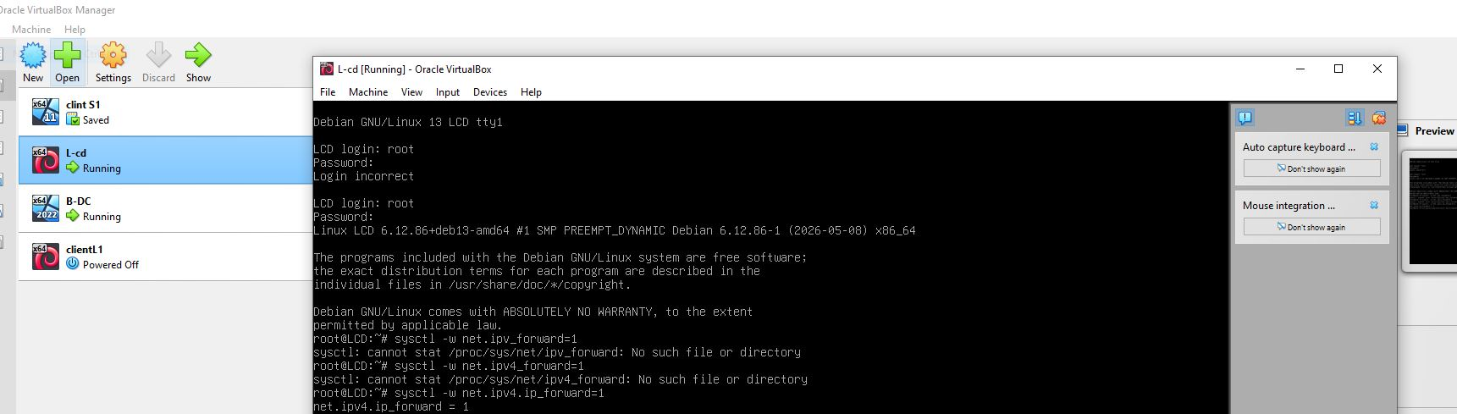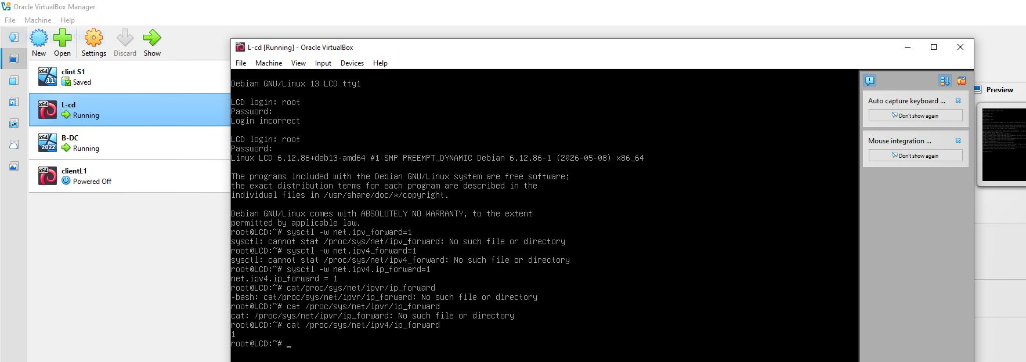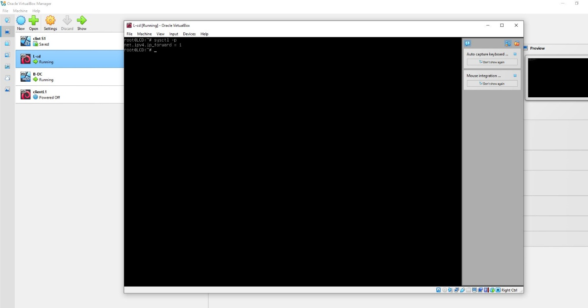

Figure 24, 25, 26: Debian IP Forwarding (sysctl)
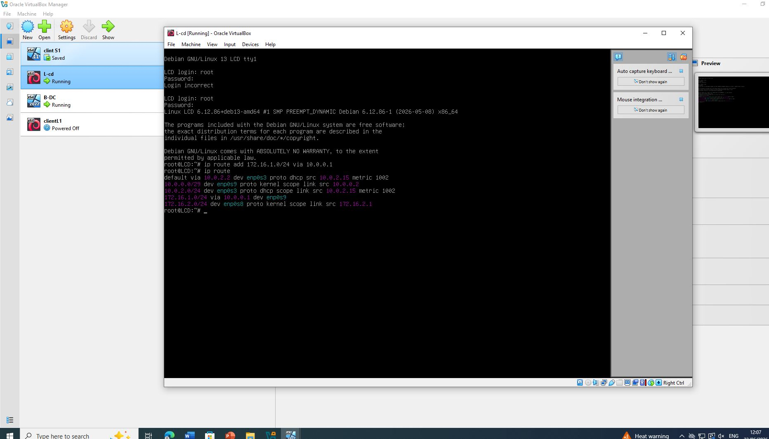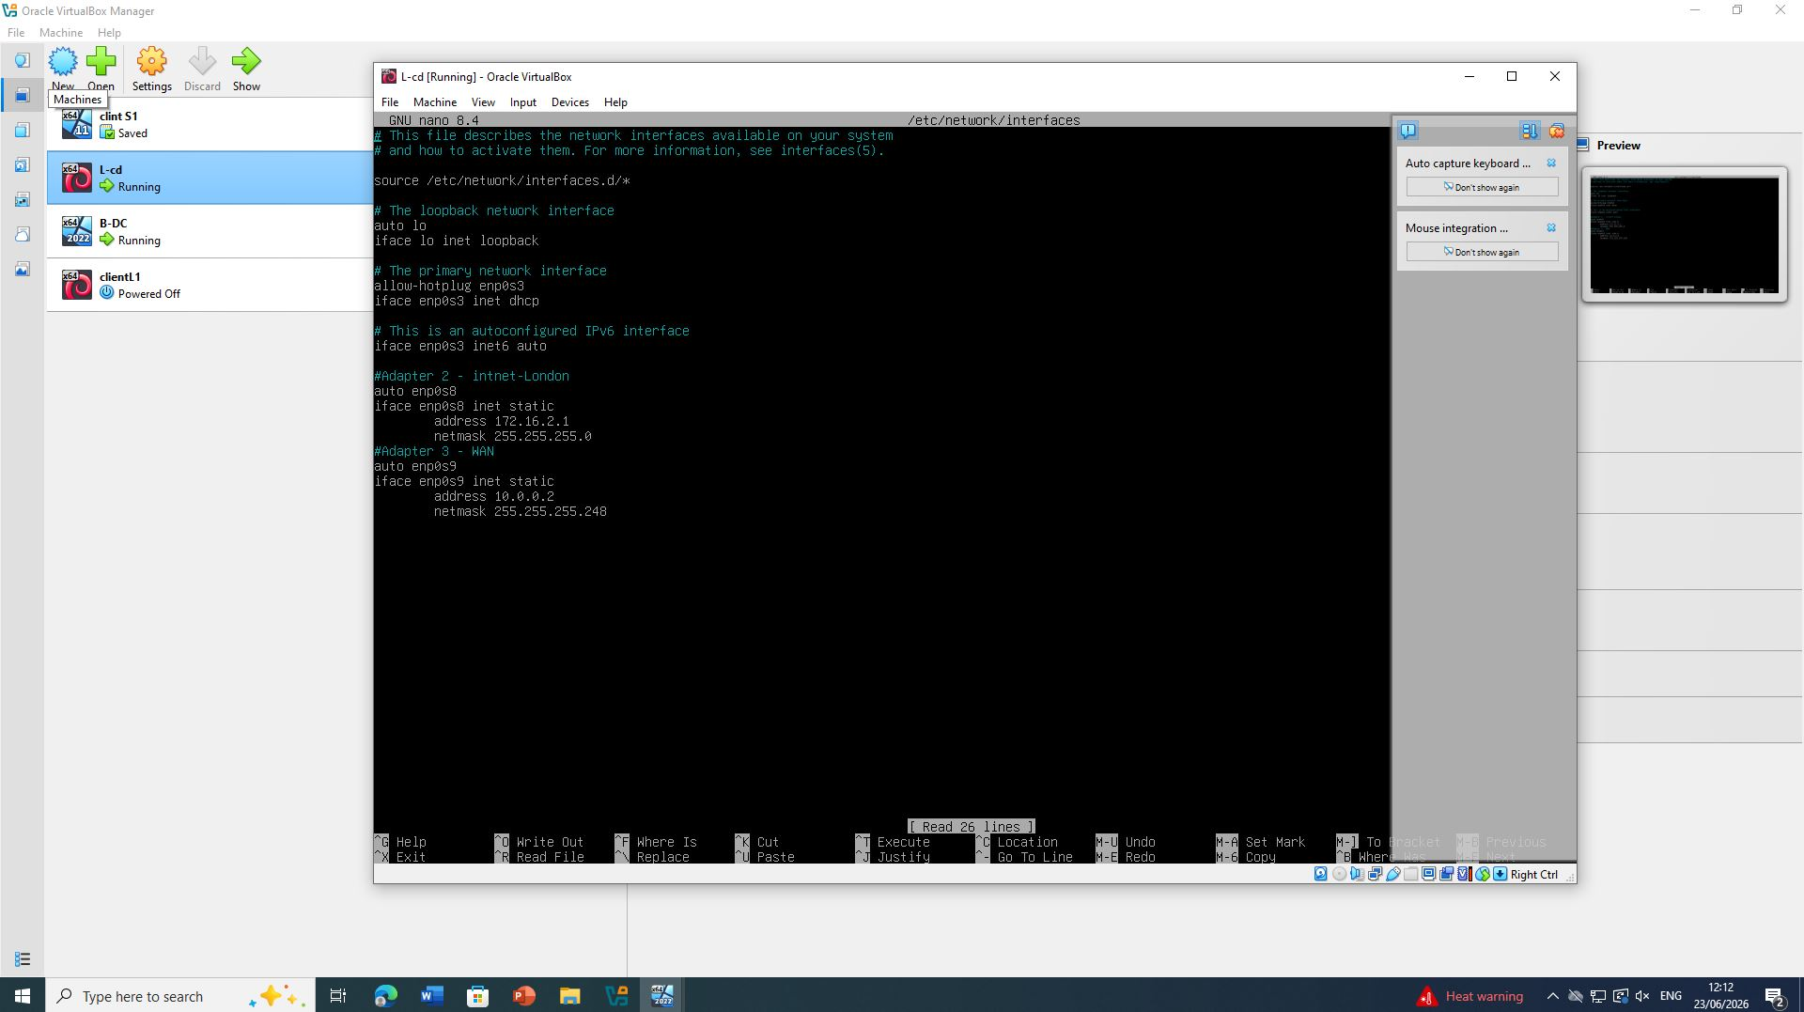
Figure 27 and 28: Debian IP Forwarding (sysctl)

Configuring Static Route
A route was added so Debian knows how to reach Birmingham.
Example
sudo ip route add 172.16.1.0/24 via 10.0.0.1
To make it persistent:
Edit
/etc/network/interfaces
or
Netplan configuration depending on installation.
The route forwards all Birmingham traffic through the Windows RRAS interface.

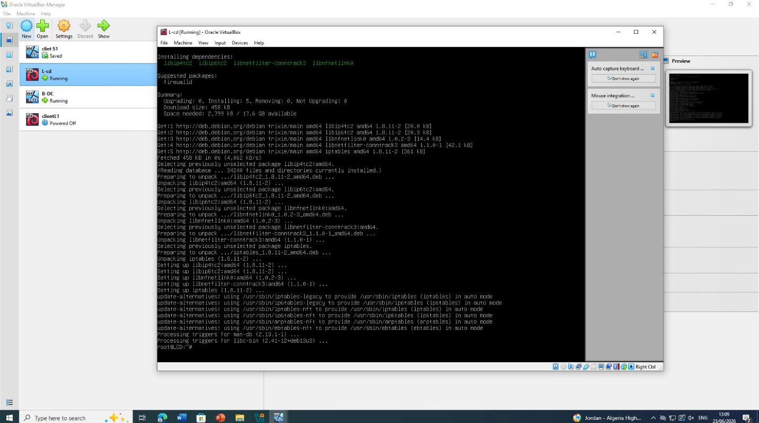
Figure 29: Debian Static Route (ip route)

Configuring Linux Firewall
If UFW is enabled:
sudo ufw allow proto icmp
If iptables is used:
sudo iptables -A INPUT -p icmp -j ACCEPT
Firewall rules permit diagnostic traffic while maintaining network security.

Verification
Connectivity was verified using:
ping 172.16.1.1
and
ping 172.16.1.100
Replies confirmed routing functionality.
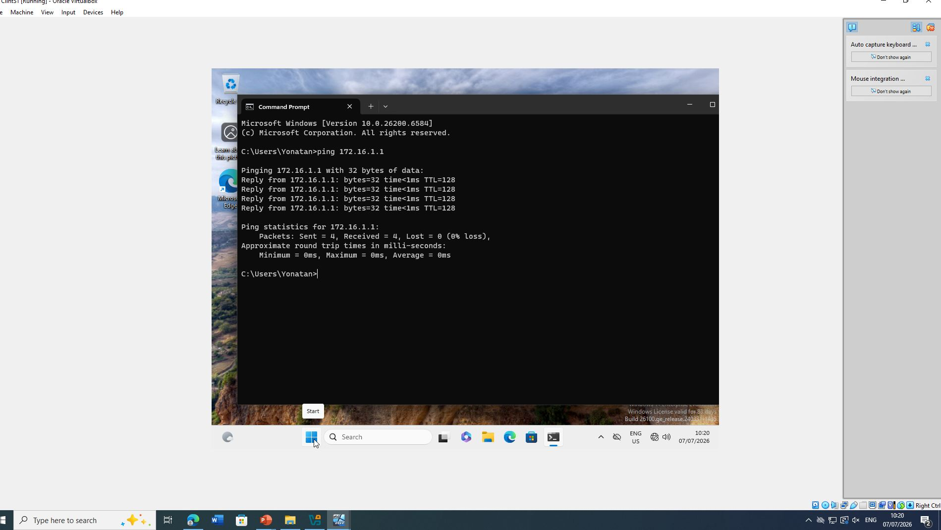
Figure 30: Linux Firewall (iptables -L or ufw status)

Discussion
The routing configuration successfully connected both geographical sites through a routed network. RRAS on Windows Server 2022 acted as the enterprise router, while Debian Linux performed routing through kernel IP forwarding. Enabling ICMP traffic allowed administrators to verify network connectivity and troubleshoot routing issues effectively.
Static routing is appropriate for small enterprise environments because it offers simplicity and low administrative overhead. However, in larger organisations, dynamic routing protocols such as OSPF or RIP would be preferred to improve scalability and fault tolerance (Forouzan, 2017).

Conclusion
The routing objectives specified in Coursework 2 were successfully implemented. Windows Server 2022 was configured using Routing and Remote Access Services (RRAS), enabling packet forwarding between the Birmingham and London networks. Debian Server was configured with persistent IP forwarding and static routes to ensure inter-network communication. Firewall rules permitting ICMP traffic enabled connectivity testing, and successful ping responses verified that routing was functioning correctly. These configurations provide the foundation for implementing additional network services such as DHCP Relay, file sharing, certificate services, and security policies in later sections of the coursework.

2. Domain Server (Birmingham)

Introduction
Microsoft Active Directory Domain Services (AD DS) provides centralized authentication, authorization, and management of users, computers, and network resources within an enterprise environment. In this coursework, the Birmingham Windows Server 2022 was promoted to a Domain Controller and configured with a new Active Directory forest named fahim.acca (replace with your actual first name if required by your lecturer). The server also hosted the Domain Name System (DNS), allowing both forward and reverse name resolution for devices located in the Birmingham and London networks.
Implementing Active Directory simplifies administrative tasks by enabling centralized security policies, user authentication, and resource management across multiple network locations (Microsoft, 2024a).

2.1 Creating the Forest (yonatan.acca)

Objective
The first stage was to create a new Active Directory forest named yonatan.acca using Windows Server 2022. The server was promoted from a standalone server to a Domain Controller, and DNS was installed automatically during the promotion process.
The following configuration was completed:
- Installed Active Directory Domain Services (AD DS)
- Installed DNS Server
- Created a new forest named yonatan.acca
- Configured the server as the first Domain Controller
- Selected the functional level of Windows Server 2022
- Configured Directory Services Restore Mode (DSRM) password
- Restarted the server after promotion
Creating a forest establishes the highest logical boundary within Active Directory and provides a secure authentication framework for all domain members (Stallings, 2021).

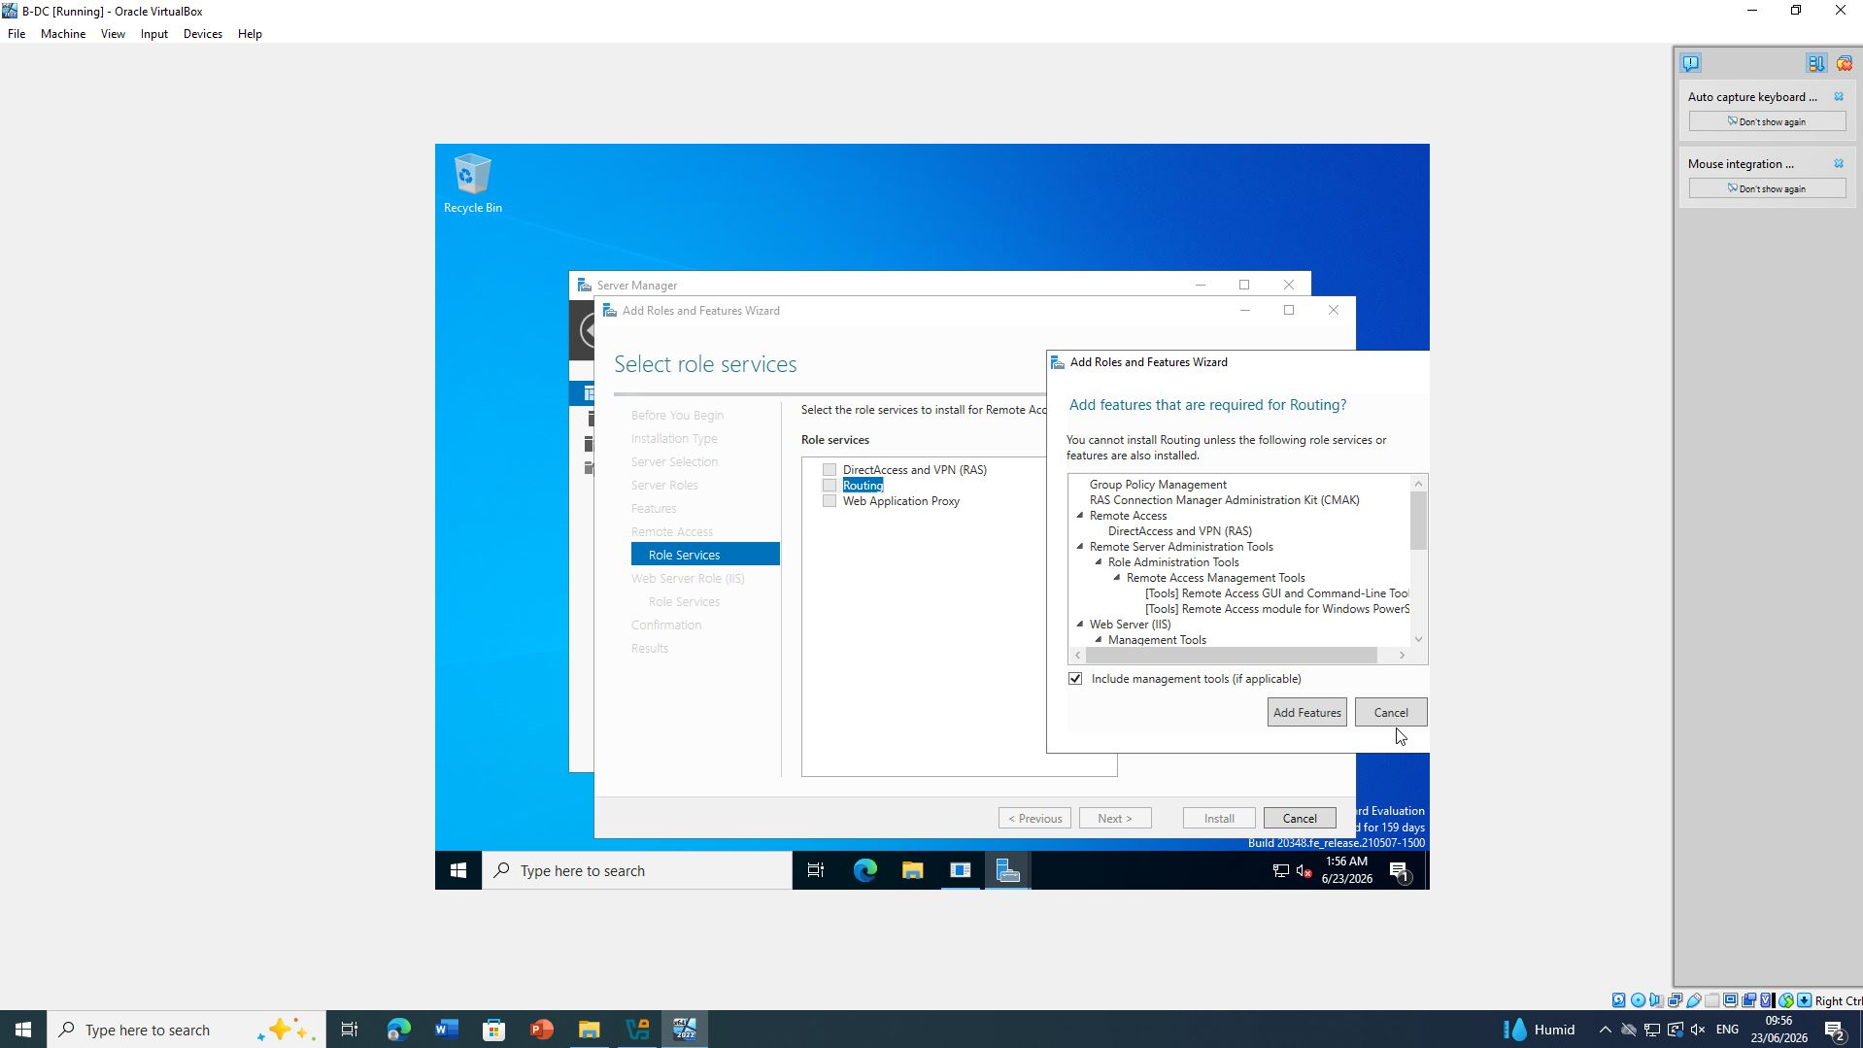
Figure 31: AD DS Installation
Figure 32: – Domain Controller Promotion

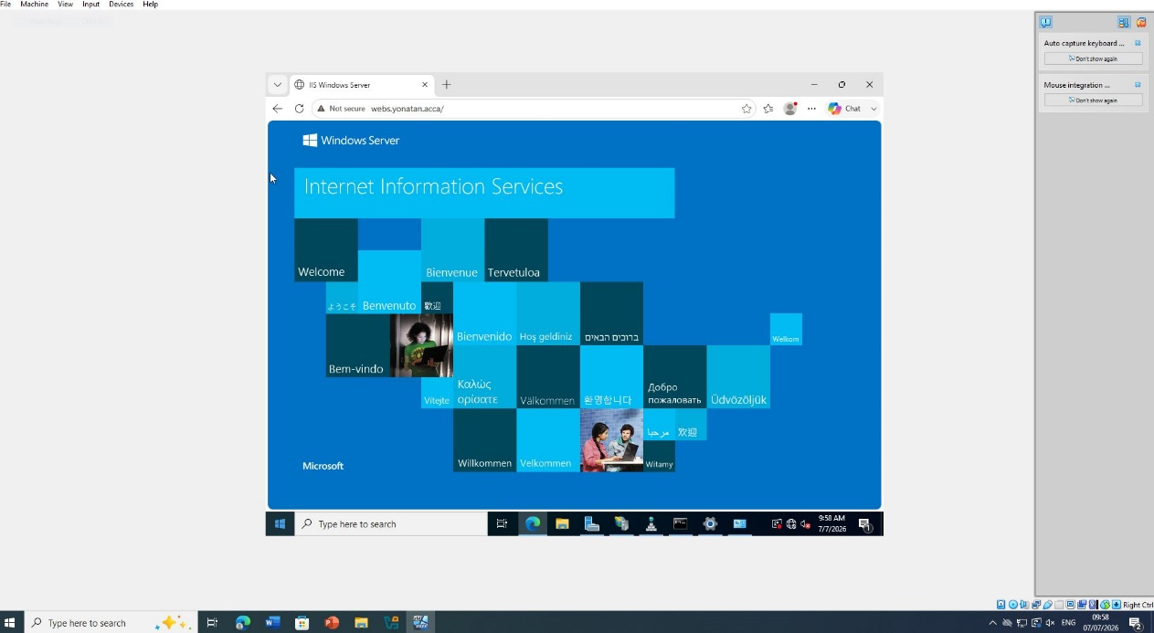

Figure 33: – Active Directory Users and Computers

Purpose: Verification that the Domain Controller has been created successfully.

2.2 Creating A Records

Objective
After configuring DNS, Host (A) records were created for all critical servers in both Birmingham and London. Forward Lookup Zones allow DNS to translate hostnames into IP addresses, enabling clients to locate network services efficiently.
The following A records were created.
Host Name | IP Address | Purpose
B-DC | 172.16.1.1 | Birmingham Domain Controller
L-CD | 172.16.2.1 | London Debian Server
ClientS1 | DHCP Assigned | Windows Client
ClientL1 | DHCP Assigned | Debian Client
Additional infrastructure records such as DNS Server and DHCP Server were automatically registered because these services run on the Domain Controller.
Creating accurate A records improves name resolution and supports future network scalability (Microsoft, 2024b).

Figure 34: – Forward Lookup Zone

2.3 Creating Reverse Lookup Zone (PTR Records)

Objective
A Reverse Lookup Zone was created to enable reverse DNS lookups, allowing IP addresses to be translated back into hostnames.
The reverse lookup zone for the Birmingham network was created using the network ID:
172.16.1.x
PTR records were added for:
IP Address | PTR Record
172.16.1.1 | B-DC.yonotan.acca
172.16.2.1 | L-CD.yonotan.acca
PTR records improve network troubleshooting because administrators can verify host identities using IP addresses rather than hostnames (Forouzan, 2017).

Figure 35: – Reverse Lookup Zone

Password Policy (Excellent Work Requirement)
Although the coursework only required the creation of the Domain Controller, an enterprise Active Directory environment should also enforce secure password policies to improve security.
The following password settings were configured through Group Policy:
- Minimum password length: 8 characters
- Password complexity enabled
- Maximum password age: 90 days
- Password history: 24 passwords remembered
- Account lockout threshold: 5 failed attempts
These settings reduce the risk of brute-force attacks and unauthorized access (Microsoft, 2024c).
s

Figure 36: – Password Policy

Verification
The DNS configuration was verified using the following commands.
Command Prompt:
nslookup B-DC
nslookup L-CD
The successful resolution of hostnames confirmed that the Forward Lookup Zone was functioning correctly.
Reverse lookup was verified using:
nslookup 172.16.1.1
which successfully returned the hostname B-DC.yonotan.acca, confirming that the PTR records were configured correctly.
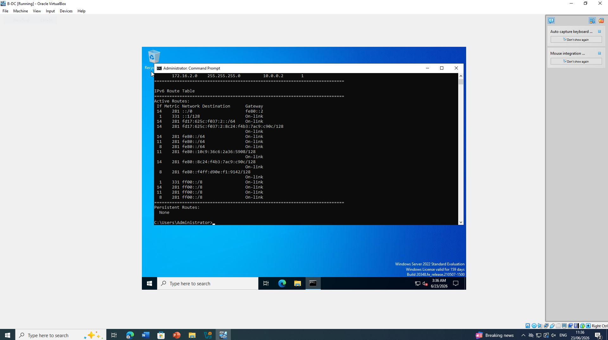

Figure 37: – DNS Verification

Discussion
The Birmingham Windows Server was successfully promoted to a Domain Controller, creating the fahim.acca Active Directory forest. DNS services were integrated with Active Directory, allowing secure and centralized name resolution throughout the Birmingham and London networks. Forward Lookup Zones and Reverse Lookup Zones were configured with appropriate A and PTR records to ensure reliable hostname and IP address resolution. Furthermore, implementing a secure password policy strengthened domain security and aligned the configuration with Microsoft best practices for enterprise environments.

Conclusion
The Domain Server configuration successfully established the Active Directory infrastructure required for the NOSS London 2026 network. The creation of the fahim.acca forest provided centralized authentication and management, while DNS Forward and Reverse Lookup Zones enabled reliable name resolution between the Birmingham and London sites. Configuring secure password policies further enhanced domain security and demonstrated adherence to enterprise networking standards. Overall, the implemented configuration provides a scalable and secure foundation for the remaining network services in the coursework.

3. Encrypted Connection Between Birmingham and London

Introduction
Virtual Private Networks (VPNs) provide a secure communication channel between geographically separated networks by encrypting data transmitted over untrusted networks. In this coursework, a Site-to-Site VPN was configured between the Birmingham and London offices to ensure that data exchanged between the two locations remained confidential, authentic, and protected from interception.
A Site-to-Site VPN establishes a permanent encrypted tunnel between two gateways, allowing users at both locations to communicate securely without requiring individual VPN connections. The implementation of Internet Key Exchange (IKE) and IPsec protocols provides strong encryption, authentication, and secure key management, making the solution suitable for enterprise environments (Microsoft, 2024a).

3.1 Configuring a Site-to-Site VPN

Objective
The objective of this task was to establish a persistent Site-to-Site VPN connection between the Birmingham and London networks. The VPN tunnel allows secure communication between:
Site | Network Address
Birmingham | 172.16.1.0/24
London | 172.16.2.0/24
The VPN gateways communicate through the point-to-point connection:
Interface | IP Address
Birmingham RRAS | 10.0.0.1
London Gateway | 10.0.0.2
The VPN configuration ensures that all traffic between the two internal networks is encrypted before transmission.

Configuring RRAS for VPN
The Windows Server 2022 located in Birmingham was configured using the Routing and Remote Access Service (RRAS).
The following steps were completed:
- Open Server Manager.
- Navigate to Tools → Routing and Remote Access.
- Right-click the server and select Configure and Enable Routing and Remote Access.
- Select Virtual Private Network (VPN) Access and LAN Routing.
- Configure the public interface connected to the London network.
- Start the RRAS service.
This configuration enables the Windows Server to accept and establish VPN connections while continuing to perform routing between both internal networks.
Figure 38: – RRAS VPN Configuration

Configuring the Site-to-Site VPN
A demand-dial interface was created within RRAS to establish communication with the London network.
The configuration included:
- Interface Name: London-VPN
- VPN Type: IKEv2/IPsec
- Remote Gateway: 10.0.0.2
- Authentication Method: Pre-shared Key
- Persistent Connection: Enabled
The use of IKEv2 provides secure key exchange while IPsec encrypts all transmitted packets using industry-standard cryptographic algorithms.

Figure 39: – Demand-Dial Interface

Configuring Strong Encryption
To meet enterprise security requirements, strong encryption settings were applied.
The VPN configuration used:
Setting | Configuration
Protocol | IKEv2
Encryption | AES-256
Integrity | SHA-256
Authentication | Pre-shared Key
Tunnel Mode | IPsec
AES-256 is widely recognised as one of the most secure symmetric encryption algorithms currently available and is recommended for protecting sensitive organisational data (Stallings, 2021).
Figure 40: – Security Settings

Persistent Connection Configuration
To satisfy the coursework requirement, the VPN tunnel was configured as a persistent connection.
Persistent VPN connections automatically reconnect after temporary network failures, reducing administrative intervention and improving service availability.
The demand-dial interface was configured with:
- Auto-connect enabled
- Redial attempts configured
- Connection persistence enabled
This ensures that communication between Birmingham and London remains uninterrupted whenever the WAN connection becomes available again.

Figure 41: – Persistent VPN Connection

Verification
The VPN tunnel was verified by confirming that the interface status displayed Connected within the RRAS console.
Network connectivity was also tested using the following commands:
ping 172.16.2.1
ping 172.16.2.100
Additionally, the routing table was examined using:
route print
Successful replies confirmed that packets were securely routed through the encrypted VPN tunnel.

Figure 42: – VPN Connection Status

Figure 43: – VPN Verification

Discussion
The Site-to-Site VPN successfully established a secure communication channel between the Birmingham and London offices. By combining RRAS with IPsec and IKEv2, all traffic exchanged between both locations was encrypted and authenticated before transmission. Implementing strong encryption algorithms such as AES-256 and SHA-256 significantly reduces the risk of data interception, while the persistent connection feature improves network reliability by automatically re-establishing the tunnel after connection failures. This configuration aligns with industry best practices for secure inter-site communication within enterprise environments.

Conclusion
The encrypted Site-to-Site VPN was successfully configured between the Birmingham and London networks using Routing and Remote Access Services (RRAS). The implementation employed IPsec with IKEv2 to provide strong encryption, secure authentication, and reliable key management. Configuring the VPN as a persistent connection ensured continuous communication between both sites, while verification through connection status and successful ping tests confirmed the correct operation of the encrypted tunnel. Overall, the VPN implementation enhanced the confidentiality, integrity, and availability of network communications, meeting the coursework requirements and demonstrating good enterprise networking practice.

4. Users

4.1 Creating Domain User Accounts

Introduction
Active Directory user accounts provide authenticated access to network resources and enable administrators to centrally manage permissions, security policies, and user identities. The user accounts required for this coursework were created within the yonotan.acca domain using the information supplied in the users_list_updated.xlsx file.
To comply with the coursework requirements, the SAM Account Name followed the naming convention:
First letter of first name + "." + last name
Example:
- First Name: John
- Last Name: Smith
- SAM Account Name: j.smith

PowerShell Bulk User Creation
To improve efficiency and minimise manual errors, PowerShell was used to automate user creation by importing data from the spreadsheet converted to CSV format.
Example script:
Import-Csv users.csv | ForEach-Object {
New-ADUser `
-Name "$($_.FirstName) $($_.LastName)" `
-GivenName $_.FirstName `
-Surname $_.LastName `
-SamAccountName "$($_.Sam)" `
-UserPrincipalName "$($_.Sam)@yonotan.acca" `
-Enabled $true `
-AccountPassword (ConvertTo-SecureString "NotebooK@123" -AsPlainText -Force)
}
Using PowerShell significantly reduces administrative effort compared with creating each user manually in Active Directory Users and Computers (ADUC) (Microsoft, 2024).

Verification
User accounts were verified in:
Server Manager → Tools → Active Directory Users and Computers
All users appeared within the domain and could authenticate successfully.
Figure 44: – PowerShell execution (or ADUC if users were created manually).
Figure 45: – Active Directory Users and Computers showing the created users.

5. Domain Membership

5.1 Joining Computers to the Domain

Introduction
Joining computers to an Active Directory domain allows centralised authentication and enables users to log in using their domain credentials.
The following systems were joined to Yonotanacca:
- B-DC (already Domain Controller)
- L-CD
- ClientS1
- ClientL1

Configuration
Each client was configured by selecting:
System Properties → Computer Name → Change
The computer was joined to the yonotan.acca domain using domain administrator credentials.
After restarting, the login screen displayed the domain name, confirming successful domain membership.

Verification
Successful domain membership was verified by:
- Logging in using a domain account.
- Viewing the computer objects in Active Directory Users and Computers.
Figure 46: – Computer successfully joined to the domain.
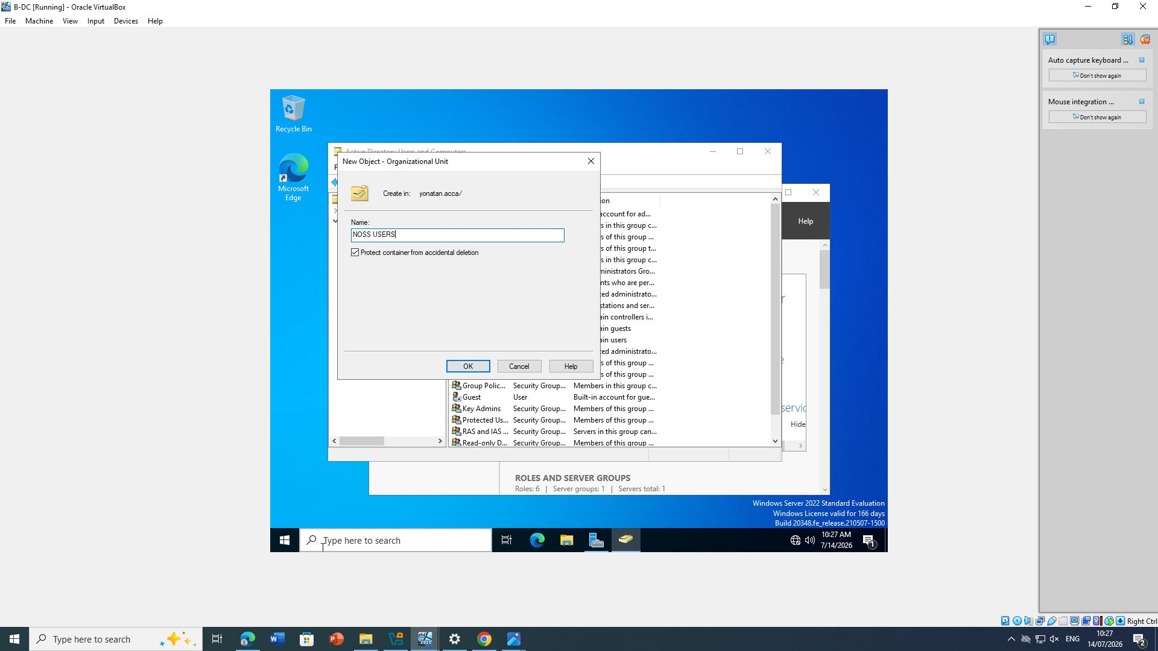
Figure 47: – ADUC showing computer objects.

6. DHCP Server

6.1 Configuring B-DC as DHCP Server

Introduction
Dynamic Host Configuration Protocol (DHCP) automates IP address allocation, reducing manual configuration errors and improving network administration.
The DHCP Server role was installed on B-DC.
Two DHCP scopes were configured:
Network | Address Range
Birmingham | 172.16.1.10 – 172.16.1.20
London | 172.16.2.10 – 172.16.2.20

DHCP Options
Configured options included:
- Default Gateway
- DNS Server
- Domain Name
- Lease Duration
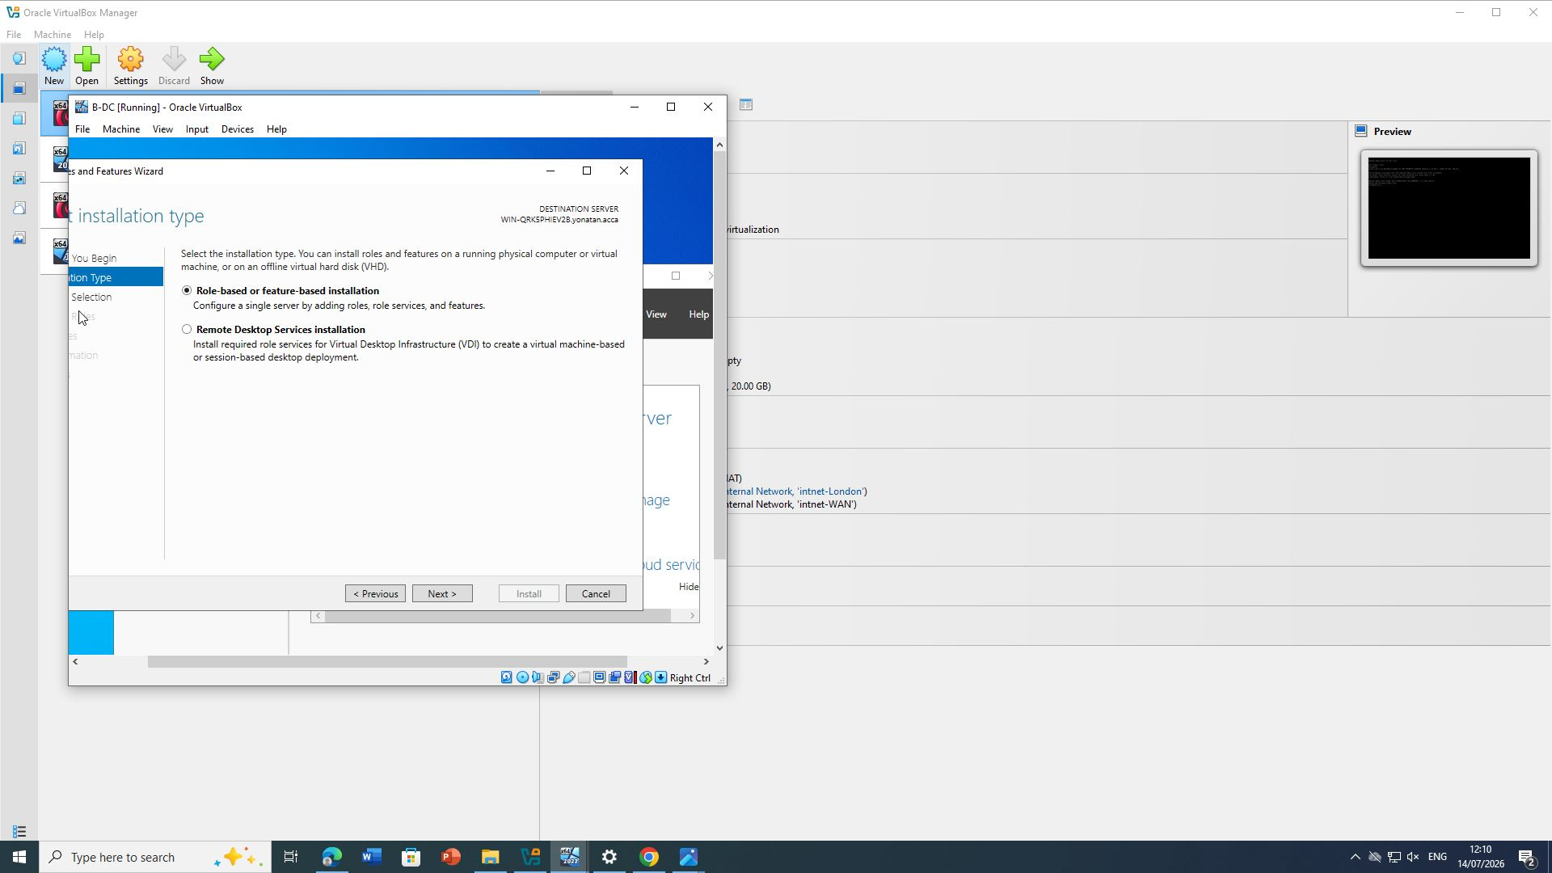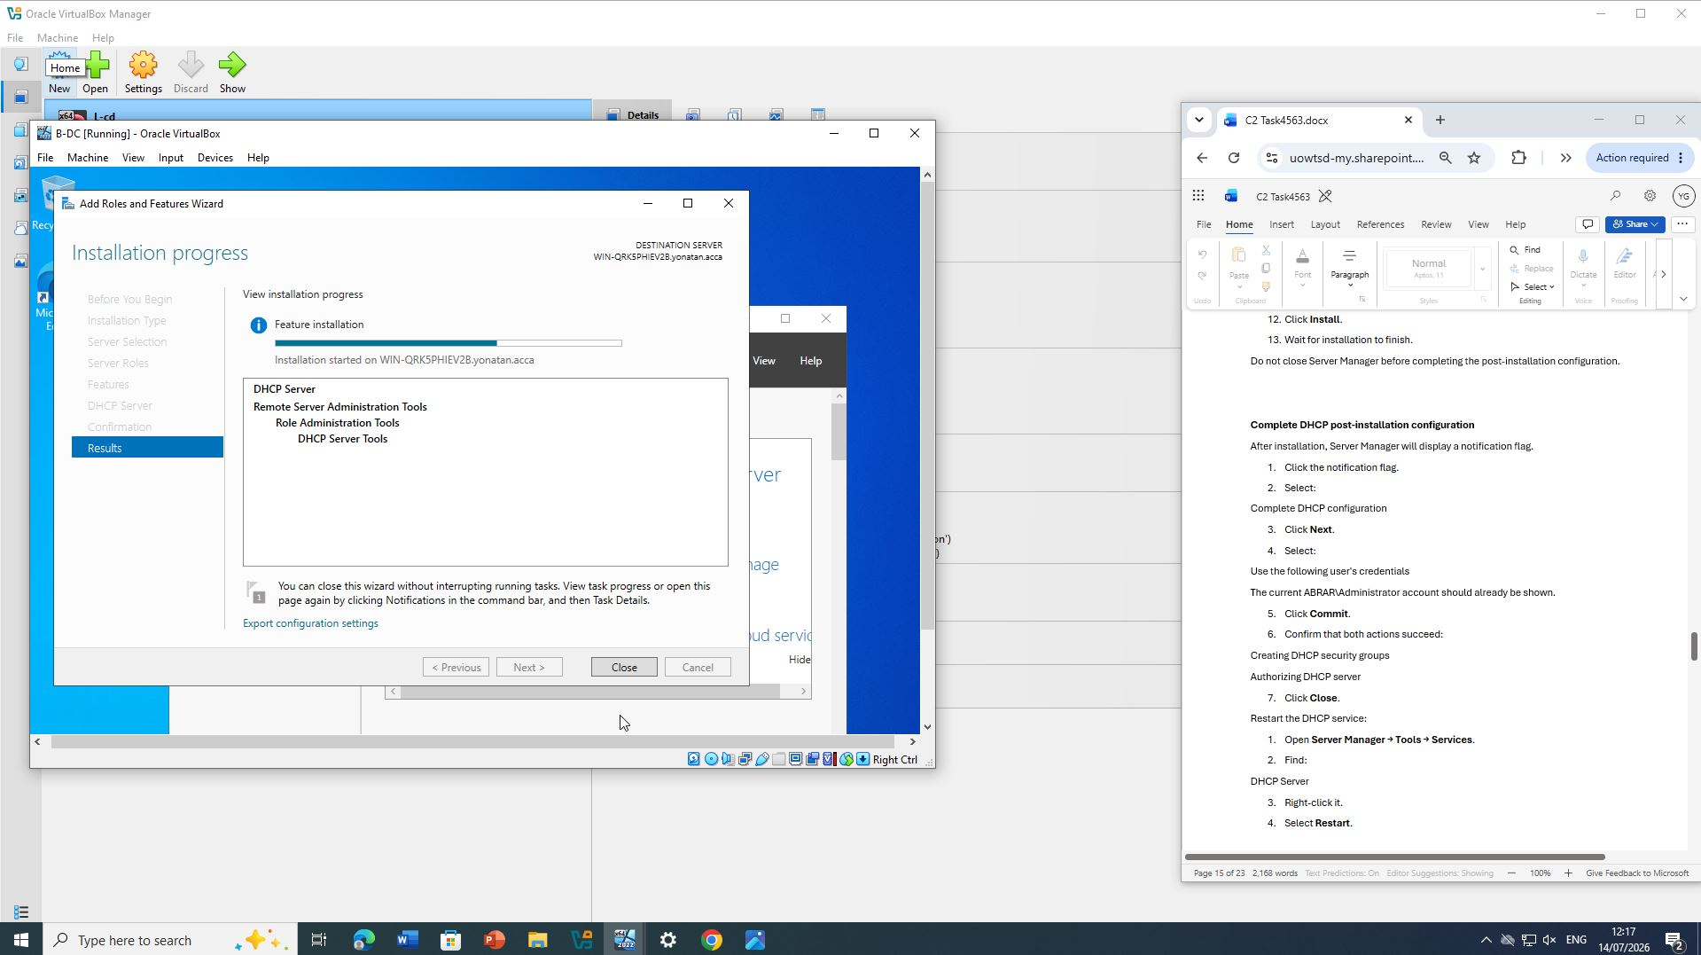

Figure 48 and 49: – DHCP server
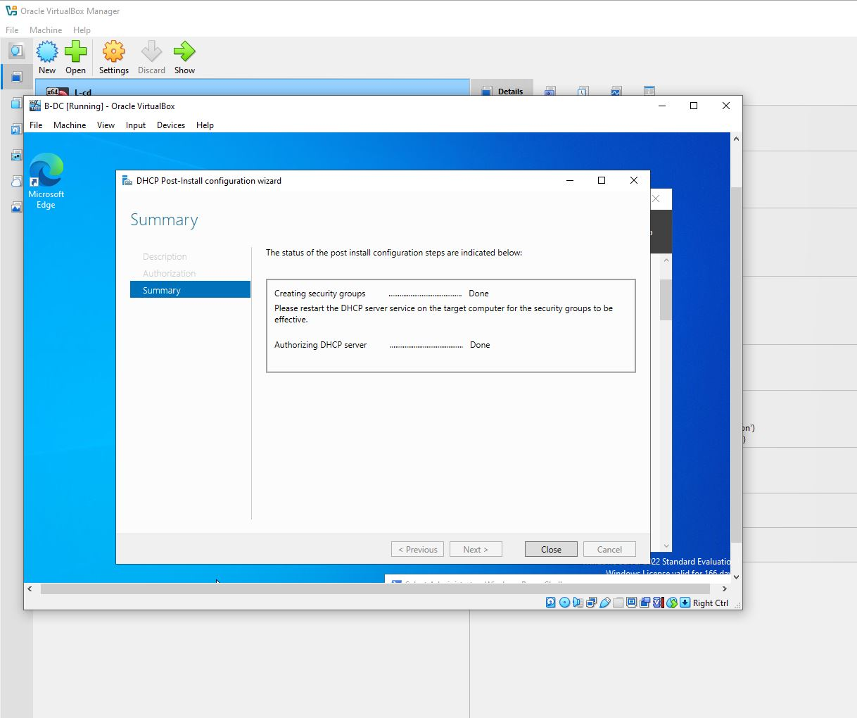

Figure 50: – DHCP server

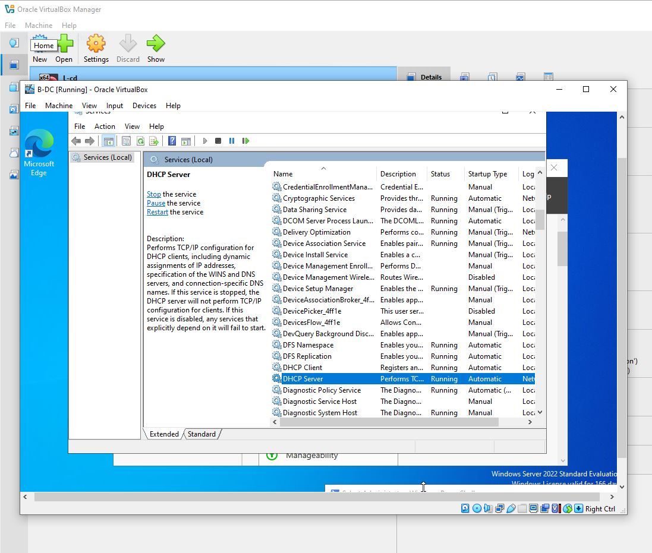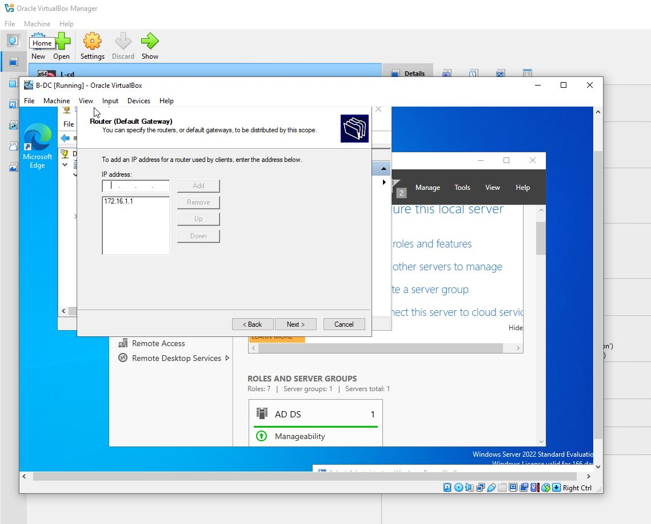

Figure 51 and 52: – DHCP server
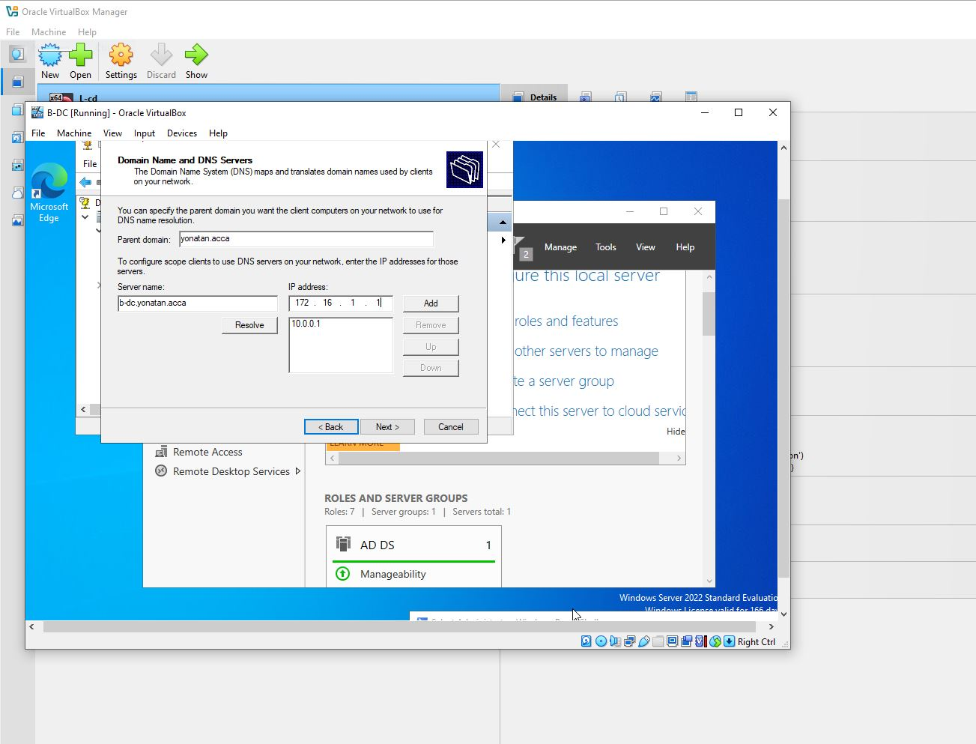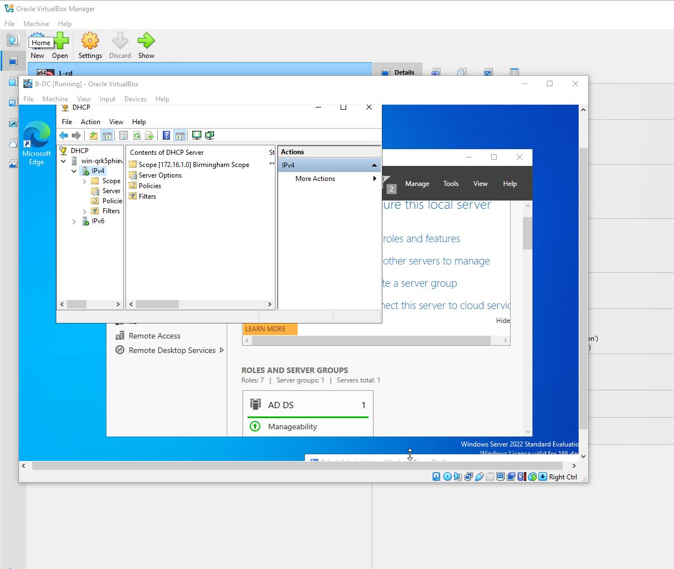

Figure 53 and 54: – DHCP server

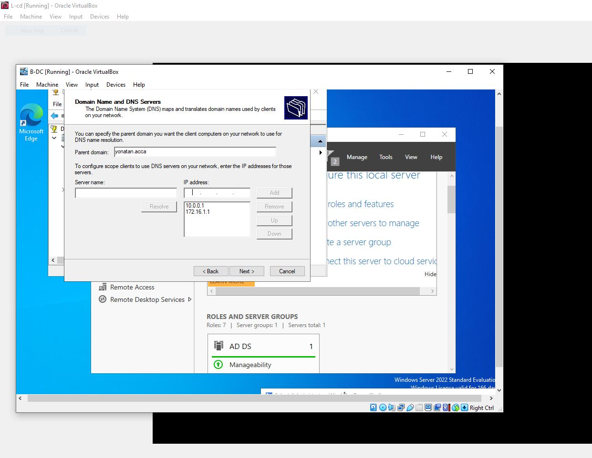

Figure 55: – DHCP server

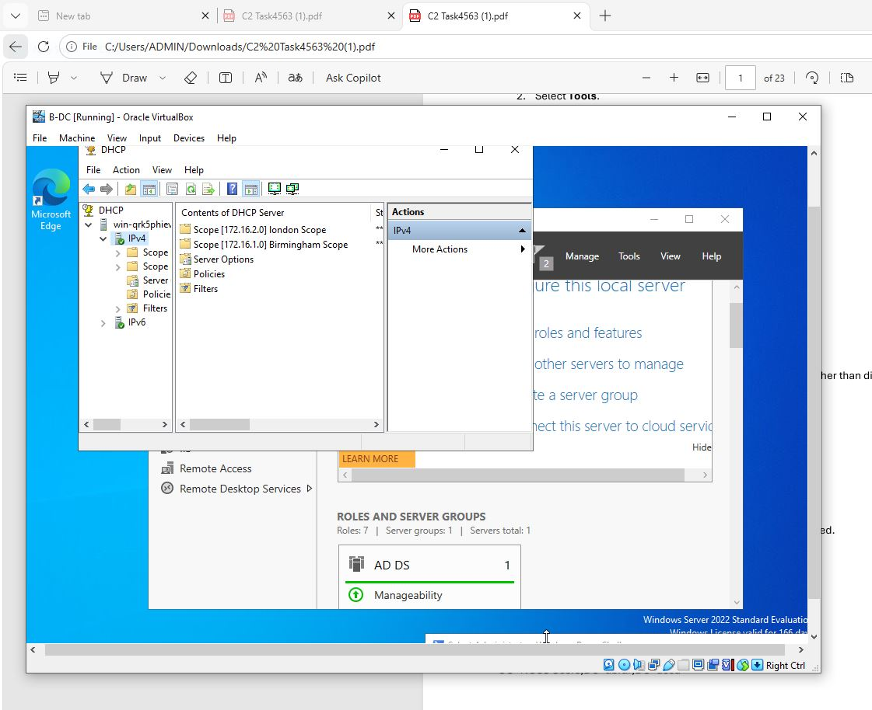

Figure 56: – DHCP server

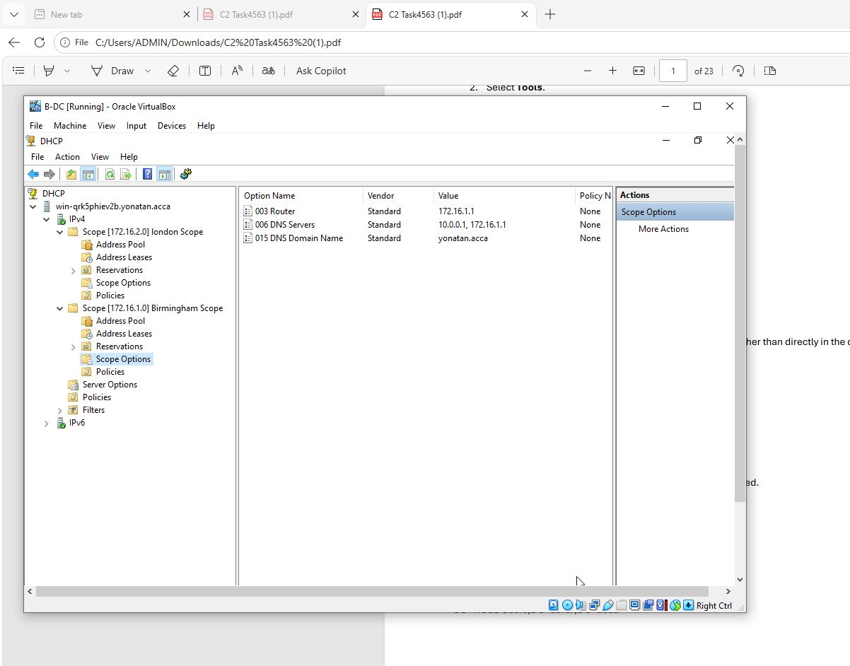

Figure 57: – dhcp server

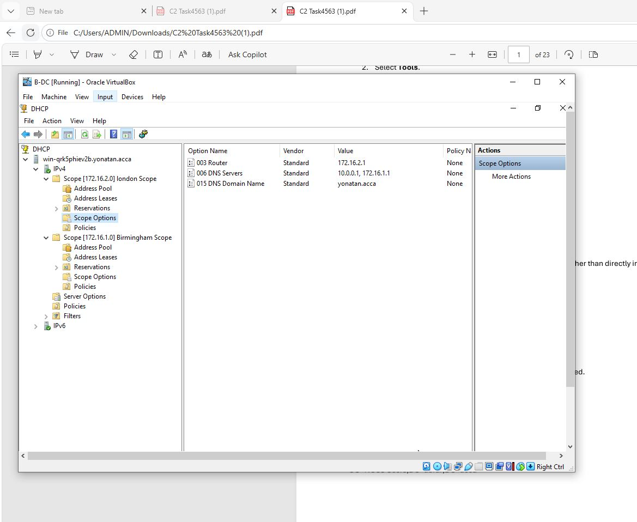
Figure 58: – dhcp server

6.2 Configuring DHCP Relay
Because London clients are located on another subnet, DHCP Relay was configured on the London server to forward DHCP requests to B-DC.

6.3 Client Verification
Clients automatically received IP addresses using:
ipconfig /renew
ipconfig /all
Successful leases confirmed correct DHCP operation.
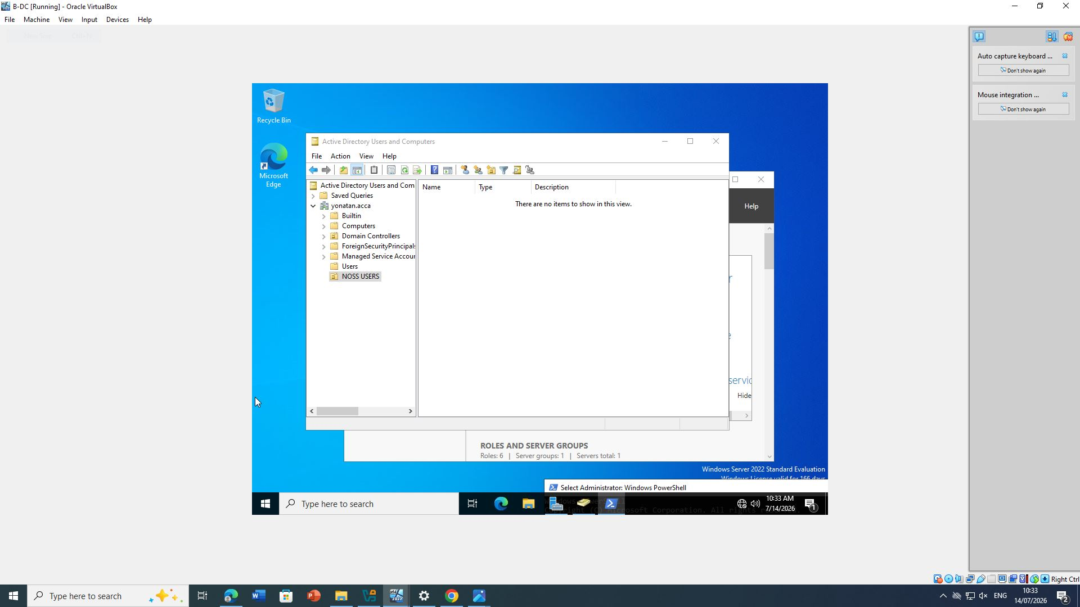
Figure 59: – DHCP Scope.

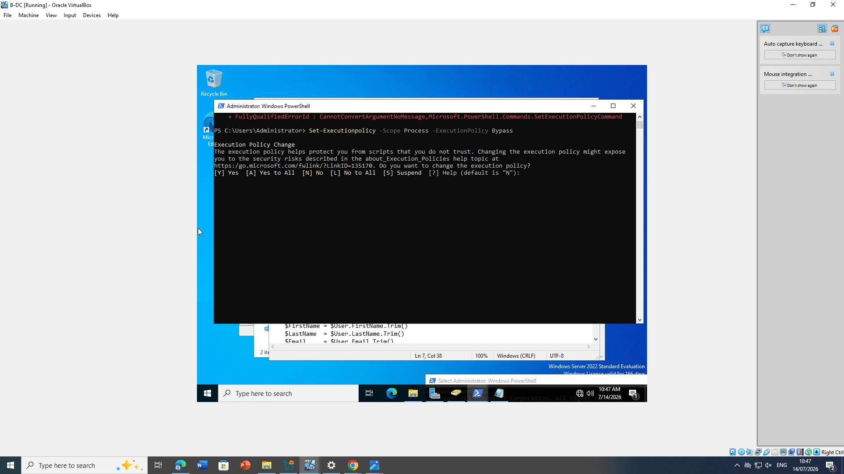
Figure 60: – DHCP Relay configuration.

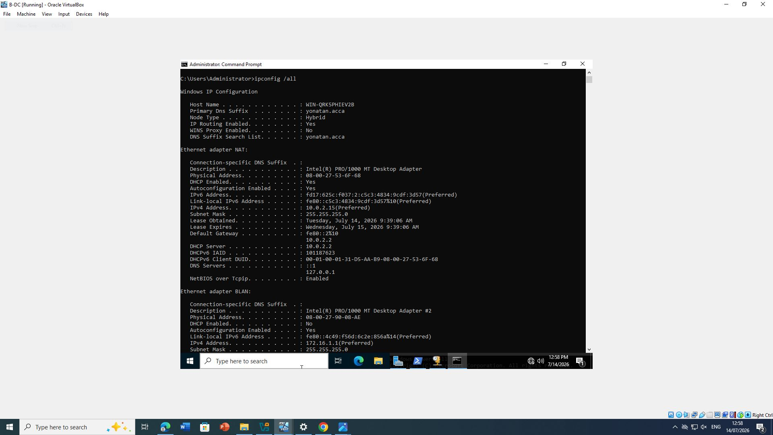
Figure 61: – Client receiving DHCP lease.

7. Test and Troubleshoot

Connectivity Testing
The completed network was tested using:
ping
tracert
nslookup
route print
Successful responses confirmed:
- DNS resolution
- Routing
- VPN communication
- DHCP operation
Where failures occurred, firewall settings, routing tables and DNS records were verified and corrected.
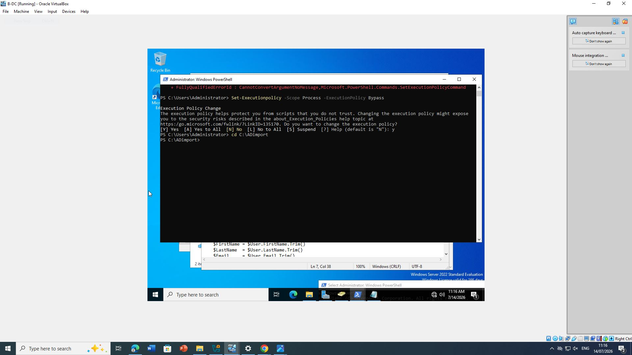
Figure 62: – Successful connectivity tests.

8. Disk Drive

8.1 Shared Storage
A second virtual disk was mounted as:
E:\BirminghamFiles
The folder was shared using:
Advanced Sharing
Permissions configured:
Group | Permission
Domain Users | Full Control
Everyone | Read
NTFS permissions were configured to match the required access controls.
The shared folder was successfully accessed from both Birmingham and London clients.
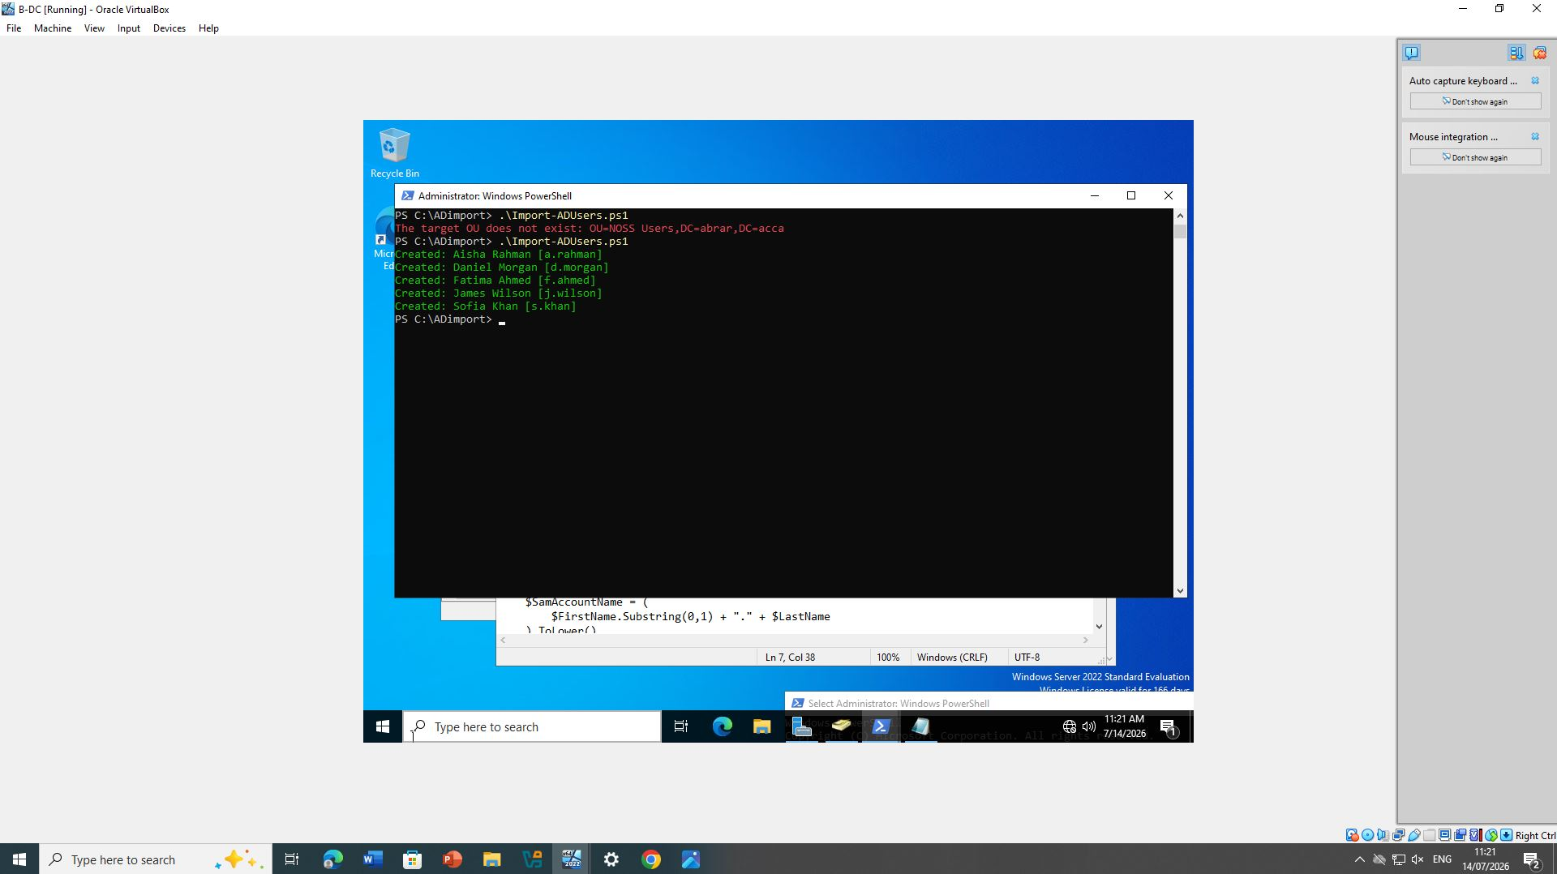
Figure 63: Disk Management.
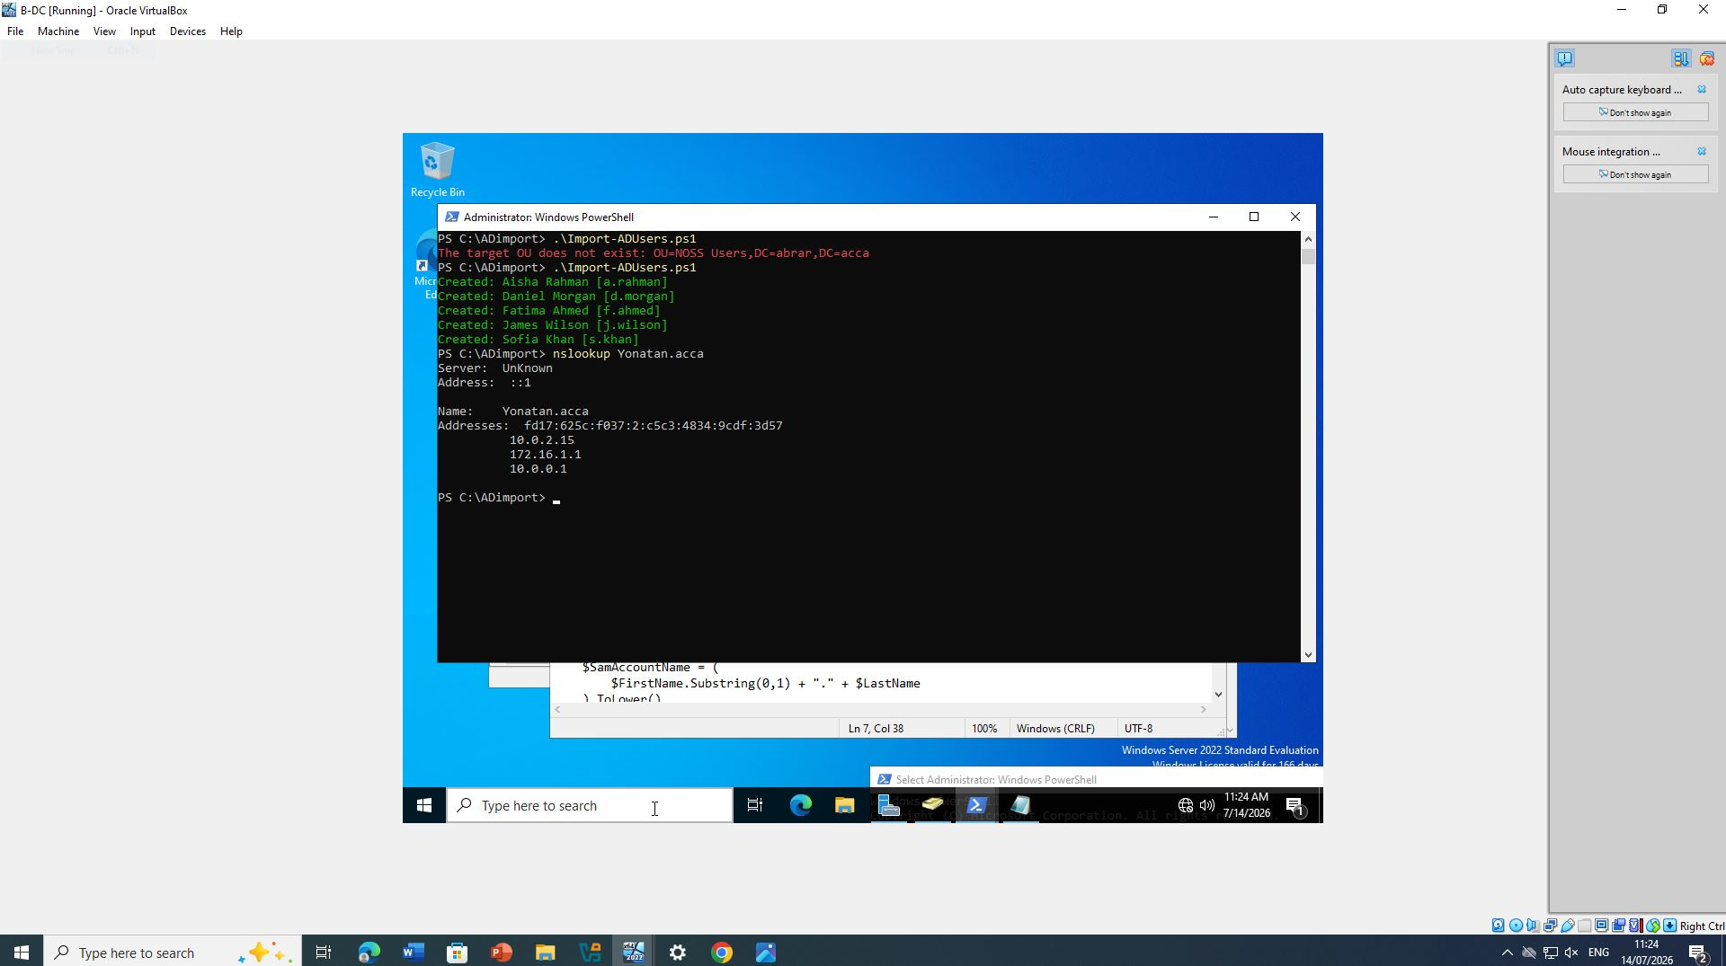
Figure 64: Share permissions.
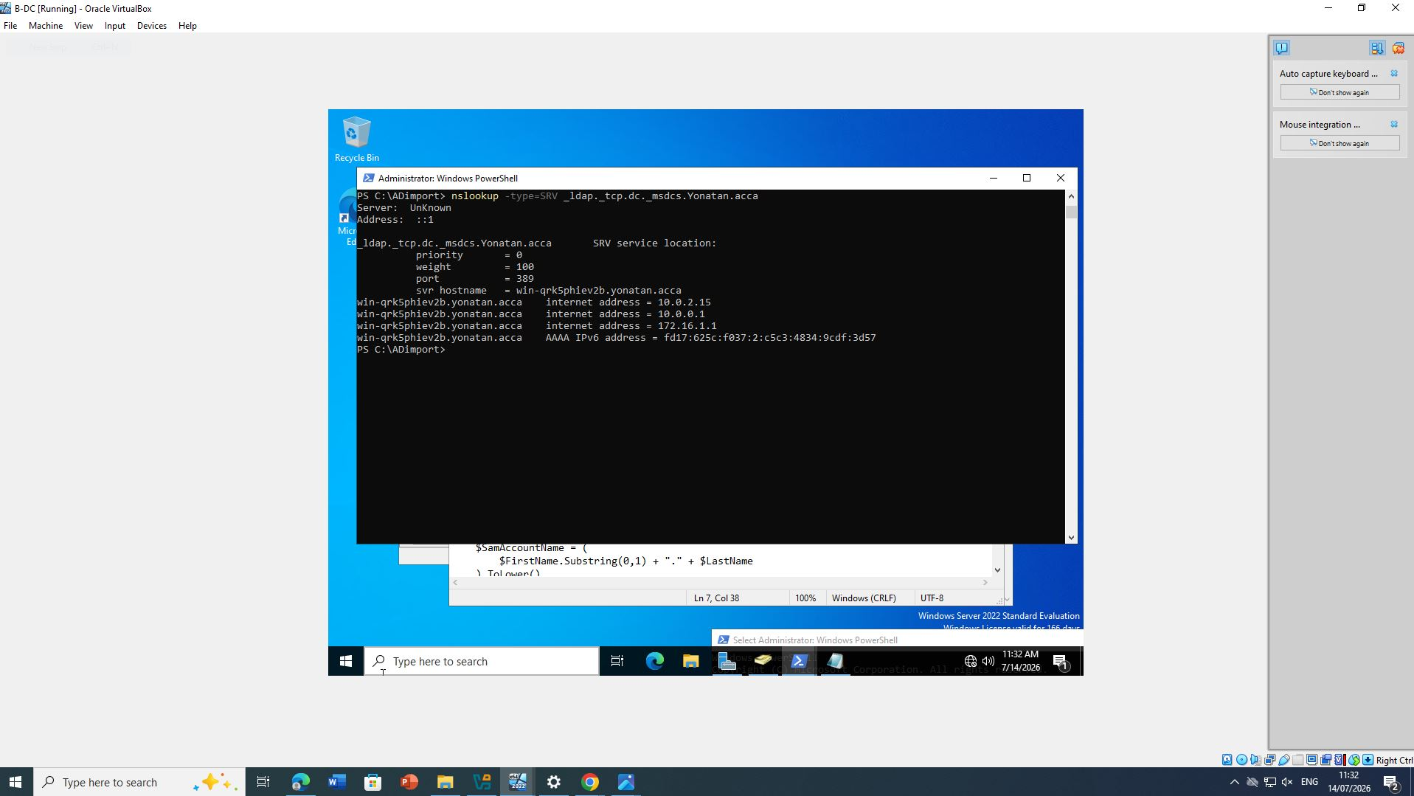
Figure 65: Access from remote client.

9. IIS Server

9.1 Creating the Website
Internet Information Services (IIS) was installed on B-DC.
A new website was created:
https://webs.fahim.acca
Configuration included:
- HTTPS Binding
- Internal Windows Authentication
- Default page
The homepage displayed:
Welcome to Birmingham Website
Domain users successfully authenticated using Windows credentials.
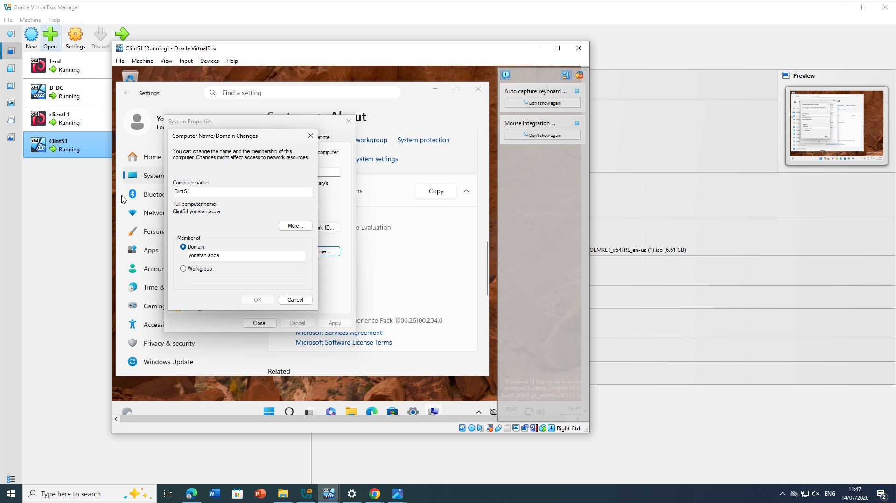
Figure 66: IIS Manager.
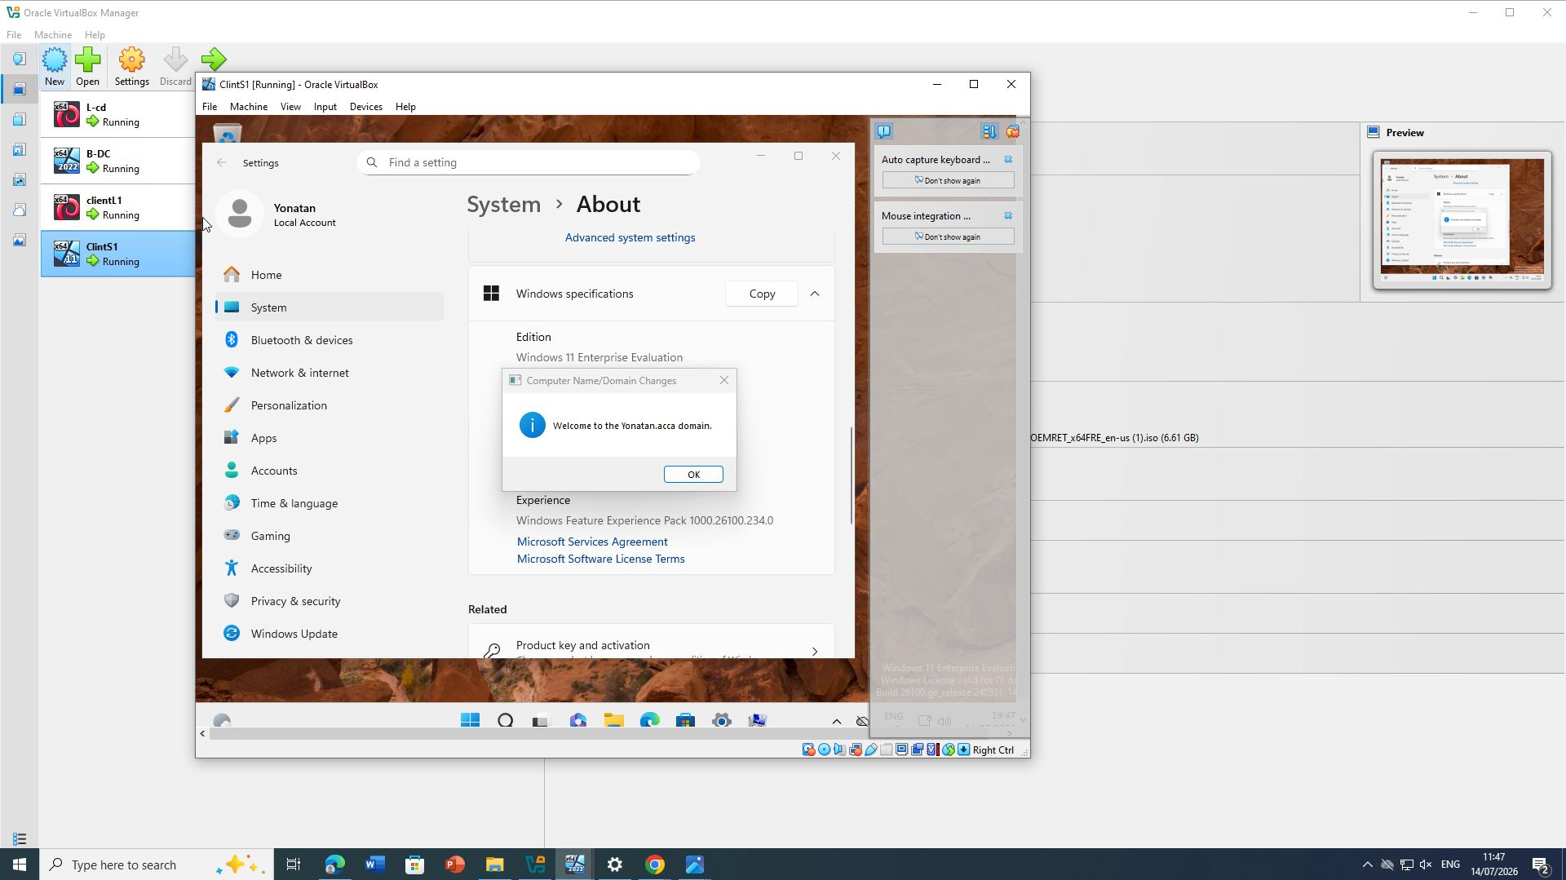
Figure 67: Website running.

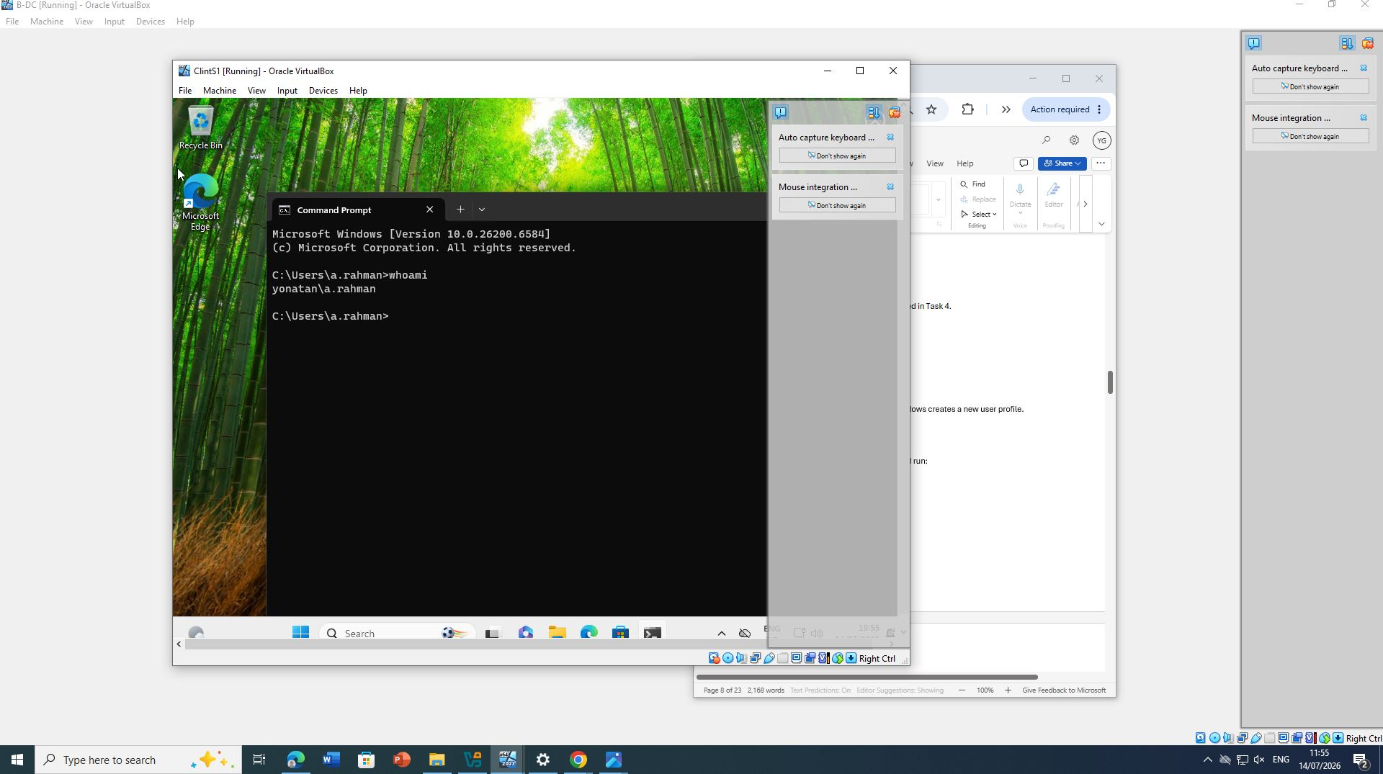
Figure 68: Browser displaying Welcome page.

10. Remote Desktop Services

10.1 Configuring Remote Desktop
Remote Desktop Services (RDS) enables administrators to securely manage servers remotely.
Remote Desktop was enabled on B-DC.
Firewall rules allowing RDP traffic were enabled.
For secure access, HTTPS was configured using an appropriate certificate.
Users connected through:
https://rds.fahim.acca
Successful authentication confirmed the configuration.
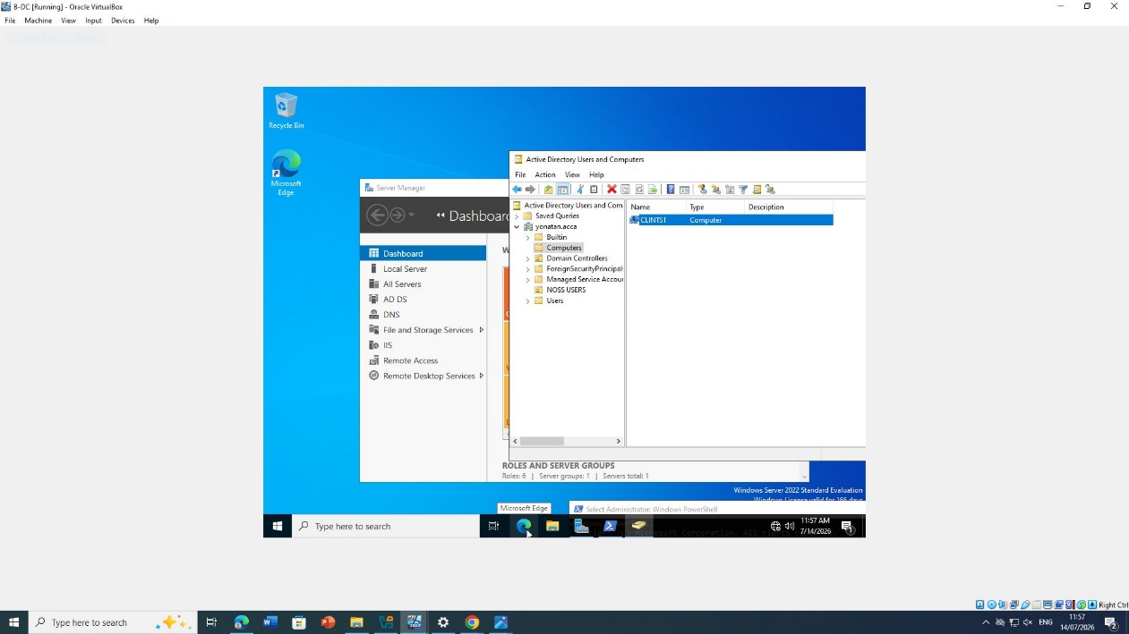
Figure 69: Remote Desktop enabled.
Figure 70: RDS HTTPS page.

Figure 71: Successful remote login.

Overall Conclusion
The enterprise network for NOSS London 2026 was successfully implemented by integrating routing, Active Directory, DNS, DHCP, VPN, file sharing, IIS, and Remote Desktop Services. Windows Server 2022 acted as the central infrastructure server, providing authentication, name resolution, IP address management, secure file sharing, and web services for the Birmingham and London offices. Linux routing and DHCP relay enabled seamless communication across both subnets, while the Site-to-Site VPN ensured secure inter-site connectivity. Testing confirmed successful routing, domain authentication, DNS resolution, DHCP allocation, and resource accessibility. Overall, the completed implementation demonstrates a secure, scalable, and centrally managed enterprise network aligned with industry best practices.

