Morsal Geesawyne Ali (2413056)

Student name: Morsal Ali
Programme: Scripting and Programming Concepts
Module code: ACCA5036
Assignment Title: Coursework- Programming Assignment with Associated Documentation
GitHub Link : scriptingandprogramming/assessment at main · Iroilko2005/scriptingandprogramming

Contents
1.INTRODUCTION 1
2.0 REQUIREMENT ANALYSIS 2
3.0 SOFTWARE DESIGN AND DEVELOPMENT 3
3.1 Design 5
3.1.1 Flowchart 5
3.1.2 Pseudocode 6
3.2 Implementation Decision 21
3.2.2 Programming Constructs 22
3.2.3 Python Modules and Libraries 23
4.0 TESTING AND DEBUGGING 25
4.2 Type of Errors in Programming 25
4.3 Example of Test Cases 26
5.0 EVALUATION 28
6 REFERENCES 29

1.INTRODUCTION
Bright Minds Academy is a small, independent tutoring service whose primary goal is to provide each student with a tailored education experience. At present, the Academy manages all equipment bookings manually by writing them down. Although this manual approach provides a basic way to manage equipment, it creates several problems. In many situations, the process leads to double bookings, confusion about reservations, and loss of important information. For example, two tutors may accidentally book the same laptop or projector for the same day because there is no automated system to confirm whether the equipment is available. Double bookings and unclear records can negatively affect both teachers and students during lessons.
To reduce these issues, a simple computerised booking application was developed using Python. The main objective of this project is to create a user-friendly tool that helps staff manage equipment more effectively. The system allows teachers to add new equipment, book items for specific students on certain dates, review existing bookings, and search for records when needed. By moving from a manual booking system to a computerised one, the Academy can reduce errors, prevent double bookings, and maintain organised booking records efficiently [1].

2.0 REQUIREMENT ANALYSIS
The main aim of the booking system at Bright Minds Academy is to replace manual recording of equipment use with a digital system. The current method increases the risk of double bookings, missing information, and conflicts when multiple users need the same equipment. Therefore, the system must be simple, fast, and easy to use for people with limited technical skills.
System requirements were organised using a MoSCoW prioritisation table to identify must-have, should-have, could-have, and won’t-have features, helping developers focus on the most important functions first.
The prototype includes basic features for managing bookings. Users can update the equipment list when new items like laptops, tablets, or projectors are added. They can create bookings by selecting equipment, entering a student name, and choosing a date. Input validation checks for errors such as empty names, invalid selections, or incorrect dates. It also prevents duplicate bookings by checking if equipment is already reserved for that date.
Users can view booking records to see which equipment is booked and when, helping avoid scheduling conflicts. A search function allows quick access to bookings by student or equipment name. The system design is supported by a structural diagram showing how components interact and how data flows.
Some features were removed due to project scope, including user accounts, admin permissions, maintenance tracking, and overdue reminders. These were low priority in the MoSCoW table. The prototype focuses on core features using Python lists and dictionaries for simplicity, reliability, and easy testing.[2]
structured diagram
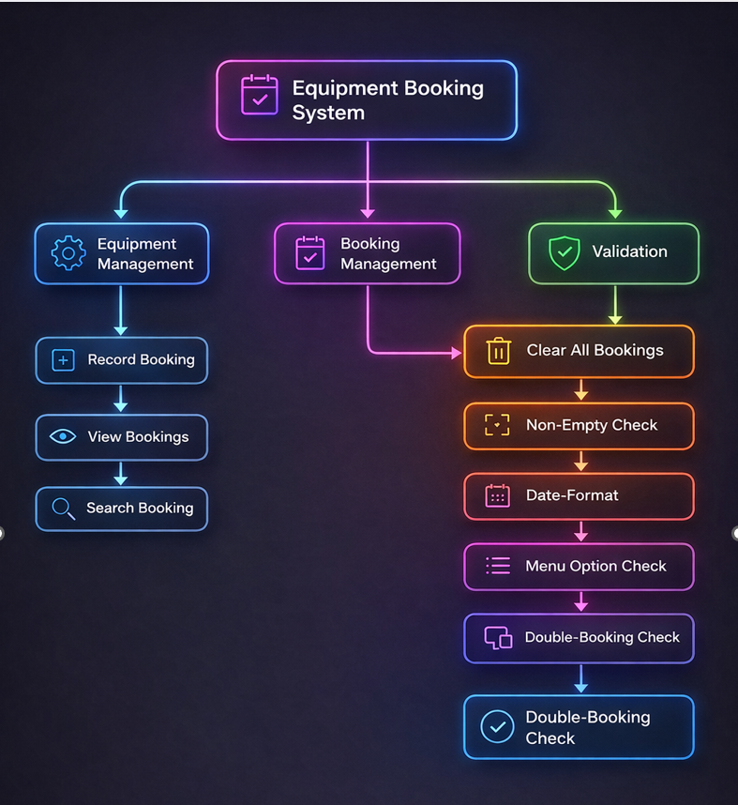

3.0 SOFTWARE DESIGN AND DEVELOPMENT
The design and development stages of software development are important in transforming a system from an original concept into an operational solution [3]. While the analysis stage focuses on identifying problems and requirements, the design and development stage converts those requirements into a structured and workable system. A well-planned design can reduce errors, improve clarity, and make the system easier to use, maintain, and test.
In developing the Bright Minds Academy Equipment Booking System, careful planning was required to ensure simplicity, efficiency, and alignment with the project brief. The system was divided into smaller functional modules, including adding equipment, recording bookings, viewing booking history, and searching records. Each module was designed separately before being integrated into a menu-based structure to improve usability.
During development, appropriate programming constructs such as loops, conditional statements, and functions were implemented to control program flow based on user input [4]. Validation processes were included to restrict incorrect data entry and to prevent duplicate bookings for the same equipment on the same date. The combination of structured design and clear development practices resulted in a reliable, user-friendly, and logically organised system that successfully met the requirements of the assignment

3.1 Design
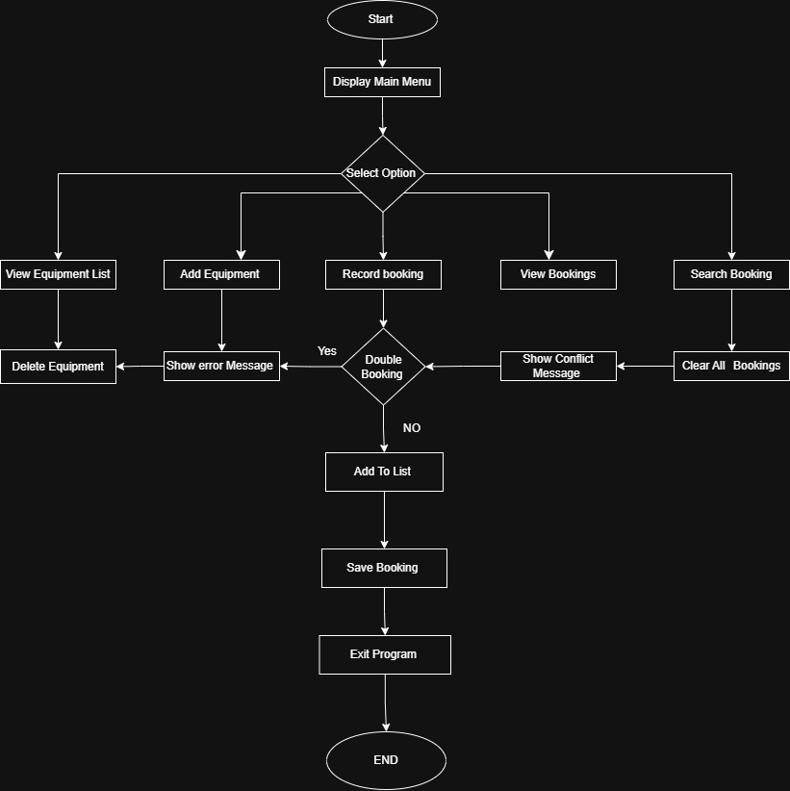

3.1.1 Flowchart
A flow chart is a graphic illustration of the sequence of operations in a process, system, or computer program [5]. A flow chart uses standard symbols to show how a system works, such as ovals for start and end, rectangles for processes, diamonds for decisions, and arrows to show flow. Flow charts help understand, communicate, and review program logic before coding.
The flow chart for the Bright Minds Academy Equipment Booking System shows how the system operates from start to exit. It helped visualise how the program works and made the design clearer before coding. It also highlighted key decisions, such as checking valid menu options and booking conflicts.
The flow chart supported the design by breaking the program into smaller sections. As the system is menu-driven with features like adding equipment, recording bookings, viewing bookings, and searching records, it showed how each option connects and how user input moves through the system. This improved organisation and made coding easier.
The flow starts with the Start symbol, followed by Display Main Menu. The user then enters a menu choice. A decision checks if the input is valid. If not, an error message is shown. If valid, the program continues.
The next section shows the selected feature. Add Equipment adds new items. Record Booking allows entry of student name, equipment, and date. A decision checks if the item is already booked for that date. If yes, a conflict message is shown; if no, the booking is saved, preventing double bookings.
Other options include View Bookings, Search Bookings, View Equipment List, Delete Equipment, and Clear All Bookings. Selecting Exit ends the program.
An Input-Process-Output (IPO) table was also used to show inputs, processes, and outputs of the system.
Table X: IPO Table
Input | Process | Output
User selects menu option | System checks if input is valid | Displays selected function or error message
Equipment name | Add equipment to list | Equipment added confirmation
Student name, equipment, date | Validate input and check double booking | Booking recorded or error message
Search term | Compare with stored bookings | Matching booking results displayed
Delete option | Remove equipment from list | Equipment removed confirmation

3.1.2 Pseudocode
START

SET equipment_list TO ["Laptop 1", "Laptop 2", "Laptop 3", "Projector A", "Projector B", "Tablet 1", "Tablet 2"]
SET bookings TO empty list

WHILE True DO
DISPLAY "--- Bright Minds Equipment Booking System ---"
DISPLAY "1. View Equipment List"
DISPLAY "2. Add Equipment"
DISPLAY "3. Record Booking"
DISPLAY "4. View Bookings"
DISPLAY "5. Search Bookings"
DISPLAY "6. Delete Equipment"
DISPLAY "7. Clear All Bookings"
DISPLAY "8. Exit"
DISPLAY "---------------------------------------------"

PROMPT user for choice (1-8)
STORE user input in option

IF option IS "1" THEN
IF equipment_list IS empty THEN
DISPLAY "No equipment added yet."
ELSE
DISPLAY all equipment in equipment_list
END IF

ELSE IF option IS "2" THEN
PROMPT user for equipment name
STORE user input in name

IF name IS empty THEN
DISPLAY "Input cannot be empty."
ELSE IF name IS only numbers THEN
DISPLAY "Equipment name cannot be only numbers."
ELSE IF equipment already exists in equipment_list THEN
DISPLAY "Equipment already exists in the system."
ELSE
ADD name TO equipment_list
DISPLAY "Equipment added successfully."
DISPLAY updated equipment_list
END IF

ELSE IF option IS "3" THEN
IF equipment_list IS empty THEN
DISPLAY "No equipment available. Please add equipment first."
ELSE
PROMPT user for student name
STORE user input in student_name

DISPLAY all equipment with numbers
PROMPT user for equipment number
STORE user input in choice

IF choice is not a number THEN
DISPLAY "Please enter a valid number."
ELSE IF choice is out of range THEN
DISPLAY "Invalid equipment number."
ELSE
SET equipment_name TO selected equipment
PROMPT user for booking date
STORE user input in booking_date

IF equipment is already booked on that date THEN
DISPLAY "This equipment is already booked on that date."
ELSE
CREATE booking with student_name, equipment_name and booking_date
ADD booking TO bookings
DISPLAY "Booking recorded successfully."
END IF
END IF
END IF

ELSE IF option IS "4" THEN
IF bookings IS empty THEN
DISPLAY "No bookings recorded yet."
ELSE
DISPLAY all bookings
END IF

ELSE IF option IS "5" THEN
IF bookings IS empty THEN
DISPLAY "No bookings available to search."
ELSE
PROMPT user for search term
STORE user input in search_term

SEARCH bookings using student name or equipment name

IF no match is found THEN
DISPLAY "No matching bookings found."
ELSE
DISPLAY matching bookings
END IF
END IF

ELSE IF option IS "6" THEN
IF equipment_list IS empty THEN
DISPLAY "No equipment available."
ELSE
DISPLAY all equipment with numbers
PROMPT user for equipment number to delete
STORE user input in choice

IF choice is not a number THEN
DISPLAY "Please enter a valid number."
ELSE IF choice is out of range THEN
DISPLAY "Invalid number."
ELSE
REMOVE selected equipment from equipment_list
DISPLAY "Equipment removed successfully."
END IF
END IF

ELSE IF option IS "7" THEN
IF bookings IS empty THEN
DISPLAY "No bookings to clear."
ELSE
PROMPT user for confirmation
STORE user input in confirm

IF confirm IS "yes" THEN
CLEAR bookings
DISPLAY "All bookings have been cleared."
ELSE
DISPLAY "Operation cancelled."
END IF
END IF

ELSE IF option IS "8" THEN
DISPLAY "Exiting program."
EXIT WHILE LOOP

ELSE
DISPLAY "Invalid option. Please choose between 1 and 8."
END IF

END WHILE

END
Write couple of sentences about Pseudocode

Pseudocode is a very basic way of describing the logic behind a program by using common language and also following the flow of the programming constructs like loops, if/else conditions and assignment [6]. Pseudocode is not a programming language; therefore, it cannot run on a computer; however, it is often used at the beginning stages of the development process of the software as a means of planning out how the program will operate prior to writing the programming language code. Pseudocode helps programmers develop the logic and flow of their operations, regardless of the programming syntax used. Using pseudocode simplifies understanding the algorithm and enables communication of the design of the system to other developers.
Pseudocode was utilized in this project to represent the logic of the Bright Minds Academy Equipment Booking System prior to developing it in Python [7] . In the pseudocode, the logic of the system when interfacing with the user is defined, including the display of the menu options to the user, acceptance of the user's input, validation of the user's input, and creation of the output from the application. Developing the pseudocode first allowed me to clearly define the overall structure of the program and to understand how each of the features of the system would interact with each other.
The pseudocode starts with a **START** statement and the initializations of two primary data structures: the `equipment_list` and the `bookings` list.
The `equipment_list` contains all of the available equipment items that can be reserved and the `bookings` list contains booking records containing the student name, the name of the equipment reserved, and the reservation date. These data structures form the basis of the system because these are the only structures that contain the information required to perform the operation of the application.
The main logic of the system is determined by a **WHILE True loop**, which causes the system to continue to run indefinitely until the user decides to exit the application. Within this loop, the system presents the user with the main menu and requests the user to select one of the options. The users' selections are captured and evaluated using a series of **IF and ELSE IF statements**, which determine which functionality of the system to execute.
Each of the menu options corresponds to a specific functionality of the system. For example, the **Add Equipment** option provides the ability to add a new piece of equipment to the list and also includes validation to ensure that no invalid or duplicate entries are added. The **Record Booking** option provides the ability to reserve a piece of equipment, provide the name of the student reserving the equipment, and provide a reservation date. When recording a booking, additional validations are conducted to confirm that the selected equipment exists, that the entered number is valid, and that the equipment is not currently reserved for the same date. These validations assist in preventing errors related to double reservations.
Other options in the pseudocode include **View Bookings**, **Search Bookings**, **View Equipment List**, **Delete Equipment**, and **Clear All Bookings**, and each of these options provide a different method for managing the equipment and booking records contained in the system. Lastly, when the user selects the **Exit** option, the system terminates the loop and exits the application.
In general, the pseudocode provided a clear definition of the systems logic and served as a template for the Python implementation. Once I converted each of the steps in the pseudocode into Python functions, loops, and conditional statements, the final application was developed in a logical and organized manner.

Figure1 – Non-Empty Input Validation Function
This screenshot shows the get_non_empty_input() function used to validate user input.
The function repeatedly prompts the user until a non-empty value is entered, ensuring that blank inputs are not accepted by the system

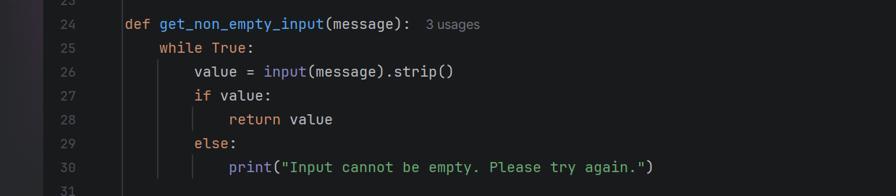

Figure2 – Date Validation Function
This screenshot shows the get_valid_date() function used to validate the booking date entered by the user.
The function checks whether the date follows the YYYY-MM-DD format, and if not, it displays an error message and asks the user to enter the date again.

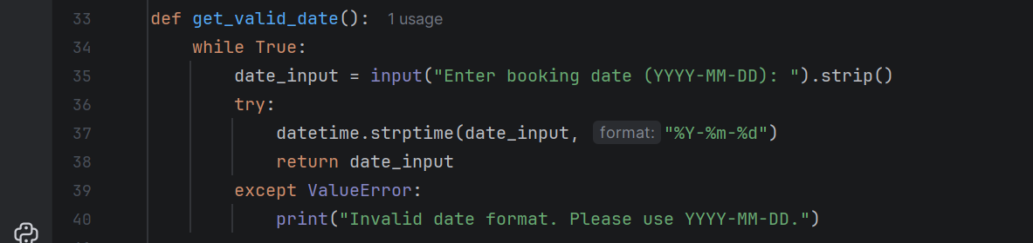

Figure3 – Equipment Exists Function
This screenshot shows the equipment_exists() function used to check whether a piece of equipment already exists in the equipment list.
The function loops through the equipment_list and compares the entered name with existing items, returning True if a match is found and False if it does not exist.

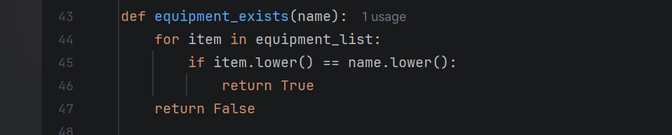
Figure4 – Double Booking Check Function
This screenshot shows the is_double_booked() function which checks if a piece of equipment has already been booked on a specific date.
The function loops through the bookings list and compares both the equipment name and booking date to prevent duplicate bookings in the system.

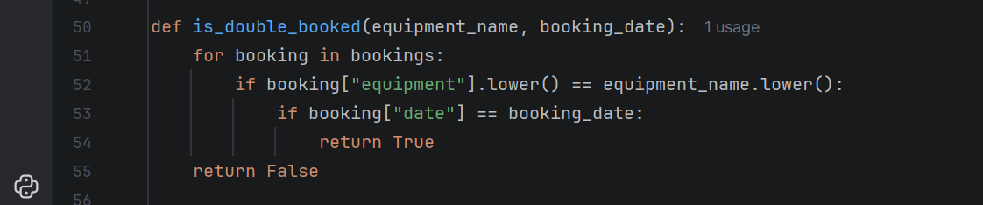

Figure5 – Add Equipment Function
This screenshot shows the add_equipment() function which allows the user to add a new piece of equipment to the system.
The function checks if the equipment name already exists or if it is invalid before adding it to the equipment_list and displaying the updated list.

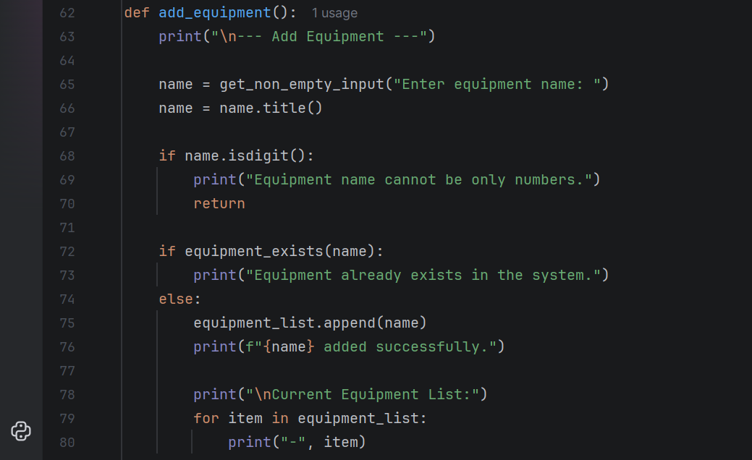

Figure6 – Record Booking Function
This section checks whether the equipment already exists in the system using the equipment_exists() function.
If the equipment does not exist, it is added to the equipment_list and the updated equipment list is displayed to the user.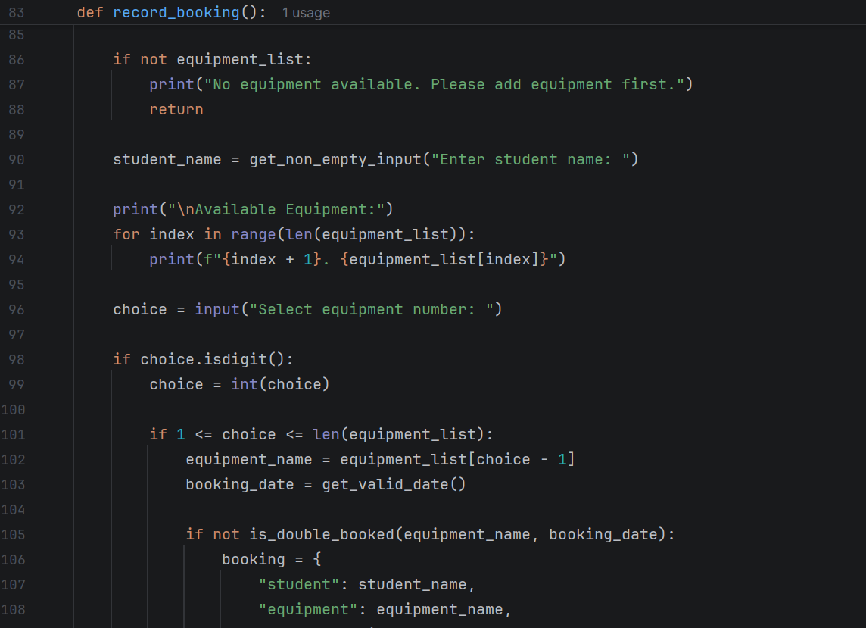
Figure 7– Record Booking Validation
This section of the code validates the booking before saving it to the system.
It checks whether the equipment is already booked for the selected date and displays an error message if a double booking occurs.

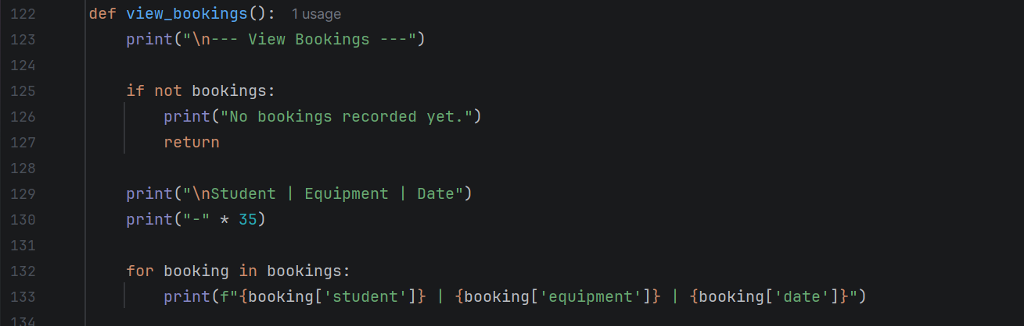

Figure 8– View Bookings Function
This screenshot shows the view_bookings() function which displays all recorded bookings in the system.
The function checks if bookings exist and then prints the student name, equipment, and booking date in a structured format.

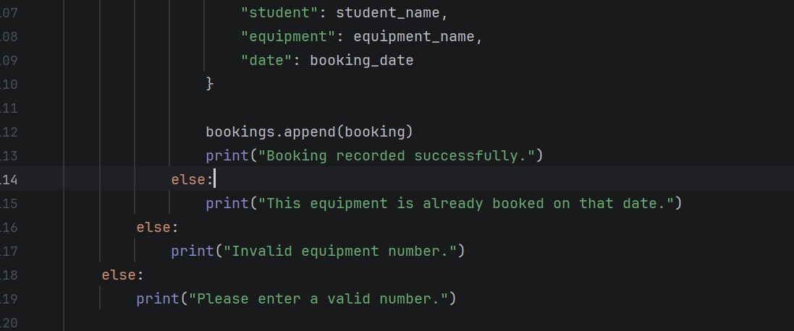

Figure9 – Search Bookings Function
This screenshot shows the search_bookings() function which allows the user to search for bookings using either the student name or the equipment name.
The function loops through the bookings list and displays matching results, or prints a message if no matching bookings are found.

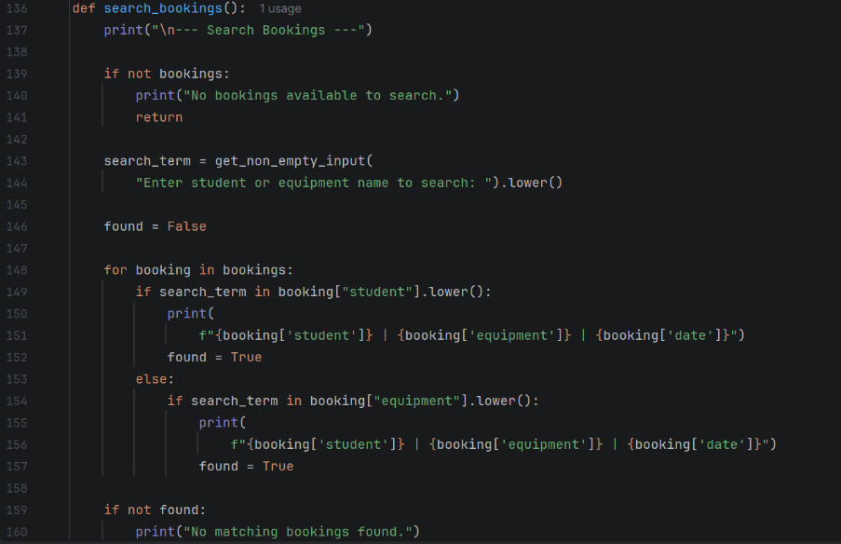

Figure10 – View Equipment Function
This screenshot shows the view_equipment() function which displays all equipment stored in the system.
The function checks if the equipment list is empty and prints all equipment items if they exist.

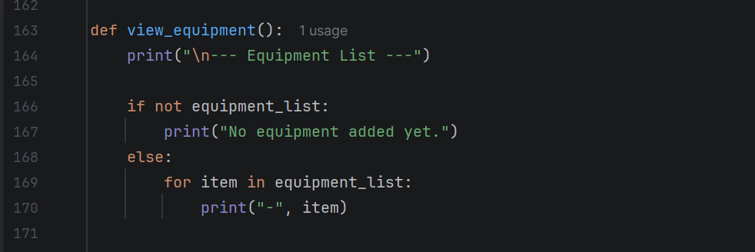

Figure 11– Delete Equipment Function
This screenshot shows the delete_equipment() function which allows the user to remove an equipment item from the system.
The function displays the equipment list, allows the user to select a number, and removes the selected item from the equipment_list if the input is valid.

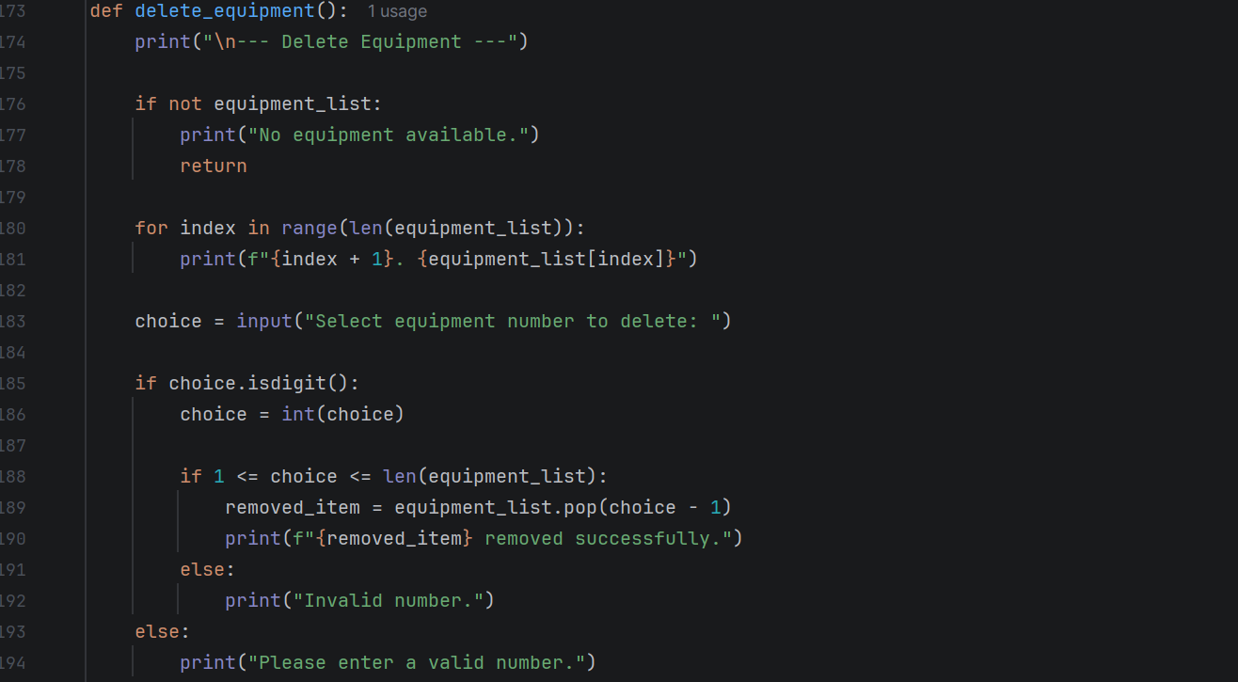

Figure 12– Menu Function
This screenshot shows the menu() function which controls the main menu of the system.
The function displays the available options and uses conditional statements to call the appropriate function based on the user’s selection.

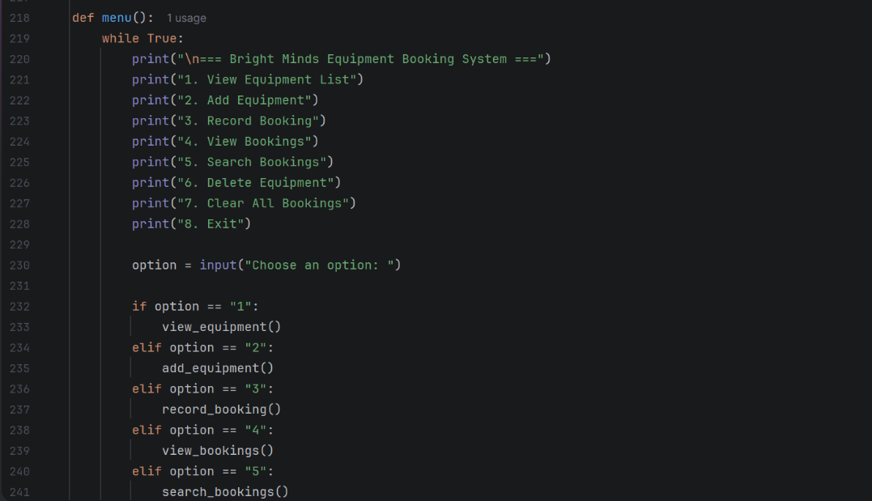

Figure13 – Menu Option Handling
This section of the menu() function processes the user’s selected option using conditional statements.
If the user chooses option 6–8 the system performs the corresponding action, and an error message is shown if an invalid option is entered.
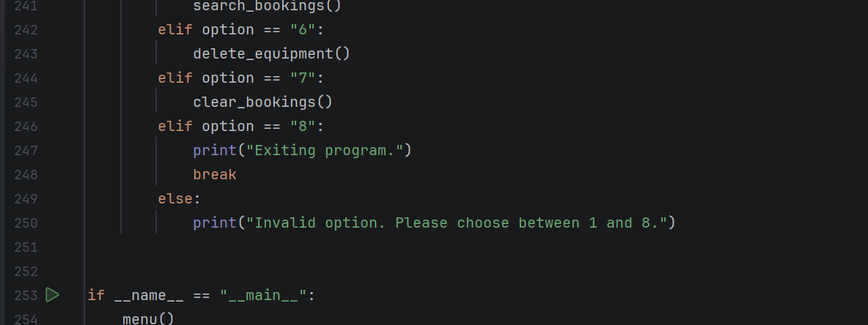

3.2 Implementation Decision
3.2.1 Data Structures:
A data structure is a method of organising and storing data so that it can be accessed, managed, and updated efficiently within a program [8]. Data structures are important in software development because they determine how information is stored and how easily it can be processed. Choosing suitable data structures helps make a program more efficient, readable, and easier to maintain.
In the Bright Minds Academy Equipment Booking System, simple data structures were selected to ensure that the program remains easy to understand and practical to use. Because the system does not require a database, Python was used to store the information directly in the program using arrays and objects. This approach is appropriate for a small menu-driven system, as it keeps the implementation simple while still allowing the software to manage the required information effectively.
The first main data structure used in the system is equipment_list. This variable is used to store all available equipment items, such as laptops, projectors, and tablets. It is suitable because it allows multiple equipment names to be stored together in one structure. It also supports adding and removing items easily when the user chooses options such as Add Equipment or Delete Equipment. Another advantage is that the equipment can be displayed with numbered positions, making it easier for the user to select an item during the booking process. This makes the structure practical for handling a collection of equipment items.
The second main data structure used is bookings. This is used to store all booking records created by the user. Each individual booking is stored in booking, which contains related details such as the student name, equipment selected, and booking date. This method was chosen because it keeps all information about one booking together in a clear and organised form. It also makes it easier to search, display, and manage booking information. For example, when the user chooses View Bookings, the program can loop through all stored booking records and display them in a readable format [9] .
A variable is a named storage location used to hold data that may change while a program is running. Several variables are used in this system to support input, processing, and output. For example, student_name, equipment_name, and booking_date are used to store information entered by the user when creating a booking. The variable option stores the user’s main menu choice. These variables help control the flow of the program and ensure that information is handled correctly throughout the system.
Table presents the key variables used in the system along with their corresponding data types.
Table X: Variables and Data Types
Variable Name | Data Type | Description
equipment_list | Array | Stores all equipment items
bookings | Array | Stores all booking records
booking | Object | Stores one booking
student_name | String | Stores student name
equipment_name | String | Stores selected equipment
booking_date | String | Stores booking date

Overall, the selected data structures are appropriate for the needs of the system. They provide a simple and effective way of storing equipment and booking information without making the program unnecessarily complex. This makes the system easier to develop, test, and maintain

3.2.2 Programming Constructs
Programming Constructs are the building blocks of programming that allow programmers to create a program's flow and structure [ 10]. They enable developers to organize their programs using methods like repetition, decisions, and grouping code into reusable blocks. Common programming constructs include conditional statements, loops, functions, and error handling mechanisms. These constructs are necessary since they provide a systematic and organized approach to translating the programmer's logic into functional coding.
A variety of programming constructs were utilized throughout the Bright Minds Academy Equipment Booking System to help ensure the system ran with efficiency and functionality. Some of the most common constructs included conditionals, loops, user defined functions, and input validation. All of the above constructs were chosen for their ease of implementation, effectiveness and suitability to creating a menu driven application.
One of the primary programming constructs used in this system is conditionals. More specifically, if, elif, and else are used to make decisions in the system. For instance, in the systems menu, conditionals are used to decide which process to run based on the users selection. Conditionals are also used to verify the user input. Examples of verification include checking if there are any items in the equipment list, validating that the equipment number entered falls within a valid range and checking if equipment has been previously reserved for a particular day. These validations help prevent logical errors and ensure that the system performs as intended and does not have double booking issues.
Loops were another key construct used in the system. Loops are typically categorized as while loops and for loops. The while true loop is used in the systems main menu to continue to run the system until the user chooses to exit. This gives the user the ability to complete multiple processes without needing to restart the system. The for loop is used to iterate over the elements of lists. For example, when listing all available equipment or booking records, the system uses a for loop to iterate over the elements and print them. Using a loop makes the code more efficient and reduces redundancy.
User defined functions were another key construct used in the system. User defined functions help break down the system into smaller, manageable pieces. Each feature in the system including add equipment, record booking, view bookings, search bookings, delete equipment and clear bookings, is contained in its own user defined function. This increases readability and makes maintaining and debugging the code much simpler. Additionally, user defined functions increase the amount of code reuse in the system. Since certain tasks can be called at any time without having to rewrite code, the codebase can be maintained for longer periods of time.
Error handling and input validation are yet another key construct used in the system. As the system is highly dependent upon user input, it is critical to ensure that the data provided by the user is valid. The system validates for empty fields, valid equipment numbers, and valid date formats. It also prevents duplicate equipment from being entered and prevents users from double booking equipment. The system will display an error message to the user if the system determines that the user's input is invalid. The additional validation increases the reliability of the system and ensures that only valid data is saved.
In conclusion, the use of the above programming constructs including conditionals, loops, functions, and validation created a very logical and efficient system. The programming constructs made the system easy to follow and the system responded to the user's input properly.

3.2.3 Python Modules and Libraries
Python modules and libraries are collections of reusable code that help developers build programs more efficiently. A module is a file containing Python code, such as functions and variables, that can be used in other programs, while a library is a collection of related modules [11]. These reusable components save time, reduce the need to write code from scratch, and help minimise programming errors. Python also provides many built-in modules that can be used directly, such as datetime for handling dates, os for file operations, and pandas for data management
In the Bright Minds Academy Equipment Booking System, the built-in datetime module was used to validate date entries made by the user. This module was selected because booking dates must follow a specific format, and it is important to ensure that the date entered is valid. Instead of manually checking each input, the datetime module provides a simple and reliable way to verify whether the date matches the required format.
The program uses the datetime.strptime() method to validate the user’s input. This method takes the entered date and checks if it follows the format YYYY-MM-DD. If the format is correct, the input is accepted as a valid date. If not, a ValueError is raised, which is then handled by displaying an error message and prompting the user to enter the date again. This process continues until a valid date is provided, ensuring data accuracy within the system.
Using the datetime module improves the overall reliability and efficiency of the program. Without it, additional code would be required to manually validate the date format, which could increase complexity and introduce potential errors. By using a built-in module, the system becomes easier to maintain and less prone to mistakes.
In addition to the datetime module, the system uses built-in Python functions such as input() and print(), as well as list methods like append() and pop(). These built-in features are part of Python’s standard functionality and do not require external libraries. They are sufficient for handling user interaction, displaying output, and managing data within the system. Overall, the use of Python modules and libraries in this project is simple but effective, allowing the program to meet its requirements while remaining easy to understand and efficient.

4.0 TESTING AND DEBUGGING
4.1 Role of Testing in Software Environment
Program testing is a method of testing a computer program to find bugs, glitches or other problems and to test that the program has been developed as per the specifications. The testing process tests how the program reacts to input data to see if it produces the correct output [12] . In other words, this type of testing identifies the problems in the software by checking the input and seeing what happens when it is run. Testing is a critical component of the Software Development Life Cycle (SDLC) as it provides assurance that the final product will be functional, perform at an acceptable level, provide a quality end-user experience and meet customer expectations.
Testing is a key element of the software development process [13]. When software is properly tested, there is less likelihood of having errors in the code that could cause the software to produce incorrect results, crash or behave unexpectedly. Therefore, testing is an essential step in identifying and correcting bugs that occur in the coding process. If software is deployed without adequate testing, users may encounter bugs that need to be repaired or fixed. Repairing bugs after the software has been deployed to customers can be difficult and expensive.
In addition, testing contributes to the overall quality and usability of a software program. Well-tested applications are typically more reliable and consistent in their behavior. This makes them more trustworthy for end-users. Also, testing ensures that the various components of the system work as required and the system delivers on its defined requirements.
Finally, testing enables the debugging phase of the SDLC. Debugging is the identification and correction of bugs in the programming code. Testing verifies that any modifications to the code have not introduced additional bugs. Overall, testing is essential to the delivery of a high-quality software application that is effective, reliable and ready for production.

4.2 Type of Errors in Programming
Errors in programming are mistakes in a program that cause it to produce incorrect results or behave unexpectedly during execution [14]. These errors can affect the functionality and reliability of software if not properly identified and fixed. Understanding different types of errors helps developers debug and improve their programs effectively.
There are three main types of errors in programming: syntax errors, logical errors, and runtime errors.

Syntax Errors
Syntax Error (Missing Colon & Indentation)
The first code is missing a colon : after def add() and the print statement is not indented, so Python cannot recognize the function block.
Fix it by adding : and indenting print(2 + 3) so it is correctly inside the function.
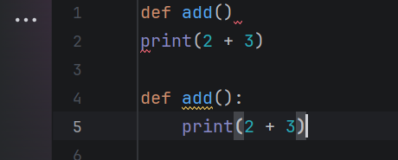

Syntax Error (Missing Brackets)
The first function is missing parentheses in def greet:, which is required in Python function definitions.
Fix it by adding () to make it def greet(): so the function is correctly defined.

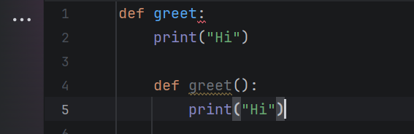

Syntax Error (Missing Colon)
The first code is missing a colon : after def greet(), so Python cannot start the function block.
Fix it by adding : to make def greet():, allowing the function to run correctly.

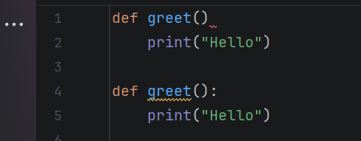

Logical Errors
Logical errors occur when the program runs but produces incorrect results due to mistakes in the logic. For example, using + instead of - in a calculation will give the wrong result. These errors can be fixed by reviewing and testing the algorithm carefully.
Logical Error (Wrong Calculation Order)
The first code uses 5 * 2 + 10, which follows the wrong order and gives an incorrect result for the intended calculation.
Fix it by using brackets (5 + 10) * 2 so the addition happens first and produces the correct output.

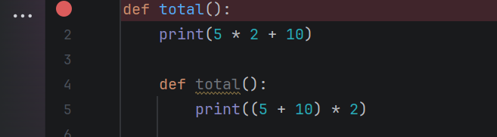
Logical Error (Wrong Output)
The first code prints "Adult" in both the if and else blocks, so it gives the wrong result for younger ages.
Fix it by changing the else part to "Child" so the program outputs the correct category.

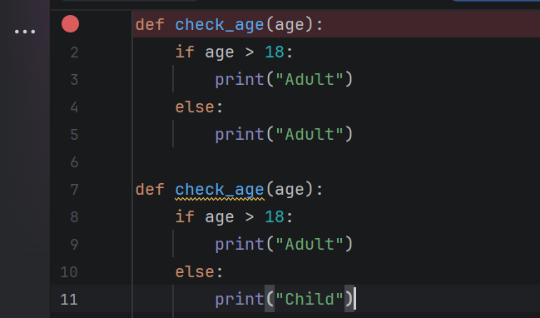
Logical Error (Infinite Loop)
The first code never increases x, so the condition x < 5 is always true and the loop runs forever.
Fix it by adding x += 1 inside the loop so x increases and the loop eventually stops.

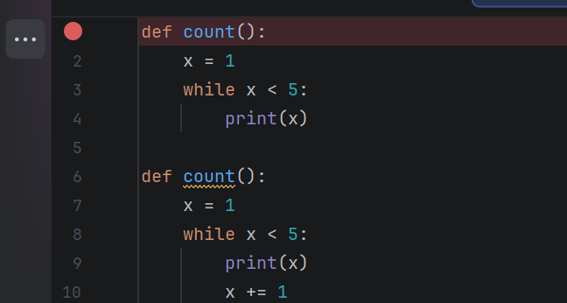

Runtime Errors
Runtime Error (Division by Zero)
The first code tries to divide by 0, which causes a runtime error when the program runs.
Fix it by dividing by a non-zero number (e.g., 10 / 2) so the program runs successfully.

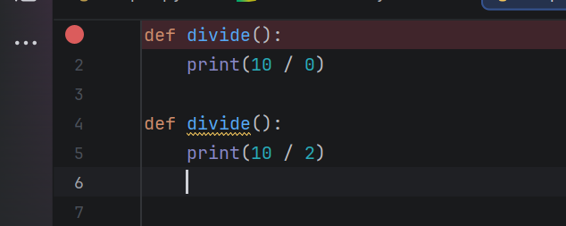

Runtime Error (Invalid Conversion)
The first code tries to convert "abc" into an integer, which causes an error during execution.
Fix it by using a valid number string like "123" so it can be converted successfully.

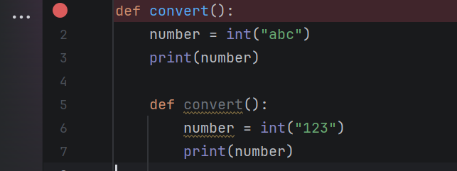
Runtime Error (Index Out of Range)
The first code tries to access items[5], but the list only has 3 elements, causing an error during execution.
Fix it by using a valid index like items[2] so the program runs correctly.

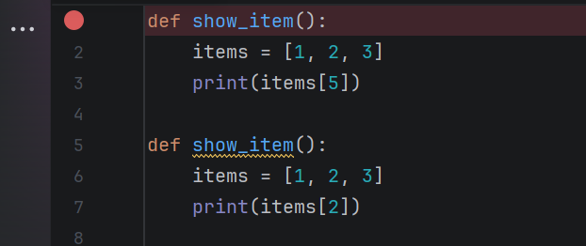

4.3 Example of Test Cases

Test cases were developed to ensure that all features of the system function correctly under different conditions. Each test case focuses on a specific function, such as adding equipment, recording bookings, or handling invalid inputs. The purpose is to check whether the system produces the correct output based on given inputs. Both valid and invalid scenarios were tested to ensure reliability and proper error handling. For example, test cases were created to verify successful equipment addition and to detect incorrect date formats. Screenshots are included to demonstrate actual inputs and the corresponding outputs, confirming that the system behaves as expected.

Test Case ID | TC002
Test Case Title | Add new equipment
Objective | Verify that the system allows adding new equipment successfully
Preconditions | System is running and menu is displayed
Test Steps | 1. Select option “2” (Add Equipment) 2. Enter equipment name “Bello”
Test Data | Equipment Name = "Bello"
Expected Result | The system displays: “Bello added successfully.”
Pass/Fail | Pass
Comments | Screenshot shows successful addition message

Figure 1 shows the system successfully adding a new equipment item called “Bello”. The user selects option 2 from the menu and enters the equipment name, after which the system confirms that the equipment has been added successfully. This demonstrates that the add equipment functionality is working correctly and updates the equipment list as expected

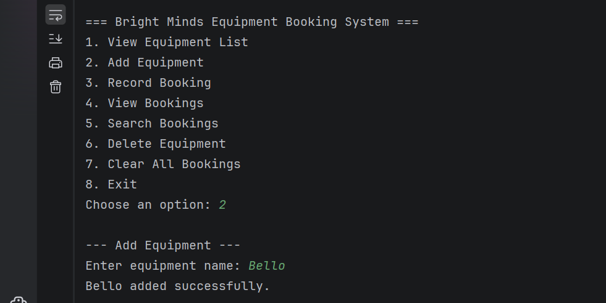
Test Case 2: Record Booking Successfully
Test Case ID | TC003
Test Case Title | Record a new booking
Objective | Verify that the system successfully records a booking with valid inputs
Preconditions | Equipment exists in the system
Test Steps | 1. Select option “3” (Record Booking) 2. Enter student name “Ali” 3. Select equipment number “1” 4. Enter valid date “2026-03-20”
Test Data | Student = "Ali" Equipment = "Laptop 1" Date = "2026-03-20"
Expected Result | The system displays: “Booking recorded successfully.”
Pass/Fail | Pass
Comments | Screenshot shows successful booking confirmation

Figure 2 Explanation
Figure shows the process of recording a booking in the system. The user selects option 3, enters the student’s name, chooses an equipment item, and provides a valid date. The system then confirms that the booking has been recorded successfully. This demonstrates that the booking functionality works correctly when valid inputs are provided.
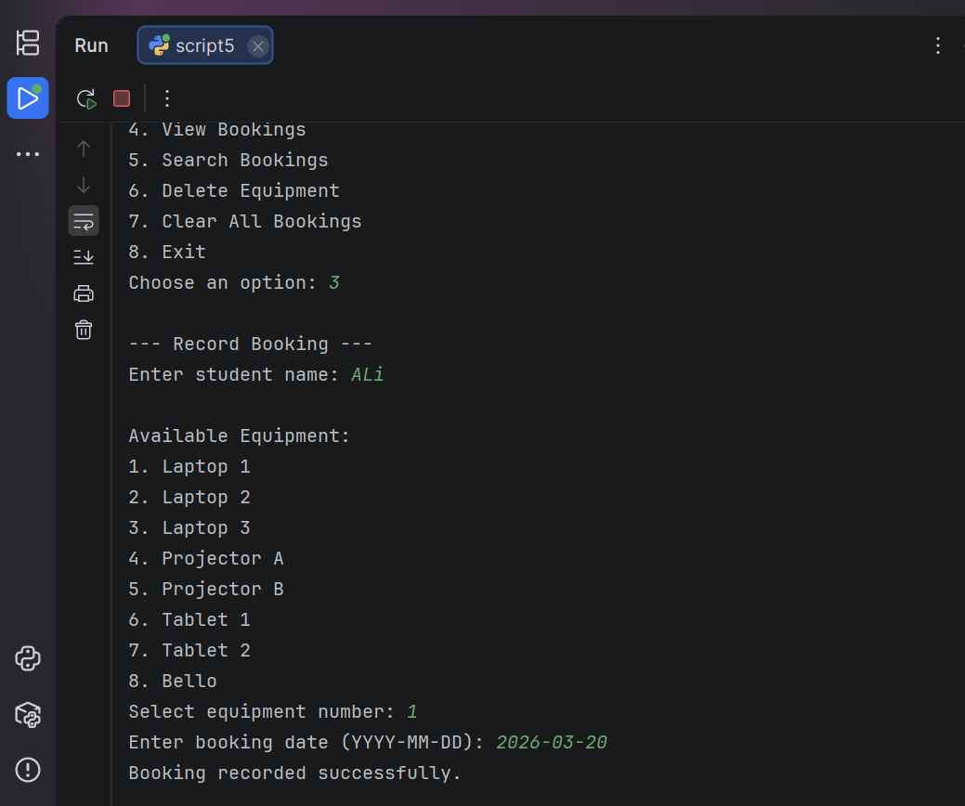
Figure 3 Explanation
Figure shows the search functionality of the system. The user enters the search term “ali”, and the system successfully retrieves and displays the matching booking record. This confirms that the search feature works correctly and can find bookings based on user input.
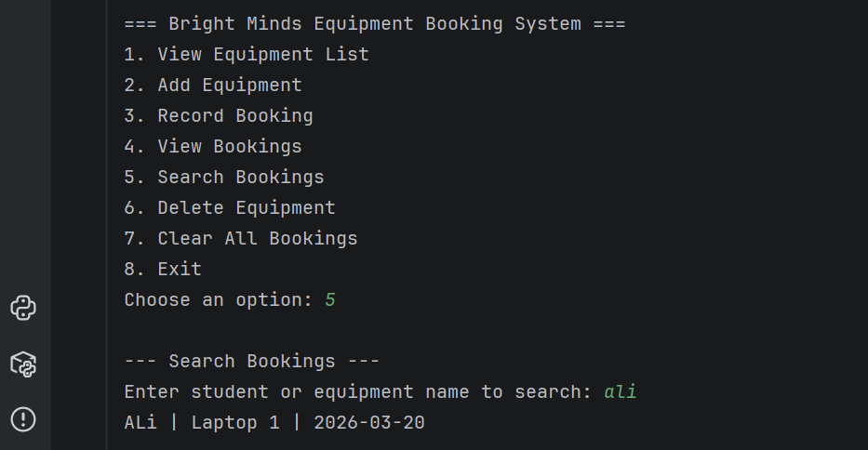

5.0 EVALUATION
Challenges Faced
Several challenges were encountered during the development of the project but especially input validation and error handling [15]. Ensuring users provided valid data, for example, a date or a number from an option list, required the use of loops and conditional statements. The biggest challenge was to prevent double bookings, and to do so I had to check if there already existed records for the same time slot when I saved new records. There were times when it was difficult to debug the program because even the smallest of errors in the logic caused the wrong output. To resolve these challenges, I tested the program numerous times. In addition, I broke the code down into smaller pieces. Finally, I reviewed all parts of the code to make sure the program did what I wanted it to and handled different scenarios correctly.

Improving Functionality
Several changes could be implemented to make the overall performance of the system better. A Graphical User Interface (GUI) should be added in place of the current text-based menu [16]. The new GUI would provide an easier to navigate and more visually pleasing option to the users. In addition to this, a database will be used to store both the booking and equipment information. The use of a database will allow for the system to process larger volumes of data more efficiently than the current list method. Additionally, data will not be lost when the program closes.
More options could be developed, such as modifying previous bookings, implementing a login feature to increase security by ensuring only authorized users can access the system, and generate historical reports of all bookings. Users being able to modify or cancel bookings will increase flexibility with the system. An additional benefit of user logins will be the ability to send users notifications/reminders about their future bookings. All of these additions will create an improved version of the system, which will be more robust, scalable, and capable of being used in a "real world" environment.

Self-Assessments
During the course of this assignment, I have been able to gain an appreciation for programming concepts and techniques including functions, loops, and data structures. I was able to take a complex problem and break it into smaller sub-problems which can be solved one at a time. I was able to learn through the process of debugging how to be more methodical when solving problems and paying closer attention to detail. I was able to practice the processes of testing and validating user input so that I could develop confidence in creating Python-based applications. I was also able to further develop my ability to create a full-fledged application from beginning to end.

6 REFERENCES
[1] M. F. H. Mohd Zahibi et al., “Enhancing the all sports booking system: addressing inefficiencies and proposed improvements for user satisfaction,” Journal of Information and Knowledge Management (JIKM), vol. 15, no. SI, pp. 206–217, 2025.
[2] O. Baron, O. Bountali, A. Gorbushin, and B. Oz, “Are No-Shows All That Bad? Strategic Double-Booking and When to Intervene,” 2024
[3] D. M. Buede and W. D. Miller, The Engineering Design of Systems: Models and Methods. Hoboken, NJ, USA: John Wiley & Sons, 2024
[4] C. Yuan, A. Villanyi, and M. Carbin, “Quantum control machine: The limits of control flow in quantum programming,” Proceedings of the ACM on Programming Languages, vol. 8, no. OOPSLA1, pp. 1–28, 2024
[5] P. Zhang, W. Dou, and H. Liu, “Hierarchical data structures for flowchart,” Scientific Reports, vol. 13, no. 1, p. 5800, 2023.
[6] K. Vayadande, P. A. Bailke, A. B. Dombale, V. R. Dange, and A. M. Kulkarni, “Converting pseudo code to code: A review,” in How Machine Learning is Innovating Today’s World: A Concise Technical Guide, pp. 57–68, 2024.
[7] T. Sarkar, Productive and Efficient Data Science with Python. Cham, Switzerland: Springer, 2022.
[8] J. A. Baaijens et al., “Computational graph pangenomics: a tutorial on data structures and their applications,” Natural Computing, vol. 21, no. 1, p. 81, 2022.
[9] P. Rita, R. Ramos, M. T. Borges-Tiago, and D. Rodrigues, “Impact of the rating system on sentiment and tone of voice: A Booking.com and TripAdvisor comparison study,” International Journal of Hospitality Management, vol. 104, p. 103245, 2022.
[10] A. Brocker, R. Schäfer, C. Remy, S. Voelker, and J. Borchers, “Flowboard: How seamless, live, flow-based programming impacts learning to code for embedded electronics,” ACM Transactions on Computer-Human Interaction, vol. 30, no. 1, pp. 1–36, 2023.

[11] M. Lutz, Learning Python: Powerful Object-Oriented Programming. Sebastopol, CA, USA: O’Reilly Media, 2025
[12] D. Sokolowski, D. Spielmann, and G. Salvaneschi, “Automated infrastructure as code program testing,” IEEE Transactions on Software Engineering, vol. 50, no. 6, pp. 1585–1599, 2024.
[13] T. Sekgweleo and T. Iyamu, “Understanding the factors that influence software testing through moments of translation,” Journal of Systems and Information Technology, vol. 24, no. 3, pp. 202–220, 2022.
[14] N. Karystinos, O. Chatzopoulos, G.-M. Fragkoulis, G. Papadimitriou, D. Gizopoulos, and S. Gurumurthi, “Harpocrates: Breaking the silence of CPU faults through hardware-in-the-loop program generation,” in Proc. 2024 ACM/IEEE 51st Int. Symp. Computer Architecture (ISCA), pp. 516–531, 2024.
[15] S. K. Jangam and P. S. R. P. Muntala, “Challenges and solutions for managing errors in distributed batch processing systems and data pipelines,” International Journal of Emerging Research in Engineering and Technology, vol. 4, no. 4, pp. 65–79, 2023.
[16] R. Mohan, “Developing a graphical user interface (GUI) for viewing and editing behavior tree policies,” 2024

