DATA HANDLING & BUSINESS INTELLIGENCE
MODULE CODE: LCBB5000
ASSIGNMENT TITLE: CURRENT TRENDS OF BUSINESS INTELLIGENCE

Table of Contents
Introduction 2
Discussion 2
5 current business intelligence trends 2
Requirement and significance of BI implementation within businesses 6
Conclusion 8
References 9

Introduction
Business intelligence is one of the most crucial innovations in the current dynamic business world because business intelligence is becoming more familiar with certain types of software tools within businesses and it involves the different strategies, tools, and functions that the companies are utilizing to collect, process, and analyze the data. Business intelligence tools can identify better opportunities for businesses to improve the existing competitive advantage and the return on investment based on the insights produced by them (Ain et al. 2019). The current report is focused on identifying the five significant business intelligence trends of 2023 and the primary requirement of the business intelligence being implemented within businesses

Discussion

5 current business intelligence trends
Just like a business, data never comes to an end. The social-economic crisis within the global market segment caused due to Covid 19 pandemic has benefited the implication of business intelligence in organizations now more than ever because most enterprises are trying to strive through the challenges and optimize all the available resources to ensure a better competitive advantage (Kaur 2023). Business intelligence, such as the cloud, automation, and mobile analytics are continuing to disrupt the entire data industry, but in 2023 these trends are continuously working towards improving the business functions and decision-making process (Lousa et al. 2019). Five significant business intelligence trends of 2023 are identified below.
Cloud BI verticals
Since the Covid-19 pandemic, most companies in different industries are going into emergencies due to the uncertainty caused by the pandemic situation globally (Kaur 2023). Most of the businesses were pressured into implementing new BI strategies and also looked into their existing ones. On-premise solutions, the challenges were required to be identified and addressed because of the remote work. Space that the companies were relying upon due to their budget issues also certainly made room for the migration of cloud BI and analytics platforms simultaneously (Villegas-Ch et al. 2020).

Figure 1: Club BI Vertical implementation
(Source: Kaur 2023)
According to Gartner, most of the organizations within which 40% of the workloads are already deployed into cloud computing systems. The mission-critical capability of the businesses is also ensuring that the companies are not shying away from implementing data solutions (Kaur 2023).
Data Science
Data science and sales service information has been overlapping the roles played by data scientists because, in most organizations, the cross-team collaboration considered through the business intelligence trend is applied within the remote workspace as a new normal (Kaur 2023). In the case of business intelligence software companies are able to offer better comments and chats that also offer visualizations with the demand of the tools such as Trello, Asana, and Click Up in combination with other tools of project management (Hamzehi and Hosseini 2022).
Augmented automation and analytics
With the current business intelligence trends forecasting, the business requirements with the help of predictive analytics are not restricted to data scientists anymore because of machine learning and automation (Kaur 2023). Automation is currently one of the most important trends in business intelligence because it is improving the delivery pipelines along with the ability to scale up analytics and increase complex data volumes. Most of the machine learning-driven algorithms are providing Better automated responses to searches by making it faster for event-driven workflows (Richards et al. 2019).
This particular trend is evaluating software solutions within organizations that can help businesses in conceiving better information sources that include connected systems and networks, web page views, and most importantly, social media comments. The primary application integration is bringing the entire concept together after relying on CRM systems, ERP systems, and business intelligence systems (Kaur 2023).
Data governance
Data governance is among some of the primary business intelligence trends in 2023 because the dedicated data rolls or assigned to the data stewards in order to identify the rich dividends with the help of software with its inbuilt role customized for permission authentication protocols of the businesses (Kaur 2023). The data governance frameworks identify the significant security of the data as per the industry standards and also help the organizations to ensure that the penalties are in line with the compliances for data breaching situations.
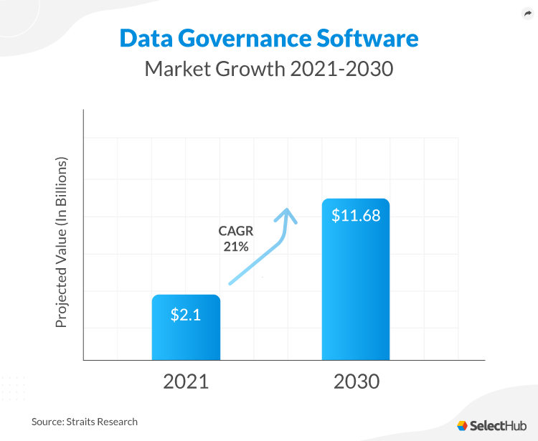
Figure 2: Data Governance Market growth by 2030
(Source: Kaur 2023)
Data quality management is considered to be a significant factor that is impacted by the implementation of data governance BI tools that are dependent on the customers trusting the organization with their data. According to the prediction, the global data governance market is estimated to grow up to $11.68 billion by 2030 (Sultana and Jimoh 2021).
Natural language insight
Natural language processing is currently one of the primary BI trends because it is holding the potential for improvement in the future of business intelligence while getting better information about the sales figures of different regions. Voice-activated searches and making data recovery easier for organizations are likely to decline the challenges for businesses as the data analytics offered by natural language Insight is in current demand (Kaur 2023).
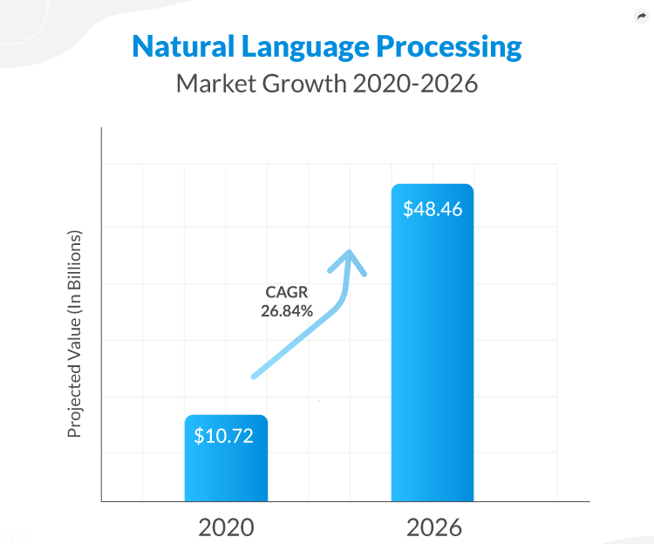
Figure 3: Natural Language Processing Market growth by 2026
(Source: Kaur 2023)
According to the prediction of the global NLP market, it is expected to grow up to $48.46 billion by the end of 2026 (Raj et al. 2019). The national language insight on national language processing is continuing to mature within the data analytics system after breaking the technical barriers of non-skilled users to allow them to use the analytics insights (Kaur 2023).

Requirement and significance of BI implementation within businesses
Business intelligence tools have the ability to perform different functions within every organization such as data visualization, predictive analytics, data mining, text mining, performance management, reporting, and other analytics which eventually result in employees harnessing better information to make the decision-making process improved by their adequate predictions about the key performance indicators in the market trends (Tavera Romero et al. 2021). In the recent time, it has become inevitable for businesses to implement BI trends within their organizational performances and business functions because business intelligence tools have a few significant benefits while working within the business such as,
Data centralization
Business intelligence tools are able to put all the data regarding customer relationships management systems, enterprise resource planning systems, portals, and other databases into one place together. This particular application of BI tools is initiating better delivery of business analytics, market trends, and organizational issues based on the queries of the customers and is addressing these queries as soon as possible (Jalil et al. 2019).
Adequate predictions
The BI tools are required to be implemented within different businesses because it helps in accessing the data from both past and present to make evidence-based decisions within the business functions. Data forecasting and predictive analytics are enabling more users within the businesses to generate adequate information regarding the performance, and history of a product and service. Additionally, the business intelligence tools are also automatically identifying the changes to help the organizations to react to any business disruptions quickly and address the issues immediately (Homocianu et al. 2019).
Business cost reduction
The BI tools have an appropriate ability to analyze the existing sales forecasting and consumers where two monitors, analyze, plan, and report the real-time process in a more effective way. It can be reported that over 50% of the BI tool users are benefiting to improve and reduce business costs by increasing revenues at the same time (Hanady et al. 2022).
Automation in reporting
The BI tools for enabling a better automation system within the business performances by eliminating the requirement of manually, inputting data into excel spreadsheets, and producing automated reports of a specific period of time with the tools that can generate it through the automation process. The information is always significant and better interactive. Visualizations can also be presented by charts and graphs generated by the BI tools automatically (Jalil et al. 2019).

Conclusion
After conducting the entire report on the recent market trends of business intelligence that have revolutionized the business dynamics it can be concluded that the customization and customer preferences in businesses are certainly impacting organizational performance. The continuous changes in customer attitude and the intelligence industry is enabling most organizations to implement better business intelligence tools in order to improve their efficiency in delivering products and services along with Organising their own performance to a great level. The BRI trends in the market segment are continuously forcing businesses since the COVID-19 pandemic to implement better business objectives and evaluate business requirements through the current trends of business intelligence tools. The report has anticipated the five significant business intelligence trends of 2023 and has also identified the requirement to implement business intelligence tools into business functions.

References
Ain, N., Vaia, G., DeLone, W.H. and Waheed, M., 2019. Two decades of research on business intelligence system adoption, utilization and success–A systematic literature review. Decision Support Systems, 125, p.113113.
Hamzehi, M. and Hosseini, S., 2022. Business intelligence using machine learning algorithms. Multimedia Tools and Applications, 81(23), pp.33233-33251.
Hanady, A.L., Ahmed, E.O., Sheta, O.E. and Adrees, M.S., 2022. Business Intelligence Systems and Knowledge Management. Advances in Dynamical Systems and Applications, 17(1), pp.311-318.
Homocianu, D., Sireteanu, N.A., Dospinescu, O. and Airinei, D., 2019, June. An Analysis of Scientific Publications on'Decision Support Systems' and'Business Intelligence'Regarding Related Concepts Using Natural Language Processing Tools. In Proceedings of the IE 2019 International Conference, Bucharest (pp. 99-104).
Jalil, N.A., Prapinit, P., Melan, M. and Mustaffa, A.B., 2019, November. Adoption of business intelligence-Technological, individual and supply chain efficiency. In 2019 International Conference on Machine Learning, Big Data and Business Intelligence (MLBDBI) (pp. 67-73). IEEE.
Kaur, R. (2023) Business intelligence trends 2023: Latest trends in Bi, SelectHub raquo. Available at: https://www.selecthub.com/business-intelligence/business-intelligence-trends/ (Accessed: March 23, 2023).
Lousa, A., Pedrosa, I. and Bernardino, J., 2019, June. Evaluation and analysis of business intelligence data visualization tools. In 2019 14th Iberian Conference on Information Systems and Technologies (CISTI) (pp. 1-6). IEEE.
Raj, R., Wong, S.H.S. and Beaumont, A.J., 2019. Empowering SMEs to make better decisions with business intelligence: a case study. In Knowledge Discovery, Knowledge Engineering and Knowledge Management: 8th International Joint Conference, IC3K 2016, Porto, Portugal, November 9–11, 2016, Revised Selected Papers 8 (pp. 306-325). Springer International Publishing.
Richards, G., Yeoh, W., Chong, A.Y.L. and Popovič, A., 2019. Business intelligence effectiveness and corporate performance management: an empirical analysis. Journal of Computer Information Systems, 59(2), pp.188-196.
Sultana, J. and Jimoh, A., 2021. Business Intelligence: Strengths, Weaknesses, and Opportunities. In Handbook of Research on Applied AI for International Business and Marketing Applications (pp. 191-206). IGI Global.
Tavera Romero, C.A., Ortiz, J.H., Khalaf, O.I. and Ríos Prado, A., 2021. Business intelligence: business evolution after industry 4.0. Sustainability, 13(18), p.10026.
Villegas-Ch, W., Palacios-Pacheco, X. and Luján-Mora, S., 2020. A business intelligence framework for analyzing educational data. Sustainability, 12(14), p.5745.

