UNIVERSITY OF WALES TRINITY SAINT DAVID

Master of Business Administration (MBA)
Assessment component 1: Individual report – HR Strategy

Student Name : Krishna Lakhu Khunti
Student ID : 2515605
Module Name: Human Capital Management
Module Code: LCMB7023
Lecturers: Gladius Kulothungan
Ejike Udeogu
Word Count : 2500 words (± 10%)
Term 1

Table of contents
0.0. Introduction .................................................................................................. 3
1.0. Designing the Talent Ecosystem ................................................................. 4
1.1 Current Talent Ecosystem ...................................................................... 4
1.2 Talent Aquisition Stratey ......................................................................... 5
1.3 Mentorship, Leadership and Learning ..................................................... 8
2.0 Reflection ...................................................................................................... 11
2.1 Evaluation using Gibb’s reflective cycle ............................................................ 11
2.2 My Action Plan .................................................................................................. 13
3.0 References ..................................................................................................... 15

0.0. Introduction
Technology sector is rapidly evolving because of AI and automation. In such times, Aether Innovations (a mid-sized tech firm) with 300 employees, is currently facing organizational challenges like flat growth, high staff turnover, and falling customer satisfaction. Human capital is the most essential strategic assets for such knowledge-intensive industries to maintain innovation, productivity and competitive advantage. Organizations like Aether must move away from traditional human capital management to newer and more integrated human capital strategies to sustain and maintain competitive advantage.
This report report examines the contemporary talent ecosystem within the tech industry to propose a strategic "build vs. buy" model for talent acquisition and retention. Then it lays out an ‘Integrated Human Capital Management Blueprint’ to realign the company’s human resource practices with its strategic organizational objectives. Furthermore, it explores how structured mentorship, defined leadership paths, and a commitment to lifelong learning and development can be integrated to attract high-potential employees and create a culture of continuous growth.

Part 1 : Designing the Talent Ecosystem

1.1 current talent ecosystem
The current talent ecosystem in the technology sector is witnessing a fundamental transformation. From traditional job-title centric models, it is shifting towards dynamic, skills-based architectures. Rapid technological innovations, the rise of Artificial Intelligence (AI) and automation plus an evolving talent ecosystem are the major driving factors for it. Companies in tech ecosystem are focusing more on skills and competencies rather than degrees and credentials. This newer hiring approach can significantly expand talent pools (LinkedIn, 2025). Organizations are now considering a pool of capabilities that can be employed for different projects across the domain(McKinsey & Company, 2025).
AI agents are now capable of predictive analysis by analyzing sentiment and engagement data, which is critical for companies like Aether Innovations experiencing high staff turnover. Where AI systems can identify ‘flight risks’, provide personalized career maps that match an employee's current skills with emerging internal opportunities (Workday, 2026).
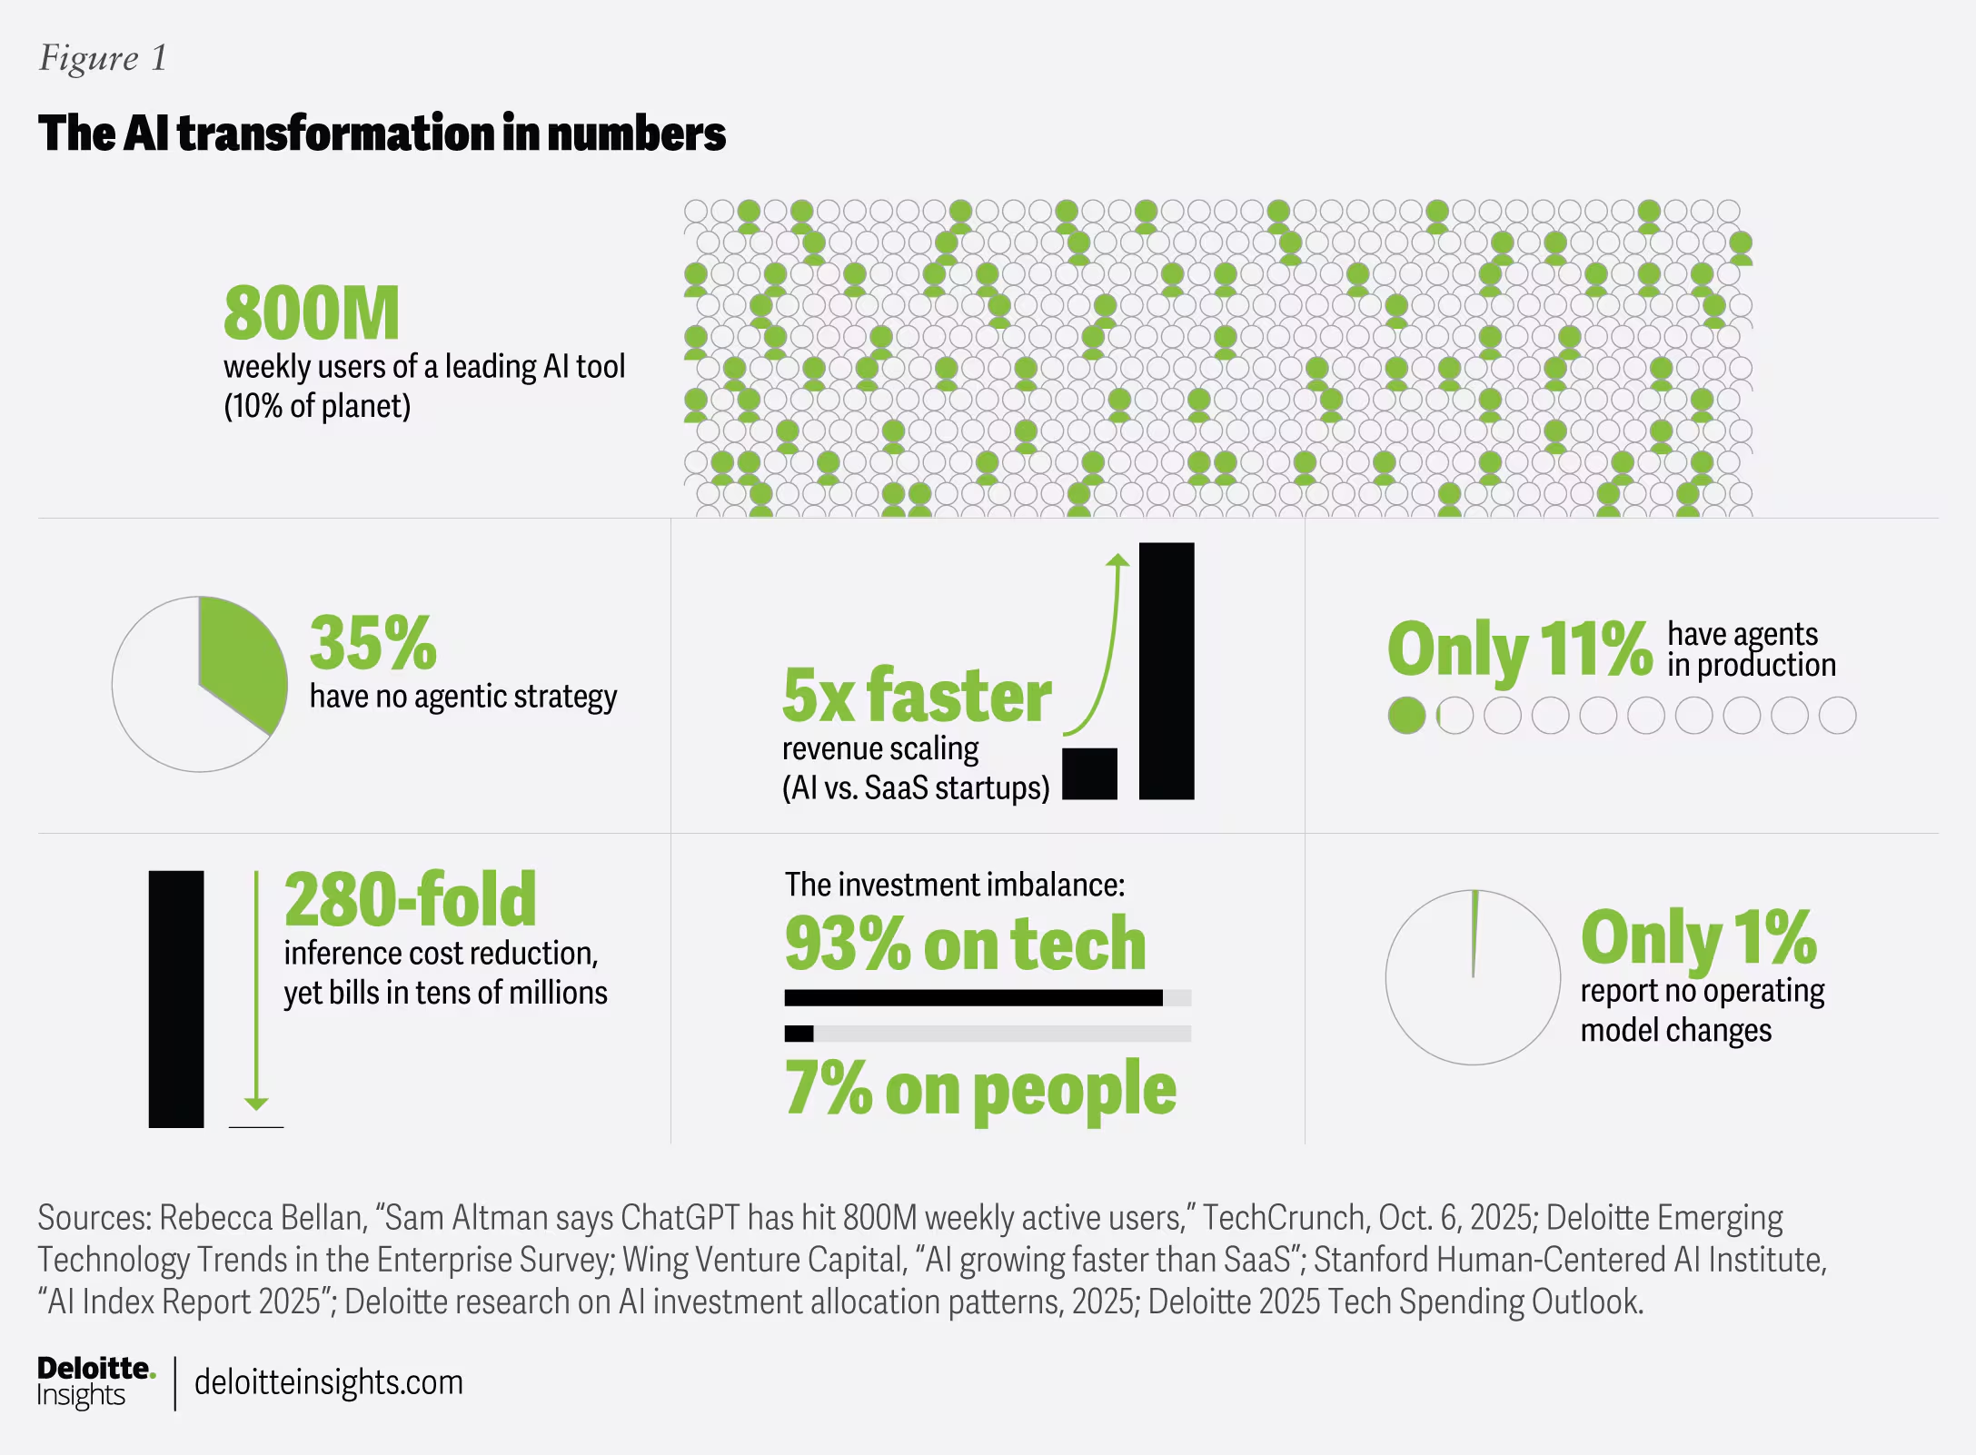
In order to attract top-tier talent globally, the majority of tech firms have either adopted hybrid or fully remote work models. Tech Companies are hiring talent based on skill availability rather than of physical location (Deloitte, 2026). As a result, Workplace flexibility has become a core component of the tech talent ecosystem instead of just an optional perk offered by very few employers.
Despite all these advancements and adjustments, the tech sector is still facing another kind of challenge - retention crisis. Aether Innovations is not an exception here. As, Modern tech talent values menaingful work with clear purpose and prioritizes internal mobility and lifelong learning over traditional benefits (Phenom, 2026). Ather innovations is forced to rethink the Employee Value Proposition (EVP).
1.2 Talent Aquisition Strategy
To effectively address Aether Innovation’s stagnation and turnover challenges, a modern version of "Build vs. Buy" talent model is required. Instead of the simple binary choice, we need a multi-dimensional approach known as "Build, Buy, Borrow, and Bot" model (Deloitte, 2026). This integrated ecosystem balances the long-term stability and rapid agility through internal development and external acquisition with AI augmentation as added layer.
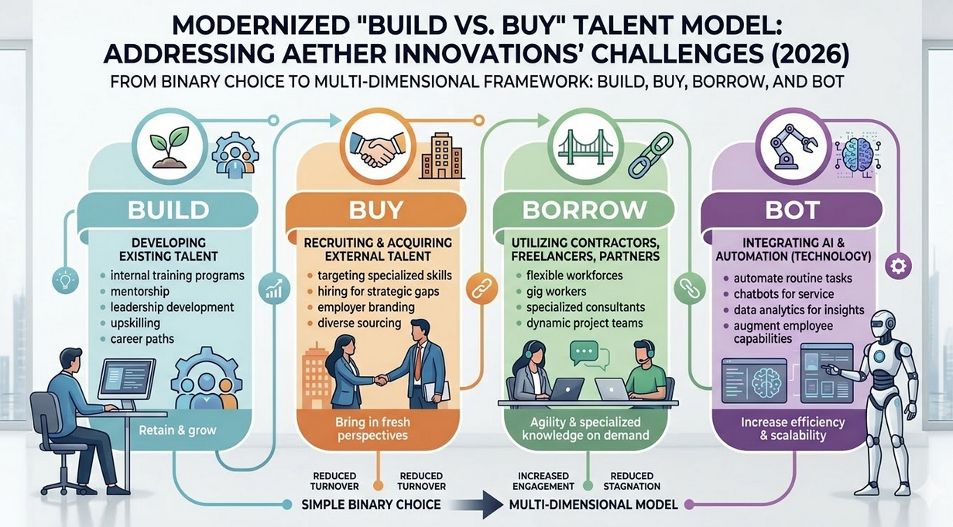
The "Build" Strategy for Cultivating Internal Excellence
For a 300-person firm like Aether Innovations, Build strategy is the most sustainable for long-term talent retention. By prioritizing internal mobility and upskilling, Aether innovation can nearly double their retention spans compared to other similar firms who rely solely on external recruitment (LinkedIn Learning, 2026). Rather than traditional promotional structure, Aether should implement a skills-based promotional architecture. This way, the firm can redeploy high-potential employees on high-impact projects based on their strongest competencies and not on the basis their current job titles (SCDL, 2026).
Because of rapid technological advancements, Hiring alone can not close the skill-gap. So, Aether innovations must invest in predictive and personalised upskilling that is more aligned with future job roles and requirements. Firm should also focus more on maintaining high senior-level mentorship capacity to pursue a ‘Build strategy’ successfully, as it preserves critical cultural context that external hires lack (Chauradia, 2026).
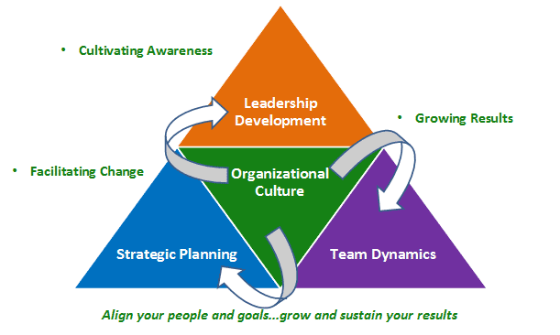

The "Buy" Strategy for Smart External Infusion
While ‘Building strategy’ fosters loyalty, ‘Buying’ is essential for agility and the infusion of immediate niche expertise. At Aether innovations, this method should only be used when absolutely nacessary. Firm can use this strategy for senior roles that require an immediate shift in organizational mindset. Such as the Chief Innovation Officer, Here the "Buy" strategy is more effective as it brings in "changefulness" and fresh perspectives that are difficult to cultivate purely from internal talent(Korn Ferry, 2026).Aether should move away from credential-heavy screening and toward AI-driven competency assessments, when hiring external talent. This strategy expands the eligible talent pool by identifying candidates who may lack a traditional degree but possess the exact technical skills required (OrangeHRM, 2025).
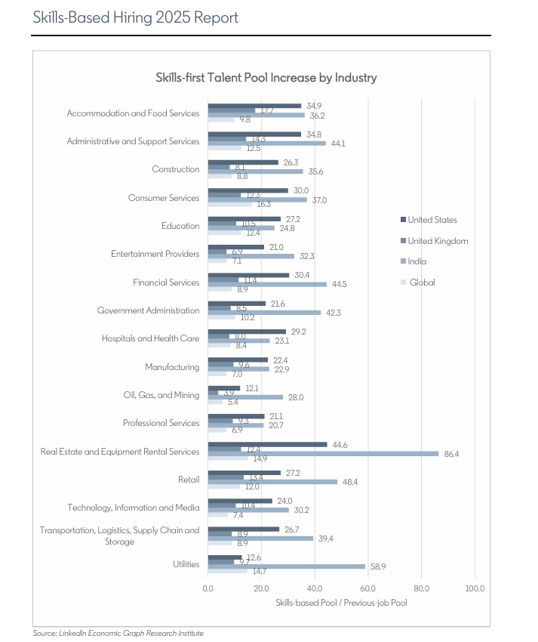
Decision Matrix : Build vs Buy (2026)
The decision to either build or buy depends on the volatility of the project environment and the availability of internal resources (Chauradia, 2026).
Driving Factor | Build (Develop Internally) | Buy (Hire External)
Primary Goal | Cultural stability & retention | Innovation & speed to market
Cost | Lower total cost | Higher upfront cost  ( salary/agency fees )
Ramp-up Time | Slow (6–12 months) | Fast (Immediate productivity)
Key Risk | Cultural stagnation | Cultural misalignment

Integrating the "Bot" and "Borrow" Layers
In order to maintain competitiveness in 2026, the Build - Buy model must also include the "Bot" (AI agents) and "Borrow" (gig/freelance) layers. Rather than hiring for routine administrative tasks, Aether can laverage "Agentic AI" to handle complex workflows, which will allow its human High Poerformance individuals to focus on higher-value critical thinking and strategic problem-solving (Korn Ferry, 2026). Ather innovations should also utilize specialist contractors for short-term projects or innovation sprints. Which will allow Aether to access niche capabilities, such as advanced cybersecurity or ethical AI auditing, without increasing permanent fixed costs (Lorien, 2026).

1.2 Retaining High Potential Employees thruogh mentorship, leadership paths, lifelong learning
Mentorship,leadership paths, and lifelong learning are no-longer peripheral benefits but it has become the core pillars of a competitive Human Capital strategy. For an organization like Aether Innovations, these elements act as a "human-centric" Employee Value Proposition (EVP) that directly addresses stagnating growth and high voluntary turnover.
Mentorship
Mentorship fosters psychological safety and institutional belonging in individuals. Nowadays, tech workforce is increasingly distributed, so human connection from mentorship becomes a critical retention driver. Research indicates that 91% of workers with a mentor report being significantly happy and setisfied at work (Mentorloop, 2026).This happiness is often attributed to the ‘salary-equivalent’ value of receiving personalized guidance and advocacy. For Aether’s younger talent pool, mentorship is a non-negotiable requirement. Millennials with mentors are twice as likely to stay with their employer for more than five years compared to those without (68% vs. 32%) (Mentorloop, 2026). Mentorship is also very effective for underrepresented groups in tech industry. Women in tech, who have mentors are 77% more likely to remain in the tech sector after three years, which is a clear pathway to closing gender-based equity and skill gaps (Women in Tech, 2026).
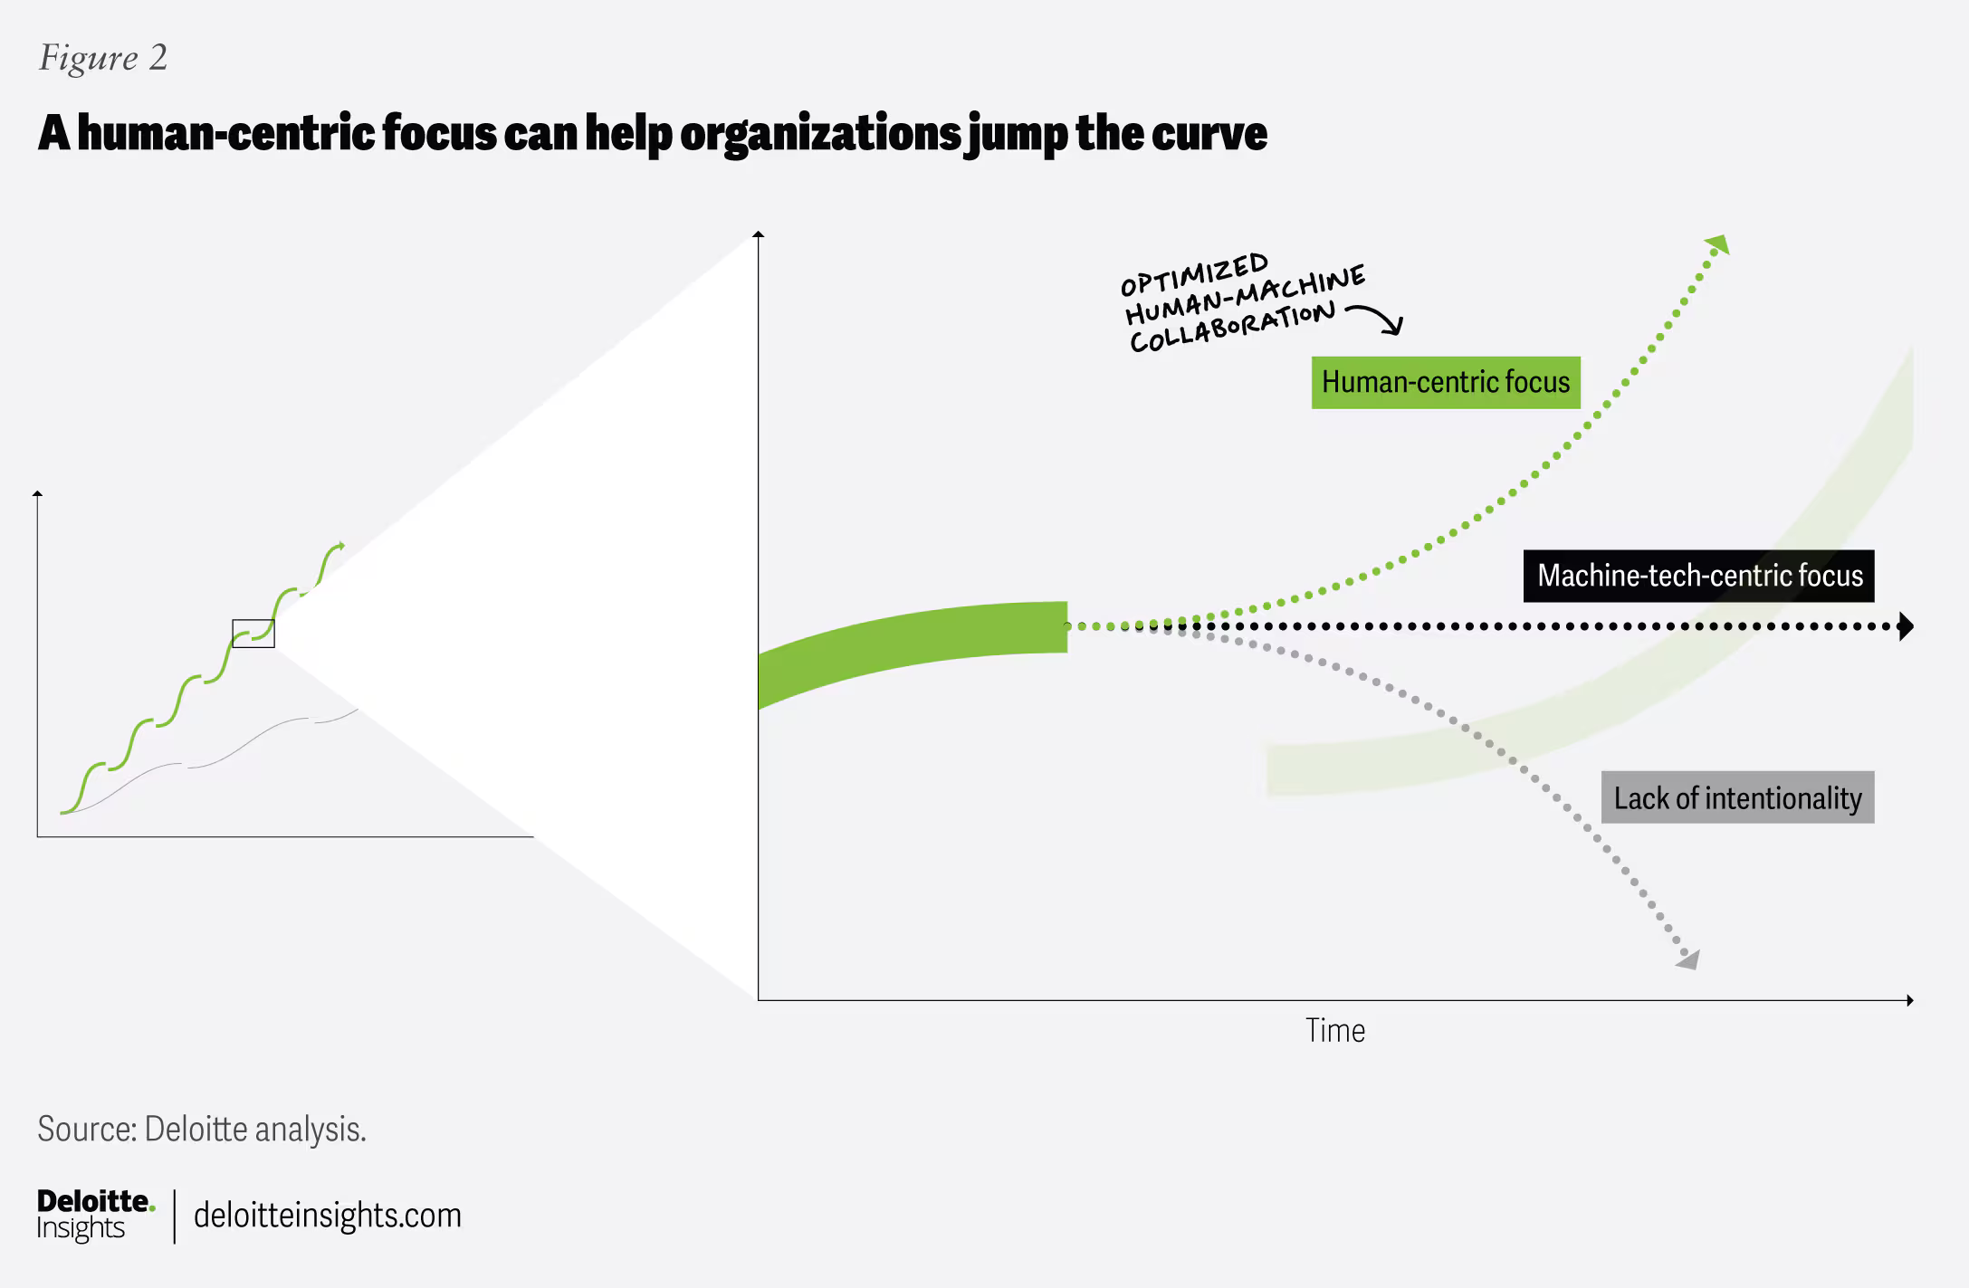
(Source : Deloitte 2026 )
Leadership
In current tech sector landscape, high-potential employees priorotise their career ownership and the ability to move through an organization with agility. Instead of traditional salary concerns, more than third of tech professionals consider career advancement and exposure to emerging technologies as their primary reason for joining or staying with a company (Lorien, 2026). AI readiness is a must for leadership paths. Aether can attract candidates who want to be at the forefront of this AI revolution by providing high performance individuals with a clear trajectory toward "Human-AI leadership" roles, Which only 22% of companies are mindful about (Korn Ferry, 2026). Organizations are 80% more likely to have top-performing teams if they utilize internal mobility to fill roles (Deloitte, 2026). Aether can rejuvenate its stagnant R&D culture by allowing their high performance individuals to lead projects regardless of their tenure.
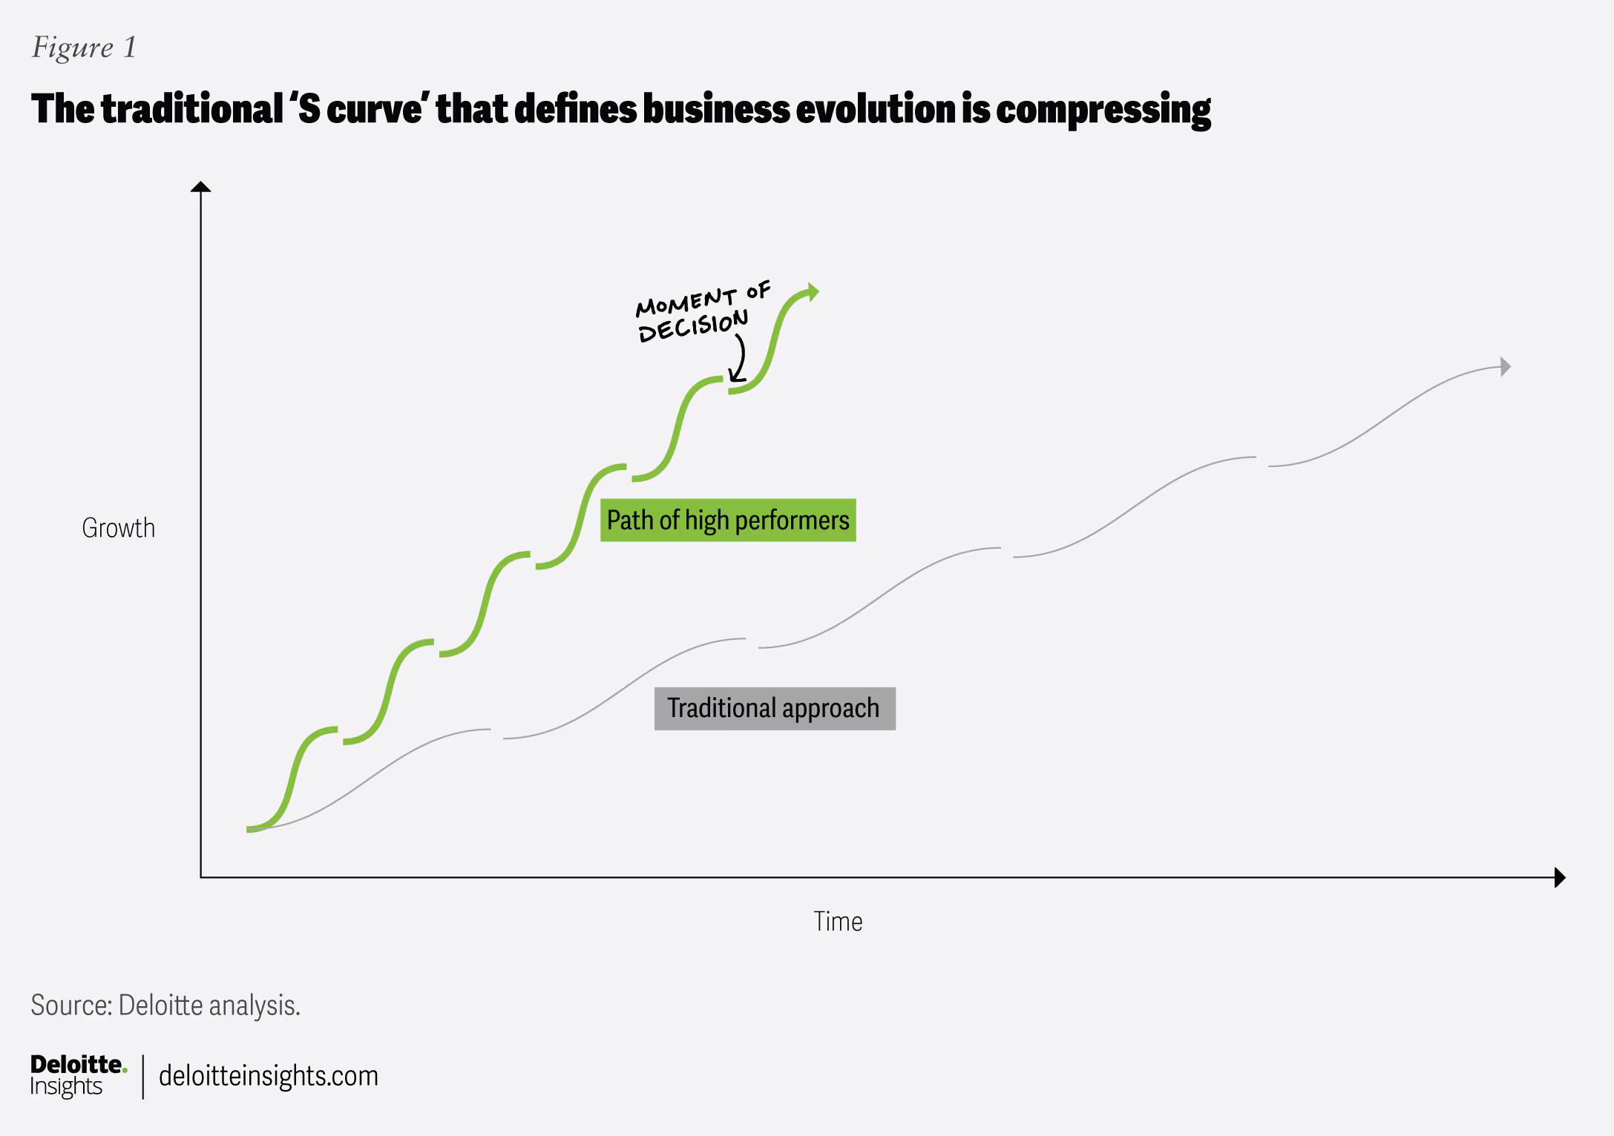
(Source : Deloitte 2026 )
Lifelong Learning
As technology cycles are shrinking, the ability to learn has become more valuable than having any static technical skill. Lifelong learning is now essential part of survival mechanism for both the employee and the firm. Which can also be seen in employees as 82% of tech sector employees believe that opportunities for learning and growth are the most important factor and massive 94% of employees state that they would stay at a company longer if it invested in their career development and continuous learning (LinkedIn Learning, 2026). On the other hand, The World Economic Forum estimates that globally one billion workers will need reskilling by 2030 due to AI and automation (WEF, 2026). Also, growth has flattened at Aether innovations, so a robust learning culture will signal high performance individuals that their personal market value is protected. Which should compell them to stay within the organization. This growth mindset will foster the much required resilience and agility to navigate the rapid transformation of tech ecosystem.
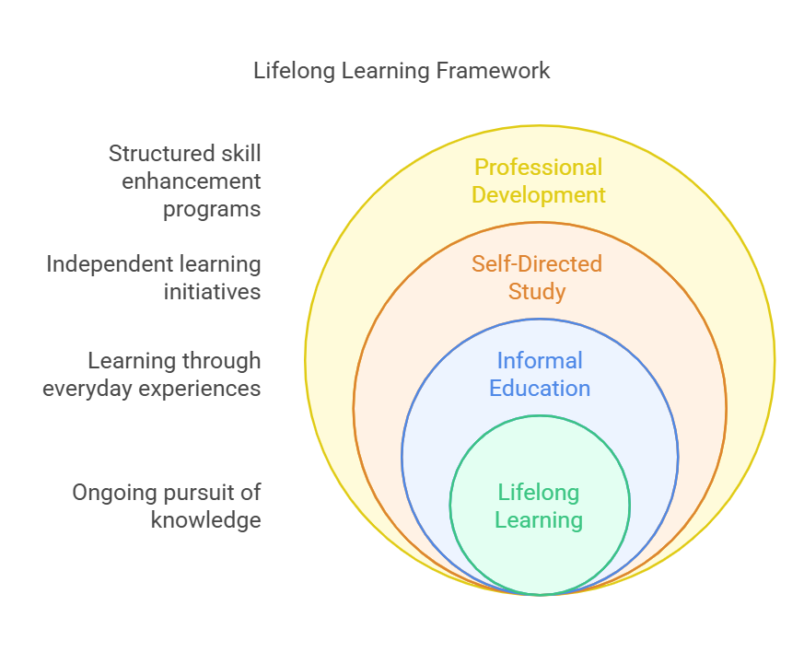

Part 2.0. Reflection
2.1 Evaluation using Gibb’s Reflective Cycle
Here I have evaluated my learning and entire journey of Cultivating Innovation and a Growth Mindset during the Human Capital Management (HCM) module. I have used Gibbs’ Reflective Cycle for evaluation and to establish a personal Learning and Development (L&D) baseline for 2026.
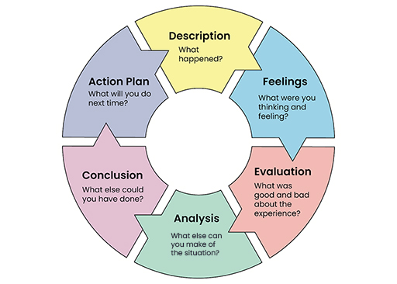
Description
Before this module, I used to consider human resource management as dealing with recruitment, payroll and compliance practices. I had a basic understanding of Human Resources, but after completion, I have develop deeper understanding of Strategic Human Capital management. Specifically analyzing the challenges at Aether Innovations and applying academic frameworks to solve them gave me much needed confidence and strategic approach to handle such scenarios. The core of this journey involved designing a "Talent Ecosystem" that balanced "Build vs. Buy" strategies, mentorship, and lifelong learning. I had to go through complex data regarding high staff turnover and flat growth. Then I had to synthesize theoretical models like the Job Characteristics Model and Skills-Based Architectures into a practical blueprint for organizational recovery.
Feelings
Initially, I felt overwhelmed because of the rapid transformation happening in the tech landscape, more particularly the "agentic AI" shift. I was also concerned that I would not be able to apply traditional HRM theories for these problems. However, as I explored these modules and Growth Mindset framework, my anxiety shifted to curiosity. I realized that Aether Innovation’s employees needed to adapt, just like I was adapting these thories to fit into current situations. Now I can navigate such scenarios with confidence and also contribute to shape the future of work at Aether Innovations.
Evaluation
Throughout this journey, I have realised that human-centric skills are more valuable than ever before because empathy, critical thinking with context and ethical leadership cannot be fully automated through AI or any such technologies. However, the challenge was reconciling the ‘speed’ from ‘buy’ strategy with the ‘culture’ from ‘build’ strategy. I didn’t want to propose a temporary patch for Aether's such deep-rooted issues, but at the same time it was really important that solution should be immediate.Which was a very diffcult task for me. This taught me that learning & development must be a continuous loop, not a one-time intervention.
Analysis
My experience perfectly aligns with recent research done by the World Economic Forum in 2025. which suggests that in future, success in the job market will depend less on what you know and more on your learning agility and how well can you adapt with rapidly changing environment. How fast someone can acquire new competencies. After linking this to Carol Dweck’s Growth Mindset, I realized that if I view my skills as fixed, I cannot design a dynamic ecosystem for others. Furthermore, the transition to "Just-in-Time" (JIT) learning made me realise that my personal L&D baseline should not be limited to isolated study sessions but it must be integrated into my daily work.
Conclusion

I have learned that strength and effectiveness of an integrated human capital strategy depends on the growth mindset of its leaders. Now I can connect micro level task of job designs to macro level of organizational strategy. Specifically for me, I have realized that my own L&D baseline must prioritize ‘human-AI collaboration’ skills. To cultivate a culture of innovation, I must be a "curriculum curator" and actively seek out cross-functional challenges that push me beyond my comfort zone.
Action Plan
To maintain a growth mindset I learned during this module and stay relevant in rapidly transforming tech sector, I will implement the following SMART goals:
Skill to aquire: I will complete a certification in "Ethical AI Governance" by September 2026 to ensure I can audit the "Bot" layer of the talent ecosystem.
Social Learning: I will create a reverse-mentorship arrangement with my junior data scientist to stay updated on emerging technical tools.
Active Experimentation: I will dedicate four hours weekly to an AI Experimentation, which will help me learn new generative tools to improve my consultancy workflows and make sure I am not only tech literate but a tech master.
2.2 My Plan to Stay Relevant in AI era
Newer tech labor market is shifting from traditional static job structures to more and more dynamic orchestration of people, skills, and technology. I have created a strategy for staying relevant using Hybrid Intelligence – to use human judgment which is unique to me and AI augmentation for efficiency.No doubt AI agents are increasingly capable of automating routine cognitive and clerical skills, but they sometimes lack the contextual understanding and ethical deliberation, which are the key primary differentiators for human leadership.
To avoid displacement in an era where AI is going to affect nearly 60% of global roles, I am prioritising ‘AI Fluency’ – meaning capable enough to not just use AI, but to govern and challenge AI systems. I am planning to use AI to frame complex organizational problems and then interpreting those AI-generated results through a cultural lens. I also want to develop an expertise in safety against disinformation and algorithmic bias to maintain digital trust within the talent ecosystem. This is going to be a really valuable skill in the upcoming future and organisations will require it to effectively utilise AI.
AI is really good with data-intensive tasks, so I can use it to assist me with complex high-impact decisions. HR of the future should be able to perform predictive workforce analytics, sentiment analysis of employee engagement, and the initial screening for skills-based hiring using AI to improve operational efficiency.
While is force multiplier, I will strictly exclude it from final decision-making. Specially where a cultural fit, high-level conflict resolution, and nuanced coaching is required. I can focus more on the human connection and strategic innovation by offloading tedious and repetitive tasks to AI. These are the core areas where technology will remain just a partner and not a replacement.

References
1. Deloitte Insights (2026) Tech Trends 2026: Architecting an AI-native tech organization. https://www.deloitte.com/us/en/insights/topics/technology-management/tech-trends.html

2. LinkedIn Economic Graph (2025) Skills-Based Hiring 2025 Report. https://economicgraph.linkedin.com/content/dam/me/economicgraph/en-us/PDF/skills-based-hiring-march-2025.pdf

3. McKinsey & Company (2025) McKinsey Technology Trends Outlook 2025. https://www.mckinsey.com/capabilities/tech-and-ai/our-insights/the-top-trends-in-tech

4. Phenom (2026) 2026 Talent Management Trends: 12 Trends Shaping the Future of Work. https://www.phenom.com/blog/talent-management-trends

5. Workday (2026) The Top 5 Human Resource Management Challenges for 2026. https://blog.workday.com/en-us/top-5-human-resource-management-challenges-2026.html

6. World Economic Forum (2026) Creating Economic Opportunities for All in the Intelligent Age. https://www.weforum.org/impact/creating-economic-opportunities-for-all-in-the-intelligent-age/

7. Deloitte (2026) 2026 Global Human Capital Trends: From Tensions to Tipping Points. https://www.deloitte.com/us/en/about/press-room/deloitte-report-winning-organizations-will-build-the-human-advantage.html

8. Chauradia, A.J. (2026) Study finds firms 'build' or 'buy' talent based on resources, demand.https://www.usf.edu/business/news/2026/01-22-build-or-buy-research.aspx

9. Deloitte (2026) 2026 Global Human Capital Trends: From Tensions to Tipping Points https://www.deloitte.com/us/en/insights/topics/talent/human-capital-trends.html

10. Korn Ferry (2026) TA Trends 2026: Human–AI Power Couple. https://www.kornferry.com/insights/featured-topics/talent-recruitment/talent-acquisition-trends

11. LinkedIn Learning (2026) Upskill or Hire Externally? How to Elevate Career Development and Internal Mobility. https://learning.linkedin.com/resources/upskilling-and-reskilling/upskilling-vs-hiring

12. Lorien (2026) 10 workforce trends tech leaders can't ignore in 2026. https://www.lorienglobal.com/insights/10-workforce-trends-tech-leaders-cant-ignore

13. OrangeHRM (2025) Navigating the Top HR Trends for 2026 with Strategic Precision. https://www.orangehrm.com/en/resources/blog/navigating-top-hr-trends-with-precision

14. SCDL (2026) Top HR Trends in 2026 Shaping Future Workplaces. https://www.scdl.net/blog/hrm/top-hr-trends-2026

15. Mentorloop (2026) Mentoring Statistics You Need to Know - 2026. https://mentorloop.com/blog/mentoring-statistics/

16. Women in Tech (2026) Women in Tech Mentorship Statistics 2026. https://www.womentech.net/women-in-tech-mentorship-statistics

17. World Economic Forum (2026) Creating Economic Opportunities for All in the Intelligent Age. https://www.weforum.org/impact/creating-economic-opportunities-for-all-in-the-intelligent-age/

