Database Design (The Bookstore)
ACCB4013 – B Holland

Isobel Sutcliffe – 1808257
1808257@student.uwstd.ac.uk
06 – May – 2019

Abstract
The bookstore database is now available for viewing. The work was not without some failures and yet some discoveries that made the process enjoyable and almost pleasurable. There is a working database, that is waiting for some feedback from the owners and staff to ensure its usability and effectiveness. There appears to be a bug within the creation of the Supplier Order Report, despite it being created in a like for like manner to the Customer Order Report, this is a piece of work that will need further investigation. Some other further pieces include getting the stock reports up and running alongside looking an invoice section, this should help with staff satisfaction as it would give them more free time to spend it keeping customers happy and searching for those highly collectable books that they are being asked after.

Contents
Section 1 – Introduction 1
Section 2 – Design Techniques for Bookstore Database 2
Section 3 – Implementation of Bookstore Database 6
3.1 User Guide to Database 8
Section 4 – Future Developments 46
References 47

Section 1 – Introduction
Dylans Book Store is a small bookshop that provides a friendly atmosphere and great service to its customers. They currently supply popular books alongside classic collectables.
The firm has been very slow in getting to grips with new technology with only 1 pc in the shop which has a document package on it. They produce a newsletter every two - three months highlighting the books that may be of interest to their customers.
They are looking to streamline their business and to provide an even more efficient service without losing sight of the friendly service and great customer care that they currently provide. There is a desire to provide a faster customer service so as to build on the reputation and a need to computerise. They have MS Access on the one computer and are looking to utilise this in their development, rather than spend large sums of capital unnecessarily.
Section 2 – Design Techniques for Bookstore Database
Considerations:
- The system needs to be faster than the current method;
- It has to be accurate;
- Enable easy input of data as well as editing and when needed deletion;
- Produce a variety of reports that aid the store;

When considering what needs to go into the database, it must be established what the entities are, entities are recognisable objects that would have an independent existence and can be differentiated from other objects. [1]
First established entities in the book store included:
- Author
- Book
- Customer
- Customer Order
- Supplier
- Supplier Order
The next step is to establish the relationships between the entities (tables), this allows data that seems unrelatable to be linked together to provide meaningful analysis and reporting, if required at a later date. Relationships are considered to be the glue that keeps tables together and are used to connect related tables together.
With the book store the Author table would be linked to the Book table as without an author a book could not be written. A customer would be linked to the book they have ordered through the customer order table as this would then be linked to the Book table and so on. . . thus allowing the firm to see how many customers like or have read books by a particular author, as they are indirectly linked in a relationship.
Below is an initial tables and fields listing identifying the primary keys and foreign keys:
For the Book and Author Tables:
Title | Author |  | Book
Fields | ID | PK | ID | PK
 | First Name |  | Author_ID | FK
 | Surname |  | Title
 | Full Name |  | Description
 |  |  | Genre
 |  |  | Bound Type
 |  |  | Retail Price £
 |  |  | Supplier Price £
 |  |  | ISBN Number (if available)

For the Customer and Customer Order/Purchase Tables:
Title | Customer |  | Purchase |  | Purchase Item
Fields | ID | PK | ID | PK | Book.ID | PKFK
 | First Name |  | Customer.ID | FK | Purchase.ID | PKFK
 | Surname |  | Purchase Status.ID | FK | Quantity
 | Address 1
 | Address 2
 | City/Town
 | Postcode
 | Phone
 | Full_Name

For Supplier and Supplier Orders/Purchase Tables:
Title | Supplier |  | Supplied |  | Supplied Item
Fields | ID | PK | ID/PO | PK | Book.ID | PKFK
 | First Name |  | Supplier.ID | FK | Supplied.ID | PKFK
 | Surname |  | Supplied Status .ID | FK | Quantity
 | Company Name
 | Address 1
 | Address 2
 | City/Town
 | Postcode
 | Phone

Primary keys (PK) on a database is a key that is selected as a unique identifying mechanism for the whole entity set (table), it cannot be null and will identify the row that it relates to throughout the whole database. A foreign key (FK) is an attribute from a table that is linked to the primary key of another table – a foreign key however can be null. If a primary key is a foreign key in another table than it must be of the same datatype for any relationships to be made.[1]
All good databases should ensure that they follow the guidelines around the third normal form (3NF). This means that all duplicate columns from the same table are removed, create a separate group for all related data ensuring that there is a primary key. (1NF)[2]
Second normal forming (2NF) does that comes with 1NF and removes all subsets of data contained with the table and places them in separate tables, ensure that the subsets have a primary key and set the foreign key to the primary key of the first table.[2]
3NF follows on from 2NF in that the user must do all that comes under 1NF and 2NF and then removes the columns in the table that do not relate or are not dependant on the primary key.[2]
Where possible the tables that have been created have followed the standard as set out in the 3NF, hence the introduction the Customer Order Details as a customer order could have many lines and therefore the customer order number, which should be unique, may appear a number of times the table.[2]
Using Visio to create an overall picture of the tables and relationships proved useful as it allowed an understanding of what may be missing from the initial thoughts around the tables.

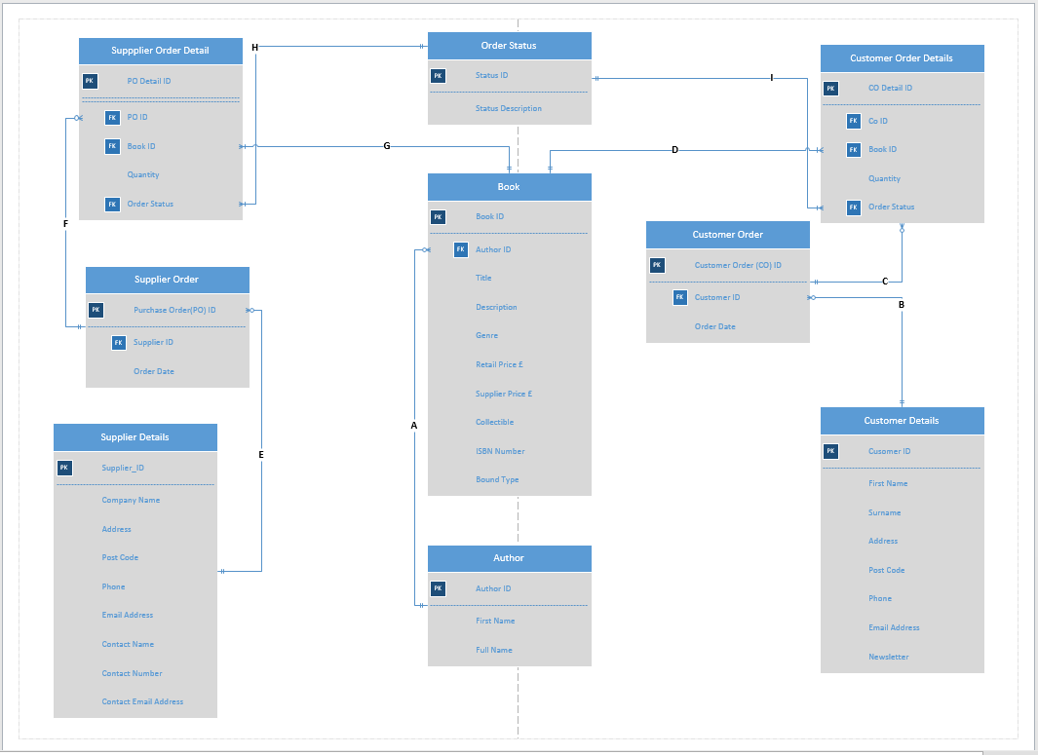

Relationship Key:
- Identifies the relationship between Author and Book, it’s a “one to many” relationship in that an author can have many books to their name.
- Customer Details to Customer Order, this is a “one to many” relationship as the Customer can have many orders.
- Customer Order to Customer Order Details, this is a “one to many” relationship as a Customer Order could have many lines to it.
- Customer Order Details to Book, this is a “one to many” relationship as order lines can have many books on it.
- Supplier Details to Supplier Orders, this is a “one to many” relationship as the Supplier can have many orders.
- Supplier Order to Supplier Order Details, this is a “one to many” relationship as a Supplier Order could have many lines to it.
- Suppler Order Details to Book, this is a “one to many” relationship as order lines can have many books on it.
- Supplier Order Detail to Order Status, this is a “one to many” relationship as an order lines can have many order statuses.
- Customer Order Detail to Order Status, this is a “one to many” relationship as an order lines can have many order statuses.
Whilst inputting the information into Visio, it was clear that it was lacking an order status field, this field will be important in establish a stock report, especially when it comes to end of year. As it would easily establish what should be on the shelves and what is on order and therefore not on the shelves, along with knowing what orders are awaiting completion from customers.
Section 3 – Implementation of Bookstore Database
Use of Standard Query Language (SQL):
Screenshot of using SQL to create tables in the database:
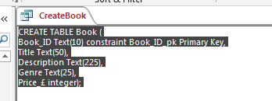
Below is an example of SQL to create a table and creating a relationship with a foreign key to the table:
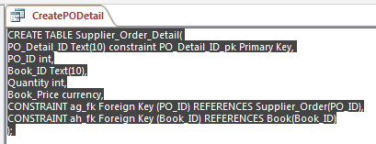

The tables that were created were done using SQL, below is a screenshot of all the SQL table creations and the tables currently in the bookstore database:
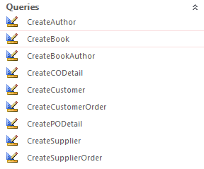
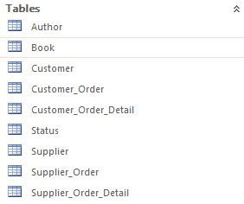
The completed Entity Relationship Diagram for the shop database:
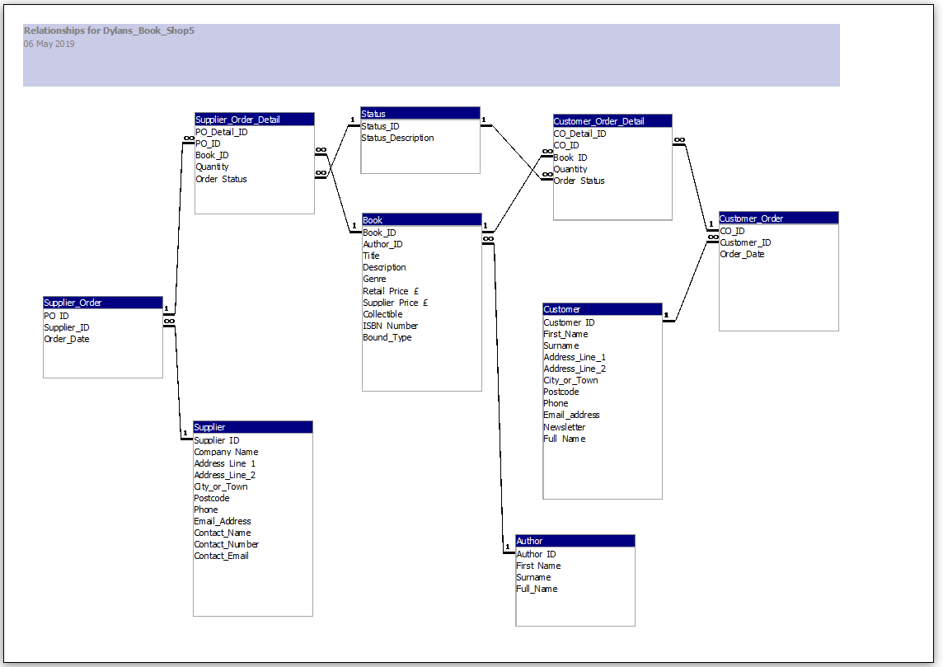

3.1 User Guide to Database

On opening the database “Dylan’s Book Store” the user should be greeted with a front sheet that looks like the main menu below:

Main Menu
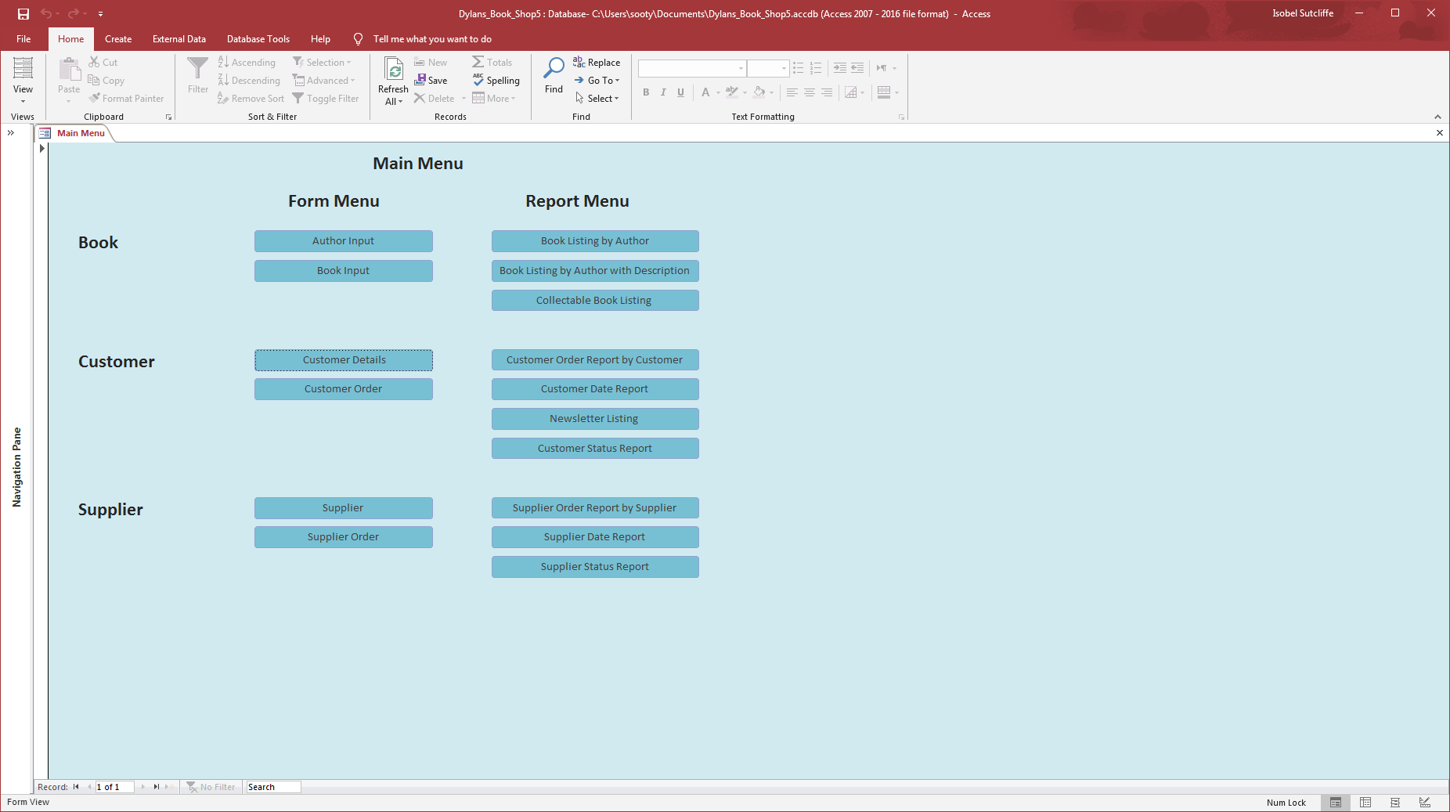
The main menu has been divided into forms for inputting data and reports that may be useful to the satff.
All the buttons on the main menu are connected to the relevant forms and reports, by simply selecting the relevant button, staff can quickly and easily go to the required page.

Using the Forms on Main Menu:
Author Input Form
Click on the button named “Author Input” – highlighted purple when the user hovers over it.
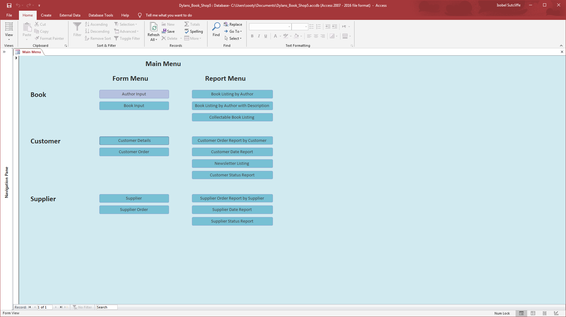

Once the button “Author Input” has be clicked the user will be directed to the user input form below:
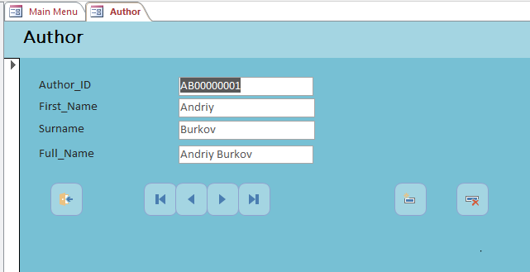
From Left to Right the navigation buttons on the bottom of the screen are as described:
- Close form;
- Go to the first record;
- Go the previous record;
- Go to the next record;
- Go to the last record;
- Add a record and delete a record.
Let’s go to add a record by clicking the 6th button along:
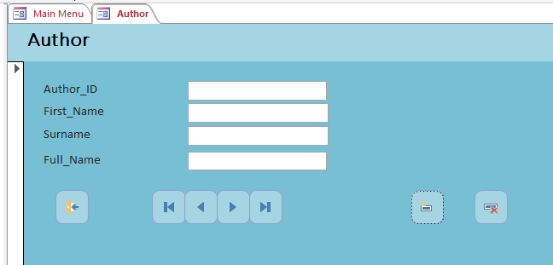
Put the details of the author that needs to be added in here.
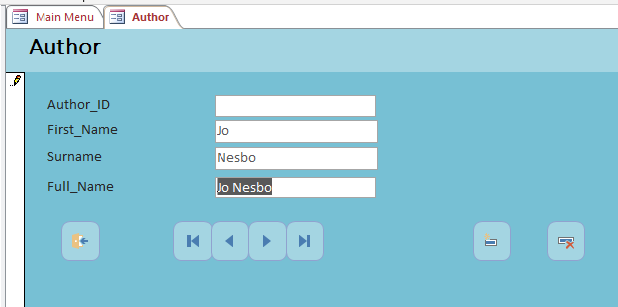
For the “Author ID” take the authors first initials JN and add up to 7 0’s and a 1. The Author ID is a unique reference alphanumeric field of 10 characters.
N.B. (This is something that can be looked at if this does not suit going forward)
If there is a duplicate, say a Jon Nolan was added and a 1 was placed at the end, an error message will come up. Click OK and replace the 1 with a 2
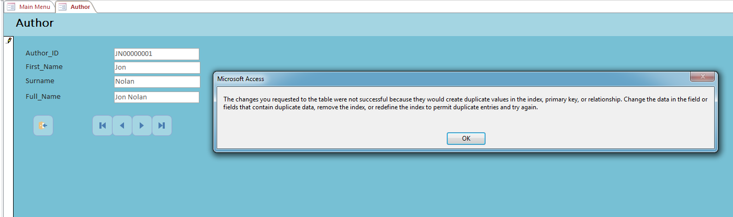

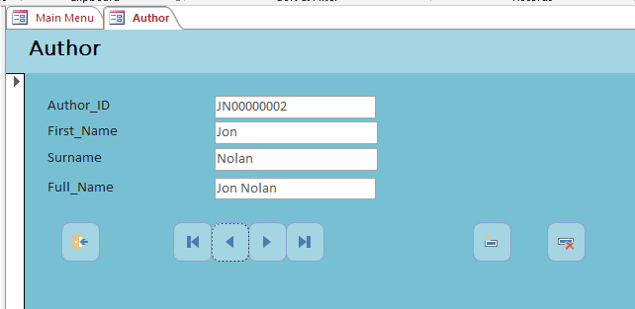
These have now been added to the database:
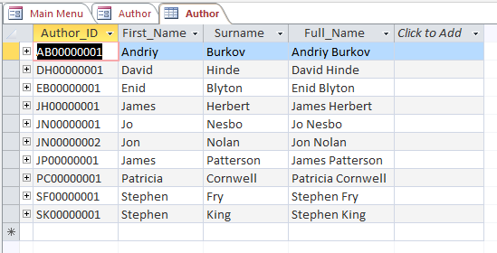
If the user wanted take Jon Nolan off, simply click on the seventh button, and delete the record:
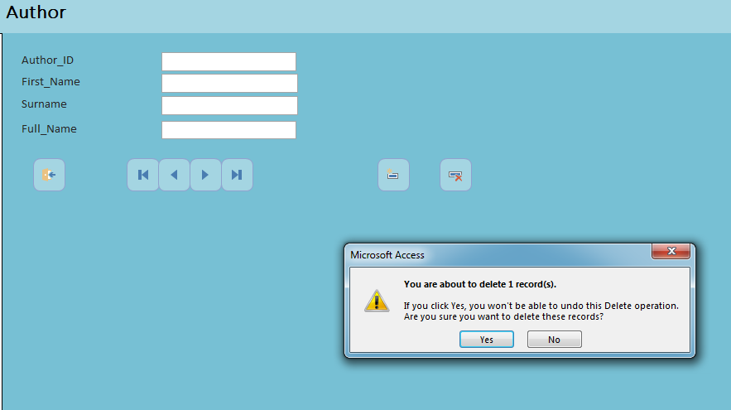
The user will be asked if they are sure they want to delete the record, click on yes and it will be deleted, as can be see below, Jon Nolan has disappeared:
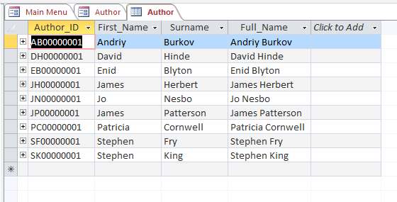+
Once the user has finished inputting authors close the form by clicking on the first navigation button.

Book Input Form
Click on the button named “Book Input” – highlighted purple when the user hovers over it.
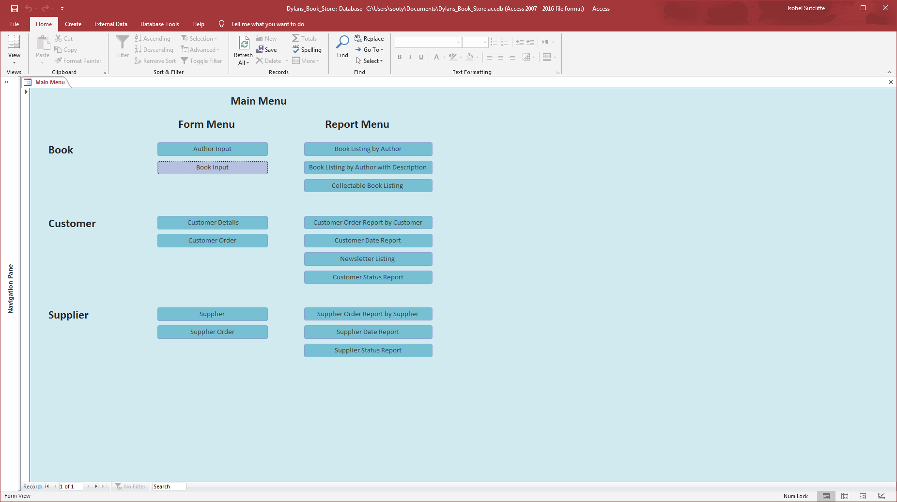

Once the button “Author Input” has be clicked the user will be directed to the user input form below:
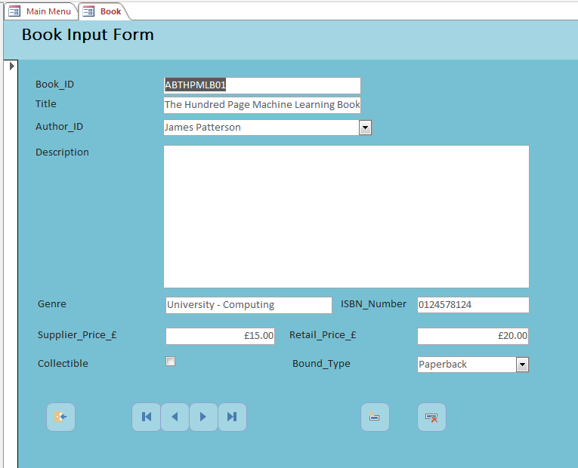
From Left to Right the navigation buttons on the bottom of the screen are as described:
- Close form;
- Go to the first record;
- Go the previous record;
- Go to the next record;
- Go to the last record;
- Add a record and delete a record.
Let’s go to add a record by clicking the 6th button along:
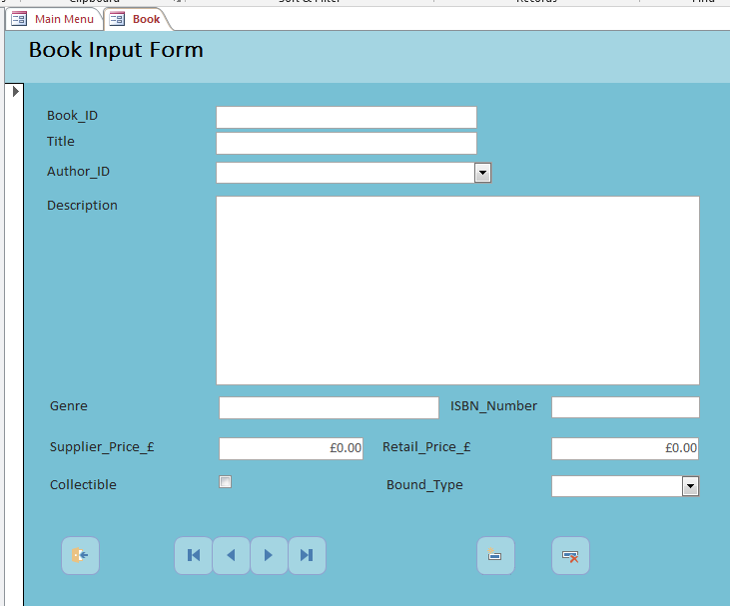
Put the details of the book that needs to be added in here.
For the Book_ID
Enter the initials of the author, Jo Nesbo would be JN, then the initials of his book, Snowman would be S and then up to 6 0’s (for this one) and a 1. The Book ID is a unique reference alphanumeric field of 10 characters.
N.B. (This is something that can be looked at if this does not suit going forward)
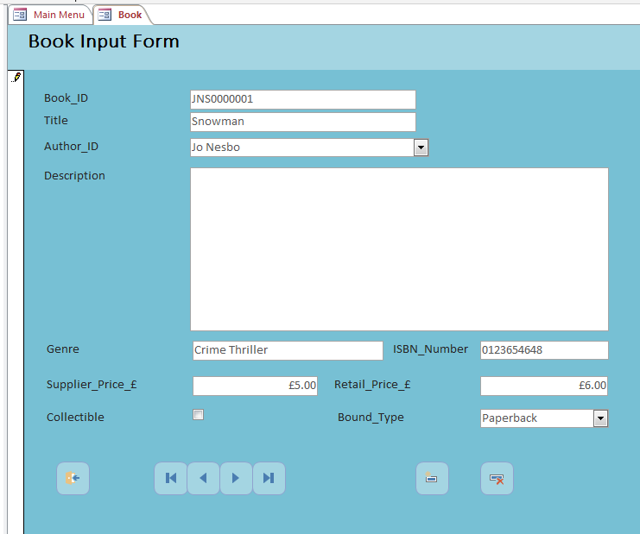

As with Author Input the user can delete the input by clicking on the delete record (last icon), move on to input more (fourth icon) or close the form, by clicking onto the first navigation button.
Customer Input Form
Click on the button named “Book Input” – highlighted purple when the user hovers over it.
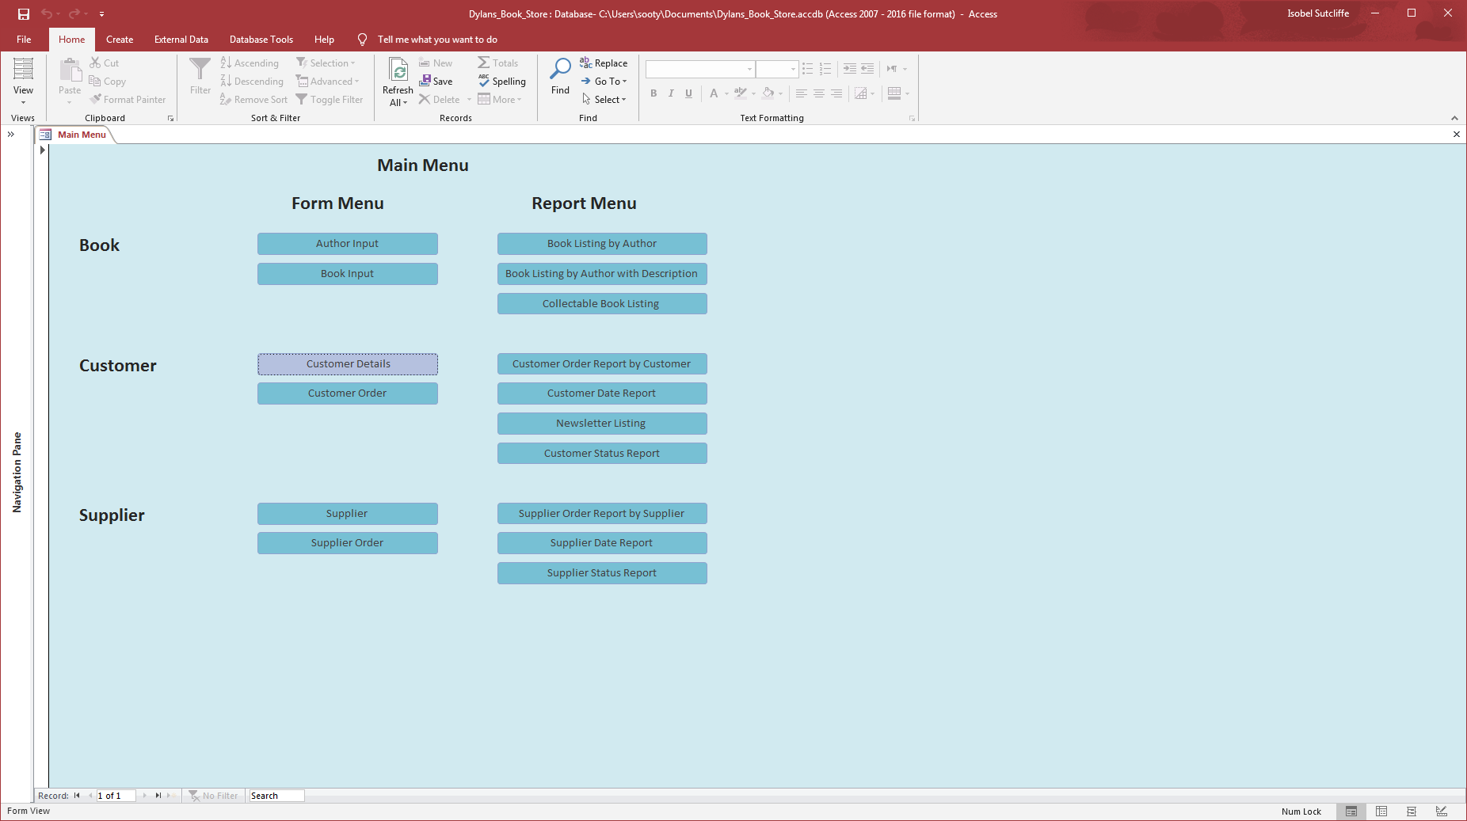

Once the button “Customer Details” has be clicked the user will be directed to the user input form below:
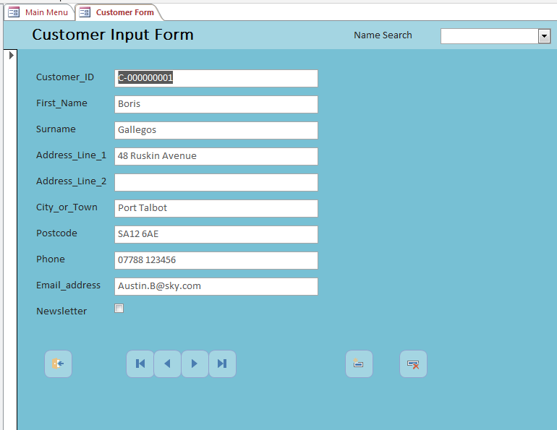
From Left to Right the navigation buttons on the bottom of the screen are as described:
- Close form;
- Go to the first record;
- Go the previous record;
- Go to the next record;
- Go to the last record;
- Add a record;
- Delete a record.
Let’s go to add a record by clicking the 6th button along:
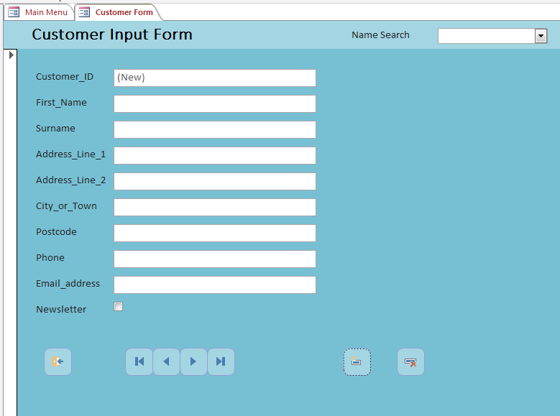
Put the details of the Customer that needs to be added in here. The Customer number is automatically generated with a “C” at the beginning to help identify it as a customer number.
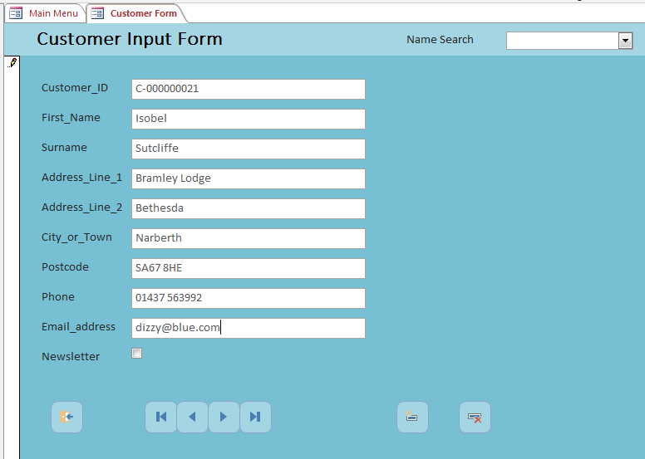
As with Author Input the user can delete the input by clicking on the delete record (last icon), move on to input more (fourth icon) or close the form, by clicking onto the first navigation button.
The search button at the top is a tool to check if there is some in the system already with the name the user is looking for, to try and help avoid duplicate records.

Customer Order Form
Click on the button named “Customer Order” – highlighted purple when the user hovers over it.
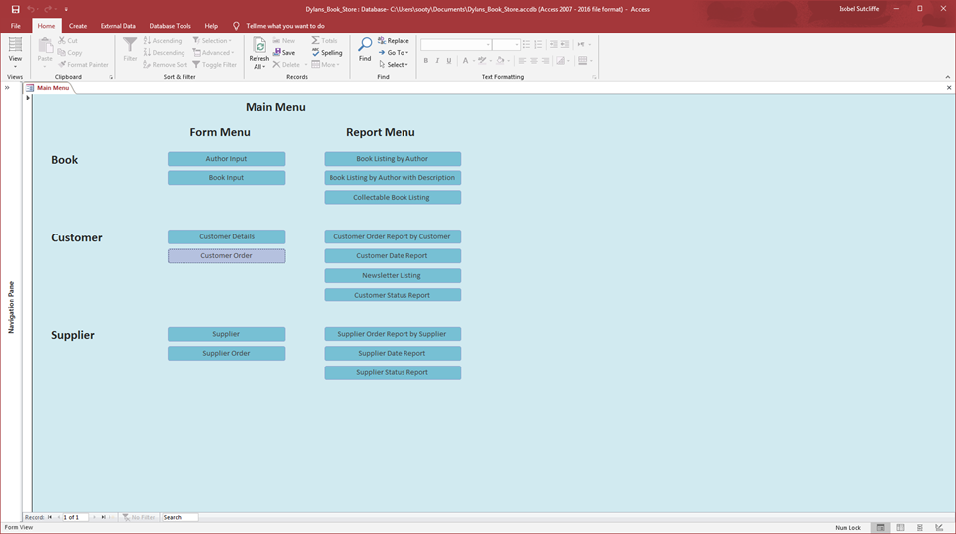

Once the button “Customer Order” has be clicked the user will be directed to the user input form below:
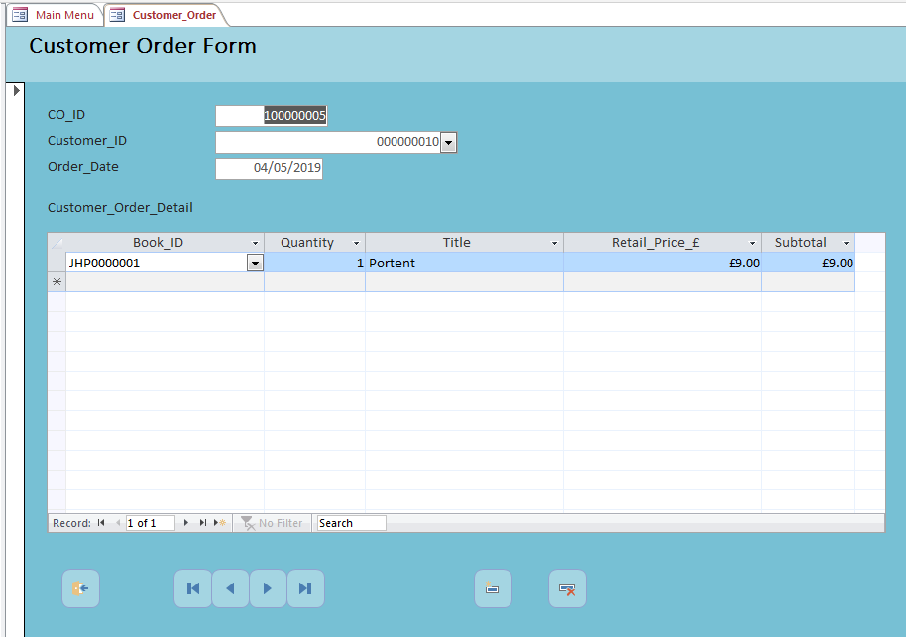
From Left to Right the navigation buttons on the bottom of the screen are as described:
- Close form;
- Go to the first record;
- Go the previous record;
- Go to the next record;
- Go to the last record;
- Add a record;
- Delete a record.
Let’s go to add a record by clicking the 6th button along:
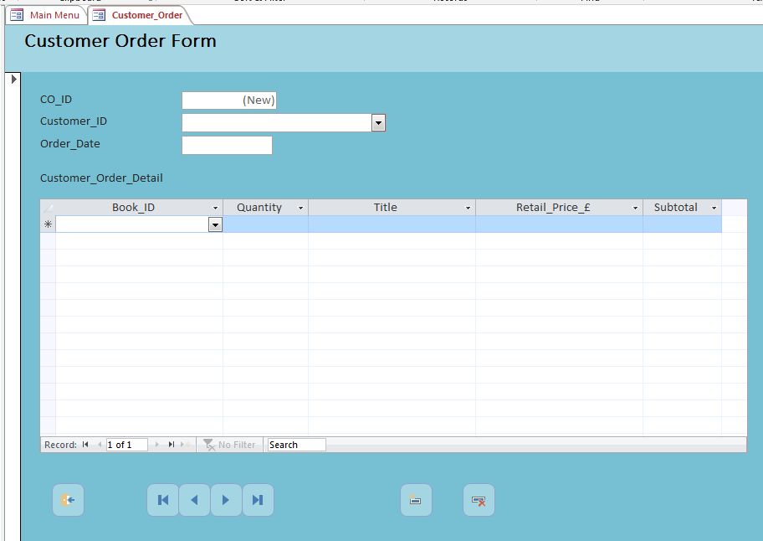
Here the user can select the name of the customer by clicking on the down arrow next to Customer_ID, there should be a drop-down list of all the customers that are registered with the store. The Customer Order Number is automatically generated and has a 1 at the beginning to identify it as a customer order number.
When selecting books another dropdown menu is available with the Book_ID and the name of the book. User enters the quantity of books that they require:
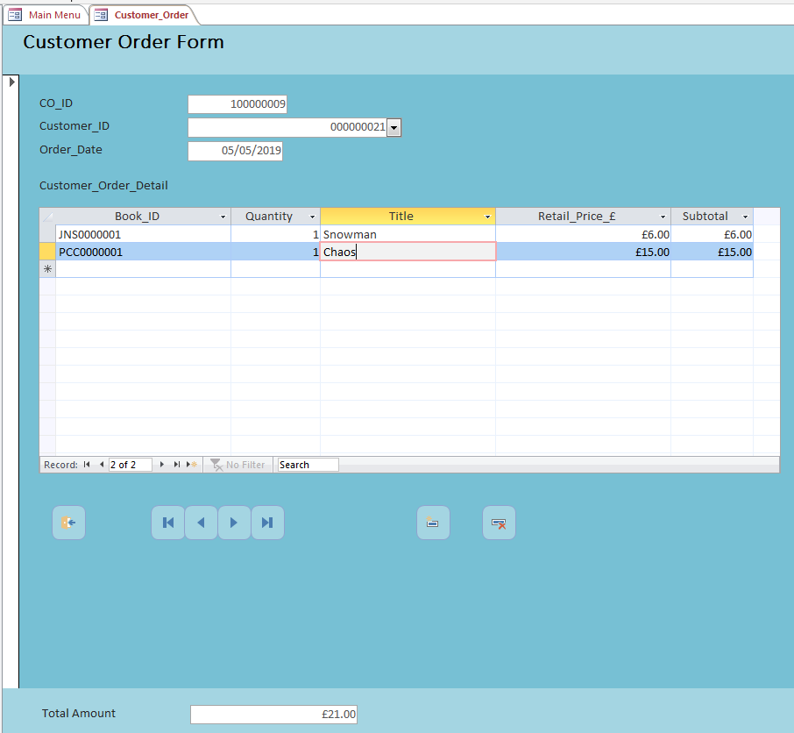

If the user needed to change the quantity to zero the form will automatically calculate the increase in costs as well. (But best keep it to 1 for now). Its also worth noting that if the user can see the total costs at the bottom of the page.

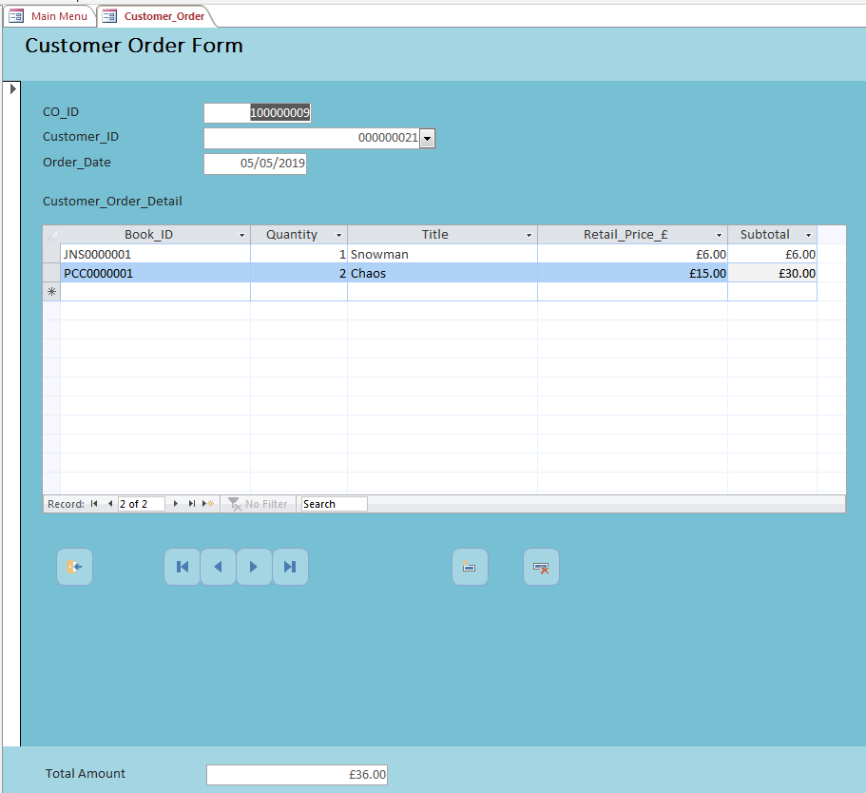
As with Author Input the user can delete the input by clicking on the delete record (last icon), move on to input more (fourth icon) or close the form, by clicking onto the first navigation button.

Supplier Input Form
Click on the button named “Supplier Details” – highlighted purple when the user hovers over it.
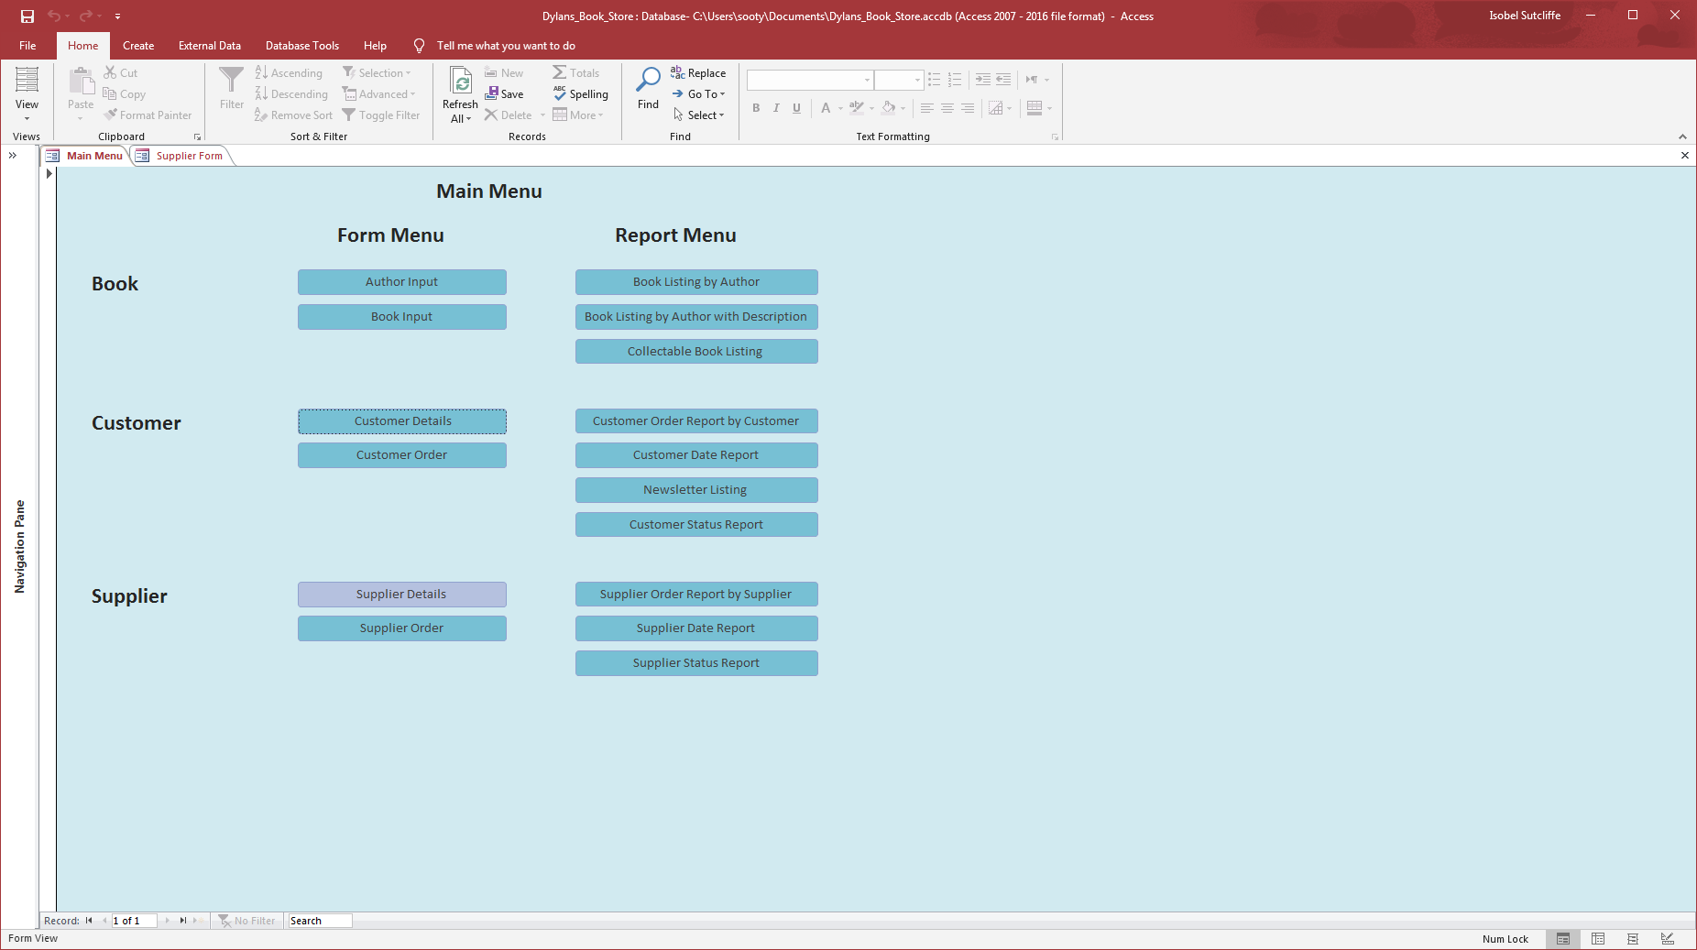

Once the button “Supplier Details” has be clicked the user will be directed to the user input form below:
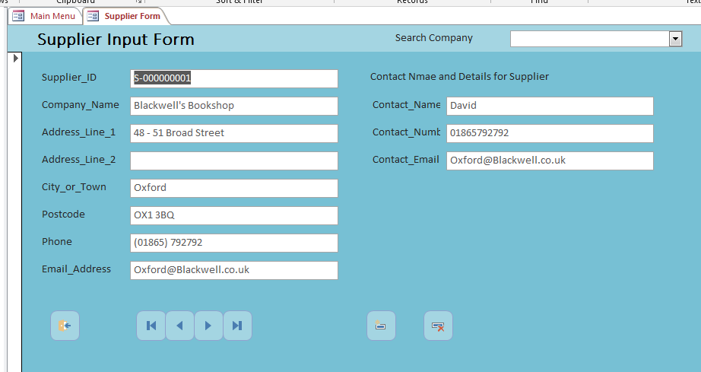

From Left to Right the navigation buttons on the bottom of the screen are as described:
- Close form;
- Go to the first record;
- Go the previous record;
- Go to the next record;
- Go to the last record;
- Add a record;
- Delete a record.
Let’s go to add a record by clicking the 6th button along:
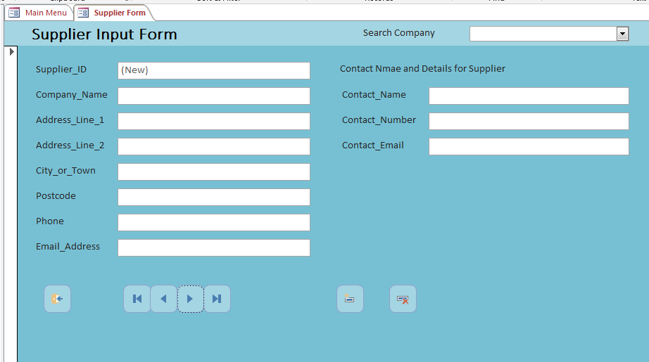
Put the details of the supplier that needs to be added in here.
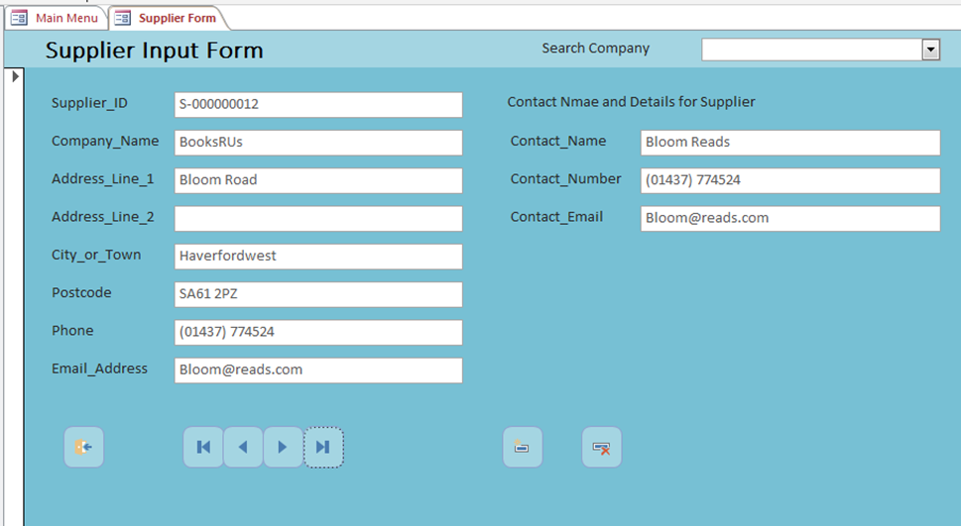
Put the details of the Supplier that needs to be added in here. The Supplier number is automatically generated with a “S” at the beginning to help identify it as a Supplier number.
As with Author Input the user can delete the input by clicking on the delete record (last icon), move on to input more (fourth icon) or close the form, by clicking onto the first navigation button.

Supplier Order Form
Click on the button named “Book Input” – highlighted purple when the user hovers over it.
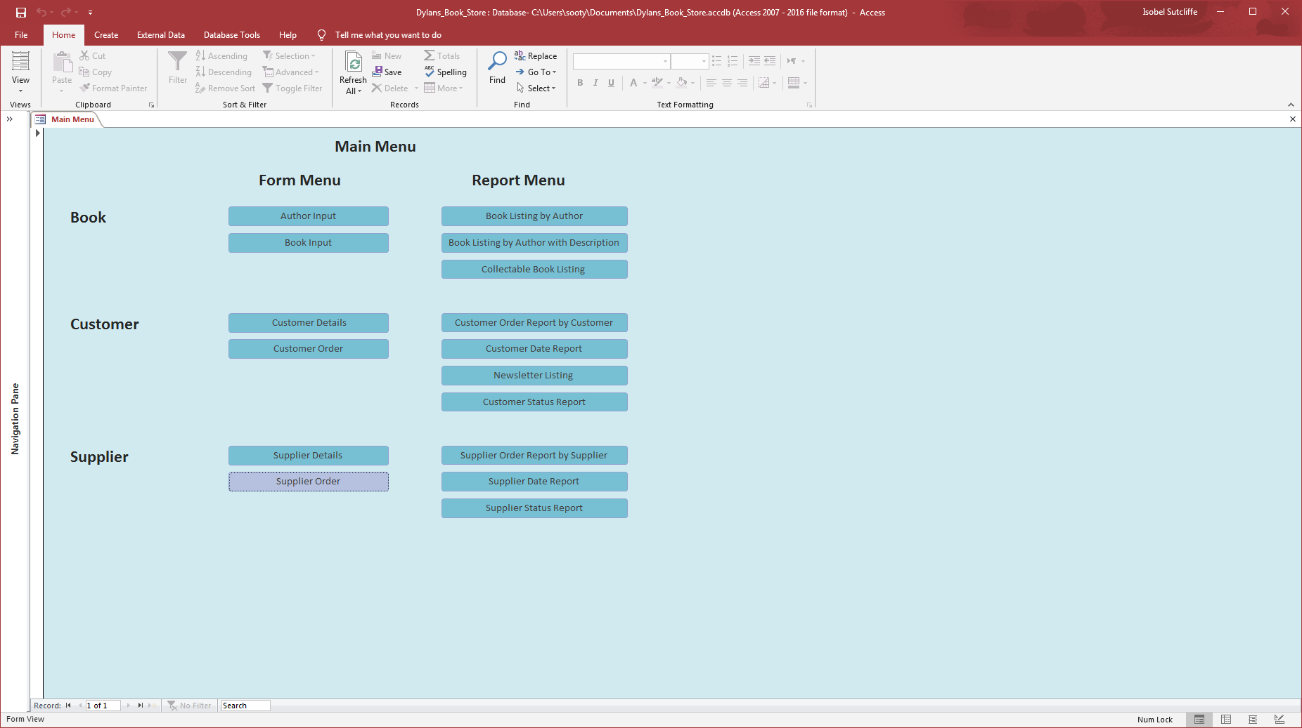

Once the button “Supplier Order” has be clicked the user will be directed to the user input form below:
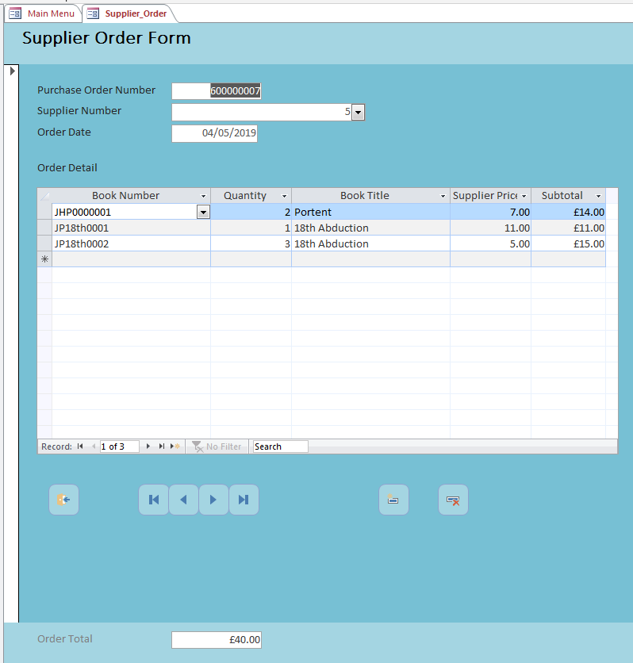

From Left to Right the navigation buttons on the bottom of the screen are as described:
- Close form;
- Go to the first record;
- Go the previous record;
- Go to the next record;
- Go to the last record;
- Add a record;
- Delete a record.

Let’s go to add a record by clicking the 6th button along:
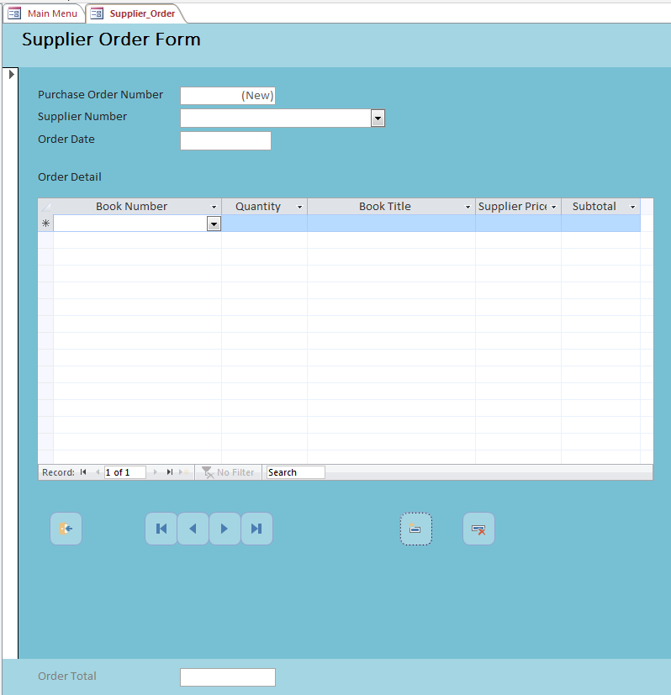
Put the details of the supplier order that needs to be added in here.
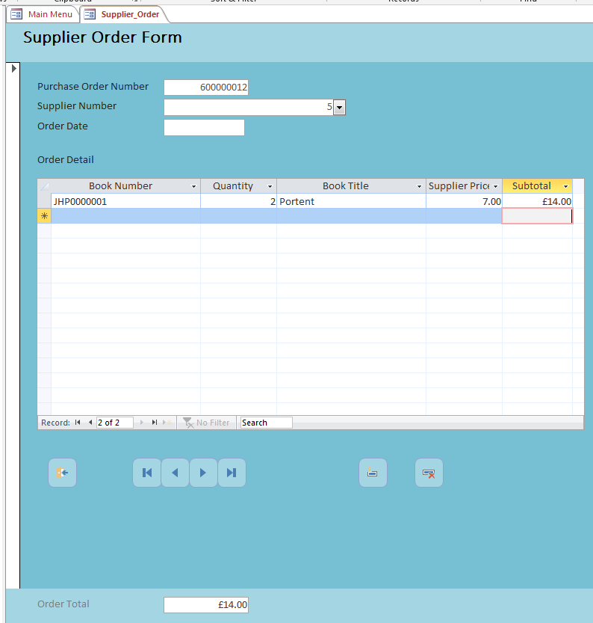
Here the user can select the name of the supplier by clicking on the down arrow next to Supplier_ID, there should be a drop-down list of all the suppliers that are registered with the store. The Supplier Order Number is automatically generated and has a 6 at the beginning to identify it as a supplier order number.
When selecting books another dropdown menu is available with the Book Number and the name of the book. User enters the quantity of books that they require:
If there is a need to change the quantity to zero the form will automatically calculate the increase in costs as well. Same as the Customer Order form.
As with Author Input the user can delete the input by clicking on the delete record (last icon), move on to input more (fourth icon) or close the form, by clicking onto the first navigation button.
Other Forms that are in the database:
There are a number of other forms on the database that feed into queries and reports, a list is provided below:
Author Parameter Form – Book Listing by Author Report
Book Sub form – forms part of the book form
CStatus Parameter Form – Customer Status Report
Customer Order Detail Sub from – this forms part of the Customer Order Form
Customer Parameter Form – Customer Order Report by Customer Report
Date Parameter Form – Customer Date Report and the Supplier Date Report
DAuthor Parameter Form – Book Listing by Author with Description
SStatus Parameter Form – Supplier Status Report
Supplier Order Detail Sub form – this forms part of the Supplier Order Form
Supplier Parameter Form – Supplier Order by Supplier Report

Output of Reports on Main Menu:
Book Listing Report by Author
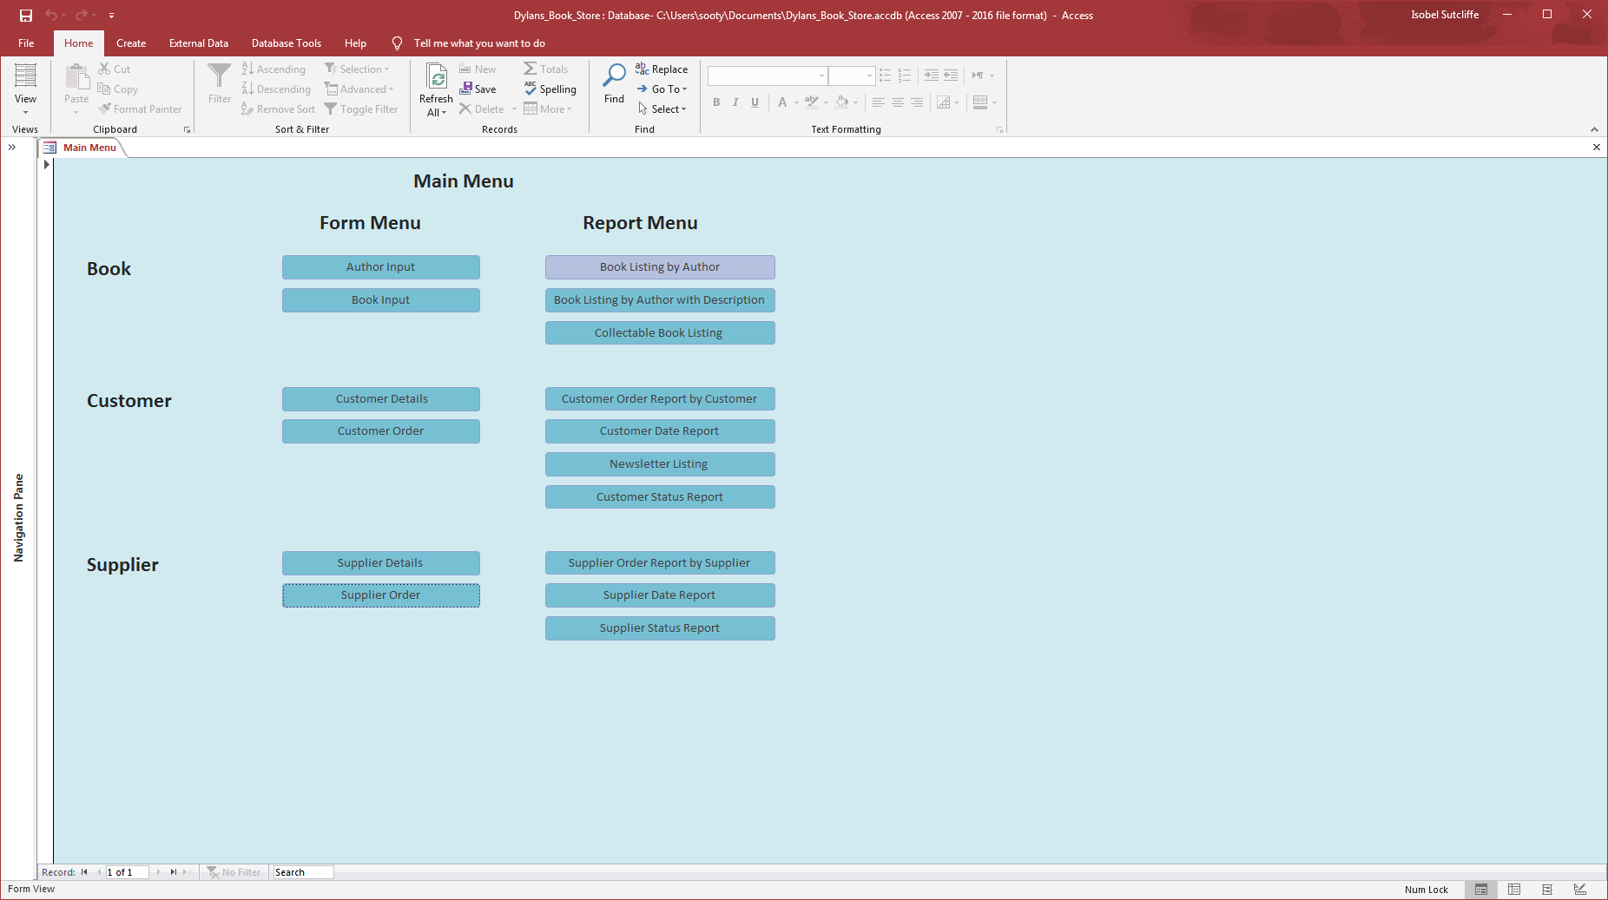
Click on the “Book Listing by Author” button, once the screen below appears the user can select the author that they want to see a list of books by.
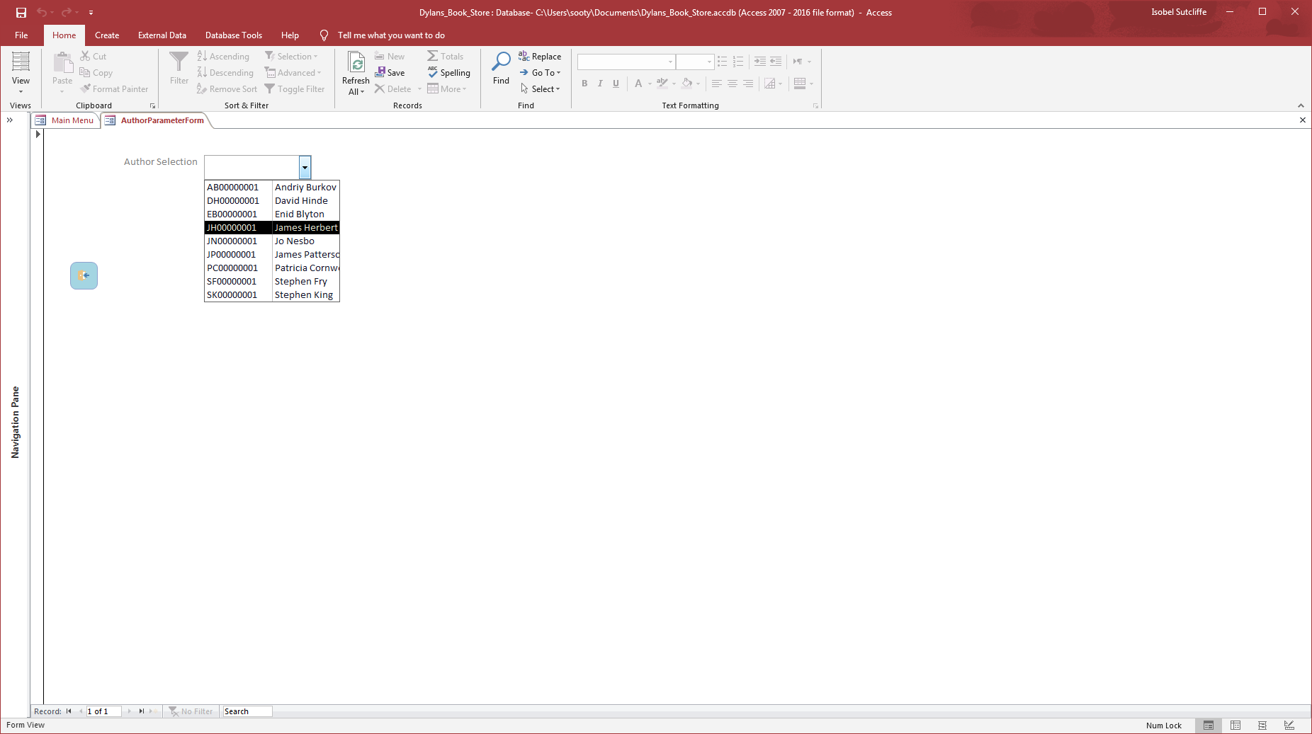
Let’s choose, Patricia Cornwell for this example, and the click on search, this should go straight the report, with all the books listed against her name.
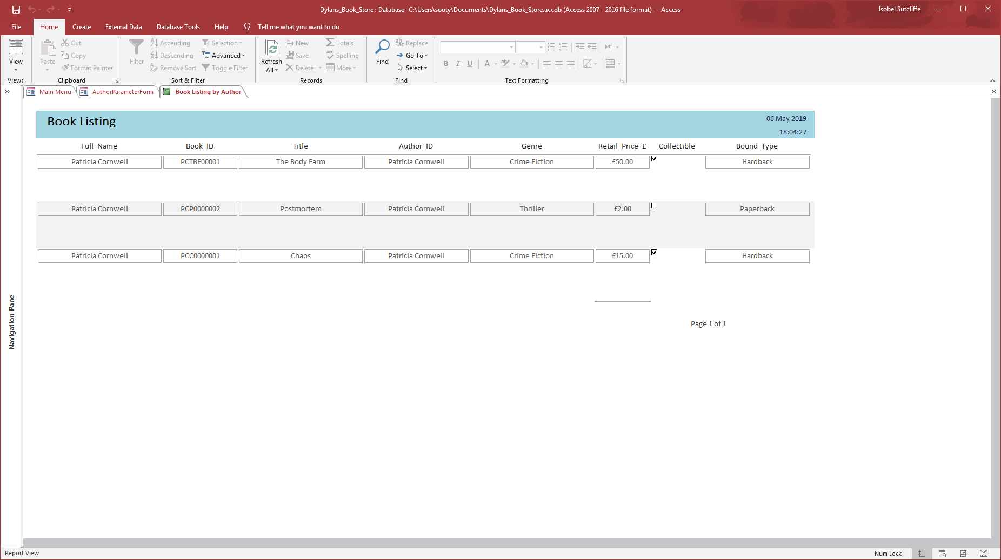
Still to have navigation tools against the report, but it gives an idea of what is available to see.

Book Listing by Author with Description
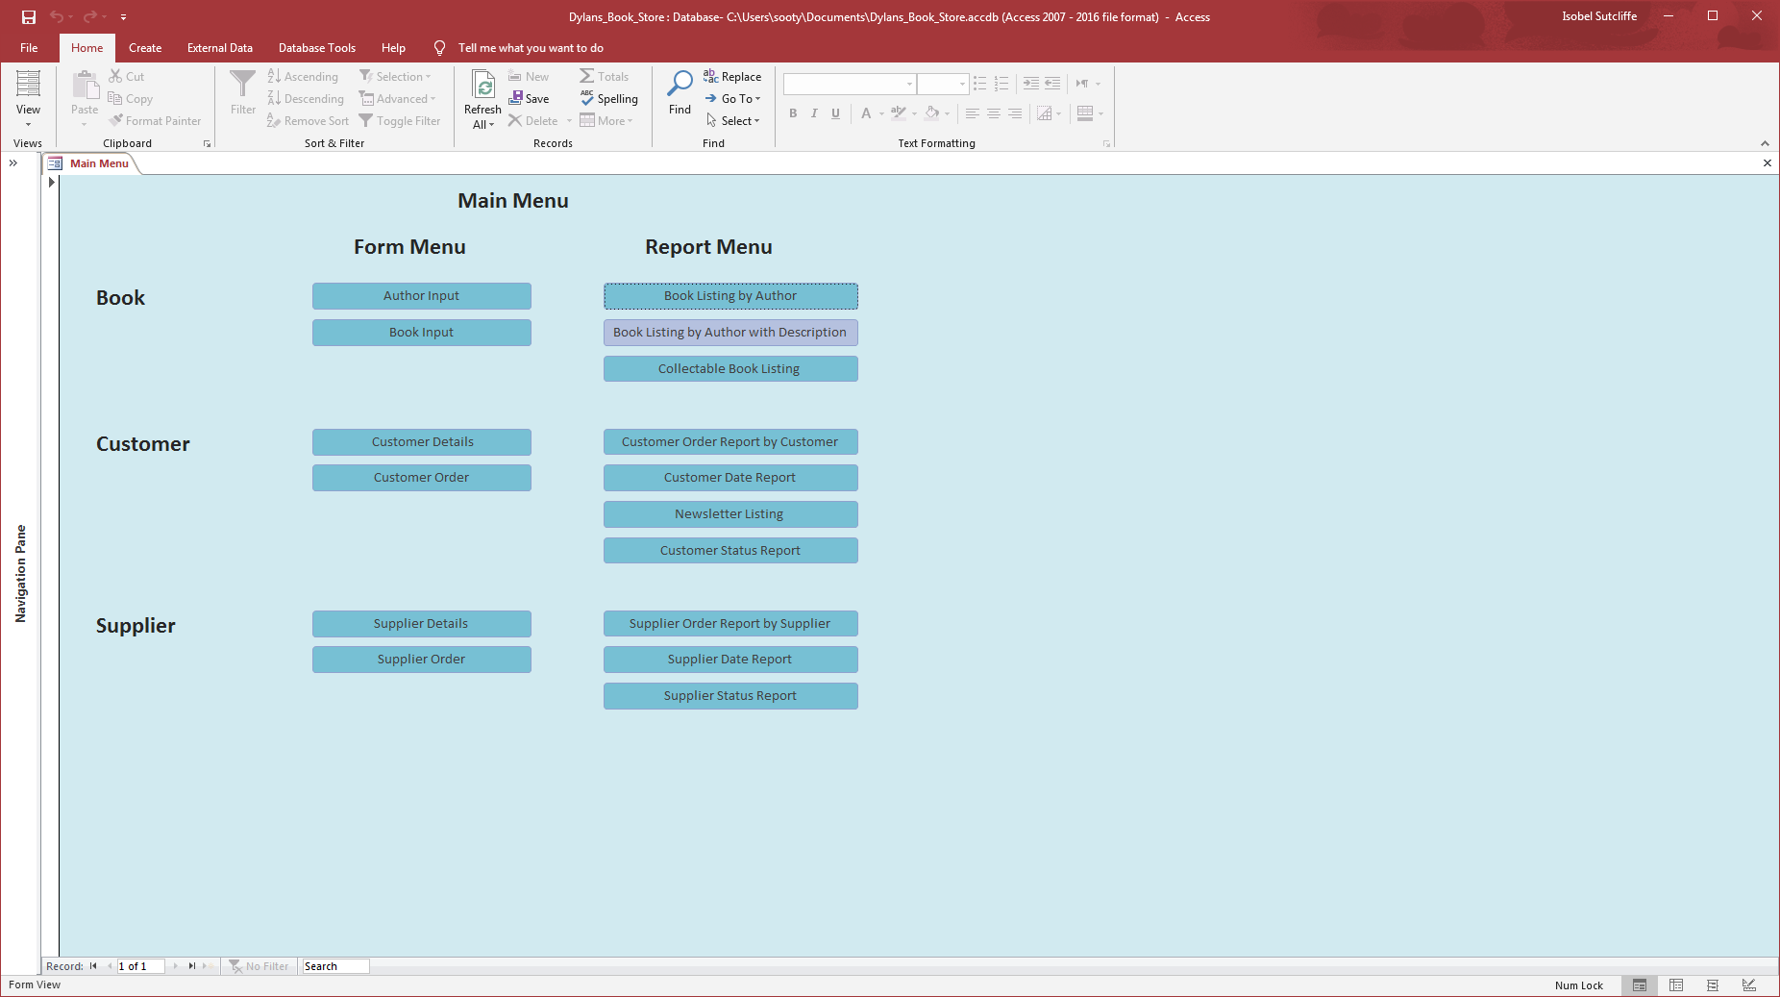
Click on the “Book Listing by Author with Description” button, once the screen below appears the user can select the author that they want to see a list of books by.
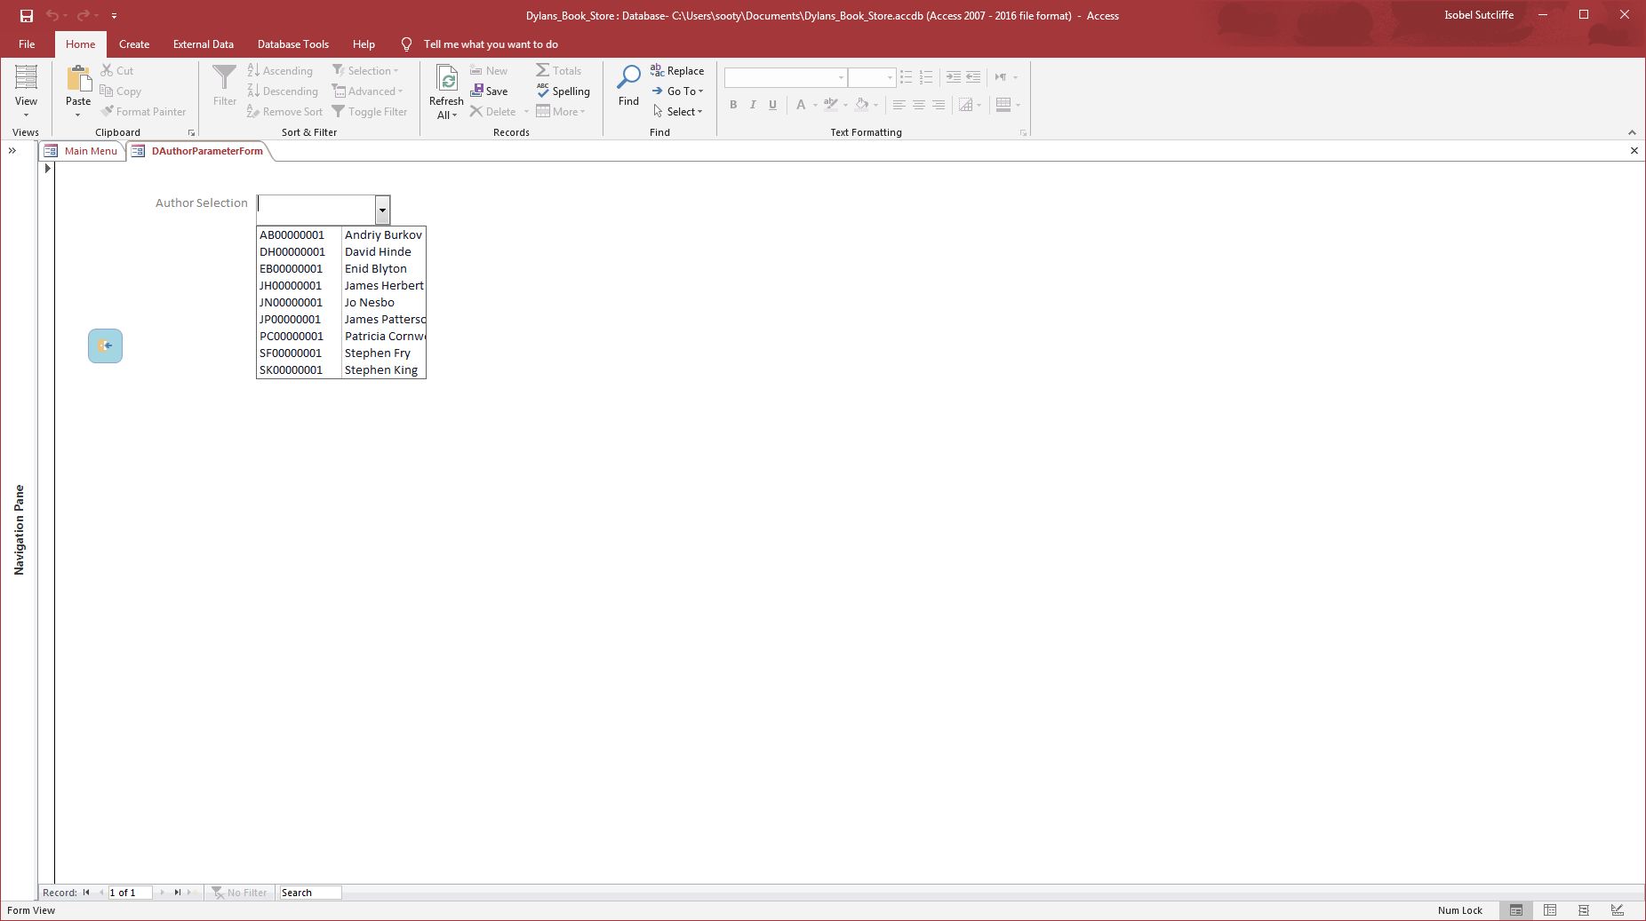
Let’s choose, David Hinde for this example, and the click on search, this should go straight the report, with all the books listed against his name, with a description of what the book is about.
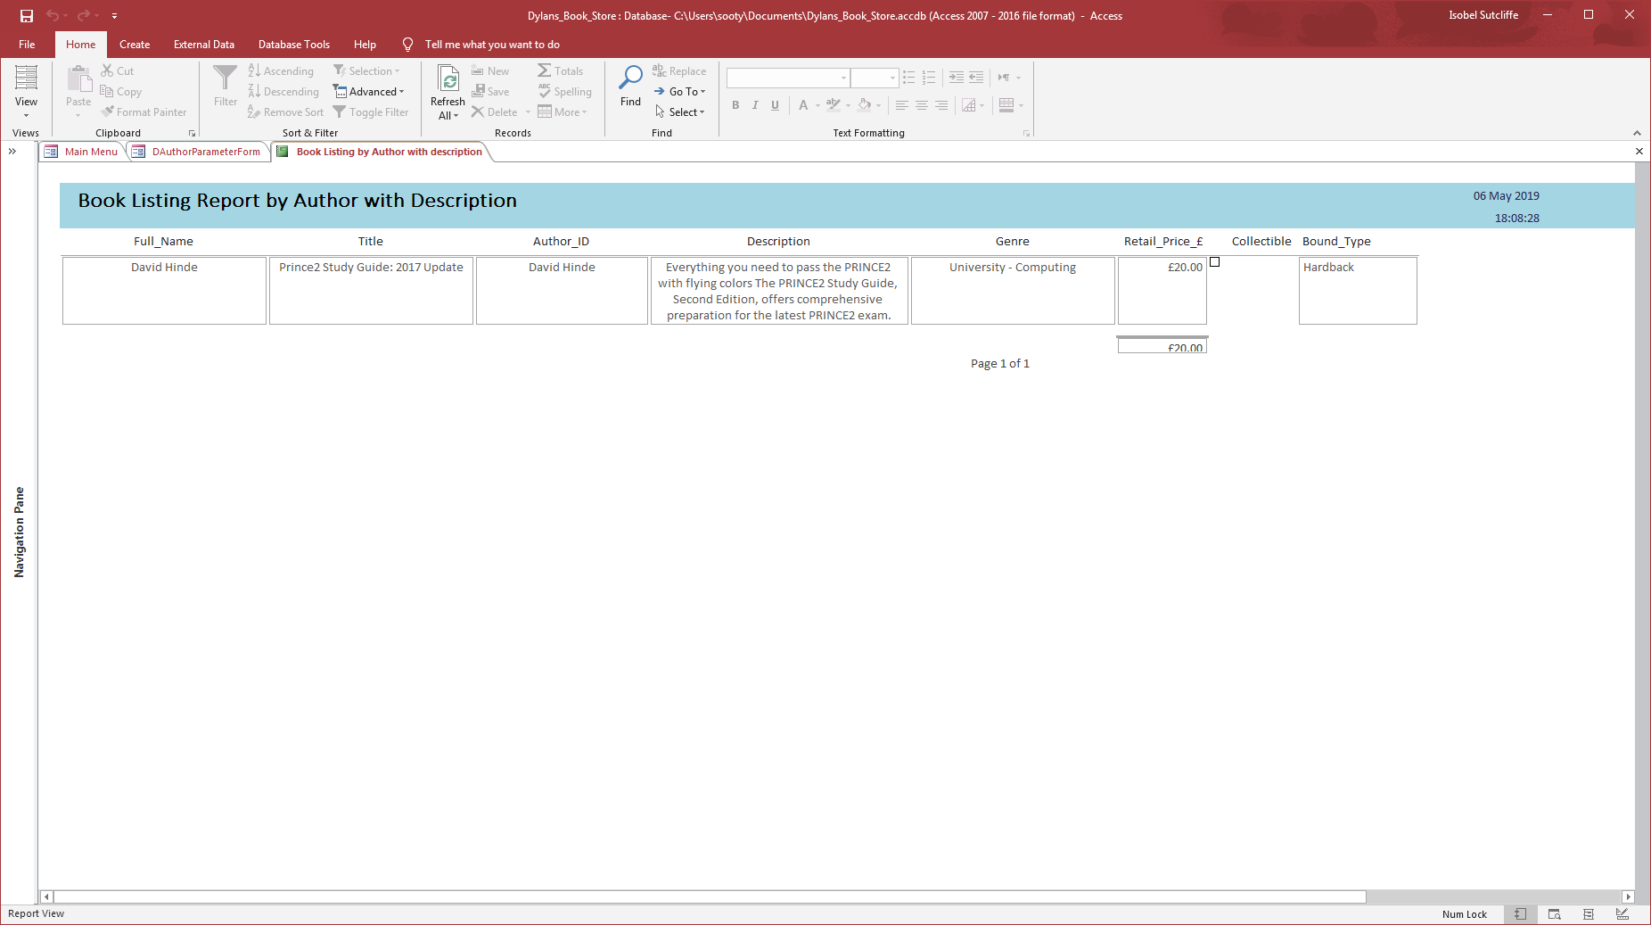
Still some work to do on the navigation panes for the reports.

Collectable Book Listing Report
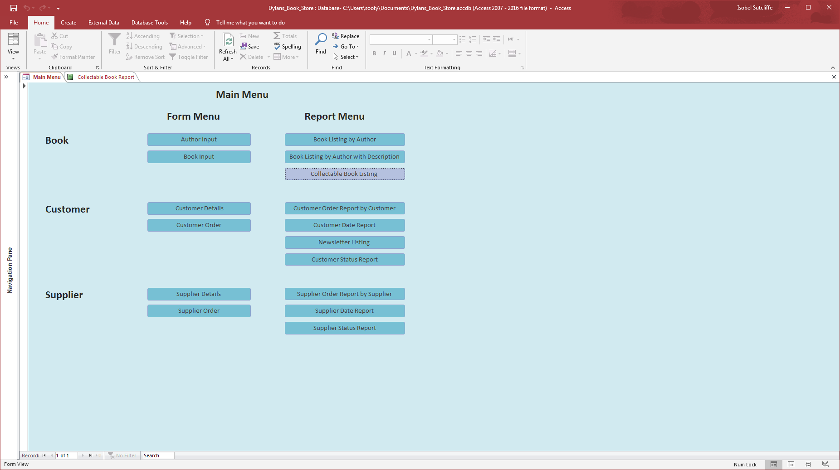
Click on the “Collectable Book Listing” button, this is a direct report as it is only bringing information form one report.
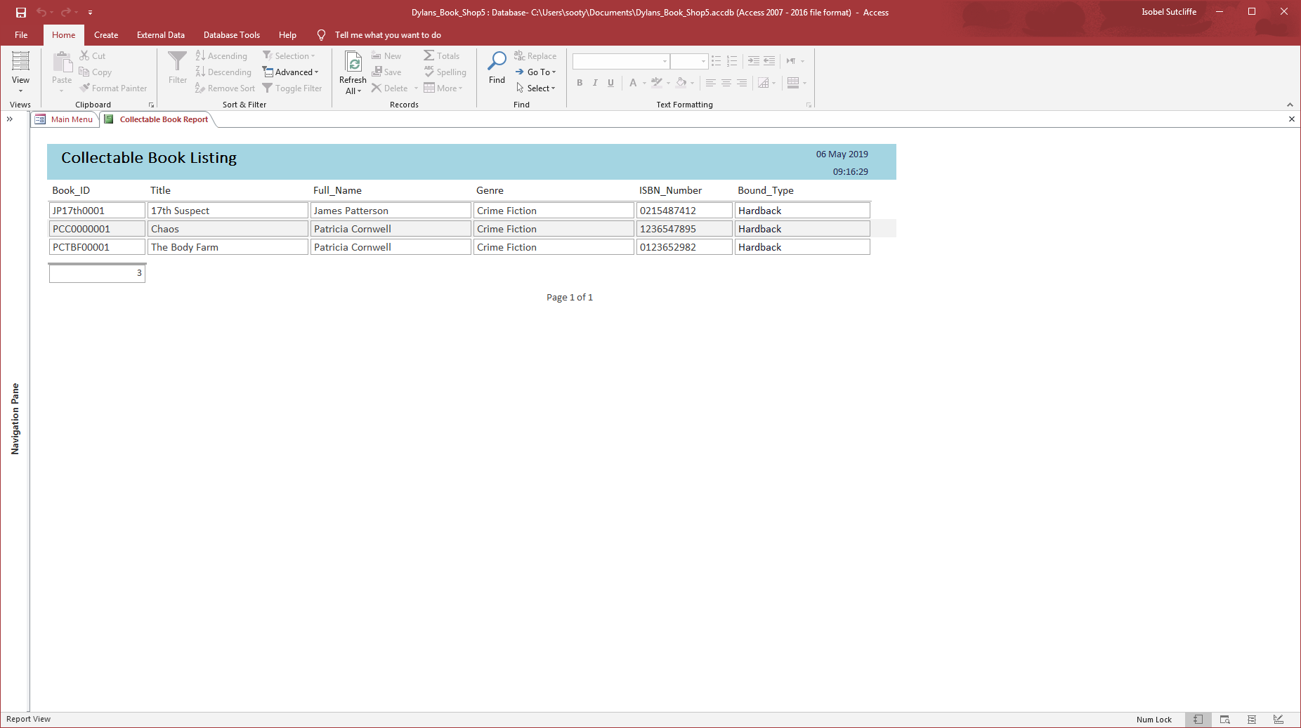

Customer Order Report by Customer
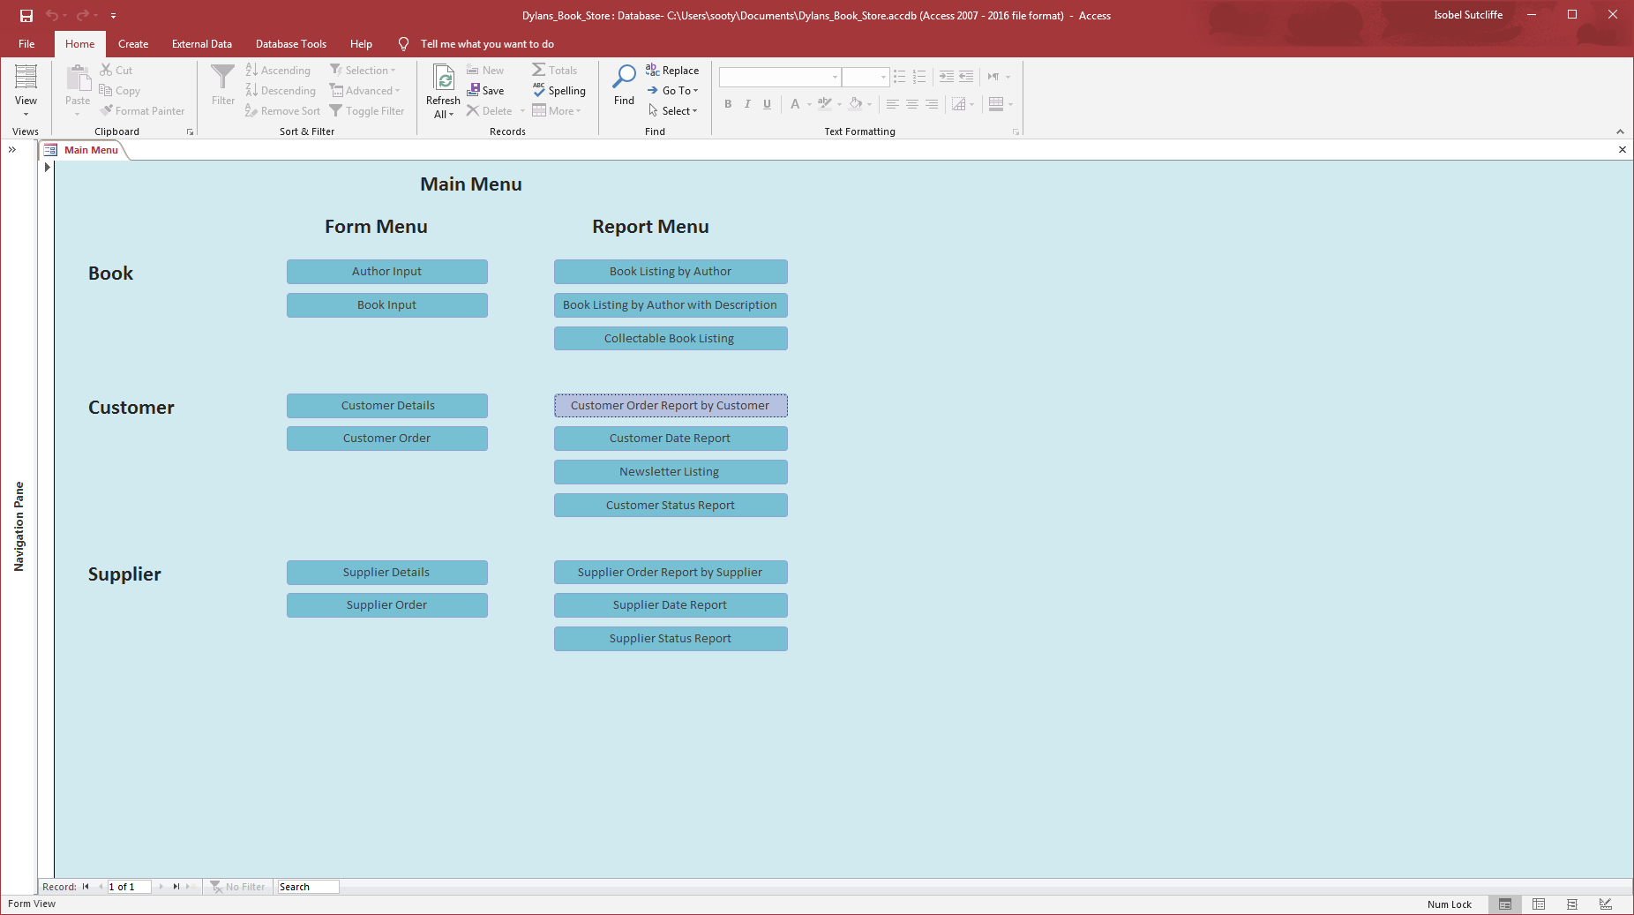
Click on the “Customer Order Report by Customer” button, once the screen below appears the user can select the author that they want to see a list of books by.
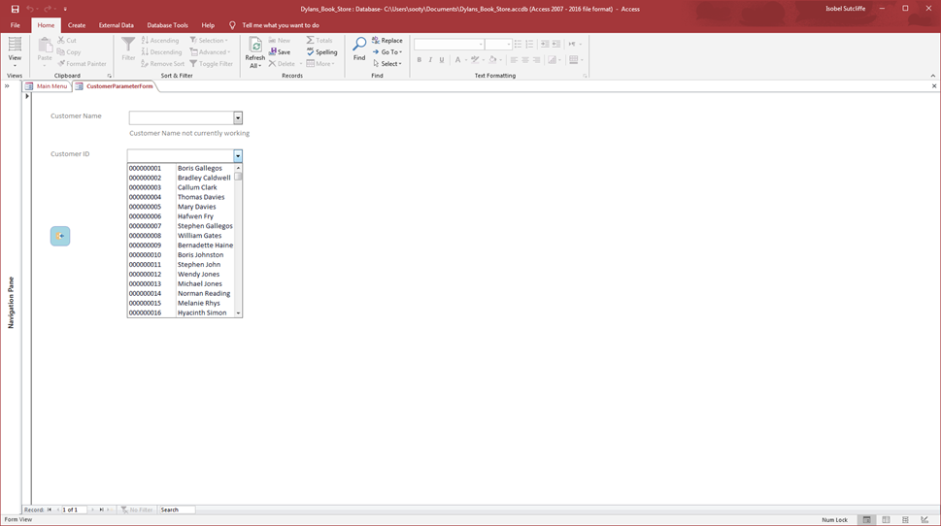
Let’s choose, Bradley Caldwell for this example, and the click on search, this should go straight to the report as there is no parameter to complete, with all orders against his name.
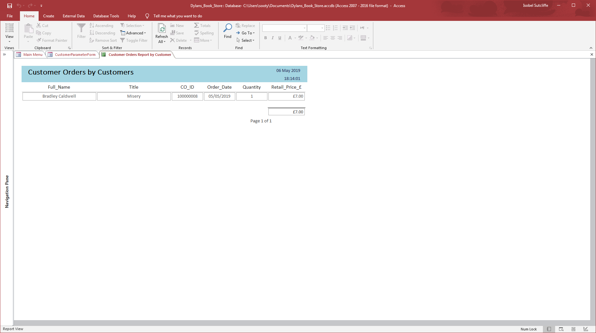
Still some work to do on the navigation panes for the reports and linking the customer name to the lookup for choosing.

Customer Date Report
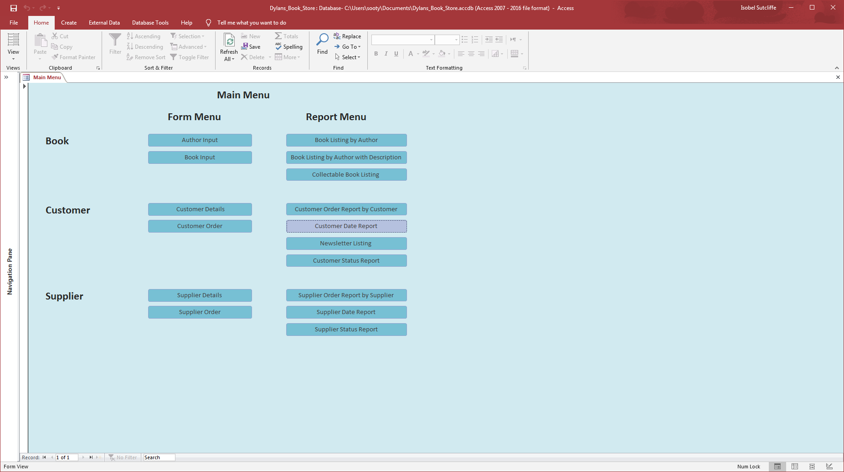
Click on the “Customer Date Report” button, once the screen below appears the user can select the date range that they want to see a list of orders for.
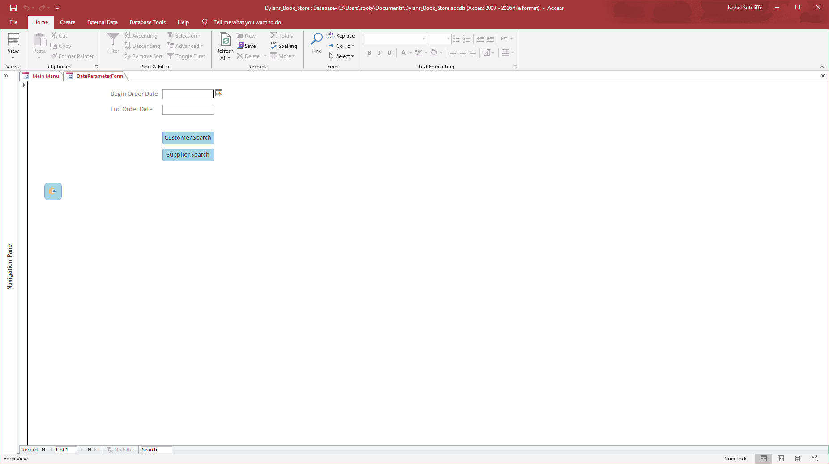
Let’s choose, 01/05/2019 and 06/05/2019 for this example, and the click on customer search, this should go straight the customer report, with all orders between the dates. As can be seen there are some fields that have not been filled in so the user can go in and amend these to reflect the order status.
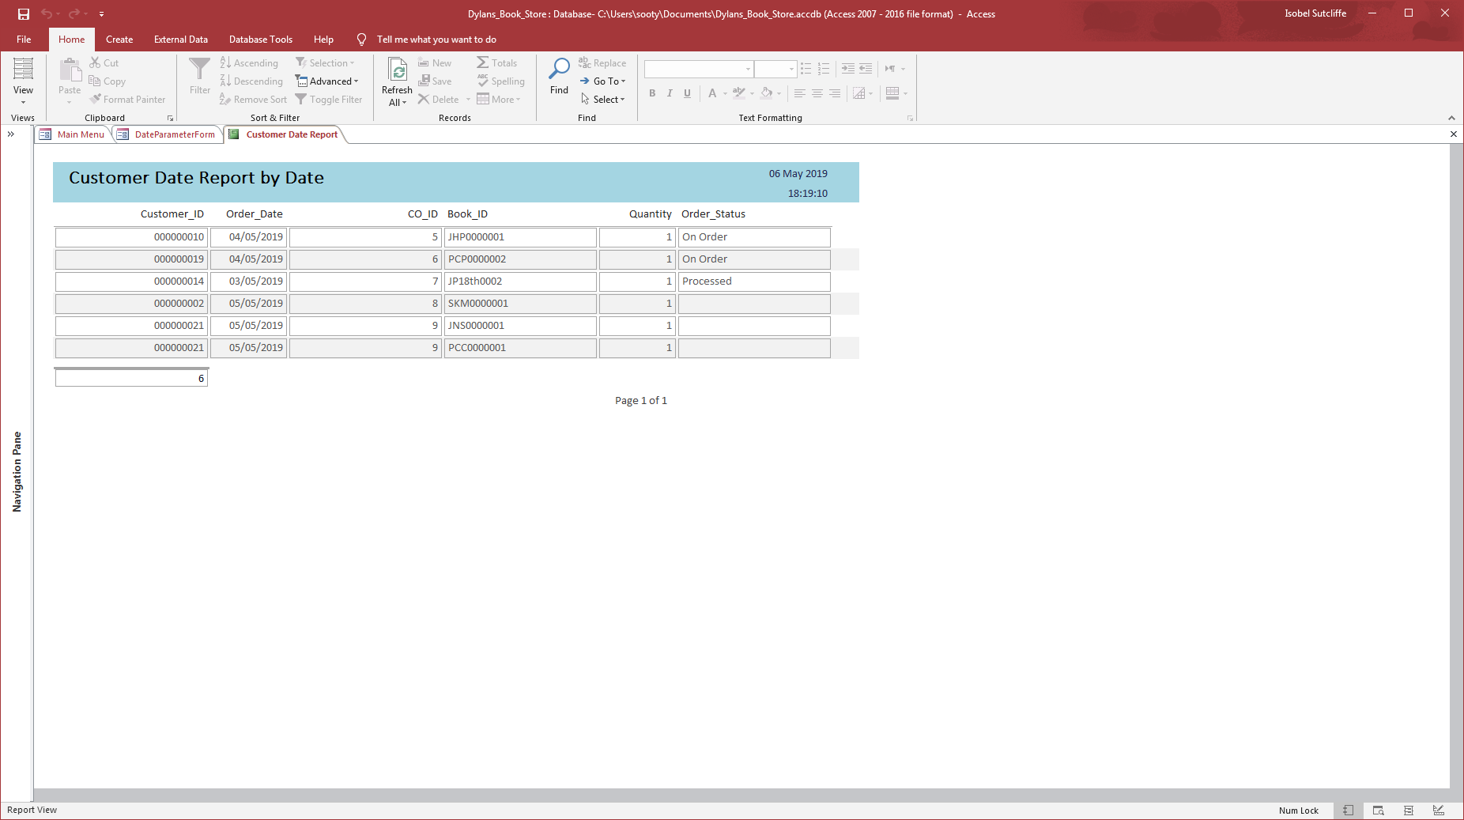
Still some work to do on the navigation panes for the reports.

Newsletter Listing Report
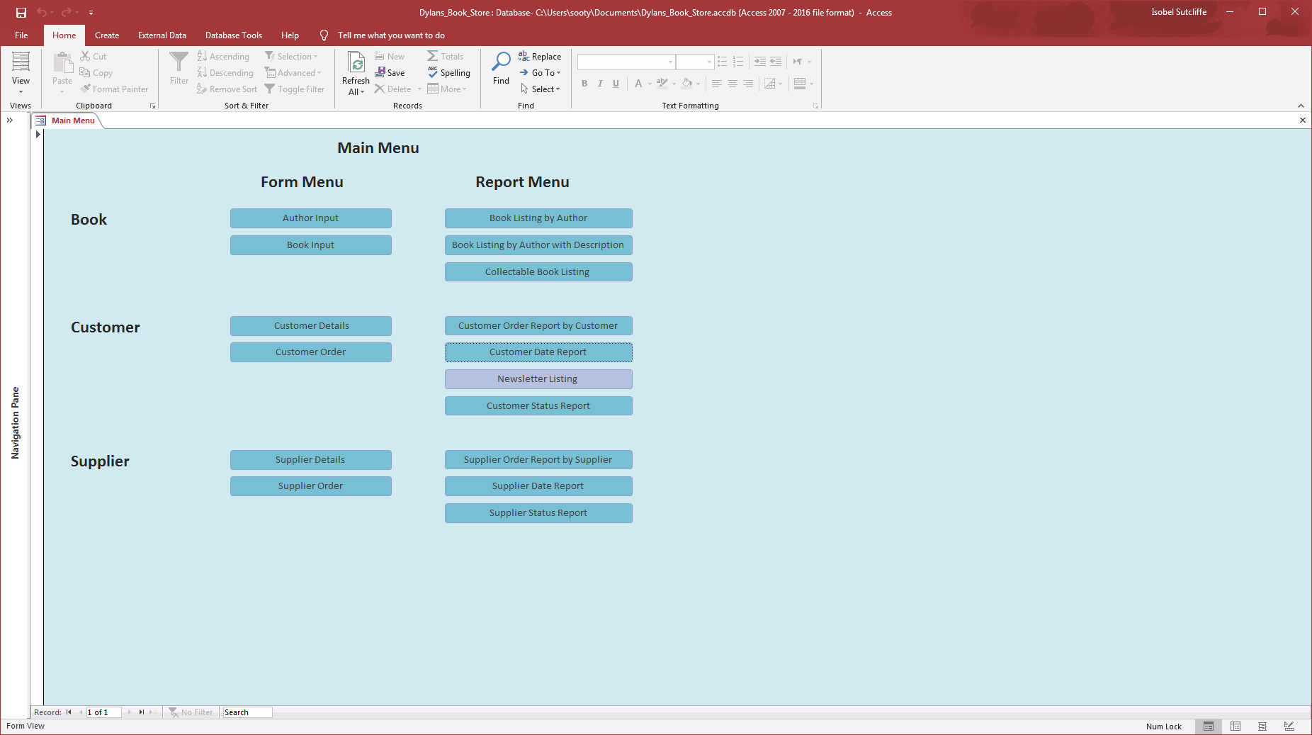
Click on the “Newsletter Report” button, this is a direct report, with no parameters to complete, as it is only bringing information from one table.
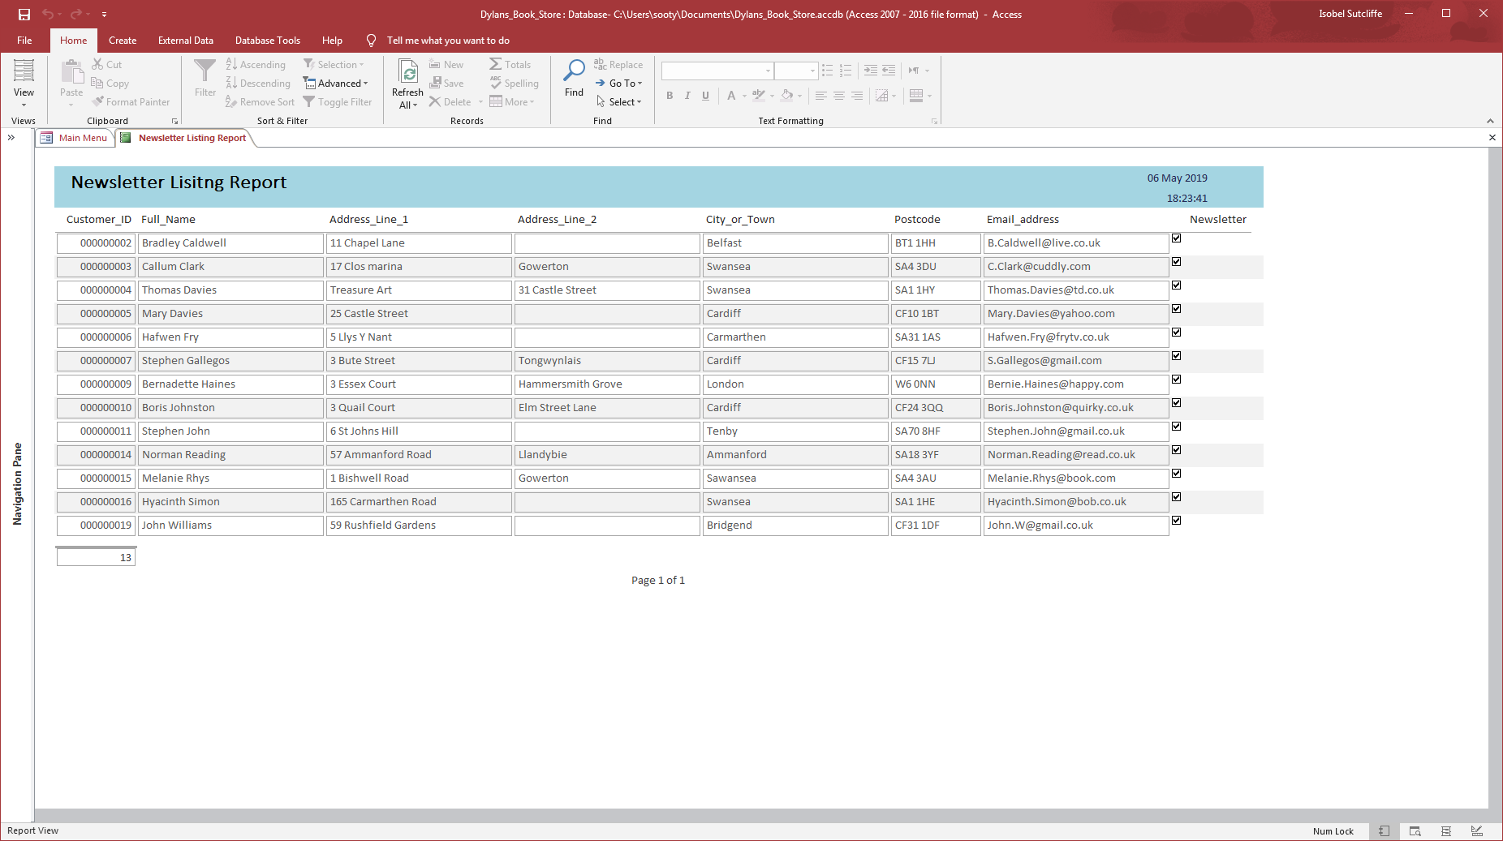
This provides the user with a list of all customers requiring a newsletter when they are due. Could be useful in ensuring information is current and up to date.

Customer Status Report
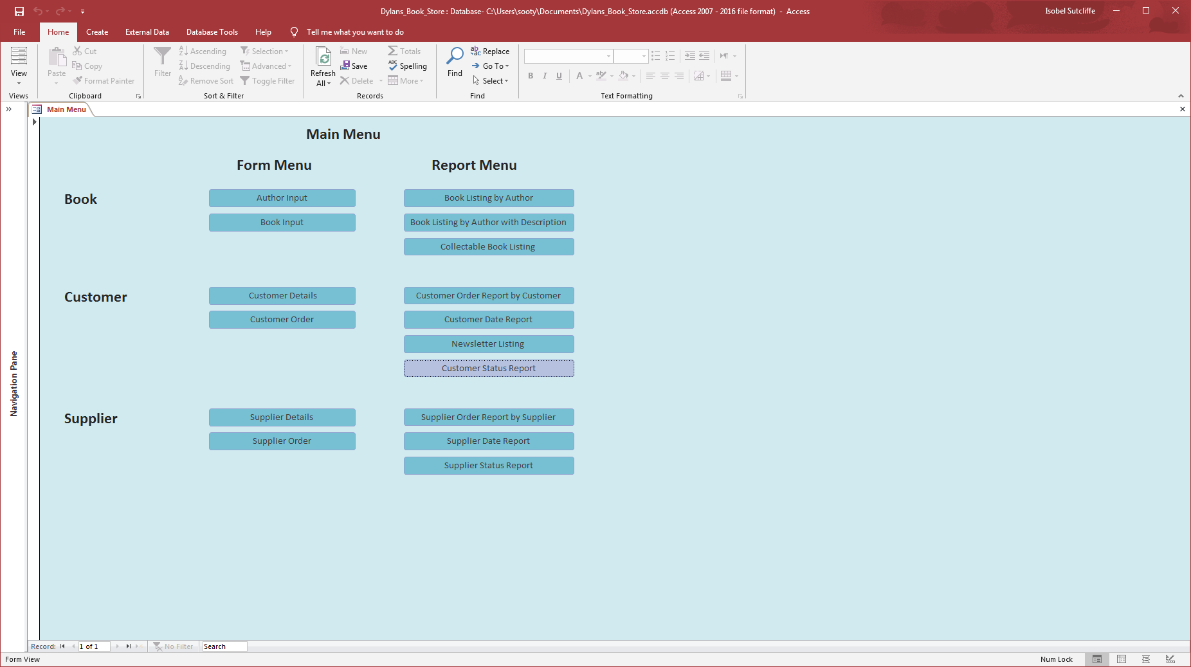
Click on the “Customer Status Report” button, once the screen below appears the user can select the status id that they require so they can see a list of customers’ orders with the status requested.
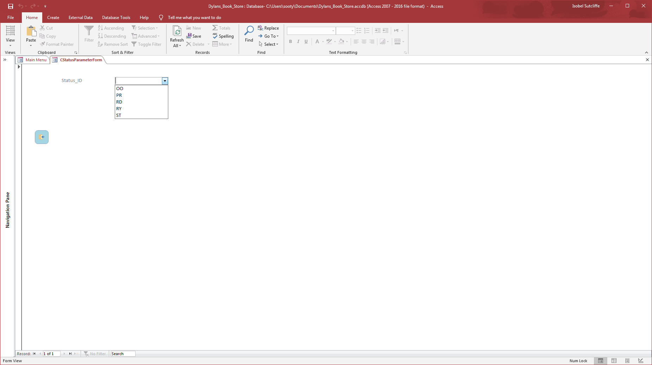
OO – On Order
PR – Processing
RD – Received In
RY – Ready
ST – Sent Out
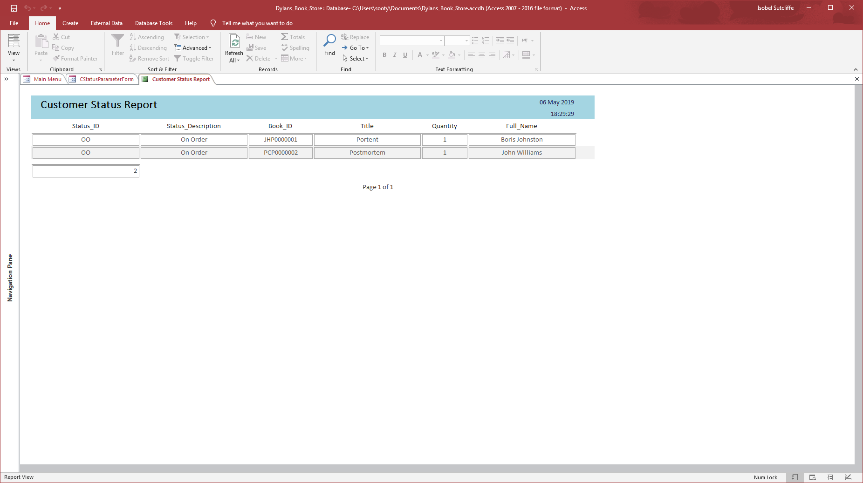
Still some work to do on the navigation panes for the reports.

Supplier Order Report by Supplier – Need to redo currently not working
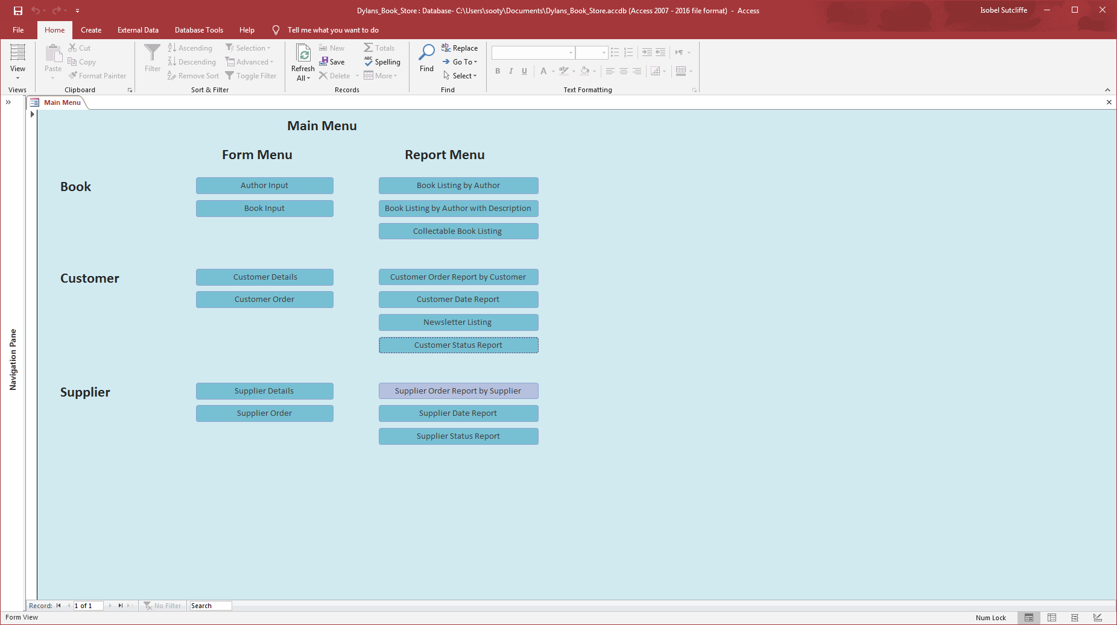
Click on the “Supplier Order Report by Supplier” button, once the screen below appears the user can select the status id that they require so they can see a list of Suppliers’ orders with the status requested.
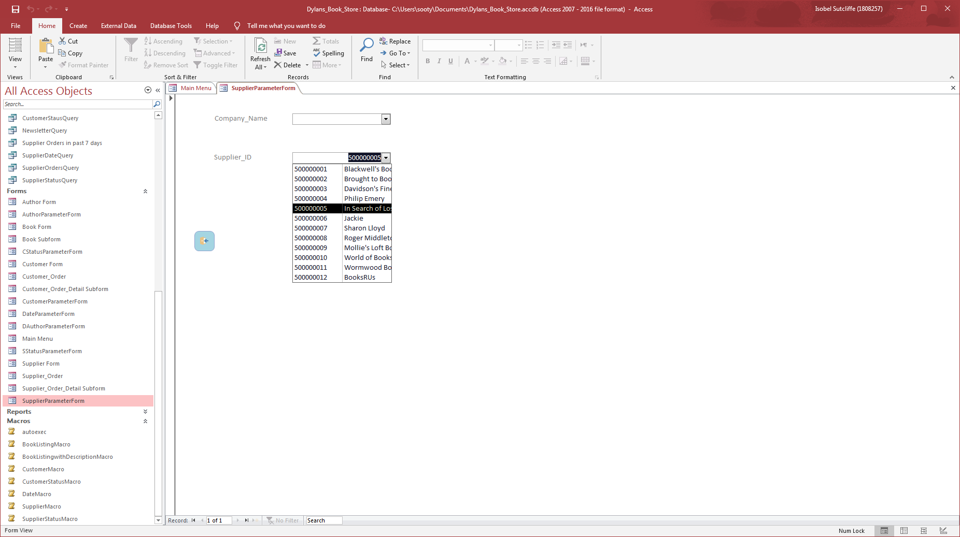
Let’s choose “In Search of Lost Time” for this example, and the click on search, this should go straight the report, with all orders against the firm’s name.
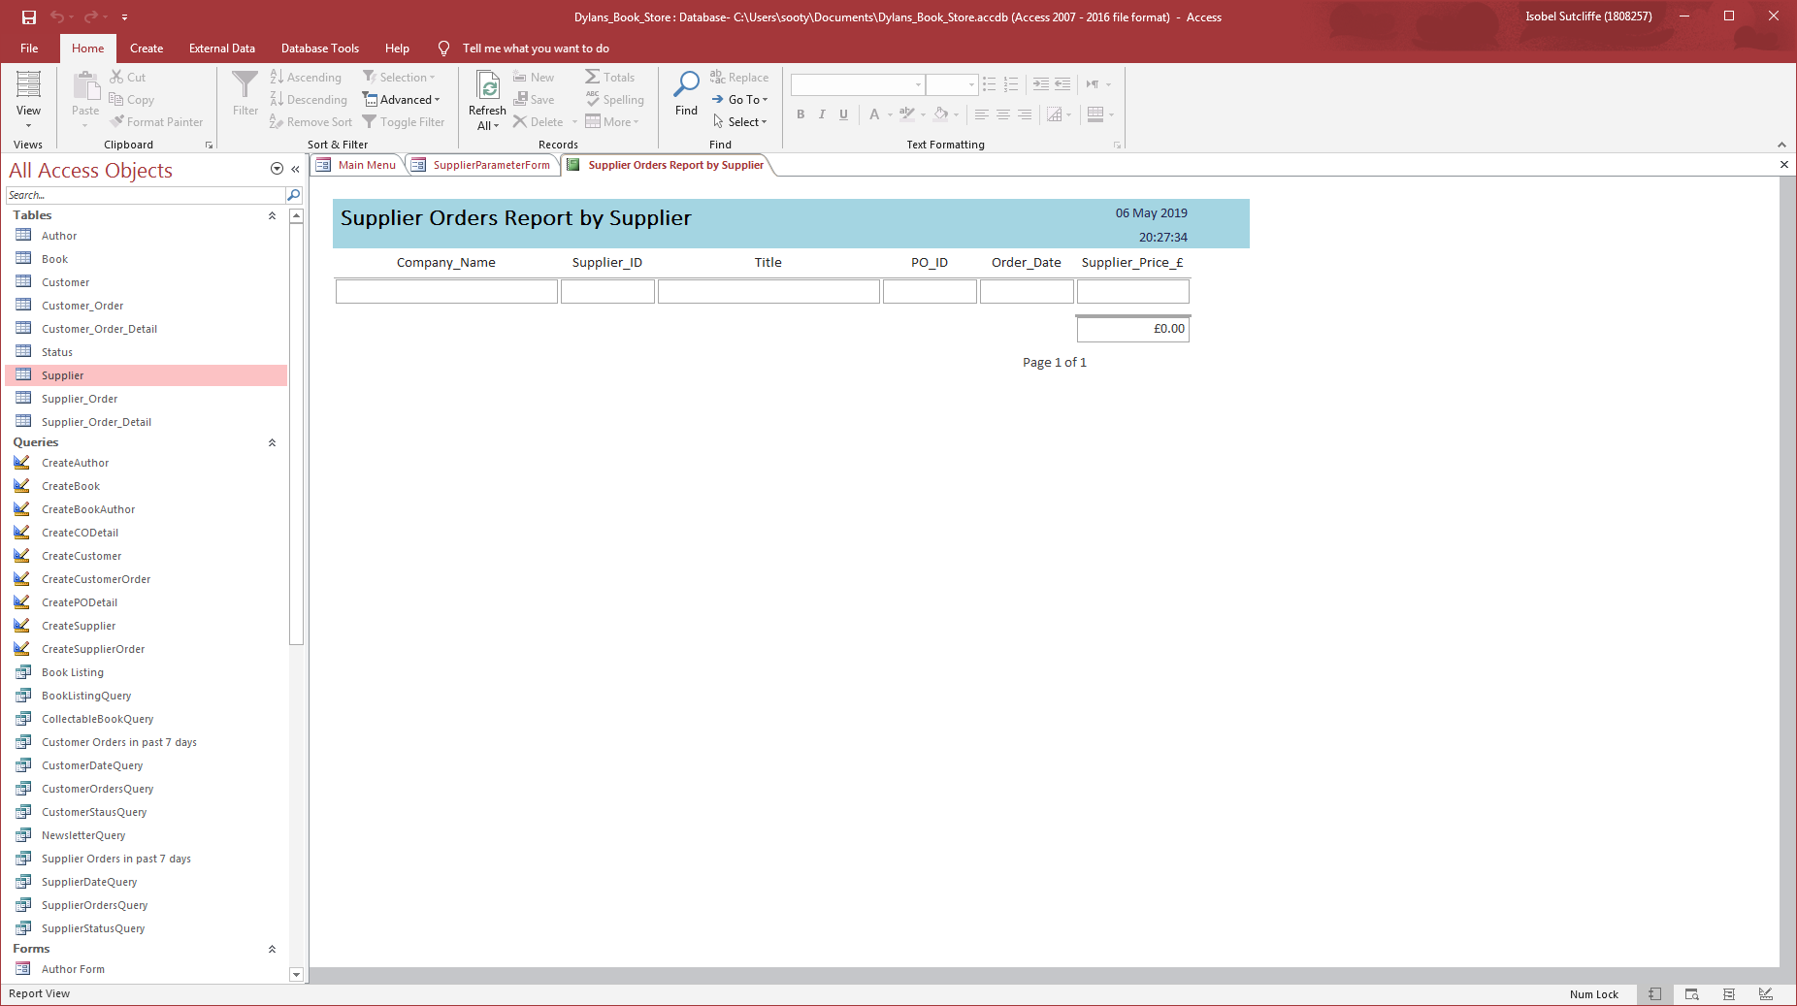
Bug – There seems to be glitch on this report so a little more investigating may be required to establish what the issue is.

Supplier Date Report
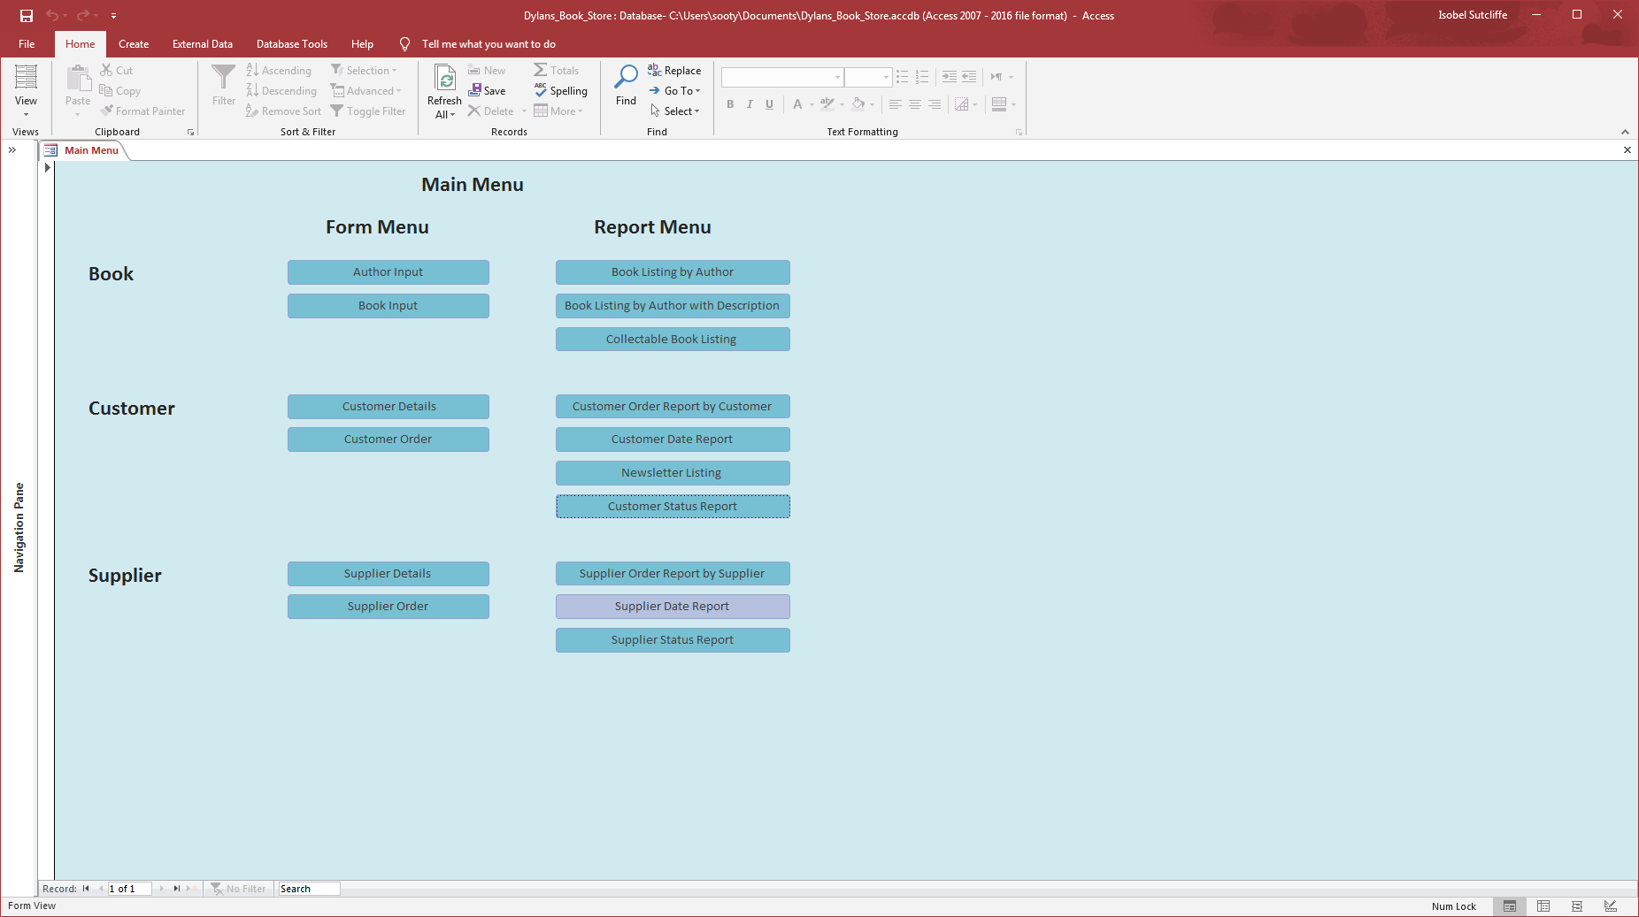
Click on the “Supplier Date Report” button, once the screen below appears the user can select the date range that they want to see a list of orders for.
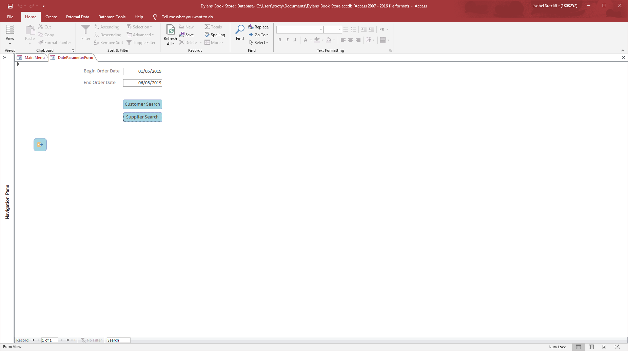

Let’s choose, 01/05/2019 and 06/05/2019 for this example, and the click on supplier search, this should go straight the supplier report, with all orders between the dates. As can be seen there are some fields that have not been filled in so the user can go in and amend these to reflect the order status.
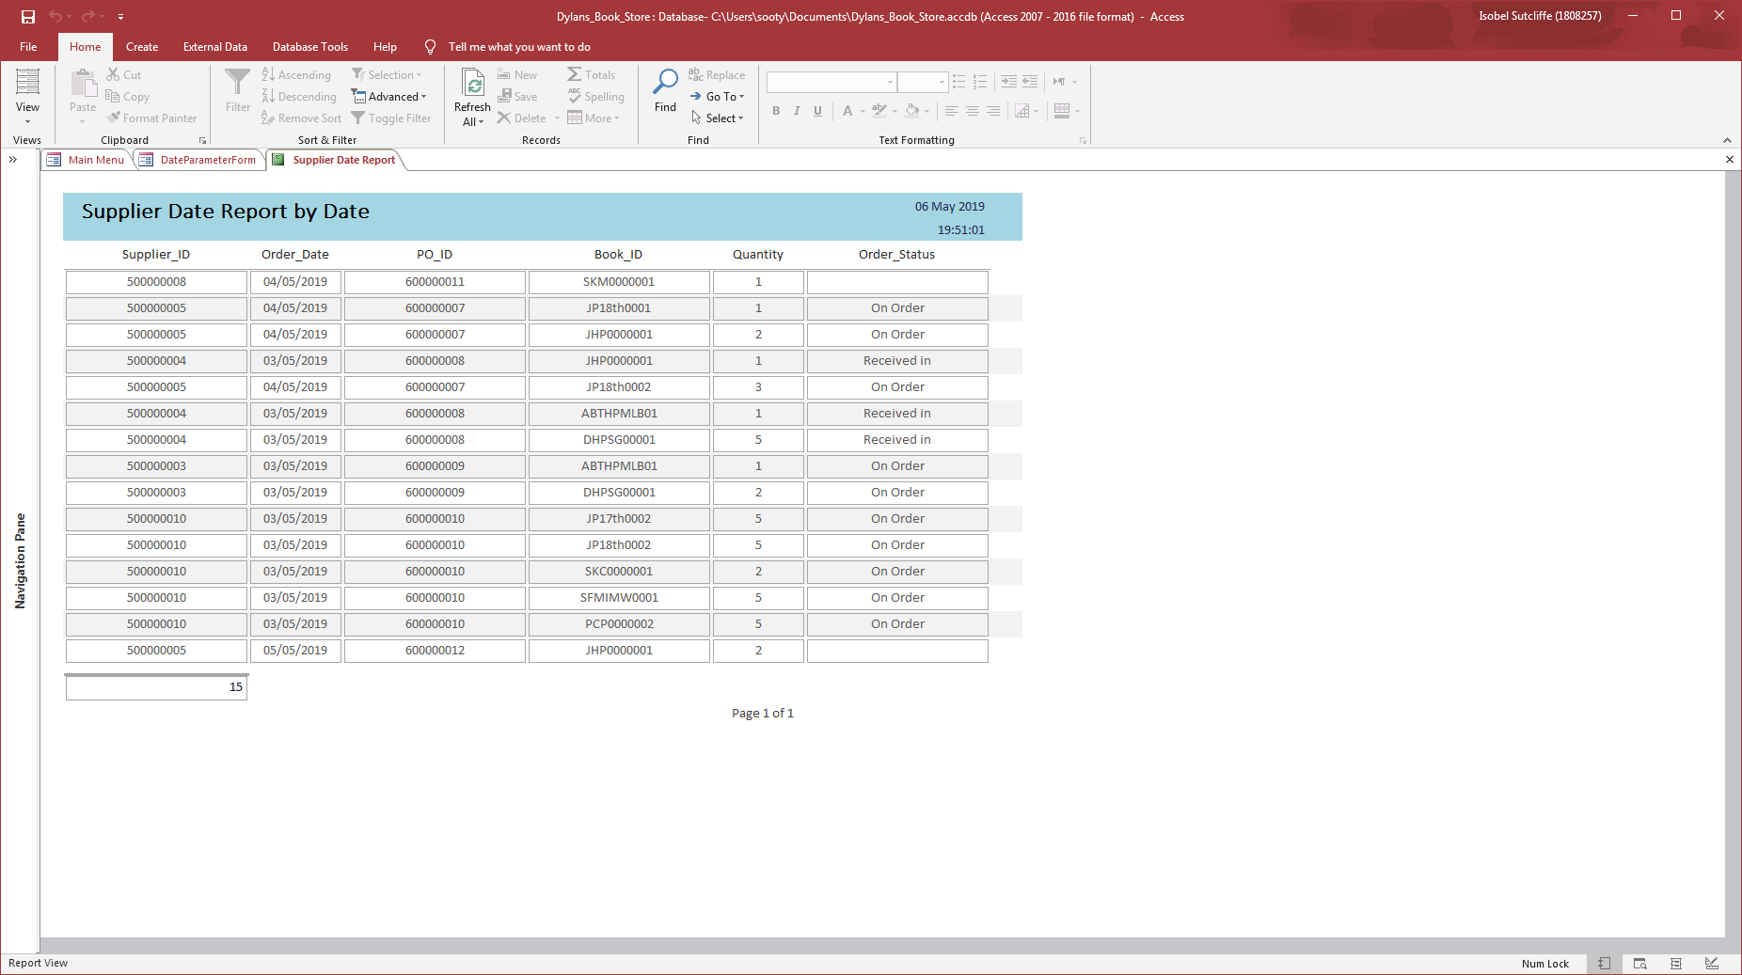
Still some work to do on the navigation panes for the reports.

Supplier Status Report
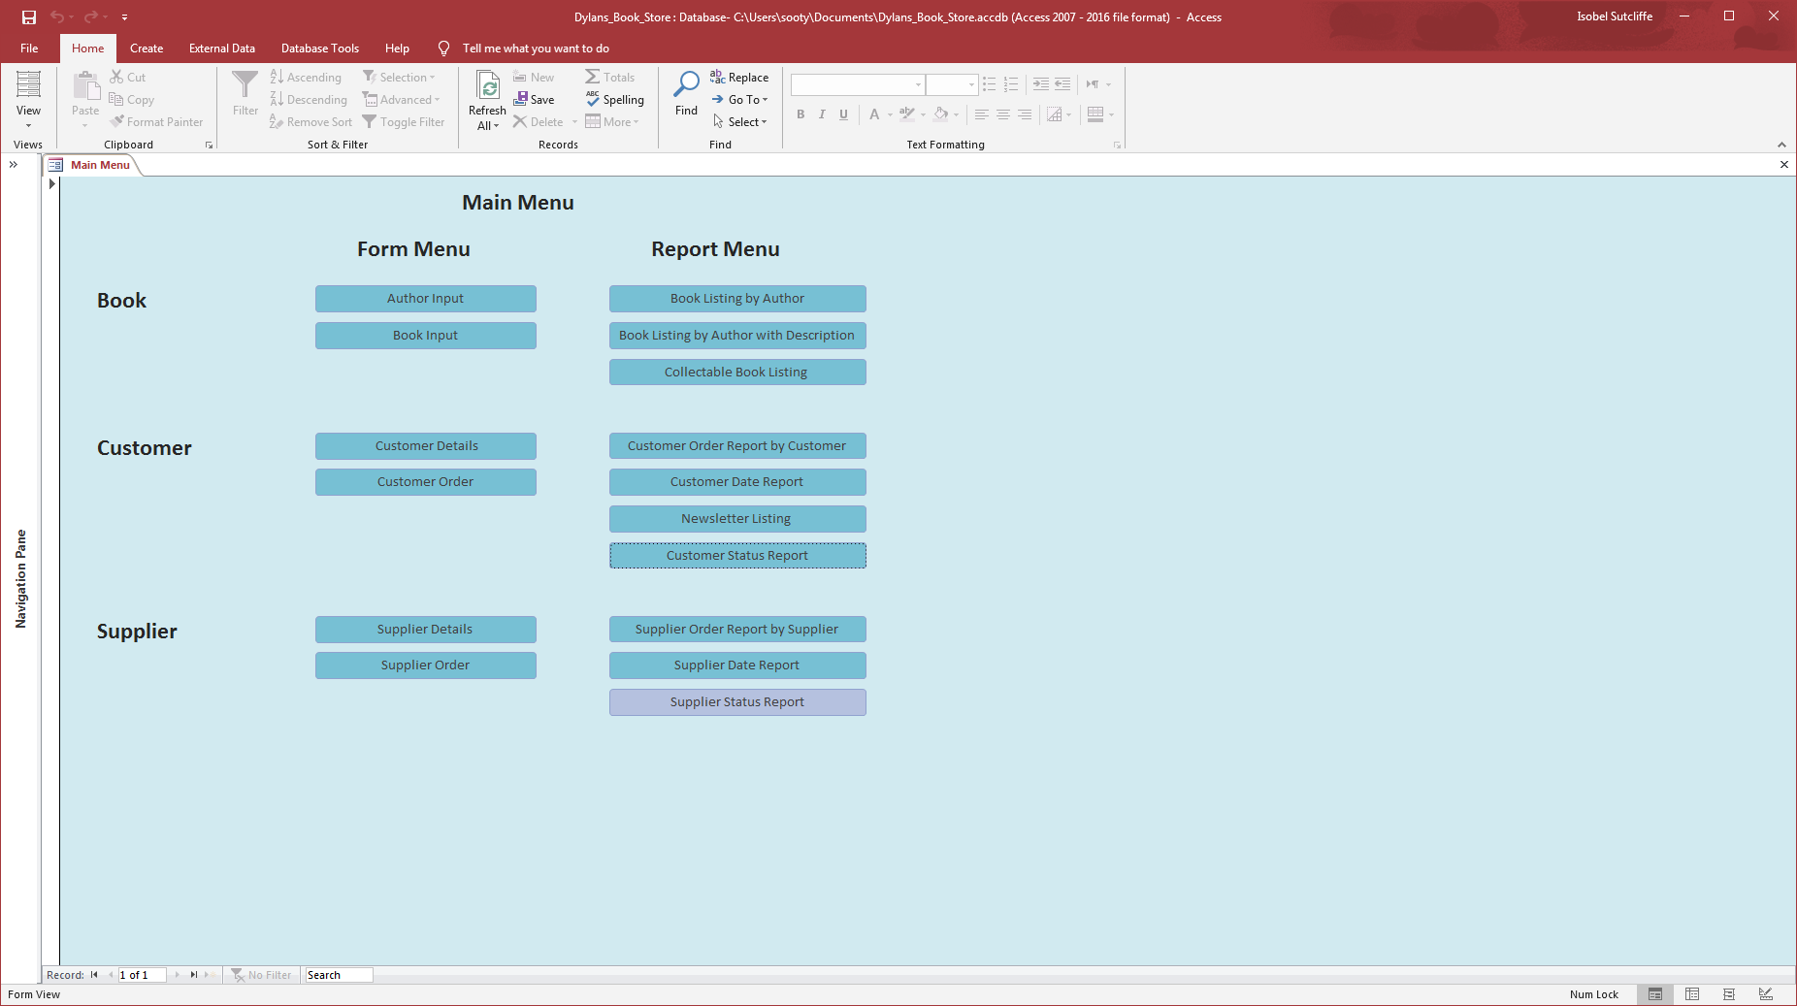
Click on the “Supplier Status Report” button, once the screen below appears the user can select the status id that they require so they can see a list of customers’ orders with the status requested.
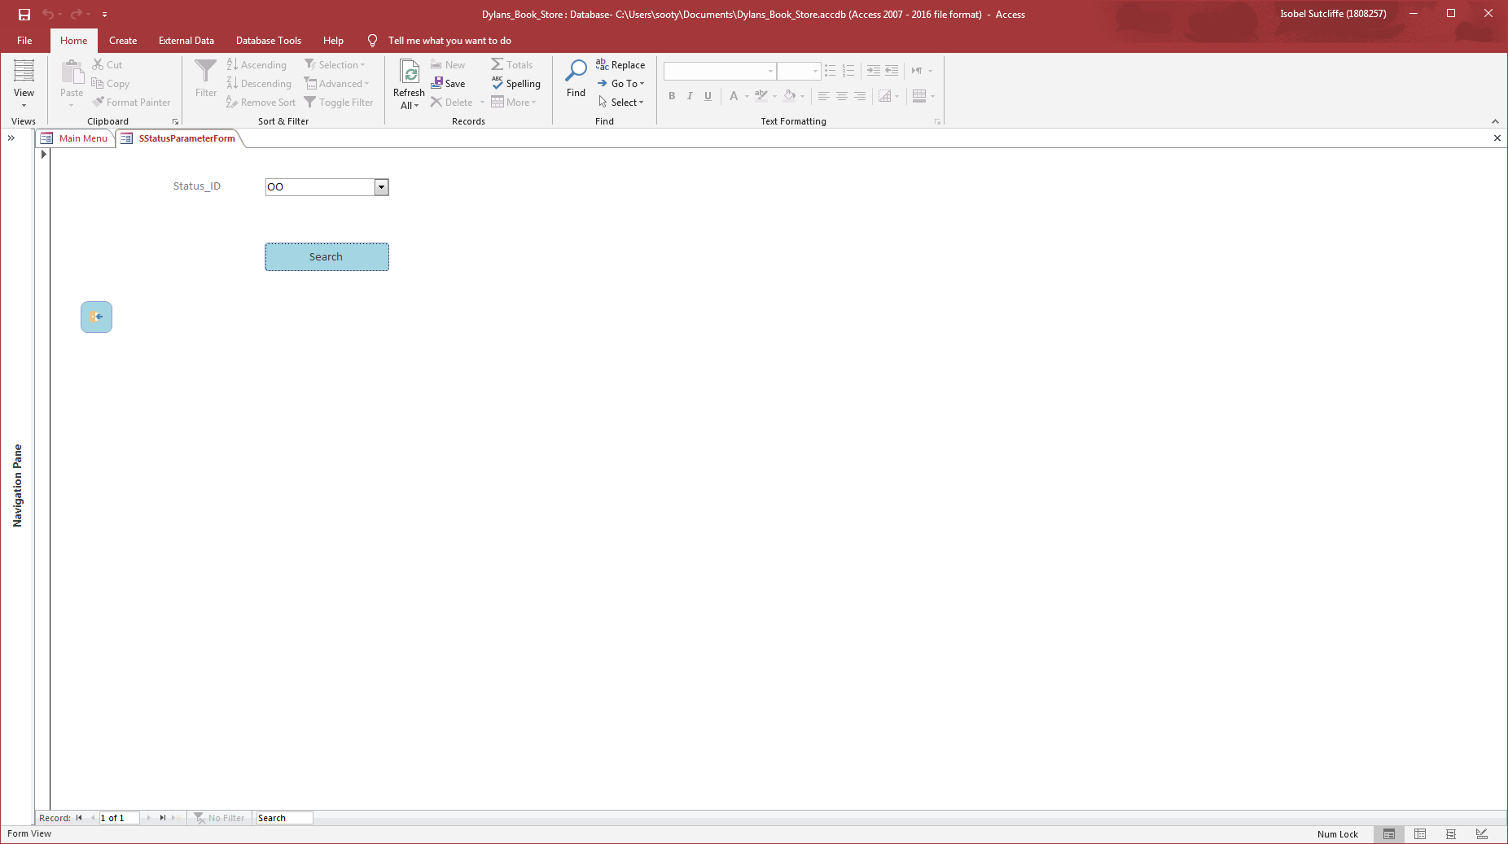
OO – On Order
PR – Processing
RD – Received In
RY – Ready
ST – Sent Out
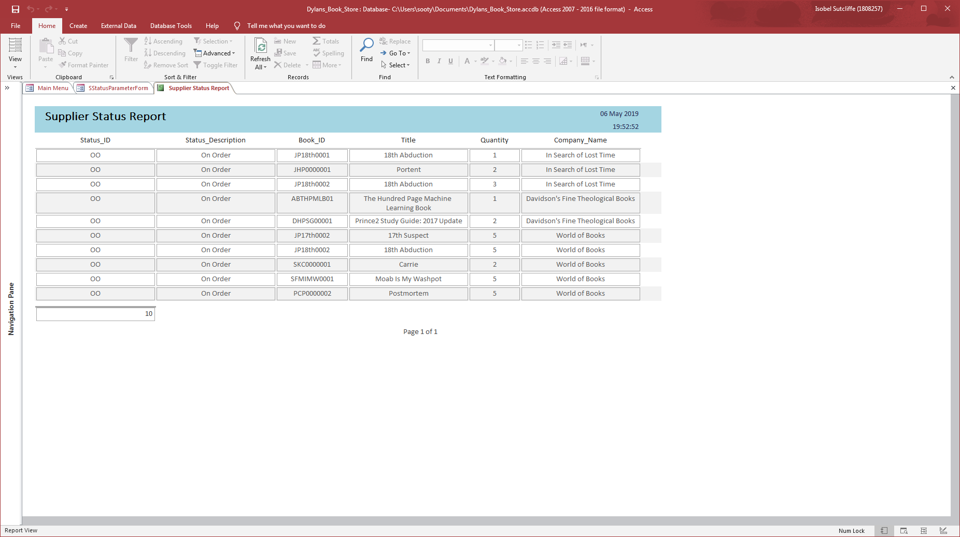

Additional Reports not on Main Menu:
Customer Orders in past 7 days
Supplier Orders in past 7 days
These reports may prove useful at some point when looking at Creditors and Debtors as the database grows and needs some control checks to be carried out.

Section 4 – Future Developments
The database is looking quite slick and almost ready to be used. There are still some future developments that are needed to greatly improve the usability for the bookstore. For instance, the stock items have yet to be brought together, but that should be a fairly reasonable process, as it simply means requires the supplier numbers to be added to stock and subtracting the customer numbers out.
It would appear that there are still one or two bugs that are in the current system that will need further investigating to ensure data quality and accuracy.
There are some areas that still need a little more polish such as getting the customer and supplier names working to ensure that the user can use either format when searching for any orders or amounts for invoicing.
Another area that could be useful if future time allows and that is to print delivery notes and invoices for customer orders, ensuring that there is a checking process when goods are sent out.
This also leads onto automating how suppliers are contacted for goods, but this is some time off and will still require some manual intervention until such a time.

References
[1] A. Watt, “Chapter 8 The Entity Relationship Data Model – Database Design – 2nd Edition.” [Online]. Available: https://opentextbc.ca/dbdesign01/chapter/chapter-8-entity-relationship-model/. [Accessed: 06-May-2019].
[2] “The Basics of Database Normalization.” [Online]. Available: https://www.lifewire.com/database-normalization-basics-1019735. [Accessed: 06-May-2019].

