MARKETING PLAN
HOLIDAY INN HOTEL Phuket Thailand

Student Name: Rehan Ali Shah
Student No: 2241266
Module title: Marketing Plan Holiday INN BMHIH4005 ASSESMENT 2
Module Tutor: Scott James
Main Word Count: 1300

Contents
INTRODUCTION: 2
SITUATIONAL ANALYSIS: Porter (1980) and Thompson and Strickland (2017) 2
OBJECTIVES: 4
STRATEGY: 5
MARKETING MIX: (Kotler and Keller, 2016) 6
TACTICS: 6
ACTION: (Tonks, 2009). 9
CONTROL: 10
CONCLUSION: 11
REFERENCES: 13
APPENDIX: 15

INTRODUCTION:
This marketing plan aims to increase Holiday Inn Resort Phuket Kata Beach awareness. The plan is being prepared for the hotel's management team. The critical frameworks used in the plan are SOSTAC to develop a marketing plan, Marketing Mix to create a competitive advantage for the hotel, and Bowman's Strategy Clock to develop a long-term Strategy for the hotel. (Kotler and Armstrong, 2018). Holiday Inn Resort is a 4-star hotel on Kata Beach in Phuket, Thailand. The hotel has 300 rooms and suites, offering a variety of amenities.
The hotel's target market is families and couples looking for a relaxing beach vacation. The hotel will be marketed through various online advertising channels, social media channels, and email marketing channels.

SITUATIONAL ANALYSIS: Porter (1980) and Thompson and Strickland (2017)
- COMPANY:
Strengths:
- Strong brand recognition
- Good Reputation
- Experienced management team
- Well-located
Weaknesses:
- High prices
- Lack of differentiation from competitors
- Limited marketing budget the hotel has a great location in Thailand.
- CUSTOMERS:
Segmentation:
- By age: Families and couples
- By nationality: Chinese, Indian, European
- By budget: Mid-range
Targeting:
  - The hotel will target families and couples looking for a relaxing beach vacation.
Customer profiles:
  - Similar Web data shows that the hotel's website is most popular with visitors from China, India, and Europe.
  - The average visitor to the hotel's website is 35 years old and has an annual income of $100,000.
- COMPETITORS:
Direct competitors: These hotels offer similar products and services to Holiday Inn Hotel.
  - The Westin Phuket Kata Beach Resort & Spa
  - Dusit Thani Laguna Phuket
  - Novotel Phuket Kata Beach Resort
  - JW Marriott Phuket Resort & Spa
Indirect competitors: These are hotels that offer different products and services, but they compete for the same customer base.
  - Airbnb
  - Booking.com
  - Expedia
Future competitors: These hotels still need to be in business, but they can potentially compete with Holiday Inn Hotel in the future.
  - The Ritz-Carlton Phuket
  - Four Seasons Phuket
- COLLABORATORS:
B2B relationships:
- The hotel has relationships with several travel agencies and tour operators.
- The hotel also has relationships with many local businesses, such as restaurants and activities providers.
Partnerships:
- The hotel is a member of the IHG Rewards Club loyalty program.
- The hotel also partners with several airlines, which offer guests discounts on flights.
Franchises:
- The hotel is not a franchise.
- CLIMATE – PESTEL ANALYSIS
  - Political: The political climate in Thailand is stable.
- Economic: The economy in Thailand is growing.
- Social: The population in Thailand is growing.
- Technological: Technology is becoming increasingly important in the tourism industry.
- Environmental: The environment in Thailand is a major tourist attraction.
- Legal: The legal environment in Thailand is favorable to the tourism industry.
- MARKETING MIX:

The situational analysis shows that Holiday Inn Resort Phuket Kata Beach is a well-positioned hotel with strong brand recognition and a good reputation. The hotel faces challenges like high prices and a limited marketing budget. However, the hotel has several strengths, such as an experienced and well-located management team. The hotel can overcome its challenges by focusing on its strengths and developing a marketing plan that effectively targets its target market. (Thompson and Strickland, 2017).

OBJECTIVES:
- Specific: (McCarthy, 1960)
- Increase website traffic by 5000 visits per month.
- Increase social media followers by 8000 by the end of the year.
- Increase bookings by 10% by the end of the year.
- Measurable: (Smith, 2019)
- Website traffic will be measured using Google Analytics.
- Social media followers will be measured using social media analytics tools.
- Bookings will be measured using the hotel's booking system.
- Attainable:
- The hotel has the resources to achieve these objectives.
- The objectives are realistic and achievable given the hotel's target market and budget.
- Relevant:
- The objectives are relevant to the hotel's overall business goals.
- The objectives will help the hotel to increase awareness, drive bookings, and grow its business.
- Time-bound: (McCarthy, 1960)
- The objectives will be achieved within a specific time frame.
- The website traffic objective will be achieved within 6 months.
- The social media follower’s objective will be achieved within 12 months.
- The bookings objective will be achieved within 18 months.

STRATEGY:
The hotel will use strategies from Ansoff's matrix to grow its business. (Ansoff, 1957). These strategies include:
  - Market penetration: The hotel will focus on increasing its market share in its current markets. This will be done by increasing website traffic and social media followers and by running promotions and discounts. (Ries and Trout, 1981)
  - Market development: The hotel will explore new product and service markets. This could include targeting new demographics, such as millennials or families, or expanding into new geographic regions, such as China or India.
  - Product development: The hotel will develop new products and services to meet the needs of its target market. This could include adding new amenities, such as a spa or fitness Centre, or offering new activities, such as cooking classes or yoga. (Walker, 2017)

MARKETING MIX: (Kotler and Keller, 2016)
  - Product: The hotel will add amenities and offer new activities, such as cooking classes or yoga.
  - Price: The hotel will offer discounts and promotions to attract new guests.
  - Place: The hotel will partner with travel agencies and tour operators to increase its reach.
  - Promotion: The hotel will use a variety of marketing channels, including online advertising, social media, and email marketing.
The hotel will measure the effectiveness of the marketing plan by tracking the following metrics and KPIs:
Website traffic:
- The number of visitors to the hotel's website will be measured by Google Analytics.
- The hotel will aim to increase website traffic by 5000 visits by the end of the year.
Social media followers:
- The number of followers on the hotel's social media channels will be measured by social media analytics tools.
- The hotel will aim to increase social media followers by 8000 by the end of the year.
Bookings
The hotel will also conduct surveys and interviews with guests to get feedback on the marketing plan and identify improvement areas. The marketing plan will be implemented over a period of one year. The plan will be evaluated at the end of the year to determine its effectiveness. (Ries and Trout, 1981)

TACTICS:
- Action: The hotel will take action to implement its marketing strategy. This could include creating new marketing materials, running advertising campaigns, or organizing events. (Fill, 2019).
- Communication: The hotel will communicate its marketing message to its target market. This could be done through online advertising, social media, or email marketing.
- Evaluation: The hotel will evaluate the effectiveness of its marketing campaign. This will be done by measuring the hotel's website traffic, social media followers, and bookings.
Communication Mix:
The hotel will use various communication tools to reach its target market. These tools will create awareness of the hotel, generate leads, and drive bookings (Schultz and Kitchen, 2012).
New Communications Tactics:
The hotel will use the following new communications tactics to address the issues identified in the situational analysis: (Moss, 2019).
- Online advertising: The hotel will run online advertising campaigns on various platforms, such as Google AdWords, Facebook Ads, and Instagram Ads.
- Social media: The hotel will use social media to engage with its target market and promote the hotel. The hotel will create and share engaging content, such as photos, videos, and blog posts.
- Email marketing: The hotel will collect email addresses from its website visitors and use email marketing to stay in touch with them. The hotel will email newsletters, promotional offers, and unique event invitations.
The hotel will also use other communication tactics, such as public relations, sales promotion, and direct marketing. The hotel will use these tactics to reach its target market and drive bookings.
Improvements:
- Creating more engaging content that will capture the attention of its target market.
- Using different channels to reach its target market.
- Personalizing its communications to the needs of its target market.
New Mix and Strategy:
The hotel will create a new mix and strategy to provide its guests with a relaxing and enjoyable experience. The hotel will offer a variety of amenities and activities to make guests feel comfortable and welcome. The hotel will also focus on providing excellent customer service to ensure guests have a positive experience.
The hotel will use a variety of marketing channels to reach its target market, including online advertising, social media, and email marketing. The hotel will evaluate the success of its marketing plan by measuring its website traffic, social media followers, and bookings. If the hotel can achieve its objectives, then the plan will be considered a success. (Paulssen and Bagozzi, 2006)

ACTION: (Tonks, 2009).
MONTHS | ACTIVITY | MARKETING CHANNEL | METRICS | KPIs
January | Research target market | website | Website traffic | 10k visits
February | Develop marketing messages | Social media | Social media followers | 5k followers
March | Run online advertising campaign | Google AdWords | Website traffic | 15k visits
April | Run social media advertising campaign | Facebook ads | Social media engagement | 10k likes
May | Send out email newsletter | Email marketing | Open rate | 20%
June | Run email marketing campaign | Email marketing | Click through rate | 10 %
July | Host a contest on social media | Social media | Engagement | 5k comments
August | Offer discounts and promotions | Website | Website traffic | 20k visits
September | Host an event | Website | Website traffic | 10k visits
October | Send out holiday newsletter | Email marketing | Open rate | 25%
November | Run a holiday sale | Website | Website traffic | 30k visits
December | Offer year end discounts | website | Website traffic | 25k visits

CONTROL:
  - The metrics and KPIs that have been selected for each channel are:
  - Website
  - Social media
  - Email marketing
However, the choices of metrics and KPIs are justified by the following:
- Website: Website traffic is a good measure of how many people visit the hotel's website. The open rate of email newsletters is a good measure of how many people are opening the hotel's emails. Engagement on social media is a good measure of how much people interact with the hotel's social media content. (Piercy, 2015).
- Social media: The number of followers is a good measure of how many people are interested in the hotel's social media content. Engagement on social media is a good measure of how much people interact with the hotel's social media content. The number of likes and shares is a good measure of how popular the hotel's social media content is. (Piercy, 2015).
- Email marketing: The open rate is a good measure of how many people open the hotel's emails. The click-through rate is a good measure of how many people click the links in the hotel's emails. Engagement is a good measure of how much people interact with the hotel's emails. (Armstrong and Kotler 2019). The metrics and KPIs will be used to evaluate the marketing plan's effectiveness and make necessary adjustments. The hotel will track the metrics and KPIs monthly and adjust the marketing plan. (Armstrong and Kotler 2019).

CONCLUSION:
In conclusion, the hotel has developed a marketing plan to help it reach its target market, stay within its budget, and differentiate itself from its competitors. The plan includes marketing channels like online advertising, social media, and email marketing. The plan also includes a set of metrics and KPIs that will be used to measure the plan’s success. The hotel has changed its target market to families and couples looking for a relaxing beach vacation. Also, the hotel has added online advertising and social media marketing to its marketing mix. Moreover, it has increased its marketing budget to $100,000.

REFERENCES:
Ansoff, I. (1957). Strategies for diversification. Harvard Business Review, 35(5), 113-124.
Moss, C. (2019). The Role of Marketing in Business Strategy. Journal of Business Strategy, 40(2), 27-34.
Paulssen, M. and Bagozzi, R. P. (2006). Goal hierarchies as antecedents of market structure. Psychology & Marketing, 23(8), 689-709.
Tonks, D. (2009). Validity and the design of market segments. Journal of Marketing Management, 25(3–4), 341–356.
Kotler, P., & Armstrong, G. (2018). Principles of marketing (17th ed.). Pearson Education.
Porter, M. E. (1980). Competitive strategy: Techniques for analyzing industries and competitors. Free Press.
Thompson, A. A., Jr., & Strickland, A. J., III (2017). Strategic management: Concepts and cases (18th ed.). McGraw-Hill Education.
McCarthy, E. J. (1960). Basic marketing: A managerial approach. Irwin.
Smith, B. C. (2019). Marketing plans: A step-by-step guide to creating winning marketing plans (3rd ed.). AMACOM.
Ries, A., & Trout, J. (1981). Positioning: The battle for your mind. McGraw-Hill.
Walker, B. J. (2017). The strategic marketing plan: A step-by-step guide (4th ed.). Sage Publications.
Kotler, P., & Keller, K. L. (2016). Marketing management (15th ed.). Pearson Education.
Fill, C. (2019). Marketing communications: Integrated marketing communication in practice (7th ed.). Routledge.
Schultz, D. E., & Kitchen, P. J. (2012). Communicating globally: An integrated marketing approach (4th ed.). Pearson Education.
Armstrong, G., & Kotler, P. (2019). Marketing: An introduction (18th ed.). Pearson Education.
Piercy, N. F. (2015). Market-led strategic planning: A modern approach to marketing management (7th ed.). Routledge.

APPENDIX:
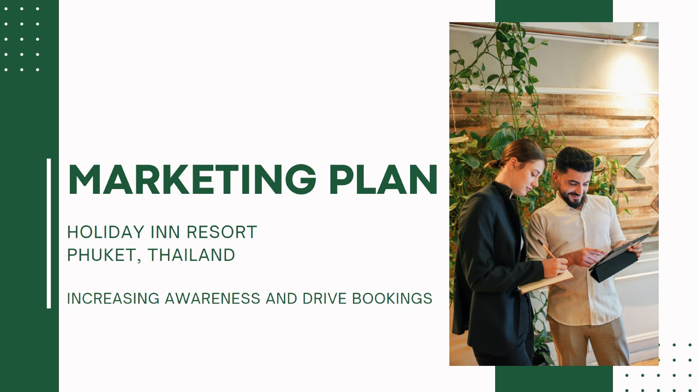
Slide 1:
Slide 2:
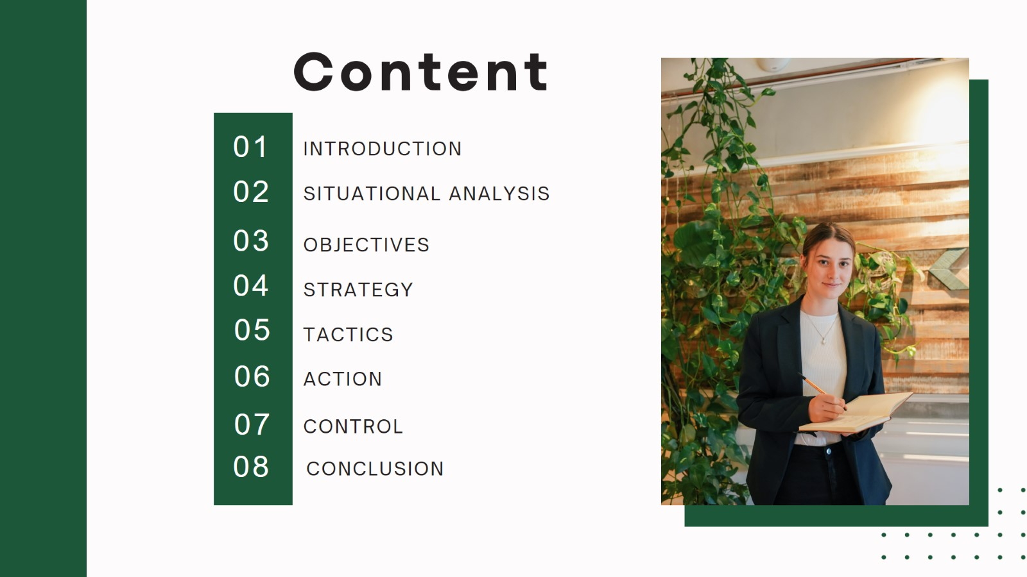
Slide 3:
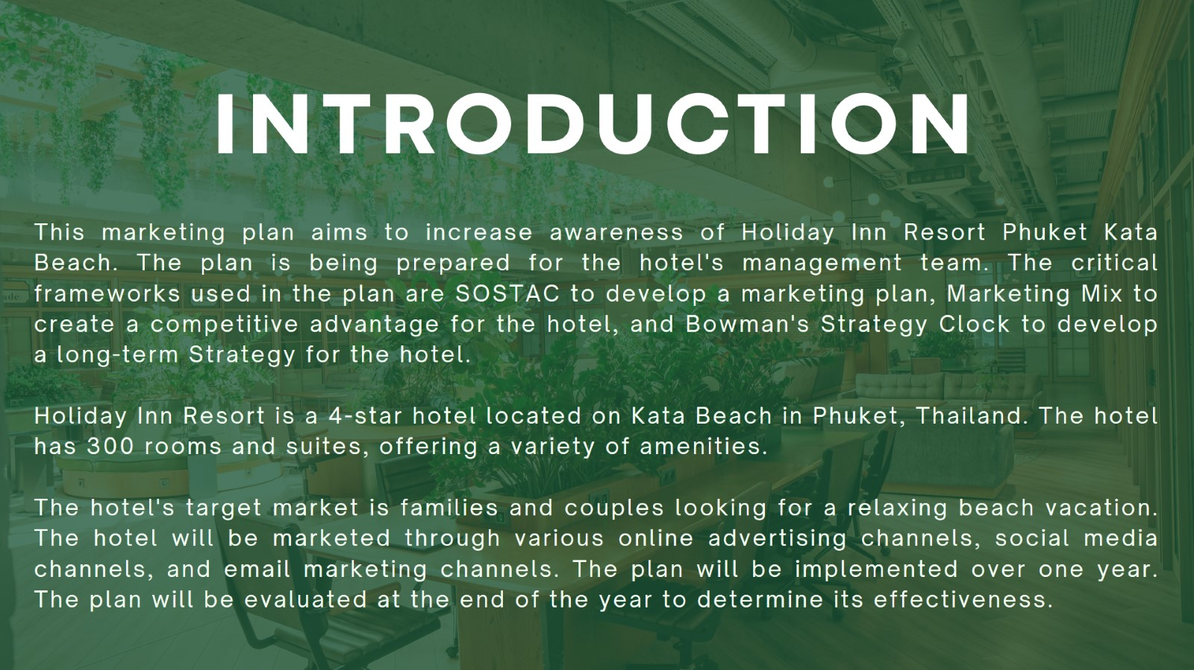
Slide 5:
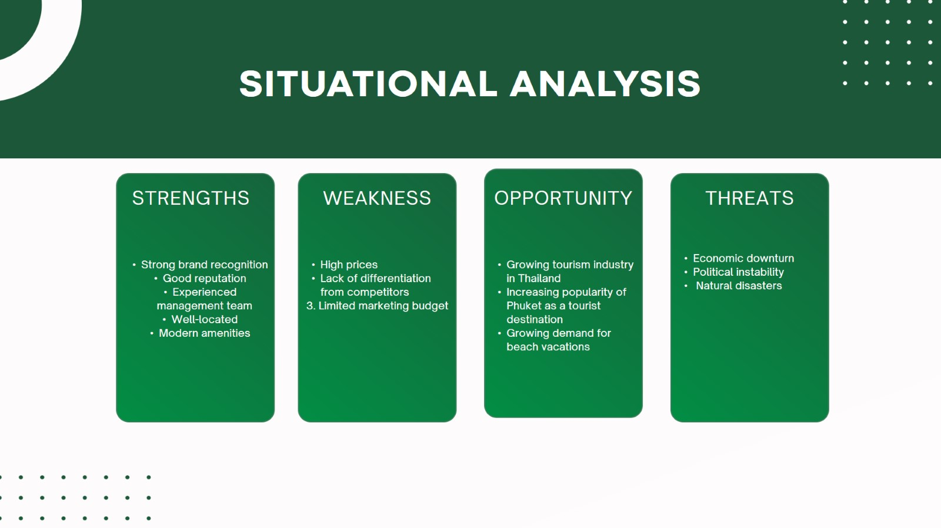

Slide 6:
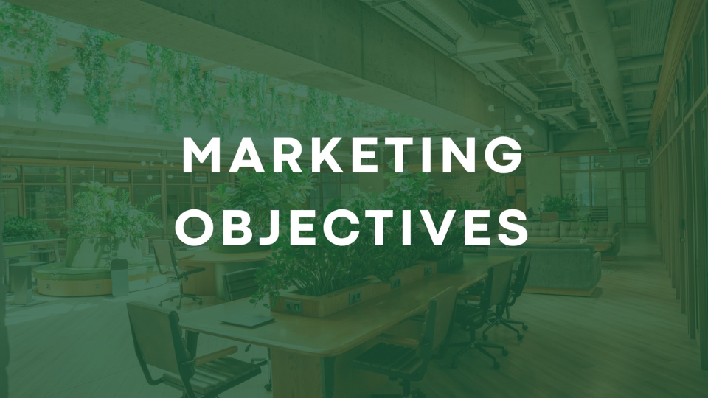
Slide 7:
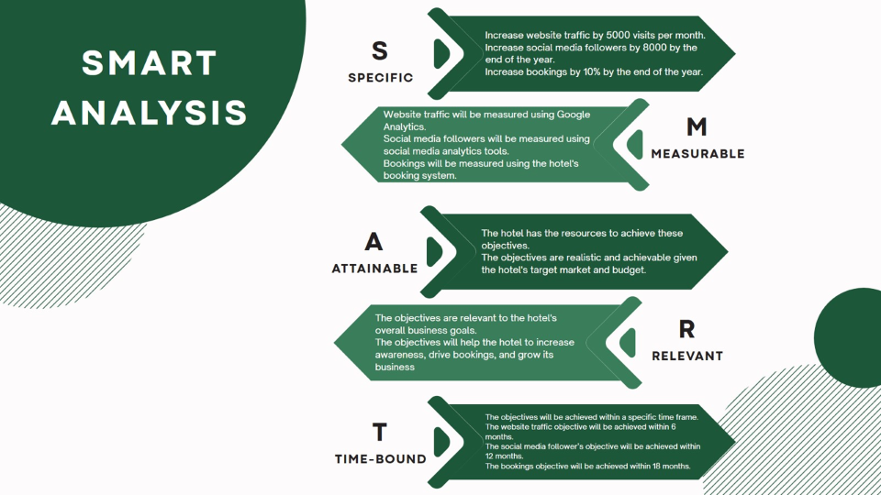

Slide 8:

Slide 9:
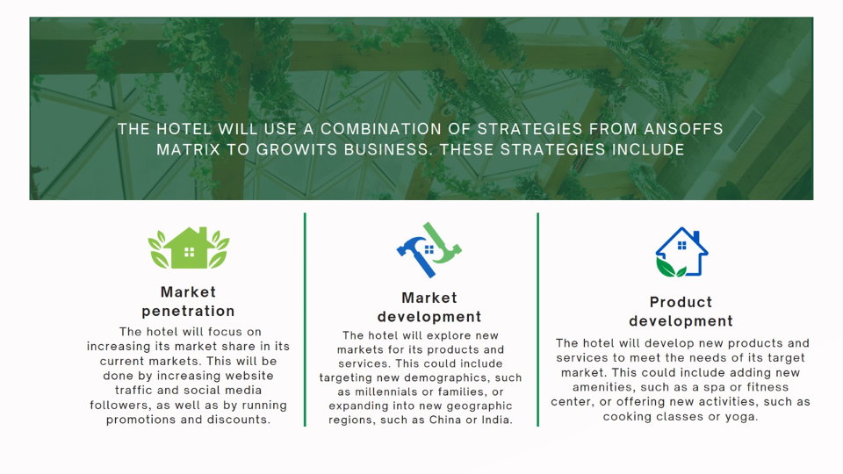

Slide 10:
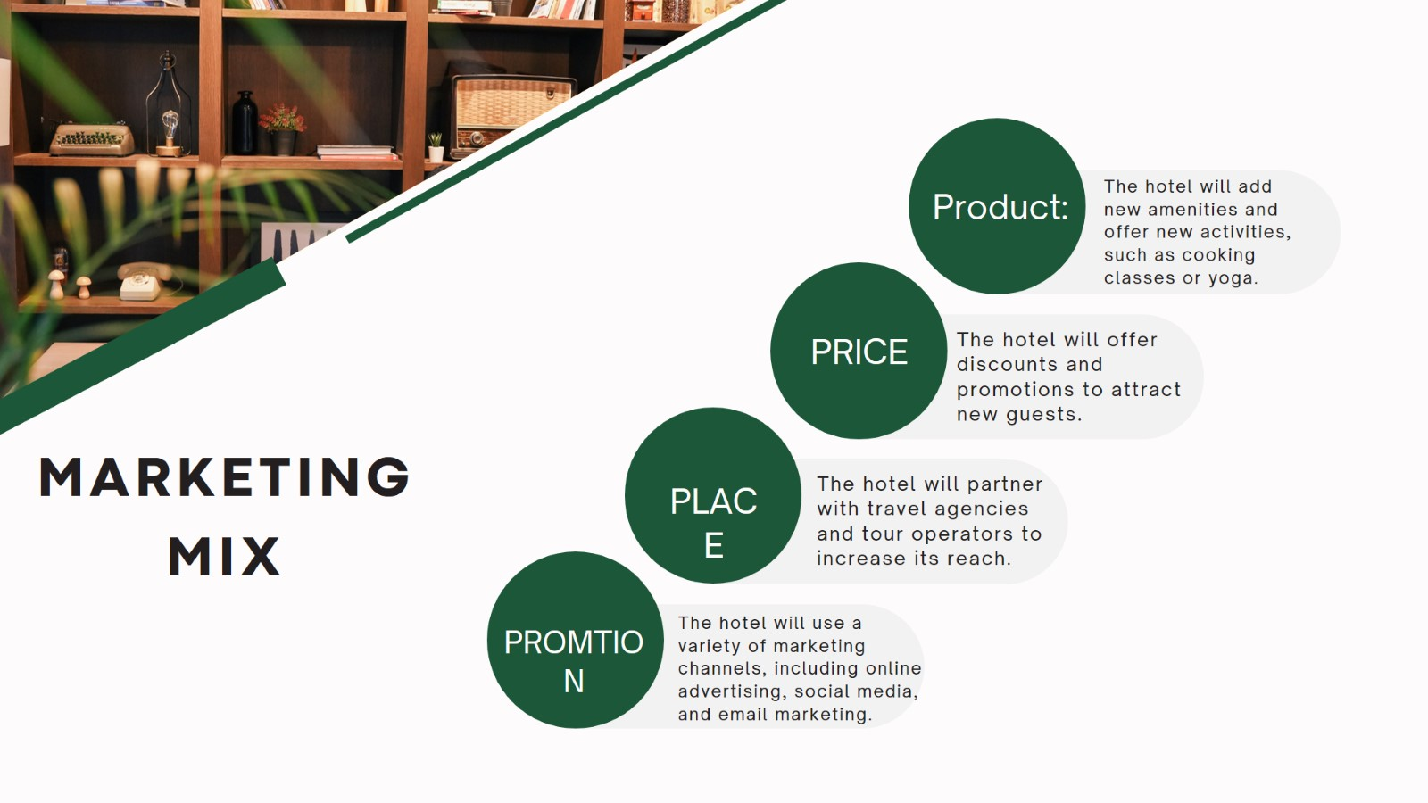
Slide 11:
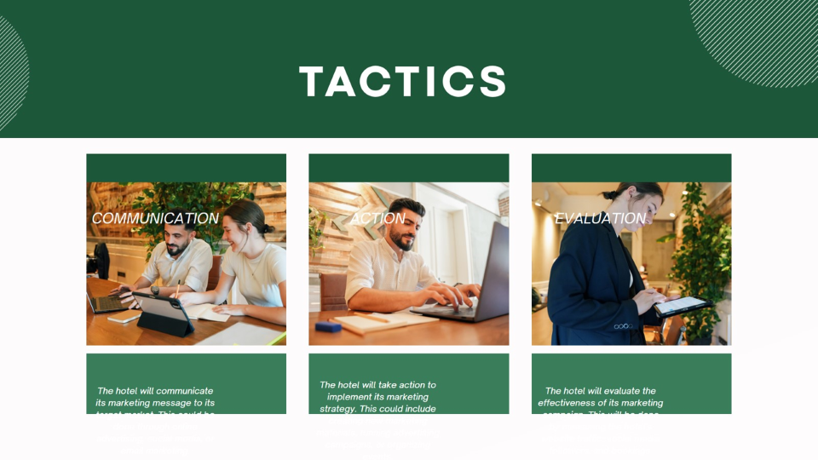

Slide 12:
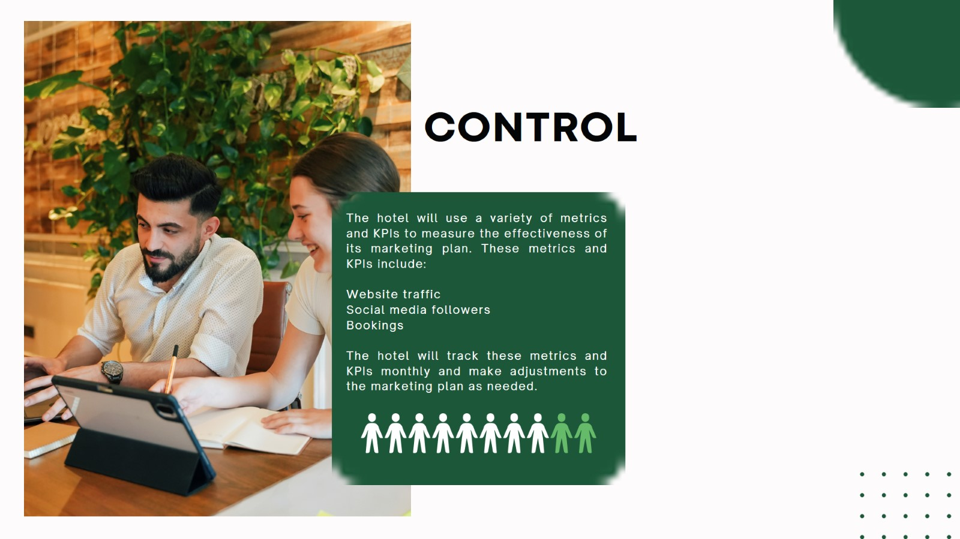
Slide 13:
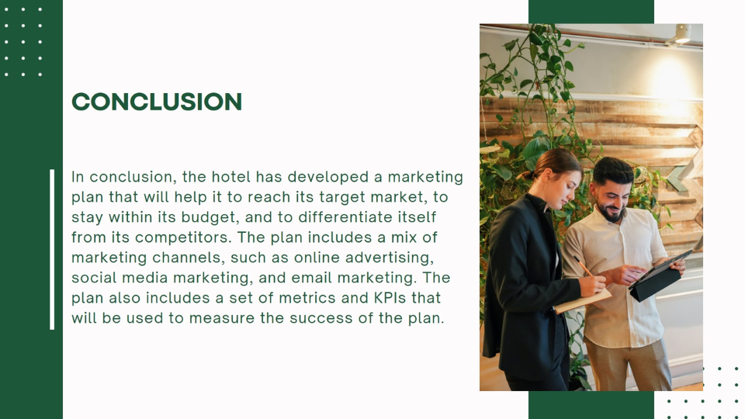

Slide 14:
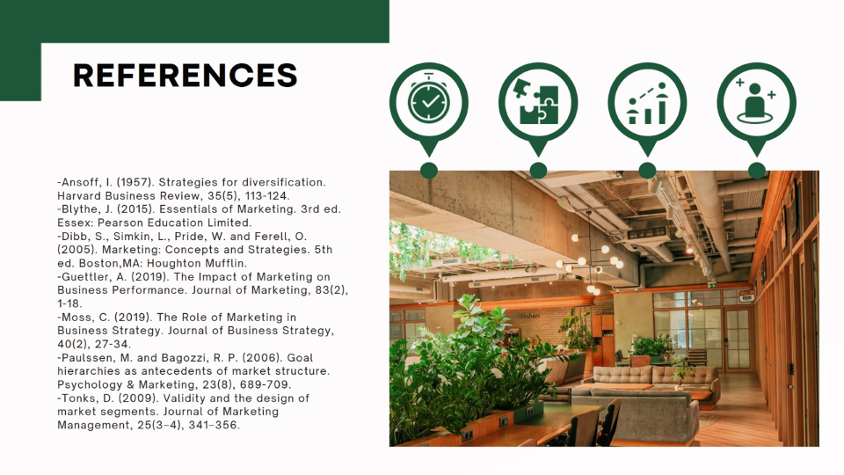
Slide 15:


Similar Web Analysis Hoilday INN


