REFERENCE SHEET FOR ACDB4011 CHEMISTRY OME
FINAL EXAM
ANSWER KEY
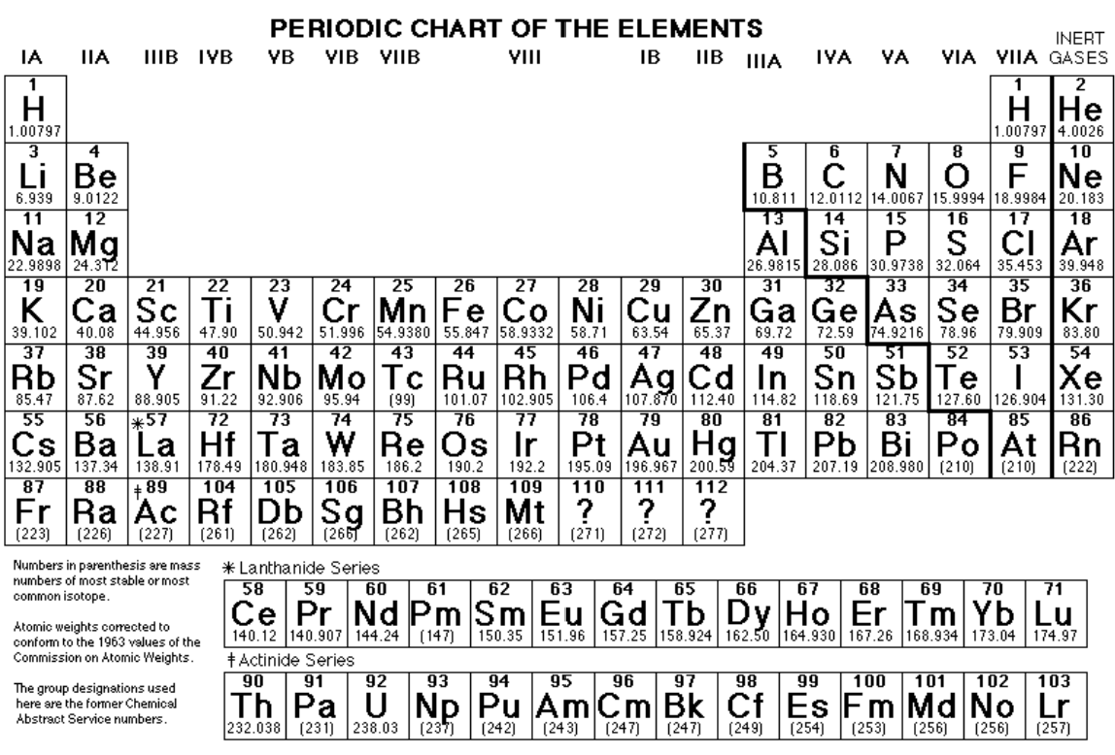

PHYSICAL CONSTANTS:
C = 3.0 x 10⁸ m/s (speed of light)
R_{H} = 3.29 x 10¹⁵ s⁻¹ (Rydberg constant)
h = 6.6 x 10⁻³⁴ Js (Plank’s constant)
1 amu = 1.66 x 10⁻²⁴ kg (atomic mass unit)
N_{A} = 6.02 x 10²³ Avogadro’s number
R = 0.0821 L-atm/mol-K OR 8.314 J-mol/K gas constant
0 degC = 273 K

1 atm = 101.3 kPa = 101,325 Pa = 760 mm Hg = 760 torr = 14.7 lb/in2 (psi)

ACDB4011 CHEMISTRY OME FINAL EXAM

NAME_____________________________________ DATE_______________

SHOW ALL WORK. USE CORRECT UNITS AND SIGNIFICANT DIGITS. YOU MAY SHOW YOUR WORK ON THE BACK OF THE SHEET BUT INDICATE YOUR ANSWER ON THE FRONT.
PERIODIC TABLE AND REFERENCE DATA CAN BE TORN OFF OF THE EXAM
THERE ARE 10 QUESTIONS, 100 POINTS TOTAL (PLUS ANY EXTRA CREDIT EARNED IN THE CLASS). TIME 120 min

QUESTION 1:
For each of the following statements determine if it is TRUE or FALSE. In each case justify your answer.
- (2p) The elements in the periodic table are arranged in the order of increasing number of electrons.
- (2p) Multiple bonds are usually shorter and stronger than single bonds between the same atoms
- (2p) In 1 mole of water there are 6.02 x 10²³ atoms of oxygen.
- (2p) Ideal gas equation describes well the behaviour of gases when the pressure and temperature of this gas tend to 0 atm and 0 K, respectively.
- (2p) Activation energy of nitrocellulose and RDX is 86 kJ/mol and 199 kJ/mol, respectively. RDX is less stable than nitrocellulose.
- (2p) The C₂H₄ molecule has six bonding electron pairs and no lone pairs.
- (2p) For a hypothetical reaction A + B C that is a second order in A, doubling the concentration of A will double the rate of the overall reaction.
- (2p) For every 10 degC increase in temperature, the rate of decomposition decreases by factor of two.
- (2p) (THE MASS) of gas produced in the detonation process decreases when the oxygen balance becomes less negative.
- (2p) The equilibrium constant will have a larger value, if more reactants is used.

QUESTION 2:
- (4p) Draw the Bohr model for a chlorine atom. Specify the number of orbits and indicate the position of all subatomic particles within the atom and their charges.

- (3p) Provide the definition of mass number and explain why for Cl atom the average atomic mass is 35.453.

- (2p) How many protons and neutrons are there in chlorine-37?

d) (2p) what will be the charge on chlorine atom when it achieves octet?

QUESTION 3:
Many fireworks contain metal compounds that emit visible light. The colour given by calcium compounds at the wavelength of 616 nm is orange-red.
- (3p) Calculate the energy of one photon of green light emitted by calcium atom. Show your calculations.

- (3p) Write the full and shorthand electron configuration for calcium and show ALL the electrons in orbitals.

- (3p) The colours seen in fireworks are a result of the emission of visible light. State how these colours are produced.

QUESTION 4:
When ammonium nitrate and magnesium metal are mixed in a stoichiometric ratio, they form a pyrotechnic composition that decomposes to form magnesium oxide, water vapour and nitrogen gas.
- (2p) Write a balanced equation showing all products for the decomposition of this mixture.

- (2p) What percentage of magnesium, by mass, is contained in the stoichiometric mixture?

- (3p) Using the standard heats of formation listed below, calculate the heat of reaction for molar quantities of the reactants. Is this process exothermic or endothermic? Explain
Ammonium nitrate (solid) -365 kJ/mol
Magnesium oxide (solid) -601 kJ/mol
Water (gas) - 242 kJ/mol

- (3p) How does the heat of reaction from this reaction compare with 2.8 kJg⁻¹ provided by one gram of TNT.

QUESTION 5:
A simple chemical equation for the combustion of gun powder can be written as:
2 KNO₃ + S + 3 C K₂S + 3 CO₂ + N₂
- (4p) Assuming that the reaction above can be carried out at STP, how many grams of CO₂ are formed from the decomposition of 45 g of KNO₃?

- (4p) How many litres of gas products would form from the decomposition of 45 g of potassium nitrate at STP?

- (4) 45 g KNO₃ at STP is heated to 100 degC and the pressure is reduced to 700 mmHg. What is the new volume of the gases? Use the appropriate gas laws to support your answer.

QUESTION 6:
The phase diagram of an unknown compound X, is shown below:
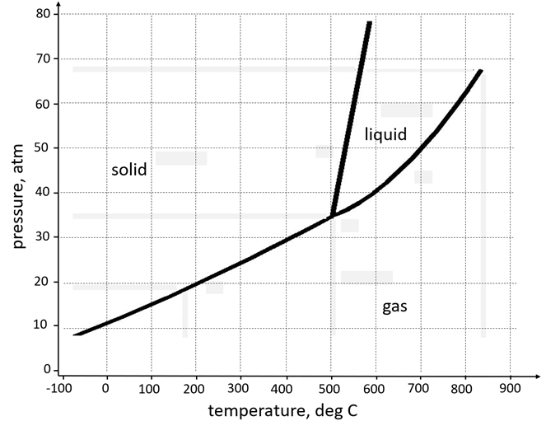
- (2p) What is the value of temperature and pressure at a critical point? How is substance X called above the critical point?
- (2p) If you stored a bottle containing compound X on the work desk in the lab, what phase would it most likely be in?
- (2p) If a sample of pure X is to be a mixture of liquid and gas, which point marks the sample's lowest possible temperature and pressure? Name all transitions occurring at this specific temperature and pressure.
- (2p) What is the vapour pressure of substance X at 700 deg C?

QUESTION 7:
(4p) The normal boiling point is 100°C for H₂O and –33.3°C for NH₃, even though the two molecules have almost identical atomic weights. Explain this difference in terms of intermolecular forces, using narrative or cartoons or both.

QUESTION 8:
Some high explosives have the general formula C_{a} H_{b} N_{c} O_{d}. The oxidiser (O) and the fuel (C, H) are present in the same molecule. Nitrogen atoms are present, so there is a highly exothermic production of hot N₂ gas.

- (4p) For an unknown explosive of general formula C_{a} H_{b} N_{c} O_{d} and a molar mass of 152 g/mol, determine the coefficients a, b c and d if 152 g of this material decomposes to form 44.8 dm³ of CO₂, 44.8 dm³ of H₂O, and 22.4 dm³ of N₂.

- (2p) Which of the produced gases will move fastest and explain why?

- (3p) The oxygen balance of an explosive is the mass of oxygen either in excess (the balance is positive) or in deficit (the balance is negative) of that required for complete oxidation of C and H. The oxygen balance is expressed as a percentage of the molar mass of the explosive. Calculate the oxygen balance for explosive with the formula determined in part a).

QUESTION 9:
An explosive, RDX has an enthalpy of detonation of -1106 kJ mol⁻¹.
- (3p) Sketch the reaction profile (“energy” vs. “progress of reaction”) showing the reactants, products, activated complex, enthalpy of detonation and the activation energy

- (3p) Using the Arrhenius equation k = A exp(-E_{a} / RT) to support your answer, explain the relationship between activation energy, E_{a}, and the fraction of colliding molecules that result in a reaction.
molecules do not react

QUESTION 10:
(4p) A 500 g sample of TNT (C₇H₅N₂O₆) is burned in a bomb calorimeter containing 610 g of water at an initial temperature of 20.0 degC. The heat capacity of the calorimeter is 420 J/degC. Once the reaction is completed final temperature of the water and calorimeter increased to 23.0 degC. Using these data, calculate the heat of combustion of TNT in kJ/mol. The specific heat of water is 4.184 J/g-degC.

