


Determination of the TNT equivalence of Nitromethane in charges of 15 kg or less
by
Natalie Coplin - 2113351

Primary supervisor: Geoff Norman
Secondary supervisor: Gareth Collett

Project submitted as part of the requirements for the award of BEng (Hons) OME

May 2026

Acknowledgements
I would like to express my sincere thanks to my two project supervisors, Geoff Norman and Gareth Collett, and my line manager Alastair Chester, for their ongoing guidance and support throughout this work. I am also grateful to the Explosives Team at DNV Spadeadam for their assistance during testing. Finally, I would like to thank the scientist team for always taking time to listen and support me along the way.

Abstract
This project investigated the TNT equivalence of nitromethane (NM) for small-scale blast testing of charge sizes up to 15 kg. This work was motivated by the increasing difficulty of sourcing Plastic Explosive 4 (PE4) and the associated rising costs, prompting the need to investigate nitromethane as a potential alternative explosive material for small-scale trials.

A series of blast trials were conducted at DNV Spadeadam, using nitromethane with four different initiation configurations. Incident peak overpressure and incident impulse were measured at standoff distances of 6, 10, and 15 m. A 0.5 kg TNT reference trial was conducted to validate the experimental setup; however, the recorded data did not align with reported values due to the charge geometry. It was determined computational fluid dynamics (CFD) modelling was a more appropriate method for validation.

The experimental data showed good repeatability across trials and were in close agreement with corresponding CFD simulations. TNT equivalent values of 1.10 based on incident peak overpressure and 1.13 based on incident impulse were determined for the configuration used in these trials.

High-speed video footage indicated interactions between the developing fireball and the ground, suggesting surface reflections may influence pressure-based equivalence measurements under these conditions.

The results demonstrate that TNT equivalence values for nitromethane using incident peak overpressure and incident impulse can be determined, supporting future blast trials at DNV Spadeadam. The results reflect the specific configurations tested which introduces some constraints on their broader applicability. Recommendations for future work include increased charge height, conventional container geometries, and additional experimental repeats to improve confidence and reliability.

List of Abbreviations
Acronym | Definition
CFD | Computational fluid dynamics
ConWep | Conventional Weapons Effects Program
COSHH | Control of Substances Hazardous to Health
DDT | Deflagration-to-detonation transition
DNV | Det Norske Veritas
FEA | Finite element analysis
Fps | Frames per second
ISO | International Organisation for Standardization
NM | Nitromethane
NS-EN | Norwegian Standard – European Norm
PE4 | Plastic explosive 4
SD | Standard deviation
SI | International system of units
TNT | Trinitrotoluene
UFC | Unified Facilities Criteria

Declaration of Originality

I, Natalie Coplin, declare that I am the sole author of this Project; that all references cited have been consulted; that I have conducted all work of which this is a record, and that the finished work lies within the prescribed word limits.

This work has not previously been accepted as part of any other degree submission.

Signed: Natalie Coplin

Date: 04/05/2026

Form of Consent

I, Natalie Coplin, hereby consent that my Project, submitted in candidature for the BEng (Hons) OME degree, if successful, may be made available for inter-library loan or photocopying (subject to the law of copyright), and that the title and abstract may be made available to outside organisations.

Signed: Natalie Coplin

Date: 04/05/2026

Copyright Acknowledgement

I acknowledge that the copyright of this project report, and any product developed as part of the project, belong to University of Wales Trinity Saint David, Swansea.

Contents
Acknowledgements i
Abstract ii
List of Abbreviations iii
Declaration of Originality iv
Copyright Acknowledgement v
List of Figures ix
List of Tables xi
List of Equations xii
1 Introduction 1
1.1 Aim and objectives 1
1.2 Dissertation structure 2
2 Literature Review 3
2.1 Explosions 3
2.2 TNT equivalence 5
2.3 Charge geometry 10
2.4 An estimation of the TNT equivalence of nitromethane 11
2.5 Nitromethane 12
2.6 Impact of weather and altitude 13
3 Methodology 15
3.1 Trial Setup 16
4 Results 23
4.1 Effect of booster 23
4.2 Trial data 24
4.2.1 Trial one 26
4.2.2 Trial two 28
4.2.3 Trial three 30
4.2.4 Trial four 32
4.2.5 Simulation data 34
4.3 Calculation of TNT equivalence 36
5 Discussion 37
5.1 Data quality 37
5.2 TNT equivalence of nitromethane 37
5.2.1 Comparison with ConWep 38
5.3 Pressure vs Impulse for TNT equivalence 38
5.4 Effect of charge geometry 39
5.5 TNT trial 41
5.6 Computer simulations 42
5.6.1 Method validation 42
5.6.2 13.9 kg TNT simulation 43
5.6.3 Mach stem modelling 43
5.7 Comparison of results with literature 45
5.8 Project constraints and limitations 46
6 Conclusions 47
7 Recommendations and Future Work 48
8 Reflection 50
References 51
Appendix 1 – TNT trial data 58
Appendix 2 – Trial and Viper data for 13.9 kg of nitromethane 61
Appendix 3 – Risk Assessment and COSHH Assessment 64
Bare Charges Risk Assessment 64
Nitromethane COSHH Assessment 79
Appendix 4 – Trial checklist 83
Appendix 5 – Project Management 85
Gantt Chart 85
Appendix 6 – Ethics Form 88

List of Figures
Figure 1 Friedlander blast wave (adapted) [6] 4
Figure 2 TNT equivalence values from multiple sources [30] 8
Figure 3 RDX TNT equivalence based on pressure and impulse [32] 9
Figure 4 Molecular structure of nitromethane [39] 13
Figure 5 Explosive charge setup 17
Figure 6 Container used for the nitromethane with detonator support 17
Figure 7 Gauge positions - showing no alignment with other gauges 18
Figure 8 Gauge and charge alignment 19
Figure 9 Final configuration of the gauges 19
Figure 10 High-speed camera in a turret 20
Figure 11 Action camera setup 20
Figure 12 Schematic of the trial setup 21
Figure 13 Overpressure for trial one 26
Figure 14 Impulse for trial one 27
Figure 15 Overpressure for trial two 28
Figure 16 Impulse for trial two 29
Figure 17 Overpressure for trial three 30
Figure 18 Impulse for trial three 31
Figure 19 Overpressure for trial four 32
Figure 20 Impulse for trial four 33
Figure 21 Overpressure for the TNT cylinder simulation 34
Figure 22 Impulse for the TNT cylinder simulation 35
Figure 23 Blast wave development from a cylindrical charge [70] 40
Figure 24 Initial blast shape 41
Figure 25 Formation of a cruciform fireball 41
Figure 26 Mach stem formation shortly after detonation 44
Figure 27 Mach stem at 5 m 44
Figure 28 Fireball and reflection of energy 45
Figure 29 New container for nitromethane trials 49
Figure 30 Overpressure for 0.5 kg of TNT 59
Figure 31 Impulse for 0.5 kg of TNT 60
Figure 32 Overpressure for 13.9 kg of nitromethane simulation 62
Figure 33 Impulse for 13.9 kg of nitromethane simulation 63
Figure 34 Original Gantt chart 86
Figure 35 Updated Gantt chart 87

List of Tables
Table 1 Experimental methods to calculate TNT equivalence 6
Table 2 Empirical methods to calculate TNT equivalence 7
Table 3 Trial set-up 16
Table 4 Weather data during nitromethane trials 21
Table 5 Weather data during TNT trial 21
Table 6 Pressure and impulse data - 6 m standoff 24
Table 7 Pressure and impulse data - 10 m standoff 24
Table 8 Pressure and impulse data - 15 m standoff 25
Table 9 Trial peak overpressure and impulse comparison with Viper TNT data 36
Table 10 Calculated TNT equivalence values based on 13.9 kg 36
Table 11 TNT pressure data - trial and ConWep 58
Table 12 TNT impulse data - Trial and ConWep 58
Table 13 Time of arrival and positive phase duration comparison 59
Table 14 Comparison of trial and Viper data for 13.9 kg nitromethane 62
Table 15 Gauge details - nitromethane trials 84
Table 16 Gauge details - TNT trial 84

List of Equations
Equation 1 TNT equivalence 6
Equation 2 TNT equivalent mass 6
Equation 3 Velocity of detonation mix [9] 23
Equation 4 Mach stem formation [37] 43

Introduction
Det Norske Veritas (DNV) Spadeadam Research and Testing undertake full-scale blast trials, assessing the performance of protective infrastructure against accidental explosions and hostile attacks. New material, structures, accidents or threats can all be assessed and characterised through full-scale blast trials, where modelling is not a suitable alternative. For charge sizes less than 50 kg these trials have traditionally used Plastic Explosive 4 (PE4) as the main charge material. However, in recent years, military and economic climates have resulted in PE4 becoming difficult to source within practical timescales and at reasonable costs. This highlighted the need to identify a suitable alternative energetic material, to ensure continuity of service.

Nitromethane (NM) has previously been used at DNV Spadeadam as an alternative explosive for large-scale trials ≥ 100 kg trinitrotoluene (TNT) equivalence. It should therefore be feasible to use nitromethane in smaller charge sizes. However, before it can be adopted for smaller trials, its suitability for use in charge sizes up to 15 kg TNT equivalence must be assessed. These trials will allow a TNT equivalence value to be determined, by directly comparing blast performance, and therefore provide confidence in future testing using nitromethane. This is of particular importance as DNV customers often require testing to standards such as International Organisation for Standardisation (ISO) 16933:2007 [1] and Norwegian Standard – European Norm (NS-EN) 13123-2:2025 [2] which specify pressures and impulses required be compliant.

Aim and objectives
This project aimed to determine the TNT equivalence for nitromethane for charge sizes up to 15 kg TNT equivalence through a series of blast trials.

The objectives were to:
- Review current literature on TNT equivalence and nitromethane to develop an understanding of the use of nitromethane as an explosive and the measurement of TNT equivalence as a suitable frame of reference in blast trials.
- Conduct a series of full-scale blast trials to collect pressure data using the air blast test for TNT equivalence.
- Undertake a reference TNT blast trial to validate the methodology and provide a known baseline measurement using the same setup as the nitromethane trials.
- Analyse data, comparing trial data to suitable comparisons, considering incident peak overpressure and incident impulse.

Dissertation structure
This report is broken down into eight chapters. Following the introduction in Chapter 1, Chapter 2 presents a literature review that provides an overview of basic explosive theory before discussing TNT equivalence and the use of nitromethane as an explosive. Chapter 3 outlines the methodology with Chapter 4 detailing the results. Chapter 5 provides a discussion of the results and compares the data to examples in literature. Chapter 6 presents the conclusions; with Chapter 7 discussing recommendations and future work. A reflection is provided in Chapter 8.

Additionally, there are five appendices:
- Appendix 1 – TNT trial data
- Appendix 2 – Trial and Viper::Blast data for nitromethane
- Appendix 3 – Risk assessment and COSHH assessment
- Appendix 4 – Trial checklist
- Appendix 5 – Project Management
- Appendix 5 – Ethics form

Note – data throughout this report adheres to the Internation System of Units (SI).

Literature Review
This literature review provides a brief introduction to explosives, outlines the advantages and limitations of TNT equivalency and reviews existing literature on nitromethane and its use as an explosive.

Explosions
Sources of explosions can vary in nature with energy generated by chemical, mechanical, or nuclear means. As this research is focused on chemical explosions, all discussions in this paper refer solely to chemical explosions.

Explosions can be defined as the sudden onset and rapid release of a large amount of energy producing a high-pressure wave and an expansion of hot gases [3] [4]. Figure 1 shows a typical Friedlander curve, representative of an ideal blast wave in the free-field with no obstacles in its path. The maximum pressure generated by an explosion is known as the peak overpressure, with an increase so rapid it can be considered instantaneous. This pressure wave then decreases back to ambient pressure at an exponential rate, referred to as the positive phase, the time-integrated area of which is the positive phase impulse. At the point of returning to ambient atmospheric pressure, the wave then enters a negative phase, before finally settling back at ambient conditions [5].
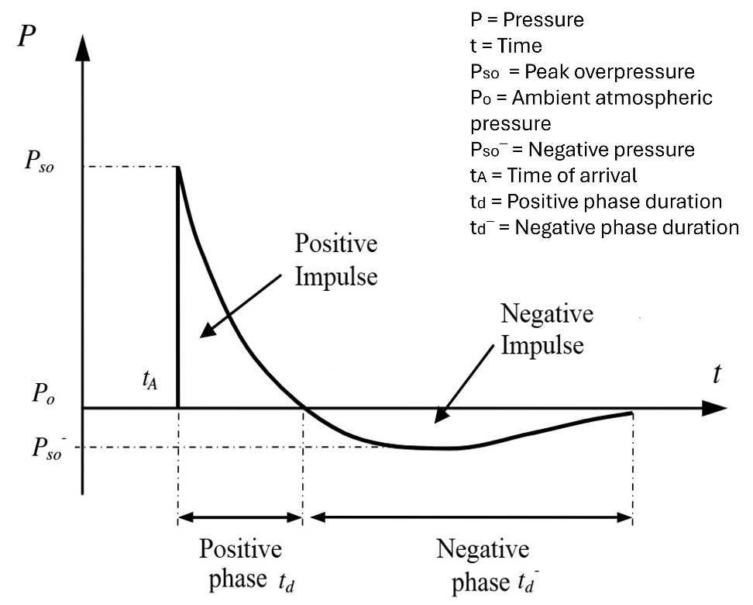
Figure 1 Friedlander blast wave (adapted) [6]
Chemical explosives and propellants do not require atmospheric oxygen for combustion to occur [3] [7]. Instead, the necessary oxidising agent and fuel is contained within the chemical structure of the material itself. This defining characteristic of energetic materials enables the extremely rapid energy release and is required for detonation. Reliance on atmospheric oxygen would result in a significantly slower reaction rate and limits combustion to a surface level burn [3]. This combustion reaction can proceed by either deflagration or detonation. Both processes are exothermic and initially influenced by the method of initiation [7] [8]. Deflagration will occur if an energetic material is subject to high temperatures, a flame, spark, friction or a weak shock [3] [9]. The reaction occurs at the surface level, with energy transfer occurring by thermal processes [10]. The burning rate will be self-sustaining, faster and more violent than conventional combustion but will remain below the speed of sound in that material [11] [12].

Detonation, by contrast, occurs when an energetic material is subjected to a sufficiently strong shock, or undergoes a transition from deflagration-to-detonation (DDT) [4]. When an explosive is subjected to a high energy shock, particles in the material compress and increase in temperature due to adiabatic heating [3] [13]. If this temperature increase exceeds the ignition temperature of the material, chemical decomposition occurs locally and energy is released rapidly inside the material. This starts a self-propagating reaction where the shock front is continually sustained as more energy is released. This process continues until the shock wave reaches the speed of sound in that material, at which point, detonation occurs [4]. Alternatively, DDT may occur when gases from the burning process become confined, causing pressure to increase at the burning surface, which increases the rate of reaction [9]. Again, if that burning rate reaches the speed of sound in the material, detonation will occur. The velocity of a shock wave during detonation is typically between 1500–9000 m·s-1, whereas in deflagration the velocity at least one or more orders of magnitude lower [3] [4].

The effectiveness of an explosive depends on two factors; the total chemical energy available and the rate at which that energy is released [4]. Several methods are available to measure this effectiveness, and they consider different explosive parameters. These include [4]:

- Velocity of detonation
- Heat of explosion
- Heat of detonation
- Power index
- Peak pressure

Blast parameters can be measured experimentally, through computational simulations or by comparison of existing data. Each parameter allows comparison of one explosive to another and forms the basis for determining TNT equivalence.

TNT equivalence
The chemical composition of an explosive influences both the total energy released and the manner in which it is released during detonation [14]. As a result, different explosive materials can produce considerably different blast effects.. Variations among explosives make direct comparisons difficult, making it is useful to compare the performance of explosives against a standard reference material, typically TNT. TNT equivalence expresses how much TNT would be required to produce the same effect as a given mass of an alternative explosive [15] [16]. TNT equivalence is therefore expressed as a dimensionless ratio of a chosen blast parameter. For any parameter X, such as peak overpressure or heat of detonation, this relationship is shown in Equation 1:
$${Eq}_{TNT}= \frac{X_{Exp}}{X_{TNT}}$$
Equation 1 TNT equivalence
Eq_{TNT} = TNT equivalence
X_{Exp} = Blast parameter of alternative explosive
X_{TNT} = Blast parameter of TNT
Once the equivalence factor is known, the TNT equivalent mass can be obtained using Equation 2:
$$W_{TNTeq}= W_{EXP }× {Eq}_{TNT}$$
Equation 2 TNT equivalent mass
Where:
W_{Exp} = Mass of alternative explosive [kg]
W_{TNTeq} = Equivalent mass of TNT [kg]
A range of experimental methods for determining the TNT equivalence have been developed for assessing each parameter relative to TNT, however, they often only consider one aspect of the detonation such as overpressure, impulse or brisance. Examples are given in Table 1 below.
Table 1 Experimental methods to calculate TNT equivalence
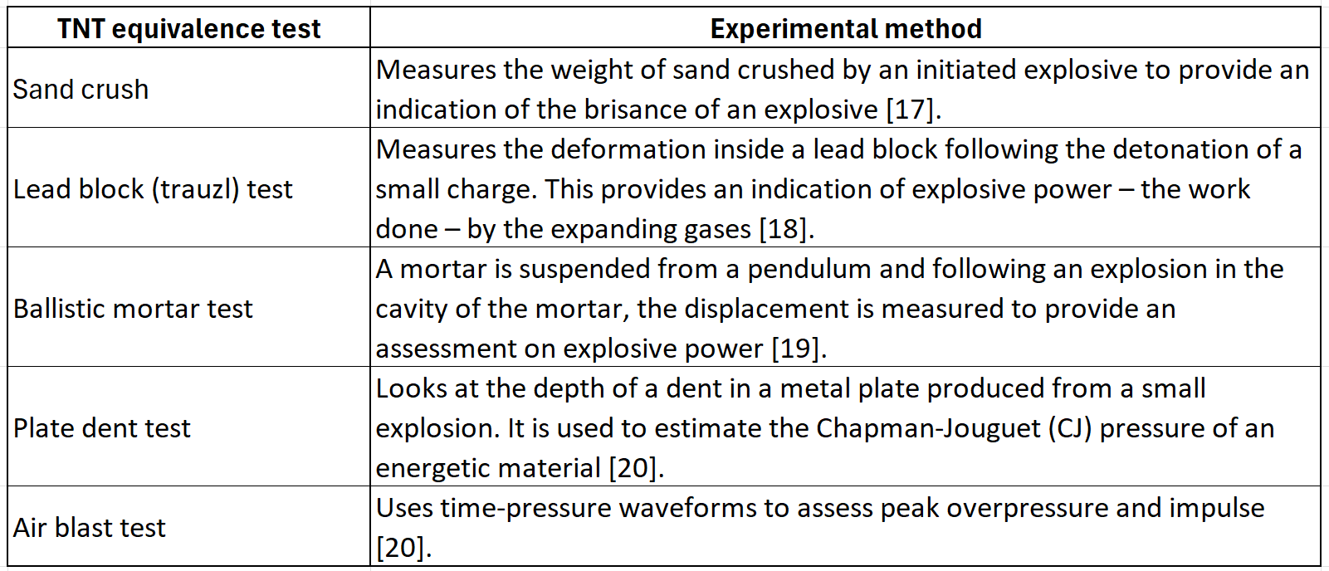
- [17].
- [18].
- [19]
- [20].
- [20].

Where experimental trials are not practical or additional data is required, numerical modelling using computational fluid dynamics or finite element analysis (FEA) can be used. Mathematical comparison of existing data also provides an alternative means of calculating TNT equivalence. Several of these methods are shown in Table 2 below.
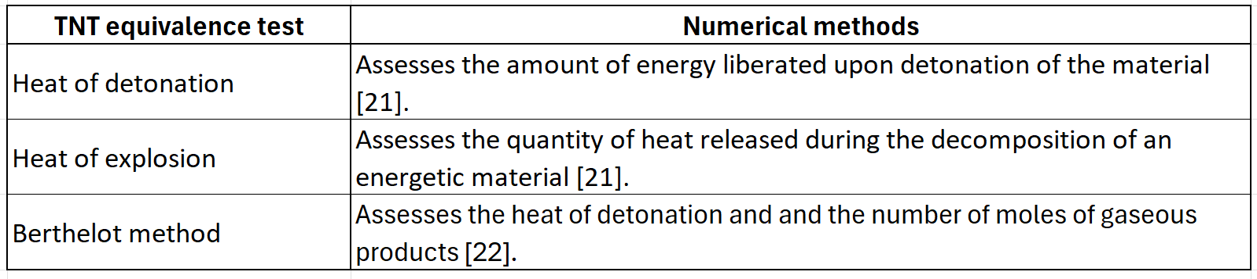
Table 2 Empirical methods to calculate TNT equivalence
- [21].
- [21].
- [22].

Understanding the origin of the data for any method is essential so that the equivalence value can be applied in an appropriate context.

Trials conducted for this report utilise the air blast test to measure incident peak overpressure and impulse, computer simulations using Viper::Blast (hereinafter referred to as Viper) and briefly examines the heat of detonation.

As shown in Table 1 and Table 2, each parameter used to define TNT equivalence reflects a different aspect of explosive behaviour. As these parameters emphasise different physical effects, they often produce differing equivalence values, which can appear to be inconsistent. For this reason, the selected blast parameter for TNT equivalence should correspond to the application for which the explosive is required [10] [23]. Given the variability between methods, any reported TNT equivalence factor must clearly state the basis on which it was determined; without this context, performance comparisons, modelling assumptions and safety assessments may be misinterpreted.

TNT equivalence values for many energetic materials have been reported extensively in literature, derived from experimental data, data-based comparisons and numerical modelling [16] [20] [24] [25] [26]. However, due to the numerous determination methods and inherent experimental variability there is often significant variation between reported values, with sources often lacking the methodology. For example, Remennikov et al [27] report a TNT equivalence of 1.12 for Composition B, whereas Sprangers et al [28] use a value of 1.34. The absence of methodology-based detail limits the usefulness of these values.

Figure 2 illustrates the reported variability using TNT equivalence values for TATB, HMX and RDX. The graph, compiled by Cheeseman [29] and reproduced by Locking [30] presents data taken from multiple sources and methodologies. The figure highlights the wide spread of reported values: RDX ranges from 1 to 1.8, HMX from 1.1 to 1.8 and TATB from 0.8 to 1.2.

A paper by Jeremić [31] looks at four methods of determining TNT equivalence and notes for nitromethane, there is 24.76% average deviation across the methods. The variation is not necessarily an indication of inaccuracy. Instead, it demonstrates that equivalence values are method dependent and therefore must be accompanied by the basis of determination.

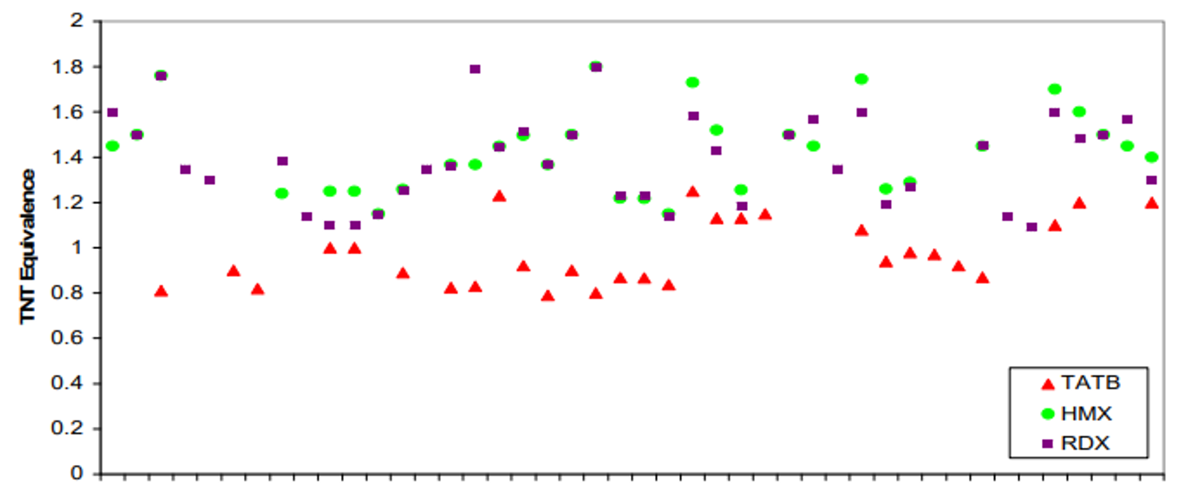
Figure 2 TNT equivalence values from multiple sources [30]
Further variation can be observed even when the same test is used to determine equivalence values. Incident peak overpressure and impulse can both be measured using the air blast test. Yet a study by Locking [32] showed the TNT equivalences for RDX derived from pressure and impulse did not reliably correlate. The graphs in Figure 3, taken from the same study by Locking, show pressure-based TNT equivalence values of up to 6, whereas the highest value derived from impulse was 1.8. The data in the graphs indicate sensitivity to both the selected parameter and the charge geometry, with similar masses of RDX in a drum and box producing different equivalence values. The effect of charge shape is discussed further in chapter 5.4. Given the nitromethane trials focus on peak overpressure and incident impulse, some variation between these parameters is therefore expected.
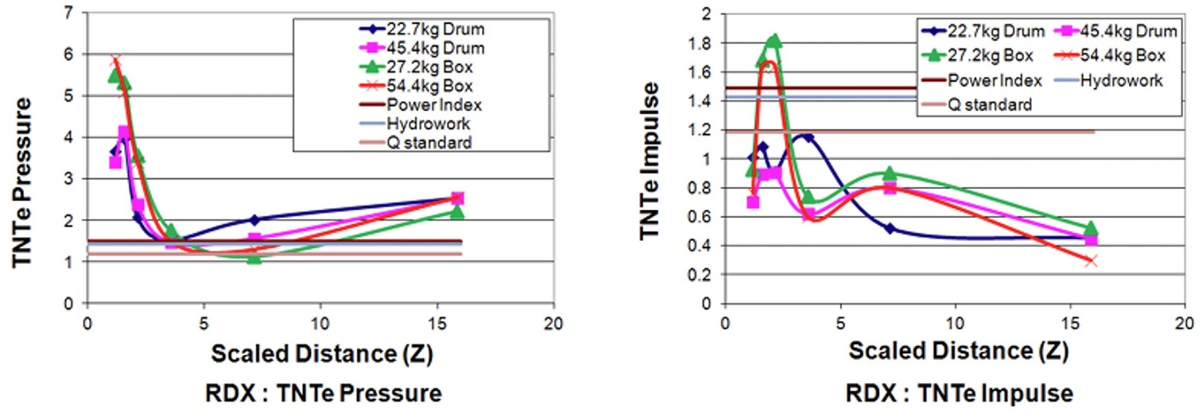
Figure 3 RDX TNT equivalence based on pressure and impulse [32]
Locking [30] also notes that performance predictions can contain significant uncertainty, with typical variability of 20-30% and, in some cases, as much as 50%. Cooper [16] similarly highlights that experimental determination of TNT equivalence is inherently prone to error.

A paper by Merrifield and Roberts [33] notes that TNT equivalence may be determined using several approaches, including experimental measurement, estimation from energetic material properties or calculation based on heats of formation. They further acknowledge that estimated values are often higher than measured values, a trend that is consistent with other literature such as Locking [32] and Fuchs [17]. However, although Merrifield and Roberts discuss alternative methods for calculating TNT equivalence, they do not provide a methodology to the subsequent TNT equivalence values presented in paper. For example, they provide a TNT equivalence value for nitromethane of 134%, which when compared to trials conducted at DNV Spadeadam, appears to be significantly higher than expected [33]. Perhaps the value was derived from an estimate of performance based on existing data, which may partially explain the higher equivalence, however, without a methodology it is difficult to compare this figure meaningfully.

The wide range of methods used to derive TNT equivalence, combined with the variation in published values means that data are not often directly comparable, making it difficult to establish reliable references for engineering or experimental use. This has clear implications for safety management where blast effects may be under- or overestimated [30]. While over-estimates are less critical from a safety perspective, they can have financial implications and increase project complexity. Such variability can undermine confidence in comparisons between energetic materials and complicates the validation of new energetic material in this context. It also makes selecting an appropriate explosive and charge size more challenging for a particular task. As Witty [34] notes, a selected charge size could be twice as large or half as small as required, with implications for under- or over testing a structure, potentially invaliding test data leading to financial and practical consequences.

In addition to the above, early work in this field relied upon several assumptions. For example, it was assumed that the charges were bare, spherical or hemispherical and initiated centrally. In practice, this is often not be the case and TNT equivalence will also be affected by the level of confinement, point and method of initiation, type of explosive and scaled distance [14].

Charge geometry
Charge geometry is particularly relevant for these trials. Historical data often assumes the charge to be spherical or hemispherical, with these shapes being associated with relatively symmetrical shockwaves and simplified blast behaviour predictions [34]. Alternative shapes, such as hexahedral charges, deviate significantly from the idealised assumptions and may influence the detonation propagation, affecting factors such as [34]:
- Peak pressure
- Impulse
- Time of arrival
- Shock wave velocity
- Shock wave shape and direction

The presence of flat faces and corners lead to an asymmetrical shock wave development with pressure distributions being heavily dependent on the aspect ratio of the shape [35]. Additionally, the height of the charge will have a significant effect on the propagation of the shockwave. When selecting the height of the charge for a trial, consideration must be given the risk of secondary fragmentation and to the potential formation of a Mach stem. This occurs when an incident shock wave generated by a blast is close enough to interact with the ground and cause reflected waves. The two waves then interact and generate a third wave known as the Mach stem [36]. The point at which all three merge is known as the triple point [34]. The combined waves can lead to increased overpressures, which could potentially result in an incorrect TNT equivalence calculation if the explosion is not compared to a comparable TNT explosion, but can also be utilised to provide additional overpressure rather than increasing the size of the charge.

Given the range of issues discussed throughout this chapter, there is a clear requirement for transparent reporting of the experimental conditions, determination methodology and the data used to determine TNT equivalence values. Without this detail, meaningful comparisons become increasingly difficult.

An estimation of the TNT equivalence of nitromethane
One method for estimating the TNT equivalence for unconfined charges uses a ratio of the heats of detonation. This method is recommended in the Unified Facilities Criteria (UFC) manual - 3-340-02 - Structures to Resist the Effects of Accidental Explosion [37]. Heat of detonation represents the total chemical energy released during the initial reaction and is therefore related to overall blast energy. Since peak pressure is related to the energy released in the detonation, it makes sense that TNT equivalence with respect to peak pressure can be estimated by comparing an explosive’s detonation energy to that of TNT [24]. However, this method does not account for the effects of secondary combustion, the volume of gas produced, or the expansion of the gases [30] and therefore may not provide a suitable equivalence. Hence, understanding the basis for which the equivalence was determined means an informed decision can be made on its applicability. Using Equation 1 and substituting the heat of detonation values for nitromethane and TNT gives:
Heat of detonation of nitromethane (Q_{Exp}) = 5150 kJ∙kg⁻¹ [38]
Heat of detonation for TNT (Q_{TNT}) = 4521 kJ∙kg⁻¹ [38]

$${Eq}_{TNT}= \frac{5150}{4521}$$
$${Eq}_{TNT} =1.14$$
This produces a TNT equivalence of 1.14, which is similar to the equivalence used at DNV Spadeadam for large nitromethane charges. Dividing the TNT charge by 1.14 provides the equivalent mass of the alternative - nitromethane.

Nitromethane
Nitromethane is a colourless, oily organic chemical widely used as a high-performance propellant in rocket motors and as a fuel in drag racing engines [39]. Additionally, it is used as a solvent and a chemical intermediate in various industrial processes [40]. More recently nitromethane has been regarded as a green propellant as it is less toxic than other propellants such as hydrazine [41]. It has a melting point of -29 °C and a boiling point of 101 °C, and it does not readily evaporate [38]. Given its high boiling point and low vapour pressure, it is relatively easy to store under normal conditions. At 20 °C it has a density of 1137 kg∙m⁻³ and a published velocity of detonation of 6300 m∙s⁻¹ [38] [42].

For storage and transport, nitromethane is classified as a flammable liquid under ambient conditions and is relatively insensitive to weak mechanical shock [39]. However, when provided with a suitably strong shock, is sufficiently confined or when chemically sensitised, nitromethane can undergo detonation [43]. For this reason, it is also regarded as a liquid explosive, but importantly this does not affect its hazardous goods classification [44] [45]. Conversely, it can also be stabilised with additives, reducing its sensitivity and making it safer to handle and store [39]. Structurally, nitromethane is a methane molecule where one hydrogen atom has been replaced with a nitro group [46]. The chemical formula for nitromethane, CH₃NO_{2,} and its molecular structure, which can be seen in Figure 4, show that the molecule contains its own oxygen source, allowing it to detonate without relying on atmospheric oxygen.
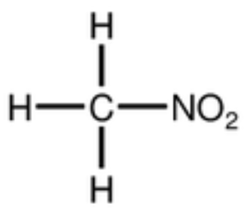
Figure 4 Molecular structure of nitromethane [39]

Prior to being characterised, there were several accidental explosions involving nitromethane. In 1958, a series of accidents during transport of the chemical resulted in an embargo on all tank-car shipments of nitromethane [47]. The report by the Interstate Commerce Commission [47] discusses tests conducted that same year by the United States Bureau of Explosives, in which researchers were unable to detonate nitromethane through impact alone. Similarly, in 2012, Shekhar [48] argued that pure nitromethane will not detonate even if subject to a strong shock and it requires sensitisation with additives such as the addition of ammonia for detonation to easily occur. This is consistent with the Interstate Commerce Commission report’s observation that nitromethane does become significantly more sensitive to detonation when contaminated but is not consistent with how nitromethane is currently used in trials at DNV Spadeadam, nor with numerous published studies. Research by Zhang et al [49], Guo et al [50] and Liu et al [51] all document the detonation behaviour of pure nitromethane and its use as an explosive. Modern material safety data sheets such as from Cole-Parmer [52] warn that nitromethane is shock and heat sensitive, and it can undergo sympathetic detonation. Hershkowitz and Dobratz [53] compiled extensive research from a nitromethane research programme, with a substantial number of papers discussing its detonation as early as the 1950s. In considering all the points above, the evidence strongly indicates that nitromethane can detonate, noting Shekhar’s claim lacked any evidence.

Impact of weather and altitude
At Spadeadam, for commercial testing or testing to a standard, it is a requirement to record weather conditions and the altitude during the trial. For some trials it is also important to consider the effect of the weather upon the target. Temperature may alter the response of a target for example. Higher altitudes can also have an impact on the propagation of the shockwave. Changes in atmospheric conditions such as reduced ambient pressure results in lower peak pressures and impulses [54] [55]. UFC 3-340-02 [37] and Swisdak [56] discuss adjustments for high altitudes. Spadeadam at 285 m, is not expected to significantly affect the data so no adjustments will be made. However, weather and pressure data are noted for each day of testing.

Methodology
A series of full-scale live trials was conducted to collect pressure data which would allow the determination of the TNT equivalence of nitromethane. The charge mass was based upon previous studies at DNV Spadeadam where a TNT equivalence value of 1.09 for nitromethane had been successfully used in live trials. This resulted in a 92 kg charge size, equivalent to a 100 kg TNT charge. As 15 kg was the charge size of interest for these trials, this weight of nitromethane was divided by the 1.09, to give 13.8 kg as an initial charge size for the trials.

The number of trials required to generate sufficient data was dictated by time and cost constraints rather than the requirements of statistical significance. Four nitromethane trials were performed, each instrumented with six pressure gauges. Two gauges were positioned at each distance to provide repeat measurements and redundancy in the event of equipment failure. The number of gauges used in the trials was based upon the number available at the time of testing.

The choice of container was determined by existing suitable options at DNV Spadeadam. Nitromethane is stable in high density polyethylene plastic jerry cans for short-term storage, and it was cost effective to use an existing supply of containers [57]. The height of the charge was set to limit the risk of secondary fragmentation whilst also ensuring good manual handling procedures could be followed.

A 0.5 kg TNT charge was also conducted, in the same trial setup as above, with the data intended to validate the methodology.

All physical and environmental hazards associated with the trials were assessed in a risk assessment and a control of substances hazardous to health assessment (COSHH), with appropriate mitigation provided where necessary to ensure the safety of personnel and to minimise the environmental impact. These can be found in Appendix 3. A trials plan was completed detailing required personnel, equipment, procedures, safety documentation, arena layout, timescales, and data to be collected. A log sheet was completed for each trial with an example provided in Appendix 4. Prior to clearing the arena for each blast, a second person check was conducted to ensure the correct setup and that equipment was running.

Trial Setup
Table 3 summarises the series of explosive trials conducted for this project. A charge mass of 13.8 kg was used for all nitromethane trials, each initiated by a different booster up to a maximum weight of 100 g. The TNT trial used a 0.5 kg block of TNT, known as a TM 500. Serial numbers for each gauge are shown Table 15 and Table 16 in Appendix 4.

Table 3 Trial set-up
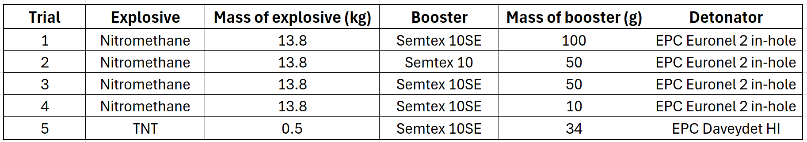

The centre of the charge was elevated to a height of 1.2 m above the concrete test pad. This was done using a 2 × 2 × 0.075 m steel charge plate with a polystyrene block and a cardboard box contributing the remaining required height to ensure the centre of the charge is at 1.2 m above the ground. The charge plate reduced the risk of secondary fragmentation from the concrete. This setup is shown in Figure 5. Nitromethane was placed in trimmed 25 L high-density polyethylene jerry cans, shown in Figure 6. The original dimensions were 294 × 245 × 470 mm (width x depth x height) with a new height of 340 mm when trimmed. For trials 1, 3, and 4 the detonator was placed directly in the Semtex 10SE booster which was suspended in the centre of the nitromethane via a wooden support across the top of the jerry can, labelled in Figure 6. The detonator was connected to shock tube, which was initiated by a shock tube initiator firing system. The setup for trial 2 with Semtex 10 was slightly different with detonation cord being used to attach the detonator to the Semtex booster. It was again initiated by a shock tube initiator firing system.

Due to cost constraints, these trials served a dual purpose with a colleague also collecting data for a second set of trials. It is for this reason that a different initiation setup was used for each nitromethane trial, and the booster configuration was predetermined. It is acknowledged it would be better practice to perform all trials using the same setup.

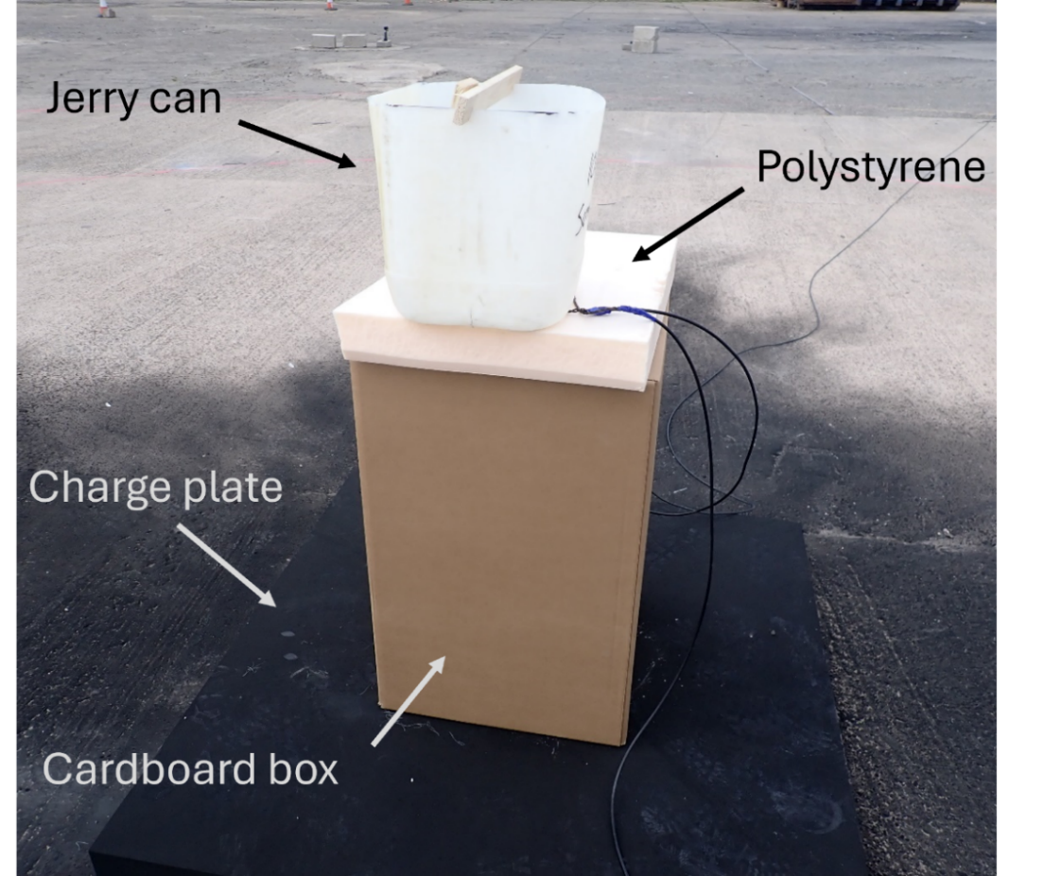
Figure 5 Explosive charge setup
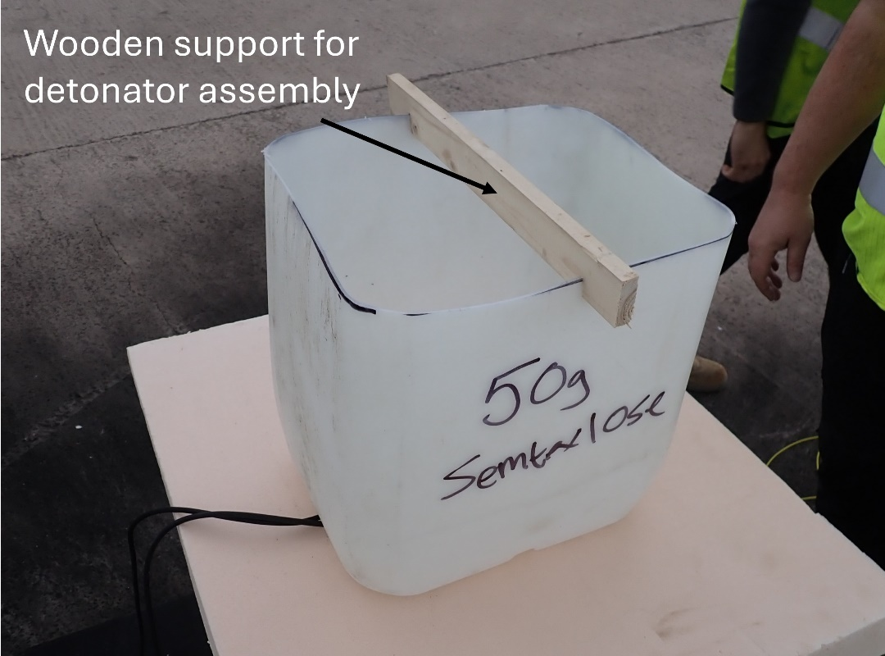
Figure 6 Container used for the nitromethane with detonator support
Six pencil gauges manufactured by PCB Piezotronics (model 137B24A [58]) were mounted on individual tripods. Two were placed at each standoff distance of 6 m, 10 m and 15 m from the centre of the charge. The pressure gauge setup is shown in Figure 7. The gauges were deliberately offset from the gauge(s) in front to ensure the shockwave could pass cleanly over each sensor. Each gauge was aligned with the centre of the charge, shown in Figure 8. Gauges were connected to a PCB 003-EB-003-AB cable, which fed into a RG58 C/U coaxial cable followed by a PCB 482C15 signal conditioner. Data acquisition was performed at 1 MHz using a HBM GN815 card in a GEN7tA chassis, positioned next to PCB 482C15 signal conditioner. Where required, all equipment had a traceable calibration certificate. Trial setup was largely based on the peer reviewed methodology in the paper by Chester et al [59] which is standard setup at Spadeadam and therefore ideal to use for these trials.

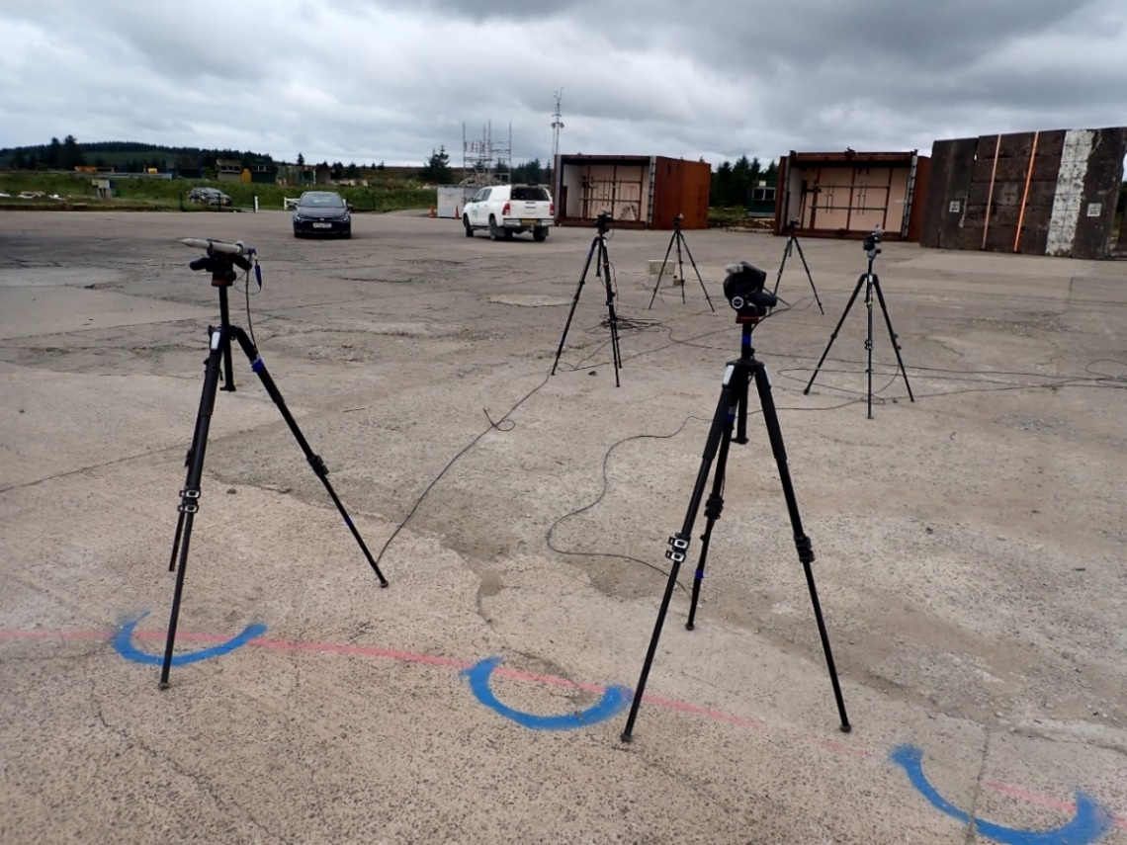
Figure 7 Gauge positions - showing no alignment with other gauges
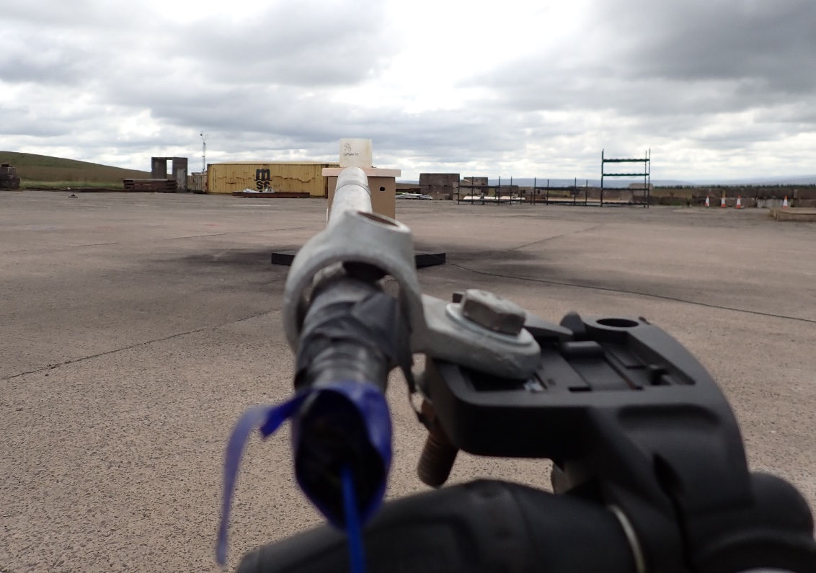
Figure 8 Gauge and charge alignment

The first trial knocked over the gauges at 6 m, and it was decided to weigh these down to prevent this from happening in the remaining trials, shown in Figure 9.

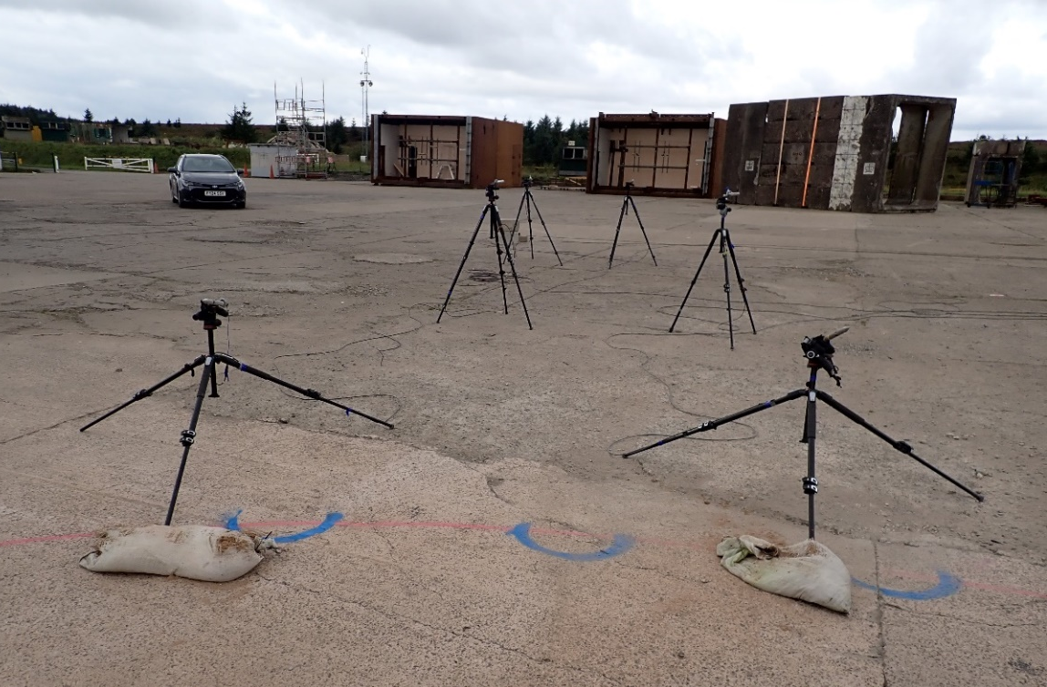
Figure 9 Final configuration of the gauges
One high-speed camera, located in a turret, operated with a frame rate of 5000 frames per second (fps). Four action cameras attached to concrete blocks were positioned around the charge. The cameras are shown in Figure 10 and Figure 11.

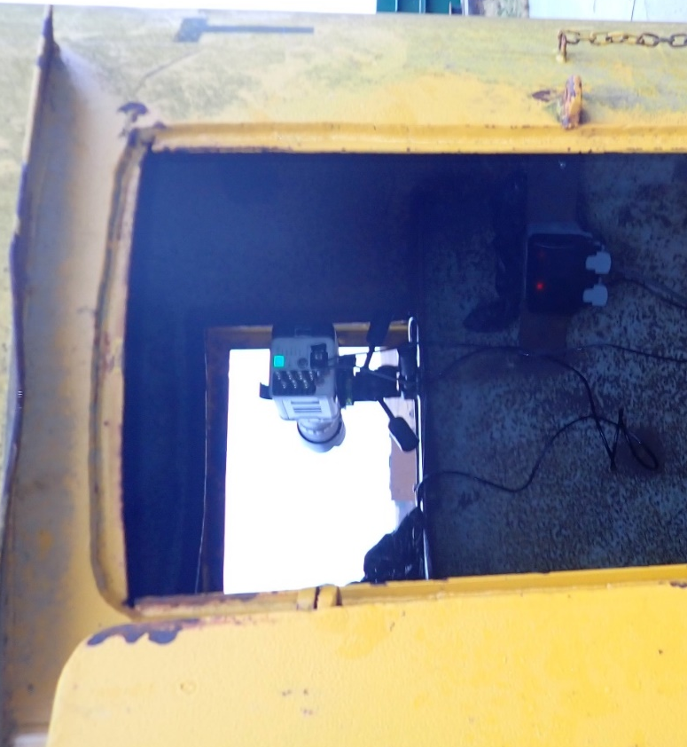
Figure 10 High-speed camera in a turret

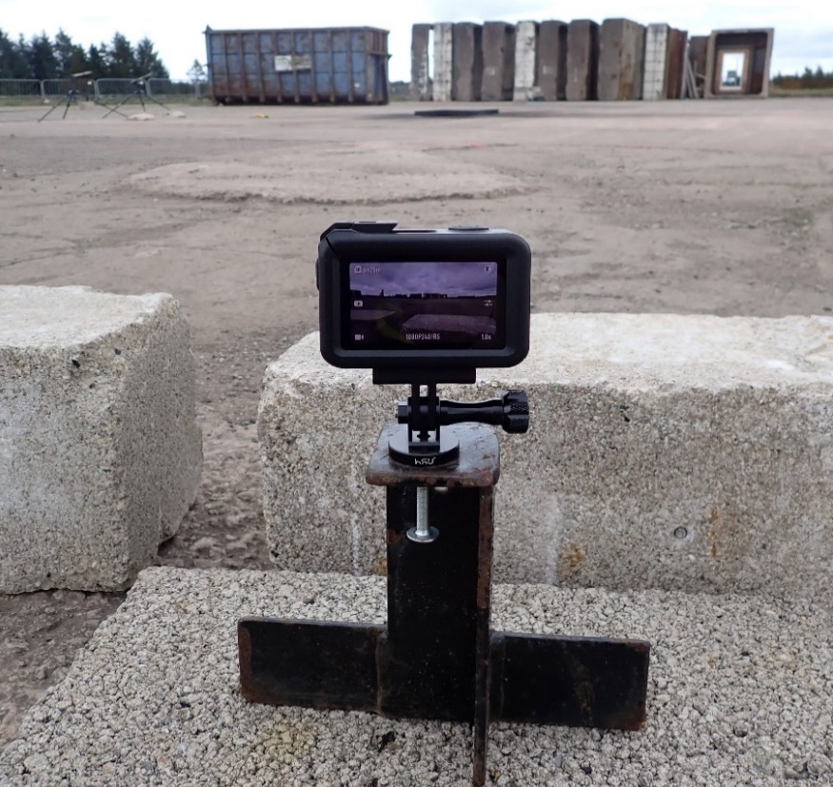
Figure 11 Action camera setup
A schematic of the trial setup in Figure 12 shows the layout of the equipment. Gauge standoff was measured for each trial to ensure accurate positioning.
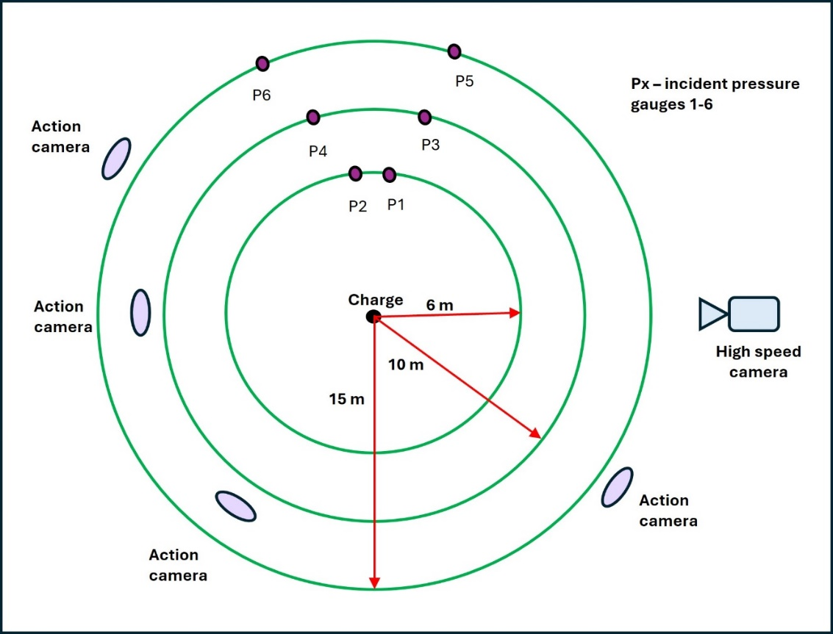
Figure 12 Schematic of the trial setup

Weather data collection during the trials is shown in Table 4 and Table 5 for reference.
Table 4 Weather data during nitromethane trials
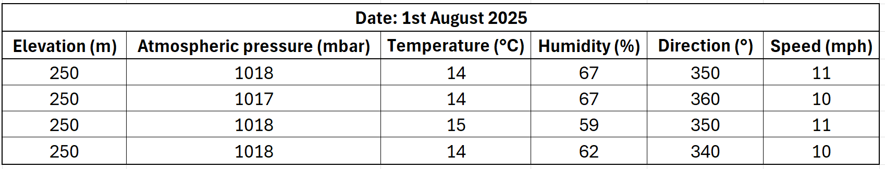
Table 5 Weather data during TNT trial
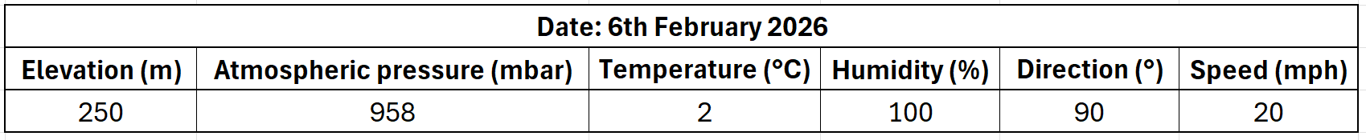
Trial success was determined by the quality of the recorded data. Pressure gauges were required to produce clean traces with a high signal to noise ratio and clearly defined shockwaves. Camera footage had to be correctly exposed and capture the full event. The high-speed recordings needed to capture the initiation and early blast development, ideally showing the shockwave.

Post trial analysis was conducted using Dplot graphing software, Viper computational blast simulation software and Conventional Weapons Effects Program (ConWep).

Results

Effect of booster
Calculations were performed to estimate the contribution of the booster to the trial data.
The maximum booster used was 100 g, and given each subsequent booster was smaller than this (50 g – 10 g), it was decided to calculate the “worst case effect” for these trials. If the effect is insignificant, calculating the effect of the smaller boosters would be redundant.

The effect of the booster can be found by considering the proportion of the overall velocity contributed by each component. This is calculated below using Equation 3.

$$D_{mix}=∑D_{i}V_{i}$$
Equation 3 Velocity of detonation mix [9]
Where:
D_{mix} = Detonation velocity of the mixture [m∙s⁻¹]
D_{i} = Detonation velocity at theoretical maximum density [m∙s⁻¹]
V_{i} = Volume fraction of the component

Therefore:
$$D_{mix}=\left(D_{1}V_{1}\right)+\left(D_{2}V_{2}\right)$$

D₁ = Detonation velocity of nitromethane = 6523 m∙s⁻¹
V₁ = Proportion of total mass from nitromethane = 0.993
D₂ = Detonation velocity of Semtex = 7220 m∙s⁻¹
V₂ = Proportion of total mass from booster = 0.007

$$D_{mix} =\left(0.993×6523 \right)+\left(0.007×7220\right)=6528$$

$D_{mix}=6528$m∙s⁻¹

When compared to the velocity of detonation for nitromethane alone (6523 m∙s⁻¹) it shows the contribution of the booster does not significantly change the velocity of detonation of the mixture and is therefore unlikely to substantially affect the overpressure or impulse and consequently the TNT equivalence. Therefore, it was decided to add 100 g to the overall mass of the charge so that any contribution, however small, is not disregarded, reducing the risk of underestimating the TNT equivalence, which may have safety implications in some situations. Therefore, the charge size is subsequently referred to as 13.9 kg.

Trial data
Table 6 to Table 8 show the peak overpressure and the incident impulse data collected in all four trials for 13.9 kg of nitromethane, with the calculated mean and standard deviation for both parameters. Sections 4.2.1-4.2.4 below show the peak overpressure and impulse data on separate graphs for each individual test. No data was recorded by gauge one in trials 2-4; hence the associated graphs show limited data at 6 m standoff.

Table 6 Pressure and impulse data - 6 m standoff
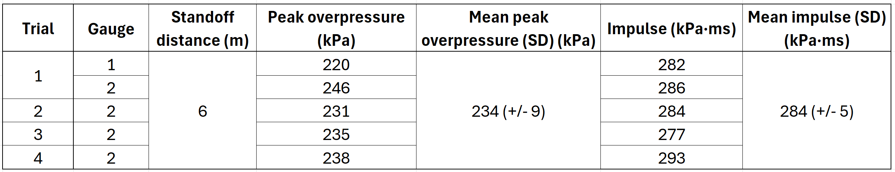

Table 7 Pressure and impulse data - 10 m standoff
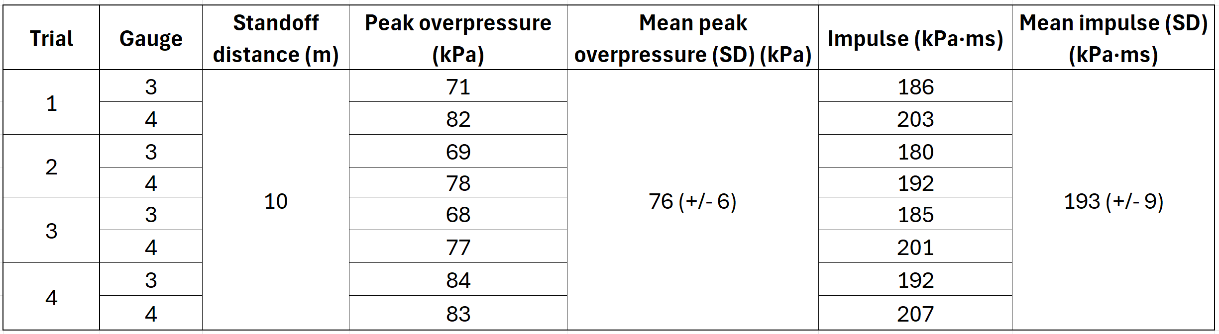
Table 8 Pressure and impulse data - 15 m standoff
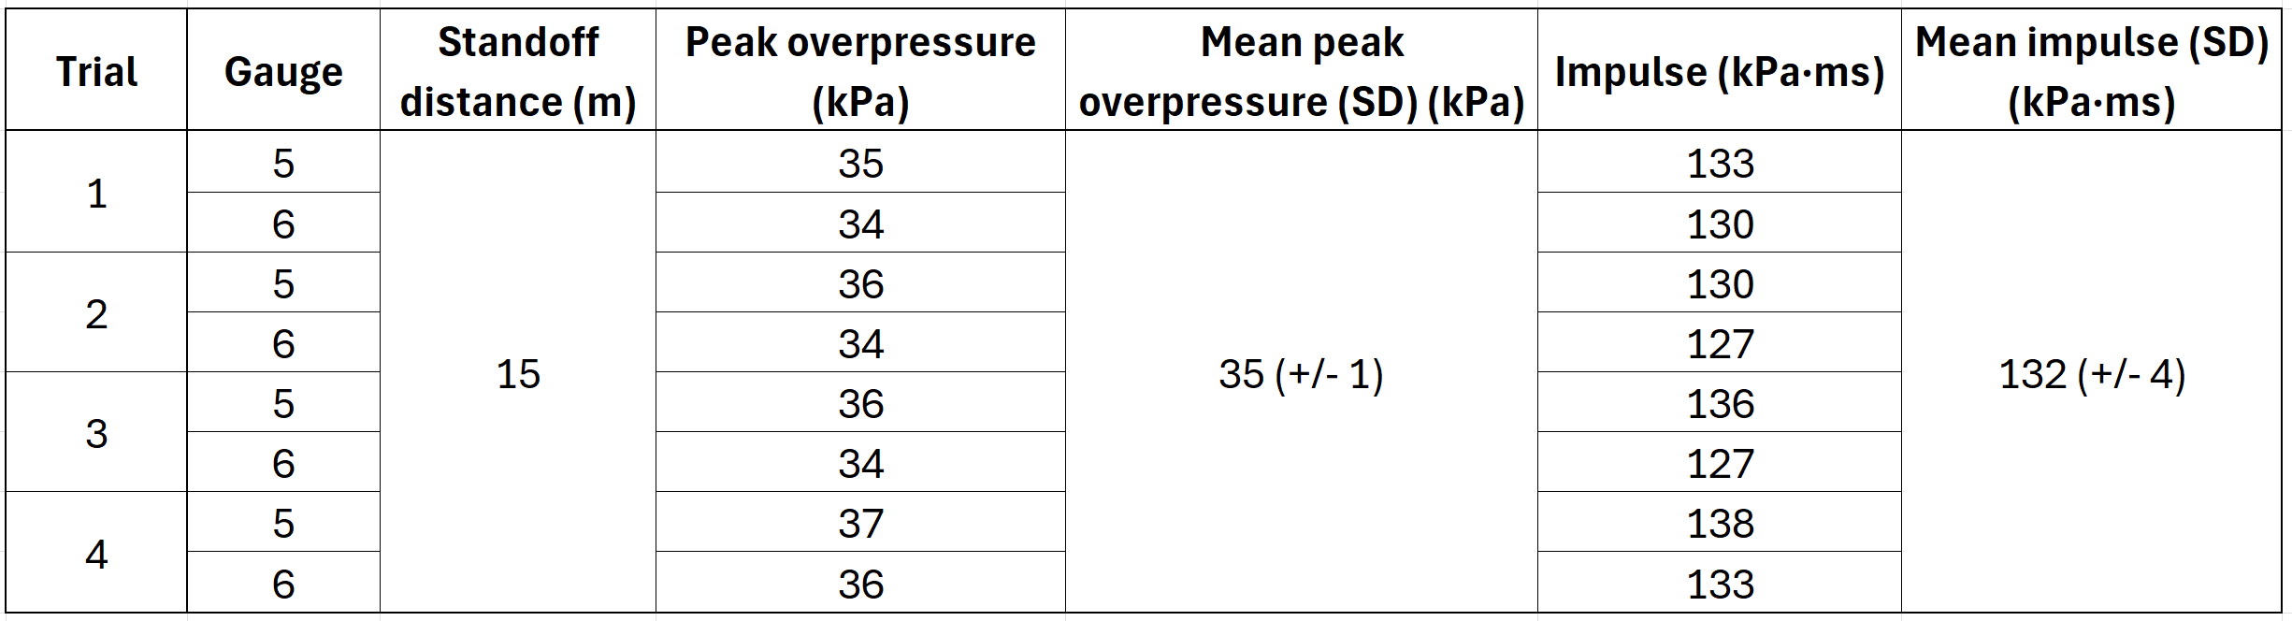

The maximum standard deviation of the measurements at all standoff distances is 9 kPa for peak overpressure and 9 kPa∙ms for impulse, indicating consistent and repeatable results.

Trial one
Trial one used 13.8 kg of nitromethane with a 100 g Semtex 10SE booster. Incident overpressure and impulse are shown in Figure 13 and Figure 14 respectively.
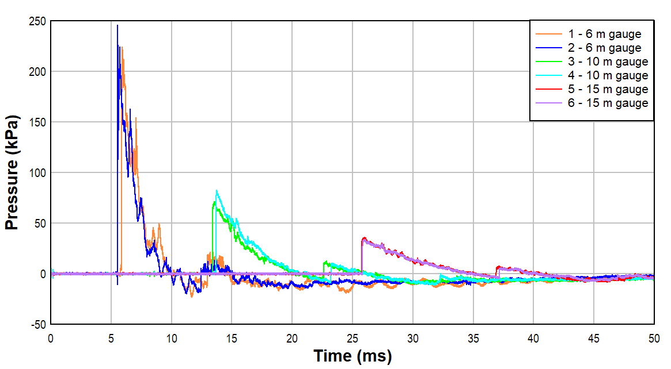
Figure 13 Overpressure for trial one
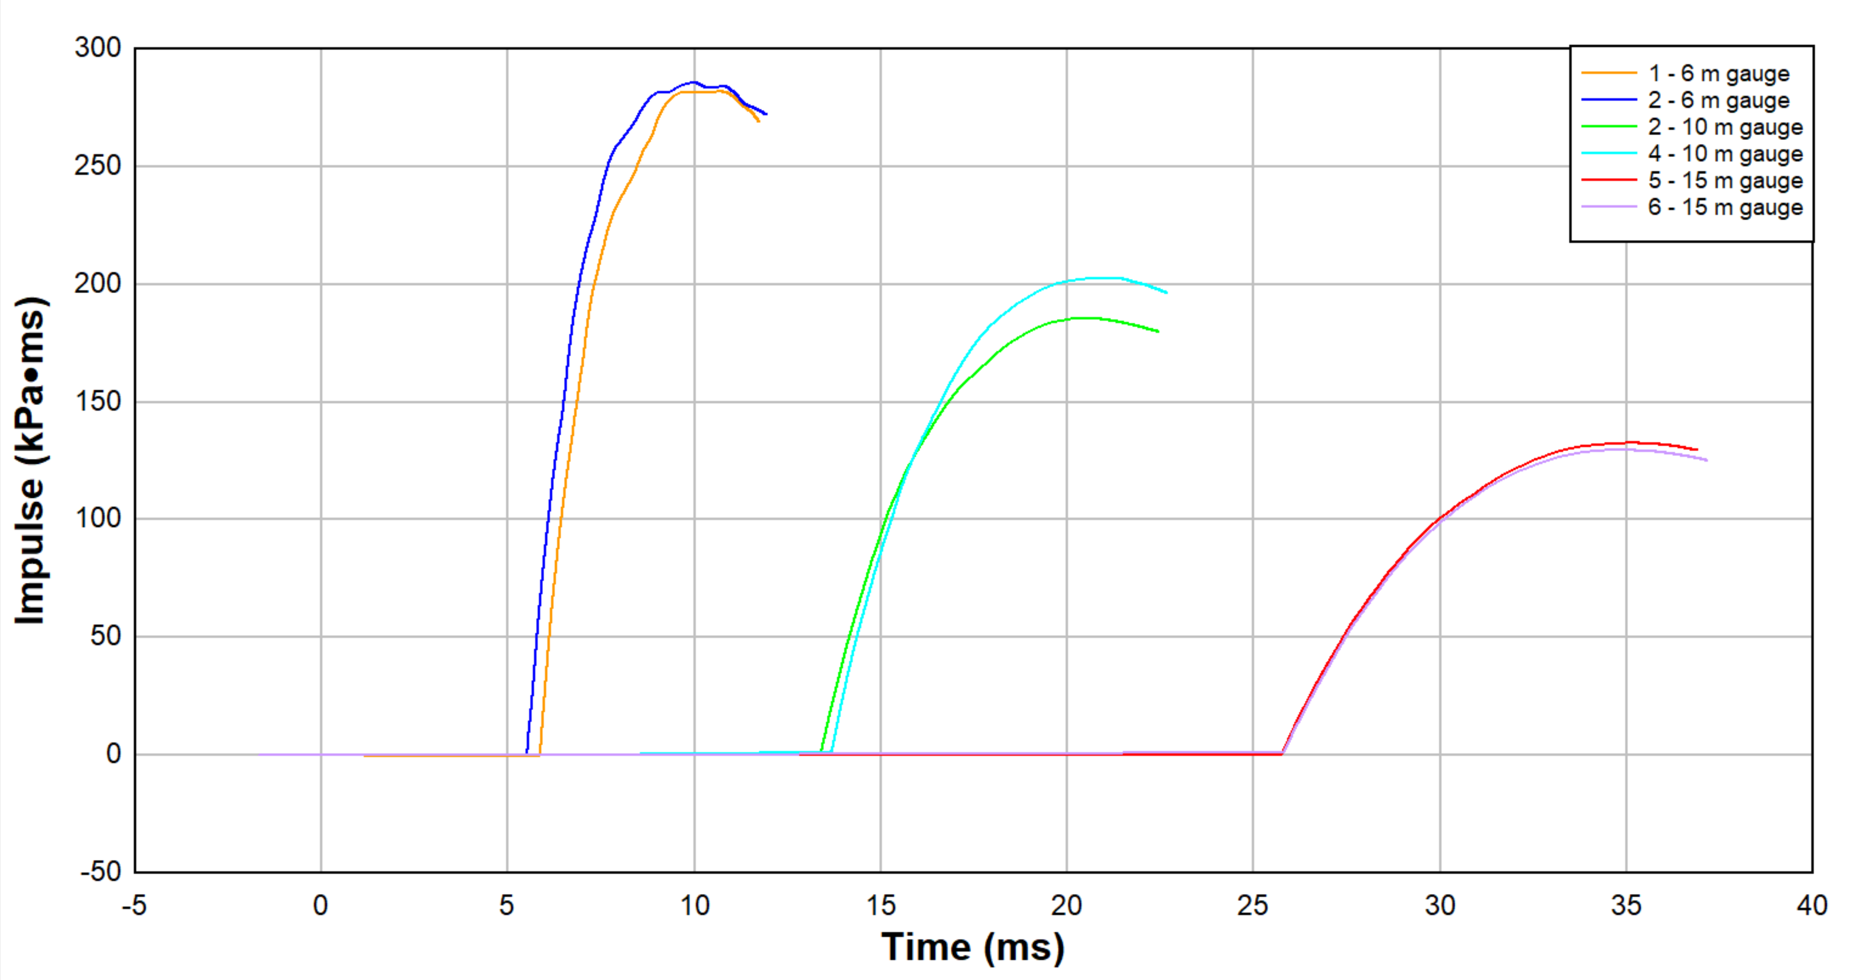
Figure 14 Impulse for trial one

Trial two
Trial two used 13.8 kg of nitromethane with a 50 g Semtex 10 booster. Incident overpressure and impulse are shown in Figure 15 and Figure 16 respectively.
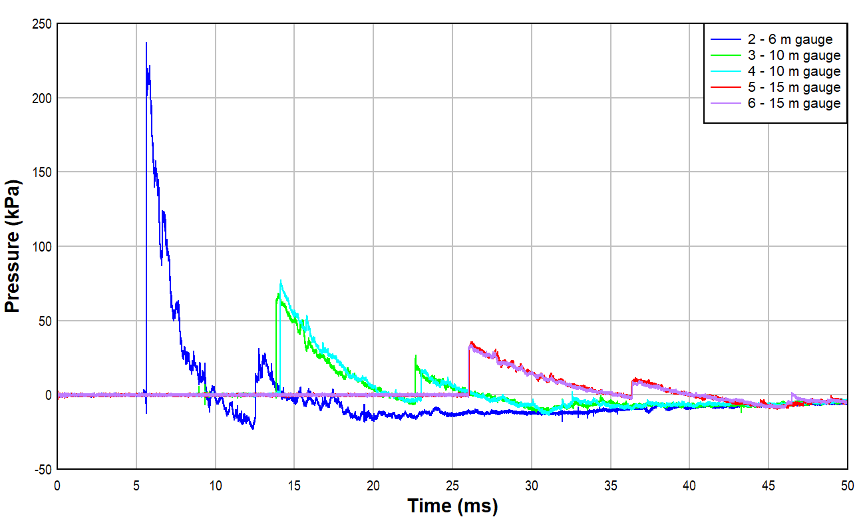
Figure 15 Overpressure for trial two
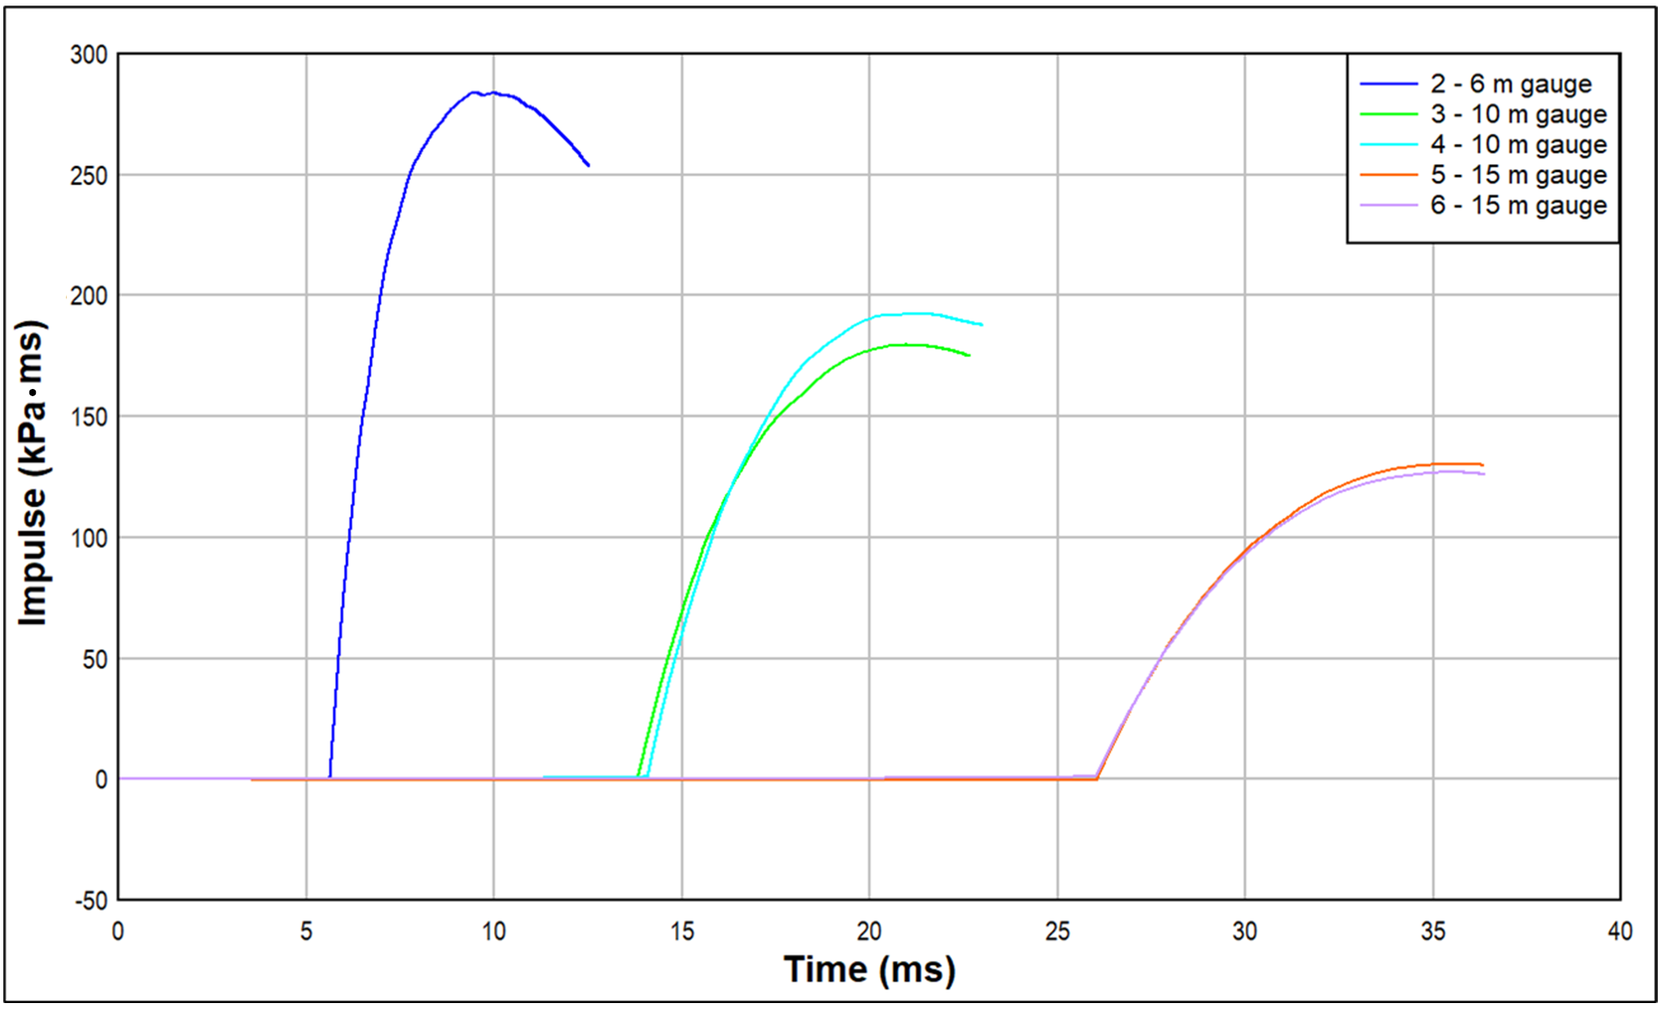
Figure 16 Impulse for trial two

Trial three
Trial three used 13.8 kg of nitromethane with a 50 g Semtex 10 booster. Incident overpressure and impulse are shown in Figure 17 and Figure 18 respectively.
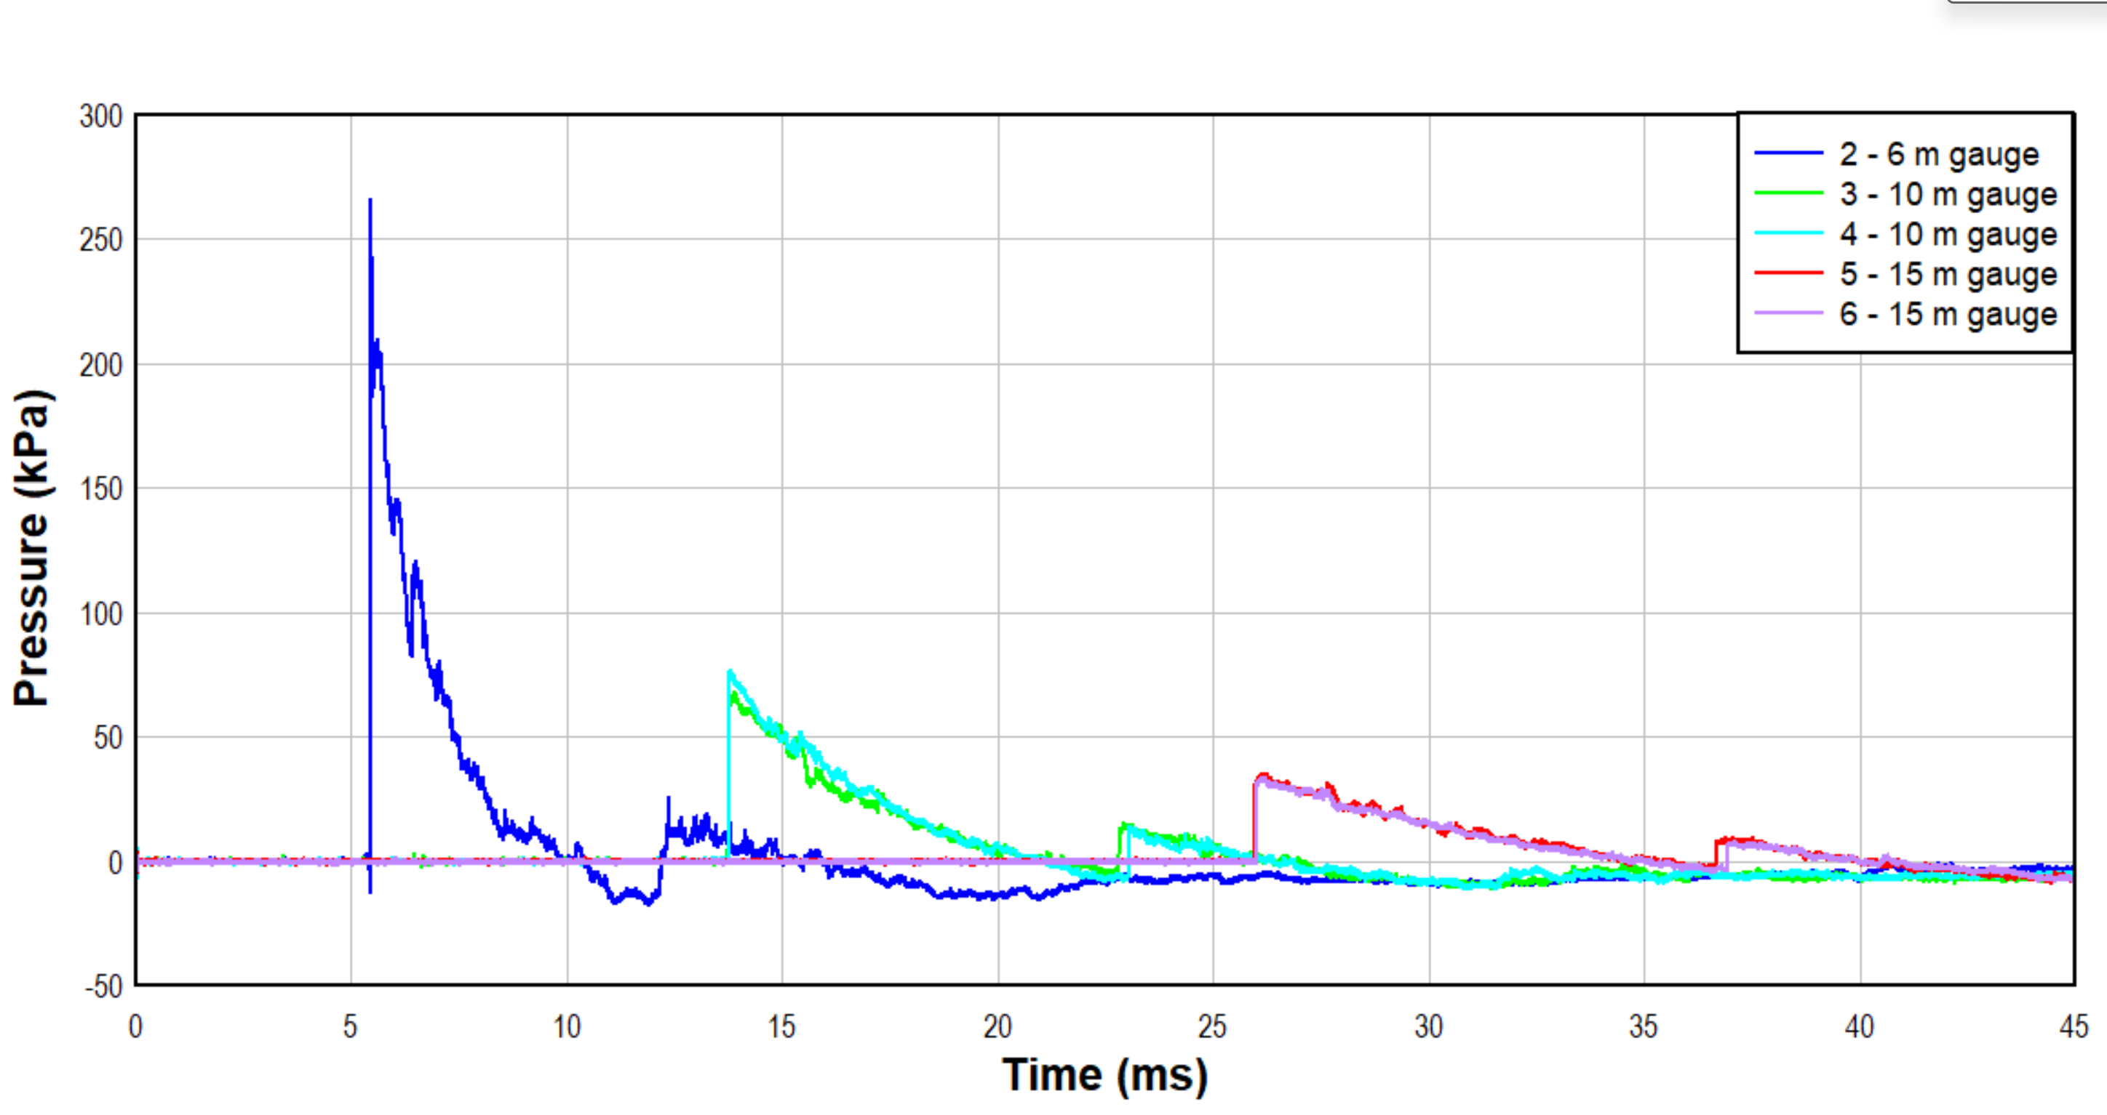
Figure 17 Overpressure for trial three
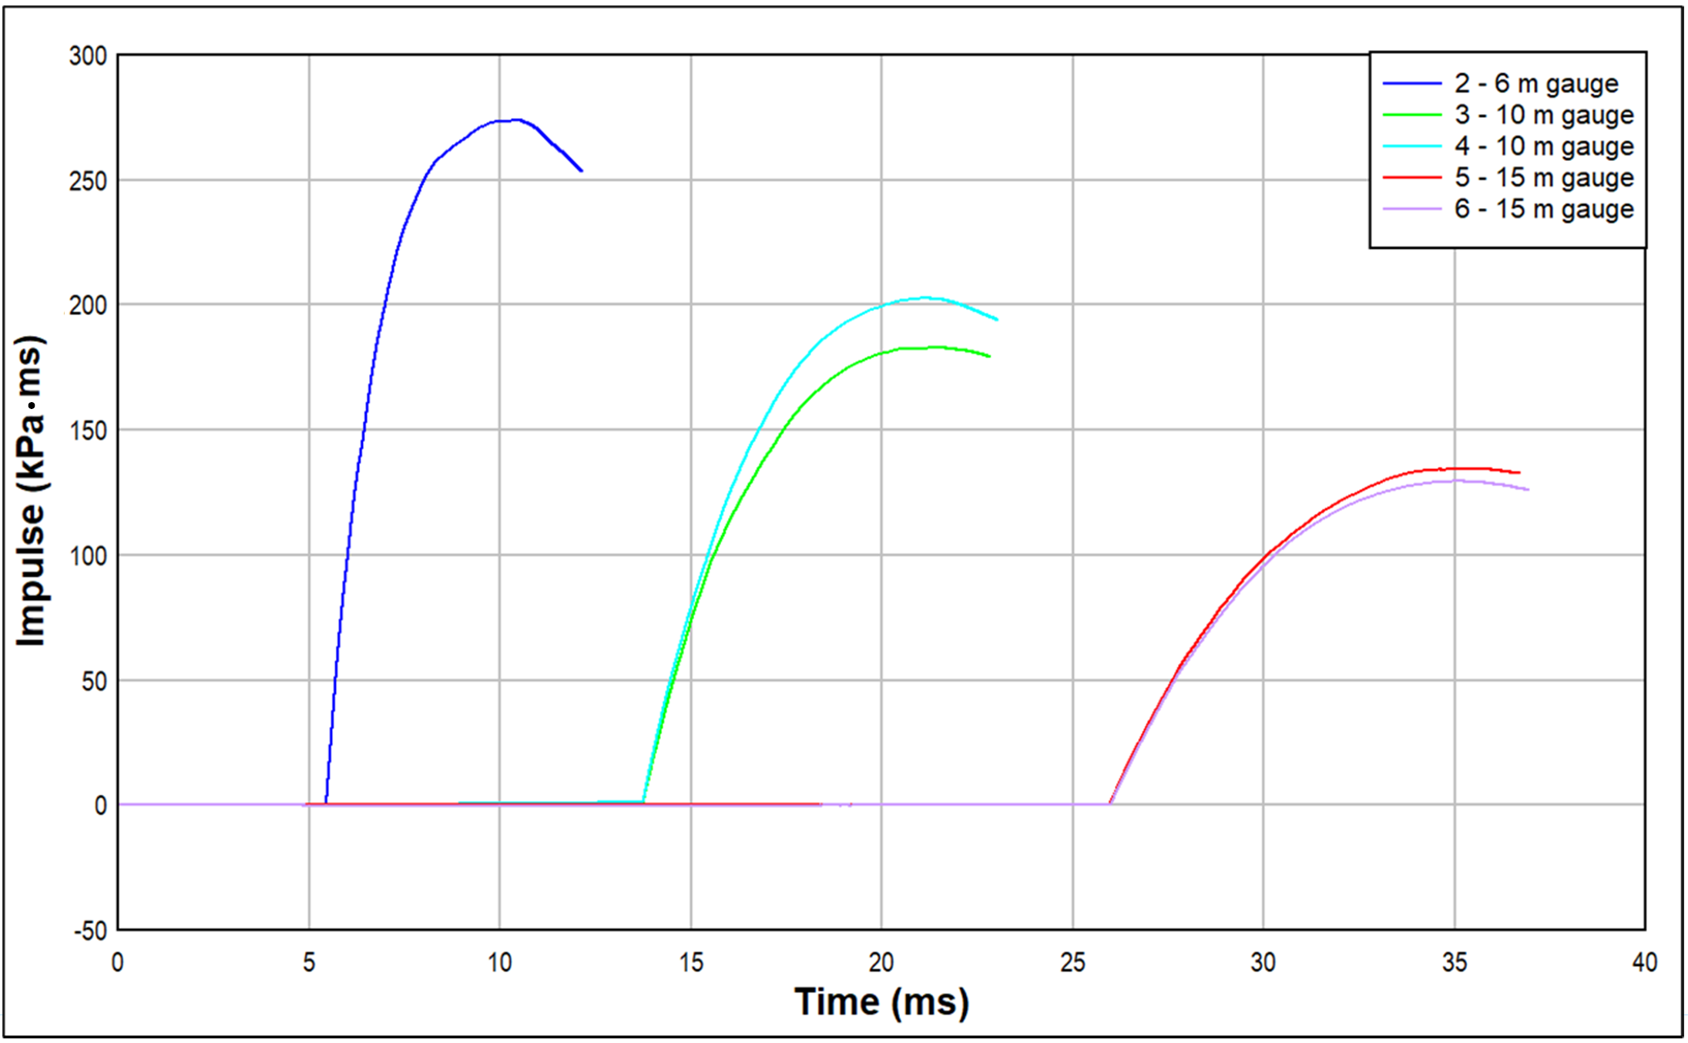
Figure 18 Impulse for trial three

Trial four
Trial four used 13.8 kg of nitromethane with a 10 g Semtex 10 booster. Incident overpressure and impulse are shown in Figure 19 and Figure 20 respectively.
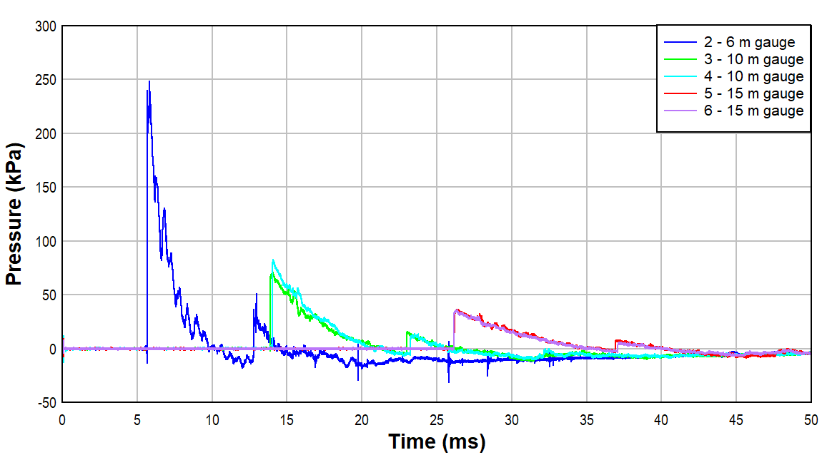
Figure 19 Overpressure for trial four

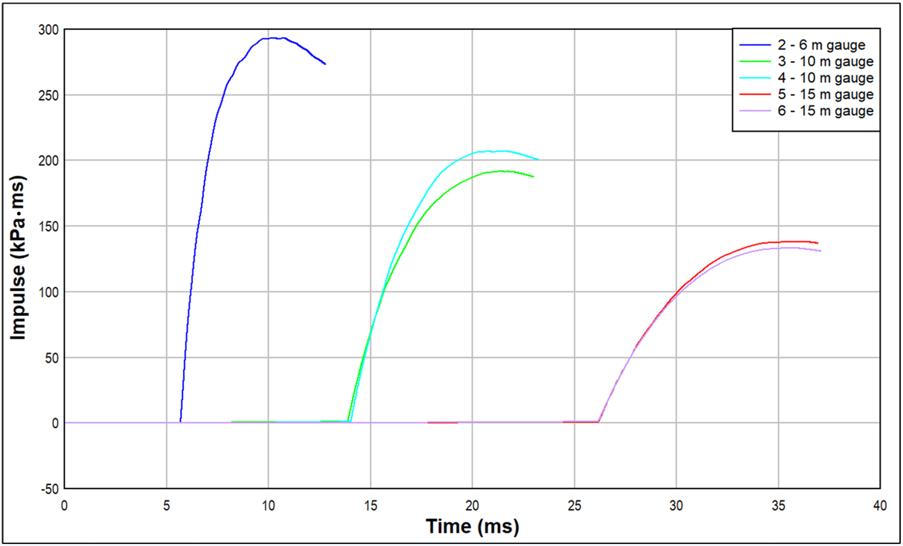
Figure 20 Impulse for trial four

Simulation data
Overpressure data from the cylindrical 13.9 kg TNT simulation is shown in Figure 21, Figure 22 shows the incident impulse.
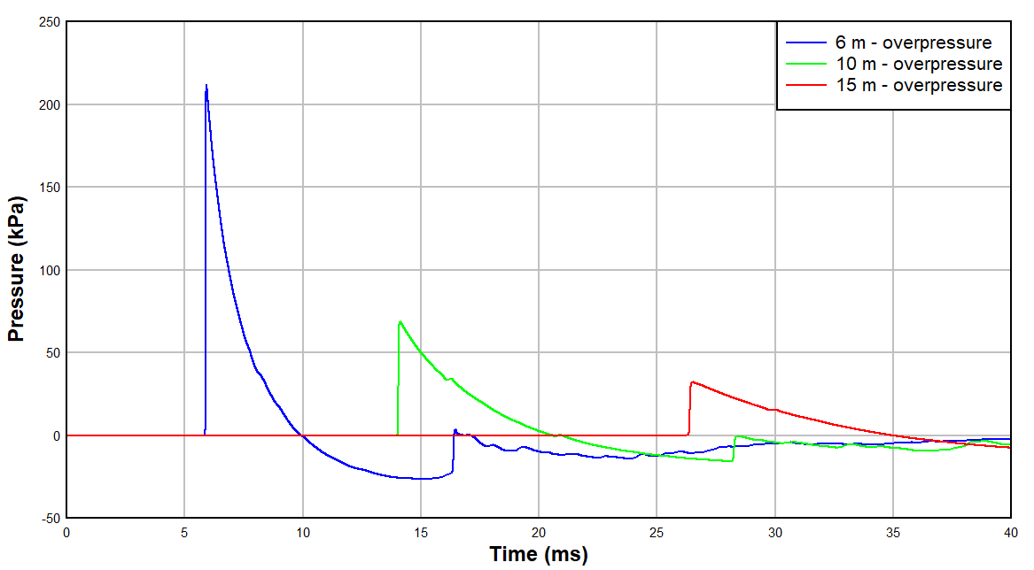
Figure 21 Overpressure for the TNT cylinder simulation

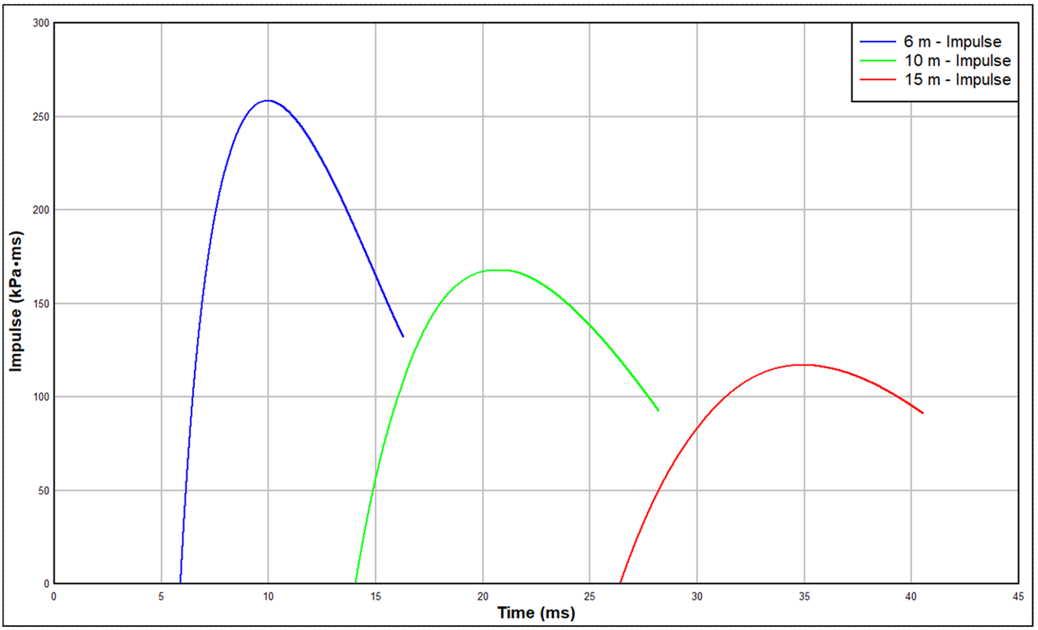
Figure 22 Impulse for the TNT cylinder simulation

Initial comparisons of trial data with ConWep indicated this method for TNT equivalence determination was not suitable. CFD modelling was utilised instead, and the data is presented in Table 9. It shows the nitromethane trial data and the simulation data from a 2D 13.9 kg cylindrical charge of TNT.

Table 9 Trial peak overpressure and impulse comparison with Viper TNT data
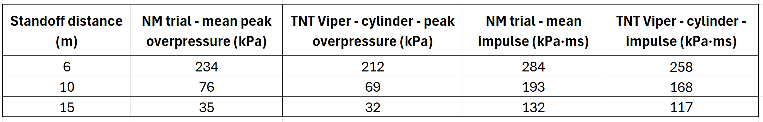

Calculation of TNT equivalence
TNT equivalency values were calculated at three standoff distances for both peak overpressure and incident impulse for 13.9 kg of nitromethane which includes any effect from the booster. To calculate the TNT equivalence for peak overpressure, Equation 1 was used, substituting for peak overpressure. Using the data from the 6 m gauges, a TNT equivalence of 1.10 is obtained:

$${Eq}_{TNT}= \frac{234}{212} =1.10$$

The same process was followed for the remaining peak overpressure and impulse data. The calculated TNT equivalence values are shown in Table 10. Peak overpressure-based TNT equivalence values are consistent for each standoff distance with values of 1.10 and 1.11. Impulse based values ranged from 1.10 to 1.15. Mean values are provided for each parameter.
Table 10 Calculated TNT equivalence values based on 13.9 kg
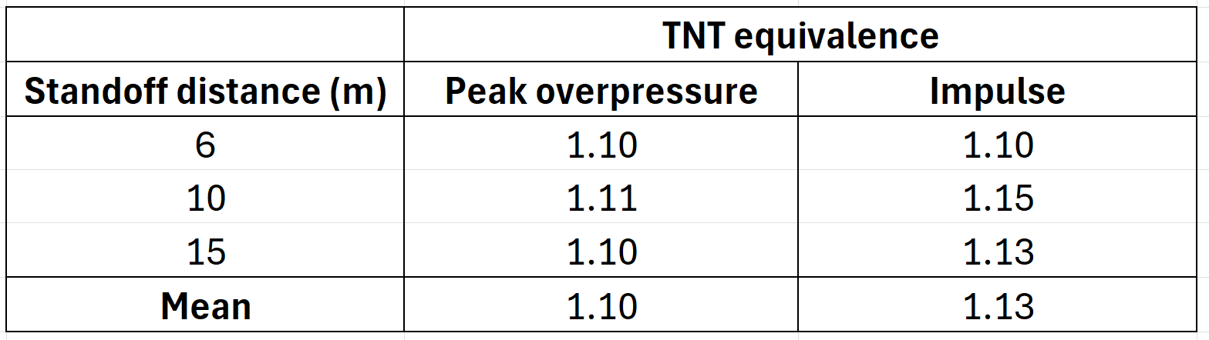

Discussion
Interpretation of the trial results required consideration of several factors, including the charge geometry and the limited availability of relevant TNT blast data, to ensure meaningful comparisons could be made.

Data quality
The nitromethane trials produced usable and consistent data at all standoff distances. Peak overpressures were recorded at each gauge location, and the corresponding incident impulses were calculated. Although gauge one failed after the first trial, resulting in limited data at 6 m, the peak overpressures obtained at this distance were consistent across the remaining trials, indicating the measurements are reliable. The height of the 6 m gauges was reduced to 0.5 m; therefore, a simulation was performed to understand if this impacted the data. An overpressure of 224 kPa and an impulse of 269 kPa∙ms⁻¹ was obtained, closely matching the results from the nitromethane simulation with gauges at 1.2 m, confirming the change in height did not affect the data.

TNT equivalence of nitromethane
TNT equivalence values for the trials were calculated by comparing the measured peak overpressure and incident impulse data at 6 m, 10 m and 15 m with the corresponding blast parameters from a representative cylindrical 13.9 kg TNT simulation in Viper. A TNT equivalence was obtained at each distance for both parameters and the mean values were calculated to provide overall equivalencies. The results are presented in Table 10. Both values are close to the current value used at Spadeadam (1.09). Using the calculated TNT equivalences, the mass of nitromethane required to represent a nominal 15 kg TNT equivalent blast would be 13.6 kg based on peak overpressure and 13.3 kg based on impulse. Conversely, the 13.9 kg charges used in the trials correspond to 15.3 kg TNT equivalent charge mass based on peak pressure and 15.7 kg TNT equivalent charge mass based on impulse. The variation between peak overpressure and impulse is consistent with the literature, with Locking [30] and Witty [34] both suggesting there is merit in considering each parameter and value separately when designing a trial. Witty goes on to discuss that taken in isolation an equivalence factor could perform as required for one parameter but under- or over-perform for the other.

Comparison with ConWep
The method for calculating the TNT equivalence was iterative during analysis of the results. It became clear early on that ConWep was not suitable for comparing the nitromethane trial data to. ConWep uses the Kingery and Bulmash equations which are based on ideal explosions and therefore ideal blast curves [60] [61]. The equations also assume the charge is either spherical or hemispherical, the charge is bare, and that the energy released in a similar manner to TNT. This rarely fits with real-world explosions [62]. The trials conducted for this study were far from ideal; the charges were hexahedral, they cannot be considered a free air burst or a surface burst, the point of initiation might have varied, and nitromethane does not detonate as an ideal explosive so will have a different blast profile [61]. It was therefore expected that trial data would vary from ConWep data but perhaps this needed further consideration prior to the trials as the degree of variation was not expected.

Pressure vs Impulse for TNT equivalence
It is generally expected that pressure-based TNT equivalence will vary more than impulse based TNT equivalence [20]. Pressure gauges are sensitive equipment and readily record reflections and noise in a test arena. This can produce noisy data which may affect peak pressure values. Impulse is time-integrated and it is therefore less sensitive to fluctuations, environmental noise or variation between trials, with the resulting curve reflecting the total positive-phase energy delivered over time [20]. This variation was not seen in these trials with impulse showing a greater variation than overpressure, although it is only minimal variation. The variation may simply reflect normal experimental uncertainty, but to fully ascertain the reason for this variation, additional trials would be required.

There are many variables associated with this trial, such as the geometry of the set-up, the height of burst, surface reflections, gauge measurements, the loading density of a user-filled booster. As such, one would expect to see some variation between trials and careful analysis of the results is required to ensure the appropriate comparisons are being made. Where possible, these areas have been discussed below, but other areas such as the loading density of the booster is beyond the scope of this project. However, understanding what factors might affect the results will help lead to robust conclusions.

Effect of charge geometry
It is strongly suspected the hexahedral shape of the nitromethane container resulted in increased peak overpressure and impulse values, indicated by the large variation when compared to ConWep. The effect of charge geometry has been widely studied in literature [63] [64]. Zhao et al [65] comments that the energy distribution of an explosive cylinder is directly linked to its aspect ratio. They also note the shockwave expands from both the ends and the sides of the cylinder with an asymmetrical shockwave, rather than a symmetrical shock wave seen with a sphere. Sherkar et al [66] concludes that in near to mid field regimes the shape of the charge significantly affects overpressure distribution which is in agreement with Mejia et al [67], who also note that the explosive energy release tends to be focused along the radial direction with an increasing aspect ratio. Sherkar et al [66], also showed an increase in incident peak overpressure and impulse values in cylindrical charges compared to spherical charges. Draganic et al [68] studied the effect of charge shape on pressure and impulse, comparing data for spherical, cylindrical and rectangular charges. They noted the rectangular charge produced the highest incident overpressure, with the cylindrical and spherical charges producing similar results. This is consistent with data collected in these trials when compared with ConWep. A 36% difference was seen between trial peak overpressure data and ConWep data (hemispherical surface burst) at 6 m, and 18% at 15 m. The difference was less pronounced when comparing impulse with the highest value being 15.3%. The effect of charge geometry has a greater impact on peak pressure at closer in gauges with the asymmetrical shockwave becoming increasingly spherical further from the charge, reducing the effect on far-field measurements, as seen in Figure 23 [69]. This effect is also seen in the data for this trial, shown by the reduction in percentage different at the 15 m gauge.
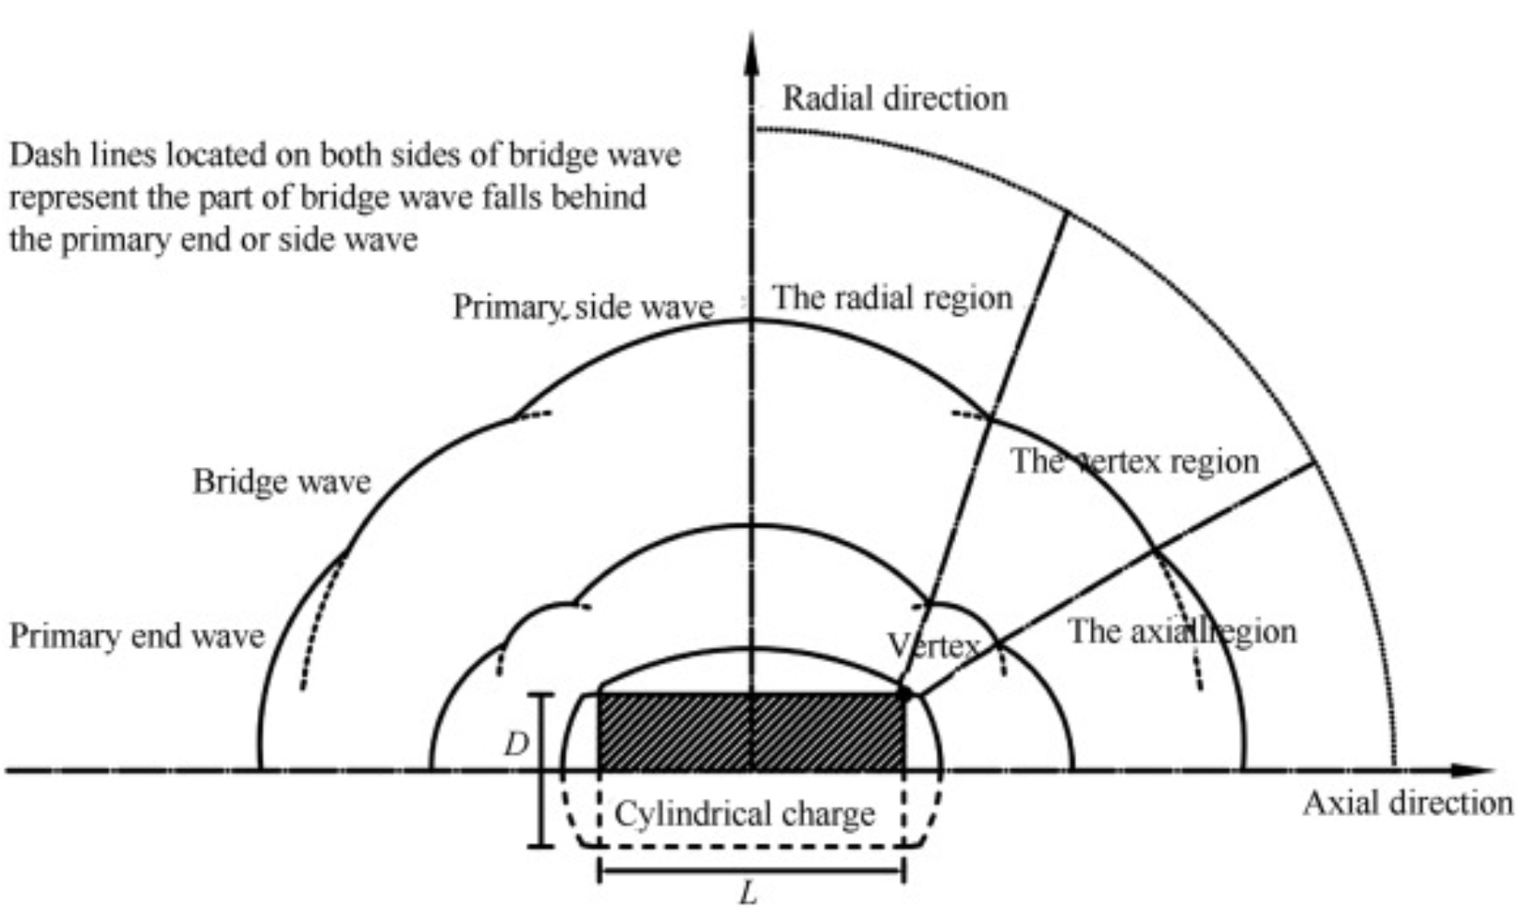
Figure 23 Blast wave development from a cylindrical charge [70]

Collett et al [71] investigated the influence of hexahedral charges on cratering shape, also using jerry cans. They found the hexahedral containers resulted in an elliptical crater rather than a spherical one. Bjelovuk et al [72] noted similar cratering shapes with elongated charges. Hryciow et al [69] commented that elongated charges produce asymmetrical pressure waves closer to the charge, with this effect becoming less noticeable further from the charge. Given the shape of the craters and the asymmetry in the pressure field noted in the above papers, there appears to be an uneven distribution of energy in the shockwave from hexahedral and cylindrical charges. For hexahedral charges, the larger faces of the container appear to generate a higher pressure compared with the smaller faces, which agrees with early research by Plooster [73]. Cylindrical charges have been shown to generate pressure differences dependent on the aspect ratio charge shape [74]. This pressure difference may help to explain the increased peak pressure seen in both the nitromethane and TNT trials, where the pressure gauges were orientated towards the larger face of the charge. The non-spherical blast from the trials can be seen in Figure 24. Figure 25 shows the formation of a cruciform fireball immediately after initiation, indicating areas of higher pressure.
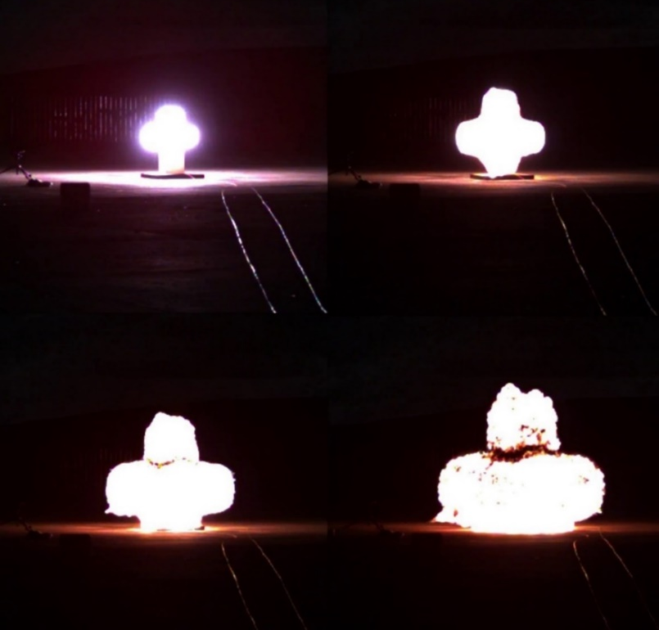
Figure 24 Initial blast shape
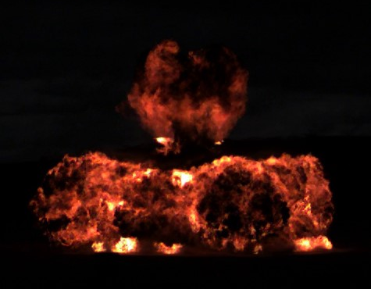
Figure 25 Formation of a cruciform fireball

TNT trial
A TNT trial was conducted with the intention of using the data to validate the methodology. However, the data collected from this trial was not usable with pressure and impulse values being up to 50% higher than expected. Initial consideration was given to trial setup and gauge placement, mainly were they at the stated distances. To determine this, the time of arrival from the trial was compared to that provided by ConWep, which indicates the gauges were placed correctly. The data for this is presented in Appendix 1.

The charge was hexahedral, and similarly to the jerry can this affected the data. An attempt was made to simulate this trial in Viper but due to the small charge in a large domain this was not possible [75]. Due to this and the potentially unreliable trial data it was decided this was not a suitable method for validation. The method discussed in 5.6.1 was used instead. Repeating this trial would have eliminated experimental error having produced erroneous results. Unfortunately, this was not possible.

Computer simulations
By using CFD simulations, it was possible to validate the trial methodology, generate usable TNT blast data to allow determination of a TNT equivalence and show the formation of a Mach stem. These are discussed below.

Method validation
Method validation was done by simulating a 13.9 kg cylindrical nitromethane blast in Viper. An attempt was made to run the model as a 3D simulation using the cuboid dimensions of the jerry can within a domain of 18 m. Unfortunately, due to limited processing capability, this was not possible in sufficient detail to provide reliable results. Therefore, a 2D simulation of a cylinder with an aspect ratio of 0.71 was performed, which is representative of the jerry cans used in the trials. A domain size study was conducted to ensure the full positive phase of the explosion was captured prior to any refractions from the domain walls interfering with the data. The mesh size was reduced to as small as possible (5 mm), to ensure there were sufficient cells to fully represent the charge as per the recommendations by Forth [75]. Gauge and charge height were both set to 1.2 m, within a domain size of 18 m x 18 m. All simulation values were within 15% of the trial data, providing confidence in the quality of the trials and demonstrating the methodology is robust. This is shown in Appendix 2.

13.9 kg TNT simulation
Initial comparisons of the trial data with ConWep produced a TNT equivalence that was significantly higher than expected when compared with previous 100 kg trials at Spadeadam. While the charge shape was suspected to have caused some variation, the difference prompted further analysis to understand if this was a realistic TNT equivalence. A 13.9 kg cylinder of TNT was simulated using the same model as above. This data is presented in Table 9 with the pressure-time and impulse-time curves shown in Figure 21 and Figure 22.

Mach stem modelling
The simulations showed the formation of the Mach stem which started to develop almost immediately after detonation, shown in Figure 26. Figure 27 shows that by 5 m the Mach stem is fully formed and at an approximate height of 1.2 m - the height of the gauges, therefore it will increase the peak overpressure. Using Equation 4, it is also possible to mathematically determine if a Mach stem is likely to develop based on the height of the burst.

$$Scaled height of burst=\frac{Height of burst above ground }{\sqrt[3]{Charge mass}}$$
Equation 4 Mach stem formation [37]
If this value is <10 then a Mach stem will form.
If this value is > 10 than a Mach stem will not form.

Scaled height of burst – m∙kg ^{-1/3}
Height of burst – 1.2 m
Charge mass – 13.9 kg
Therefore:
$$\frac{1.2}{2.4} =0.5 m∙{kg}^{-1/3}$$

A Mach stem would form from this a charge height of 1.2 m, meaning the trials are technically an air burst. However, so long as a comparison to a suitable TNT blast is made i.e. the simulation above, then the Mach stem formation has already been addressed.
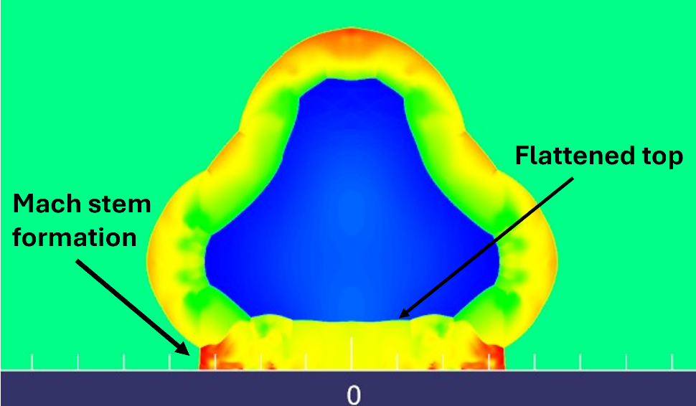
Figure 26 Mach stem formation shortly after detonation

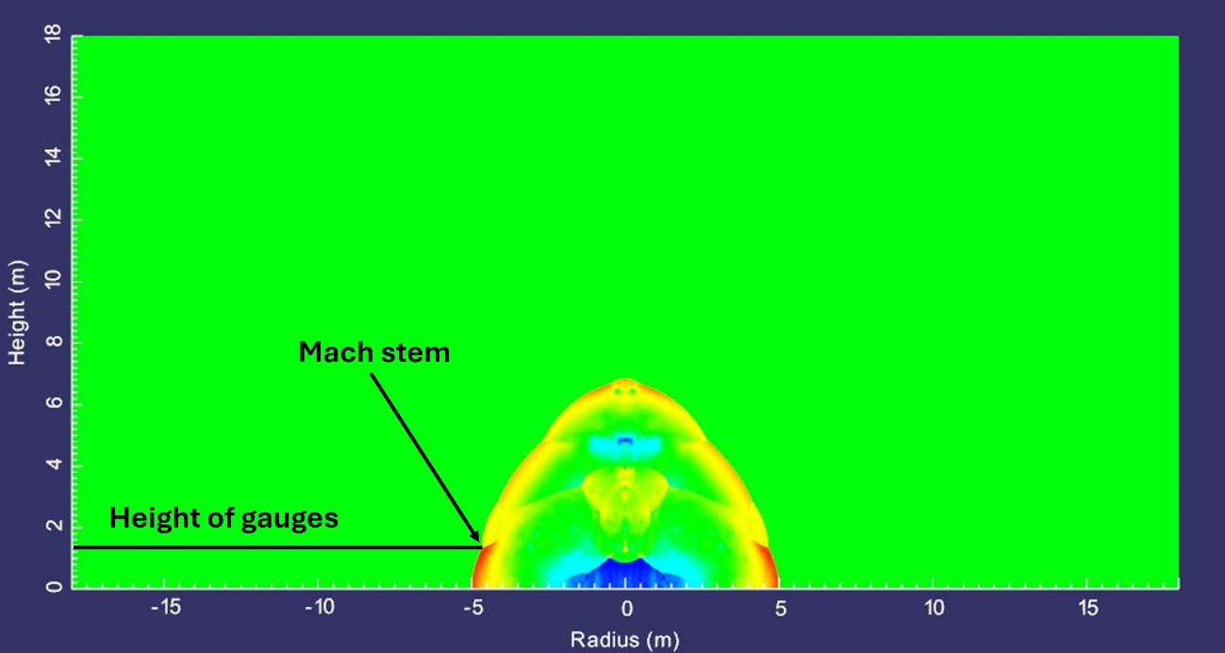
Figure 27 Mach stem at 5 m

Stills from the high-speed footage, shown in Figure 28, revealed interaction between the shockwave, the fireball and the ground and was also shown in the simulation in Figure 26. This is evident from the flattened surface in the fireball. It was expected this interaction might have increased the measured overpressure, however, confirming this would require repeat trials with an increased charge height for comparison.
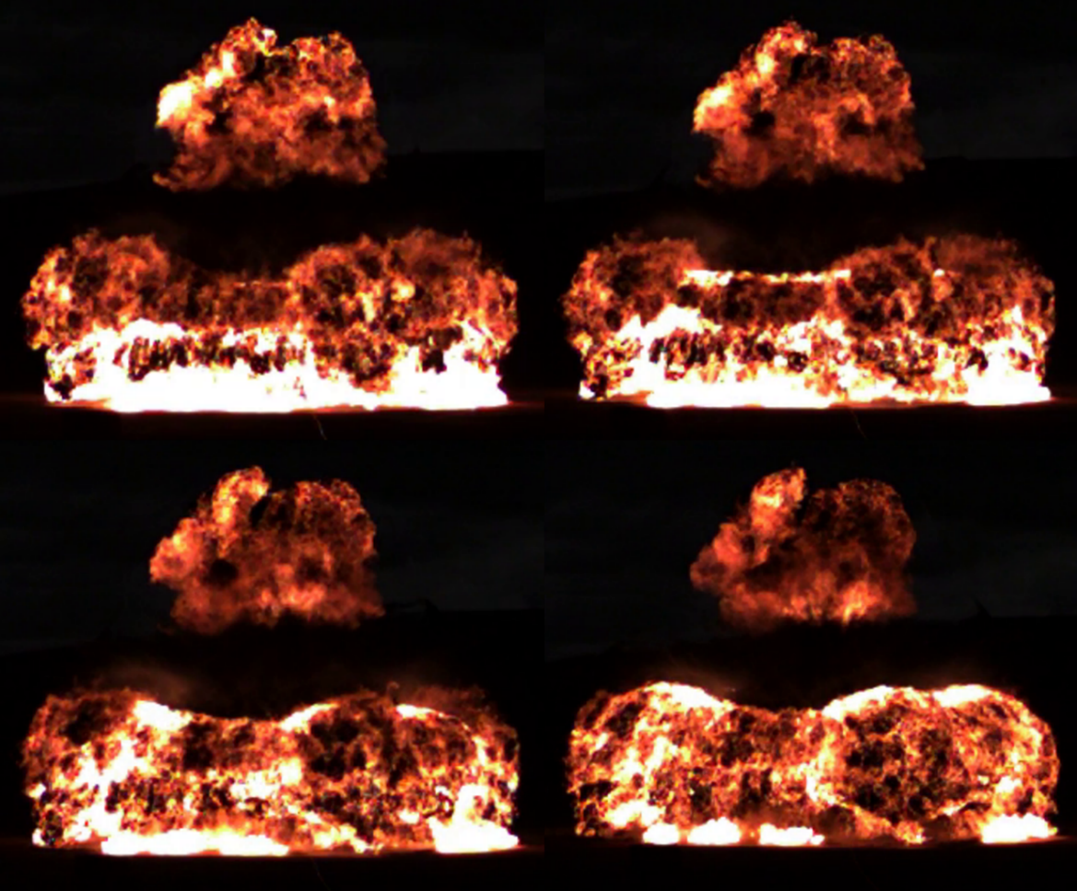
Figure 28 Fireball and reflection of energy

Comparison of results with literature
As noted earlier, Merryfield and Roberts [33] quote nitromethane as having a TNT equivalence of 1.34, which appeared to be high compared with previous DNV Spadeadam trials and it does not match the values determined in these trials. Interestingly, their value is close to the TNT equivalence obtained when the nitromethane trial data was originally compared to ConWep. Unfortunately, without knowing their methodology, it is impossible to draw any conclusions on the different values. ConWep contains nitromethane in its database and provides a TNT equivalence of 1.0. It has not been possible to establish how this value was determined but again it does not agree with the values from this study. A nitromethane trial using a spherical air burst or hemispherical surface burst would allow a more accurate comparison to ConWep providing a better understanding of its accuracy.

Project constraints and limitations
The results of this project must be considered alongside several limitations arising from practical trials constraints. As these trials also supported a concurrent study, different initiation methods were used, introducing slight variations in booster setup for each trial and a potential for variation in booster loading density. Ideally, additional trials would have been conducted using each initiation method to confirm this had no measurable effect on the results.

All trials were conducted with fixed charge geometry and with a fixed level of confinement. This means the measured blast parameters only represent the behaviour of nitromethane under one defined configuration and may not fully capture the variability associated with differing geometries and confinement.

Despite these limitations, the trials produced consistent data and showed good agreement with the simulations, giving confidence in the results. The analysis provided a clear understanding of the TNT equivalence of nitromethane for the configuration tested and highlighted key factors influencing the measurements. The methodology followed established best practice procedures used at DNV Spadeadam and reported in peer reviewed literature [59], giving confidence in the process. However, the inherent constraints of the trial may limit the wider application of the findings beyond the configuration tested.

Conclusions
The overall aim of determining the TNT equivalence of nitromethane for charge sizes up to 15 kg TNT equivalence was achieved. TNT equivalences were found to be:

- 1.10 for peak overpressure
- 1.13 for incident impulse

To accomplish this, a series of blast trials were successfully completed, where overpressure and incident impulse were determined. It was found that due to the charge geometry, the trial data could not be compared to ConWep, and instead, a representative TNT simulation was performed. This provided suitable reference data for determination of TNT equivalences.

To validate the methodology a simulation representing the nitromethane trials was conducted. Data from the simulation was within 12% of the live trials giving confidence in the methodology and simulation accuracy. Whilst the TNT simulation didn’t fully achieve the aim of using a TNT blast to validate the methodology, the alternative approach was considered suitable.

Despite the non-ideal nature of the detonation and the effect of charge geometry on the data, the derived TNT equivalence values are considered appropriate for the current trial setup at DNV Spadeadam.

The aim of conducting a literature review was achieved. However, there is limited information on the use of nitromethane as an explosive. This subsequently affected the scope of the literature review, but it also provided an opportunity to contribute to an area of relatively new research.

The TNT equivalence values align with expected results, based on previous large-scale trials at DNV Spadeadam and existing literature on the effects of charge geometry. Consequently, recommendations have been made below.

Recommendations and Future Work
Several straightforward modifications could be implemented if this work is continued to further improve the methodology and robustness of the results.

Placing pressure gauges circularly around the charge, rather than predominately within a single plane, would provide a greater insight into the pressure distribution arising from different faces of the hexahedral charge container. Collecting data at additional standoff distances would help to determine if the TNT equivalence of nitromethane varies with distance. Trials involving a range of charge sizes would also aid in characterising the behaviour of nitromethane across different scaled distances.

To increase confidence in the results, it is recommended that further repeat trials are conducted, including the TNT trial to eliminate experimental error. Additional tests with each initiation method would indicate if the method of initiation influences the detonation behaviour of nitromethane.

The charge height used in these trials was based on current methodology at DNV Spadeadam.
While testing in the intended configuration has its merits, it limits the application of the resulting data to other trials. Conducting additional trials with the charge configured as a free-air burst would allow the data to be applied more widely. Replacing the hexahedral container with a spherical shape would improve alignment with existing reference data, and this is recommended where appropriate for the trial. Following these trials, it has been decided to change the container to the type shown in Figure 29, without the lid. It is recommended to perform additional trials to confirm the TNT equivalence with the new trial setup.

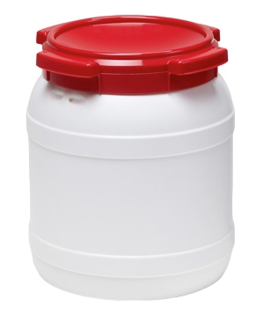
Figure 29 New container for nitromethane trials

For customer testing, it is recommended to confirm which blast parameter is of interest, as this choice affects the equivalence value. Where test standards require reflected measurements, it is recommended the proposed trial is simulated in advance to determine the required mass of nitromethane.

Reflection
Lessons learned during this project are outlined below.
Critical evaluation:
- Allocate sufficient time for reviewing data between trials. Time constraints prevented the high-speed footage being reviewed between trials. Therefore, it was not identified until afterwards that the shockwave was not visible in the footage. Whilst not essential this would have been used to determine the velocity of the shockwave. Reviewing the data would also have revealed that gauge one had stopped functioning, allowing it to be replaced.
- Liaise with the trial team early in the planning process. Clear communication of trial requirements reduces the likelihood of delays or misunderstandings. This includes visiting the arena ahead of the trial to conduct a planning session. This action proved valuable in the nitromethane trials, identifying infrastructure in the arena which may have caused reflections had they remained in place.
- Planning extra time into the course of the project meant conflicts for arena time did not affect the project progression.
- Data analysis was more complex than expected, and additional processing was required, however, this ultimately strengthened the report and was a key learning opportunity on managing an evolving project.
- Additional research was undertaken after the influence of charge geometry became apparent. This required adapting the planned approach to the literature review, demonstrating the need for flexibility throughout the project.

Some issues were anticipated during the project planning stage, such as delays to testing, and mitigation proved effective. Other difficulties such as gauge one failing were not predicted and highlighted a need for further detail in the technical planning. These reflections highlight the importance of communication and ongoing review during a project and will inform improvements in conducting future work. They also demonstrate how project objectives can be achieved despite facing challenges. Gantt charts tracking project progress are shown in Appendix 5 and the ethics form outlining the scope of the research is shown in Appendix 6.

References

[1] | International Organization for Standardization, “Glass in building — Explosion-resistant security glazing — Test and classification for arena air-blast loading,” ISO, Geneva, 2007.
[2] | Standards Norway, “Windows, doors, shutters and curtain walling - Explosion resistance - Requirements and classification - Part 2: Arena test,” Standards Norway, Oslo, 2025.
[3] | J. Akhavan, The Chemistry of Explosives, Cambridge: The Royal Society of Chemistry, 2004.
[4] | A. Bailey and S. G. Murray, Explosives, propellants and pyrotechnics, London: Brassey's, 1989.
[5] | V. Karlos, G. Solomos and M. Larcher, “Analysis of blast wave parameters in the near-field for spherical free-air explosions,” Joint Research Centre, EUR, 2016.
[6] | T. Ngo, P. Mendis, A. Gupta and J. Ramsay, “Blast Loading and Blast Effects on Structures – An Overview,” Electronic Journal of Structural Engineering, no. EJSE Special Issue: Loading on Structures, 2007.
[7] | T. M. Klapotke, Chemistry of High Energy Materials, Berlin, Germany: De Gruyter, 2022.
[8] | R. K. Eckhoff, Explosion Hazards in the Process Industries, Oxford, UK: Gulf Professional Publishing, 2005.
[9] | P. W. Cooper, Explosives Engineering, Wiley, 1996.
[10] | G. F. Kinney and K. J. Graham, Explosive Shocks in Air, New York: Springer, 1985.
[11] | M. R. Jorolemon, R. A. Lopez and D. M. Krywko, Blast Injuries, Treasure Island: StatPeals [Internet], 2023.
[12] | D. P. Mishra, Fundamentals of Combustion, Dehli: PHI Learning Pvt. Ltd., 2013.
[13] | W. Fickett and W. C. Davis, Detonation: Theory and Experiment, Mineola, New York: Dover Publications, 2000.
[14] | W. Xiao, M. Andrae and N. Gebbeken, “Air blast TNT equivalence factors of high explosive material PETN for bare charges,” Journal of Hazardous Materials, vol. 377, pp. 152-162, 2019.
[15] | D. Bogosian, M. Yokota and S. Rigby, “TNT equivalence of C-4 and PE4: a review of traditional sources and recent data,” in 24th Military Aspects of Blast and Shock, Halifax, 2016.
[16] | P. W. Cooper, “Comments on TNT Equivalence,” in 20th International Pyrotechnics Seminar, Colorado Springs, Colorado, 1994.
[17] | B. E. Fuchs, J. Covino and E. Baker, “A Critical Review of TNT Equivalency,” in International Explosives Safety Symposium & Exposition, San Diego CA, 2018.
[18] | P. Locking, “TNT equivalence, Berthelot theory and the trauzl lead block test,” in 32nd International Symposium on Ballistics, Reno, NV, 2022.
[19] | C. M. Mason and E. G. Aiken, “Methods for Evaluating Explosives and Hazardous Materials,” United States Department for th Interior - Bureau of Mines, Washington, DC, 1972.
[20] | G. M. M. James, R. L. Bauer, E. M. Johnson and C. E. Johnson, “Experimental determination of TNT equivalence values for binary energetic materials,” vol. 15, no. 1, p. 15578, 2025.
[21] | M. H. Keshavarz and T. M. Klapötke, Energetic Compounds: Methods for Prediction of their Performance, Berlin, Germany: De Gruyter, 2017.
[22] | M. Berthelot, Explosives and their power, London: J. Murray, 1892.
[23] | I. Sochet, Blast Effects - Physical Properties of Shockwaves, Cham, Switzerland: Springer, 2018.
[24] | J. L. Maienschein, “Estimating Equivalency Of Explosives Through A Thermochemical Approach,” in 12th International Conference Symposium, San Diego, California, 2002.
[25] | P. S. Shirbhate and M. D. Goel, “A Critical Review of TNT Equivalence Factors for Various Explosives,” in Recent Advances in Computational Mechanics and Simulations, Singapore, 2020.
[26] | R. K. Wharton, S. A. Formby and R. Merrifield, “Airblast TNT equivalence for a range of commercial blasting explosives,” Journal of Hazardous Materials, vol. 79, no. 1-2, pp. 31-39, 2000.
[27] | A. M. Remennikov, J. Youssef, T. D. Ngo and I. Mentus, “Breach diameter analysis of concrete panels subjected to contact charge detonations,” International Journal of Impact Energy, vol. 120, pp. 95-109, 2018.
[28] | K. Spranghers, I. Vasilakos, D. Lecompte, H. Sol and J. Vantomme, “Numerical simulation and experimental validation of the dynamic response of aluminium plates under free air explosions,” International Journal of Impact Engineering, vol. 54, pp. 83-95, 2013.
[29] | R. Cheeseman, “Definition and use of TNT equivalencies in assessing loading in confined structures.,” in International Conference on Protective Structures, Manchester, UK, 2010.
[30] | P. M. Locking, “The Trouble with TNT Equivalence,” in 26th International Symposium on Ballistics, Miami, 2011.
[31] | R. Jeremić and Z. Bajić, “An approach to determining the TNT equivalent of high explosives,” Scientific Technical Review, vol. 56, no. 1, pp. 58-62, 2006.
[32] | P. M. Locking, “TNT equivalence - Experimental comparison against prediction,” in 27th International Symposium on Ballistics, Feiburg, Germany, 2013.
[33] | R. Merrifield and T. A. Roberts, “A comparison of the explosion hazards associated with the transport of explosives and industrial chemicals with explosive properties,” in ICHEME Symposium Series No. 124 - Hazards XI, Manchester, UK, 1991.
[34] | L. Witty, “The sensitivities of blast parameters in predicting TNT equivalence from experimental data,” University of Sheffield, Sheffield, UK, 2023.
[35] | C. Langran-Wheeler, S. Rigby, S. Clarke, A. Tyas, C. Stephens and R. Walker, “Near-field spatial and temporal blast pressure distributions from non-spherical charges: Horizontally-aligned cylinders,” International Journal of Protective Structures, vol. 12, no. 4, 2021.
[36] | J. Krishna Vaishnavi and B. Murali Krishna, “Determination of response of multistorey structure subjected to blast loading,” Journal of Building Pathology and Rehabilitation , vol. 7, no. 75, 2022.
[37] | U. S. D. f. Defense, “Unified Facilities Criteria (UFC) 3-340-02: Structures to Resist the Effects of Accidental Explosions,” Department of Defense, Washington, DC, 2008.
[38] | B. M. Dobratz, “LLNL Explosives Handbook: properties of chemical explosives and explosive simulants,” Lawrence Livermore National Laboratory, Livermore, California, 1972.
[39] | E. Boyer and K. K. Kuo, “Characteristics of nitromethane for propulsion applications,” in 44th AIAA Aerospace Sciences Meeting and Exhibit, Reno, Nevada, 2006.
[40] | S. B. Markofsky and W. G. Grace, “Nitro Compounds, Aliphatic,” in Ullmann's Encyclopedia of Industrial Chemistry, 7th edition, volume 24, Columbia, Maryland, Wiley, 2011, pp. 291-300.
[41] | M. Kurilov, L. Werling, C. Kirchberger, H. Ciezki and S. Schlechtriem, “Combustion behavior of NMP-001, a nitromethane-based green rocket propellant,” Acta Astronautica, vol. 223, pp. 1-14, 2024.
[42] | M. Kurilov, L. Werling and C. Kirchberger, “Nitromethane as a green propellant: first results of a combustion test campaign,” in Aerospace Europe Conference - 10th EUCASS - 9th CEAS, Lausanne, Switzerland, 2023.
[43] | F. E. Walker, “Initiation and detonation studies in sensitized nitromethane,” Acta Astronautica, vol. 6, no. 7-8, pp. 807-813, 1979.
[44] | M. Bhowmick, E. J. Nissen and D. D. Dlott, “Detonation on a tabletop: Nitromethane with high time and space resolution,” Journal of Applied Physics, vol. 124, no. 7, 2018.
[45] | A. Remennikov, T. Ngo, D. Mohotti, B. Uy and M. Netherton, “Experimental investigation and simplified modeling of response of steel plates subjected to close-in blast loading from spherical liquid explosive charges,” International Journal of Impact Engineering, vol. 101, pp. 78-89, 2017.
[46] | PubMed, “Nitromethane,” National Library of Medicine, 2026. [Online]. Available: https://pubchem.ncbi.nlm.nih.gov/compound/Nitromethane. [Accessed 13 April 2026].
[47] | Interstate Commerce Commission, “Railroad Accident Investigation,” Interstate Commerce Commission, Washington, 1958.
[48] | H. Shekhar, “Explosive characteristics and shaped charge applications of nitromethane (NM): a review,” Central European Journal of Energetic Materials, vol. 9, no. 1, pp. 87-97, 2012.
[49] | T. Zhang, L. Chen, K. Yang, B. Zhang, T. Yang, Y. Long, J. Lu, D. Liu and J. Chen, “Kinetic modelling and reactivity of liquid nitromethane under detonation conditions,” Communications Chemistry, vol. 8, no. 1, 2025.
[50] | D. Guo, S. V. Zybin, W. A. Goddard and Q. An, “Enhancing the Detonation Properties of Liquid Nitromethane by Adding Nitro-Rich Molecule Nitryl Cyanide,” Journal of Physical Chemistry C, vol. 124, no. 18, pp. 9787-9794, 2020.
[51] | Q. Liu, C. Bai, L. Jiang and W. Dai, “Deflagration-to-detonation transition in nitromethane mist/aluminum dust/air mixtures,” Combustion and Flame, vol. 157, no. 1, pp. 106-117, 2010.
[52] | Cole-Parmer, “Material Safety Data Sheet - Nitromethane - ACC 01129,” 2005. [Online]. Available: https://pim-resources.coleparmer.com/sds/01129.pdf. [Accessed 17 March 2026].
[53] | J. Hershkowitz and B. M. Dobratz, “Compendium of nitromethane data relevant to the tactical explosive system (TEXS) program,” U.S. Army Armament Research, Development an Engineering Center, Picatinny Arsenal. New Jersey, 1989.
[54] | L.-q. Wang and D.-r. Kong, “Research on the distribution characteristics of explosive shock waves at different altitudes,” Defence Technology, vol. 24, pp. 340-348, 2023.
[55] | L. Chen, Z. Li, R. Chen and F. Lu, “Propagation characteristics of blast shock waves in low-pressure environment,” Shock Waves, vol. 33, pp. 61-74, 2023.
[56] | M. M. Swisdak, “Explosion Effects and Properties Part 1- Explosion Effects in Air,” White Oak Laboratory, Naval Surface Weapons Centre, Silver Springs, FL, 1975.
[57] | Thermofisher, “Labware Chemical Resistance Table,” Thermofisher, [Online]. Available: https://tools.thermofisher.com/content/sfs/brochures/D20480.pdf. [Accessed 21 April 2026].
[58] | PCB Piezotronics, “Quartz blast pressure sensor,” PCB Piezotronics, 2026. [Online]. Available: https://www.pcb.com/products?m=137b24a. [Accessed 10 March 2026].
[59] | A. Chester, R. Hazael and R. Critchley, “Comparative analysis of blast prediction software for far-field shock wave effects behind a blast wall,” International Journal of Protective Structures, vol. 16, no. 4, pp. 825-852, 2024.
[60] | D. Hyde, “User's guide for microcomputer program CONWEP, application of TM5-855-1, fundamentals of protective design for conventional weapons,” US Army Waterways Experiment Station, Vicksburg, Mississippi, 1993.
[61] | G. Randers-Pehrson and K. A. Bannister, “Airblast loading model for DYNA2D and DYNA3D,” Army Research Laboratory, Aberdeen Proving Ground, MD, 1997.
[62] | S. E. Rigby, C. Osborne, G. S. Langdon, S. B. Cooke and D. J. Pope, “Spherical equivalence of cylindrical explosives: Effect of charge shape on deflection of blast-loaded plates,” International Journal of Impact Engineering, vol. 155, p. 103892, 2021.
[63] | C. Knock and N. Davies, “Predicting the peak pressure from the curved surface of detonating cylindrical charges,” Propellants, Explosives and Pyrotechnics, vol. 356, pp. 203-209, 2011.
[64] | J. Liu, C. Z. Gao, Z. Y. Sun and J. W. Yin, “On the estimation of near-field air blast peak overpressure from cylindrical charges,” International Journal of Protective Structures, vol. 15, no. 3, pp. 442-454, 2024.
[65] | A. Ullah, F. Ahmad, H.-W. Jang, S.-W. Kim and J.-W. Hong, “Shock Wave Propagation Characteristics of Cylindrical Charge and Its Aspect Ratio Effects on the Damage of RC Slabs,” Advances in Materials Science and Engineering, vol. 2021, no. 2, pp. 1-17, 2021.
[66] | P. Sherkar, A. Whittaker and A. Aref, “On the influence of charge shape, orientation and point of detonation on air-blast loadings,” in Structures Congress, Boston, Massachusetts, 2014.
[67] | N. Mejia, R. Mejia and T. Toulkeridis, “Characterization of blast wave parameters in the detonation locus and near field for shaped charges,” Mathematics, vol. 10, no. 18, pp. 1-21, 2022.
[68] | H. Draganic, S. Lukic, I. Radic, G. Gazic and M. Jelec, “Analysis of charge shape Influence on blast pressure,” WIT Transactions on The Built Environment, vol. 209, pp. 85 - 96, 2022.
[69] | Z. Hryciów, W. Borkowski, P. A. Rybak and J. Wysocki, “Influence of the shape of the explosive charge on blast profile,” Journal of KONES Powertrain and Transport, vol. 21, no. 4, pp. 167-176, 2014.
[70] | C. Gao, X.-z. Kong, Q. Fang, J. Hong and Y. Wang, “Numerical investigation on free air blast loads generated from center-initiated cylindrical charges with varied aspect ratio in arbitrary orientation,” Defence Technology, vol. 18, no. 9, pp. 1662-1678, 2022.
[71] | G. Collett, J. Akhavan and R. Critchley, “Understanding the explosion risk presented by ammonium nitrate and aluminium home-made explosives detonated as surface charges in hexahedral main charge containers,” Discover Materials, vol. 4, no. 1, 2024.
[72] | I. D. Bjelovuk, S. Jaramaz, P. Elek, D. Micković and L. Kricak, “Estimation of the explosive mass based on the surface explosion crater on asphalt,” Tehnicki vjesnik - Technical Gazette, vol. 22, no. 1, pp. 227-232, 2015.
[73] | M. N. Plooster, “Blast effects from cylindrical explosive charges: experimental measurements,” Denver Reaeorch Institute - Naval Weapons Centre, China Lake, California, 1982.
[74] | M. M. Swisdak and L. D. Sadwin, “Airblast equivalent weights of various explosive charge shapes for testing structures,” APT Research, Inc, Huntsville, AL, 2010.
[75] | S. Forth, “ProSAir 2018.4 user guide,” Cranfield University, Shrivenham, 2018.
[76] | B. Zhang, N. Zou, W. Wang and Z. Wang, “Investigation of an accidental explosion in a nitromethane rectification process,” Process Safety and Environmental Protection, vol. 94, pp. 358-365, 2015.
[77] | R. Li, R. Sun, M.-h. Hu, Y.-j. Chen, Q. Wang, D.-D. Zhang, X.-j. Li and X.-r. Cui, “Blast characteristics of center-initiated cylindrical charge in high-altitude environments,” AIP Advances, vol. 15, no. 3, p. 035352, 2025.

Appendix 1 – TNT trial data
A TNT reference trial was conducted using 0.5 kg charge of TNT, known as a TM 500. The data is presented in Table 11 and Table 12 with the percentage difference to the ConWep data. For interest the pressure-time and impulse-time curves are shown in Figure 30 and Figure 31 below. The data shows large variation from the expected TNT overpressure and impulse values; therefore, the time of arrival and positive phase duration were compared to values on ConWep to establish if there was an error with trial setup or equipment. As can be seen in Table 13 there is very little difference between the time of arrival data but up to 22% variation in the positive phase duration. The cause of the increase in positive phase duration is not immediately obvious. However, the time of arrival data indicates the gauges functioned properly and the trial was correctly setup, therefore these factors are unlikely to be the cause of the high values.

ConWep assumes spherical or hemispherical charges, but the TNT used in the trial was a hexahedral block, as such, some variation was expected in the results. However, with a difference of between 20-50% it was decided not to use this data to determine the TNT equivalence of nitromethane. It is possible the observed differences are solely due to the shape of the TNT charge, however, without further trials, it is not possible to draw any reliable conclusions.
Table 11 TNT pressure data - trial and ConWep
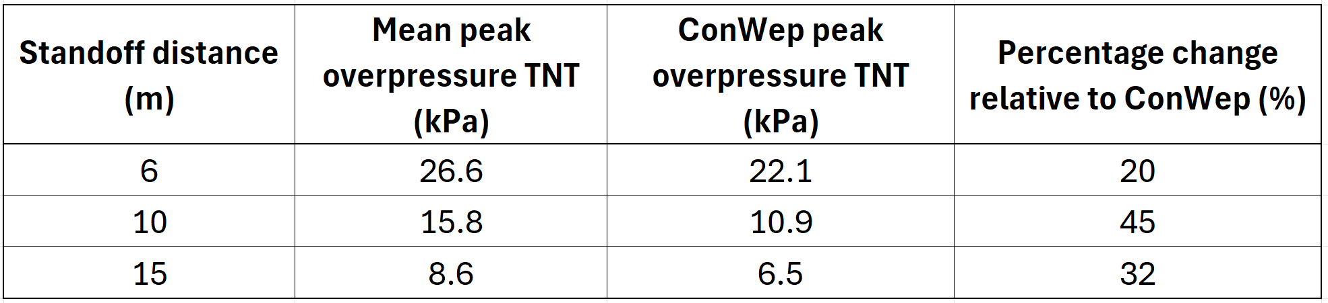
Table 12 TNT impulse data - Trial and ConWep
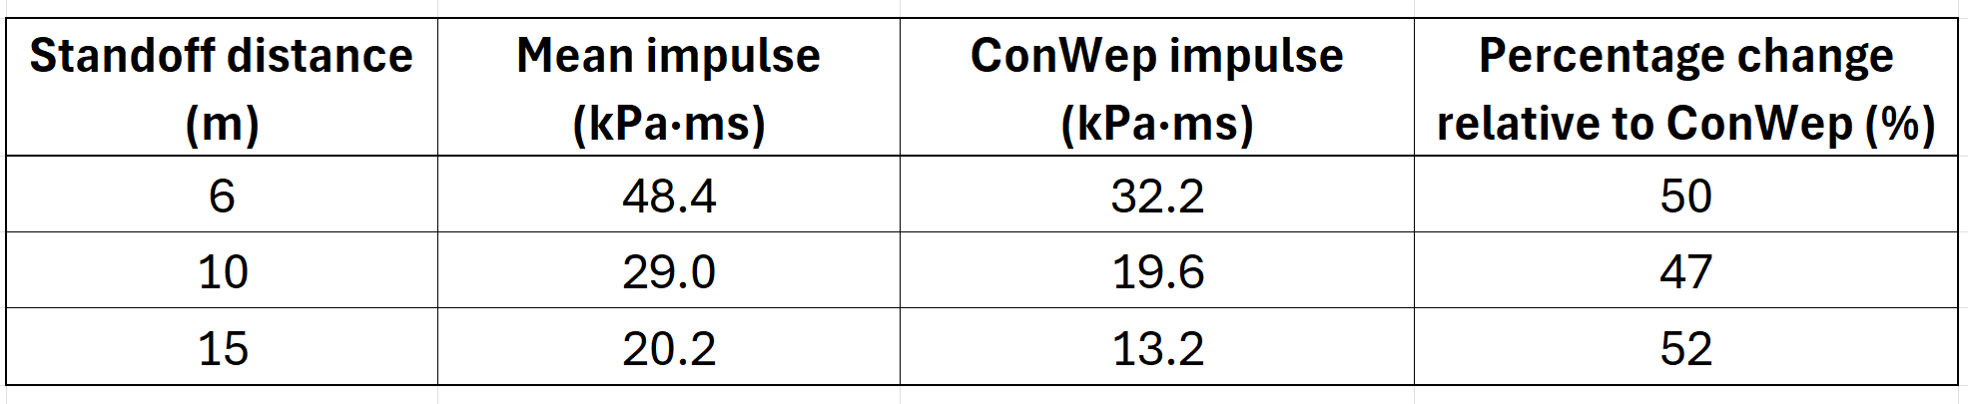

Table 13 Time of arrival and positive phase duration comparison
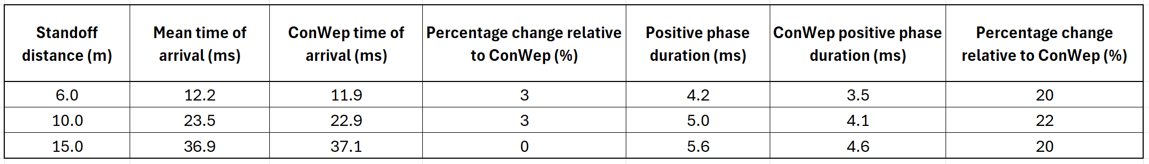

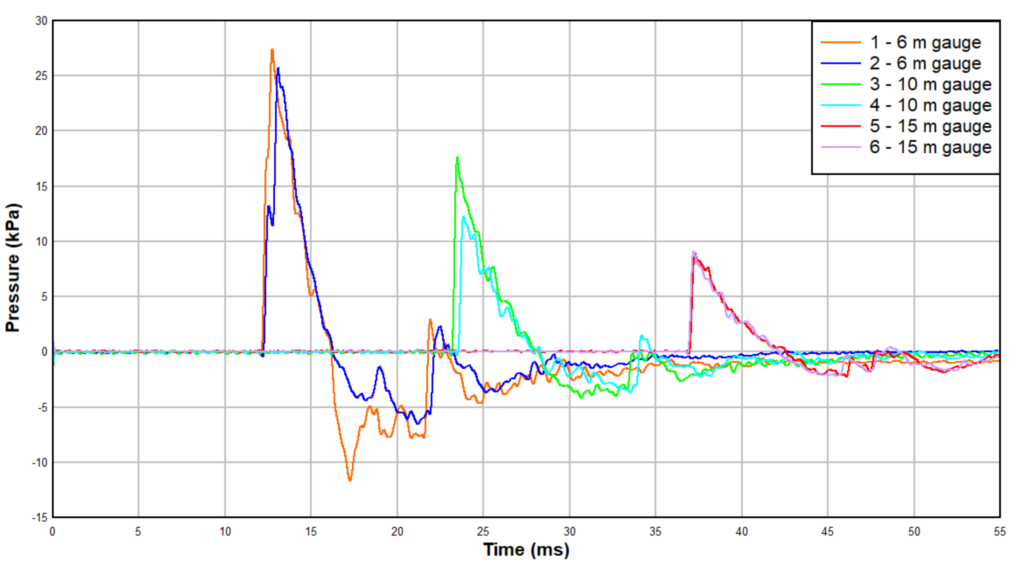
Figure 30 Overpressure for 0.5 kg of TNT
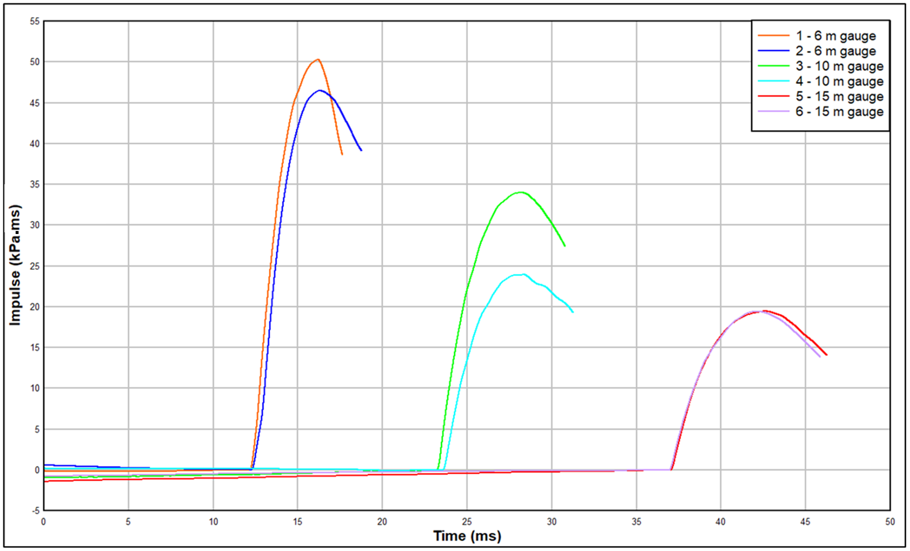
Figure 31 Impulse for 0.5 kg of TNT

Appendix 2 – Trial and Viper data for 13.9 kg of nitromethane
Table 14 shows a comparison of the trial data and Viper data obtained for a cylindrical charge of 13.9 kg of nitromethane at 6 m, 10 m, and 15 m. This helped to determine if the modelling approach used to produce TNT blast data was appropriate. There is good agreement between the two data sets, indicating the simulation reflects the experimental trial, therefore it was appropriate to use the Viper cylindrical TNT model data to determine the TNT equivalence. The pressure and impulse curves are shown in Figure 32 and Figure 33

Table 14 Comparison of trial and Viper data for 13.9 kg nitromethane
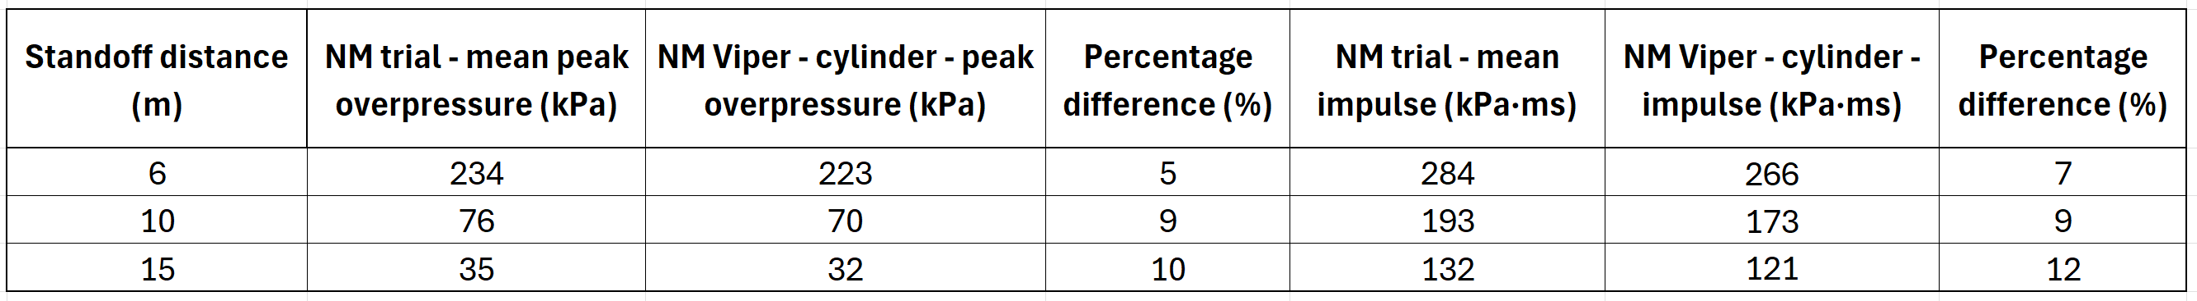

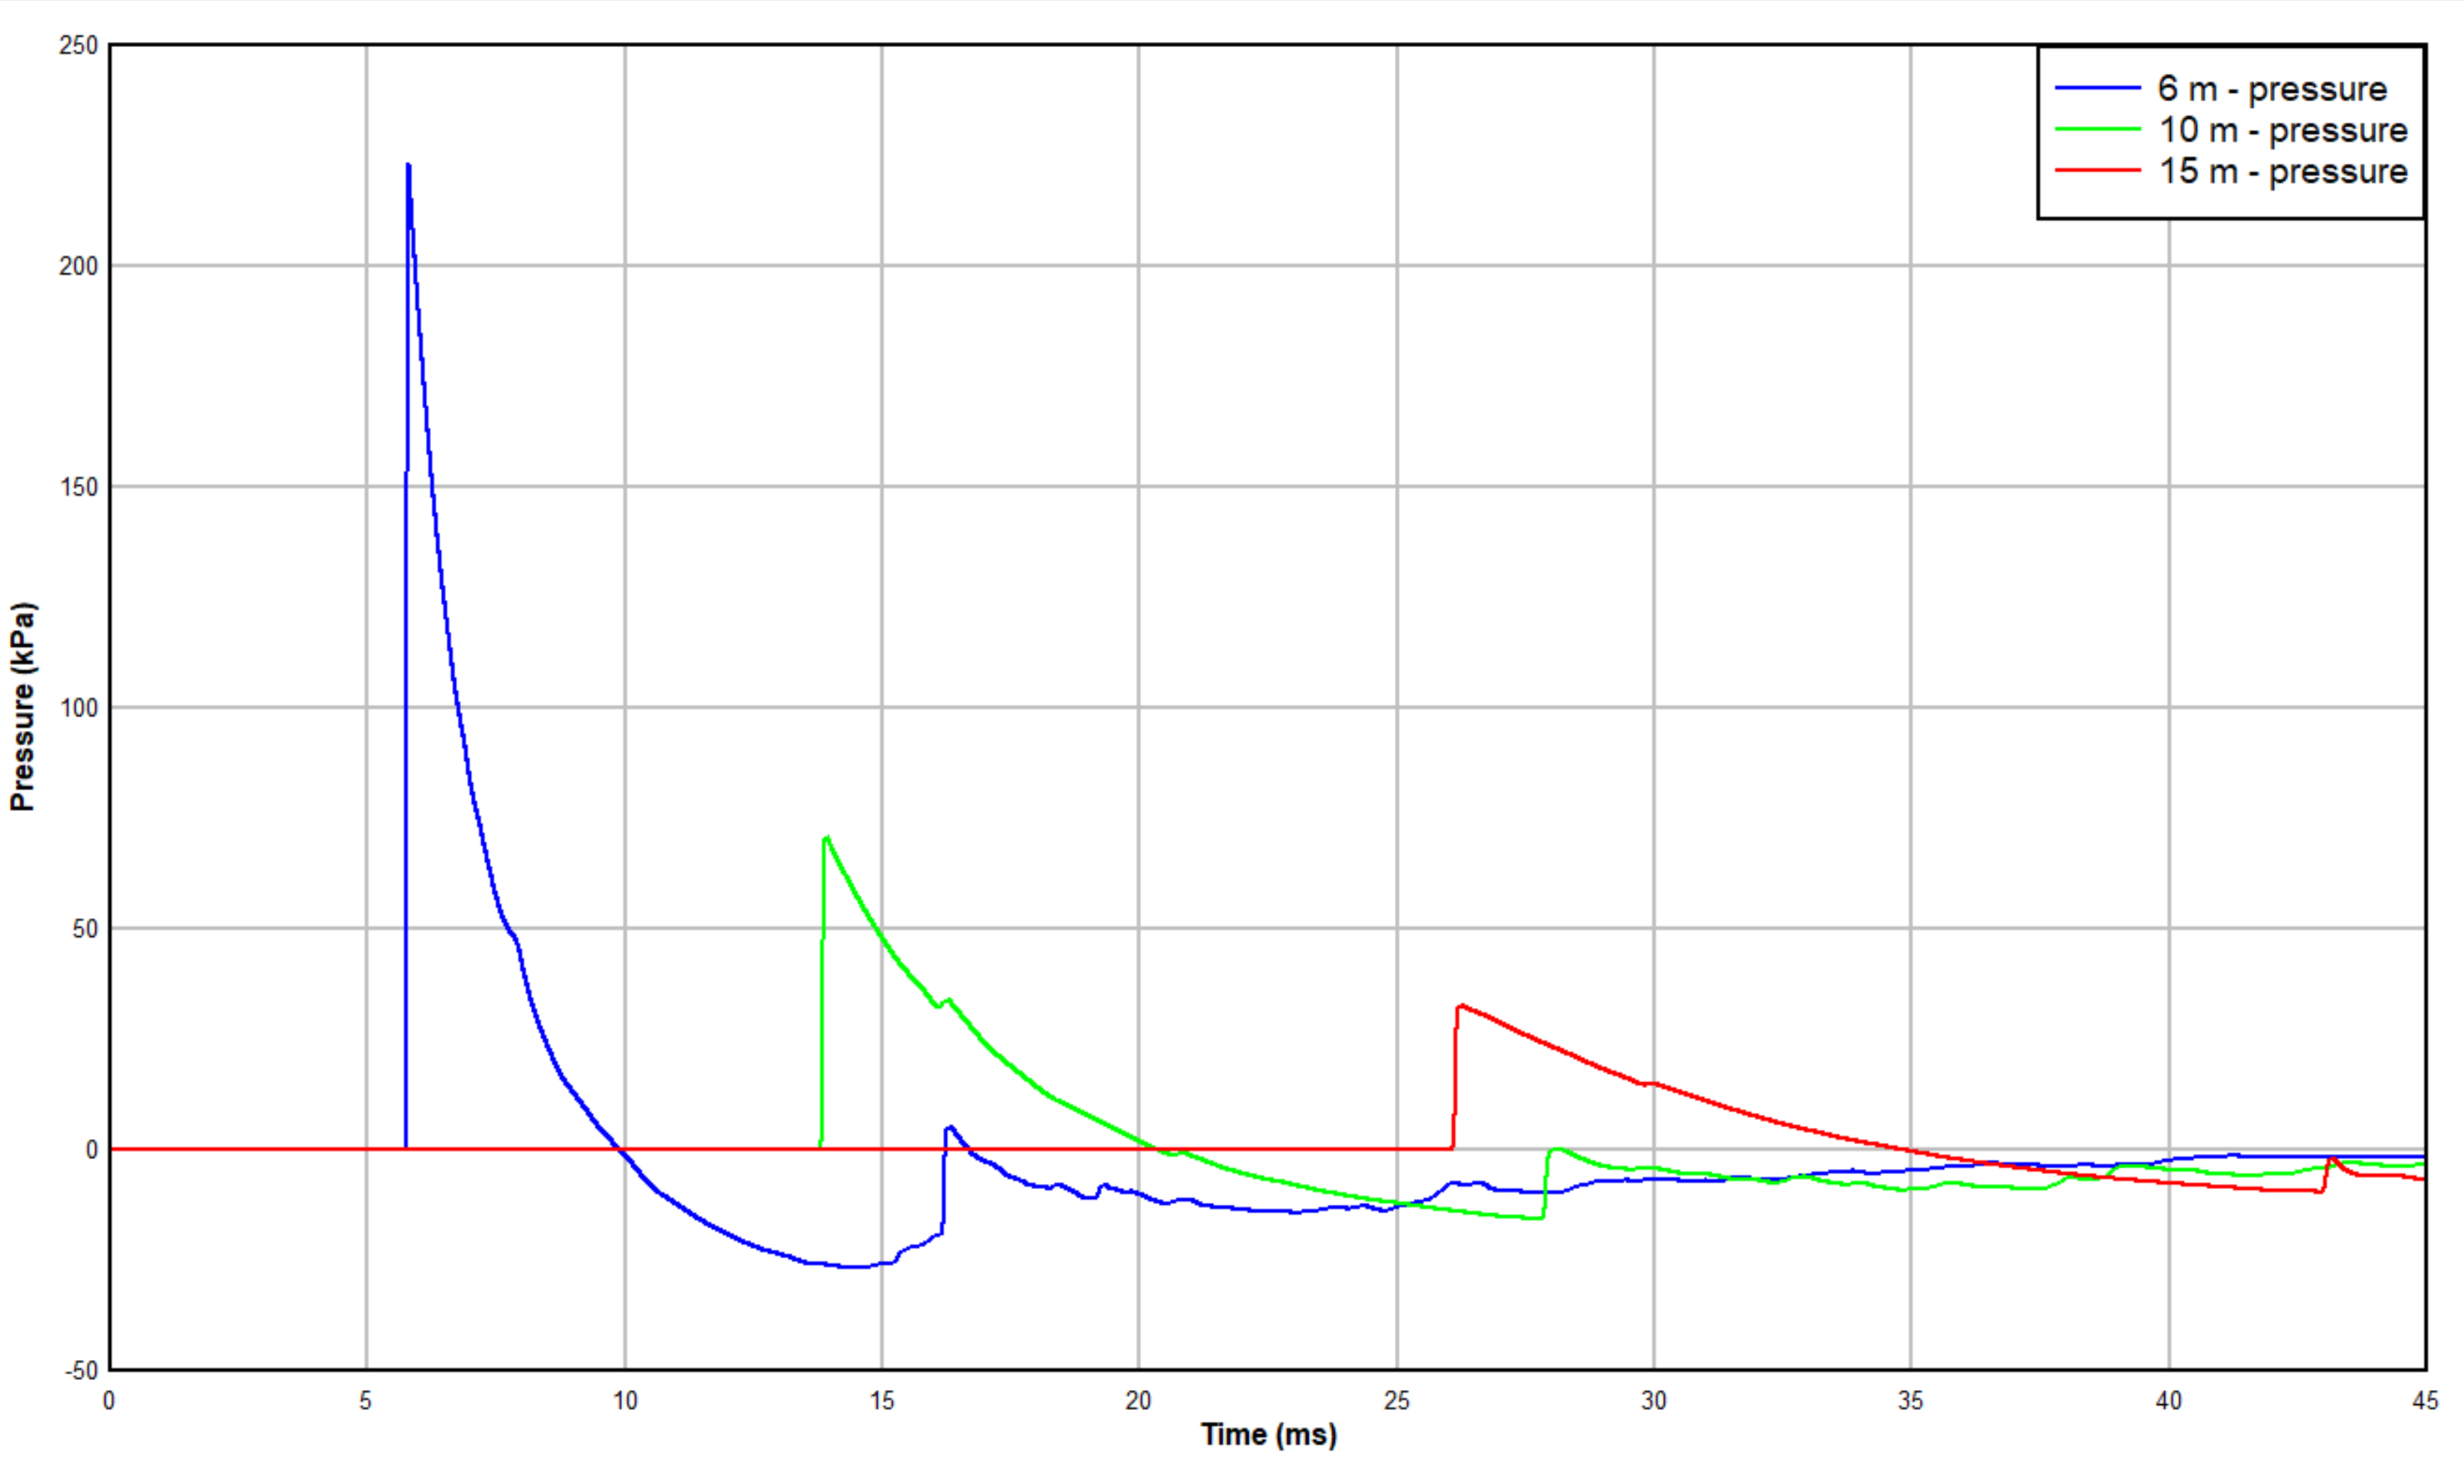
Figure 32 Overpressure for 13.9 kg of nitromethane simulation
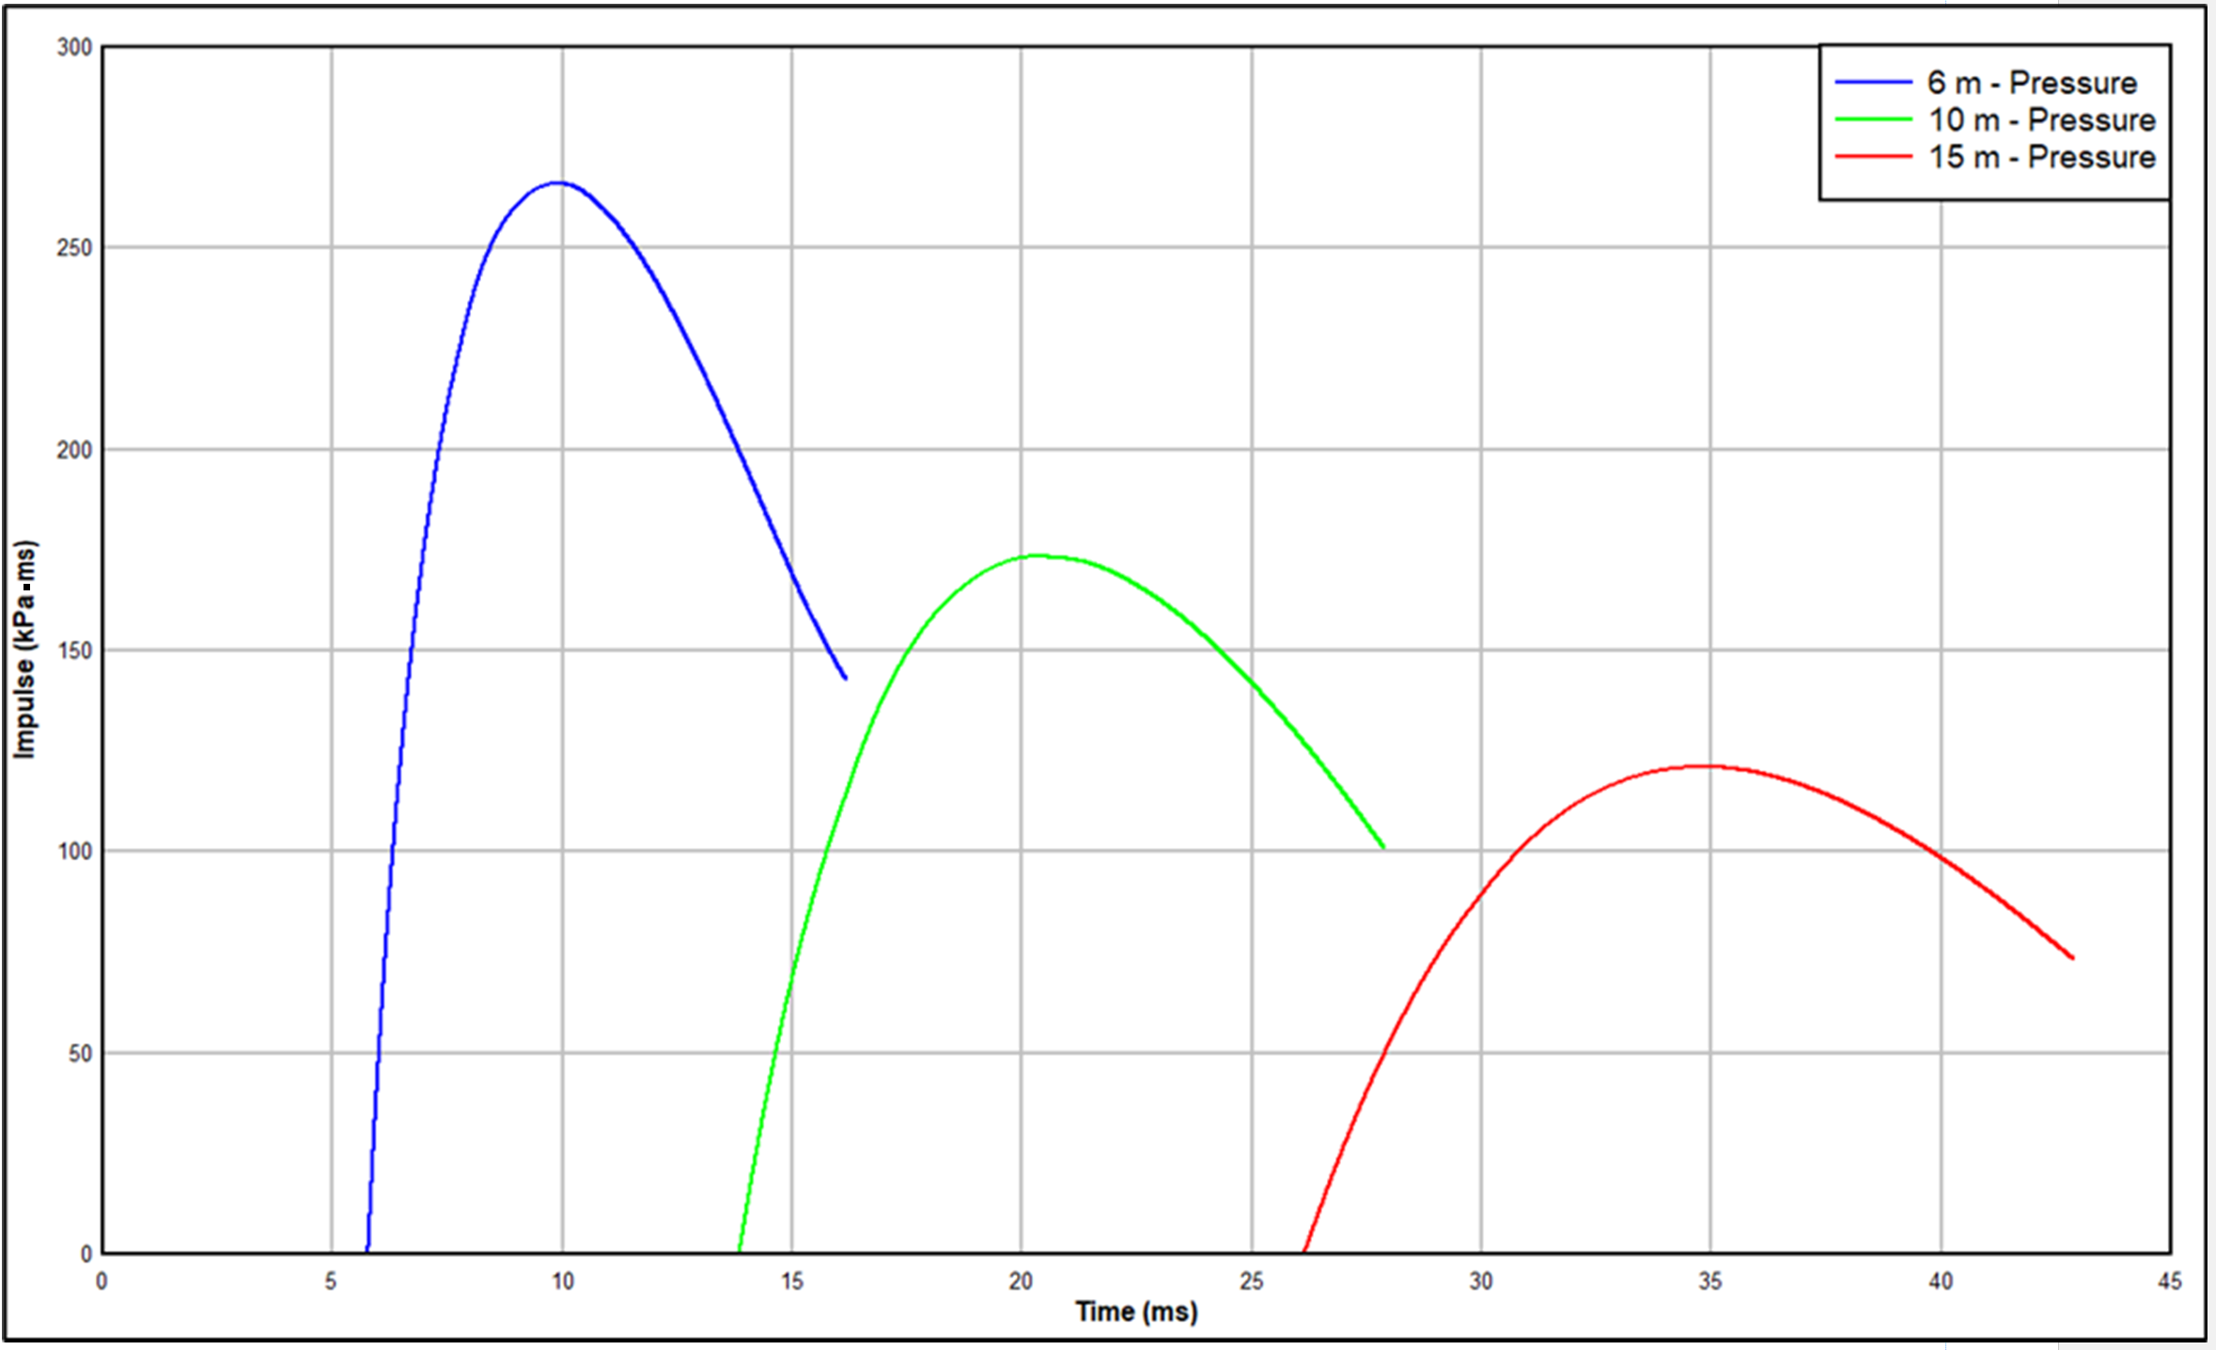
Figure 33 Impulse for 13.9 kg of nitromethane simulation

Appendix 3 – Risk Assessment and COSHH Assessment

Bare Charges Risk Assessment
A copy of the risk assessment used for bare charge explosions is included below; names and sensitive information have been removed.
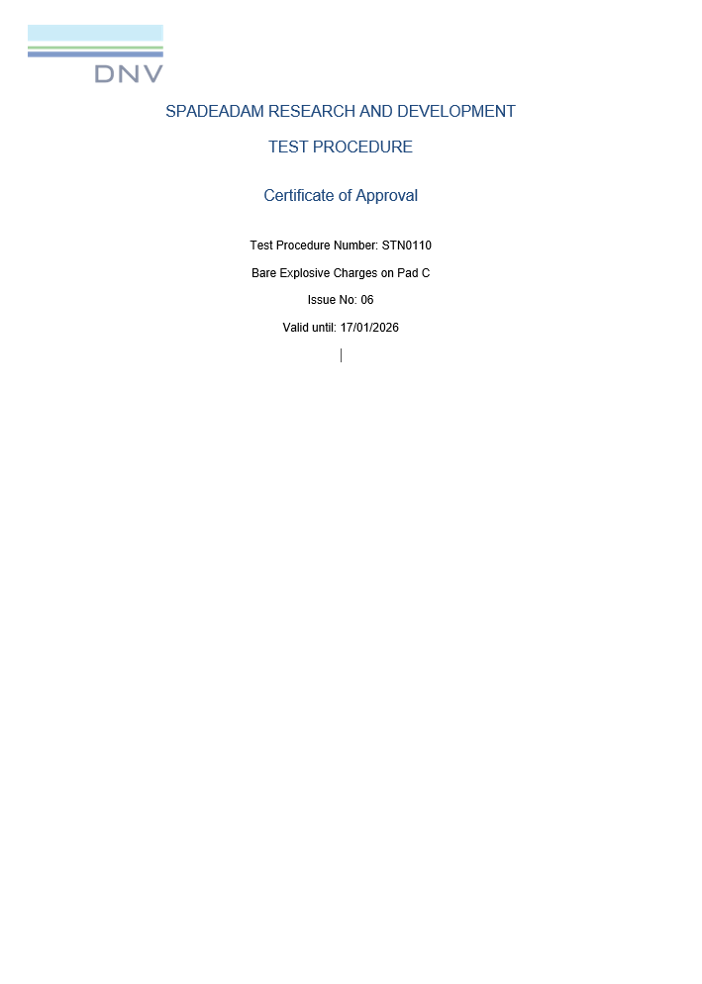
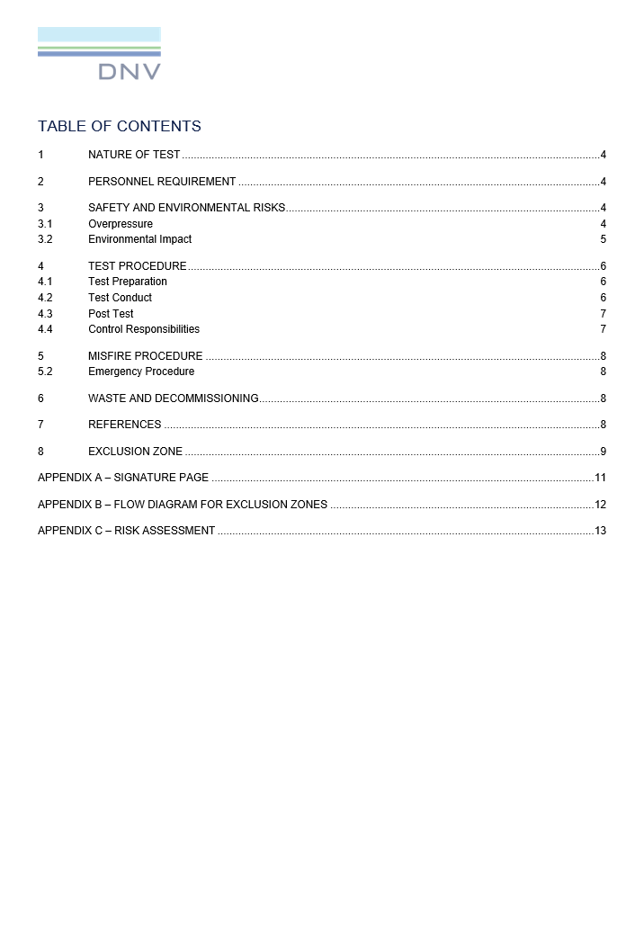
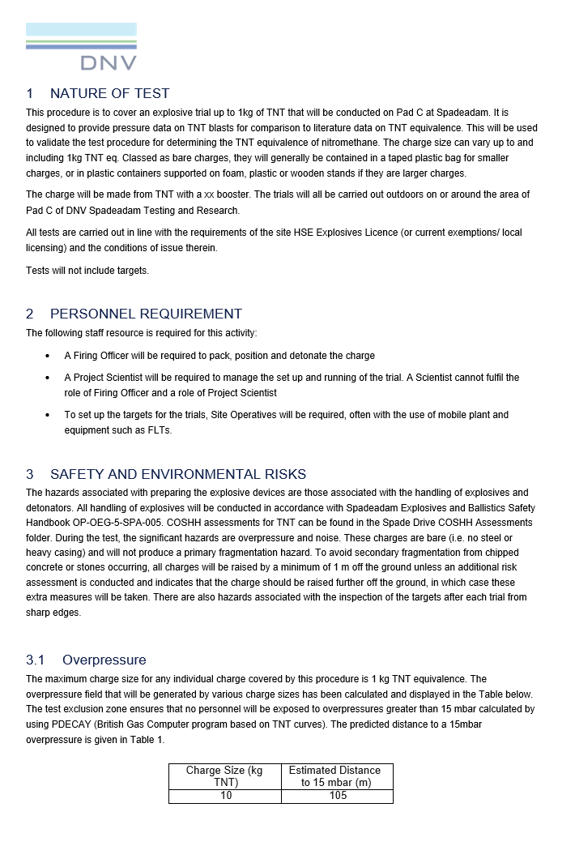

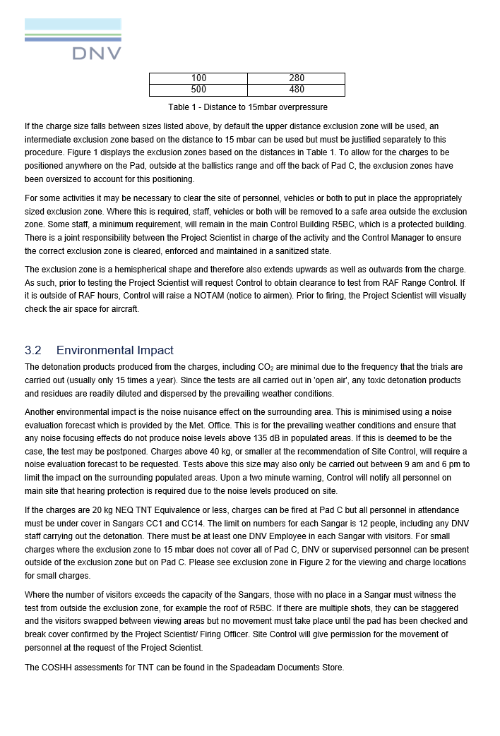

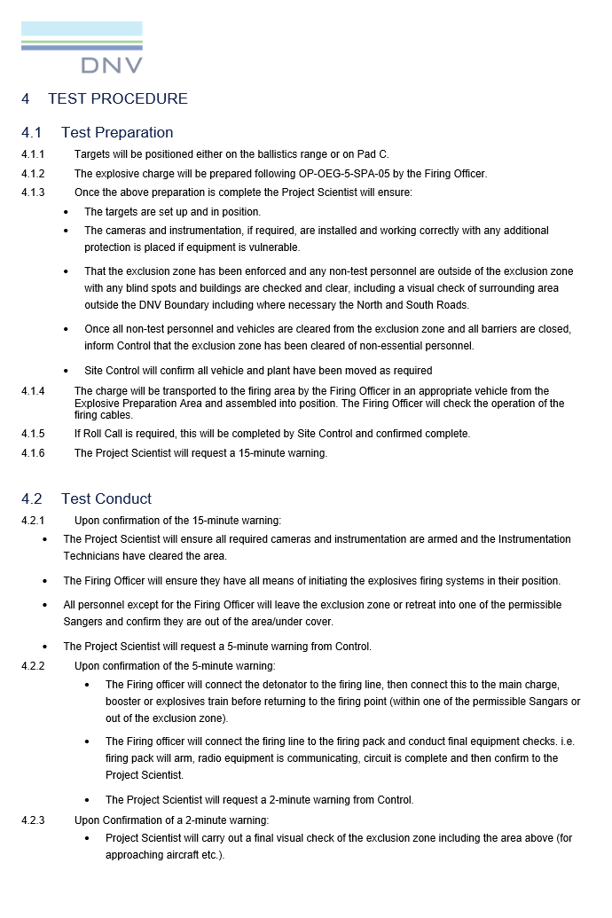
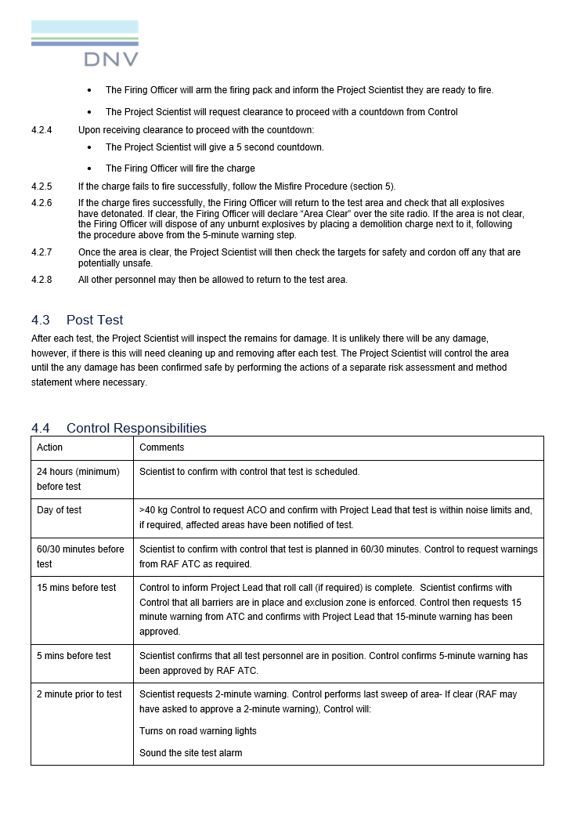

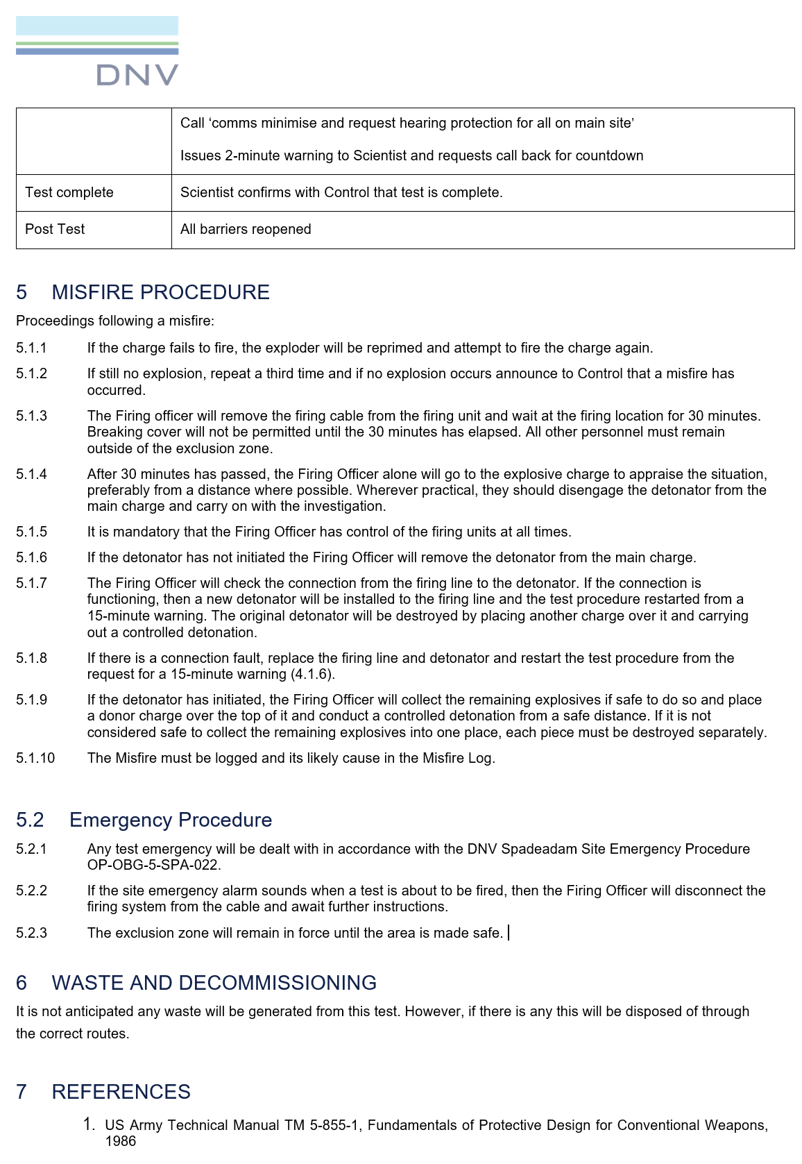

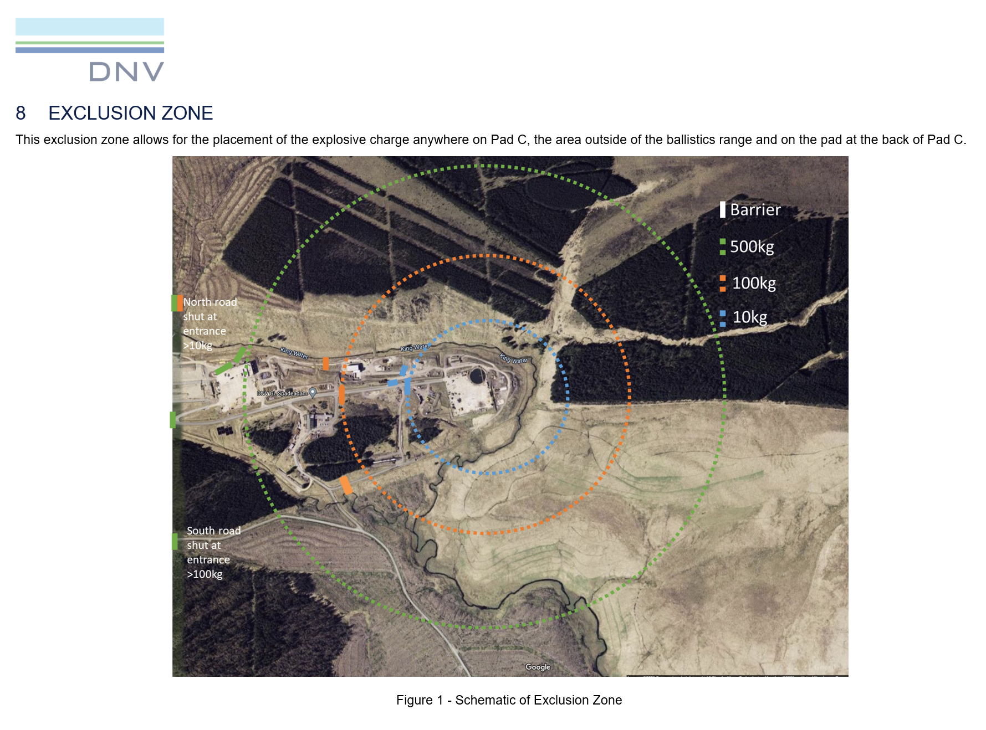
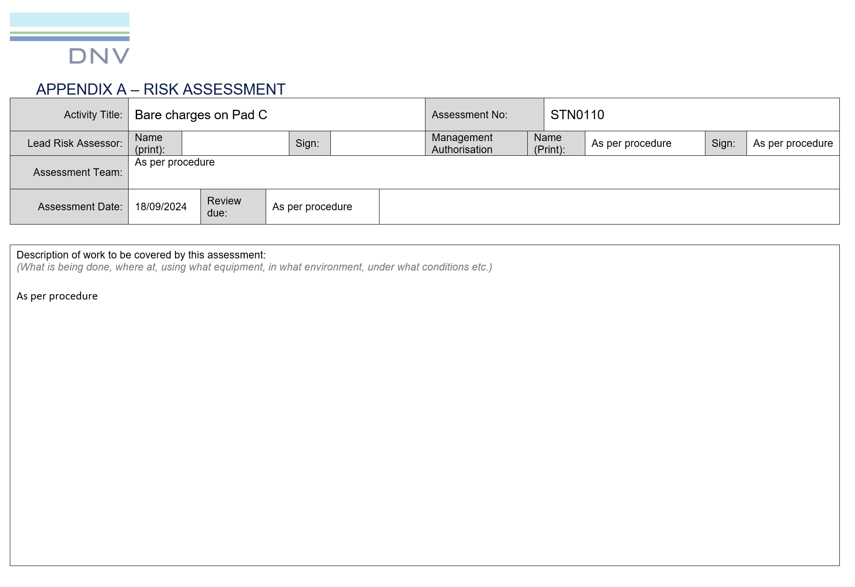
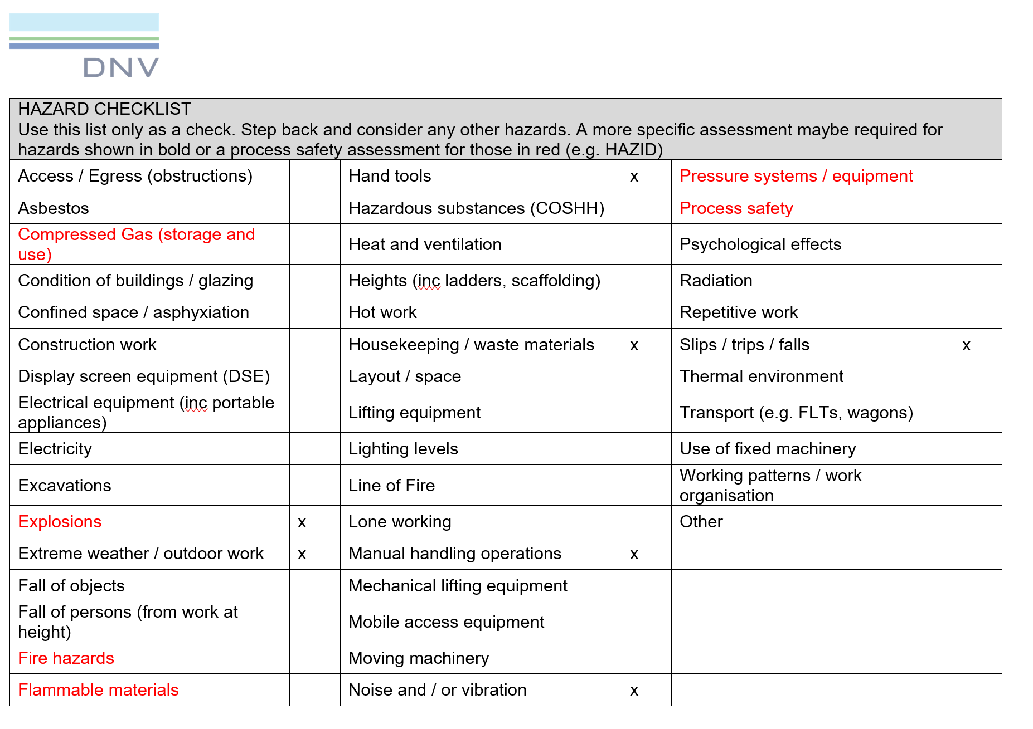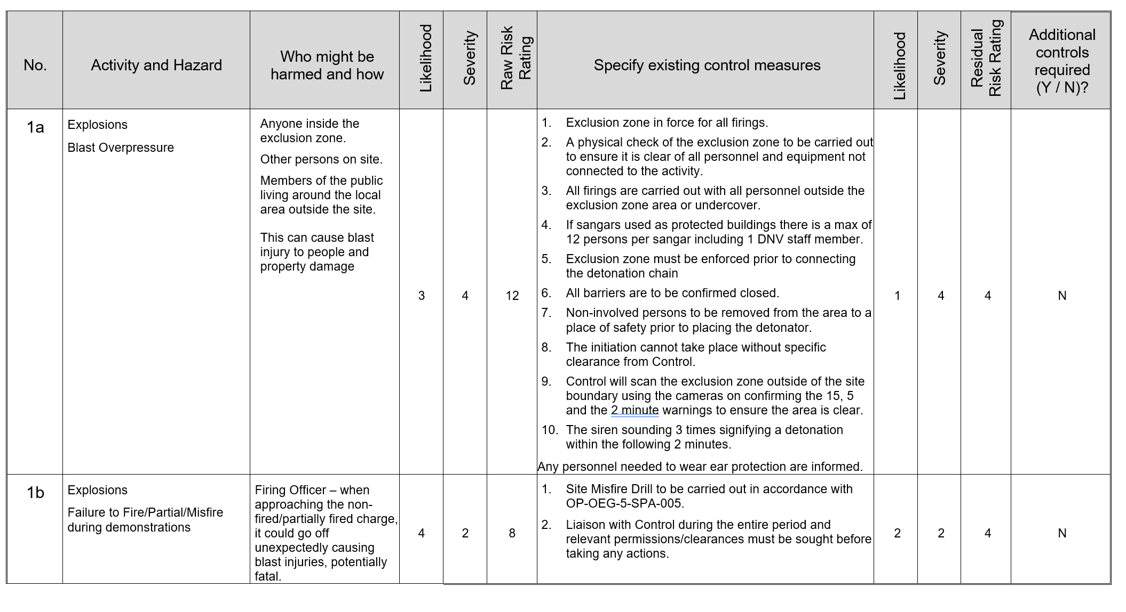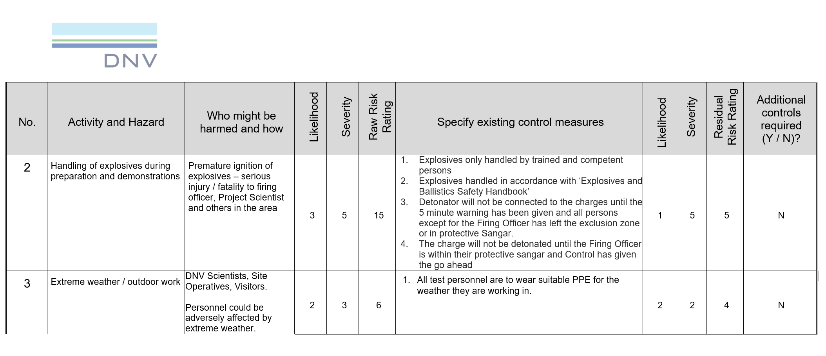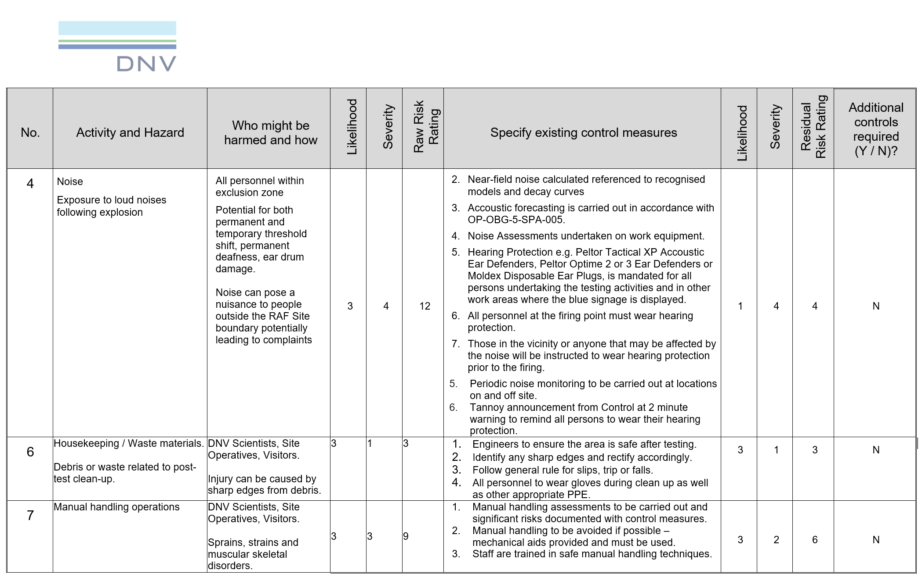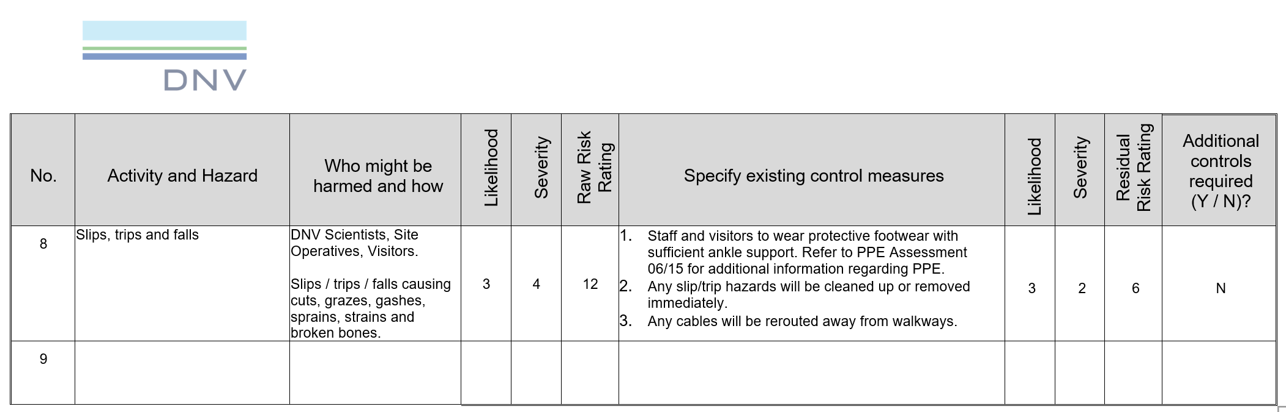
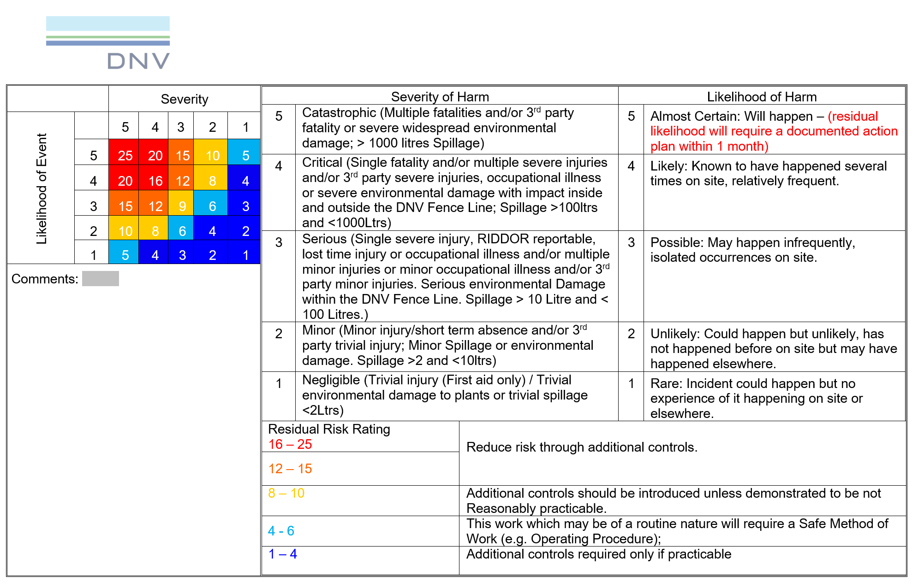

Nitromethane COSHH Assessment
The nitromethane COSHH assessment has been included below; names and sensitive information have been removed.
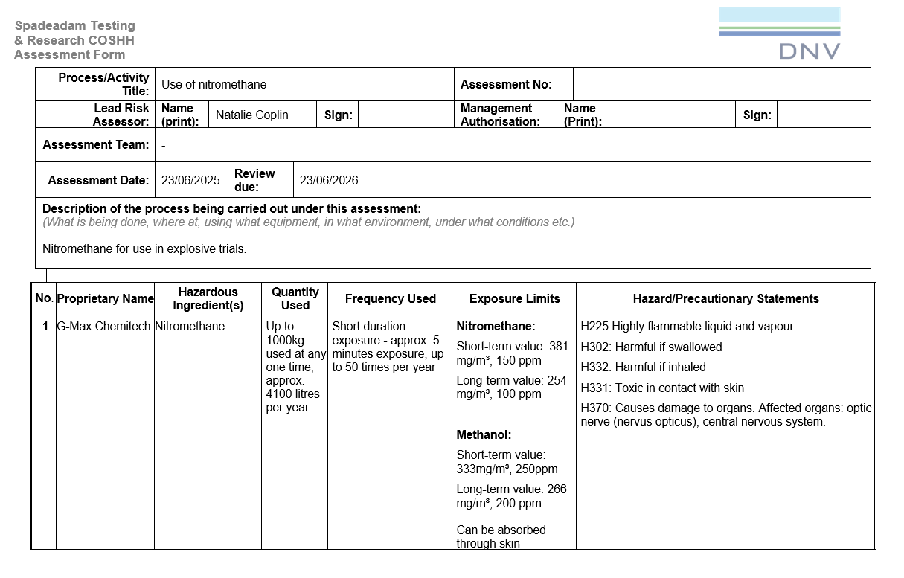
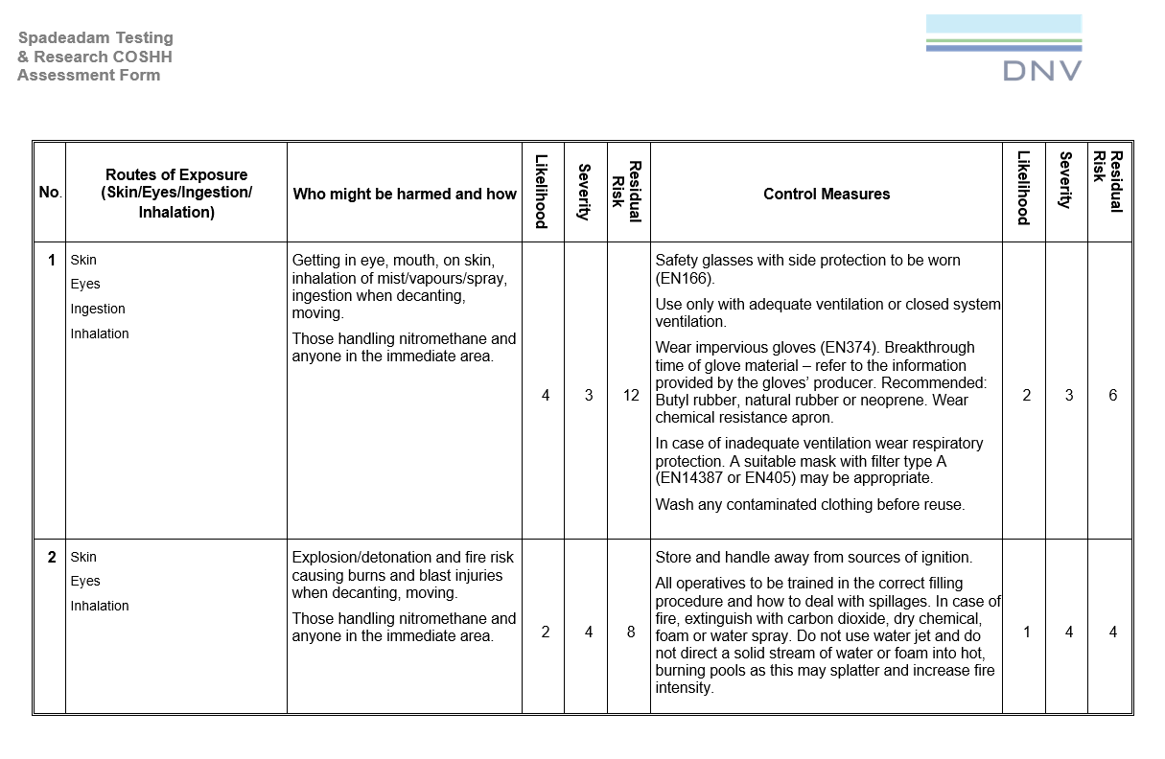
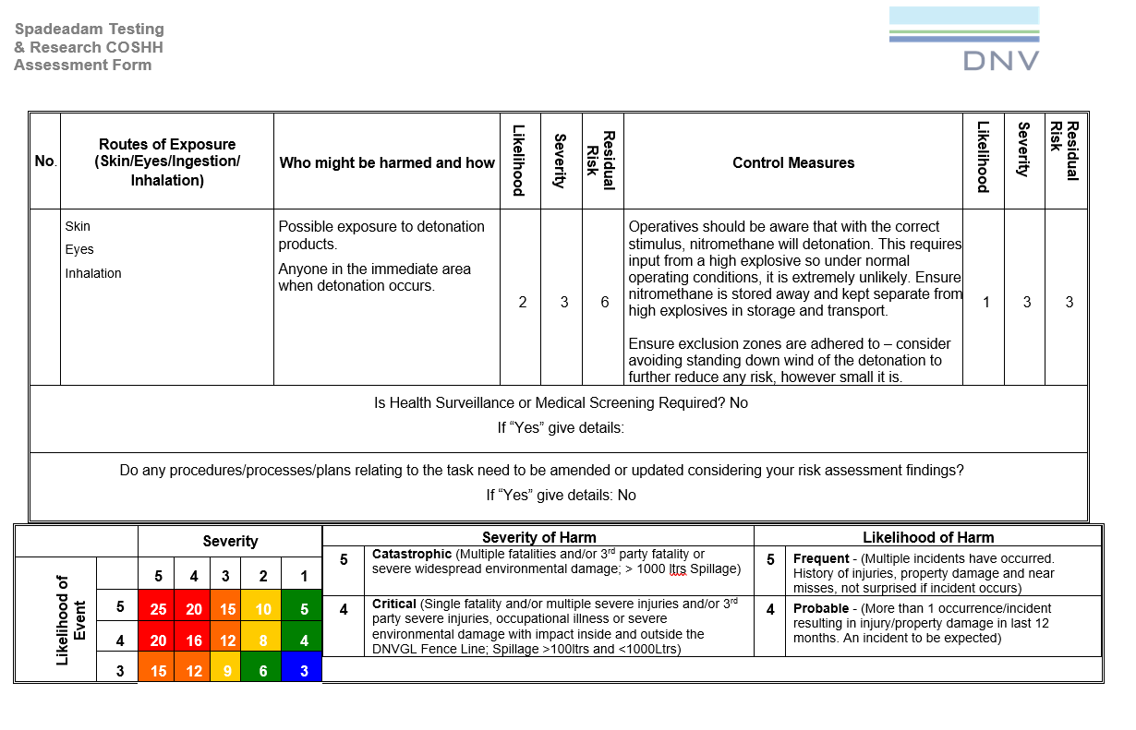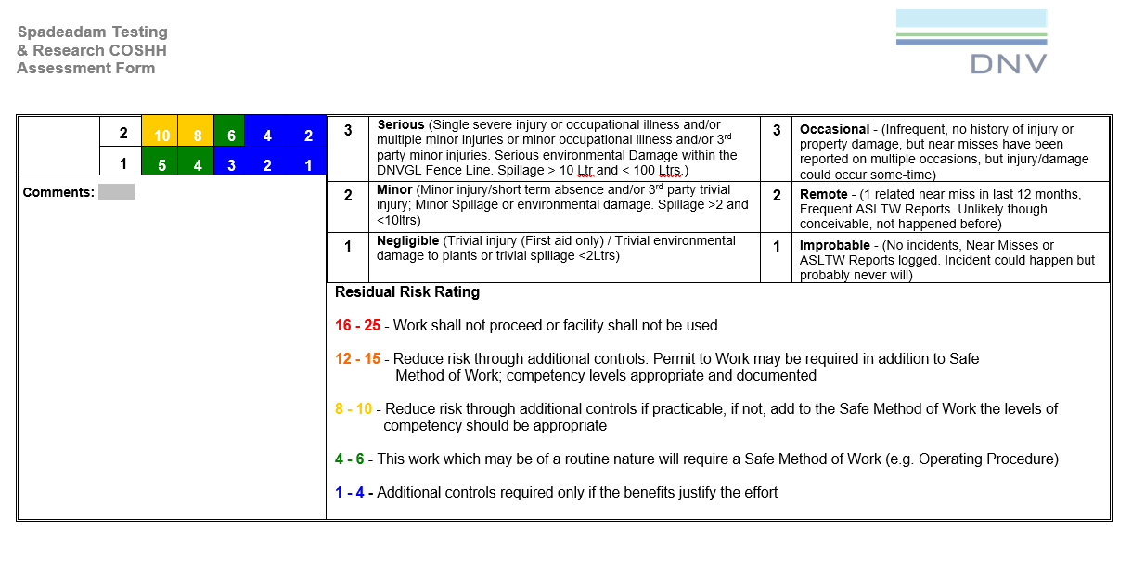

Appendix 4 – Trial checklist
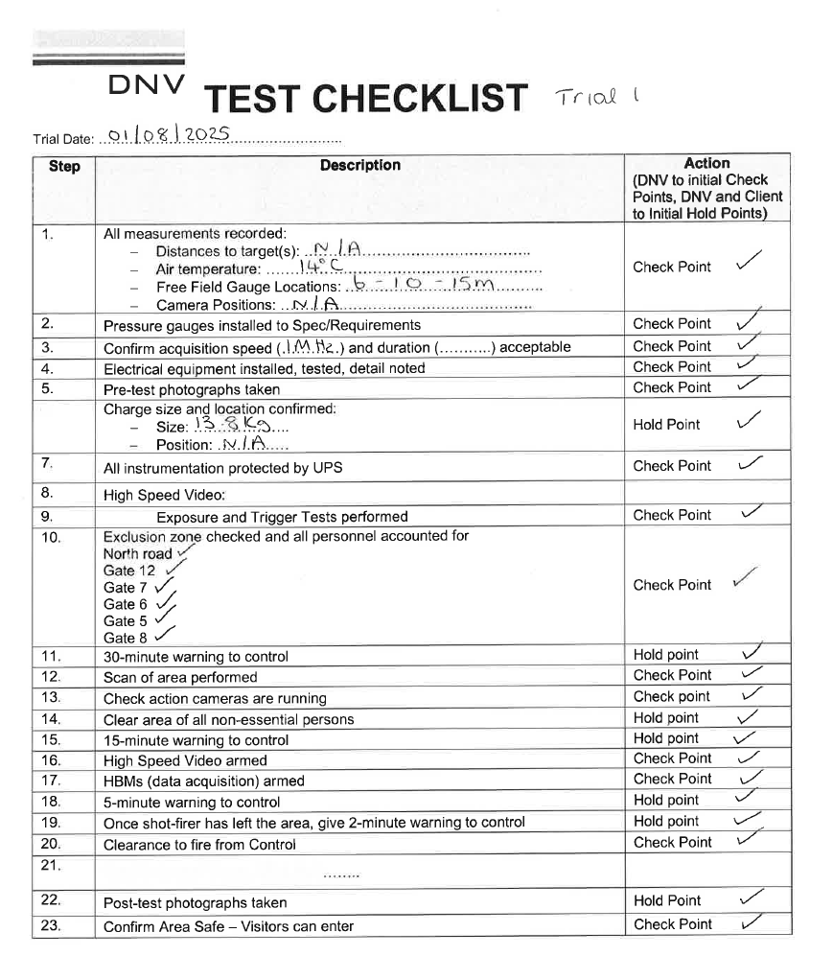

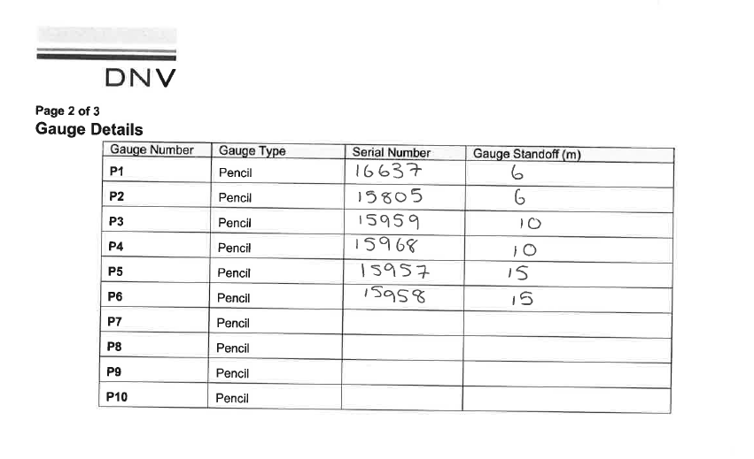
Table 15 Gauge details - nitromethane trials
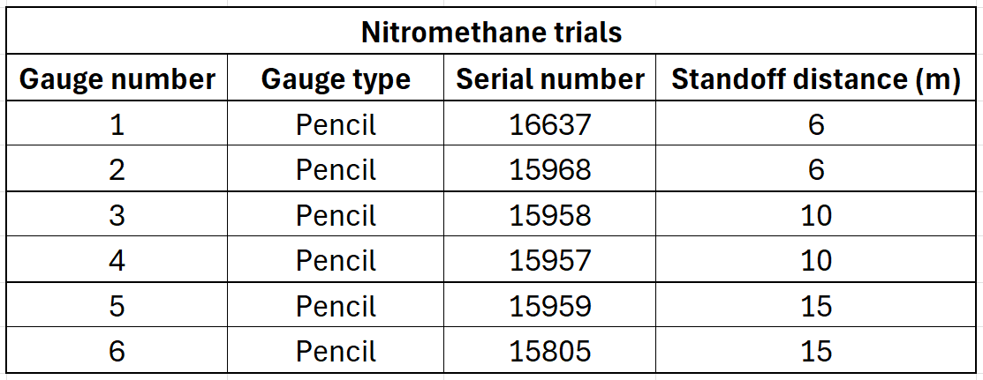

Table 16 Gauge details - TNT trial
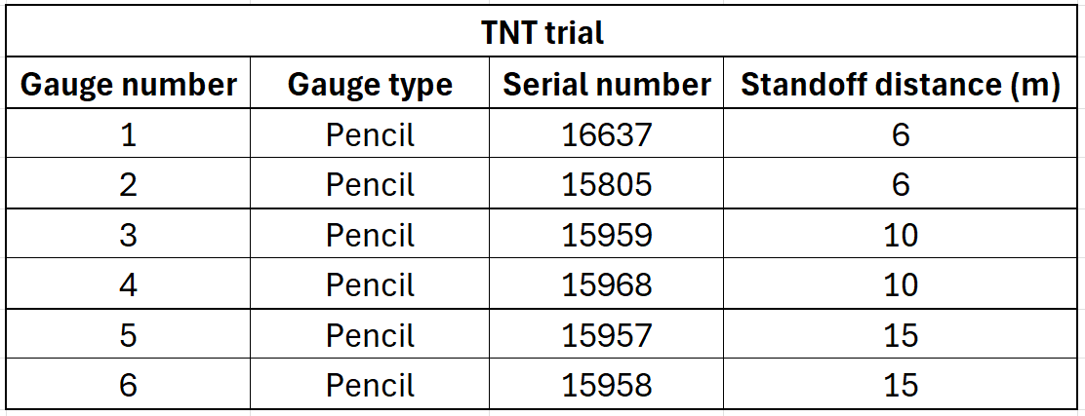

Appendix 5 – Project Management

Gantt Chart
Figure 34 shows the original project Gantt chart and Figure 35 shows the updated version reflecting the actual progression. Due to conflicting demands for the test pad at DNV Spadeadam, the trials were delayed until August, and the TNT trial took place in February. Although this differed from the original plan, contingency time had been built into the schedule and therefore the delay did not impact the progression of the project, nor did it result in a change in the methodology. Progress was tracked through regular meetings with the Explosives Team Project Manager, and the Gantt chart was updated accordingly. As a result, the delays did not affect the project reporting phase, or the achievement of the project aims.
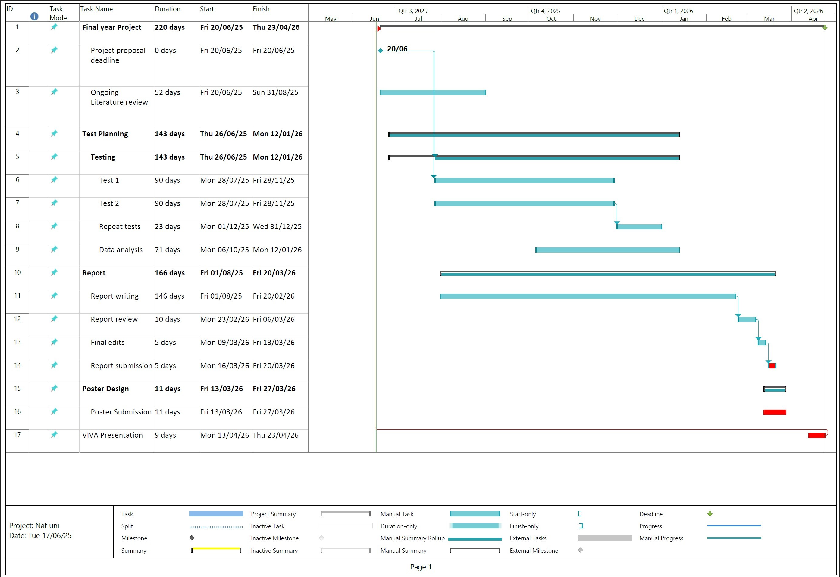
Figure 34 Original Gantt chart
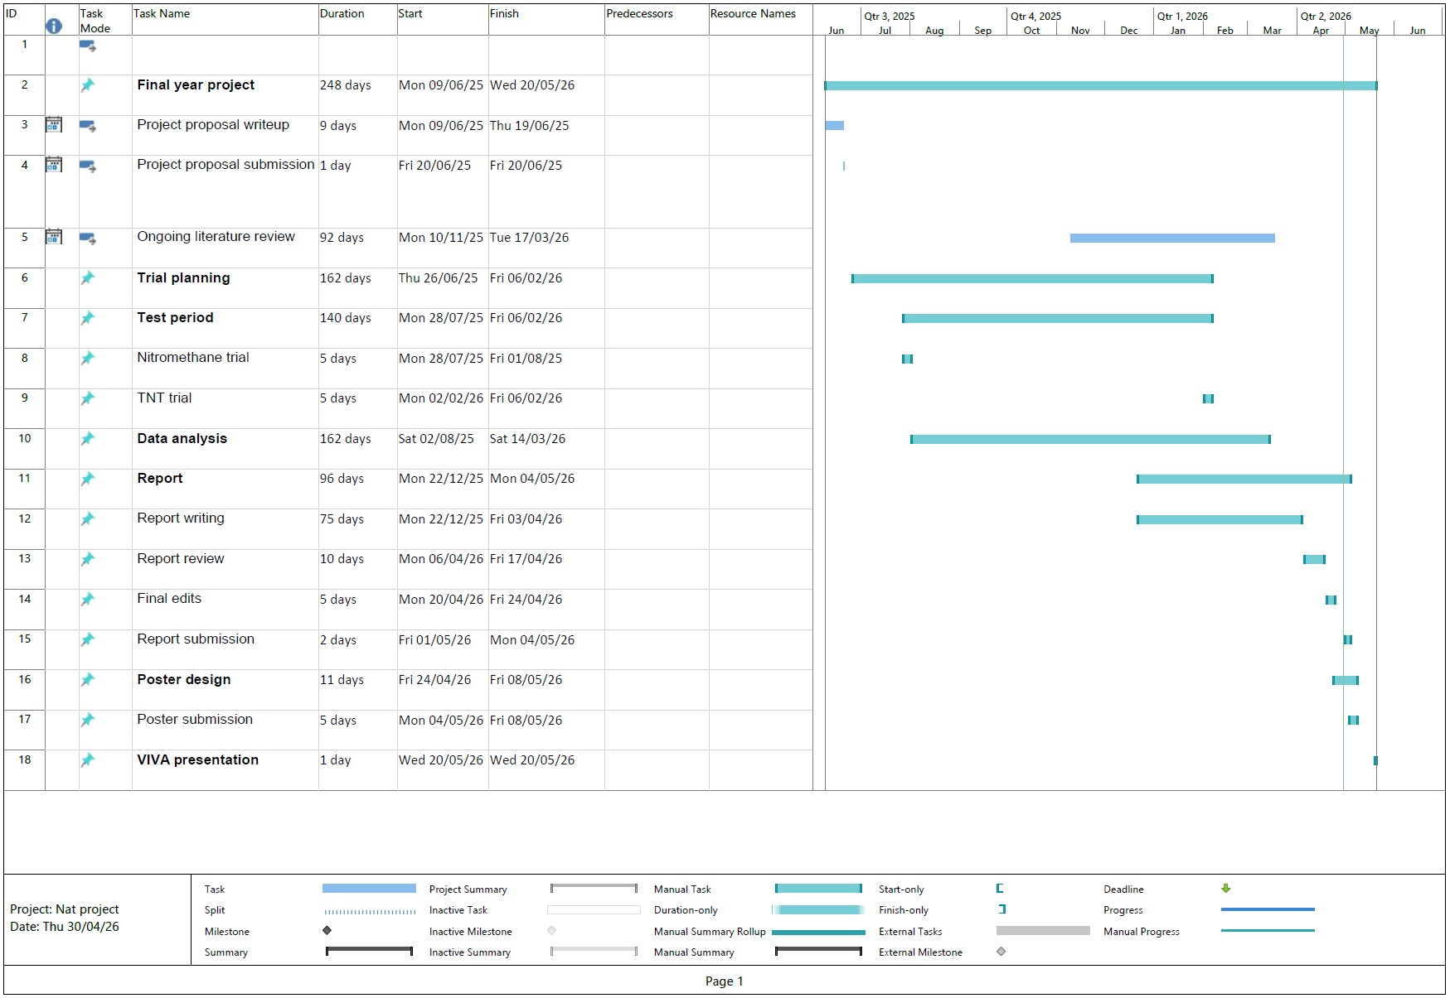
Figure 35 Updated Gantt chart

Appendix 6 – Ethics Form
APPLICATION FOR ETHICAL APPROVAL

In order for research to result in benefit and minimise risk of harm, it must be conducted ethically.

The University follows the OECD Frascati manual definition of research activity: “creative work undertaken on a systematic basis in order to increase the stock of knowledge, including knowledge of man, culture and society, and the use of this stock of knowledge to devise new applications”. As such this covers activities undertaken by members of staff, postgraduate research students, and both taught postgraduate and undergraduate students working on dissertations/projects.
The individual undertaking the research activity is known as the “principal researcher”.
This form must be completed and approved prior to undertaking any research activity.
SECTION A: About You (Principal Researcher)
1 | Full Name: | Natalie Coplin
2 | Student Number: | 2113351
3 | Email address: | 2113351@student.uwtsd.ac.uk
4 | Programme of Study: | Ordnance, munitions and explosives
5 | Director of Studies/Supervisor: | TBC

SECTION B: Internal and External Ethical Guidance Materials
 | Please list the core ethical guidance documents that have been referred to during the completion of this form (including any discipline-specific codes of research ethics, location-specific dodes of research ethics, and also any specific ethical guidance relating to the proposed methodology). Please tick to confirm that your research proposal adheres to these codes and guidelines. You may add rows to this table if needed.
1 | UWTSD Research Ethics & Integrity Code of Practice | ☒
2 | UWTSD Research Data Management Policy | ☒
3 |  | ☐

SECTION C: Details of Research Activity
1 | Indicative title: | Determination of TNT equivalence of Nitromethane in charge sizes of 15kg or less.
2 | Proposed start date: | August 2025 | Proposed end date: | End of Dec 2025
Introduction to the Research (maximum 300 words in each section)
Ensure that you write for a Non-Specialist Audience when outlining your response to the three points below:
- Purpose of Research Activity
- Proposed Research Question
- Aims of Research Activity
- Objectives of Research Activity
Demonstrate, briefly, how Existing Research has informed the proposed activity and explain
- What the research activity will add to the body of knowledge
- How it addresses an area of importance.
3 | Purpose of Research Activity  To establish if a plastic mouldable explosive (PE4) can be replaced by the fuel nitromethane, in small charge sizes. To do so, when nitromethane is made to detonate, it will need to produce the same blast effect as PE4 for it to be useable in future tests. DNV Spadeadam have already performed this test on larger charge sizes, but now there is a requirement to see if the tests can be scaled down, providing justification to replace PE4 with nitromethane. The requirement has been generated due to poor lead times and rising costs of PE4.
4 | Research Question  What is the TNT equivalence of Nitromethane in charges of 15kg and less.
5 | Aims of Research Activity  To determine the TNT equivalence value of nitromethane and compare this value to that of PE4.
6 | Objectives of Research Activity  The objectives of this project are:  - Conduct a literature review into the use of nitromethane as an explosive.  - Perform a series of blast tests to collect pressure-time data.  - Analyse data and calculate a TNT equivalence for nitromethane.  - Produce an 8000-word report on the trial and data.  - Document blast tests and results in a poster presentation
Proposed data collection methods (maximum 600 words)
Provide a brief summary of all the methods that may be used in the research activity to collect data, making it clear what specific techniques may be used. If methods other than those listed in this section are deemed appropriate later, additional ethical approval for those methods will be needed. You do not need to justify the methods here but should instead describe how you intend to collect the data necessary for you to complete your project.
7 | Pressure data from nitromethane (and potentially TNT) detonations will be collected. This is done by attaching pressure gauges to data loggers and measuring the over pressure generated during a blast test. Video recordings of the detonations may take place using go-pro like cameras on the test site. There will no recordings of individuals.

SECTION D: Scope of Research Activity
 | Will the research activity include: | YES | NO
1 | Use of a questionnaire or similar research instrument? | ☐ | ☒
2 | Use of interviews? | ☐ | ☒
3 | Use of focus groups? | ☐ | ☒
4 | Use of participant diaries? | ☐ | ☒
5 | Use of video or audio recording? | ☒ | ☐
6 | Use of computer-generated log files? | ☒ | ☐
7 | Participant observation with their knowledge? | ☐ | ☐
8 | Participant observation without their knowledge? | ☐ | ☒
9 | Access to personal or confidential information without the participants’ specific consent? | ☐ | ☒
10 | Administration of any questions, test stimuli, presentation that may be experienced as physically, mentally or emotionally harmful / offensive? | ☐ | ☒
11 | Performance of any acts which may cause embarrassment or affect self-esteem? | ☐ | ☒
12 | Investigation of participants involved in illegal activities? | ☐ | ☒
13 | Use of procedures that involve deception? | ☐ | ☒
14 | Administration of any substance, agent or placebo? | ☐ | ☒
15 | Working with live vertebrate animals? | ☐ | ☒
16 | Procedures that may have a negative impact on the environment? | ☒ | ☐
17 | Other primary data collection methods. Please indicate the type of data collection method(s) below. | ☐ | ☒
 | Details of any other primary data collection method: | ☐ | ☒

If you have ticked NO to every question then the research activity is (ethically) low risk and you may skip section E and continue to section F.
If YES to any question, then no research activity should be undertaken until full ethical approval has been obtained.

SECTION E: Intended Participants
 | Who are the intended participants: | YES | NO
1 | Students or staff at the University? | ☐ | ☒
2 | Adults (over the age of 18 and competent to give consent)? | ☐ | ☒
3 | Vulnerable adults? | ☐ | ☒
4 | Children and Young People under the age of 18? (Consent from Parent, Carer or Guardian will be required) | ☐ | ☒
5 | Prisoners? | ☐ | ☒
6 | Young offenders? | ☐ | ☒
7 | Those who could be considered to have a particularly dependent relationship with the investigator or a gatekeeper? | ☐ | ☒
8 | People engaged in illegal activities? | ☐ | ☒
9 | Others. Please indicate the participants below, and specifically any group who may be unable to give consent. | ☐ | ☒
 | Details of any other participant groups: | ☐ | ☒

Participant numbers and source
Provide an estimate of the expected number of participants. How will you identify participants and how will they be recruited?
10 | How many participants are expected? | N/A
11 | Who will the participants be? | N/A
12 | How will you identify the participants? | N/A

 | Information for participants: | YES | NO | N/A
13 | Will you describe the main research procedures to participants in advance, so that they are informed about what to expect? | ☐ | ☐ | ☒
14 | Will you tell participants that their participation is voluntary? | ☐ | ☐ | ☒
15 | Will you obtain written consent for participation? | ☐ | ☐ | ☒
16 | Will you explain to participants that refusal to participate in the research will not affect their treatment or education (if relevant)? | ☐ | ☐ | ☒
17 | If the research is observational, will you ask participants for their consent to being observed? | ☐ | ☐ | ☒
18 | Will you tell participants that they may withdraw from the research at any time and for any reason? | ☐ | ☐ | ☒
19 | With questionnaires, will you give participants the option of omitting questions they do not want to answer? | ☐ | ☐ | ☒
20 | Will you tell participants that their data will be treated with full confidentiality and that, if published, it will not be identifiable as theirs? | ☐ | ☐ | ☒
21 | Will you debrief participants at the end of their participation, in a way appropriate to the type of research undertaken? | ☐ | ☐ | ☒
22 | If NO to any of above questions, please give an explanation
 | You should be able to tick YES for all of these questions. If not, then explain why not in this box.

 | Information for participants: | YES | NO | N/A
24 | Will participants be paid? | ☐ | ☐ | ☒
25 | Is specialist electrical or other equipment to be used with participants? | ☐ | ☐ | ☒
26 | Are there any financial or other interests to the investigator or University arising from this study? | ☐ | ☐ | ☒
27 | Will the research activity involve deliberately misleading participants in any way, or the partial or full concealment of the specific study aims? | ☐ | ☐ | ☒
28 | If YES to any question, please provide full details
 | You should be able to tick NO for most of these questions. For any cases that you have ticked YES then provide details in this box. If you are using cameras/voice recorders to record interviews then please state that in this box.

SECTION F: Anticipated Risks

 | Outline any anticipated risks that may adversely affect any of the participants, the researchers and/or the University, and the steps that will be taken to address them.
1 | Risks to participants  For example: sector-specific health & safety, emotional distress, financial disclosure, physical harm, transfer of personal data, sensitive organisational information. If you have identified in section D that there are no participants then enter N/A and go skip to question 3.
 | Risk to participants:  N/A | How you will mitigate the risk to participants:  N/A
2 | If research activity may include sensitive, embarrassing or upsetting topics (e.g. sexual activity, drug use) or issues likely to disclose information requiring further action (e.g. criminal activity), give details of the procedures to deal with these issues, including any support/advice (e.g. helpline numbers) to be offered to participants. Note that where applicable, consent procedures should make it clear that if something potentially or actually illegal is discovered in the course of a project, it may need to be disclosed to the proper authorities
 | N/A
3 | Risks to the investigator  For example: personal health & safety, physical harm, emotional distress, risk of accusation of harm/impropriety, conflict of interest
 | Risk to the investigator:  Contact with nitromethane (skin, eyes, inhalation, ingestion).  Blast and fire risk. | How you will mitigate the risk to the investigator:  A COSHH assessment for nitromethane been completed. Protective measures are outlined in detail in there and will be followed:  - Wear PPE, including chemically resistance gloves, full arm/leg covering, safety glasses.  - Use only in well-ventilated areas.  - Do not transport with explosives.  - Strict adherence to site exclusion zones for 15kg blasts.  - Strict adherence to the blast testing protocol.  - Only those trained in test set up will be allowed to handle material.  - Permission to fire must be obtain from the control room before testing can occur. This enables control room to ensure the exclusion zone is clear of all personnel.  - No lone working, test only between 9-5.
4 | University/institutional risks  For example: adverse publicity, financial loss, data protection
 | Risk to the University:  Reputational damage due to student injury  (this box should expand as you type) | How you will mitigate the risk to the University:  Workplace test procedures will be followed, including exclusion zones and control room permission before any test takes place. No lone working will take place.  Testing will only be conducted between 9-5.
5 | Environmental risks  For example: accidental spillage of pollutants, damage to local ecosystems
 | Risk to the environment:  Noise impact to the area local to the test site.  Detonation products.  Accidental spillage. | How you will mitigate the risk to environment:  The student’s workplace has a uses a noise forecast technique based on the weather. Anticipated noise pollution will be checked prior to any testing and if above the limit, no testing will take place until such time that the noise will not be a nuisance.  Any detonation products will dissipate quickly and are not considered to be an environmental risk. Only small quantities will be used and minimal testing will be performed.  Nitromethane is stored in a fully bunded site. All staff who may handle nitromethane are trained to deal with any spills.

SECTION G: Feedback, Consent and Confidentiality
If you have identified in section D that there are no participants, then enter skip this section and continue to section H.
1 | Feedback  What de-briefing and feedback will be provided to participants, how will this be done and when?
2 | Informed consent  Describe the arrangements to inform potential participants, before providing consent, of what is involved in participating. Describe the arrangements for participants to provide full consent before data collection begins. If gaining consent in this way is inappropriate, explain how consent will be obtained and recorded in accordance with prevailing data protection legislation.
 | N/A
3 | Confidentiality / Anonymity  Set out how anonymity of participants and confidentiality will be ensured in any outputs. If anonymity is not being offered, explain why this is the case.
 | N/A

SECTION H: Data Protection and Storage
 | Does the research activity involve personal data (as defined by the General Data Protection Regulation 2016 “GDPR” and the Data Protection Act 2018 “DPA”)? | YES | NO
1 | “Personal data” means any information relating to an identified or identifiable natural person (‘data subject’). An identifiable natural person is one who can be identified, directly or indirectly, in particular by reference to an identifier such as a name, an identification number, location data, an online identifier or to one or more factors specific to the physical, physiological, genetic, mental, economic, cultural or social identity of that natural person. Any video or audio recordings of participants is considered to be personal data. | ☐ | No
 | If YES, provide a description of the data and explain why this data needs to be collected:
2 | This includes audio/video data of participants, but can also include IP addresses and usernames. Names, addresses and emails also count, as do consent forms.
 | Does it involve special category data (as defined by the GDPR)? | YES | NO
3 | “Special category data” means sensitive personal data consisting of information as to the data subjects’ –  (a) racial or ethnic origin,  (b) political opinions,  (c ) religious beliefs or other beliefs of a similar nature,  (d) membership of a trade union (within the meaning of the Trade Union and Labour Relations (Consolidation) Act 1992),  (e) physical or mental health or condition,  (f) sexual life,  (g) genetics,  (h) biometric data (as used for ID purposes), | ☐ | No
 | If YES, provide a description of the special category data and explain why this data needs to be collected:
4 | What counts as ‘sensitive’ will differ between cultures. Any information on behaviour that is not in accordance with cultural norms would count as sensitive personal data.

 | Will data from the research activity (collected data, drafts of the thesis, or materials for publication) be stored in any of the following ways? | YES | NO
5 | Manual files (i.e. in paper form)? | ☐ | ☒
6 | University computers? | ☐ | ☒
7 | Private company computers? | ☐ | ☒
8 | Home or other personal computers? | ☒ | ☐
9 | Laptop computers/ CDs/ Portable disk-drives/ memory sticks? | ☒ | ☐
10 | “Cloud” storage or websites? | ☐ | ☒
11 | Other – specify: | ☐ | ☒
12 | For all stored data, explain the measures in place to ensure the security of the data collected, data confidentiality, including details of backup procedures, password protection, encryption, anonymisation and pseudonymisation:
If possible, save your data on computers that are secure and regularly backed up. Many cloud services only provide GDPR-compliant storage for business customers. An example of suitable text is given below.

All test data will be kept on a password protected network at the student’s workplace which
will not be shared with anyone who does not require access. There are no confidentiality issues.

 | Data Protection
 | Will the research activity involve any of the following activities: | YES | NO
13 | Electronic transfer of data in any form? | ☒ | ☐
14 | Sharing of data with others at the University outside of the immediate research team? | ☐ | ☒
15 | Sharing of data with other organisations? | ☐ | ☒
16 | Export of data outside the UK or importing of data from outside the UK? | ☐ | ☒
17 | Use of personal addresses, postcodes, faxes, emails or telephone numbers? | ☐ | ☒
18 | Publication of data that might allow identification of individuals? | ☐ | ☒
19 | If YES to any question, please provide full details, explaining how this will be conducted in accordance with the GDPR and Data Protection Act (2018) (and/or any international equivalent):
No personal data will be collected or stored. Experimental data collected will be shared with my workplace.
(this box should expand as you type)
20 | List all who will have access to the data generated by the research activity:
Researcher, university supervisor, workplace team, external examiner, second marker, endpoint assessment team.

(this box should expand as you type)
21 | List who will have control of, and act as custodian(s) for, data generated by the research activity:
Principal researcher.

(this box should expand as you type)
22 | Give details of data storage arrangements, including security measures in place to protect the data, where data will be stored, how long for, and in what form.
N/A
(this box should expand as you type)
22 | Confirm that you have read the UWTSD guidance on data management (see https://www.uwtsd.ac.uk/library/research-data-management/) | ☒
23 | Confirm that you are aware that you need to keep all data until after your research has completed or the end of your funding | ☒

SECTION I: Declaration
The information which I have provided is correct and complete to the best of my knowledge. I have attempted to identify any risks and issues related to the research activity and acknowledge my obligations and the rights of the participants.

In submitting this application I hereby confirm that I undertake to ensure that the above named research activity will meet the University’s Research Ethics and Integrity Code of Practice which is published on the website: https://www.uwtsd.ac.uk/research/research-ethics/
 | 1 | Signature of applicant: | Natalie Coplin | Date:  16/06/2025
2 |  | Director of Studies/Supervisor: |  |  | Date:
3 |  | Signature: |  |  | Date:

FOR INTERNAL USE ONLY:
 | Ethical approval given
1 | Signature of assessor: |  | Date:
2 | Name:
3 | Role:

