Llyr Owen Lloyd
(1803229)
(M4X01274)
E-Business Development and Impact
Virtual Team Working (Formula 1 Engineers)
This report will be focusing on how Formula 1 Engineers use Virtual team working in order to help their team be more successful on the track. To understand the full effect of Virtual Team Working, it will be focusing on the different role’s engineers have to help maximise their team’s performance on and off the track. The focus is to look at the engineers on the pit wall and pit stop on race weekends and how they depend on modern technology to help them get the best outcome. Explaining this will show the impact Virtual team working has on the team and what difference it can make. It will also show how good communication skills can be the difference in giving the team the best outcome.
There are a lot of engineers in a formula 1 team. Majority of them work behind the scenes, designing and constantly looking for ways to improve the car in order to make sure the car is reliable and fast. There are only a limited number of engineers that work on the weekend on the race itself, all the engineers that work on the track are responsible for extracting the maximum performance out of the car. Around 15 to 20 Engineers work at the racetrack and they all work in different locations at the time of the race. With most of the working in the pit wall and others working in the pit stop. Before and after each race, all the engineers come together in one room for a meeting in order to talk about how the race went and if there needs to be any changes or improvements made. Pit wall and Pit Stops Engineer depend highly on modern technology these days just as many of us do, Formula 1 teamwork is mostly physical throughout the race weekend but once the cars are on the track Virtual team working is highly dependable between wining and losing.

Engineers Role (Pit wall)
Pit wall engineers are the closest point of contact top the car and driver, its their responsibility to be an extra pair of eyes for the car and the driver. They follow every move the car makes and keep the Pit stop engineers updated if necessary.
In formula 1 these days, every team treats their pit wall differently. Some might acquire a team of 4 engineers, other may have as many as 8. It really does depend on the team and what suits them.
Sporting director has the role to make sure the car and the driver always operates withing the FIA (International Automobile Federation) regulations. For example, if an issue did occur, it would be the sporting director’s responsibility to contact FIA Formula 1 in order to resolve it on try and avoid for the race to come to a stop.
Trackside Engineer has the role to extract the most performance out of the car on the race weekend. They work very closely with the Engineers back in the Garage (Pit stop) as it’s up to the trackside engineer to give them the best information about the car while its out on the track and pass it on to them in order for them to make any changes if needed.
Technical Director usually sits in the middle of the pit wall between the other engineers, they oversee the overall technical operation at the track, and they are usually on standby to help any other engineers if necessary.
Chief Strategist works closely with other Strategist back in the pit stop, they have the responsibility to develop strategy that will give out the best results for the team. They also have the responsibility to make some vital final decisions on the strategy, for example make the call when to take the cars to the pits in order to change tyres.
Chief engineer trackside looks after the reliability of the cars when on the racetracks and is the first point of contact of FIA at the track for any matters pertaining to compliance with the technical regulations. Its up to them to make a call to stop the car or bring it into the pit stop for reliability reasons. Making these decisions are important as it could stop the car from making anymore terminal damage. They are also in contact with the race engineers back in the pit stop to be able to inform them if he wants the driver to adapt his driving style in order to make sure the car does not reach a critical condition. For example, telling the driver to try not break to break wear or drive slowly to the pit stop as the temperature of the car is high.
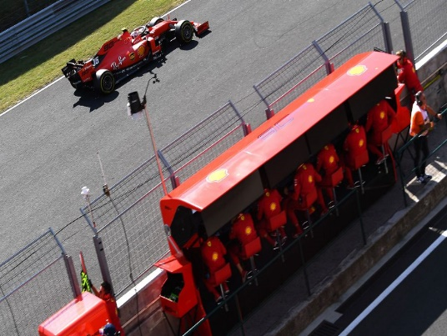
This picture show how Pit wall looks like on a racing weekend. This picture from Ferrari shows how close they’re to the driver and the car on the track. In Formula 1 term Pit wall are known as ‘the best seats in the house’.

Engineers Role (Pit Stop)
There are five key engineers who work in the pit stop garage, the race engineer, performance engineer, controls engineer, engineer performance engineer and engine systems engineer. All these engineers have close contact with the pit wall as they give them information about the car and keep them updated throughout the race.
Race engineer has a close link with the car and the driver, they are like a second pair of the eyes and ears for the driver. Their role is to keep the driver updated on the current situation on the track, such as what lap times the driver is doing, updating him on any incoming traffic and if there are any hazards on the track. Race engineer is also the main contact with team members that work behind the scenes in an office, is up to the race engineer to tell them about any addition information about the car and give the feedback from the driver, doing this helps give them power to try and deliver the maximum performance to the driver and to ensure a smooth, executed successful race weekend.
Performance engineer works closely with the race engineer. During and after race weekend, the race engineer takes responsibility of the garage by making sure the car and the driver are properly managed. This is where performance engineer come into role as they have the responsibility looking into the telemetry and simulations side of the car. They also look at performance subsystems such as the torque transfer between the rear wheels and the break balance. Based on the car data, they will give feedback to the race engineer who will then inform the driver of a setting change to the car that will help improve their performance, for example by changing the break balance or making the car go around tighter corners better.
Controls engineer is to focus on the controls of the car. Their responsibility is too adjust or change different gear shift patterns in the gearbox if necessary. They will make sure the settings are correct and that I will help deliver maximum performance without posing any threat to the liability of the car. They also have the responsibility to manage all the electric preparation on the car for the race starts.
There are 2 engineers that work on the car’s engine. Engine performance engineer works to maximise the performance of the power unit. Engine systems engineer looks after the reliability of it. If they spot a way, they to improve the performance or see any potential failure, its up to the engine engineer to inform the race driver to change any settings to the car if necessary.
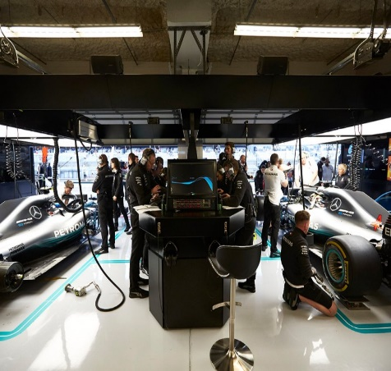
This picture shows how the Engineers work inside the pit stop. With Engineers/mechanics working on the team cars and the computer technology in the middle where most of the work happen when the cars are on the track and that is where most of the virtual team working happens.
Virtual Team Working Effect (Conclusion)
With all engineer roles being said and explained, it’s clear to show that their influence on the team, car and the driver is widespread throughout the race weekend. Pit wall communication with Pit stops engineers is crucial especially during the time of the race, A lot of things can happen on the racetrack unexpected and within seconds. Therefore, they are so dependable on Virtual team working as they can contact each other much quicker and constantly keep each other updated on any situation on the track. It also helps and improves the relationship between the pit wall and pit stop engineers, improving this can help them be comfortable with disagreements and resolve things quicker as there is very short time to think of what decisions to make especially when the car is out on the track. With technology improving rapidly, virtual team working will only get better and easier to use in the future of Formula 1.

References
Mercedes, (2019), Trackside Engineers (online), Available at https://www.mercedesamgf1.com/en/news/2018/11/insight-the-trackside-engineers/#:~:text=There%20are%20a%20lot%20of,is%20both%20reliable%20and%20fast. (accessed 6th Aug 2020)

Formula1, (2020), The insider’s guide to The pit Wall (online), Available at https://www.formula1.com/en/latest/article.the-insiders-guide-to-the-pit-wall.CFwHwjTcLNO5Gf4B3Dy4o.html, (accessed 6th Aug 2020)
Inap, (2012), What Formula 1 can teach us about Teamwork (online), Available at https://www.inap.com/blog/what-formula-1-can-teach-us-about-teamwork/ (accessed 6th Aug 2020)
Sinha, G, (2014), Formula 1 Technical: Importance of a F1 Pit wall (online), Sportskeeda, Available at https://www.sportskeeda.com/f1/formula-1-technical-importance-of-a-f1-pit-wall, (accessed 6th Aug 2020)
Moran, S, (2017), Ten teamwork Skills we can learn from Formula one (online), F1experiences, Available at https://f1experiences.com/blog/10-teamwork-skills-we-can-learn-from-formula-one, (6th Aug 2020)

