MARKETING FUNDAMENTALS

LCBB4004

ASSIGNMENT 1

Blogging to communicate
LEGO

Dr Tushara Balendran

Lilija Tconeva
2029799
Word count: 1683

London

December 2021

TABLE OF CONTENTS

We are the Lego Company 4

Pick a Brick 6

LEGO Marketing Strategy 6

Products 7

Price 8

Place 9

Promotion 10

REFERENCES 11

REFERENCES (FIGURES) 12

TABLE OF FIGURES

Figure No | Description | Page No
1 | Lego owned by Kirkbi A/S 75% and Lego Foundation 25% | 4
2 | Lego Duck | 4
3 | Figure from Lego | 4
4 | The Lego Framework | 5
5 | COVID-19 Lego | 5
6 | Lego World map | 6
7 | Lego Movies | 7
8 | Lego Play | 7
9 | Lego products | 8
10 | Lego Accessories | 8
11 | Lego Store Leicester | 10
12 | Lego house | 10
13 | Fact | 10

WE ARE THE LEGO COMPANY - named “Toy of the Century” Twice


Figure 1: Lego owned by Kirkbi A/S 75% and Lego Foundation 25% (Source: Lego, 2021)

In 1932 Kirk Kristiansen founded Lego and since then his family still maintains an ownership of the company. The name comes from two Danish words “leg godt” which means play well and it’s what the company stands for. The Lego group history (Lego, 2021)

Ole Kirk Kristiansen was born in Denmark 1891. In his teens he became an apprentice carpenter and started his own business in 1916. In 1924 his children tried to light a stove for warmth, but things went wrong and the house with the workshop burned down to ashes. This same year Kirk Kristensen built a new house and a big workshop, where he started to make small cabinets, picture frames and wooden toys. The beginning of the Lego history (Lego, 2021) One of the toys he made was a wooden duck, which sets the foundation of Lego. 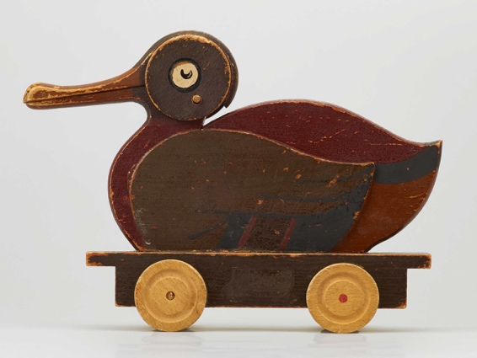 
Figure 2: Lego Duck Figure 3: Figure from Lego (Source:
(Source: Lego, 2021) publicdomainpictures, 2021)

Over the last 90 years, Lego came a long way from a small carpenter’s workshop to one of the top toy manufacturers in the world, offering a wide range of products. Lego has been very savvy in its techniques to build the brand into global enterprise that now produces films, educational and play experiences which are very profitable for the company and drive the sales of Lego products. Recently Lego has been focusing on sustainability and in 2018 started producing the famous bricks from polyethylene- the first step towards sustainability by 2030. Other important objective includes recycling all operational waste by 2025 as Lego currently recycles 91% of the waste. (MarketLine, 2021)

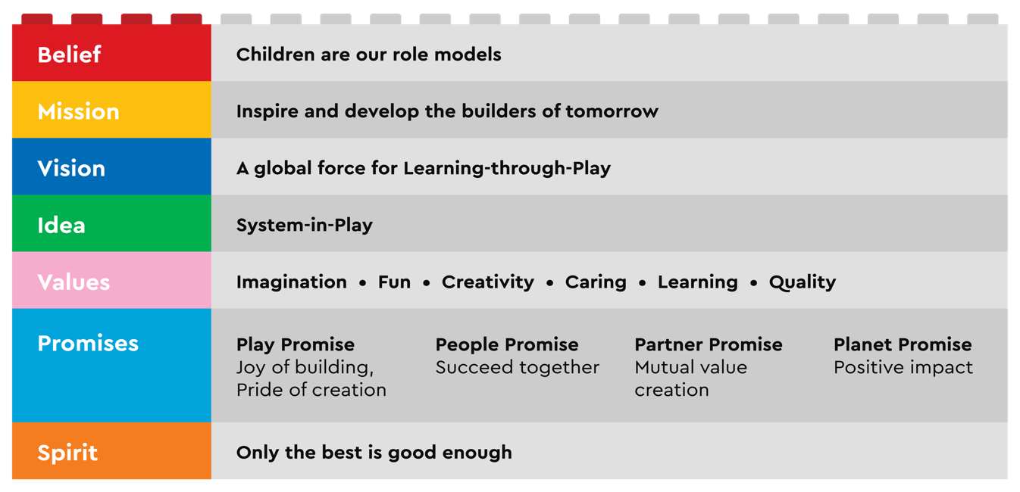
Figure 4: The Lego Framework (Source: Lego, 2021)

Despite the extensive product developments throughout the years, our brick remains the foundation product. It was launched in 1958 in its present form, so unique with its interlocking principle allowing unlimited building possibilities. So, it’s only a matter of imagination to get creative ideas emerge through play. (Lego, 2021)

Kirkbi A/S is the investment company of Kristensen’s family that deals with investment and strategic activities. Lego Foundation is the corporate organisation and shares the mission with the Lego Group. Their job is ensuring that people understand the importance of play to release children’s potential and its huge value in equipping them with essential skills for life in this day and age. (Lego, 2021)
Due to lockdowns and stay at home policies, Lego sales have gone up 14%
in the first half of 2020. Niels Christensen emphasized on the importance of e-commerce investment at these times. As a result, Lego operating profit rose to $622million. (Julia Horowitz, 2020)

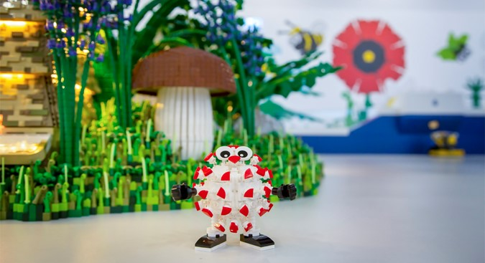
Figure 5: COVID-19 Lego (LEGO House, 2021)
Why did the Lego man sneeze?
(Because he had a blocked nose )
Pick a Brick
40+ COUNTRIES
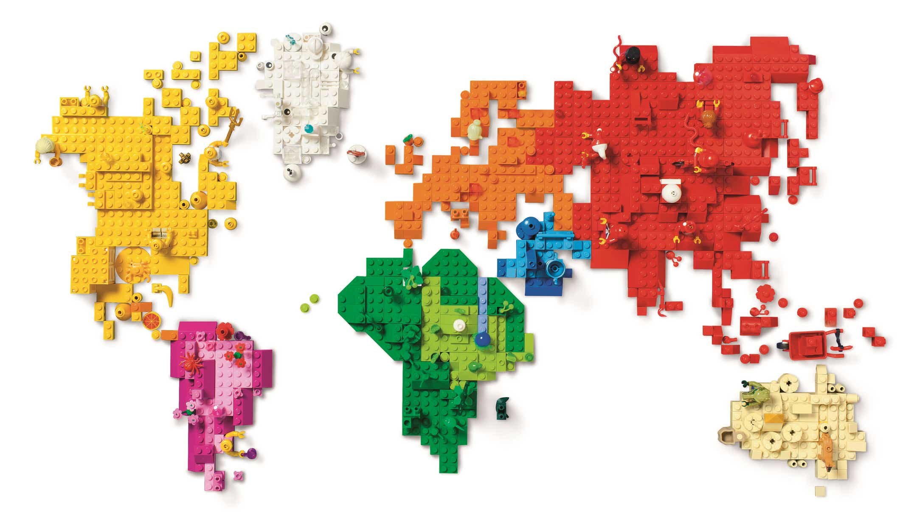
Figure 6: Lego World map (Source: Lego, 2021)

Lego is headquartered in Denmark and has strong presence in over 40 countries across US, Europe, Africa and Asia. (MarketLine, 2021)
Did you know that Lego uses 60+ colours in production and there are 3,400+ different Lego shapes?

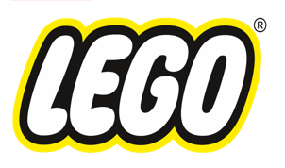Marketing strategy
Only the best is good enough
Diversification is the key to our successful marketing strategy. We have been able to address target audiences quite efficiently with a wide range of products and impressive in store experience, promoting the company’s philosophy of “play”.
As a result, LEGO has been researching the market in a variety of situations. According to Kotler, et al. (2020), marketing research gives an insight into consumers’ purchasing behaviour, motivation and satisfaction. Moreover, it allows them to gain a better understanding of market potential and market share, while measuring the effectiveness of product, pricing, distribution and promotion activities.

What did the battery say when it stood on a Lego?
(AAA )
PRODUCTS WE ARE THE WORLD’S FAVOURITE TOY BRAND

To ensure the quality of our products our facilities are quality certified, and the company adheres to several product safety and hazardous substances regulations. Such regulations include Consumer Products Safety Act, Flammable Fabrics Act, Federal Hazardous Substances Act and consumer protection. However, the iconic brick still relies heavily on plastic as a raw material. Every year, Lego manufactures around 110- 120 billion plastic pieces with 80% being oil-based plastics. In 2018, the company started using polyethylene, following growing environmental concerns, and currently 5% of its plastic products are made of sugar cane polymer. (MarketLine, 2021, p.5- 7) Product quality is essential for LEGO, as a major positioning tool. According to Kotler, et al., (2020) quality is linked directly to customers’ perceived value of a product and satisfaction. We have 0 product recall since 2009!
Films, Apps, Video and Board Games
The LEGO Movie Franchise and The LEGO Batman Movie hugely increased the Lego products’ profile. It partners with DC Comics, Marvel and Disney in creating Lego sets based on the characters. Lego Media International Ltd offers video games such as Batman, Lego Island, Star Wars with Minotaurus, Creationary & Ramses Pyramid – board games by Lego Games.

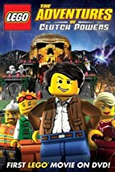
Figure 7: Lego Movies (Source: IMDb, 2017)
Lego Education offers learning and teaching opportunities based on curriculum materials for school.
After all, the positive impact that Lego has on the world is undisputed. It releases a child potential the moment they pick up their first brick and start shaping their own worlds. Lego bricks are based on Lego system - building over and over again. (Lego, 2021)

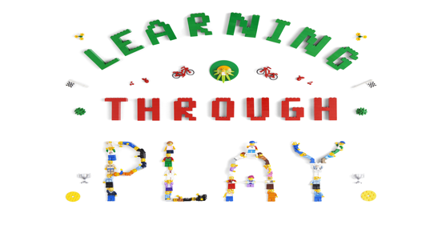
Figure 8: Lego Play (Source: Lego, 2021)
LEGO SETS FOR ALL AGES LET YOUR IMAGINATION RUN WILD
The brick is the most popular product of the company.
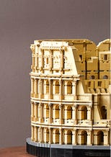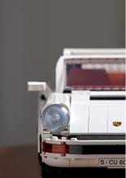

Variety of Lego for adults interested in history, art and design, music, tech…
Figure 9: Lego products (Source: Lego, 2021)

OTHER PRODUCTS

Lego offers magazines and books such as Star Wars and the Ultimate Book and children’s clothing line called Legowear.

ACCESSORIES

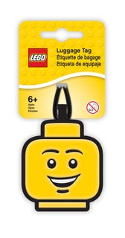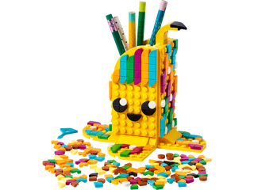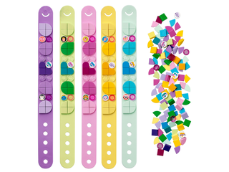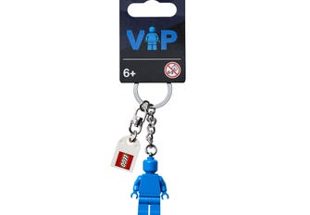

$5.99 $19.99 $19.99 $9.99 $5.99
Figure 10: Lego Accessories (Source: Lego, 2021)

PRICE
Pricing has an important part in accomplishing a company’s objectives at many levels. For instance, price can be set to attract and retain consumers, prevent rivals from entering the market or stabilizing the market with prices set at competitors’ level. Effective pricing strategy keep resellers loyal and supportive and avoids government intervention. A product can be priced to help sales of other products in the line. (Kotler, et al., 2020, p.312)

Colosseum (Figure 9) is the largest Lego set of 9036 pieces $999.99
It’s been debated that price per piece matter in pricing the sets, however Lego Group pointed out this is not the only factor in the pricing strategy but also licencing cost of the theme brand, price of the new mould and others. However, most expensive sets offer better price per piece. High quality production, demand and increasing size and resale value of exclusive sets contribute to the high price tag. Large sets over 2000 pieces cost more than $200, medium- $100 to $200 and small, under 1000 pieces are under $100. (Shane, 2021) Consumers take part in product design and packaging to pricing and distribution. Our company embraces customer empowerment by placing the consumer in the centre of every project.
Did you know that around 70 billion Lego elements are sold per year?

PLACE
Lego uses selective channel of distribution (combination of intensive and exclusive) selecting just some of the intermediaries willing to distribute the products. It gives good market coverage with reduced costs and more control than intensive distribution. Selective distribution allows the company to form good working relations with the channel members and get better than average selling effort in return. (Kotler, et al.,2020, p. 364)

Lego’s primary distribution centre is in Prague from where the products are shipped to warehouses all over the world and distributed to retailers. The company has very efficient outbound logistics taking 10 days from moulding to distribution and 3 days for delivery to retailers. Kotler, e al. (2020) states that efficient supply management makes all the difference to a company’s fortune because control over the entire supply chain would deliver value to customers and set the company afront of competition. By creating customer value, the company acquires loyalty and increases profits. (Kotler, et al., 2020, p.20)

Lego has 678 stores around the world and retails its products through some of the largest retailers such as Amazon, Walmart, Tesco, independent stores and smaller chains and several websites. E-commerce has been very important in the pandemic with the official website LEGO.com visited by 100 million times in the first half of 2020. (MarketLine, 2021)
LEGO has several theme parks in UK, US, UAE, Malaysia, Japan and Germany and a Lego House which offers the best play date and inspires visitors to embrace creativity.

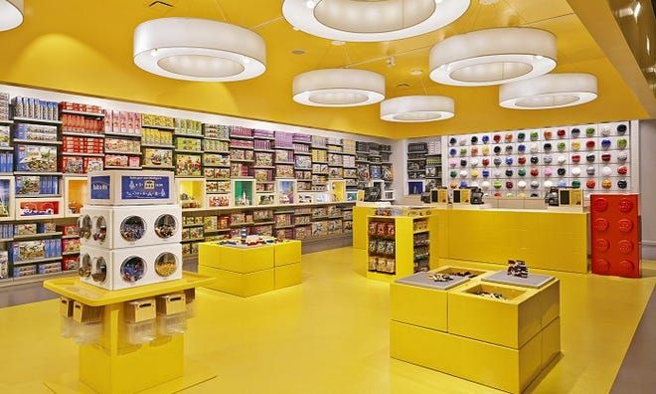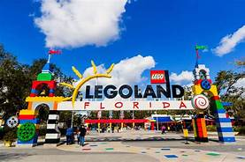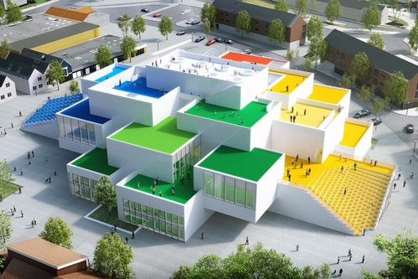
Figure 11: Lego Store Leicester Square (Source: Lego, 2021) Figure 12: Lego House (Lego, 2021)

PROMOTION

There are 5 promotion tools to reach to customers: direct and social media marketing, advertising, sales promotions, personal selling and public relations such as new store openings, store magazines, special events. By using websites, blogs and emails, online ads apps and catalogues, retailers digitally interact with consumers and maintain a full social media presence. Thus, they deliver targeted brand messages, encourage engagement and awareness as well as entertain the audience. (Kotler, et al., 2020, p. 397)

LEGO’s “Let’s build together” digital campaign, launched in the pandemic, saw 2 million downloads of the building instructions in the first half of 2020 and drove growth to the Lego website. Facebook page with 14 million followers and Instagram also show high consumer engagement. Lego has designed social network App- Lego Life, aimed at under 13s and in 2020 it had nine million users. It also offers Lego Ideas, app for adults to share creations with the online community. (MarketLine, 2021)
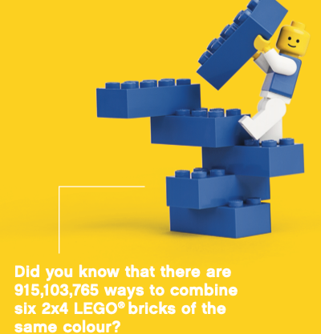
Lego’s price promotions create excitement about the brand. The toy maker offers VIP loyalty program with VIP card to collect points and access online rewards and gifts. Monthly deals (online and in-store) and promo codes are listed on the website. Lego offers student discount and free delivery day offer.
Figure 13: Fact (Lego, 2021)
REFERENCES

Lego (2021) Lego Group History. Available at: https://www.lego.com/en-gb/aboutus/lego-group/the-lego-group-history (Accessed: 26 December 2021)

Lego Ideas (2021) The beginning of the Lego history. Available at: https://ideas.lego.com/projects/ddb75bfd-f764-4f83-86cb-25501c7a685e (Accessed: 26 December 2021)

MarketLine (2021) Lego AS: Value chain analysis. Available at: https://advantage-marketline-com.ezproxy.uwtsd.ac.uk/Analysis/details/lego-as-value-chain-analysis-138060 (Accessed: 26 December 2021)

Lego (2021) Lego Group presentation. Available at: https://www.lego.com/cdn/cs/aboutus/assets/blt4ee78e0776fce92f/LEGO_Company_Profile.pdf (Accessed 27 December 2021)

Julia Horowitz (2020) ‘Lego sales are surging during the pandemic’ [ CNN Business Online]. Available at: https://edition.cnn.com/2020/09/02/investing/lego-sales-pandemic-trnd/index.html (Accessed: 26 December 2021)

Kotler, et al. (2020) Principles of Marketing. 8th Ed. Harlow: Pearson Education

Shane (2021) ‘What is Lego price per piece?’ [Brickbucks.net Online] Available at: https://brickbucks.net/what-is-lego-price-per-piece/( Accessed: 27 December 2021)

REFERENCES (FIGURES)

Lego (2021) Lego owned by Kirkbi 75% and Lego Foundation 25% [Figure 1]. Available at: https://www.lego.com/en-gb/aboutus/lego-group/ownership (Accessed: 26 December 2021)

Lego (2021) Lego Duck [Figure2]. Available at: https://www.lego.com/en-gb/aboutus/lego-group/the-lego-group-history (Accessed: 26 December 2021)

Figure from Lego (2021) Lego [Figure 3]. Available at: https://www.publicdomainpictures.net/pictures/200000/velka/figure-from-lego-pieces-1476775603T6S.jpg (Accessed 26 December 2021)

Lego (2021) Lego Framework [Figure 4]. Available at: https://www.lego.com/en-gb/aboutus/lego-group/the-lego-brand (Accessed: 26 December 2021)

Lego House (2021) Lego House is closed [Figure 5]. Available at: https://legohouse.com/en-gb/info/lets-play-again/ (Accessed: 26 December 2021)

Lego (2021) Lego World Map [Figure 6]. Available at: https://www.lego.com/en-gb/aboutus (Accessed: 26 December 2021)

IMDb (2017) Lego Movies [Figure 7]. Available at: https://www.imdb.com/list/ls068935205/ (Accessed: 27 December 2021)

Lego (2021) Lego play [Figure 8]. Available at: https://www.lego.com/cdn/cs/aboutus/assets/blt4ee78e0776fce92f/LEGO_Company_Profile.pdf (Accessed 27 December 2021)

Lego (2021) Lego products [Figure 9]. Available at: https://www.lego.com/cdn/cs/aboutus/assets/blt4ee78e0776fce92f/LEGO_Company_Profile.pdf (Accessed: 27 December 2021)

Lego (2021) Accessories [ Figure 10]. Available at: https://www.lego.com/en-us/categories/accessories (Accessed 27 December 2021)

Lego (2021) Lego store [Figure 11]. Available at: https://www.lego.com/en-gb/stores/store/london-leicester-square (Accessed: 27 December 2021)

Architectmagazine (2017) Lego House [Figure 12]. Available at: https://www.architectmagazine.com/design/spend-the-night-at-bigs-lego-house_o (Accessed: 26 December 2021)

Lego (2021) Fact [Figure 13]. Available at: https://www.architectmagazine.com/design/spend-the-night-at-bigs-lego-house_o (Accessed 28 December 2021)

