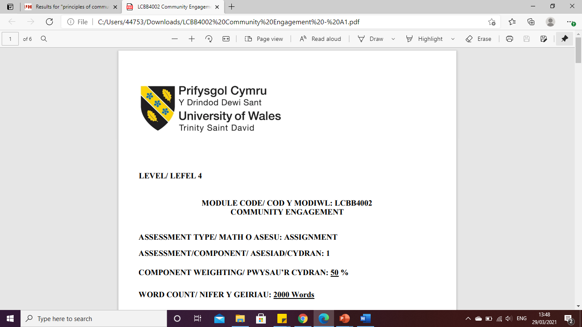

LEVEL 5

EMPLOYEE ENGAGEMENT
MODULE CODE: LCBB5004
MANAGING PEOPLE

ASSESSMENT TYPE: ASSIGNMENT
ASSESSMENT/COMPONENT: 2
COMPONENT WEIGHTING: 50 %
WORD COUNT: 2089 Words
SUBMISSION DETAILS:
Name: Cosmin Adrian Mitu
Student Number: 2021613

Table of Contents

1. Introduction 3
2. The concept and drivers of employee engagement 3
3. Theories of employee engagement 4
3.1. William Kahn’s theory. 4
3.2. Meaningfulness. 4
3.3. Goal setting theory and employee engagement 5
4. Diagnostic tools to measure engagement 5
4.1. Employee surveys 5
4.2. HR tools 6
4.3. Social media 6
5. Employee value proposition from ideas 6
6. Strategies to raise levels of employee engagement 7
7. Conclusion 8
References 9

Introduction

The main reason for this study is to evaluate the importance of their employees' engagement with each other while doing their job. The concept of the human resources to show their hard work and dedication regarding a field works and they feel while doing any work and their working spirit while doing it. The main causes are their work causes and their hard work which shows by demonstrating it and making them understand by qualitative and quantitative. According to a study it shows that many drivers and their concept regarding their jobs are awful, as per the diagnostic tools shows the employees measurement engagement, as per the employee’s strategies and ideas to give a massive rise in the engagement. The context tells that the Organizational strategies sometimes did not get that effective that builds more customers by reducing staff turnover, creating a better workplace, and relationships. And with some personal growth among the whole organization by rewards, personal growth, leadership, recognition.

The concept and drivers of employee engagement

Some concepts on drivers of employee engagement are:
It is very important for the company to have a crystal path direction with a well-defined mission statement, cultural code, employees value proposition, and core value. By setting the company's goal for the work and their purpose by collaborative efforts that considers the view of the company so they could walk on that path in near future (Burnett and Lick, 2019). Recruiting many more networking talented employees is also the reason for their direction which will help them to hire new employees who will work for them beyond anything, and by making minimum help in development I'd have a cohesive strategy on Branding employees. Resources and tools which helps in order to allocate the resources and to stay close and do the work as it needs to be done financially, experientially, sheer human power, and educationally (Garg et al. 2018) Considering their response most of the relation and areas need to be improved. It's very important to ensure that employees have to appreciate tools to do that job as for the software it's to complete their work by organizational tool.
Balancing their work life according to the studies which has been stated that 72% of the people are looking for jobs so it's a great chance to attract candidates for the interview and make an environment that they like so they could work there, which engages harder and more on a daily basis (Soares and Mosquera, 2019). Due to the lack of work-life balance the candidate does not want to appear for the interview and a mass resignation, which prioritize balance in a company to secure employee engagement.
Company's culture as per the other drivers of employee engagement, this is different. The cultural company starts with the inception of their company evolving them by hiring new and new workers as the business grows, it will be very difficult to change the reality. It Impacts on life significantly for daily engagement of employees, it considers that 77% of the employees have a strong resistance and relationships with their colleagues for engagement of employees, 82% of the employees have some friends too.
As per the engagement survey that most of the famous companies are managing to drive this engagement thing, that was considered a great effect on implementation. 89% of the HR professionals to their feedback surveyed that it has a positive impact.

Theories of employee engagement

They are mainly included into emotions, intentions, behavior, and rational thoughts. As the model revolves around the six employees six engagement drivers are pays, basics, job security, work-life balance, benefits, work environment (Pandith and Ray, 2018). As the high-level company with having a pro workers with loyalty and motivation which shows that the employees of engagement are beneficial by lower turnover, increased creativity, innovation and higher costumers’ satisfaction, bigger bottom lines, absenteeism.
  - William Kahn’s theory- it was proposed that the engaged individuals are to invest their full time significantly for the personal resources, and by forming of times and effort, by completing their tasks successfully (Mayhem et al. 2019), the meaningfully connection on their daily based tasks, organizational mission and their task role for the availability meaningfulness and safety, and companies’ culture.
  - Meaningfulness- It has been referred to that behind their back of work. All the employees should understand those familiar with the company's services and is beneficial to the product was focus of the goals by with significantly great job.
  - Goal setting theory and employee engagement- it has the one of the best major components that engagement applies of the employees. While the goals should be easy, precisely and specific to understand their goal (Dither and Dhanesh, 2018). As per the leader should have to provide their direction pointed at them and their feedback as per playing which also shows by maintaining through economic important.

Diagnostic tools to measure engagement

It's been mostly used as the tools which measures like employee engagement for the survey with a very important tools which are being provided by them (Aloud, 2018). Measuring the employee’s engagement by the help of survey engagement it shows that in order to get any feedback regarding a thing on employee everything changes the attitude and many more (Malik and Garg, 2020). It has been the most effective of all the surveys of the time which can be founded as they submitted on the filed-out ratio and with the rise on the peoples who are participating more often and by responding with a great and honest reply on the employees (Meijer ink et al. 2020). As for the bigger organizations they give their employees a better workplace to work as they can have a great time, and working flexible hours, work from home and they will give a great environment. Engagement culture exposes that they survey which are designed to measure and have access to ensure the staff are engaged and stayed motivated to continue their field of work by their best performance (Motyka, 2018). The surveys are said to be the most useful as it touches an important and essential compound for the employee engagement with a satisfaction, alignment, and as a future goal. It is been diagnosed as the employees with many merits by bigger or smaller present in it as per conductive exit, stay interviews, focus groups, and many many more also evaluating the tools those are being used to evaluate to engagement of their employees with a certain exit role on the interview life cycle of the employees is been under the advantageous right, HR tools, surveys and many more. Measuring and monitoring the level of engagement Employees are:
  - Employee surveys
These tools are used by leaders of all the organizations and to identify all the positive comments regarding them, boost the morale of their employees, increasing their performance, and by measuring the employee’s engagement towards to company or organization. At the time of pandemic, the employees were getting a flexible time for their works and on their work from home (Mone and London, 2018). With a good survey by helping the employees to become more fonder of their company, and quality of relationships. Their growth in their work place makes them now and more motivated to continue their job quite nicely.
  - HR tools
The tools that are used for the wide range problems and find them a technological solution which helps their organizations to manage their day-to-day lives of HR activities. The processes of the HR are mostly compliance driven for performing them it's manually used on time-consuming, arduous, and cumbersome (Ahmed et al. 2018). Their software management can perform more and more frequent to converse and the feedback in between the managers and the employees.
  - Social media
A computer-based technology which facilitates the idea of sharing, any information through virtual views, directly to networks or communities, and their thoughts (Panteli et al. 2018). For rising the social media, the meaning is that to tell the employees use and having another kind of tools the organization or company can measure their employees by their internal networking region of social media. With the help of this tools the manager of any organization or company can understand their employees more accurately and over all culture of their teams.

Employee value proposition from ideas

The proposition value form ideas are true offer with working flexibility- in schedules and locations can be by their employees whose dreams are to work where ever they want to and make their own name and by working an achieve their goals by growth and fulfillment offers. This type helps their employees to live freely in their day-to-day lives and they have their purpose of dealing with everything by their own. Having their vision clear for that they have to go beyond 'the work' as in most of the workers who are currently young, they have always paid attention to what they want to do send what they do not as their interests varies and was proposed everywhere. The values of company which goes beyond making and kind of profile are:
- The LGBTQ movements.
- Society builds ups.
- Supporting their illness and mental health.
- To establish equality
As the candidates find them quite comfortable for working and have clear mind set for doing their job. Genuine employee connection it shows that in current time most of the great talents prefer their work to be remotely and going back to their work only five days a week, while keeping a connection with their colleagues or team members in a meaningful manner in all the different ways of connections that they connect with each other throughout the workplace:
- Lunchtime banter.
- Small celebration on the desks.
- Catching on snacks breaks or drink.
- Seeing each other daily
- Real time meetings
So that they did not mention that in their searching list they know how to patronize their connection employees towards cultural company will certainly attract more talents than any others.
The values that the company propagates to their employees and in return the values also have to get rewards and benefits in their offer which the employees are giving them with their skills and what they capable of. Organizational Management uses this all information to offer by their flexibility on their employees, have to go beyond 'the work', genuine connections with the employees, and with true working flexibility towards their work with schedule and location, and the offers to their support Integration of their working life's and many more.

Strategies to raise levels of employee engagement

At the time of pandemic most of the employees were not able to get ready for their workplace. That's why the companies have to take some actions to help their employees in their works and problems. They provided them flexible hours and work from home so they could do their work properly while not getting affected by the virus, but the flexible hours does not helped the company or organizations as in some of the employees were not taking their work seriously and they do not want to complete their job accurately to develop their employees engagement They had to try various ways as for empowering people, recognition of their good work, and to define the organizations work, communication deliberately and regularly, invite feedback, investing in wellbeing. The engagement of the employees is the main cause of the organization to achieve some goals and they all committed their work for the best values and wellbeing. For contributing a success or motivating in the organization. That said the organization takes a various attempt to motivate their employees by giving the offers, flexible hours and work from home giving them a respect they need and an environment they are comfortable with. Communicating deliberately and regularly, investing in wellbeing, and invite feedback are the main reasons they raise it to them.

Conclusion

In the above-mentioned study, it shows the employee engagement is the main reason for the success of the organization. It shows that the human resources concepts show a different way to dedicate their employees to engage towards their work. Caring the performance in the company. Some of the reasons for the employee engagements core elements are to trust in leading managers, a positive working environment, hands on management, opportunities toward their growth, and many more. And strategically doing everything so it all goes as they suspect like wellbeing investors, feedback invitations, communication deliberately or regularly plays a

References

Ahmed, U., Shah, S.A., Qureshi, M.A., Shah, M.H. and Khuwaja, F.M., 2018. NURTURING INNOVATION PERFORMANCE THROUGH CORPORATE ENTREPRENEURSHIP: THE ODERATION OF EMPLOYEE ENGAGEMENT. Studies in Business & Economics, 13(2).\
Alzyoud, A.A.Y., 2018. The influence of human resource management practices on employee work engagement. Foundations of Management, 10(1), pp.251-256.
Burnett, J.R. and Lisk, T.C., 2019. The future of employee engagement: Real-time monitoring and digital tools for engaging a workforce. International Studies of Management & Organization, 49(1), pp.108-119.
Duthler, G. and Dhanesh, G.S., 2018. The role of corporate social responsibility (CSR) and internal CSR communication in predicting employee engagement: Perspectives from the United Arab Emirates (UAE). Public relations review, 44(4), pp.453-462.
Garg, K., Dar, I.A. and Mishra, M., 2018. Job satisfaction and work engagement: A study using private sector bank managers. Advances in Developing Human Resources, 20(1), pp.58-71.
Malik, P. and Garg, P., 2020. Learning organization and work engagement: The mediating role of employee resilience. The International Journal of Human Resource Management, 31(8), pp.1071-1094.
Meijerink, J., Bos-Nehles, A. and de Leede, J., 2020. How employees’ pro-activity translates high-commitment HRM systems into work engagement: The mediating role of job crafting. The International Journal of Human Resource Management, 31(22), pp.2893-2918.
Milhem, M., Muda, H. and Ahmed, K., 2019. The effect of perceived transformational leadership style on employee engagement: The mediating effect of leader's emotional intelligence. Foundations of Management, 11(1), pp.33-42.
Mone, E.M. and London, M., 2018. Employee engagement through effective performance management: A practical guide for managers. Routledge.
Pandita, D. and Ray, S., 2018. Talent management and employee engagement–a meta-analysis of their impact on talent retention. Industrial and Commercial Training.
Panteli, N., Yalabik, Z.Y. and Rapti, A., 2018. Fostering work engagement in geographically-dispersed and asynchronous virtual teams. Information Technology & People.
Soares, M.E. and Mosquera, P., 2019. Fostering work engagement: The role of the psychological contract. Journal of Business Research, 101, pp.469-476.

