Module Name: BA (Hons) Leadership and Management Skills for the Workplace
Module code: LCLM 5005
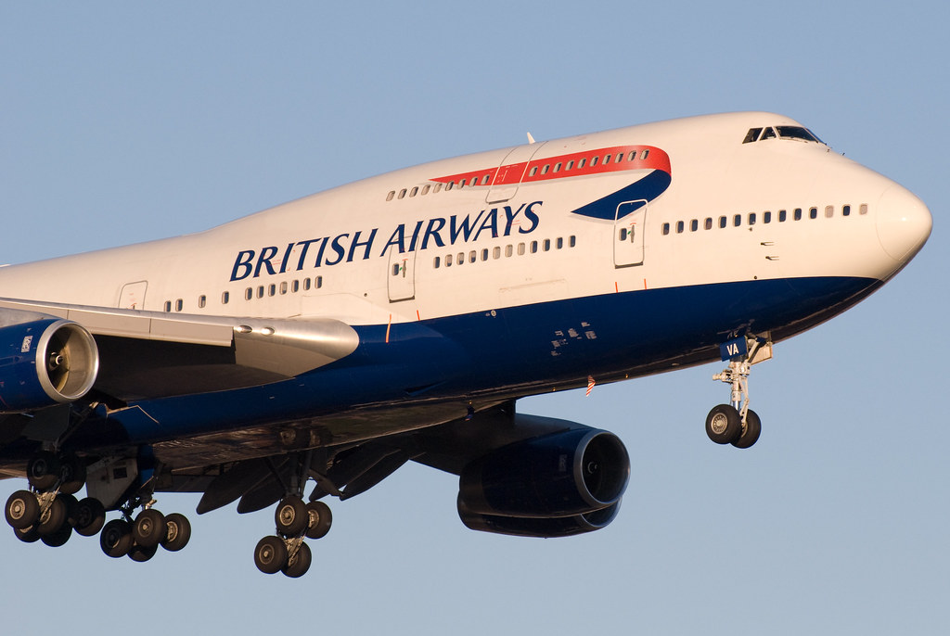

Assignment Title Component 1
- Organisational Culture in British Airways:
Individual Report
- Student Name: Mario Massaro
- Student ID: 2335126
- Lecturer’s Name: Dr. Amir Homayounfard

Table of Contents
Introduction 4
Task 1 - Critically evaluate how organizational culture influences the company’s structure and decision-making processes 4
1.1. Influence on Structure 4
1.2. Influence on Decision-Making 4
Organizational structure: 5
1.3. The Influence of Organizational Culture in British Airways 5
1.4. Influence of Organizational Culture on Decision‑Making Processes 6
1.5. Critical Evaluation 6
Task 2 - Identifying Organizational Culture in British Airways Using Hofstede’s Cultural Dimensions Model 6
2.1. Application of Hofstede’s Dimensions to British Airways 7
2.1.1. Power Distance 7
2.1.2. Individualism vs. Collectivism 7
2.1.3. Masculinity vs. Femininity 7
2.1.4. Uncertainty Avoidance 8
2.1.5. Long‑Term vs. Short‑Term Orientation 8
2.1.6. Indulgence vs. Restraint 8
Task 3 - British Airways’ Organizational Culture and Adaptation to External Environmental Influences: A Hofstede Framework Analysis 8
3.1. External Environmental Influences on British Airways 9
3.2. Hofstede’s Cultural Dimensions and BA’s Adaptation to External Pressures 9
3.2.1. Power Distance and Regulatory Compliance 9
3.2.2. Individualism and Customer‑Service Adaptation 9
3.2.3. Masculinity and Competitive Market Pressures 9
3.2.4. Uncertainty Avoidance and Industry Volatility 9
3.2.5. Long-Term Orientation and Strategic Investment 9
3.2.6. Indulgence and Evolving Customer Expectations: 9
Task 4 – Impact of British Airways’ Organizational Culture on effective functioning: acts as a barrier or an enabler. Providing justification for your conclusion. 10
4.1. How BA’s Culture Acts as an Enabler 10
4.1.1. Strong Values that Support Service Quality 10
4.1.2. Culture of Safety and Security 10
4.1.3. Supportive People Practices and Wellbeing 10
4.1.4. Adaptability and Change Orientation 10
4.2. How BA’s Culture Acts as a Barrier 11
4.2.1. Cultural Change Challenges and Legacy Issues 11
4.2.2. Tension Between Empowerment and Hierarchy 11
4.2.3. Employee Relations Strains 11
4.3. Overall Evaluation and Justification 11
Task 5 - Evaluation of the impact of Organizational Culture on organizational performance of British Airways 12
5.1. Understanding Culture-Performance Link 12
5.2. Employee Recognition and Engagement 12
5.3 Positive Impacts 12
5.2 Negative Impacts 12
6. Conclusion and Recommendations 12
6.1. Conclusion 12
6.2. Recommendations for Sustaining and Enhancing Cultural Effectiveness 13
References 14

Introduction
Organizational culture is a foundational force that influences all areas of a company's operations. According to Mullins (2019), it consists of the collective values and beliefs that drive everything from decision-making and structural design to employee motivation and management systems. As globalization creates more complex, international work environments, mastering the integration of diverse nationalities into a unified corporate culture has become essential.
This report provides a comprehensive analysis of how organizational culture influences key organizational processes and explores the challenges and strategies for managing cultural diversity in global organizations. This section critically evaluates how British Airway’s culture influences its structure and decision‑making.

Task 1 - Critically evaluate how organizational culture influences the company’s structure and decision-making processes
Organisational culture significantly shapes how British Airways structures its operations and makes decisions. BA’s culture emphasises Excellence, Caring, and Open-mindedness, supported by a strong safety ethos (British Airways, 2026). These values influence both structural design and decision-making processes.

1.1. Influence on Structure
- BA’s culture supports a hybrid structure: hierarchical in safety-critical areas and collaborative in customer-facing roles.
- Safety culture necessitates clear authority lines, while service culture encourages empowerment and teamwork.
- Research shows that structure must align with culture to avoid inefficiency (StrategicLeadersConsulting, 2025).

1.2. Influence on Decision-Making
- BA’s culture acts as a decision-making framework, guiding behaviour and priorities (FasterCapital, 2025).
- Safety-driven areas rely on centralised, rule-based decisions, while customer service encourages autonomy and initiative.
- Leadership plays a key role in reinforcing cultural norms; BA’s shift toward transformational leadership has improved decision quality (Quarterdeck, 2025).

Organizational structure:
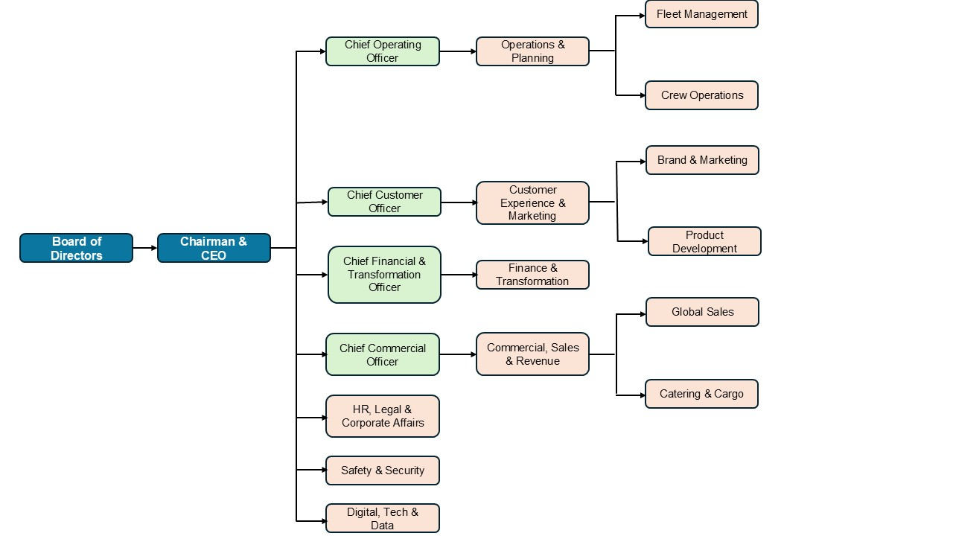
Source: The Author

1.3. The Influence of Organizational Culture in British Airways
Based on the historical accounts from the 1980s and 1990s, BA's culture was indeed rigidly hierarchical. Before its major transformation, the airline was characterised by a top-down management structure that fostered complacency, internal politics, and a significant disconnect from customers.
This structure reflected a control‑oriented culture, emphasizing rules, standardization, and top‑down authority. Grugulis & Wilkinson (2002), note that BA’s cultural initiatives often struggled because the underlying structure remained centralized and managerial. This led to implications such as:
- Slow decision-making due to multiple levels of approval.
- Limited employee autonomy, which reinforces a culture of compliance rather than innovation.
- Clear role boundaries, which support operational security but reduce flexibility.
In recent years, BA has sought to modernize its structure to support a more agile corporate culture.
According to BA's official culture statements, they emphasize empowerment, originality, and the appreciation of employee contributions. Furthermore, leadership transformation efforts have aimed to reduce rigidity and encourage cross-functional collaboration. This led to implications such as:
- More team‑based structures in customer service and operations.
- Greater emphasis on innovation and continuous improvement.
- Attempts to horizontalize the hierarchy, although legacy systems still limit full structural flexibility.

1.4. Influence of Organizational Culture on Decision‑Making Processes
Historically, senior managers made all the important plans and told everyone else what to do. This strict style was used because the airline wanted to keep total control over how things were run. Experts at Quarterdeck point out that, in the past, BA relied on this rigid way of making decisions, where orders simply flowed from the bosses down to the workers (Quarterdeck, 2025). This led to effects such as:
- Consistency and safety in operations.
- Low employee involvement, reducing motivation and innovation.
- Slow response to market changes, especially compared to low‑cost competitors.
Furthermore, diversity and inclusion initiatives further support broader participation in decision-making. This led to effects such as:
- Improved employee engagement and sense of ownership.
- More innovative solutions, especially in customer experience.
However, legacy hierarchical norms still constrain full decentralization.

1.5. Critical Evaluation
Despite BA’s progress, the alignment between culture, structure, and decision-making remains imperfect. The current culture both enables and constrains its structure and decision-making process. The company is moving toward a more collaborative and accountable culture, but structural inertia and historical norms continue to shape the way decisions are made (Marchetti & Puranam, 2025).
- Strengths:
- Strong cultures enhance alignment, motivation, and clarity in decision‑making.
- Cultural consistency supports strategic coherence and employee engagement.
- Limitations:
  - Overly strong cultures can create groupthink, suppress dissent, and hinder innovation.
  - Cultures resistant to change can obstruct structural reforms and slow decision-making.
  - Misalignment between culture and structure can reduce organisational effectiveness.

Task 2 - Identifying Organizational Culture in British Airways Using Hofstede’s Cultural Dimensions Model
The model chosen for this report is Hofstede's Cultural Dimensions framework.
Hofstede’s Cultural Dimensions Model provides a framework for analysing how national cultural values influence organisational behaviour and workplace practices. The model identifies six dimensions: Power Distance, Individualism vs Collectivism, Masculinity vs Femininity, Uncertainty Avoidance, Long‑Term Orientation, and Indulgence vs Restraint (Hofstede Insights, 2021a; Mooij & Hofstede, 2010). Applying this model to BA helps explain how cultural values shape leadership, communication, decision‑making, and employee relations within the organisation.

2.1. Application of Hofstede’s Dimensions to British Airways

2.1.1. Power Distance
In the UK, a low score on power distance reflects a cultural inclination toward horizontal organizational setups and collaborative leadership. According to Hofstede Insights (2021), this suggests that British employees generally expect to be consulted and prefer a more egalitarian relationship with their managers. This is reflected in BA’s organizational culture, where employees are encouraged to communicate openly with supervisors and contribute ideas.
However, as a large airline with strict safety and operational protocols, BA still maintains hierarchical decision‑making in critical areas such as flight operations and safety compliance (British Airways, 2016). This creates a balance between empowerment and necessary authority.
Implication: decision-making tends to be top‑down, though recent cultural reforms aim to empower frontline staff.

2.1.2. Individualism vs. Collectivism
The UK is a highly individualistic society, emphasising personal responsibility and autonomy (Hofstede Insights, 2021a). BA’s culture reflects this through performance‑based evaluations, individual accountability, and reward systems. Cabin crew and customer‑service staff are expected to take initiative when resolving passenger issues. However, teamwork remains essential in-flight operations, where coordination and collective responsibility are critical for safety and service delivery (Schein & Schein, 2016).
Implication: this supports innovation and accountability but can create silos between departments.

2.1.3. Masculinity vs. Femininity
The UK scores moderately high on masculinity, indicating a competitive and achievement‑oriented culture (Hofstede Insights, 2021a). BA demonstrates this through its focus on service excellence, operational efficiency, and competitive positioning in the global aviation market. Performance metrics, punctuality targets, and customer‑satisfaction scores reinforce a results‑driven environment (British Airways, 2016). At the same time, BA promotes customer care and employee wellbeing, reflecting a blend of masculine competitiveness and feminine relationship‑orientation.
Implication: high performance expectations can motivate employees but may also increase stress and reduce work–life balance.

2.1.4. Uncertainty Avoidance
The UK has a relatively low uncertainty‑avoidance score, meaning people are comfortable with ambiguity and flexible rules (Hofstede Insights, 2021a). BA’s culture reflects this through adaptability in customer service and problem‑solving. However, aviation as an industry requires strict adherence to safety regulations, meaning BA must enforce high levels of procedural compliance regardless of national cultural tendencies (Schein, 2010). This creates a dual culture: flexible in customer‑facing roles but highly structured in safety‑critical operations.
Implication: this supports safety and reliability but can slow innovation and flexibility.

2.1.5. Long‑Term vs. Short‑Term Orientation
The UK leans toward short‑term orientation, focusing on quick results and tradition (Hofstede Insights, 2021a). BA’s strategic decisions often reflect short‑term market pressures, such as cost‑cutting, restructuring, and rapid responses to industry disruptions. However, BA also invests in long‑term initiatives such as fleet modernisation and sustainability programmes, indicating a gradual shift toward long‑term strategic thinking (British Airways, 2016).
Implication: the culture is mixed—strategic but reactive when necessary.

2.1.6. Indulgence vs. Restraint
The UK scores high on indulgence, suggesting a culture that values enjoyment, leisure, and personal freedom (Hofstede Insights, 2021a). BA incorporates this dimension into its brand identity by emphasising customer comfort, travel experience, and premium services. Internally, BA promotes work‑life balance initiatives, although operational demands can sometimes challenge this, especially for flight crews (UKEssays, 2017).
Implication: professionalism is high, but creativity and spontaneity may be limited.
In summary, British Airways exhibits a hierarchical, performance‑oriented, and professionally disciplined culture, shaped by both its national context and the operational demands of the aviation industry. While the organisation has attempted to modernise and empower employees, its core cultural characteristics remain rooted in structure, control, and high-performance expectations.

Task 3 - British Airways’ Organizational Culture and Adaptation to External Environmental Influences: A Hofstede Framework Analysis
British Airways (BA) operates in one of the most volatile and externally influenced industries globally. Political instability, economic fluctuations, technological change, environmental pressures, and social expectations all shape how BA must adapt its organisational culture. Using Hofstede’s Cultural Dimensions Model provides a useful lens for understanding how BA’s culture responds to these external forces and how national cultural values influence organisational behaviour and strategic adaptation.

3.1. External Environmental Influences on British Airways
External environmental factors affecting BA include political regulations, economic conditions, technological advancements, social expectations, and environmental pressures. BA is heavily influenced by geopolitical events, regulatory changes, fuel‑price volatility, technological innovation, and sustainability demands (The Strategy Story, 2024).

3.2. Hofstede’s Cultural Dimensions and BA’s Adaptation to External Pressures
3.2.1. Power Distance and Regulatory Compliance: the UK’s low power‑distance culture encourages flatter structures and participative decision‑making (Hofstede Insights, 2021a).
3.2.2. Individualism and Customer‑Service Adaptation: the UK’s high individualism score supports BA’s emphasis on personal accountability and initiative in customer-facing roles (Hofstede Insights, 2021a).
3.2.3. Masculinity and Competitive Market Pressures: the UK’s moderately high masculinity score reflects a competitive, achievement-oriented culture (Hofstede Insights, 2021a). BA’s organisational culture mirrors this through its focus on performance metrics, punctuality, and service excellence.
3.2.4. Uncertainty Avoidance and Industry Volatility: although the UK scores low on uncertainty avoidance, the airline industry is highly regulated and risk-averse. External factors force BA to adopt strict operational procedures despite national cultural tendencies toward flexibility (The Strategy Story, 2024). This creates a dual culture: flexible in customer-service roles but rigid in safety-critical operations.
3.2.5. Long-Term Orientation and Strategic Investment: the UK’s short-term orientation emphasises quick results (Hofstede Insights, 2021a). However, external technological and environmental pressures—such as sustainability regulations and the need for fleet modernisation—push BA toward long-term strategic planning. BA’s investments in new aircraft and digital transformation reflect adaptation beyond national cultural norms (Blog Trends, 2024).
3.2.6. Indulgence and Evolving Customer Expectations: the UK’s high indulgence score aligns with BA’s focus on enhancing customer experience through comfort, leisure, and premium services (Hofstede Insights, 2021a). Social and environmental pressures—such as demand for sustainable travel and personalised service—require BA to innovate while maintaining its indulgence-aligned brand identity (PESTLE Analysis, 2024).
In conclusion it can be said that British Airways effectively leverages its organizational culture to remain adaptable in a dynamic external environment. By focusing on customer service, innovation, employee engagement, sustainability, global diversity, and crisis management, BA positions itself to thrive in the competitive airline industry.

Task 4 – Impact of British Airways’ Organizational Culture on effective functioning: acts as a barrier or an enabler. Providing justification for your conclusion.
Organisational culture plays a decisive role in shaping employee behaviour, service quality, leadership effectiveness, and overall organisational performance. British Airways (BA) has a well‑defined culture built around values such as Excellence, Caring, and Open‑mindedness, underpinned by a strong emphasis on safety and security (British Airways, 2026). Whether this culture enables or hinders BA’s effective functioning depends on how consistently these values are enacted across the organisation.

4.1. How BA’s Culture Acts as an Enabler
4.1.1. Strong Values that Support Service Quality: British Airways (2026) defines its culture through a commitment to excellence, customer focus, and an open-minded approach. These core principles are designed to motivate staff to provide superior service and ensure every passenger has a positive experience.
- The culture promotes warmth, inclusivity, and pride, which strengthens BA’s brand identity as the UK’s national carrier.
- Empowerment and originality are encouraged, enabling staff to contribute ideas and improve service delivery.
4.1.2. Culture of Safety and Security: safety is a core cultural pillar at BA, ensuring consistent operational reliability. This is essential in aviation, where safety culture directly affects performance and regulatory compliance (British Airways, 2026).
- A strong safety culture reduces operational risks and enhances trust among passengers and regulators.
4.1.3. Supportive People Practices and Wellbeing: BA invests heavily in wellbeing, inclusion, and diverse initiatives, which contribute to employee satisfaction and organisational stability.
- Over 570 wellbeing champions and dedicated support services help maintain a healthy workforce (British Airways, 2026).
- Inclusive hiring and equitable pay practices strengthen employee morale and retention.
4.1.4. Adaptability and Change Orientation: BA’s culture emphasises originality and thriving on change, which supports innovation and transformation.
- The airline’s ongoing transformation programmes demonstrate cultural readiness for modernisation and sustainability initiatives (British Airways, 2026).
- This adaptability is crucial in a volatile industry affected by geopolitical, economic, and technological shifts.

4.2. How BA’s Culture Acts as a Barrier
4.2.1. Cultural Change Challenges and Legacy Issues: historical analyses show that BA has faced difficulties sustaining cultural change over time.
- Grugulis and Wilkinson (2002) suggest that British Airways' famous cultural overhaul in the late 20th century was somewhat exaggerated. They argue that despite the positive PR, fundamental structural problems remained unresolved within the organisation.
- Attempts to reshape culture sometimes clashed with operational realities, creating inconsistency between rhetoric and practice.
4.2.2. Tension Between Empowerment and Hierarchy: although BA promotes empowerment and open-mindedness, the aviation industry requires strict hierarchy and procedural control.
- This creates cultural tension: employees are encouraged to be innovative yet must operate within rigid safety and regulatory frameworks.
- Such contradictions can reduce clarity and slow decision‑making in certain departments.
4.2.3. Employee Relations Strains: BA has historically experienced industrial disputes, strikes, and employee dissatisfaction, often linked to cultural misalignment or communication gaps.
- These issues indicate that cultural values are not always consistently experienced across the organisation.
- When employees perceive a gap between stated values and lived reality, trust, and engagement decline.

4.3. Overall Evaluation and Justification
British Airways’ organisational culture is both an enabler and a barrier, but the evidence suggests it functions more as an enabler in its current form.
- Why it is primarily an enabler:
- Strong values (Excellence, Caring, Open-mindedness) support high service standards.
- A robust safety culture enhances operational reliability.
- Inclusion and wellbeing initiatives strengthen employee engagement.
- Adaptability and innovation are embedded in the culture, supporting transformation.
- Why some barriers remain:
- Legacy cultural issues and past resistance to change still influence parts of the organisation.
- Tensions between empowerment and hierarchical control can create confusion.
- Employee relations challenges occasionally undermine cultural cohesion.
Justification: While BA’s culture is not without weaknesses, its current strategic direction, strong values, and investment in people indicate that culture enables effective functioning more than it hinders it. The enablers outweigh the barriers, particularly as BA continues to modernise and align its culture with contemporary organisational needs.

Task 5 - Evaluation of the impact of Organizational Culture on organizational performance of British Airways

5.1. Understanding Culture-Performance Link
Organisational culture is widely recognised as a key determinant of organisational performance, influencing employee behaviour, service quality, leadership effectiveness, and strategic outcomes. British Airways has a distinct culture built around values such as Excellence, Caring, and Open‑mindedness, underpinned by a strong emphasis on safety and security (British Airways, 2026).

5.2. Employee Recognition and Engagement
The effectiveness of British Airways' cultural shift is most visible through its "Above & Beyond" recognition programme. Revitalised in 2022, the initiative uses diverse engagement tools to ensure its 39,000 employees feel consistently valued.
This strategic investment yielded a massive 60-point increase in BA’s employee Net Promoter Score (eNPS). According to (Meyer and Allen, 1997), which suggest that when employees feel emotionally connected through recognition, they are more likely to go the extra mile and less likely to quit.

5.3 Positive Impacts
- Service excellence improves customer loyalty.
- Safety culture enhances reliability and reduces operational risk.
- Inclusive people practices improve productivity and retention (British Airways, 2026).
- Transformational leadership strengthens strategic performance (Quarterdeck, 2025).

5.2 Negative Impacts
- Hierarchical remnants slow decision-making.
- Cultural inconsistency weakens trust (Fern Fort University, 2026).
- Empowerment vs. safety contradictions reduce clarity.

6. Conclusion and Recommendations

6.1. Conclusion
British Airways' organizational culture is best understood as a dynamic and constantly evolving system that both enables and constrains its effective operations. Investments in digital transformation, employee engagement, sustainability, and inclusion have further strengthened its ability to adapt and compete in a challenging industry.
However, pre-existing issues, such as hierarchical inertia, labour tensions, and inconsistencies in service delivery, continue to pose obstacles to achieving optimal effectiveness.
Overall, the data suggests that BA's culture is now more of an enabler than a constrainer, especially in the context of recent leadership initiatives, strategic investments, and cultural initiatives. The airline's ability to achieve record operational performance, improve employee engagement, and take a lead in sustainability demonstrates the positive impact of cultural transformation.
In summary, British Airways' organizational culture is a key enabler of effective operations, but it must continually evolve to meet the demands of a complex and competitive industry.

6.2. Recommendations for Sustaining and Enhancing Cultural Effectiveness
- Deepen Employee Engagement: continue to invest in recognition, wellbeing, and open communication to sustain high levels of engagement and morale.
- Foster Agility and Innovation: build on digital transformation successes by embedding agile practices and supporting continuous learning and adaptation.
- Strengthen Industrial Relations: maintain constructive dialogue with unions and address underlying concerns to prevent industrial unrest and support operational stability.
- Advance Diversity and Inclusion: accelerate progress towards representation targets and address pay gaps through targeted interventions and transparent reporting.
- Embed Sustainability: integrate sustainability considerations into all decision-making processes and engage employees at all levels in the journey to net zero.
- Monitor and Address Cultural Gaps: use regular surveys, feedback mechanisms, and performance data to identify and address inconsistencies between stated values and actual behaviours.
By pursuing these recommendations, British Airways can further leverage its organisational culture as a source of competitive advantage and ensure sustained effectiveness in the years ahead.

References
Blog Trends, (2024). British Airways PESTEL analysis in 2024. Available at: https://www.blog-trends.com (Accessed: 7 April 2026).
British Airways, (2016). British Airways Cultural Practice Analysis. Available at: https://www.britishairways.com (Accessed: 7 April 2026).
British Airways, (2024). Management Committee. Available at: https://www.britishairways.com (Accessed: 7 April 2026).
British Airways, (2026). Our Culture. Available at: https://www.britishairways.com (Accessed: 8 April 2026).
British Airways, (2026). People: Inclusion, Diversity & Representation. Available at: https://www.britishairways.com (Accessed: 8 April 2026).
Fern Fort University, (2026). Changing the Culture at British Airways: Case Study Solution. Available at: https://fernfortuniversity.com (Accessed: 8 April 2026).
Grugulis, I. & Wilkinson, A. (2002). Managing Culture at British Airways: Hype, Hope and Reality. Long Range Planning. Available at: https://research-repository.griffith.edu.au (Accessed: 10 April 2026).
Hofstede Insights, (2021a). Country Comparison: United Kingdom. Available at: https://www.hofstede-insights.com (Accessed: 11 April 2026).
Marchetti, A. and Puranam, P., (2025). Are less hierarchical firms organized around stronger cultures? Evidence from big data. Strategic Management Journal, 47(2), pp. 463-493.
Meyer, J.P., and Allen, N.J., (1997) Commitment in the Workplace: Theory, Research, and Application. Thousand Oaks, CA: Sage Publications.
Mooij, M. & Hofstede, G., (2010). The Hofstede model: Applications to global branding and advertising strategy and research. International Journal of Advertising, 29(1), pp. 85–110.
Mullins, L.J., (2019). Management and Organisational Behaviour. 11th ed. Harlow: Pearson Education.
PESTLE Analysis, (2024). British Airways PESTLE Analysis. Available at: https://pestleanalysis.com (Accessed: 11 April 2026).
Quarterdeck, (2025). What Leadership Style Does British Airways Use? A Strategic Analysis. Available at: https://quarterdeck.co.uk (quarterdeck.co.uk in Bing) (Accessed: 9 April 2026).
Schein, E.H., (2010). Organizational Culture and Leadership. 4th ed. San Francisco: Jossey-Bass.
Schein, E.H., and Schein, P., (2016). Organizational Culture and Leadership. 5th ed. Hoboken, NJ: Wiley.
StrategicLeadersConsulting, (2025). What Impact Does Organisational Culture Have on the Success of a Particular Structure? Available at: https://strategicleadersconsulting.com (Accessed: 8 April 2026).
The Strategy Story, (2024). British Airways PESTEL Analysis. Available at: https://thestrategystory.com (Accessed: 10 April 2026).
UKEssays, (2017). British Airways Cultural Practice Analysis. Available at: https://www.ukessays.com (Accessed: 12 April 2026).

