Part 1 – Descriptive statistics and Forest Plot table regarding the distribution of disease incidence in Wales
Descriptive Statistics
Fig. 1 shows the descriptive statistics for disease occurrence in Wales. Descriptive Statistics provide quick observations to be made (Kent State University, 2023). The descriptive statistics table (Fig. 1) shows us that the biggest disease from those included within Wales is the population having a BMI that is classed as overweight or obese. The BMI metrics sustain the highest score for the mean, minimum and maximum. It also shows that the population with a BMI that is overweight or obese is over double the mean to any other disease in Wales. Diabetes has the smallest presence as it scores the lowest score in all three metrics of mean, minimum and maximum.
The standard deviation displays the dataset's average level of variability (Bhandari, 2023). It indicates the average deviation of each result from the mean (Bhandari, 2023). The smallest standard deviation with the descriptive statistics is diabetes. A low standard deviation suggests that values for diabetes are therefore concentrated around the mean (Bhandari, 2023).

Descriptive Statistics
 | N | Minimum | Maximum | Mean | Std. Deviation
High Blood Pressure | 94 | 15 | 25 | 19.41 | 2.649
Respiratory Illness | 94 | 8 | 20 | 13.76 | 2.430
Mental Illness | 94 | 4 | 14 | 9.62 | 2.338
Diabetes | 94 | 3 | 10 | 5.94 | 1.343
Health Status: Poor or Fair | 94 | 14 | 34 | 21.47 | 5.054
Smoker | 94 | 14 | 36 | 25.37 | 4.207
BMI Overweight or Obese | 94 | 48 | 63 | 55.81 | 3.952
Valid N (listwise) | 94
Fig. 1

Z-score table
To expand on the descriptive statistics table, a z-score table has been created (Fig. 2). A z-score table is the abbreviation for a standard normal table (Statistics How To, 2023). A z-score table is used within hypothesis testing (Statistics How To, 2023). This includes tests on proportions and the difference between two means (Statistics How To, 2023). A normal distribution curve has a total area under it of 1, or 100%. By displaying the percentage under the curve at each location, the z-table is useful (Statistics How To, 2023).
Descriptive Statistics
 | N | Minimum | Maximum | Mean | Std. Deviation
Zscore: High Blood Pressure | 94 | -1.66635 | 2.10803 | .0000000 | 1.00000000
Zscore: Respiratory Illness | 94 | -2.36798 | 2.56932 | .0000000 | 1.00000000
Zscore: Mental Illness | 94 | -2.40284 | 1.87494 | .0000000 | 1.00000000
Zscore: Diabetes | 94 | -2.18707 | 3.02704 | .0000000 | 1.00000000
Zscore: Health Status: Poor or Fair | 94 | -1.47769 | 2.47965 | .0000000 | 1.00000000
Zscore: Smoker | 94 | -2.70322 | 2.52620 | .0000000 | 1.00000000
Zscore: BMI Overweight or Obese | 94 | -1.97580 | 1.81968 | .0000000 | 1.00000000
Valid N (listwise) | 94
Fig. 2
Histograms
Histograms have been produced to visualise the occurrence of each disease (Fig. 3-9). Histograms are a useful tool, as a graph illustrates the distribution of values for a numerical variable as an assortment of bars (Yi, 2021). A histogram is useful in this instance, as it demonstrates the general distribution of each disease in Wales (Yi, 2021).
Fig. 3

Fig. 4
Fig. 5

Fig. 6

Fig. 7

Fig. 8

Fig. 9

Forest Plot
Four forest plots have been produced to signify the disease rate in Wales for respiratory illness. A forest plot displays the comparison between what the research demonstrates and the quality of the outcome in one location directly (Cantley, 2016). Fig. 10 forest plot includes the ’all Wales’ rate of 14 represented by the green circle. However, it was felt that this made the diagram hard to interpret. To Improve on this Fig. 11 removes the ‘all Wales’ rate as a plot point and instead represented by a yellow line. This enables better interpretation of the respiratory illness rate along with the high and low confidence interval. Fig. 12 and Fig. 13 repeat the process; however, the results are shown in descending order of respiratory illness.
Fig. 10
Fig. 11
Fig. 12
Fig. 13

The forest plots for respiratory illness within Wales indicate that the majority of the age-standardised percentiles are not statistically significant because the confidence intervals cross the ‘all Wales’ average (Public Health Wales Observatory, 2012, p. 10). However, there are a few that can be seen clearer in Fig. 13 that are both below and above the ‘all Wales’ average, a higher percentage is below the average of 14. Suggesting that the age-standardisation for the USOA code is significantly lower than the ‘all Wales’ average (Public Health Wales Observatory, 2012, p. 10). The fact that none of the included studies alone can be used as the basis for determining the status of the expected effect is a crucial point to keep in mind, even though the data from each of the included studies presented in the forest plot can help us understand the overall estimate of the outcome (Alavi, 2021, p. 1099).
Further Analysis
Most of the time, factors like where people live, the quality of the environment, genetics, level of education and income all have significant effects on a person’s health (World Health Organization, 2017). Other factors that could analyse the data to explore further patterns or correlations include health equality, genetics, residence, air pollution, occupation, wage, and age.

References
Alavi, M., Hunt, G.E., Visentin, D.C., Watson, R., Thapa, D.K. and Cleary, M. (2021) 'Seeing the forest for the trees: How to interpret a meta‐analysis forest plot', Journal of advanced nursing; J Adv Nurs, 77(3), pp. 1097-1101. Available at: https://doi.org/10.1111/jan.14721.
Bhandari, P. (2023) How to Calculate Standard Deviation (Guide) | Calculator & Examples. Available at: How to Calculate Standard Deviation (Guide) | Calculator & Examples (scribbr.com) (Accessed: 08 May 2023).
Cantley, N. (2016) Tutorial: How to read a forest plot. Available at: Tutorial: How to read a forest plot - Students 4 Best Evidence (cochrane.org) (Accessed: 08 May 2023).
Kent State University (2023) SPSS TUTORIALS: DESCRIPTIVE STATS FOR MANY NUMERIC VARIABLES (DESCRIPTIVES). Available at: Descriptive Stats for Many Numeric Variables (Descriptives) - SPSS Tutorials - LibGuides at Kent State University (Accessed: 08 May 2023).
Public Health Wales Observatory (2012) Sub-local authority analysis of the Welsh Health Survey. Available at: https://phw.nhs.wales/services-and-teams/observatory/data-and-analysis/publication-documents/sub-local-authority-analysis-of-the-welsh-health-survey/whs-usoa-analysis-report-v1-eng-pdf/ (Accessed: 09 May 2023).
Statistics How To (2023) Z-table (Right of Curve or Left). Available at: Z-table (Right of Curve or Left) - Statistics How To (Accessed: 08 May 2023).
World Health Organization (2017) Determinants of health. Available at: Determinants of health (who.int) (Accessed: 09 May 2023).
Yi, M. (2021) A Complete Guide to Histograms. Available at: A Complete Guide to Histograms | Tutorial by Chartio (Accessed: 09 May 2023).

Part 2 – Data Analysis Plan for Patient Participation Booking
Introduction
Current situation
Cardiff and Vale University Health Board (C&VUHB) suspended automated booking (AB) in March 2020. C&VUHB originally suspended AB due to the high reduction of outpatient appointments during the immediate start of the pandemic (Welsh Government, 2021a, p. 1). C&VUHB decided not to reintroduce the AB system due to it no longer being fit for purpose in a post pandemic world. The previous system known as Fully Automated Booking (FAB) could only book selected new outpatient appointment slots that were face to face (F2F). This system is no longer viable with the new hybrid approach to outpatient appointments, because of a greater focus on virtual appointments (Welsh Government, 2021b, p. 23).
The removal of an AB system within C&VUHB has led to regression back to manual booking (MB) of appointments. MB has led to an increase in patients that do not attend (DNA) their appointment. An increase in the DNA rate leads to wasted time, appointment slots and money to the National Health Service (NHS) (NHS Benchmarking Network, 2019). This impacts on waiting list (W/L) times (Cheng et al., 2010, p. S37). Negatively affecting W/L already impacted heavily by the pandemic, setting record highs for patient wait (Welsh Government, 2021a, p. 25).
MB also leads to a burden on administrative teams within C&VUHB to book all new outpatient appointments. This leaves administrative time not being used wisely. It also leads to issues with patient satisfaction, as patients must wait endless hours to get through to the appointment booking centre (ABC) to rearrange or cancel (Tan et al., 2017, p. 1). This impacts on patients who are trying to get through to the ABC regarding other queries. Anxious patients waiting to speak to an operator can put further pressure on the administrative staff with complaints regarding the long wait times, leading to staff burnout (Johnson et al., 2020, p. 6).
Project Solution
The dissertation project will focus on the introduction of Patient Participation Booking (PPB) within C&VUHB. PPB will incorporate the automation of the booking and cancelling of new outpatient appointments within C&VUHB. Alleviating a lot of the problems caused by the MB process. PPB will look to include all new acute appointments, incorporating timely and multiple opportunities, as well as ways for patients to engage with the booking process. An emphasis on patient participation and choice in the process at the core of PPB and seen as essential (Welsh Government, 2021a, p. 27).
PPB will prioritise a reduction in DNA rates for outpatient activity that will help in W/L volume reductions. C&VUHB will do this through requesting patients to confirm, cancel or rebook their appointment prior to attendance. In addition to appointments that have had no response from patients released six days prior to allow the appointments to be reutilised.
The solution will align with C&VUHB policies by integrating a digital first approach to communication where patients are able and wish to engage (Cardiff & Vale University Health Board, 2020, p. 6).
Project Scope
PPB will only incorporate new outpatient appointments booked on the C&VUHB patient management system (PMS). The first phase of PPB will not look to include non-acute and follow-up appointments; however, these appointments will look to be added in subsequent phases. The project in its first iteration will only look to book patients that can fit the AB process of booking slots six weeks in advance. This will mean exception may exclude some slots in the first phase to allow the booking to continue for urgent and urgent suspected cancers outside of PPB. Ensuring the appropriate care is being provided to each cohort of patients (Cardiff and Vale University Health Board, 2021).
Project’s Aim and Objectives
PPB Aim
DNA rates are currently higher than pre-pandemic levels with an average at around 12% for 2022 (Fig. 1). This has affected the recovery for C&VUHB post pandemic. The W/L’s in Wales are still altered from the impact of the pandemic. Some patients have been waiting over 2 years for their first appointment (Welsh Government, 2023a). However, these numbers are beginning to fall from their peak in March 2022 (Welsh Government, 2023a). The project’s aim is to boost the outpatient W/L recovery further, by reducing the DNA to under 6% with PPB for new outpatient appointments. This will aid in waiting time reduction.
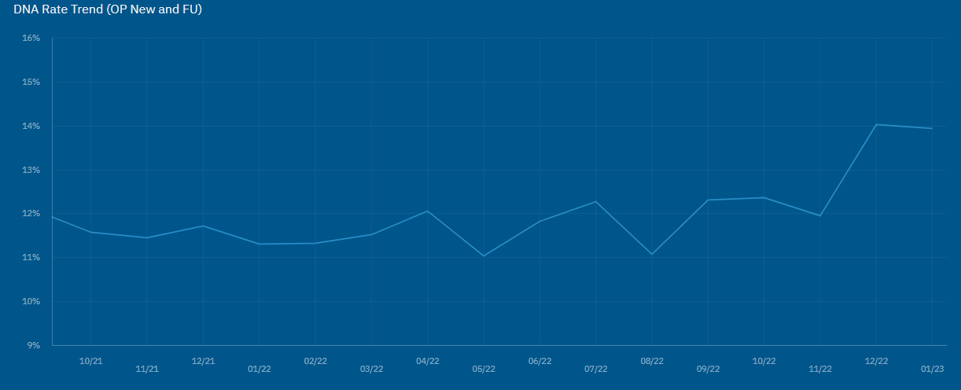
Fig. 1
Reducing the DNA rate is a major necessity for C&VUHB due to wasted money, resources, and outpatient slots. By having the aim of PPB to deliver a reduction in the DNA rate, C&VUHB will achieve its own goals, and align them with the Welsh Government policy of reducing DNA rates of all outpatient appointments to 5% (Welsh Government, 2020, p. 21).
The precursor to PPB, known as FAB, showed that it was beneficial to reducing the DNA rate by averaging a DNA rate of 5.9%. This shows that a rate of under 6% is achievable for an AB solution with new outpatient appointments. By having this data available on FAB the projects aim can be realistic and a benchmark to be set for the new AB process.
The aim of reducing DNA rates will also be of benefit in achieving the project objectives of increasing clinic utilisation (CU), a higher compliance with referral to treatment (RTT) times and a reduction in W/L times which is a requirement by Welsh Government (2022, p. 3).
PPB Objectives
Waiting List Reduction and RTT Compliance
The Welsh Government (2022, p. 3) has made reducing W/L times a key requirement for all health boards. As Fig. 2 shows in December 2022, the NHS in Wales currently still has around 75,000 patients waiting over a year for their first appointment (Welsh Government, 2023b, p. 5). Failing the planned care recovery target set out by the Welsh Government (2022, p. 4). Coupled with W/L times being one of the main areas of concern for patients (Appleby et al., 2020, p. 3). Therefore, a key objective of PPB is to reduce W/L times for outpatient appointments and ensure patients are receiving their first outpatient appointment within a year. C&VUHB will achieve this by ensuring slots are better utilised through the repurpose of appointment slots not required by appointed patients.
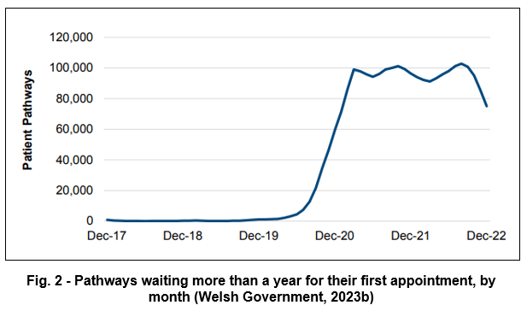

The current high wait times for patients to receive their first appointment have impacted on RTT compliance (Welsh Government, 2022, p. 25). This has led to 45% of patients waiting over 26 weeks, which is significantly high to pre-pandemic levels (Welsh Government, 2023b, p. 4). Currently, the average wait time for treatment is roughly 22 weeks (Welsh Government, 2023b, p. 5). By improving the DNA rate and increasing CU, more patients can receive their first appointment sooner. Helping achieve the Welsh Government’s (2022, p. 26) plans and objectives.
Increased Clinic Utilisation
Increased CU is an objective of the project because reducing the DNA rate alone will not help in improving W/L times and RTT compliance. It is vital for the project that PPB does not just transfer the DNA slots into could not attend (CNA) slots. Therefore, success needs to be assessed on how the regained slots from the PPB process are no longer a DNA slot and are reutilised. C&VUHB will do this through clinical utilisation. By increasing CU, C&VUHB will see more patients in a session, enabling greater utilisation of appointment slots and facilitating more patients to be seen, reducing W/L’s (Welsh Government, 2022, p. 27). Decreasing the need for additional overtime clinics to help with outpatient recovery, alleviating the increased chance of staff burnout (Relias Learning, 2013, p. 1).
Improving Patient Communication
The project’s objective is to ensure patients receive the correct communication at the correct time by having a redesign of current appointment letters, improving patient satisfaction. The Welsh Government (2020, p. 11) has revealed that there is a lack of patient satisfaction with outpatient communication. Findings indicate that miscommunication and administrative errors are a major factor in patient non-attendance (McLean et al., 2014, p. 52).
Scheduling of appointments will occur six weeks prior. This is to ensure the approval of all clinician requests for annual leave prior to sending of appointments as per C&VUHB policies and procedures. Leading to less hospital appointments being cancelled. The project will also achieve improved communication and experience for the patient by using a digital approach (Welsh Government, 2021c, p. 16) through letters being sent digitally. Aligning with C&VUHB’s (2020, p. 6) high-level aim of a digital first approach for patients. Incorporating a digital first approach, will enable the project to measure success by recording and analysing successful logins and responses to achieve a digital acceptance rate for patients.
Resource Redistribution
The automation of the booking process for new case appointments within PPB will enable the project to redistribute administrative resources (Willis et al., 2019, p. 8). The administrative team currently takes a high proportion of time daily in booking outpatient appointment slots. This includes selecting the correct patients based on clinical need and patients’ wait time for an appointment. The aim of the project is to automate the process of patient selection, as well as appointment booking. Automating this process means administrative time can be repurposed and used more efficiently (Willis et al., 2019, p. 8).
Conclusion
PPB’s aim of reducing the DNA rate of new outpatients’ appointments along with the objectives of increasing CU, reducing W/Ls, improving RTT compliance and increasing virtual appointment uptake will permit C&VUHB to comply fully with the Welsh Government Policies and vison (Welsh Government, 2022, p. 14). Objectives of improving patient satisfaction and resource redistribution will give patients and staff at the heart of the project improved experiences of the system. This will be a major factor in calculating success. Incorporating all these aims and objective in the project from the outset will provide improved efficiency and communication for new outpatient appointments.
Data Collection
Introduction
Data collection for PPB will be a vital element within the project for successful integration. Before implementation, the project team must define data to measure project performance of PPB's improvement to the service (Scheider, Ostermann and Adams, 2017, p. 16). To guarantee full realisation of the project, it will require accurate and consistent data as a requirement (Pajouheshnia, 2019, p. 2). It is crucial when analysing the data, the project critically evaluates the results (Scheider, Ostermann and Adams, 2017, p. 12). By completing these tasks, the project team will have the ability to discover any issues and resolve them.
Defining data requirements
Data capture for PPB will require a mixed method approach of both quantitative and qualitative data, with an emphasis on quantitative data (Table 1). Quantitative data will be required to capture data such as the DNA rates and CU. Qualitative data will be required to give the project more context (Flick, 2018, p. 5). The project may reduce the DNA rate but, PPB could contribute to patient and staff dissatisfaction. Likely leading to project failure, causing staff to find a workaround or patients not engaging (Cresswell et al., 2017, p. 547).
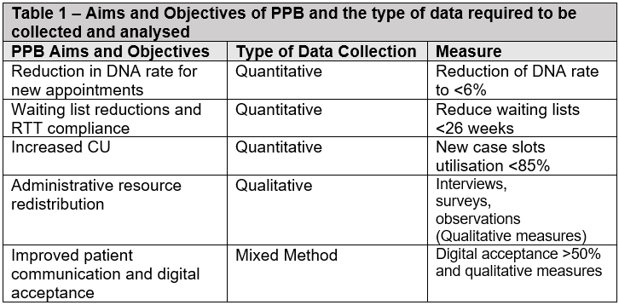
Quantitative Data Collection
The aim of the project requires the capture of the DNA rate for outpatient appointments. The project can access this data, along with W/L times, RTT compliance and CU, through the oracle database within C&VUHB. Data can then be captured prior to launch and continuously throughout to deliver robust results (Sun et al., 2017, p. 2).
The project will look to capture over a year's worth of data and the project can look at seasonal trends, such as the Christmas period. Permitting the project to obtain an accurate and comprehensive picture of the existing situation (Vanzant Stern, 2019, p. 56). Seasonal trends, like the Christmas period, can have a major influence on outpatient appointments (Fig. 3). As the date and time of the appointment is one of the main reasons for a patient’s DNA (NHS England, 2023b).
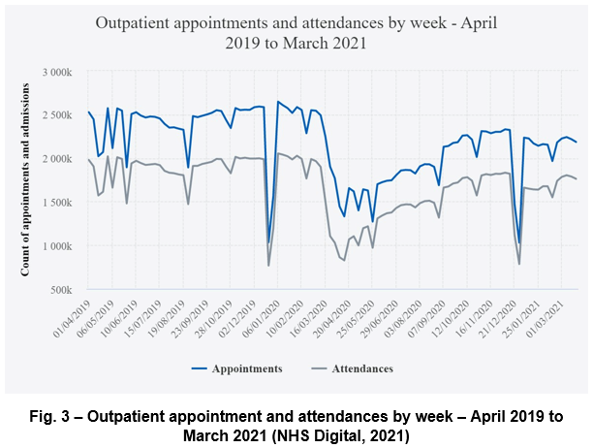
Seasonal trends can also affect slot availability, which can cause variance in data (Office for National Statistics, 2021), slot availability effects CU figures, W/L times and the DNA rate percentage. The project will also need to factor in appointment slot availability in data collection.
Consideration needs to be taken for the number of W/L initiative clinics that are being held. As NHS trusts use W/L initiative clinics to reduce W/L times (Appleby, 2005, p. 5). This could skew the results to look better than they are.
Data will need to be captured on the percentage of appointments in a clinic that PPB can book. The project must distinguish the impact PPB has on individual clinics.
The project will capture the DNA rate for all appointment slots, not just PPB. This will enable the project to compare multiple booking methods and show potential benefits of PPB to these booking types. The project must be mindful of differing booking methods and Urgent Suspect Cancer (USC) appointments. USC appointment booking occurs by telephone and is booked with only a few days’ notice. This is a more labour-intensive booking method but can lead to a lower DNA rate.
The project will capture CU to confirm that the slots released by PPB are reutilised. This is to guarantee the project is not turning an appointment slot from a DNA to CNA, leading to continued wasted resources (NHS England, 2023a).
The project will also capture the CNA and reutilisation rate. Along with these two rates, the project will monitor the number of days prior to the appointment the patient releases the appointment slot. Establishing if and when the slots could have been reutilised. Other items to be captured include when C&VUHB reutilised the slot after release and if the patient has confirmed prior to cancelling their appointment.
Quantitative Analysis
Analysis of the quantitative data will establish the project a logical foundation of solution outcomes (Vanzant Stern, 2019, p. 75). The project team will display the analysed information in charts and graphs, as it makes it easier to understand and visualise when presenting data (Vanzant Stern, 2019, p. 75).
Statistical Process Control
One way the project will analyse quantitative data is by using Statistical Process Control (SPC). SPC is a technique for analysing data from time-series graphs. It facilitates understanding of variation and guides the project in choosing the optimal course of action (NHS England, 2019). The project will be able to determine whether there is a link between the deployment of PPB and a significant decline in DNA rates over time, through time-series analysis (Shin, 2017, p. 10).
The wide use of SPC charts is mostly for sequential process monitoring (Qui, 2018, p. 49). SPC is a useful tool since it provides up-to-date information to aid in making prompt decisions (Fretheim and Tomic, 2015, p. 748). Fig. 4 shows an example of SPC which could be useful to presenting the DNA rate for PPB.
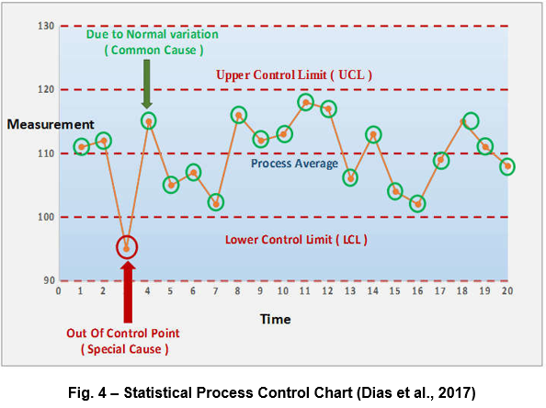
The benefit of SPC is that SPC graphs can show whether a process is subject to common cause variation or special cause variation (Connelly, 2018, p. 332).
A disadvantage of using SPC as Qui (2018) notes, is that one must adequately adjust or generalise conventional SPC charts when the data structure grows more complex to remain relevant. SPC also ignores secular trends like the holiday season, which has the potential to produce incorrect findings with the DNA rate (Fretheim and Tomic, 2015, p. 749). The project will need to reduce or eliminate seasonal trends when analysing data (McDowall, McCleary and Bartos, 2021, p. 44). Therefore, alternative methods of analysis will be required.
Interrupted Time Series
Within Interrupted Time Series (ITS), there are three methods available to deal with seasonal trends. These are: causal modelling, de-seasonalisation, and ARIMA modelling (McDowall, McCleary and Bartos, 2021, p. 44). The “best” way to handle seasonal trends is to use causal modelling (McDowall, McCleary and Bartos, 2021, p. 44).
Additionally, ITS uses the data to compare levels and patterns immediately preceding and following an intervention. (Fig. 5) (Fretheim and Tomic, 2015, p. 749). Meaning that regular data collection before and after the intervention is a requirement (Office for Health Improvement and Disparities, 2020).
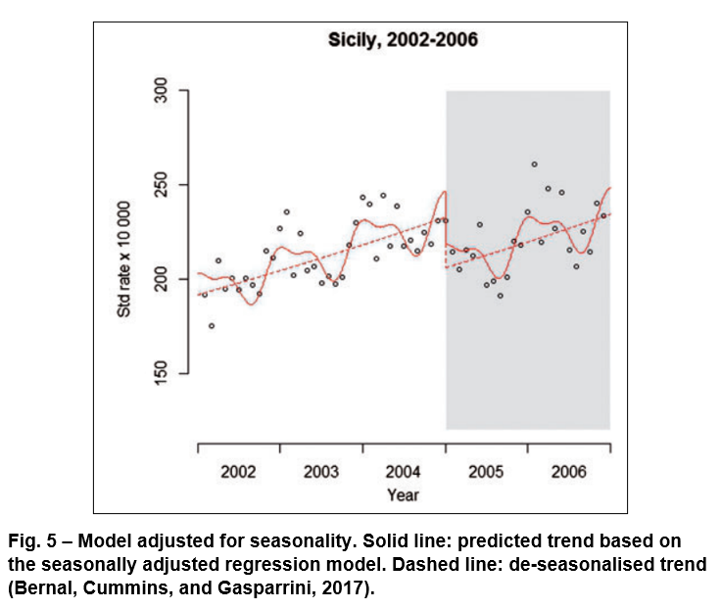
ITS will be beneficial to PPB as ITS can measure at least two time series against each other. The intervention given to one, while the untreated control is given to the other (Fig. 6) (McDowall, McCleary and Bartos, 2021, p. 4). This provides the control time series to create a link between the intervention and the impact by eliminating a common threat to its own validity (McDowall, McCleary and Bartos, 2021, p. 4). The project will benefit from this as it will enable a visual demonstration of the effect of PPB on the DNA rate against manual booking in the same clinics or specialities. Like how the project will use descriptive statistics to compare the DNA rates between PPB and other appointment booking methods by bivariate data (Hayes, 2023).
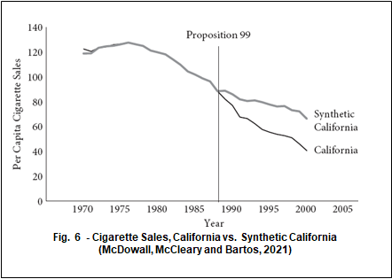
SPSS
Other methods to analyse the quantitative data will include the use of SPSS. SPSS is a user-friendly piece of software that is a superb data-management tool (Byrne, 2002, p. 96). Advantages of SPSS are that you can use it to explore and summarise the data (Byrne, 2002, p. 96). Through exploration, the project can reorder the data in a way that makes it possible to spot significant patterns (Byrne, 2002, p. 97). Having results then being able to be shown using graphical representations, this creates an easier understanding when analysing the data (Byrne, 2002, p. 97). The graphical representation can include items such as histograms, bar charts, line graphs, scatterplots, and boxplots (Fig. 7) (Pallant. 2010, p. 66).

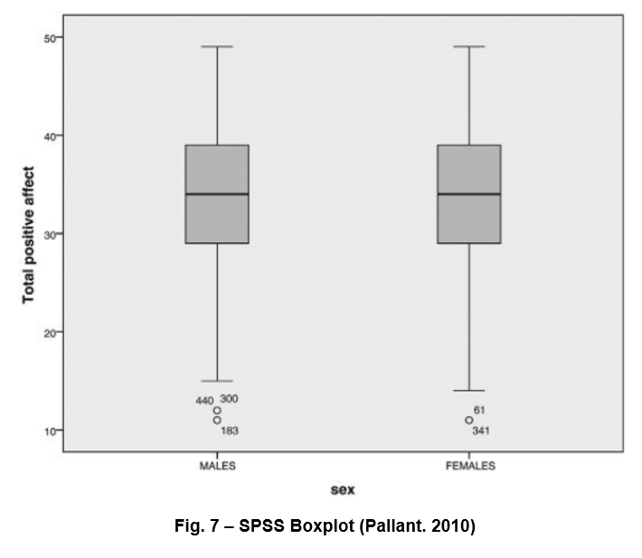
Boxplots are a good graphical representation of several pieces of data on the same scale (Byrne, 2002, p. 97). The project can partition the data like CU into distinct groups, for example booking type (Pallant. 2010, p. 77). Another advantage of a boxplot within SPSS is you can add an additional variable, such as the appointment type, to be analysed (Pallant. 2010, p. 77), for greater understanding of the data and trends.
Further Analysis
The project will use regression analysis in the project to measure the association between PPB usage and DNA rates, whilst accounting for various confounding factors (Madecraft and Buscha, 2022).
The project will also look to use a cost benefit analysis. By comparing the anticipated or predicted costs and benefits connected with PPB, the project will assess whether it makes sense from a business point of view to continue with PPB (Stobierski, 2019).

Qualitative Data Collection
Qualitative data will be required to ascertain if the project has been successful in the redistribution of administrative time. Through surveys, work observations, and interviews with staff and management, the project will gather the qualitative data (Flick, 2014, p. 5).
Interviews will occur to gage how staff and management feel about PPB, focusing on capturing words verbatim to help give the project greater insight into the interviewee’s thoughts (Yin, 2016, p. 166).
The project will need to consider how certain questions will function in practise, how respondents will interpret them, and how they will probably react in the actual interview setting (Flick, 2018, p. 27). Therefore, it is vital that the project defines the questions well and pilot tests them when collecting qualitative data from administrative staff to ensure collection of the correct data from the administrative teams and managers that use PPB. Questions will concern the difficulties administrative teams experience when applying PPB, the advantages of PPB for administrative workers and potential areas for PPB enhancement.
Observations will assist the project in collecting information on how long each task takes, how much work they leave at the end of each day and recognising the differences in atmospheres between each stage of the project (Flick, 2018, p. 323).
Capturing of qualitative data will occur prior to the launch of PPB and once fully operational. The project can then get a richer volume of data and acquire different perspectives on how PPB impacts on the distribution of work at different stages of the project (Flick, 2018, p. 243).
Qualitative Analysis
The project will look to analyse the qualitative data by using a thematic analysis approach. The benefit of thematic analysis is that it will give PPB a way to organise and summarise the results of a broad and varied body of data (Pope, Mays and Popay, 2007, p. 97). It will give PPB the chance to dig deeper and find clearer meaning in terms of themes by looking beyond the words that participants have said during data collection (Shaheen, Gupta, and Prathap, 2019, p. 214).
To enable PPB to use thematic analysis, the project will need to format the qualitative data and separate the data into specific data sets for analysis (Yin, 2016, p. 192). Then the project can code identify themes within the data (Yin, 2016, p. 198).
Once discovery of themes is complete, the narratives that reflect staff experiences and points of view together with diagrams and other visual representations of key concepts will illustrate the qualitative data (Flick, 2014, p. 305).
Since thematic analysis is, in large part, a narrative technique, it can also manage quantitative as well as qualitative data (Pope, Mays and Popay, 2007, p. 97). This will permit the project to use quantitative data, such as the time spent by administrative staff to perform appointment booking duties before and after the implementation of PPB, such as a time-motion study (Lopetegui, 2014, p. 292).
Mixed Method Data Collection
A mixed method approach involves the cooperation and integration of quantitative and qualitative methodologies (Oflazoglu and Oflazoglu, 2017). The primary objective of the project is to direct the entire process formulated from the outset (Oflazoglu and Oflazoglu, 2017). For PPB, this is the link between the digital acceptance and improving patient satisfaction.
To check patients are engaging with PPB, the project will capture the digital acceptance rate. This will include the number of login attempts, successful logins, and the number of confirms, cancellations and rebooks entered. These numbers will be further broken down to time attempted or actioned after PPB sent the digital message. Other captured data will include how many appointments reverted to a physical letter, sent a second invite letter, or responded to the text remind sent 10 days prior to appointment date. Data collected will also include how the patient responded. For example, did the patient respond digitally or did the patient use the automated telephone number or contact the ABC. Additional items to consider include the number of patients who did not respond, responded too late, and those who did not respond but still turned up to the clinic for their appointment. The project will collect additional data on the number of patients using PPB and the average amount of time saved by patients when using PPB rather than phoning ABC.
The project will look to use secondary captured data on patient communication from the patient experience team. They will capture data on patient communication questionnaires and surveys (Flick, 2014, p. 5). Fig. 8 shows an example of possible survey questions.
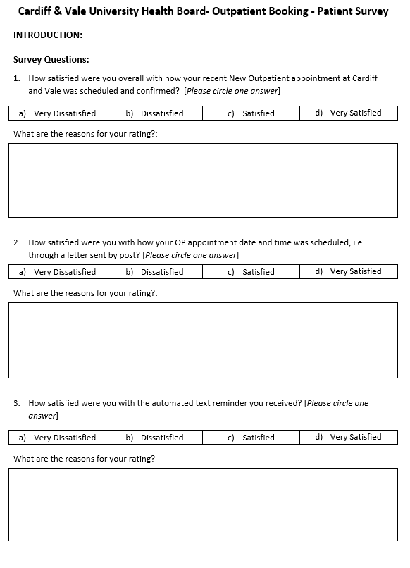
Fig. 8

Mixed Method Analysis
A mixed method analysis will offer the chance to give greater context to quantitative data. Enabling the project for instance, to study less than optimum data, such as low engagement of PPB (Williams and Trenton, 2017, p. 269). The qualitative information such as the patient experience data gives context and influence for these figures (Williams and Trenton, 2017, p. 269). For example, low engagement with the digital letter could have a link to poor intuitive design of the app or lack of trust.
Once data capturing is complete, the project can proceed with quantitating the data sets using content analysis on the results from the data capture (Fig. 8) (Williams and Trenton, 2017, p. 277). To fully analyse the data, the project must first define relationships of interest in the data (Williams and Trenton, 2017, p. 278). Looking at the failed login attempts and questions related to user remarks with the intuitiveness of the digital letter. The project can also code a subset of the data to assess how well the relationships established in the first phase work (Williams and Trenton, 2017, p. 278). Helping validate the results.
The analysis can then use graphs and tables like a pie chart and bar graphs (Fig. 9) to display the findings. A further method to display results will be to use the Fit between Individuals, Task and Technology (FITT) framework. The project can use the FITT framework to assess PPB’s success and areas requiring improvement (Tsiknakis and Kouroubali, 2008, p. 40). An example of this is using the patient as the individual, improved communication as the task and PPB representing the technology (Fig. 10).

Fig. 9

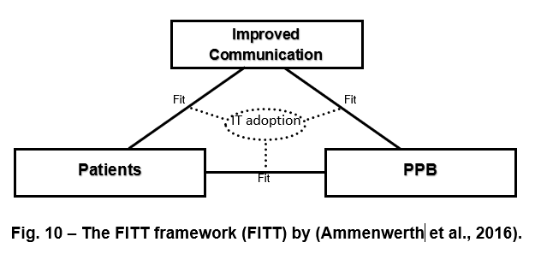
Other methods to determine issues such as digital acceptance will be to use root cause analysis. By using root cause analysis, the project will identify the root causes of the issue with PPB digital acceptance and deal with them in the proper sequence to truly fix it (Yankelevitch, 2022).
The project will also look to use descriptive statistics to compare how frequently patients communicated with ABC pre and post PPB adoption regarding appointment changes (Hayes, 2023).
Conclusion
By capturing the quantitative and qualitative data as outlined in this paper, the data will not only provide an understanding of the successes of the project but in addition demonstrate further innovation of PPB (Blackburn et al., 2017, p. 48). By collecting and analysing data for an extended period it will make the project consider any seasonal trends or outside factors that may affect the project outcomes. Whilst giving the project time to discover the themes of PPB’s usage from staff members.
By incorporating a mixed method analysis, the project can explore the possible outcomes of PPB through the investigation of new research inquiries that would not be possible using quantitative and qualitative analysis alone (Williams and Trenton, 2017, p. 277). Combining qualitative and quantitative data, a mixed method approach can highlight contextual variables and help PPB evaluate the nature of what they convey through these relationships (Williams and Trenton, 2017, p. 277). Ensuring the prospect of proving the effect of PPB on the aims and objectives.

Ethical or information governance issues
Introduction
Any new digital project like PPB has the potential to pose security and privacy issues (Pal et al., 2019, p. 58). Patient level data will need to be transferred for digital letters to be sent. Patient level data is also required to be stored for data analysis and reporting. Thus, the project must deal with any ethical and information governance (IG) issues and considerations before PPB goes live. Some of these issues include using a third-party provider, the use of patient information, and data. Therefore, the project must comply with data protection legislation. Guaranteeing the rights of all living people to their freedoms, including their right to privacy when it comes to their personal information (NHS Wales, 2021, p. 5).
Third-party provider
C&VUHB must consider IG practises in advance to guarantee the protection of personal data for all new projects, such as PPB (Cardiff and Vale University Health Board, 2019, p. 9). This is to give reassurance that C&VUHB are operating to required standards and in compliance with data privacy laws (NHS Wales, 2021, p. 6).
As PPB is a cloud-bases service that will use a third-party operator to send the digital letters, it will require a legally binding written contract. Any contract must comply with data protection regulations and must be in place for the third-party to process personal data on behalf of C&VUHB (2019, p. 9). The project must formalise the arrangements for the processing and sharing of personal data that the UHB controls in accordance with UHB documents and specifications, such as the UHB’s Data Processing Contract, Security Arrangements, Contracts, Procurement technical specification, codes of conduct and access specifications (Cardiff and Vale University Health Board, 2019, p. 9). PPB must select an appropriate processor of the digital letter and consider proper and authorised standards of conduct or certification programmes to show that (NHS Wales, 2021, p. 7). By doing this, it guarantees the consistent process of personal data, and that everyone involved is aware of their individual responsibilities (Cardiff and Vale University Health Board, 2019, p. 9).
Automation of Appointment Booking
One consideration for PPB is that a patient has the right to request a human person to review the use of any “automated decision making” software (Health Education and Improvement Wales, 2023). To deal with this issue, the project will incorporate the production of a daily booking report that is sent to all service managers to review appointment bookings made by PPB. To further safeguard any issues, PPB will implement a pre-PPB run function that will enable service users to produce a report before PPB books appointments and show future appointment bookings. Service managers can then ensure the correct patients are being booked into the correct slot.
Data Collection
The project will generate and capture new data from the digital acceptance rate to the number of cancelled appointments. Therefore, the project must make certain that any data that PPB creates, or processes is accurate, up to date and fit for purpose (NHS Wales, 2021, p. 9). The project will only store information that is deemed essential. As data and information must meet a certain criterion to be useful (NHS Wales, 2021, p. 9). The project will guarantee that the data and information it holds and processes is of the highest quality and is practical because low-quality data and information can impede the project’s efforts to achieve its objectives (NHS Wales, 2021, p. 9).
To achieve enforcement of data minimisation, the project must adhere to organisational policies and guidelines (NHS Wales, 2021, p. 6). Personal data being anonymised or pseudonymised as necessary (NHS Wales, 2021, p. 6). To reduce IG concerns, the service evaluation of PPB will not be using patient level data.
Collection of the qualitative data will require consent from the individuals. Consideration will need to make sure that the interviewees understand the process. As it might be difficult to obtain informed consent if it is unclear what the person is agreeing to and where their participation starts and stops (Mauthner, 2002, p. 53). The project can routinely obtain participants’ informed consent for data collection (Miller, 2012, p. 163), through questionnaires being taken anonymously (Fig. 11).
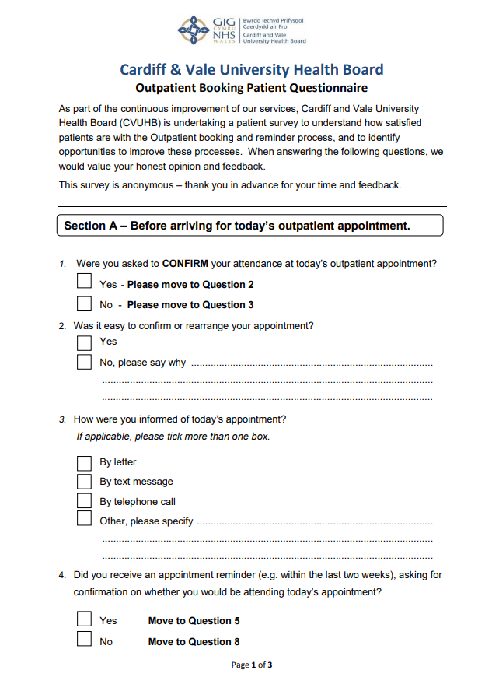
Fig. 11
The project will store the data collected by PPB in a format that complies with acknowledged national standards, to guarantee that the data collected is accurate (Cardiff and Vale University Health Board, 2019, p. 12). The computer systems will accept only correct entries and map the data via codes to national values (Cardiff and Vale University Health Board, 2019, p. 12). To achieve this, PPB will capture quantitative data through C&VUHB’s oracle database.
Ethical Form
Publishing sensitive or potentially damaging data may give rise to ethical dilemmas (Flicker et al., 2007, p.482). Therefore, the study on PPB needs to be done to the right standards and in accordance with commonly accepted ethical guidelines (University of Wales Trinity Saint David, 2023). To accomplish this, the project will complete an ethical form (see appendix).
An ethics form is documentation that requests details about the project, like PPB to make sure that the project is adhering to predetermined standards (University of Derby Library, 2023). However, it is not acceptable to ignore ethical issues after satisfactorily completing an ethics form at the start of a study and receiving ethics permission; rather, ethical considerations should remain a constant component of the research (Mauthner, 2002, p. 53).
Conclusion
The project around PPB will raise ethical and IG issues that will require consistent monitoring throughout. Before implementation of PPB, the project needs to validate the third-party provider, whilst finalising the consideration of data collection and storage. By following the recommendations listed above the project will consider all variables and deal with issues accordingly.
The project will look to only collect data that is relevant, with patient data anonymised (NHS Wales, 2021, p. 6). As the data collected is being stored to national standards, this will alleviate IG issues (Cardiff and Vale University Health Board, 2019, p. 12). An ethical form and continuous consideration for ethical issues throughout (Mauthner, 2002, p. 53), will enable PPB to maintain the highest ethical standards for the project (University of Wales Trinity Saint David, 2022, p. 3).

Appendix
APPLICATION FOR ETHICAL APPROVAL
RESEARCH STUDENTS
This form is to be completed by the student within SIX months for full-time students and TWELVE months for part time students, after the commencement of the research degree or following progression to Part Two of your course.

Once complete, submit this form via the MyTSD Doctoral College Portal at (https://mytsd.uwtsd.ac.uk).

This document is also available in Welsh.

RESEARCH STAFF ONLY
All communications relating to this application during its processing must be in writing and emailed to pgresearch@uwtsd.ac.uk , with the title ‘Ethical Approval’ followed by your name.

STUDENTS ON UNDERGRADUATE OR TAUGHT MASTERS PROGRAMMES should submit this form (and receive the outcome) via systems explained to you by the supervisor/module leader.

In order for research to result in benefit and minimise risk of harm, it must be conducted ethically. A researcher may not be covered by the University’s insurance if ethical approval has not been obtained prior to commencement.
The University follows the OECD Frascati manual definition of research activity: “creative work undertaken on a systematic basis in order to increase the stock of knowledge, including knowledge of man, culture and society, and the use of this stock of knowledge to devise new applications”. As such this covers activities undertaken by members of staff, postgraduate research students, and both taught postgraduate and undergraduate students working on dissertations/projects.
The individual undertaking the research activity is known as the “principal researcher”.
Ethical approval is not required for routine audits, performance reviews, quality assurance studies, testing within normal educational requirements, and literary or artistic criticism.
Please read the notes for guidance before completing ALL sections of the form.
This form must be completed and approved prior to undertaking any research activity. Please see Checklist for details of process for different categories of application.
SECTION A: About You (Principal Researcher)
1 | Full Name: |  | Jonathan Daryl Davies
2 | Tick all boxes that apply: |  | Member of staff: | ☐ | Honorary research fellow: | ☐
 | Undergraduate Student | ☐ | Taught Postgraduate Student | ☒ | Postgraduate Research Student | ☐

3 | Institute/Academic Discipline/Centre: | Digital Health and Care
4 | Campus: | Carmarthen/Online
5 | E-mail address: | 2112927@student.uwtsd.ac.uk
6 | Contact Telephone Number: | 07882892060
 | For students:
7 | Student Number: | 2112927
8 | Programme of Study: | MSc Digital Skills for Health and Care Professions
9 | Director of Studies/Supervisor: | Philip Scott

SECTION B: Approval for Research Activity
1 | Has the research activity received approval in principle?  (please check the Guidance Notes as to the appropriate approval process for different levels of research by different categories of individual) |  | YES | ☐ | NO | ☒
 |  |  |  |  | Date
2 | If Yes, please indicate source of approval (and date where known): Approval in principle must be obtained from the relevant source prior to seeking ethical approval | Research Degrees Committee |  | ☐
2 |  | Institute Research Committee |  | ☐
2 |  | Other (write in) |  | ☐

SECTION C: Internal and External Ethical Guidance Materials
 | Please list the core ethical guidance documents that have been referred to during the completion of this form (including any discipline-specific codes of research ethics, location-specific codes of research ethics, and also any specific ethical guidance relating to the proposed methodology). Please tick to confirm that your research proposal adheres to these codes and guidelines. You may add rows to this table if needed.
1 | UWTSD Research Ethics & Integrity Code of Practice | ☒
2 | UWTSD Research Data Management Policy | ☒
3 | [List any other relevant documents here] | ☐

SECTION D: External Collaborative Research Activity
If there are external collaborators then you should gain consent from the contact persons to share their personal data with the university. If there are no external collaborators then leave this section blank and continue to section E.
1 | Institution
2 | Contact person name
3 | Contact person e-mail address
4 | Is your research externally funded? |  | YES | ☐ | NO |  | ☐
5 | Are you in receipt of a KESS scholarship? |  | YES | ☐ | NO |  | ☐
6 | Are you specifically employed to undertake this research in either a paid or voluntary capacity? | Voluntary | YES | ☐ | NO | ☐
7 |  | Employed | YES | ☐ | NO | ☐
8 | Is the research being undertaken within an existing UWTSD Athrofa Professional Learning Partnership (APLP)? | If YES then the permission question below does not need to be answered. | YES | ☐ | NO |  | ☐
9 | Has permission to undertake the research has been provided by the partner organisation? | (If YES attach copy)  If NO the application cannot continue | YES | ☐ | NO |  | ☐

Where research activity is carried out in collaboration with an external organisation
10 | Does this organisation have its own ethics approval system? | YES | ☐ | NO | ☐
 | If Yes, please attach a copy of any final approval (or interim approval) from the organisation (this may be a copy of an email if appropriate).

SECTION E: Details of Research Activity
1 | Indicative title: | Reducing outpatient DNA rate by using automated booking
2 | Proposed start date: | 28/09/2023 | Proposed end date: | 24/05/2024
Introduction to the Research (maximum 300 words per section)
Ensure that you write for a Non-Specialist Audience when outlining your response to the points below:
- Purpose of Research Activity
- Proposed Research Question
- Aims of Research Activity
- Objectives of Research Activity
Demonstrate, briefly, how Existing Research has informed the proposed activity and explain
- What the research activity will add to the body of knowledge
- How it addresses an area of importance.
3 | Purpose of Research Activity  The purpose of the research activity is to have a system evaluation of the auto booking system for new outpatient appointments know as patient participation booking (PPB). PPB automates and standardises the appointment booking process. PPB uses a digital first approach to align with Cardiff and Vale University Health Board’s objectives. Ensuring patients will receive a digital appointment letter in the first instance unless they are not capable of receiving one digitally. Existing research has shown forgetfulness can be a major factor in patient Did Not Attend (DNA) rates. Therefore, appointments are to be scheduled 6 weeks prior and patients are being asked to confirm, cancel or change their appointment. Appointments are cancelled 6 days prior to the appointment if no response is received after 3 attempts, including text reminds from Cardiff and Vale University Health Board requesting a response. This is to allow slots to be reutilised and improve clinic utilisation. Test reminds have been incorporated into PPB as existing research shows that text remind services are useful for reducing DNA rates.  The emphasis of the system evaluation will be on PPB’s ability to incorporate the standardisation of appointment booking along with required patient participation and the impact of text reminds to reduce the DNA rate within outpatient clinics. Enabling greater clinic utilisation and reduction of waiting list times. The reduction of waiting list times is a key requirement from the Welsh Governments in the recovery from Covid-19.
4 | Research Question  The research questions for my dissertation are as follows  - Can PPB reduce the DNA rate for new outpatient appointments?  - Can PPB improve patient communication and reduce demand on services such as the appointment booking centre?  - Can PPB enable the redistribution of administration time through the automation of appointment booking?
5 | Aims of Research Activity  The aim of the research is to successfully show how PPB can reduce the DNA rate within new outpatient appointments by a minimum of 5%. Current DNA rates within Cardiff and Vale are averaging 12%. To achieve this PPB will require patients to confirm, cancel or change their appointments digitally. Giving patients greater control of their appointments. To enhance patients’ responses rates, PPB will digitise appointment letter delivery with patients able to respond digitally with a click of a button. This permits standardisation of the delivery of appointment letters and the date they are sent.
6 | Objectives of Research Activity  The objectives of the research are to show through the reduction of the DNA rate that PPB can reduce waiting list times within new outpatient appointments that can facilitate specialities within the Cardiff and Vale University Health Board to comply with referral to treatment guidelines.  Other objectives will include the ability to show the difference PPB has on clinic utilisation. As reduction of the DNA rate alone will not show how PPB has impacted on waiting list reductions because PPB could be turning DNA slots into vacant slots. Therefore, one of the objectives of the service evaluation will be to show how PPB has changed clinic utilisation within Cardiff and Vale University Health Board.  Evaluating patient participation through PPB and if it has an impact on other services like the appointment booking centre which dealt with all appointment changes prior to PPB will be a further objective.  The final objective will be to discover if PPB has helped rebalance resource distribution in administrative teams. Due to the automation of previous administrative resource being heavy on manual booking. Meaning tasks that were previously unable to be completed in a standard working day could now be completed.
Proposed methods (maximum 600 words)
Provide a brief summary of all the methods that may be used in the research activity, making it clear what specific techniques may be used. If methods other than those listed in this section are deemed appropriate later, additional ethical approval for those methods will be needed. You do not need to justify the methods here, but should instead describe how you intend to collect the data necessary for you to complete your project.
7 | A mixed method approach will be required for gathering data for PPB, focusing on quantitative data.  Quantitative data will be required to capture items such as the new appointment DNA rates within Cardiff and Vale University Health Board. Other data that will be required include clinic utilisation, the patient cancellation rate, waiting list times and referral to treatment compliance of specialities. Data will also include the number of slots available to PPB to book appointments.  This quantitative data is readily available from the business intelligence systems within Cardiff and Vale University Health Board as the information is stored in the health boards oracle database. This information is already reported and shared by the Welsh Government. Information will only be required at clinical level and will not include any patient identifiable information.  Quantitative data will include items such as when slots are released for reutilisation by PPB. This will be done by the project capturing data on how and when the appointment slots are made available. This is done to determine if and when the slots have been reused. Information to be recorded includes when the appointment slots are used again after being released and whether the appointment was confirmed before the cancellation.  The project will provide the data as charts and graphs because they make the data easier to comprehend and visualise. The project will use items such as statistical process control and interrupted time series to analyse the data along with SPSS to analyse and produce charts like boxplots to compare and contrast items for instance clinic utilisation on PPB versus other booking methods.  Items of analysis will include root cause analysis and cost benefit analysis.  In order to examine seasonal trends, including those during the Christmas season, the study will attempt to collect data spanning more than a full year. Information will be collected prior and after launch.  The project will capture the digital engagement of PPB with patients by capturing the data. This will include the number of successful logins, accessing of digital letter, successful replies and other items such as access of digital extras such as changing of language. The project will also look to use secondary qualitative patient data collected by Cardiff and Vale University Health Board on patient communication methods.  Information on patient engagement with PPB will be acquired from the information stored within Healthcare Communications reporting and audit tools. This has passed all the information governance requirements by Cardiff and Vale University Health Board. All data is anonymised, and all patient identifiable information has been removed before being analysed.  The project will then use content analysis to decipher any relationships from the data captured. For instance, questions about user comments with the digital letter's intuitiveness and failed login attempts.  Qualitative data will be required to give the project more context. The project will acquire the qualitative data by using questionnaires, work observations, and interviews with administrative staff and management who will be using the service intervention of PPB. Qualitative data will be collected before PPB is launched, during the pilot stage, and after it is fully operational. This will support the project to obtain a bigger amount of data and gain access to various viewpoints on how PPB affects the workload at various project stages. All interviews and questionnaires will be anonymous and no personal identifiable information on participations is recorded.  The study will attempt to use a thematic analysis method to analyse the qualitative data. The use of thematic analysis will enable PPB to organise and summarise the findings of a large and diverse body of data.
Location of research activity
Identify all locations where research activity will take place.
8 | The location of research will take place in Cardiff and Vale University Health Board
Research activity outside of the UK
If research activity will take place overseas, you are responsible for ensuring that local ethical considerations are complied with and that the relevant permissions are sought. Specify any local guidelines (e.g. from local professional associations/learned societies/universities) that exist and whether these involve any ethical stipulations beyond those usual in the UK (provide details of any licenses or permissions required). Also specify whether there are any specific ethical issues raised by the local context in which the research activity is taking place, for example, particular cultural and/or legal sensitivities or vulnerabilities of participants. If you live in the country where you will do the research then please state this.
9 | N/A

10 | Use of documentation not in the public domain: Are any documents NOT publicly available? | NO | ☐
10 |  | YES | ☒
11 | If Yes, please provide details here of how you will gain access to specific documentation that is not in the public domain and that this is in accordance with the current data protection law of the country in question and that of England and Wales.  Information on patient engagement with PPB will be captured from the information stored within Healthcare Communications reporting and audit tools. This has passed all the information governance requirements by Cardiff and Vale University Health Board. All data is anonymised, and all patient identifiable information is removed before being analysed.

 | Does your research relate to one or more of the seven aims of the Well-being of Future Generations (Wales) Act 2015? | YES | NO
12 | A prosperous Wales | ☐ | ☐
13 | A resilient Wales | ☐ | ☐
14 | A healthier Wales | ☒ | ☐
15 | A more equal Wales | ☐ | ☐
16 | A Wales of cohesive communities | ☐ | ☐
17 | A Wales of vibrant culture and thriving Welsh language | ☐ | ☐
18 | A globally responsible Wales | ☐ | ☐
19 | If YES to any of the above, please give details:
 | The project uses the design principles of a healthier Wales’ national transformation programme by supporting patients to receive better quality and experience, providing a digital approach for their outpatient appointment letters.

SECTION F: Scope of Research Activity
 | Will the research activity include: | YES | NO
1 | Use of a questionnaire or similar research instrument? | ☒ | ☐
2 | Use of interviews? | ☒ | ☐
3 | Use of focus groups? | ☐ | ☒
4 | Use of participant diaries? | ☐ | ☒
5 | Use of video or audio recording? | ☐ | ☒
6 | Use of computer-generated log files? | ☒ | ☐
7 | Participant observation with their knowledge? | ☒ | ☐
8 | Participant observation without their knowledge? | ☐ | ☒
9 | Access to personal or confidential information without the participants’ specific consent? | ☐ | ☒
10 | Administration of any questions, test stimuli, presentation that may be experienced as physically, mentally or emotionally harmful / offensive? | ☐ | ☒
11 | Performance of any acts which may cause embarrassment or affect self-esteem? | ☐ | ☒
12 | Investigation of participants involved in illegal activities? | ☐ | ☒
13 | Use of procedures that involve deception? | ☐ | ☒
14 | Administration of any substance, agent or placebo? | ☐ | ☒
15 | Working with live vertebrate animals? | ☐ | ☒
16 | Procedures that may have a negative impact on the environment? | ☐ | ☒
17 | Other primary data collection methods. Please indicate the type of data collection method(s) below. | ☒ | ☐
 | Details of any other primary data collection method:  Using national available data on outpatient activity such as waiting list times and DNA rates. | ☒ | ☐
If NO to every question, then the research activity is (ethically) low risk and may be exempt from some of the following sections (please refer to Guidance Notes).
If YES to any question, then no research activity should be undertaken until full ethical approval has been obtained.
SECTION G: Intended Participants
If there are no participants then do not complete this section, but go directly to section H.
 | Who are the intended participants: | YES | NO
1 | Students or staff at the University? | ☐ | ☒
2 | Adults (over the age of 18 and competent to give consent)? | ☒ | ☐
3 | Vulnerable adults? | ☐ | ☒
4 | Children and Young People under the age of 18? (Consent from Parent, Carer or Guardian will be required) | ☐ | ☒
5 | Prisoners? | ☐ | ☒
6 | Young offenders? | ☐ | ☒
7 | Those who could be considered to have a particularly dependent relationship with the investigator or a gatekeeper? | ☐ | ☒
8 | People engaged in illegal activities? | ☐ | ☒
9 | Others. Please indicate the participants below, and specifically any group who may be unable to give consent. | ☐ | ☒
 | Details of any other participant groups:  (this box should expand as you type) | ☐ | ☒

Participant numbers and source
Provide an estimate of the expected number of participants. How will you identify participants and how will they be recruited?
10 | How many participants are expected? | 10-12 participants as the pilot team currently only has 16 members of staff and not all will be taking part in the pilot of PPB. As there are restrictions on certain clinics not being included in the initial phase, for instance the urgent suspected cancer bookings.
11 | Who will the participants be? | Managers, Supervisors and administrative staff who will be using Patient Participation Booking.
12 | How will you identify the participants? | Discussions will be undertaken with the manager and supervisors of medical records, to consider who they feel will be appropriate for the study and who will be in the independently selected team to pilot Patient Participation Booking. Selected individuals will be asked if they consent to being observed and interviewed regarding PPB and used as part of this service evaluation.  (this box should expand as you type)

 | Information for participants: | YES | NO | N/A
13 | Will you describe the main research procedures to participants in advance, so that they are informed about what to expect? | ☒ | ☐ | ☐
14 | Will you tell participants that their participation is voluntary? | ☒ | ☐ | ☐
15 | Will you obtain written consent for participation? | ☒ | ☐ | ☐
16 | Will you explain to participants that refusal to participate in the research will not affect their treatment or education (if relevant)? | ☒ | ☐ | ☐
17 | If the research is observational, will you ask participants for their consent to being observed? | ☒ | ☐ | ☐
18 | Will you tell participants that they may withdraw from the research at any time and for any reason? | ☒ | ☐ | ☐
19 | With questionnaires, will you give participants the option of omitting questions they do not want to answer? | ☒ | ☐ | ☐
20 | Will you tell participants that their data will be treated with full confidentiality and that, if published, it will not be identifiable as theirs? | ☒ | ☐ | ☐
21 | Will you debrief participants at the end of their participation, in a way appropriate to the type of research undertaken? | ☒ | ☐ | ☐
22 | If NO to any of above questions, please give an explanation
 | (this box should expand as you type)

 | Information for participants: | YES | NO | N/A
24 | Will participants be paid? | ☐ | ☒ | ☐
25 | Is specialist electrical or other equipment to be used with participants? | ☐ | ☒ | ☐
26 | Are there any financial or other interests to the investigator or University arising from this study? | ☐ | ☒ | ☐
27 | Will the research activity involve deliberately misleading participants in any way, or the partial or full concealment of the specific study aims? | ☐ | ☒ | ☐
28 | If YES to any question, please provide full details
 | (this box should expand as you type)

SECTION H: Anticipated Risks

Outline any anticipated risks that may adversely affect any of the participants, the researchers and/or the University, and the steps that will be taken to address them.

If you have completed a full risk assessment (for example as required by a laboratory, or external research collaborator) you may append that to this form.
1 | Full risk assessment completed and appended? |  | Yes | ☐
1 |  |  | No | ☒
2 | Risks to participants  For example: sector-specific health & safety, emotional distress, financial disclosure, physical harm, transfer of personal data, sensitive organisational information
 | Risk to participants:  No risk to participants | How you will mitigate the risk to participants:  N/A
3 | If research activity may include sensitive, embarrassing or upsetting topics (e.g. sexual activity, drug use) or issues likely to disclose information requiring further action (e.g. criminal activity), give details of the procedures to deal with these issues, including any support/advice (e.g. helpline numbers) to be offered to participants. Note that where applicable, consent procedures should make it clear that if something potentially or actually illegal is discovered in the course of a project, it may need to be disclosed to the proper authorities
 | N/A
4 | Risks to the investigator  For example: personal health & safety, physical harm, emotional distress, risk of accusation of harm/impropriety, conflict of interest
 | Risk to the investigator:  No risk to investigator | How you will mitigate the risk to the investigator:  N/A
5 | University/institutional risks  For example: adverse publicity, financial loss, data protection
 | Risk to the University:  No risk to university | How you will mitigate the risk to the University:  N/A
6 | Environmental risks  For example: accidental spillage of pollutants, damage to local ecosystems
 | Risk to the environment:  No risk to the environment | How you will mitigate the risk to environment:  N/A

 | Disclosure and Barring Service
 | If the research activity involves children or vulnerable adults, a Disclosure and Barring Service (DBS) certificate must be obtained before any contact with such participants. | YES | NO | N/A
7 | Does your research require you to hold a current DBS Certificate? | ☐ | ☐ | ☒
8 | If YES, please give the certificate number. If the certificate number is not available please write “Pending”; in this case any ethical approval will be subject to providing the appropriate certificate number.

SECTION I: Feedback, Consent and Confidentiality

1 | Feedback  What de-briefing and feedback will be provided to participants, how will this be done and when?
 | Feedback will be a requirement as part of the project to give participants more knowledge of the outcome and findings of the service evaluation into PPB and to support them after participating in the study. Participants will be provided an oversight and de-briefing when originally giving their evidence. The service evaluation can then explain to participants how much access they have to any transcripts of interviews and field notes, as well as how they can change the data's interpretation or content. Further feedback will be provided once the service evaluation is complete.
2 | Informed consent  Describe the arrangements to inform potential participants, before providing consent, of what is involved in participating. Describe the arrangements for participants to provide full consent before data collection begins. If gaining consent in this way is inappropriate, explain how consent will be obtained and recorded in accordance with prevailing data protection legislation.
 | The project will inform participants of the aims and objectives of the service evaluation of PPB and will obtain their agreement to take part in the evaluation process. Participants will be asked to give their consent by signing a consent form if evidence gathering is done in person. Or if the interview is completed remotely, they will be asked to verbally provide consent once what is involved in participating is outlined.
3 | Confidentiality / Anonymity  Set out how anonymity of participants and confidentiality will be ensured in any outputs. If anonymity is not being offered, explain why this is the case.
 | Participants will be reassured that any information they contribute will not be revealed to anybody outside of the scope of the service evaluation without their consent, the information provided will be rendered anonymous.

SECTION J: Data Protection and Storage

 | Does the research activity involve personal data (as defined by the General Data Protection Regulation 2016 “GDPR” and the Data Protection Act 2018 “DPA”)? | YES | NO
1 | “Personal data” means any information relating to an identified or identifiable natural person (‘data subject’). An identifiable natural person is one who can be identified, directly or indirectly, in particular by reference to an identifier such as a name, an identification number, location data, an online identifier or to one or more factors specific to the physical, physiological, genetic, mental, economic, cultural or social identity of that natural person. Any video or audio recordings of participants is considered to be personal data. | ☐ | ☒
 | If YES, provide a description of the data and explain why this data needs to be collected:
2 | (this box should expand as you type)
 | Does it involve special category data (as defined by the GDPR)? | YES | NO
3 | “Special category data” means sensitive personal data consisting of information as to the data subjects’ –  (a) racial or ethnic origin,  (b) political opinions,  (c ) religious beliefs or other beliefs of a similar nature,  (d) membership of a trade union (within the meaning of the Trade Union and Labour Relations (Consolidation) Act 1992),  (e) physical or mental health or condition,  (f) sexual life,  (g) genetics,  (h) biometric data (as used for ID purposes), | ☐ | ☒
 | If YES, provide a description of the special category data and explain why this data needs to be collected:
4 | (this box should expand as you type)

 | Will data from the research activity (collected data, drafts of the thesis, or materials for publication) be stored in any of the following ways? | YES | NO
5 | Manual files (i.e. in paper form)? | ☐ | ☐
6 | University computers? | ☐ | ☐
7 | Private company computers? | ☒ | ☐
8 | Home or other personal computers? | ☐ | ☐
9 | Laptop computers/ CDs/ Portable disk-drives/ memory sticks? | ☒ | ☐
10 | “Cloud” storage or websites? | ☐ | ☐
11 | Other – specify: | ☐ | ☐
12 | For all stored data, explain the measures in place to ensure the security of the data collected, data confidentiality, including details of backup procedures, password protection, encryption, anonymisation and pseudonymisation:
 | All data will be anonymised with no personal identifiable information stored or collected. The majority of the information will be collected as part of Cardiff and Vale University Health Board’s regular reporting tools and stored in the health boards oracle database. Any data used as part of the service evaluation will follow Cardiff and Vale University Health Board’s policy and procedures including Caldicott principles.

 | Data Protection
 | Will the research activity involve any of the following activities: | YES | NO
13 | Electronic transfer of data in any form? | ☒ | ☐
14 | Sharing of data with others at the University outside of the immediate research team? | ☐ | ☒
15 | Sharing of data with other organisations? | ☐ | ☒
16 | Export of data outside the UK or importing of data from outside the UK? | ☐ | ☒
17 | Use of personal addresses, postcodes, faxes, emails or telephone numbers? | ☐ | ☒
18 | Publication of data that might allow identification of individuals? | ☐ | ☒
19 | Use of data management system? | ☐ | ☒
20 | Data archiving? | ☐ | ☒
21 | If YES to any question, please provide full details, explaining how this will be conducted in accordance with the GDPR and Data Protection Act (2018) (and any international equivalents, where appropriate):
 | No personal data or personal identifiable information will be transferred in any form therefore complying with GDPR and the Data Protection Act (2018). Only information and data that is required and has a purpose will be transferred and analysed. For instance the digital login success rate of PPB accessed from the Healthcare communications portal.
22 | List all who will have access to the data generated by the research activity:
 | Jonathan Davies
23 | List who will have control of, and act as custodian(s) for, data generated by the research activity:
 | Jonathan Davies
24 | Give details of data storage arrangements, including security measures in place to protect the data, where data will be stored, how long for, and in what form. Will data be archived – if so how and if not why not.
 | The majority of the data required for this service evaluation will be accessed from the Cardiff and Vale University Health Boards oracle database. The information requires Cardiff and Vale University Health Board credentials to access. The remaining quantitative data is being stored by Healthcare Communications as agreed by Cardiff and Vale University Health Board using the required GDPR and data protection requirements in place. Qualitative data will be stored in password protected folders with no personal identifiable information stored. Qualitative data will be destroyed on completion of the service evaluation.
25 | Please indicate if your data will be stored in the UWTSD Research Data Repository (see https://researchdata.uwtsd.ac.uk/ ). If so please explain. (Most relevant to academic staff)
 | N/A
26 | Confirm that you have read the UWTSD guidance on data management (see https://www.uwtsd.ac.uk/library/research-data-management/) | YES | ☒
27 | Confirm that you are aware that you need to keep all data until after your research has completed or the end of your funding | YES | ☒

SECTION K: Declaration
The information which I have provided is correct and complete to the best of my knowledge. I have attempted to identify any risks and issues related to the research activity and acknowledge my obligations and the rights of the participants.

In submitting this application I hereby confirm that I undertake to ensure that the above named research activity will meet the University’s Research Ethics and Integrity Code of Practice which is published on the website: https://www.uwtsd.ac.uk/research/research-ethics/
1 | Signature of applicant: |  | Date: 10/05/2023

For STUDENT Submissions:
2 | Director of Studies/Supervisor: |  | Date:
3 | Signature: |  | Date:

For STAFF Submissions:
4 | Academic Director/ Assistant Dean: |  | Date:
5 | Signature: |  | Date:

Checklist: Please complete the checklist below to ensure that you have completed the form according to the guidelines and attached any required documentation:
☒ | I have read the guidance notes supplied before completing the form.
☒ | I have completed ALL RELEVANT sections of the form in full.
☒ | I confirm that the research activity has received approval in principle
☐ | I have attached a copy of final/interim approval from external organisation (where appropriate)
☐ | I have attached a full risk assessment (where appropriate) ONLY TICK IF YOU HAVE ATTACHED A FULL RISK ASSESSMENT
☒ | I understand that it is my responsibility to ensure that the above named research activity will meet the University’s Research Ethics and Integrity Code of Practice.
☒ | I understand that before commencing data collection all documents aimed at respondents (including information sheets, consent forms, questionnaires, interview schedules etc.) must be confirmed by the DoS/Supervisor, module tutor or Academic Director.

RESEARCH STUDENTS ONLY
Once complete, submit this form via the MyTSD Doctoral College Portal at (https://mytsd.uwtsd.ac.uk).

RESEARCH STAFF ONLY
All communications relating to this application during its processing must be in writing and emailed to pgresearch@uwtsd.ac.uk , with the title ‘Ethical Approval’ followed by your name.

STUDENTS ON UNDERGRADUATE OR TAUGHT MASTERS PROGRAMMES should submit this form (and receive the outcome) via systems explained to you by the supervisor/module leader.

References
Ammenwerth, E., Iller, C. and Mahler, C. (2006) 'IT-adoption and the interaction of task, technology and individuals: a fit framework and a case study', BMC medical informatics and decision making; BMC Med Inform Decis Mak, 6(1), pp. 3. Available at: https://doi.org/10.1186/1472-6947-6-3.
Appleby, J. (2005) 'CUTTING NHS WAITING TIMES: Identifying strategies for sustainable reductions'. Available at: https://www.kingsfund.org.uk/sites/default/files/dhwaitingtimessummary.pdf. (Accessed: 18 April 2023).
Appleby, J., Hemmings, N., Maguire, D., Morris, J., Schlepper, L. and Wellings, D. (2020) Public satisfaction with the NHS and social care in 2019. Available at: https://www.kingsfund.org.uk/sites/default/files/2020-04/BSA_2019_NT-KF_WEB_update.pdf (Accessed:
Bernal, J.L., Cummins, S. and Gasparrini, A. (2017) 'Interrupted time series regression for the evaluation of public health interventions: a tutorial', International journal of epidemiology; Int J Epidemiol, 46(1), pp. 348-355. Available at: https://doi.org/10.1093/ije/dyw098.
Blackburn, M., Alexander, J., Legan, J.D. and Klabjan, D. (2017) 'Big Data and the Future of R&D Management: The rise of big data and big data analytics will have significant implications for R&D and innovation management in the next decade', Research Technology Management, 60(5), pp. 43-51. Available at: https://doi.org/10.1080/08956308.2017.1348135.
Byrne, D.S. (2002) Interpreting quantitative data London: SAGE.
Cardiff and Vale University Health Board (2020) Delivering Digital: Building a learning health and care system. A Five Year Strategy. Available at: Delivering Digital Building a learning health and care system A Five Year Strategy (nhs.wales) (Accessed: 11 March 2023).
Cardiff and Vale University Health Board (2019) Cardiff and Vale University Health Board Information Governance Policy. Available at: https://cavuhb.nhs.wales/files/policies-procedures-and-guidelines/corporate-policy/i-j-corporate-policy/cv-ig-policy-v4-pdf/ (Accessed: 22 April 2023).
Cardiff and Vale University Health Board (2021) Right Bed, First Time – An overview for staff. 21 May 2001. Available at: (57) Right Bed, First Time – An overview for staff - YouTube (Accessed: 19 March 2023).
Cheng, L.H.H., Walton, A., Conway, H., James, D., Canning, F., White, P., Franklin, S., Harrison, V., Ezsias, A., Ali, E., Ratcliffe, S. and Qureshi, R. (2010) 'P47 How to reduce Did Not Attend (DNA) rates and achieve treatment targets in a NHS Foundation Hospital in the UK', British journal of oral & maxillofacial surgery, 48, pp. S37. Available at: https://doi.org/10.1016/S0266-4356(10)60138-6.
Connelly, L.M. (2018) 'Statistical Process Control', Medsurg nursing, 27(5), pp. 331-332.
Cresswell, K.M., Mozaffar, H., Lee, L., Williams, R. and Sheikh, A. (2017) 'Workarounds to hospital electronic prescribing systems: a qualitative study in English hospitals', BMJ quality & safety; BMJ Qual Saf, 26(7), pp. 542-551. Available at: https://doi.org/10.1136/bmjqs-2015-005149.
Dias, T., Andrade, M., Oliveira, A., Teixeira, E. (2017) ‘STATISTICAL PROCESS CONTROL APPLICATION IN AUTOMOTIVE INDUSTRY.’. Available at: https://doi.org/10.26678/ABCM.COBEM2017.COB17-2905
Flick, U. (2018) The Sage handbook of qualitative data collection London: SAGE Publications Ltd.
Flick, U. (2014) The SAGE handbook of qualitative data analysis Los Angeles: SAGE.
Flicker, S., Travers, R., Guta, A., McDonald, S. and Meagher, A. (2007) 'Ethical dilemmas in community-based participatory research: recommendations for institutional review boards', Journal of urban health; J Urban Health, 84(4), pp. 478-493. Available at: https://doi.org/10.1007/s11524-007-9165-7.
Fretheim, A. and Tomic, O. (2015) 'Statistical process control and interrupted time series: a golden opportunity for impact evaluation in quality improvement', BMJ quality & safety; BMJ Qual Saf, 24(12), pp. 748-752. Available at: https://doi.org/10.1136/bmjqs-2014-003756.
Hayes, A. (2023) Descriptive Statistics: Definition, Overview, Types, Example. Available at: Descriptive Statistics: Definition, Overview, Types, Example (investopedia.com) (Accessed: 05 May 2023).
Health Education and Improvement Wales (2023) Information Governance. Available at: Information governance - HEIW (nhs.wales) (Accessed: 22 April 2023).
Johnson, A., Conroy, S., Thompson, D., Hassett, G., Clayton, A. and Backhouse, E. (2022) 'Staff Experience in the NHS: A National Study—An Experience-Based Design Approach', Journal of patient experience; J Patient Exp, 9, pp. 23743735221143921. Available at: https://doi.org/10.1177/23743735221143921.
Lopetegui, M., Yen, P., Lai, A., Jeffries, J., Embi, P. and Payne, P. (2014) 'Time motion studies in healthcare: What are we talking about?', Journal of Biomedical Informatics; J Biomed Inform, 49, pp. 292-299. Available at: https://doi.org/10.1016/j.jbi.2014.02.017.
Madecraft and Buscha, F. (2022) Regression Analysis Fundamentals. Carpenteria, CA: linkedin.com. Available at: Importance of regression analysis (linkedin.com) (Accessed: 04 May 2023).
Mauthner, M.L. (2002) Ethics in qualitative research London: SAGE.
McDowall, D., McCleary, R. and Bartos, B.J. (2021) Interrupted time series analysis New York, NY: Oxford University Press.
McLean, S., Gee, M., Booth, A., Salway, S., Nancarrow, S., Cobb, M. and Bhanbhro, S. (2014) 'Targeting the Use of Reminders and Notifications for Uptake by Populations (TURNUP): a systematic review and evidence synthesis', Health Services and Delivery Research, 2(34), pp. 1-184. Available at: https://doi.org/10.3310/hsdr02340.
Miller, T. (2012) Ethics in qualitative research. 2nd edn. Los Angeles, California: SAGE.
NHS Benchmarking Network (2019) 2019 Outpatient project – Results published Available at: 2019 Outpatients project – Results published — NHS Benchmarking Network (Accessed: 11 March 2023).
NHS England (2019) Statistical process control. Available at: NHS England » Statistical process control tool (Accessed: 15 April 2023).
NHS England (2023a) NHS drive to reduce ‘no shows’ to help tackle long waits for care. Available at: NHS England » NHS drive to reduce ‘no shows’ to help tackle long waits for care (Accessed: 18 April 2023).
NHS England (2023b) Reducing did not attends (DNAs) in outpatient services. Available at: NHS England » Reducing did not attends (DNAs) in outpatient services (Accessed: 18 April 2023).
NHS Digital (2021) Hospital Outpatient Activity 2020-21. Available at: Impact of COVID-19 - NDRS (digital.nhs.uk) Accessed: 18 April 2023).
NHS Wales (2021) All Wales Information Governance Policy. Available at: NHS Wales Information Governance Policy (Accessed: 22 April 2023).
Office for Health Improvement and Disparities (2020) Interrupted times series study: How to use an interrupted time series to evaluate your digital health product. Available at: Interrupted time series study - GOV.UK (www.gov.uk) (Accessed: 15 April 2023).
Office for National Statistics (2021) Seasonal adjustment. Available at: Seasonal adjustment - Office for National Statistics (ons.gov.uk) (Accessed: 18 April 2023).
Oflazoglu, S. and Oflazoglu Dora, S. (2017) Qualitative versus quantitative research Place of publication not identified: IntechOpen.
Pajouheshnia, R., Groenwold, R.H.H., Peelen, L.M., Reitsma, J.B. and Moons, K.G.M. (2019) 'When and how to use data from randomised trials to develop or validate prognostic models', BMJ (Online); BMJ, 365, pp. l2154. Available at: https://doi.org/10.1136/bmj.l2154.
Pal, S., Hitchens, M., Varadharajan, V. and Rabehaja, T. (2019) 'Policy-based access control for constrained healthcare resources in the context of the Internet of Things', Journal of network and computer applications, 139, pp. 57-74. Available at: https://doi.org/10.1016/j.jnca.2019.04.013.
Pallant, J. (2010) SPSS survival manual : a step by step guide to data analysis using SPSS. 4th edn. Maidenhead, Berkshire, England: McGraw Hill.
Pope, C., Mays, N. and Popay, J. (2007) Synthesizing qualitative and quantitative health evidence a guide to methods Maidenhead, England: Open University Press, McGraw Hill Education.
Qiu, P. (2018) 'Some perspectives on nonparametric statistical process control', Journal of quality technology, 50(1), pp. 49-65. Available at: https://doi.org/10.1080/00224065.2018.1404315.
Relias Learning (2013) 'Study: Long nursing shifts linked to burnout, job dissatisfaction, negative patient assessments', ED Management; ED Manag, 25(2), pp. 20-23. Available at: Study: Long nursing shifts linked to burnout, job dissatisfaction, negative patient assessments - ProQuest (Accessed on: 16 March 2023).
Scheider, S., Ostermann, F.O. and Adams, B. (2017) 'Why good data analysts need to be critical synthesists. Determining the role of semantics in data analysis', Future Generation Computer Systems, 72, pp. 11-22. Available at: https://doi.org/10.1016/j.future.2017.02.046.
Shaheen, M., Gupta, M. and Prathap Reddy, K. (2019) Qualitative techniques for workplace data analysis Hershey, Pennsylvania: Business Science Reference.
Shammout, S., Wall, R., Murphy, P.N. and Jain, K. (2022) 'Virtual clinics versus face-to-face review: Is the benefit the same for new orthopaedic patients?', Health policy (Amsterdam); Health Policy, 126(7), pp. 688-692. Available at: https://doi.org/10.1016/j.healthpol.2022.05.007.
Shin, Y. (2017) Time series analysis in the social sciences : the fundamentals Berkeley, CA: University of California Press.
Stobierski, T. (2019) How to do a cost-benefit analysis & why it’s important. Available at: Cost-Benefit Analysis: What It Is & How to Do It | HBS Online (Accessed: 04 May 2023).
Sun, J., Lin, Q., Zhao, P., Zhang, Q., Xu, K., Chen, H., Hu, C.J., Stuntz, M., Li, H. and Liu, Y. (2017) 'Reducing waiting time and raising outpatient satisfaction in a Chinese public tertiary general hospital-an interrupted time series study', BMC public health; BMC Public Health, 17(1), pp. 668. Available at: https://doi.org/10.1186/s12889-017-4667-z.
Tan, E., Shah, A., De Souza, W., Harrison, M., Chettur, C., Onathukattil, M., Smart, M., Mata, M., Chitewe, A. and Binley, E. (2017) 'Improving the patient booking service to reduce the number of missed appointments at East London NHS Foundation Trust Community Musculoskeletal Physiotherapy Service', BMJ open quality; BMJ Open Qual, 6(2), pp. e000093. Available at: https://doi.org/10.1136/bmjoq-2017-000093.
Tsiknakis, M. and Kouroubali, A. (2008) 'Organizational factors affecting successful adoption of innovative eHealth services: A case study employing the FITT framework', International journal of medical informatics (Shannon, Ireland); Int J Med Inform, 78(1), pp. 39-52. Available at: https://doi.org/10.1016/j.ijmedinf.2008.07.001.
University of Derby Library (2023) Dissertation Skill Guide. Available at Ethics Form - Dissertations - Skills Guide - LibGuides at University of Derby (Accessed: 23 April 2023).
University of Wales Trinity Saint David (2022) Research Ethics & Integrity Code of Practice. Available at: REICoP-July-2022.pdf (uwtsd.ac.uk) (Accessed: 23 April 2023).
University of Wales Trinity Saint David (2023) Research Ethics. Available at: Research Ethics | UWTSD (Accessed: 23 April 2023).
Vanzant Stern, T. (2019) Leaner Six Sigma : making Lean Six Sigma easier and adaptable to current workplaces United States: Productivity Press.
Welsh Government (2020) Transforming the way we deliver outpatients in Wales Available at: transforming-the-way-we-deliver-outpatients-in-wales--a-three-year-strategy-and-action-plan-2020-2023.pdf (gov.wales) (Accessed on: 15 March 2023).
Welsh Government (2021a) Health and Social Care in Wales – COVID-19: Looking forward. Available at: health-and-social-care-in-wales--covid-19-looking-forward_0.pdf (gov.wales) (Accessed on: 11 March 2023).
Welsh Government (2021b) National Clinical Framework: A Learning Health and Care System Available at: National Clinical Framework 8.0 (gov.wales) (Accessed on: 11 March 2023).
Welsh Government (2021c) A Healthier Wales: our Plan for Health and Social Care Available at: A Healthier Wales (gov.wales) (Accessed on: 16 March 2023).
Welsh Government (2022) Our programme for transforming and modernising planned care and reducing waiting lists in Wales Available at: Our programme for transforming and modernising planned care in Wales and reducing the waiting lists (gov.wales) (Accessed on: 14 March 2023).
Welsh Government (2023a) Welsh Government response to latest NHS Wales performance data Available at: Welsh Government response to latest NHS Wales performance data | GOV.WALES (Accessed on: 15 March 2023).
Welsh Government (2023b) NHS activity and performance summary: December 2022 and January 2023 Available at: NHS activity and performance summary: December 2022 and January 2023 | GOV.WALES (Accessed on: 15 March 2023).
Williams, T.A. and Shepherd, D.A. (2017) 'Mixed Method Social Network Analysis: Combining Inductive Concept Development, Content Analysis, and Secondary Data for Quantitative Analysis', Organizational Research Methods, 20(2), pp. 268-298. Available at: https://doi.org/10.1177/1094428115610807.
Willis, M., Duckworth, P., Coulter, A., Meyer, E.T. and Osborne, M. (2019) 'The Future of Health Care: Protocol for Measuring the Potential of Task Automation Grounded in the National Health Service Primary Care System', JMIR research protocols; JMIR Res Protoc, 8(4), pp. e11232. Available at: https://doi.org/10.2196/11232.
Yankelevitch, S. (2022) Root Cause Analysis: Getting to the Root of Business Problems. CA: linkedin.com. Available at: What is root cause analysis? (linkedin.com) (Accessed: 04 May 2023).
Yin, R.K. (2016) Qualitative research from start to finish. 2nd edn. New York: Guilford Press.

