Assignment feedback

Student Name: Flavia Stevens
Student University Email: 1604815@student.uwtsd.ac.uk
Module code: AHAH4005  Module title: Introduction to Fieldwork | Student ID number:  1604815 |  | Educational support needs:  Dyslexia &  Dyspraxia
Assignment title: Graveyard Survey at Saint Peter’s, Lampeter

Assignment due date:30/05/2018

Assignment Number: 2

Marker’s signature: |  | Date:
Provisional.
NB. All marks are provisional until confirmed by the final examination board.

Graveyard Survey at Saint Peter’s Lampeter

by

Flávia Stevens

Table of Contents

Graveyard Survey at Saint Peter’s Lampeter 2
Introduction to graveyard surveys in general 4
Methods 6
Results 11
People Buried 11
Grave Style Classifications 12
Discussion 14
Bibliography 16
Articles and journals 16
Websites 17

Introduction to graveyard surveys in general

This survey will focus on the graveyard headstones styles at St. Peter’s Church in Lampeter and comment on religion, language and profession. The graveyard survey is a technique used by specialist archaeologists to record and analyse what should to be done to preserve material culture or historical documents to the future citizens.
To find relevant information on different ethics, social class, language and habits. The graveyard is not just about the architecture found there, but the people who were buried there. The graveyard gives us information about the type of community that lived there before us, also had success or failures.
.
According to Jones, many carved stones have the risk of erosion or damage over time because of the weather. There is also the risk of some overgrowing plants which perhaps could damage the graveyard and cause a slight movement of the monuments. Due to this instability of these graveyard memorials, a full accurate record of them is vital. (Jones, J.1979: 4). In this research I found some monuments covered in weed, some stones are covered with mosses and lichens. I also found some stones with worn out letters, which may possibly relate to exposure to the sun and rain.

In Ireland cemeteries are where the burial is for those people of diversified religions or even no religion at all, whereas graveyards in the churches are reserved to members of the Christian denomination. O’Brien described that a graveyard is different to a cemetery because burial in a graveyard is reserved to the parish community members.

It is a place where the ancestors of the parish have been interred, a place where, in some instances, burial practices may be traced back to the origins of Christianity and in other graveyards to the 12th century with the introduction of the parish church and its adjoining graveyard (O’Brien, C. 2011: 8).
O’Brien describes some ideas that will help before starting to do a graveyard survey. When work is done inside the graveyard, care should be taken to not destroy or have a negative impact on the surroundings, but rather improve the character and configuration of the graveyard. It is also important that it does not cause problems to visitors and church members. Importance is placed on ensuring that the work is concerned with maintenance and conservation of the historical heritage, not causing destruction or alteration in the graves (O’Brien, 2011:7). To create a record of the graves and different memorials, one must take into consideration historical preservation and authorisation must be gained from the Church (O’Brien, C. 2011: 6). Before starting any work, it is important to consult the Conservation Officer / Heritage Officer so that they can provide guidance on the best practices to be used when recording specific graves and coffins, as they have previous survey recordings (O’Brien, 2011:9).
The Monuments and Places Registry consists of a manual that is a list of monuments and a set of maps. Maps are organized numerically according to the country. For example, in Ireland they use a digital reference for map identification (OS). A copy of the manual and maps can be accessed at the county library. A complete list of historical cemeteries and all other archaeological monuments in each county can be accessed online (archaeology.ie) and (O'Brien, 2011).

Methods

It is extremely important that when doing a real graveyard survey to check for permission to record the information. Before starting the survey, the person or department in charge of the graveyard must be contacted for help (2018. Scottish graveyards). According to Archaeology of Scotland resources in the library archives can be accessed to avoid any duplication of work before starting the survey (2018. Archaeology Scotland). In the case of this essay, the National Library of Wales in Aberystwyth has been visited to access the St. Peters church archive.
At the beginning of this survey a sketch of the graveyard ground was made. The sketch contained the plots, pathways and the church (see Fig.2). A compass was used to find the position of the church graveyard which is facing east. Most Christian churches all over the world are orientated east as described in the Gospel of Mathew (Mathew, 24:23-27).
According to Jones (1979) and O’Brien (2011), the best time for a graveyard survey is in the winter, because the plants are small or dormant. The time of this survey is the beginning of spring which is good. It was quite difficult to work alone as the graveyard has ten plots and they are considerably big. For a survey to be done efficiently and accurately, it needs a team with experience which knows how to work in a group. Recording the information without a team was not easy. The plot was divided into five rows named A to F and the graves were numbered in each row (see Fig.3). The material used were a compass (phone app), pencil, rubber, pencil sharpener, clip board covered with paper, measuring tape (30m), plastic ruler and record forms that were printed days before to the first visited (Mytum, 2000.:70).
Table sheets to collect the information about each grave were prepared before going to the graveyard. Then the table sheets were printed and filled in at the site. When they were completed they were stored on the computer and saved as a PDF file, as Mytum suggested in his book (Mytum, 2000:70).
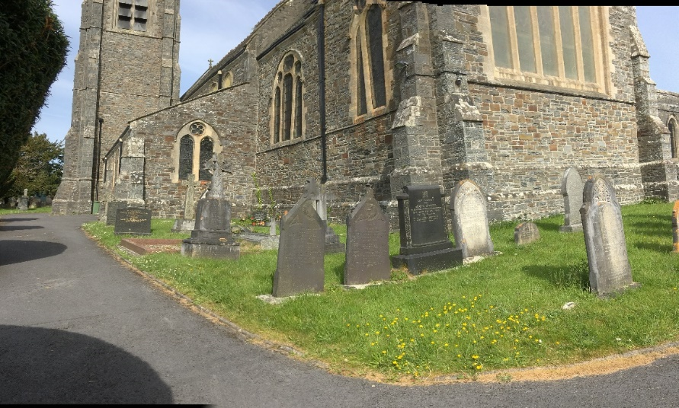
Picture 1.
St. Peter’s Church East end of the church and Plot A (taken by Flávia Stevens, 2018)

Some photographs were taken in order to carry out a more detailed analysis of the styles away from the site and to find out what is needed for the preservation of the monuments in the graveyard (see Picture 1).
To do an accurate analysis it is necessary to record as much information as possible about an individual memorial (as an example see Fig.1). Each grave was analysed for size, style, family or single grave, inscription writing style and conservation needs. This recording form was used to record the twenty-seven graves from plot A. The photos accurately illustrate each monument and its inscription. The photos can be used to compare the writing and the style of the headstones. The example of the form below in Fig. 1 demonstrates the type of analysis conducted.
Graveyard  Denomination: Church of Wales  Recorder: 17/05/18 F. S | Memorial number: A3  Weather condition: Sunny day, but normally cloudy and rain.
Material: Marble
Shape: Gothic pointed headstone
Letter styles: clarendon / Egyptian
Inscription: In memory of  Mary Elizabeth  Only daughter  David and Margaret Richards  Treherbert (I am guessing this is where she comes from) Ram – I have no idea!  Born January 23, 1800  Died January 10, 1899  This Headstone is written in the Welsh language (translated to English by Annang, L.2008) | 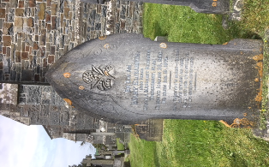  Dwi rhanwyd I’w hhiem hir alar hwyr wylant am dami.  Bydd cof per o’I holder hi a’I da synwyr dwys heini’.  From “Gwinllan y bard sef pyndyddwaith or amarywiol desturan a gwahurol fesuaran.  A Welsh poem translated as:  “I’m shared to my parents – Who have long been making and weeping for me.  Short memory of her fortress and very intense emotions”. (archaic Welsh writing) (translated to English by Annang, L.2008)
Comments: It was difficult to read the inscriptions of this headstone because it is covered with lichens and some of the carved metal letters have faded. The weather conditions in Wales are not favourable to the material of the headstone.
Fig.1 Recording form with picture and details

Fig. 1 uses some of the coding Mytum describes in his book, with few alterations because the area is small, and time was short (Mytum, 2000:70).
According to Coflein Mapping, the record of map reference is SN54NE and the grid reference is SN5754448356 from Ceredigion. This means that anyone wishing to search for the site or look at the map can locate the graveyard easily. In the graveyard history record in the National Library of Wales in Aberystwyth this graveyard is classified as religious and it was founded in the 19th century (Coffein, 2018).
The map is not drawn to scale because this essay is only a practice for the development of the understanding of how to conduct a graveyard record and analyse it. Fig. 2 illustrates a plan of the whole churchyard. The sketch demonstrates the plots and church position.
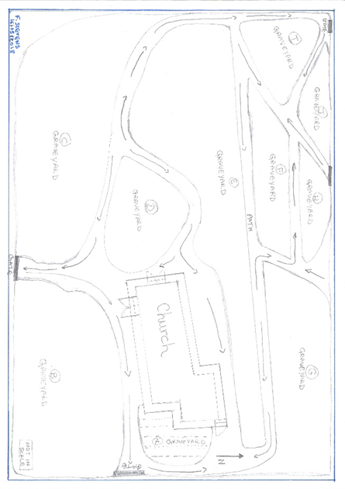
Fig.2 Graveyard
The map of the survey exercise (Fig.2) can help to see the plot more easily and analyse what should be done. (Mytum, 2000: 148-149). In this survey 27 memorials from the East end from the church were chosen.
This site was divided into plots A-F and numbered according to the number of graves. Below in Fig.3 is the second sketch which illustrates the graves in plot A.
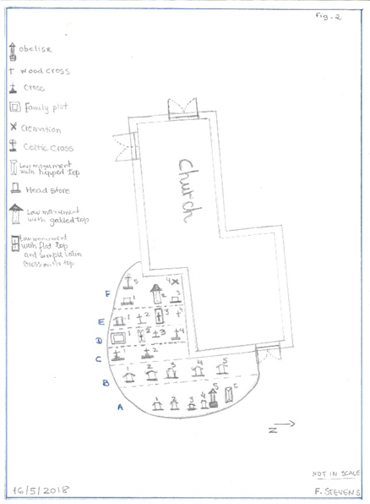
Fig.3 demonstrates the graveyard site A

Results

The focus of this study is to analyse the style of the graves and how the Lampeter community responded to this style in the 19th century, as a small town in South West Wales which was part of St. David College (and actually is UWTSD) as described in two low monuments in the graveyard.

People Buried

Row A-F of plot A | Number of people | Number of Men | Number of Women | Number of  children | Number of  other
A | 12 | 5 | 5 | 2
B | 12 | 6 | 5 | 1
C | 9 | 4 | 5
D | 6 | 1 | 1 |  | 4
E | 5 | 3 | 2
F | 12 | 7 | 5
Totals | 56 | 26 | 23 | 3 | 4

Fig.4 Total of people were burial between 1800 to 2016.

Grave Style Classifications
Styles required on demand | Low Monuments | Gothic pointed headstone | Square with scroll headstone | Sinuous concave shoulders headstone | Cremation box | Triangular top headstone | Obelisk | Kerb | Latin cross and wood cross | Celtic  cross  (ring and simple)
1800-1820 |  |  |  |  |  |  | 1 |  | 1
1820-1840
1840-1860
1860-1880 | 1
1880-1900 | 1 | 6 |  |  |  | 1 |  | 1 | 1 | 1
1900-1920 | 1 | 1 |  |  |  | 1 |  | 1
1920-1940 |  |  |  | 1
1940-1960 |  |  | 1 | 1
1960-1980
1980-1900
1920-1940 |  |  |  |  |  |  |  |  |  | 2
1940-1960
1960-1980 |  |  |  |  |  |  |  |  | 1
1980-2000 |  |  |  | 1
2000-2016 |  |  |  | 1
Totals | 3 | 7 | 1 | 4 | 1 | 2 | 1 | 2 | 3 | 3

Fig.5 Table of styles of memorial.

The most common style of headstone was in the gothic pointed style which was influenced by the Victorian revival Romanticism movement. It was chosen perhaps because this style of headstone was more affordable but also possibly because it was prestigious.
The Builder was a magazine created to keep archives up to date in the 19th century. Perhaps the creators of this magazine had a great influence on the choice of headstone. And with the movement of Romanticism, the Gothic style prevailed in this period to show high-class status, elegance and fashion (The Builder, 1843).
The table and the graphic (Fig.5 and Fig.6) show an increase of gothic pointed headstones. During the 19th centuries with the Romanticism, Britain developed a fashionable design in the factory of monuments. Francaviglia describes the importance of this type of architecture in this period.
…the gothic, or pointed, upright monument. Usually of marble, and averaging about thirty-four inches (ninety cm) in height, this type resembles the pointed arch, important in ecclesiastical architecture in western culture for the last 900 years… (Francaviglia, R.V:1971:502)

Figure 6 illustrates the dominance of this style in the Lampeter graveyard.
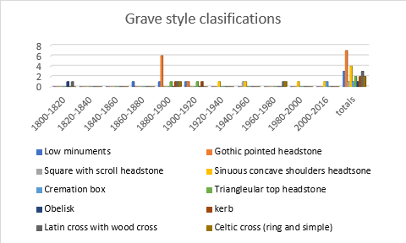
Fig.6 Grave style classification

Discussion

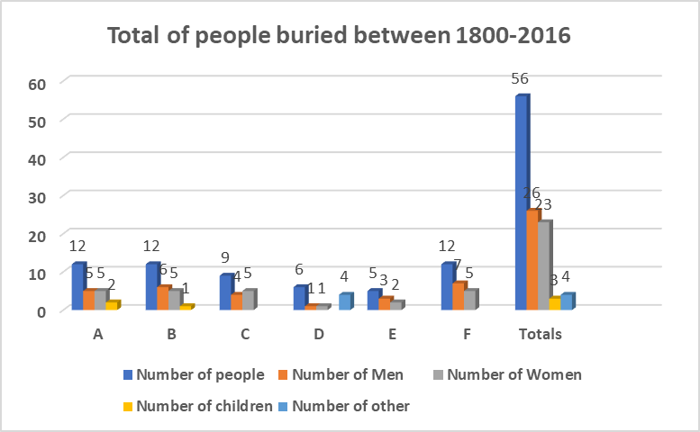
Fig. 7 shows how many people were buried between in 1800 to 2016 in plot A. There are about 26 men, 23 women, three children and four unknow. The average age of death was 66. It was observed that the earliest grave was from 1776 and the latest grave dates from 2016 in plot A. Therefore, one can say that the plot has been used over a span of 230 years. The profession most commonly seen in plot A is vicar and two of the vicars were also Principals of St. David College (known as UWTSD). The inscriptions on most of the monuments were written in the Welsh language which made it quite difficult to read and recognise the inscription.

Fig.7 graphic demonstrating the number of people buried in the east end of the church graveyard.
Mytum and Alasdair described the most frequently style found in the 19th century which is Victorian Gothic Revival. This is the most easily recognized element of Gothic architecture. It became fashionable in the whole of Europe and other countries such as America, New Zealand and Canada. The Gothic style uses varying forms of pointed arches as well as circles and ornamentation such as the Ball Flower and Ogee, commonly seen in the monuments in plot A. The Romanticism movement of the nineteenth century is not only a restoration of the Egyptian style of architecture, but also of the Gothic style because of many expeditions sponsored by Queen Victoria. Both styles of architecture inspired by the Romantic movement had an impact on the architecture of the Gothic monuments of the middle class and upper class of society (Alasdair, 2015 and Mytum, 1989). Possibly this Gothic style, was chosen by the upper classes to show their status or to compete with the most respected people in Lampeter.

Bibliography

Deetz, J., 1977. In Small Things Forgotten- The Archaeology of Early America Life. Anchor Books Doubleday. New York, London, Toronto, Sydney, Auckland.
Jones, J., 1979. How to record Graveyards. 2nd Ed., Council for British Archaeology. London-UK
Mytum, H., 2002: Recording and Analysing graveyards, Practical Handbook in Archaeology 15, Council for British Archaeology, York-UK.
Mytum, H., 1989.The Development of Cemetery Architecture and Funerary Monuments from the Eighteenth Century Onwards – Wold Archaeology, Vol.21, 2- The Archaeology of Public Health.Pg.283-297

Articles and journals

Richard V. Francaviglia. 1971. The Cemetery as an Evolving Cultural Landscape -Annals of the Association of American Geographers. Vol. 61, No. 3, pp. 501-509 Available from: http://www.jstor.org/stable/2569228 [ Accessed: 27-05-2018]

Finnegan, E., Hart T. and Halkett, D.:2011. The 'Informal' Burial Ground at Prestwich Street, Cape Town: Cultural and Chronological Indicators for The Historical Cape Underclass. The South African Archaeological Bulletin, Vol. 66, No. 194 pp. 136-148 Available from http://www.jstor.org/stable/23631416 [ Accessed: 27-05-2018]
Mytum, H., 1989. The Development of Cemetery Architecture and Funerary Monuments from the Eighteenth Century Onwards. World Archaeology, Vol. 21, No. 2, The Archaeology of Public Health pp. 283-297 Available from: http://www.jstor.org/stable/124914 [Accessed:27-05-2018]
Mytum, H., 1994. Language as Symbol in Churchyard Monuments: The Use of Welsh in Nineteenth- and Twentieth-Century Pembrokeshire. World Archaeology, Vol. 26, No. 2, Communication and Language, pp. 252- 267 Available from: http://www.jstor.org/stable/124855 [Accessed:27-05-2018]

The Builder, 1843.vol.1 available from: http://www.bodley.ox.ac.uk/ilej/journals/
[Accessed:29-05-2018]

Websites

2002. Cemeteries and cemetery symbols – exploring the meaning of cemeteries symbols and other graveyards mysteries. For genealogy sleuths, taphophiles and goths kids.
Available from: https://cemeterysymbols.com/2006/10/02 [Accessed: 10/05/2018]

John Tierney, 2015. Simple steps to survey an historic graveyard
Available from: http://historicgraves.com/blog/how/simple-steps-survey-historic-graveyard [Accessed :09/05/2018]

Carved Stones Adviser Project: Making a graveyard plan Available from: https://www.scottishgraveyards.org.uk/downloads/12graveyardplan.pdf
[Accessed: 09/05/2018]

O’Brien .2011 Guidance for the Care Conservation and Recording of Historical Graveyards Available from: https://www.heritagecouncil.ie/content/files/guidance_care_conservation_recording_historic_graveyards_2011 [Accessed: 11/05/2018]

Alasdair B., 2015.The Importance of British Material Culture to Historical Archaeologies of Ninetieth Century. University of Nebraska Press and the Society for Historical Archaeology. London. Google scholar
Available from: books.google.co.uk [Accessed 28-05-2018]

Coflein – Royal Commission on the Ancient and Historical Monuments of Wales
Available from: http://www.coflein.gov.uk/en/site/270/details/st-peters-church-lampete
[Accessed: 13/05/2018]

SELF-REFLECTION SHEET.

PLEASE COMPLETE BEFORE SUBMISSION AND ATTACH TO YOUR WORK

Date: 30/05/2018 Module: Introduction to Fieldwork Name: Flavia Stevens
Guidance: You might consider the following elements:

- Argument: does it have one/ is it backed by sufficient evidence/ how lucid is it?
- Structure: how clear is it / is my essay easy to follow/ does it help my argument?
- Analysis: is more/less analytical than narrative/ does it address the question?
- Reading: was this sufficiently broad/ have I referenced properly?
- How might I improve my performance in future?

Strengths
All the questions above has fundament.

Weaknesses: My weaknesses were that I token long to decide to choose the form and the plot. If I could do it again I will choose to mark the plot in different way. But for the number of the grave was fine to me.

General Comments: I enjoy to leaned about the graveyard and the influence of Victorian revival architecture. As a student we had a lot of support from the lectures and the student support. It was a good practice and skills.

Please give a mark for your work:
(for e.g.: 1st = 70+: 2/1 = 69-60: 2/2 = 59-50: 3rd = 45-49: pass = 40-44: fail = 39- )

