

Academic & Employability Skills
(Reflective)

Natasha Coeur de Lion
1814417

Module: BMSK4001

Lecturer: Lloyd Beharry

Introduction
The purpose of this report is to reflect on an experience that occurred and how my learning journey has helped me to progress in my both academic and employability skills.
To begin my reflective report, the Gibb’s Reflective Cycle (1988) would be the pivotal journey of this report.

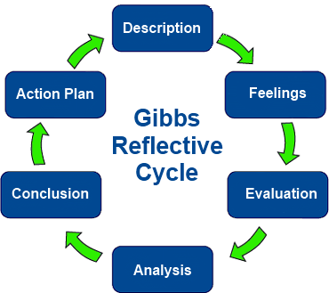
Figure 1 "Learning by Doing" Gibbs Reflective Cycle (1998)

Description
As a full-time mother, I had embraced motherhood naturally a continuous role of positive experiences and a purpose. Yet, a year ago I felt the need to invest in myself and to re-evaluate my vision. A feeling of deconditioning had overcome me, impacting on my inner confidence and general wellbeing (Campbell, Kidsley and Hooper, 2018). I was recommended to see a Life Coach, after several weeks of de-cluttering, strategies and questioning. It came to light, the need to connect with like-minded people and to seek out new challenges by stepping out of my comfort zone. Not to mention, the stigma of being a single parent and its inevitable barriers I will face within the competitive job market.
I decided to take on this course, an opportunity to polish up on my employability skills and to resurrect my academic skills. The prospect of enriching my current life, I could not allow this to pass. Now, that I had enrolled, this very particular module had stood out. The key element to improving my skills set. What was to develop after six weeks into the first semester was totally unexpected, I have learnt to adapt to the academic settings and procedures.

Feelings
Six weeks into the course (first semester), I felt overwhelmed and anxious and doubted my university abilities, it had really tested my self-belief. I did not want my limited academic skills to defeat me. I felt completely apprehensive.
The lecturer unique teaching methods had left us at times bewildered, not only with the weekly objective but the assignment requirements. As a novice student returning to higher education after long period out of education, had become a contributing factor to those overwhelming feelings.
As the class was underway, the topic that week creditable materials and books of recommendations. A female student at the back of the class, had timidly commented on using other resources than the lecturer’s recommendations, the lecturer abruptly answered, ‘you would fail with a low mark’. This comment took me by surprise, as I know all too well words have a negative impact. I composed myself and compelled to air my disagreement by that comment and took this opportunity to convey the class low level of motivation.

Evaluation / Analysis
Afterwards, a mixture of feelings had dawn on me relieved, apprehensive and out of character the thought of expressing my views in a passionate way makes me nervous, especially in an unfamiliar setting. From the other student’s reaction, they were very forth coming with their views in a constructive approach. The lecturer acknowledged the class consensus of what had been expressed. According to (Jokic, Albrecht, Smith,2019) adult learners that are reentering back into higher education faces challenges of unfamiliar academic studies, deadlines and limited academic skills. As a result, these students face intense stress and low levels of wellbeing. Notably, (Rubenson, 2011) mentions a segment of students may have had a bad experience with school, returning to academic studies with anxiety and low-esteem. This perhaps explains the bewilderment we were all discreetly experiencing.
The incident had changed the energy of the class, it had opened the flood gates of honesty between us and the lecturer. It had stimulated conversations to ease our anxiety levels and reinforced my purpose on this course, for a promising career prospect.

Illustrated in figure 2, Malcolm Knowles (1984). A respected and well-known adult educator had adopted The Andragogy Theory, specifically for adult learning.
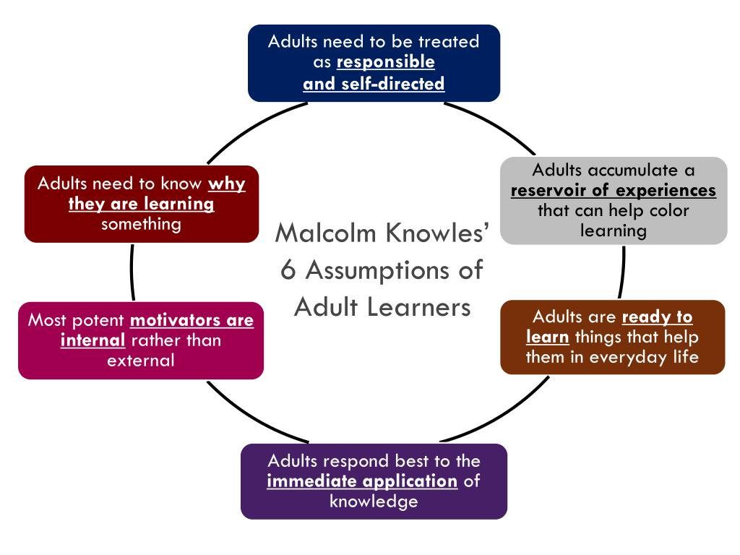
Figure 2 (Malcolm Knowles, Andragogy Theory. 1984)
From reviewing the six assumptions of adult learning, could perhaps be the framework for adult learners reentering into higher education.

Conclusion
Having experienced this new-found power voice, I now realise it had given me a boost of inner confidence. In the past my subtle introvert character would not question anything, I would allow my frustration to turn into emotional tension; however, I felt really compelled to express my views whether it was right or wrong. Recongise it as part of the learning process of my self-discovery journey, and I will continue to welcome those moment of opportunities to improve on my personal development to project a right attitude. I had an autocratic approach which is a form of a Leadership skill.
In retrospect, I would change my approach to this experience differently. Firstly, speak to the other students collectively to generate some feedback about their understanding of the assignments, and their morale levels. Secondly, arrange with the lecturer a private meeting to discuss these concerns. Thirdly, as a form of diplomacy I would suggest with the lecturer to have a class session to go through the assignment in-depth.

- Academic Skills
I have significantly improved on my skills in Research and Reflective/Creative thinking, as these two skills are transferable in every day activity as well as professional capacity. An example, In June I went on a family holiday to Turkey. Prior to booking the holiday considerable amount of time went into researching for that suitable resort. Regarding academic research, the correlation of reading through articles, journals and website for that one creditable segment for the assignment is crucial.
As for Reflective/Creative thinking, being a mother to a four-year-old creativity comes natural in ways to entertain with limited resources. It is suggested reflective thinking is a form of action research process, it is important we take time out and effort to reflect, to improve on our learning and practices. The only time we would reflect is on a negative experience or on a crisis that took place, (Gelter, 2003).
To illustrate another example of reflective thinking team collaboration, after a group presentation and contrustive feedback, the team regroups for reflection this enhances the learning process and promotes self-awareness.
However, I have not sufficiently developed my skills in critical analysis, referencing, paraphrasing and academic writing which warrants a high mark. It continues to be a work in progress. This makes me feel these skills will be essential to me as a learner, if I have the desire to continue with my academic studies. It is important that I perfect those areas to improve my marks, to elevate my chances of the highest grade. Moreover, will equip me to be an asset to prospective employers or acquire the necessary skills to become my own boss.

- Employability skills
In my previous employment, I played a key role in supporting the Customer Services Director, for the local authority in East London. Not only providing high quality administrative support, but also responsible for ensuring high standards of reception duties. By taking on this course it has reinforced skills set that would be a driving force to push me into a senior position within an organisation.

Communication Skills
The ability to communicate effectively with other students and with lecturers, not just by verbal communication, but the importance of nonverbal communication. I am actively giving my full attention by eye contact, body language and hand gestures. Listening skills is fundamental in communication, how the process of decoding the message indicates my understanding. As a prospective employee it will display my level of aptitude.

Interpersonal Skills
As part of the course assessment, we are required to showcase a group presentation. As a team member, I try to encourage good working relationship with each other as it contributes to positive working environment. There is a small segment of students in my course which are non-native English speaking, this has proven my ability to actively engage with people from different cultures.

Team working
I have significantly developed in this area, the wealth of knowledge gained from collaborating with other students has been stimulating, a combination of diverse ideas and talents, which is evident from group presentations and in class activity base. I have demonstrated that I can work effectively in a team.

Organisational Skills
This skill is a pivotal part in my personal and academic studies. The ability to adopt new working habits to increase productively. This is one of a few skills set that has truly been imbedded in me. For instance, I am always prepared for each lecture with relevant materials and assignments are submitted on time or in advance. This has been accomplished by allocating enough time for researching, and to work on one assignment at a time, to ease pressure. On a personal capacity, quality time is put aside for my daughter and to ensure daily chores/task are met to run a functional home. To balance many tasks has enable me to stay focus in order to achieve the desired outcome.

Time Management Skills
A skill set that I am confident in exhibiting, and the ability to priorities effectively. As a proactive and self-disciplined person, I make use of my time by minimizing interruptions and disruptions to regain momentum in my assignments. By monitoring my to do list, will enable me to schedule important activities with my daughter to avoid assignments becoming urgent. I believe with my time management skills this would highly be beneficial to a prospective employer.

Applying the Time Management Matrix, by Stephen Covey, (1995). Explains, by prioritising tasks and categorising by the four quadrants will free up time and minimize stress.
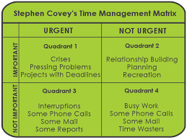
Figure 3 Time Management Matrix (Stephen Covey,1995)

Action Plan
It is notably, there are areas in both my academic and employability skills that require improvements, to enrich my life journey. This is highlighted below in my personal SWOT analysis.

Personal SWOT Analysis, Academic Skills
Strengths | Weaknesses | Opportunities | Threats
Great communication, interpersonal, organsational, time management skills. | Presentation Skills, not allowing my nerves to overpower me | A Degree, and may consider continuing further in my academic studies,  Government funding, as well as childcare | Overqualified - for a position
Research and Reflective Skills | Being critical and logical, reflected in my assignments  Academic skills - referencing, paraphrasing and essay style writing  Problem-solving in an academic view point. | Feedback from Lecturers to improve on my marks.  Read further materials, to improve my academic skills - attending additional lectures for support, watch various YouTube channels on academic skills and networking with other students to form a study group | Fear of failure
Working under pressure and under limited times | Confidence in my academic abilities | To find a Mentor - to keep me motivated and provide academic advice - increase well-being and confidence | Disconnecting with family and friends, for a period.  Limited quality time with my daughter

Personal SWOT Analysis, Employability Skills
Strengths | Weaknesses | Opportunities | Threats
Great communication skills | Communication, at times can be misunderstood when anxious | Reflect on what needs to be communicated, speak to trusted people that can assist and give advice how best to convey. | Missing out on Job benefits or promotions.
Great time management skills  Exceptional organizational skills | My confidence can be fluid, cause by unfamiliar surroundings | By repetitive action and 'showing up" can ease anxiety levels and promote growth. | Fear of failure
Collaborate well with others | Networking for potential employers | Start attending conferences and exhibition of interest - improve on my networking skills. | Flexibility is very limited as a parent
Problem-solving in various situations. | Being critical and logical | Actively listening and ask question that will evaluate my thinking process  Be committed with my decision and run with it, and be accountable for the outcome | Irrelevant information and no real impact on my CV.
Self -discipline | I can only commit to part time work  Lack of work experience | Voluntary work to polish on work experience and work on skills gap, for instance numeracy skill and negotiation skills. | Job market is competitive  Financial burden  Travel further to work

Overall Conclusion
I am yet to finalise my destined path. So, I have kept my options open for the duration of this course. There are areas in my skill gap that requires attention, for instance negotiation and numeracy skills. With further relevant courses or training will be the apex of my personal development within the next twelve months. It is important to remain focus and stay committed, as this builds momentum and a habit of consistency. To give myself an advantage amongst my peers within today current competitive market.
Reference

Campbell, A., Kidsley, K. and Hooper, A. (2018). Deconditioning, The hidden menace in the palliative care patient. BMJ Supportive & Palliative Care, (8), p.135.

Covey, S.R., Merrill, A.R. and Merrill, R.R., 1995. First things first. Simon and Schuster.

Gelter, H, 2003. Why is reflective thinking uncommon? Reflective practice, 4(3), pp.337-344.

Jokic, S. Albrecht, N. and Smith, S. (2019). Mindful Self-Compassion and Adult Learner Retention in Post-Compulsory Education. OBM Integrative and Complementary Medicine, 4(1).

Keillor, C. & Littlefield, J. (2012). Engaging Adult Learners with Technology, Macalester College: Available at: http://digitalcommons.macalester.edu/libtech_conf/2012/sessions/43/ - Accessed on 09 August 2019

Mindtools.com. (2014). Available at:https://www.mindtools.com/blog/corporate/wp-content/uploads/sites/2/2014/08/Gibbs-Reflective-Cycle.pdf – Accessed on 08 August 2019

Rubeenson, K. (2011). Adult Learning and Education. Available at: https://books.google.co.uk/books?hl=en&lr=&id=_Jiu_HRGZkEC&oi=fnd&pg=PP1&dq=adult+learning+and+education+&ots=HOIZ6XipYG&sig=x_gKONxHBRkaWQMrG8xmOBGS24I&redir_esc=y#v=onepage&q=adult%20learning%20and%20education&f=false – Accessed on 09 August 2019

