VFX Compositing Sequence “A Guide to Tokyo”

Tyrone Hudson
VFX Composition
BA - Computer Animation
Nabeel Masih

Pre-production

The premise of my production is going to be a Japanese animated character talking to the viewer as if they were just entering Japan for the first time.

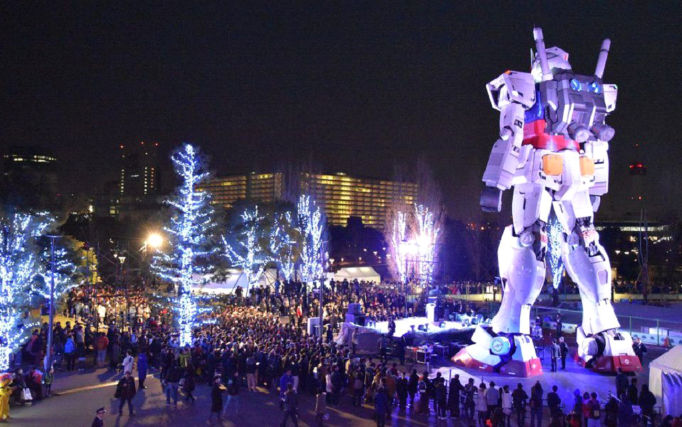

The movements will be life-like but the character will retain some sense of being an animated character due to his bionic eye and robotic voice.

The robotic voice will be voiced by myself using a VR voice mod which will computerize my voice, to achieve this I will be recording myself using an open broadcasting software where I can also change the audio settings such as gain, noise suppression, and pitch to match the desired effect I'm trying to achieve.

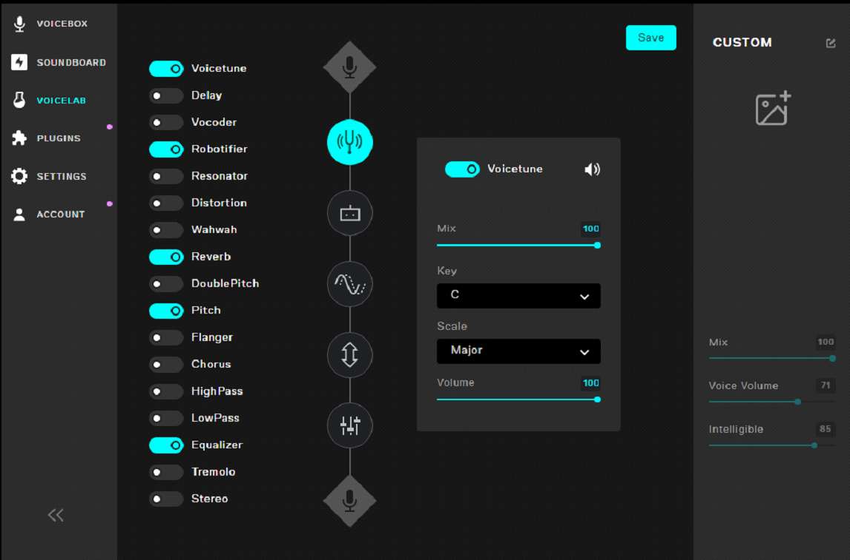

The robotic eye will be made using motion tracking and putting together elements such as the circuit board, thicker shape, circles, and rings.

whilst changing the color gradients and being animated to help better visualize that he has a robotic eye.

The character model and animations are being produced via in-game means, I used a software called Gshade which is a graphics injector that allows me to manipulate the graphics fidelity of the model and allows me to put a character on greenscreen background.

I had the idea that this would be a broadcast of sorts being put on a social media platform or tv, with that idea in mind I'm going to have Japanese subtitles so it would look more akin to a news channel or vlog.

To achieve this look I took inspiration from vlog channels on Youtube and Newsbeat, this helped me better visualize what I wanted to portray.
The goal is to translate everything I will be saying from English to Japanese using a translator, the video being multilingual will also help with reaching a broader audience (in an industry setting).

With the background I want it to be in the heart of Tokyo with beaming neon lights in the bustling city center.

I did some research and found 4k footage of the Shibuya crossing which is a famous location in Tokyo, I spliced 25 seconds of which I thought would be the ideal location.

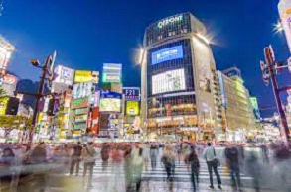

To make this composition come to life I need some background audio, so I'm going to use audio of people talking and city noises.

Production & Postproduction

The production process started with me going through all the software that was necessary to make the creation I had in mind.

Firstly I loaded up Gshade in FFXIIV and started to adjust the settings such as gaussian blur, HDR, fakeHDR, ambient lighting, focalDDF, tint, technicolor, levels, FXAA, vibrance, bloom, MXAO and qMXAO, and chromakey, plus many more.

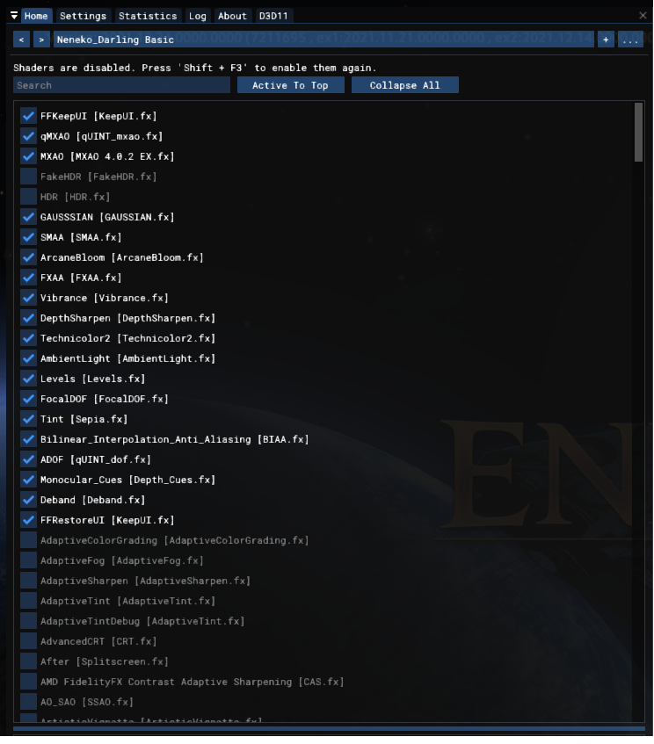

I then proceeded to take the wav file into premiere pro to splice the video to 25secs for the scene that I wanted to use as the background, this would serve as the area in which the 3D model would be implemented.

Once I had the video ready for editing I imported it into Ae, this is where I was adjusting the camera lighting using Lumari faded 25 to dim down the brightness and give it an old film effect, I then used a camera blur on the background scene as the main focal point was the foreground 3D model.

When I had both files imported I then started on my dialogue recordings using a voice changer mod and OBS, as the character was going to be a robotic character I had to make sure he sounded semi-realistic.

To do this, I used my normal voice but added an echo and distortion effect which helped create a robot sound.

during this process, I had to make sure the voice recordings lined up with the character's movements and actions so it didn’t look jarring.

After I did an OBS recording of the character using in-game emotes, I then took the recording into Ae to do some more technical adjustments to the 3D model such as lighting and color levels to match the scene I was using as a background.

I also wanted to create dialogue as the vlog would be Japanese, I created the text using the type tool and then animated it by changing the percentage on the opacity timer in the transform options.

I had to animate the text because I had quite a lot of text that needed to fade away at some point.

Once the text was done, I had to animate the character's name moving to the corner of the screen to do this I used the timer on the anchor point and then moved the text to the position I wanted.

After all the assets were imported I started to make the robotic eye by first tracking the characters' eye movements by using 3D camera tracking, any time the tracking would go off course I had to re-adjust the tracking data manually by moving the nodes.
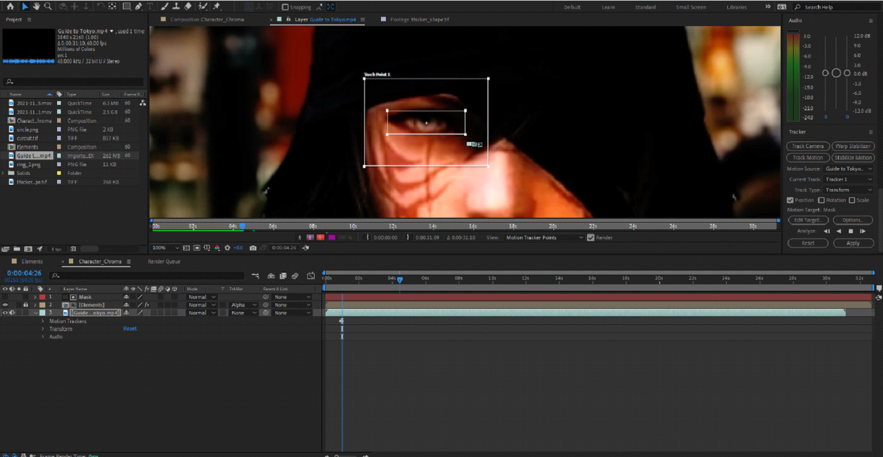

I had a lot of issues with the tracking data because of the 3D models' fast and exaggerated movements which caused me to manually adjust nearly all of the 25 seconds of tracking on the eye.

After the tracking was done, I started to make the eye using the assets that Nabeel gave, but first I had to create a mask where I wanted the robotic eye to be.

During the masking process, I had to re-adjust the mask all through the scene, as the model was either blinking, moving his head, or emoting.

This process has taken a long time to try and get it looking as good as possible, although there was an issue with one part that I couldn’t, fortunately, fix because the mask nodes would reset their position even when I aligned them correctly.

However, with this issue, I had a feeling that it might have been caused by the tracking data because the eye was closed at that given point.

After the masking was done, I changed its transparency to alpha matte and linked it with the object that I wanted to be tracked, in this case, it was the assets such as the circuit board, thicker shape, circle, and ring used for the robotic eye.

To make the eye I first used the thicker shape and moved it just to the outer area of the iris, I then grouped up all the rest of the assets to make it one asset.

I adjusted the color of each asset and used the glow option, I animated the glow to change over time for each different part of the eye.

Once each part of the eye was done, such as the tracking, masking, and assets I had a working robotic eye.

I then made a second tracking data on the face, to recreate the circuit board but on the side of the 3D model's face, for this, I went through the same process of motion tracking as the eye, and used the glow option, and animated the colors a second time.

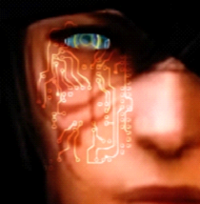

At this point I was happy with what I produced, so to clean up the production a little bit I took the Ae source file and imported it into Premiere Pro to add an outro, the outro was compiled of design text that I edited and sourced music.

Bibliography

CGI & VFX Breakdowns: “Attraction VFX breakdown” - by Main Road Post, April 23rd 2017 https://www.youtube.com/watch?v=kKfvjvTJKbo, accessed November 25 2021

Dynamic Camera to FACE MOTION TRACKING in 5 Minutes Explained! After Effects 2020 Tutorial https://www.youtube.com/watch?v=y6JFkMngH3g, accessed November 29th 2021

Why “The Mandaloriian” Uses VIrtual Sets Over Green Screen Movie Insider, June 11th 2020 https://www.youtube.com/watch?v=Ufp8weYYDE8, accessed 30th November 2021

The technology that’s replacing the green screen, October 23, 2020 , https://www.youtube.com/watch?v=8yNkBic7GfI, accessed 2nd December 2021

How Iron Man’s VFX evolved over 11 years Movie Insider July 10th 2020, https://www.youtube.com/watch?v=GqsO40pm0-I, accessed 2nd December 2021

AFTER EFFECTS BASICS VFX TUTORIAL, October 4th 2019, https://www.youtube.com/watch?v=9anmdLHV_DA, accessed 5th December 2021

5 Simple VFX You Can Try, April 17th 2020, https://www.youtube.com/watch?v=2ipV5bGMhAs, accessed 3rd December 2021

5 Overlooked Tips for VFX, August 1st 2020, https://www.youtube.com/watch?v=y3Kt1XfUHAo, accessed 7th December 2021

9 VFX Terms You Should Know, February 11th 2021, https://www.youtube.com/watch?v=vQtMmSm0zLs, accessed 10th December 2021

Lessons from 7 years of VFX, An Interview with Wren Weichman of Corridor Digital, May 15th 2018, https://www.youtube.com/watch?v=XOXeRNw9XX4, accessed 9th December 2021

How to Succeed in the VFX industry with Andrew Kramer, January 30th 2018, https://www.youtube.com/watch?v=gNh9r-VbSVg, accessed 12th December 2021

