Case Study

Modern and Traditional Construction – Managing the Design and Construction Process – ACBA5000

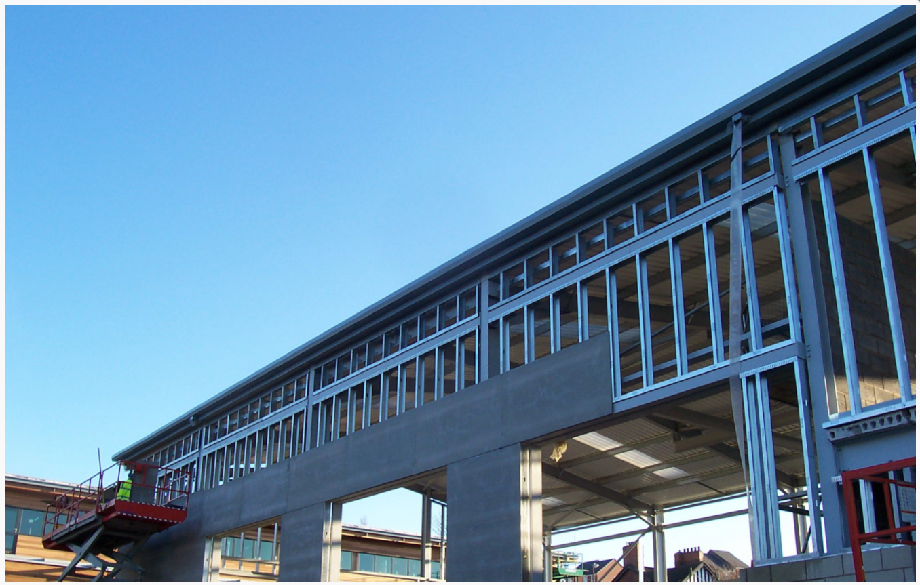
March 2022

Written by: Jonathan Phillip Langstone
Prepared for: D. Hughes

Table of Contents
1.0 Introduction 2
2.0 The Site 3
3.0 The Foundations 3
4.0 Structural Elements 5
4.1 Structural Frame (Beams and Columns) 5
4.2 The Walls and System of Enclosure 6
4.3 Floors 7
4.4 Roofing system 7
5.0 Accommodating for Wind Loads 8
6.0 Summary 8
7.0 References 9
Appendix 1 Borehole Logs SA1 10
Appendix Borehole log 1.1 10
Appendix borehole log 1.2 11
Appendix 2 Plans & Elevations Drawings 12
Appendix 2.1 Long Section & Ground Floor Plan 12
Appendix 2.2 First & Second Floor Plan 13
Appendix 2.3 Elevations 14
Appendix 3.0 METSEC SFS Infill Walling system 15
Appendix 4.0 Typical Bison Beam cross sectional view 16

Table of Figures
Figure 1 Pile driving of Precast Pile using a vibrating piling machine (SkyCiv, 2022). 4
Figure 2 Steel bolt connection (Boake, n.d.). 5
Figure 3 cladding support system cross section (greenspec, n.d.) 7
Figure 4 M-Tray Modular Green Roof Installation (Wallbarn, n.d.) 8

Introduction

This case study aims to choose and describe a primary structure and system of enclosure for the proposed buildings provided in the appendices of this document. The structure proposed is an office building that will be based in the SA1 area of Swansea, Wales. The body of work will aim to identify the Foundation type, material consideration, structural elements (which consist of columns, walls, beams, floors, and roof types). The case study will also cover appropriate strategies for the building in question to accommodate wind loads. The elements chosen, such as the system of the enclosure, and the primary structural system for the proposed building will be indicated and annotated in the drawings in the appendices, and they will be referenced to the appropriate and relevant standards and regulations in use in the industry today. The proposed building studied in this report came with a set of recent borehole logs of the proposed site, and supplementary two-dimensional drawings that give a clear basis for the decisions given in the following chapters.

2.0 The Site

The proposed site for the proposed office building is designated as a brownfields site. “brownfield sites that have been built on in the past and which have been cleared to provide the base for a new construction” (Mike Riley A. C., 2014) As with brownfields sites, the specific area in SA1, Swansea boasts a rich industrial and historical past, due to the industrial revolution in the late 1700s and 1800s, and later the tragic bombing of Swansea docks throughout the 1940s (Swansea Council, 2022). The past industrial works in the area pose risks as the ground on the site can be categorized as made ground. The made ground can be described as ground that has been raised by artificial means and may contain contaminants (boreholesolutions, 2021). Due to the city being bombed by the German air force throughout the 1940s, there is still the risk of uncovering or accidentally detonating unexploded ordnance (UXO), which could be excavated when preparing for the construction of the substructure.
With ‘made ground’ being found present, it makes the surrounding area unsuitable for loadbearing for a large structure, unless the load could be transferred to a depth that is sufficient to take the required loads in question. In addition to the site, borehole logs have been provided, found in appendix 1, using the digimaps service (Digimaps, 2022) for this case study suggests that at a depth of roughly 19 metres below the ground, past the made ground (1-5m’s) and boulder clay (5-18m’s) , there is a natural bed of Grey mudstone which would be ideal to act as the bearing ground base for the foundation. Only if piled foundations are used as the anchor point to the bearing ground below. The boulder clay and ‘made ground’ that make up the first 16metres of the strata are unsuitable for load-bearing any large structure, especially the one in question in this case study. Major consideration must be applied when deciding the specific pile foundation type for the office building.

3.0 The Foundations

As discussed in the previous chapter, after analysing the borehole log for the SA1 area, and the depth needed to transmit the building loads to the grey mudstone, which sits at approximately 18metres below the ground, and the fact that the shallow made ground and further clay strata will not be sufficient to support the proposed structure, this means that a pile foundation must be utilized in this case. A quote from Bryan explains this further: “if sufficient bearing capacity for an economic shallow foundation cannot be achieved near the surface, it may become necessary to consider deep foundations” (bryan, 2010). Considering the state of the substrata on the site, clearly shown in the borehole logs provided (appendix 1), the best type of pile foundation would be an array of end bearing, driven concrete precast piles.
Typically pile foundations consist of a pile cap and a single or group of piles below. The pile cap distributes applied loads to the individual piles, which then transfer the load to the bearing ground (Greeno, 2020), which in this case study, is the grey mud stone indicated on the borehole log in appendix1.2. Driven piles are often the most cost-effective pile foundation solution for ground conditions such as brown-field sites, where excavation is cautionary and expensive. Driven precast concrete piles are driven into the ground by using hydraulic hammer machinery (Concrete Society, n.d.). They may also be square or octagonal. They may be cast to the full length required (depending on the ability to transport and handle them) or units may be joined to form longer lengths. As a bonus the precast piles are also Unaffected by ground water.
The concrete precast piles would come from specialist manufacturer and are transported to the site using large lorries. once in transit, it is important to take great care of the material as it is quite fragile in a horizontal position and prone to cracking if struck with sudden large force. The concrete precast piles are designed to reach very large depths, sometimes exceeding 80metres below ground in some cases. But for the proposed building in this study, the depth of 18metres below ground is easily achievable. As an alternative material, steel could be used to pile the foundations instead of precast concrete. The issue with steel, is that it is considerably more expensive than precast concrete. And with the ground on the site experiencing so much wet weather, the risk of the steel experiencing rust over time, is quite high. Fig.1 below illustrates the method for piling precast concrete into the ground, with use of vibrating hammer piling machine:
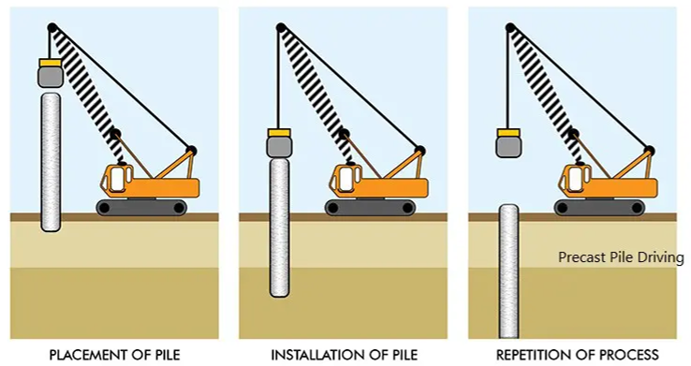
Figure 1 Pile driving of Precast Pile using a vibrating piling machine (SkyCiv, 2022).
After the piles have been correctly installed in the designated pattern needed to support the superstructure above ground. The piling concrete caps will be set in place to allow further development of the structure above ground. Sufficient time should be allowed for the concrete caps to cure before any further works be applied to the foundations.

The driven precast concrete pile foundations for the case study are identified in the elevation drawing, Appendix 2.

4.0 Structural Elements

This chapter will cover the chosen structural elements being used for the proposed office building and why they have been chosen.

4.1 Structural Frame (Beams and Columns)
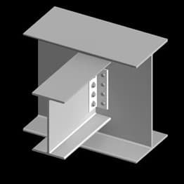
As the proposed building is intended for large spanning office space, it would seem beneficial to use a framing system that allowed large areas of internal open-plan space. A skeletal steel frame with bracing would be the best type of framing system for this building, as steel frame buildings generally offer larger open internal spans compared to reinforced concrete structural frames (White, 2018). The steel frame would need to be braced in specific areas where there is potential risk of stresses in the building fabric, especially when accommodating for wind loads (which will be discussed further on). Steel frame offers benefits for allowing sufficient free space for services and ventilation systems to be installed inside the building, compared to more common concrete structural frames, which put a limit on the amount of space between floors. Another aspect for the steel frame is the building regulations that surround the essential use of ‘fire stops’, in between openings and weak spots in the building. Fire stops are seals provided to close an imperfect fit between elements that are designed to restrict the passage of fire and smoke and would be in full use for this building (M.J.Billington, 2017). The beams and columns would be categorized as ‘I beams’ which are bolted together, as illustrated in fig.2 below:
Figure 2 Steel bolt connection (Boake, n.d.).
Fig.2 shows a simple steel bolt connection that is often used in structural steel framing where it is necessary to allow for a floor system to sit on top of the beams.
The structural steel beams and columns for the proposed office building will be clearly labelled in appendix 2.1.
Any structural component that has been designed and fabricated for the steel frame must meet the BS EN 1991 series of standards (Eurocode 3 and 9) for steel and structures in buildings. Also, all structural elements must adhere to the building regulations set out in the Approved document A. The Welsh approved document A gives a list of the British standards in use for specific structural elements. For example, “BS 5950-1:2000 Structural use of steelwork in building. Code of practice for design in simple and continuous construction: hot rolled and welded sections” (Welsh Government, 2010).

The layout for the structural steel beams and columns for the proposed office building will be clearly labelled in appendix 2.1.

4.2 The Walls and System of Enclosure
Ground floor Walls
To accompany the steel frame on the Ground floor external walls, there will be ‘enviroblock’ concrete block cavity walls. The recycled dense concrete block walls will make up the largest surface area of the ground floor walls, so ensuring good thermal mass and low U-values is important. The use of dense concrete block work will offer the potential for high thermal mass, especially if used to create not just the external walls, but also some elements of the internal partitions (Mark, 2012). The concrete blocks will be identified in elevations drawing in appendix 2.3.

First & Second Floor Walls
The walls on the first and second floor will not be concrete block. They will be built using Metsec SFS infill walling. SFS stands for ‘steel framing system’. This steel frame partition and external walling system (for the 1st and 2nd floor) would form a secondary structure which is fixed between the primary super structure at floor and soffit level. It would allow insulation and external finishes to be installed continuously outside the main structural frame (METSEC, n.d.). This form of partition wall can be installed quite quickly, as it is light weight and easily maneuverable by hand. This is due to the SFS being thin in comparison to other forms of steel framing. The SFS also cuts quite easily with the use of common appropriate power tools found on site, and it has visible centre line indents that indicate fixing locations. Appendix 3 shows the mock up of an SFS system in place. Much like the structural steel frame, the SFS systems only floor is that it needs to be properly fire proofed, as it cannot stop or slow the spread of fire as well as concrete can.

External Wall Cladding
As Swansea is an area of the United Kingdom that receives huge amounts of rainfall per year, the use of rainscreen cladding would help ensure that the entire external walling system of the office building, would act as a moisture free barrier from the inclement weather outside. Although rain screen cladding does not prevent all moisture from entering the building envelope, it does allow the moisture that enters to escape by draining away. Essentially, the outer layer sheds most of the weather, and the inner layer takes care of what little moisture gets through (Thallon, 2016). The air gap provides ventilation and, depending on the design, may provide pressure equalisation across the outer skin. The specific rainscreen that has been chosen, is a terracotta panel rainscreen. Terracotta is a long-lasting building material and has only recently emerged as a warm and timeless medium for modern rainscreen design (ecocladding.com, n.d.).

The terra cotta rain screen would be supported by an aluminium bracket system which would tie it back to the structural frame, whether it be the concrete blocks or the METSEC SFS system on the 1st and 2nd floor. Behind the terra cotta would be an air gap, then a layer of 100mm insulation, further on behind the insulation would sit the breather membrane.

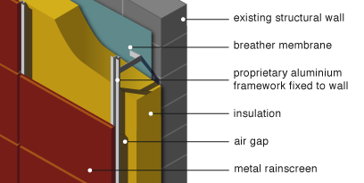
Fig.3 below illustrates a cross sectional view of the external wall system.
Figure 3 cladding support system cross section (greenspec, n.d.)

4.3 Floors
For the Floors of the building, Beam and block Bison beams have been chosen, as it is a robust solution for cost effective suspended floors. It is suitable for use on the ground and upper floors on all kinds of construction. The system works well to support the structural steel frame and offer rigidity and strength for the entire building. beam and block floors are durable concrete floor systems that provide extremely good fire resistance as well as helping to reduce noise transmittance throughout the building. Appendix 4.0 illustrates the use of beam and block bison beams inside the envelope of a typical building.

4.4 Roofing system
The roof structure provides support roof and transfers the dead load and applied load to the structural frame of the building (Mike Riley A. C., 2014) . Because of the size of the proposed office building and its structural steel frame, the decision to use a flat green roofing system would be appropriate for the building as it can offer the people who work in the offices an area to relax and unwind in the outdoor environment above the building. The specific green roofing system is called M-Tray® instant modular Green Roof. The roofing system product comprises of modular ‘M-Trays’ that are essentially small patches of topsoil and greenery, about 500mm^{2,} which are connected to make any size combined on a flat roofing space (Wallbarn, n.d.).
Underneath the soil ‘M-trays’, there should be a waterproofing membrane to stop any moisture to leak through to the envelope of the building. Ensuring the roof membrane is properly protected and free from dirt and debris is very important. This will act as a protective layer and a filter for drainage. The M-trays are very easy to install and are a cost-effective system to combat the local climate, that brings so much rain.
Green roofs are mainly on flat roofs and being a composite structure of insulation, drainage layers soils and vegetation that create an environmentally friendly building element for the end user to enjoy for many years. This green roofing system is classed as fire rated and a safe feature for any sustainably designed building. The main issue with green roofs is that they need to be properly maintained to work efficiently as a source of insulation for the roof.

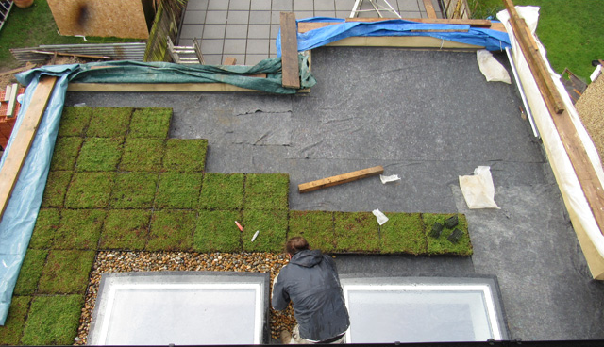
Below in Fig.4, clearly shows how the modular ‘M-Tray’ units are installed to a flat roof structure:
Figure 4 M-Tray Modular green roof installation (Wallbarn, n.d.)

5.0 Accommodating for Wind Loads
When considering where this building is placed in SA1, close to the coastline, wind will be a major concern. Wind has the greatest potential to cause damage to the cladding and even to the building structure (MCRMA, 2022). In this case, the sheer size of the building means that it will invariably have huge amounts of wind loads acting on the structure throughout the year. Requirement A1 of Part A of the Building Regulations in Wales and the UK requires that buildings shall be constructed to safely transfer loads, including wind loads, to the ground. Section 3 of Approved Document A (Structure) provides guidance on wall cladding (Welsh Government, 2010).
With the risk of the wind damaging the cladding and the structure of the building, the only way to be confident that the design and materials are sufficient to withstand the wind loads, is to calculate which cladding and fasteners are strong enough to deflect the wind for good. And sufficient bracing to be put in place between the structural columns and beams.

6.0 Summary
This case study has shown that major considerations have been made regarding the surrounding environment and strata that envelope the sites location in SA1, Swansea. Each component that makes up the structure and system of enclosure have been carefully chosen to work together to create an office building that offers comfortable open space for the end users.

7.0 References
Boake, T. M. (n.d.). Understanding Framing. Retrieved from tboake.com: http://www.tboake.com/SSEF1/understanding.shtml
boreholesolutions. (2021, April). Geotechnical & Geo-Environmental Investigations | What Is “Made Ground”? Retrieved from www.boreholesolutions.co.uk: https://www.boreholesolutions.co.uk/blog/geotechnical-geo-environmental-investigations-what-is-made-ground/
bryan, T. (2010). Foundation type. In T. Bryan, Construction Technology (pp. 368-369). Oxford: Wiley Blackwell.
Concrete Society. (n.d.). Pile Foundations. Retrieved from concrete.org.uk: https://www.concrete.org.uk/fingertips-nuggets.asp?cmd=display&id=348
Digimaps. (2022). Digimap roaming. Retrieved from digimap.edina.ac.uk: https://digimap.edina.ac.uk/
ecocladding.com. (n.d.). TERRACOTTA. Retrieved from ecocladding.com: https://www.ecocladding.com/system/terracotta
Greeno, C. &. (2020). Building Construction Handbook. London: Routledge.
greenspec. (n.d.). Housing Retrofit: Insulation: Rainscreen cladding. Retrieved from greenspec.co.uk: https://www.greenspec.co.uk/building-design/rainscreen-cladding/
M.J.Billington, S. K. (2017). Part 7 - Fire. In S. K. M.J.Billington, The Building Regulations Explained and illustrated (p. 7.11). Chichester: Wiley Blackwell.
Mark, L. (2012). Blockwork. Architects Journal.
MCRMA. (2022). Wind loadings guidance. Retrieved from mcrma.co.uk: https://mcrma.co.uk/wind-loadings-guidance/
METSEC. (n.d.). Infill solutions. Retrieved from www.metsec.com: https://www.metsec.com/products/steel-framing/sfs-framing/infill-solutions/
Mike Riley, A. C. (2014). Construction Technology 2: Industrial & commercial buildings. Palgrave Macmillan.
Mike Riley, A. C. (2014). Flat Roof forms. In A. C. Mike Riley, Construction Technology 2: industrial and commercial building (pp. 338-344). Palgrave Macmillan.
SkyCiv. (2022, February 8). Concrete Piles: An Overview. Retrieved from skyciv.com: https://skyciv.com/docs/skyciv-foundation/piles/an-overview-of-concrete-piles/
Swansea Council. (2022, february 28). Remembering the Blitz. Retrieved from swansea.gov.uk: https://www.swansea.gov.uk/article/7102/Remembering-the-Blitz
Thallon, R. (2016). Walls, Siding. In R. Thallon, Graphic Guide to Frame Construction (p. 112). Newtown: Taunton.
Wallbarn. (n.d.). green-roofs m-tray. Retrieved from .wallbarn.com: https://www.wallbarn.com/green-roofs/m-tray/
Welsh Government. (2010). Approved Document A. Retrieved from gov.wales/building-regulations-guidance-part-structural-safety: https://gov.wales/building-regulations-guidance-part-structural-safety
White, G. (2018, January 12). Structural Steel Vs Reinforced Concrete – Which Is stronger? Retrieved from glwengineering.co.uk: https://blog.glwengineering.co.uk/structural-steel-vs-reinforced-concrete-which-is-stronger

Appendix 1 Borehole Logs SA1

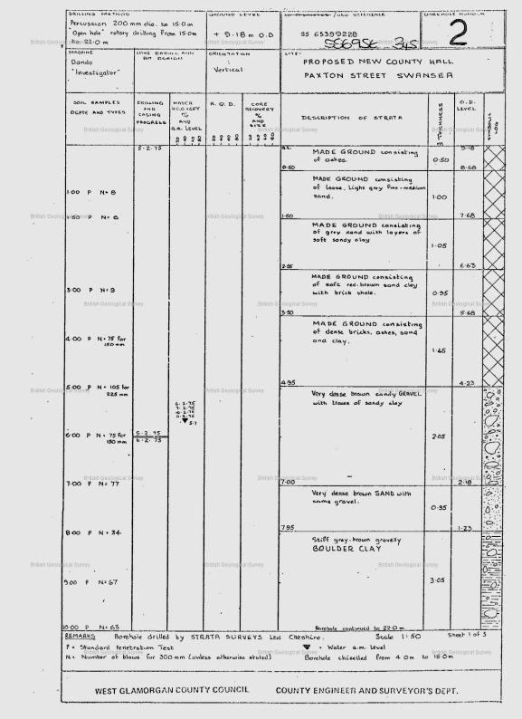
Appendix Borehole log 1.1

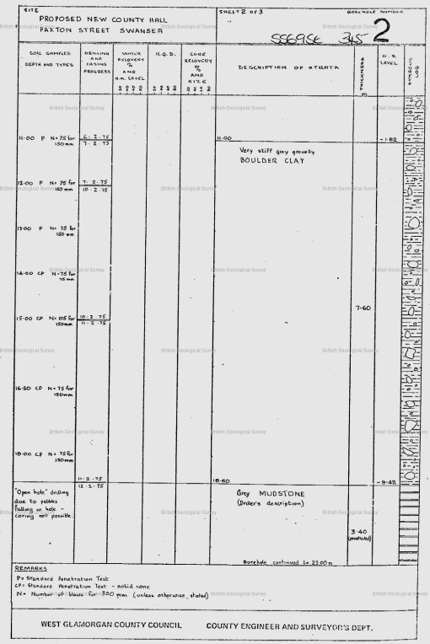
Appendix borehole log 1.2

Appendix 2 Plans & Elevations Drawings

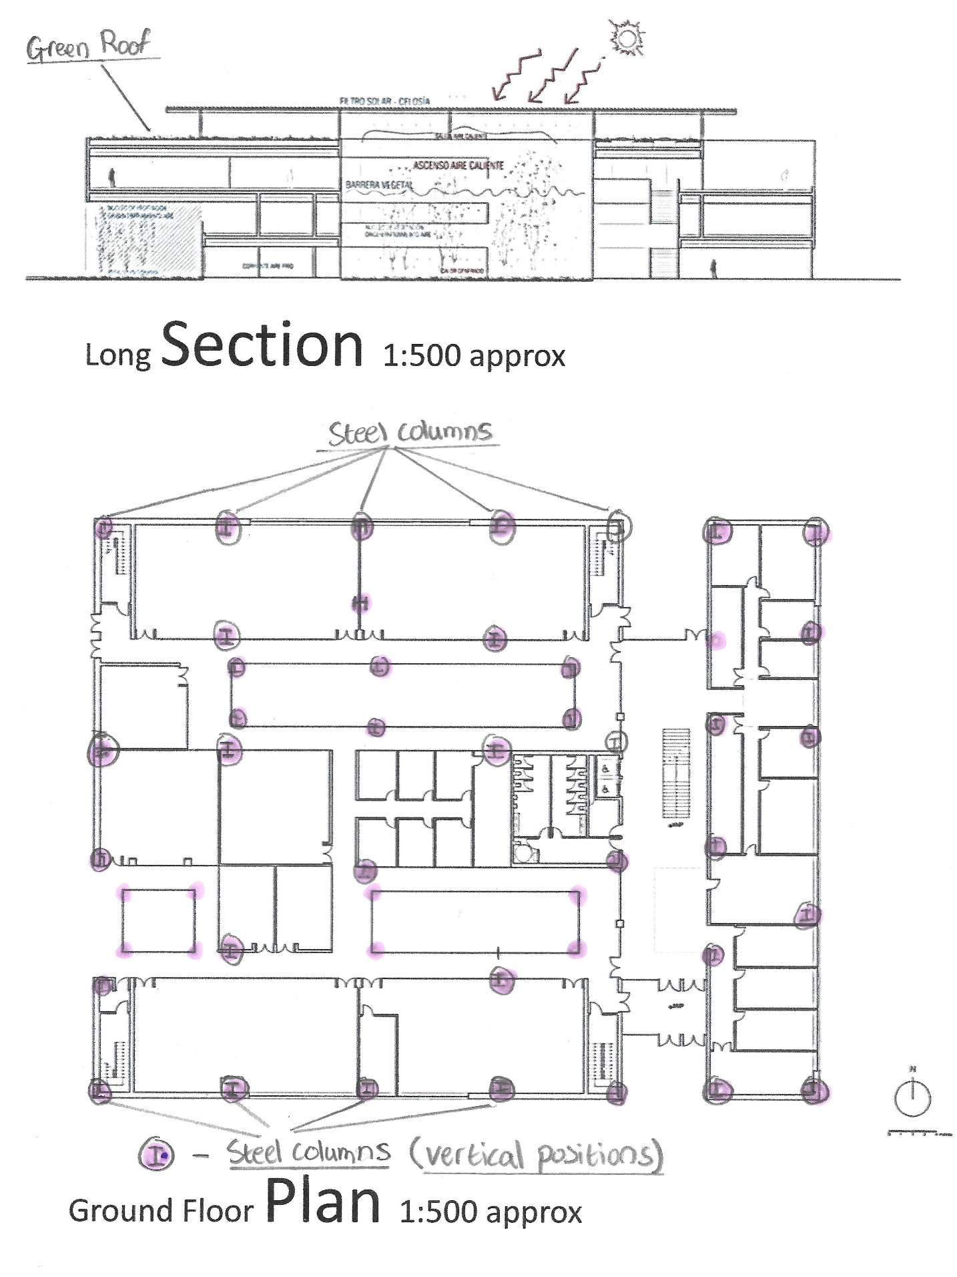
Appendix 2.1 Long Section & Ground Floor Plan

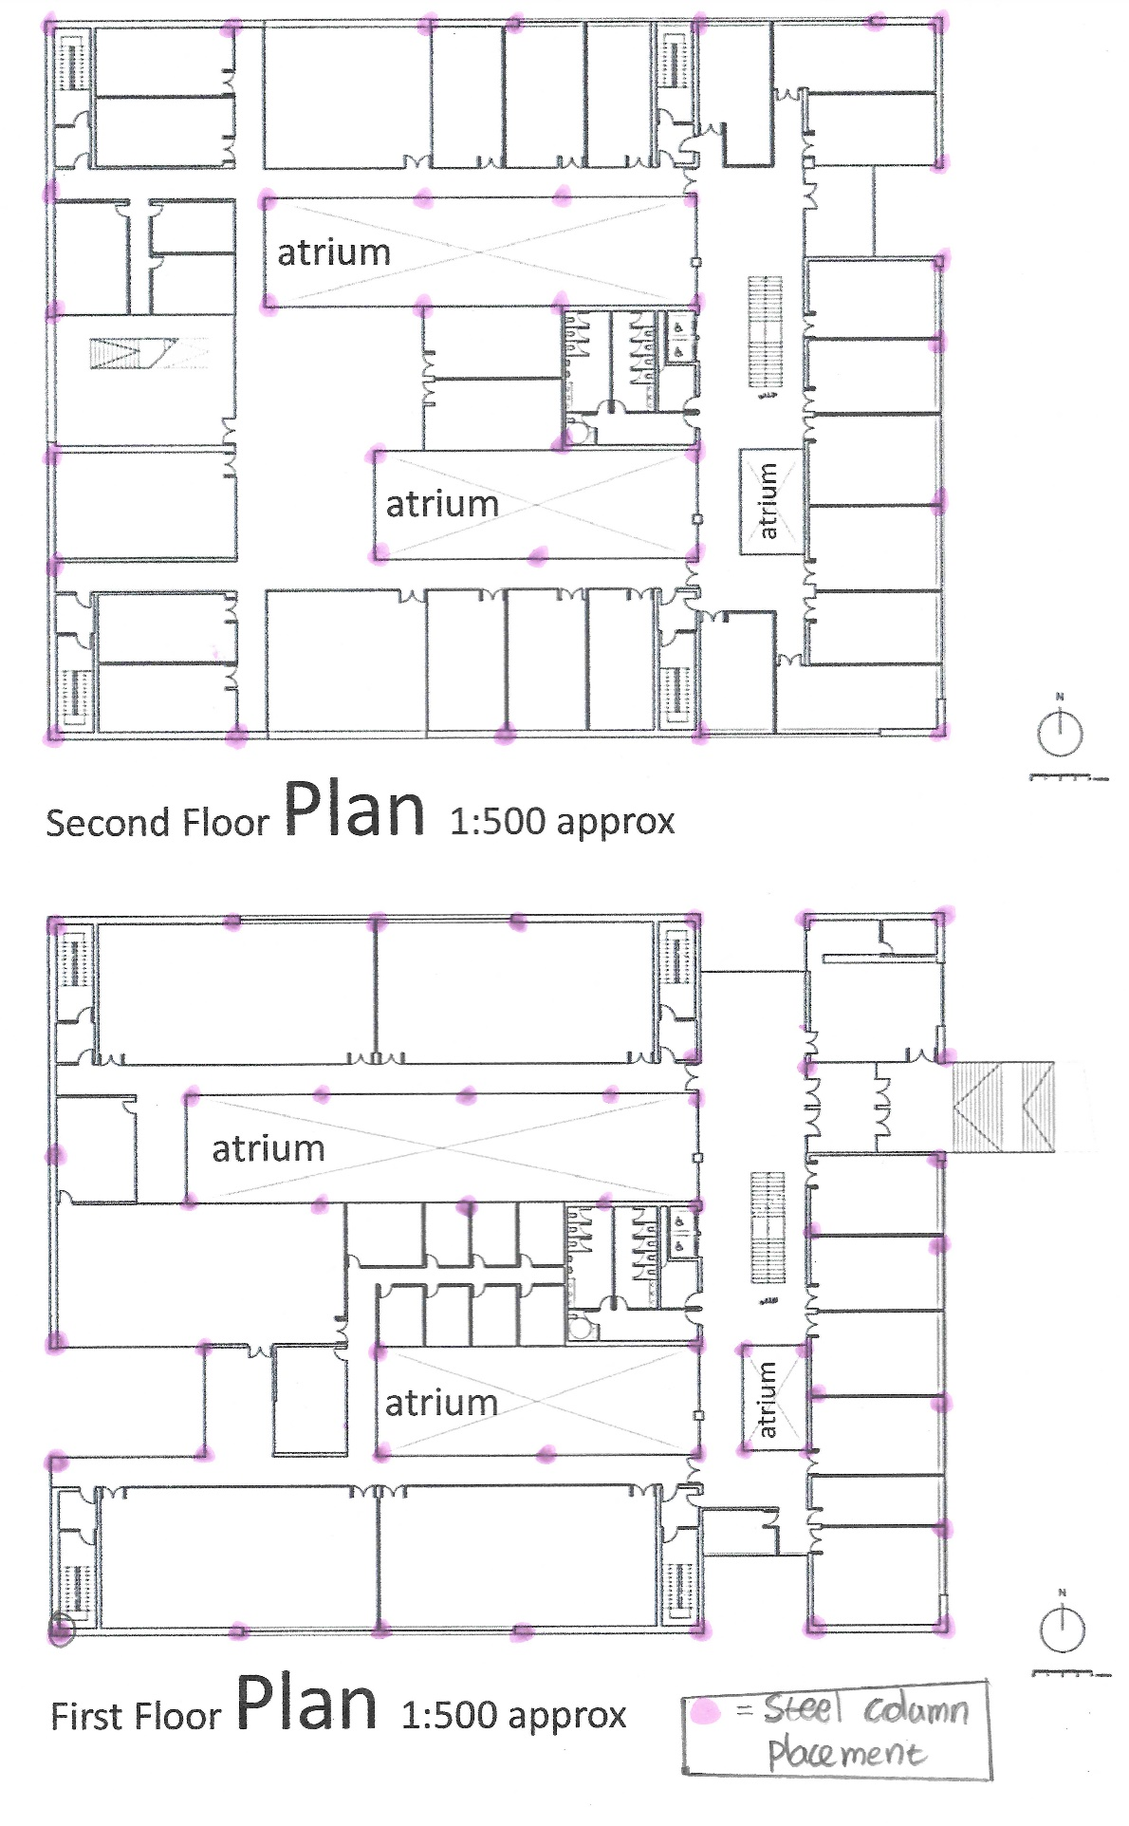
Appendix 2.2 First & Second Floor Plan

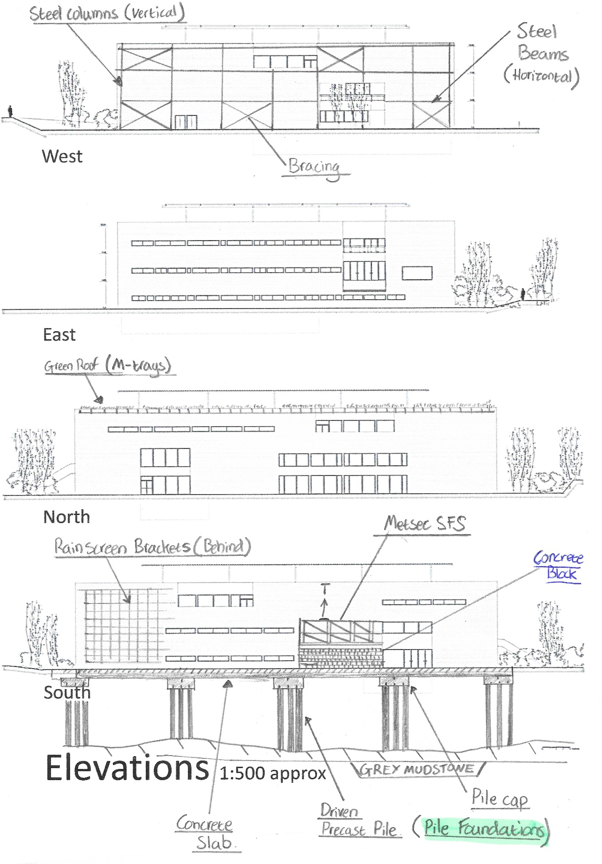
Appendix 2.3 Elevations

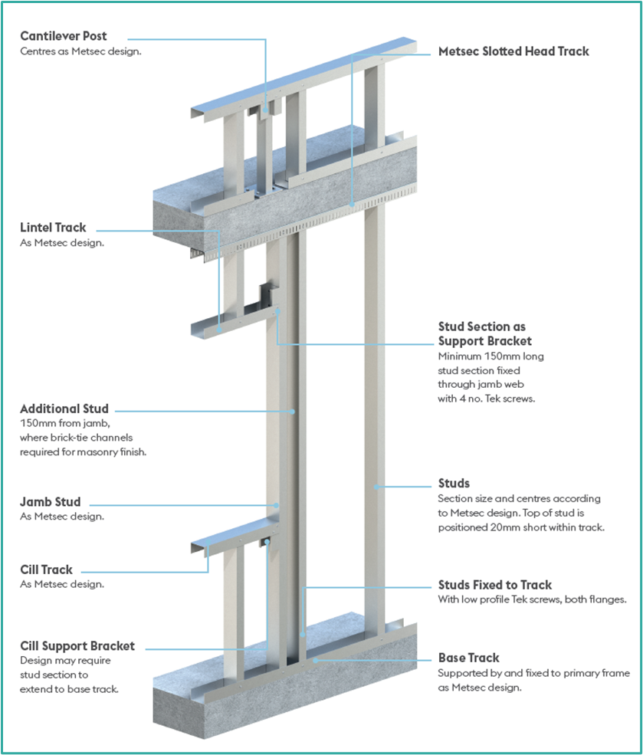
Appendix 3.0 METSEC SFS Infill Walling system

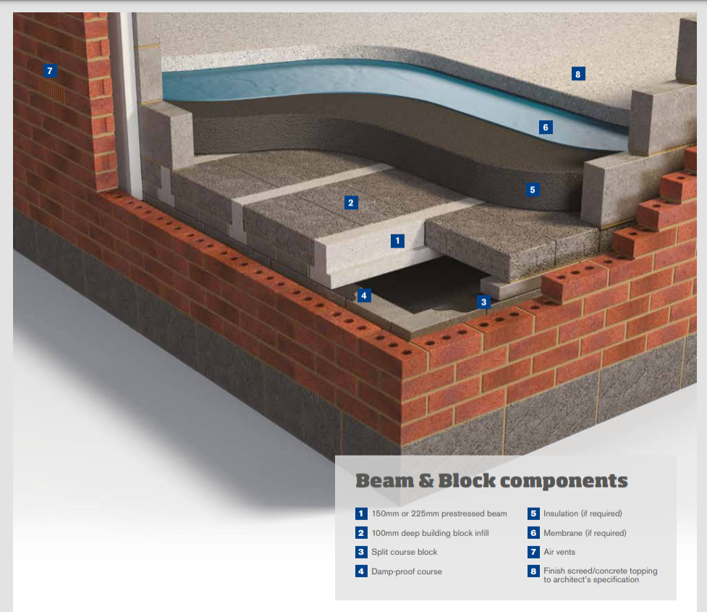
Appendix 4.0 Typical Bison Beam cross sectional view

