

Improving the Accuracy of Entry
Qualification Data via Automated
Imports from the Learning Record
Service (LRS) in a UK
Higher Education Institution
by
Kallum Doyle

Supervisor: Nathan Morgan

Project submitted as part of the requirements for the award of
BSc (Hons) Applied Computing (Software Engineering)

July 2026

Declaration Form and Form of Consent

DECLARATION

I, Kallum Michael Doyle declare that I am the sole author of this Project; that all references cited have been consulted; that I have conducted all work of which this is a record, and that the finished work lies within the prescribed word limits.

This work has not previously been accepted as part of any other degree submission.

FORM OF CONSENT

I Kallum Michael Doyle hereby consent that my Project, submitted in candidature for the BSc (Hons) Applied Computing (Software Engineering) degree, if successful, may be made available for inter-library loan or photocopying (subject to the law of copyright), and that the title and abstract may be made available to outside organisations.

Abstract
The accurate recording of student qualification data is a regulatory requirement in UK higher education, with direct obligations in the Higher Education Statistics Agency (HESA) student return. There is no automated mechanism to verify and map qualifications to Universities and Colleges Admissions Service (UCAS) codes for students that do not apply via UCAS, which creates a significant administrative burden. This project investigates how automated qualification data retrieval from the Learning record Service (LRS) can improve data quality, enhance regulatory compliance and reduce administrative burden in a university.
To address this, an automated qualification mapping pipeline was designed and implemented in C# .NET 8 and sourced data from four regulatory datasets to resolve student qualification records to their corresponding UCAS qualification type and subject codes. The system employs a multi-tier priority matching algorithm to map qualifications and is supported by multiple forms of testing.
Evaluated against a dataset of 755 student qualification records, the system achieved a mapping resolution rate of 92.7% for this academic year cycle, which significantly exceeds the 80% target threshold. Overall functional coverage was 69.5% with LRS API integration and an exception management interface remaining outstanding. The results demonstrate that automated qualification mapping is viable at production scale and represents a meaningful improvement over manual processing in both accuracy and auditability.

Contents Page
Contents
1. Declaration Form and Form of Consent 2
1. Abstract 3
2. Contents Page 4
2.1. Table of Figures 8
3. Chapter 1 – Introduction 10
3.1. Research Aim / Question 10
3.2. Research Objectives 10
3.3. Report Introduction 11
4. Chapter 2 – Research & Review of Literature 12
4.1. Data Governance 13
4.2. UCAS Centric 14
4.2.1. Quantitative Coverage Gap 14
4.2.2. Qualitative Risk and “Weak Knowledge Structures” 14
4.2.3. Unreliability of Predicted Metrics 14
4.3. Data Quality 15
4.3.1. Dimensions of Data Quality in Higher Education 15
4.3.2. System Integration and “Dirty Data” 15
4.3.3. Strategic and Regulatory Consequences 15
4.4. Dilemmas and Risks of Datafication 16
4.4.1. Impacts of Metric and Data Orientated Platforms 16
4.4.2. Reliance on External Software 16
4.5. Data Insights & Decision Making 17
4.5.1. Strategic Value and the Information-Decision Gap 17
4.5.2. The Risks of Data-Only Thinking 17
4.5.3. Balancing Systems with Human Intuition 18
4.6. API & Automation 19
4.6.1. RESTful Architecture for Integration 19
4.6.2. Reducing Effects of Fragmented Services 19
4.7. In-house Development 20
4.7.1. Customisation and Workflow Synergy 20
4.7.2. Strategic Risks of Outsourcing Expertise 20
4.7.3. Productivity and Performance Contrast 21
4.8. Concluding Summary 22
5. Chapter 3 – Research & Development Methodology 23
5.1. Research Philosophy 23
5.2. Research Approach 23
5.3. Research Strategy 23
5.4. Research Methodological Choice 23
5.5. Time Horizon 23
5.6. Evaluation Criteria 23
5.6.1. Objective 1: Requirements Engineering by Week 16 23
5.6.2. Objective 2: Functional Coverage by Week 24 24
5.2.3. Objective 3: Mapping Accuracy 24
5.2.4. Ethical Considerations 24
5.2.5. Statistical Limitations 24
5.7. Development Methodology 24
5.7.1. Software Development Life Cycle: Scrumban 24
5.7.2. Justification of Scrumban Framework 24
5.7.3. Coding Frameworks 25
5.7.4. Reliance on External Data Sources 25
5.7.5. Hardware 25
6. Chapter 4 – Design & Implementation 26
6.1. Requirements 26
6.2. Integral Design Components 26
6.2.1. Priority-Based Greedy Matching Algorithm 26
6.2.2. HashSet-Based Referential Integrity Pre-filtering 27
6.2.3. ILookup<TKey, Element>: The Primary Matching Index 28
6.2.4. DataImportModel Registry: Manual Metadata Class 29
6.2.5. Two Tier Transaction Design 30
6.2.6. Wales Two-Path Strategy 31
6.2.7. Primary Data Source: CSVs 32
6.2.8. EF Core Code-First Migrations as Schema Files 32
6.3. Implementation 32
6.3.1. Tools and Techniques 32
6.3.2. Overcoming Difficulties 32
6.4. Testing 33
6.4.1. Unit Testing 33
6.4.2. System Testing 33
6.4.3. Acceptance Testing 34
6.4.4. Usability Testing 34
7. Chapter 5 – Evaluation 35
7.1. Data Insights / Conclusions 35
7.1.1. Requirements Engineering 35
7.1.2. Coverage of Requirements 37
7.1.3. Qualification Mapping 38
7.1.4. Resolution Tier Breakdown 39
7.1.5. Qualification Type Distribution 40
7.1.6. Awarding Body Analysis 41
7.2. Consistency with Literature Review 43
7.2.1. Data Quality 43
7.2.2. UCAS Centric 43
7.2.3. Data Insights and Decision Making 44
7.2.4. API Integration 44
7.3. Objective Achievement 45
7.3.1. Objective 1 – Requirements Engineering 45
7.3.2. Objective 2 – Functional Coverage 46
7.3.3. Objective 3 – Mapping Accuracy 47
7.3.4. Objectives – Overview of Thresholds 48
7.4. Overall Aim Achievement 49
7.4.1. The API Dimension – Unresolved Organisational Constraint 49
7.4.2. Data Quality 49
7.4.3. Administrative Workload Reduction 49
7.4.4. Regulatory Compliance 50
7.5. Divergence from Expectations 51
7.6. Better Approach 52
8. Chapter 6 – Conclusions and Recommendations 53
8.1. Contribution to Objectives Achievement 53
8.1.1. Essence of The Project & Research 53
8.1.2. Unmet Coverage 53
8.1.3. Overall Aim Achievement 53
8.2. Benefits to the Employer / Workplace 53
8.2.1. Workload Reduction 53
8.2.2. Auditability 54
8.2.3. Domain Visibility 54
8.3. Suggestions for Further Work 54
8.3.1. LRS API Integration 54
8.3.2. Exception Management UI 54
8.3.3. Expanded Manual Mapping 54
8.3.4. Test Coverage 54
9. Chapter 7 – Reflection 55
9.1. Domain Knowledge 55
9.2. Working Independently as an Expert 55
9.3. Project and Time Management 55
9.4. Lessons Learned 55
10. Chapter 8 - References 57
11. Chapter 9 – Bibliography 61
12. Appendixes 62
12.1. Project Requirements 62

Table of Figures
Table 1 | Chapters and a brief description of what they contain. 11
Table 2 | Folders related to the schema implementation. 32
Table 3 | Keys for the resolution tier breakdown table. 39
Table 4 | Breakdown of the resolution tiers. 39
Table 5 | Components and the plans they were included in. 45
Table 6 | Examples of UAL qualifications that were successfully mapped. 47
Table 7 | Examples of why NCFE and UAL qualifications are more difficult to match compared to BTECs or A Levels. 48
Table 8 | Objective thresholds and whether the threshold was met. 48

Figure 1 | A snippet of the priority tier algorithm in the codebase. 26
Figure 2 | A snippet of the HashSets in the codebase. 27
Figure 3 | A snippet of the MappingLookupsContext class with ILookUp<> collections. 28
Figure 4 | A snippet of the DataImportModel displaying the metadata required in the import process. 29
Figure 5 | A snippet of the ResetAndImport() function highlighting one side of the transactional design. 30
Figure 6 | A snippet of the ProcessWalesQualifications() function that joins onto Ofqual data with existing UCAS mappings. 31
Figure 7 | A snippet of a unit test showing the general structure of unit tests present for the qualification matching engine. 33
Figure 8 | A snippet of a system test analysing whether the outputted mapping table exceeds the defined threshold. 33
Figure 9 | A snippet of all tests passing. 34
Figure 10 | The flowchart engineered in the design phase showcasing the expected application flow of the LRS API. 35
Figure 11 | The original designed ERD of the discovered data relationships before the qualifications were mapped. 36
Figure 12 | The designated plans of the project and the respective components each contained. 36
Figure 13 | A graph showcasing the achieved coverage of each requirement component versus the expected coverage. 37
Figure 14 | A graph showcasing the percentage of qualifications resolved in this academic year, with a dashed red line denoting the expected threshold. 38
Figure 15 | A pie chart showcasing the different tiers of qualification resolution. 39
Figure 16 | A horizontal bar graph displaying qualification codes and their total amount of resolutions. 40
Figure 17 | A bar chart showcasing the resolved versus unresolved qualifications by awarding body. 41
Figure 18 | A horizontal bar chart highlighting the resolution rate percentage by awarding body with a yellow dashed line showcasing the overall average. 42
Figure 19 | A snippet of the SQL present in the student record integration component required to translate LRS sourced qualification grades to UCAS grades. 43
Figure 20 | Two horizontal bar charts showcasing the status of each subcomponent where overall requirement coverage was greater than 0 but less than 20. 46
Figure 21 | An infographic showcasing the components of the aim achieved (green blocks) versus the component unachieved (red block). 49
Figure 22 | An infographic showcasing the planned versus implemented system components. 51
Figure 23 | An image denoting that testability is a component of maintainability, and the other components of maintainability. Source: [36] 52

Chapter 1 – Introduction
In UK higher education, the accurate recording of student qualification data is required for regulatory compliance in the HESA student return. For students entering through UCAS, qualification data is largely provided automatically during A level award cycles. However, for non-UCAS applicants there is no equivalent-automated mechanism. Qualifications must be verified and manually mapped to UCAS codes, which creates a significant administrative burden during the most time critical period of the academic year: the period in which the HESA student return is due.
The project will aim to address this gap by developing an automated qualification mapping pipeline that will gather data from four regulatory databases:
- Ofqual Qualification Register
- Department for Education (DfE) QAN
- Qualifications Wales
- HESA / UCAS Data
To resolve student qualification records from the Learning Record Service (LRS) to their corresponding UCAS qualification type and subject codes. The system will be designed to be used within a university student records context, with the intention of reducing manual intervention and improving the consistency and auditability of qualification data.

Research Aim / Question
To investigate how API-driven automation of qualification data retrieval can improve data quality, reduce administrative workload, and enhance regulatory compliance in UK higher education student records systems.

Research Objectives
- Conduct a requirement engineering phase by analysing regulatory data standards (e.g., HESA, DfE) and LRS technical specifications, resulting in a comprehensive System Requirements Specification (SRS) and a software architecture design for an automated qualification retrieval system by Week 16.
- Develop a modular, LRS-integrated system using C# .NET 8 that implements a customisable rule-based validation engine. The system must successfully manage complex grade structures and subject codes, achieving 80% functional coverage of the defined requirements by Week 24.
- Evaluate the system's efficacy by measuring the accuracy of its automated translation logic against standardised UCAS qualification frameworks. Success will be achieved by demonstrating that the system can correctly map a diverse range of raw Ofqual level 3 qualification inputs to their corresponding UCAS subject codes and tariff points. The system must achieve a minimum of 80% mapping accuracy on validated test datasets by Week 26.

Report Introduction
The report begins with a review of the relevant literature in chapter 2 such as data governance in higher education, data quality frameworks, the benefits of API driven automation and the case for in-house development. Research and development methodology adopted including the philosophical approach, research strategy and the agile scrumban framework used to manage the project are all covered in chapter 3. Details of the design and implementation of the system are found in chapter 4, which covers key algorithmic and architectural designs, alongside the tools and techniques used and the testing strategies to be used.
The evaluation of the system's performance against the project’s objectives and success criteria, and the examination of the results against the literature review, are all covered in chapter 5. Chapter 6 makes conclusions from the project and identifies any benefits to the employer, areas of unmet scope, and future work suggestions. A personal reflection on the project experience is conducted in the concluding chapter; chapter 7.
Table 1 | Chapters and a brief description of what they contain.
Chapter | Title | Description
2 | Research & Review of Literature | Literature reviewal of data governance in higher education, data quality frameworks, benefits of API driven automation and case for in house development.
3 | Research & Development Methodology | Details the philosophical approach, research strategy and agile framework used for project management.
4 | Design & Implementation | Outlines key algorithmic and architectural decisions, the tools and techniques used, and testing strategies used.
5 | Evaluation | Assesses the system’s performance against the objectives and success criteria and reviews the results against the literature review.
6 | Conclusions | Identifies benefits to employer, areas of unmet scope and suggestions for future work.
7 | Reflection | Personal reflection on the project experience alongside lessons learned.

Chapter 2 – Research & Review of Literature
The HESA student return places direct obligations on UK higher education institutions regarding the accuracy of student qualification data, making data quality a fundamental component of institutional procedure [25]. The current reliance on manual processing for verifying qualifications on entry data generates a significant administrative burden during time-critical periods of the academic year. This project is being developed to address the specific vulnerability of non-UCAS applicants who often lack the automated qualification data provided by UCAS during A-level award cycles, which leads to disproportionate manual intervention.

Data Governance
The state of university governance is a field ever-growing in complexity. University governance can be a formal governmental style of higher education systems, to formal legal, administrative paradigms, or to decision strategy. A stronger “compliance culture” is growing increasingly as higher education institutions undergo “massification,” with the relationship between governance and management systems becoming increasingly complex. Universities are finding themselves subject to more explicit rules and regulation due to their growth and higher accessibility to students of all backgrounds, alongside the increasing number of courses offered from professional to vocational programmes. Additionally, the “audit society” means that universities are increasingly under scrutiny as there is a wider erosion of trust, and the more sophisticated data systems in place allow for greater analysis of performance [1].
Furthermore, performance data is an important part in higher education governance. Big data is providing a “competitive advantage and long-term growth” for public sectors implementing data analysis, as converting unstructured data into insights allows for the improvement of core areas of higher education, providing reduced costs in the services they provide. Performance data is used in university ranking and information guides, which forms a critical part of the student choice, as it can inform what university they wish to intend. However, there are implications of the implementation of big data measures in higher education. It is essential to realise that data alone cannot answer full questions in education due to the complexity of the area. Big data can provide an avenue for critical thinking by providing detailed information, but the amount and quality of the data may overcast other critical considerations in the decision-making process [2].

UCAS Centric
The Universities and Colleges Admissions Services (UCAS) highly dominate the current UK admissions process. This framework can cause manual administrative intervention as UCAS does not oversee all full-time undergraduate applications, which can cause fragmented datasets with students who have entered via separate sources.

Quantitative Coverage Gap
[3] found that UCAS data is an incomplete representation of the UK higher education landscape. This can primarily be seen in Scotland where approximately a third of full-time undergraduate courses are delivered via further education colleges that fall outside of UCAS’ coverage. These records are not comparable to the rest of the UK due to not being captured by the central application services, which causes a data silo that requires independent verification. Furthermore, while UCAS oversees greater than 90% of UK-domiciled entrants to higher education, it can miss the larger view of the overall landscape and can miss thousands of applicants who enter via direct institute application or specific clearing avenues [3].

Qualitative Risk and “Weak Knowledge Structures”
This gap is compounded by the qualitative unreliability of student-reported data. [4] found applicant’s “knowledge structures” can determine the quality of the information they provide, students from less-advantaged backgrounds can lack individual insight and rely on word-of-mouth reasoning. This can lead to students providing “partial, out-of-date, or simply wrong” information in the manual application process [4]. An institution that relies or has a component of this manual data collection from students has a vulnerability of introducing considerable risk of error into the HESA student return due to incorrect qualification coding.

Unreliability of Predicted Metrics
The necessity for a verified, real-time data source like the LRS-API is further demonstrated by the inaccuracy of the UK’s predicted grade model. Research by [5] displays 84% of teacher-predicted grades are inaccurate with approximately 75% being overly predicted. This can become problematic if the UCAS Data for HESA (*J) imports fail or are not received by the university processing the student return [6], as the qualifications returned for these students could be higher than the reality.

Data Quality
For a university to function as an organisation focused on data quality, it must address the underlying quality of the data it collects, processes, and reports. The potential for coverage and timing gaps within UCAS data only represent one facet of the challenge in ensuring high quality data.

Dimensions of Data Quality in Higher Education
Data quality is a multidimensional concept, [7] identified four primary dimensions that are essential for higher education data: Completeness, which represents the extent that the data contains all expected attributes (i.e. data on a student having their full name, address, email, etc.) Validity which measures how well the data is stored and presented in a consistent format (i.e. how a students A Levels are mapped to the same codes.) Accuracy ensures data is “correct, consistent and unambiguous.” Finally, currency, which is how well data represents the state of the data object [7].
Data quality assessments suggest these standards are frequently unmet, with only 21.15% of business rules for completeness and 45.45% for accuracy being satisfied within higher education information systems. This can be attributed to the lack of mandatory validation rules and unavailability of necessary data columns required by government regulators [7].

System Integration and “Dirty Data”
UK Universities face significant struggles in establishing a reliable data driven digital infrastructure. [8] notes that universities frequently operate with fractured systems rather than a single integrated centre, despite the recognition of data being an asset. One institution was found to have fragmented student data across thirty-six separate databases which demonstrates how a lack of information directly contributes to “dirty data.” [8] This lack of centralisation prevents universities from systematically acting on analytics as the quality and nature of evidence base could be completely different depending on the data source, and this impacts how institutions make critical decisions.

Strategic and Regulatory Consequences
Poor data quality has risks that extend beyond the administrative inconvenience, it can result in damaging institutional misrepresentation. [9] provide an important example in the context of UK Performance Indicators (PIs). There was an instance where a UK university was classified as the “worst” performing institute in the country due to incorrect data as the university miscoded 267 students on a course. These students were coded as non-progressing when they had achieved a better than average graduation rate of 88.8% [9].
These examples demonstrate how omission or miscoding of data can lead to biased data quality assessments. The research also suggests implementing data monitoring can result in more consistent data quality over time, as seen with the PI monitoring as after the first year of PI reporting the number of “unusual” universities declined [9].

Dilemmas and Risks of Datafication
[11] shows that the increasing datafication of society introduces new methods to measure, capture and represent social life in data. Within higher education, this transformation affects how future generations can construct reality through data as much as it is used to organise teaching and learning [10]. This gives rise to a digital profile that can represent a student’s history, known as a “data double.” [12] highlights an ethical problem with this reformat as digital profiles can lead to predictive algorithms using them to drive decision making. This can exclude students from certain course content or opportunities. Students and teachers may also find themselves as “data subjects” whose actions are visible through digital traces. This presents a potential for companies to treat student data only as “raw material” for commercial analysis and profit, instead of the bettering of society and education in the higher education landscape [11].

Impacts of Metric and Data Orientated Platforms
Metrics are an essential component of managing curriculum in education institutes. [10] argues that metrics possess “metric power” and are not just a reflection of performance but also have an impact on institutional behaviour, raising reactions like anxiety or competitive motivation. Platforms driven solely by data can suppress opportunities for critique or dialogue around the subject. This can foster a negative culture of marketisation and audit. There is also commonly an assumption that automated systems are objective and neutral, however their design can often represent their producers’ business plans or otherwise objectives [12].

Reliance on External Software
[12] highlights how educational institutes can become overly reliant on software provided by market leaders and how this can create a model known as “data rent” where institutions pay subscriptions and provide data that companies exploit to develop new commercial products. This phenomenon can erode professional judgement and institutional autonomy due to key decisions being offloaded to algorithms. Additionally, there are scenarios where providers may collect more information than necessary and cause a burden on institutes and parents trying to manage student data protection [11].

Data Insights & Decision Making
Higher education institutions (HEIs) are becoming increasingly dependent on data-driven decision (DDD) making for their operations. [13] define DDD as the systematic application of empirical data to guide institutional policy. This replaces historical trends and human intuition with real-time analytics and predictive modelling, providing an essential transition for addressing challenges such as changes in student enrolment and a critical need for improved student retention. Leveraging large datasets from student information systems (SIS) allows universities to minimise human bias and ensure institution strategy is centred around evidence. The authors identify a “data-to-action” pipeline where data is transformed into intelligence via algorithms, which is a critical stage for improving institutional performance. This evidence-based decision making facilitates more agile responses to obstacles in the higher education landscape and fosters a culture of continuous innovation and accountability [13].

Strategic Value and the Information-Decision Gap
Data collection does not inherently provide organisational value. Its worth is only realised when leadership can recognise its strategic significance and extract actionable information. [14] demonstrates that despite the advantages of decision support systems (DSS) they remain underutilised in HEIs, which leaves significant room for further research and implementation. There is a persistent requirement for human involvement to analyse and interpret data streams even with automated tools like educational data mining and business intelligence in place that provide the information logic through analysing trends. Software can provide value through intuitive dashboards; however, the decision logic resides with managers who must interpret historical data to make strategic decisions. Bridging the gap between the automated data processing and human led decision making allows institutions to optimise student enrolment campaigns and academic staff evaluations. This means these tools are a critical component of superior learning systems that turn raw data into knowledge that supports the sustainable development of an institution [14].

The Risks of Data-Only Thinking
Moving toward evidence-based strategies is often evaluated as progress, however, [15] argues there are concerns about how we understand and trust the knowledge gained from large datasets. A major challenge is the shift in focus from understanding why things happen through cause and effect to predicting what might happen through data. This creates a risk of finding false patterns in datasets. Furthermore, data is rarely unprocessed, it is often “cleaned” by humans before analysis, meaning invisible personal judgements could already be built into the system. The authors also note that automated systems can rely on hidden human labour to function as expected, a concept coined as “heteromation.” [15] These patterns alone can lead to a narrow view of reality that ignores the complex reasons behind human behaviour.

Balancing Systems with Human Intuition
[16] highlight the danger of becoming overly reliant on digital insights. They argue that data systems should be a support of human expertise instead of replacing it. Tools like business intelligence can provide a necessary historical foundation for strategy, however, human judgement is considered irreplaceable for interpreting data within its context. Becoming too reliant on technology can lead to a narrow focus, where complex operational issues are oversimplified and qualitative factors are disregarded. This can result in “decision fatigue” caused by information overload and a lack of flexibility when conditions change. The researchers suggest a suitable strategy for mitigating these risks is a balanced approach where technical insights are checked against human wisdom and ethical standards [16]. For educational institutions, this means ensuring automated data streams are balanced with the experience of personnel to maintain stability and long-term success.

API & Automation
Adopting automated frameworks is increasingly seen as crucial for managing complex multi-team workflows in modern organisations. It is argued in [17] that manual workflows can be plagued by inefficiencies and a significant lack of coordination, particularly when multiple teams are managing overlapping datasets. One limitation of automated systems is that they can be overly reliant on static rules and can fail to adapt to dynamic environments. This can lead to a “bottleneck” when project scopes shift. Integrating real time metrics into an automated framework allows institutions to move away from outdated information that can skew the decision-making process, and toward a dynamic view of performance. The authors propose the centralisation of the data source as a backbone of this mechanism, which ensures all stakeholders access a single and consistent source of truth. This allows for initiative-taking adjustments and automated task triggers that reduce operational costs and enable a more agile and collaborative work environment [17].

RESTful Architecture for Integration
The exponential increase of fragmented information system creates an urgent need for uniform data communication to prevent duplication and mismatch. As noted in [18], it is emphasised that separate, related systems must communicate seamlessly to ensure business processes run smoothly. The authors present the REST API architecture as a primary mechanism for this integration and use simple methods alongside underlying HTTP protocols to build data communication between previously isolated applications [18]. By establishing data communication in a uniform format, applications such as verified qualification trackers can be built faster and more reliably. This infrastructure provides a necessary component for institutions to function as modern and data-enabled organisations.

Reducing Effects of Fragmented Services
Administrative operations in higher education can suffer from fragmented and paper-based processes that can cause significant delays or data quality risks during peak periods in the academic year. [19] introduces intelligent forms automation to facilitate digital transformation. This automation combines intelligent document processing (IDP) with workflow coordination to reduce the administrative burden. This approach provides a shift from a traditional system which can struggle with noisy or non-standard student records to a process that understands the semantic meaning of academic data. Using these types of special software can coordinate tasks across various systems without re-keying data manually, while minimising repetitive work and enhancing decision making speed. This results in standard cases being approved automatically and allows staff to focus on truly exceptional cases or other high-value advisory duties [19].

In-house Development
Selecting an appropriate software sourcing model is a key factor that influences the entire development process of a software piece and the subsequent management of commercial risks. [20] classifies these models into four primary categories and identifies insourcing as the model where an organisation uses in-house resources to conduct development tasks. This model has the highest level of management and operational control which makes it the most suitable for products where complete control of development is desired. Furthermore, insourcing has the highest level of confidentiality and develops in-house IT expertise and innovation which can be vital for long term growth of an organisation. External models like crowdsourcing or outsourcing can offer lower initial costs but can also sacrifice structured and tailored development that are inherent to in house teams. Institutions dealing with sensitive student data are likely to favour the operational control provided by insourcing as it ensures the technical infrastructure remains a core part of institutional strategy [20].

Customisation and Workflow Synergy
One primary argument for in-house development is software should be a tool that adapts to a user’s workflow rather than dictating it. [21] observes that external software is often designed to meet the requirements of a broad client base rather than the unique requirements of a specific environment. This creates a scenario where institutions must adjust their operational strategies to match the limitations of the outsourced software. Contrastingly, internally developed software has a greater positive influence on efficiency and productivity as they can be tailored to the specific infrastructure within the organisation. Additionally, internally developed software is adaptable and can be modified to match changing institutional requirements. This approach also mitigates vendor dependence, where customisations can be expensive and constrained by the tools of the external provider [21].

Strategic Risks of Outsourcing Expertise
Outsourcing can introduce significant risks to the core strengths of an organisation despite the prospect of financial savings. [22] warns excessive outsourcing can “hollow out” a company by not sufficient cultivating internal knowledge and skills to innovate. There is a risk of transferring expertise and insider knowledge to vendors which can impact an organisation’s ability to learn and take advantage of future changes in the landscape. Core functions that are critical to business success or organisational culture should not be outsourced as they require a deep understanding of the local environment and a high degree of trust. Additionally, benefits like cost savings do not often come to fruition due to system incompatibilities and demands that fall outside standard software packages [22]. For universities, this means the management of verified qualification data is a core competency that, if offloaded, could negatively influence the internal technical image and result in a loss of strategic autonomy.

Productivity and Performance Contrast
Software development performance is heavily influenced by the proximity and coordination of the development team. [23] found that the performance of distributed software development projects is generally lower compared to in-house projects. Research suggests the productivity of team members in these environments can decrease by up to 50% compared to team members in proximity, resulting in a significantly longer delivery window. These losses come because of the challenges of communication, coordination and control that are inherent in an external or offshore setup. In-house teams can show better results in both productivity and quality as they can manage projects timelier and with fewer defects [23]. This suggests despite the potential of lower labour costs in outsourcing, management complexities and performance losses often balance the total cost at best and often are higher than initially projected once the total cost of ownership is considered [21 - 23]. This makes a strong business case for the higher efficiency and reliability of a dedicated in-house development strategy.

Concluding Summary
The literature reveals a challenge between the increasing regulatory demands for high-quality data in the “audit society” and the fragmented, often inaccurate reality of current university information systems. While UCAS provides a dominant framework for admissions, its coverage gaps and potential unreliability of predicted metrics necessitate a verified, real-time supplementation like the GOV.UK Learning Record Service (LRS) API. Additionally, while the transition toward data driven decision making offers strategic advantages, it introduces significant ethical risks and the potential for “dirty data” to skew institutional strategy.
Technical analysis suggests a RESTful API architecture combined with intelligent automation provides an effective mechanism for reintegrating fragmented services and reducing the administrative burden of manual processing. Finally, the business case for in-house development ensures the institution retains operational control and the “decision logic” required to maintain strategic autonomy. By integrating these findings, this project proposes a tailored technical solution that is designed to bridge the “data gap” and ensure student qualification records are not only complete but verified against regulated standards for statutory reporting.

Chapter 3 – Research & Development Methodology
This chapter details the theoretical framework and technical procedures used to investigate automated qualification retrieval. It justifies the choice of an investigate research strategy and an iterative development life cycle to solve the manual data entry challenges within a university’s student records.

Research Philosophy
Pragmatism is a research paradigm that is centrist in the ontological continuum and acknowledges that the individual experience is unique to all. It acknowledges a real problem but also acknowledges the measurement of truth is difficult from a human perspective [27]. This makes it perfect for this project, as the research is driven by a practical administrative concern: the manual burden of HESA data returns, rather than theoretical concerns.

Research Approach
A deductive approach is the primary basis for this project as the research is primarily quantitative. Specifically, the hypothesis reviews how automated qualification retrieval can improve data quality and meet a specific success threshold of 80% mapping accuracy [28]. However, the analysis goes beyond confirming or denying this hypothesis and will explore patterns found, such as patterns in the data or any patterns in the developmental process. These components require interpretative reasoning, which reinforces pragmatism as the appropriate philosophy given its support for methodological flexibility [27].

Research Strategy
An experimental and investigative strategy is employed as the research investigates missing data patterns within the university’s database and experiments with how automated qualification retrieval can correct these gaps.

Research Methodological Choice
The study is a mono-method quantitative study as it relies on numerical data: specifically, the quantification of missing records and percentage accuracy of qualifications resolved by the solution.

Time Horizon
The search is cross-sectional and focuses on the data requirements for the 25/26 academic student return.

Evaluation Criteria
This section defines the criteria which each project objective is evaluated against, alongside ethical considerations and statistical limitations in the analysis.

Objective 1: Requirements Engineering by Week 16
The requirement’s engineering phase is evaluated against the successful write-up of a system requirements specification and a software architecture design by week 16. The SRS document defines five primary components of the system and incorporates percentage weightings against each component to provide an estimate and measurable framework for subsequent development phases. Evaluation of this objective is based on the completeness of these components against the week 16 milestone.

Objective 2: Functional Coverage by Week 24
The functional coverage of the application is evaluated by mapping implemented system behaviour against the percentage weighted requirements defined in the requirements specification. The following contains each component and their respective estimated weighting:
- Qualification Mapping Engine (30%)
- Internal Database Integration (30%)
- Automated Validation (20%)
- Exception Management UI (10%)
- LRS API Integration (10%)

Objective 3: Mapping Accuracy
The mapping accuracy of the qualification resolution engine is evaluated descriptively against the 80% accuracy threshold in the requirements specification non-functional requirements. The resolution rate of the retrieved qualifications to UCAS QualTypeIDs is to be measured and compared against this threshold.

Ethical Considerations
When evaluating the mapping success of student qualification data, identification information will not be provided in the calculation. For calculation purposes, the student number can be removed and replaced with a simple binary identifier to indicate whether they were found from the portal or not. The evaluation can then take purely place on how that qualification maps from LRS to UCAS, there are no unique personal identifiers involved in this.

Statistical Limitations
It is worth noting that the dataset for the evaluation of the mapping accuracy is criteria-based rather than randomly drawn and contains the full population of LRS-retrieved records for this cycle rather than a random sample. Conclusions therefore apply specifically to this cohort and cannot be statistically generalised to future cycles.

Development Methodology
The section details the software engineering framework used to construct the qualification retrieval system and the rationale for the technical tools selected.

Software Development Life Cycle: Scrumban
The project uses Scrumban, a hybrid framework that blends the structure of Scrum with the workflow flexibility of Kanban. This methodology was selected to manage the complexity of building a modular, LRS integrated system while adhering to strict project deadlines.

Justification of Scrumban Framework
Implementing Scrumban [24] mitigates the drawbacks of implementing Scrum or Kanban individually, such as Scrum’s tendency to introduce rigidity to the development process, or Kanban’s lack of structured prioritisation. Scrumban offers a “well balanced” approach that is suitable for the fast paced and iterative nature of this project due to the unpredictable complexities involved in mapping raw Ofqual Level 3 data to UCAS data.
The specific implementation of Scrumban in this project consists of multiple components to ensure transparency and consistent progress. Daily 15-minute stand up meetings are conducted to review technical tasks, discuss blockers, and maintain effective communication. These daily interactions are supported by Kanban reviews where the visual board it uses to track the workflow and limit the amount of work in progress (WIP). Enforcing strict WIP limits at each stage of development results in effective identification and reduction in technical bottlenecks. Furthermore, the project operates on a three-week cycle for sprint reviews and planning sessions. These sessions provide a platform to inspect and adapt the workflow of the project to ensure that progress is being made consistently and efficiently through each sprint [24].

Coding Frameworks
The system is developed using the C# .NET, serving primarily as a console application with the potential to use ASP.NET Core for a frontend. C# is a “modern, general-purpose, strongly typed and object orientated programming language.” The use cases of C# are wide, which make it suitable for this project due to the complexity in its respective components [39]. The object orientated nature of C# is perfect for a project of this size, with its modularity and need for continual development being critical.
CsvHelper is a major package used within this project due to the requirement of importing external data. The external data source providers provide this information in CSV formats, which needs to be imported for mapping purposes. CsvHelper is a widely used C# package for processing CSVs. The amount of documentation available alongside its accessibility make it suitable for this project due to the deadline driven nature of the project [26].

Reliance on External Data Sources
There are a few different data sources this project relies upon to replace the manual gathering of qualification data. This includes:
- The Learning Record Service (LRS) API or Portal.
- Department for Education QAN Data
- Ofqual Database Register.
- UCAS Tariff Data (provided by HESA).
The LRS services are used for retrieving student qualification data, whereas the other sources are used to provide a framework for mapping the student qualifications from Ofqual data to UCAS data. This data is required as the university’s systems provider currently does not provide this complete set of data themselves.

Hardware
Existing server hardware located within the university that currently hosts the student record system is to be used to host the automated qualification retrieval solution. Additionally, a workplace provided laptop is used to develop the solution.

Chapter 4 – Design & Implementation
This chapter details the design and implementation of the application and covers key algorithms, data structures, design patterns, transactional design, difficulties encountered and unit testing.

Requirements
The project requirements were established through primarily means of data discovery. A conceptual application was proposed by coordination of two primary departments: registry and MIS data, and the general concept was to form an end-to-end automated data pipeline connecting the LRS API to the student record system with minimal manual intervention. The requirements included five components:
- Forming a data connection with the LRS API.
- Mapping the LRS qualifications (Ofqual) to UCAS qualifications.
- Automated validation of the application’s inputs and outputs.
- Importing the converted UCAS qualifications into the student record system.
- Providing means of resolving unresolved qualifications via a frontend.

Integral Design Components
This section details the key design elements as a foundation for the system’s implementation.

Priority-Based Greedy Matching Algorithm
The main algorithm in the qualification mapping engine is a priority based greedy matching algorithm. This type of algorithm operates by assigning outcomes to elements in a specific, fixed, and predetermined order and the algorithm selects the locally optimal choice at every step [38]. This implementation implements five matching strategies in a set priority order:
- Qualification Number (QAN) code match.
- Title match (comparison of descriptor fields in the dataset).
- Two tiers of manual matches.
- A hardcoded exception lookup.
The result is determined using null-coalescing, meaning that if a QAN match is found, none of the other matching strategies are considered. The tier one and tier two manual matches differ only in that tier one uses guided learning hours alongside its secondary matching field (typically Ofqual qualification type or a simplified and extracted qualification type from the qualification title). The resolution of the qualification subject (e.g. “Mathematics” in “WJEC Advanced GCE in Mathematics”) follows an equivalent algorithm.
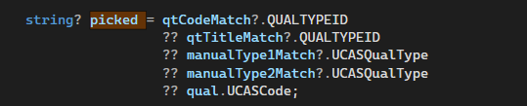
Figure 1 | A snippet of the priority tier algorithm in the codebase.

HashSet-Based Referential Integrity Pre-filtering
Before anything is imported to the database, ImportDefinition.LoadAll() constructs HashSet<string> collections of valid foreign key values from each parent entity before filtering dependent records against these sets. Making these a HashSet provides an O(1) average look up [39] which makes the full filter over N records an O(N) operation regardless of the number of valid keys.
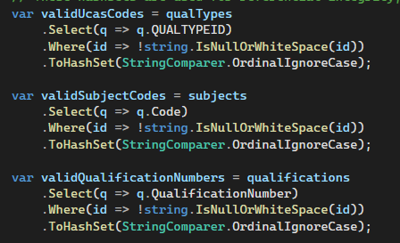
Figure 2 | A snippet of the HashSets in the codebase.
This approach was chosen over the alternative of attempting the insert and catching exceptions as it produces a clean diagnostic output as dropped counts are logged explicitly. It also makes the data quality sourcing visible in application code compared to a database constraint violation.

ILookup<TKey, Element>: The Primary Matching Index
Matching indexes are constructed as an ILookUp<> collection instead of a Dictionary<> collection as it can be used to index multiple values against a key. This is useful specially with the manual mapping entries, as the qualification type may be the same, but differ by GLH. [40] alongside returning an empty sequence on missing index instead of throwing an exception, which eliminates the requirement of defensive guards.
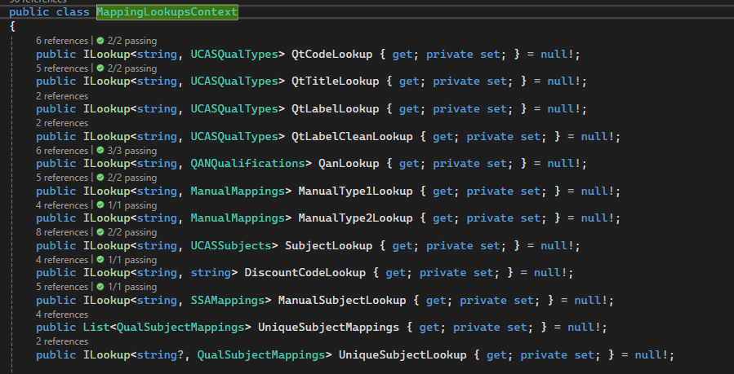
Figure 3 | A snippet of the MappingLookupsContext class with ILookUp<> collections.
All lookups are constructed with StringComparer.OrdinalIgnoreCase which manages case variation across data sources.

DataImportModel Registry: Manual Metadata Class
The whole import pipeline is structured around the DataImportModel class. This class follows a registry pattern, which is “a well-known object that other components can use to find common objects and services” [41]. Each entry has its own metadata such as table name, seed order, file path, type of entity, etc. Adding a new entity type requires only creating the entity, its EF core configuration and a new DataImportModel entry.
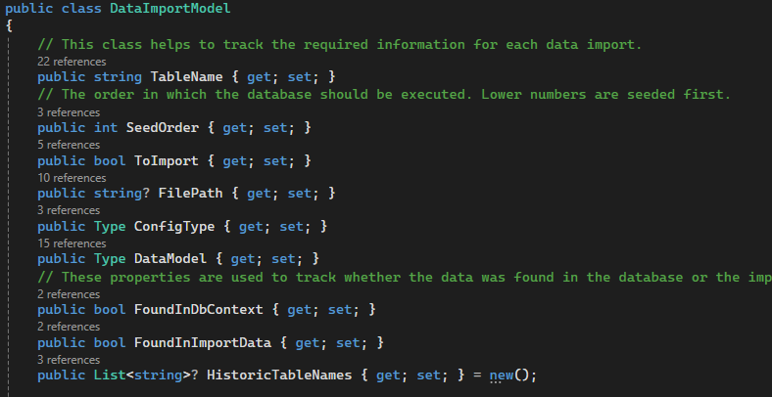
Figure 4 | A snippet of the DataImportModel displaying the metadata required in the import process.
The database seeding mechanism, pre-import validation check of the model, and drop/recreate logic all adapt without modification given a migration is ran after entry addition. Designing this model as easy to extend was a deliberate design goal given the full set of source entities was unknown from the beginning.

Two Tier Transaction Design
Two transactions are used with deliberately designed scope. They are each scoped to their own section of code and must either succeed or fail together [41]. The reset and import operation are its own isolated section of work and a failure partway through should leave the database as it was in its original state.
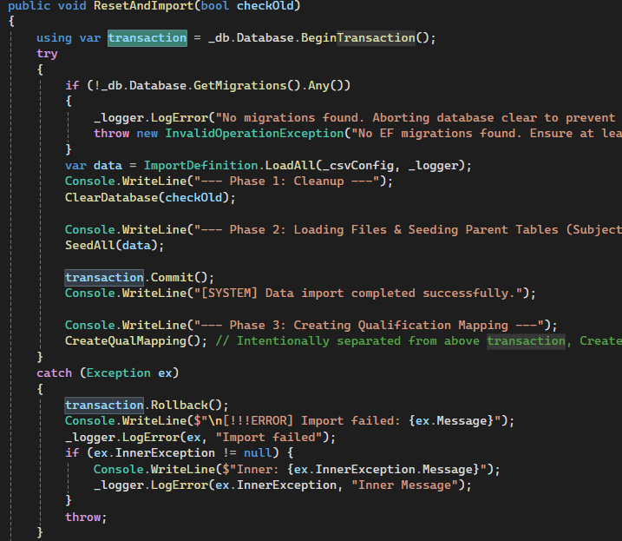
Figure 5 | A snippet of the ResetAndImport() function highlighting one side of the transactional design.
The qualification mapping is its own separate workflow as it can be called independently of the full import process. Having both as a single transaction would have made conflated the two workflows and made it impossible to have the qualification mapping run without the full import. Each transaction reflects what is meaningful to the application rather than a pure technical possibility.

Wales Two-Path Strategy
Wales qualifications can contain an Ofqual qualification number that may have been resolved in the workflow by their associated Ofqual number. This means a join can be made onto the Ofqual qualification to bypass the matching engine entirely. The leftover qualifications with no Ofqual qualification number are parsed through a similar algorithm to the Ofqual qualifications, but with fewer tiers.
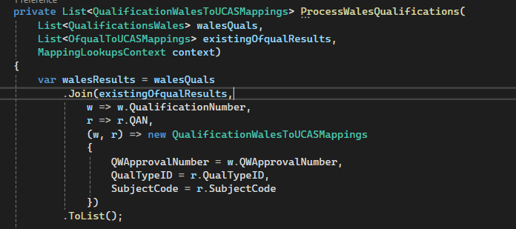
Figure 6 | A snippet of the ProcessWalesQualifications() function that joins onto Ofqual data with existing UCAS mappings.

Primary Data Source: CSVs
All source data enters the system via CSV datasets drawn from multiple sources, including:
- Ofqual
- Department for Education
- Qualification Wales
- HESA (provides UCAS)
- Manually mapped data.
The CsvHelper C# package streams each file via StreamReader instead of loading it into memory of a raw string, which is suitable given the volume of the qualification’s datasets. Header matching is normalised to lowercase to accommodate inconsistent casing conventions across the data sources. All data loading and cleaning occurs in memory before any database write begins to keep the transformation logic visible and testable.

EF Core Code-First Migrations as Schema Files
The database schema is constructed in code by entity framework core’s configuration classes, which are applied at assembly and discovered automatically by the package. The generated migration is a complete record of the intended schema. At runtime, the application deliberately truncates the entity framework core migrations history before calling Migrate() to force table creations. This was a deliberate design choice to not rely on incremental migration tracking and to provide consistency between application runs.
Table 2 | Folders related to the schema implementation.
Folder | Contains
Migrations | The entity framework core generated schema / files from the configuration files.
Models/Configurations | The actual schema configurations for each entity existing within the database. Normalised data types can be found in FieldLengths.cs. The rest is relating to a data entity.

Implementation

Tools and Techniques
The system uses C# .NET 8 with entity framework core for database interaction and CsvHelper for CSV parsing. SQL server is the target database. It is a code-first approach as detailed above. All data transformations occur in the codebase and Serilog is used for providing structured logging to files. Serilog is configured to suppress entity framework core’s SQL command logging to avoid burying manual data logs.

Overcoming Difficulties
The greatest difficult was maintaining modularity as the system grew organically from a prototype under a scope that was continuously expanding. It was originally unknown that qualification data would have to be sourced from Ofqual, QAN and Qualification Wales, and with each new source the pressure to get the matching logic working correctly took priority over architectural purity. This resulted in a few components having a greater number of responsibilities than desired. However, the result still is substantially modular with clear boundaries in pipeline stages across multiple distinct classes. The matching engine has all dependencies injected to make it a dynamically allocatable class. While there is an uncomplete separation of concerns across all classes, this is as a known trade off rather than an oversight.

Testing
This section covers all forms of testing applied or not applied within the application.

Unit Testing
The unit tests of the application target individual components in isolation and ignore the rest of the system to follow standardised principles of unit testing [42]. There are seven tests that cover the primary qualification matching engine (QualMatchingEngineTests.cs) that use xUnit. It assesses all five matching tiers and subject code fallback behaviour alongside the GLH sub priority and the null return on no match. Mock look ups are injected to achieve isolation and the cleaning functions for the Wales and Ofqual qualifications are evaluated in CleaningFunctionTests.cs.
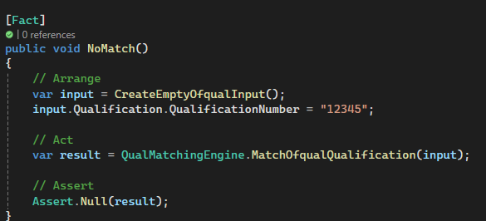
Figure 7 | A snippet of a unit test showing the general structure of unit tests present for the qualification matching engine.

System Testing
The application also implements system testing to ensure the system works as a workflow rather than in isolation [42] and this is seen in SystemTests.cs, where database reachability is tested before any workflow is enacted, alongside acceptable percentage and numeric thresholds respectively for the UCAS QualTypeID resolution and main qualification mapping output. These measures ensure that any run that produces significantly fewer rows than expected will surface immediately rather than requiring manual investigation.
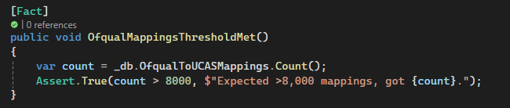
Figure 8 | A snippet of a system test analysing whether the outputted mapping table exceeds the defined threshold.

Acceptance Testing
There is a degree of user acceptance testing in the application to verify that the results meet defined acceptance criteria before the system is suitable for usage [43]. This appears in AcceptanceTests.cs which loads a file using CsvHelper of twenty verified records of various awarding bodies and verifies each qualification mapping to its expected UCAS QualTypeID and subject code after a full run of the workflow.

Usability Testing
The tool is a console-based data pipeline that targets a technical operator in its current format. Due to their being limited user facing interface, the scope for formal usability testing is negligible and was not conducted.

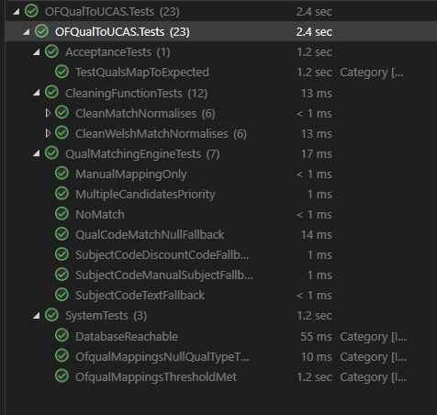
Figure 9 | A snippet of all tests passing.

Chapter 5 – Evaluation
This chapter consists of a system performance evaluation against the project’s success criteria, the overall consistency with the literature review, and the overall achievement of the aim.

Data Insights / Conclusions
This section presents the findings from each evaluation objective and draws conclusions from the data produced by the system.

Requirements Engineering
The requirements engineering phase produced a systems requirement specification covering five weighted functional components alongside non-functional requirements, and a suite of architectural artefacts that included a partial ERD and a process flow diagram for the LRS API.
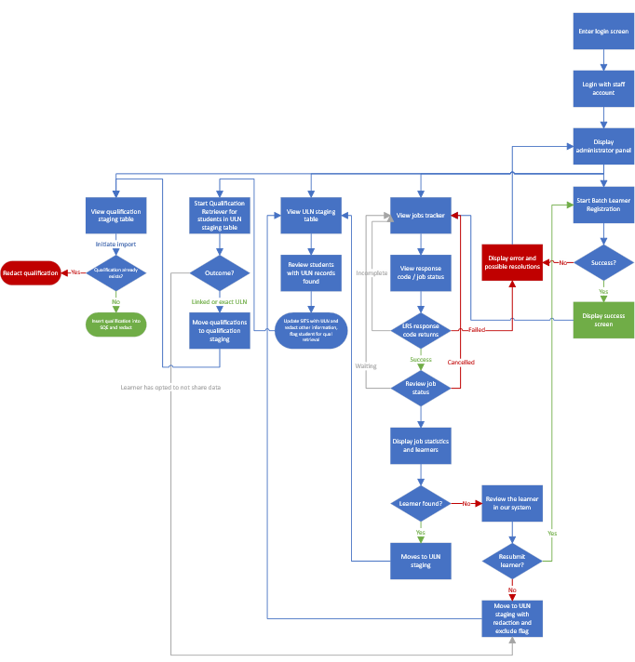
Figure 10 | The flowchart engineered in the design phase showcasing the expected application flow of the LRS API.
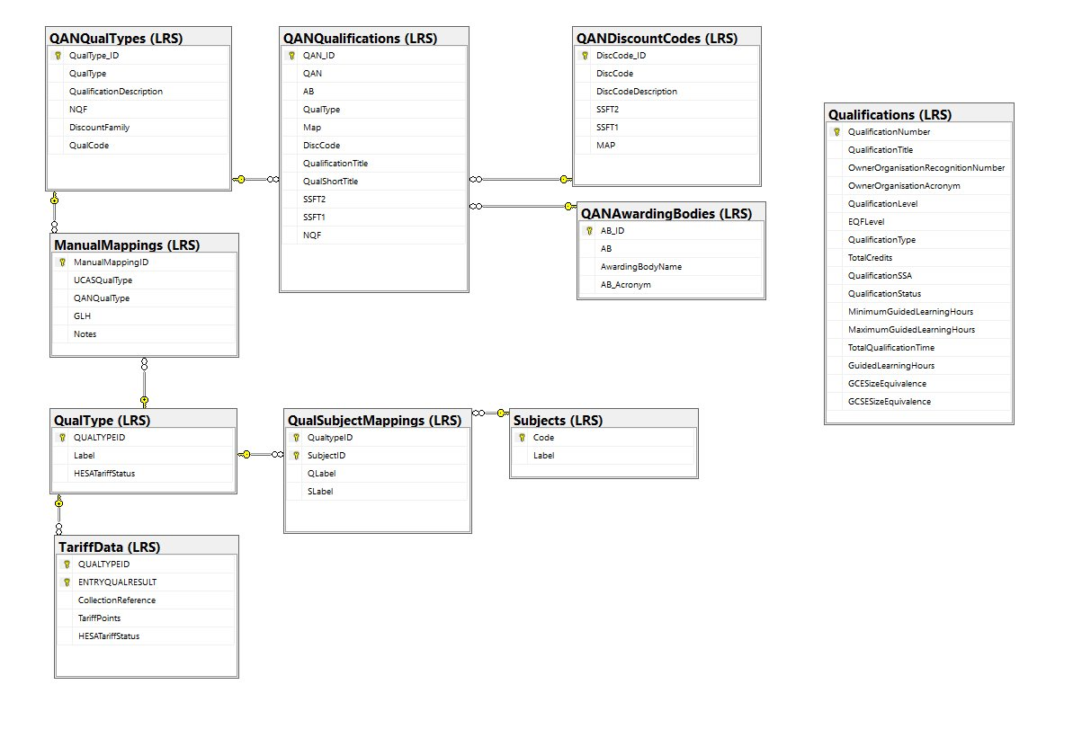
Figure 11 | The original designed ERD of the discovered data relationships before the qualifications were mapped.
One notable observation is that the delivered application diverged from the original design, designated Plan A. The application evolved from targeting a Plan A design to a Plan C Design as external constraints emerged during development. This is consistent with Sommerville’s characterisation of incremental and iterative development where software processes adapt to changing conditions [29]. The removal of the LRS API Integration and frontend components from the final architecture represents the evolutionary process in practise with the system focusing on a deliverable scope with the external constraints considered.
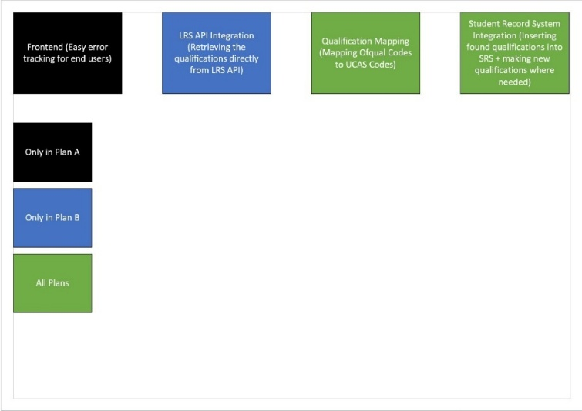
Figure 12 | The designated plans of the project and the respective components each contained.

Coverage of Requirements
Functional coverage was evaluated across five components with estimated weights of development time as defined in the requirements specification and each component’s achievement was estimated against its allocated weighting. The qualification mapping engine was the only component to achieve full coverage, while internal database integration followed by 26.2% and automated validation at 13.3% achieved coverage. LRS API integration and exception management UI returned 0% coverage. Overall, the system achieved an estimated functional coverage of 69.5% against the 80% target.
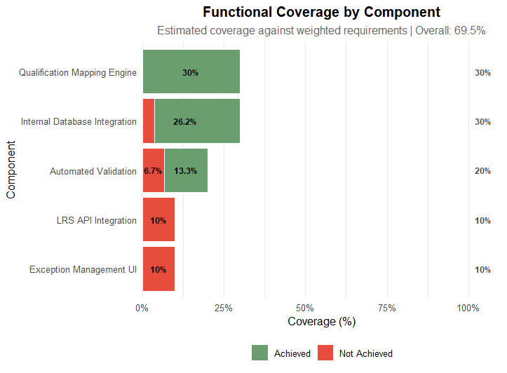
Figure 13 | A graph showcasing the achieved coverage of each requirement component versus the expected coverage.

Qualification Mapping
The evaluation dataset is composed of 755 student records successfully retrieved with qualifications from the LRS portal during the 25/26 academic year. Each record represents a binary outcome; a qualification is resolved to a UCAS QualTypeID or not. Of the 755 retrieved records, 700 were successfully partially or completely resolved.
$$\frac{700}{755}*100=92.715\%$$
This produces a resolution rate of 92.7% which exceeds the predefined 80% accuracy threshold by 12.7%.
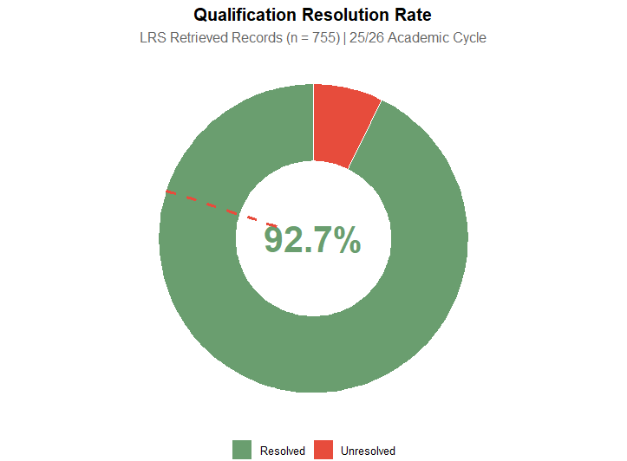
Figure 14 | A graph showcasing the percentage of qualifications resolved in this academic year, with a dashed red line denoting the expected threshold.

Resolution Tier Breakdown
While the primary objective focuses on the headline resolution rate, more granular tier analysis showcases a wider depth of the resolution across the four output fields that the engine populates. The tiers are:
Table 3 | Keys for the resolution tier breakdown table.
KEY | MEANING
Y | Yes: This field was resolved.
M | Maybe: Of all the fields that contain this value, one was present. For example, ESGCode was present, or AYRCode. As a result, this qualification was partially resolved.
N | No: This field was not resolved.

Table 4 | Breakdown of the resolution tiers.
Tier | QualTypeID | SubjectCode | ESGCode (Grade) | AYRCode (Year) | Amount
1 | Y | Y | Y | Y | 692
2 | Y | Y | M | M | 7
3 | Y | N | N | N | 1
4 | N | N | N | N | 55

It is worth noting ESGCode and AYRCode are products of the successful SITS integration rather than the qualification mapping engine, but this still provides oversight into how well the application performs. The primary analysis value of 92.7% does not count tier 4, only tier 1 – 3 and therefore gives a suitable measure of performance of the qualification mapping engine.
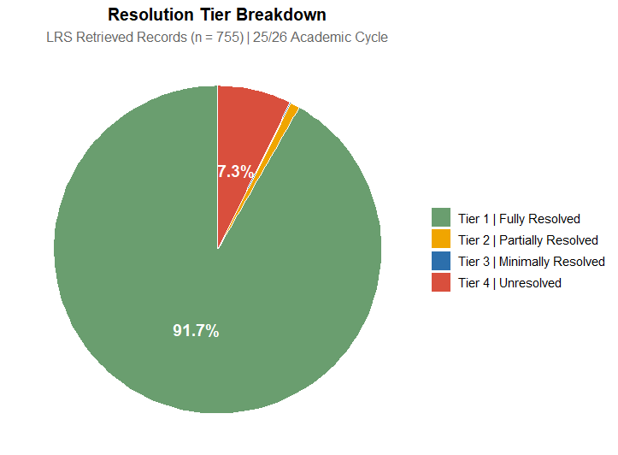
Figure 15 | A pie chart showcasing the different tiers of qualification resolution.

Qualification Type Distribution
A crucial success of the engine was found when examining resolution completeness by qualification type. All QualTypeIDs with five or more records achieved a 100% resolution rate. The 55 unresolved records carry a null QualTypeID which confirms failure occurs at the QAN matching stage instead of the qualification type mapping stage. This distinction is important for future development and suggests improvement should be directed at QAN normalisation and coverage instead of qualification type resolution logic.
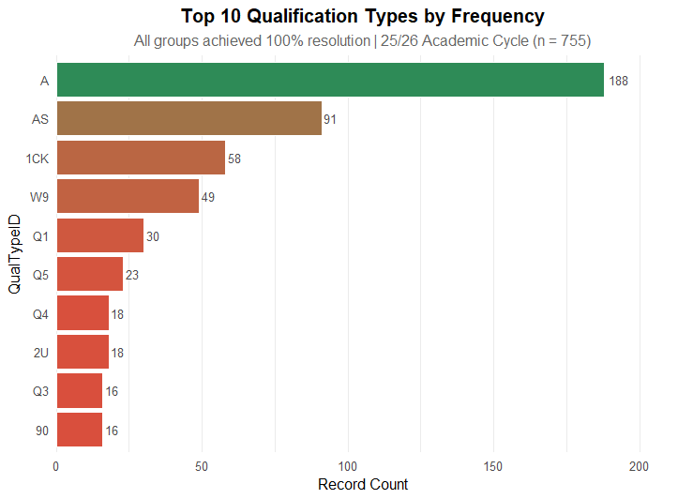
Figure 16 | A horizontal bar graph displaying qualification codes and their total amount of resolutions.

Awarding Body Analysis
An interesting avenue of analysis was venturing into the distribution of qualification resolution across different awarding bodies. The total resolved versus total unresolved were documented and showcases a substantial variation in performance across awarding bodies:
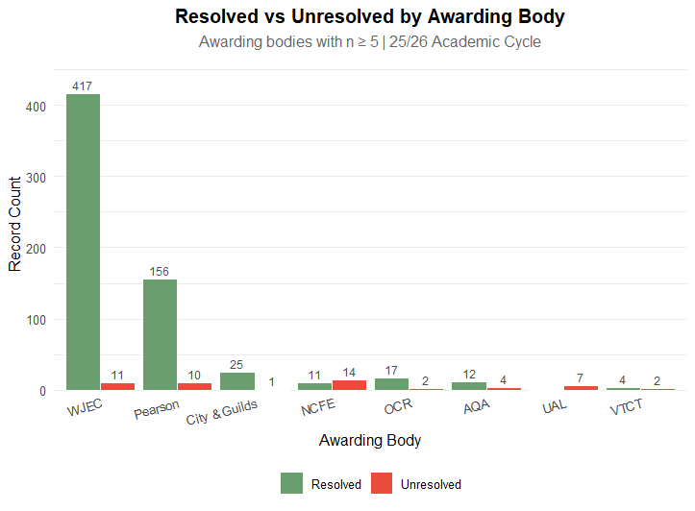
Figure 17 | A bar chart showcasing the resolved versus unresolved qualifications by awarding body.

WJEC, Pearson (counting Edexcel) and City & Guilds are the strongest performers and assume the majority. These three awarding bodies perform above the average resolution rate of 92.7%. However, there are significant outliers, specifically NCFE and UAL at 44% and 0%, respectively. Their qualifications appear in the LRS portal but fail to match to UCAS QualTypeIDs. This suggests these qualifications have not been covered by the manual mapping process that serves as a fallback resolution for these cases.
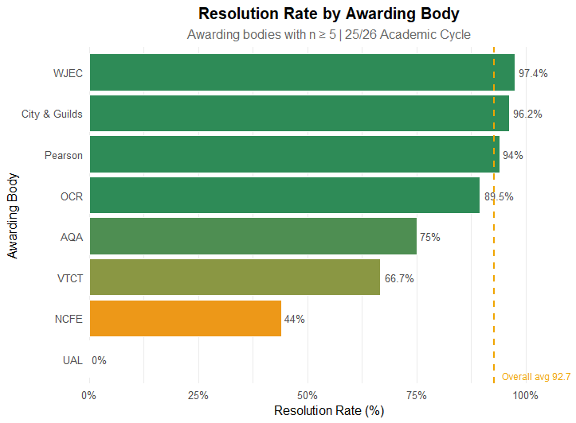
Figure 18 | A horizontal bar chart highlighting the resolution rate percentage by awarding body with a yellow dashed line showcasing the overall average.

Consistency with Literature Review
The findings of this research are largely consistent with the literature reviewed prior to the full-scale development of the application. It reinforces several themes and extends the UCAS centric theme in a direction not first fully anticipated.

Data Quality
The data quality literature emphasises the complexity of qualification data and how student record systems often contain dirty data. It identifies manual processes as a primary source of inconsistency and error (section 4.4). The system’s 92.7% resolution rate showcases automation reduces the reliance on manual input and directly addresses this issue. The engine also has a traceable mapping process that makes it auditable and therefore supports the literature’s position on how automated systems produce more consistently structured and reviewable data than manual inputs.
[30] identified that data transformations are a critical phase of data cleaning pipeline that targets both the schema and object level transformation and converts the source data into a consistent target format. This is displayed in the engine’s matching logic which applies multiple stages of transformation rules to match Ofqual qualification codes to UCAS compatible formats, which confirms data quality risks are present even in structured regulatory datasets.

UCAS Centric
The UCAS centric literature highlights how predicted qualification metrics can be unreliable and are a source of data quality risk (section 4.3) The findings build on this and showcases how achieved qualifications can also have unpredictable qualification metrics. Pattern matching logic was required to normalise qualification grades from Ofqual to UCAS codes and reveal that even achieved qualifications are subject to input errors or inconsistent formatting.
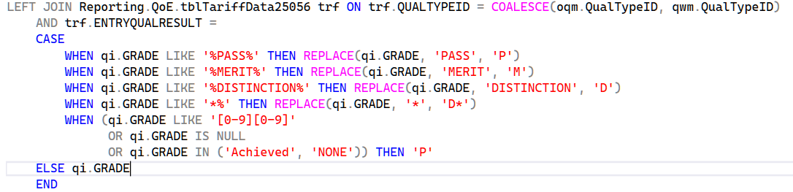
Figure 19 | A snippet of the SQL present in the student record integration component required to translate LRS sourced qualification grades to UCAS grades.
This showcases how data quality risk is not only in prediction data but also in qualifications that are achieved, which represents an extension of the original findings.

Data Insights and Decision Making
The data insights literature discusses the need for a balance between automated systems and human intuition and how automation should supplement human judgement rather than replacing it (section 4.6). This is reflected in the systems design, where there is functionality to allow manual mappings of qualifications where they cannot be automatically mapped to each other. This preserves the role of human oversight while automating the majority, and the 7.3% unresolved rate represents the category where human judgement is especially necessary for qualification recording.

API Integration
The API centric literature identifies combining multiple data sources as a key challenge in automation (section 4.7). While LRS API integration was left pending due to external constraints, the application’s multi source data pipeline as described by [31], partially supports the literature’s position. Full validation of the API specific claims remains outstanding.

Objective Achievement
This section details to what degree each objective was met.

Objective 1 – Requirements Engineering
The first objective required completing a requirement engineering phase that produced a requirements specification and software architecture design by week 16. This objective was fully met. The requirements specification was produced within the defined period and contained five weighted functional components alongside non-functional requirements. Architectural artefacts were produced and included:
- an entity relationship diagram
- a schema for the different plans of the project depending on the real deliverable scope.
- a process flow diagram mapping the intended LRS integration lifecycle.
Table 5 | Components and the plans they were included in.
Component | Plan A | Plan B | Plan C
Frontend / Exception Management UI | Y | N | N
LRS API Integration | Y | Y | N
Qualification Mapping Engine (Ofqual Codes to UCAS QualTypeID) | Y | Y | Y
Student Record System Integration (Qualifications Importing) | Y | Y | Y

The delivered architecture diverged from the original Plan A design and evolved to Plan C as external constraints emerged during the development. This evolution is consistent with an iterative software development practise and does not represent a failure of the requirements engineering phase – the requirements specification provided a sufficient foundation for the development that took place.

Objective 2 – Functional Coverage
The second objective facilitated the development of a modular application that integrates LRS with the student record system and achieves 80% functional coverage of the defined requirements by week 24. This objective was not fully met. The estimated completion percentage is 69.5% against the 80% threshold mentioned in section 7.1. The qualification mapping engine achieved full coverage at 30% and internal database integration achieved 26.25% of its 30% allocation, with the percentage missing being attributed to impractical requirements due to how the seeding architecture was implemented. Automated validation achieved 13.33% of its 20% allocation as the core validation requirements were met but the dynamic schema discovery was unmet.
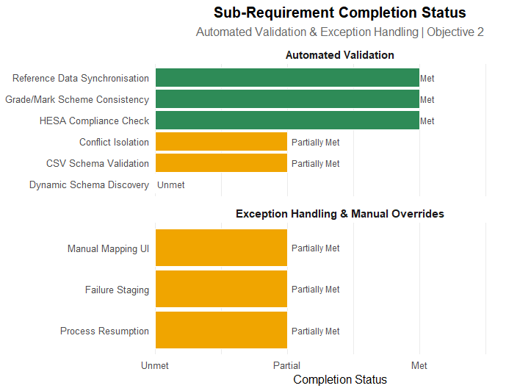
Figure 20 | Two horizontal bar charts showcasing the status of each subcomponent where overall requirement coverage was greater than 0 but less than 20.
The exception management UI and LRS API Integration had 0% integration of both components. These two components are structurally dependant on each other as the frontend works on top of the API integration, therefore the coverage gap is related to a single root cause. The LRS API integration remained blocked as an application was required for access to the governmental API and the procedure was held up in departmental dispute.
Without this constraint the estimated coverage would be closer to the 80% threshold and the lack of coverage in these components is not reflective of the overall delivery of the application, it would have simply strengthened the projects position further in reducing the manual workload of administrative staff.

Objective 3 – Mapping Accuracy
This objective was fully met. 700 of 755 LRS retrieved student qualification records were successfully resolved to a UCAS QualTypeID which produced a resolution rate of 92.7% and exceeded the 80% threshold by 12.7%, as shown in 7.1. Conclusions are specific to this cohort as noted in section 5.
The awarding body analysis identifier NCFE and UAL as significant outliers at 44% and 0%, respectively. Looking at the database:
Table 6 | Examples of UAL qualifications that were successfully mapped.
QualMappingID | QAN | QualificationTitle | QualTypeID | Label | SubjectCode
4876 | 610/0915/5 | UAL Level 3 Extended Project Qualification | 1DJ | UAL Level 3 Extended Project Qualification | E10
7264 | 603/3138/0 | UAL Level 3 Foundation Diploma in Art and Design | GHWEJ | UAL Level 3 Foundation Diploma in Art and Design (603/3138/0) | A15
3133 | 603/1459/X | UAL Level 3 Applied General Extended Diploma in Art & Design | TX | UAL Level 3 Applied General Extended Diploma in Art & Design | A15
The above UAL qualifications have resolved, showcasing the mapping logic is working, but they are not present in this round of imports. To investigate further, the following SQL script was run:
SELECT COUNT(QualTypeID)
FROM LRS.UCASQualTypes
WHERE Label LIKE 'UAL %' – UCAS Tariff Data does not have a specific awarding body field, so wildcard pattern matching is required.
This reveals there are 16 total QualTypeIDs, meaning only $\frac{3}{16} (18.75\%)$ QualTypeIDs are mapped for the possible UAL qualifications. There are many reasons this can occur, but a highly relevant data point is that both NCFE and UAL do not have generic QualTypeIDs like Pearson quals do.
This naturally can leave them out of potential tariff calculations. Any Pearson BTEC Extended Diploma at Level 3 can be generalised under the B1 qualification code if a specific qualification code does not exist. This is not the same for UAL and NCFE, all QualTypeIDs for these subjects contain the qualification and subject.
Table 7 | Examples of why NCFE and UAL qualifications are more difficult to match compared to BTECs or A Levels.
QualTypeID | Label | Awarding Body
B1 | Pearson (BTEC) Extended Dip. (was National Dip. 180+) | Pearson
A | GCE A Level | Pearson, WJEC, AQA, etc.
63 | NCFE CACHE Level 3 Extended Diploma Children's Care Learning and Development NI | NCFE
MX | NCFE Level 3 Certificate in Sport and Physical Activity | NCFE
9A | UAL Level 3 Extended Diploma in Creative Practice: Art, Design and Communication | UAL
U1 | UAL Level 3 Diploma in Fashion Business and Retail | UAL

Objectives – Overview of Thresholds
Table 8 | Objective thresholds and whether the threshold was met.
Objective | THRESHOLD | THRESHOLD STATUS
Requirements Engineering | BINARY | MET
Functional Coverage | 80% | 69.5%
Mapping Accuracy | 80% | 92.7%

Overall Aim Achievement
The research aim of investigating how API driven automation retrieval can improve data quality, reduce administrative workload, and enhance regulatory compliance in UK higher education student system records is partially met. The three primary concerns of improvement are delivered; however, the API driven component of the process could not be fully evidenced due to a departmental approval process that remained unresolved at submission. This does not undermine the core contribution; the project confirms the existence of the problem alongside how a data pipeline is able to provide a solution.
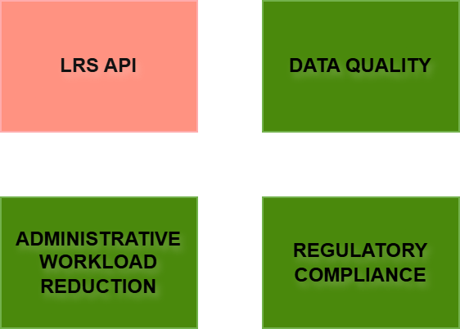
Figure 21 | An infographic showcasing the components of the aim achieved (green blocks) versus the component unachieved (red block).

The API Dimension – Unresolved Organisational Constraint
Due to the external constraints around the implementation of the LRS API, the project cannot claim it is a fully integrated end to end data pipeline in a live environment; however, it does showcase that the remaining components are implemented, validated and functional and the evaluation results showcase what the finished pipeline would produce, due to the qualifications being sourced from the LRS web portal. The aim is not completely disproven, as the investigation confirms the problem of mapping UCAS qualifications to Ofqual qualifications is real. Implementation would only further supplement the findings of the existing results.

Data Quality
A resolution rate of 92.7% (700 of 755 eligible records) significantly exceeds the 80% evaluation threshold. Unresolved records were attributable to upstream QAN matching failures instead of the primary UCAS qualification mapping engine. The engine maintains a five-tier matching process and produces a clean and auditable output that meaningfully improves on a pure manual process and reduces data quality errors by providing a solution that detects typical manual typos or data omissions from the very beginning by utilising relational data and data processing [32].

Administrative Workload Reduction
As discussed above, the pipeline involves resolving 92.7% of qualifications without human intervention and eliminates a substantial amount of routine manual resolution. Unresolved records are imported to the same place as the resolved qualifications but carry no UCAS identifiers, these are flagged for manual review and have the possibility to be automated via the manual mapping functionality for future imports. This shifts the workload from focus on complete resolution to targeted exceptions and represents a meaningful workload reduction.

Regulatory Compliance
The system draws directly from governing body datasets such as UCAS, HESA, Ofqual and Qualification Wales to ensure mappings reflect current regulatory recognition. UCAS qualification types and subject codes specifically match the schema required for HESA statutory returns, and by sourcing qualification data directly from these regulatory bodies, the system can reduce the risk of non-compliant student qualifications in the student record system that results from institutional sourced data.

Divergence from Expectations
The development trajectory diverged from its original design in two related ways: development scope and testing approach. The LRS API was intended as a prototyping instrument that would provide real response data early enough to establish a stable data schema and support iterative unit test integration alongside development. Without this access, the CSV driven prototype became the production system organically rather than by deliberate design.
Additionally, domain knowledge is required to define test assertions and must often be discovered rather than provided upfront [33]. This effect was worsened by the fact that the full scope of the datasets required was unknown at the design stage. It was assumed Ofqual data was sourced from a singular central dataset; however, this diverged into three central separate datasets as the mapping requirements developed. This is consistent with research finding that pipelined testers can frequently lack advance knowledge of source-to-target mappings [34].
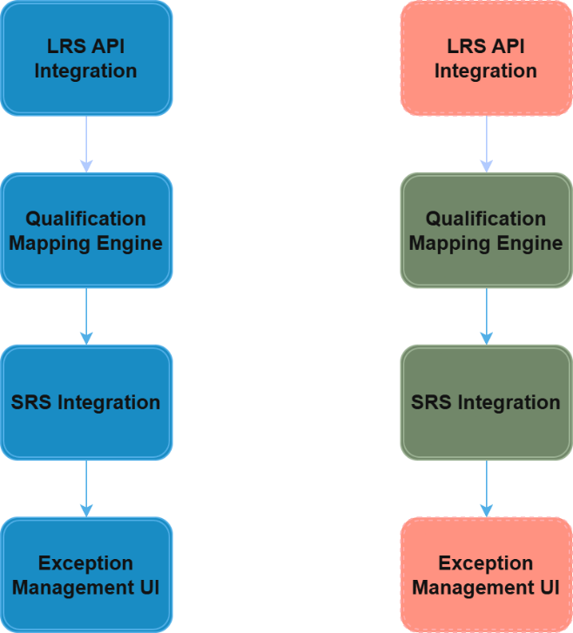
Figure 22 | An infographic showcasing the planned versus implemented system components.
The second divergence concerned the application’s architecture and testability. The pipeline was initially a monolithic structure. This architectural type is difficult to isolate and evaluate due to their lack of clear modularity [35]. As a result, significant refactoring was undertaken to attempt to mitigate this by creating a specified matching engine, formulating two separate stages of the qualification mapping stage, and modularising the pipeline stages. During early development, SQL based data exploration served as the primary validation mechanism due to the developers existing knowledge base on the domain, and the output tables were queried to assess match rates and trace failure patterns. This provided useful feedback; however, it lacked the repeatability and detection of formal unit tests, resulting in a clear developmental gap that the system and acceptance tests introduced later partially address.

Better Approach
Reflecting from a developmental perspective, the single most significant improvement that could have been achieved was implementing a modular architecture from the beginning rather than allowing it to emerge through refactoring. Testability is an attribute of maintainability, which is linked to the level of discrete components in a system. The more discrete components there are, the lesser impact a change has on one another [36]. Designing the pipeline with clear component outlines from the beginning would have led to more independently testable units from day one instead of tightly related elements that required decoupling before testing could be automated.

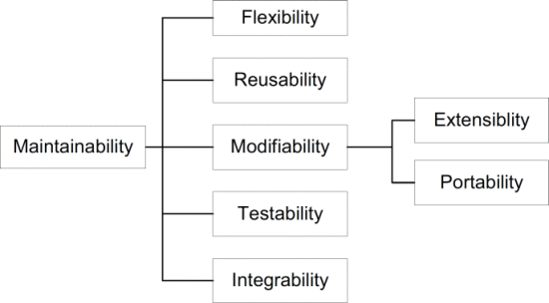
Figure 23 | An image denoting that testability is a component of maintainability, and the other components of maintainability. Source: [36]
It is also found that unit testing in service-based systems is reliant on service isolation, as each service must be evaluated as an independent module to validate its respective business logic. Without this isolation, meaningful unit test coverage is hard to implement even when sought after [37]. This architectural design would have shifted the project closer to the iterative and test-driven development approach originally envisioned and would have reduced the reliance on SQL based exploration as a substitute for documented validation.

Chapter 6 – Conclusions and Recommendations
This chapter draws conclusions from the project, summarises the contribution to each objective, identifies benefits to the employer, and suggests areas for further work.

Contribution to Objectives Achievement
The project set out to investigate how API-driven automation of qualification data retrieval could improve data quality, reduce administrative workload, and enhance regulatory compliance in UK higher education system records system. This was grounded in literature identifying manual processes as a primary source of inconsistency in data and API integration was found to be a suitable mechanism to reduce inconsistency.

Essence of The Project & Research
The qualification mapping engine was the core integral piece of this project and exceeded its targeted accuracy threshold at 92.7%, and the two objectives tied directly to it (requirements engineering and mapping accuracy) were both fully met. The engine’s five tier qualification matching algorithm drew from various regulatory datasets to showcase how automated qualification resolution is achievable at production scale. The design and implementation phase produced a modular data pipeline that gained a level of testability after significant refactoring to support various degrees of testing.

Unmet Coverage
Coverage of the requirements fell short at 69.5% against the 80% target, with the LRS API integration and exception management UI remaining unimplemented due to an unresolved departmental approval process.

Overall Aim Achievement
The overall aim is best viewed as being validated instead of fully demonstrated as the pipeline confirms the problem identified in the literature and showcases the validity of the matching process. The benefits to data quality and administrative workload reduction are evident from the results. The API dimension remains the outstanding piece of the aim and is the priority for any future work.

Benefits to the Employer / Workplace
This section identifies the practical benefits the system delivers to the employer across three dimensions: workload reduction, auditability, and domain visibility.

Workload Reduction
The main benefit is a reduction in routine manual effort as the pipeline resolved 92.7% of student qualifications to a UCAS QualTypeID for this academic cycle without human intervention, which allowed a shift of administrative focus from dedicated workflow to a business-as-usual task for exception handling. The 7.3% of unresolved records are surfaced clearly for review rather than silently left unresolved, which only supplements the degree of improvement of this solution over a purely manual workflow.

Auditability
The secondary benefit is how every run of the pipeline produces a structured log with counts at each stage to give a quality signal that was otherwise absent without manual data analysis. The system also draws directly from governing body datasets such as Ofqual, Department for Education, Qualification Wales, and HESA to ensure mappings reflect current regulatory requirements.

Domain Visibility
The final significant benefit from this project is the visibility the system provides into the overall qualifications landscape. The university student record data is largely isolated from LRS data and is very UCAS and inner institutionally centric. By drawing data from the multitude of governing body datasets, it provides a broader view of the qualification space than would otherwise be accessible through the established procedures. This is a potential resource that expands beyond the immediate mapping use case.

Suggestions for Further Work
This section outlines the areas of unmet scope and other identified improvements that would add value in future development.

LRS API Integration
The most significant outstanding piece of work is the integration of the LRS API. Integrating this component would streamline and automate the workflow almost entirely and complete the data pipeline.

Exception Management UI
While the exception qualifications are visible to staff members currently, it is not the most ideal solution as it requires a degree of specific coding in a separated system to present to staff. A lightweight interface directly integrated into the application workflow would be a more suitable solution and would help in making the tool accessible beyond a developer audience.

Expanded Manual Mapping
The awarding body analysis identifier NCFE and UAL as significant outliers, with 44% and 0% coverage respectively in this academic cycle. The evaluation confirmed the matching logic itself is not at fault with QualTypeIDs with five or more records achieving 100% resolution. The failure points to gaps in the manual mapping data rather than deficiencies in the established pipeline and so extending the manual mappings to cover these awarding bodies qualification types would directly improve resolution rates without any code change.

Test Coverage
While there is testing infrastructure in place, the coverage is narrow. Certain areas such as the string normalisation functions and computed values used in the qualification mapping engine have been prioritised, but this needs further extension to ensure that any changes are non-breaking. Beyond unit tests, there should also be testing to ensure that the number of qualifications fall within a certain range of the last imported count for each table.

Chapter 7 – Reflection
This project was the largest and most complex piece of independent work completed during the apprenticeship and reflecting on it requires acknowledging what went well and where lessons could be learned.

Domain Knowledge
The most significant area of personal development gained was the depth of knowledge around the UK qualifications landscape. The relationship between Ofqual, Department for Education QAN, Qualification Wales, UCAS and HESA was not well understood beyond a surface level at the beginning, but over time it became increasingly clear how diverse the qualification landscape is and how there is no real central data documentation that maps how these datasets relate to one another. Sources were discovered incrementally over months, with the QAN data source only being revealed through AI assisted research, and the Qualification Wales dataset only became apparent when a significant gap in WJEC qualification coverage emerged during live import. This kind of domain knowledge is only acquired by doing in the current landscape, and the project was structured in a way that allowed that discovery to happen organically. By the end of the project, a working knowledge of the UK qualifications landscape had been built that did not previously exist within the institution, showcasing a real and measurable outcome.

Working Independently as an Expert
The project presented an unusual challenge in that there were no other experts in the organisation with sufficient domain knowledge to validate decisions as they were made. Requirements were self-defined and design choices were self-directed, with the go live also being self-determined. This forced a level of ownership and leadership in decision making that a more stakeholder heavy project would not have developed in the same way. Every architectural design, every algorithmic design and every data source had to be justified internally which requires discipline and confidence.
Navigating organisational constraints, particularly regarding the LRS API approval blockage required self-reliance. The contingency was identified and the pivot was made swiftly, with the core application being protected. The adaptability displayed in this instance was developed directly under the project’s influence.

Project and Time Management
Managing a project of this scope independently over a prolonged period and balancing with other work came with its own challenges. While the agile scrumban methodology provided structure, there were times when the workload had to keep delayed, prioritising other developmental pieces. This meant learning at what point should the priority switch to this developmental piece through careful consideration and tracking of the remaining pieces of work in comparison to the requirements specification.

Lessons Learned
The biggest challenge encountered repeatedly throughout the project was explaining what the project was doing to people outside of the domain. Supervisors and colleagues all required a translation of a complex and niche problem into easily understandable terminology, which proved to be difficult. The qualifications landscape is not especially clear to even those with a minor understanding of the area, let alone someone without any domain knowledge. Communicating a five-tier matching algorithm that sources data from four regulatory datasets of varying structure and governing bodies to anyone is not straightforward.
In retrospect, earlier measures should have been taken to accurately describe the problem clearly to a non-specialist audience as this would have provided tangible benefits beyond communication alone. Being able to clearly frame the problem space might have accelerated organisational buy-in for the API approval, made requirements validation easier despite the lack of expert stakeholders, and made the project easier to defend under scrutiny at every stage. While the technical work is strong, the communication of it had to be developed under pressure and developing it earlier would have made the entire process smoother.

Chapter 8 - References
[1] P. Scott, “Compliance and Creativity: Dilemmas for University Governance,” European Review, vol. 26, no. S1, pp. S35–S47, 2018. doi:10.1017/S1062798717000527
[2] M. Beerkens, ‘An evolution of performance data in higher education governance: a path towards a “big data” era?’, Quality in Higher Education, vol. 28, no. 1, pp. 29–49, Jan. 2022, doi: 10.1080/13538322.2021.1951451.
[3] P. Bolton, ‘Higher education student numbers’, Feb. 2026. Available: https://commonslibrary.parliament.uk/research-briefings/cbp-7857/
[4] S. McGrath and L. Rogers, ‘Do less-advantaged students avoid prestigious universities? An applicant-centred approach to understanding UCAS decision-making’, British Educational Research Journal, vol. 47, no. 4, pp. 1056–1078, 2021, doi: 10.1002/berj.3710.
[5] R. Murphy and G. Wyness, ‘Minority report: the impact of predicted grades on university admissions of disadvantaged groups’, Education Economics, vol. 28, no. 4, pp. 333–350, 2020, doi: 10.1080/09645292.2020.1761945.
[6] ‘Student record 2019/20 - The UCAS data for HESA (*J) transaction | HESA’. [Online]. Available: https://www.hesa.ac.uk/collection/c19051/starj
[7] W. Wijayanti, A. Hidayanto, N. Wilantika, I. R. Adawati, and S. Yudhoatmojo, ‘Data Quality Assessment on Higher Education: A Case Study of Institute of Statistics’, Nov. 2018, pp. 231–236. doi: 10.1109/ISRITI.2018.8864476.
[8] J. Komljenovic, S. Sellar, and K. Birch, ‘Turning universities into data-driven organisations: seven dimensions of change’, High Educ, vol. 89, no. 5, pp. 1369–1386, May 2025, doi: 10.1007/s10734-024-01277-z.
[9] D. Draper and M. Gittoes, ‘Statistical analysis of performance indicators in UK higher education’, Journal of the Royal Statistical Society: Series A (Statistics in Society), vol. 167, no. 3, pp. 449–474, 2004, doi: https://doi.org/10.1111/j.1467-985X.2004.apm12.x.
[10] B. Williamson, S. Bayne, and S. Shay, ‘The datafication of teaching in Higher Education: critical issues and perspectives’, Teaching in Higher Education, vol. 25, no. 4, pp. 351–365, May 2020, doi: 10.1080/13562517.2020.1748811.
[11] J. Jarke and A. Breiter, ‘Editorial: the datafication of education’, Learning, Media and Technology, vol. 44, no. 1, pp. 1–6, Jan. 2019, doi: 10.1080/17439884.2019.1573833.
[12] O. Erstad et al., ‘Datafication in and of Education - a literature review’, European Schoolnet / Agile-EDU project, Oslo, Norway (University of Oslo), Jun. 2025.
[13] K. C. Gonugunta and K. Leo, ‘Role of Data-Driven Decision Making in Enhancing Higher Education Performance: A Comprehensive Analysis of Analytics in Institutional Management’, International Journal of Acta Informatica, vol. 3, no. 1, pp. 149–159, Jun. 2024.
[14] S. Gaftandzhieva, S. Hussain, S. Hilcenko, R. Doneva, and K. Boykova, ‘Data-driven Decision Making in Higher Education Institutions: State-of-play’, International Journal of Advanced Computer Science and Applications, vol. 14, Jan. 2023, doi: 10.14569/IJACSA.2023.0140642.
[15] H. Ekbia et al., ‘Big data, bigger dilemmas: A critical review’, Journal of the Association for Information Science and Technology, vol. 66, no. 8, pp. 1523–1545, 2015, doi: 10.1002/asi.23294.
[16] N. Ashal and A. Morshed, ‘Balancing data-driven insights and human judgment in supply chain management: The role of business intelligence, big data analytics, and artificial intelligence’, JIPD, vol. 8, no. 6, p. 3941, Jun. 2024, doi: 10.24294/jipd.v8i6.3941.
[17] H. Adebusayo, A. Adepoju, B. Austin, A. Eweje, and A. Collins, ‘Framework for Automating Multi-Team Workflows to Maximize Operational Efficiency and Minimize Redundant Data Handling’, vol. 5, pp. 663–679, Mar. 2022.
[18] A. A. Prayogi Alimuddin, M. Niswar, Indrabayu, and M. Rijal, ‘Design and Implementation of REST API for Academic Information System’, IOP Conference Series: Materials Science and Engineering, vol. 875, p. 012047, Jul. 2020, doi: 10.1088/1757-899X/875/1/012047.
[19] Y. Jayaram and J. Bhat, ‘Intelligent Forms Automation for Higher Ed: Streamlining Student Onboarding and Administrative Workflows’, International Journal of Emerging Trends in Computer Science and Information Technology, vol. 3, pp. 100–111, Dec. 2022, doi: 10.63282/3050-9246.IJETCSIT-V3I4P110.
[20] N. Naik, ‘Crowdsourcing, Open-Sourcing, Outsourcing and Insourcing Software Development: A Comparative Analysis’, 2016 IEEE Symposium on Service-Oriented System Engineering (SOSE), pp. 380–385, 2016.
[21] J. Sinard and P. Gershkovich, ‘Custom software development for use in a clinical laboratory’, Journal of pathology informatics, vol. 3, p. 44, Dec. 2012, doi: 10.4103/2153-3539.104906.
[22] M. Belcourt, ‘Outsourcing — The benefits and the risks’, Human Resource Management Review - HUMAN RESOURCE MANAGEMENT REV, vol. 16, pp. 269–279, Jun. 2006, doi: 10.1016/j.hrmr.2006.03.011.
[23] R. Colomo-Palacios, C. Casado-Lumbreras, P. Soto-Acosta, F. García-Peñalvo, and E. Tovar, ‘Project managers in global software development teams: A study of the effects on productivity and performance’, Software Quality Journal, vol. 22, Mar. 2014, doi: 10.1007/s11219-012-9191-x.
[24] S. N. Donthi, ‘A Scrumban Integrated Approach to Improve Software Development Process and Product Delivery’, Emerging Frontiers Library for The American Journal of Interdisciplinary Innovations and Research, vol. 7, no. 09, pp. 70–82, Sep. 2025.
[25] ‘Student Record (25056) | HESA’. [Online]. Available: https://www.hesa.ac.uk/collection/25056/
[26] ‘A .NET library for reading and writing CSV files. Extremely fast, flexible, and easy to use. | CsvHelper’. [Online]. Available: https://joshclose.github.io/CsvHelper/
[27] C. L. Sim, T. A. Wong, K. Y. Sin, and V. M. Sivakumaran, ‘Pragmatism as a paradigm for quality management research in bridging academic-practitioner gaps’, International Journal of Quality and Service Sciences, vol. 16, no. 2, pp. 330–342, Jul. 2024, doi: 10.1108/IJQSS-07-2024-192.
[28] D. S. Kumar, ‘INDUCTIVE AND DEDUCTIVE APPROACHES TO QUALITATIVE RESEARCH’, vol. 13, no. 1, 2024.
[29] I. Sommerville, Software engineering, Tenth edition, Global edition. Harlow, Essex, England: Pearson, 2016.
[30] E. Rahm, H. H. Do, and others, ‘Data cleaning: Problems and current approaches’, IEEE Data Eng. Bull., vol. 23, no. 4, pp. 3–13, 2000.
[31] P. Vassiliadis, A. Simitsis, and S. Skiadopoulos, ‘Conceptual modeling for ETL processes’, in Proceedings of the 5th ACM international workshop on Data Warehousing and OLAP, 2002, pp. 14–21.
[32] M. Bilal, G. Ali, M. W. Iqbal, M. Anwar, M. S. A. Malik, and R. A. Kadir, ‘Auto-Prep: Efficient and Automated Data Preprocessing Pipeline’, IEEE Access, vol. 10, pp. 107764–107784, 2022, doi: 10.1109/ACCESS.2022.3198662.
[33] H. Homayouni, ‘Testing Extract-Transform-Load Process in Data Warehouse Systems’, in 2018 IEEE International Symposium on Software Reliability Engineering Workshops (ISSREW), Memphis, TN: IEEE, Oct. 2018, pp. 158–161. doi: 10.1109/ISSREW.2018.000-6.
[34] S. Vyas and P. Vaishnav, ‘A comparative study of various ETL process and their testing techniques in data warehouse’, Journal of Statistics and Management Systems, vol. 20, no. 4, pp. 753–763, Jul. 2017, doi: 10.1080/09720510.2017.1395194.
[35] J. Christian, Steven, A. Kurniawan, and M. S. Anggreainy, ‘Analyzing Microservices and Monolithic Systems: Key Factors in Architecture, Development, and Operations’, in 2023 6th International Conference of Computer and Informatics Engineering (IC2IE), Sep. 2023, pp. 64–69. doi: 10.1109/IC2IE60547.2023.10331155.
[36] M. Matinlassi and E. Ovaska, ‘The impact of maintainability on component-based software systems’, in 2003 Proceedings 29th Euromicro Conference, Sep. 2003, pp. 25–32. doi: 10.1109/EURMIC.2003.1231563.
[37] M. Waseem, P. Liang, G. Márquez, and A. D. Salle, ‘Testing Microservices Architecture-Based Applications: A Systematic Mapping Study’, in 2020 27th Asia-Pacific Software Engineering Conference (APSEC), Dec. 2020, pp. 119–128. doi: 10.1109/APSEC51365.2020.00020.

[38] N. Lesh and M. Mitzenmacher, ‘BubbleSearch: A simple heuristic for improving priority-based greedy algorithms’, Information Processing Letters, vol. 97, no. 4, pp. 161–169, Feb. 2006, doi: 10.1016/j.ipl.2005.08.013.
[39] M. Jamro, C# data structures and algorithms: harness the power of C# to build a diverse range of efficient applications. Packt Publishing, 2024. [Online]. Available: https://portal.igpublish.com/book/PACKT0007033
[40] dotnet-bot, ‘Lookup<TKey,TElement> Class (System.Linq)’. Accessed: Jul. 12, 2026. [Online]. Available: https://learn.microsoft.com/en-us/dotnet/api/system.linq.lookup-2?view=net-10.0
[41] M. Fowler, Patterns of enterprise application architecture. Addison-Wesley, 2012.
[42] M. Aniche, ‘1 Effective and systematic software testing’, in Effective Software Testing: A Developer’s Guide, New York, UNITED STATES: Manning Publications Co. LLC, 2022. [Online]. Available: http://ebookcentral.proquest.com/lib/trinity/detail.action?docID=6950772
[43] H. K. Leung and P. W. Wong, ‘A study of user acceptance tests’, Software quality journal, vol. 6, no. 2, pp. 137–149, 1997.

Chapter 9 – Bibliography

Appendixes

Project Requirements
Project Requirements
(Link only works for UWTSD accounts)

https://www.gov.uk/find-a-regulated-qualification
https://collectdata.education.gov.uk/qwsweb/
https://www.qiw.wales/export
https://www.hesa.ac.uk/collection/25056/
OFQUALToUCAS\OFQUALToUCAS\Models\Entities\Data\Mapping\QualMatchingEngine.cs MatchOfqualQualification()
OFQUALToUCAS\OFQUALToUCAS\Models\Entities\Data\ImportDefinition.cs LoadAll()
OFQUALToUCAS\OFQUALToUCAS\Models\Entities\Data\Mapping\MappingLookupsContext.cs
OFQUALToUCAS\OFQUALToUCAS\Models\Entities\Data\DataImportDefinition.cs
OFQUALToUCAS\OFQUALToUCAS\Models\Entities\Data\FileImporter.cs ResetAndImport()
OFQUALToUCAS\OFQUALToUCAS\Models\Entities\Data\FileImporter.cs ProcessWalesQualifications()

