
Project Planning
Engineering Management, Innovation and Sustainability
BEng Automotive, Motorsport and Motorcycle Engineering
ACHA5012
Will Davies
2400569
Mark Sandford
Word Count: 2430

Contents
Project Planning 1
Introduction 3
1.0 Introduction 4
2.0 Roles and Responsibilities 4
2.1 Aerodynamics 4
2.2 Suspensions Kinematics 5
2.3 Data Acquisition 5
3.0 Group Tasks and Timings 6
4.0 Detailed List 6
4.1 Task Duration 7
4.2 Bill of Materials 7
4.3 Special Equipment 7
5.0 Significant Milestones 7
5.1 Gateway Objective 8
6.0 Areas of Concern 9
6.1 Weld 9
6.2 Grade of Bolt 9
6.3 Meshing 9
7.0 Overall GANTT Chart 10
8.0 Bibliography 10

Introduction
This following assignment will be demonstrating how project planning is managed in an industry with deadlines within a project. The assignment will be representing how specific and cognitive skills in recognising and evaluating accounting methods, planning throughout a project, the costs, monitoring the projects as they happen alongside with workforce motivation and the team dynamics. The assignment will include and introduction to the project, members and their roles, number of tasks and areas of concern.

1.0 Introduction
The Level 5 group project is a combination of multiskilled areas which are split up where each member of the group is investigating and trying to improve the base models of the MCR university race car and come up with a new bodywork design. The group project is split into 3 areas with Aerodynamics, Suspension Kinematics and Data Acquisition. The team have decided upon themselves who’s doing what role in the team and what their roles entail and expectations throughout the group project. The aim of this project is to understand how a race vehicle works by studying and testing the vehicle. Understanding how each component works with airflow or in a suspension system and learning how to achieve a bigger and better performance outcome. The success will be measured by listing jobs and having timescales, always updating what were doing and ticking off when the task is complete.

2.0 Roles and Responsibilities

2.1 Aerodynamics
Ethan – Project Management:
Establishing objectives and setting performance targets for each area of the group. Coordinating CFD analysis and design development. Ensuring tasks are delegated evenly, and deadlines are met accordingly.
Aerodynamics
In charge of the design and development of the splitter, floors & nosecone for the MCR. Using CAD & CFD analysis to optimize airflow to the rear of the car to activate the deck as well as reducing the overall pitch sensitivity. Collaborating closely with Noah & Cara to ensure integration and manufacturability.
Louis – Responsible for designing and analysing the effects of introducing a downforce generating device over the roll hoop and its effects on the aerodynamic efficiency of the rear wing in different locations and mounting styles. This will be proved with the use of a CAD file in CFD. Using CFD he will assess the different styles to find a model that works best with other members designs to keep the overall balance and COP within tolerance.
Cara – Her role focuses on the design and development of the midriff, sidepods, and cockpit regions of the car. These areas are key to managing airflow from the front to the rear, ensuring efficient aerodynamic performance across the vehicle. She will be responsible for refining these surfaces using CAD and CFD analyses. Her aim is to reduce drag and optimize airflow continuity, ensuring smooth integration with surrounding components while enhancing overall car efficiency and on-track performance.
Evan – Responsible for the rear deck and engine cover aerodynamics, ensuring smooth airflow from the cockpit/sidepods to the rear wing region. The design will aim to reduce current drag, manage airflow over the engine cover while maintaining aerodynamic balance across the whole car.
Noah – Noah’s role focuses solely on the aerodynamic refinement on the front section of the car, which consists of, front pontoons, pushrod covers, and wishbone shrouds. The front components of the car are crucial to the aero-mechanical interaction, where suspension and aerodynamic efficiency are directly in contact.
His responsibility is to improve the airflow around the front of the car using CFD simulations. His aim is to reduce drag and turbulence through improving designs, ensuring that the sidepods and rear deck receive smoother airflow while enhancing front-end stability and aerodynamic efficiency.

2.2 Suspensions Kinematics
Will – Responsible for the investigation into front droop stops. Understanding how droop stops work and understanding how car characteristics change with and without droop stops during cornering. Investigating where they’ll be mounted and what type of design will be beneficial for performance. Also, with a critical link between suspension kinematics and aerodynamic stability.
Jason – Responsible for investigating droop stops and implementing them on the car. His role requires analysis of the car’s current performance and position on the track using MoTeC Software. He will investigate how droop stops will affect the car and whether they are plausible with the current aero package through data analysis and testing. He is also responsible for the manufacture and installation of droop stops on the car.

2.3 Data Acquisition
Kiera – Responsible for all data and simulation analysis tasks within the project. Her role involves the use of VI-Grade to simulate droop stop modifications and CFD developments using a virtual model that will be created using MoTeC software to compare real-world data to a previous baseline model.

2.4 My Role
I believe for my role in the team I need to be creative, trying to be innovative when coming up with a car performance upgrade. I think patience is key, not everything goes right, it’s a lot of redeveloping and taking time to focus on FEA testing. Relating to Belbin’s model I think that my actions are organised and predictable. I can take in ideas and produce them either on paper or CAD, however I take my time to ensure it’s thorough. What I bring to the table is I can evaluate the situation; I think of the bigger picture and come to a solution accurately. When being in my role being a team worker is vital, bringing an upgrade to the car but also working with the other half of the group and being able to understand that my project affects the car aerodynamically.

3.0 Group Tasks and Timings
Name | Task | Start Date | End Date
Will | Research, design and manufacture droop stops | 29/09/2025 | 07/11/2025
Ethan | Investigate splitter and floors, run CFD | 29/09/2025 | 20/11/2025
Louis | Investigate roll hoop and wing optimisation | 02/10/2025 | 25/10/2025
Noah | Investigate pontoons and run CFD | 02/10/2025 | 10/11/2025
Evan | Run CFD on rear deck and investigate into high drag areas | 30/09/2025 | 09/11/2025
Cara | Run CFD on midriff and investigate an improved package efficiency | 29/09/2025 | 27/11/2025
Jason | Research and design droop stops with data acquisition | 30/09/2026 | 07/11/2025
Kiera | Learn VI Grade and try and simulate a perfect lap | 05/10/2025 | 23/10/2025

4.0 Detailed List
Research Droop Stops – I will need to research the effects, characteristics and explain how droop stops work with efficiency. Researching will include the use of books and reliable websites to provide a satisfactory understanding.
Measuring and weighing suspensions components – will be me measuring the unsprung mass of the suspension system so I am able to work out the amount of load that the suspension is taking. Measuring the rockers will give me an idea of what shape the droop stops need to be and how far apart the holes need to be to ensure the bolts fit.
Mock Design – I produced a mock design of what the droop stops would look like. Never ended up making 5-6 designs but with the one I chose and testing it in Ansys. It proved to me that the design I came up with was an efficient one.
Validation – to validate the use of Ansys I had to conduct my own cantilever beam test. This is because the use of the droop stops acts and is fixed in a similar way to a cantilever beam. Once I conducted the experiment, I copied the measurements and the boundary layers the exact same into Ansys and the results I got were like what I had, which proved that the use of Ansys would be appropriate.
Final design & Manufacturing – the process of my final design was helped with the data recollection when concept 1 was tested at Pembrey. With a more improved and lighter design it was manufactured and used on the car. Tested in final winter Pembrey session with good data results.
Documenting – when going along the whole year of the project, documenting every progress and backward steps of the droop stops. This allowed me to show the amount of progress made from the any backward steps that occurred.

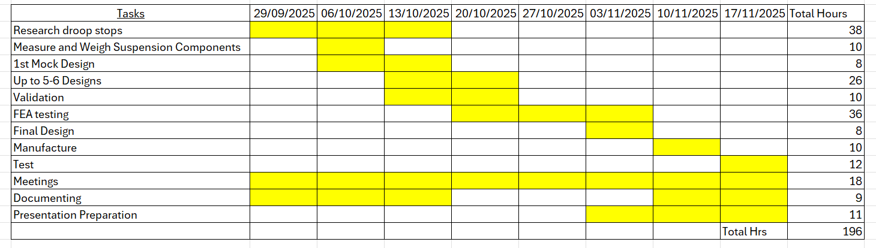
4.1 Task Duration

4.2 Bill of Materials
Tasks | Cost
Mild Steel | £40
Test Day | £150
Books | £70
Total Costs | £260

4.3 Special Equipment
- Solidworks
- Ansys
- Scales
- Cantilever Beam Testing Equipment (Steel, Metal Frame, DTI gauge, Mouting Point, Ruler, Weights)
- Welder
- Bending machine
- Angle Grinder

5.0 Significant Milestones
Milestone | Date
1st Mock Design and CFD progress | 06/10/2025
Pembrey Test Day #1 | 14/11/2025
VIVA | 27/11/2025
Developing Components | 01/01/2026
Pembrey Test Day #2 | 08/02/2026
Continuous Testing of new upgraded components | 17/02/2026
Start of Season | 13/04/2026
Final Assessments | 25/05/2026

5.1 Gateway Objective
When carrying out my project the gateway objective enables me to carry out a checklist when making progress. The gateway objective I am aiming to achieve is ensuring that the dimensions of the droop stops are correct to prototype and fit onto the MCR race car.
The droop stops will need to be a specific dimension regarding the angle and size of the rocker for the suspension. To begin with this idea, I followed my own methodology regarding measuring the rocker and moving forward into testing and manufacturing prototype 1. I measured the rockers on the car when it was at a static ride height. I measured what the angle of the rockers were as the rockers are not flat to the plane of the tubular chassis bar. I then went onto measuring the distance between the 2 bolt holes.
After the measuring process I thought of a design based on the measurements I had taken and went into SolidWorks. I went through a process of trying different designs and seeing what works best. I decided what design worked best through the use of FEA testing on Ansys. This allowed me to apply an upward force to the underside of the rocker and fixing the droop stop to the rocker as this would be my fixed boundary layer. When each design was tested, I wrote down the deformation, stress and strain and compared the data I had collected. The constant variable was the location of force and fixed points and what the material was. This then simply allowed me to see what design could withstand the force that would be applied underload.
I then moved onto the manufacturing stage. Gathering a 90-degree angled piece of mild steel, I measured where the holes would go, drilled them out, and test fitted them onto the car. I realised that due to the angle of the rocker the steel would be hitting the tub chassis without it doing its job, therefore while fitted I bent up a sectional area of the steel allowing to be parallel to the tub chassis while the rest of the steel was maintaining its angled shape. As I had to cut off some steel to allow the bending, I welded in the gap between the two planes of the steel. I then radiused the edges to follow the profile of the rocker allowing for droop stop prototype number 1 to be complete.
The next part of the project plan was to manufacture and test the design. I tested the droop stops on the car at Pembrey. All of this went to plan regarding the design and how it held, however due to the rain it compromised the data I gathered due to the driver not being able to go 100% into the corners.

6.0 Areas of Concern
I think that there would be a few areas of concern regarding my design e.g. welds, grade of bolts, my meshing

6.1 Weld
When it comes to the weld, when I bent the steel the I had to make some cuts to allow the bending therefore I had to weld. However, I only welded the underneath plane of the steel not the top. I think if the weld was to crack when in use, I think it’s because its weak I do believe that to mitigate this flaw I could always weld on the top plane of the material, doubling up either side of the weld ensuring the strength and rigidity of the steel.
Another part that was welded was the nuts onto the material. I had to weld a nut to the steel due to the steel not being thick enough to tap a thread through. I do think this could be a concern due to the outer coating of the nut being chrome and making it difficult to weld. Due to this, the weld might be weak and there could be a very small chance that it won’t hold. Even though this isn’t a huge concern for me or the design it could be something to investigate and mitigate. I would do this for my next design but polishing away the chrome to its base material making it easier to weld.

6.2 Grade of Bolt
Due to an incident in 2024 all bolts had to be upgraded to a grade 12.2, however the bolt I have used is 8.8 grade. Even though the accident occurred on a high loaded point, I think due to this, this is something to think about. I don’t believe it’ll snap as there isn’t much load going into the bolt. I think to correct this for the next design I would use a higher graded bolt.

6.3 Meshing
Regarding the ideology of the design, when it comes to me FEA testing the design, I did get great results from running a simulation on stress and deformation testing and saw little to no issues. The only issue I had was mesh sizing and generating a mesh, so I used a larger element size. This will compromise my results and wont be as accurate, therefore, to ensure I get the best results possible, I think that if I do the tests again, I can refine the mesh sizes as much as possible ensuring I get good results.

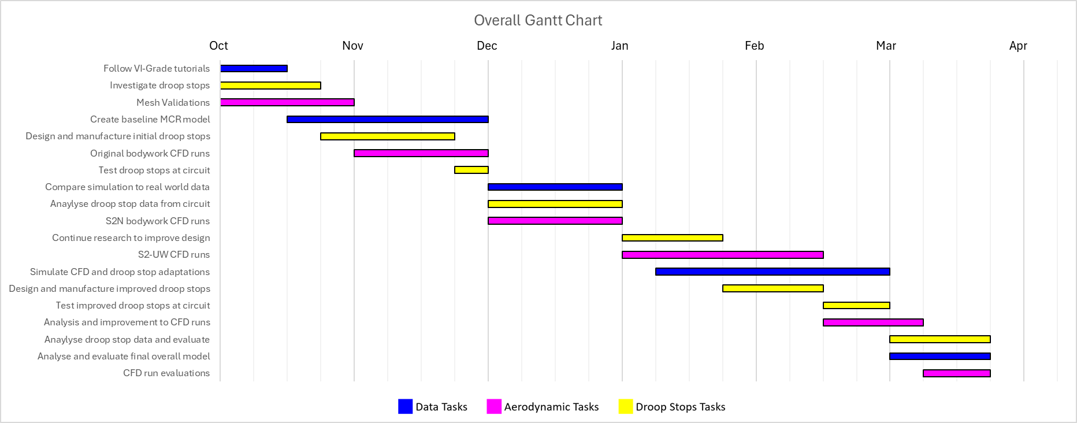
7.0 Overall GANTT Chart

8.0 Bibliography
UWTSD logo – page 1, used on 26/10/2025. Published by OnePlanetLife.comhttps://www.bing.com/images/search?view=detailV2&ccid=P86Ap0dK&id=76185929C2BAF0AE3D078EC77539FDFE7EEEB8FD&thid=OIP.P86Ap0dKhaRvKnBXV5koJgHaDt&mediaurl=https%3a%2f%2fi1.wp.com%2ftheoneplanetlife.com%2fwp-content%2fuploads%2f2019%2f06%2fUWTSD-logo.jpg&cdnurl=https%3a%2f%2fth.bing.com%2fth%2fid%2fR.3fce80a7474a85a46f2a705757992826%3frik%3d%252fbjufv79OXXHjg%26pid%3dImgRaw%26r%3d0&exph=450&expw=900&q=uwtsd&FORM=IRPRST&ck=4CDE0D6FAD22C5B0219C35903E8609CE&selectedIndex=0&itb=0
Belbins Model – https://www.belbin.com/about/belbin-team-roles page 4, 2.4, used on 17/11/2025. Published by Belbin

