ECAD6009/7003 – Part A (Parental engagement)

Rhestr gyfeirnodi / Reference list:

Harris, A. and Goodall, J. (2008) Do Parents Know They Matter? Engaging all Parents in Learning. Educational Research, 50 (3), pp 277. Available at: https://www-tandfonline-com.ezproxy.uwtsd.ac.uk/doi/epdf/10.1080/00131880802309424?needAccess=true

Hingle, M.D.O., O’Connor, T.M., Dave, J.M., Baranowski, T. (2010) Parental Involvement in Interventions to Improve Child Dietary Intake: A Systematic Review, 51 (2), pp 103. Available at: https://www-sciencedirect-com.ezproxy.uwtsd.ac.uk/science/article/pii/S0091743510001696?via%3Dihub

Riadil, I.G. (2020) Teaching English: An Afresh Sophisticated Technique to Cultivate Digital Native Learners’ Vocabulary by Utilising Seesaw Media as Digital Literacy, 1 (2), pp 62. Available at: https://riset.unisma.ac.id/index.php/JREALL/article/view/6855

Stevenson, A., Wainwright, N. and Williams, A. (2022) Interventions Targeting Fine Motor Skills in Pre-School-Aged Children with Direct or Indirect Parent Engagement: A Systematic Review and Narrative Synthesis. Available at: https://repository.uwtsd.ac.uk/id/eprint/1907/1/Stevenson%2C%20A.%2C%20Wainwright%20N.%2C%20Williams%2C%20A.%20%282022%29%20Final%20Parent%20engagement%20influence%20on%20motor%20skills%20Review.pdf

Taylor, C. and Power, S. (2020) Re-Educating the Nation? The Development of a New Curriculum for Wales. Wiley; Curriculum Journal; London, England, 31 (2), 177. Available at: https://web-p-ebscohost-com.ezproxy.uwtsd.ac.uk/ehost/pdfviewer/pdfviewer?vid=0&sid=a8bba4e3-e630-4409-bfab-00e4c0a2b7ff%40redis

Van De Kolk, I., Verjans-Janssen, S.R.B., Gubbels, J.S., Kremers, S.P.J. and Gerards, S.M.P.L. (2019) Systematic Review of Interventions in the Childcare Setting with Direct Parental Involvement: Effectiveness on Child Weight Status and Energy Balance-Related Behaviours. International Journal of Behavioural Nutrition and Physical Activity, 16 (1), pp 110. Available at: https://www.proquest.com/docview/2328352148?accountid=130472&parentSessionId=iXia6M8PB%2BOcGrPHC7S5FJoF%2FqJ8M0%2FV3EMC2DEjsDQ%3D&pq-origsite=primo&sourcetype=Scholarly%20Journals

Figure 1.
The Four Purposes of the Curriculum for Wales. Welsh Government. Available at: https://www.gov.wales/sites/default/files/publications/2018-03/the-four-purposes-of-the-curriculum-for-wales.pdf
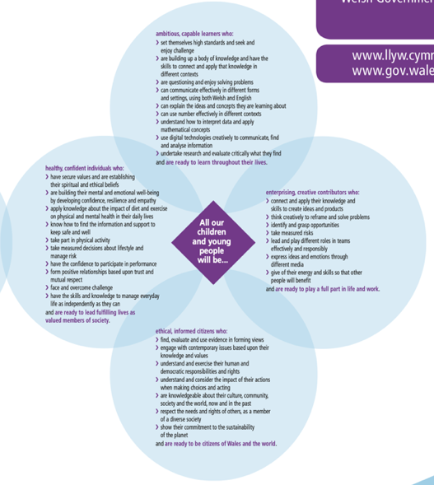

Figure 2.
School Development Plan (2024) School X. Unpublished
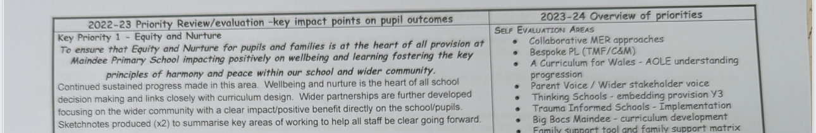

Figure 3. School X
School X (2024) School X. Newport. Unpublished

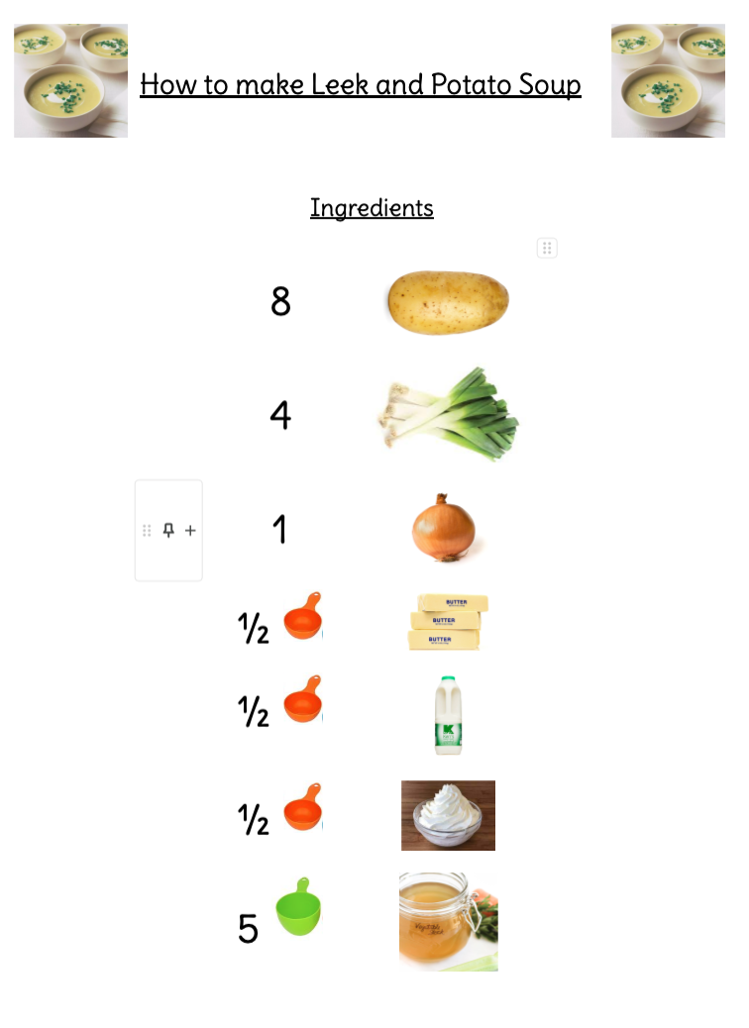
Figure 4. School X
School X (2024) School X. Newport. Unpublished
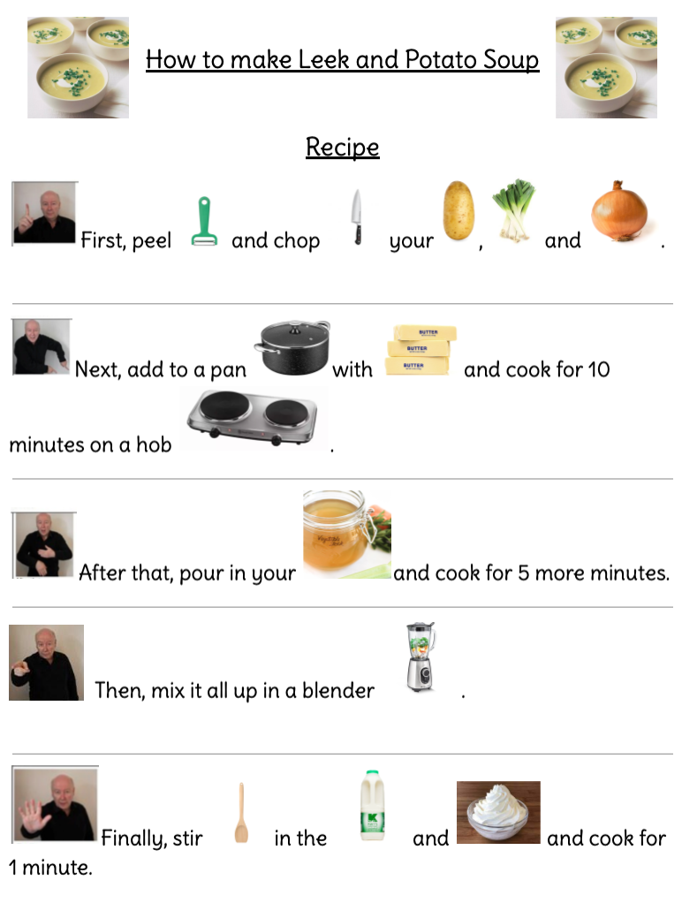

Figure 5. School X
School X (2024) School X. Newport. Unpublished



