Name:__Rami El Tayeb_______________________________

Student Number: _2523863
__________________________

WORKSHEET 1 – TESTING (Using Variables)

- Original code:
[Copy and paste your original code from Moodle into this box. Do not change it.]
surname = input("Please enter your surname:")
ni_number = input("Please enter your National Insurance Number:")
age = int(input("Please enter your age"))
hours = float(input("Please enter number of working hours peer week"))

while age < 1 or age > 115:
print ("Age must be greater than 1 and less than 115")
age = int(input("Please re-enter your age"))

while hours < 1 or hours > 48:
print ("Hours must be at least 1 and cannot exceed 48")
hours = float(input("Please re-enter number of working hours per week"))

while len(ni_number) > 10 :
print ("National Insurance Number must not exceed 9 characters")
ni_number = input("Please re-enter your National Insurance Number")

print("Details entered:")
print("Surname:",surname)
print("National Insurance Number:", ni_number)
print("Age:",age)
print("Number of working hours per week:", hours)

- Code Testing

For each test below, run your code and enter the values provided. Present a screenshot of the programme running. Did the programme behave correctly or did it do something unexpected, and if so, why?

Surname:
- Enter JONES
- Leave blank
- Enter A
- Enter 123

National Insurance Number:
- Enter PE534121B
- Leave blank
- Enter AB11223344556677 (ie too long for National Insurance number format)
- Enter 22PE4088A (ie wrong format)

Age
- Enter 34
- Enter 150
- Enter -4
- Enter a letter

Number of working hours per week:
- Enter 37.5
- Enter 150
- Enter 0
- Enter -2

Fill in a box for each test above. You should present 16 separate boxes, 1 for each test. (Note: the first two boxes are provided as a template)

Test:
Surname i. Enter JONES

Screenshot(s) of output:
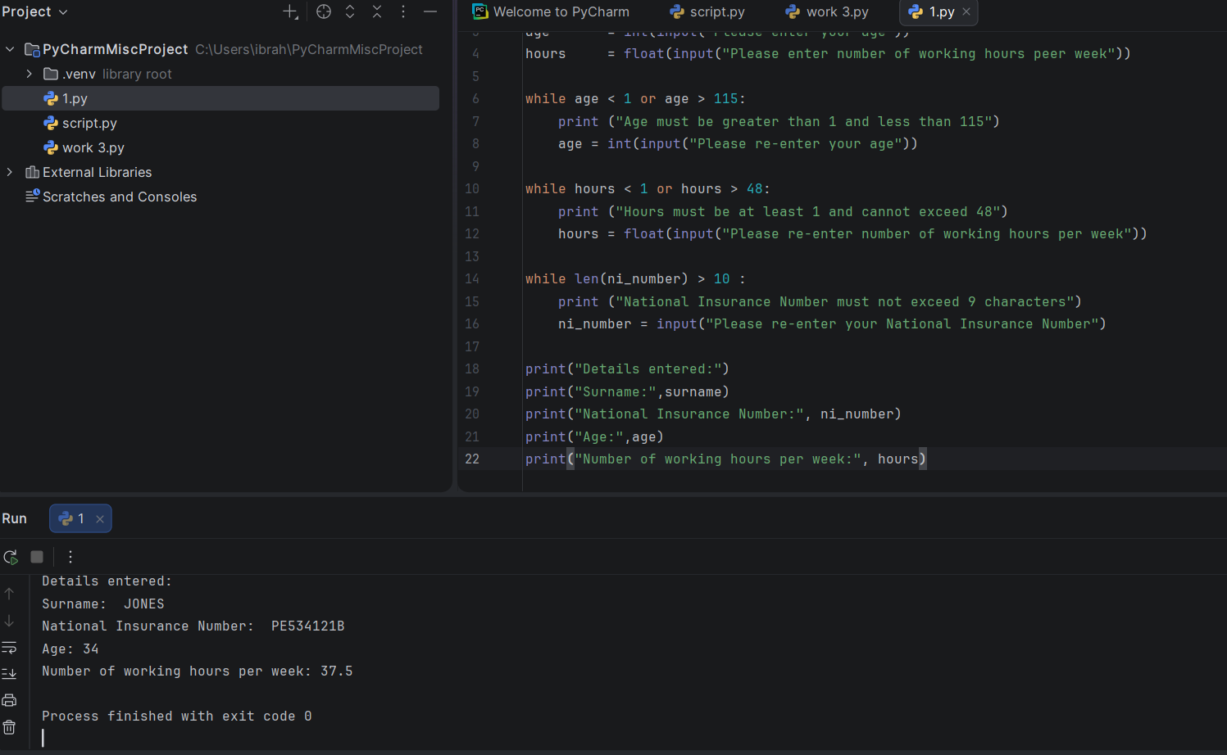
Result: Did the programme behave as expected ie syntactically and logically correct?
YES

The program behaved correctly. The surname “JONES” was accepted and the program continued to run. The final output displayed the surname correctly with the other valid details, and the program finished without crashing.

Test:
Surname ii Leave blank

Screenshot(s) of output:
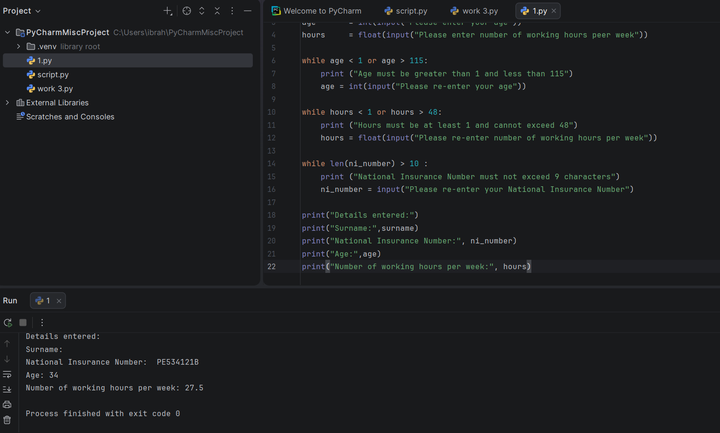
Result: Did the programme behave as expected ie syntactically and logically correct?

NO
The program did something unexpected. The surname field was left blank, but the program still accepted it and continued running normally. There is no validation in the code to check whether the surname input is empty.

Continue the rest of the tests below. (Copy and paste a box for each one)

Test: Surname iii Enter A

Screenshot(s) of output:
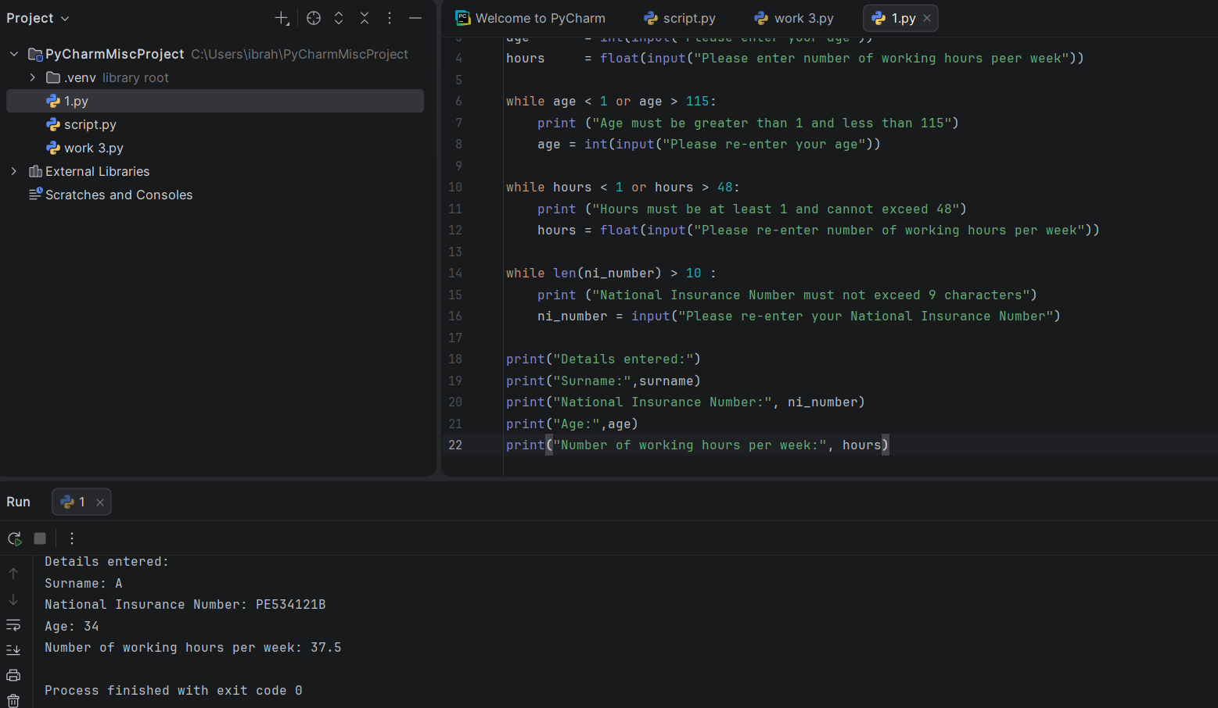
Result: Did the programme behave as expected ie syntactically and logically correct?
NO

The program did something unexpected. A single letter surname (“A”) was accepted and the program continued running normally. There is no validation in the code to check whether the surname entered is a realistic full surname or contains enough characters.

Surname Test: Enter 123

Screenshot(s) of output:
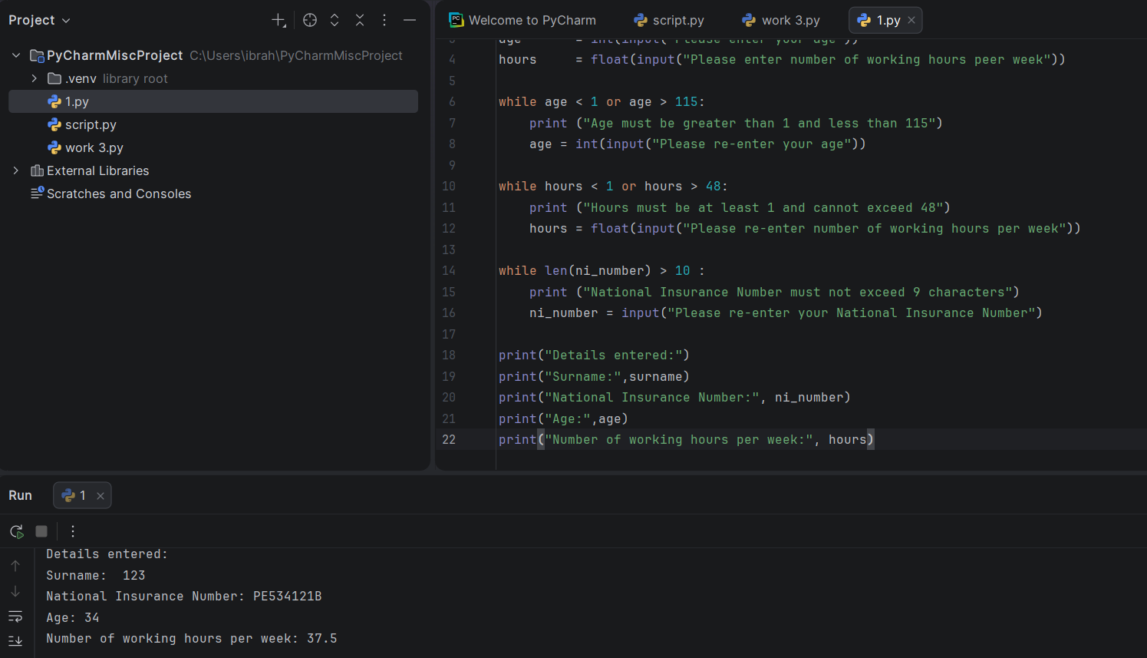
Result: Did the programme behave as expected ie syntactically and logically correct?
NO

The program did something unexpected. The surname “123” was accepted even though a surname should normally contain letters rather than numbers. The code does not include validation to check whether the surname contains only alphabetic characters.

- Test: NI Enter PE534121B

Screenshot(s) of output:
Result: Did the programme behave as expected ie syntactically and logically correct?

YES

The program behaved correctly. The National Insurance Number “PE534121B” was accepted because it met the length requirement in the code. The program continued running normally and displayed the details correctly at the end.

Test: NI Leave blank

Screenshot(s) of output:
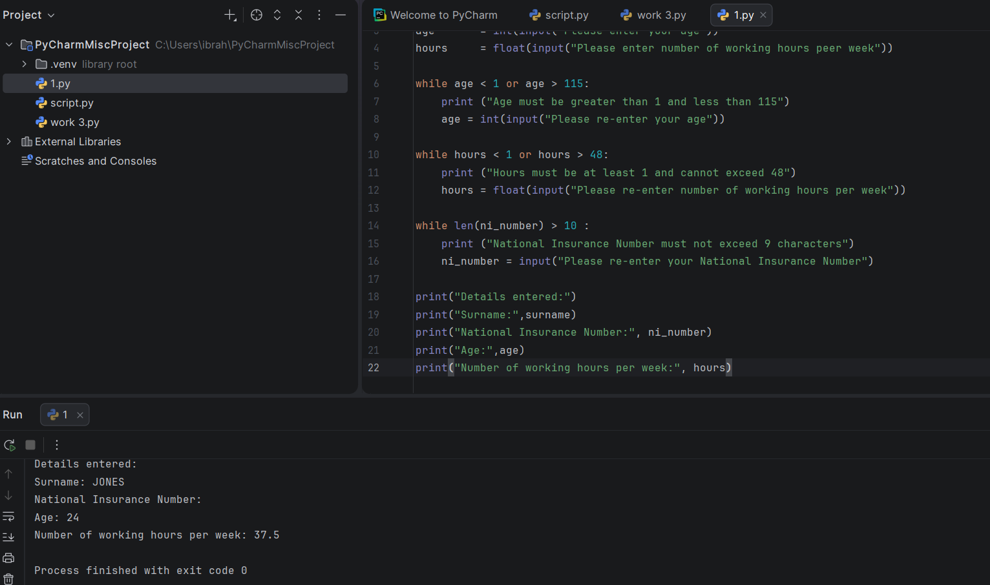
Result: Did the programme behave as expected ie syntactically and logically correct?

NO

The program did something unexpected. The National Insurance Number field was left blank, but the program still accepted it and continued running normally. The code only checks the length of the input and does not check whether the field is empty.

Test: Enter AB11223344556677 (ie too long for National Insurance number format)

Screenshot(s) of output:
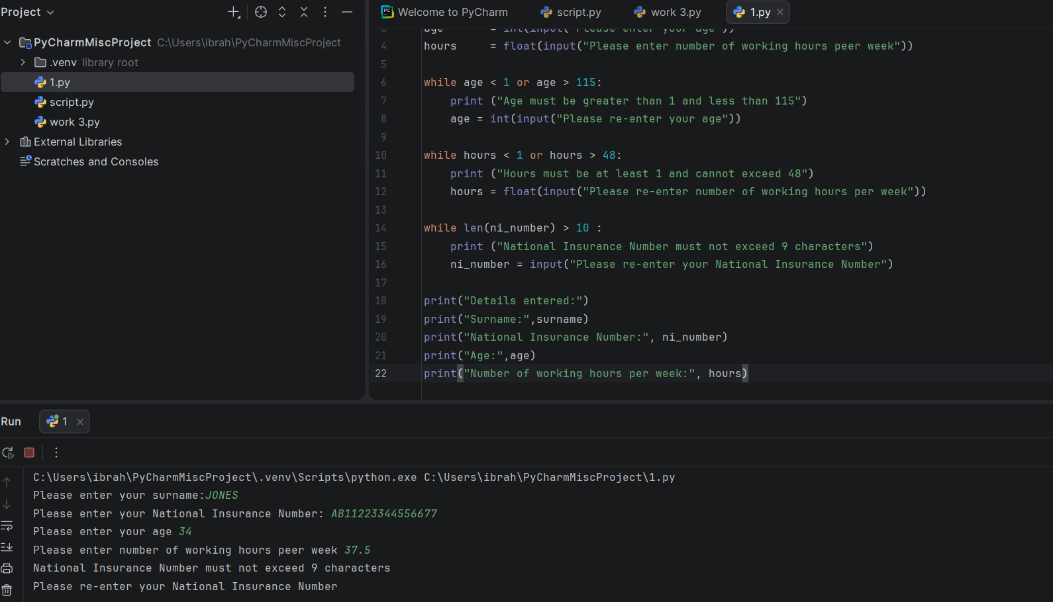
Result: Did the programme behave as expected ie syntactically and logically correct?
YES

The program behaved correctly. The National Insurance Number entered was too long, so the validation check detected this and displayed the message “National Insurance Number must not exceed 9 characters”. The program then asked the user to re-enter the value.

Test: Enter 22PE4088A (ie wrong format)

Screenshot(s) of output:
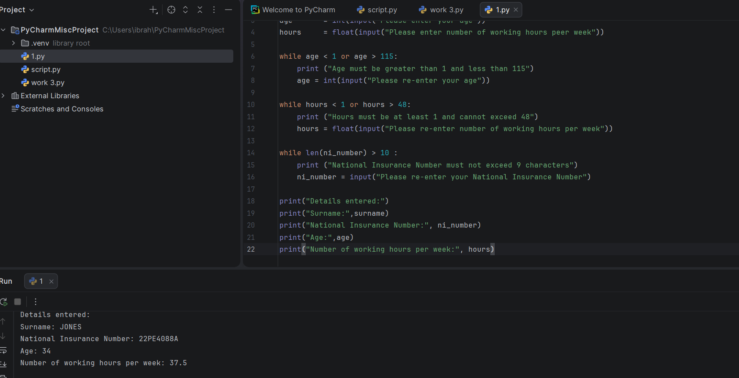
Result: Did the programme behave as expected ie syntactically and logically correct?
NO

The program did something unexpected. The National Insurance Number “22PE4088A” was accepted even though it is in the wrong format. The code only checks the length of the input and does not validate the correct National Insurance Number structure or character order.

Test: Age enter 34
Result: Did the programme behave as expected ie syntactically and logically correct?
YES

The program behaved correctly. The age “34” is within the valid range allowed by the code, so it was accepted and displayed correctly in the final output. The program completed successfully without any errors.

Test: Age enter 150

Screenshot(s) of output:
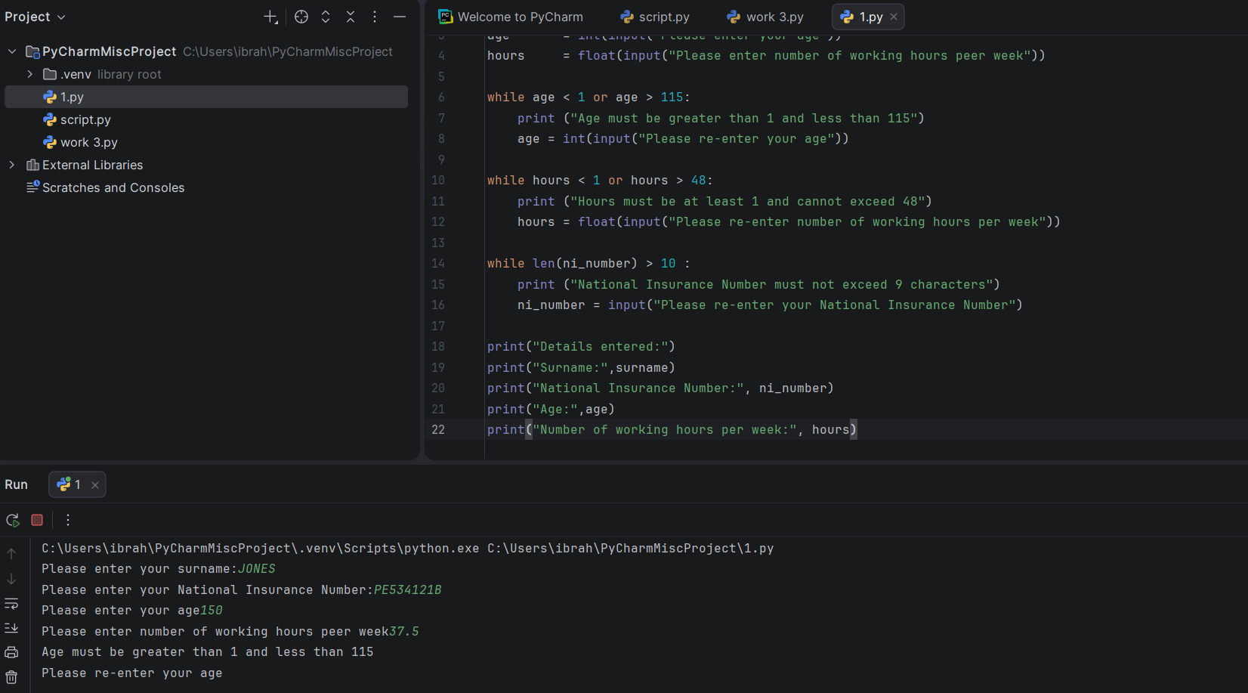
Result: Did the programme behave as expected ie syntactically and logically correct?
YES

The program behaved correctly. The age “150” is outside the valid range set in the code, so the validation check displayed the message “Age must be greater than 1 and less than 115” and asked the user to re-enter their age.

Test: Age enter -4

Screenshot(s) of output:
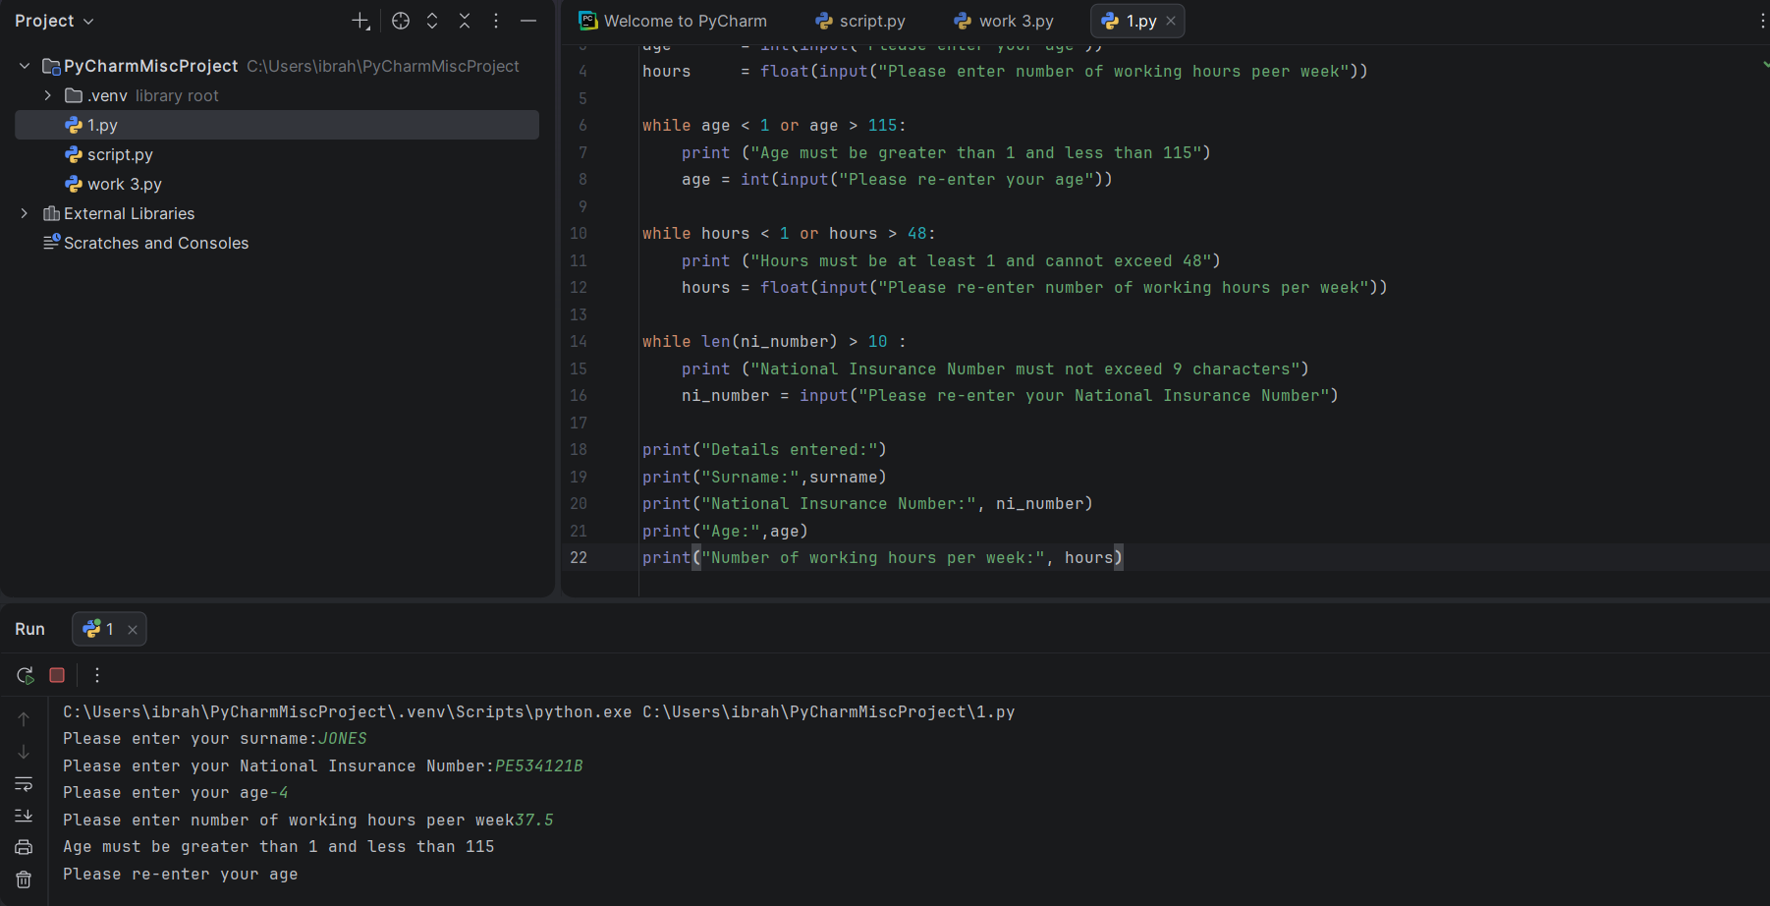
Result: Did the programme behave as expected ie syntactically and logically correct?
YES

The program behaved correctly. The age “-4” is below the valid range allowed by the code, so the validation check displayed an error message and asked the user to re-enter their age.

Test: Age enter a letter

Screenshot(s) of output:
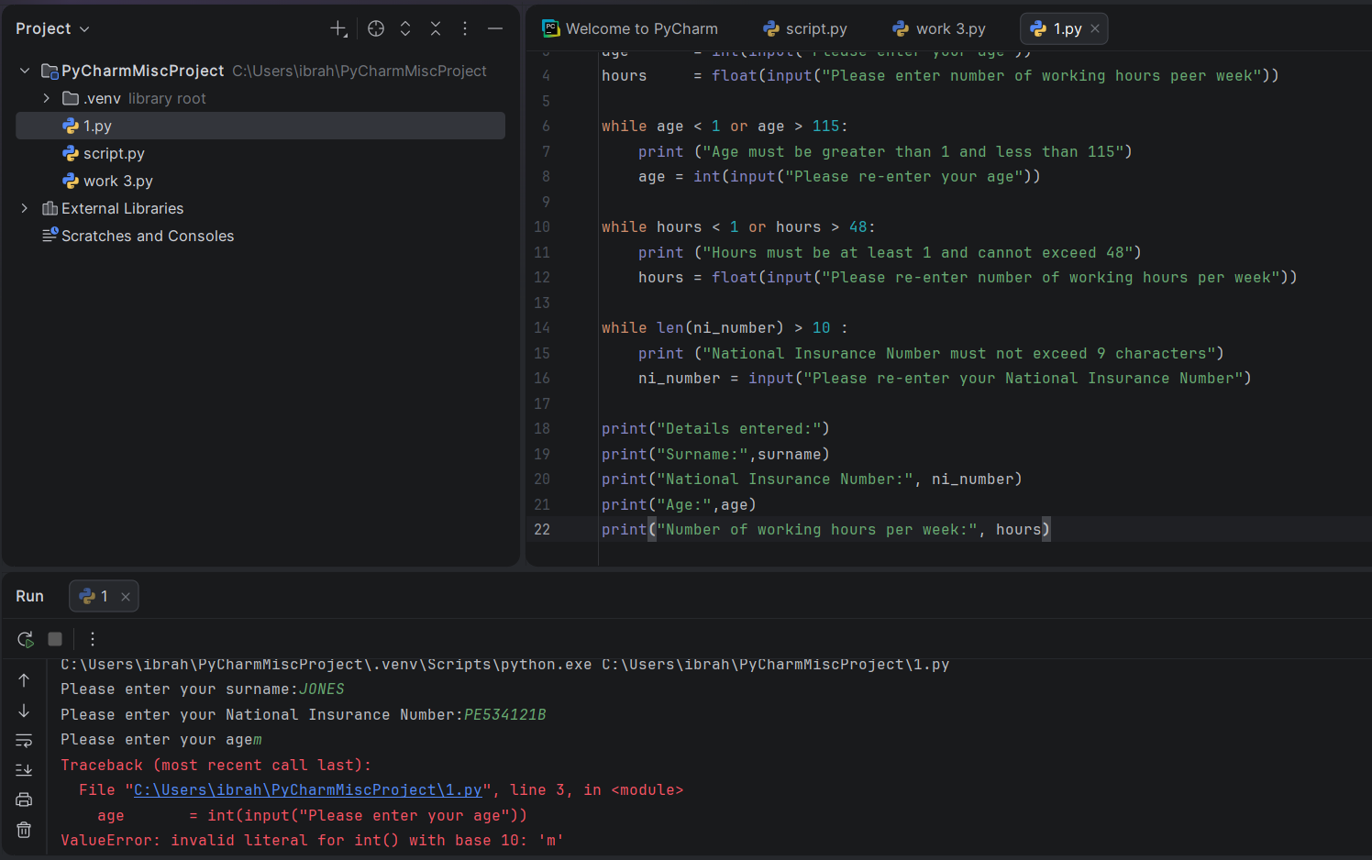
Result: Did the programme behave as expected ie syntactically and logically correct?
NO

The program did not behave correctly. Instead of displaying a validation message and asking the user to re-enter their age, the program crashed with a ValueError. This happened because the code uses int(input()), and Python cannot convert the letter "m" into an integer.

Test: Hours 37.5

Screenshot(s) of output:
YES

The program behaved correctly. The value 37.5 is within the valid range of 1 to 48 hours, so the program accepted the input and displayed the entered details successfully.

Test: Hours enter 150

Screenshot(s) of output:
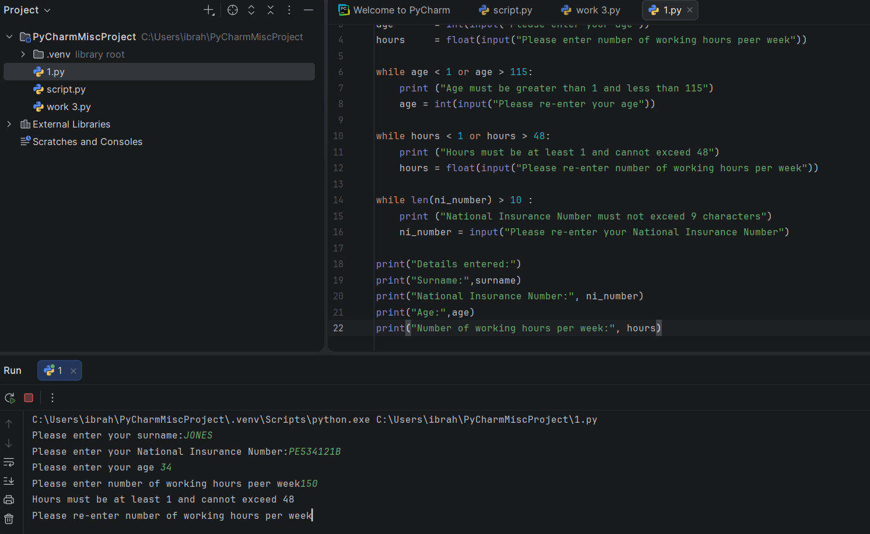
Result: Did the programme behave as expected ie syntactically and logically correct?
YES

The program behaved correctly. The value 150 is greater than the maximum allowed value of 48, so the validation message was displayed and the user was asked to re-enter the number of working hours.

Test: Hours enter 0

Screenshot(s) of output:
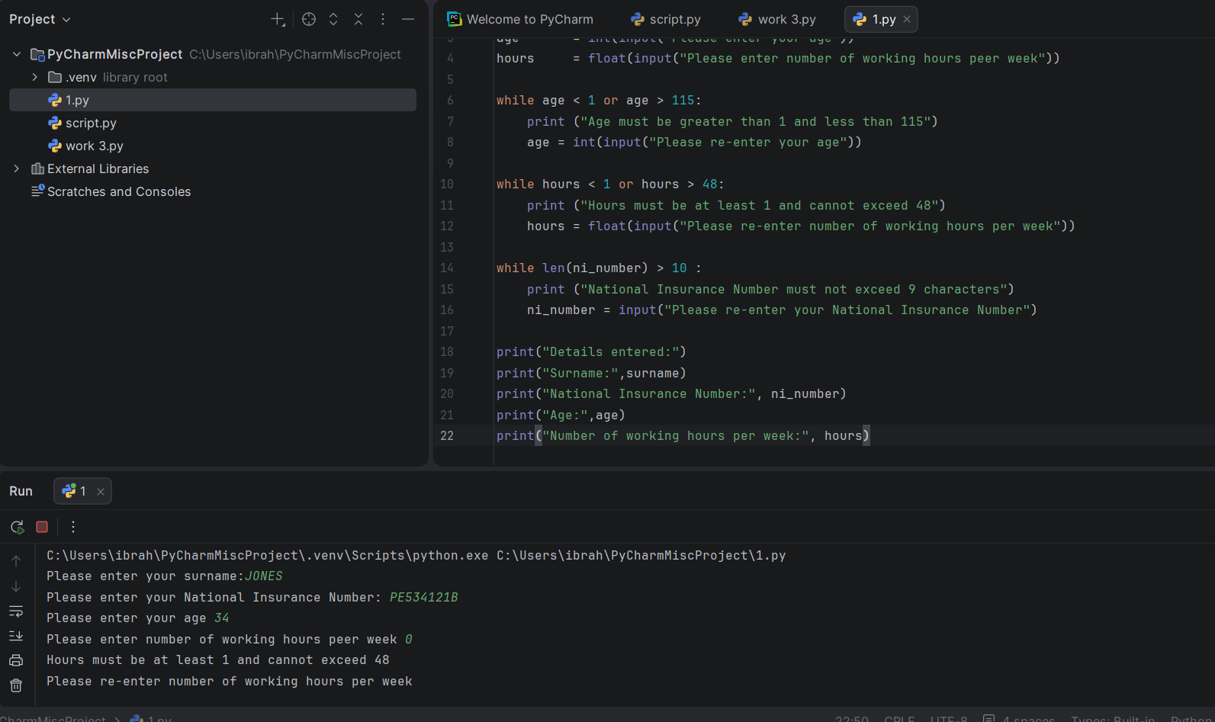
Result: Did the programme behave as expected ie syntactically and logically correct?
YES

The program behaved correctly. The value 0 is below the minimum allowed value of 1, so the validation message was displayed and the user was asked to re-enter the number of working hours.

Test: Hours enter -2

Screenshot(s) of output:
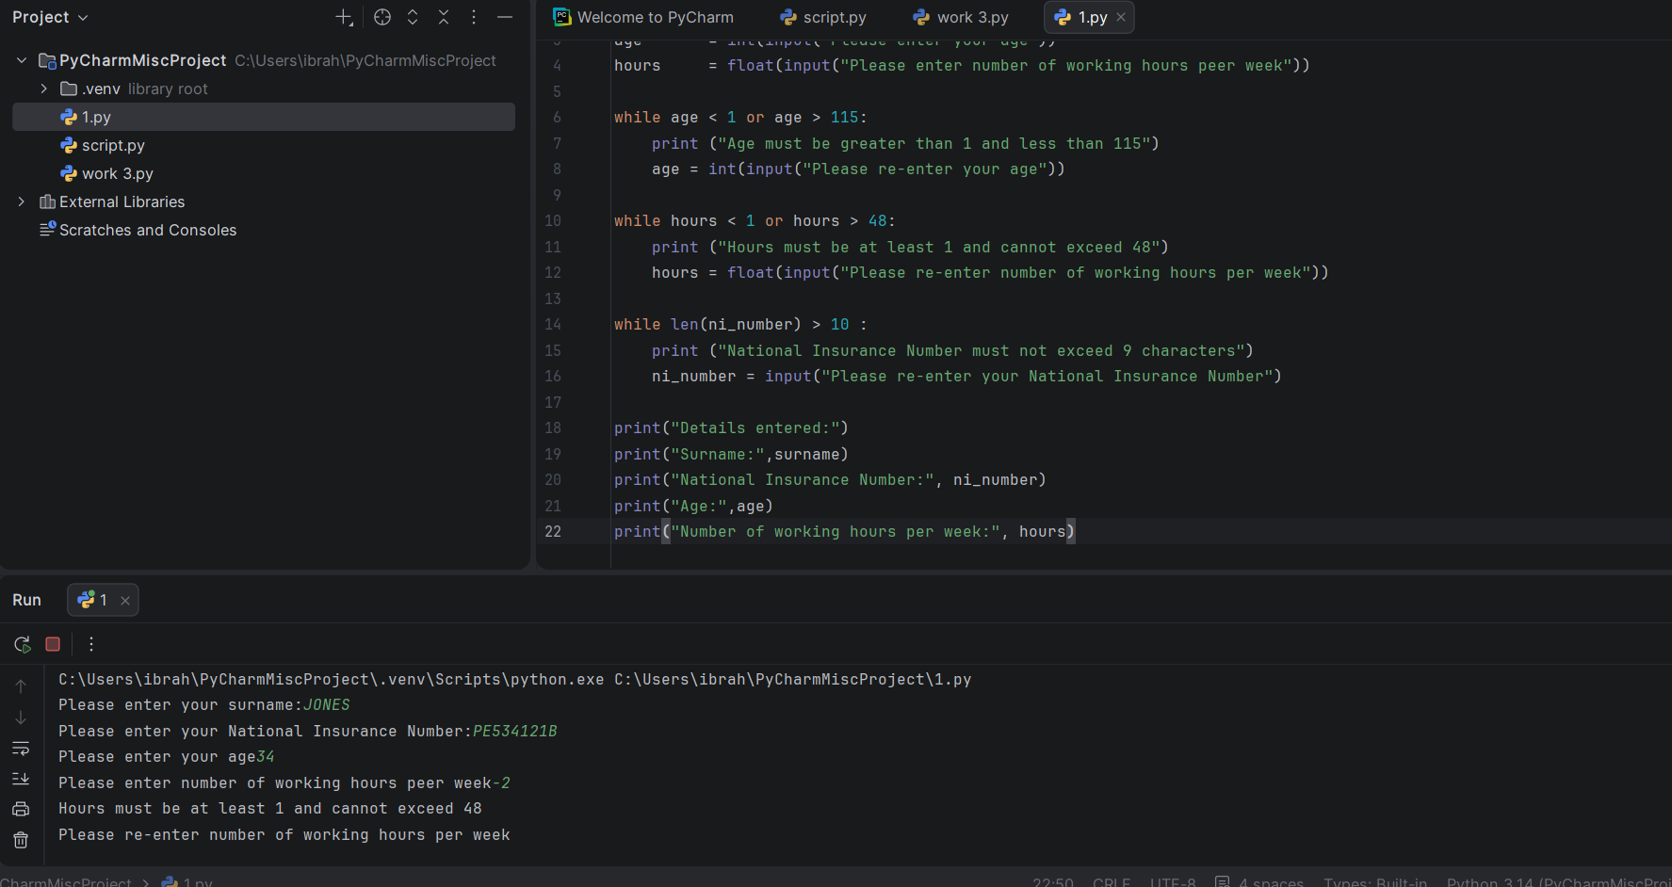
Result: Did the programme behave as expected ie syntactically and logically correct?

YES

The program behaved correctly. The value -2 is below the minimum allowed value of 1, so the validation message was displayed and the user was asked to re-enter the number of working hours.

- Consider the results of the above tests and revisit your code in order to solve the problems. (Note: you may not be able to solve all of them, but solve as many as you can.)

Paste your revised code here:

[Copy and paste your revised code here – note, do not use a screenshot]

surname = input("Please enter your surname:")

while surname == "":

print("Surname cannot be blank")

surname = input("Please re-enter your surname:")

ni_number = input("Please enter your National Insurance Number:")

while len(ni_number) > 10 or ni_number == "":

print("National Insurance Number is invalid")

ni_number = input("Please re-enter your National Insurance Number:")

age = input("Please enter your age")

while age.isdigit() == False:

print("Age must be a number")

age = input("Please re-enter your age")

age = int(age)

while age < 1 or age > 115:

print("Age must be greater than 1 and less than 115")

age = int(input("Please re-enter your age"))

hours = float(input("Please enter number of working hours per week"))

while hours < 1 or hours > 48:

print("Hours must be at least 1 and cannot exceed 48")

hours = float(input("Please re-enter number of working hours per week"))

print("Details entered:")

print("Surname:", surname)

print("National Insurance Number:", ni_number)

print("Age:", age)

print("Number of working hours per week:", hours)

