

Using and Programming the 7-Segment
Display Prototype Circuit

BEng Electronics Engineering
ACDA4004 –Micros, Peripherals and Interfaces

Prepared by:
Mr Aaron Hillam
P141233

Submitted to:
Mr Gareth Jones
School of Computing
21/05/2020

Contents
1.0 Introduction 3
1.1 Aims and Objectives 4
1.2 Component Appraisal 5
2.0 Section 1 9
2.1 Section 2 10
2.1.1 Assembly Code 11
2.1.2 Flow-Chart 14
3.0 Evaluation 15
4.0 References 16

Figures
Figure 1: Led Sequence 6
Figure 2: Power Regulator 8
Figure 3: First Circuit Build 9
Figure 4: Upgraded Circuit 10
Figure 5: Code part 1 11
Figure 6: Code part 2 12
Figure 7: Code part 3 13
Figure 8: Flow-Chart 14


1.0 Introduction
This report focuses on the development of a circuit which enables a user to adjust a 7-segment display, which in turn modifies an output sound.
There are two sections of focus, the first is to reproduce the circuit, identify all components within a circuit and understand the purpose that they play within the circuit.
The second section heavily focuses on the programming of the circuit, as well as to improvement the first sections circuit design.

1.1 Aim and Objectives
The aim is to reproduce and repair circuit design, which can output various tones. The following objectives have been determined:

- Identify and appraise each component within the design
- Improve the design
- Construct a sufficient code

1.2 Component Appraisal
- Capacitors
  - A capacitor is a device with two terminals which holds the property of capacitance. Like a battery it can hold an electrical charge. The difference to a battery consists of a capacitor only being able to store a very small electric charge however the capacitor is charged and discharged much quicker than a battery. [1] [2]
  - The inside of the capacitor consists of two conductive plates separated by a dielectric plate. [1] [2]
  - Within a circuit a capacitor initially charges up / takes from the voltage source then the capacitor gives back to the voltage source over time. These two operations allows the capacitor to be used in many ways, which include:
    - Removal of interruptions – as a voltage source is being applied to a circuit, the current may not be adequate, thus resulting in intermittent powering, the capacitor can be used to fill in between the intermittence to reduce it to an acceptable performance. [1] [2]
    - Power factor correction – When there are too many inductors used within the circuit, it can result in the current starting to lag behind the voltage. Capacitors can then be used to bring the current into alignment with the voltage. [1] [2]
    - Smoothing – During the conversion of AC to DC power, a full bridge rectifier to flip the AC flow, creating a DC flow. This conversion introduces intermittent power supply, which a capacitor can be used to fill in the gaps and provide a more reliable flow. [2] [1]
    - Pulse Regulating / coupling capacitance – With a circuit which uses a crystal resonator, the pulses are not regulated as they are turned on. This can cause inaccurate outputs. Capacitors can be used to provide a steady flow of power ensuring that pulses are regulated. In addition, the capacitor can also be used as a delay mechanism, so that the early pulses are removed until the capacitor is able to fill in the gaps. [1] [2]

- Crystal
  - The purpose of a crystal oscillator is to control the timing of a device. The piezo electrical effect of the crystal enables the designer to input a set frequency, which can then be amplified to suit various applications. By specifically using a crystal oscillator, it allows a waveform to be generated, which is crucial for generating audio outputs. [1] [2]

- Resistors
  - Resistors consist of an input and an output wire, which are connected through a more resistive material. The purpose of the resistor is to reduce the current supply to various components. [1] [2]
- 7 segment display
  - A 7-segment display consists of 7 LED strips, connected to in sequence. As shown in figure 1. The purpose is to communicate information to the user / designer. [1] [2]
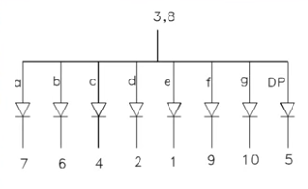
Figure 1: LED Sequence
- Push buttons
  - Push buttons are used to change the state of a circuit from high (1) to low (0). When not pushed, the button breaks the circuit from one side to the other. When pushed, the circuit on both sides are temporarily connected, thus the change in state is completed. [1] [2]
- Switch
  - Switches are used to change the state of a circuit from high (1) to low (0). When not pushed, the button breaks the circuit from one side to the other. When pushed, the circuit on both sides are permanently connected until it is pushed off, thus the change in state is completed. [1] [2]
- Ground wire
  - A ground wire connects the circuit to ground / the negative terminal of a battery. With electrical circuits, the current follows the best route to ground, by changing the most likely route to ground makes it possible for components to be powered.
- Voltage wire
  - The voltage wire is means of powering a device regardless of where the power source comes from, such as battery or mains.
- PIC16F84A
  - The PIC, is a micro-controller, which acts as a method of communication / relay between various aspects of a circuit. The PIC uses machine code, which can be programmed by using assembly language. It is possible to alternate the pins to inputs and outputs, rendering them as multi-functional. Various PIC’s have other components integrated, allowing for further capabilities.
- Transistor
  - A transistor is a semi-conductor which works as a switch. By default, it is not conducting, thus the switch is off. By applying a voltage to the base, it allows the current to start flowing through from the collector through the emitter, thus completing the circuit. The transistor is in solid-state enabling it to be turned on and off rapidly. This makes it possible to control pulses going through, thus changing the frequency as and when required.
- Piezo-Sounder
  - A piezo-sounder consists of a ceramic plate encased in a shell. The plate is connected to a power supply and a ground. A power source is used to cause the ceramic plate to resonate, inducing a sound wave to be generated, as the frequency is changed, the sounder changes the pitch at which it sounds.

- Power Regulator
  - A power regulator takes in an unregulated input voltage which could be fluctuating over time and outputs a lower perfectly regulated constant voltage. The regulator works by having a reference op-amp. Which checks if the voltage is the correct amount, if the voltage is too high, it stops power to the base of a transistor, thus stopping the voltage, when the voltage is low, power returns to the transistor base, causing voltage to continue. This loops to maintain the correct voltage. Dependant on how big the voltage source is to drop by, starts to generate heat. To prevent the regulator from over-heating, a heatsink is added, to divert the heat externally. In modern power regulators, they also have a thermal shutdown feature, which further prevents overheating / damage to the component. Figure 2 depicts an example of current flow. [1] [2]
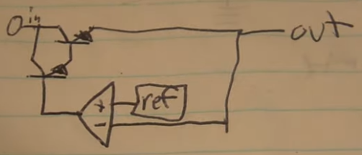
Figure 2: Power Regulator
- Signal Terminal Block
  - A terminal block has the purpose of securing a connection between two live wires. The signal terminal block has the specific feature of reducing delays in current flow. As a signal may need to be as precise as possible, any delays could render the signal pointless. [1] [2]

- Section 1
Figure 3 depicts a rebuild of the 7-segment display prototype board.
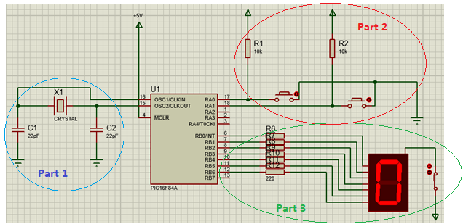
Figure 3: First Circuit Build
The following specification of how each component grouping contributes to the functionality of the display.
Part 1 of the circuit depicts the X1 crystal connected between the capacitors C1 and C2, forming a coupling feature. The coupling setup ensures that any signal generated by the crystal oscillator are of high/reliable quality. The crystals purpose is to apply an adjustable frequency.
The purpose of part 2 of the circuit is to enable a user input. The user / designer can control the frequency by increasing or decreasing the amount of outputs which are available, by pressing the relevant button. For each output which is set to high (1), the frequency is also changed.
As shown in part 3 of the circuit, the 7-segment LED display is connected to a power switch which enables the display to be turned off. To protect each of the LEDs inside the display, the set of resistors are connected. The LED inputs are connected to the PIC output in order. This allows the output sequence to be modified, thus modifying the display.
The +5v connected to the MCLR provides the power source to operate the pic and circuit.
The PIC16F84A is a basic, general use PIC, it has an ideal set of output ports to operate the display and the addition of another output, such as the piezo sounder.
2.1 Section 2
Figure 4 depicts the updated circuit diagram, with the added buttons SW3 and SW2 and the 4th circuit group.
The 4th circuit group includes the transistor which pulses on and off as the frequency from the outputs changes; the sounder, which changes the pitch of sound as the frequency of pulses is altered; the power regulator is secured by the setup of coupling capacitors. These ensure that the voltage supply is smoothened out further; the switch SW1 makes it possible to disconnect the 4th circuit group; the signal terminal block ensures that the current is flowing with as little interruptions as possible. This is ideal to get the correct pitch/frequency.
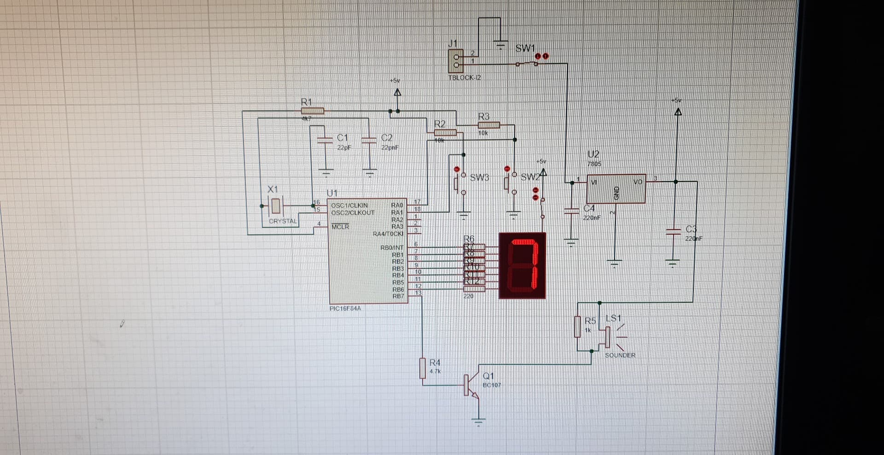
Figure 4: Upgraded Circuit

2.1.1 Assembly Code
The code shown in this section, consists of the broken code with a few improvements, to help meet the assignment brief. portA and the buttons connected to portA have been defined, making it possible to apply an input signal. In addition portB is also defined enabling output signals to become possible. The variables count, ncount and mcount have been used to map out the entire memory size by using the outer loop counter as a multiplier for the inner counter, essentially equal to 16 x 16 = 256 bits.
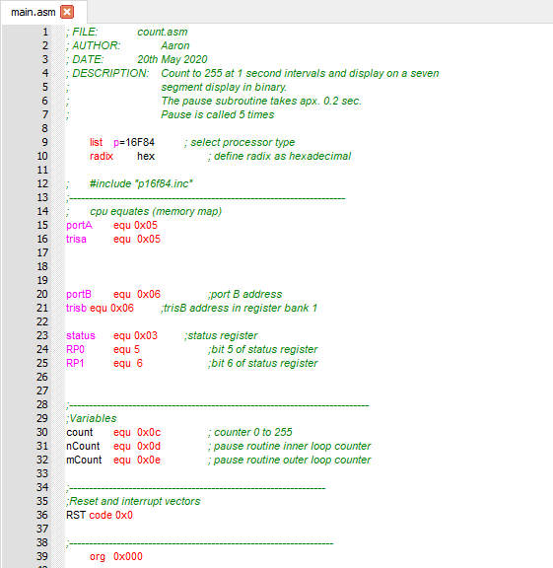
Figure 5: Code part 1

Org 0x000 defines the starting location for the code.
Start is the label to identify the starting point of the code.
The coding first clears the ‘F’ registers by setting them all to 0 and then back to 1, this is important to ensure that no previous data is stored prior to the loop functioning.
As stated in the brief, the display must start from 0, as a result the hex value for displaying 0 is 0xC0. This value has been loaded into trisb as the initial/default output display.
Portb is then set back to low (0), awaiting the input high (1) from the buttons.
Once the buttons have been pressed, it will jump to the code label ‘get_count’, there the stored value in the ‘w’ register will be either increased using addlw 1, or decreased using sublw 1. The new value is then stored into the ‘w’ register. The code loops back to label ‘start’, where the new value in the ‘w’ register is moved into portb using the movlw. The new value of portb will light up the relevant LEDs.
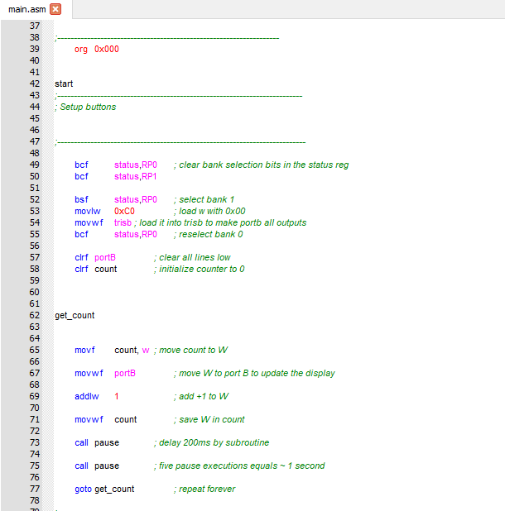
Figure 6: Code part 2
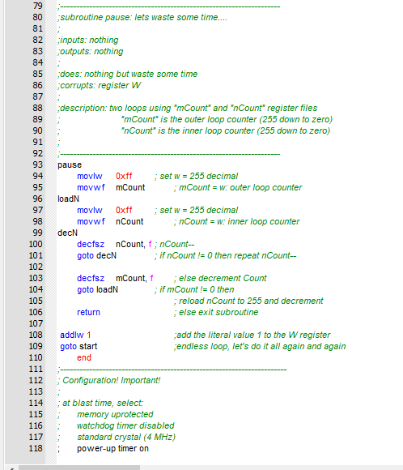
Figure 7: Code part 3

2.1.2 Flow-Chart
Due to the lack of software available during the covid-19 pandemic, the following flow chart has been used to show how the coding should work and the steps it should take. This should hasten the repair of the code, once the relevant software is available.
Figure 8: Flow-Chart

- Evaluation
The completion of section 1 of the assignment brief has been successful. All of the components have been thoroughly appraised and identified to be suitable for the circuit.
As for section 2, the current circuit and coding enables the display to change in a loop, the display is able to show 0 – F. The buttons set an input, however the outputs do not yet accept the input. The added switch to the LED display, does turn off the display. The circuit starts at 0 everytime it is turned on. The piezo sounder does present a sound, but as the buttons do not yet modify the output, the sound is of a single tone / frequency.
Unfortunately, due to the covid-19 pandemic, it has not been possible to access the relevant software to ensure that the coding in section 2 is functioning adequately. However, prior to the pandemic, some of the coding had been saved thus allowing some of the circuit to function. Further repairs to the coding is still required.

4.0 References

[1] | D. B. Albert Malvino, Electronic Principles, New York: McGraw-Hill, 2016.
[2] | W. H. Paul Horowitz, The Art of Electronics, New York: Cambridge University Press, 2015.
[3] | C. Bowick, RF Circuit Design, Burlington: Elsevier Inc., 2008.
[4] | N. Kularatna, Electronic Circuit Design: From Concept to Implementation, 2017.
[5] | J. H. W. M. Rudy J. van de Plassche, Analog Circuit Design: High-Speed Analog-to-Digital Converters, Mixed Signal Design; PLLs and Synthesizers, New York: Springer Science + Business Media, LLC, 2000.

